Expect the Unexpected - A Rare Case of Nasal Floor SCC

¹ Department of Otorhinolaryngology & Head & Neck Surgery, Queen Elizabeth Hospital, Kota Kinabalu, Sabah, Malaysia
² Department of Otorhinolaryngology, Faculty of Medicine and Health Sciences, University Malaysia Sabah, Kota Kinabalu, Sabah, Malaysia

ABSTRACT
BACKGROUND
Reported cases of malignancy involving nasal cavity and paranasal sinuses (Sinonasal tract) are rare, they account for less than 0.5 % of all malignancies and less than 3% of all aerodigestive tract cancers ⁴, even though 50% of all Sinonasal malignancies are of squamous cell carcinoma (SCC) variant, those reported to arise from the subsite of nasal floor are exceedingly rare ¹.

CASE REPORT
We report an odd case of sinonasal SCC in an elderly farmer involving the nasal floor which led to the eventual disfiguring destruction of nasal septum and columella, highlighting its rarity in literature, difficulty in detecting and a glimpse of its surgical treatment.

CONCLUSION
Nasal floor SCC being a rare entity deserves its own staging system. Due to its vague presentation of symptoms , early assessment is crucial in clinching the diagnosis early and a combined approach of surgical intervention with adjuvant chemoradiotherapy can be given to patient for a good cosmetic as well prognostic outcome.

INTRODUCTION
About half of primary sinonasal malignancies consists of SCC variant, however not all subsites are being equally implicated as the site of origin, as the title of this report suggests, nasal floor is the least implicated ^{2,12}. Aside from the rarity of the disease, limited existing literature and reports regarding SCC of the nasal floor becomes a major setback for clinicians effort in early recognition and treatment, especially in recognizing the presenting symptoms from history, needless to say that the known presenting symptoms such nasal obstruction and epistaxis are not disease specific¹³. There are however certain established etiological factors such as wood dust exposure, leatherwork chemicals, nickel, chromium, human papilloma virus (HPV) and cigarette smoke to help narrow down the differential diagnosis during clinical history review ¹⁵.

KEY WORDS
Case report, nasal floor, squamous cell carcinoma

CASE PRESENTATION
A 68-years-old gentleman who works as a farmer presented with 1 month history of nasal itchiness and epistaxis post nose-scratching. He has underlying hypertension and also a chronic smoker of 14-pack-years. Patient has no other complaints.
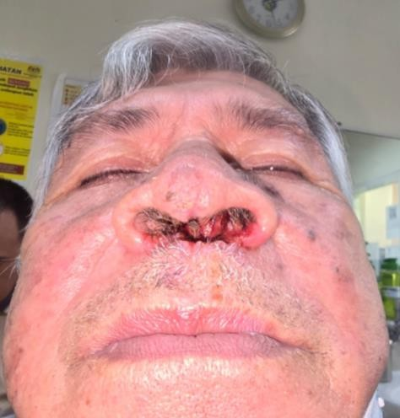


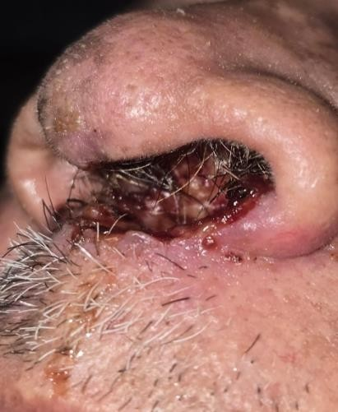
Upon examination, patient’s columella noted have moth-eaten appearance surrounded by dried blood crustings. Also noted eroded inferior aspect of septal cartilage (Figure 1 & 2).

=

Figure 1 : Moth-eaten appearance of columella
Figure 2 : Eroded inferior aspect septal cartilage with bloody crustings

CECT (Contrast-enhanced computed tomography) scan showed focal left bony nasal septum thickening with mild nasal septum deviation and no bony erosion or focal enhancing lesion within nasal cavity or septum.
Biopsy of irregular nasal floor mucosa came back as keratinizing nasal floor squamous cell carcinoma and CECT staging showed a localized disease.
Post multidisciplinary discussion, patient underwent wide local excision with bilateral inferior turbinectomy , cartilaginous septectomy, tracheostomy and nasal floor reconstruction with right paramedian forehead flap and nasal lining reconstruction with full thickness skin graft
(Figure 3 & 4)

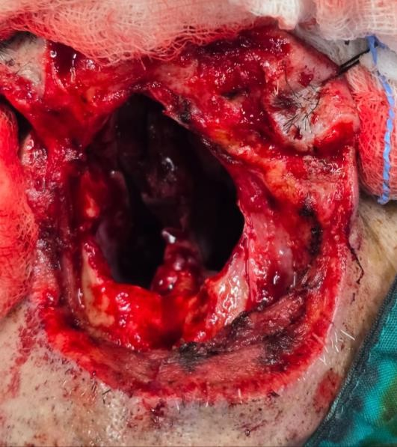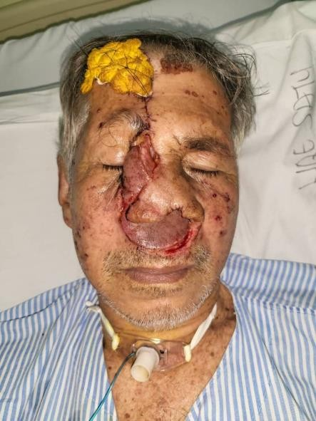
Figure 3 : Wide local excision with bilateral inferior turbinectomy & cartilaginous septectomy
Figure 4 : Tracheostomy and nasal floor reconstruction with right paramedian forehead flap & nasal lining reconstruction with full thickness skin graft

Patient recovered well and 1 month post-surgery, patient underwent curative radiotherapy of 33 fractions. Post-treatment surveillance CECT scan did not show any recurrence.
Patient is currently well and under regular surveillance (Figure 5)
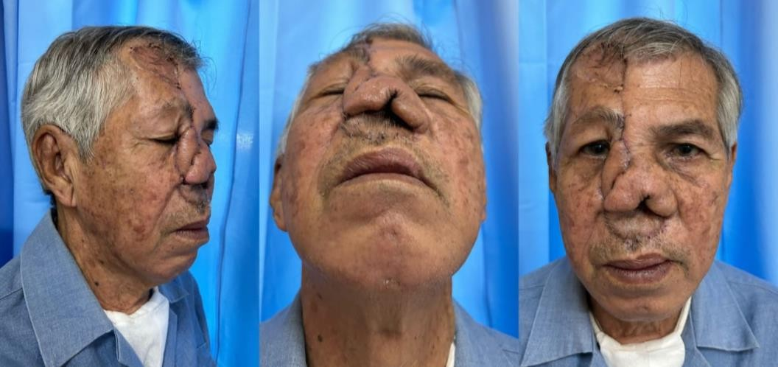





Figure 5 : Patient well post surgical resection and completion of radiotherapy with no signs of recurrence

DISCUSSION
The sinonasal tract consists of paranasal sinuses and nasal cavity, and the nasal cavity is further subdivided into 4 subsites i.e septum, floor, lateral walls and vestibule, therefore for the ease of clinical practice, sinonasal tract SCC are classified into 2 broad categories, Paranasal SCC (PNSCC) and Nasal cavity SCC (NCSCC)¹⁸. Classically PNSCC arise from the maxillary sinus and ethmoid sinuses, commonly from malignant transformation of benign inverted papilloma (Ringertz tumor)¹⁶. Tumorigenesis and pathogenesis of NCSCC on the other hand, is not as well established as those involving paranasal sinuses, correspondingly in regard to its etiological factors, current data however seems to suggest incorporation of Human papilloma virus components, Human epidermal growth factor overexpression and FGRG3 gene mutations as a part of pathological process¹⁷.
There is currently a large gap of data with regard to specific epidemiology, prognostic factors and clinical characteristics of nasal floor SCC, despite the fact that SCC is the most common variant of malignancy in the subdiscipline of Head and Neck Oncology. Our extensive search in major scientific platforms such as Google Scholars, ScienceDirect.com, PubMed and AI-powered Semantic scholar has found but 2 brief mentions of nasal floor SCC in case reports, in our opinion this phenomenon is either due to masking of true data by a broad AJCC classification system or due to nasal floor SCC cases being reported as hard palate SCC as the disease extend to oral cavity, rather than purely due to rarity of disease itself. Adapting data from nasal vestibule SCC studies, whereby alcohol consumption of at least 5 units per week, smoking at least 10 pack years along with sunlight exposure are considered to be risk factors, we noted a similar clinical history correlation of our patient in this case report of nasal floor SCC⁶.

Malignant tumors of paranasal sinus and nasal cavity may not exhibit any symptoms in the early stages of disease, they often noticed when disease has become extensive or when adjacent structures involved, unilateral nasal obstruction, intermittent epistaxis, persistent nasal crusting, pain of burning sensation, discomfort at the nasal base are hypothetically the possible chief complaints, as generic and non specific as they are, it poses a challenge for early diagnosis and detection, as endoscopic visualization of nasal floor is not a routine method of examination available in most primary healthcare facilities¹³.
Although SCC typically appeared as exophytic wart like projections or as ulcerative proliferative lesion, our patient presented to us with erosion of nasal columella, nasal vestibule and anterior nasal septum with granulations tissue on the edges of erosion, which initially prompted us to rule out tertiary syphilis and granulomatous disease, furthermore, initial biopsy result showed inconclusive inflammatory picture while patient’s underlying cardiac prevented our team to expedite a second biopsy. As literature from nasal vestibule - columella cancers study concluded, a delay in diagnosis of malignancy in these esthetically important structures, adversely affect the outcome of treatment and reconstruction, which is the case of our reported patient ⁵.

Currently, nasal floor SCC is staged according to the AJCC TNM staging system for nasal cavity malignancies, in our case, imaging demonstrates localized disease without bony erosion or nodal involvement consistent with early-stage nasal cavity carcinoma of T1, however in terms of actual clinical scenario, the destruction of supporting framework of nasal cartilages and resulting tip recession has devastating impact on patient, particularly in social life, as facial plastic practitioners generally agreed that nose is the most prominent part of facial profile, losing a nose is equivalent to losing a facial identity¹⁹. For NCSCC, literature suggests non-surgical approaches achieve good oncological results, with 5-year local control rate of 95–98%, and provide better cosmetic outcomes when compared to surgical excision¹⁰. However, in the case of our patient surgical intervention with concurrent oncological management is chosen due to few social factors that prevent our patient from the ability to come for frequent follow-ups in the oncological unit. Tumor was excised with 0.5cm margin with reconstruction using forehead flap in the same surgical setting.
Many may support the idea of delayed reconstruction from 2 to up to 24 months to ensure oncological clearance ⁹, however in our case, patient’s cardiac co-morbid is a major General Anesthesia risk that is worth taking only once. As most locoregional recurrences occur within 2 years from primary treatment of NCSCC, follow-up duration for patients with early-stage tumours can be limited to 3 to 5 years duration.⁶

CONCLUSION
Nasal floor SCC should be considered being a distinct site of nose and paranasal sinuses with new and specific T-staging.
Due to its vague presentation of symptoms, one should be able to perform a thorough nasal cavity examination to clinch the disease in its early stages.

REFERENCES
- Mendenhall WM, Stringer SP, Cassisi NJ, Mendenhall NP (1999) Squamous cell carcinoma of the nasal vestibule. Head Neck 21:385–393
- Young JR. Malignant tumours of the nasal septum. J Laryngol Otol. 1979;93(8):817-33
- DiLeo MD, Miller RH, Rice JC, Butcher RB. Nasal septal squamous cell carcinoma: a chart review and meta-analysis. Laryngoscope. 1996;106(10):1218-22.
- Tel, A., Bagatto, D., Tuniz, F., Sembronio, S., Costa, F., D’Agostini, S., & Robiony, M. (2019). The evolution of craniofacial resection: A new workflow for virtual planning in complex craniofacial procedures. Journal of Cranio-Maxillofacial Surgery, 47(9), 1475.
- Iyer S, Akali NR, Rao NN (2021) Nasal vestibule and columella cancer: a therapeutic and reconstructive conundrum. Curr Opin Otolaryngol Head Neck Surg 29:93–99
- Scheurleer WFJ et al (2022) Long-term oncological follow-up after mold-based pulsed dose rate brachytherapy for early stage squamous cell carcinoma of the nasal vestibule: a single center experience of 68 patients over a 17-year period. Brachytherapy
- Jeannon JP, Riddle PJ, Irish J, et al. Prognostic indicators in carcinoma of the nasal vestibule. Clin Otolarngol 2007;32(1):19–23. DOI: 10.1111/j.1365-2273.2007.01353.x
- Lambertoni A et al (2021) Squamous Cell Carcinoma of Nasal Vestibule and pyramid: outcomes and reconstructive strategies. Laryngoscope 131:E1198–e1208
- Horsmans JD, Godballe C, Jørgensen KE, Bastholt L, Løntoft E (1999) Squamous cell carcinoma of the nasal vestibule. Rhinology 37:117–121
- Czerwinski MD et al (2019) Image guided Brachytherapy for Cancer of the nasal vestibule: local control and Cosmesis. Int J Radiat Oncol Biol Phys 103:913–921
- Day TA, Beas RA, Schlosser RJ, et al. Management of paranasal sinus malignancy. Curr Treat Options Oncol. 2005;6(1):3-18
- Lahiri, A. K., Singh, K., & Sherif, D. M. M. (2023). Acute presentation of locally

advanced squamous cell carcinoma of frontal sinus—imaging findings of a rare entity: case report. The Egyptian Journal of Radiology and Nuclear Medicine, 54(1).
- Dale, O., Pring, M., Davies, A., Leary, S., Ingarfield, K., Toms, S., Waterboer, T., Pawlita, M., Ness, A., & Thomas, S. (2019). Squamous cell carcinoma of the nasal cavity: A descriptive analysis of cases from the head and neck 5000 study. Clinical Otolaryngology, 44(6), 961.
- Lee, S. H., Park, J. H., Lee, D. B., & Lee, S. H. (2023). A Case of Squamous Cell Carcinoma of Nasal Septum Removed Through the External Rhinoplasty Approach. Korean Journal of Otorhinolaryngology - Head and Neck Surgery, 66(8), 546.
- Elgart, K., & Faden, D. L. (2020). Sinonasal Squamous Cell Carcinoma: Etiology, Pathogenesis, and the Role of Human Papilloma Virus. Current Otorhinolaryngology Reports, 8(2), 111.
- Upadhya IB, Rao K. Sinonasal Inverted Papilloma: A Narrative Review. Indian J Otolaryngol Head Neck Surg. 2022 Oct;74(Suppl 2):1017-1022. doi: 10.1007/s12070-020-02089-0. Epub 2020 Aug 28. PMID: 36452822; PMCID: PMC9701979Upadhya
IB, Rao K. Sinonasal Inverted Papilloma: A Narrative Review. Indian J Otolaryngol Head Neck Surg. 2022 Oct;74(Suppl 2):1017-1022. doi: 10.1007/s12070-020-02089-0. Epub 2020 Aug 28. PMID: 36452822; PMCID: PMC9701979
- Wang, T.-C. (2019). Challenging Issues on Paranasal Sinuses. In IntechOpen eBooks. IntechOpen.
- Unsal, A. A., Dubal, P. M., Patel, T. D., Vazquez, A., Baredes, S., Liu, J. K., & Eloy, J.
A. (2016). Squamous cell carcinoma of the nasal cavity: a population-based analysis.
The Laryngoscope, 126(3), 560-565.
- Jankowska A, Janiszewska-Olszowska J, Grocholewicz K. Nasal Morphology and Its Correlation to Craniofacial Morphology in Lateral Cephalometric Analysis. Int J Environ Res Public Health. 2021 Mar 16;18(6):3064. doi: 10.3390/ijerph18063064. PMID: 33809695; PMCID: PMC8002216.

