Simulation-Based Evaluation of Joining Methods of Engineering Plastic Materials
Yogesh Gajanan Petkar¹, Dattatray P Kamble²
¹Mechanical (Design Engineering), Anantrao Pawar College of Engineering and Research, Pune
²Professor, Mechanical (Design Engineering), Anantrao Pawar College of Engineering and Research, Pune
ABSTRACT
The reliability of joints in plastic assemblies depends strongly on the interaction between material behaviour, joining technique, and loading conditions. In this study, Engineering components made from PMMA and PC-ABS were joined using two different methods: laser welding and adhesive joining. The objective is not a full comparative evaluation, but rather to understand the joint formation mechanisms and assess their mechanical response under typical service-level loading. Numerical simulations were carried out in LS-DYNA, where thermal and mechanical coupling were used to model the laser-welded inter-face, while a cohesive-zone approach represented the adhesive bond line. These models were used to predict pull strength and shear strength, capturing stress distribution, damage initiation, and failure progression for each joint type.
Keywords: PMMA, PC‑ABS, Laser welding, Adhesive joining, simulation.
INTRODUCTION
Polymethyl methacrylate and Polycarbonate-Acrylonitrile Butadiene Styrene are widely adopted in the automotive industry, particularly for interior and exterior trim components, due to their balanced combination of mechanical strength, dimensional stability, and surface quality. PMMA offers excellent optical clarity and scratch resistance, making it suitable for decorative trims, light guides, and transparent covers. PC‑ABS, on the other hand, provides high impact resistance and good thermal stability, which are essential for parts exposed to varying environmental conditions within the vehicle. Because these materials often appear together in automotive assemblies, understanding how to effectively join PMMA and PC-ABS is crucial for achieving reliable structural and aesthetic performance.
This study focuses on joining PMMA and PC-ABS components using laser welding and adhesive Plexus MA3940LH and evaluating their performance under pull and shear loading. While the work is not intended as a complete comparative assessment, it provides a useful understanding of how the two joining methods respond to mechanical stresses and how material properties influence joint performance. By integrating LS-DYNA simulations with the physical characteristics of the selected polymers, the research aims to support informed decisions regarding joining strategies for plastic assemblies in applications where reliability and structural performance are essential.
LITERATURE REVIEW
For the knowledge of various plastic joining methods, I have studied different research papers. The behaviour of the plastics and their properties are studied and analysed. There are various joining methods available, such as Mechanical joining, Adhesive joining, and Welding processes.
Grewell, D., & Benatar, A. (2007), et al [1] provide information on the welding processes which are widely used in the current automotive market, such as Friction welding, Hot plate welding, ultrasonic welding, Laser welding, RF welding, and Hot gas welding.
Coelho, J. P., Abreu, M. A., & Pires, M. C. (2000), et al [2] provide elaborate details about Laser welding and its applications in the fast-welding process. Also, they used Laser welding for the thin films such as Polypropylene and polyethylene materials.
Bucknall, C. B., Drinkwater, I. C., & Smith, G. R. (1980), et al [4] authors concluded that process parameters such as Temperature, pressure, and heating time will affect the joining bond directly between the plastic components and hence these parameters are to be taken care of. The proper Thermoplastic characteristics, along with suitable weld conditions, lead to molecular diffusion and hence a proper joint between them.
METHODOLOGY
An explicit analysis was performed to investigate the adhesive bond strength between two thermoplastic materials, Polymethyl Methacrylate (PMMA) and Polycarbonate-Acrylonitrile Butadiene Styrene (PC-ABS). The study was carried out using the CAE solver LS-DYNA, with Hyper mesh as the pre-processor for geometry definition and meshing, and HyperView was used as the post-processor for visualization and data interpretation. The material properties of both substrates and the adhesive were defined based on established values to ensure accurate representation of their mechanical behaviour. The adhesive interface was modelled to capture debonding and progressive failure under applied loading conditions. The results obtained from the simulation are presented, highlighting Force-Displacement responses and failure characteristics. In addition, graphs were plotted and shown to illustrate the comparative bond strength between PC-ABS and PMMA, providing clear insight into adhesive performance under the chosen loading scenario.
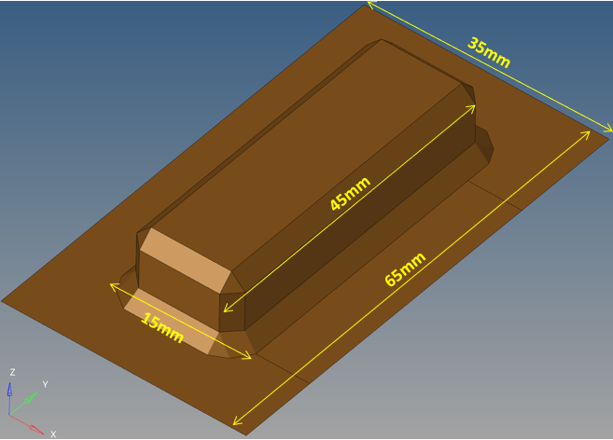
Fig 1: Dimensions of the Base plastic component
In the first stage, the gap is filled with an industrial adhesive [4], 35 mm × 5 mm × 5 mm, and adhesion is analysed using LS-DYNA as in Figure 2. The simulation incorporates appropriate material models for both plastics and the adhesive to capture joint behaviour under load.
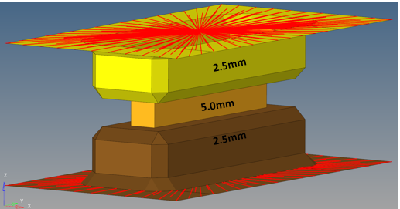
Fig 2: Simulation test setup of Adhesive joint (yellow coloured) between the plastic components

Both components are modeled as hollow cuboidal structures, as shown in Figure 1. The Dimensions of each cuboid are 45 mm × 15 mm × 2.5 mm, with the PMMA block positioned at the bottom and the PC‑ABS block placed directly above. In the simulation environment, the PMMA cuboid is constrained to the base to represent its attachment to the vehicle structure, whereas the PC‑ABS cuboid is fixed to the top boundary. A 1 mm gap is maintained between the two components. This gap represents the space where the joint is formed, either through Adhesive bonding or Laser welding, depending on the joining process being evaluated.
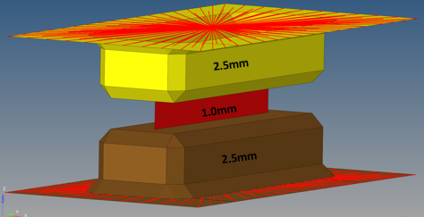
Fig 3: Simulation test setup of Weld joint (Red colour) between the two plastic components
In the second stage, the same geometric configuration is used, but the components are assumed to be joined by laser welding 35 mm × 5 mm × 5 mm, as in Figure 3. The welded interface is modeled according to the expected fusion characteristics of PMMA and PC‑ABS under laser energy. This configuration is again simulated in LS‑DYNA to evaluate its mechanical response.
For both joining methods, only tensile (pull) strength and shear strength are considered. Loads are applied to the PC‑ABS component while the PMMA base remains fixed, enabling the study of joint performance under controlled boundary conditions. The material properties of both Polymethyl methacrylate and Polycarbonate-Acrylonitrile Butadiene Styrene are listed in Table 1 and Table 2, while the properties of adhesive Plexus MA3940LH are referred to.[8]
Table 1. Properties Of Polymethyl Methacrylate
S. No | PMMA Property | Value
1 | Material | Thermoplastic
2 | Density | 1180–1190 kg/m³
3 | Ultimate Tensile Strength | 72 MPa
4 | Yield Tensile Strength | 54–73 MPa
5 | Ultimate Compressive Strength | 72–124 MPa
6 | Young’s Modulus | 3.036 GPa
7 | Flexural Modulus | 2.24–3.17 GPa
8 | Melting Point | 45 °C
9 | Thermal Conductivity | 0.17–0.19 W/m·K
10 | Specific Heat Capacity | 1450 J/kg·K
Table 2. Properties Of Polycarbonate-Acrylonitrile Butadiene Styrene
S. No | PC-ABS Property | Value
1 | Material | Thermoplastic
2 | Density | 1050 – 1020 kg/m³
3 | Melting Temperature | 250 °C
4 | Tensile Strength | 40 – 60 MPa
5 | Flexural Strength | 78.5 MPa
6 | Poisson’s Ratio | 0.392
7 | Elastic Modulus | 2 – 2.6 GPa
RESULTS & DISCUSSION
Tensile load simulation test results of adhesive joint are shown below in the Figure 4 and graphical values in Figure 5,
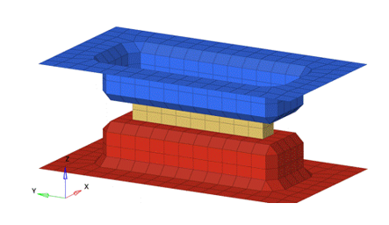
Fig 4. Tensile load simulation results of Adhesive bonded PMMA and PC-ABS Plastics.
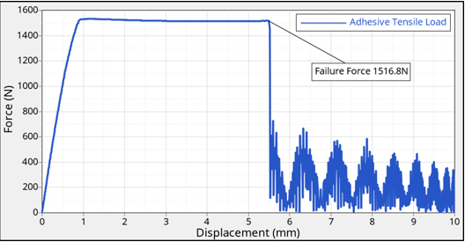
Fig 5. Tensile Force(N) vs Displacement (mm)
Also, the Tensile load simulation results of welded joint are shown in the Figure 6 and graphical values in Figure 7.
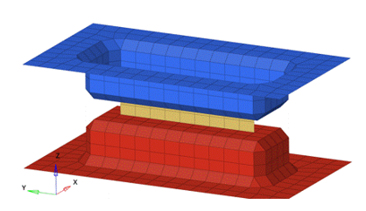
Fig. 6. Tensile load simulation results of weld joined PMMA and PC-ABS Plastics
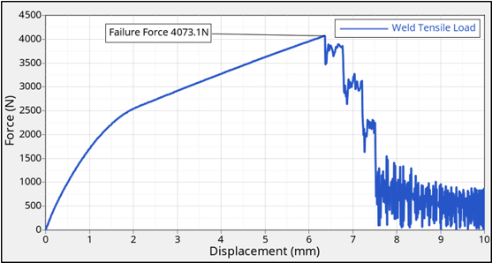
Fig. 7. Tensile Force(N) vs Displacement (mm)
In the shear test along the X-direction, the adhesive joint sustains 989.2 N (Figure 9), whereas the welded joint carries 3517.7 N (Figure 11). The large gap between these values suggests that welding provides better resistance against lateral sliding forces.
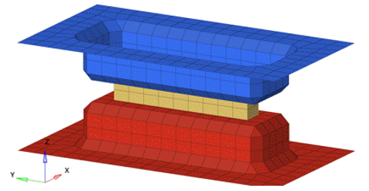
Fig. 8. Shear load simulation model for adhesive bonded PMMA and PC-ABS plastic components along X-direction
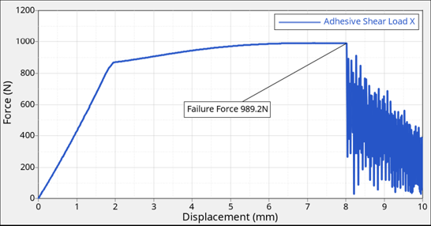
Fig. 9. shear Force(N) along X-direction vs Displacement (mm)
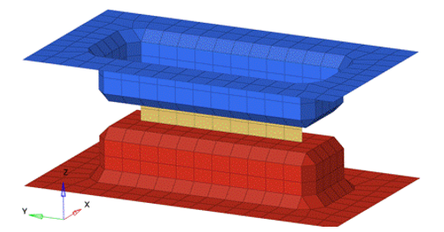
Fig. 10. Shear load simulation model for Laser welded joint between PMMA and PC-ABS plastic components along X-direction
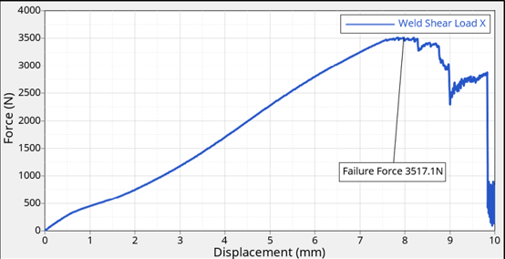
Fig. 11. shear Force(N) along X-direction vs Displacement (mm)
Shear performance along the Y-direction follows the same trend, with the adhesive joint failing at 919.0 N (Fig 13) and the welded joint resisting up to 2494.8 N (Fi 15). This confirms that the welded interface is structurally more robust across multiple shear orientations.
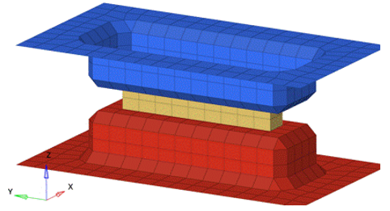
Fig. 12. Shear load simulation model for adhesive bonded PMMA and PC-ABS plastic components along Y-direction
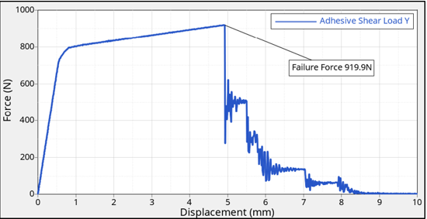
Fig. 13. shear Force(N) along Y-direction vs Displacement (mm)
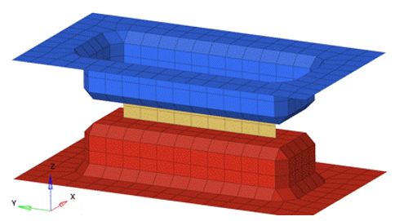
Fig. 14. Shear load simulation model for Laser welded joint between PMMA and PC-ABS plastic components along Y-direction
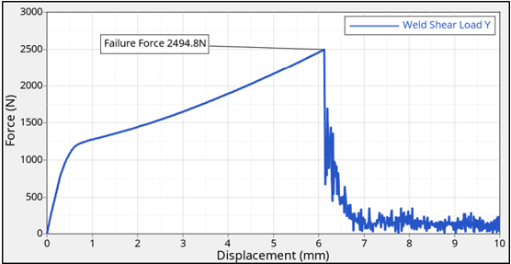
Fig. 15. shear Force(N) along Y-direction vs Displacement (mm)
Across all loading modes, the adhesive bond consistently shows lower strength compared to the weld joint. This difference likely results from the continuous material fusion achieved during welding, which eliminates the weakness of an additional interlayer.
Overall, the simulation results clearly demonstrate that laser welding gives superior tensile and shear strength for PMMA and PC-ABS joints. These findings can help guide material joining decisions in automotive applications where durability and load capacity are critical.
CONCLUSIONS
This numerical investigation highlights the strong influence of the joining technique on the structural performance of PMMA and PC‑ABS assemblies. The simulated tensile response shows that the Laser‑welded joint sustains a higher load of 4073.1 N than the adhesive joint (1516.8 N), indicating a substantially greater capacity to transfer axial forces across the interface.
A comparable trend is observed under shear loading. In the X‑direction, the welded configuration withstands 3517.7 N, exceeding the adhesive joint strength of 989.2 N. In the Y‑direction, the welded joint supports 2494.8 N, compared with 919.0 N for the adhesive‑bonded joint. The consistency of these results across multiple loading modes demonstrates that the welded interface provides improved mechanical stability.
The enhanced performance of the Laser‑welded joints is primarily associated with the formation of a continuous fusion zone, which promotes efficient stress transmission and reduces interfacial discontinuities. By contrast, adhesive bonding relies on a distinct intermediate layer whose mechanical characteristics and interfacial adhesion limit the load‑carrying capability of the assembly.
In summary, the simulation outcomes indicate that laser welding offers superior strength and reliability for PMMA and PC‑ABS joints under both tensile and shear conditions. These findings provide a useful computational basis for selecting appropriate joining strategies in polymer component design, particularly in engineering applications where structural integrity and load resistance are critical.
REFERENCES
- Bucknall, C. B., Drinkwater, I. C., Smith, G. R. (1980). Hot plate welding of plastics: factors affecting weld strength. Polymer Engineering Science, 20(6), 432-440.
- Moskvitin, G. V., Polyakov, A. N., Birger, E. M. (2013). Laser welding of plastics. Welding International, 27(9), 725-734.
- K. Elissa, “Title of paper if known,” unpublished.
- https://itwperformancepolymers.com/data-sheets/technical-datasheets?i=plexus-ma3940lh.
- Roesner, A., Scheik, S., Olowinsky, A., Gillner, A., Reisgen, U., Schleser, M. (2011). Laser assisted joining of plastic metal hybrids. Physics Procedia, 12, 370-377.
- Troschitz, J., Gr¨oger, B., W¨urfel, V., Kupfer, R., Gude, M. (2022). Joining processes for fibre-reinforced thermoplastics: phenomena and characterisation. Materials, 15(15), 5454.
- Tijs, B. H. A. H., Doldersum, M. H. J., Turon, A., Waleson, J. E. A., Bisagni, C. (2022). Experimental and numerical evaluation of conduction welded thermoplastic composite joints. Composite Structures, 281, 114964.
- Ridha, M., Su, Z., Yek, W. M. A., Narayanaswamy, S., Tay, T. E. (2024). Effect of geometry and adhesion on the performance of fiber reinforced thermoplastic composite joints with metal inserts.
- Composites Part A: Applied Science and Manufacturing, 187, 108482.

