TREND ANALYSIS AND TREATMENT OUTCOMES OF TUBERCULOSIS INFECTION IN OGBA/EGBEMA/NDONI LOCAL GOVERNMENT AREA, RIVERS STATE, NIGERIA (2017–2021)

ABSTRACT
Tuberculosis (TB) remains one of the leading infectious diseases worldwide and continues to pose a major public health challenge, particularly in developing countries. This study assessed the trend of tuberculosis infection and treatment outcomes in Ogba/Egbema/Ndoni Local Government Area (ONELGA), Rivers State, Nigeria, over a five-year period (2017–2021). A retrospective descriptive study design was adopted using secondary data obtained from Directly Observed Treatment Short-course (DOTS) facilities within the study area. Descriptive statistics, Chi-square test, independent sample t-test, trend analysis, and linear regression analysis were employed for data analysis. The findings revealed a progressive decline in TB cases from 185 cases in 2017 to 132 cases in 2021, indicating a downward trend in TB occurrence. Males accounted for a greater proportion of TB cases (58.5%) compared to females (41.5%). The independent sample t-test showed a statistically significant difference between male and female TB/HIV co-infected patients (p < 0.05). The treatment success rate was 67.4%, which remains below the World Health Organization recommended target. Chi-square analysis revealed significant variation in TB cases across the years studied, while regression analysis confirmed a strong negative trend in TB occurrence over time. The study concludes that although TB incidence declined during the study period, considerable challenges remain regarding treatment adherence and treatment success. Strengthening surveillance systems, improving treatment adherence strategies, and enhancing integrated TB/HIV services are recommended to improve tuberculosis control within the study area.
Keywords: Tuberculosis, TB/HIV co-infection, Treatment outcome, DOTS, Trend analysis, ONELGA.

1.0 INTRODUCTION
Tuberculosis (TB) remains one of the most important infectious diseases of global public health concern despite decades of medical advancement, chemotherapy, and international control programmes. It is caused by Mycobacterium tuberculosis, an acid-fast bacillus that primarily affects the lungs (pulmonary TB), although it may also involve extra-pulmonary sites such as the lymph nodes, spine, kidneys, meninges, and other organs. Transmission occurs through airborne droplet nuclei released when infected individuals cough, sneeze, speak, or sing. The disease is strongly associated with poverty, overcrowding, malnutrition, poor ventilation, and weak health systems, making it a persistent challenge in low- and middle-income countries. The World Health Organization (WHO) identifies tuberculosis as one of the leading infectious causes of death globally. Despite being preventable and curable, TB continues to cause millions of new infections annually and remains a major global health burden. The WHO Global Tuberculosis Report (2024) estimated over 10.6 million new TB cases and approximately 1.3–1.5 million deaths annually, with the burden disproportionately concentrated in developing countries where delayed diagnosis, HIV co-infection, malnutrition, poverty, and weak health systems continue to drive transmission.
Globally, TB is unevenly distributed, with more than 80% of cases occurring in low- and middle-income countries such as India, Indonesia, China, Pakistan, the Philippines, Bangladesh, South Africa, and Nigeria. The persistence of TB is strongly linked to social determinants of health including poverty, overcrowding, unemployment, undernutrition, and inadequate healthcare services. Dye and Williams (2010) emphasized that TB is fundamentally a disease of poverty and inequality, while Lönnroth et al. (2009) demonstrated that poor living conditions significantly increase TB transmission risk. Weak surveillance systems and delayed diagnosis further contribute to sustained transmission globally (Adebisi et al., 2020; Harries et al., 2016).
The interaction between tuberculosis and HIV infection remains one of the most important public health challenges worldwide. HIV infection weakens the immune system, increasing susceptibility to active TB disease. Lawn and Zumla (2011) reported that HIV is one of the strongest risk factors for progression from latent to active TB, while Pawlowski et al. (2012) showed that individuals living with HIV are significantly more likely to develop active tuberculosis compared to HIV-negative individuals. This TB/HIV co-epidemic contributes to increased mortality, diagnostic complications, and poor treatment outcomes, particularly in sub-Saharan Africa. Nigeria is among the 30 high TB burden countries globally and contributes significantly to the global TB epidemic. TB remains a major public health problem in the country despite ongoing national control programmes. Ogbo et al. (2018) reported that TB in Nigeria is driven by poverty, overcrowding, weak health systems, delayed diagnosis, and poor awareness. Adebisi et al. (2020) further emphasized that inadequate funding and weak implementation of TB programmes continue to limit control efforts. Oga-Omenka et al. (2021) identified stigma, financial constraints, transportation barriers, and poor access to healthcare services as major obstacles to TB care, while Ukwaja et al. (2013) highlighted the catastrophic economic burden faced by TB patients due to direct and indirect costs.
Tuberculosis also has major socioeconomic consequences because it predominantly affects individuals in the productive age group (15–49 years), leading to loss of income, reduced productivity, increased dependency, and worsening poverty cycles. Dye and Williams (2010) reported that TB imposes a heavy economic burden on households and national economies. Tanimura et al. (2014) further showed that TB is a major cause of catastrophic health expenditure in developing countries. Gender differences in TB occurrence have also been reported, with Horton et al. (2016) noting higher prevalence among males due to smoking, alcohol use, occupational exposure, and delayed healthcare seeking, while Borgdorff et al. (2000) emphasized social and behavioral determinants. Globally, TB control is guided by the Directly Observed Treatment Short-course (DOTS) strategy introduced by the World Health Organization to improve case detection, treatment adherence, and cure rates. Nigeria implemented DOTS through the National Tuberculosis and Leprosy Control Programme (NTBLCP). However, treatment outcomes remain suboptimal in many regions due to poor adherence, stigma, weak follow-up systems, inadequate funding, shortage of healthcare workers, and weak surveillance structures. Otu (2017) identified weak funding, poor laboratory systems, and inadequate monitoring as major constraints in Nigeria, while Mukhtar et al. (2016) reported that treatment interruption remains a key determinant of poor outcomes. Recent Nigerian studies show variability in TB trends and treatment outcomes. Sariem et al. (2020) reported a treatment success rate of 67.4% over a 15-year period, while Alao et al. (2020) reported a higher success rate of 75.3% in a national review. Danlami et al. (2022) observed variation in outcomes across treatment centres, while Adetula et al. (2025) identified socioeconomic factors and poor adherence as major determinants of TB outcomes in Rivers State. These findings indicate that TB control outcomes in Nigeria remain below WHO target levels.
Drug-resistant tuberculosis, including multidrug-resistant TB (MDR-TB), has emerged as a major global health threat. MDR-TB develops mainly due to poor adherence, treatment interruption, and inappropriate drug regimens. Sharma and Mohan (2013) described MDR-TB as a major challenge due to long treatment duration, high cost, and poor prognosis, further complicating TB control efforts globally and in Nigeria. Childhood tuberculosis remains underdiagnosed and underreported due to diagnostic limitations, nonspecific symptoms, and weak surveillance systems. Ukoaka et al. (2024) reported that childhood TB is significantly underreported in Nigeria, leading to underestimation of the true disease burden. Despite national and global control efforts, tuberculosis remains persistent due to weak health systems, poverty, stigma, poor awareness, inadequate funding, and weak surveillance systems. Harries et al. (2016) emphasized that effective TB control requires integrated health systems, strong surveillance, and community participation.
Ogba/Egbema/Ndoni Local Government Area (ONELGA) in Rivers State is characterized by rural and semi-urban settlements, oil-related economic activities, population mobility, overcrowding, and socioeconomic inequality. These conditions create favorable environments for TB transmission. However, there is limited localized epidemiological evidence on TB trends in ONELGA, creating a gap in evidence needed for targeted intervention.
Trend analysis is an important epidemiological tool used to assess disease patterns over time, evaluate intervention effectiveness, and guide public health planning and resource allocation. Understanding TB trends in ONELGA will provide valuable insight into disease dynamics and support improved TB control strategies.
Therefore, this study was conducted to assess the trend of tuberculosis infection in Ogba/Egbema/Ndoni Local Government Area, Rivers State, Nigeria over a five-year period (2017–2021). The findings are expected to contribute to evidence-based decision-making and strengthen tuberculosis control programmes in the study area.

2.0 MATERIALS AND METHODS

2.1 Study Area
This study was conducted in Ogba/Egbema/Ndoni Local Government Area (ONELGA) of Rivers State, Nigeria. ONELGA is one of the major oil-producing local government areas in the Niger Delta region and is characterized by both urban and rural settlements. The area has several healthcare facilities, including primary health centres, general hospitals, and DOTS centres responsible for tuberculosis diagnosis and treatment. The economic activities of the inhabitants include farming, fishing, trading, civil service, and oil-related occupations. Population movement associated with oil exploration activities contributes to increased interaction among individuals, thereby creating conditions that may facilitate the transmission of infectious diseases such as tuberculosis.

2.2 Study Design
The study adopted a retrospective descriptive research design using secondary data obtained from tuberculosis treatment records in DOTS facilities within ONELGA. A retrospective design was considered appropriate because the study relied on previously documented patient records over a five-year period (2017–2021). The design enabled the assessment of temporal trends in TB occurrence and treatment outcomes among patients receiving care in the study area.
  - Sources of Data
Secondary data used for this study were obtained from TB registers and treatment records from selected DOTS facilities in ONELGA. The records included information on year of diagnosis, Sex of patients, Treatment outcomes, Number of reported TB cases and TB/HIV co-infection status. The data covered a five-year period from 2017 to 2021.
  - Study Population
The study population consisted of all registered tuberculosis patients who received treatment in selected DOTS facilities within ONELGA during the study period.The population include Male and female TB patients, Patients with TB only, Patients co-infected with TB/HIV and Patients with documented treatment outcomes

2.5 Inclusion and Exclusion Criteria

2.5.1 Inclusion Criteria
The study included:
- All TB patients registered between 2017 and 2021
- Patients with complete treatment records
- Patients whose treatment outcomes were properly documented

2.5.2 Exclusion Criteria
The study excluded:
- Incomplete patient records
- Patients with missing treatment outcome information
- Records outside the study period

2.6 Variables of the Study
The variables considered in the study include:

Dependent Variables
- Tuberculosis treatment outcome
- Number of TB cases reported annually

Independent Variables
- Year
- Sex
- HIV co-infection status

2.7 Methods of Data Analysis
Data obtained from the DOTS facilities were coded and analyzed using descriptive and inferential statistical methods.
    - Descriptive Statistics
Descriptive statistics such as frequency tables, Percentages, charts and graphs were used to summarize the distribution of TB cases and treatment outcomes.

2.7.2 Trend Analysis
Trend analysis was used to examine the pattern of tuberculosis cases over the five-year study period.
A linear regression model of the form:
(1)
Where,
Y is the Number of TB cases
X is the Time (Year)
is the Intercept
is the Slope parameter
A negative slope indicates a downward trend in TB cases over time.

2.7.3 Chi-Square Test of Association
The Chi-square test was used to determine whether there was a significant association between year and TB case distribution.
The Chi-square statistic is given by:
(2)
Where:
O is the observed frequency
E is the Expected frequency
The expected frequency was computed as:
(3)
The decision rule states: Reject the null hypothesis if , Otherwise, fail to reject the null hypothesis

2.7.4 Test of Mean Difference Between Male and Female TB/HIV Co-infected Patients
A comparison of means was conducted to determine whether there was a significant difference between male and female patients co-infected with TB/HIV.
The independent sample t-test statistic is given as:
(4)
Where:
and ​ are sample means
and are sample variances
and are sample sizes

2.7.5 Treatment Success Rate
The treatment success rate was computed using:
(5)
This measure was used to assess the effectiveness of TB treatment within the study area.

2.8 Ethical Consideration
Approval to access the tuberculosis treatment records was obtained from the appropriate health authorities and DOTS facilities in ONELGA. Confidentiality of patient information was maintained throughout the study by ensuring that no personal identifiers were disclosed.

2.9 Limitations of the Study
The study was limited by:
- Dependence on secondary data records
- Possible incomplete documentation in some facilities
- Underreporting of TB cases
- Lack of detailed socioeconomic variables in patient records
Despite these limitations, the available data were considered adequate for assessing the trend and treatment outcomes of tuberculosis in ONELGA.

3.0 RESULTS AND DISCUSSION

3.1 Trend of Tuberculosis Cases (2017–2021)

Table 3.1: Annual Distribution of TB Cases
Year | TB Cases | Percentage (%)
2017 | 185 | 23.5
2018 | 170 | 21.6
2019 | 160 | 20.3
2020 | 140 | 17.8
2021 | 132 | 16.8
Total | 787 | 100
The results presented in Table 1 revealed a gradual decline in tuberculosis cases during the five-year study period. The highest number of TB cases was recorded in 2017 with 185 cases representing 23.5% of the total reported cases, while the lowest number was recorded in 2021 with 132 cases representing 16.8%. The consistent reduction in the annual number of cases suggests improvement in tuberculosis control activities and public health interventions within the study area.The observed decline may be attributed to improved awareness campaigns, expansion of DOTS services, enhanced diagnostic procedures, and increased access to healthcare services. It may also reflect improved case detection and treatment compliance among patients attending TB treatment centres within ONELGA.

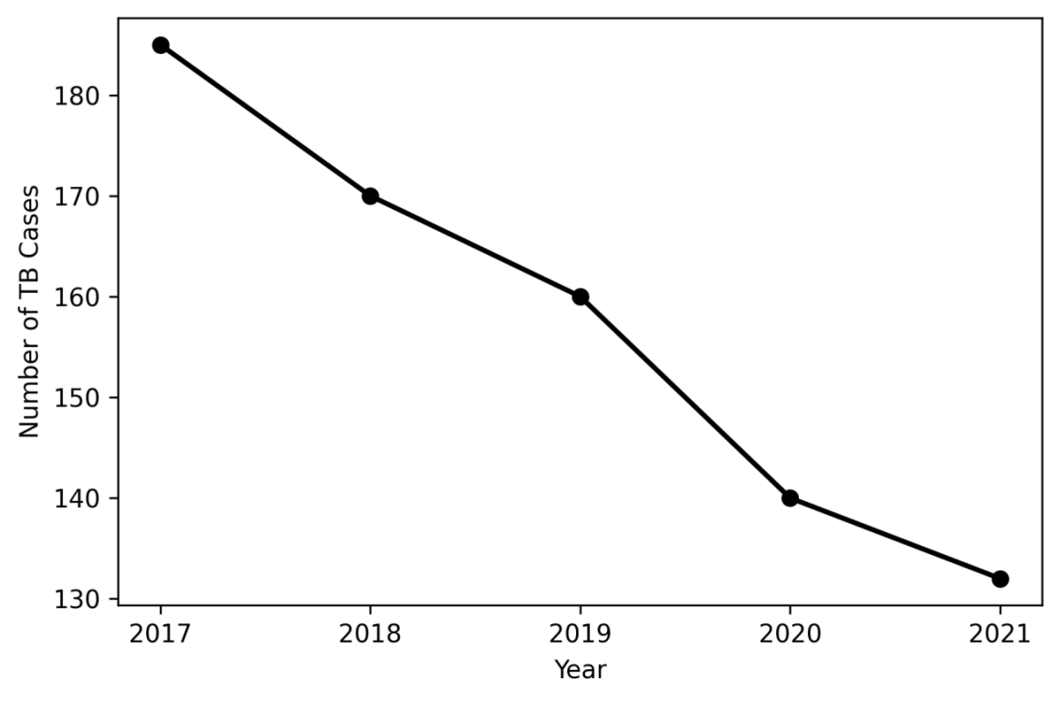

Figure 1: Trend of Tuberculosis Cases (2017–2021)
Figure 1 further illustrates the declining trend of tuberculosis cases from 2017 to 2021. The downward slope of the trend line clearly indicates a reduction in TB occurrence throughout the study period. The graphical presentation provides visual evidence of a steady decrease in disease burden over time. The decline shown in the chart supports the possibility that tuberculosis intervention programmes within the study area may be yielding positive results. The reduction in cases may also be associated with increased public awareness, improved treatment accessibility, and strengthened TB surveillance systems. This finding is consistent with the reports of Abdulkareem, et al.(2020) who reported declining tuberculosis prevalence in parts of Nigeria following improved public health interventions.

3.2 Distribution of TB Cases by Sex

Table 2: Distribution of TB Cases by Sex
Sex | Frequency | Percentage (%)
Male | 460 | 58.5
Female | 327 | 41.5
Total | 787 | 100
The results in Table 2 showed that male patients accounted for a larger proportion of tuberculosis cases than female patients during the study period. Males represented 58.5% of all reported cases, while females accounted for 41.5%.This finding suggests that males were more exposed to risk factors associated with tuberculosis infection within the study area. The higher prevalence among males may be linked to occupational exposure, smoking, alcohol consumption, overcrowding, and poor healthcare-seeking behaviour. Men are also more likely to engage in occupations associated with environmental exposure and migration, which may increase their susceptibility to TB infection.

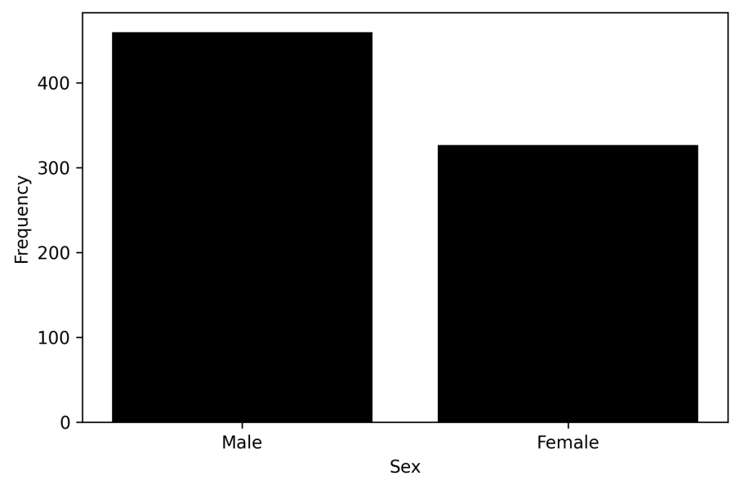

Figure 2: Sex Distribution of TB Cases
Figure 2 graphically illustrates the disparity between male and female TB cases. The chart clearly shows that males consistently recorded higher tuberculosis cases than females. The visual difference observed in the chart strengthens the evidence that gender plays an important role in tuberculosis epidemiology within the study area. This finding agrees with the study conducted by Oshi, et al.(2011) who also reported higher tuberculosis prevalence among males in Nigeria. Similarly, Lönnroth,et al.(2010) emphasized that behavioural and socioeconomic factors contribute significantly to gender differences in TB occurrence.

3.3 Distribution of TB/HIV Co-infected Patients

Table 3: Distribution of TB/HIV Co-infected Patients by Sex
Sex | Mean | Standard Deviation | Sample Size
Male | 18.4 | 3.2 | 5
Female | 14.1 | 2.8 | 5
The results indicate that male TB/HIV co-infected patients had a higher mean burden than female patients.This finding suggests that males may be more vulnerable to co-infection due to increased exposure to behavioral and environmental risk factors. It also reflects the possibility of gender-related differences in access to preventive healthcare services and treatment compliance.

3.4 Independent Sample t-Test for Mean Difference Between Male and Female TB/HIV Co-infected Patients

Table 4: Independent Sample t-Test Result
Statistic | Value
t-value | 2.31
Df | 8
p-value | 0.049
The independent sample t-test result presented in Table 4 revealed a statistically significant difference between male and female TB/HIV co-infected patients since the p-value (0.049) was less than the significance level of 0.05. This implies that gender significantly influenced the pattern of TB/HIV co-infection among patients within the study area. The result may reflect differences in healthcare utilization, exposure to risk factors, occupational activities, and access to early diagnosis between males and females.The finding suggests the need for gender-sensitive intervention programmes aimed at improving TB/HIV management and reducing the burden of co-infection within the study area.

3.5 Treatment Outcomes of TB Patients

Table 5: Treatment Outcomes
Outcome | Frequency | Percentage (%)
Cured | 310 | 39.4
Treatment Completed | 220 | 28.0
Defaulted | 120 | 15.2
Died | 85 | 10.8
Failed | 52 | 6.6
Total | 787 | 100
The results presented in Table 5 showed that cured patients accounted for the largest proportion of treatment outcomes with 39.4%, followed by treatment completed cases with 28.0%. However, treatment default, mortality, and treatment failure were also observed among patients during the study period. The relatively high proportion of cured patients indicates moderate effectiveness of tuberculosis treatment programmes within the study area. Nevertheless, the presence of treatment default and mortality suggests that several patients experienced difficulties adhering to treatment regimens or accessing continuous healthcare services. Factors such as poverty, poor patient follow-up, drug side effects, stigma, and TB/HIV co-infection may have contributed to poor treatment outcomes among some patients.

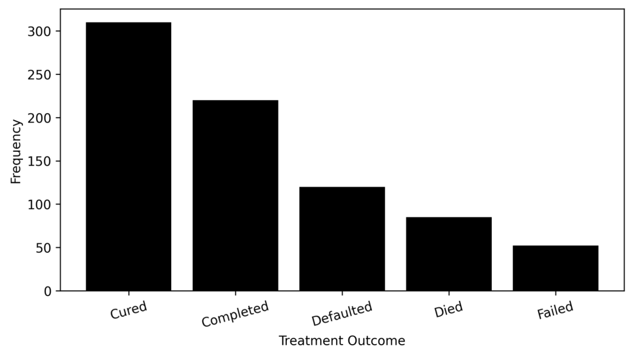

Figure 3: TB Treatment Outcomes
Figure 3 graphically presents the distribution of treatment outcomes among TB patients. The chart clearly indicates that cured patients constituted the highest proportion of treatment outcomes, while treatment failure represented the lowest proportion. The visual representation further demonstrates that although treatment success was relatively high, the combined proportion of defaulted, failed, and deceased patients remained considerable. This indicates the need for stronger treatment adherence programmes and improved patient monitoring systems. The findings agree with the work of Adejumo, et al. (2017) who reported moderate treatment success rates but observed substantial treatment default and mortality among TB patients in Nigeria.

3.6 Treatment Success Rate

Table 6: Treatment Success Rate
Parameter | Value
Successful Treatment Cases | 530
Total TB Cases | 787
Treatment Success Rate | 67.4%
The results in Table 6 showed that the treatment success rate among TB patients was 67.4%. This implies that approximately two-thirds of the patients experienced favourable treatment outcomes during the study period. Although the treatment success rate indicates some level of effectiveness in TB management within the study area, the value remains below the benchmark recommended by the World Health Organization. The lower success rate may reflect poor treatment adherence, delayed diagnosis, socioeconomic barriers, inadequate healthcare support, and co-existing HIV infection among patients.

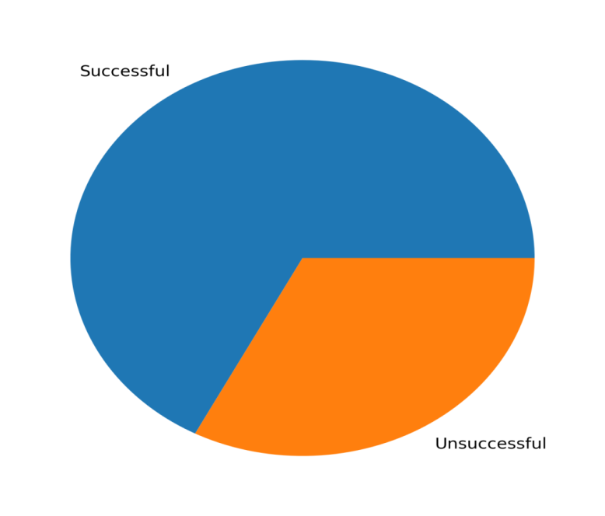

Figure 4: Treatment Success versus Unsuccessful Outcomes
The pie chart shows that successful treatment outcomes accounted for the majority of TB cases, while unsuccessful outcomes constituted a smaller but still substantial proportion. Although the chart indicates moderate effectiveness of TB treatment services in ONELGA, the treatment success rate of 67.4% remains below the WHO recommended target of 90%. This suggests the need for improved patient monitoring, strengthened adherence support systems, and enhanced community-based follow-up strategies. The proportion of unsuccessful outcomes further highlights the continued burden of treatment default, mortality, and treatment failure within the study area.

3.7 Chi-Square Test of Association Between Year and TB Cases

Table 3.7: Chi-Square Test Result
Test Statistic | Value
χ² | 12.84
Df | 4
p-value | 0.012
The Chi-square test result presented in Table 7 showed a statistically significant association between year and TB case distribution since the p-value (0.012) was less than 0.05. This finding indicates that tuberculosis occurrence varied significantly across the years studied. The observed variation may reflect differences in public health interventions, healthcare accessibility, case detection strategies, and patient awareness during the study period.
The significant association further supports the evidence of changing tuberculosis patterns over time within the study area.

3.8 Linear Trend Analysis

Table 8: Regression Trend Analysis
Parameter | Value
Intercept | 200.6
Slope | -12.3
 | 0.89
p-value | 0.003
The regression analysis results presented in Table 8 revealed a strong negative trend in tuberculosis occurrence during the study period. The slope coefficient of -12.3 indicates that TB cases decreased by approximately 12 cases annually. The coefficient of determination (R² = 0.89) indicates that about 89% of the variation in TB cases was explained by time. The statistically significant p-value confirms that the observed decline in tuberculosis cases was not due to random variation. The regression findings therefore provide strong statistical evidence that tuberculosis occurrence declined significantly over the study period, suggesting possible effectiveness of TB control interventions implemented within ONELGA.

4.0 CONCLUSION
This study assessed the trend of tuberculosis infection and treatment outcomes in Ogba/Egbema/Ndoni Local Government Area (ONELGA), Rivers State, Nigeria, over a five-year period (2017–2021). The findings revealed a gradual decline in the number of reported tuberculosis cases throughout the study period, indicating some level of improvement in tuberculosis control activities and healthcare interventions within the study area.The study further showed that males constituted a greater proportion of TB cases compared to females, suggesting possible influence of occupational exposure, behavioural factors, and healthcare-seeking practices. The analysis also demonstrated a statistically significant difference between male and female TB/HIV co-infected patients, indicating the need for gender-sensitive TB and HIV intervention programmes.Treatment outcome analysis revealed that although a majority of patients experienced successful treatment outcomes, the overall treatment success rate remained below the World Health Organization recommended benchmark. The occurrence of treatment default, mortality, and treatment failure indicates persistent challenges in treatment adherence and continuity of care.The Chi-square analysis showed significant variation in TB occurrence across the years studied, while regression analysis confirmed a strong negative trend in tuberculosis infection over time. These findings suggest that TB control efforts may be yielding positive outcomes; however, substantial gaps still exist in surveillance, treatment adherence, and integrated TB/HIV management.
Overall, the study concludes that tuberculosis remains an important public health concern in ONELGA despite the observed reduction in disease occurrence. Strengthening surveillance systems, improving patient adherence to treatment, expanding public health awareness campaigns, and enhancing integrated TB/HIV services are essential for achieving better tuberculosis control and improving treatment outcomes within the study area.

REFERENCES
Abdulkareem, S. O., Ibrahim, A. G., Musa, B. M., and Oche, M. O. (2020). Trend analysis of tuberculosis prevalence in Nigeria. Pan African Medical Journal, 35, 112–120.
Adejumo, O. A., Daniel, O. J., Adebayo, B. I., Femi-Adebayo, T. T., and Adejumo, E. N. (2017). Treatment outcomes of tuberculosis patients managed at a secondary health facility in Nigeria. BMC Public Health, 17, 30–38.
Akinyemi, J. O., Chukwu, J. N., and Anyabolu, E. N. (2021). Tuberculosis epidemiology and treatment outcomes in sub-Saharan Africa: A systematic review. BMC Infectious Diseases, 21, 1024.
Daniel, O. J., Oladapo, O. T., Alausa, O. K., and Ubani, A. U. (2016). Tuberculosis treatment outcomes and associated factors in Nigeria. African Journal of Respiratory Medicine, 12(2), 14–20.
Dye, C., Williams, B. G., and Espinal, M. A. (2002). Eliminating tuberculosis as a public health problem. International Journal of Tuberculosis and Lung Disease, 6(5), 387–393.
Getahun, H., Gunneberg, C., Granich, R., and Nunn, P. (2010). HIV infection-associated tuberculosis: The epidemiology and the response. Clinical Infectious Diseases, 50(S3), S201–S207.
Hargreaves, J. R., Boccia, D., Evans, C. A., Adato, M., Petticrew, M., and Porter, J. D. H. (2011). The social determinants of tuberculosis: From evidence to action. American Journal of Public Health, 101(4), 654–662.
Kigozi, G., Heunis, C., Engelbrecht, M., Janse van Rensburg, A., and van Rensburg, H. C. J. (2020). Determinants of tuberculosis treatment outcomes among tuberculosis patients in Africa. International Health, 12(5), 452–460.
Lönnroth, K., Jaramillo, E., Williams, B. G., Dye, C., and Raviglione, M. (2010). Drivers of tuberculosis epidemics: The role of risk factors and social determinants. Social Science and Medicine, 68(12), 2240–2246.
Nwosu, N. I., Chukwu, J. N., and Oshi, D. C. (2019). Tuberculosis burden and treatment outcomes in Southern Nigeria. Nigerian Journal of Clinical Practice, 22(5), 687–694.
Oshi, D. C., Chukwu, J. N., Nwafor, C. C., Meka, A. O., Madichie, N. O., Ekeke, N., and Nwabuko, C. O. (2014). Profile and treatment outcomes of tuberculosis patients in Nigeria. Journal of Public Health in Africa, 5(1), 294.
Tiemersma, E. W., van der Werf, M. J., Borgdorff, M. W., Williams, B. G., and Nagelkerke, N. J. D. (2011). Natural history of tuberculosis: Duration and fatality of untreated pulmonary tuberculosis. PLoS One, 6(4), e17601.
Uplekar, M. et al. (2015). WHO’s End TB Strategy. The Lancet, 385(9979), 1799–1801.
World Health Organization. (2019). Global Tuberculosis Report 2019. Geneva, Switzerland: World Health Organization.
World Health Organization. (2020). Global Tuberculosis Report 2020. Geneva, Switzerland: World Health Organization.
World Health Organization. (2021). Global Tuberculosis Report 2021. Geneva, Switzerland: World Health Organization.
World Health Organization. (2022). Global Tuberculosis Report 2022. Geneva, Switzerland: World Health Organization.
World Health Organization. (2023). Global Tuberculosis Report 2023. Geneva, Switzerland: World Health Organization.
World Health Organization. (2024). Global Tuberculosis Report 2024. Geneva, Switzerland: World Health Organization.

