Climate Change Reporting Aligned with the TCFD Framework: A Bibliometric Mapping

Abstract
Climate change reporting (CCR) has emerged as a medium of communication in the corporate reporting landscape, focusing on information related to the transition to a low-carbon economy or net-zero carbon emissions. The provision of climate information has evolved beyond narrative and qualitative forms, and the provision of quantitative data has made the CCR a valuable source for stakeholders’ environmental evaluations. Meanwhile, the influential role of the Task Force on Climate-related Financial Disclosure (TCFD) framework in shaping the climate disclosure regulatory landscape globally has prompted the current study to analyse the development of CCRs aligned with TCFD. The bibliometric analysis was conducted in the Scopus database, and the results show that publications on CCR aligned with TCFD began in 2009, with the most prominent authors and leading institutions coming from developed countries. Other developing countries contributing to the publications include India and Malaysia. Findings also reveal the most-used keyword in the research area related to the climate regulatory landscape, corporate climate transparency, and accountability. The shift of the keyword used in current documents to the ISSB reflects the ongoing development of the monitoring role of climate reporting under the purview of the International Sustainability Standards Board (ISSB), as the TCFD has been disbanded. Future research may focus on science mapping of bibliometric analysis to gain insight and comparison into the past, present and future direction of research on the development of climate-related information disclosures.
Keywords: Bibliometric, Climate change reporting, Disclosure, ISSB, and TCFD
INTRODUCTION
Climate change reporting (CCR) has emerged as a form of communication within the corporate landscape to enhance business climate accountability and transparency amidst the heightened concerns over climate risks (Ahmad, 2017). According to the Global Risks Report 2026 released by the World Economic Forum, environmental risks, specifically extreme weather, biodiversity loss and critical changes to the Earth systems, have topped the long-term risks ranked by their severity (Zahidi, 2026). The report shows that environmental risks have consistently been identified as humanity's main concern since 2020 (Franco, 2020). In addressing climate issues, the information disclosed generally centres on the transition to a low-carbon economy or net-zero carbon emissions, a critical mechanism for mitigating the climate crisis. Nevertheless, the focus of the information disclosed is not only on the narrative or qualitative data, that quantitative environmental performance data are commonly used to substantiate their climate initiatives (Liu & Wu, 2023). With that, CCR may project the firm’s climate-strategic performance, serving as a valuable source of information for stakeholders' environmental evaluations.
In discharging their climate responsibilities, few frameworks are available to provide quality information to their stakeholders, such as the Global Reporting Initiative (GRI), the Carbon Disclosure Project (CDP), the Sustainability Accounting Standards Board (SASB), and the Task Force on Climate-Related Financial Disclosure (TCFD). Despite the TCFD framework being released only in 2017, a number of developed countries, such as Australia, New Zealand, and Japan, have adopted it within their local regulatory landscape for climate-related information disclosure (Dey, 2024). The move is also reported in developing countries such as Malaysia, with the TCFD framework adopted by Bursa Malaysia, the stock regulator, for public-listed companies in Malaysia, marking a departure from GRI (BM, 2015, 2022), projecting its influential impact on the CCR realms globally. It is worth noting that although the TCFD disbanded in October 2023, the monitoring role of overseeing climate-related information disclosure has been taken over by the International Financial Reporting Standards (IFRS). IFRS is a well-known and reputable standard setter globally, with more than 85 per cent of the world's jurisdictions adopting its framework. It strengthened TCFD's influence in shaping the global CCR landscape.
Therefore, the main objective of the study is to comprehensively map the global development of CCR aligned with the TCFD framework. Specifically, the following research questions are investigated :
- What are the research trends in CCR aligned with the TCFD framework?
- Who are the most prominent authors in CCR aligned with the TCFD framework?
- Which institutions are mostly contributing to the research on CCR aligned with the TCFD framework?
- Which countries are mostly contributing to the research on CCR aligned with the TCFD framework?
- What are the keywords that are mostly used in the CCR aligned with the TCFD framework?
- What are the keyword trends in the CCR aligned with the TCFD framework?
METHODOLOGY
Research Design
The study employed a bibliometric approach to address the proposed research questions. It is a quantitative, rigorous method for analysing large volumes of bibliographic data (Donthu et al., 2021). VOSviewer was employed to conduct the analysis due to its ability to construct and visualize the analysis proposed by the current study.
In collecting the data, the Scopus database was selected for its access to global peer-reviewed journals, indicating its reliability across multidisciplinary fields. In addition, the Scopus database has produced analyses of the search results as part of the performance metrics used to address the research questions proposed by the current study. The search was conducted on 31 May 2026 with the use of Boolean queries that was conducted on 30 May 2026 using the following keywords:
TITLE-ABS-KEY ( ( "climate change" OR "climate" OR "global warming" OR "greenhouse gas*" OR "GHG" OR "carbon emission*" OR "carbon" OR "climate risk*" OR "climate opportunit*" ) AND ( "report*" OR "disclos*" OR "account*" OR "audit*" OR "assur*" ) AND ( "TCFD" OR "Task Force on Climate-related Financial Disclosures" OR "CDSB" OR "Climate Disclosure Standards Board" OR "ISSB" OR "International Sustainability Standards Board" ) ) AND ( LIMIT-TO ( DOCTYPE , "ar" ) )
FINDINGS AND DISCUSSION
Descriptive Analysis
The initial search returned 264 documents. After filtering journal publications only, the search returned 181 journal publications. The focus on journal publications was due to their higher quality, given the rigorous peer-review process. Meanwhile, the time span and language were not restricted, allowing the inclusion of comprehensive documents within the investigated area.
Performance Analysis
Figure 1 illustrates the research trend for these 181 publications. The earliest publications indexed by Scopus began in 2009, with only 1 document, and publication numbers remained low and stagnant until 2021, with fewer than 10 publications published. Publications reported an exponential surge from 2022 to 2025, with 21 and 49 documents published in 2022 and 2025, respectively. The TCFD released its final recommendations to the public only in June 2017, with the final changes released in October 2021 (TCFD, 2017, 2021) which may explain its prominence in research starting from 2021 that focuses on corporate readiness (Chiu et al., 2023; Ding et al., 2023), disclosure quality (Braasch & Velte, 2023), and their financial consequences (Maji et al., 2025; Maji & Kalita, 2022). In addition, the trend is consistent with regulatory moves by major economies such as the European Union, New Zealand, and Japan, which have mandated TCFD for their publicly listed companies and financial institutions regarding climate-related information disclosures (Dey, 2024).
Figure 1. Number of publications on CCR aligned with TCFD
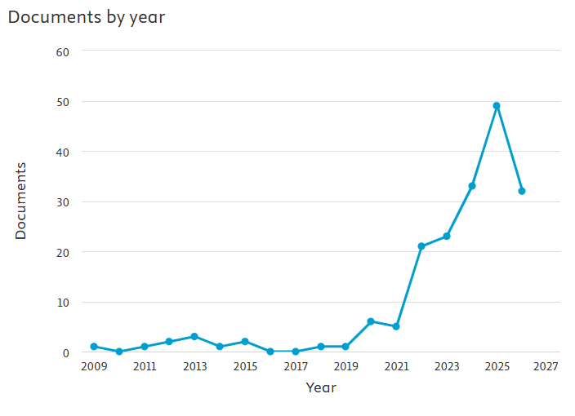
Figure 2 illustrates the top researchers producing CCR aligned with TCFD, with nine researchers having similar publication counts (Susanne Arvidsson, Samira Demaria, Huang Hsiung Hsu, Christine A. Jubb, Jayanthi Kumarasiri, Shihyun Kuo, Chiachi Lee, Santi Gopal Maji, Sandra Rigot). These prominent authors mainly come from developed countries such as Sweden, France, Taiwan, and Australia, as the TCFD has been part of regulatory requirements in these countries since the framework was released to the public. The results show that there is no significant number of publications by a single author in the field of CCR aligned with the TCFD framework.
Figure 2. Top researchers producing publications on CCR aligned with TCFD
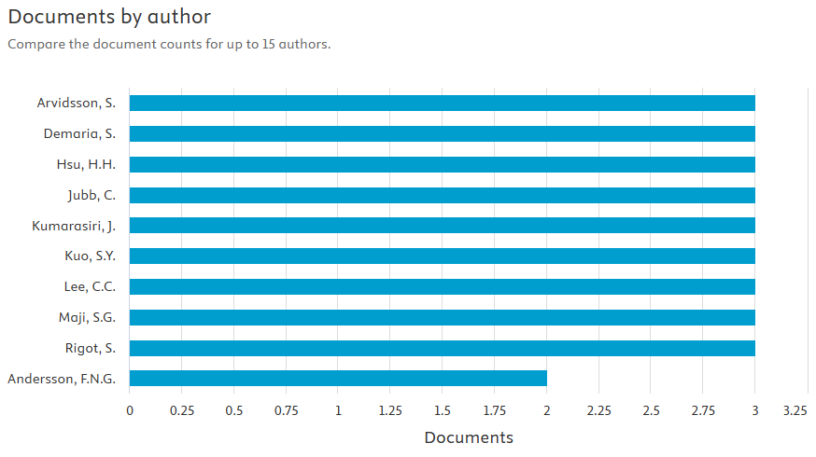
Figure 3 presents the leading academic institutions contributing to the publication of CCR aligned with the TCFD framework. Surprisingly, one of the top global institutions contributing to the research area is Tezpur University in India and sharing the same spot is the University of Sydney in Australia. Both reported 5 documents, with the University of Sydney reporting a higher number of citations of 112, and Tezpur University reporting 90 citations.
Figure 3. Top institutions producing publications on CCR aligned with TCFD
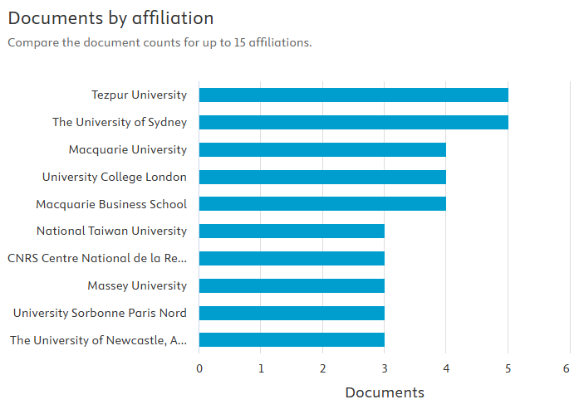
Figure 4 illustrates the top countries producing publications related to CCR aligned with TCFD, with a significant number of publications reported for the United Kingdom (27 documents) and Australia (26 documents). While most of the list comes from developed countries, Malaysia and India are two developing countries that contribute to CCR-aligned TCFD documents. Malaysia has embraced the TCFD framework via its listing requirements released by the regulator, the stock exchange, on September 22, 2022 (BM, 2022).
Figure 4. Top countries producing publications on CCR aligned with TCFD
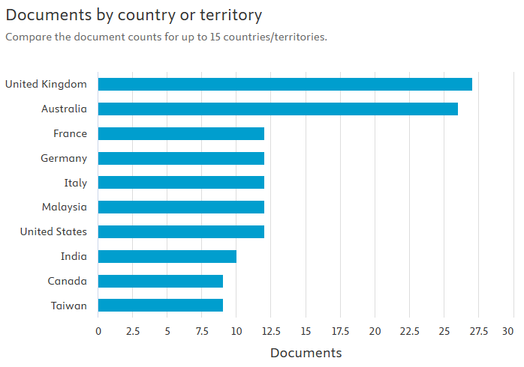
Science Mapping
Using the same database, the authors determined that 45 of 960 keywords met the 5-keyword threshold, yielding 6 clusters, as depicted in Figure 5. The significance of the co-occurrence analysis reveals the words’ relevance in the field based on their frequencies. The top three keywords are climate change (61 occurrences), TCFD (40 occurrences) and sustainability (30 occurrences). Figure _ presents the network structure of the analysis. The clusters were thematically analysed according to the author’s qualitative and inductive interpretation. The first cluster (red) has 8 keywords, including environmental economics, standards (regulation), corporate strategy, environmental policy and corporate governance. It focuses on the regulatory landscape towards climate-related initiatives. Meanwhile, the word corporate governance highlights the importance of corporate internal functions to monitor and execute climate regulation within the business operation system. The second cluster in green has 8 keywords, including climate change, climate disclosure, risk assessment, and climate risks, reflecting corporate responses to climate change via transparency. The third cluster (blue) has 7 keywords, including carbon accounting, carbon emissions, stakeholders and governance, highlighting corporate carbon accountability. These clusters reveal the multidimensional scope of studies on CCR, which are strongly related to regulation and climate policy in navigating green endeavours by business players. Callen and Thomas (2010) highlighted that, from the perspective of economics, environmental quality is a public good. However, individuals and businesses may choose not to contribute anything to get the benefit but expect others to bear the cost. It leads to underinvestment in environmental protection, where government intervention is crucial to promote environmental accountability and transparency.
Figure 5. Co-occurrence analysis of CCR aligned with TCFD
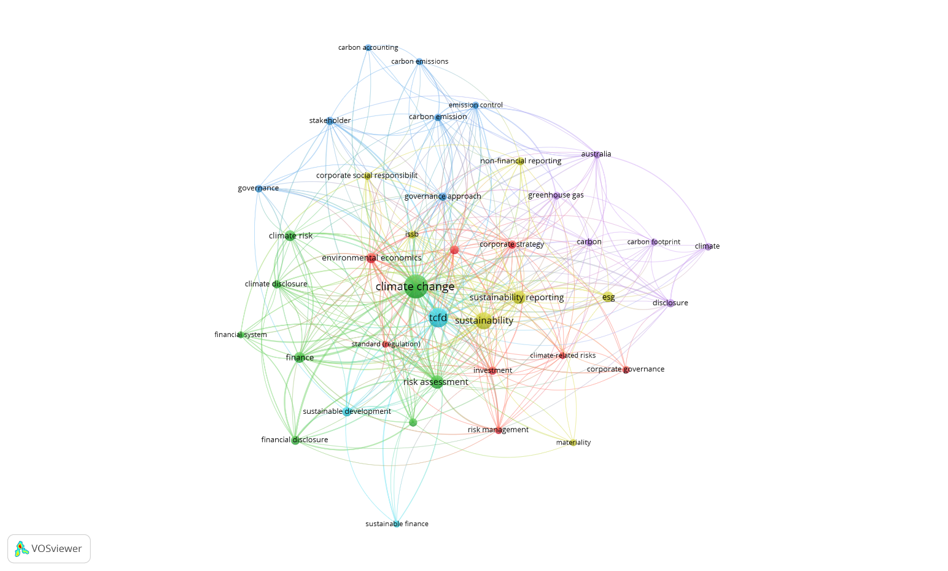
Figure 6 introduces the temporal aspect to the keyword network. The blue nodes denote keywords from earlier years in the CCR studies, and yellow nodes are used by the current publications. The blue nodes represent the words carbon, emissions control, standard (regulation) and financial disclosure. The shift in colour from one year to another shows that the keywords TCFD, sustainable finance, and governance have emerged, with the latest keyword used by the researchers being ISSB, corporate strategy and risk management. As the IFRS has taken over the monitoring role from TCFD under the purview of the International Sustainability Standards Board (ISSB), this trend makes sense. Researchers are aware of the convergence of these frameworks, and greater focus should be given to the ISSB as the current standard-setter for climate-related information disclosure globally. A comparison between these two frameworks provides valuable insight into market players’ readiness to adopt the new framework.
Figure 6. Keyword co-occurrence overlay visualisation map according to year

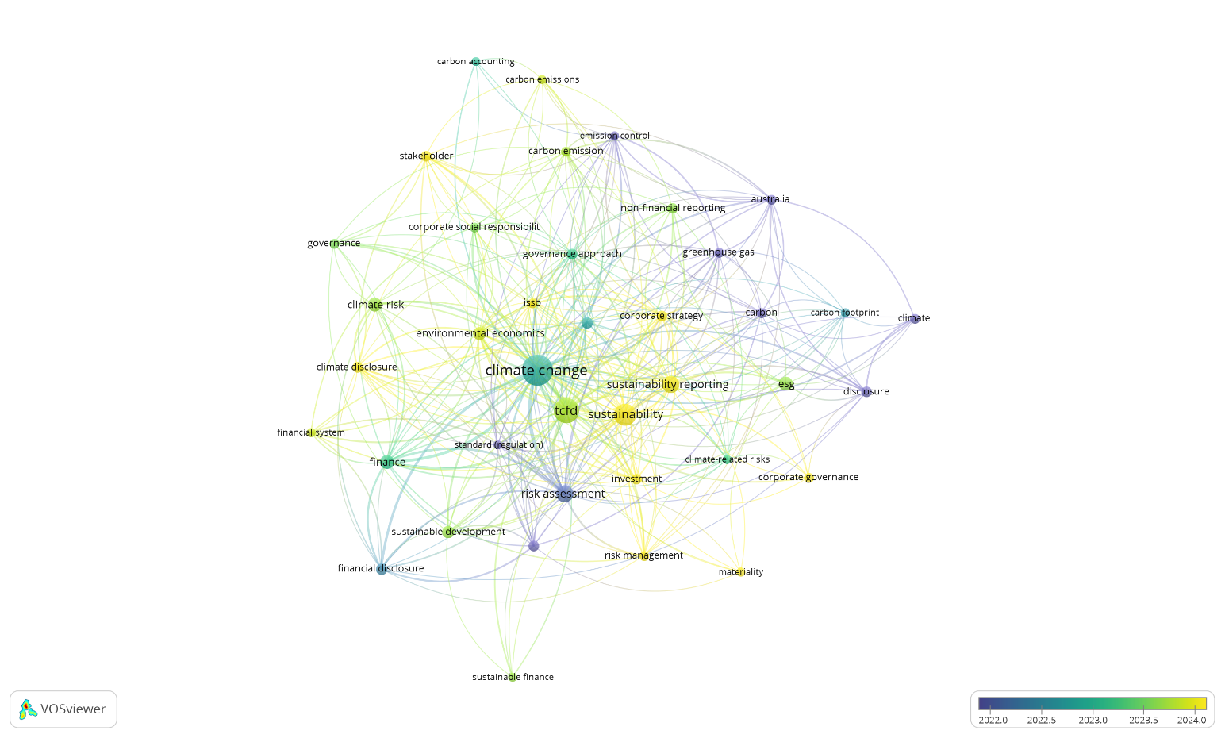
CONCLUSIONS
Based on the results above and the documents from the Scopus database, the bibliometric analysis reveals that Australia has been leading in contributions to the research area, given the number of prominent researchers and institutions. The findings are strengthened by the top countries producing publications aligned with the CCR and the TCFD framework, with Australia in the top 3. In addition, Australia has been one of the most frequently used keywords by researchers, according to the co-occurrence analysis, further supporting the findings, as depicted in Figure 5. In Australia, sub-national governments began enacting climate legislation before the federal government, with South Australia enacting its climate law in 2007, followed by Tasmania and the Australian Capital Territory in 2008 (Christoff & Eckersley, 2021). Following that, the national climate change legislation was passed in September 2022, setting a target to reduce GHG emissions by 43% from 2005 levels by 2030 and to achieve net-zero emissions by 2050, along with several complementary policy measures (Australia, 2022). The government's active move could shape researchers’ motivations and interest in investigating the development of CCR in the country. Meanwhile, based on the keyword clusters mostly used by researchers, it can be concluded that, as part of sustainability reporting, the CCR is focusing on managing carbon and greenhouse gas emissions, which are the main cause of climate change (Zarzycki, 2025). Therefore, providing such information may yield key strategic climate performance data that is useful at the firm and national levels, while advancing climate transparency and accountability. While firms may utilise the information to assess their climate risks, the information is useful for the country to fulfil its responsibility of submitting Nationally Determined Contributions (NDCs) every five years to the United Nations under the Paris Agreement (Falkner, 2016).
The study limits the search to the Scopus database and to journal articles only. Other publications such as conference papers or chapters in books may consist of valuable information and insights that the current study may have missed (Donthu et al., 2021). In addition, the current research included minimal findings on science mapping in the bibliometric analysis, which could be a focus of future research. Science mapping through bibliometric analysis can compare and report the past, present, and future research directions and provide qualitative analysis of keyword clusters. The inclusion of qualitative analysis in the science mapping provides a value-added element to the findings reported for the research area.
References

- Ahmad, F. M. (2017). Beyond the horizon: Corporate reporting on climate change. Center for Climate and Energy Solutions.
- Australia. (2022). Climate Change Bill 2022. Australia Retrieved from https://www.aph.gov.au/Parliamentary_Business/Bills_Legislation/Bills_Search_Results/Result?bId=r6885#:~:text=Introduced%20with%20the%20Climate%20Change,statement%3B%20requires%20the%20Climate%20Change
- BM. (2015). Amendments relating to sustainability statement in annual reports. Malaysia: Bursa Malaysia (BM) Retrieved from https://www.bursamalaysia.com/sites/5bb54be15f36ca0af339077a/content_entry5ce3b5005b711a1764454c1a/5ce3c81c39fba2619023d12d/files/Appendix_1_MainLR_Sustainability_final__7Oct2015_.pdf?1570701455
- BM. (2022). Amendments to the main market listing requirements in relation to Enhanced Sustainability Reporting framework. Malaysia: Bursa Malaysia (BM) Retrieved from https://www.bursamalaysia.com/sites/5bb54be15f36ca0af339077a/content_entry5c11a9db758f8d31544574c6/63312a2439fba20d86ba8e16/files/26Sept_2022_Bursa_Malaysia_Enhances_Sustainability_Reporting_Framework_With_New_Climate_Change_Reporting.pdf
- Braasch, A., & Velte, P. (2023). Climate reporting quality following the recommendations of the Task Force on Climate‐related Financial Disclosures: A Focus on the German capital market. Sustainable Development, 31(2), 926-940. https://doi.org/10.1002/sd.2430
- Callen, S. J., & Thomas, J. M. (2010). Environmental economics & management: Theory, policy and applications (6th ed.). South Western.
- Chiu, M. C., Wei, C. J., Wang, Y. C., & Kao, M. C. (2023). Applying unsupervised learning method to develop a regional risk model based on TCFD: A case study in the United States [Article]. Journal of Cleaner Production, 400, Article 136669. https://doi.org/10.1016/j.jclepro.2023.136669
- Christoff, P., & Eckersley, R. (2021). Convergent evolution: Framework climate legislation in Australia. Climate Policy, 21(9), 1190-1204.
- Dey, D. (2024). Overview of climate disclosures. British Actuarial Journal, 28, Article e13. https://doi.org/10.1017/S135732172300017X
- Ding, D., Liu, B., & Chang, M. (2023). Carbon emissions and TCFD aligned climate-related information disclosures. Journal of Business Ethics, 182(4), 967-1001.
- Donthu, N., Kumar, S., Mukherjee, D., Pandey, N., & Lim, W. M. (2021). How to conduct a bibliometric analysis: An overview and guidelines. Journal of business research, 133, 285-296.
- Falkner, R. (2016). The Paris Agreement and the new logic of international climate politics. International Affairs, 92(5), 1107-1125.
- Franco, E. G. (2020). The Global Risks Report 2020. World Economic Forum Retrieved from https://www3.weforum.org/docs/WEF_Global_Risk_Report_2020.pdf
- Liu, C., & Wu, S. S. (2023). Green finance, sustainability disclosure and economic implications. Fulbright Review of Economics and Policy, 3(1), 1-24.
- Maji, S. G., Boruah, R., & Rani, N. (2025). Corporate climate change financial disclosure and financial performance in emerging nations: Evidence from Fortune Global firms. Meditari Accountancy Research, ahead-of-print(ahead-of-print). https://doi.org/10.1108/MEDAR-03-2024-2428
- Maji, S. G., & Kalita, N. (2022). Climate change financial disclosure and firm performance: Empirical evidence from Indian energy sector based on TCFD recommendations [Article]. Society and Business Review, 17(4), 594-612. https://doi.org/10.1108/SBR-10-2021-0208
- TCFD. (2017). Final Report: Recommendations of the Task Force on Climate-related Financial Disclosures. Switzerland: Task Force on Climate-related Financial Disclosure (TCFD) Retrieved from https://assets.bbhub.io/company/sites/60/2021/10/FINAL-2017-TCFD-Report.pdf
- TCFD. (2021). Implementing the recommendations of the Task Force on Climate-related Financial Disclosures. Switzerland Retrieved from https://assets.bbhub.io/company/sites/60/2021/07/2021-TCFD-Implementing_Guidance.pdf
- Zahidi, S. (2026). The Global Risks Report 2026. World Economic Forus Retrieved from https://reports.weforum.org/docs/WEF_Global_Risks_Report_2026.pdf
- Zarzycki, R. (2025). What is the main mechanism of earth’s temperature changes? Chemistry-Didactics-Ecology-Metrology, 30(2), 1-10. https://doi.org/10.2478/cdem-2025-0001

