EduActive: Designing an Interactive and Gamified Learning

ABSTRACT
The growing reliance on technology in education has created persistent gaps, particularly for early learners and students with visual impairments who remain underserved by existing e-learning platforms. Common challenges include limited subject coverage, lack of engaging content, poor accessibility, and overly complex interfaces that overwhelm young users. This study addresses these concerns through the development of EduActive, an AI-powered interactive and gamified e-learning platform designed specifically for early learners. The platform was developed with three primary objectives: (1) to implement an AI-driven voice command system that reduces reliance on guardian assistance for visually impaired students when navigating and engaging with the platform; (2) to incorporate gamification elements including badges, points, and streak tracking that transform lessons into motivating and enjoyable experiences; and (3) to provide a broad yet age-appropriate range of subjects that build a strong educational foundation for young learners. This study employed a developmental research design combined with an Agile-based methodology, allowing iterative cycles of planning, design, development, testing, and evaluation. The system was built using React.js for the frontend, Node.js with Express.js for backend operations, and SQLite for database management, with Firebase handling user authentication and session control. The Web Speech API and Speech Synthesis API were integrated to power the platform's voice command and text-to-speech features without relying on third-party services. The platform covers core subjects including Mathematics, Science, English, and Filipino, each featuring animated lesson content and structured quizzes. Evaluation conducted in a controlled environment involving early learners and their guardians demonstrated that the platform's voice command and text-to-speech features significantly reduced the level of guardian assistance required for visually impaired students to navigate and interact with the system. Gamification elements positively influenced learner engagement and motivation, while the subject variety supported a well-rounded early learning experience. The findings affirm that EduActive presents a viable and inclusive model for early childhood digital education, offering a practical approach to minimizing accessibility barriers for visually impaired learners in developing-country contexts.
Keywords: e-learning, gamification, voice navigation, accessibility, early learners
INTRODUCTION
Digital learning technologies have transformed modern education by providing flexible and accessible learning environments through e-learning systems and interactive platforms. These technologies enable learners to access educational materials, activities, and assessments beyond traditional classroom settings. However, despite the continuous development of e-learning platforms, several challenges remain, particularly for early learners. Many existing systems provide limited subject coverage and rely heavily on text-based instruction and repetitive activities, which may reduce learner engagement, participation, and knowledge
Accessibility also remains a significant concern, especially for visually impaired learners. Most e-learning platforms primarily depend on visual interaction, making navigation and independent learning difficult for students with visual impairments. In addition, complex interfaces may overwhelm early learners and reduce meaningful interaction with educational content. Considering that many learners have access to mobile devices and internet connectivity despite educational and financial limitations, digital learning systems can serve as alternative and accessible educational tools.
To address these concerns, the proponents developed EduActive, an interactive and gamified e-learning platform designed for early learners, including visually impaired students. The platform integrates AI-powered voice navigation to improve accessibility and support independent learning. It also incorporates gamification features such as rewards, badges, missions, daily streaks, and interactive activities to increase learner motivation and engagement. Furthermore, EduActive provides multimedia educational content in Mathematics, English, Math, Reading, Filipino, and Science through a child-friendly interface, along with progress monitoring tools for parents and guardians.
This study aims to evaluate the effectiveness, accessibility, usability, and engagement of EduActive in supporting the educational needs of early learners. Through the integration of AI technology, gamification, and accessibility features, the study seeks to contribute to the development of more inclusive and engaging digital learning environments.

RELATED LITERATURE
Educational technology continues to transform modern learning environments by providing learners with flexible, accessible, and interactive educational experiences. E-learning platforms have become important tools in supporting both traditional and digital learning through the integration of multimedia resources, adaptive systems, and online communication tools. According to Mohamed Ally (2004), effective e-learning platforms should combine technology with proper instructional design principles to create meaningful and interactive learning experiences. Similarly, Dela Peña-Bandalaria (2009) explained that e-learning in the Philippines evolved from simple online support systems into more comprehensive digital learning environments through the use of Learning Management Systems and mobile technologies. These studies highlight the growing role of technology in improving educational accessibility and learner participation.
Several studies emphasized the importance of adaptive learning and user-centered educational systems in improving the overall learning experience. Maaliw (2020) stated that adaptive e-learning systems personalize educational content according to learners’ needs and prior knowledge, resulting in richer and more effective learning experiences. In support of this, Gligorea et al. (2023) explained that artificial intelligence and machine learning technologies can personalize lessons based on students’ learning styles and abilities, improving learner engagement and educational outcomes. Phillips et al. (2012) also emphasized that user-centered e-learning systems should provide simple navigation, multimedia integration, and timely feedback to enhance learner understanding, accessibility, and usability.
Gamification has also been widely recognized as an effective strategy in increasing learner motivation and engagement in digital education. Alsubhi, Sahari, and Wook (2020) explained that gamification improves student participation in e-learning platforms through the integration of game elements and mechanics into educational activities. Likewise, Nand et al. (2019) found that primary school learners demonstrated better engagement and learning performance when educational content included graphical presentations, feedback systems, and levels of difficulty. Tokarieva and Chyzhykova (2022) further stated that gamified learning applications contribute to the development of learners’ cognitive, motivational, and social skills through educational games, quizzes, and interactive activities.
Local studies also support the effectiveness of gamified and mobile learning systems in improving learner participation and educational experiences. Duterte (2024) found that educational gamification positively affects student engagement, motivation, and academic performance through the use of points, badges, leaderboards, and collaborative challenges. Similarly, Magallanes et al. (2024) revealed that gamification tools such as Kahoot increased learner participation and motivation among Alternative Learning System students through interactive assessments and game-based learning activities. Diesto and A.M.N. (2024) also demonstrated that interactive educational games and mobile learning applications improved language learning and student engagement through gamified educational environments.
Studies also discussed the importance of accessibility and reliable digital learning systems, especially for learners facing educational and technological challenges. Casillano (2020) highlighted that internet connectivity plays a significant role in supporting education, particularly in economically limited areas where learners rely heavily on internet access for online learning. Similarly, Sabio and Sabio (2024) identified internet connectivity problems, workload difficulties, and environmental distractions as common challenges experienced by students during online learning. These findings emphasize the need for accessible, flexible, and user-friendly e-learning platforms capable of supporting learners under different learning conditions.
Furthermore, researchers highlighted the value of multimedia integration, blended learning, and interactive educational technologies in improving learner engagement and understanding. Hagen-Hall and Verhaart (2014) explained that iterative development and continuous feedback improve the quality and usability of e-learning systems through features such as interactive videos, animated diagrams, and self-assessment tools. Keengwe, Onchwari, and Agamba (2014) also emphasized that blended learning environments improve learner participation and communication by combining traditional instruction with collaborative digital technologies.
The reviewed literature and studies collectively show that e-learning systems, gamification, artificial intelligence, accessibility features, and interactive educational technologies positively influence learner engagement, motivation, participation, and academic performance. However, most existing studies focus primarily on older learners such as high school and college students. There remains a limited number of studies specifically designed for early learners who require simpler interfaces, engaging visuals, interactive activities, and playful educational experiences. This research gap supports the development of EduActive, an interactive and gamified e-learning platform designed specifically for early learners. The proposed system aims to provide an engaging, accessible, and inclusive learning environment through gamified lessons, AI voice navigation, interactive activities, and progress monitoring features that promote enjoyable and effective learning experiences for young learners.

METHODOLOGY
This section presents the methods, procedures, and technologies utilized in the development and evaluation of EduActive: An Interactive and Gamified Learning Platform for Early Learners. The study focused on designing, developing, and assessing an accessible educational platform intended to improve engagement, learning experiences, and accessibility for early learners, including visually impaired students.

Research Design
The study utilized a developmental research design integrated with the Agile Software Development Methodology in the design, development, and evaluation of the EduActive platform. Developmental research was appropriate because the study focused on creating and assessing an interactive educational system intended to enhance learner engagement, accessibility, and educational effectiveness.
The Agile methodology was adopted to support iterative development through continuous cycles of planning, design, development, testing, and evaluation. This approach enabled the proponents to refine system functionalities and improve the platform based on observations and testing results gathered throughout the development process.
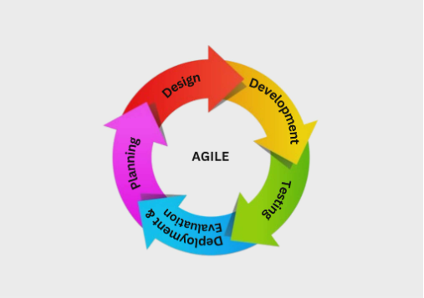
Figure 1. Agile Software Development Method

The figure illustrates the Agile Software Development Method utilized in the study. The methodology follows an iterative process consisting of planning, design, development, testing, deployment, and evaluation to continuously improve system functionality and user experience.
Planning stage
Where the goals and requirements of the system are identified. In this study, the researchers planned to develop an animated educational game that is engaging, accessible to early learners, and supportive of visually impaired students through features such as voice navigation and interactive quizzes.

Design phase
Where the structure and interface of the system are created. The application was designed to be user-friendly, visually appealing, and easy to navigate, with organized layouts for animations, quizzes, and the dashboard for parents or guardians.
Development stage
Where the actual system is built. The researchers developed the animated content, implemented voice navigation, and created quizzes for different subjects such as Mathematics, English, Reading, and Science.
Testing phase
Where its functionality, usability, and accessibility are evaluated. The researchers tested the effectiveness of the animations, the accuracy of quiz results, and the performance of the voice navigation, especially for visually impaired users.
Deployment & Evaluation phase
Where the system is implemented and used by the target users. Feedback from students and guardians is collected through the dashboard and observation, allowing the researchers to identify areas for improvement.

System Development
EduActive was developed as a web-based interactive learning platform designed to support early learners through engaging educational activities and accessible learning features. The platform integrates animated lessons, gamified quizzes, learner progress monitoring, and AI-powered voice navigation to improve usability and educational engagement.
The system includes educational content for subjects such as Mathematics, English, Reading, and Science. In addition, a guardian dashboard was integrated to enable parents or guardians to monitor learner progress, quiz performance, and earned achievements. The platform was developed using modern web technologies, including React.js for the user interface, Node.js and Express.js for backend operations, SQLite for database management, and Firebase Authentication for secure user access.

System Architecture
The EduActive platform consists of interconnected components designed to manage learning activities, accessibility features, and learner monitoring. The system architecture includes the user layer, frontend interface, backend services, database management, and external accessibility services.
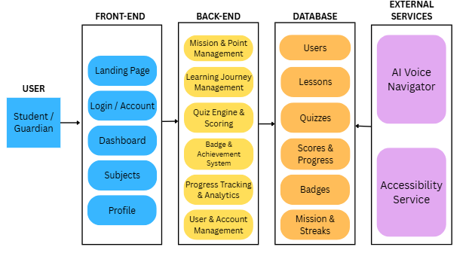
The frontend layer manages user interaction through lessons, quizzes, dashboards, and accessibility features, while the backend layer handles quiz processing, learner progress tracking, score management, and account operations. The database stores user information, lesson progress, quiz scores, achievements, and learning records. Additionally, AI-powered voice navigation and speech services were integrated to support visually impaired learners and improve accessibility.
Figure 2. System Architecture of EduActive

The figure presents the interaction between the major system components, including the frontend, backend, database, and accessibility services that support learning activities and learner monitoring.

System Flow
The system flow illustrates the sequence of processes performed within the EduActive platform. The process begins when users access the platform and authenticate their account through login or registration. After authentication, learners may select educational subjects and participate in lessons and interactive quiz activities.
Upon completion of quizzes, the system automatically evaluates learner responses and provides corresponding feedback. Quiz results, learner progress, earned badges, and achievements are recorded within the database to support continuous monitoring and engagement.

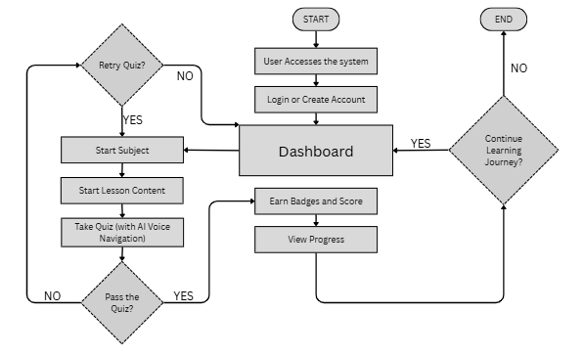

Figure 3. System Flowchart of EduActive

The figure illustrates the overall process flow of the EduActive platform, from user authentication to lesson participation, quiz completion, feedback generation, and learner progress monitoring.

System Evaluation
The developed system was evaluated through controlled testing involving one hundred (100) selected participants, consisting of early learners under guardian supervision and selected individuals who participated in the system evaluation process. The evaluation focused on assessing the system’s usability, accessibility, functionality, engagement, and educational effectiveness.
Observations and user feedback gathered during system interaction were analyzed to assess the effectiveness of EduActive in supporting interactive learning and accessibility for early learners. The findings were used to identify possible improvements and determine whether the platform effectively meets its intended objectives
RESULTS AND DISCUSSION
This section presents the implementation and evaluation results of the EduActive platform. It discusses the developed system features, accessibility functions, and findings gathered during system evaluation to determine the platform’s usability, engagement, and educational effectiveness for early learners.
System Implementation
This section presents the implementation of the EduActive platform and its major features developed to support interactive and accessible learning for early learners. The platform integrates educational lessons, gamified quizzes, learner progress monitoring, guardian supervision, and voice-assisted accessibility features to improve learner engagement and usability. The following figures present the implemented interfaces and functionalities of the system.
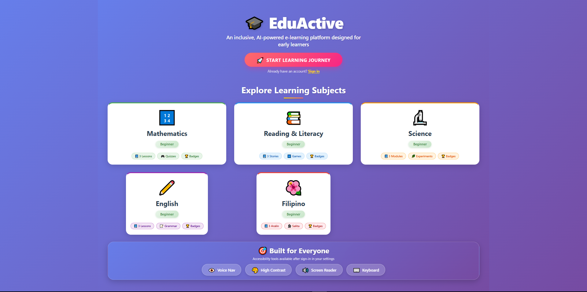
Figure 4. EduActive Landing Page Interface
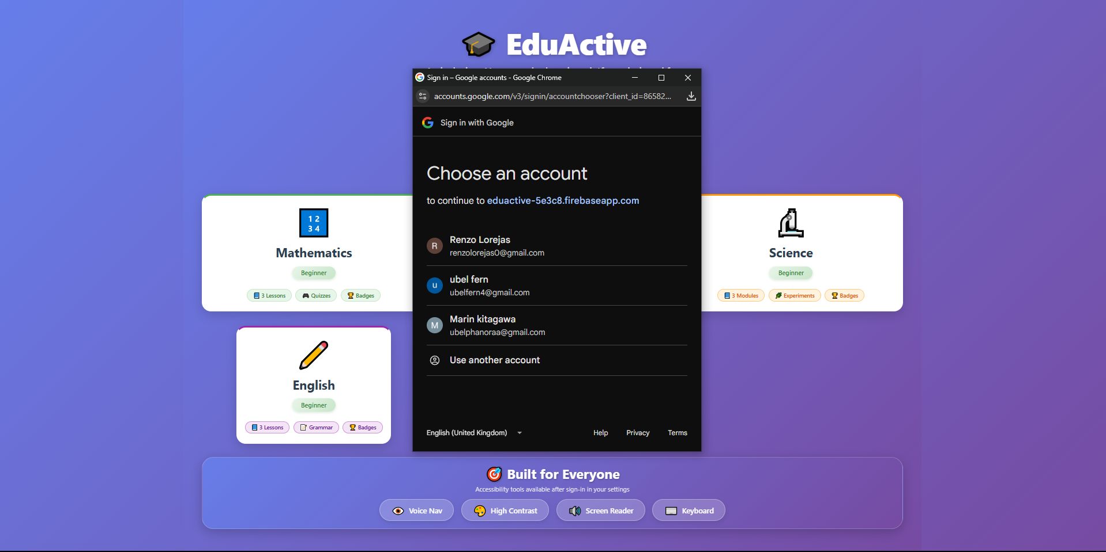
Figure 4 presents the landing page of the EduActive web system. The page introduces users to the platform by displaying the five available subjects to provide an overview of the learning content before login. The interface uses colorful visuals, animations, and interactive elements to create an engaging and child-friendly environment for early learners. These design features aim to encourage user interaction and support the study’s objective of providing an enjoyable and accessible learning experience.
Figure 5. EduActive Login Interface
Figure 5 presents the login page of the EduActive web system. The interface was designed to provide quick and convenient access for early learners through a simplified login process using a Google account. Instead of requiring a separate registration process, the system allows users to log in directly, reducing complexity and improving accessibility for young learners. Additionally, the use of individual accounts enables the system to save user progress, including completed lessons and achievements, allowing learners to continue their educational activities efficiently.
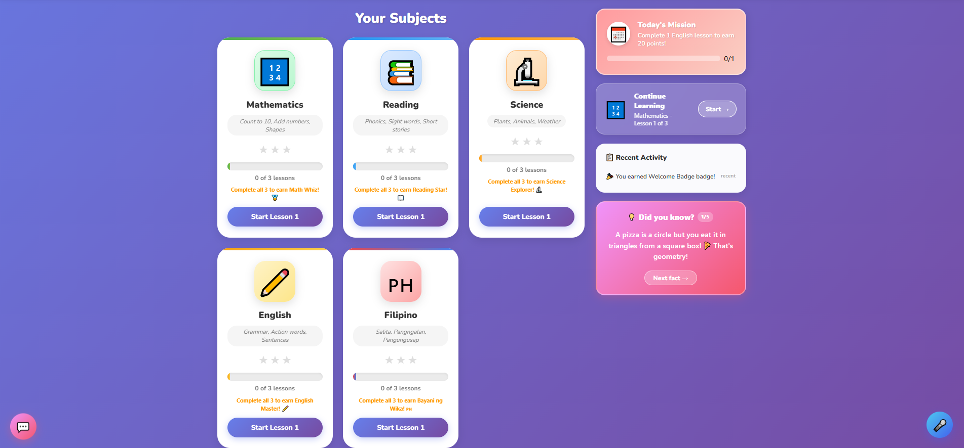
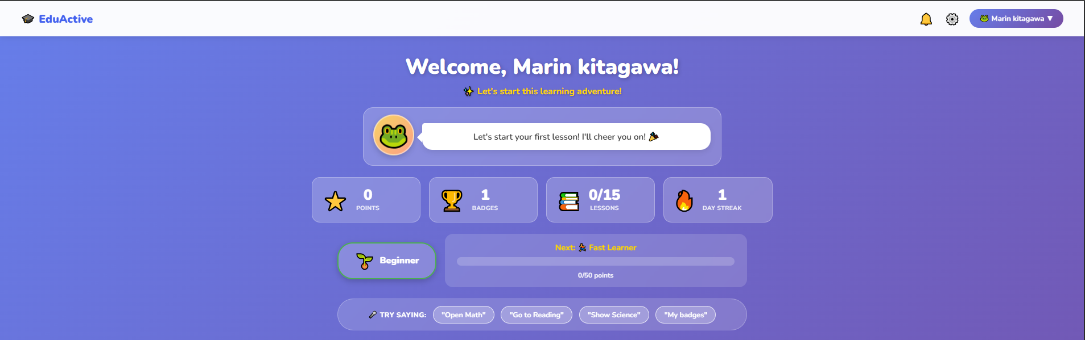
Figure 6. EduActive Dashboard Interface
Figure 6 presents the dashboard of the EduActive web system, which contains the major features and functions of the platform. The dashboard provides access to different subjects where learners can select lessons and quizzes based on their preferred topic. Additionally, playful visual elements and interactive components were incorporated to maintain learner engagement and create a more enjoyable learning environment for early learners. This design supports the study’s objective of providing an engaging, user-friendly, and interactive educational experience.
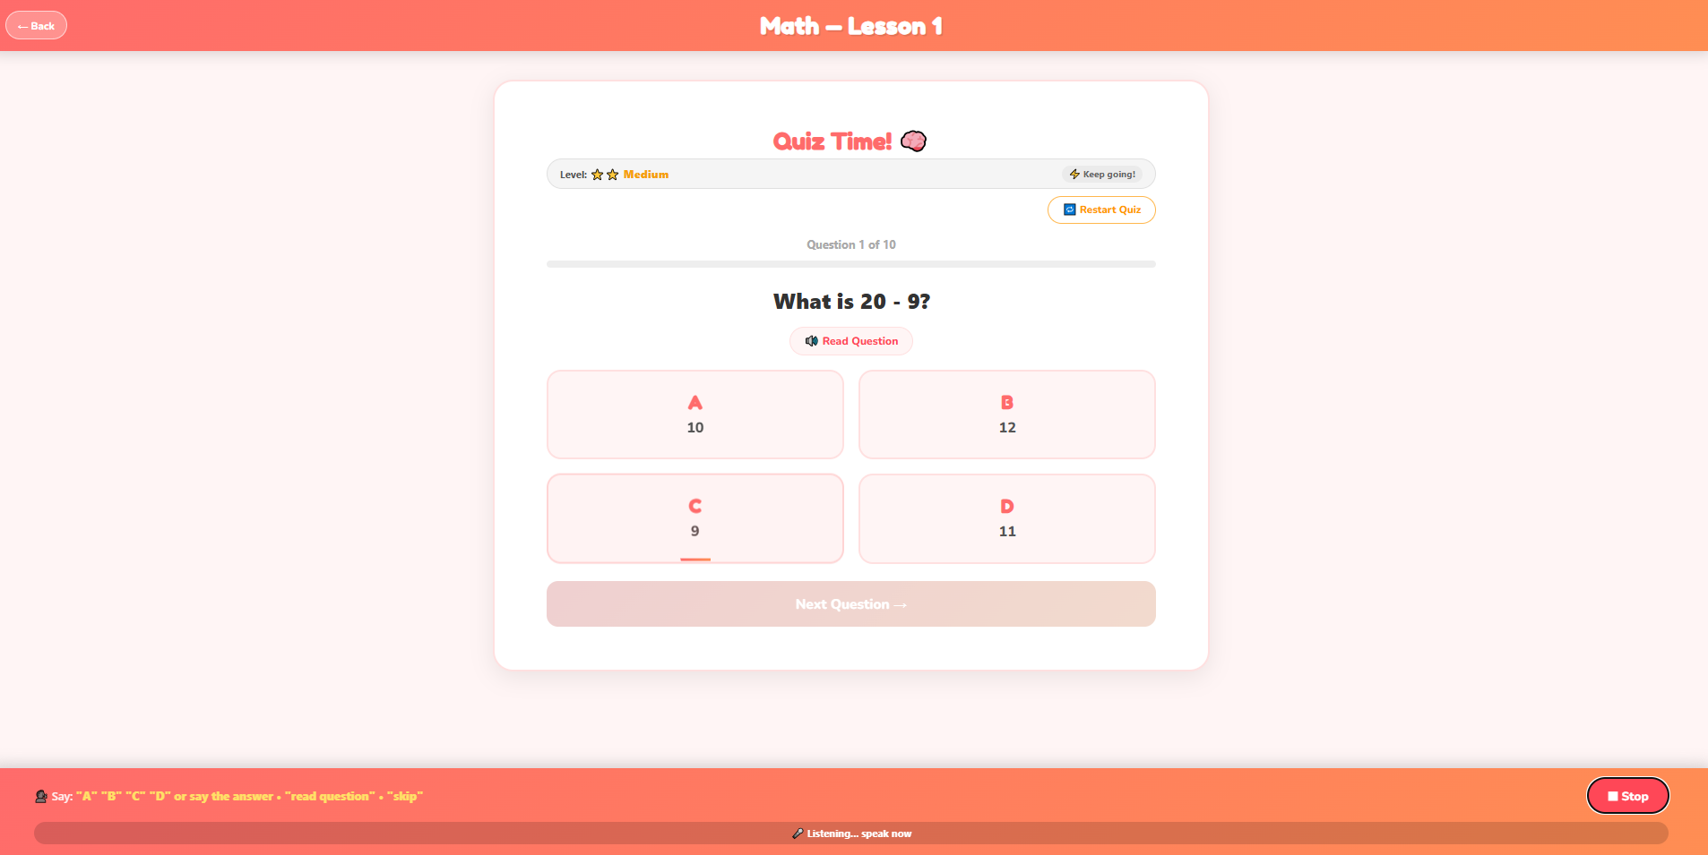
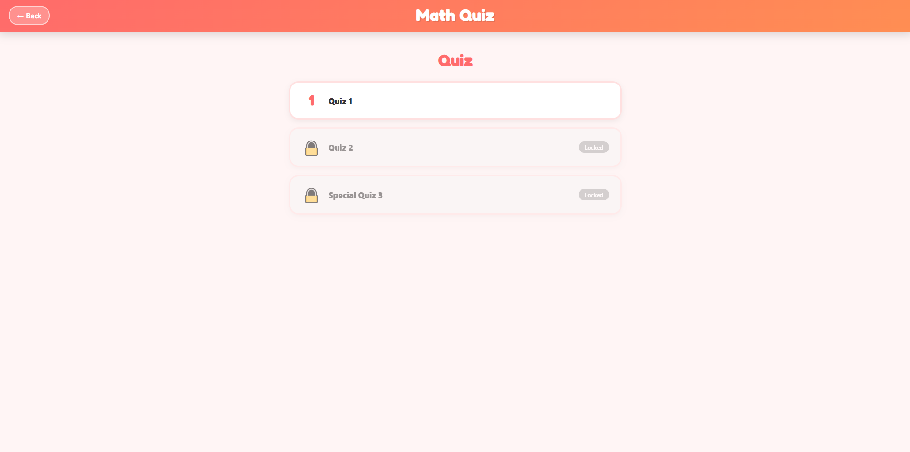
Figure 7. EduActive Quizzes Interface
Figure 7 presents the quiz feature of the EduActive web system, which consists of three progressive levels of difficulty. Learners are required to complete the lower level before accessing the next, allowing for structured learning progression. As the level increases, the difficulty of questions also becomes more advanced to match the learner’s development. Additionally, the system applies adaptive questioning, where questions automatically become more difficult after correct responses and easier after incorrect answers. This approach provides a more personalized learning experience while helping learners progress according to their level of understanding.

Figure 8. EduActive Voice Assistant Interface
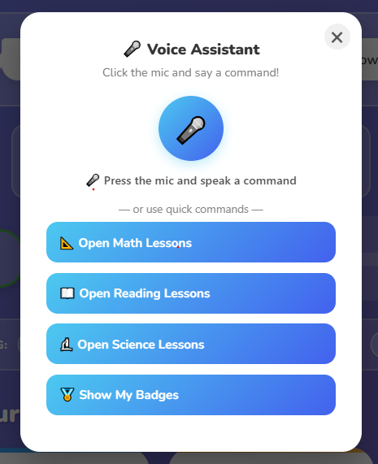
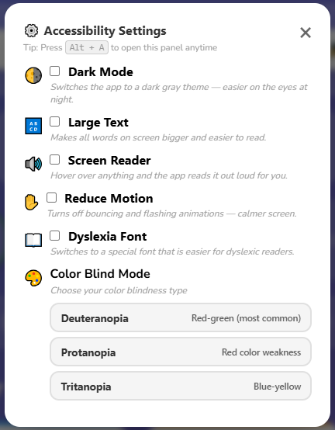
Figure 8 presents the voice assistant feature of the EduActive web system, which supports navigation and interaction within the platform through voice commands. The feature allows learners, particularly visually impaired users, to navigate different sections of the system and respond to quiz questions using spoken input. By reducing reliance on manual interaction, the voice assistant enhances accessibility and promotes a more inclusive learning experience for early learners.
Figure 9. EduActive Accessibility Interface

Figure 9 presents the accessibility features of the EduActive web system, which were designed to support visually impaired learners and improve overall usability. The system includes assistive features such as screen reading functionality that helps users understand quiz questions through audio output. These accessibility tools enable learners to interact with educational content more independently, supporting the study’s objective of providing an inclusive and accessible learning environment for all users.

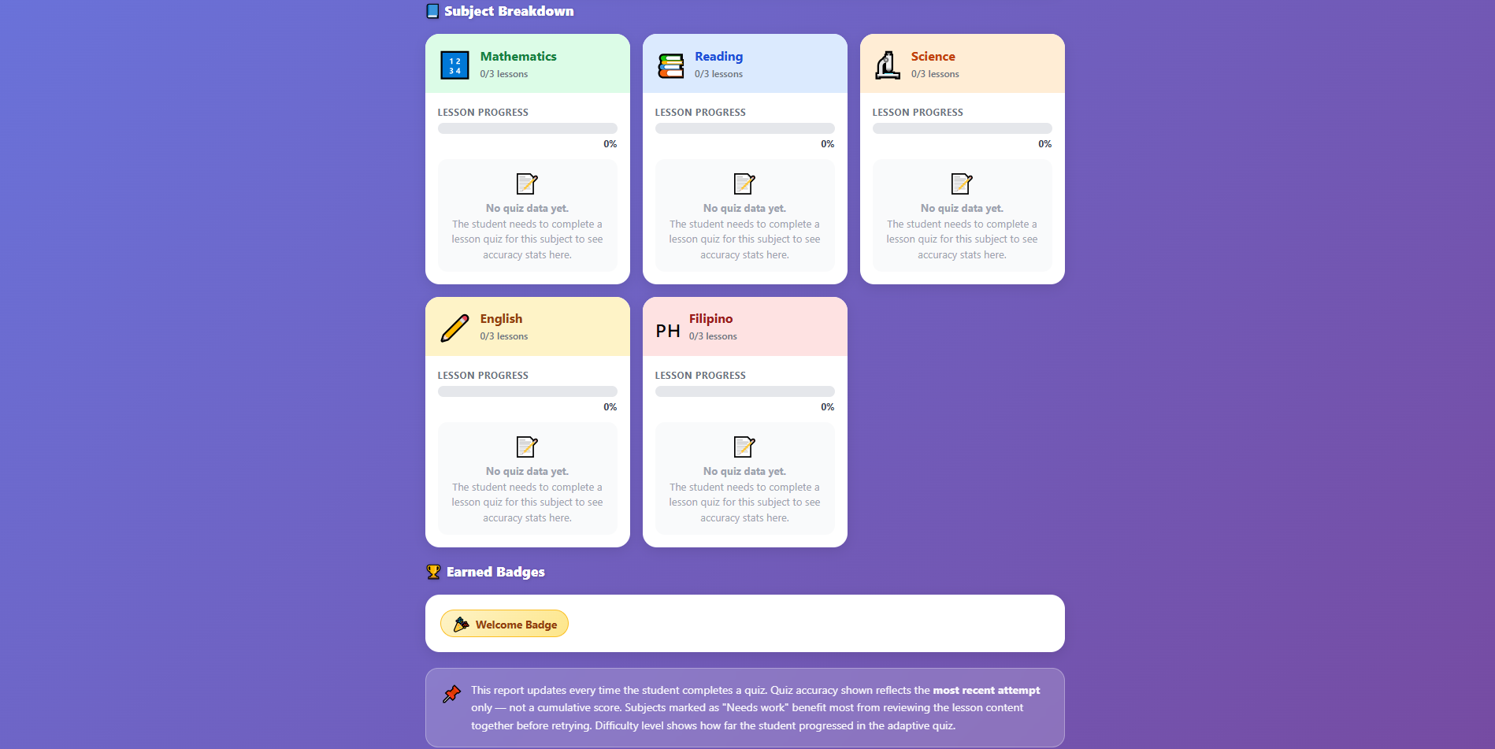
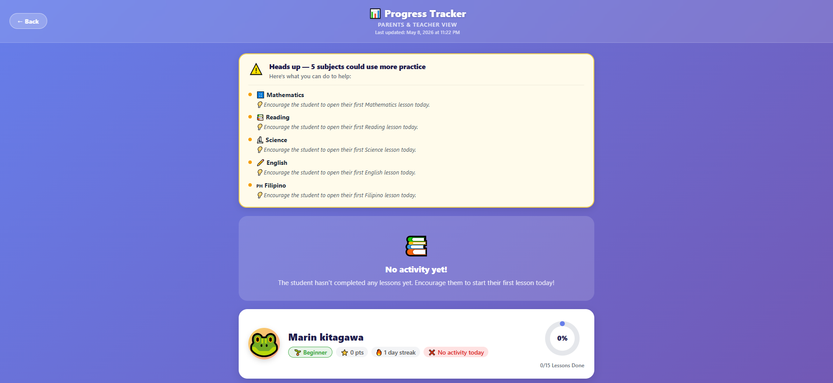
Figure 10. EduActive Progress Tracker Interface

Figure 10 presents the progress tracker feature of the EduActive web system, which provides detailed information regarding learner performance across different subjects. The feature displays quiz completion, correct and incorrect responses, and overall subject progress to help identify areas that require improvement. Additionally, the progress tracker supports parents or guardians by providing insights into the learner’s performance, allowing them to determine which subjects require more attention and guidance. This feature supports continuous monitoring and promotes a more guided learning experience for early learners.
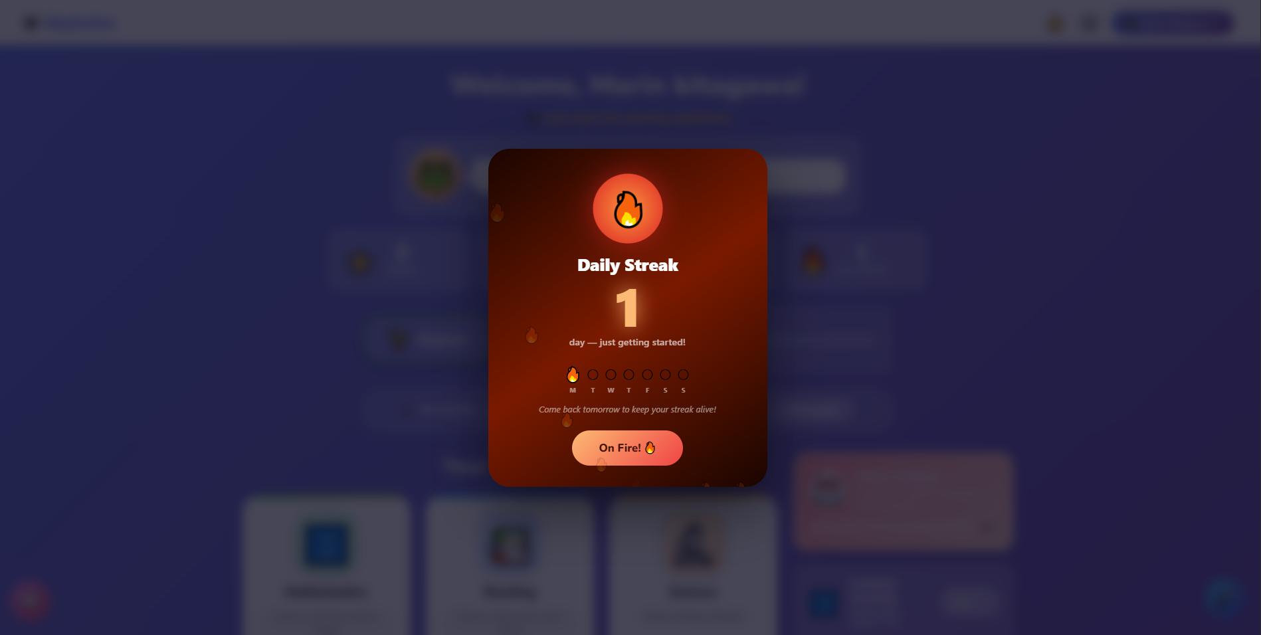
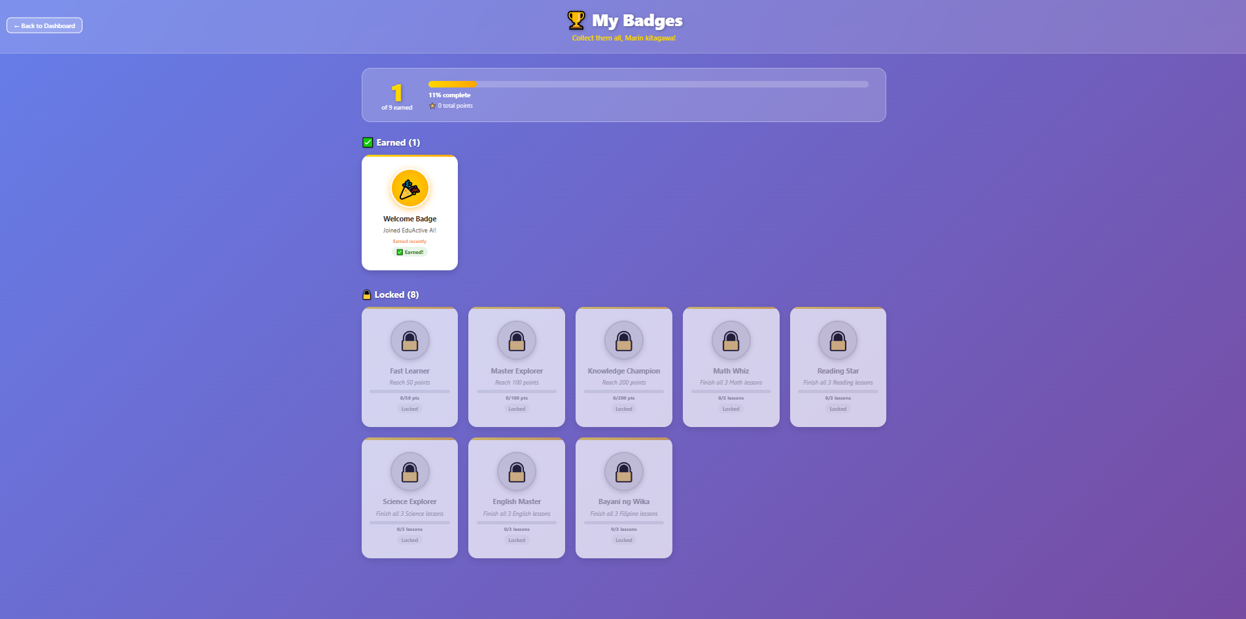
Figure 11. EduActive Badges Interface
Figure 11 presents the badge and streak feature of the EduActive web system, which was designed to encourage learner motivation through gamification. The system rewards learners with badges based on quiz completion and tracks daily login streaks to promote consistent engagement with educational activities. These game-based elements aim to motivate early learners to participate actively, complete quizzes, and maintain continuous interaction with the platform, supporting a more engaging learning experience.

System Evaluation Results and Discussion
This section presents the findings gathered from the observational evaluation of EduActive. The platform was evaluated through trial runs involving more than one hundred (100) selected participants composed of early learners under guardian supervision and selected evaluators. The evaluation focused on determining the system’s usability, accessibility, engagement, functionality, and educational effectiveness through user interaction and observation.
Usability
Based on observations during the system trial, participants found EduActive easy to use and navigate due to its child-friendly interface and organized educational structure. Learners were able to access lessons, quizzes, and activities with minimal difficulty, while guardians were able to navigate monitoring features efficiently. The simplicity of the platform contributed to a more convenient learning experience for both learners and guardians.
Accessibility and Functionality
The accessibility and functionality features of EduActive operate effectively during system interaction. The implemented voice navigation and accessibility features supported learner engagement and provided additional assistance during navigation. Major system functionalities, including lessons, quizzes, learner progress monitoring, and guardian supervision, functioned as intended throughout the evaluation process.
Engagement and Educational Experience
Observations revealed that early learners actively engaged with the platform and found the learning activities entertaining and enjoyable. Gamified elements such as quizzes, rewards, and achievements encouraged continuous participation and sustained learner interest. Learners demonstrated enthusiasm while interacting with educational content, indicating the platform’s potential to support interactive learning experiences.
Guardian Involvement and Learning Support
During system interaction, guardians were observed actively monitoring learner progress and assisting early learners throughout educational activities. The platform enabled guardians to keep track of learner achievements, quiz performance, and educational progress. Furthermore, observations suggested that EduActive encouraged meaningful interaction between learners and guardians, promoting opportunities for shared learning and bonding experiences through educational engagement.

CONCLUSION
The study successfully developed EduActive: An Interactive and Gamified Learning Platform for Early Learners, a web-based educational platform designed to support interactive, accessible, and engaging learning experiences for early learners, including visually impaired students. The platform integrated educational lessons, gamified quizzes, learner progress monitoring, guardian supervision, and voice-assisted accessibility features to improve educational interaction and learning support.
Findings gathered through observational evaluation indicated that EduActive was easy to use, engaging, and effective in supporting learner participation during educational activities. Early learners demonstrated enthusiasm and enjoyment while interacting with the platform, while guardians were able to monitor learner progress and participate more actively in the learning process. The implementation of gamification features and voice navigation contributed to improved learner engagement, accessibility, and overall usability of the system.
Furthermore, the study demonstrated the potential of EduActive to encourage meaningful educational interaction between learners and guardians through guided learning and progress monitoring. The developed platform may serve as an alternative educational tool for supporting interactive and accessible learning among early learners. Future enhancements may include additional educational content, improved accessibility features, and further system evaluation to strengthen learning effectiveness and user experience.

REFERENCES
- Ally, M. (2004). Foundations of educational theory for online learning. In T. Anderson & F. Elloumi (Eds.), Theory and Practice of Online Learning (pp. 3–31). Athabasca University.
- Alsubhi, M. A., Sahari, N., & Wook, T. T. (2020). A study of gamification elements for e-learning platforms. International Journal of Advanced Computer Science and Applications, 11(3), 1–10.
- Alonso, F., López, G., Manrique, D., & Viñes, J. M. (2005). An instructional model for web-based e-learning education with a blended learning process approach. British Journal of Educational Technology, 36(2), 217–235.
- Bagarinao, R. T. (2015). Navigational patterns of learners in an online course in Science, Technology, and Society. Asia Pacific Journal of Multidisciplinary Research, 3(5), 45–52.
- Bandalaria, M. D. P. (2009). E-learning in the Philippines: Trends, directions, and challenges. International Journal on E-Learning, 8(4), 495–510.
- Beck, K., Beedle, M., van Bennekum, A., Cockburn, A., Cunningham, W., Fowler, M., & Thomas, D. (2001). Manifesto for Agile Software Development. Agile Alliance.
- Benito, O. P., et al. (2024). Factors influencing the acceptance of eLearning platforms in medical education during the COVID-19 pandemic in the Philippines. Journal of Educational Technology Systems, 52(1), 45–62.
- Cambronero, P. P., R., B., Jr. (2018). Development of an e-learning system for graduate programs. International Journal of Advanced Research in Computer Science, 9(2), 120–128.
- Caraig, G. A., et al. (2020). Evaluation of e-learning resources and mobile technology integration among elementary education students in Batangas. Asia Pacific Journal of Educational Perspectives, 7(1), 34–42.
- Casillano, N. F. B. (2020). Challenges of internet connectivity and e-learning in Eastern Samar. International Journal of Computing Sciences Research, 4(1), 12–25.
- Dela Cruz, R. A. (2023). Online learning and student adaptation in the Philippines during COVID-19. Philippine Journal of Education, 98(2), 67–81.
- Diesto, B. R. D., & Mañago, A. M. N. (2024). Development of an interactive game for foreign language learners using Agile methodology. Philippine Journal of Educational Technology, 16(1), 55–70.
- Duterte, J. P. (2024). Educational gamification and student engagement in higher education. Philippine Journal of Educational Research, 29(1), 78–95.
- Eugenio, D., Sawi, K. J., & Sagud, R. (2024). Online cohort educational models and learning support systems in Philippine higher education. Journal of Distance Education Philippines, 12(2), 88–104.
- Garcia, M. (2017). E-learning technology adoption in the Philippines: An investigation of factors affecting Filipino college students' acceptance of learning management systems. International Journal of E-Learning and Educational Technologies in the Digital Media, 3(3), 118–130.
- Gligorea, I., et al. (2023). Artificial intelligence and adaptive learning systems in educational platforms: Benefits and challenges. Education and Information Technologies, 28(4), 4561–4583.
- Jemni, M., Laabidi, M., & Ben Ayed, L. (2014). Accessible e-learning for students with disabilities. In Advances in Educational Technologies and Instructional Design (pp. 45–63). IGI Global.
- Keengwe, J., Onchwari, G., & Agamba, J. (2014). Promoting effective e-learning practices through blended learning. Education and Information Technologies, 19(2), 253–269.
- Laranas, J. S., Apam, B., & Serrano, E. P. (2022). Acceptability of e-learning platforms for agriculture researchers and scientists in the Philippines. Journal of Agricultural Education and Extension, 28(3), 211–228.
- Mahajan, D. (2024). LearnIt: An educational system for identifying and supporting slow learners using MERN stack technologies. International Journal of Advanced Educational Systems, 11(1), 25–38.
- Maaliw, R. R. (2020). Adaptive learning personalization in e-learning systems. Philippine Journal of Information Technology Research, 15(2), 89–101.
- Muthuprasad, T., Aiswarya, S., Aditya, K. S., & Jha, G. K. (2021). Students’ perception and preference for online education in India during COVID-19 pandemic. Social Sciences & Humanities Open, 3(1), 100101.
- Nand, K., Baghaei, N., Casey, J., et al. (2019). Engaging children with educational gamification for numeracy learning. Education and Information Technologies, 24(2), 1189–1210.
- Peña-Bandalaria, M. M. D. (2009). Mobile learning and bridging the digital divide in Philippine education. University of the Philippines Open University Journal, 5(1), 23–39.
- Skiada, R., et al. (2014). EasyLexia: A mobile application for children with learning difficulties. Procedia Computer Science, 27, 218–228.
- Tokarieva, A., & Chyzhykova, I. (2022). Educators’ experiences with gamified learning applications in digital pedagogy. Educational Technology Quarterly, 2022(4), 425–442.
- Zainuddin, Z., et al. (2019). Gamified e-quizzes and learner engagement in science education. Computers & Education, 142, 103638.

