Brand Positioning Beyond Marketing: A Strategic Management Perspective on Competitive Advantage

Jafirullah Khan
Assistant Professor and Chairman
Department of Business Administration, Atish Dipankar University of Science and Technology
jafirullah.khan@gmail.com

Ishmum Muhib
MBA, Department of Business Administration, Atish Dipankar University of Science & Technology (ADUST) (Ongoing)
ishmummuhib3@gmail.com

Tanveerullah Khan Adnan
Doctor of Business Administration (DBA, Ongoing)
University of West of Scotland (London Campus)
tanveer.adnan@hotmail.com

Abstract
Brand positioning was once a sensitive marketing communication practice attuned to consumer perceptions. Positioning, however, has expanded its scope of management in the contemporary business world owing to heightened competition. It explores brand positioning as a strategic management tool and, in an argumentative sense, argues that it should be regarded as an organizational capability rather than a promotional instrument. This research examines how positioning is used to evaluate its influence on competition, strategic decisions, and the organization's long-term performance. The research indicates that effective positioning involves coordinating internal strengths and capabilities with external market strengths to enable companies to develop distinctive and sustainable market identities. Corporate business policy and positioning facilitate organizational performance through high differentiation and reduce the likelihood of imitation by rivals. The discourse explains how positioning could influence managerial operations, organizational culture, and cross-functional coordination. Lastly, the article advises that the policy component of positioning be grounded in regular governance, strategic control regimes, and market repositioning. There is an argument that positioning is a dynamic strategic process that should be periodically reviewed and revised in response to technological change or an upsurge in customer demand. The findings demonstrate that the competitive edge of companies whose positioning is the strategic planning device is more substantial and, in the long term, stronger. Altogether, the article is a significant contribution to the management literature, as it presents a multidimensional strategic tool for positioning the brand that integrates organizational identity, market perceptions of the company, and its competitive performance.
Keywords: Brand Positioning, Strategic Management, Competitive Advantage, Business Strategy

Introduction

Strategic Importance of Brand Positioning
The contemporary business landscape is marked by globalisation, the digital revolution, and intensifying competition; therefore, business establishments are finding it challenging to develop their strategic identities. Brand positioning has, in this instance, been among the most popular tools for creating differentiation and creating consumer perceptions. The question of whether organizations form perceptions of products and services relative to those of competitors is sensitive and necessitates consideration of long-term applicability. The positioning helps companies articulate value propositions that align with customer expectations and are compatible with companies' competencies (Porter, 1985). A consistent corporate approach to brand positioning is tactical and supports competitive focus and market credibility (Aaker, 1996).
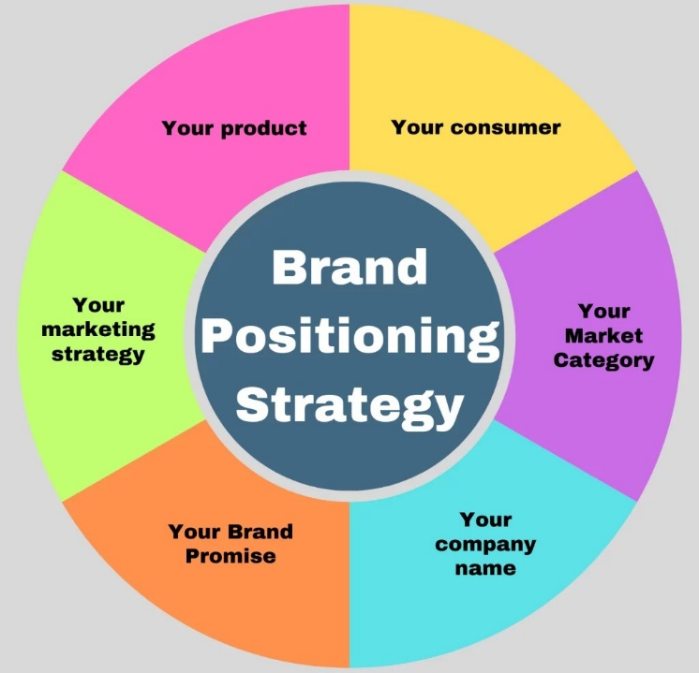
Figure 1: Brand Positioning Strategy Parts (DesignerPeople, 2024).

From Marketing Function to Strategic Capability
The brand positioning concept has long been regarded as a marketing communication activity, but its effects are no longer confined to promotion. Existing organizations recognize that positioning decisions determine the innovation strategy, resource allocation, and organizational policy. Brand positioning shapes stakeholders' perceptions and an organization's success in the market. The effectiveness of forming unique mental associations among consumers is increasingly dependent on competition (Keller, 2013). Positioning, when incorporated into overall strategic planning, may enable organizations to develop defensible market positions that are difficult for other organizations to overcome (Barney, 1991).

Purpose and Scope of the Study
The article would criticize brand positioning from a strategic management perspective rather than a marketing perspective. Positioning is an organizational experience discussed in the discussion, which helps the organization increase its competitive advantage and sustainability. Strategic consistency in business policy and brand positioning can guarantee uniform performance in dynamic markets (Kapferer, 2012). The positioning multidimensional strategic tool is more helpful for understanding how managers are expected to navigate complex competitive business environments (Kotler & Keller, 2016).

Conceptual Background

Understanding Brand Positioning
Brand positioning is a strategic approach to creating a memorable and meaningful image of a product or organization in the minds of target consumers. It is a tactical act by which companies shape their desired image relative to their competitors. Positioning choices aim to identify the specific qualities, advantages, and values that will distinguish a brand in saturated markets. The modern positioning theory states that companies must create a distinct image; otherwise, they are likely to be mispositioned among substitutes (Ries & Trout, 1981). Good positioning is related to the compatibility between the promise during the communication and the experience provided to the consumer (Fuchs & Diamantopoulos, 2010). Without this kind of coherence, positioning will be only superficial and will not be remembered by consumers.
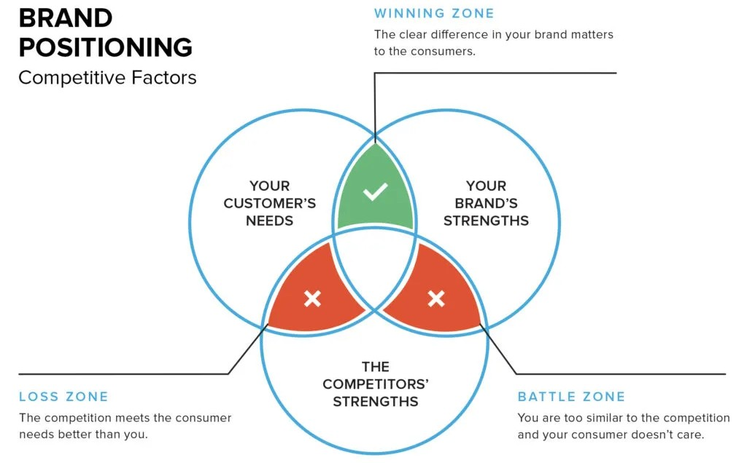
Figure 2: Brand Positioning Competitive Factors (Chopra, 2025).

Dimensions of Strategic Positioning
The available scholarly literature considers brand positioning a complex phenomenon encompassing product qualities, symbolic meaning, and organizational profile. Companies develop brands through advertisements and quality of service, corporate behavior and stakeholders' involvement. The strategic positioning would then require internal competencies aligned with internal capabilities and market demand. Positioning approaches must be continually modified in response to changes in the competitive environment and consumer preferences (Blankson & Kalafatis, 2007). Providing more coherent value propositions and communicating across all touchpoints can help organizations build a stronger, more sustainable brand image (Hooley et al., 2017). The broader definition is based on the managerial richness of effective positioning.

Positioning within Strategic Management Thought
Brand positioning is now considered an organizational resource rather than a marketing instrument. Positioning determines how stakeholders perceive the company's plans and how credible they are. It influences the planning and decision-making processes for product development and the priorities for innovation and market expansion. Adequate positioning helps companies acquire market positions that are difficult for competitors to replicate (Urde & Koch, 2014). Brand equity is an enduring construct that entails the establishment of emotional attachment and trust in the product and among consumers (Beverland, Napoli, & Farrelly, 2010). Positioning is a strategic process; hence, it provides a theoretical context for discussing its role in establishing competitive advantage.

Brand Positioning as a Strategic Tool

Positioning as a Strategic Orientation
One of the strategic resources organizations use to shape their competitive identities is brand positioning. It provides a procedural channel for allocating organizational resources in accordance with long-term business objectives rather than promoting short-term objectives. Companies that embark on short positioning plans are well positioned to ensure synchronized product development, customer involvement, and market development plans. The strategic positioning helps corporations develop differentiated value propositions that are difficult for competitors to replicate (Cravens & Piercy, 2008). It transforms the corporate vision into market actions that change the relationship with the key stakeholders (Hatch & Schultz, 2003). Positioning plays a role in managerial decision-making and in achieving organizational goals.

Integration of Positioning with Business Strategy
The brand positioning strategy should align with the company's overall strategy to achieve long-term outcomes. Without a connection between positioning and organizational policy, the likelihood of creating weak messages and failing to penetrate the market increases. Good companies have ensured that internal capabilities, operational mechanisms, and strategic investments can explain positioning decisions. Corporate communication can be made effective with brand positioning and organizational strategy (Day, 2011). Positioning matters in managers' resource allocation and strategic focus within functional areas (Srivastava, Shervani, & Fahey, 1998). The coordination of business processes will ensure that the organization's offering is well managed in this integration.
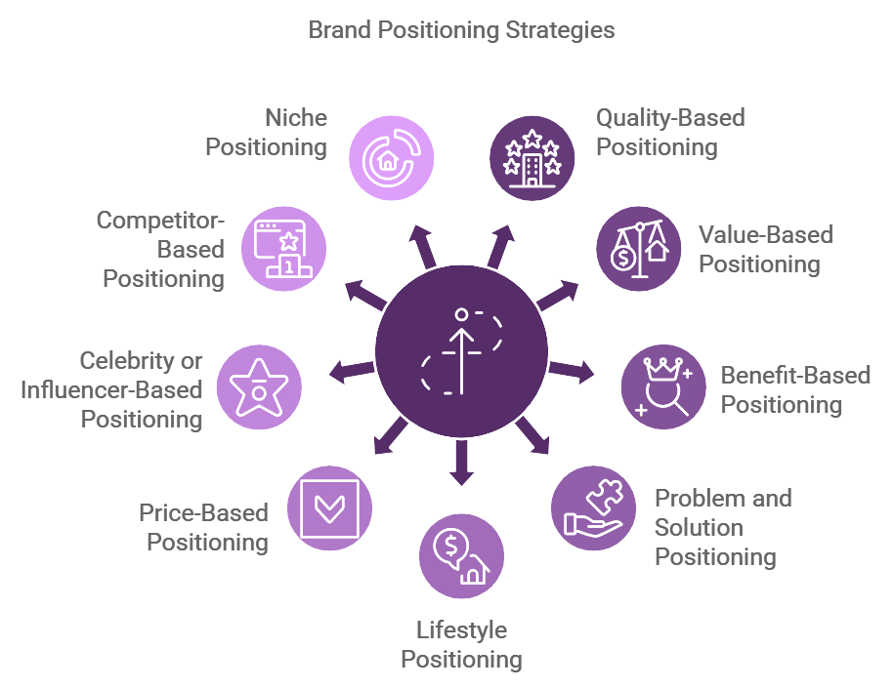
Figure 3: Brand Positioning Strategies (Sharma, 2024).

Positioning as a Basis for Differentiation
Another strategic importance of brand positioning is to create a strong competitive advantage. The functional attributes do not constitute a point of differentiation, making it difficult for the organizations to maintain a competitive advantage due to the high similarity of the products and services they offer. Positioning aids companies in distinguishing themselves through symbolic associations, emotional connections, and brand narratives. Proper positioning can reduce consumers' price sensitivity and foster long-term brand loyalty (Sharp, 2010). Organizations with services that are clearly distinguished and those where the advantages are obvious are in a better position to escape imitations and commoditization in the market (Trout & Rivkin, 2008). Positioning is therefore a fortification of strategy that cushions profitability and long-term market share.

Achieving Organizational Alignment
Brand positioning is addressed under internal organizational alignment. Defined positioning provides employees with a shared understanding of what the organization is and what it will do in the competitive environment. This transparency has an impact on corporate culture and quality of service, and it is based on the manner in which the organization makes decisions. Position statements are strategic policies that offer a new direction for activities and administrative decisions (de Chernatony, 2010). The departments will be able to communicate with one another through positioning, thereby facilitating the articulation of strategic goals (Simoes & Dibb, 2001). The alignment of internal processes with external positioning has resulted in a cohesive and natural brand experience for customers.

Adaptability of Strategic Positioning
It must be sufficiently rigid to maintain its position but loose enough to accommodate market changes. Technological change, evolving consumer needs, and competitive disruption continue to affect industries. Companies that view positioning as a strategic tool that evolves are better positioned to address new opportunities and threats (Morgan et al., 2019). Positioning is long-term and helps ensure that businesses do not lose their relevance at the expense of long-term brand equity (Esch et al., 2009). Positioning, by contrast, is part of strategy, never transient but revitalizing.

Positioning and Competitive Advantage

Linking Positioning to Competitive Advantage
Brand positioning is essential for establishing an organization's competitive strength in modern markets. When an organization is in a position to provide high value to customers in a manner that can be easily duplicated, it has a competitive advantage. The positioning helps in this by establishing a mental association that influences consumers' choice among alternatives. Organizations can develop positioning strategies that differentiate them and create a unique presence. The ability to take a noble and meaningful role will enable organizations to be more influential in shaping customer preferences and loyalty. Good positioning is, therefore, a useful strategic instrument for developing sustainable advantage (Porter, 1985). Without a clear position, companies cannot articulate their value and are susceptible to competitive duplication.

Positioning as a Source of Perceived Value
Customer perceptions have become more significant determinants of competitive advantage than mere product features. One of the most famous elements of technological and quality gaps of competitors in a variety of industries is that the gaps are smaller, but the psychological division is more prominent. Positioning helps companies shape customers' perceptions and comparisons of competing products. A well-positioned brand will reduce confusion during purchase decisions and strengthen emotional connections among consumer groups. Less price-sensitive consumers are those who perceive a brand as highly suitable and aligned with their needs and values. Strategic positioning thus introduces mundane products and services into great value propositions (Keller, 2013). Such a perception-based source of competitive advantage becomes a strong defensive mechanism against competition.

Differentiation and Strategic Focus
One contributor to competitive advantage is positioning, which helps companies achieve focused differentiation. Organizations that aim to win all market segments often lose their identity and become weak in terms of strategy. On the other hand, positioning would encourage companies to target particular segments and add value in a personalized manner. A hydrated role controls the product development, quality of service, and communication. This is a narrow-based strategy that helps companies be more resourceful and avoid direct competition with stronger competitors. Strategic focus that is created through positioning makes the organization more efficient and effective in the market. Specialization in a competitive space enhances companies' competitiveness (Hooley et al., 2017). Positioning is thus one of the strategic specialization tools.

Long-Term Sustainability through Positioning
The final contribution of brand positioning to competitive advantage concerns long-term sustainability. Competitive environments are changing, and the advantage in terms of technology or price might be quite seasonal. Positioning is better, however, when developing strong, coherent, long-term relationships with consumers in which a coherent brand meaning is established. High positioning fosters trust, credibility, and loyalty that endure even amid changing market conditions. Organizations that have retained their positions over time possess reputational capital that competitors have found difficult to erode. Coherence in positioning is necessary, as it would strengthen the organization and enable it to maintain consistent financial performance. This means that long-run profits will be achieved when positioning is treated as a long-term strategic process rather than a short-term marketing activity (Aaker, 1996). These views underscore the importance of positioning for long-term competitive success.

Managerial & Policy Implications

Strategic Alignment for Managers
Managers should regard brand positioning as a strategic consideration rather than a marketing activity. Positioning decisions made by top managers should be based on the corporate vision, corporate capabilities, and long-term business objectives. The positioning strategies not only affect external communication but internal decisions regarding product development, service design, and resource prioritization. Successful administrators recognize that positioning provides a strategic focus for organizing activities (Wilson & Gilligan, 2005). As part of business planning, positioning helps companies develop more nuanced competitive identities and business models and become more focused (McDonald & Wilson, 2016). The lack of such integration would render positioning activities random and would not affect any significant change.

Organizational Implementation and Governance
The positioning strategies should be implemented using effective cross-functional coordination and internal governance. Managers must inform all departments and ensure alignment in achieving the planned brand position. The promised brand experience should correspond to human resources, operations, and customer service. It should be used in positioning to recruit, train, and assess performance, and it should result in homogeneous organizational behavior (Homburg, Klarmann, & Schmitt, 2010). Additionally, internal communications must support the positioning message, as staff serve as important brand ambassadors (Ind, Iglesias, & Schultz, 2013). Once the principles of positioning are integrated into organizational activities, companies can provide more credible and reliable value to their customers.

Policy Formulation and Strategic Control
At the policy level, the organization is advised to establish formal structures that enable and support long-term brand positioning. The target market positioning should be aligned with the business policies, including pricing, innovation and customer relationship management. Managers would be required to develop performance measures to assess the attainment of the positioning objectives. Strategic control tools may help companies assess the efficiency of positioning activities and changes (Varadararayan, 2010). Moreover, it is suggested that organizations establish policies to safeguard their brands in both the online space and foreign markets (Chaffey & Ellis-Chadwick, 2019). The reason is that governance structures are open, and thus they generate similar corporate stances toward diversification and growth.

Adaptation to Dynamic Markets
Notably, positioning requires managers and policymakers to adapt to the new environment frequently. Some factors that have led market expectations to diverge from consumer needs include consumer preferences, technological advancements, and competition. Enterprises are advised to reconsider their positioning strategies to avoid losing their way in the process. The concept of strategy agility enables companies to reduce their value propositions without losing brand equity over the long term. Market research and customer responses should inform policy changes and shifts in position (Wedel & Kannan, 2016). Positioning may be considered a dynamic strategic process; thus, treating it as dynamic enables managers to respond dynamically to disruptions and to secure a competitive edge in highly dynamic business environments.

Conclusion
Brand positioning is one of the most strategic tools, with far greater utility than marketing communication. In contemporary competitive environments, positioning is used to help organizations define their identity by differentiating their products and retaining customer interest. This study has demonstrated that effective positioning is an internal organizational process rather than a promotional strategy. Positioning, in conjunction with corporate strategy, provides solid direction for decision-making, resource allocation, and long-term strategy.
Good positioning will help a business reach its target market and a niche within a competitive market. Similar organizations are those that, although they are positioned differently, do not differ in the core of their capabilities or strategic objectives, and are more effective at keeping their promises and fulfilling them. This type of affiliation promotes the brand and helps ensure long-term customer loyalty. Moreover, positioning helps companies adjust to fluctuating market conditions by providing a guideline to which to return.
It should ensure positioning at both the managerial and policy levels. Managers should learn about organizational structures, processes, and cultures to articulate the preferred brand position. Positioning strategy must be continually revised to remain current in a dynamic environment. Finally, positioning is an important competitive advantage that has played a vital role in shaping organizational behaviour and stakeholder attitudes and may facilitate the sustainability of business performance in the long term.

Reference List
Aaker, D. A. (1996). Building Strong Brands. New York: Free Press.
Barney, J. (1991). Firm resources and sustained competitive advantage. Journal of Management, 17(1), 99–120. https://doi.org/10.1177/014920639101700108
Beverland, M. B., Napoli, J., & Farrelly, F. (2010). Can all brands innovate in the same way? A typology of brand position and innovation effort. Journal of Product Innovation Management, 27(1), 33–48. https://doi.org/10.1111/j.1540-5885.2009.00698.x
Blankson, C., & Kalafatis, S. P. (2007). Positioning strategies of international and multicultural-oriented service brands. Journal of Services Marketing, 21(6), 435–450. https://doi.org/10.1108/08876040710818921
Chaffey, D., & Ellis-Chadwick, F. (2019). Digital marketing: Strategy, implementation and practice (7th ed.). Pearson Education.
Chopra, S. (2025). Brand positioning: A strategic guide to help you stand out. FreshSparks. https://freshsparks.com/brand-positioning/ (accessed on: 06/02/2026).
Cravens, D. W., & Piercy, N. F. (2008). Strategic marketing (9th ed.). McGraw-Hill Education.
Day, G. S. (2011). Closing the marketing capabilities gap. Journal of Marketing, 75(4), 183–195. https://doi.org/10.1509/jmkg.75.4.183
de Chernatony, L. (2010). From brand vision to brand evaluation: The strategic process of growing and strengthening brands (3rd ed.). Routledge.
DesignerPeople. (2024). Brand positioning – Ultimate guide to captivate your audience in 2026. DesignerPeople Blog. https://www.designerpeople.com/blog/brand-positioning-strategy/ (accessed on: 06/02/2026).
Esch, F. R., Schmitt, B., Redler, J., & Langner, T. (2009). The brand anchoring effect: A judgment bias resulting from brand awareness and temporary accessibility. Psychology & Marketing, 26(4), 383–395. https://doi.org/10.1002/mar.20278
Fuchs, C., & Diamantopoulos, A. (2010). Evaluating the effectiveness of brand-positioning strategies from a consumer perspective. European Journal of Marketing, 44(11/12), 1763–1786. https://doi.org/10.1108/03090561011079873
Hatch, M. J., & Schultz, M. (2003). Bringing the corporation into corporate branding. European Journal of Marketing, 37(7/8), 1041–1064. https://doi.org/10.1108/03090560310477654
Homburg, C., Klarmann, M., & Schmitt, J. (2010). Brand awareness in business markets: When is it related to firm performance? International Journal of Research in Marketing, 27(3), 201–212. https://doi.org/10.1016/j.ijresmar.2010.03.004
Hooley, G., Piercy, N., Nicoulaud, B., & Rudd, J. (2017). Marketing strategy and competitive positioning. Pearson Education.
Ind, N., Iglesias, O., & Schultz, M. (2013). Building brands together: Emergence and outcomes of co-creation. California Management Review, 55(3), 5–26. https://doi.org/10.1525/cmr.2013.55.3.5
Kapferer, J. N. (2012). The new strategic brand management: Advanced insights and strategic thinking (5th ed.). Kogan Page.
Keller, K. L. (2013). Strategic brand management: Building, measuring, and managing brand equity (4th ed.). Pearson Education.
Kotler, P., & Keller, K. L. (2016). Marketing management (15th ed.). Pearson Education.
McDonald, M., & Wilson, H. (2016). Marketing plans: How to prepare them, how to profit from them (8th ed.). Wiley.
Morgan, N. A., Whitler, K. A., Feng, H., & Chari, S. (2019). Research in marketing strategy. Journal of the Academy of Marketing Science, 47(1), 4–29. https://doi.org/10.1007/s11747-018-0598-1
Porter, M. E. (1985). Competitive advantage: Creating and sustaining superior performance. Free Press.
Ries, A., & Trout, J. (1981). Positioning: The Battle for Your Mind. New York: McGraw-Hill.
Sharma, A. (2024). 9 types of positioning in marketing. Young Urban Project. https://www.youngurbanproject.com/types-of-positioning-in-marketing/ (accessed on: 06/02/2026).
Sharp, B. (2010). How brands grow: What marketers do not know. Oxford University Press.
Simões, C., & Dibb, S. (2001). Rethinking the brand concept: New brand orientation. Corporate Communications: An International Journal, 6(4), 217–224. https://doi.org/10.1108/13563280110409854
Srivastava, R. K., Shervani, T. A., & Fahey, L. (1998). Market-based assets and shareholder value: A framework for analysis. Journal of Marketing, 62(1), 2–18. https://doi.org/10.1177/002224299806200102
Trout, J., & Rivkin, S. (2008). Differentiate or die: Survival in our era of killer competition (2nd ed.). Wiley.
Urde, M., & Koch, C. (2014). Market and brand-oriented schools of positioning. Journal of Product & Brand Management, 23(7), 478–490. https://doi.org/10.1108/JPBM-11-2013-0445
Varadarajan, R. (2010). Strategic marketing and marketing strategy: Domain, definition, fundamental issues and foundational premises. Journal of the Academy of Marketing Science, 38(2), 119–140. https://link.springer.com/article/10.1007/s11747-009-0176-7
Wedel, M., & Kannan, P. K. (2016). Marketing analytics for data-rich environments. Journal of Marketing, 80(6), 97–121. https://doi.org/10.1509/jm.15.0413
Wilson, R. M. S., & Gilligan, C. (2005). Strategic marketing management: Planning, implementation and control (3rd ed.). Routledge.

