“Formulation and Evaluation of Polyherbal Tea Bag for the management of Diabetes Mellitus”

Ganesh Kolekar, Yasir Khonde, Rohini Kshirsagar, Shweta Lashkare, Manasi Sukumar
Guided by: - Sakshi P Dhutmal

- INTRODUCTION: -

1.1 DIABETES: -
Diabetes is a chronic metabolic condition where the body cannot properly regulate blood sugar (glucose) due to insufficient insulin production or insulin resistance, Symptoms include extreme thirst, frequent urination, fatigue, and blurry vision. It is managed with medication, diet, and lifestyle changes to prevent complications like heart disease.
Diabetes mellitus is a rapidly rising global metabolic disorder characterized by chronic hyperglycaemia, resulting from defects in insulin secretion, action, or both. Type 2 diabetes (T2DM) dominates, accounting for over 90% of cases, primarily driven by obesity, genetics, and sedentary lifestyles. It occurs when the pancreas does not produce enough insulin or when the body cannot effectively use the insulin it produces.
Effective management requires a combination of lifestyle modifications (diet/exercise), medication (insulin, metformin), and continuous blood glucose monitoring to prevent severe complications like nephropathy and cardiovascular disease. While there is no cure, diabetes can be managed. Uncontrolled diabetes can lead to severe health issues, including nerve damage (neuropathy), kidney failure (nephropathy), cardiovascular disease, blindness (retinopathy), and potential amputations.

- TYPES OF DIABETES: -

- Type 1 Diabetes: - An autoimmune condition where the immune system destroys pancreatic cells that produce insulin. It often starts in childhood/adolescence.
- Type 2 Diabetes: - The most common form, occurring when the body becomes resistant to insulin. It is highly linked to obesity, lifestyle, and genetics.
- Gestational Diabetes (GDM): - Diabetes diagnosed in the second or third trimester of pregnancy that was not clearly present before.
- Monogenic Diabetes: - Rare, inherited forms such as Maturity-Onset Diabetes of the Young (MODY) or neonatal.

1.2 HERBAL TEA: -

Herbal tea bags, are convenient, single-serving infusions made from dried fruits, flowers, herbs, roots, or spices rather than traditional tea leaves. They are typically caffeine-free, offering various health benefits such as aiding digestion, relaxation, and providing antioxidants.
Herbal tea, according to many, look like tea and is brewed as the same way as tea, but in reality, it is not considered a tea at all. This is due to the fact that they do not originate from the Camellia Sinensis bush, the plant from which all teas are made. Herbal teas are actually mixtures of several ingredients, and are more accurately known as Tisanes. Tisanes are made from combinations of dried leaves, seeds, grasses, nuts, barks, fruits, flowers, or other botanical elements that give them their taste and provide the benefits of herbal teas.
Unlike most other forms of tea, herbal teas do not contain caffeine. They also taste great and are easy to drink. Most herbal teas may consist of one main herbal ingredient or a blend of herbal ingredients, intended to bring about a specific purpose, such as relaxation, rejuvenation, relief from a specific condition, amongst other things.
It is also important to understand that there are a huge variety of herbal teas available in the market, each of which is designed to have a specific therapeutic or medicinal benefit. However, there are some general benefits that can be obtained from most herbal teas, and these are as follows:
- Achieving a more calm and relaxed state of mind.
- Supporting heart health.
- Aiding with stomach and digestive problems providing cleansing properties for the body.
- Promoting energy and wellness.
- Nourishing the nervous system.
- Strengthening the immune system.
- Providing antioxidants to the body.
1.3 TEA BAG: -

Tea is one of the most widely consumed beverages in the world, cherished for its flavours, aroma, and potential health benefits. Among the various ways to brew tea, the tea bag has become a symbol of convenience and simplicity, making it a staple in households, offices, and cafes worldwide. A tea bag is essentially a small, porous packet containing dried tea leaves or herbal blends that infuse into hot water, producing a flavourful drink within minutes.
Tea bags come in various types, sizes, and materials. Traditional tea bags are made of filter paper, often a combination of wood and vegetable fibres, which allows water to pass through while keeping the tea leaves contained. Modern alternatives include biodegradable options made from cornstarch-based materials or silk-like fabrics, which appeal to environmentally conscious consumers.
Tea bags can contain whole leaves, broken leaves, or fanning and dust - smaller fragments left over from tea processing. While whole leaf bags often provide a richer flavour, broken leaves or dust allow for quicker infusion, catering to those who prioritize convenience.
The preparation of tea using tea bags is straightforward. The bag is placed in a cup or teapot, hot water is poured over it, and the tea is allowed to steep for a few minutes. The steeping time and water temperature depend on the type of tea; for instance, black tea generally requires boiling water and 3-5 minutes of steeping, while green tea is best brewed at lower temperatures for 1-3 minutes to avoid bitterness. Once brewed, the tea bag is removed, and the beverage can be enjoyed plain or with additions such as milk, sugar, honey, or lemon.
Tea bags offer several advantages over loose-leaf tea. They are highly convenient, portable, and produce minimal mess. They also provide consistent flavour since the quantity of tea in each bag is standardized. Additionally, tea bags have enabled the creation of countless flavoured blends, including herbal, fruit-infused, and spiced teas, allowing consumers to explore diverse tastes with ease.

- Definition: - A tea bag is a small, porous packet made of paper, cloth, or other filter materials, containing dried tea leaves or herbal blends, designed to be steeped in hot water to brew a cup of tea quickly and conveniently.

- HOW IT WORKS: -

- Porous Material – Tea bags are made of filter paper, silk, or biodegradable materials with tiny holes. These allow water to pass through but keep the tea leaves contained.
- Steeping – When the tea bag is placed in hot water, the heat causes the water to extract soluble substances from the tea leaves, such as caffeine, tannins, essential oils, and Flavours.
- Diffusion – The water molecules carry these compounds out of the tea leaves and into the water, creating a flavourful beverage.
- Brewing Time – The longer the tea bag stays in the water (within recommended times), the stronger the tea will be. Over-steeping can make it bitter, especially for green or black tea.
- Removal – After steeping, the tea bag is removed, leaving the brewed tea ready to drink. The bag contains all the solid leaves, preventing them from floating in the cup.

- CORE PURPOSES FOR BREWING: -

- Convenience & Portion Control: - Each bag contains a pre-measured amount of tea (typically about 2 grams), ensuring consistent flavour and strength for every cup.
- Rapid Infusion: - Tea bags often contain "fanning" or "dust" (smaller tea particles), which have a larger surface area than whole leaves, allowing them to release flavour and caffeine much faster.
- Mess Reduction: - They eliminate the need to scrape soggy loose leaves from the bottom of a pot or cup, as the entire bag can be easily removed and disposed.
- Leaf Containment: - The porous material (usually filter paper, food-grade plastic, or silk) allows water to flow through while keeping the leaves contained.

- ADVANTAGES: -

- Convenience - Easy and quick to use; no need to measure loose tea.
- Portability - Lightweight and easy to carry anywhere.
- Consistent Flavour - Each bag contains a standard amount of tea for uniform taste.
- Minimal Cleanup - Leaves stay inside the bag, so no mess.
- Variety - Available in many Flavors, including herbal.
- Quick brewing - Smaller tea particles in bags infuse faster.
- Hygienic - Sealed bags protect tea from dust and contamination.
- Cost-effective - Usually cheaper and widely available than loose-leaf tea.

- LITERATURE SURVEY: -

- Suna Banakar, et.al (2025)
The developed herbal tea showed enhanced mineral content, antioxidants, and phytochemicals. The most acceptable formulation (T3) contained higher levels of potassium, calcium, iron, sodium, phenolics, flavonoids, and antioxidant capacity, supporting oxidative stress reduction, heart and neural health, and prevention of mineral deficiencies. The addition of herbs and spices with lemongrass improved both nutritional and sensory qualities. The tea can be safely stored for up to two months at ambient conditions using aluminium laminated bags and tin boxes.

- B Parimaladevi, et.al (2025)
Based on the above results, the plant extract Costus igenus Nak found to possess significant diuretics and hypolipidemic property. As this extract contains groups of phytoconstituents that may synergistically support the effectiveness of the therapeutic claim based on the literature.

- Wahyu Widowati, et.al (2024)
CTE enhances liver protein and antioxidant enzymes (CAT and SOD) while reducing inflammatory markers, liver enzymes, and oxidative stress in diabetic and dyslipidemic rats, indicating its potential as a treatment for diabetes mellitus.

- Manjula kola, el.al (2024)
Sensory evaluation showed that the formulation with high levels of turmeric, rosemary, basil, and nutmeg was least acceptable in aroma, colour, and astringency, while Product 199 was the most accepted, particularly for astringency.

- Ch. Nooka Raju, et.al (2024)
All five plants exhibited antioxidant activity compared to green tea, with varying effective concentrations. The polyherbal formulation (Aegle marmelos: Momordica charantia: Azadirachta indica in a 3:2:1 ratio) showed superior antioxidant activity, achieving 78% DPPH radical inhibition at 20 µg/ml, outperforming marketed green tea.

- Meysam Zarezadeh, et.al (2023)
Cinnamon shows potential as an add-on anti-diabetic treatment for improving glycemic control in T2D patients and women with PCOS, though further studies on dosage, bioactive compounds, and long-term effects are needed.

- Satyam Anand Singh, et.al (2023)
The study concluded that the prepared herbal tea is health-promoting, acceptable for consumption, and contains beneficial secondary metabolites. It showed good physical, chemical, stability, flow, and antimicrobial properties, indicating a stable and safe formulation.

- Shamim Neda, et.al (2023)
Growing awareness has increased the use of herbal preparations worldwide for disease management. Adhatoda vasica (Adusa) and Tinospora cordifolia (Giloy) contain antidiabetic compounds that help reduce blood glucose levels, and their incorporation into foods and herbal preparations enhances nutritional value while supporting diabetes management.

- Dr. Aamer Quazi, et.al (2023)
The present work is based on herbal formulation for treatment of PCOS including various drugs as formulated in above table 1, The herbal preparation was prepared and evaluated and finally packed in tea bags.

- Meysam Zarezadeh, et.al (2023)
Cinnamon can be used as an anti-diabetic agent and an add-on treatment to control some glycemic indices among T2D patients and women with PCOS. Future studies with focus on the different dosage of cinnamon supplementation, the bioactive ingredients of cinnamon preparations, and longer duration are needed to shedlight on these specific aspects and their potential role as effect modifiers.

- .Robiatun Rambe et, al. (2023)
The results of this study showed that the clove flower extract (Eugenia aromatica L.) obtained was 116.4 g and contained flavonoids, alkaloids, saponins and tannins. Clove flower extract (Eugenia aromatica L.) can be formulated into hand sanitizer gel preparations. The hand sanitizer gel preparation of clove flower extract (Eugenia aromatica L.) has a thick concentration and shows physical stability during storage. The preparation preferred by volunteers was F3 with a concentration of 15%.

- Hari Hariadi et, al (2023)
Based on the research results regarding the effect of three drying methods on the physicochemical properties of powdered butterfly pea flower extract (C. ternatea L.), it can be concluded.

- Philip F. Builders et, al(2023)
Three variants of herbal tea containing blends of H. sabdariffa, M. oleifera, Z. officinale and C. limon were developed. The different herbal tea blends showed differences in some physicochemical properties. Such remarkable differences were in some of the intrinsic properties such as organoleptic, pH, ash values and anti-oxidant properties as well as nonintrinsic properties such as flow, moisture content and particle size respectively.
- AIM AND OBJECTIVE: -

AIM: - “Formulation and Evaluation of Polyherbal Tea Bag for the management of Diabetes
Mellitus”

OBJECTIVES: -

- To offer consistent taste and quality in every cup.
- To save time compared to loose-leaf tea preparation.
- To enhance portability and storage convenience.
- To use biodegradable or recyclable materials to reduce environmental impact.
- To be easy to use, handle, and dispose of after brewing.
- To provide a convenient, natural, and cost-effective approach to control blood sugar levels.
- To reduce fasting and postprandial (after-meal) blood glucose levels.
- To improve the body’s sensitivity to insulin and stimulate insulin secretion, particularly in Type 2 diabetes.
- To reduce oxidative stress and inflammation, which are primary drivers of diabetes complications.

- PLAN OF WORK: -

- TIMELINE: -

Time duration | Work plan
1-10 days | Literature Review
11-15 days | Selection of Topic
16-30 days | Collection of Plant Samples
31-35 days | Authentication
36-51 days | Preformulation Study
52-67 days | Formulation of Polyherbal Tea bag
68-72 days | Evaluation Test
73-83 days | Compilation of data
84-90 days | Submission

- PLANT PROFILE: -

6.1 BUTTERFLY PEA FLOWER (Aparajita): -
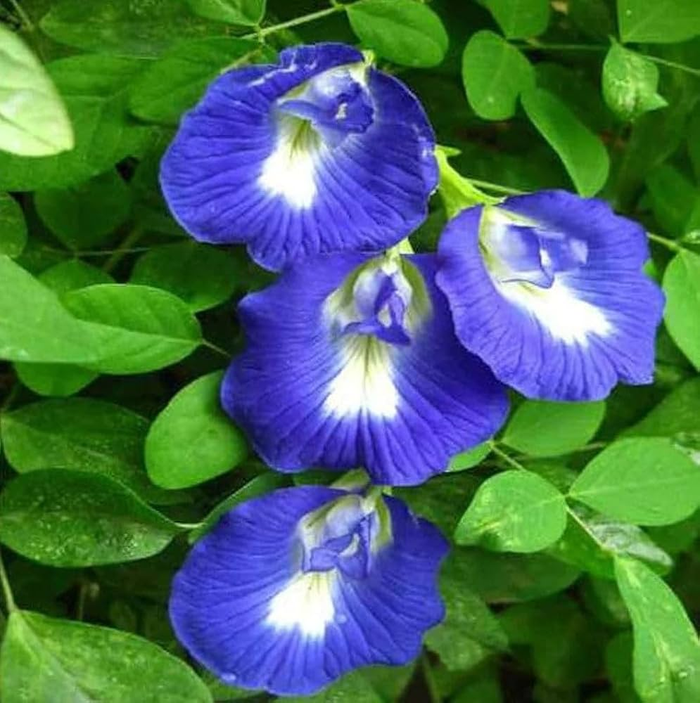
Img.6.1: - Butterfly pea flower

Scientific Name: Clitoria ternatea
Common Name: Butterfly Pea, Blue Pea, Aparajita.
Biological Source:
- Flowers and roots of Clitoria ternatea.
Family: Fabaceae (also called Leguminosae)
Chemical Constituents:
- Rich in Anthocyanins (specifically Ternatins, which give the blue colour).
- It also contains flavonoids like Quercetin and Kaempferol.
Uses:
- Used as a natural food colorant, memory enhancer (nootropic), and for its powerful antioxidant and anti-inflammatory properties.
- Improves Skin Health Naturally.
- Drinking butterfly pea flower tea every day helps control blood sugar levels and reduces the risk of complications caused by diabetes.

  - PERIWINKLE: -
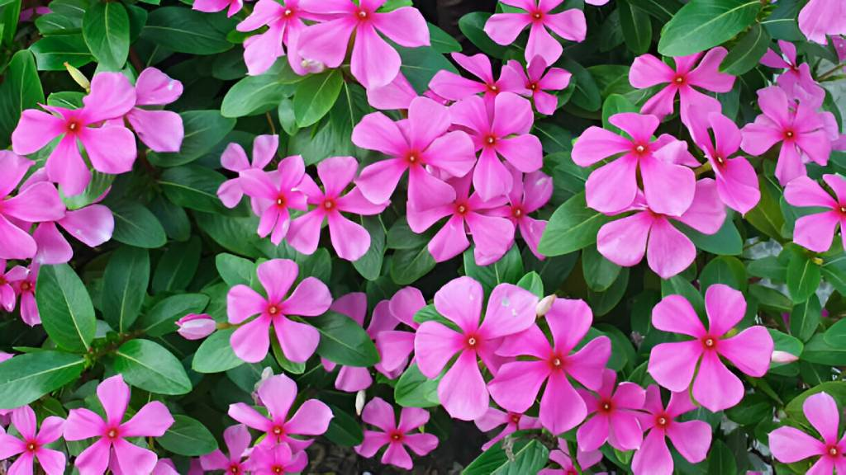
Img.6.2: - Periwinkle.

Scientific Name: Catharanthus roseus
Common Name: Madagascar Periwinkle, Sadabahar, Vinca.
Biological Source:
- Dried entire plant of Catharanthus roseus Linn.
Family: Apocynaceae.
Chemical Constituents:
- Contains over 90 alkaloids, most importantly the anti-cancer indole alkaloids Vinblastine and Vincristine. Other alkaloids include Ajmalicine, Serpentine, and Vindoline.
Uses:
- Used primarily as an anti-tumor/anti-cancer agent (especially for Hodgkin's disease and leukemia).
- It also has anti-diabetic properties in traditional medicine.
- Widely used in traditional medicine across India, South Africa, China, and Malaysia for the treatment of diabetes.
- Traditionally applied to treat sore throats, skin infections, diarrhea, and to help wounds heal.

  - CINNAMON (dalchini): -

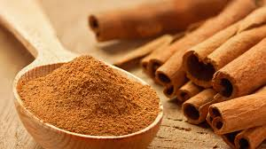
Img.6.3: - Cinnamon

Scientific Name: Cinnamomum zeylanicum or (C. verum)
Common Name: Cinnamon, Dalchini, Ceylon Cinnamon.
Biological Source:
- Dried inner bark of the shoots of Cinnamomum zeylanicum Nees.
Family: Lauraceae.
Chemical Constituents:
- The main constituent is Cinnamaldehyde (60–70%).
- It also contains Eugenol, Benzaldehyde, and tannins.
Uses:
- Used as a carminative, mild astringent, flavouring agent,
- It is also used as anti-diabetic (blood sugar lowering) effects.
- It also prevents heart diseases.
- It shows strong anti-oxidant properties and is used to treat inflammation such as arthritis.
- It is used in traditional medicine to enhance digestion.

  - MORINGA (Drumstick): -

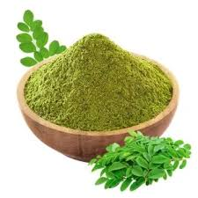
Img.6.4: - Moringa

Scientific Name: Moringa oleifera.
Common Name: Moringa, Drumstick Tree, Sahjan.
Biological Source:
- Fresh or dried leaves, seeds, and pods of Moringa oleifera.
Family: Moringaceae.
Chemical Constituents:
- High in vitamins (A, C, E) minerals (Calcium, Potassium) and polyphenols like Quercetin and Chlorogenic acid.
Uses:
- Used as a nutritional supplement, anti-inflammatory agent, and for treating malnutrition and high blood pressure.
- Lowering blood sugar, improving insulin sensitivity, and reducing inflammation.
- Its compounds may help improve how your body uses insulin.
- It helps with digestion, bloating and constipation.
- It is also helpful in brain health.
- It boosts immunity.

  - STEVIA: -

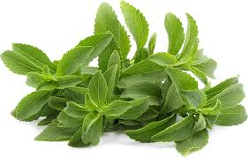
Img.6.5: - Stevia.

Scientific Name: Stevia rebaudiana
Common Name: Stevia, Honey Leaf, Sweet Leaf.
Biological Source:
- Dried leaves of Stevia rebaudiana Bertoni.
Family: Asteraceae.
Chemical Constituents:
- Contains Steviol glycosides (mainly Stevioside and Rebaudioside A), which are up to 300 times sweeter than sugar.
Uses:
- Used as a non-caloric sweetener for diabetic patients and as a sugar substitute in the food industry.
- It is used for anti-inflammatory purposes, including managing skin conditions like eczema.
- It supports improved digestion.
- Helps manage blood sugar and boosts insulin production.
- Due to its antioxidant properties, it is used to combat signs of aging (fine lines) and treat acne.

- MATERIALS AND APPARATUS: -

- MATERIALS: -

Sr.no | Ingredients | Botanical name | Part used | Role
1 | Butterfly pea flower | Clitoria ternatea | Flower | Anti-oxidant, Colour, Health tonic
2 | Periwinkle | Catharanthus roseus | Leaf | Antidiabetic, Medicinal
3 | Cinnamon | Cinnamomum verum | Bark | Flavour, Digestive, Preservative
4 | Moringa | Moringa oleifera | Leaf | Nutritional supplement
5 | Stevia | Stevia rebaudiana | Leaf | Natural sweetener

- APPARATUS: -

- Tea bags (same brand and type)
- Beakers and transparent cups
- Thermometer
- Weighing balance
- Funnel
- Stopwatch
- Measuring cylinder
- pH meter
- Sieve (18#, 22#, 24#, 44#)

- PREFORMULATION STUDY: -

- Bulk density: -
Bulk Density is the ratio between the given mass of a powder and its bulk volume. Required amount of the powder is dried and filled in a 50 ml measuring cylinder up to 50 ml mark. Then the cylinder is dropped onto a hard wood surface from a height of 1 inch at 2 second intervals. The volume of the powder is measured. Then the powder is weighed. This is repeated to get average values. The Bulk Density is calculated by using the below given formula. Bulk density of formulation should not be more than 0.5 gm/cc.
$Bulk Density =\frac{Mass}{Volume}$

- Tapped density: -
Tapped density is an increased bulk density attained after mechanically tapping a container containing the powder sample. After observing the initial powder volume or mass, the measuring cylinder or vessel is mechanically tapped for 1 min and volume or mass readings are taken until little further volume or mass change was observed. It was expressed in grams per cubic centimetre. Tapped density of formulation should not be more than 0.5 gm/cc.
$Tapped density =\frac{Mass}{Tapped volume}$

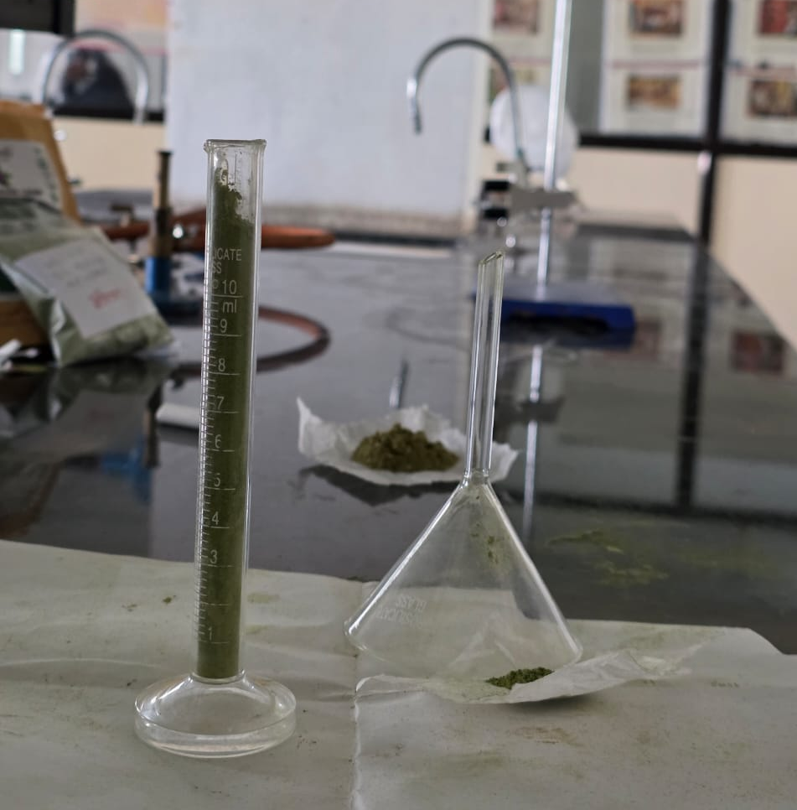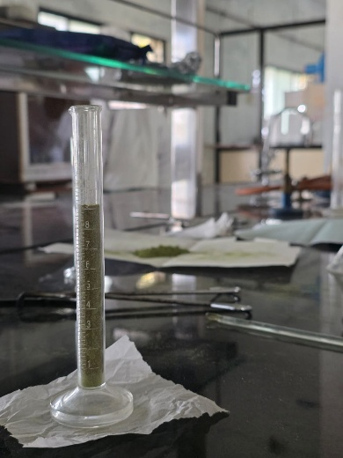
Img.8.1: - Bulk density. Img.8.2: - Tapped density.

- Carr's Index: -
Carr's Index is a pharmaceutical and industrial measure of powder compressibility and flowability, calculated as 100.
$$Carr's Index=\frac{Tapped Density - Bulk Density}{Tapped Density}×100$$

- Hausner's ratio: -
The major function of the Hausner’s ratio is to check the powder’s flow ability since it is the primary phenomenon of flow property. if the Hausner ratio is falling the powder has great properties if it is increasing, the powder`s flow ability decreases. It`s also reported that the flow is good.
$${Hausner}^{'}s ratio =\frac{Tapped Density}{Bulk Density}$$

- Angle of repose: -
This is the largest angle that can exist between the powder pile`s surface and the horizontal flow. This is the most crucial approach since it provides the precise result of whether your powder flows well or poorly. This approach mostly depends on the powder`s angle, as the pile`s angle grows, the flow properly decreases. The following formula is provided to determine the angle of repose.
$Angle of repose = \tan^{-1}{\frac{H}{R}}$
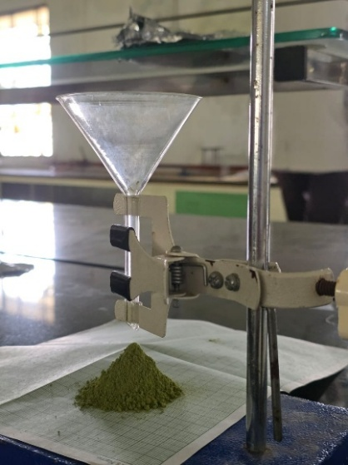
Img.8.3: - Angle of repose.
- Solubility: -
Solubility is the maximum amount of a solute that can dissolve in a given amount of solvent at a specific temperature and pressure to form a saturated solution. It is a physical property that indicates a substance's ability to dissolve, and it depends on the type of solute and solvent, the temperature, and the pressure.
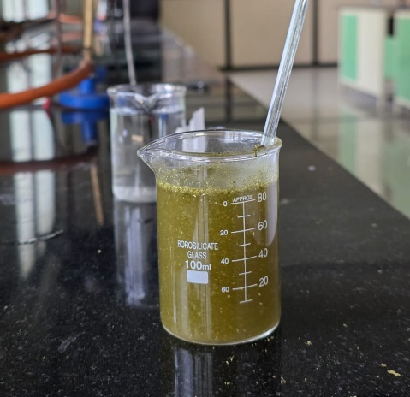
Img.8.4: - Solubility.

- Ash value: -
Ash value or ash content, is the inorganic residue remaining after a substance is incinerated. It serves as a measure of the total mineral content and inorganic impurities in a material and is used as a key quality control parameter to assess the purity, authenticity, and quality of raw materials and finished products, especially in herbal medicines and pharmaceuticals.

$$Ash Content \left(\%\right)=\frac{Weight of Ash Residue}{Weight of Original Sample}×100$$

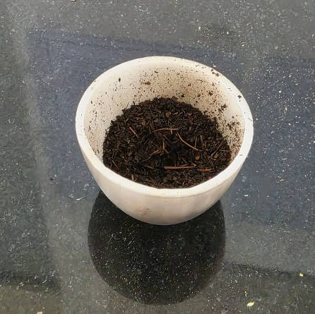
Img.8.5: - Ash Value.

Sr. No. | Drug | Butterfly pea flower powder
Sr. No. | Sieve no. # | 22 # | 24 # | 44 #
1 | Bulk Density | 0.18g/ml | 0.16g/ml | 0.23g/ml
2 | Tapped Density | 0.20g/ml | 0.21g/ml | 0.31g/ml
3 | Carr’s Index | 10% | 23% | 25%
4 | Hausner’s Ratio | 1.11 | 1.31 | 1.34
5 | Angle Of Repose | 34° | 45° | 40°9`
6 | % Ash Value | 12%

TABLE. 8.1: BUTTERFLY PEA FLOWER POWDER

Sr. No. | Drug | Moringa leaves powder
Sr. No. | Sieve no. # | 22 # | 24 # | 44#
1 | Bulk Density | 0.20g/ml | 0.21g/ml | 0.25g/ml
2 | Tapped Density | 0.21g/ml | 0.23g/ml | 0.29g/ml
3 | Carr’s Index | 4% | 8.69% | 13%
4 | Hausner’s Ratio | 1.05 | 1.09 | 1.16
5 | Angle Of Repose | 40°7` | 38°6` | 36°8`
6 | % Ash Value | 7%

TABLE. 8.2: MORINGA LEAVES POWDER

Sr. No. | Drug | Sadabahar leaves powder
Sr. No. | Sieve no. # | 22 # | 24 # | 44#
1 | Bulk Density | 0.27g/ml | 0.26g/ml | 0.29g/ml
2 | Tapped Density | 0.28g/ml | 0.28g/ml | 0.33g/ml
3 | Carr’s Index | 3% | 7% | 12%
4 | Hausner’s Ratio | 1.03 | 1.07 | 1.13
5 | Angle Of Repose | 33°1` | 35°2` | 32°
6 | % Ash Value | 8%

TABLE.8.3: SADABAHAR LEAVES POWDER.

Sr. No. | Drug | Stevia leaves powder
Sr. No. | Sieve no. # | 22 # | 24 # | 44#
1 | Bulk Density | 0.23g/ml | 0.19g/ml | 0.25g/ml
2 | Tapped Density | 0.25g/ml | 0.21g/ml | 0.29g/ml
3 | Carr’s Index | 8% | 9% | 13%
4 | Hausner’s Ratio | 1.08 | 1.10 | 1.16
5 | Angle Of Repose | 37°5` | 31°5` | 30°2`
6 | % Ash Value | 10%

TABLE.8.4: STEVIA LEAVES POWDER

Sr. No. | Ingredients | Solubility
1 | Butterfly pea flower powder | Partially Soluble
2 | Moringa Leaves powder | Partially Soluble
3 | Sadabahar leaves Powder | Partially soluble
4 | Stevia Leaves powder | Partially Soluble
TABLE.8.5: SOLUBILITY.

  - PHARMACOGNOSTIC STUDY: -

Sr. No. | Test | Observation | Inference
1 | 5 ml of extract + few drops of 1% lead acetate were added. | A yellow precipitate was formed. | Presence of Tannin.
2 | To 1 ml of the extract, few drops of dilute sodium hydroxide were added. | An intense yellow colour was produced in plant extract becomes colourless on addition of dilute acid. | It Indicates  Flavonoids.

TABLE.8.6: CHEMICAL TEST OF BUTTERFLY PEA FLOWER POWDER.

Sr. No. | Test | Observation | Inference
1 | Few drops of Mayer’s reagent was added to 1ml of plant extract. | A deep yellow or white precipitate was formed. | Presence of Alkaloids.
2 | Equal amount of Fehling A and Fehling B reagents were mixed together and then 2ml of crude extract was added and gently boiled. | A brick red precipitate appeared at the bottom of the test-tube. | It indicates presence of Glycosides.

TABLE.8.7: CHEMICAL TEST OF MORINGA LEAVES POWDER.

Sr. No. | Test | Observation | Inference
1 | To 1 mL of extract added 1 mL of Mayers reagent and few drops of Iodine solution. | Formation of yellow colour precipitate. | Alkaloids are present.
2 | To 1 mL of crude extract added 1 mL of FeCl_{3.} | A blue green or black colour was formed. | Phenol and Tannin are present.

TABLE 8.8: CHEMICAL TEST OF SADABAHAR LEAVES POWDER.

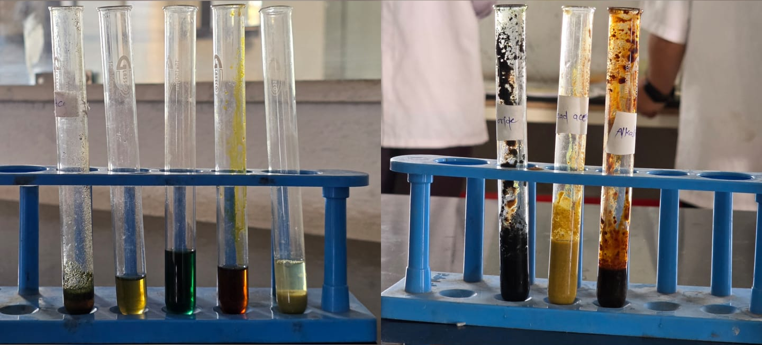
Img.8.1: - Phytochemical screening.

- FORMULATION: -

  - FORMULATION BATCH: -
Ingredients | Batch
Ingredients | F1 | F2 | F3 | F4
Butterfly Pea flower | 0.20gm | 0.14gm | 0.28gm | 0.25gm
Moringa | 0.44gm | 0.63gm | 0.28gm | 0.40gm
Sadabahar | 0.39gm | 0.35gm | 0.42gm | 0.28gm
Stevia | 0.22gm | 0.15gm | 0.16gm | 0.21gm
Cinnamon | 0.13gm | 0.13gm | 0.26gm | 0.26gm
Total  (gm) | 1.40gm | 1.40gm | 1.40gm | 1.40gm

‘

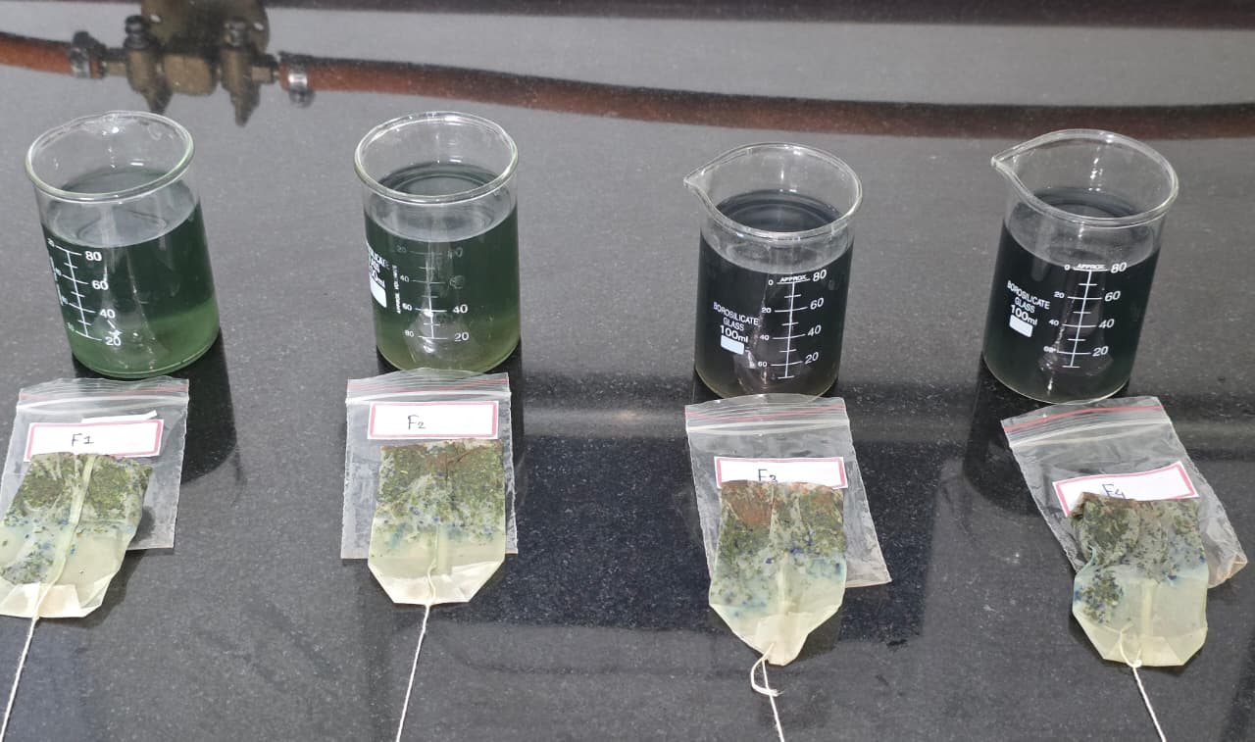
Img.9.1: - Formulation batches.

  - FORMULATION TABLE: -

Sr. No. | Ingredients | Quantity | Role
1 | Butterfly pea flower | 0.20 gm | Anti-oxidant
2 | Moringa | 0.44 gm | Nutritional supplement
3 | Sadabahar | 0.39 gm | Anti-diabetic
4 | Stevia | 0.22 gm | Natural sweetener
5 | Cinnamon | 0.13 gm | Preservative

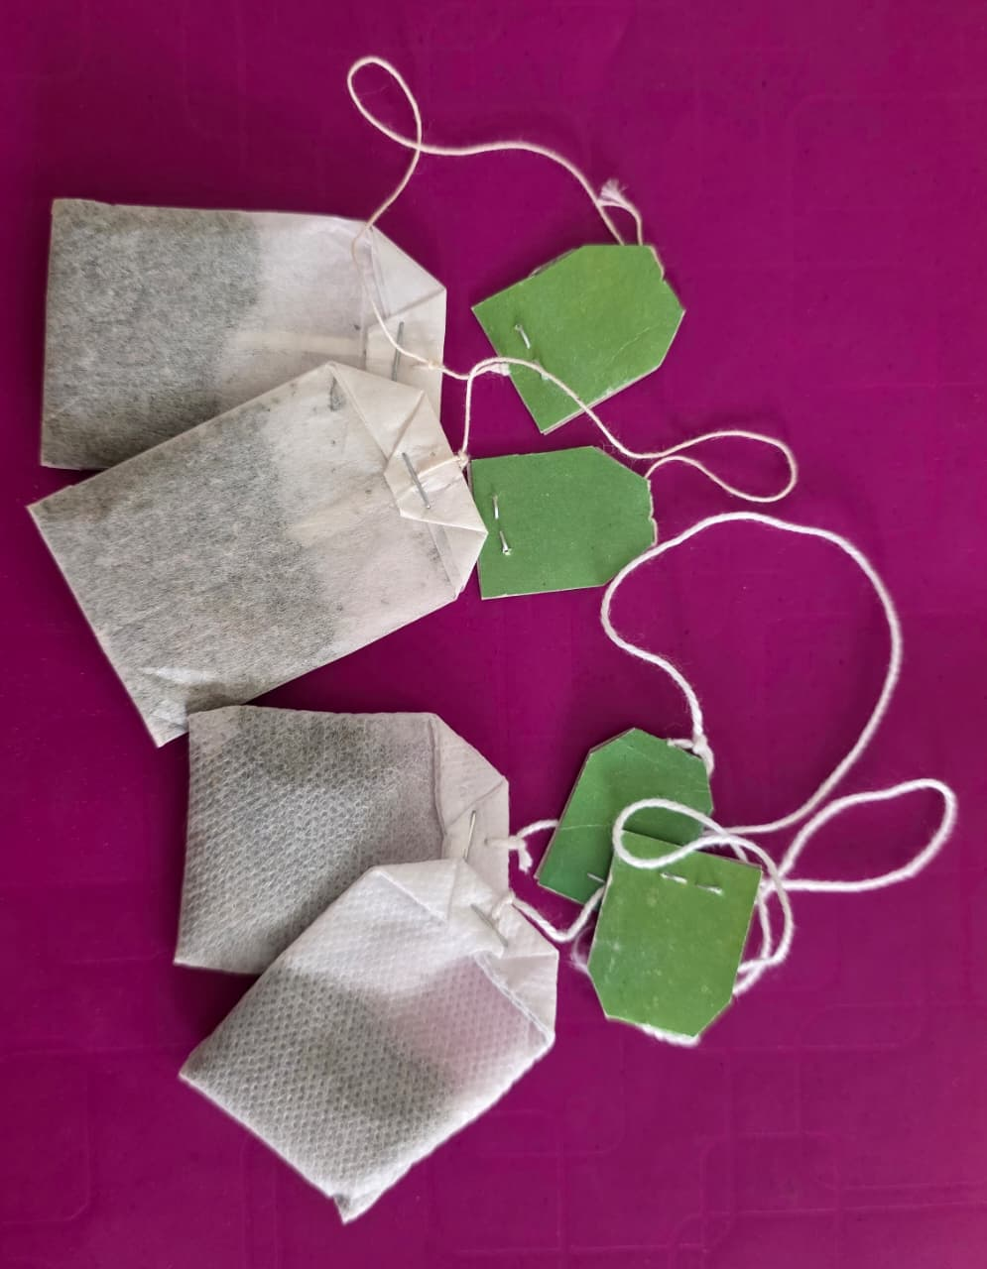
Img.9.2: - Polyherbal tea bag.

- METHOD OF PREPARATION: -

1. Collection of Raw materials: - Raw materials such as Butterfly pea flower, Moringa leaves, Sadabahar leaves, Stevia and Cinnamon were collected from nearby plants and reliable supplier or local markets. Ensured that materials are fresh, free from contamination, and organically sourced.
2. Processing of Raw materials: - Wash leaves and flowers with distilled water to remove dirt and unwanted bacteria.
- Drying: Dry these leaves and flowers in sunlight or shaded dry place
- Grinding: Roughly triturate these materials in Morter pestle.
- Sieving: Pass these roughly grinded powders through the 3-4 sieve size (18#, 22#, 24#, 44#) to get uniform particle size.
3. Preformulation Study: - Calculate Bulk density. Tapped density, Carr’s index, Hausner’s ratio, Angle of repose, Ash value and Solubility of powder of Butterfly pea flower, Sadabhar leaves, Moringa leaves and Stevia to check flow property, packaging ability and settlement of particles.
- Identification Test: - Perform qualitative tests for flavonoids, tannins, alkaloids etc to confirm therapeutic compounds in sample.
4. Formulation: - Weigh accurate amount of ingredients as given in above table. Mix these ingredients uniformly.
5. Evaluation Test: - Perform test to identify pH (target 5.5-7.4), texture, solubility, odour, taste, colour and consistency.
- Stability Testing: - Store samples under varying conditions (room temperature) for 1–3 months to check for changes in colour, odour, or microbial growth.
- Microbial Testing: - Ensure absence of harmful microbes using standard protocols.
6. Optimization: - Adjust ingredient proportions or additives based on test results to improve efficacy, texture, or stability.
7. Packaging: - Fill these ingredients in filter paper bag and enclose it with string to deep easily without mess. Later pack it in closed air tight pouch to avoid contamination.
8. Storage: - Store this polyherbal tea bag in a cool and dry place.

- EVALUATION PARAMETERS: -

- Physical appearance: -
The physical appearance of polyherbal tea powder was inspected visually. Organoleptic properties such as Colour, Odour, Taste, Texture etc. are also determined. These results are recorded and shown in below table.

- Texture: -
Herbal tea powder typically has a fine to medium-coarse, dry, and powdery texture, often resembling a mixture of dust and microscopic botanical fragments. It often features a mix of textures from blended flowers, leaves, or roots, producing a powdery feel that can clump slightly if not stored properly, similar to dried spices or matcha.

- Solubility: -
Herbal tea powder solubility refers to the amount of powder that dissolves in water to create an infusion, with higher solubility indicating better extraction of flavor and compounds. It is commonly enhanced using finer powder, hot water, or vacuum freeze- drying techniques. Improved powder formulations often show increased Water Solubility Indices and better reconstitution.

- pH: -
Herbal tea powders (like chamomile, mint, and fennel) generally have a mildly acidic to neutral pH, typically ranging between 6.0 and 7.0. While some herbal formulations can range from 5.4 to over 10 depending on the ingredients, most brewed herbal teas are much closer to neutral compared to fruity or black teas, making them gentle on the stomach.

- Wettability Test: -
- Preparation of tea bags: Obtain a set of identical tea bags with the materials want to compare.
- Weight of each bags: Accurately weigh each tea bag to ensure consistent starting mass.
- Immersion in water: Place each tea bag in a container filled with a known volume of water at room temperature.
- Time recording: Start a timer as soon as the tea bag touches the water and note the time when the tea bag appears fully saturated and releases its contents visibly.
- Repeating the test: Repeat the test with multiple tea bags for each sample to ensure reliable results. The time taken for wetting the herbal tea bag in 2-3minutes.

- Bag Material: -
- Common materials: filter paper, non-woven fabric, silk/mesh, or biodegradable Fibers, should be porous, heat-resistant, and food-safe.

- Dimensions / Size of Tea Bag: -
- Common shapes: rectangular, square, round, pyramid.
- Size affects space for expansion and infusion efficiency.

- RESULT: -

Sr. No. | Evaluation Parameters | Standard Limit | Result
1 | Description | Coarse polyherbal powder | Coarse polyherbal powder in heat seat filter paper
2 | Colour | Greenish brown powder | Greenish brown powder
3 | Odour | Characteristic aroma of cinnamon/moringa | Aromatic, Warm with subtle earthy
4 | Texture | Granular, gritty and rough | Gritty and free flowing granules
5 | Taste | Bitter-sweet with pungent undertone | Sweet with slightly bitter
6 | State | Dry and solid | Dry and free flowing solid
7 | pH | 5.1 – 7.4 | 6.1
8 | Wettability Test | 2 – 3 minutes | 1 – 1.5 minutes
9 | Dimensions | 6×4 | 5.3×3.8

- AUTHENTICATION OF INGRIDENTS: -

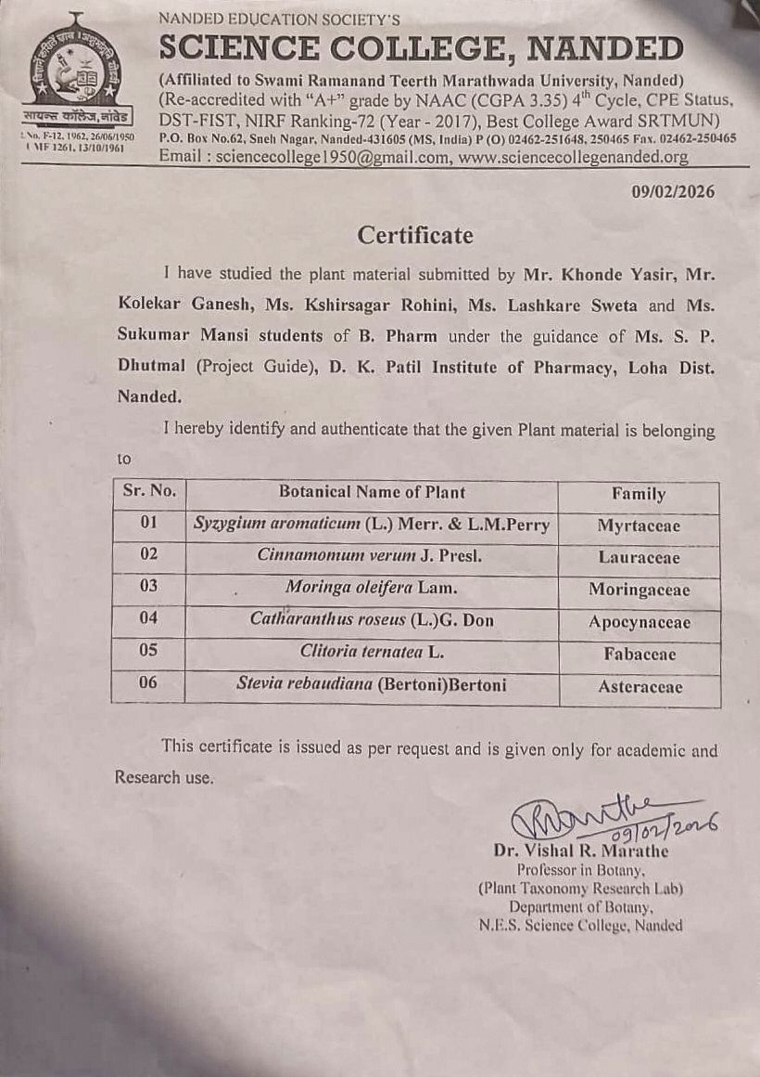
- CONCLUSION: -

The present study was successfully undertaken to design, formulate, and evaluate a polyherbal tea bag (1.40g) specifically targeted for the management of Diabetes Mellitus. By blending Sadabahar (Vinca rosea), Moringa (Moringa oleifera), Butterfly Pea (Clitoria ternatea), Cinnamon (Cinnamomum verum), and Stevia (Stevia rebaudiana), a synergistic formulation was achieved that bridges traditional Ayurvedic wisdom with modern pharmaceutical standards. All four experimental batches (Batch 1 to 4) were evaluated against the stringent quality control parameters of the Indian Pharmacopoeia (IP). The average weight of 1.40g per bag was maintained. The therapeutic efficacy of the tea bags was validated through Water-Soluble Extractive values, which ranged between 25% and 35%. This high extraction rate ensures that a significant portion of the active antidiabetic principles (such as Vincamine and Cinnamaldehyde) is released into the infusion within a standard 1- 1.5 minutes brewing time. The chemical stability of the infusion was confirmed by a pH value of 6.1, which is slightly acidic-ideal for maintaining the stability of the anthocyanins in Butterfly Pea and ensuring the solubility of the bitter alkaloids. A critical hurdle in herbal antidiabetic formulations is the inherent bitterness of herbs like Sadabahar. This study successfully masked these notes by incorporating Stevia (a natural non-caloric sweetener) and Cinnamon (an aromatic flavour enhancer). Organoleptic evaluation revealed a Sweet with slightly bitter taste, a pleasant Aromatic, Warm with subtle earthy aroma, and a bluish green colour (from the Butterfly Pea), which significantly enhances patient compliance-a vital factor in the long-term management of chronic conditions like Diabetes Mellitus.
In conclusion, the developed 1.40g polyherbal tea bags are pharmaceutically stable, chemically standardized, and sensory- optimized. They offer a safe, non-invasive, and cost-effective adjuvant therapy for Type 2 Diabetes Mellitus. The study confirms that these formulations meet all necessary regulatory benchmarks for herbal dosage forms and are ready for further long-term stability testing and clinical correlation.

- REFERENCE: -

- Poswal FS, Russell G, Mackonochie M, MacLennan E, Adukwu EC, Rolfe V. Herbal teas and their health benefits: A scoping review. Plant Foods Hum Nutr 2019;74:266-76.
- Sagona WC, Chirwa PW, Sajidu SM. The miracle mix of Moringa: Status of Moringa research and development in Malawi. S Afr J Bot 2020;129:138-45.
- Abd Rani NZ, Husain K, Kumolosasi E. Moringa genus: A review of phytochemistry and pharmacology. Front Pharmacol 2018;9:108.
- Boukandoul S, Casal S, Zaidi F. The potential of some Moringa species for seed oil production. Agriculture 2018;8:150.
- McKay DL, Blumberg JB. The role of tea in human health: An update. J Am Coll Nutr 2002;21:1-13.
- Kamboj VP. Herb and Herbal medicine [Article]. [Herbal tea and its benifits]. 2000.78:35-36.
- Pal SK, Shukla Y. Herbal Medicine: Current Status and the Future [Chapter/Article]. 2003.4.281-288.
- Shanbhag TV, Shenoy S. Pharmacology for medical graduates. 5th ed. New Delhi, India: Jaypee Brothers Medical Publishers; c2019.
- Stancu C, Sima A. Statins: mechanism of action and effects [Article]. 2001.5.378.
- Stael B, Dallongeville J, Auwerx J, Schoonjans K, Leitersdorf E, Fruchart JC, et al. Mechanism of Action of Fibrates on Lipid and Lipoprotein Metabolism. Circ Res. 1998 Oct 26;83(8):883-890.
- Management A, Primary OF, Due I, Polycystic TO, Dei LP. International Journal of Ayurveda Ayurvedic Management of Primary Infertility Due To Polycystic Ovarian Syndrome Associated with Multiple Uterine Fibroids. A Case Report. 2018;6(1):19–25.
- Nestler JE. Metformin for the Treatment of the Polycystic Ovary Syndrome. 2008;47–54.
- Treatment N, Kabel AM. Journal of Pharmacological Reports Polycystic Ovarian Syndrome. Insights into Pathogenesis, Diagnosis, 2016;1(1):1–5.
- Review P. Anti-androgenic effect of Symplocosracemosa Rox. Against letrozole induced polycystic ovary using rat model. J Coast Life Med. 2013;1(4):309–14.
- Bharathi RV, Swetha S, Neerajaa J, Madhavica JV, Moorthy D, Rekha SN, et al. An epidemiological survey. Effect of predisposing factors for PCOS in Indian urban and rural population. Middle East FertilSoc J. 2017;7–10.
- Poswal FS, Russell G, Mackonochie M, MacLennan E, Adukwu EC, Rolfe V. Herbal teas and their health benefits: A scoping review. Plant Foods Hum Nutr 2019;74:266-76.
- Sagona WC, Chirwa PW, Sajidu SM. The miracle mix of Moringa: Status of Moringa research and development in Malawi. S Afr J Bot 2020;129:138-45.
- Abd Rani NZ, Husain K, Kumolosasi E. Moringa genus: A review of phytochemistry and pharmacology. Front Pharmacol 2018;9:108.
- Boukandoul S, Casal S, Zaidi F. The potential of some Moringa species for seed oil production. Agriculture 2018;8:150.
- McKay DL, Blumberg JB. The role of tea in human health: An update. J Am Coll Nutr 2002;21:1-13.
- Byeon JO, Han JS. A study on perception and actual status of utilization for green tea. Korean J Food Cult 2004;19:184-92.
- Cohen PA, Ernst E. Safety of herbal supplements: A guide for cardiologists. Cardiovasc Ther 2010;28:246-53.
- Ravikumar C. Review on herbal teas. J Pharm Sci Res 2014;6:236
- Leone A, Spada A, Battezzati A, Schiraldi A, Aristil J, Bertoli S. Moringa oleifera seeds and oil: Characteristics and uses for human health. Int J Mol Sci 2016;17:2141.
- Kokate CK, Purohit AP, Gokhale DS. Pharmacognosy. Pune: Nirali Prakashan; 2008.
- Rathaur P, Raja W, Ramteke PW, John SA. Turmeric: The golden spice of life. Int J Pharm Sci Res 2012;3:1987-94.
- Mahata G. Potentiality of sugarcane juice & jaggery for immunity and employment generation in COVID19 pandemic situation. Int J Agric Biotechnol Food Sci. 2020;1:25-28
- Hirpara P, Thakare N, Kele VD, Patel D. Jaggery: A natural sweetener. J Pharmacogn Phytochem 2020;9:3145-8.
- Bhandare SL, Borkar SP. Formulation and evaluation of immune boosting herbal tea. J Pharmacogn Phytochem 2019;8:3529-35.
- Virshette SJ, Patil MK, Shaikh JR. A review on pharmacological properties and phytoconstituents of indigenous carminative agents. J Pharmacogn Phytochem 2020;9:142-5.

