Global Research Trends in Mobile Health (mHealth):

ABSTRACT
Over the past ten years, there has been a discernible increase in the number of mHealth publications. However, a lack of attention has been given to the Asian context. Therefore, this study presents a comprehensive overview of research landscape on mobile health applications (mHealth apps) by conducting a bibliometric analysis of the field over the years. The present review paper is employes bibliometric analysis in a nascent attempt to document the research and offers a rigorous analysis of journal papers on mHealth that have been published. A total of 207 research papers consisting of peer-reviewed articles from the Scopus database were retrieved and analyzed. Based on keyword co-occurrences and co-authorship mapping, the paper identifies emerging trends and research patterns by using the VOSviewer software. It is anticipated that applications of mHealth will be observed in numerous health services given the high volume of citations obtained in this subject. The findings of the current work may provide useful contribution for further research in this discipline that focuses on bringing attention to the nature of the subject matter. This overview could guide and be a central resource for researchers and practitioners looking for information that can help with cross-disciplinary projects by directing them to recognized peer-reviewed publications, journals, and networks and eventually in defining their research focus and aspects of mHealth to be explored.

Keywords: Bibliometric Analysis, Mental Health, MHealth, Mobile Mental Health Apps, Mental Health App
INTRODUCTION

The global burden of mental health disorders has reached a critical juncture, with nearly one in eight individuals worldwide living with a mental health condition (Tian & Wu, 2022). According to the World Health Organization (WHO, 2022), mental health disorders are now a substantial contributor to the global disease burden, with depression alone representing the leading cause of disability globally. Emotional regulation is necessary for daily functioning, and it is directly related to a complex mental health (Kruse et al., 2022). As reported by WHO (2001), more than 50% of people experienced mental health challenges in their lifetime with the average of 1 in 4 people are affected by mental health disorders each year globally (WHO, 2001). Those with good mental health will enable them to work productively, to relate to others in a way that is mutually satisfying, and to feel comfortable and able to be independent, and live satisfactorily and peacefully. Contrarily, mental illness can manifest itself in terms of depression and anxiety. Someone who had depression may experience a symptom, a syndrome or disorder and fluctuated mood (the rollercoaster feeling of sadness or lack of enjoyment (Muñoz, 19870).
On the other hand, those who affected by anxiety often experienced fear, distress, and a constant state of worry over events or actual situations, or in general, they may face multiple mental and physiological phenomena (Foa et al., 2017). It is estimated that mental illness accounts for approximately 14% of the global burden of disease and main burden of disease in children and adolescents (Madonsela et al., 2023). In addition, the other studies found that 75% of people with mental health disorders have an onset of illness between the ages of 12 and 24 years (Ding et al., 2023). Previously, WHO on 2022 highlighted that over 80% of 970 million people globally that reside in low-and middle-income countries (LMICs) with large youth populations are suffered with mental health disorders (WHO, 2022). Kaczmarczyk et al. (2024) confirmed that the crisis in LMICs is exacerbated by a severe shortage of specialized professionals and the fact that less than 1% of national health budgets are typically allocated to psychiatric. Yet a study by Ridout and Camplell, 2018) and Madonsela et al. (2023) highlighted that the adolescent mental disorders in LMICs remain largely untreated due to reluctance to seek help, limited services and often not tailored to youth or mental health or both, and other barriers such as cost, confidentiality concerns, stigma, and lack of mental health literacy.
Driven by the sharpening of the public awareness of health, there is a growing demand for medical and health services, which is mainly reflected as actively requiring the monitoring of vital signs, prevention of chronic diseases and health intervention. As posited by Olawade et al. (2024), the convergence and transformation in healthcare that evolving paradigm in mental health nowadays are inevitable. It is based on its capabilities in facilitating the comprehensive examination of complex data and relations with the extensive datasets. Mobile health (mHealth) technologies have emerged as a "digital pulse" to bridge this treatment gap, offering scalable, accessible, and cost-effective interventions that bypass traditional geographical and socio-economic barriers. Recent projections suggest the mHealth market will grow to over $260 billion by 2029, reflecting a paradigm shift toward "Internet Plus" healthcare models that prioritize patient empowerment and continuous monitoring (Kaczmarczyk et al., 2024; Tian & Wu, 2022). Researchers in digital health communities are constantly interested in the support needs and preferences of groups or communities and had analysed the effectiveness of technologies used for mental health assistance (Ding et al., 2023). Amagai et al. (2022) posited that the factors related to particular elements of the app (eg, feedback, appropriate reminders, and in-app support from peers or coaches) and research strategies (eg, compensation and niche samples) had resulted to the retention use of mHealth.
Mobile health (mHealth) is an implementation of mobile technology that aims to enhance health outcomes through the transmission and acquisition of health data and information (Chou et al., 2023; Vesel et al.. 2015). mHealth is defined by the World Health Organization’s Global Observatory as a public health practice that is aided by mobile technology, including smartphones, personal digital assistant (PDAs), patient monitoring devices, and other wireless gadgets (Jembai et al., 2022). mHealth refers to the use of wireless technology to transmit and facilitate various health data and services that may be easily accessed through mobile devices, including mobile phones, smartphones, PDAs (including medical sensors), laptops, and tablet PCs (Exe et al., 2020; Guo et al, 2023). The utilization of smartphone programs, generally referred to as apps, has significantly risen worldwide because of the greater prevalence of smartphones. Nearly all developed nations, as well as certain developing nations, have achieved a mobile penetration rate that is approaching 100%.
The growing enthusiasm for mHealth solutions as a transformative force in global health has been driving interest (Alam et al., 2020). The mHealth concept was first introduced by Jones in 2001 and was further developed in the work of Ventresca and Mohr in 2000 (Ventresca & Mohr, 2017). Recently, there has been a growing trend in developing nations towards the adoption of mHealth (Abaza & Marschollek, 2017). The two largest online app stores that provide mHealth apps are Google Play and the Apple App Store (iTunes). A lesser selection of apps is available for other platforms including BlackBerry World and the Windows Phone Store (Cheng et al., 2019). A study by Ding et al. (2023) reported a total of 54,603 health care and medical apps were available on the Google Play Store in 2022, up by almost 4% compared to the previous quarter. Digital devices have grown in importance in many developing nations because of technology’s ability to address health-related problems and its ability to offer affordable technical solutions that lessen the financial burden of a patient’s illness (Saare & Hussain, 2019; Bidargaddi et al., 2020). While some studies highlighting the flexible usage of mHealth for teenagers and youth (Ding et al., 2023; Litke et al., 2023; McGorry et al., 2022), other studies also focus the benefit of mHealth for adolescents and older people (Madonsela et al., 2023; Tajudeen et al., 2022; Geirhos, et al., 2022).
Moreover, many governments in these countries have acknowledged the potential advantages of mHealth and have incorporated it into their strategies to achieve their health system objectives in line with the SDGs (Alam et al., 2020). The digital health sector has experienced significant growth, along with increased investment in digital technologies. Among these technologies, mHealth has garnered significant interest from patients, healthcare professionals, providers, and scholars (Gagnon et al., 2016; Galetsi et al., 2023). This is because mHealth allows individuals to access healthcare services without being limited by time or location, thereby improving the availability and quality of healthcare services (Meng et al., 2022). Numerous health services, such as the reductions in weight and in perceived stress levels (Zheng et al., 2023), encouraging medication adherence, preventing behaviors linked to certain diseases, providing psychological support for patients with chronic illnesses, helping patients quit smoking, and many more also among the benefits offered by mHealth (Sweileh et al, 2017). According to Eze et al. 2020), the growth of mobile technology in developing nations has been extraordinary, prompting governments, non-governmental organizations, and practitioners to utilize its potential for expanding developmental initiatives to impoverished rural areas mostly located in emerging countries (Chib et al., 2015).
Mobile health has the potential to benefit public health systems in many ways. These include improving mental health, raising awareness and health literacy, and promoting healthy eating and physical activity to prevent diseases and other health problems before they arise, also known as preventive medicine or health (Aydin, 2023). mHealth is seen as a simple, inexpensive, and cost-effective way to increase access to healthcare services, particularly for individuals who have a severe lack of medical resources (Hoque & Sorwar, 2017; Iribarren et al., 2017). mHealth is used to provide healthcare information to the public, collect health data, monitor patients remotely, access health records, make medical diagnoses, and assist in disease prevention and management (Jembai et al., 2022). According to a prior study, users of mHealth services can experience shorter waiting times (97%) and save money (91%), as well as traveling time (98%) (Akter & Ray, 2010). By utilizing big data and cloud computing, mHealth (such as digital personal healthcare services, remote consultations, and remote monitoring) can track people's health conditions, assess how their conditions are changing over time, and offer prompt treatment. The time and expense of diagnosis can be reduced using mHealth services. Additionally, it contributes positively to raising the standard and effectiveness of medical resources, which is turning into one of the health industry’s most promising future developments (Zhao & Zhou, 2018). Recent studies also found that mHealth is significantly helping to improve people’s mental health including to elderly (Chou et al., 2023), students (Johnson & Kalkbrenner, 2017; Bendtsen et al., 2020), mental health patients (Atallah et al., 2018; Anastasiadou et al., 2019) , suicide prevention (O'Grady, et al., 2020), schizophrenia (Torous et al., 2017), physical activity, diet, drug and alcohol use (Milne-Ives et al., 2020), clinical psychiatry (Torous et al, 2017), adolescent (Aschbrenner et al., 2019), people with or without mental health problems (Thornton et al., 2018), and others.
Technology acceptance theories have been used in earlier research to assess people’s behavioral intentions to adopt new technologies and their level of happiness after using them. In particular, the theory of reasoned action (TRA) by Ajzen and Fishbein (Ajzen, 1991; Benny, 2021); the theory of planned behavior (TPB) by Ajzen (1991); the technological acceptance model (TAM) by Davis (1989) and the innovation diffusion theory (IDT) by Rogers (2003). Most studies look at smartphone users’ behavioral intentions which are dominated by this hypothesis (Samsuri et al., 2022). In the past, most studies have examined key components from well-known theories including the TAM, the theory of planned behavior (TPB), the motivation theory (Zhao & Zhou, 2018; Zhang et al., 2019) and the unified theory of acceptance and use of technology (UTAUT) (Khatun et al., 2017). However, there are some limitations in the individual mobile health services adoption proposed by previous research.
Despite the rapid proliferation of mHealth applications evidenced by over 70 million downloads for leading meditation platforms, the significant challenges remain regarding long-term user engagement and clinical integration. While initial adoption rates are high, research indicates a "law of attrition" where 40% to 60% of users discontinue app usage within the first few weeks, often due to a lack of interactive human-like support or cultural misalignment (Kaczmarczyk et al., 2024). Funnell et al. (2022) evidenced that the drop-out rate and low user engagement of mHealth are due to the issues related to usability. Additionally, other factors are including concerns about the security of user data (Alqahtani & Orji (2020), the app not adequately meeting the users’ needs and considered untrustworthy by users (Borghouts et al., 2022). Furthermore, the academic landscape is characterized by a "saturation of innovation" but a "deficiency in implementation" (Tian & Wu, 2022). Most existing literature focuses on technological feasibility and short-term efficacy, leaving a critical knowledge gap in understanding the institutional, ethical, and policy frameworks required to sustain these digital interventions within formal healthcare systems (Kaczmarczyk et al., 2024).
According to Alam et al. (2020), it is still unclear how to understand what factors influence the uptake of mHealth apps. Furthermore, the variables influencing the younger generation’s use of mHealth apps have received comparatively little attention. Moreover, research on how to encourage users to continue using these IT services to preserve their health and keep an eye out for others is still scarce. While a prior study identified that the primary drawbacks of previously published mHealth research include the use of underpowered pilot data in certain patient groups or with apps, or the concentration on medical professionals alone (Salgado et al., 2020)
To gain a deeper understanding of where research is headed in the healthcare field, it is crucial to analyze and classify the existing literature on the given subject. Recent studies have utilized bibliometric mapping techniques to analyze extensive datasets, aiming to reveal research patterns within a particular subject. This analysis helps to tap into the growing pool of knowledge, and assess specific research, its impact, and article connections. It also aids in defining the current knowledge landscape. The analysis of co-authors’ countries (or regions) and research institutions to shed light on collaboration between various regions or research institutions, the extraction of keywords for co-occurrence analysis to pinpoint research hotspots, the visualization of the intellectual structure and evolution of innovation systems research, and keyword clustering to pinpoint the primary research directions in a field are just a few of the many tools that researchers have recently developed to meet the needs of bibliographic analysis and enhance the bibliographic treatment. As a result, bibliometrics is crucial for both offering a historical perspective and making predictions (Chao et al., 2021).
A bibliometric analysis focusing on mobile health intervention for depression was conducted by Gao et al. (2025) highlighting the significant benefit of bibliometric study as a link macro-level publication structure with clinical endpoints and behaviourally grounded, culturally sensitive research, thereby offering a more nuanced and clinically relevant map of study. As added by Zhang et al. (2025), bibliometric methods provide a powerful tool to map intellectual trajectories, identify influential contributors, and highlight emerging research priorities in digital mental health. A bibliometric analysis capable in making the inferences from objective scient metric indicators compared to counting the publication that poorly portrays the scientific scenery (Helha et al., 2022). As asserted by Cobelli and Blasioli (2023). bibliometric analysis are important tools to evaluate the research trends and address the knowledge gaps for the future researchers and offering large-scale bibliometric research with the creation and development of the Science Citation Index (SCI).
To date, the studies of mHealth are scarce in Malaysia. While mHealth acceptance has been studied in different contexts, the adoption among employees at the workplace received limited attention (Sari et al., 2018). Some of the identified mHealth are only focusing on the use of mHealth among obese people (Nisha et al., 2015; Kamaruzaman et al., 2023) medical students (Jembal et al., 2022), pharmacy clients (Meng et al., 2022), and the general population (Shamsuri et al., 2022). Recent bibliometric analysis studies include those conducted by Sweileh et al. (2017) covering 2006-2016, Cao et al. (2021) covering from 2000 to 2020. The researchers created the following research questions considering the growing body of knowledge on mHealth and the dearth of bibliometric analysis: i) What is the publication trend of mHealth research from 2013 to 2023?; ii) Which countries and institutions have produced the highest number of articles?; iii) Who are the authors that are most prolific and have the highest citation counts?; iv) Which are the key publications in mHealth research?; v) Which subject area dominates the studies? and vi) What are trends in co-authorship and keywords in mHealth research?
An overview of the body of knowledge on mHealth published in academic journals between 2013 and 2023 is the primary goal of this endeavor. The principal aim of the research is to conduct an analysis of mHealth research and to significantly add to the body of knowledge on the topic. This will be achieved through the explanation of several statistical studies and a critical evaluation of the trends and scope of this topic from 2013 to 2023 using a bibliometric analysis based on publications indexed in Scopus. This study provides important insights into how the field of mHealth research is changing by looking at highly cited papers, identifying nations with significant productivity in the field, identifying significant journals, emphasizing research areas, tracking annual data, and identifying prolific authors in mHealth research.

METHODOLOGY

Design

This study aimed to analyze and assess literature published in the field of mHealth that was published between 2013 and 2023. The study’s main goals are to assess mHealth research and greatly expand the corpus of already published works. The Scopus database was used to retrieve articles in mHealth. The year 2013-2023 was chosen as the study period. VOSviewer was employed to visualize the data. Using common bibliometric measures, the growth of publications, citation analysis, and research output were displayed. This study provides valuable insights into the evolving context of mHealth research by examining highly cited papers, identifying countries with significant productivity in mHealth research, identifying influential journals, highlighting research areas, tracking annual data, and identifying prolific authors in the field. Future researchers will find it useful in comprehending the research area and in determining the best areas to focus their efforts.

Eligibility criteria

The criteria for including and excluding research papers for the systematic review are presented in Table 1. Research studies have only been included if these conditions are met. Thus, from Table 1, we can infer that the articles and documents relating to the field of social sciences, business, management and accounting, and arts, and humanities are in the final study.

Bibliographic database

This analysis only looks at publications published between 2013 and 2023 to reflect the most recent developments in this subject. The articles were collected in December 2023 using publications from the Scopus database, including research papers published between 2013 and 2023. Data for mHealth were taken from Scopus, a bibliographic database that includes around 22,000 titles in the social, scientific, technic and medical sciences. In addition, Scopus has the largest database as compared to PubMed or Web of Science, therefore, it becomes the choice by researchers.

Table 1: Criteria for Selecting Research Paper

Access type | Document type | Subject area | Publicaiton year | Number of publications
Open access | Article | Social Sciences | 2013 | 283
 |  | Business, Management and Accounting  Arts and Humanities | 2014  2015  2016  2017  2018  2019  2020  2021  2022  2023 | 61  38

Search strategy and validity

One method used to find journal publications was to search for them using the term “mobile health” in the author’s keywords or the title abstract. Since not all publications in the field of mobile health could be found in this manner, the second strategy was employed. The three terms or acronyms most frequently used to refer to “the practice of medicine and public health supported by mobile devices” are mobile health, m-Health, and mHealth (WHO, 2011). In this review, however, the terms employed were expanded to include “mobile health” OR “m-Health” OR “mHealth” OR “mobile health application” OR “mHealth app” OR “mobile application”. The time frame for each strategy was established between 2013 and 2023, and the sources should only be journal papers. To get the most articles returned, the "OR" operator was applied. In this method, any documents that might contain the terms we utilized were searched to guarantee a thorough examination along with a word related to any area of health while adhering to the guidelines for analysis and conclusions provided by the preferred reporting items for systematic reviews and meta-analyses (PRISMA) statement as shown in Figure 1.

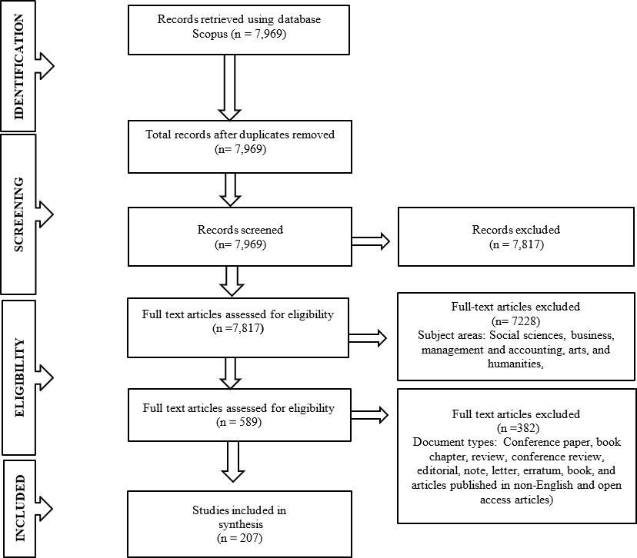

Figure 1. PRISMA flowchart

RESULTS AND DISCUSSION

What is the publication trend of mHealth research from 2013 to 2023?

Figure 2 shows the trend of publications from 2013 to 2023. The data showed that only one publication was produced during 2014, five to six in 2015 and 2016. The average volume has been produced from 2017 to 2018. There is a sharply growing trend in mHealth publications from 2019 to 2023. Researchers’ interest in studying this topic was expanded in tandem with the global pandemic that swept the globe. Of the research output published in 2019, 21 publications were published, indicating a significant rise. Nevertheless, publishing appeared to be a little slow in 2020 (17 publications). During that period, the global community was fighting the COVID-19 pandemic and prioritizing physical and mental well-being areas. As individuals learn to cope with the pandemic, the focus shifts to improving mental health, which has emerged as the illness that is least marketable. Consequently, the number of publications escalated to 36 in 2021 and continued to rise to 48 in 2022. In 2023, the total number of publications is 43. The statistics within the past few years proved that the fields of social sciences and medicine have recently dominated the publication.
The increasing pattern of publications indicates that scholarly studies on this topic are receiving more attention. The COVID-19 problem, which has forced various sectors to integrate the usage of mHealth applications in enhancing employees’ mental health, is one possible element leading to this situation. This demonstrates that academics continue to recognize the importance and influence of mHealth, indicating their optimism about it is significance and effects. The application of mHealth in domains beyond medicine has shown that it is a helpful strategy for treating mental health problems in a variety of multidisciplinary fields and industries. Further publications are anticipated in the future as knowledge of it benefits to employees grow.
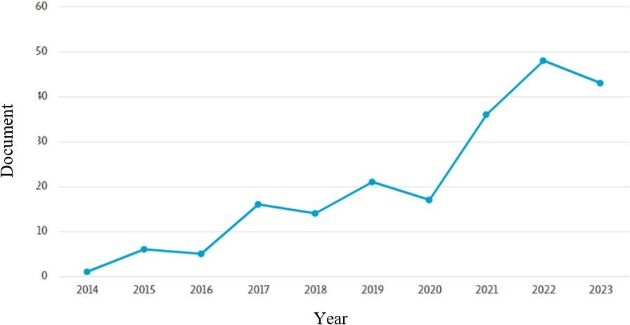

Figure 2. Publication trend from 2013 to 2023

Which countries and institutions have produced the highest number of articles?

Research on mobile health has been conducted in a total of 50 countries. The United States has the most publications, with 62 between 2013 and 2023. The United Kingdom (34), Germany (17), Canada (15), Australia (14), and China (11) come next. The top ten nations that have published on mobile health are listed in Figure 3. These nations’ current publications reflect their roles as the world’s developed nations.
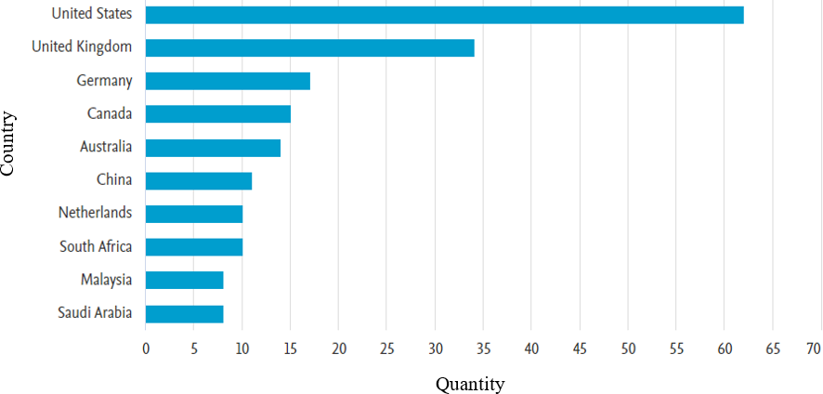

Figure 3. Most productive countries on mobile health publications

The universities that published the greatest number of studies on mobile health were included in Table 2. They include Université McGill (5 publications), the University of Tasmania, the University of Toronto, and Universität Heidelberg produced four publications each. While other universities produced three publications each.
The findings of this study also found that several articles have actively been published during 2013-2023. As shown in Figure 4, the highest number of publications is JMIR Human Factors Journal (Universities and research institutions in Canada) which focuses on the Medicine and Social Sciences area (H-Index 27, Quartile 2) with 29 publications. The second highest productive journal is JMIR Aging Journal (the universities and research institutions in Canada) which focuses on medicine, nursing, and social science area (H-Index 18, Quartile 1) with 12 publications. The third-ranked journal is Patient Preference and Adherence Journal, which belongs to a university and research institution located in New Zealand with H-Index=61 and focus on Medicine, Pharmacology, Toxicology, and Pharmaceutics and Social Sciences with Quartile 1. It produced 11 articles throughout this period of the study’s duration. The other journals include the Journal of Technology in Behavioral Science (5 publications), Sustainability Switzerland (4 publications), Human Resources for Health, and Sociology of Health and Illness, then followed by the other journals that published 3 publications each including AIDS Education and Prevention, and Computers in Human Behavior. Table 3 shows the first nine top journal publications.

Table 2. Most productive universities

Rank | Universities | Publications
1  2  3  4  5  6  7  8  9  10 | Université McGill  University of Tasmania  University of Toronto  Universität Heidelberg  University of Johannesburg  Universiteit van Amsterdam  Centre Universitaire de Santé McGill  The University of Vermont  King's College London  University of Leeds | 5  4  4  4  3  3  3  3  3  3

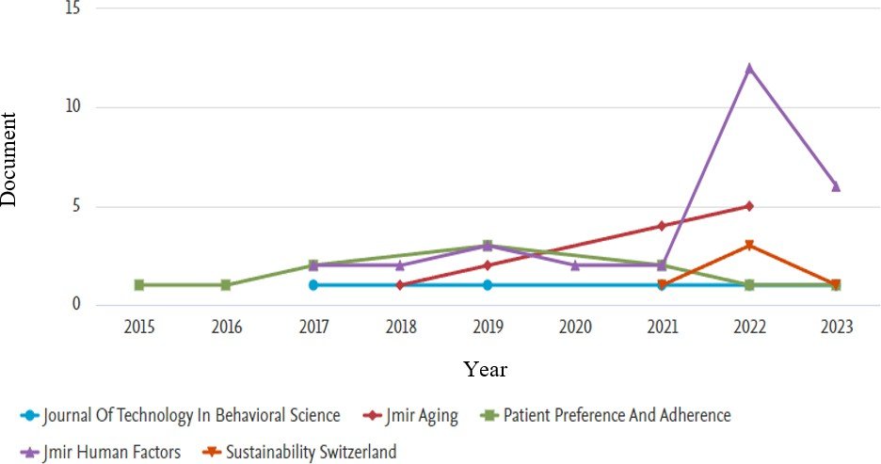

Figure 4. Publication by top journal by year
Rank | Universities | Publications
1  2  3  4  5  6  7  8  9 | JMIR Human Factors  JMIR Aging  Patient Preference and Adherence  Journal of Technology in Behavioral Science  Sustainability Switzerland  Human Resources for Health  Sociology of Health and Illness  AIDS Education and PreventionKing's Computers in Human Behavior | 29  12  11  5  5  4  4  3  3
Table 3: Publication by top journal by year

Who are the authors that are most prolific and have the highest citation counts?

The most influential author in the field of mobile health is Schnall, Rebecca B., with three publications. It is followed by Al-Samarraie, H., Frandes, M., Garafalo, R., Hingle, M. and others with two publications, respectively. Figure 5 indicates the most prolific authors and the first top ten authors with most publication in mobile health research. As shown in the figure, the majority of authors published two papers, while only one author published three academic papers. Table 4 reveals that Briz-Ponce et al. (2017) were in the top place with 256 citations for the paper “Learning with mobile technologies: Students’ behavior” followed by Fox et al. (2021) with 80 citations per paper. Munos et al. (2016) in their study “Mobile health: the power of wearables, sensors, and apps to transform clinical trials” obtained 72 citations. The other authors received an average of 71-46 citations for their studies.
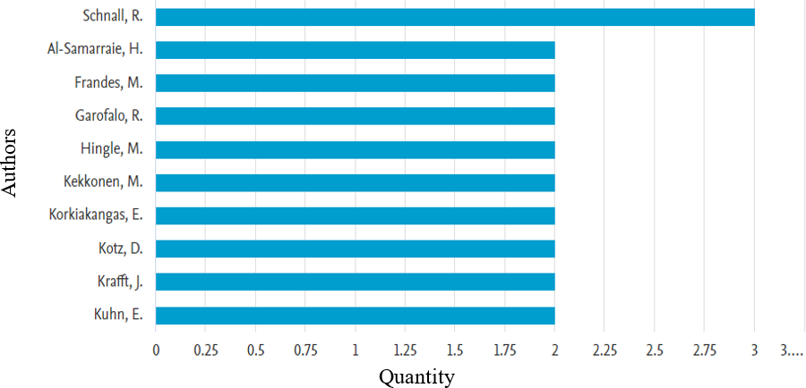

Figure 5. Most prolific authors on mobile health

Table 4. Most cited publications and authors

Authors | Title | Year | Source title | Cited by
Briz-Ponce et al (2017)  Fox et al. (2021)  Munos et al. (2016)  van Emmerik et al. (2020)  Thies et al. (2017)  Chib et al. (2017)  Sandström et al. (2016)  Gordon & Crouch (2019)  Regmi et al. (2017)  Out et al. (2016) | Learning with mobile technologies: Students’ behaviour  Exploring the competing influences of privacy concerns and positive beliefs on citizen acceptance of contact tracing mobile applications  Mobile health: The power of wearables, sensors, and apps to transform clinical trials  Efficacy of a mindfulness-based mobile application: A randomized waiting-list controlled trial  Lack of adoption of a mobile app to support patient self-management of diabetes and hypertension in a federally qualified health centre: interview analysis of staff and patients in a failed randomized trial  Theoretical advancements in mHealth: A systematic review of mobile apps  Smartphone threshold audiometry in underserved primary health-care contexts  Digital information technology use and patient preferences for internet-based health education modalities: Cross-sectional survey study of middle-aged and older adults with chroming health conditions  Effectiveness of mobile apps for smoking cessation: a review  Using a mHealth tutorial application to change knowledge and attitude of frontline health workers to Ebola virus disease in Nigeria:  A before-and-after study | 2017  2021  2016  2018  2017  2016  2019  2017  2016 | Computers in Human  Behavior Computers in Human Behavior  Annals of the New York  Academy of Sciences Mindfulness  JMIR Human Factors  Journal of health communication  International Journal of Audiology  JMIR Aging  Tobacco Prevention and Cessation  Human Resources for Health | 256  80  72  61  58  58  57  57  53  46

Which subject areas dominate the studies?

There are no subject-matter restrictions that were employed even though this bibliometric analysis of mobile health covered selected topic areas (social sciences, business, management and accounting, and arts and humanities). The objective of this analysis is to offer a comprehensive understanding and insight into the areas of subject publication that exert the most significant influence. The data reveals that there is a stronger emphasis on publications in the field of social sciences as it is the highest discipline contributed to mobile health publications with 73 (35.29%) articles. This is followed by the medicine discipline, which accounts for 46 (22.4%) number of publications. The third biggest concentration is observed in the domain of computer science representing 18 (8.7%) number of publications. Business, management, and accounting as well as psychology contributed to 11 (5.3%) articles and 10 (4.3%) articles from the total publications. Based on this analysis, it appears that there is significant room for expansion in the fields of art and humanity, engineering, medicine, decision science, and computer science in the context of future research. Figure 6 illustrates the most influential publications on the subject area accordingly.

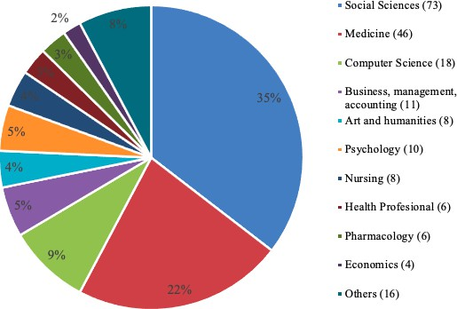

Figure 6. Most influential publication on subject area

What are trends in co-authorship and keywords in mHealth research?

Co-Authorship and country analysis: bibliographies or data sets with bibliographic fields (title, author, journal) can be visualized using VOSviewer (Salgado et al., 2020). VOSviewer is a tool used in the field of research for bibliometric analysis, which involves finding the most frequently used references in particular domains and themes that still have the potential for further investigation (Bayu et al., 2021). Numerous studies examined the use of international co-authorship as a measure of global scholarly collaboration and emphasized the benefits it offers for raising the profile, significance, caliber, or output of research (De Moya-Anegon et al., 2018). Co-authorship, which includes author co-citation, co-authorship, and co-word analysis, is a popular issue in bibliometrics research and is one of the most significant ways to show that the social network among scholars in a certain research field exists (Cheng et al., 2019). As a valuable technique for evaluating interdisciplinary science, social network analysis (SNA) assesses several kinds of collaboration networks, including co-authorship networks. As a result, this approach can help understand networking trends and could be a potent tool for organizing future joint research projects (Higaki et al., 2020). Moreover, working together is crucial to enhance the effectiveness, efficiency, and scope of scientific research and experimentation (Khan et al., 2018). Figure 7 represents the analysis of co-authorship based on countries. The mobile health publication data set included 50 countries. Among the 50 countries involved, 16 had met the threshold; hence, 107 links were found. Researchers had set five minimum documents from each country and the top 16 countries with the most frequent co-authorship ties were used in this analysis.
There were 4 clusters created by VOSviewer software. The cluster is a group of scholars who frequently work with one another and are more likely to co-author articles with one another than with other researchers outside the cluster. Figure 7 explains the respective co-authorship and country analysis. Cluster 1 showcases the collaboration among the co-authors from the United Kingdom, Saudi Arabia, Germany,
Switzerland, India, and Norway. Cluster 2 involves co-authors from Malaysia, Australia, China, and Singapore; cluster 3 involves collaboration among the United States, Canada, Netherlands, and South Africa. and cluster 4 reflects researchers from Spain and Portugal.
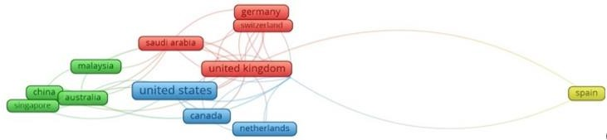
Figure 7. Co-authorship and country analysis

Clusters 1 and 2 exhibit collaborations between high-income countries, developing, and developed countries. In cluster 1, the United Kingdom collaborates with the United States, Canada, and the Netherlands, while Saudi Arabia also collaborates with Malaysia, China, Australia, and Singapore. In cluster 2, Malaysia collaborates with Saudi Arabia, Australia collaborates with Canada, and Singapore collaborates with the United States. Moreover, cluster 3 which involves the United States, Canada, and the Netherlands demonstrates the collaborations with the United Kingdom, Australia, and Singapore. Lastly, cluster 4 (Spain) shows the collaboration only among high-income countries, the United Kingdom. Figure 7 illustrates the co-authorship and country analysis of this study and Table 5 listed the top ten co-authorships and the country total link strength details.

Table 5. Top 10 co-authorship and country total link strength

No. | Country | Documents | Citations | Total link strength
1  2  3  4  5  6  7  8  9  10 | United Kingdom  South Africa  Australia  United States  Canada  China  Saudi Arabia  Germany  India  Norway | 34  10  14  62  15  11  8  17  7  6 | 407  119  198  865  121  42  50  108  32  19 | 22  15  13  12  10  10  10  7  6  6

Keyword analysis: one selection criterion in VOSviewer aids in understanding the relationships between documents. The essential information that reflects the articles' main topic is made clearer by the inclusion of keywords. This means that only terms that appear three or more times are recognized by the software. A list of mHealth-related terms that appeared three or more times in the Scopus database between 2013 and 2023 is shown in Figure 8.
The software recognizes a total of 1569 distinct keywords in the screening result. Only 55 keywords, with 6 clusters, 659 links, and a total link strength of 1,683, match this predetermined requirement. Additionally, every node symbolizes a term, and the association between two connected nodes is represented by the formation of a link between them. The size of the node indicates the frequency of occurrences of the keyword. Keywords such as mobile health, procedures, mental health, usability, self-care, and others show the highest occurrence in mHealth research. Figure 8 visualizes the occurrence of keywords on mHealth research while Table 6 represents the top 10 keywords used in mHealth research. The highest keyword weas mobile health, while the lowest one is attitude to health. In addition, procedures were in the second rank, followed by mental health and usability.

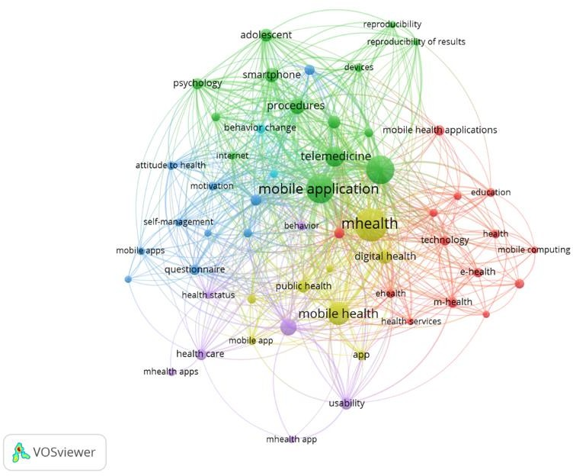

Figure 8. Network visualization of author keywords occurrence

Table 6. Top 10 keywords used by author in mhealth studies

No. | Keyword | Occurance | Total link strength
1  2  3  4  5  6  7  8  9  10 | Mobile health  Procedures  Mental health  Usability  Usage  Self-care  Telehealth  Behavior change  Technology  Attitude to health | 46  21  14  13  13  11  9  8  8  7 | 148  132  69  45  45  81  61  44  39  39

DISCUSSION

The purpose of this research is to describe and offer useful information to everyone with an interest in the mHealth research area by identifying the trends in mHealth publications between 2013 and 2023. The result revealed that there is a considerable increase in the number of publications from 2013 and 2023. Over 95% of the documents retrieved in the subject of mobile health were written in English, making it the language of science in this field. The United States ranked first in productivity, far ahead of other nations and areas, but the contribution made by the United Kingdom and Germany was also prominent. Literature in mHealth covered a wide range of disciplines including the top three disciplines including social studies, medicines, and computer sciences.
JMIR Human Factors Journal is the preferred journal for publishing documents in mHealth (29 publications), followed by JMIR Aging Journal (12) and Patient Preference and Adherence Journal (11 publications). The volume of literature in mHealth showed an exponential increase in the second half of the study, i.e., after 2019. The mean number of authors per document increased throughout time, which is consistent with an increase in author collaboration on research, along with the volume of literature. Additionally, there was a notable increase in the quantity of publications in mHealth research from 2019 to 2023. Mobile health became a top priority for organizations of all stripes due to two main factors: the COVID-19 pandemic and the advent of digitalization, or IR 4.0. It is agreed that the technology development and the advent of health applications for smartphones and other mobile devices have improved people’s access to healthcare services and lessened the workload for healthcare professionals [20]. Consequently, a great deal of research was done on mHealth, leading to a significant rise in empirical studies.
On the other hand, the most productive institutions are Université McGill (Canada), the University of Tasmania (Australia), and the University of Toronto (Canada) which took the top spot with 5 and 4 publications, respectively, when ranked among the most productive universities as similar studies done by previous researchers such as Sweileh et al. [20]; Peng et al. (2020). The study also reveals that the authors with the highest number of citations are Schnall, Rebecca B, who obtained a total of 3,087 citations with 171 documents. The author is from the Columbia University, United States. Al-Samarraiem Hosam University of Leeds, United Kingdom with 2,323 citations and 92 documents. The third highest citation received by Frandes, Mirela with 377 citations from 43 documents. It is possible to conclude that high-income countries and developed nations dominate the field in terms of most productive universities, most productive authors, and the highest cited authors. The most frequently keywords used in mHealth research are mobile health, procedures, mental health, usability, self-care, telehealth, behavior change, technology, and attitude to health. Nevertheless, national economies, regulatory regulations, and privacy concerns will all pose obstacles to mHealth’s progress. Thus, to advance the mHealth study area, future researchers should work on related topics. Governments, companies, and even private institutions may consider or prioritize investing in mHealth. As agreed by Chen et al. (2021), technology has impacted smart digital devices and apps beyond all else, and research into developing and applying technologies to facilitate the creation of cutting-edge digital devices and applications will continue. Consequently, to make digital devices and applications smart and effective, attention should be paid to the application and incorporation of various cutting-edge technologies, rather than just computer/web-based ones. Emerging new mobile technologies ought to be developed to assist individuals and nations in addressing a serious public health crisis and enhancing national health. The information provided in this study will also be used in the future to compare and record how mHealth is affecting the next studies.

CONCLUSION

Mobile health (mHealth) has demonstrated a great deal of promise for application in various facets of our lives in recent years. This study aims to provide a bibliometric analysis of mHealth from 2013 to 2023. In general, this study significantly contributes to the understanding of mHealth research trends over the past decade. Over the past ten years, there has been an apparent rise in the number of mHealth publications. It is anticipated that applications of mHealth would be observed in numerous health services given the high volume of citations obtained in this subject. The increasing number of publications in this field underscores its growing importance. However, it is important to note the limitations of this study. The choice of the database depends on the goals of the study, the field of study, and the requirements of the analysis. Although Scopus is a well-known and credible bibliographic database that offers comprehensive coverage of scholarly literature, researchers must recognize that there are other databases available. Thus, future researchers can use the patterns and directions identified in this study as a starting point for probing important questions about cutting-edge studies on the impact of mobile health among researchers. It can be summarized that bibliometric analysis and network visualization have illuminated the research horizon, trends, and hot subjects surrounding mobile health app development. These results can offer insightful advice on potential avenues for future investigation and viewpoints on this quickly evolving topic. Specifically, given the key findings, the researchers suggest future studies to examine the dynamics of cross-country collaborations and comparative studies of productive countries to understand the unique strategies, policies, and research ecosystem.

ACKNOWLEDGEMENTS

We would like to express our sincere gratitude to all authors from Universiti Teknologi MARA Kelantan, as well as Universitas Negeri Malang, Indonesia on their unwavering support and courage throughout the process of preparing the final manuscripts. Their encouragement has been invaluable, and we are truly grateful for the opportunities provided by these esteemed institutions.

REFERENCES

Abaza, H., & Marschollek, M. (2017). mHealth application areas and technology combinations. Methods of information in medicine, 56(S 01), e105-e122.
Ajzen, I. (1991). The theory of planned behavior. Organizational behavior and human decision processes, 50(2), 179-211.
Ajzen, I., & Fishbein, M. (1975). A Bayesian analysis of attribution processes. Psychological bulletin, 82(2), 261.
Akter, S., & Ray, P. (2010). mHealth-an ultimate platform to serve the unserved. Yearbook of medical informatics, 19(01), 94-100.
Alam, M. Z., Hu, W., Kaium, M. A., Hoque, M. R., & Alam, M. M. D. (2020). Understanding the determinants of mHealth apps adoption in Bangladesh: A SEM-Neural network approach. Technology in Society, 61, 101255.
Alqahtani F, Orji R. Insights from user reviews to improve mental health apps. Health Informatics J. (2020) 26:2042–66. doi: 10.1177/1460458219896492
Amagai, S., Pila, S., Kaat, A. J., Nowinski, C. J., & Gershon, R. C. (2022). Challenges in participant engagement and retention using mobile health apps: literature review. Journal of medical Internet research, 24(4), e35120.
Anastasiadou, D., Folkvord, F., Serrano-Troncoso, E., & Lupiañez-Villanueva, F. (2019). Mobile health adoption in mental health: user experience of a mobile health app for patients with an eating disorder. JMIR mHealth and uHealth, 7(6), e12920.
Aschbrenner, K. A., Naslund, J. A., Tomlinson, E. F., Kinney, A., Pratt, S. I., & Brunette, M. F. (2019). Adolescents' use of digital technologies and preferences for mobile health coaching in public mental health settings. Frontiers in public health, 7, 178.
Atallah, N., Khalifa, M., El Metwally, A., & Househ, M. (2018). The prevalence and usage of mobile health applications among mental health patients in Saudi Arabia. Computer methods and programs in biomedicine, 156, 163-168.
Aydin, G. (2023). Increasing mobile health application usage among Generation Z members: evidence from the UTAUT model. International Journal of Pharmaceutical and Healthcare Marketing, 17(3), 353-379.
Bayu, A., Novia, D., Husaeni, A. L., & Fitria, D. (2021). A bibliometric analysis of chemical engineering research using. Journal of Engineering Science and Technology, 16(6).
Bendtsen, M., Müssener, U., Linderoth, C., & Thomas, K. (2020). A mobile health intervention for mental health promotion among university students: randomized controlled trial. JMIR mHealth and uHealth, 8(3), e17208.
Benny, V. (2021). A Study on Attitude of Women Investors towards Stock Market Investment in Kerala. anvesak.
Bidargaddi, N., Schrader, G., Klasnja, P., Licinio, J., & Murphy, S. (2020). Designing m-Health interventions for precision mental health support. Translational psychiatry, 10(1), 222.
Borghouts J, Eikey E, Mark G, De Leon C, Schueller SM, Schneider M, et al. Barriers to and facilitators of user engagement with digital mental health interventions: systematic review. J Med Internet Res. (2021) 23:e24387. doi: 10.2196/24387
Briz-Ponce, L., Pereira, A., Carvalho, L., Juanes-Méndez, J. A., & García-Peñalvo, F. J. (2017). Learning with mobile technologies–Students’ behavior. Computers in human behavior, 72, 612-620.
Cao, J., Lim, Y., Sengoku, S., Guo, X., & Kodama, K. (2021). Exploring the shift in international trends in mobile health research from 2000 to 2020: bibliometric analysis. JMIR mHealth and uHealth, 9(9), e31097.
Chen, X., Zou, D., Xie, H., & Wang, F. L. (2021). Past, present, and future of smart learning: a topic-based bibliometric analysis. International Journal of Educational Technology in Higher Education, 18(1), 2.
Cheng, F. F., Huang, Y. W., Tsaih, D. C., & Wu, C. S. (2019). Trend analysis of co-authorship network in Library Hi Tech. Library Hi Tech, 37(1), 43-56.
Chib, A., Van Velthoven, M. H., & Car, J. (2015). mHealth adoption in low-resource environments: a review of the use of mobile healthcare in developing countries. Journal of health communication, 20(1), 4-34.
Chou, Y. H., Lin, C., Lee, S. H., Chang Chien, Y. W., & Cheng, L. C. (2023). Potential mobile health applications for improving the mental health of the elderly: A systematic review. Clinical Interventions in Aging, 1523-1534.
Cobelli, N., & Blasioli, E. (2023). To be or not to be digital? A bibliometric analysis of adoption of eHealth services. The TQM Journal, 35(9), 299-331.
Davis, F. D. (1989). Perceived usefulness, perceived ease of use, and user acceptance of information technology. MIS quarterly, 13(3), 319-340.
De Moya-Anegon, F., Guerrero-Bote, V. P., Lopez-Illescas, C., & Moed, H. F. (2018). Statistical relationships between corresponding authorship, international co-authorship and citation impact of national research systems. Journal of informetrics, 12(4), 1251-1262.
Ding, X., Wuerth, K., Sakakibara, B., Schmidt, J., Parde, N., Holsti, L., & Barbic, S. (2023). Understanding mobile health and youth mental health: scoping review. JMIR mHealth and uHealth, 11, e44951.
Eze, E., Gleasure, R., & Heavin, C. (2020). Mobile health solutions in developing countries: a stakeholder perspective. Health Systems, 9(3), 179-201.
Foa EB, Franklin M, McLean C, McNally RJ, Pine D, Jane Costello E, et al. Defining anxiety disorders. In: Evans D, editor. Treating and Preventing Adolescent Mental Health Disorders: What We Know and What We Don't Know (2nd Edition). Oxford, UK: Oxford Academic; Sep 1, 2017:189-212.
Fox, G., Clohessy, T., van der Werff, L., Rosati, P., & Lynn, T. (2021). Exploring the competing influences of privacy concerns and positive beliefs on citizen acceptance of contact tracing mobile applications. Computers in Human Behavior, 121, 106806.
Gagnon, M. P., Ngangue, P., Payne-Gagnon, J., & Desmartis, M. (2016). m-Health adoption by healthcare professionals: a systematic review. Journal of the American Medical Informatics Association, 23(1), 212-220.
Galetsi, P., Katsaliaki, K., & Kumar, S. (2023). Exploring benefits and ethical challenges in the rise of mHealth (mobile healthcare) technology for the common good: An analysis of mobile applications for health specialists. Technovation, 121, 102598.
Geirhos, A., Domhardt, M., Lunkenheimer, F., Temming, S., Holl, R. W., Minden, K., ... & Baumeister, H. (2022). Feasibility and potential efficacy of a guided internet-and mobile-based CBT for adolescents and young adults with chronic medical conditions and comorbid depression or anxiety symptoms (youthCOACHCD): a randomized controlled pilot trial. BMC pediatrics, 22(1), 69.
Gordon, N. P., & Crouch, E. (2019). Digital information technology use and patient preferences for internet-based health education modalities: cross-sectional survey study of middle-aged and older adults with chronic health conditions. JMIR aging, 2(1), e12243.
Guo, B., Syufiza, N., & Ahmad Shukor, N. S. (2023). Systematic literature review of healthcare services for the elderly: trends, challenges, and application scenarios. Int J Public Health Sci, 12, 1637-46.
Haque, M. R., & Rubya, S. (2023). An overview of chatbot-based mobile mental health apps: insights from app description and user reviews. JMIR mHealth and uHealth, 11(1), e44838.
Helha, F. N. M., & Wang, Y. P. (2022). Trends in complementary and alternative medicine for the treatment of common mental disorders: A bibliometric analysis of two decades. Complementary Therapies in Clinical Practice, 46, 101531.
Higaki, A., Uetani, T., Ikeda, S., & Yamaguchi, O. (2020). Co-authorship network analysis in cardiovascular research utilizing machine learning (2009–2019). International Journal of Medical Informatics, 143, 104274.
Hoque, R., & Sorwar, G. (2017). Understanding factors influencing the adoption of mHealth by the elderly: An extension of the UTAUT model. International journal of medical informatics, 101, 75-84.
Iribarren, S. J., Cato, K., Falzon, L., & Stone, P. W. (2017). What is the economic evidence for mHealth? A systematic review of economic evaluations of mHealth solutions. PloS one, 12(2), e0170581.
Jembai, J. V. J., Wong, Y. L. C., Bakhtiar, N. A. M. A., Lazim, S. N. M., Ling, H. S., Kuan, P. X., & Chua, P. F. (2022). Mobile health applications: awareness, attitudes, and practices among medical students in Malaysia. BMC Medical Education, 22(1), 544.
Johnson, K. F., & Kalkbrenner, M. T. (2017). The utilization of technological innovations to support college student mental health: Mobile health communication. Journal of technology in human services, 35(4), 314-339.
Kamaruzaman, K. N., Hussein, Z., & Fikry, A. (2023). Factors Affecting BehaviouraláIntention to Use Mobile Health Applications among Obese People in Malaysia. European Journal of Business Science and Technology, 9(1), 92-117.
Khan, F., Sandelski, M. M., Rytlewski, J. D., Lamb, J., Pedro, C., Adjei, M. B., ... & Kacena, M. A. (2018). Bibliometric analysis of authorship trends and collaboration dynamics over the past three decades of BONE's publication history. Bone, 107, 27-35.
Khatun, F., Palas, J. U., & Ray, P. K. (2017). Using the unified theory of acceptance and use of technology model to analyze cloud-based mHealth service for primary care. Digital Medicine, 3(2), 69-75.
Kruse, C. S., Betancourt, J. A., Gonzales, M., Dickerson, K., & Neer, M. (2022). Leveraging mobile health to manage mental health/behavioral health disorders: systematic literature review. JMIR Mental Health, 9(12), e42301.
Litke, S. G., Resnikoff, A., Anil, A., Montgomery, M., Matta, R., Huh-Yoo, J., & Daly, B. P. (2023). Mobile technologies for supporting mental health in youths: scoping review of effectiveness, limitations, and inclusivity. JMIR mental health, 10(1), e46949.
McGorry, P. D., Mei, C., Chanen, A., Hodges, C., Alvarez‐Jimenez, M., & Killackey, E. (2022). Designing and scaling up integrated youth mental health care. World Psychiatry, 21(1), 61-76.
Meng, F., Guo, X., Peng, Z., Zhang, X., & Lai, K. H. (2022). Understanding the antecedents of the routine use of mobile health services: A person–technology–health framework. Frontiers in psychology, 13, 879760.
Milne-Ives, M., Lam, C., De Cock, C., Van Velthoven, M. H., & Meinert, E. (2020). Mobile apps for health behavior change in physical activity, diet, drug and alcohol use, and mental health: systematic review. JMIR mHealth and uHealth, 8(3), e17046.
Munos, B., Baker, P. C., Bot, B. M., Crouthamel, M., de Vries, G., Ferguson, I., ... & Wang, P. (2016). Mobile health: the power of wearables, sensors, and apps to transform clinical trials. Annals of the New York Academy of Sciences, 1375(1), 3-18.
Muñoz R. Depression Prevention: Research Directions. London, UK: Hemisphere Publishing Corp; 1987.
Nisha, N., Iqbal, M., Rifat, A., & Idrish, S. (2015). Mobile health services: A new paradigm for health care systems. International Journal of Asian Business and Information Management (IJABIM), 6(1), 1-17.
O'Grady, C., Melia, R., Bogue, J., O'Sullivan, M., Young, K., & Duggan, J. (2020). A mobile health approach for improving outcomes in suicide prevention (SafePlan). Journal of medical Internet research, 22(7), e17481.
Olawade, D. B., Wada, O. Z., Odetayo, A., David-Olawade, A. C., Asaolu, F., & Eberhardt, J. (2024). Enhancing mental health with Artificial Intelligence: Current trends and future prospects. Journal of medicine, surgery, and public health, 3, 100099.
Otu, A., Ebenso, B., Okuzu, O., & Osifo-Dawodu, E. (2016). Using a mHealth tutorial application to change knowledge and attitude of frontline health workers to Ebola virus disease in Nigeria: a before-and-after study. Human resources for health, 14(1), 5.
Peng, C., He, M., Cutrona, S. L., Kiefe, C. I., Liu, F., & Wang, Z. (2020). Theme trends and knowledge structure on mobile health apps: bibliometric analysis. JMIR mHealth and uHealth, 8(7), e18212.
Regmi, K., Kassim, N., Ahmad, N., & Tuah, N. A. (2017). Effectiveness of mobile apps for smoking cessation: a review. Tobacco Prevention & Cessation, 3, 12.
Saare, M. A., & Hussain, A. (2019). Conceptualizing Mobile Health Application Use Intention and Adoption Among Iraqian Older Adults: From the Perspective of Expanded Technology Acceptance Model. International Journal of Interactive Mobile Technologies, 13(10).
Salgado, T., Tavares, J., & Oliveira, T. (2020). Drivers of mobile health acceptance and use from the patient perspective: survey study and quantitative model development. JMIR mHealth and uHealth, 8(7), e17588.
Samsuri, A. S., Hussin, S. M., Badaruddin, M. N. A., Arifin, T. R. T., Zainol, S. S., & Mohamad, Z. Z. (2022). Antecedents of user satisfaction and continuance usage of mobile health applications: a study on MySejahtera Apps in Malaysia. Asian Journal of Behavioural Sciences, 4(2), 91-105.
Sandström, J., Swanepoel, D. W., Carel Myburgh, H., & Laurent, C. (2016). Smartphone threshold audiometry in underserved primary health-care contexts. International Journal of Audiology, 55(4), 232-238.
Sari, H., Othman, M., & Al-Ghaili, A. M. (2018). A proposed conceptual framework for mobile health technology adoption among employees at workplaces in Malaysia. In International conference of reliable information and communication technology (pp. 736-748). Cham: Springer International Publishing.
Sweileh, W. M., Al-Jabi, S. W., AbuTaha, A. S., Zyoud, S. E. H., Anayah, F. M., & Sawalha, A. F. (2017). Bibliometric analysis of worldwide scientific literature in mobile-health: 2006–2016. BMC medical informatics and decision making, 17(1), 72.
Tajudeen, F. P., Bahar, N., Maw Pin, T., & Saedon, N. I. (2022). Mobile technologies and healthy ageing: A bibliometric analysis on publication trends and knowledge structure of mHealth research for older adults. International Journal of Human–Computer Interaction, 38(2), 118-130.
Thies, K., Anderson, D., & Cramer, B. (2017). Lack of adoption of a mobile app to support patient self-management of diabetes and hypertension in a federally qualified health center: interview analysis of staff and patients in a failed randomized trial. JMIR human factors, 4(4), e24.
Thornton, L. K., & Kay-Lambkin, F. J. (2018). Specific features of current and emerging mobile health apps: user views among people with and without mental health problems. Mhealth, 4, 56.
Torous, J., Staples, P., Slaters, L., Adams, J., Sandoval, L., Onnela, J. P., & Keshavan, M. (2017). Characterizing smartphone engagement for schizophrenia: results of a naturalist mobile health study. Clinical schizophrenia & related psychoses.
van Emmerik, A. A., Keijzer, R., & Schoenmakers, T. M. (2020). Integrating mindfulness into a routine schedule: The role of mobile-health mindfulness applications. In Nutrition, fitness, and mindfulness: An evidence-based guide for clinicians (pp. 217-222). Cham: Springer International Publishing.
Ventresca, M. J., & Mohr, J. W. (2017). Archival research methods. The Blackwell companion to organizations, 805-828.
Vesel, L., Hipgrave, D., Dowden, J., & Kariuki, W. (2015). Application of mHealth to improve service delivery and health outcomes: Opportunities and challenges. Etude de la Population Africaine, 29(1), 1683.
World Health Organization, Mental disorders. 〈https://www.who.int/news -room/fact-sheets/detail/mental-disorders/, 2022,
Zhang, B., Lau, L. Y., & Chen, Y. (2025). Trends in digital mental health interventions: A 20-year bibliometric analysis. Digital Health, 11, 20552076251403203.
Zhang, X., Liu, S., Wang, L., Zhang, Y., & Wang, J. (2020). Mobile health service adoption in China: integration of theory of planned behavior, protection motivation theory and personal health differences. Online Information Review, 44(1), 1-23.
Zheng, S., Edney, S. M., Goh, C. H., Tai, B. C., Mair, J. L., Castro, O., ... & Mueller-Riemenschneider, F. (2023). Effectiveness of holistic mobile health interventions on diet, and physical, and mental health outcomes: a systematic review and meta-analysis. EClinicalMedicine, 66.

