Redefining Student Privacy and Engagement in the Age of AI: A Critical Exploration of Digital Dependency and Behavioral Transformation

Abstract
From the perspective of technological advancement, especially in today’s digitalisation, analytical applications supported by artificial intelligence (AI) are extremely efficient in all areas, and people are very privy to the latest technological advancements, which help them work with maximum efficiency in minimum time. AI technologies are widely implemented across many fields of the economy, such as health and education, and large amounts of money are spent on businesses related to artificial intelligence. The government also seems to have embarked on several measures to boost the prospects of a digitized, AI-based economy. Of course, AI has transformed the world and makes it important for people to understand the great risks and moral issues concerning overreliance on AI-based products and services. In pursuing the above objectives, the paper seeks to address key ethical issues on artificial intelligence such as how it infringes on the privacy of individuals and the level of enthusiasm that AI brings to promote indolence amongst students. One hundred and twenty-eight participants’ data were collected,m and the linear regression analysis was used. Upon reviewing the findings, safety and privacy were categorized into factors that are moderately to substantially influenced by AI, and AI heightens individual laziness.
Keywords: Artificial Intelligence, Privacy & Safety, Laziness, Ethical Concerns, Automation

1.Research Scholar, Faculty of Commerce, Banaras Hindu University, Varanasi, Uttar Pradesh- 221005. Contact No. 8317000650 {Email id- roshni@bhu.ac.in}
2. Research Scholar, Faculty of Commerce, Banaras Hindu University, Varanasi, Uttar Pradesh- 221005. Contact No. 8887906946 {Email id- sarveshyadav637@gmail.com
3. Research Scholar, Faculty of Commerce, U.P. College Varanasi, Uttar Pradesh- Contact No. 7499441056; {Email id- surendrabhu74@gmail.com}

1. Introduction
AI as a concept was introduced in the year 1956, though because of advancements in data amount, algorithms, and computing power, AI has not seen much action until the recent two decades. AI is becoming more widely used in a range of sectors including production, the medical field, the financial sector, and the selling business. It is possible that the extent of radical uses of AI in the future could be much more abrupt and radical as the technology advances. Many fields and industries are affected by artificial intelligence such as manufacturing and production, fashion, the automotive industry, agriculture & farming, sports analytics, health care and the medical system. Although the function is two-fold, there is good evidence that this mechanical technology has the possibilism of influencing and shaping the future of both humankind and the industry. AI systems and applications are ubiquitous in all aspects of life such as chatting with a bank’s chatbot found on a bank’s website, communicating with a smart speaker, sorting emails and messages into different folders and tabs, as well as using recommendation systems in the streaming services deployed in the increase in AI misuse has been linked to the growing adoption of AI. Over the course of the past ten years there has been many concerns on the misuse of AI especially concerning security, trust and data privacy. People can harness technology for positive or negative uses, and the importance of it rises in turn. The same is applicable to autonomous weapon systems and robotic systems designed to replace soldiers, dangerous technologies that can be used for ill purpose. Cybersecurity will become far more important because these battles will not only be fought on the field. In the end, we are talking to a system that is exponentially faster and intelligent than humans. Business is using Artificial Intelligence (AI) to create solutions that are more standardized. But equity conscience is now starting to show up in AI systems because it has been observed that some AI systems are prone to error for some community. In this year Apple Cards was found to have used an AI algorithm that favoured men and denied women reasonable credit limits. Male clients are again offered higher credit limits than the female clients. However, similar problems also arise in other AI systems. One of the significant threats affecting the companies’ image, regulation, and law compliance is the materialisation of the ethics of data and AI violations. Analyzing the modern development of artificial intelligence that is AI this type of technology might be deemed to be inevitable and people all across the globe are already experiencing it in some ways. According to the IBM Global AI Adoption Index in 2022, 27% of organisations in India were considering AI, although 57% of responding organisations said they had adopted AI. Although many times, access, quality, and efficiency can represent the objectives of AI in the organization, some concerns and challenges associated with AI have emerged in the organization as well. At present, AI is ubiquitous and is deployed by all age groups as means of enhancing growth and/or efficiency by AI-enabled applications. It need not be restricted as a gatekeeper to stop the use of AI tools for ancillary research tasks. Students are provided with toolkits to implement chatbots and other intelligent agents (IA) applications for learning new things. The AI has also been used for study in a few papers, such as syllabus development and evaluation of student grades, etc. Embedding AI in teaching is an opportunity—but also a moral dilemma that needs to be addressed in order to have considered, and ultimately acceptable, use of it. Data security and privacy are two key issues. When AI is used in education, there is the potential to collect huge datasets pertaining to students (including but not limited to student personal identification data and learning history) . The authors define a list of fundamental research issues of interest to the field of information management and security. However, since the privacy concern to the student is concerning a coding question and there are proofs that not authorized access to (modify) and extraction of the student data are possible as well, to that extent it is very much desirable to avoid unauthorized access and/or manipulation of the student data, and to also have an encrypted protocol. On the other hand, informed parental and child consent is a requirement, since parents and children should be fully informed of the data that are going to be collected (information) and how it is going to be exploited in the future. This paper's main objective is to assess how artificial intelligence (Al) can impact students' anxiety in the context of privacy, therefore leading to apathy.
2. Literature Review
With the advent of increasingly sophisticated artificial intelligence (AI) technologies, profound ethical concerns have emerged, including, among others, what and to what degree aspects of individual privacy are infringed upon and how individual behaviour can be influenced. While privacy issues are correlated with awareness in the light of the enormous number of privacies concerns, they are connected to, the task of AI, with its power in machine learning and the volume of big data, has introduced not just efficiency but also creativity time and again across different domains. Most AI systems to operate as they should have access to personally identifiable information which in and of itself gives us a glimpse into a person’s PI. Carmody et al. (2021) provide an example of how artificial intelligence (AI) might be used to "mine" personal information, that is, addressable information, from seemingly less relevant information, e.g., consumption profiles of energy from smart meters. This power asks the question what level of control users will have over the data, what may be done with that data and used to exploit it and whether current statutory protections for privacy are adequate. Also, there is fear of the possibility that human sloth could increase due to more and more the pervasiveness of AI, which are increasingly integrated into human life and hence increasingly more of human life depends on the ubiquitousness of AI. Al-enhanced tools' application to decision-making within the learning environment continues to gain momentum and AI is becoming an ever-increasing part of academic and administrative activities across university campuses. AI is used for a variety of tasks, for example, giving guidance on admission procedures for students, or for applying for courses/degrees. A fundamental function of AI in the learning process is the creation of individual learning and tutoring, automatic generation of correct answers, 24 hours a day availability of learning content, solving and explaining the instructional process, and handling of learning activities (Karandish 2021). Man, machine interaction in the community has been in the spotlight to guarantee that the interaction with man machine system will be useful to prevent human being form its adverse impact, thus, the ethical aspect of man machine system must be estimated and considered from now. In their research paper (Fulop et al. (2023) and accountancy firm) have reported that for the most part the accountants in the sample are already acquainted with the technologies of the field and most accountants at least present some awareness for the field. All of them, however, agree about the ethical aspect in AI and have claimed that a regulated, rule-based and anthropogenic approach is needed to deal with the ethical implications linked to the AI systems. Ahmad et al. (2023) also found in their research paper titled "Effect of artificial intelligence on human death through decision making, idleness and safety in education" that learners get lazier due to the increasing spread of AI tools and this indirectly leads to them developing problems in their decision-making abilities and causes them security violations. They databased the role of artificial intelligence (AI) in the life of Chinese and Pakistani students from university education and the results are that artificial intelligence (AI) rather than invigorates students to engage in sloth, privacy has been spiraling into panic and decreasing in role playing. HR produces vast quantities of data, and as companies become more and more reliant on efficient data processing, they often overlook the significance of data management in humans, due to the rise in artificial intelligence (AI). Although humans tend to view as if AI has already been working in support of them and saving them time, while exploiting the available AI-based decision-making tool, this change in approach is redrafting human cognitive performances since gradually, AI is becoming the superior tool rather than that of humans (Jarrahi, 2018). Evidence from studies of the expert literature and professional organizations alike indicate the revolutionary potential of automation across the enterprise and across industries. Digitisation has the consequence that the work becomes all the more efficient, effective and faster. Yet digitisation has become an important driver of business expansion and innovation with broad economic and social impact. As highlighted by Ionescu et al. The automation of those procedures on a large scale not only enhances workflow, but also has a cascading effect of further improvement and competition in the market. Hence, digitization is viewed recently as a motor behind the current agenda of business developments, organizational development, and positive effects and spillover. Human intelligence has a unique property that it can intellectualize information independently and, as a result, can answer a variety of questions and problems. The goal is to simulate such mental states in machines, with the result that machines will be able to perform tasks that hitherto have remained beyond the ability of human intelligence. As highlighted by Cho et al2020; Ionaşcu et al. (2022) the goal is to transfer those powers to machines in order that they are able to perform tasks previously requiring human action. The key distinction between human intelligence and artificial intelligence (AI) is the conscious awareness that characterizes humans as well as their ability to contextualize and frame complex problems. Humans possess an inborn capacity for linguistic and/or rational knowledge, which allows them to efficiently and smoothly get around complex worlds (Loureiro et al. 2021). [AI] is, in contrast, engineered on the basis of mathematical equations and data processing, but has neither the quality of consciousness nor intuitive understanding. In turn, AI should be designed as it should complement and use humans' intelligence. The goal is not to "box" AI into tasks alone, but rather, to deal with it in a general manner that is adaptable, meaning it can learn and adjust depending on experimental conditions, challenges and unique environments (Pazarskis et al. 2022).
3. Conceptual Framework
Figure 1: The impact of AI on student’ Privacy and laziness
Artificial Intelligence
Privacy and Safety

Human Laziness

Illustrating the conceptual model is shown in figure, which describes the relationship of artificial intelligence (AI), independent variable, and privacy concerns/human laziness, dependent variable. Possible effects of AI on privacy problems and depletion of human motivation have been simulated in this model.
AI and Privacy Concerns
As human-AI interaction is increasing and increasing with time. Education and e-learning, e.g., are starting to utilize a variety of AI applications, from chatbots to robots, e.g. Measurement is a hot issue in the computer vision community [12] and is applicable to decision/pattern recognition, not to mention it will always be a dilemma in the field of privacy. Privacy is a key problem in artificial intelligence, and possibly also the one that is drawing the most attention from the users, as the user privacy cannot be faked. It is without question that AI has become, and will remain, an integral part of the classroom and the learning itself (Sayantani, 2021). Different tools have their means of interacting with students and the teacher they are used in, depending on the tool itself. These applications are interactive playful learning, activity, i.e., voice-based information retrieval but they will also pose privacy and security concerns (Gocen and Aydemir, 2020).
AI and Human Laziness
People are eventually going to become less intelligent as a consequence of the increasing use of artificial intelligence tools. Consequently, this triggers a sharp decline in human intelligence. Humans have become more machinelike, since they have failed to realize how learning has ceased to be understood. More, the accumulated, "mixed", experience of working with the technology has led us to be algorithms without understanding (Sarwat, 2018). However, the problem for the daily use of artificial intelligence technology in every single domain of human activity continues. It is hardly surprising that it has risen living standards and speed, but it also has a lethal effect on human behavior, creating idleness and impatience (Krakauer, 2016).
4. Research objectives
Doubts about AI are the primary focus of research for this paper: the approach used establishes the aim to quantify AI repercussions on students. As a research question, this work seeks to understand how application of artificial intelligence increases violation of students’ privacy and promotes laziness. It aims at establishing if augmented use of AI tools has adverse effects on students; chiefly, the level of thinking skills is lowered. Based on the evaluation of these issues, the paper will have a great perspective on possible threats of applying AI in learning environments.
5. Research Hypothesis
- H₁: Artificial intelligence significantly impacts students' security and privacy.
- H₂: Artificial intelligence significantly contributes to increased laziness among students.
6. Research Methodology
Consequently, this study adopted a descriptive research design and aimed at targeting students of Banaras Hindu University as the population. The data was collected using an online survey using Google Form link with 200 participants; 150 participants completed them; however, 128 participants’ responses meet the inclusion criteria. The type of sampling selected for this study was convenience sampling. The research data collection methods comprise both primary and secondary data collection techniques. The first approach was a structured-questionnaire administration, which used items that were originally borrowed from other studies but after critical evaluation were chosen because of its relevance and reliability. For the purpose of this study, responses for seven items assessing artificial intelligence were collected, adopting measures used by Suh & Ahn (2022), five items regarding privacy and security were taken from Youn (2009), four items evaluating the concept of human laziness were borrowed from Dautov (2020). For secondary data, books, journals, articles, reports, and website resources were sources used in the study. Questions inside the self-administered questionnaire completed by the participants were subjected to reliability analysis using Cronbach Alpha. Descriptive and inferential statistics were used in the analysis of data. Frequency, percentage, and mean were used to analyze descriptive summary, while inferential summary used linear regression to analyze the relationship in variables. The use assume- galaxy approach enabled the researchers to consider all the factors surrounding the use of artificial intelligence, privacy and Behavioral change among the students.
Major Concerns Associated with Artificial Intelligence
The AI ethical issues include a broad category of contentious issues that stem from the enablement of high impact AI technologies and systems. AI is a technology which is currently undergoing fast growth and hence the discourse on the use and regulation of AI is also evolving. Today, more and more organizations, the business community, and various nation states are advancing “AI ethical principles.” In the current world, students use AI technologies to search for new topics of study or to do other class and assignment related tasks. They know these technologies and the growth in the use of Artificial Intelligence technology in education systems has led to new tragic phenomenas, so there is need to look at the main ethical concerns relating to the use of AI in education. AI overdependence results in comprehensive cognitive degradation, passivity level rising, and a threat to student security and privacy. The first research question of this paper is, thus, as follows: how does artificial intelligence impact the students’ privacy and boost the laziness level?
Figure 2: Major concerns of AI
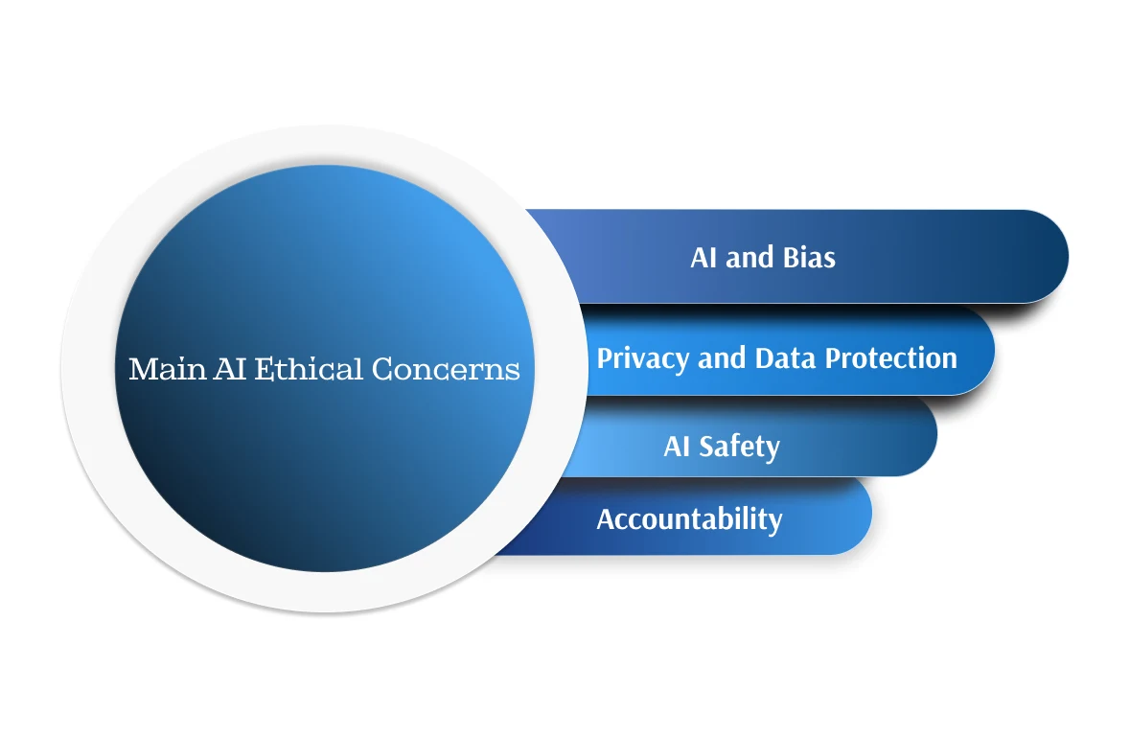
Source: https://litslink.com/blog/ai-regulation
AI is advantageous but comes to question on major important ethical questions. Another important challenge related to the increasing use of AI is problem such as; bias. This negative characterisation can occur when and only when an AI system is designed in a way that embeds and reinforces bias from the training data in these high-risk applications for decision making such as employment, policing and credit risk assessment. He has discovered that when the training data used to feed the AI’s algorithms is biased through some lens, the AI can manifest bias in its operation and end up prejudice against some groups and people in society and a means of perpetuating unfair social disparities. This bias can reduce the level of acceptance and usage of the AI systems and even affect any implementation plans that may be in place. The second emerging one might be Data Privacy. It is common knowledge that in order to operate efficiently AI systems need large volumes of personal information. This generate question on how this data is being gathered, processed, and managed. Pertaining to the confidentiality and security of data, permission must be obtained before data is collected and adequate protection from anyone attempting to breach the privacy of any collected data must be met. Organizations of the world today face the risk of their client data get breached by third parties when adequate data security measures have not been employed as may lead to extortion, or unlawful access to personal details. Another represents a concern of accountability. Who is in accountability of decisions made by AI systems that work on their own is sometimes difficult to define. While some AI algorithms lack transparency, which could be called the problem of the “black box.” It becomes difficult to decipher how entities arrived at certain decisions, hence the process of seeking to pin legal responsibility on such decision makers where certain choices prove unpalatable or detrimental becomes cumbersome. Accountability is essential for complaints to be resolved, and justice to be squarely delivered where AI systems have done wrong.
Figure below represents the black box model of decision making by the AI algorithms that depicts that the end users are unaware about the mechanisms of decisions made that further hinders the transparency which is crucial of ethical and legal compliance. So, there is need to address the issue and develop an explainable and interpretable model of AI.
Figure 3: Black Box and Interpretable AI Model
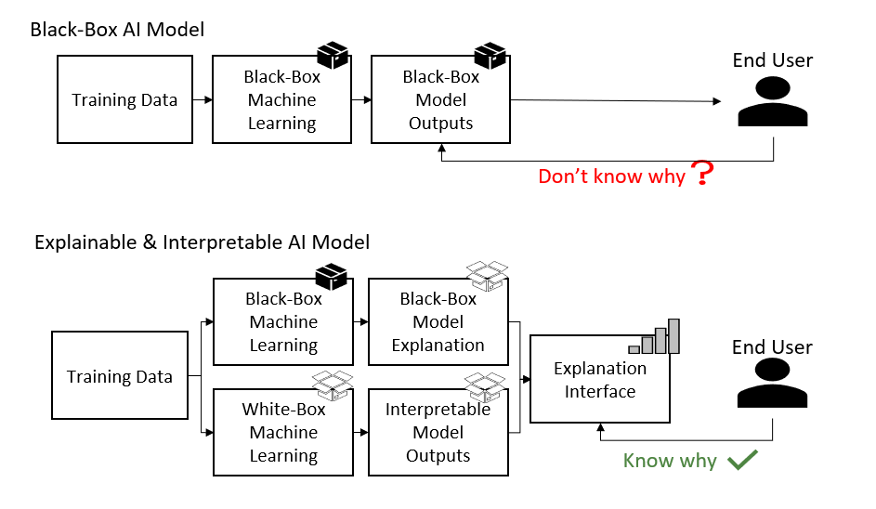
Source: Abnave(2023) https://pub.aimind.so/ethical-considerations-in-ai-and-data-science-navigating-the-complex-landscape-c5809f3584f6
In addition to growing significance for the independence and integration of the AI technologies which are integrated into all areas of daily life, also increased the range of concerns about AI safety. Testing and validation of "due diligence" can be needed to ensure that such systems are at a functional level and do not unintentionally cause harm. In order that AI system causes to not yield undesired outcomes, the AI system shall have to be stable and tolerant over a wide range of contexts and at the same time they shall have to be sufficiently aligned with human values over a particular sense with humans. AI technology should be used in combination with appropriate risk management and safety regulation so that it remains reliable and thus effective at reference levels.
7. Analysis and Interpretation
Table 1: Frequency table for gender wise distribution in sample
Category |  | Frequency | Percent
 | Female | 67 | 52.34
 | Male | 61 | 47.66
 | Total | 128 | 100.0
Source: Author’s compilation
This section illustrates the gender analysis of the sampling of the population with females having a slightly better representation than the male. Female participants are 52.34% with 67, out of 128 while 61 are males, making up 47.66%. This means that the study sample was relatively equally divided between the male and female participants.
Table 2: Frequency table for age wise distribution in sample
Category |  | Frequency | Percent
 | Up to 20 years | 61 | 47.6
 | 21-25 years | 50 | 39.2
 | 26 and above Years | 17 | 13.2
 | Total | 128 | 100.0
Source: Authors’ compilation
This shows that the age distribution of the sample, the largest age group of the participants are of up to 20 years of age taking 47. % of the sample. The least proportion of the sample is the participants aged 26 and above with only 13.2%; the 21-25 years age group has 39.2% participants.

Table 3: Frequency table for educational qualification wise distribution in sample
Category |  | Frequency | Percent
 | Diploma and Other Courses | 20 | 15.6
 | Post Graduate (PG Student) | 48 | 37.5
 | Under Graduate (UG Student) | 60 | 46.9
 | Total | 128 | 100.0
Source: Authors’ compilation
The educational qualification of the participants reveal by table 3 and it was found that the majority of the students are undergraduates, with 60 individuals making up 46.9% of the sample. The second largest group is the postgraduate students, with responses from 48 participants or 37.5%. Diploma and other course takers make up the smallest percentage with 20 or 15.6%.
Reliability & Normality Test
 | Cronbach’s Alpha | Number of items
Artificial Intelligence | 0.854 | 7
Privacy and Safety | 0.705 | 5
Human Laziness | 0.701 | 4
Table 4: Reliability Testing
Source: Authors’ compilation
 | Minimum | Maximum | Mean | Std. Deviation | Skewness | Kurtosis
Artificial Intelligence | 2.00 | 5.00 | 3.9392 | .50437 | -0.253 | 1.459
Privacy and Safety | 2.60 | 5.00 | 4.1721 | .41223 | -0.303 | 1.450
Human Laziness | 2.50 | 5.00 | 4.4063 | .45679 | -0.535 | 1.527
Valid N (listwise)
Table 5: Normality Testing
Source: Authors’ compilation
Internal consistencies of the construct of the study are the measures of reliability. Its reliability will therefore be considered high if the alpha (α) value is above 0.70 (Hair et.al, 2013). Reliability is established internally using Cronbach’s Alpha, while external reliability is determined using item to total correlation. The result summarized in Table 4 indicates that the construct with higher reliability with alpha of more than 0.70. The normality of the data was assessed Skewness and kurtosis as presented the Table 5. In present study 128 participants were considered in the analysis and result has declared that skewness and kurtosis of data is inacceptable range. Skewness: Skewness is measure at +2/-2 from George at Mallery (2010) while Kurtosis is good from the range of -10/+ 10 according to Collier (2020) Therefore on the basis of the results it asserted that all the three variables in this study are normally distributed and therefore fit the regression model for analysis.
Table 6: Descriptive statistics
 | N | Minimum | Maximum | Mean | Std. Deviation
Artificial Intelligence | 128 | 2.00 | 5.00 | 3.9392 | .50437
Privacy and Safety | 128 | 2.60 | 5.00 | 4.1721 | .41223
Human Laziness | 128 | 2.50 | 5.00 | 4.4063 | .45679
Source: Authors’ compilation
Meanwhile, the collected data based on the five-point Likert scale is viewed as interval measurement, while the range of the mean score is perspective on the perception of students regarding rising privacy concerns and human laziness owing to the further introduction of the artificial intelligence. A score of 1 to 1.8 reflects strongly disagree or negative attitude; 1.81 to 2.60 for disagree; 2.61 to 3.40 for neutral; 3.41 to 4.20 for agree or favour towards or for the statement given; 4.21 to 5 is highly agree. As postulated in table six the mean was highly significant mean that majority of the respondents agreed that artificial intelligence has impact on the privacy and also increased the level of laziness among student.
 | AI | PS | LN
AI | 1
PS | .588** | 1
LN | .634** | .318** | 1
Table 7: Correlation Matrix among variables
**. Correlation is significant at the 0.01 level (2-tailed). (Authour’s compilation)
In order to assess relationship among variables correlation matrix was computed and results are presented in Table 7, Artificial intelligence is positively related with the privacy and Safety(r=.588, p=.000) and human laziness (r=.634,p=.000). The correlation cofficient for aAI and PS is .588 which indicates moderate positive relationship it means greater the use of artificial intelligence leads to the rise of privacy and safety concerns among individuals. Similarly, the corrrelation cofficient between AI & LN is .634 with p value less than 0.01 indicates that there is high correlation which is satisticaaly significant. Thus, it is concluded that Artificial intelligence in positively related with the privacy concerns and laziness in individuals.

Hypothesis Testing
In our study we have investigated the impact of using AI on privacy and human laziness, linear regression model was adopted to test the hypotheses and to assess the extent of AI’s impact on rising privacy concerns and making humans lazy. Table 8 depicts that both hypotheses are supported, as model shows direct relationship between the variables. The first direct relationship is between artificial intelligence to privacy & security issues with the beta value 0.588 and R² .346. The beta shows that a one-unit increase in artificial intelligence will increase security and privacy issues by 0.588 among university students. This relationship having t value 8.164 that is greater than the threshold value 1.96 amd p value is 0.000 < 0.05 which confirms that the relationship is statiscally significant.
The another direct relationship shown in Table 8, between artificial intelligence and human laziness with beta value 0.534, which states that one unit increase in tha AI will make the students lazy by 0.534 units. The t value for this relationship is 7.089, which is greater than the threshold limit and p value 0.000 that is less that spcified limit of 0.05 that means the relationship is statistically significant
Table 8: Regression Analysis
Hypothses | Regression weight | Beta Cofficient | R² | F | t-value | p-value | Hypotheses Supported
H₁ | AI PS | .588 | .346 | 66.644 | 8.164 | .000 | Yes
H₂ | AI LN | .534 | .295 | 50.235 | 7.089 | .000 | Yes
Source: Authors’ compilation
Note: *p<0.05. AI: Artificial Intelligence(Predictor),PS: Privacy&Safety(Dependent Variable),HL:Human Laziness(Dependent Variable)
Hence, it may be concluded that the predictors, i.e., privacy safety and human indolence, were influenced by the predictor of artificial intelligence. The study hypothesis, which posits that AI is highly relevant to safety and privacy and also to human sloppiness, was retained. As shown by our research, which is in accord with the empiricist results of earlier research (Ahmad et al., 2023), AI is effective on mitigating the human aversion to work and privacy issues. This shows that students have become unmotivated and are also not comfortable with their privacy while using artificial intelligence increasing. So, both the hypotheses of our study is accepted.
H₁: Artificial intelligence significantly impacts students' security and privacy. | Accepted
H₂: Artificial intelligence significantly contributes to increased laziness among students. | Accepted
8. Conclusion and Recommedations
Through AI (Artificial Intelligence) a lots of possibilities are available to achieve deep change in activity and improved quality of life of people, but it also involves great ethical issues that must be solved. Privacy erosion has now become an inseparable problem because AI algorithms are very sensitive to individual information and, in most cases, they do not apply the right guardrails to adequately protect the privacy of users. With the continuing ubiquity of use of these systems, the susceptibility to unauthorized access and exploitation of biometric data also increases and so does the need for more robust regulatory guidelines and ethical charters. As AI technology spreads even to more students, students become indolent and lethargic. The application of AI to education is also potentially profound. Although it is not too modest to say that the positive consequences of gaining relief from many academic and administrative tasks and a duty education are very much in hand, the negative sides of sloth and security are not to be lightly dismissed. While it can automate some of the process as the learner makes a number of learning decisions, it can also be used to augment decision making and hence the activity of the educator and the learner. All this complicates when the use of AI in education applications increases because of the increasing application of AI to automate tasks and reasoning approaches in education pedagogical content creation.When applying AI to automate tasks and decision making approaches, AI can reduce human efforts and interventions to produce a reduction in critical thinking and problem solving capabilities. Unsurprisingly, the fact is that machine intelligence (AI) can better maximise efficiency, but in so doing, it becomes at least as important to make a virtue of generating an appropriate balance between promoting human engagement with, and active learning from, technology, where technology is precisely technology as opposed to human capabilities, on which to improve, rather than restrict, human abilities. [I] Addressing the ethical challenge at the heart is critical if its integrity as a revolutionary technological force is to be preserved alongside those fundamental values and rights that constitute humankind.
Thus, it is seen that to tackle the ethical issues consequent of Artificial Intelligence, a multiple layered solution is needed.Government should enforcing more stricter laws that is enhancing data privacy regulations that in turn helps in transparency and safe collection of personal data. laws that is strengthening data privacy regulations which further ensure transparency and secure handling of personal data. Organizations which embrace the use of ethical AI development practices should be committed to user privacy and fairness ainsi qu’à la transparence. It is therefore important that management of AI also entail the encouraging to responsibly implement AI; to make users and organizations understand and embrace the known bounds of AI so as promote AI in a manner that in effect enhances the user’s cerebral faculties and not the juxtapose. Promoting human–AI collaboration should assist in keeping humans involved as well as developing AI to co-support rather than replace all work processes. Last of which, the creation of accountability will fix culpability when AI systems are involved in creating harms or violations of user privacy while adhering to norms of ethical and legal perspectives. Through the steps outlined above then, society will be able to mitigate the ethical impacts of AI, especially in the areas of privacy, within the general context of ensuring that information technology remains useful in society in an appropriate manner.

Conflict of Interest Statement
The authors declare that the research was conducted without any financial link that may lead to conflicts.
References
Ahmad, S. F., Han, H., Alam, M. M., & et al. (2023). Impact of artificial intelligence on human loss in decision making, laziness and safety in education. Humanities and Social Sciences Communications, 10(1), 311. https://doi.org/10.1057/s41599-023-01787-8
Bhalla, N., Brooks, L., & Leach, T. (2023). Ensuring a ‘responsible’ AI future in India: RRI as an approach for identifying the ethical challenges from an Indian perspective. AI Ethics. https://doi.org/10.1007/s43681-023-00370-w
Camilleri, M. A. (2024). Artificial intelligence governance: Ethical considerations and implications for social responsibility. Expert Systems, 41(7), e13406. https://doi.org/10.1111/exsy.13406
Cardona, M., Rodríguez, R., & Ishmael, K. (2023). Artificial intelligence and the future of teaching and learning: Insights and recommendations.
Carmody, J., Shringarpure, S., & Van de Venter, G. (2021). AI and privacy concerns: A smart meter case study. Journal of Information, Communication and Ethics in Society, 19(4), 492-505. https://doi.org/10.1108/JICES-04-2021-0042
Farhud, D. D., & Zokaei, S. (2021). Ethical issues of artificial intelligence in medicine and healthcare. Iranian Journal of Public Health, 50(11), i-v. https://doi.org/10.18502/ijph.v50i11.7600
Fülöp, M. T., Topor, D. I., Ionescu, C. A., Cifuentes-Faura, J., & Măgdaș, N. (2023). Ethical concerns associated with artificial intelligence in the accounting profession: A curse or a blessing? Journal of Business Economics and Management, 24(2), 387–404. https://doi.org/10.3846/jbem.2023.19251
Gocen, A., & Aydemir, F. (2020). Artificial intelligence in education and schools. Research in Educational Media, 12(1), 13–21. https://doi.org/10.2478/rem-2020-0003
Jackaria, P. M., Hajan, B. H., Mastul, A. H., & Sali, F. Z. (2024). Generation AI in a reimagined classroom: Challenges, opportunities and implications to education. In Exploring Youth Studies in the Age of AI (pp.174-185). https://doi.org/10.4018/979-8-3693-3350-1.ch009 ISBN: 979-836933351-8, 979-836933350-1
Karandish, D. (2021). 7 benefits of AI in education. The Journal. https://thejournal.com/Articles/2021/06/23/7-Benefits-of-AI-in-Education.aspx
Khan, S., & Rabbani, M. R. (2020). Artificial intelligence and NLP-based chatbot as Islamic banking and finance expert. International Journal of Information Retrieval Research, Special Issue: Optimization and Convergence of Machine Learning Algorithms Leveraging IoT, Blockchain, and Artificial Intelligence.
Krakauer, D. (2016). Will AI harm us? Better to ask how we’ll reckon with our hybrid nature. Nautilus. http://nautil.us/blog/will-ai-harm-us-better-to-ask-how-well-reckon-withour-hybrid-nature
Rainie, L., Anderson, J., & Vogels, E. A. (2021). Experts doubt ethical AI design will be broadly adopted as the norm within the next decade. Pew Research Center.
Sarwat, S. (2018). Is AI making humans lazy? Here’s what UAE residents say. Khaleej Times. https://www.khaleejtimes.com/nation/dubai/Is-AI-making-humans-lazy-Here-what-UAE-residents-say
Sayantani. (2021). Is artificial intelligence making us lazy and impatient? IndustryWired. https://industrywired.com/is-artificial-intelligence-making-us-lazy-and-impatient/
Tahiru, F. (2021). AI in education: A systematic literature review. Journal of Cases on Information Technology, 23(1), 1–20. https://doi.org/10.4018/JCIT.2021010101
https://www.fortanix.com/blog/confidential-computing-ai-to-overcome-data-privacy-challenges
https://www.shiksha.com/online-courses/articles/ai-and-privacy-balancing-need-for-data-and-privacy-rights/
https://www.ibm.com/topics/artificial-intelligence
https://www.xenonstack.com/blog/ethical-ai-challenges-and-architecture

