The Rise of Coffee Culture: Exploring Consumer Purchase Intention Through the Theory of Planned Behavior

Abstract

This study investigates the determinants of coffee purchase intention among working adults by applying and extending the Theory of Planned Behavior (TPB). Although TPB has been widely used to explain behavioural intention, its application in routine consumption settings such as coffee purchasing remains relatively underexplored, particularly regarding the role of personal characteristics. To address this gap, this study integrates personal factors (age, lifestyle, and economic status) into the TPB framework alongside attitude, subjective norms, and perceived behavioral control to provide a more comprehensive explanation of coffee purchase intention. A quantitative, cross-sectional design was adopted. Data were collected from 221 coffee consumers aged 18 years and above using a structured online questionnaire. Measurement items were adapted from established scales, and the data were analysed using SPSS through descriptive statistics, reliability analysis, Pearson correlation, and multiple regression techniques. The findings reveal that attitude, subjective norms, perceived behavioral control, and personal factors all significantly influence coffee purchase intention. The results indicate that coffee purchasing decisions are shaped not only by psychological and social determinants but also by consumers’ lifestyle orientations and economic capacity. Theoretically, this study extends TPB by empirically validating the relevance of personal factors in explaining purchase intention within a contemporary consumption context. Practically, the findings offer meaningful insights for coffee businesses seeking to design marketing strategies aligned with consumers’ behavioural drivers and lifestyle preferences.

Keywords: Theory of Planned Behavior, coffee purchase intention, personal factors, attitude, subjective norms, perceived behavioral control.

Introduction
Coffee has established itself as one of the world's most cherished beverages and the second best-selling product globally, with Malaysia experiencing particularly rapid growth in consumption as coffee shops become integral to daily life and modern urban culture (Ali et al., 2021; Buranananont et al., 2022; Salmiah et al., 2023). Among Malaysians, coffee purchasing has increased markedly across millennials, teenagers, and professionals, transforming coffee consumption into a symbol of status, experience, and lifestyle (Ronald et al., 2023; Putithanarak et al., 2022). This growth trajectory is reflected in market projections, with revenue expected to reach USD9 million by 2024 and expand at an annual rate of 8.43% through 2029, while per capita consumption is forecast to rise from approximately 110 cups in 2025 to over 140 cups by 2030, driven by urbanization, café culture expansion, and evolving preferences among Millennials and Generation Z (Statista Research Department, 2023; 17 Gram Beans, 2025). Despite this growing cultural and economic significance, research on consumer behavior within Malaysia's coffee industry remains limited, particularly regarding the integration of personal factors with established behavioral theories; while several studies have applied the Theory of Planned Behavior (TPB) to examine coffee consumption, most have focused on standard TPB components without adequately addressing how individual characteristics such as age, lifestyle, and economic status interact with psychological determinants to shape purchase intentions (Yahya et al., 2022; Samoggia & Riedel, 2019). This study addresses this gap by extending the TPB framework to include personal

1

factors, offering a more comprehensive understanding of what motivates coffee consumption in Malaysia's evolving sociocultural landscape.

Literature Review

Purchase Intention

Purchase intention, defined as the likelihood that a consumer will purchase a specific product or service, is a critical metric for businesses to forecast sales and analyze behavior, representing a cognitive predisposition that may subsequently manifest as actual purchasing action (Abdul Rahim et al., 2019; Kwak et al., 2022). Shaped by a complex interplay of personal preferences, brand image, past experiences, price sensitivity, marketing efforts, and social influence, this intention is theoretically framed within the Theory of Planned Behavior (TPB) as being determined by attitudes, perceived behavioral control, and subjective norms (Ajzen, 1991; Agriqisthi et al., 2023). A high purchase intention signals a strong alignment between consumer demands and perceived product value, whereas low intention indicates barriers or unfavorable perceptions necessitating strategic intervention (Dionysis et al., 2021). Its significance in consumer research, particularly for understanding behavior in dynamic categories like coffee consumption, lies in its role as a proximal predictor of actual purchase, encompassing consumers' willingness, decisions, and plans (Buranananont et al., 2022; Gaji et al., 2022; Yahya et al., 2022). Although the complexity of purchase decisions involves analyzing product knowledge, comparing alternatives, and evaluating attitudes (Salmiah et al., 2023), and while intention does not always guarantee action, its robust theoretical grounding makes it an appropriate dependent variable for this study, consistent with established TPB research practices.

Personal Factor

In consumer behavior theory, personal factors which comprising inherent attributes such as demographic characteristics (e.g., age and income), lifestyle patterns, psychological elements (e.g., motivation and attitudes), and social influences collectively shape an individual’s identity and decision-making processes, significantly impacting purchasing intentions and consumption patterns (Qureshi et al., 2023; Aziz et al., 2022). Research has demonstrated that these factors drive consumption intentions through both utilitarian considerations and subjective norms (Samoggia et al., 2021), with lifestyle and personal preferences playing a particularly influential role in categories such as coffee intake, especially among younger consumers (Utama et al., 2021). Demographic variables like age and income not only determine consumers' purchasing capacity but also shape their preferences for specific coffee products (Norazami et al., 2025), while lifestyle and economic status guide consumption choices and discretionary spending on premium offerings (Yahya et al., 2022; Mohammed, 2024). Given that social, personal, and psychological factors collectively influence consumer decisions regarding coffee brands with age, lifestyle, and economic status emerging as especially impactful variables (Yahya et al., 2022) this study focuses specifically on these three personal factors. Age shapes cognitive capacities and social responsibilities, lifestyle encompasses the habitual behaviors and routines that influence well-being, and economic status determines access to resources and consumption opportunities, together providing a comprehensive framework for understanding how individual characteristics interact with psychological determinants to guide coffee purchasing decisions..

    - Age

Age, as a fundamental demographic variable quantifying an individual's life stage, profoundly shapes consumer behavior through generational cohort characteristics such as those of baby boomers, Generation X, millennials, and Generation Z, each exhibiting distinct consumption patterns informed by shared socio-cultural experiences (Fitria et al., 2024; Zamborita et al., 2024). Generation Z, as digital natives, display behaviors driven by FOMO (fear of missing out) and a pursuit of psychological fulfillment through social connectivity, while younger millennials gravitate toward high-quality "craft" coffee as a medium for individualization and self-expression, prompting coffee companies to emphasize flavor, freshness, and experiential enjoyment in targeting these groups (Fitria et al., 2024; Zamborita et al., 2024). Beyond generational identity, age influences consumer decision-making through its direct impact on physical and cognitive capacities, health considerations, and evolving social responsibilities, with research confirming that age and lifecycle stage significantly shape buying intention and position age as a critical personal attribute affecting purchasing behavior (Yahya et al., 2022). Furthermore, age-related experiences and convictions can mediate how consumers evaluate perceived risks and engage in ethical decision-making, demonstrating that age not only determines product preferences but also the cognitive processes underlying those choices (Hein, 2022). In the coffee consumption context, a nuanced understanding of these age-based differences enables marketers to tailor strategies to the distinct motivations, preferences, and behavioral patterns characteristic of each generational cohort, thereby enhancing the relevance and effectiveness of their offerings.Therefore, this leads to the first hypothesis (H1a) of this study:

H1a: There is a positive relationship between age and purchase intention.
2

    - Lifestyle

Lifestyle, defined as the comprehensive pattern of how individuals live through their activities, habits, and daily routines, reflects their beliefs, values, and socioeconomic standing while manifesting in choices regarding eating habits, physical exercise, work, leisure, and social connections (Aziz et al., 2022). In the context of coffee consumption, lifestyle factors play a particularly significant role, as caffeine intake patterns vary systematically with sociodemographic characteristics such as age, education level, and marital status (Bawazeer et al., 2024), with research consistently demonstrating that these lifestyle factors exert the strongest influence on coffee consumption preferences, surpassing even health considerations and sensory appeal (Utama et al., 2021). This is evident in the transformation of coffee shops from mere beverage outlets into vibrant social spaces where people gather, network, and share experiences, particularly among younger generations (Az-Zahrah et al., 2025; Zamborita et al., 2024). For contemporary consumers, especially millennials and Generation Z, coffee consumption has evolved into a significant lifestyle indicator representing both individual preferences and broader cultural phenomena (Nurrahma & Sudarmiatin, 2025), with café visits serving as a lifestyle practice encompassing collaborative workspaces, social gathering venues, and environments for meeting personal needs - extending beyond mere consumption to express identity, allocate time and money, and pursue self-discovery (Aziz et al., 2022). This strong connection is reflected in consumer preferences for brands that align with their way of life, where product quality and availability further reinforce purchasing decisions (Hapsari et al., 2023; Yahya et al., 2022). Consequently, coffee has transcended its status as a mere beverage to become associated with positive experiences, high-quality living, and social standing (Czarniecka-Skubina et al., 2021), and although not a fundamental consumer need, it has become so integrated into many people's lifestyles that it is challenging to relinquish (Agriqisthi et al., 2023). This lifestyle-driven consumption pattern is reflected in Malaysia's projected coffee market growth, with revenue expected to increase from RM4.9 billion in 2025 to RM6.6 billion by 2030, driven by shifting lifestyle patterns including heightened consumption among younger demographics, increasing preference for specialty café experiences, and adoption of premium at-home brewing practices (17 Gram Beans, 2025; Maciejewski et al., 2020). Thus the following hypothesis (H1b) of the study was designed as below:

H1b: There is a positive relationship between lifestyle and purchase intention.

    - Economic Status

Economic status, reflecting an individual's financial and social standing through income, occupation, and education, fundamentally shapes consumption behavior by determining resource access and quality of life (Lone et al., 2023). Higher income expands consumer choices and enhances life satisfaction, while lower economic status can limit opportunities and perpetuate disadvantage (Livingston et al., 2022; Dimitri, 2024; Nutakor et al., 2023). In coffee consumption, economic status manifests through varied purchasing patterns - young Malaysians, even infrequent buyers, occasionally splurge on branded coffee, reflecting preferences tied to economic capability (Ali et al., 2021). Consumers often equate higher prices with superior quality, purchasing premium products as markers of economic standing (Putithanarak et al., 2022; Kim et al., 2023), and as coffee culture evolves, customers increasingly seek quality, atmosphere, and service. Conversely, those with limited income exhibit greater price sensitivity, treating coffee as an unaffordable luxury and prioritizing essential needs (Az-Zahrah et al., 2025; Agriqisthi et al., 2023). Economic disruptions like the COVID-19 pandemic further illustrate how constrained finances directly limit coffee purchasing despite strong social media engagement, underscoring that economic status fundamentally shapes consumption possibilities and priorities (Nugroho et al., 2024). Accordingly, H1c constitutes as the hypothesis of this study:

H1c: There is a positive relationship between economic status and purchase intention.

Attitude

Attitude, as a psychological construct within the Theory of Planned Behavior, represents an individual's degree of favor or disfavor toward a particular behavior, encompassing cognitive (beliefs), affective (emotions), and behavioral (action tendencies) components that develop through direct experience, social interactions, and cultural norms, ultimately serving as a powerful predictor of intentions and actions across various contexts (Ajzen, 1991; Veenarat et al., 2021; Pascual et al., 2020; Wibowo et al., 2022). In the context of coffee consumption, empirical evidence strongly supports the significant relationship between attitude and purchase intention, with studies examining specialty coffee among Brazilian consumers revealing that attitudes toward behavior significantly predict purchase intention, often outweighing the influence of social pressures (Correa et al., 2020). Consumer opinions about coffee products, whether favorable or unfavorable, directly shape purchasing decisions, as positive attitudes lead to stronger intentions to buy while negative attitudes result in avoidance behaviors (Khaliqi et al., 2021; Kim et al., 2023). Research has documented statistically significant effects of attitude on intentions to purchase
3

both instant coffee and specialty coffee, confirming that consumers must hold positive evaluations before forming purchase intentions (Gaji et al., 2022; Correa et al., 2020). For coffee businesses, cultivating positive customer attitudes through satisfying experiences, quality products, and favorable relationships can enhance customer satisfaction and strengthen purchase intentions, demonstrating the practical importance of understanding and assessing attitudes in consumer behavior research (Pratama et al., 2023). Hence, a hypothesis was formed as H2 below:

H2: There is a positive relationship between Attitude and Purchase Intention

Subjective Norms

Subjective norms, as conceptualized within the Theory of Planned Behavior, refer to the perceived social pressures and expectations from significant others such as family, friends, and broader society that shape an individual's behavioral decisions, arising from normative beliefs about what referents think one should do and the motivation to comply with those expectations (Ajzen, 1991; Kim et al., 2023; Pascual et al., 2020; Samoggia et al., 2021). These perceived social forces significantly influence consumer behaviors, including coffee shop patronage and caffeine consumption, particularly through direct social invitations and peer influences, with young consumers and adolescents being especially susceptible as they often find it difficult to decline social gatherings at coffee shops (Pratama et al., 2023; Lee & Kim, 2020; Agriqisthi et al., 2023). Research confirms that subjective norms serve as significant predictors of behavioral intention, though typically exhibiting weaker effects compared to attitudes within the TPB framework (Veenarat et al., 2021; Correa et al., 2020). When consumers visit coffee shops, they actively seek validation from others regarding the worthiness of the establishment, and recommendations from influential others substantially impact their decisions (Pratama et al., 2023). Gaji et al. (2022) found that subjective norms directly affect purchase intention, highlighting that beyond its habitual nature, coffee drinking carries important social value across home, work, and social contexts. The influence of subjective norms may be amplified when consumption becomes publicly visible, suggesting that brand identification and conspicuous consumption can strengthen social pressures on purchase intentions (Correa et al., 2020), underscoring the particular importance of understanding subjective norms in collectivist societies where social expectations and group conformity heavily shape lifestyle-related consumption decisions. Hypothesis H3 therefore was formed as below:

H3: There is a positive relationship between Subjective Norms and Purchase Intention.

Perceived Behavioral Control

Perceived behavioral control (PBC), a key construct in the Theory of Planned Behavior, refers to an individual's perception of how easy or difficult it is to perform a specific behavior, shaped by beliefs about available resources, potential obstacles, and the perceived influence of these factors on action (Ajzen, 1991, 2020; Pascual et al., 2020). Informed by prior experience and secondhand information, PBC encompasses internal factors such as skills and confidence, as well as external constraints like time, money, and accessibility (Samoggia et al., 2021; Veenarat et al., 2021). In coffee consumption research, PBC alongside attitude and subjective norms significantly predicts purchase intention; individuals who believe they have the necessary time, financial means, and confidence tend to form stronger intentions to purchase (Correa et al., 2020; Agriqisthi et al., 2023; Veenarat et al., 2021). Conversely, when perceived control is low, even positive attitudes may not translate into actual behavior, often leading to avoidance (Kim et al., 2023). Practical considerations such as travel convenience to coffee shops, availability of disposable income, and confidence in decision-making all contribute to PBC (Pratama et al., 2023). Given its consistent and substantial association with purchase intention, PBC plays a crucial role in bridging favorable dispositions and actual behavioral execution in the coffee industry. Accordingly, H4 is advanced as the fourth hypothesis of this study.

H4: There is a positive relationship between Perceived Behavioral Control and Purchase Intention.

4

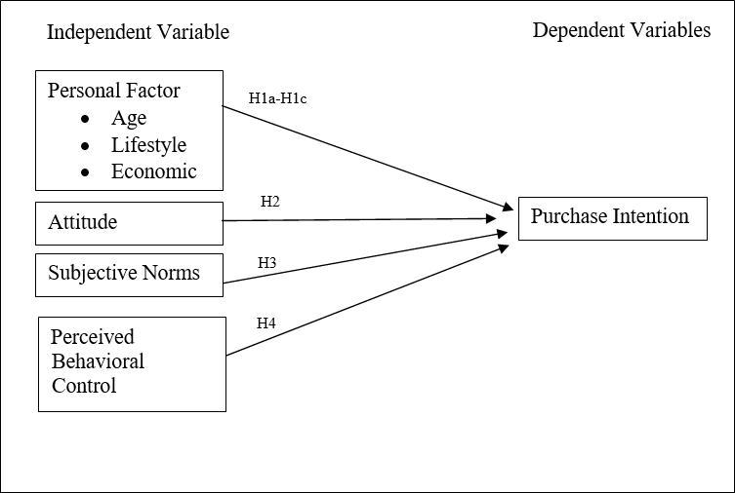

Figure 1: The Research Framework

Research Methodology
This study employed a quantitative, cross-sectional research design to examine the factors influencing coffee purchase intention among Malaysian consumers, utilizing the Theory of Planned Behavior as the theoretical framework. The target population comprised working adults aged 18 years and above who are coffee consumers, selected due to their financial independence and purchasing autonomy. Using G*Power analysis, a minimum sample size of 146 was required; however, 221 valid responses were ultimately retained after data cleaning, exceeding the minimum requirement. Convenience sampling was employed as the sampling technique due to practical constraints of time and accessibility, allowing for efficient data collection from readily available participants. Data were collected through a structured online questionnaire distributed via Google Forms over four weeks, from November 19 to December 15, 2024. The instrument comprised three sections: Section A gathered demographic information, while Sections B and C measured purchase intention and the independent variables (attitude, subjective norms, perceived behavioral control, age, lifestyle, and economic status) using five-point Likert scales adapted from established sources including Brandauer (2024), Mohammed (2024), Agriqisthi et al. (2023), Hagger et al. (2022), Yahya et al. (2022), and Veenarat et al. (2021). Content validity was established through expert panel review comprising an academician, an industry professional, and a coffee consumer, while reliability was confirmed through Cronbach's alpha coefficients ranging from 0.781 to 0.942, all exceeding the acceptable threshold of 0.70. A pilot study with 54 respondents was conducted to refine the questionnaire, leading to improvements in clarity and age categorization. Ethical approval was obtained from the institutional review board on November 4, 2024, ensuring voluntary participation, informed consent, and confidentiality. Data analysis was performed using IBM SPSS Version 29, employing frequency analysis, descriptive statistics, normality testing, Pearson correlation analysis, and multiple regression analysis to test the hypothesized relationships.

5

Results
The data were analyzed using descriptive statistics, correlation analysis, and multiple regression analysis to address the research objectives examining factors influencing coffee purchase intention among Malaysian consumers. Descriptive analysis was employed to summarize the survey responses and characterize the demographic profiles of the 221 respondents, providing an overview of sample characteristics including age distribution, gender composition, educational attainment, marital status, income levels, and coffee consumption frequency. Correlation analysis was conducted to test the hypothesized relationships between the independent variables - attitude, subjective norms, perceived behavioral control, age, lifestyle, and economic status and the dependent variable of purchase intention, determining both the strength and statistical significance of these associations. Subsequently, multiple regression analysis was utilized to evaluate the predictive power of the independent variables on purchase intention, assessing the unique contribution of each factor while controlling for the effects of other variables in the model, thereby providing insights into the relative importance of psychological and personal determinants in shaping consumers' coffee purchasing intentions.

Profile of Respondents
Table 1 summarizes the respondents’ demographic profiles. The demographic data reveals that the majority of respondents were aged 29-45 years (46.6%), female (67.0%), held a bachelor's degree (58.8%), were married (52.5%), and earned between MYR3,001-MYR6,000 (33.5%). Regarding coffee consumption, 46.2% consumed 1-2 cups daily, indicating moderate consumption as the most common trend.

Table 1: Respondent Demographics
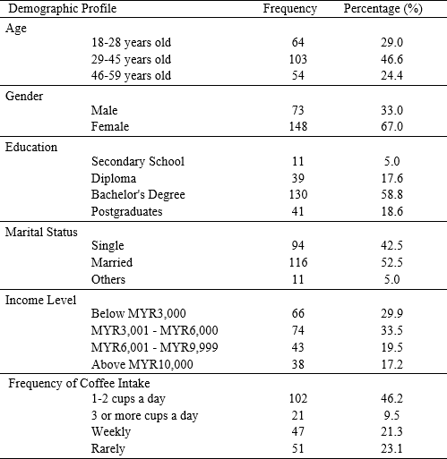

Descriptive Statistics Results
Table 2 summarizes the descriptive analysis revealed that perceived behavioral control recorded the highest mean score (Mean=4.01, SD=0.78), indicating that respondents perceived substantial autonomy, accessibility, and confidence in their ability to purchase coffee according to their preferences. Purchase intention demonstrated a moderate positive level (Mean=3.49, SD=1.14), suggesting that consumers generally hold favorable dispositions toward purchasing coffee, though they may not exert excessive effort to do so. Among the Theory of Planned Behavior components, attitude (Mean=3.27, SD=1.06) and subjective norms (Mean=3.14, SD=1.03) exhibited moderate mean scores, reflecting that while consumers hold positive evaluations of coffee purchasing and acknowledge some social influence, these factors are not overwhelmingly
6

strong. Regarding personal factors, age showed the highest mean (Mean=3.45, SD=1.04), indicating that respondents recognize age as a relevant factor in their coffee consumption decisions, particularly regarding spending capacity and brand evaluation. Conversely, lifestyle (Mean=2.78, SD=1.15) and economic status (Mean=2.30, SD=1.17) recorded lower mean scores, suggesting that respondents do not strongly associate their coffee consumption with lifestyle identity or status-seeking behavior, nor do they perceive their purchasing habits as highly sensitive to economic fluctuations.

Table 2: Respondent Demographics
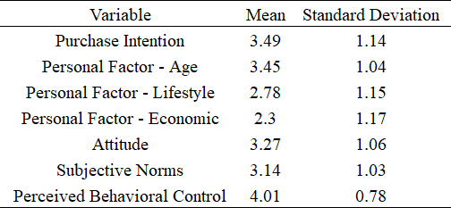

Reliability Analysis
Reliability was assessed using Cronbach's Alpha coefficient to determine the internal consistency of the measurement scales. According to Bougie and Sekaran (2019), Cronbach's alpha values exceeding 0.70 are considered acceptable for social science research. The reliability analysis revealed that all constructs demonstrated high internal consistency, with Cronbach's alpha values ranging from 0.781 to 0.942. Purchase intention (α=0.942), attitude (α=0.937), subjective norms (α=0.914), and the personal factors of age (α=0.912), lifestyle (α=0.910), and economic status (α=0.915) all exhibited excellent reliability, while perceived behavioral control (α=0.781) remained within the good range, confirming the overall robustness of the measurement instruments. A pilot study conducted with 54 coffee consumers further enhanced the questionnaire's clarity and accuracy, leading to refinements in age categorization and question phrasing prior to full-scale data collection.

Table 3: Reliability Test Results
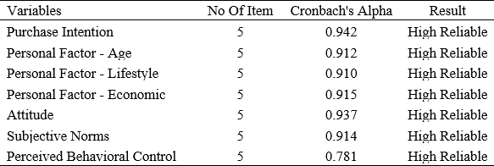

Relationship between variables
Pearson correlation analysis was conducted to examine relationships between independent variables and purchase intention. The correlation analysis revealed that all six hypothesized relationships were statistically supported, confirming that each independent variable significantly relates to coffee purchase intention. Among all factors, attitude demonstrated the strongest positive correlation with purchase intention (r = 0.817, p < 0.01), indicating that consumers who hold favorable evaluations and positive feelings toward coffee purchasing are substantially more likely to form strong intentions to buy. Subjective norms also showed a strong positive correlation (r = 0.660, p < 0.01), suggesting that social influences from family, friends, and significant others play an important role in shaping consumers' coffee purchasing decisions. Among the personal factors, economic status exhibited the strongest correlation (r = 0.504, p < 0.01), highlighting that financial capacity and disposable income significantly influence consumers' intention to purchase coffee. Age demonstrated a moderate positive correlation (r
= 0.395, p < 0.01), indicating that life stage and generational differences contribute to varying coffee consumption patterns. Perceived behavioral control showed a moderate positive correlation (r = 0.353, p < 0.01), reflecting that consumers' perceptions of their ability to access, afford, and control their coffee purchasing behavior positively influence their intentions. Lifestyle, while demonstrating the weakest correlation among the variables (r = 0.306, p < 0.01), still showed a significant

7

positive relationship, confirming that daily routines, social activities, and personal interests shape coffee consumption intentions, albeit to a lesser degree than other factors.

Table 4: Pearson’s Correlation
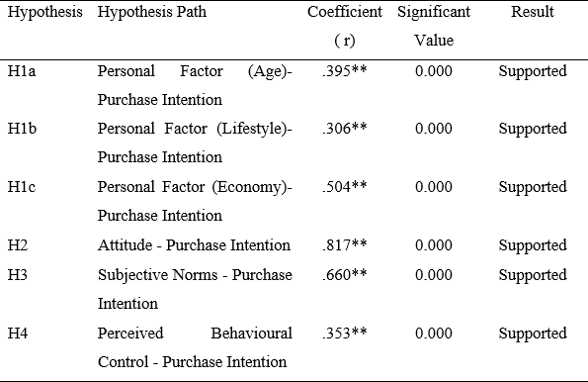

Regression Analysis
Multiple regression analysis was conducted to examine the predictive power of the independent variables (attitude, subjective norms, perceived behavioral control, age, lifestyle, and economic status) on coffee purchase intention. The regression analysis produced a statistically significant model (F = 76.907, p < 0.001) that explained 67.4% of the variance in coffee purchase intention, indicating that the six predictors collectively exert a strong influence on consumers' purchasing decisions. Attitude emerged as the most powerful predictor (β = 0.719, p < 0.001), showing that consumers with favorable views toward coffee are far more likely to intend to purchase it. Perceived behavioral control also contributed significantly (β = 0.108, p = 0.013), suggesting that consumers who feel they have the time, money, and access needed to buy coffee are more inclined to do so. Interestingly, subjective norms and all three personal factors - age, lifestyle, and economic status did not show significant predictive power in the regression model, even though they were significantly correlated with purchase intention in the earlier analysis. This pattern suggests that these variables may influence purchase intention indirectly through attitude and perceived behavioral control, rather than directly. In other words, factors like age, lifestyle, and social pressure may shape how consumers develop their attitudes and sense of control, which in turn drive their actual purchase intentions.

Table 5: Multiple Regression Analysis Results
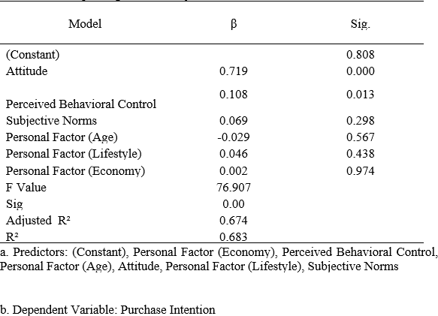
8

Discussion and Conclusion
This study presents the key findings from an analysis of factors influencing coffee purchase intention within Malaysia’s expanding coffee culture, framed by the Theory of Planned Behavior (TPB). The study achieved its first objective by establishing that consumers demonstrate a moderate yet positive level of purchase intention (mean = 3.49), though the lower score for willingness to exert effort (mean = 3.09) underscores the critical role of convenience in purchasing decisions (Fahlevi et al., 2024). Addressing the second objective, statistical analysis revealed that all examined personal factors - age (r = .395, p < .01), lifestyle (r = .306, p < .01), and particularly economic status (r = .504, p < .01) demonstrate significant positive relationships with purchase intention. These findings align with prior research indicating that urban consumers in the 29–45 age range, those with socially active lifestyles, and individuals with greater financial capacity exhibit higher coffee purchase intentions (Yahya et al., 2022; Djamaludin & Silmie, 2021; Leo et al., 2018). Regarding the core TPB constructs, attitude emerged as the most influential predictor of purchase intention (r = .817, p < .01), consistent with Bhutto et al. (2022), followed by subjective norms (r = .660, p < .01) and perceived behavioral control (r = .353, p < .01), thereby confirming the significant relationships hypothesized in objectives three through five and supporting recent findings in comparable Asian markets (Khaliqi et al., 2021; Wu et al., 2025).

The study's integration of personal factors with traditional TPB components yields meaningful implications for consumers, businesses, and future research directions. For individual consumers, understanding how age, lifestyle, and economic status interact with psychological drivers enables more conscious consumption choices. From a business perspective, this multidimensional framework supports more effective customer segmentation and targeted marketing strategies by revealing how different demographic groups form purchase intentions. The research identifies several avenues for future investigation, including extending the focus from purchase intention to actual purchase behavior, examining moderating effects of personal factors within Malaysia's diverse socioeconomic landscape, and testing mediating effects through structural equation modeling (Kristiyani et al., 2025). Longitudinal designs and cross-regional comparisons across Peninsular Malaysia, Sabah, and Sarawak are recommended to capture evolving consumption patterns, particularly among emerging segments such as health-conscious consumers and sustainability-driven millennials (World Coffee Portal, 2024; Sinar Daily, 2025). As Malaysia's coffee culture continues to evolve in response to post-pandemic behavioral shifts, this research provides a valuable theoretical and practical foundation for understanding and responding to changing consumer preferences.

Acknowledgment
The authors would like to sincerely thank the members of the study and the Faculty of Business and Management, Universiti Teknologi MARA, for the opportunities given to complete this research. The assistance and encouragement provided are deeply valued and gratefully acknowledged.

References
  - Abd Rahim, F., Cheah, L. F., & Jin, G. (2019). Malaysian coffee culture: Attributes considered to purchase coffee beverages. Journal of Marketing Advances and Practices, 1(1).
  - Agriqisthi, Nasrah, R., & Saludin, M. N. (2023). The trend of women enjoying coffee: Coffee shop consumption behaviour model during the pandemic and after the COVID-19 pandemic based on the theory of planned behaviour. Journal of Management Scholarship, 2(1). https://doi.org/10.38198/JMS/2.1.2023.5
  - Ajzen, I. (1991). The theory of planned behavior. Organizational Behavior and Human Decision Processes, 50(2), 179–211.
  - Ajzen, I. (2020). The theory of planned behavior: Frequently asked questions. Human Behavior and Emerging Technologies, 2(4), 314–324. https://doi.org/10.1002/hbe2.195
  - Az-Zahrah, N., Junipriansa, D., & Widokarti, J. R. (2025). Determinants of green purchase behavior of local coffee shop: The moderating impact of price sensitivity. Journal of Consumer Sciences, 10(1), 97–117. https://doi.org/10.29244/jcs.10.1.97-117
  - Aziz, P., Sumarwan, U., & Krisnatuti, D. (2022). Behavior of purchasing and consuming coffee in the era of COVID-19 pandemic. International Journal of Research and Review, 9(12), 309–318. https://doi.org/10.52403/ijrr.20221234
  - Bawazeer, N. M., Binsunaid, F., Alraqea, A., Al Fayez, M. M., Alhumaidan, O., Fallata, G., Aldahash, R., & Benajiba, N. (2024). Comparative study of Saudi and Turkish coffee consumption in Saudi Arabia: Insights into sociodemographic factors and caffeine intake. Frontiers in Nutrition, 11, 1407590. https://doi.org/10.3389/fnut.2024.1407590
9

  - Bhutto, M. Y., Soomro, Y. A., & Yang, H. (2022). Extending the theory of planned behavior: Predicting young consumer purchase behavior of energy-efficient appliances (Evidence from developing economy). SAGE Open, 12(1).
  - Bougie, R., & Sekaran, U. (2019). Research methods for business: A skill-building approach (8th ed.). Wiley.
  - Buranananont, P., Dumrongsiri, A., Chanvarasuth, P., & Chongphaisal, P. (2022). Factors affecting purchase intention to coffee shop. *Proceedings of the 2022 International Symposium on Artificial Intelligence and Natural Language Processing (iSAI-NLP)*, 1–4. https://doi.org/10.1109/iSAI-NLP56921.2022.9960244
  - Czarniecka-Skubina, E., Pielak, M., Sałek, P., Korzeniowska-Ginter, R., & Owczarek, T. (2021). Consumer choices and habits related to coffee consumption by Poles. International Journal of Environmental Research and Public Health, 18(8), 3948. https://doi.org/10.3390/ijerph18083948
  - Dimitri, H. (2024). Socioeconomic status and health outcomes: Addressing disparities. Social and Criminology, 12, 303–318.
  - Dionysis, S., Chesney, T., & McAuley, D. (2022). Examining the influential factors of consumer purchase intentions for blockchain traceable coffee using the theory of planned behaviour. British Food Journal, 124(12), 4304–4322. https://doi.org/10.1108/BFJ-05-2021-0541
  - Djamaludin, M. D., & Silmie, D. M. (2021). Lifestyle, advertising effectiveness and instant coffee consumption among peri-urban farmers. International Journal of Multicultural and Multireligious Understanding, 8(7), 290–299.
  - Fahlevi, R., Giorgyna, G., & Sinambela, F. A. (2024). Analysis of factors influencing purchase intention. Jurnal Fokus Manajemen Bisnis, 14(1), 32–53. https://doi.org/10.12928/fokus.v14i1.8974
  - Fitria, N., Hadromi, F., & Ekmarinda, E. (2024). FOMO and its effect on Gen Z performance. [Proceedings title not provided]. https://doi.org/10.2991/978-94-6463-346-7_27
  - Gajić, T., Raljić, J. P., Blešić, I., Aleksić, M., Petrović, M. D., Radovanović, M. M., Vuković, D. B., Sikimić, V., Pivac, T., Kostić, M., Sekulić, D., Vukolić, D., Penić, M., & Munitlak Ivanović, O. (2022). Factors that influence sustainable selection and reselection intentions regarding soluble/instant coffee—The case of Serbian consumers. Sustainability, 14(17), 10701. https://doi.org/10.3390/su141710701
  - Gregorio-Pascual, P., & Mahler, H. I. M. (2020). Effects of interventions based on the theory of planned behavior on sugar-sweetened beverage consumption intentions and behavior. Appetite, 145, 104491. https://doi.org/10.1016/j.appet.2019.104491
  - Hapsari, A., & Lisdayanti, A. (2023). Millennial generation decisions are based on social factors and prices which are moderated by lifestyle. Jurnal Ilmiah Manajemen, Ekonomi, & Akuntansi (MEA), 7(3), 539–549. https://doi.org/10.31955/mea.v7i3.3397
  - Hein, N. (2022). Factors influencing the purchase intention for recycled products: Integrating perceived risk into value-belief-norm theory. Sustainability, 14(7), 3877. https://doi.org/10.3390/su14073877
  - Khaliqi, M., Gurning, H. R. H., Pane, T. C., Novanda, R. R., & Darmansyah, D. (2021). The prediction of consumers' intention in choosing organic coffee: An application of theory planned behaviour. IOP Conference Series: Earth and Environmental Science, 782(2), 022057. https://doi.org/10.1088/1755-1315/782/2/022057
  - Kim, J., Kim, C.-S., & Jo, M. (2023). Cross-country analysis of willingness to pay more for fair trade coffee: Exploring the moderating effect between South Korea and Vietnam. Sustainability, 15(23), 16440. https://doi.org/10.3390/su152316440
  - Kristiyani, T., Hudzaifah, Y., & Susilo, J. (2025). Purchase intention as a mediator of price and product toward purchase decision at Kedai Kopi Abah Sintang. EKOMBIS Review: Jurnal Ilmiah Ekonomi Dan Bisnis, 13(4). https://doi.org/10.37676/ekombis.v13i4
  - Kwak, M.-K., & Cha, S.-S. (2022). Can coffee shops that have become the red ocean win with ESG? Journal of Distribution Science, 20(3), 83–93. https://doi.org/10.15722/JDS.20.03.202203.83
  - Lee, K. E., & Kim, Y. (2020). The structural equation model of intention to discontinue drinking highly caffeinated beverages of undergraduate students. Child Health Nursing Research, 26(1), 35–46. https://doi.org/10.4094/chnr.2020.26.1.35
  - Leo, Y., Karsai, M., Sarraute, C., & Fleury, E. (2018). Correlations and dynamics of consumption patterns in socio-economic networks. Applied Network Science, 3(1), 1–20. https://doi.org/10.1007/s41109-018-0095-0
  - Livingston, V., Jackson-Nevels, B., & Reddy, V. V. (2022). Social, cultural, and economic determinants of well-being. Encyclopedia, 2(3), 1183–1199. https://doi.org/10.3390/encyclopedia2030079
  - Lone, A., Alnawah, A., Hadadi, A., Alturkie, F., Aldreweesh, Y., & Alhedhod, A. (2023). Coffee consumption behavior in young adults: Exploring motivations, frequencies, and reporting adverse effects and withdrawal symptoms. Psychology Research and Behavior Management, 16, 3925–3937. https://doi.org/10.2147/PRBM.S427867
  - Maciejewski, G., & Mokrysz, S. (2020). New trends in consumption on the coffee market. Zeszyty Naukowe SGGW, Polityki Europejskie, Finanse i Marketing, 22(71). https://doi.org/10.22630/PEFIM.2019.22.71.31
  - Mohammed, A. (2024). Factors influencing young consumers' purchasing behavior toward Saudi coffee product:
10

An application of the extended theory of planned behavior model. Innovative Marketing, 20(3), 42–55. https://doi.org/10.21511/im.20(3).2024.04
  - Norazami, N., Nik Azwaddi, N. N., Rahman, R., Abdullah, R., & Husin, N. (2025). Personal factors that influence coffee purchase intention among young adults in Johor Bahru. Journal of Tourism, Hospitality & Culinary Arts, 17(2), 124–142.
  - Nugroho, R. H., Ihsan, F., Shafrullah, F., Indrawati, L., Ismail, S., & Pratiwi, P. A. (2024). Consumer purchase decisions at Bare Coffee Surabaya: An analysis of the impact of social media and promotion. Migration Letters, 21(3), 1259–1268.
  - Nurrahma, A. A., & Sudarmiatin, S. (2025). E-WOM on social media platform: An investigation on before and after visiting café, study in Indonesia. International Journal of Business and Applied Economics, 4(3), 1165–1176.
  - Pratama, M., Adam, M. K., Larassati, N., & Yuniarty, Y. (2023). Application of planned behavior theory for analysis of customer's revisit intention to a small business coffee shop in Malang City. Proceedings of the 2023 International Conference on Business and Industrial Research (ICBIR), 56–60. https://doi.org/10.1109/ICBIR57571.2023.10147619
  - Putithanarak, N., Klongthong, W., Thavorn, J., & Ngamkroeckjoti, C. (2022). Predicting consumers' repurchase intention of ready-to-drink coffee: A supply chain from Thai producers to retailers. The Journal of Distribution Science, 20(5), 105–117. https://doi.org/10.15722/jds.20.05.202205.105
  - Qureshi, F., Sokić, K., Zia, T., & Khawaja, S. (2023). The impact of emotions on consumer behaviour: Exploring
gender differences. [Journal title not provided], 88, 69–80.
  - Ramanathan, R., & Ali, N. (2021). Coffee Consumption and the Sustainability of the Coffee Industry in Malaysia. Trends in Undergraduate Research, 4(2). https://doi.org/10.33736/tur.3465.2021
  - Ramírez-Correa, P., Rondan-Cataluña, F., Moulaz, M., & Arenas-Gaitán, J. (2020). Purchase intention of specialty coffee. Sustainability, 12(4), 1329. https://doi.org/10.3390/su12041329
  - Ronald, R., Salim, M., Theresia, M., & Utama, Y. (2023). Analysis of purchase intention factors based on social media marketing in food and beverage (F&B) industries. 2023 International Conference on Computer Science, Information Technology and Engineering (ICCoSITE), 720–725. https://doi.org/10.1109/ICCoSITE57641.2023.10127837
  - Salmiah, S., Sahir, S. H., & Fahlevi, M. (2024). The effect of social media and electronic word of mouth on trust and loyalty: Evidence from generation Z in coffee industry. International Journal of Data and Network Science, 8(1), 641–654. https://doi.org/10.5267/j.ijdns.2023.8.021
  - Samoggia, A., & Rezzaghi, T. (2021). The consumption of caffeine-containing products to enhance sports performance: An application of an extended model of the theory of planned behavior. Nutrients, 13(2), 344. https://doi.org/10.3390/nu13020344
  - Samoggia, A., & Riedel, B. (2019). Consumers' perceptions of coffee health benefits and motives for coffee consumption and purchasing. Nutrients, 11(3), 653. https://doi.org/10.3390/nu11030653
  - Sekaran, U., & Bougie, R. (2016). Research methods for business (7th ed.). Wiley.
  - Sinar Daily. (2025, February 2). Coffee culture on the rise among Malaysian youth.
  - Utama, A., Sumarwan, U., Suroso, A., & Najib, M. (2021). Influences of product attributes and lifestyles on consumer behavior: A case study of coffee consumption in Indonesia. Journal of Asian Finance, Economics and Business, 8(5), 939–949. https://doi.org/10.13106/jafeb.2021.vol8.no5.0939
  - Ut-tha, V., Lee, P.-P., & Chung, R. (2021). Purchase intention of certified coffee: Evidence from Thailand. Journal of Asian Finance, Economics and Business, 8(8), 583–592. https://doi.org/10.13106/jafeb.2021.vol8.no8.0583
  - Wibowo, S. F., Najib, M., Sumarwan, U., & Asnawi, Y. H. (2022). Rational and moral considerations in organic coffee purchase intention: Evidence from Indonesia. Economies, 10(12), 308.
https://doi.org/10.3390/economies10120308
  - World Coffee Portal. (2024). Coffee market insights: Southeast Asia 2024 report. Allegra Strategies.
  - Wu, Q., Ismail, I., & Rahim, H. L. (2025). Factors influencing customers' coffee shop purchase intentions in Guangzhou, China: The mediating role of satisfaction in the extended TPB framework. International Journal of Entrepreneurship and Management Practices, 8(1), 98–112.
  - Yahya, N., Mazlan, N., & Wan Kamarudin, W. N. B. (2022). Personal factor and consumer purchase intention: The rise of coffee culture in Klang Valley. Journal of Tourism, Hospitality & Culinary Arts, 14(2), 130–148.
  - Zamborita, D., & Burhani, A.-M. (2024). Purchasing decisions and consumer preferences of millennials and zoomers at coffee shops. Journal of Consumer Sciences, 9(1), 102–121. https://doi.org/10.29244/jcs.9.1.102-121
  - 17 Gram Beans. (2025, July 24). Malaysia coffee industry forecast (2025–2030). https://www.17grambeans.com.my/malaysia-coffee-industry-forecast-2025-2030/

11

