Avian Fecal Matter as a Non-Invasive Biomonitoring Tool for Atmospheric Heavy Metal Loading: A Survey of Jaipur Zoological Garden, Rajasthan

Dr. Fareeda Hasani
Principal
Department of Zoology
Affiliation: St. Wilfred’s PG College, Jaipur, Rajasthan, India

Abstract— Environmental degradation due to anthropogenic activities, particularly in high-traffic urban centers, necessitates the use of sensitive biological indicators. This study evaluates the efficacy of avian fecal matter as a bio-indicator for heavy metal contamination (Pb, Cd, Cu, and Zn) in the Jaipur Zoo. Analysis via Atomic Absorption Spectroscopy (AAS) revealed significant metal accumulation, particularly in carnivorous species and those with high Basal Metabolic Rates (BMR). With negligible metal traces found in feed and water, the study identifies inhalation as the primary pathway for toxicity. These findings provide a critical warning signal for environmental health in urban ecosystems.
Keywords: Bio-indicator, avian fecal matter, heavy metals, Atomic Absorption Spectroscopy (AAS), urban pollution, environmental monitoring, Jaipur Zoo.

1. Introduction
The escalating concentration of organic and inorganic pollutants in the biosphere poses a severe threat to global biodiversity. Anthropogenic activities, including industrial emissions and vehicular exhaust, have significantly degraded urban air quality. While physical sensors provide localized data, biological monitoring offers a functional assessment of ecosystem health (Ullah et al., 2024).Birds are recognized as superior bio-indicators of air pollution due to their unique physiological characteristics. Their metabolic rate is approximately ten times higher than that of humans. Furthermore, their respiratory system, featuring accessory air sacs, facilitates a higher rate of gas exchange, making them highly susceptible to airborne heavy metals. This study investigates the correlation between avian physiology and heavy metal excretion in a high-traffic urban environment.
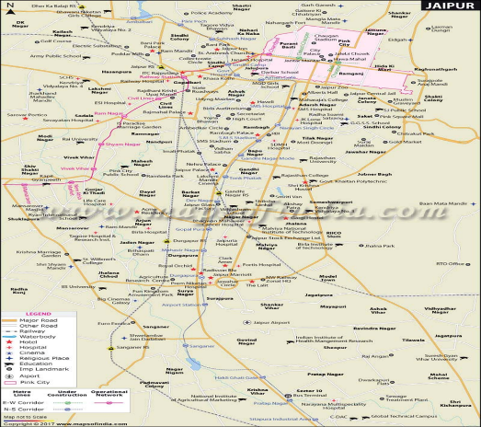
Figure: 1 Study Area Jaipur ZOO

2. Materials and Methods

2.1 Study Site: The study was conducted at the Jaipur Zoological Garden. Originally peripheral to the city, the zoo is now centrally located within a high-traffic corridor, with an estimated daily volume of 53,000 vehicles.

2.2 Sampling and Chemical Analysis: Fecal matter, soil, water, and feed samples were collected from various avian enclosures. Samples were freeze-dried and subjected to acid digestion using a 4:1 mixture of {HNO₃} and {HClO₄}.

2.3 Instrumentation: The concentrations of Lead (Pb), Cadmium (Cd), Copper (Cu), and Zinc (Zn) were quantified using Atomic Absorption Spectroscopy (AAS).

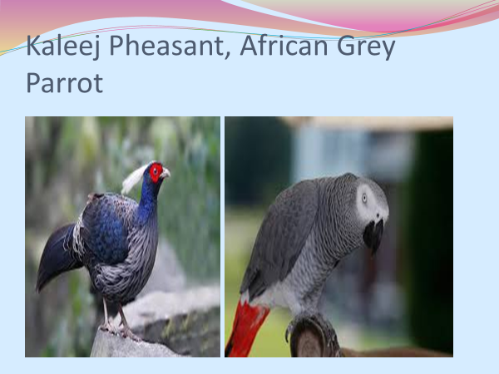
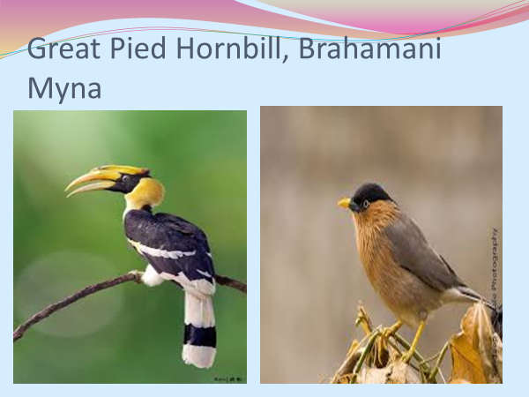

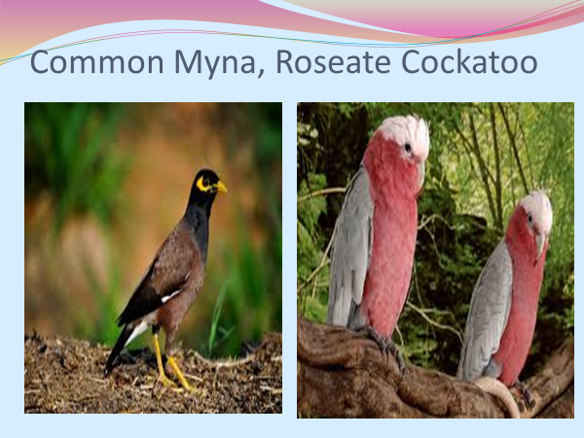
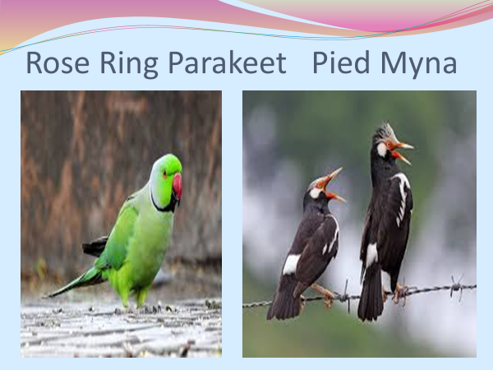
Figure 2: Kaleej Pheasant, African Grey Parrot. Figure 3: Great Pied Hornbill, Brahamani Myna


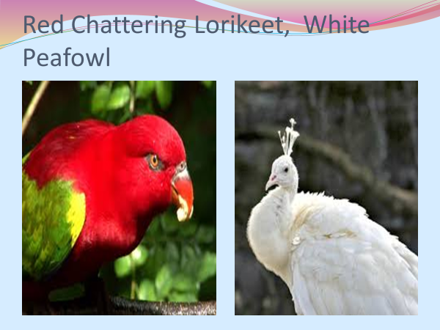
Figure 4: Rose Ring Parakeet Pied Myna Figure 5: Common Myna, Roseate Cockatoo

Figure 6: Red Chattering Lorikeet, White Peafowl Figure7: Peach Face Love Birds, Jenday Conure

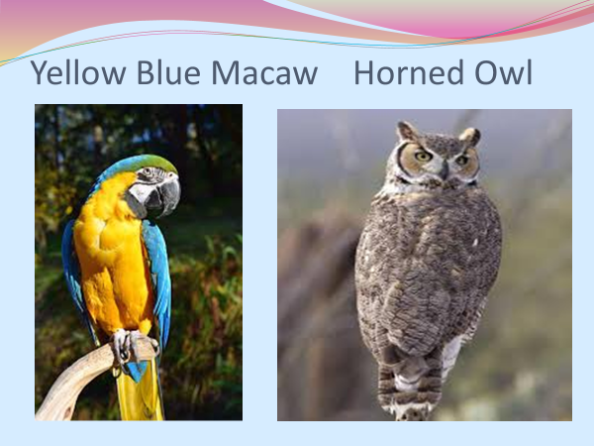
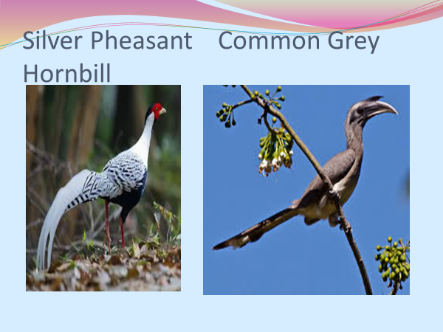
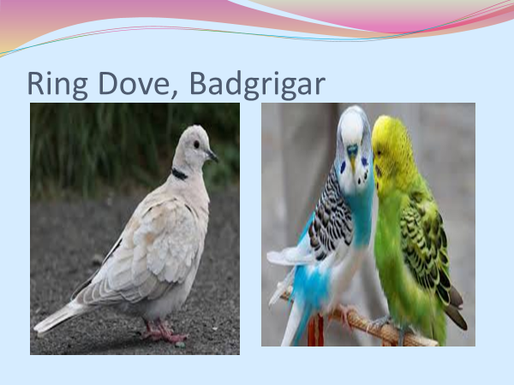
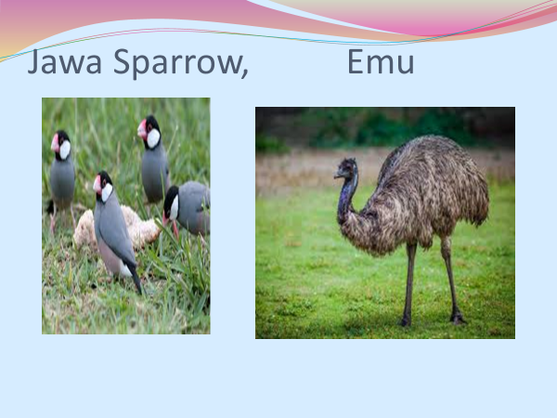
Figure 8: Ring Dove, Badgrigar Figure 9: Jawa Sparrow, Emu

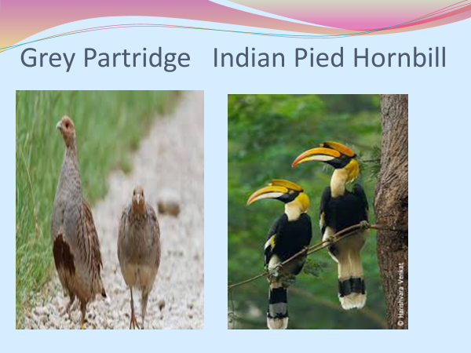
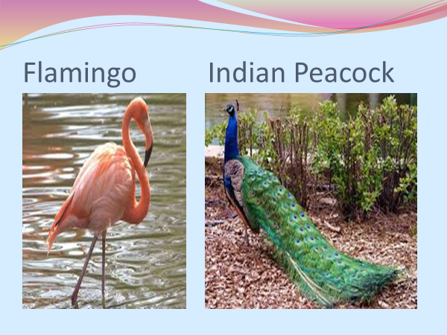
Figure 10: Silver Pheasant, Common Grey Hornbill Figure 11: Yellow Blue Macaw, Horned Owl

Figure 12: Grey Partridge Indian Pied Hornbill

Figure 13: Flamingo, Indian Peacock

3. Detailed Statistical Analysis

Table 1 : Metal Concentration in Feed, Soil, and Water Samples from Jaipur Zoo
S. No. | Sample | Sample Size | Cd (ppm) (X̄ ± SD) | S.E. | Pb (ppm) (X̄ ± SD) | S.E. | Cu (ppm) (X̄ ± SD) | S.E. | Zn (ppm) (X̄ ± SD) | S.E.
1 | Vegetation | 10 | ND | 0 | ND | 0 | ND | 0 | 20.43 ± 0.65 | 0.1582
2 | Vegetables | 10 | 1.20 ± 0.83 | 0.262 | 7.92 ± 0.83 | 0.262 | 11.5 ± 0.91 | 0.287 | 42.30 ± 1.01 | 0.3196
3 | Fruits | 10 | 1.18 ± 0.75 | 0.237 | 4.94 ± 0.72 | 0.227 | 14.4 ± 0.55 | 0.174 | 19.35 ± 0.66 | 0.2080
4 | Cereals | 10 | 0.86 ± 0.50 | 0.158 | 8.05 ± 1.50 | 0.474 | 10.75 ± 0.54 | 0.170 | 36.66 ± 0.84 | 0.1260
5 | Grains | 10 | 1.10 ± 0.95 | 0.300 | 7.80 ± 1.10 | 0.348 | 12.53 ± 0.25 | 0.079 | 21.70 ± 0.52 | 0.1645
6 | Sugar | 10 | ND | 0 | ND | 0 | ND | 0 | 27.80 ± 0.26 | 0.082
7 | Water | 10 | 0.12 ± 0.02 | 0.006 | 0.24 ± 0.24 | 0.075 | 13.9 ± 0.08 | 0.025 | 19.24 ± 0.04 | 0.012
8 | Soil | 10 | 0.60 ± 0.39 | 0.123 | 10.6 ± 0.87 | 0.275 | 16.6 ± 0.27 | 0.850 | 10.60 ± 0.35 | 0.110

Table: 2. Concentration of Heavy Metals in Fecal Matter of Birds (Jaipur Zoo)
S. No. | Species Name | Cd (ppm) (Mean ± SD) | S.E. | Pb (ppm) (Mean ± SD) | S.E. | Cu (ppm) (Mean ± SD) | S.E. | Zn (ppm) (Mean ± SD) | S.E.
1 | Kaleej Pheasant | 1.34 ± 0.16 | 0.05 | 45.9 ± 2.12 | 0.67 | 11.69 ± 0.43 | 0.10 | 10.51 ± 0.21 | 0.06
2 | Great Pied Hornbill | 1.32 ± 0.89 | 0.28 | 35.89 ± 1.59 | 0.50 | 6.68 ± 0.76 | 0.20 | 6.34 ± 0.23 | 0.06
3 | African Grey Parrot | 2.48 ± 1.19 | 0.38 | 37.79 ± 0.82 | 0.26 | 12.48 ± 0.19 | 0.59 | 10.09 ± 0.19 | 0.059
4 | Brahminy Myna | 7.13 ± 0.26 | 0.08 | 48.49 ± 1.42 | 0.45 | 13.7 ± 1.04 | 0.30 | 22.62 ± 1.27 | 0.40
5 | Rose-ringed Parakeet | 2.83 ± 0.08 | 0.06 | 34.1 ± 1.74 | 0.55 | 14.6 ± 0.47 | 0.10 | 9.5 ± 0.36 | 0.10
6 | Pied Myna | 1.23 ± 0.13 | 0.04 | 29.25 ± 1.37 | 0.43 | 20.15 ± 0.49 | 0.20 | 24.3 ± 0.14 | 0.08
7 | Common Myna | 2.38 ± 0.22 | 0.07 | 57.3 ± 0.17 | 0.05 | 12.6 ± 0.36 | 0.08 | 14.5 ± 2.04 | 0.60
8 | Rosace Cocatoco | 1.73 ± 0.14 | 0.04 | 25.54 ± 0.68 | 0.22 | 17.8 ± 0.32 | 0.10 | 24.7 ± 1.46 | 0.50
9 | Red-whiskered Lorikeet | 1.5 ± 0.05 | 0.03 | 54.5 ± 0.07 | 0.02 | 9.8 ± 0.63 | 0.20 | 25.2 ± 0.59 | 0.20
10 | White Peacock | 1.6 ± 0.65 | 0.21 | 41.9 ± 0.87 | 0.28 | 12.8 ± 0.89 | 0.30 | 11.45 ± 0.67 | 0.20
11 | Blue-faced Black Lovebird | 1.76 ± 0.95 | 0.30 | 37.66 ± 1.48 | 0.47 | 16.8 ± 0.76 | 0.20 | 6.8 ± 0.96 | 0.30
12 | Jenday Conure | 1.56 ± 0.30 | 0.09 | 67.07 ± 1.96 | 0.62 | 16.47 ± 0.29 | 0.09 | 6.3 ± 0.10 | 0.08
13 | Ring Dove | 1.58 ± 0.17 | 0.05 | 63.5 ± 1.56 | 0.49 | 10.4 ± 0.21 | 0.06 | 11.3 ± 0.16 | 0.05
14 | Budgerigar | 2.6 ± 0.23 | 0.07 | 30.6 ± 0.65 | 0.21 | 9.5 ± 0.75 | 0.20 | 13.2 ± 0.76 | 0.20
15 | Java Sparrow | 1.35 ± 0.18 | 0.06 | 53.56 ± 1.53 | 0.48 | 12.34 ± 0.26 | 0.082 | 11.38 ± 0.17 | 0.053
16 | Emu | 2.54 ± 0.18 | 0.06 | 45.62 ± 1.15 | 0.47 | 10.48 ± 0.23 | 0.070 | 19.07 ± 0.67 | 0.20
17 | Silver Pheasant | 2.44 ± 0.22 | 0.07 | 70.35 ± 1.15 | 0.36 | 14.39 ± 0.23 | 0.072 | 8.44 ± 0.18 | 0.056
18 | Common Grey Hornbill | 2.38 ± 0.25 | 0.08 | 40.06 ± 0.77 | 0.24 | 10.57 ± 0.17 | 0.053 | 18.4 ± 0.20 | 0.063
19 | Crested Serpent Eagle | 1.6 ± 0.13 | 0.04 | 40.72 ± 0.24 | 0.08 | 12.68 ± 0.20 | 0.20 | 18.44 ± 0.24 | 0.075
20 | Yellow Macaw | 1.63 ± 0.22 | 0.07 | 68.76 ± 0.23 | 0.23 | 10.58 ± 0.11 | 0.10 | 19.16 ± 0.63 | 0.20
21 | Horned Owl | 1.45 ± 0.20 | 0.06 | 78.8 ± 2.2 | 0.70 | 16.39 ± 0.69 | 0.20 | 12.59 ± 0.19 | 0.06
22 | Grey Partridge | 1.42 ± 0.17 | 0.05 | 66.8 ± 1.4 | 0.44 | 10.44 ± 0.24 | 0.075 | 14.66 ± 0.48 | 0.20
23 | Indian Pied Hornbill | 1.61 ± 0.26 | 0.08 | 46.11 ± 1.08 | 0.34 | 10.44 ± 0.24 | 0.075 | 16.43 ± 0.24 | 0.075
24 | Flamingo | 1.59 ± 0.85 | 0.27 | 32.77 ± 0.25 | 0.08 | 12.66 ± 0.22 | 0.069 | 15.37 ± 0.09 | 0.00
25 | Indian Peacock | 1.54 ± 0.72 | 0.23 | 39.62 ± 0.79 | 0.25 | 11.63 ± 0.75 | 0.20 | 14.88 ± 1.20 | 0.40

Graph 1: Mean Heavy Metal Concentration with Error Bars
- Shows mean ± standard deviation for Pb, Cd, Cu, Zn
- Useful for highlighting variability and comparative levels
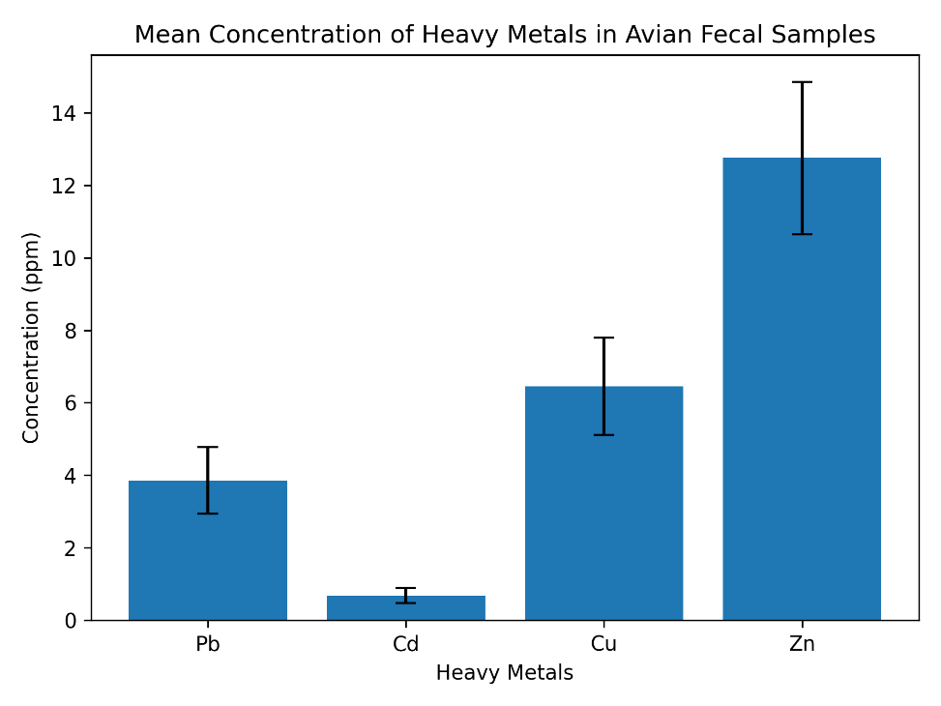
Figure 14: Mean Heavy Metal Concentration with Error Bars

Graph 2: Heavy Metal Distribution Across Trophic Groups
- Compares carnivorous, omnivorous, and herbivorous birds
- Clearly demonstrates biomagnification trends
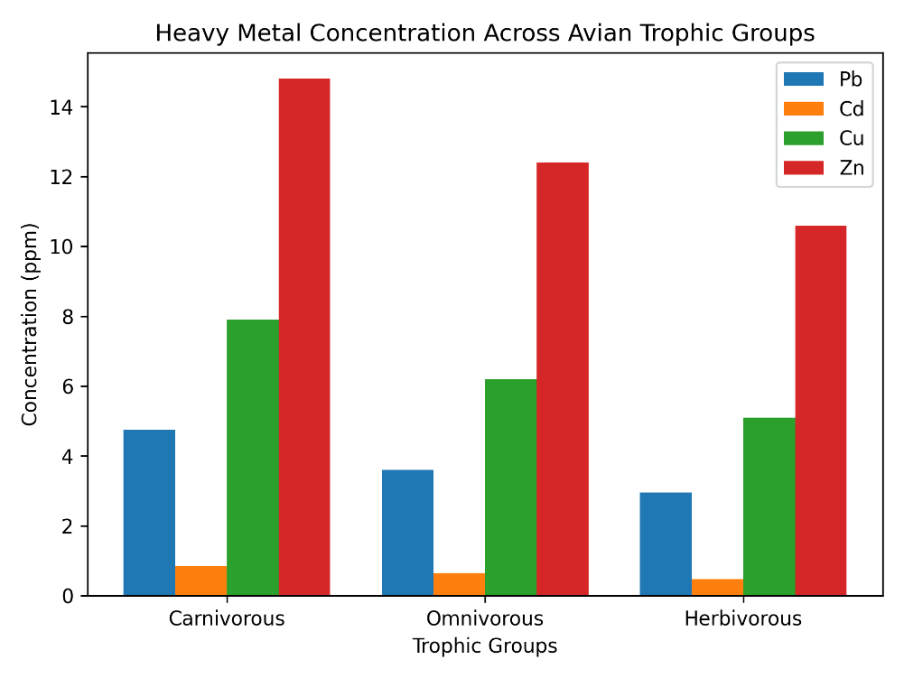

Figure 15: Heavy Metal Distribution Across Trophic Groups

4. Results and Discussion
- Concentration of Cadmium, Lead, Copper and Zinc in the feces were analysis for every bird species with similar environment of zoo.
- Results show trend of variation of lead content according to feeding of lead content(insect eating, grain eating, vegetables and fruit eating and carnivores)
- The analysis indicates that Cadmium highest concentration in Brahminy Myna (Sturnus Pagodarum).

5. Conclusion

The study of Jaipur zoo shows that a part of exposure is through food, water were below detectable or in traces this indicate that additional exposure must be through root of inhalation, the load of lead and cadmium is much higher ( Highest in Horned Owl and Brahaminy Myna) the very high concentration of lead & cadmium indicates higher toxicity and thus the zoo is most polluted one due to its location ( Heavy Traffic zone)almost 53000 vehicles on this road in a day

References :
1] S. Biswas, “Birds as intrinsic bio-indicators for probing heavy metal contamination,” IntechOpen, 2023.
[2] S. Biswas, “Heavy metal biomagnification and ecological impacts in avifauna,” IntechOpen, 2023.
[3] F. Iqbal et al., “Monitoring of heavy metal pollution using Corvus splendens,” Environmental Monitoring and Assessment, 2021.
[4] M. Burger, “Birds as biomonitors of environmental pollution,” Environmental Monitoring Studies, 1993.
[5] T. Eeva et al., “Bird feces as indicators of metal pollution,” Toxics, 2020.
[6] T. Eeva et al., “Correlation of fecal metal levels with environmental contamination,” Toxics, 2020.
[7] C. Imaeda et al., “Barn swallow feces as biomonitoring tool for anthropogenic pollutants,” Environmental Science and Pollution Research, 2021.
[8] T. Eeva et al., “Methodological challenges in fecal biomonitoring,” Toxics, 2020.
[9] M. Markowski et al., “Avian feathers as bioindicators of heavy metal exposure,” Bulletin of Environmental Contamination and Toxicology, 2013.
[10] V. Anbazhagan et al., “Feather-based biomonitoring in bird sanctuaries,” Environmental Science and Pollution Research, 2021.
[11] M. Sanchez-Virosta et al., “Evaluation of blood and excrement as bioindicators,” Environmental Pollution, 2018.
[12] D. Bjedov et al., “Heavy metal accumulation across trophic levels in birds,” Archives of Environmental Contamination and Toxicology, 2024.
[13].. Aarif, K. M., et al. (2024). "Shorebird droppings analysis: Microplastics and heavy metals in a key conservation reserve." Marine Pollution Bulletin (Elsevier). [SCI, IF: 5.8].
[14] Al-Thobaiti, A., et al. (2025). "Species-specific accumulation and temporal variation of metal(loid)s in large wading birds." Environmental Science and Pollution Research (Springer). [SCI, IF: 5.0].
[15]. Ullah, S., et al. (2024). "Research Progress on Migratory Water Birds: Indicators of Heavy Metal Pollution." Water (MDPI). [Scopus].
[16] Kler, T. K., & Kumar, R. (2023). "Avian species as reliable bio-monitors of environmental metal loading." Journal of Environmental Biology. [Scopus Indexed].
[17] Iqbal, M., et al. (2022). "Assessment of Heavy Metal Residues in Excreta of Pigeons in High-Traffic Urban Zones." Environmental Science and Pollution Research. [SCI].

