EVALUATING THE INFLUENCE OF CIRCULATION EFFICIENCY AND FUNCTIONAL ZONING ON GUEST SATISFACTION IN FOUR-STAR HOTELS

ABSTRACT
Circulation efficiency and functional zoning determine guest room access time, staff-guest path overlap, and orientation within four-star hotels, yet Nigeria's hospitality sector has no published study measuring these factors against guest satisfaction. This study examined how circulation efficiency and functional zoning influence guest satisfaction in four-star hotels, to produce measurable design strategies for hospitality developments in Nigeria. A qualitative comparative case study design analysed three four-star hotels of differing spatial typologies using secondary data: architectural floor plans, project documentation, and Space Syntax Theory. Each hotel's floor plans were digitized into justified graphs of convex spaces; Mean Depth, Integration, and Choice were computed for every space, alongside average path length, diameter, and articulation-point counts, to quantify circulation efficiency and locate single points of failure in each layout. Results showed the linear single-corridor typology recorded the highest mean integration value (1.971) but placed 21.1% of its spaces as articulation points around one corridor; the vertically stratified tower typology separated public, guest, and service functions onto distinct floors but recorded articulation-point proportions up to 50.0% on its least integrated floor; and the garden-courtyard typology recorded intermediate integration values, with its ground floor alone reaching 37.5% articulation points at the lobby and fountain courtyard. Across all three hotels, the entrance/lobby sequence recorded the highest Integration and Choice values while also functioning as each building's single largest circulation risk point. The study concludes that circulation routes and functional zones must be planned in the same design stage, not sequentially, and recommends centralized reception placement, physical separation of guest and service corridors, and the use of integration and articulation-point values as design-stage evaluation metrics for four-star hotels in Nigeria.
Keywords: Circulation Efficiency, Functional Zoning, Space Syntax, Guest Satisfaction, Four-Star Hotels

INTRODUCTION
Hotel performance is not evaluated solely on the basis of service quality, but also by how spatial design influences guest satisfaction. Research confirms that the built environment significantly affects customer perception, behavioural intention, and satisfaction in hospitality settings (Hwang & Seo, 2016; Dedeoğlu et al., 2020). In hotels, spatial configuration, especially circulation efficiency and functional zoning, directly affects movement, accessibility, and user comfort. Effective zoning enhances navigation and operational efficiency, whereas poor circulation leads to congestion and disorientation. Studies show that spatial configuration significantly shapes user experience in complex environments, with wayfinding difficulties linked to negative psychological and physiological outcomes for users (Jamshidi, Ensafi, & Pati, 2020).
STATEMENT OF PROBLEM
Although architectural research recognizes spatial layout as an important factor influencing guest experience, empirical studies focused on Nigeria’s hospitality sector remain limited. Previous studies in Nigeria have primarily examined hospitality service quality and hotel amenities. Poorly planned circulation and zoning in hotels leads to overlapping guest and service movement, causing congestion, reduced privacy, and operational inefficiency. Addressing these through proper architectural design is essential for improving functionality in 4-star hotels.
AIM
To examine how spatial configuration specifically circulation efficiency and functional zoning affect guest satisfaction in four-star hotels Nigeria.
OBJECTIVES
- To assess spatial layout characteristics (zoning, circulation, wayfinding) in 4-star hotels.
- To propose recommendations for maximizing spatial planning in future hospitality developments in Nigeria.
RESEARCH QUESTIONS
- What spatial layout characteristics (zoning, circulation, and wayfinding) are present in four-star hotels?
- What recommendations can be made to improve spatial planning in future hospitality developments in Nigeria?
SCOPE OF THE STUDY
This study is analytically confined to three internationally recognized four-star hotels selected as comparative precedent case studies due to their differing spatial typologies and publicly available architectural documentation. The research utilizes secondary architectural floor plan data, analysed through comparative architectural analysis and Space Syntax Theory, to generate design strategies applicable to the planning of four-star hotels in Nigeria, including Akwa Ibom State.
SIGNIFICANCE OF STUDY
This study contributes to hospitality and architectural knowledge by examining how spatial configuration influences guest satisfaction, particularly within the Nigerian context where such research is limited. The physical environment has been shown to significantly affect customer experience and satisfaction in hotels (Hwang & Seo, 2016; Dedeoğlu et al., 2020). It also provides recommendations for future design strategies to architects and hotel developers by offering evidence-based insights into how circulation and zoning impact user experience and operational efficiency. Effective spatial configuration improves navigation and reduces the negative outcomes associated with wayfinding difficulty in complex environments (Jamshidi, Ensafi, & Pati, 2020).
LITERATURE REVIEW
1.1 Hotel and circulation design
Hotel buildings are classified within the hospitality typology, which includes spaces designed for accommodation, leisure, and service functions. In this category, four-star hotels offer a balance between luxury and affordability, characterized by relatively high service standards and a structured mix of public, private, and service areas (Hotelstars Union, 2022). The arrangement of these spaces is guided by functional zoning, which defines how different activities are organized and related within the building. Circulation design refers to the planning of movement systems that connect these functional zones. It plays a key role in ensuring smooth guest movement, clear wayfinding, and separation of service and guest traffic. Studies show that poorly structured wayfinding systems reduce navigability and negatively affect user experience and satisfaction in tourism and hospitality environments (Zhang, Zhu, Zhang, Zhang, & Lu, 2020). In large and complex hotel settings, circulation elements such as lobbies, corridors, elevators, staircases, and service routes must accommodate high traffic and operational demands. When poorly designed, circulation systems can lead to congestion, confusion, and reduced efficiency, particularly where zoning and movement patterns are not well coordinated (Amusan, Kolawole, & Adewunmi, 2018).
1.2 Concept of space planning and spatial configuration in four-star hotels
Space planning in four-star hotels refers to the systematic arrangement of functional areas such as guest rooms, public spaces, and service zones to ensure efficiency, comfort, and smooth operation. It focuses on how spaces are organized to support user needs, movement patterns, and operational workflows within the hotel environment. Good space planning allows for separation of guest and service functions while ensuring access and convenience. The spatial configuration, on the other hand, refers to the physical connections and structures of these spaces in relation to one another. It defines circulation paths, visual connections, access and ease of wayfinding within the building. In hotel environments, spatial configuration directly influences how guests navigate the space and how efficiently services are delivered. Research shows that spatial arrangement significantly affects user experience and satisfaction in hospitality settings (Hwang & Seo, 2016; Zhang, Zhu, Zhang, Zhang, & Lu, 2020). In four-star hotels, the integration of space planning and spatial configuration is critical because these facilities must balance operational efficiency with high guest comfort standards. Therefore, effective hotel design depends on the alignment of functional space planning with coherent spatial configuration.
1.3 Guest satisfaction in four-star hotels
Guest satisfaction in four-star hotels is shaped by both service quality and the physical environment, with recent hospitality research confirming that spatial and experiential factors significantly influence overall satisfaction and behavioural intentions (Hwang & Seo, 2016). In particular, the hotel environment is no longer viewed as passive infrastructure but as an active contributor to customer experience and perceived value. Spatial configuration within hotels including circulation layout, zoning, and wayfinding systems plays a critical role in shaping how guests perceive comfort and usability. Studies show that well-structured environments improve navigation, reduce cognitive load, and enhance overall experience, while poorly designed layouts lead to confusion and disorientation (Bagheri & Pourfathollah, 2026; Chang & Lin, 2024). Recent empirical findings also confirm that hotel design elements such as room layout, lighting, and spatial organisation significantly influence guest satisfaction levels (Kamotho, 2024). Furthermore, systematic reviews of hotel spatial design highlight that circulation efficiency and zoning are among the most important spatial factors affecting guest comfort and satisfaction, particularly in upscale hospitality environments (Daramola et al., 2025). Overall, guest satisfaction in four-star hotels is strongly linked to how effectively spatial systems are designed to support movement, accessibility, privacy, and user comfort, making spatial configuration a key determinant of hospitality performance.
1.4 Relationship between spatial design and guest satisfaction
Spatial design in hotels refers to the organisation of physical spaces such as circulation routes, functional zones, and wayfinding systems that shape how users experience the built environment. In hospitality research, it is widely established that the physical environment is a key determinant of guest satisfaction because it influences perception, comfort, and behavioural response (Hwang & Seo, 2016). The relationship between spatial design and guest satisfaction is primarily behavioural and experiential. A more favorable visitor experience results from well-organized spatial layouts that improve accessibility, ease of movement, and confusion reduction. On the other hand, poorly planned spatial arrangements lead to discomfort, traffic, and trouble navigating, all of which have a detrimental effect on satisfaction levels. Furthermore, spatial configuration affects cognitive processes such as wayfinding and environmental understanding. Research shows that clear circulation systems and legible spatial layouts improve users' ability to navigate complex built environments, thereby reducing cognitive load (Bagheri & Pourfathollah, 2026; Jamshidi, Ensafi, & Pati, 2020). This demonstrates that guest satisfaction is not only dependent on service delivery but also on how effectively the physical environment supports movement and spatial experience. Therefore, spatial design and guest satisfaction are directly linked, as effective architectural planning enhances usability, comfort, and overall perception of hotel quality.
1.5 Gaps in literature
Although hospitality research has increasingly examined guest satisfaction, most studies focus on overall service quality and general hotel experience, with limited attention to specific spatial factors such as circulation efficiency and functional zoning (Hwang & Seo, 2016). Furthermore, while spatial configuration and wayfinding have been shown to influence user experience in complex environments such as hospitals, airports, and office buildings, few studies apply these findings specifically to four-star hotel design, where spatial performance is critical to balancing guest comfort and operational flow (Jamshidi, Ensafi, & Pati, 2020). In addition, there is a clear contextual gap in Nigeria, where empirical studies on hotel spatial design and guest satisfaction remain limited, with most research focusing on service delivery rather than architectural layout (Daramola et al., 2025).
METHODOLOGY
2.1 Research design
This study adopted a qualitative comparative case study design. A case study design was appropriate because it enabled the investigation of circulation efficiency and functional zoning within real world hotel environments (Yin, 2018). Three hotels with similar hospitality functions but different spatial layouts were selected to identify how variations in circulation and zoning influence spatial organization, operational efficiency, and guest satisfaction. The comparative findings informed the proposed design strategies for four-star hotels in Nigeria (Creswell & Poth, 2018; Yin, 2018). To strengthen the objectivity of the comparative analysis, the study also employed Space Syntax Theory as an analytical framework for examining the configurational properties of circulation within the selected case studies, thereby complementing the qualitative comparative approach with a quantifiable spatial analysis technique.
2.2 Source of data
This study made use of secondary data exclusively. Data were obtained from architectural drawings, published journal articles, books, project documentation, official hotel and architect websites, and reputable architectural databases. Architectural floor plans obtained from these sources served as the base drawings for both the comparative architectural analysis and the space syntax analysis. The integration of multiple data sources enhanced the credibility and depth of the comparative case study analysis (Yin, 2018).
2.3 Data collection instruments and methods
2.3.1 Document and drawing review
A systematic review of architectural floor plans was carried out for each of the three case studies. Floor plans were obtained from architectural project documentation and reputable architectural databases (ArchDaily) and examined to identify functional spaces, circulation routes, zoning arrangements, and spatial adjacencies within each building. Architectural drawings constitute a recognized form of documentary evidence in case study research, capable of supporting systematic spatial analysis when obtained from verified project sources (Yin, 2018). This review formed the basis for digitizing each floor plan into convex spaces and adjacency relationships for the space syntax analysis, and for identifying the functional zoning patterns discussed in the comparative analysis.
2.3.2 Space syntax analysis
Space syntax is a theory and set of analytical techniques developed by Hillier and Hanson (1984) that examines how the configuration of spaces how they connect to and are accessed from one another shapes patterns of movement and use within a building. It was employed in this study as a quantitative instrument to measure the configurational efficiency of circulation in each case study, complementing the qualitative data from document review and comparative architectural analysis.
The three basic elements of the theory applied were:
- Convex Space: The largest space in which every point is visible and reachable from every other point without obstruction (e.g., a room, lobby, or corridor).
- Axial Line: The longest, fewest straight lines of movement/sight needed to cover a spatial system.
- Isovist/Visibility Field: The area visible from a single vantage point within a space.
Each hotel's architectural floor plan was digitized into a justified graph, in which every functional space (convex space) was represented as a node, and every door or opening connecting two spaces was represented as an edge, rooted at the main entrance of each floor. The following configurational measures were computed for every space:
Mean Depth (MD) = TD / (k - 1)
Relative Asymmetry (RA) = 2(MD - 1) / (k - 2)
Real Relative Asymmetry (RRA) = RA / Dk, where Dk = 2[k(log₂((k+2)/3) - 1) + 1] / [(k-1)(k-2)]
Integration (i) = 1 / RRA
Where TD is the total depth (sum of step-distances from a space to all other spaces in the system) and k is the total number of spaces in the system. In addition, Choice (betweenness centrality) was computed to measure the proportion of shortest paths in the system passing through each space, indicating its role as a through-movement route. Graph-theoretic checks, including articulation points (single points of failure), average path length, and system diameter, were also computed to assess circulation redundancy and efficiency. The factors considered in the space syntax analysis included: spatial configuration (depth, integration, choice), the public-private gradient (guest circulation versus staff/back-of-house circulation), wayfinding and legibility of routes, redundancy versus bottleneck risk, functional zoning and adjacency, and overall movement efficiency (path directness and average depth). Data for the space syntax analysis were collected from the architectural floor plans obtained as secondary data. Each floor plan was reviewed to identify discrete functional spaces, which were coded as convex spaces (nodes), while physical adjacencies (doors, openings, corridors) linking these spaces were mapped as edges based on the drawn layout. The resulting graph for each case study was analysed computationally, using the standard space syntax formulas above, to generate Mean Depth, RA, RRA, Integration, and Choice values for every space, which were then compared across the three case studies.
2.3.3 Validity and reliability
Content validity was established by preparing the document review protocol and comparative analysis checklist from the study objectives and literature on circulation efficiency and functional zoning in four-star hotels. Two experts in the Department of Architecture, Rivers State University, reviewed the instruments to determine whether the items measured the variables of the study. Their comments were incorporated before the instruments were used for data collection. Reliability was established by applying the same document review protocol, comparative analysis checklist, and space syntax computational procedure to all three case studies. The same formulas, node-granularity convention, and evaluation criteria were used for each case study, and all floor plans were sourced from the same category of verified architectural databases and project documentation. This maintained consistency in data collection and analysis across the three case studies (Yin, 2018; Creswell & Poth, 2018).
2.4 Data analysis techniques
The collected data were analysed using comparative architectural analysis. Data obtained from document review, the comparative analysis checklist, and documentary sources were systematically examined and compared across the three selected case studies to identify similarities, differences, strengths, and limitations in their architectural design. In addition, space syntax analysis was applied to the architectural floor plans of the three case studies to generate quantitative circulation and configurational data, which were compared alongside the qualitative findings. The findings were synthesized to establish design strategies that informed the proposed four-star hotel (Yin, 2018).
2.5 Data analysis
The analysis focuses on the evaluation of effective circulation and functional zoning in 4-star hotels based on various parameters gathered from document review, comparative case study analysis, and space syntax analysis.
CASE STUDIES
A detailed examination of three 4-star hotels which are: Akmani Hotel Indonesia, Bandung Hilton Indonesia and Katamama provided insights into successful design strategies. Literature from sources used through out the journal supported the findings with theoretical frame works and best practices.
Table 1: Case study project profiles
 | Bandung Hilton | Akmani Boutique Hotel | Katamama
Architect | WOW Architects - Warner Wong Design | TWS & Partners | Andra Matin
Location | Bandung, West Java (mountain-valley city) | Jl. KH Wahid Hasyim, Central Jakarta (dense urban commercial strip) | Seminyak, Bali
Completion | 2009 | 2009 | 2015
Scale/type | Four-star, 186-room contemporary urban business hotel with world-class conferencing and event function facilities | Boutique business hotel located on a main busy road in central Jakarta, on a compact relatively small parcel of land, around 1,500 square meters | 58-suite boutique hotel
  - Case study 1 (Bandung hilton)

3.1.1 Pattern of analysis
- Digitization of each floor plan into convex spaces (nodes)
- Mapping of physical adjacencies (doors, openings, corridors) as edges
- Computation of mean depth, relative asymmetry (ra), real relative asymmetry (rra), and integration using hillier's formulas
- Computation of choice (betweenness centrality) to identify through-movement load
- Assessment of average path length, diameter, and articulation points to evaluate circulation redundancy and risk.
Hilton Bandung was analysed across three floors: the Ground Floor (entrance, parking, lobby, and back-of-house), the Podium/Garden Floor (guest rooms opening onto the landscaped garden, bar/service, and outdoor amenity features), and a Typical Guest Floor (upper-level standard rooms and suites). This building represents a low-rise, garden-courtyard resort typology.
Table 2: Space Syntax Values for Hilton bandung (All Floors)
Floor | k (Spaces) | Mean Integration | Avg. Path Length | Diameter | Articulation Points (%) | Most Integrated Space | Highest-Choice Space
Ground Floor | 8 | 0.945 | 2.250 | 4 | 37.5% | Lobby / Fountain Courtyard (1.72) | Lobby (0.71)
Podium/Garden Floor | 14 | 1.274 | 2.495 | 5 | 28.6% | Corridor (3.47) | Corridor (0.92)
Typical Guest Floor | 14 | 1.734 | 1.857 | 2 | 7.1% | Corridor (perfect hub) | Corridor (1.00)
    - Discussion of findings
The Typical Guest Floor recorded the highest circulation efficiency of the three floors, with the lowest diameter (2) and lowest proportion of articulation points (7.1%). Its corridor functions as a near-perfect configurational hub, with every guest room and suite positioned at an equal, single step of depth. This reflects a single-loaded corridor arrangement in which all rooms are directly and equally accessible, representing the simplest and most efficient circulation topology recorded in this study. The Podium/Garden Floor showed a similarly efficient corridor structure (Integration = 3.47) but recorded a lower overall floor efficiency (Mean Integration = 1.274) due to the additional depth introduced by the bar/service and garden amenity sequence (Garden Walk, Roundabout Feature, Lounge Deck), which extends circulation outward from the corridor toward the landscaped garden. The Ground Floor recorded the lowest mean integration value (0.945) and the highest proportion of articulation points (37.5%) of all floors analyzed in this case study. The Lobby and Fountain Courtyard emerged as tied dominant integrators and through-movement carriers, indicating that the entire entrance sequence drop-off, reception, parking, kitchen/back-of-house, and dining terrace is dependent on these two adjacent nodes, with no alternative circulation route. This represents a structurally significant bottleneck risk at the building's primary arrival point.
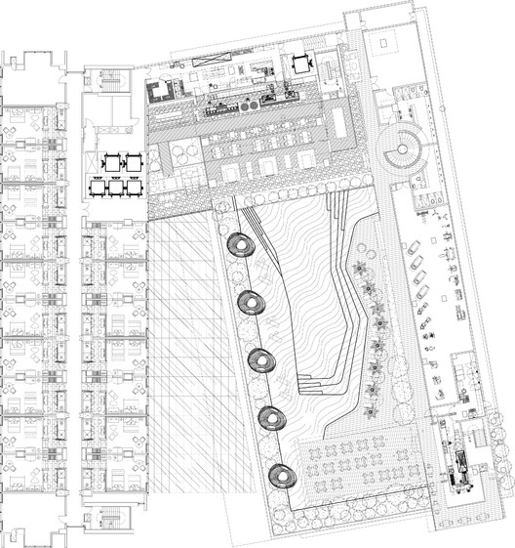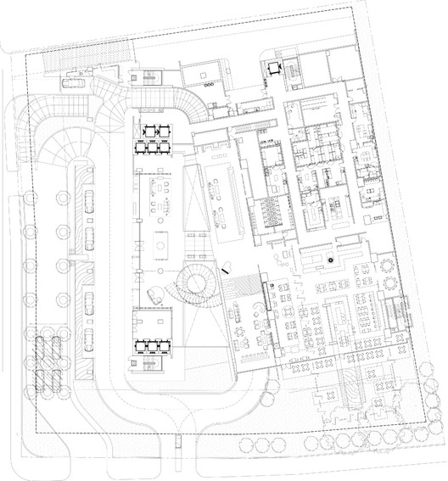
Figure 1. Typical floor plans of Bandung Hilton
SOURCE: <https://www.archdaily.com/72303/bandung-hilton-wow-architects-warner-wong-design> ISSN 0719-8884
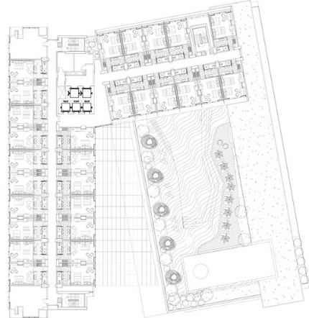
Figure 2. Typical floor plan of Bandung Hilton
SOURCE: <https://www.archdaily.com/72303/bandung-hilton-wow-architects-warner-wong-design> ISSN 0719-8884
3.2 Case study 2 (Akmani hotel)
3.2.1 Pattern of analysis
The space syntax analysis of AKMANI Hotel followed a consistent five-stage procedure applied uniformly across all six floors of the building (Ground Floor, 1st Floor, Mezzanine, Typical Guest Floor, Podium Roof, and Penthouse), in line with the justified graph method established by Hillier and Hanson (1984):
- Digitization: Each floor plan was examined and decomposed into convex spaces the largest, fewest spatial units required to represent the plan (e.g., Reception, Ballroom, Main Storage, individual guest rooms). Each convex space was treated as one node.
- Adjacency Mapping: Physical connections (doors, openings, corridors) linking the convex spaces were identified from the plan and represented as edges, producing a justified graph for each floor.
- Depth-Based Computation: For every node, the shortest-path step-distance to all other nodes was calculated, from which Mean Depth (MD), Relative Asymmetry (RA), Real Relative Asymmetry (RRA), and Integration were derived using the standard Hillier formulas: MD = Total Depth / (k − 1)
RA = 2(MD − 1) / (k − 2)
RRA = RA / Dk, where Dk = 2[k(log₂((k+2)/3) − 1) + 1] / [(k−1)(k−2)]
Integration = 1 / RRA (k = total number of spaces in the system)
- Movement Computation: Choice (betweenness centrality) was calculated for every node to identify which spaces carry the highest proportion of through-movement in the system, distinguishing accessibility from actual traffic load.
- Robustness Assessment: Average path length, system diameter, and articulation points (single points of failure) were computed for each floor to evaluate circulation redundancy and structural risk.
The same formulas and node-granularity convention (one convex space = one node) were applied to every floor to ensure comparability of results across the building.
Table 3: Space Syntax Values for Akmani hotel
Floor | k (Spaces) | Mean Integration | Avg. Path Length | Diameter | Articulation Points (%) | Most Integrated Space | Highest-Choice Space
Ground Floor | 19 | 0.811 | 3.637 | 8 | 47.4% | Main Storage (1.31) | Main Storage (0.51)
1st Floor (Public) | 22 | 0.943 | 3.476 | 7 | 31.8% | Reception (1.88) | Reception (0.74)
Mezzanine | 17 | 1.522 | 2.412 | 4 | 23.5% | Foyer (4.88) | Foyer (0.90)
Guest Floor (Typical) | 25 | 1.366 | 2.787 | 4 | 12.0% | Lobby (2.76) | Corridor (0.67)
Podium Roof | 15 | 1.035 | 2.838 | 6 | 33.3% | Spa Staff (1.96) | Spa Staff (0.68)
Penthouse | 16 | 0.754 | 3.550 | 8 | 50.0% | Dining Room (1.26) | Dining Room (0.64)
    - Discussion of findings
The results show that circulation efficiency varies systematically with floor function. The Mezzanine recorded the highest mean integration value (1.522) and the shortest diameter (4), indicating a highly efficient, low-conflict layout suited to its conferencing function, where the Foyer operates as a dominant, centrally accessible hub (Integration = 4.88). The Guest Floor followed closely (Mean Integration = 1.366), reflecting the efficiency of its double-loaded corridor arrangement, with the lowest proportion of articulation points (12.0%) of any floor, indicating strong circulation redundancy and low structural risk. In contrast, the Ground Floor and Penthouse recorded the lowest mean integration values (0.811 and 0.754 respectively) and the highest proportions of articulation points (47.4% and 50.0%). On the Ground Floor, Main Storage emerged as both the most integrated and the busiest space, indicating that back-of-house kitchen and logistics functions are heavily dependent on a single circulation node, representing a potential operational vulnerability. On the Penthouse floor, the high articulation point percentage reflects a deliberately sequential, privacy-driven spatial arrangement rather than a design deficiency, consistent with the expected configuration of private residential-type spaces. The 1st Floor and Podium Roof occupy an intermediate position, with Reception and Spa Staff respectively serving as the dominant integrators and through-movement carriers on their floors. In both cases, the concentration of high Choice and Integration values in a single node identifies that space as the critical point through which floor-wide circulation efficiency is determined.

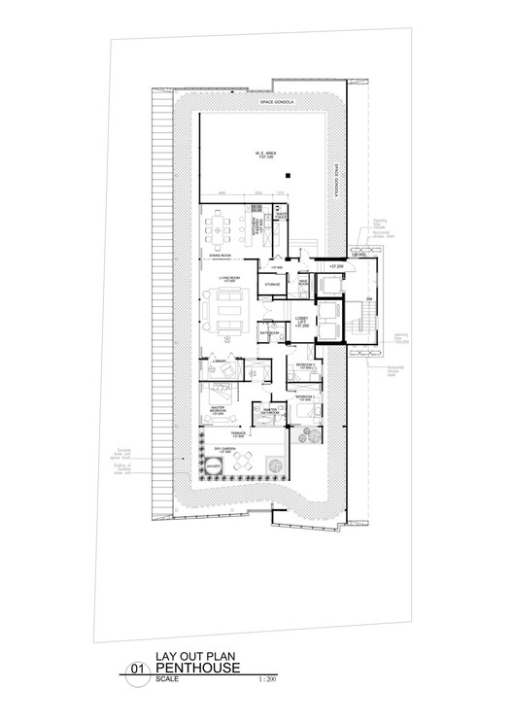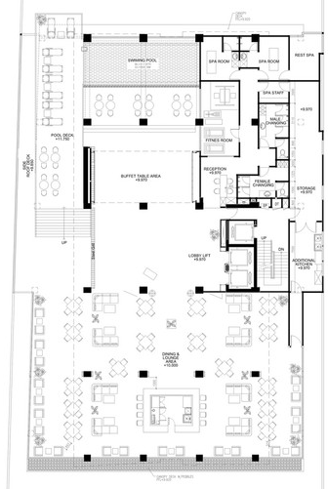
Figure 3. Penthouse and podium roof plan of Akmani hotel
SOURCE: <https://www.archdaily.com/37656/akmani-botique-hotel-tws-partners> ISSN 0719-8884
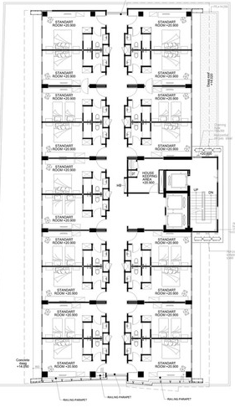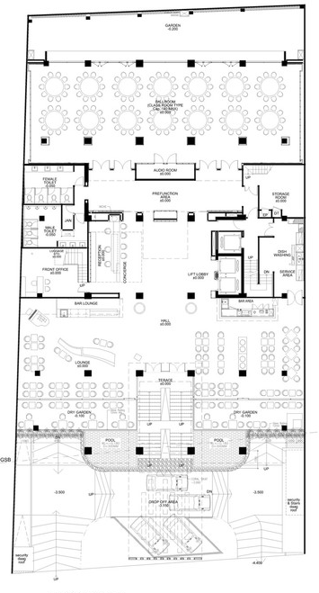
Figure 4. 2nd - 8th floor plan and 1st floor plan of Akmani hotel
SOURCE: <https://www.archdaily.com/37656/akmani-botique-hotel-tws-partners> ISSN 0719-8884
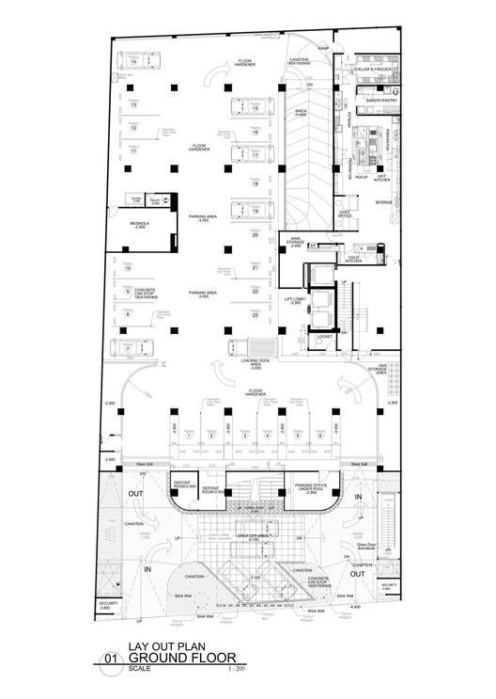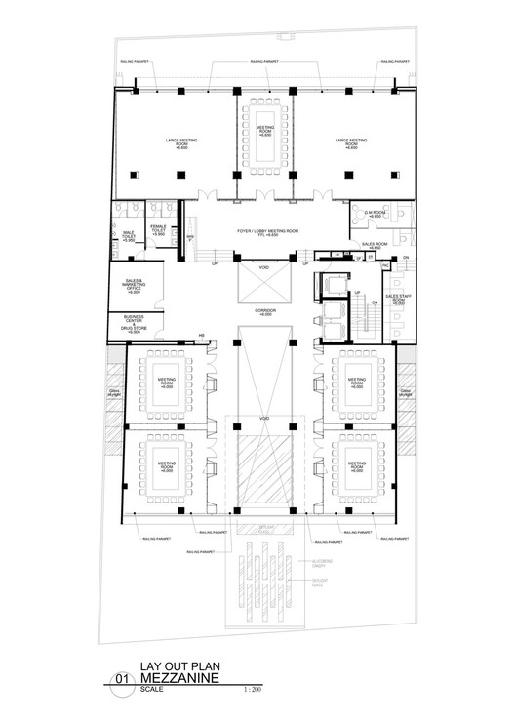
Figure 5. Ground floor plan and mezzannie floor plan of Akmani hotel
SOURCE: <https://www.archdaily.com/37656/akmani-botique-hotel-tws-partners> ISSN 0719-8884
  - Case study 3 (Katamama hotel)
    - Pattern of analysis
The space syntax analysis of Katamama Hotel followed the same five-stage justified graph procedure applied to the previous two case studies:
- digitization of the labeled floor plan into convex spaces (nodes)
- mapping of physical adjacencies as edges
- computation of Mean Depth, Relative Asymmetry (RA), Real Relative Asymmetry (RRA), and Integration using Hillier's formulas
- computation of Choice (betweenness centrality) to identify through-movement load
- assessment of average path length, diameter, and articulation points to evaluate circulation redundancy and risk.
The analysis covers Level 2 of Katamama Hotel, comprising the Bridge and Entry sequence, Bar, Restaurant, Kitchen, Toilet, Linen room, and eleven Guest Rooms (labelled 1- 8 and 7 respectively on the reference plan), all arranged along a single continuous corridor overlooking a central courtyard. This building represents a linear, single-corridor "gallery" typology, distinct from Akmani and Hilton Bandung.

Table 4: Space Syntax Values for Katamama Hotel
Space | Mean Depth | RRA | Integration | Choice
Corridor | 1.22 | 0.113 | 8.835 | 0.974
Restaurant | 1.94 | 0.481 | 2.079 | 0.209
Entry | 2.06 | 0.538 | 1.860 | 0.111
Bar / Guest Rooms (1-11) / Linen | 2.17 | 0.594 | 1.683 | 0.000
Kitchen | 2.78 | 0.905 | 1.104 | 0.111
Bridge | 3.00 | 1.019 | 0.982 | 0.000
Toilet | 3.72 | 1.387 | 0.721 | 0.000
k = 19 spaces | Mean Integration = 1.971 | Avg. Path Length = 2.257 | Diameter = 5 | Articulation Points = 4/19 (21.1%): Corridor, Entry, Kitchen, Restaurant
    - Discussion of findings
The results show that the Corridor functions as an overwhelming configurational hub (Integration = 8.835, Choice = 0.974), carrying almost all circulation in the building. All eleven guest rooms, the bar, and the linen room record identical Integration and Choice values (1.683 and 0.000 respectively), indicating a perfectly uniform, single-loaded gallery arrangement in which every room is equidistant from the corridor and none functions as a through-route for any other space.
The Restaurant recorded the second-highest Integration value (2.079), reflecting its position close to the entry sequence and its role as a secondary gathering point along the corridor. The Kitchen and Toilet, by contrast, recorded the lowest Integration values (1.104 and 0.721), consistent with their function as enclosed, service-oriented spaces requiring separation from guest circulation. With an average path length of only 2.257 and a diameter of 5, Katamama Hotel recorded the shortest overall circulation distances of the three case studies, reflecting the efficiency of its linear single-corridor typology. However, the Corridor's extreme dominance means that four spaces (21.1%) function as articulation points; a disruption at the Corridor, Entry, Kitchen, or Restaurant would isolate a significant portion of the building's circulation, indicating that despite its efficiency, the layout carries concentrated structural risk in a small number of critical nodes.

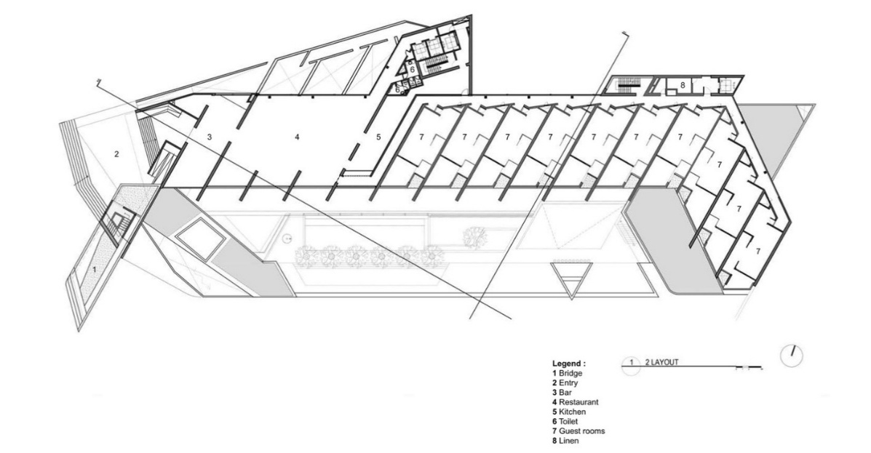
Figure 6. Layout plan of Katamama Hotel
SOURCE: <https://www.archdaily.com/791287/katamama-andra-matin> ISSN 0719-8884
Table 5: Summary of Comparative Analysis of Circulation Efficiency and Functional Zoning
Analysis Criteria | Akmani Hotel, Jakarta | Hilton Bandung, Indonesia | Katamama Hotel, Bali | Comparative Finding
Planning Strategy | Compact podium-and-tower arrangement on a restricted urban site. | Central-atrium planning with podium and guestroom wings. | Courtyard planning organized around an internal open space. | Each hotel used a different planning strategy to organize circulation and zoning.
Functional Zoning | Public spaces at ground level, meeting rooms on podium, leisure deck between podium and guestrooms, guestrooms above. | Public and conference facilities grouped around the atrium, guestrooms located in separate wings above, leisure facilities on roof level. | Public facilities arranged around the courtyard, guestrooms surrounding the courtyard, service spaces concealed behind guest areas. | All hotels clearly separated public, private and service functions but applied different zoning arrangements.
Horizontal Circulation | Short and direct circulation because of the compact floor plate and double-loaded corridor. | Circulation distributed through bridges, corridors and promenades around the atrium. | Open galleries and courtyard walkways connect all functional spaces. | Akmani provides the shortest circulation routes, while Katamama provides the longest experiential routes.
Vertical Circulation | Central guest lift and stair core serving the guestroom tower. | Dedicated lift core connected to guestrooms with feature staircases linking public spaces. | Vertical circulation positioned around the courtyard with access to accommodation floors. | Hilton provides the strongest vertical circulation hierarchy due to separate public and guest movement.
Circulation Hierarchy | Moderate separation between guest and public circulation. | Clear separation between guest, conference and service circulation. | Public circulation concentrated around the courtyard while private circulation serves guestrooms. | Hilton demonstrates the clearest circulation hierarchy.
Guest and Service Circulation | Partial separation. Some support spaces are adjacent to guest circulation. | Guest circulation is separated from back-of-house and conference service circulation. | Service circulation is concealed behind guest accommodation and public spaces. | Hilton and Katamama achieve greater separation of guest and service movement.
Wayfinding | Simple because of the compact layout and direct visual connection between entrance, lobby and café. | Central atrium acts as the primary orientation space supported by bridges and visual connections. | Courtyard serves as the main orientation element connecting all major spaces. | Atrium and courtyard layouts provide stronger visual orientation than compact corridor layouts.
Accessibility | Direct access from entrance to reception and public facilities. | Multiple accessible routes connect lobby, conference spaces, guestrooms and leisure facilities. | Continuous circulation around the courtyard provides uninterrupted movement between spaces. | All hotels provide continuous circulation, although Hilton offers the greatest route flexibility.
Spatial Relationships | Lobby, café and meeting spaces are closely connected to reduce travel distance. | Public spaces are visually interconnected through the atrium while guestrooms remain private. | Public, leisure and accommodation spaces maintain strong visual relationships through the courtyard. | Hilton and Katamama emphasize visual connectivity more than Akmani.
Operational Efficiency | Compact planning reduces travel distance but may create congestion during peak periods. | Separate circulation systems improve conference operations and reduce movement conflicts. | Courtyard planning improves privacy but increases walking distance between some functions. | Hilton achieves the highest operational efficiency through circulation segregation, while Akmani prioritizes compactness and Katamama prioritizes spatial experience.
Influence on Guest Experience | Direct circulation provides quick access to facilities but offers limited spatial variety. | Atrium, bridges and public promenade improve orientation and create memorable spatial experiences. | Courtyard circulation creates a calm atmosphere and strong visual connection with outdoor spaces. | Different circulation strategies influence guest experience differently: Akmani emphasizes efficiency, Hilton balances efficiency with orientation, and Katamama prioritizes experiential movement.
The research confirmed that designing clear and unobstructed circulation pathways is essential for achieving efficient movement, improving user mobility, reducing movement conflicts, and enhancing operational performance in four-star hotel environments. Well-defined circulation networks and functional zoning facilitate wayfinding, improve accessibility, and strengthen the overall user experience by providing logical connections between interconnected hotel spaces (Daramola & Alagbe, 2025; Daramola et al., 2025).
FINDINGS
The study found that well-planned circulation routes and functional zoning improved accessibility, movement, hotel operations, and guest satisfaction by reducing movement conflicts between guests, staff, and service activities. For architects, integrating circulation planning with functional zoning during the design stage produced better spatial relationships and movement within the hotel. For hotel operators, separate guest and service circulation routes improved service delivery and reduced operational interference. For regulatory bodies, the findings showed that circulation planning, functional zoning, accessibility, and wayfinding should be included as assessment criteria for four-star hotel developments. These findings agree with previous studies that identified spatial planning and circulation systems as important factors influencing hotel operations and guest satisfaction (Daramola & Alagbe, 2025; Daramola et al., 2025).
4.1 Application of findings
The findings of this study can be applied in the planning and design of four-star hotels through the following architectural strategies:
- Provide clear and unobstructed circulation pathways to improve movement efficiency and reduce congestion.
- Adopt logical functional layouts that establish direct relationships between interconnected spaces.
- Separate public, private, and service zones to minimize movement conflicts and enhance operational efficiency.
- Position reception and lobby areas centrally to facilitate orientation and provide easy access to major hotel facilities.
- Incorporate clearly defined horizontal and vertical circulation systems to improve accessibility between floors and functional areas.
- Design intuitive wayfinding systems through clear signage and visual landmarks to enhance user navigation.
- Locate vertical circulation elements, such as elevators and staircases, at strategic points to improve accessibility and reduce travel distances.
- Separate guest and service circulation routes to maintain privacy and support efficient hotel operations.
- Provide adequate corridor widths and waiting areas to accommodate peak user movement and improve comfort.
CONCLUSION
The study concluded that circulation efficiency and functional zoning are critical in the planning and design of modern four-star hotels. The comparative analysis of the selected case studies, supported by document review and space syntax analysis, revealed that effective hotel environments are created by combining clear pathway design, logical functional zoning, strategic separation of guest and service areas, and coordinated horizontal and vertical circulation systems. The study found that implementing universal design principles, centralized reception planning, and effective wayfinding and signage improves accessibility, user mobility, spatial orientation, and operational efficiency. Overall, the study found that combining these architectural design strategies creates functional, user-centered, and operationally efficient hotel environments while also providing a practical framework for the design of proposed four-star hotels.
RECOMMENDATIONS
- Architects should adopt a circulation zoning integration framework during the conceptual design stage of four-star hotels. Rather than designing circulation systems after functional spaces have been allocated, circulation planning and functional zoning should be developed simultaneously to establish efficient spatial relationships, minimize movement conflicts, and improve operational performance.
- Hotel design should incorporate circulation performance evaluation during the early design stages using measurable indicators such as circulation area ratio (CAR), travel distance between key functional spaces, and the degree of separation between guest and service circulation. This enables circulation efficiency to be assessed before construction, reducing costly post-design modifications.
- Future studies should develop and validate a Circulation Zoning Integration Framework (CZIF) for four-star hotels that combines circulation efficiency, functional zoning, accessibility, and operational performance into a single architectural design assessment model.

REFERENCES
- Amusan, L., Kolawole, A., & Adewunmi, T. (2018). Space planning efficiency in hospitality buildings. Journal of Building Performance, 9(3), 60 -72.
- andramatin. (2016, July 18). Katamama / andramatin. ArchDaily. https://www.archdaily.com/791287/katamama-andra-matin
- Bagheri, M., & Pourfathollah, M. (2026). Cognitive and behavioral decision-making in architectural environments: A scoping review of wayfinding strategies and environmental cues. Theoretical Issues in Ergonomics Science, advance online publication. https://doi.org/10.1080/1463922X.2026.2628617
- Chang, T.-Y., & Lin, Y.-C. (2024). The role of spatial layout in shaping value perception and customer loyalty in theme hotels. Buildings, 14(6), 1554. https://doi.org/10.3390/buildings14061554
- Creswell, J. W., & Poth, C. N. (2018). Qualitative inquiry and research design: Choosing among five approaches (4th ed.). SAGE Publications.
- Daramola, O. F., & Alagbe, O. A. (2025). Space planning and service efficiency in 4-star hotels: Correlating spatial layouts with operational performance in Abuja. Journal of Built Environment and Geological Research, 8(4). https://doi.org/10.70382/ajbegr.v8i4.048
- Daramola, O. F., Ibitoye, O. A., Olasunmbo, A. O., Olaoye, G. O., & Ogunnaike, A. O. (2025). Guest satisfaction and spatial layout in hotels: A systematic review with contextual insights for Nigeria. African Journal of Environmental Sciences and Renewable Energy, 19(1), 265-285. https://doi.org/10.62154/ajesre.2025.019.01027
- Dedeoğlu, B. B., van Niekerk, M., Küçükergin, K. G., De Martino, M., & Okumuş, F. (2020). Effect of social media sharing on destination brand awareness and destination quality. Journal of Vacation Marketing, 26(1), 33-56. https://doi.org/10.1177/1356766719858644
- Hotelstars Union. (2022). Hotel classification criteria - Four-star hotels.
- Hillier, B., & Hanson, J. (1984). The social logic of space. Cambridge University Press.
- Hwang, J., & Seo, S. (2016). A critical review of research on customer experience management: Theoretical, methodological and cultural perspectives. International Journal of Contemporary Hospitality Management, 28(10), 2218-2246. https://doi.org/10.1108/IJCHM-04-2015-0192
- Jamshidi, S., Ensafi, M., & Pati, D. (2020). Wayfinding in interior environments: An integrative review. Frontiers in Psychology, 11, 549628. https://doi.org/10.3389/fpsyg.2020.549628
- Kamotho, J. (2024). Influence of hotel design on guest experience and satisfaction in Kenya. Journal of Hospitality and Tourism, 4(2), 23-33. https://doi.org/10.47672/jht.2384
- TWS & Partners. (2011, September 25). Akmani Boutique Hotel / TWS & Partners. ArchDaily. https://www.archdaily.com/37656/akmani-botique-hotel-tws-partners
- WOW Architects | Warner Wong Design. (2010, August 8). Bandung Hilton / WOW Architects | Warner Wong Design. ArchDaily. https://www.archdaily.com/72303/bandung-hilton-wow-architects-warner-wong-design
- Yin, R. K. (2018). Case study research and applications: Design and methods (6th ed.). SAGE Publications.
- Zhang, W., Zhu, L., Zhang, Z., Zhang, Z., & Lu, L. (2020). A sustainable evaluation method for a tourism public wayfinding system: A case study of Shanghai Disneyland Resort. Sustainability, 12(20), 8489. https://www.mdpi.com/2071-1050/12/20/8489

