The Role of Artificial Intelligence in Shaping Global Market Strategies and Economic Decision-Making among Multinational Corporations

ABSTRACT
Artificial intelligence (AI) is a key technical innovation impacting business strategy, long-term viability of businesses, and economic decisions in rapidly changing digital marketplaces. Multinational companies that use AI technology have a great impact on their strategy plan, on the way they interact customers, on their operational efficiency and on their capacity to compete in the global market. This study is concerned with the impact of Artificial Intelligence (AI) on economic decision-making and strategy planning of transnational enterprises in world markets. The research utilizes secondary data analysis derived from international economic papers, AI industry publications, and global business databases released throughout 2020-2025. Qualitative descriptive methodology is used. The findings point to AI’s role in making it easier to predict the market, generate targeted marketing campaigns, run organizations more efficiently, and make data-driven decisions. The study concludes that AI increases the competitiveness of international companies, provides them with additional strategic options and allows them to survive for a long period in rapidly changing global digital markets.

Keywords: Artificial Intelligence, Global Market Strategies, Economic Decision-Making, Digital Economy, Multinational Corporation
INTRODUCTION
Artificial intelligence (AI) has emerged as one of the most important new technologies that is transforming the way businesses operate throughout the world, how competitive markets are and how economic decisions are made in today’s digital economies. The rapid development of AI technology, machine learning systems, big data analytics and smart automation has had a profound impact on the way international organizations operate, compete and engage with customers across various worldwide marketplaces. Recent studies have demonstrated that AI-powered solutions are becoming increasingly vital for multinational corporations in highly competitive digital environments in terms of operational efficiency, strategic flexibility, and long-term business sustainability.
In recent years, AI has accelerated the digitalization of many organizations throughout the world, including manufacturing, healthcare, banking, logistics, retail, and international trade. As of 2025, the OECD claims firms are turning to AI more and more, using AI-powered solutions to increase efficiency, strategic management and operational innovation. According to the World Bank (2025), AI technologies are becoming more and more vital for the development of the digital economy and the long-term competitiveness of global companies, especially in foreign markets, which are rapidly changing.
Similarly, in previous research, AI has been found to have a large impact on global market strategies and firm competitiveness. Davenport and Ronanki (2018) argued AI improves business through intelligent automation, predictive analytics and operational optimization. Brynjolfsson and McAfee (2017) mentioned that AI-driven innovation is making digital economies more productive and flexible for firms. Recent studies have shown that multinational corporations are increasingly leveraging AI to enhance their strategic planning, market prediction, consumer engagement, and data-driven business decisions (Dwivedi et al., 2023; Huang & Rust, 2021). These technological advances have made it easy for multinational organizations to adjust to the changing habits of customers, operational instability and competition in the global market.

Recent global surveys reveal that the application of AI by international corporations has risen significantly from 2024 to 2025. According to the McKinsey Global Survey 2025, global organizations are increasingly employing generative AI to add value to their operations, increase output and gain a competitive advantage in digital economies. Similarly, the Artificial Intelligence Index Report (2025) highlighted that AI has a greater impact on the world economies, commercial innovation, and the strategic change of developed and emerging countries. Reuters (2026) notes that “globally, companies are increasingly concentrating on integrating AI into operational systems, market analytics, and strategic planning to improve productivity and business performance without significant additional hiring.”
Global companies are increasingly using artificial intelligence, and this has also transformed the way economic decisions are made. AI-powered technologies enable organizations to analyse massive quantities of market data, forecast economic trends, determine what customers desire and improve operational efficiencies more precisely and rapidly than traditional methods. According to Chui et al. (2018), AI technologies enable firms to make faster strategic decisions and respond more rapidly to changes in complicated global business environments. Multinational corporations are also increasingly using AI-powered digital systems, smart automation, and predictive analytics to improve financial forecasting, manage company risks, and remain competitive in the long term amid economic shifts.
Artificial Intelligence (AI) is becoming increasingly crucial to global business but there are still gaps in the existing research. Most of the previous research have only examined technological advancement, digital transformation or the usage of AI in select businesses. They have not examined the relationship between AI guided market strategies and economic decision making in the context of international enterprise. Other than that, there are a few studies comparing strategic business competitiveness, operational sustainability and AI-based economic decision making among global companies. This study aims to explore the effect of Artificial Intelligence on the worldwide market strategies and economic decisions of international enterprises in fast-changing digital economies.
Secondary data is used in the research, including worldwide economic reports, publications in the field of AI, global corporate databases, and reports on the digital economy, published from 2020 to 2025. This study adopts a qualitative descriptive approach based on secondary data analysis. The study is mainly focused on multinational corporations as they are the greatest users of AI technology and are important players in the world economy, in the transition to digital and in competition on the international market. Thus, the objective of this study is to examine the impact of Artificial Intelligence on the strategic planning of international enterprises for the global market and their economic decision-making. The study explores how AI-enabled technologies can support long-term efficiency of operations, agility of strategies, competitiveness of markets and stability of organizations in dynamic digital economies. Such research contributes to the literature of Artificial Intelligence, digital transformation and sustainability of international enterprises, by exploring new technologies and multinational business challenges.
LITERATURE REVIEW
Artificial Intelligence and Business Transformation
Artificial intelligence (AI) is one of the most important new technologies that are transforming the way businesses operate globally and how international organizations manage their operations in rapidly changing digital economies. Today’s AI technologies, machine learning systems, predictive analytics, and smart automation are reshaping how multinational firms plan their strategies, run their businesses, and engage with clients in diverse nations (Dwivedi et al., 2023). With the world’s business landscape more focused on technology and data, multinational organizations are slowly integrating AI technologies in their day-to-day operations to make them more efficient, productive and long-lasting.

Studies have demonstrated that AI is helpful in helping global firms make radical shifts in their plans and maintain their operations functioning smoothly. Davenport and Ronanki (2018) stated that AI makes organizations more successful by smartly automating jobs, making operations operate more smoothly, and leveraging predict business analytics. Likewise, Brynjolfsson and McAfee (2017) noted that AI-driven innovation improves productivity, strategic agility and organizational capacity to adapt in highly competitive digital economy. Recent studies have demonstrated that multinational organizations are increasingly employing AI to enhance market research, customer engagement, operational monitoring, and strategic planning in rapidly changing international marketplaces (Huang & Rust, 2021; Dwivedi et al., 2023) . The changes reveal that the deployment of AI has become a crucial strategic asset that impacts the operational resilience and long-term business sustainability of multinational corporations.

AI and Economic Decision-Making

Artificial intelligence is increasingly being used by worldwide businesses. It has impacted the way those companies make their economic judgments. AI technologies can help multinational firms process tons of market data, discover patterns in customer behaviour, forecast economic trends, and make corporate operations more effective than traditional management methods. Chui et al. (2018) point out that predictive market analytics, intelligent automation and real-time business intelligence systems are AI technologies that make firms far more responsive and assist them to make better strategic decisions.

Several researchers noted the AI technologies benefit multinational corporations a lot with topics like operational efficiency, financial forecasting, supply chain optimization and risk management. AI-driven technologies make it possible for corporations to be cleverer and better able to adapt their organizations when the economy is unpredictable and market conditions change rapidly. To increase productivity, encourage innovation, and quickly respond to changes in global marketplaces, international companies are increasingly integrating AI-powered analytics, digital platforms, and smart automation into their corporate processes (OECD, 2025). These technical improvements enable multinationals to better manage their operations and remain competitive in highly-connected digital economies.

AI and Global Market Competitiveness

International corporations had a massive surge in their use of AI between 2024 and 2025, as seen in recent global surveys. This was due to the rapid technological change and intense rivalry in the world market. A McKinsey (2025) study indicated that global firms are turning increasingly to generative AI technologies to improve productivity, operational efficiency and strategic innovation. Similarly, the Artificial Intelligence Index Report (2025) noted that AI continues to influence global economic systems, multinational companies’ competitiveness, and firm transformation in both established and emerging countries. These results demonstrate that AI has become an indispensable element for maintaining global operations and for remaining competitive in the long run in rapidly evolving digital economies.

Multinational organizations are also embracing AI technologies increasingly to boost client interaction in international markets and to strengthen their digital marketing strategies. International enterprises can use AI-powered recommendation systems, automatic customer service platforms, predictive consumer analytics and tailored digital marketing techniques to make customers happier and perform better in the international market (Huang & Rust, 2021). Such technological advances have made it easier for multinational corporations to respond to changing tastes of customers, operational instability, and changing trends in the global market. As the global economy continues to evolve, worldwide corporations are putting greater importance on AI-led innovation and digital transformation strategies to stay competitive in the market and develop their business in the long run.

RESEARCH GAP

Artificial intelligence is increasingly being applied in international corporate operations, however there are still significant gaps in the studies that have been done on this subject. To date, most studies have focused on technological growth, digital change or the application of AI in some businesses. They have not considered global market strategies, multinational competitiveness, or economic decision-making in the round. Also, there are not many studies that examine how multinational corporations employ AI technologies to make their operations more resilient, their strategies more adaptable and their businesses more stable in the long term in constantly changing international business settings. This study aims to fill these gaps by examining the impact of Artificial Intelligence on the worldwide market strategies and economic decisions of international enterprises operating in fast-changing digital economies.

THEORETICAL FRAMEWORK

Resource-Based View (RBV)

Using the Resource-Based View (RBV), this study explores how AI might aid multinational organizations to remain strategically competitive and sustain their enterprises in the fast-changing digital markets. The Resource-Based View was introduced by Barney (1991). He argued that firms who have valuable, unusual, unique and hard to replace resources are better able to sustain their competitive advantage and increase their overall performance. Multinational corporations are increasingly seeing artificial intelligence as a major strategic resource for improving their operational capabilities, organizational efficiency and market competitiveness.

AI-based solutions provide firms enhanced adaptability, operational flexibility, and strategic responsiveness in highly competitive overseas markets as highlighted by Teece et al. (2016) and Dwivedi et al. (2023). Multinational firms are increasingly using AI-powered systems, predictive analytics, intelligent automation and digital business tools to optimize their operations, improve market foresight and make data-driven decisions. The technological developments enable organizations to create better strategic business strategies, better interact with customers, operate more efficiently and remain competitive in the long term in changing digital economies.

The Resource-Based View assumes that multinationals with better technological know-how and digital innovation processes are more prepared to react to changing client behaviours, volatile economies, and fierce competition in the global market. It is a new technology but also a strategy organizational competence that assists multinational firms to continue in business and to be strong in worldwide marketplaces.

CONCEPTUAL FRAMEWORK

The research utilizes the Resource-Based View (RBV) to argue that the application of artificial intelligence significantly influences the multinational firm’s formulation of global market strategies and economic choices. Multinational enterprises can combine AI technologies to improve their data analysis, improve operational efficiency, improve strategy planning, and make the organization more flexible in rapidly changing international marketplaces.

AI-powered systems help firms become more competitive in the market and continue in business for a long time by making plans more flexible, assessing markets more correctly, automating jobs intelligently and coming up with innovative ways to do things, the framework states. Therefore, the implementation of strategies on AI and digital transformation is an increasingly common feature of multinational organizations that seek to be more competitive in international marketplaces and to keep the efficient operations of their businesses in the highly interconnected global economies.
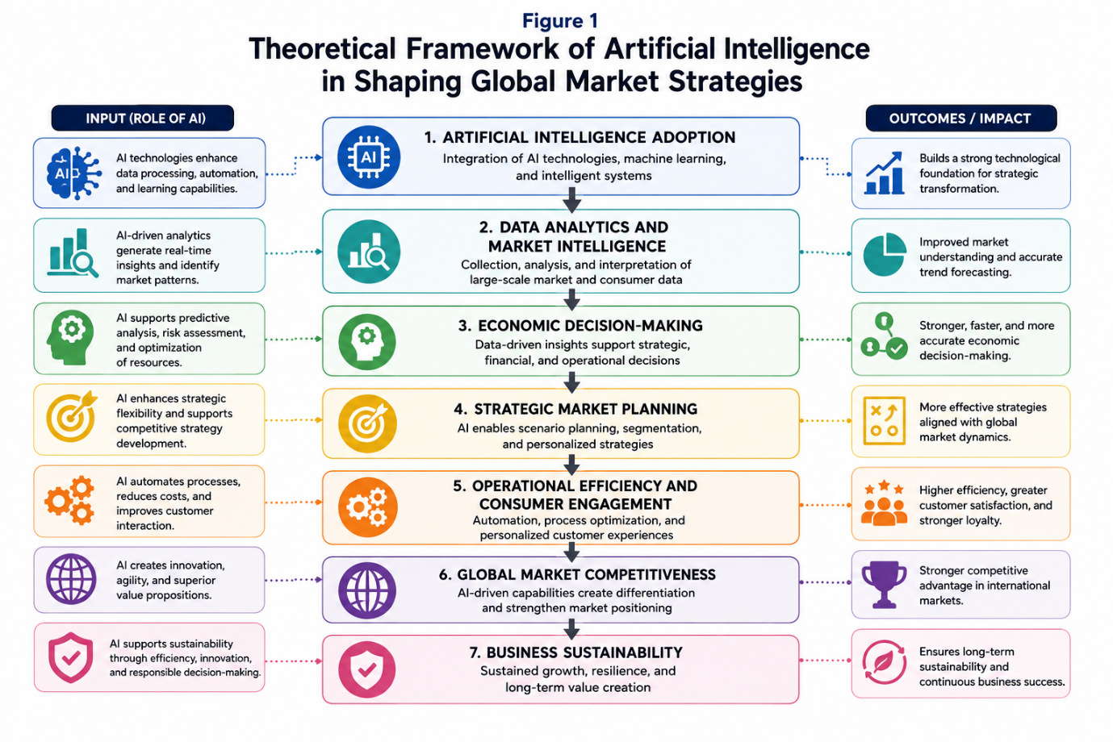Source: Developed by the researchers based on Barney (1991), Teece et al. (2016), Dwivedi et al. (2023), and OECD (2025).

RESEARCH METHODOLOGY

Research Design

The current study aims to investigate the impacts of Artificial Intelligence (AI) on economic decision making and worldwide market planning of multinational organizations by employing qualitative descriptive research approach based on secondary data analysis. This research is more appropriate for a qualitative approach as it does not involve testing statistical relationships or primary data collection. Rather, it focuses on examining and interpreting market trends, existing knowledge, and strategic developments related to AI adoption.
Careful assessment and combination of information gathered from a variety of credible sources allow researchers to learn what is happening in the business world today through secondary data analysis. This method is used in much business and management research to analyse new trends, strategic shifts and technical development in the global corporate environment (Johnston, 2017).

Data Collection

The present study is solely based on secondary data obtained from academic journal articles, worldwide economic reports, industry publications, and global company databases, published throughout the period of 2020-2025. Key sources include reports from the OECD, World Bank, International Monetary Fund (IMF), McKinsey & Company, Stanford Artificial Intelligence Index Report and World Economic Forum. Another key source is peer-reviewed scientific books on artificial intelligence, digital transformation, strategic management, and multinational organizations. The selected sources were evaluated on their relevance, credibility, recency and ability to shed light on the use of AI and its impact on multinational company operations.

Data Analysis

The secondary data collected was analysed by thematic content analysis. This method was used to identify, categorize, and explore recurring themes, patterns, and trends in the use of artificial intelligence (AI) by global corporations. Systematic study and comparison of data from academic journal articles, international economic reports, industry publications and global corporate databases provided a full understanding of AI’s role in global market strategies and economic decision-making.

The study's key themes were AI adoption, strategic market planning, economic decision-making, operational efficiency, market competitiveness, and corporate sustainability. Other sources yielded similar results to underscore persistent trends and emerging developments in the deployment of AI in global corporate contexts.

The Resource-Based View (RBV) theory was employed as the guiding theoretical framework for the interpretation of the data. The research explored how AI may be deployed as a strategic organizational resource to enhance operational performance, develop organizational capabilities, nurture strategic flexibility and offer a persistent competitive advantage in international markets. This enables the research to present a holistic view of the impact of AI on strategic and financial decisions of multinational companies in fast-paced digital economies.

FINDINGS AND DISCUSSION

Global AI Adoption Trends among Multinational Corporations

The fast-digital transformation and increasing global market competition have led to the fact that artificial intelligence is considerably more widely used by multinational enterprises in today’s digital economy. Multinational industries like banking, healthcare, manufacturing, logistics, retail and international commerce are increasingly deploying AI in their operations to make them more efficient, better strategic planning and firms more competitive. Multinational organizations are increasingly focusing on AI integration as part of their long-term agenda to become more digital and continue in business, according to recent studies around the world.

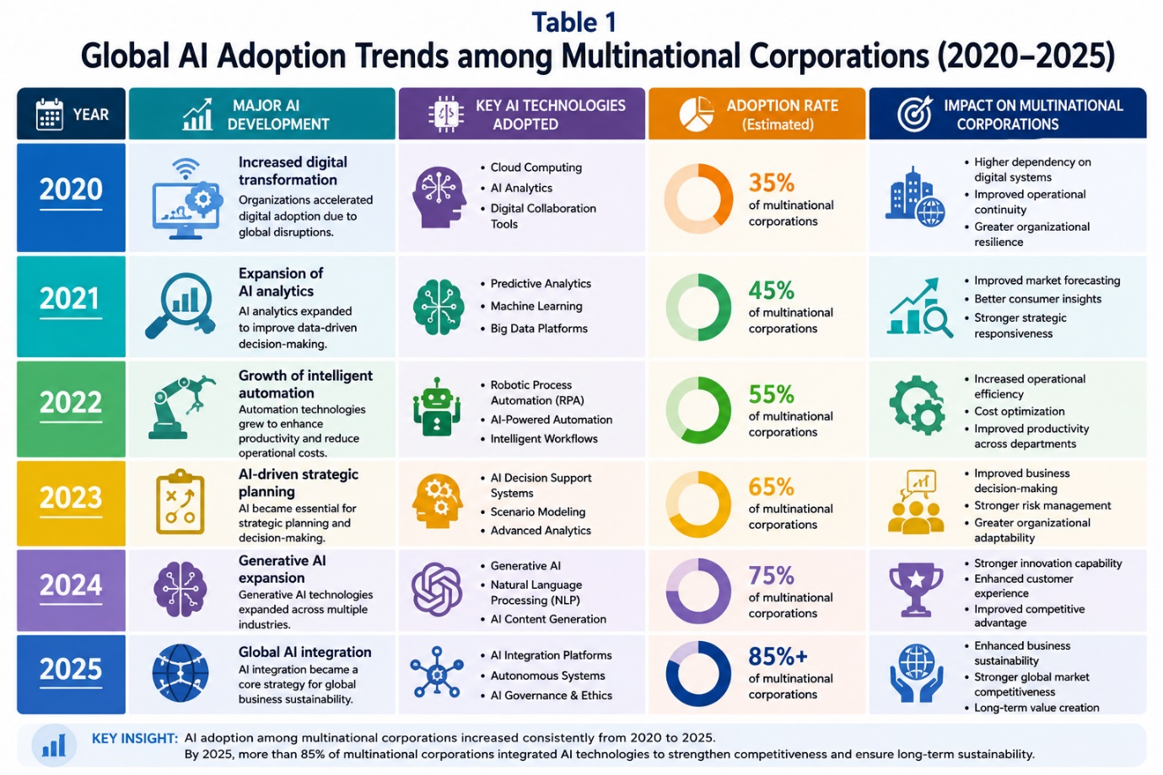
Source: Compiled by the researchers based on McKinsey Global Survey (2025), OECD (2025), and Artificial Intelligence Index Report (2025). The figures presented represent synthesized trends derived from multiple international reports and are intended for illustrative purposes.
Table 1 presents an illustrative summary of global AI adoption trends among multinational corporations from 2020 to 2025. The results reveal that the amount of utilization of artificial intelligence (AI) increased significantly in the selected time period. This was due to the fast-digital transformation, technological progress and growing competitiveness in the markets of worldwide enterprises. Multinational corporations are increasingly adopting AI in their operational systems, strategic planning, consumer contact and organizational management. This makes their businesses more competitive and longer lasting in a constantly changing global business environment.

The COVID-19 pandemic of 2020 posed operational issues that accelerated the digital transformation of multi-national organizations. Businesses turned to digital systems, remote operational technologies and AI-powered business platforms to keep operations running smoothly and the firm running efficiently during times of economic uncertainty. In 2021, multinationals relied more and more on AI-powered analytics and predictive technologies to enhance market forecasting, operational monitoring and strategic responsiveness in fast-changing corporate environments.

Also, the data reveal that the adoption of intelligent automation technologies increased significantly in 2022. This is because an increasing number of worldwide firms have started using AI technologies to increase productivity, save costs and make organizational processes more fluid. In 2023, strategic planning with AI was more crucial than ever as global corporations employed predictive analytics, smart market systems, and automated operational management to make strategic decisions easier and to make their enterprises more agile. These changes make AI technology increasingly valuable as strategic organizational tools to assist multinational organizations stay competitive and keep their operations operating smoothly.

New events in 2024 and 2025 reveal that generative AI technologies are spreading rapidly and the use of AI in international companies is increasing. Multinational firms have adopted more and more the generative AI systems, automated customer contact technologies, and AI-powered decision-support systems to remain competitive in the market and keep their enterprises alive. In the era of digital economies, such technology breakthroughs allowed international corporations to respond to shifting consumer tastes, volatile markets, and global economic challenges.

AI and Decision Making

In today's highly competitive global business contexts, artificial intelligence has a great impact on the economic decision-making of international companies. AI-powered solutions are replacing old ways, enabling multinational corporations to process vast volumes of corporate data, detect market patterns, predict economic trends, and make their organizations more responsive. Gradually, multinational firms are integrating AI-powered analytics, predictive systems and smart automation into their strategic business operations to make them more efficient and long-lasting. That’s because the global economy is growing increasingly complex and data-driven.

AI-powered financial prediction and supply chain management tools also help global corporations pivot their strategy and strengthen their businesses simpler. Data-driven strategic management is helping global firms to manage operational risks, optimize resource allocation, reduce supply chain disruptions, and ensure sustainable operations with AI technologies. Such technological improvements highlight the fact that AI is an increasingly salient strategic instrument that influences the economic decisions of global firms and their long-term market competitiveness.

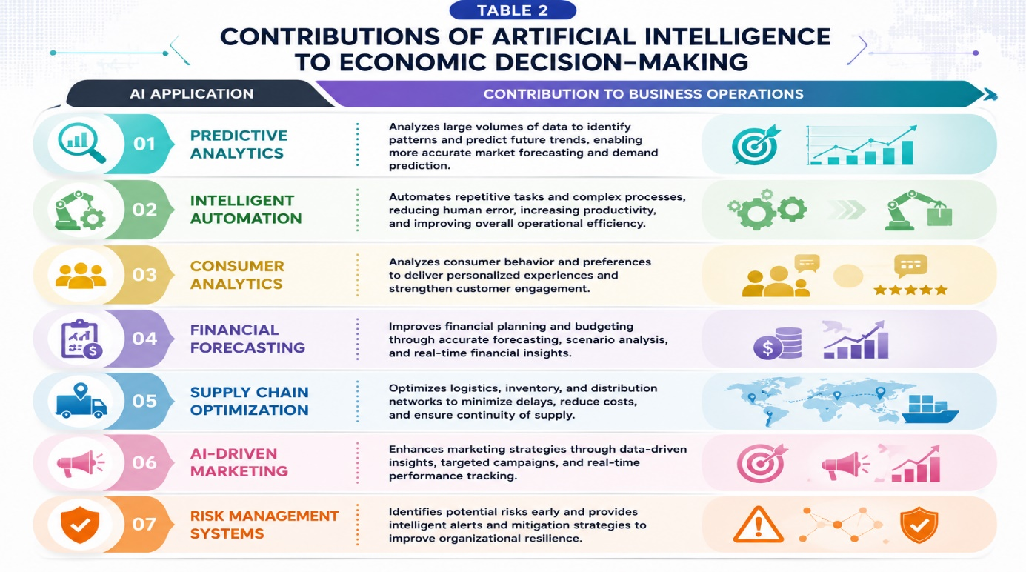
Source: Compiled by the researchers based on OECD (2025), McKinsey Global Survey (2025), and Artificial Intelligence Index Report (2025). The figures presented represent synthesized trends derived from multiple international reports and are intended for illustrative purposes.

The most important ways AI has helped with economic decisions and running global businesses are shown in Table 2. The results reveal that the present global marketplaces are driven by firms that are considerably more efficient, responsive to operations and adept at preparing for the future with the support of AI-powered technologies. Multinationals are increasingly using predictive analytics and intelligent automation systems to improve market forecasting, the efficiency of operational activities and the flexibility of their organizations in times of economic uncertainty and changing customer behaviour.

The results indicate that AI-powered consumer analytics and digital marketing systems contribute significantly to the increase in customer engagement and the improvement of the competitiveness of firms in international marketplaces. AI technology assist multinational firms to analyse data in real time, run smart operational systems, find out what customers want, customize their marketing campaigns for each customer and improve their customer relationship management. These features help global companies to respond to the changing needs of markets, and to sustain long-term business success in highly competitive digital economies.

Recent developments further reveal that multinational corporations increasingly prioritize AI integration as part of organizational digital transformation and business sustainability strategies. AI-driven systems improve operational monitoring, strategic planning, and organizational innovation while simultaneously reducing operational inefficiencies and improving productivity. Consequently, Artificial Intelligence continues to strengthen multinational corporations’ operational resilience and strategic adaptability within highly dynamic global business environments.

AI Global Market and Competitiveness

Artificial Intelligence is becoming increasingly crucial in helping international companies to be more competitive in the global market especially in the ever-changing digital economies. As global markets become more competitive, multinational corporations can leverage AI-driven solutions to boost operational efficiency, increase strategic response, improve customer engagement and fuel long-term corporate success. With the digital revolution accelerating all over the world, multinational organizations are slowly integrating AI technology in their strategic business operations, in order to increase the flexibility of their companies and maintain their competitive advantage.

Recent developments around the world reveal that multinational corporations are focusing more on AI-powered innovation to stay in business and embrace digital change. AI technologies improve a lot strategic planning, predictive market research, automated operational systems and flexibility of enterprises. According to the Artificial Intelligence Index Report (2025), organizations with multinational presence that implement AI-based systems have more productivity growth, operational resilience, and strategic competitiveness than companies that solely use traditional business management systems.

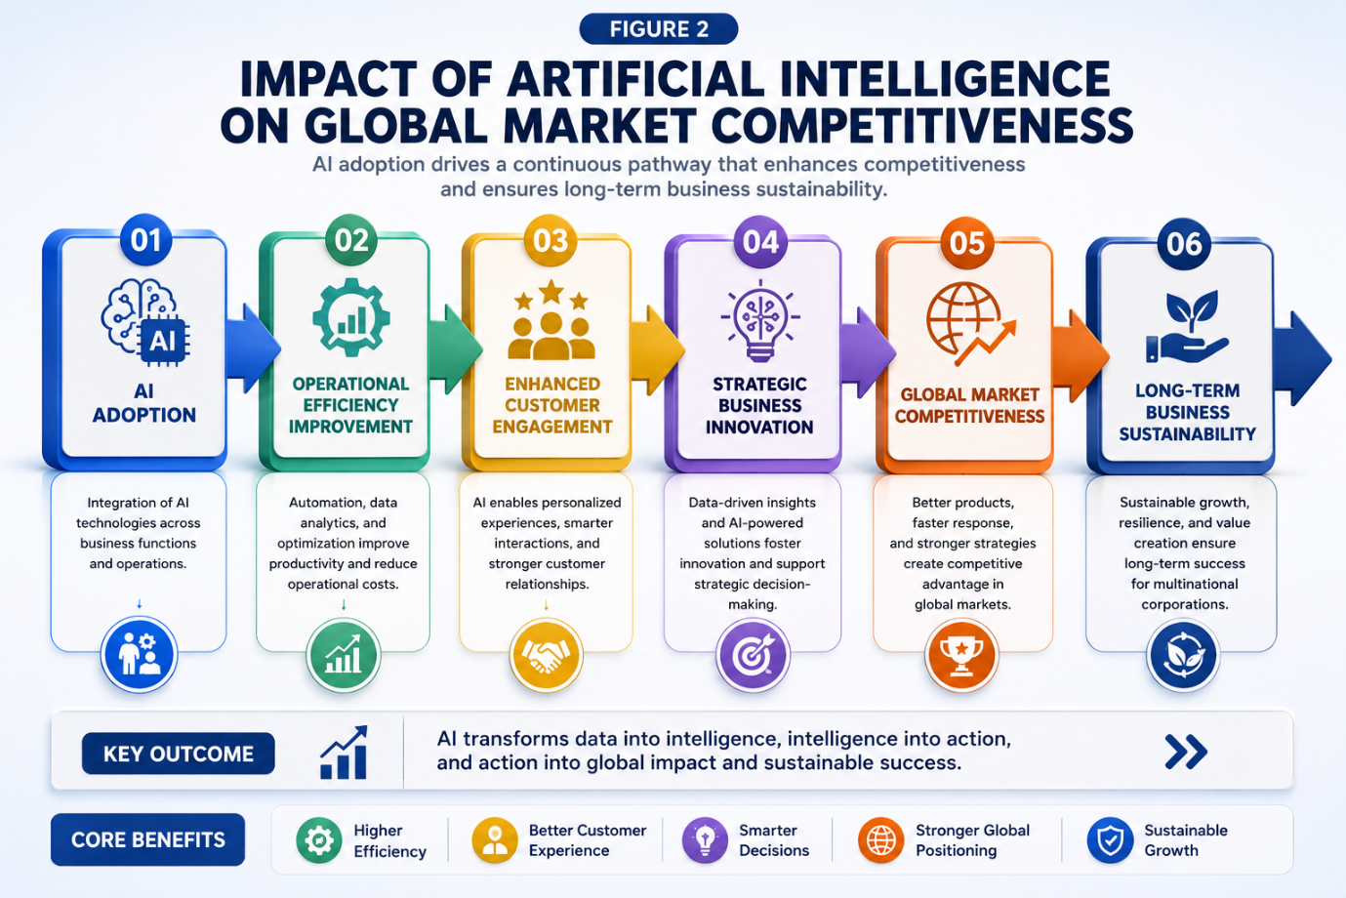
Source: Developed by the researchers based on McKinsey Global Survey (2025), OECD (2025), and Artificial Intelligence Index Report (2025).

Figure 2 depicts how artificial intelligence assists foreign enterprises to be more competitive in the world market and to continue their activities for a long period. The results demonstrate that AI allows enterprises to be far more efficient through smart automation, predictive analytics and data-driven operations management. With these technical developments, international corporations may enhance their business processes, reduce waste in operations and make their organizations agile in rapidly changing worldwide marketplaces.

The results also demonstrate that AI-driven solutions enable global organizations to connect with their customers and devise novel business models with far more ease. AI-driven recommendation engines, tailored digital marketing, automated customer support platforms and predictive consumer analytics all make customers happier and help a company stand out in foreign markets. Technology advances have made it easier for multi-national corporations to adapt to shifting client patterns, unstable markets and greater competition around the world.

Furthermore, strategic business innovation based on AI technology helps multinational organizations to be much more competitive and helps their operation to survive for a long period. AI-powered solutions aid with strategy planning, market forecasting, supply chain management and make firms more agile in highly interconnected global markets. This has led to an increased focus on digital transformation and AI integration projects by global corporations to make their strategies more flexible, organizations more robust and to secure long-term commercial growth in fast changing digital economies.

Recent developments between 2024 and 2025 indicate that generative AI technology gradually affects the competitiveness of multinational firms in both developed and developing countries. Multinational corporations are progressively deploying AI-driven business models, intelligent operational systems, and automated strategic management platforms to increase efficiency and maintain a competitive edge in intensely competitive global marketplaces. These findings demonstrate the continued importance of artificial intelligence as a strategic tool that influences multinational corporations' long-term competitiveness and operational viability.

Strategic Challenge and Organizational Adaption

While the deployment of AI in multinational organizations is increasing, some strategic obstacles still exist that hinder the integration of AI and the smooth operation of global company. Harnessing AI technologies will need enterprises to make significant investments in technology infrastructure, digital skills and the capacity to adapt their plans. Multinational organizations face operational challenges when integrating AI, including cybersecurity risks, ethical considerations, workforce adaptation, regulatory compliance, and technological unpredictability which can make it difficult for them to manage their businesses.

Recent studies have demonstrated that the challenges in integrating AI are having a considerable effect on a company’s readiness and its ability to survive in the long term. With AI continuing to drive changes in how organizations operate, the OECD said firms are more anxious about data privacy, cyber security concerns, bias in algorithms and digital governance. These issues call for global firms to enhance their digital security, organizational governance and strategic technical management so that AI is employed responsibly in highly connected digital economies.

Statistical Trends of AI Adoption and Market Growth

There is fresh study from all over the world that shows multinational companies will employ AI extremely swiftly a lot more between 2020 and 2025. According to the McKinsey Global Survey 2025, about 78% of organizations globally have adopted at least one AI technology in their company. This is a huge increase from past years. Generative AI technology, smart automation systems and ever-evolving predictive analytics have accelerated the digital transformation strategies and operational model modernization efforts of global corporations in many industries.

According to the Artificial Intelligence Index Report (2025), over USD 184 billion was invested on AI technology worldwide in 2024. This is a case in point of the growing importance of AI-powered creativity in today’s digital markets. To generate more money, stay in business longer, and enhance output, global corporations are investing more in AI infrastructure, machine learning systems, data analytics platforms, and smart operating technologies. These developments have put the application of AI among the forefront issues for multinational corporations operating in highly competitive global markets.

Recent occurrences also suggest that multinational organizations are increasingly embracing AI technologies in strategic planning and customer analytics for increased flexibility and competitiveness in the market. In their strategic business planning, almost 70% of the organizations worldwide reported the use of AI systems, and 72% employed AI-powered customer analytics technology to make their digital marketing more personalized and better engage customers. These results prove that the AI is still an important strategic component affecting the long-term competitiveness of global markets, the digital transformation of the multinational operations and the possibility to stay in business.

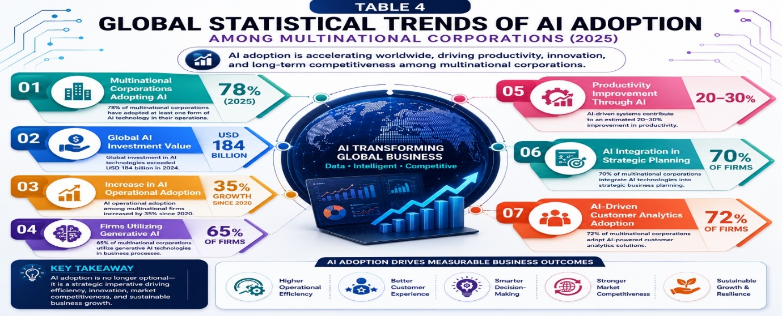
Source: Compiled by the researchers based on McKinsey Global Survey (2025), Artificial Intelligence Index Report (2025), OECD (2025), and World Economic Forum (2025). The figures presented represent synthesized trends derived from multiple international reports and are intended for illustrative purposes.

Table 4 presents recent statistics trends on the use of AI by multinational enterprises in international digital markets. The results suggest that the rapid technical progress, digital transformation, and the rise of global market competitiveness have led to a significant increase in AI integration from 2020 to 2025. In fact, nearly 78% of multinational firms deployed AI-driven solutions in organizational analytics, strategic planning, customer contact, and operational management to improve productivity and operational efficiency.

Results also reveal that the generative AI technologies, predictive analytics, and AI-powered customer intelligence systems are increasingly essential organizational competencies of global organizations. By 2025, over 65% of multinationals adopted generative AI technology, mostly to improve operational automation, strategic innovation and responsiveness to the digital market. Furthermore, worldwide business operations are believed to have seen a 20% to 30% rise in productivity through the use of AI-enabled operational solutions. However, the success of AI implementation depends on organizational readiness, technological capability, workforce adaptation, and regulatory compliance.

CONCLUSION

In conclusion, AI has become one of the most important technological developments that influence the way international companies compete in global marketplaces and make economic decisions in rapidly changing digital economies. The findings of this study reveal that AI technologies assist run operations efficiently, provide additional strategy options to firms, keep customers interested, make them more competitive in the market and retain them in enterprises for a long time. From 2020 to 2025, global firms took digital transformation and organizational innovation to the next level, leveraging more AI-driven systems, predictive analytics, intelligent automation and generative AI technologies.

The report also revealed that multinational firms are increasingly applying AI to strategic planning, operational management, financial forecasting and customer analytics. This enables the companies to become more agile and sustain their competitive advantage in fast changing global markets. Statistics also suggest that foreign companies are using AI more and more. That’s because technology is moving so fast, there’s greater competition all over the world, and businesses are becoming more and more reliant on data-driven systems. But global firms still have to tackle the challenges of using AI and ensuring the seamless operation of their activities, including cybersecurity threats, workforce adaptation, ethical issues and the lack of clarity in technology.

This research extends the growing literature on AI, global market competitiveness, and multinational corporate sustainability by integrating the adoption of AI, strategic decision-making, and operational resilience in a contemporary multinational context. The findings provide meaningful insights for multinational corporations, policymakers, business strategists and stakeholders of the digital economy, in terms of the importance of AI-driven innovation and organizational adaptation for long-term competitiveness, in the highly interconnected digital business environments. Future research could push this topic farther by quantitative analysis, broader global datasets and comparative regional studies on AI and digital economic development.

POLICY RECOMMENDATION

Some policy implications can be drawn with regard to the findings of this research. First, large organizations must invest more in AI, upgrade their digital infrastructure, and innovate new ways of doing business. This will assist them to become more efficient and to remain competitive in fast-moving digital economies. Companies can also focus on digital training and upskilling programs for their staff to enhance workforce flexibility during the AI merger process.

Second, states and regulators should strengthen AI governance frameworks, cybersecurity rules and digital regulatory systems to ensure that AI is utilized responsibly and ethically in international commercial contexts. Strong governance structures are critical to reduce cybersecurity threats, preserve customer data privacy and enhance organizations’ accountability in AI-driven operational systems.

Third, global corporations must continuously enhance their strategic agility, digital transformation initiatives and AI-powered innovation capabilities to build resilience in their organizations and secure their long-term commercial success. Digital innovation, international partnership, collaboration on technology and smart AI management might make the global market even more competitive and contribute to the long-term digital economic growth.

NOVELTY OF THE RESEARCH

This research introduces several crucial new concepts in the field of AI, worldwide market strategies and long-term sustainability of international businesses. Firstly, the study brings together the application of artificial intelligence, competition in global marketplaces and economic decision-making in a unified analytical framework. The book is mainly about foreign firms operating in fast changing digital economies. This study differs from other studies in that it discusses strategic management, operational sustainability and digital transformation from a global company perspective. Most other studies have focused on either AI adoption or technological innovation.

Second, the report looks into the recent global changes in generative AI technologies, AI-powered strategic planning, intelligent automation and digital transformation of multinational companies from 2020 to 2025. By adding the latest worldwide reports and data patterns, the study is more relevant to today’s world, and it provides us with new knowledge on how global companies use AI in digital economies after a pandemic.

Third, the study contributes to the literature that uses the Resource-Based View (RBV) to show how Artificial Intelligence (AI) can be used as a strategic organizational capability to improve operational efficiency, market competitiveness, strategic flexibility, and long-term viability of a business. The development of the theoretical framework enables us to understand more about the relationship between the use of AI, economic decision-making and the competitiveness of transnational enterprises in highly connected global markets.

Finally, the study makes a real difference by showing to multinational companies, policy-makers and those involved in the digital economy the importance of AI-driven innovation, organisational agility and responsible digital transformation to stay competitive and operationally resilient in fast changing international business environments.

Author Contributions: The Authors have contributed equally to this work. All authors have read and agreed to the publish version of the manuscript.

Conflict of interest declarations: The authors declare no conflict of interest

REFERENCES

- Barney, J. (1991). Firm resources and sustained competitive advantage. Journal of Management, 17(1), 99–120. https://doi.org/10.1177/014920639101700108
- Brynjolfsson, E., & McAfee, A. (2017). Machine, platform, crowd: Harnessing our digital future. W. W. Norton & Company.
- Chui, M., Manyika, J., & Miremadi, M. (2018). What AI can and can’t do (yet) for your business. McKinsey Quarterly, 1(1), 1–9.
- Davenport, T. H., & Ronanki, R. (2018). Artificial intelligence for the real world. Harvard Business Review, 96(1), 108–116.
- Dwivedi, Y. K., Hughes, L., Baabdullah, A. M., et al. (2023). So what if ChatGPT wrote it? Multidisciplinary perspectives on opportunities, challenges and implications of generative conversational AI for research, practice and policy. International Journal of Information Management, 71, 102642. https://doi.org/10.1016/j.ijinfomgt.2023.102642
- Gartner. (2025). Top strategic technology trends 2025: Artificial intelligence and digital transformation. Gartner Research. https://www.gartner.com
- George, G., Lakhani, K. R., & Puranam, P. (2020). What has changed? The impact of Artificial Intelligence on the organization of work. Academy of Management Discoveries, 6(4), 544–568. https://doi.org/10.5465/amd.2019.0186
- Huang, M. H., & Rust, R. T. (2021). A strategic framework for artificial intelligence in marketing. Journal of the Academy of Marketing Science, 49(1), 30–50. https://doi.org/10.1007/s11747-020-00749-9
- International Monetary Fund. (2025). Artificial intelligence and the future of work in global economies. IMF Publications. https://www.imf.org
- Johnston, M. P. (2017). Secondary data analysis: A method of which the time has come. Qualitative and Quantitative Methods in Libraries, 3(3), 619–626.
- Kaplan, A., & Haenlein, M. (2020). Rulers of the world, unite! The challenges and opportunities of Artificial Intelligence. Business Horizons, 63(1), 37–50. https://doi.org/10.1016/j.bushor.2019.09.003
- Kshetri, N. (2021). Artificial Intelligence in global supply chains and international business operations. IT Professional, 23(4), 11–15. https://doi.org/10.1109/MITP.2021.3079150
- McKinsey & Company. (2025). The state of AI in 2025: Generative AI’s organizational impact. https://www.mckinsey.com
- Mikalef, P., Boura, M., Lekakos, G., & Krogstie, J. (2019). Big data analytics capabilities and innovation: The mediating role of dynamic capabilities. Information and Management, 56(8), 103169. https://doi.org/10.1016/j.im.2019.04.003
- OECD. (2025). The adoption of artificial intelligence in firms. OECD Publishing. https://www.oecd.org
- PwC. (2025). Sizing the prize: The economic impact of AI on global business. PricewaterhouseCoopers. https://www.pwc.com
- Shrestha, Y. R., Ben-Menahem, S. M., & Von Krogh, G. (2019). Organizational decision-making structures in the age of Artificial Intelligence. California Management Review, 61(4), 66–83. https://doi.org/10.1177/0008125619862257
- Stanford Institute for Human-Centered Artificial Intelligence. (2025). Artificial intelligence index report 2025. Stanford University. https://hai.stanford.edu/ai-index

- Teece, D. J., Peteraf, M., & Leih, S. (2016). Dynamic capabilities and organizational agility: Risk, uncertainty, and strategy in the innovation economy. California Management Review, 58(4), 13–35. https://doi.org/10.1525/cmr.2016.58.4.13
- World Bank. (2025). Digital development overview 2025. World Bank Group. https://www.worldbank.org
- World Economic Forum. (2025). Future of jobs report 2025. World Economic Forum. https://www.weforum.org

