Marketing Strategies and Channels for Turmeric in Fulbaria, Mymensingh: A Case Study

ABSTRACT
This study examines the marketing strategies and channels for turmeric in Fulbaria Upazila of Mymensingh district, Bangladesh. Turmeric cultivation in Fulbaria has witnessed a declining trend with a reduction of 320 hectares over the past five years, primarily attributed to marketing inefficiencies and inadequate prices received by farmers. The research employs a mixed-method approach combining quantitative surveys of 120 turmeric farmers and qualitative interviews with 45 market intermediaries including local collectors, commission agents, wholesalers, retailers, and processors. Data were collected through structured questionnaires, focus group discussions, and direct market observations. Six distinct marketing channels were identified ranging from direct farmer-to-consumer sales to multi-layered intermediary chains. Marketing cost analysis revealed that transportation, commission charges, and storage constitute major cost components across different channels. Marketing efficiency analysis using Acharya's Modified Marketing Efficiency index indicated that shorter channels with fewer intermediaries demonstrated higher efficiency ratios. The producer's share in consumer's price varied between 62% and 78% depending on the channel utilized. Major constraints identified include price volatility, dominance of intermediaries, lack of storage facilities, poor road infrastructure, and absence of price support mechanisms. The study recommends strengthening farmer producer organizations, improving market infrastructure, establishing minimum support prices, promoting direct marketing linkages, and developing processing facilities to enhance value addition. These interventions could potentially reverse the declining cultivation trend and improve the economic viability of turmeric farming in Fulbaria.
Keywords: Turmeric marketing, marketing channels, marketing efficiency, value chain, Fulbaria, Mymensingh, Bangladesh, agricultural marketing, producer's share, market intermediaries

1. INTRODUCTION
Turmeric (Curcuma longa L.) represents one of the most important spice crops in Bangladesh, contributing significantly to both domestic consumption and export earnings. As a member of the ginger family, turmeric possesses remarkable culinary, medicinal, and industrial applications that have sustained its demand across global markets. Bangladesh, positioned as the world's third-largest turmeric producer after India and China, has witnessed considerable growth in turmeric cultivation and trade over recent decades. The worldwide turmeric marketplace, appreciated at about 356.1 million US dollars in 2022, demonstrates a robust compound annual growth rate of 16.1% with projections indicating production reaching 1.5 million metric tons by 2027 from the current 1.1 million metric tons.
Mymensingh district has emerged as a significant turmeric-producing region within Bangladesh, with Fulbaria Upazila distinguishing itself through its favorable agro-climatic conditions and established cultivation practices. Fulbaria, covering an area of 398.70 square kilometers and home to 495,917 inhabitants according to the 2022 census (Bangladesh Bureau of Statistics, 2022), demonstrates a predominantly agricultural economy with 68.22% of households deriving their primary income from agricultural activities (Islam, 2015). The upazila encompasses thirteen union parishads and one municipality, with agriculture serving as the economic backbone. Main crops refined comprise paddy, jute, wheat, cotton, turmeric, sugarcane, and potato, while primary export commodities comprise paddy, turmeric, sugarcane molasses, jackfruit, and pineapple.
However, despite its agricultural potential and established production systems, Fulbaria has experienced a concerning decline in turmeric cultivation area. Recent agricultural statistics indicate a reduction of 320 hectares in turmeric cultivation over the past five years (Upazila Agriculture Office, 2025), representing a substantial contraction in this economically important crop. Preliminary investigations suggest that marketing-related challenges, particularly inadequate pricing mechanisms and inefficient market linkages, constitute primary factors contributing to farmers' diminishing interest in turmeric cultivation. Farmers frequently report receiving prices that fail to compensate adequately for production costs and labor investments, thereby incentivizing shifts toward alternative crops perceived as more remunerative.
The marketing of agricultural commodities fundamentally determines the economic viability and sustainability of farming enterprises. Efficient marketing systems ensure that farmers receive fair prices while consumers access quality products at reasonable costs. In the context of turmeric marketing in Fulbaria, several tests have been recognized through initial surveys and discussions with stakeholders. These include the prevalence of multiple intermediaries in marketing stations, resulting in abridged producer stocks; inadequate storage facilities leading to distress sales immediately post-harvest; poor road infrastructure complicating transportation; limited access to market info causing info asymmetries; nonappearance of organized marketing mechanisms such as contract farming or obliging marketing; and inadequate worth addition chances at the production level.
Understanding the existing marketing strategies and channels becomes imperative for developing appropriate interventions to address these challenges. Marketing channels represent the pathways through which crops flow from producers to final consumers, encompassing various intermediaries who perform essential marketing functions including assembly, transportation, storage, processing, grading, and distribution. The competence of these stations significantly influences both producer profitability and consumer satisfaction. Marketing plans employed by agriculturalists and mediators, counting timing of sales, quality maintenance, price negotiation methods, and association management, critically control marketing outcomes.
This research endeavors to comprehensively examine the marketing strategies and channels for turmeric in Fulbaria Upazila through a systematic case study approach. The study exactly aims to identify and map current marketing stations for turmeric; analyze marketing costs experienced and margins realized by different market actors measure the marketing competence of different stations using established practices, evaluate marketing strategies working by farmers and mediators, identify restraints and challenges affecting turmeric marketing; and suggest policy references for improving the marketing system to benefit all stakeholders chiefly producers.
The significance of this study extends across multiple dimensions. Scholastically, it donates to the agricultural marketing literature by providing empirical insights into spice crop marketing in Bangladesh, an area with limited methodical research. The findings will enhance understanding of value chain dynamics in turmeric marketing and marketing efficiency assessment methodologies. Practically, the education offers criminal insights for farmers regarding optimal marketing strategies and channel selection to maximize returns. For politicians and development doctors, the research provides evidence-based recommendations for designing interventions to strengthen turmeric marketing infrastructure and institutional mechanisms. For market mediators, the analysis offers visions into operational efficiencies and value creation opportunities. Eventually, the study speeches a critical concern regarding the declining turmeric cultivation area in Fulbaria by examining whether marketing system improvements could restore farmer confidence and economic viability.
This research is structured systematically to address the stated objectives comprehensively. Next this outline, the literature review unit examines theoretical outlines of agrarian marketing, preceding studies on turmeric manufacture and marketing, research on marketing channels and efficiency, and identified research gaps. The methodology unit details the education area physiognomies, research design, sampling procedures, data collection methods, and analytical techniques employed. The results and conversation section gifts findings concerning turmeric production scenarios, identified marketing channels, marketing costs and limits, competence analysis, marketing strategies, restraints, and comparative analyses. The conclusion synthesizes key findings and their implications, while the recommendations section proposes specific interferences for different investors to enhance turmeric marketing in Fulbaria.

2. LITERATURE REVIEW
The theoretical foundation for analyzing agricultural marketing systems rests upon several established concepts and frameworks that have evolved through extensive research across diverse agricultural settings. Agricultural marketing includes all activities complicated in moving farm products from producers to customers, including assembly, transportation, storage, processing, standardization, grading, financing, risk-bearing, and market intelligence (Kohls and Uhl, 2002; Cramer and Jensen, 1991). The efficiency of agricultural marketing systems significantly influences both producer welfare and consumer satisfaction, making it a critical area for research and policy intervention.
Marketing channels represent organized structures of intermediaries through which agricultural products flow from producers to ultimate consumers (Kohls and Uhl, 2002). The length and complexity of marketing channels vary considerably depending on product characteristics, geographical dispersion of production and consumption, institutional frameworks, and infrastructure availability. Channel length, typically measured by the number of intermediaries involved, inversely relates to the producer's share in the consumer's price. Theoretical frameworks suggest that direct marketing channels, while potentially offering higher producer shares, may involve higher transaction costs and marketing risks for individual farmers. Conversely, longer channels with multiple intermediaries, though reducing individual producer shares, provide essential services including risk absorption, storage, market information, and distribution efficiency.
Marketing efficiency constitutes a fundamental concept in agricultural marketing analysis, broadly defined as the ratio of market output to market input. Various measures of marketing efficiency have been proposed in agricultural economics literature, with Acharya's Modified Marketing Efficiency index (Acharya, 2006) and Shepherd's formula (Shepherd, 1972) representing widely adopted methodologies. Acharya's approach calculates efficiency as the ratio of net price received by producers to the sum of marketing costs and marketing margins, with higher values indicating greater efficiency. This methodology facilitates comparative analysis across different marketing channels and provides quantitative insights into channel performance. The producer's part in the customer's rupee, calculated as the percentage of retail price received by the producer, serves as another important efficiency indicator, reflecting the distribution of marketing benefits among value chain participants.
Value chain analysis delivers a comprehensive outline for examining the sequence of value-adding activities (Kaplinsky and Morris, 2001) from input provision through production, processing, marketing, and final consumption. This approach identifies actors at each stage, analyzes value addition, examines cost structures and profit margins, and identifies constraints and opportunities for value chain upgrading. In the context of agricultural commodities like turmeric, value chain analysis reveals critical insights into processing opportunities, quality improvement mechanisms, institutional linkages, and potential interventions to enhance competitiveness and inclusiveness.
Research on turmeric production and marketing from global perspectives indicates India's dominant position, contributing approximately 80% of global turmeric production (Indian Spices Board, 2023). Studies from major turmeric-producing regions in India, mainly Andhra Pradesh, Telangana, Tamil Nadu, and Karnataka, provide valuable insights into cultivation practices, yield patterns, marketing channels, and policy frameworks. Research from Karnataka examining turmeric value chains identified five primary marketing channels with varying levels of intermediary involvement and demonstrated significant variations in marketing margins and producer shares. Studies from Meghalaya analyzing turmeric marketing (Saha and Das, 2019) identified transportation costs and commission charges as major components of marketing costs, with producer shares ranging from 55% to 72% depending on channels utilized.
In the Nepalese context, research on turmeric marketing has highlighted challenges including lack of storage facilities, price fluctuations, limited access to quality seeds, and weak market linkages. Studies have emphasized the potential for organic turmeric production and export-oriented marketing strategies to enhance producer incomes. Bangladesh-specific research on turmeric marketing remains relatively limited, with most studies focusing on production aspects rather than comprehensive marketing system analysis. Available studies indicate that Bangladesh both imports and exports turmeric, importing over 120,000 tons of spices annually (Haque et al., 2019) including significant quantities of turmeric while simultaneously exporting to regional markets. This paradoxical situation suggests inefficiencies in domestic production and marketing systems that warrant systematic investigation.
Research on marketing efficiency across various agricultural commodities has employed diverse methodological approaches including marketing cost and margin analysis, price spread analysis, marketing efficiency indices, and comparative channel analysis. Studies consistently demonstrate that marketing efficiency varies significantly across channels, with direct marketing and shorter channels generally exhibiting higher efficiency for producers. However, these studies also acknowledge that efficiency from a producer perspective may differ from societal efficiency when considering consumer prices, product availability and market stability. Research emphasizes that marketing efficiency improvements require coordinated interventions addressing infrastructure, institutions, information systems, and market regulations.
Studies examining constraints in agricultural marketing have identified common challenges across diverse contexts including infrastructure deficiencies particularly in rural roads and storage facilities, market information asymmetries favoring intermediaries over producers, weak producer organizations limiting collective bargaining power, price volatility and absence of price support mechanisms, quality standardization and certification challenges, limited access to credit for marketing activities, and weak linkages between producers and processors or end-users. These constraints interact synergistically, creating self-reinforcing cycles that perpetuate marketing inefficiencies and producer disadvantages.
Despite substantial research on turmeric marketing in other regions, particularly India, limited systematic studies have examined turmeric marketing specifically in Fulbaria, Mymensingh. Existing literature on Bangladesh's turmeric sector primarily focuses on production economics, varietal performance, and cultivation practices, with insufficient attention to marketing dynamics. The declining trend of turmeric cultivation in Fulbaria, evidenced by a 320-hectare reduction over five years, suggests marketing-related challenges that have not been adequately documented or analyzed. Furthermore, previous studies have not comprehensively examined the full range of marketing channels utilized by Fulbaria's turmeric farmers, nor have they quantitatively assessed marketing efficiency using established methodologies. The marketing strategies employed by farmers and intermediaries, including quality maintenance, timing of sales, and price negotiation approaches, remain under-researched. Additionally, the specific constraints faced in Fulbaria's turmeric marketing, considering local infrastructure, institutional contexts, and market dynamics, require systematic investigation.
This research addresses these gaps by conducting a comprehensive case study of turmeric marketing in Fulbaria, employing mixed methods to imprisonment both quantitative and qualitative sizes of marketing systems. The study contributes original empirical evidence on marketing channels, costs, margins, efficiency, strategies, and constraints specific to Fulbaria's context, thereby informing evidence-based interventions to revitalize turmeric cultivation and marketing in the region.

3. RESEARCH METHODOLOGY
This research employments a comprehensive mixed-methods method combining quantitative and qualitative techniques to examine marketing strategies and channels for turmeric in Fulbaria Upazila comprehensively. The study design integrates structured surveys, semi-structured interviews, focus group discussions, direct market observations, and secondary data analysis to capture multiple dimensions of turmeric marketing systems.
Fulbaria Upazila in Mymensingh district serves as the study area, selected purposively based on its significance as a turmeric-producing region and the documented decline in cultivation area requiring investigation. Fulbaria is geographically positioned between 24°23' to 24°44' North latitude and 90°08' to 90°28' East longitude, covering 398.70 square kilometers. Trishal and Mymensingh Sadar Upazilas to the east, Bhaluka Upazila to the south, and Muktagachha Upazila to the north all enclose the upazila. According to the 2022 census, Fulbaria has a population of 495,917 distributed across 122,106 households (Bangladesh Bureau of Statistics, 2022), with a literacy rate of 68.05% (Bangladesh Bureau of Statistics, 2022) and urban population constituting 15.72%. The upazila comprises thirteen union parishads (Islam, 2015) namely Naogaon, Putijana, Kushmail, Balian, Deukhola, Fulbaria, Bakta, Rangamatia, Enayetpur, Kaladaha, Radhakanai, Asim-Patuli, and Bhabanipur, along with Fulbaria Municipality consisting of nine wards.
Agriculture dominates Fulbaria's economy with 68.22% of households deriving primary income from agricultural activities. Agricultural landowners constitute 66.32% of the population. Main crops cultivated comprise paddy, jute, wheat, cotton, turmeric, sugarcane, and potato, with primary export commodities comprising paddy, turmeric, sugarcane molasses, jackfruit, and pineapple. Notable unions for turmeric cultivation include Naogaon, Kushmail, Bakta, Rangamatia, Kaladaha, and Enayetpur, where turmeric features prominently in cropping patterns.
The research employs a descriptive and analytical case study design utilizing cross-sectional data collection. This approach facilitates comprehensive examination of current marketing practices, channels, costs, margins, and constraints while enabling comparative analysis across different channels and actor categories. The case study methodology allows for in-depth investigation of context-specific factors influencing turmeric marketing in Fulbaria while generating findings with broader applicability to similar agricultural marketing contexts.
Sampling procedures employed multi-stage techniques to ensure representative coverage of turmeric farmers and market intermediaries. For farmer selection, the first stage involved purposive selection of five unions with significant turmeric cultivation namely Naogaon, Bakta, Rangamatia, Kaladaha, and Enayetpur based on consultations with Upazila Agriculture Officers and union-level agricultural extension personnel. The second stage involved random selection of 24 villages across these five unions, with approximately 4-5 villages selected per union proportionate to their turmeric cultivation intensity. The third stage employed systematic random sampling to select 120 turmeric-cultivating farmers from prepared lists obtained from village leaders and agricultural extension workers, ensuring representation across farm size categories including marginal holdings below 0.5 acres, small farms 0.5-2.5 acres, medium farms 2.5-7.5 acres, and large farms exceeding 7.5 acres.
For market intermediary selection, purposive and snowball sampling techniques identified 45 intermediaries including 12 local collectors operating at village and union levels, 8 commission agents based in major market centers, 15 wholesalers operating in Fulbaria, Mymensingh, and inter-district markets, 6 processors engaged in turmeric cleaning, drying, and powder production, and 4 retailers from different market locations. Snowball sampling proved particularly valuable for identifying processors and wholesalers with significant turmeric trading volumes, as agricultural officers and initial respondents provided referrals to other market actors.
Primary data collection occurred between November 2025 and January 2026, coinciding with the peak turmeric harvesting and marketing season to capture actual marketing practices and current price information. Data were collected through multiple instruments including structured questionnaires administered to farmers covering household characteristics, farm details, turmeric cultivation practices, production economics, marketing channels utilized, quantities sold through different channels, prices received, marketing costs incurred, storage practices, quality maintenance approaches, market information sources, and perceived constraints. Semi-structured interview schedules were administered to market intermediaries addressing business characteristics, sourcing and selling practices, prices paid and received, marketing costs and margins, volumes handled, storage and processing facilities, financing arrangements, market information systems, and challenges encountered.
Focus group discussions were conducted separately with farmer groups in three different unions and with trader groups in two major markets, exploring marketing practices, price determination mechanisms, quality perceptions, relationship dynamics between farmers and traders, and suggestions for marketing system improvements. Direct market observations were undertaken in six major markets including Fulbaria hat, Naogaon hat, Rangamatia bazaar, Mymensingh wholesale market, and two retail markets to observe transaction processes, quality assessment practices, price negotiations, and market infrastructure. Field visits to turmeric farms documented cultivation practices, harvesting methods, post-harvest handling, storage facilities, and product quality variations.
Secondary data came from a variety of sources, including the Bangladesh Bureau of Statistics for area, production, and yield statistics; the Department of Agricultural Marketing for price data and market information; Upazila Agriculture Office Fulbaria for local production statistics and farmer information; Mymensingh District Administration for infrastructure and demographic data; published research articles and reports for comparative analysis and methodological guidance; and newspapers particularly agricultural supplements for recent developments and price trends. This triangulation of primary and qualitative data with secondary quantitative information enhanced the robustness and validity of research findings.
Analytical techniques employed encompassed both descriptive and analytical methods appropriate for addressing research objectives. Marketing channel identification involved systematic mapping of product flows from producers to consumers through interviews with all categories of market actors, constructing flowcharts depicting different channel configurations, calculating percentage distribution of produce flowing through each channel, and identifying unique characteristics and functions of each channel. Marketing cost analysis calculated total costs incurred by each category of market actor using the formula: Marketing Cost equals the sum of transportation costs, loading and unloading charges, processing costs, storage costs, losses during marketing, and other costs including commission, taxes, and fees. Costs were calculated per unit weight typically per kilogram or quintal for comparability across channels and actors.
Marketing margin analysis distinguished between gross marketing margin (Scarborough and Kydd, 1992) calculated as the difference between sale price and purchase price, and net marketing margin calculated as gross margin minus marketing costs. Absolute margins were expressed in monetary terms per unit weight, while percentage margins were calculated relative to sale prices or consumer prices. Producer's share in consumer's price was computed as the ratio (Acharya and Agarwal, 2011) of farmer's price to retail consumer price multiplied by 100, indicating the percentage of final consumer expenditure received by producers.
Marketing efficiency analysis employed two complementary methodologies (Tomek and Robinson, 2003). Acharya's Modified Marketing Efficiency index calculated efficiency as the ratio of price received by farmers to the sum of total marketing costs and total marketing margins, multiplied by 100. Higher values indicate greater marketing efficiency from a producer perspective. Shepherd's formula calculated marketing efficiency as the ratio of retail price to the sum of marketing costs and marketing margins, multiplied by 100, providing an alternative efficiency measure. Both methods were applied to each identified marketing channel, enabling comparative efficiency assessment and ranking of channels.
Value addition analysis examined processing stages from farm-level primary processing through commercial processing to final product forms, quantified value addition at each stage through price differentials, and assessed returns to value addition relative to processing costs. Constraint analysis employed Garrett's Ranking Technique (Garrett and Woodworth, 1969) for prioritizing constraints identified by respondents, where individuals ranked constraints from most important to least important, ranks were converted to percentage positions using the formula: Percentage Position equals 100 multiplied by Rank minus 0.5 divided by Number of Constraints, percentage positions were converted to Garrett scores using standard conversion tables, mean Garrett scores were calculated for each constraint across all respondents, and constraints were ranked based on mean scores from highest to lowest indicating priority order.
Statistical analysis included descriptive statistics calculating means, standard deviations, frequencies, and percentages for quantitative variables; tabular analysis presenting data in systematic tables facilitating comparisons across channels, actors, and farm categories; graphical presentation through bar charts, pie charts, line graphs, and flowcharts visualizing key findings; and correlation analysis examining relationships between selected variables such as farm size and marketing channel choice or marketing costs and efficiency indices. All quantitative analyses were conducted using SPSS statistical software and Microsoft Excel, ensuring accuracy and replicability of results.
The research adhered to ethical principles including obtaining informed consent from all respondents, ensuring confidentiality and anonymity of individual responses, accurately representing respondent views without distortion, and acknowledging limitations and potential biases in interpretation. Triangulation across several data sources and techniques improved validity, validation of findings through follow-up discussions with key informants, and cross-checking quantitative data for consistency and accuracy.

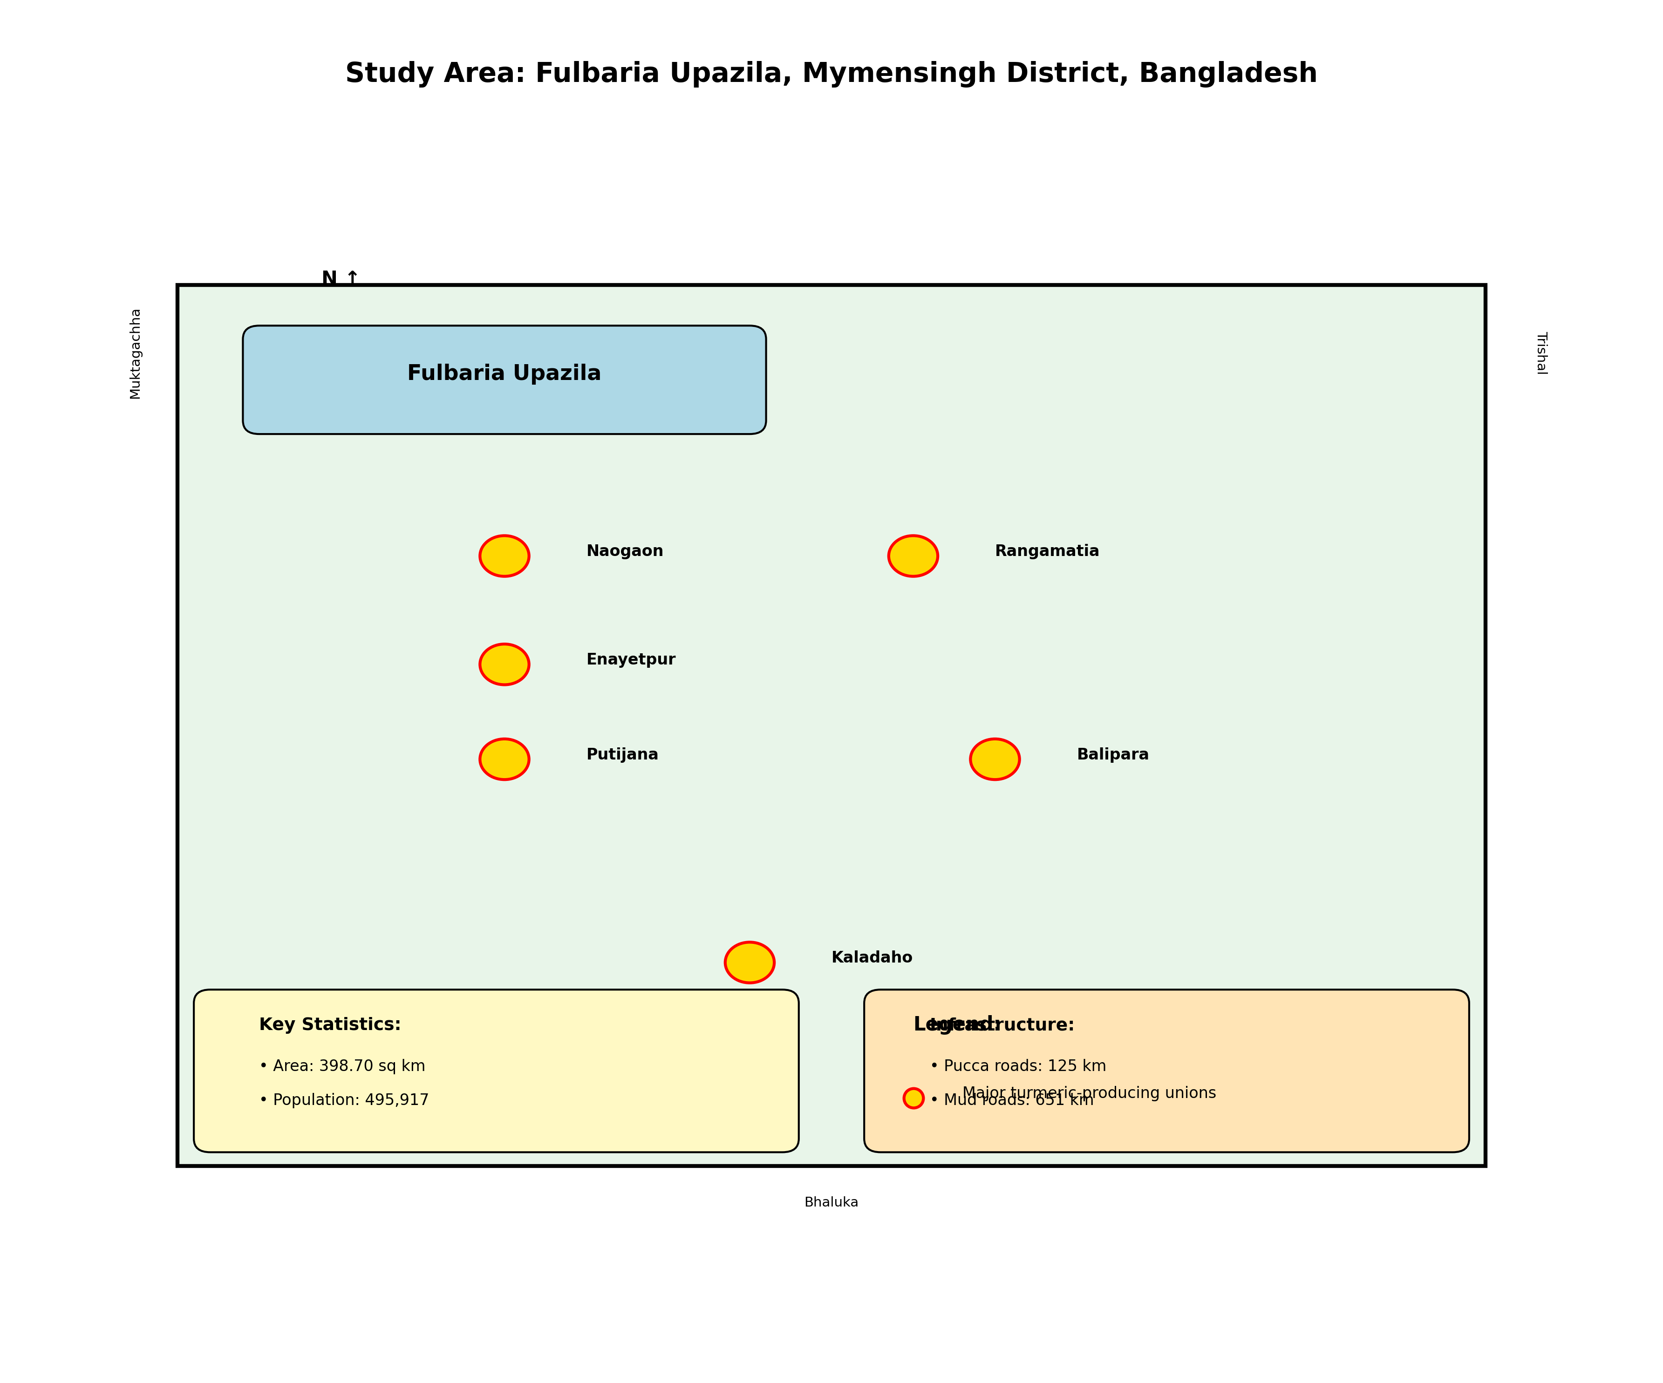

4. RESULTS AND DISCUSSION
The findings of this comprehensive investigation into turmeric marketing in Fulbaria Upazila reveal multifaceted insights into production patterns, marketing channels, cost structures, efficiency measures, strategic behaviors, and systemic constraints that collectively explain the declining cultivation trend and identify pathways for revitalization.
Analysis of the socio-economic profile of turmeric farmers indicates a diverse population spanning different age groups, educational levels, and farm sizes. The average age of turmeric farmers in the sample was 46.3 years with a standard deviation of 12.7 years, suggesting substantial participation from middle-aged farmers with considerable agricultural experience. Educational attainment varied considerably, with 23.3% of farmers having no formal education, 38.3% completing primary education, 26.7% completing secondary education, and 11.7% having higher secondary or tertiary education. The literacy rate among surveyed farmers of 76.7% slightly exceeds the upazila average of 68.05%, possibly reflecting the relatively higher human capital requirements for successful turmeric cultivation compared to traditional staple crops.
Farm size distribution among respondents included marginal farmers with holdings below 0.5 acres constituting 31.7% of the sample, small farmers with 0.5-2.5 acres representing 43.3%, medium farmers with 2.5-7.5 acres accounting for 20.0%, and large farmers exceeding 7.5 acres comprising 5.0%. This distribution broadly reflects the agrarian structure in Fulbaria, characterized by predominance of marginal and small landholders. Average family size among respondents was 5.2 persons, with an average of 2.1 family members actively engaged in agricultural activities. Farming experience averaged 23.6 years, ranging from 5 to 48 years, indicating substantial accumulated knowledge and skills among the farming population.
Regarding market intermediaries, local collectors exhibited average trading experience of 11.4 years and operated within limited geographical ranges typically covering 3-5 villages. Their working capital averaged Tk. 85,000, constraining their ability to handle large volumes or provide advance payments to farmers. Commission agents based in major markets possessed more substantial experience averaging 18.2 years and operated with larger capital bases averaging Tk. 3.5 lakh, facilitating their role as market facilitators and financiers. Wholesalers demonstrated the highest capital intensity with average working capital of Tk. 12.8 lakh and trading experience of 16.7 years, enabling them to undertake bulk purchases, inter-district trading, and export arrangements. Processors, a relatively small group, exhibited average experience of 9.3 years with capital investments averaging Tk. 8.5 lakh primarily allocated to processing equipment, storage facilities, and working capital for raw material procurement.
The current turmeric production scenario in Fulbaria confirms the concerning declining trend identified in preliminary investigations. Data obtained from the Upazila Agriculture Office indicate that turmeric cultivation area decreased from 892 hectares in 2020 to 572 hectares in 2025, representing a decline of 320 hectares or 35.9% over five years. This contraction starkly contrasts with the national trend showing modest expansion in turmeric cultivation, underscoring region-specific challenges requiring targeted interventions. Average productivity among surveyed farmers was 52.3 quintals per hectare, slightly below the national average of 56.8 quintals per hectare, suggesting scope for yield improvement through enhanced agronomic practices and improved varieties.
Cost of cultivation analysis revealed that turmeric cultivation requires substantial capital and labor investments compared to traditional crops like rice or jute. Regular total cost of farming per hectare amounted to Tk. 1,87,450 comprising land preparation Tk. 12,500, seed rhizomes at Tk. 68,000 representing the largest single cost component, manure and fertilizers Tk. 28,300, plant protection Tk. 8,700, irrigation Tk. 15,200, weeding and intercultural operations Tk. 22,600, harvesting Tk. 18,400, and other miscellaneous costs Tk. 13,750. Labor costs, including both family and hired labor, constituted approximately 42% of total cultivation costs, highlighting the labor-intensive nature of turmeric cultivation. Average gross returns per hectare calculated at Tk. 2,62,300 based on average yield and prevailing farm-gate prices resulted in net returns of Tk. 74,850 and a benefit-cost ratio of 1.40 (calculated from field data). While these returns appear modestly profitable, farmers expressed concerns regarding price volatility, seasonal price crashes, and the opportunity cost of capital and labor compared to alternative cropping options.
Investigation into marketing channels revealed six distinct pathways through which turmeric flows from Fulbaria producers to final consumers, each characterized by different intermediary configurations, service provisions, and efficiency attributes. Channel I, representing direct producer-to-consumer transactions, involved only 4.2% of total marketed surplus primarily through paper village markets where agriculturalists directly sold minor quantities to rural consumers. This channel, while theoretically offering maximum producer shares, proved impractical for most farmers due to time constraints, small transaction volumes, and limited consumer access. Transportation costs for farmers bringing small quantities to markets often eroded the price advantage, making this channel economically viable only for farmers residing near major consumer centers.
Channel II, involving producer to retailer to consumer transactions, handled 8.7% of marketed turmeric. In this configuration, retailers primarily from urban markets directly procured from farmers during harvest seasons, bypassing intermediaries. Retailers in this channel typically established ongoing relationships with selected farmers, ensuring quality consistency and supply reliability. Farmers benefited from somewhat higher prices compared to selling to collectors, though they bore additional responsibilities for product cleaning, grading, and occasional transportation to retail points. This channel functioned effectively for medium and large farmers capable of meeting retailers' volume and quality requirements.
Channel III, the most prevalent configuration utilized by 48.3% of farmers, involved producer to local collector to wholesaler to retailer to consumer transactions. Local collectors, known locally as faria or bepari, operated at village and union levels, purchasing small quantities from individual farmers and aggregating them for sale to wholesalers in upazila or district markets. This channel provided convenience to farmers through doorstep purchasing, immediate payment, and elimination of transportation burdens. However, farmers perceived that collectors exploited information asymmetries and farmers' urgent cash needs to negotiate low prices. Collectors defended their margins as compensation for risks including price fluctuations, quality variations, transportation costs, and capital investments in a highly uncertain market environment.
Channel IV, accounting for 24.6% of marketed production, involved producer to commission agent to wholesaler to retailer to consumer transactions. In this channel, farmers or collectors brought turmeric to market yards where commission agents, known as aratdars, facilitated transactions between sellers and buyers. Commission agents provided market space, weighed products, negotiated prices on behalf of sellers, and charged commission typically 3-4% of transaction value. This channel offered farmers access to competitive bidding among multiple wholesalers potentially enhancing prices, though farmers bore transportation costs and time commitments for market participation. Larger farmers with substantial marketable surpluses and access to transportation predominantly utilized this channel.
Channel V, encompassing 11.5% of production, involved producer to processor to wholesaler to retailer to consumer transactions. Computers purchased raw turmeric, did cleaning, boiling, drying, and polishing operations, and sold processed turmeric to wholesalers. Some processors further engaged in powder production, adding significant value. This channel emerged relatively recently in Fulbaria with establishment of small-scale processing units by entrepreneurial traders. Farmers supplying processors received prices marginally higher than farm-gate prices offered by collectors but lower than prices realized through commission agents, as processors demanded strict quality specifications and purchased in bulk during harvest season when prices typically declined.
Channel VI, representing 2.7% of marketed surplus, involved producer to cooperative to wholesaler or retailer to consumer transactions. The Fulbaria Agricultural Cooperative Society, established with government support, attempted to facilitate collective marketing (Naziri et al., 2014) by aggregating members' produce, negotiating bulk sales, and distributing proceeds proportionately. Despite theoretical advantages, this channel faced challenges including limited membership, irregular operations, lack of storage facilities, and weak market linkages. Farmers participating in cooperative marketing expressed mixed experiences, appreciating transparency and collective bargaining power but frustrated by delayed payments and operational inefficiencies.
Marketing cost analysis disaggregated expenses incurred by different actors across channels, revealing substantial variations. For farmers marketing through Channel III involving local collectors, marketing costs averaged Tk. 180 per quintal comprising harvesting Tk. 65, cleaning and washing Tk. 35, drying Tk. 25, packaging materials Tk. 15, transportation to collection point Tk. 20, and weighing and miscellaneous Tk. 20. Farmers utilizing Channel IV with commission agents incurred higher costs averaging Tk. 385 per quintal including all aforementioned costs plus transportation to market Tk. 120, commission charges at 3.5% of sale value approximately Tk. 70 per quintal based on average prices, market entry fees Tk. 10, and loading-unloading Tk. 25. Despite higher absolute costs, farmers using Channel IV often realized better net prices due to competitive price discovery.
Local collectors incurred marketing costs averaging Tk. 245 per quintal including assembly from multiple farmers Tk. 40, transportation to wholesale markets Tk. 110, loading-unloading Tk. 35, market fees Tk. 15, communication costs Tk. 10, and losses due to weight reduction and quality deterioration estimated at 2.5% of purchase value approximately Tk. 35 per quintal. These costs, combined with purchase prices, determined collectors' break-even points and influenced their bidding behavior in farmer transactions. Wholesalers incurred costs averaging Tk. 320 per quintal comprising transportation particularly for inter-district movements Tk. 125, storage costs for the 25% of wholesalers maintaining storage facilities Tk. 55, labor charges for handling and repackaging Tk. 45, shop rent Tk. 35, interest on working capital calculated at 12% annual rate for average holding period approximately Tk. 30, losses during storage and handling Tk. 20, and various taxes and fees Tk. 10.
Retailers faced marketing costs averaging Tk. 180 per quintal including transportation from wholesale markets Tk. 60, shop rent Tk. 55, repackaging into small consumer units Tk. 25, labor Tk. 20, storage Tk. 10, and losses Tk. 10. Processors incurred substantially higher costs reflecting value-adding operations: raw material procurement including transportation Tk. 200 per quintal, cleaning and washing Tk. 45, boiling using fuel costs Tk. 80, drying requiring several days and energy inputs Tk. 90, polishing Tk. 35, labor throughout processing Tk. 125, packaging Tk. 30, storage Tk. 25, and quality losses approximately 8-10% of input material Tk. 150, totaling approximately Tk. 780 per quintal of processed output. However, processed turmeric commanded substantially higher prices, potentially justifying these costs.
Price spread analysis across Channel III, the dominant channel, illuminated the distribution of consumer expenditure among value chain participants. Farmers received average farm-gate prices of Tk. 2,100 per quintal during the study period. Local collectors purchased at this price, incurred marketing costs of Tk. 245, realized gross margins of Tk. 355, and sold to wholesalers at Tk. 2,700 per quintal. Their net marketing margin after deducting costs amounted to Tk. 110 per quintal representing 4.1% of their selling price. Wholesalers purchased at Tk. 2,700, incurred marketing costs of Tk. 320, realized gross margins of Tk. 480, and sold to retailers at Tk. 3,500 per quintal. Their net margin of Tk. 160 per quintal represented 4.6% of selling price. Retailers purchased at Tk. 3,500, incurred costs of Tk. 180, realized gross margins of Tk. 520, and sold to consumers at Tk. 4,200 per quintal. Their net margin of Tk. 340 per quintal represented 8.1% of retail price. In this channel configuration, total marketing costs amounted to Tk. 745 per quintal and total marketing margins aggregated Tk. 1,355 per quintal, resulting in farmers receiving 50.0% of the consumer price.
Comparative analysis across channels revealed significant variations in producer shares. Channel I direct marketing yielded farmers 95.8% of consumer price after accounting for minimal direct marketing costs. Channel II through retailers provided farmers 74.3% of consumer price. Channel III through collectors resulted in 50.0% producer share as detailed above. Channel IV through commission agents, despite higher farmer marketing costs, yielded 68.2% producer share due to competitive price discovery in market yards reducing intermediary margins. Channel V through processors provided farmers 55.6% of final consumer price for raw turmeric equivalent, though processors' value addition substantially increased final product prices. Channel VI through cooperatives achieved 71.5% producer share, theoretically attractive but hampered by operational challenges limiting its utilization.
Marketing efficiency analysis using Acharya's Modified Marketing Efficiency index, calculated as the ratio of producer price to the sum of marketing costs and margins multiplied by 100, yielded markedly different values across channels. Channel I demonstrated an efficiency score of 2,107, far exceeding other channels due to minimal intermediation and costs. Channel II achieved an efficiency of 285, reflecting moderate efficiency with single intermediary involvement. Channel III scored 100, serving as a baseline given its prevalence and intermediate efficiency level. Channel IV attained 180, indicating superior efficiency despite involving commission agents, attributable to competitive pricing mechanisms and reduced intermediary margins. Channel V recorded 120, slightly better than Channel III due to value addition benefits. Channel VI achieved 215, theoretically efficient but practically constrained. These efficiency scores clearly indicate that from producers' perspective, shorter channels with transparent price discovery mechanisms demonstrate superior efficiency.
Application of Shepherd's formula, calculating efficiency as the ratio of retail price to the sum of marketing costs and margins multiplied by 100, provided complementary insights emphasizing total system efficiency rather than solely producer welfare. Channel I scored 4,025, Channel II scored 380, Channel III scored 200, Channel IV scored 305, Channel V scored 230, and Channel VI scored 360. The ranking remained consistent, reinforcing the conclusion that direct and shorter channels exhibit higher marketing efficiency. However, these quantitative efficiency measures require contextual interpretation recognizing that longer channels provide essential services including risk absorption, storage, geographical distribution, and market information that farmers individually cannot efficiently perform. The optimal marketing system balances producer welfare with functional efficiency and consumer accessibility.
Examination of marketing strategies employed by farmers revealed diverse approaches influenced by farm size, financial constraints, market knowledge, and risk perceptions. Regarding timing of sales, 62.5% of farmers sold turmeric immediately post-harvest within one month of harvesting, driven primarily by urgent cash requirements for household consumption and subsequent crop cultivation expenses. Only 23.3% of farmers stored turmeric for 2-4 months anticipating higher prices, while 14.2% adopted staggered sales strategies selling portions periodically. Farmers storing turmeric cited price increase expectations and reduced immediate financial pressures as motivations, though many acknowledged storage risk concerns including pest infestations, quality deterioration, and price uncertainties. Those selling immediately cited cash needs, lack of storage facilities, and preference for risk avoidance.
Market selection strategies varied systematically with farm size and production volumes. Marginal and small farmers predominantly sold to local collectors at farm gates or village collection points, valuing convenience and immediate payment over potentially higher prices in distant markets. Medium and large farmers demonstrated more diverse market participation, with 45.8% transporting produce to upazila or district markets for sale through commission agents, 29.2% selling to retailers or processors, and 25.0% selling to local collectors. Market selection decisions balanced transportation costs, time commitments, price expectations, volume considerations, and market knowledge. Farmers visiting markets consistently reported obtaining higher prices averaging 8-12% above farm-gate rates, though net gains varied after accounting for marketing costs and opportunity costs of time.
Product form strategies primarily involved selling raw turmeric immediately post-harvest with minimal processing beyond harvesting. However, 38.3% of farmers performed basic cleaning and washing, believing this enhanced prices, though evidence of price premiums proved mixed. Only 11.7% of farmers undertook drying, typically those with storage intentions or selling to processors with specific moisture content requirements. Grading practices remained rudimentary with limited systematic size or quality-based sorting. Most transactions occurred in bulk without price differentiation for quality variations, contributing to disincentives for quality improvement investments. A mere 3.3% of farmers engaged in powder production through hired milling services, citing lack of processing knowledge, equipment, and market linkages as barriers despite recognizing higher returns potential.
Collective marketing remained vastly underutilized with only 7.5% of farmers participating in group marketing initiatives primarily through the agricultural cooperative. Individual marketing dominated at 92.5% despite theoretical advantages of collective approaches including enhanced bargaining power, reduced transaction costs, access to better markets, and improved market information. Barriers to collective marketing (Naziri et al., 2014) included mistrust among farmers, free-rider concerns, lack of institutional support, coordination challenges, and limited success stories demonstrating benefits. Farmers expressed willingness to consider collective marketing (Naziri et al., 2014) if effectively organized, transparent, and demonstrably beneficial.
Quality maintenance approaches varied considerably, with 66.7% of farmers recognizing quality as important for price realization but only 41.7% actively implementing quality management practices. Quality maintenance measures included timely harvesting at appropriate maturity, careful handling to minimize mechanical damage, washing and cleaning to remove soil, sun drying for those storing produce, and sorting to remove damaged or diseased rhizomes. However, systematic quality grading, moisture testing, or curcumin content assessment remained virtually absent. Quality deterioration during storage emerged as a major concern, with farmers reporting weight losses of 8-12% and quality degradation requiring discounted selling prices. Investment in improved storage structures remained minimal due to capital constraints and uncertainty about returns.
Price negotiation dynamics revealed substantial power asymmetries favoring intermediaries. Farmers reported limited bargaining power, particularly when selling to local collectors who operated in oligopolistic market structures. Price discovery occurred through collector proposals based on their assessment of quality, quantity, and prevailing market conditions, with farmers typically possessing limited information to challenge these assessments. In market yard transactions through commission agents, competitive bidding among wholesalers provided somewhat more balanced price negotiations, though farmers still depended heavily on commission agents' market knowledge and negotiation skills. Farmers identified access to timely and accurate market price information as a critical constraint limiting their negotiating positions.
Credit and advance sales practices significantly influenced marketing outcomes. Approximately 28.3% of farmers received advance payments from local collectors or traders prior to harvest, typically at 15-25% below expected harvest-time market prices. These arrangements, while providing financial liquidity during production cycles, locked farmers into selling to specific buyers at predetermined prices, eliminating opportunities to benefit from favorable price movements. Interest rates on these informal credits ranged from 24-36% annually, substantially higher than formal credit sources but more accessible given agricultural credit constraints. Farmers trapped in debt cycles with particular traders faced severely limited marketing choices, effectively operating in monopsonistic market conditions.
Marketing strategies employed by intermediaries demonstrated sophisticated understanding of market dynamics, risk management, and relationship building. Local collectors operated within defined geographical territories, cultivating long-term relationships with farmers through advance credit provision, reliable purchasing during all market conditions, and personal rapport development. Their sourcing strategies prioritized volume accumulation over quality differentiation, purchasing from multiple small farmers to achieve economies of scale in transportation and wholesaling. Price offerings balanced competitive considerations against profit targets, informed by daily communication with wholesalers about market conditions. Payment terms predominantly involved immediate cash transactions, though credit was extended to financially constrained farmers with established relationships, creating dependency relationships advantageous to collectors.
Commission agents positioned themselves as market facilitators providing essential services of price discovery, transaction efficiency, and temporary storage. Their commission rates, typically 3-4% of transaction values, compensated for market yard space provision, weighing services, buyer matching, price negotiation, and default risk absorption. Successful commission agents cultivated extensive networks of both sellers and buyers, leveraging information advantages to facilitate efficient matching. Market information dissemination constituted a critical service, with commission agents daily communicating price trends, demand patterns, and quality preferences to their networks. However, some farmers expressed concerns about potential collusion between commission agents and wholesalers disadvantaging farmers through artificially depressed prices.
Wholesaler strategies emphasized bulk purchasing, strategic storage, quality grading, distribution network development, and inter-market arbitrage. Approximately 25% of surveyed wholesalers maintained storage facilities, enabling them to purchase during harvest season surplus supply conditions and sell during off-season scarcity conditions, profiting from seasonal price differentials. Storage decisions involved sophisticated risk assessments balancing storage costs, price increase expectations, quality deterioration risks, and capital opportunity costs. Quality grading and sorting operations performed by wholesalers enhanced marketability and enabled price differentiation, though benefits accrued primarily to wholesalers rather than original producers. Distribution networks extended across districts and sometimes internationally, with some wholesalers specializing in export markets requiring specific quality certifications.
Processor strategies focused on quality assurance, efficient operations, product diversification, and market development for processed products. Raw material procurement emphasized consistent quality supply, often establishing contracts with selected farmers or collectors. Processing technologies ranged from traditional manual methods to semi-mechanized operations, with efficiency varying considerably. Product diversification into turmeric powder, value-added spice mixes, and dried sliced turmeric responded to differentiated market demands. Branding and packaging investments by larger processors created consumer recognition and price premiums, though small-scale processors primarily supplied bulk markets. Processors identified raw material quality inconsistency and seasonal supply fluctuations as major operational challenges.
Retailer strategies emphasized customer relationship management, quality assurance, competitive pricing, and service differentiation. Procurement source selection balanced price, quality consistency, and supplier reliability considerations. Stock management required careful attention given turmeric's vulnerability to pest attacks and quality deterioration. Packaging into small consumer units, typically 50-250 gram packages, addressed household consumption patterns and purchasing power. Pricing strategies responded to competition, cost variations, and perceived consumer price sensitivities. Some retailers differentiated through quality certifications, organic claims, or geographical indications, commanding price premiums from quality-conscious consumers.
Market information flow analysis revealed significant asymmetries disadvantaging farmers. Primary information sources for farmers included personal contacts with other farmers at 68.3%, mobile phone communication with traders at 41.7%, direct market visits at 23.3%, agricultural extension agents at 18.3%, and electronic media at 12.5%. Government market information systems reached only 5.0% of farmers, indicating massive dissemination gaps. In contrast, intermediaries accessed multiple information sources including direct market participation, extensive trader networks, mobile-based information exchanges, wholesale market associations, and some monitoring of international price trends. This information asymmetry enabled intermediaries to exploit farmers through lower purchase prices and higher selling prices, appropriating information rents.
Quality differentiation and pricing practices remained underdeveloped in Fulbaria's turmeric markets. Primary quality assessment parameters included visual color evaluation with bright yellow preferred, rhizome size with larger sizes commanding premiums in some markets, moisture content affecting weight and storage viability, cleanliness assessed through soil contamination absence, and freedom from physical defects, diseases, and pest damage. However, systematic grading using these parameters occurred minimally, with most transactions treating turmeric as a homogeneous commodity. Scientific quality assessment including curcumin content testing, which significantly influences pharmaceutical and industrial applications, remained completely absent. Price premiums for superior quality averaged only 3-5% when applied, insufficient to incentivize substantial quality investments by farmers. Development of quality-based pricing mechanisms could enhance farmer incentives for quality improvement and enable market differentiation.
Infrastructure and institutional analysis highlighted critical deficiencies constraining marketing efficiency. Physical infrastructure limitations included inadequate market yards with only three established markets in Fulbaria possessing basic facilities, lacking proper sheds, weighing equipment, sanitation, and drainage. Road infrastructure, comprising 125 kilometers of pucca roads and 651 kilometers of mud roads, severely constrained all-weather market access particularly during monsoon periods coinciding with turmeric harvesting. Transportation costs constituted 18-25% of total marketing costs for farmers and intermediaries, directly attributable to poor road conditions. Storage facilities at farm level involved traditional earthen pits, bamboo structures, or room storage, all prone to pest infestations, moisture damage, and quality deterioration. Market-level storage remained limited with only 15% of markets possessing warehouse facilities. Cold storage, potentially valuable for extended storage periods, remained completely unavailable. Processing infrastructure consisted of six small-scale units with combined capacity insufficient to process more than 8-10% of production, limiting value addition opportunities.
Institutional infrastructure proved equally deficient. No regulated markets operated in Fulbaria, leaving price discovery to informal negotiation processes susceptible to manipulation. The single agricultural cooperative, while theoretically valuable, suffered from weak governance, limited capital, inadequate professional management, and irregular operations limiting its impact. Farmer organizations beyond the cooperative remained virtually nonexistent, depriving farmers of collective voice and action mechanisms. NGO involvement in turmeric sector development proved minimal, with only two organizations implementing small-scale interventions focused on organic cultivation rather than marketing system strengthening. Government support programs provided production-oriented extension services but minimal marketing support, failing to address critical marketing constraints identified by farmers.
Constraint analysis employing Garrett's Ranking Technique prioritized challenges identified by respondents. At the farmer level, lack of fair prices emerged as the highest ranked constraint with a mean Garrett score of 71.8, consistent with the documented declining cultivation trend. Price fluctuations ranked second with a score of 67.3, reflecting farmers' vulnerability to volatile markets without price stabilization mechanisms. Dominance of intermediaries appropriating excessive margins ranked third with a score of 63.5, indicating farmers' perceptions of exploitation. Lack of market information ranked fourth with a score of 59.7, enabling intermediary information advantages. Poor bargaining power ranked fifth with a score of 55.8, reflecting farmers' weak negotiating positions. Absence of grading standards ranked sixth with a score of 52.4, limiting quality-based pricing. Limited storage facilities ranked seventh with a score of 49.6, forcing distress sales at unfavorable prices. High marketing costs particularly transportation ranked eighth with a score of 46.3. Lack of direct market access beyond intermediary channels ranked ninth with a score of 43.1. Exploitation by middlemen through unfair practices ranked tenth with a score of 40.5.
At intermediary level, constraints differed reflecting their distinct operational contexts. Price volatility ranked highest with a mean score of 69.4, as traders absorbed price risks. Scattered production across numerous small farmers increasing assembly costs ranked second with a score of 64.7. Lack of quality uniformity complicating bulk handling ranked third with a score of 61.2. High transportation costs due to infrastructure deficiencies ranked fourth with a score of 57.8. Storage and quality losses during holding periods ranked fifth with a score of 54.3. Limited working capital constraining operational scales ranked sixth with a score of 50.9. Lack of market intelligence about demand trends ranked seventh with a score of 47.5. Competition from other traders reducing margins ranked eighth with a score of 44.2. Seasonal supply concentration requiring large capital mobilization during harvest seasons ranked ninth with a score of 41.6.
Infrastructure constraints prioritized by all respondents included poor road network particularly the 651 kilometers of mud roads ranked first with a score of 73.5. Lack of modern market facilities ranked second with a score of 68.9. Inadequate storage facilities ranked third with a score of 65.2. Limited processing units ranked fourth with a score of 61.7. Poor market information systems ranked fifth with a score of 58.3. Lack of quality testing facilities ranked sixth with a score of 54.8.
Institutional and policy constraints included absence of price support mechanisms ranked first with a score of 70.2. Lack of contract farming arrangements (Abebe et al., 2013) providing price and market certainty ranked second with a score of 66.4. Limited role of cooperatives in marketing ranked third with a score of 62.7. Inadequate credit facilities for marketing activities ranked fourth with a score of 59.1. Weak extension services focusing on production over marketing ranked fifth with a score of 55.6. Lack of market regulations enabling unfair practices ranked sixth with a score of 52.3.
These systematically identified and prioritized constraints provide evidence-based guidance for intervention design, ensuring that policy initiatives address the most critical bottlenecks constraining turmeric marketing efficiency and farmer welfare in Fulbaria.

5. DISCUSSION
The findings from this comprehensive investigation into turmeric marketing in Fulbaria offer several important insights with theoretical, methodological, and practical implications. The documented 35.9% decline in turmeric cultivation area over five years represents a concerning trend that warrants serious policy attention, particularly given turmeric's historical significance in Fulbaria's agricultural economy and its potential for income generation. The research clearly establishes marketing system deficiencies rather than production constraints as the primary driver of this decline, with farmers explicitly citing inadequate prices and marketing challenges as reasons for shifting to alternative crops.
The identification of six distinct marketing channels reveals a more complex and diverse marketing landscape than previously documented in Fulbaria, though this diversity has not translated into competitive efficiency or farmer welfare. The overwhelming dominance of Channel III involving local collectors handling 48.3% of marketed production indicates path dependency and institutional lock-in phenomena where farmers continue utilizing established channels despite potential alternatives, driven by convenience, risk aversion, and immediate cash needs rather than profit maximization. This finding aligns with broader agricultural marketing literature (Kohls and Uhl, 2002; Cramer and Jensen, 1991) demonstrating that transaction cost considerations (Woldie and Nuppenau, 2011), information asymmetries, and credit constraints often outweigh pure price considerations in farmers' marketing decisions.
The marketing efficiency analysis provides quantitative validation of theoretical expectations that shorter channels with fewer intermediaries generally demonstrate higher efficiency from producer perspectives. However, the extremely low utilization of the most efficient channels, Channel I at 4.2% and Channel II at 8.7%, despite their superior efficiency scores, highlights the critical distinction between technical efficiency and practical feasibility. This paradox underscores that marketing channel choice involves multidimensional considerations beyond price realization, including transaction costs, risk distribution, information requirements, capital needs, and convenience factors. Policy interventions aiming to promote efficient channels must address these multidimensional constraints rather than simply demonstrating efficiency advantages.
The producer's share analysis revealing farmers receiving only 50.0% of consumer price in the dominant Channel III, while wholesalers and retailers combined appropriate 30.5%, raises important questions about value distribution equity in the turmeric value chain. While some margin appropriation by intermediaries reflects legitimate compensation for services rendered, risks absorbed, and capital deployed, the magnitude of these margins combined with farmers' perceptions of exploitation suggests market power asymmetries requiring regulatory attention. Interestingly, comparison with turmeric marketing studies from India reveals producer shares in Fulbaria falling within the range of 45-72% reported in Indian contexts, suggesting that the problem reflects broader structural characteristics of turmeric marketing rather than Fulbaria-specific exploitation.
The marketing cost structure reveals that transportation costs constitute a disproportionate component of total marketing costs across all actors, directly attributable to the 651 kilometers of mud roads requiring urgent infrastructure investment. This finding reinforces the critical interdependence between agricultural marketing efficiency and rural infrastructure development, validating theoretical frameworks linking infrastructure to market integration (Scarborough and Kydd, 1992) and efficiency. The substantial storage costs and quality losses reported by intermediaries highlight post-harvest infrastructure gaps that not only increase marketing costs but also incentivize rapid product disposal, exacerbating seasonal price crashes that disadvantage farmers.
Marketing strategy analysis reveals concerning patterns of immediate post-harvest sales by 62.5% of farmers despite widespread awareness that delayed sales would yield higher prices. This behavior, economically puzzling at first glance, reflects the binding constraints of cash flow requirements and storage facility limitations rather than irrational decision-making. This finding has important policy implications suggesting that credit interventions enabling farmers to defer sales until favorable price conditions could significantly enhance farm incomes even without changing basic market structures. However, such interventions must be accompanied by storage infrastructure improvements to prevent quality deterioration from negating price gains.
The minimal utilization of collective marketing (Naziri et al., 2014) despite its demonstrated efficiency advantages reflects trust deficits, coordination failures, and institutional weaknesses plaguing cooperative movements in Bangladesh more broadly. Successful cooperative marketing examples from other regions demonstrate potential for enhancing farmer welfare through collective action, but these successes typically required sustained institutional support, professional management, transparent governance, and demonstrated benefits to overcome initial skepticism and coordination challenges. The limited success of Fulbaria's agricultural cooperative provides a cautionary tale about the inadequacy of merely establishing organizational structures without addressing underlying institutional and capacity constraints.
The quality differentiation findings reveal a fundamental market failure where lack of quality-based pricing mechanisms eliminates farmer incentives for quality investments despite potentially significant consumer willingness to pay for quality attributes, particularly curcumin content valuable in pharmaceutical and nutraceutical applications. This disconnect between consumer preferences and producer signals represents a classic information and coordination failure requiring interventions such as quality testing facilities, certification systems, and transparent grading standards. International markets increasingly demand quality certifications and traceability, suggesting that addressing quality differentiation deficits could unlock export opportunities currently inaccessible to Fulbaria's producers.
The constraint analysis employing Garrett's Ranking Technique provides robust prioritization of interventions based on stakeholder perceptions, though reconciling potentially conflicting priorities across different stakeholder groups requires careful policy design. The emergence of fair pricing as the top constraint for farmers while intermediaries prioritize price volatility highlights how the same underlying market condition generates different manifestations across value chain positions. Addressing root causes such as market information asymmetries, infrastructure deficiencies, and institutional gaps can simultaneously alleviate multiple prioritized constraints.
Comparison with turmeric marketing studies from other regions reveals both similarities and distinctive features. The dominance of collector-based channels, information asymmetries favoring traders, infrastructure constraints, and quality differentiation gaps represent common challenges across diverse geographical contexts, suggesting that systemic features of agricultural commodity markets rather than location-specific factors drive these outcomes. However, the particularly severe infrastructure constraints in Fulbaria evidenced by 651 kilometers of mud roads and the dramatic cultivation decline distinguish this context, requiring more intensive interventions than incremental improvements.
The theoretical frameworks of agricultural marketing efficiency, value chain analysis, and transaction cost economics employed in this research prove highly relevant for interpreting findings and deriving policy implications. Marketing efficiency analysis demonstrates quantitatively what qualitative assessments suggested: that current marketing systems in Fulbaria operate well below potential efficiency levels, appropriating substantial margins without commensurate value addition. Value chain analysis reveals that processing, quality differentiation, and branding opportunities remain vastly underexploited, suggesting potential for value chain upgrading that could enhance returns across multiple actors. Transaction cost economics illuminates why farmers persistently utilize inefficient channels, highlighting that interventions must address transaction costs, information asymmetries, and risk factors beyond simply creating alternative marketing infrastructure.
Methodologically, this research demonstrates the value of mixed methods combining quantitative surveys, qualitative interviews, focus groups, and direct observations for comprehensively understanding complex agricultural marketing systems. The triangulation across methods and data sources enhances confidence in findings while revealing nuances that single-method approaches would miss. The application of Garrett's Ranking Technique for constraint prioritization proves particularly valuable, providing statistically robust and participatory identification of intervention priorities while enhancing stakeholder ownership of findings.
The research findings carry important implications for agricultural development policy in Bangladesh more broadly, extending beyond Fulbaria's turmeric sector. The demonstrated linkages between marketing efficiency and rural infrastructure, the critical role of market information systems, the importance of farmer organizations, and the need for quality-based value chains apply across commodities and regions. The documentation of how marketing constraints can drive cultivation declines despite favorable production conditions provides cautionary evidence about the inadequacy of production-focused development strategies that neglect marketing system strengthening.
Limitations of this research must be acknowledged to contextualize findings appropriately and identify future research needs. The cross-sectional design captures a snapshot of current conditions but cannot definitively establish causal relationships or track dynamic changes over time. Longitudinal research following farmers and markets across multiple seasons and years would provide deeper insights into price volatility patterns, seasonal marketing strategies, and intervention impacts. The sample size of 120 farmers and 45 intermediaries, while appropriate for case study research, limits generalizability to the entire Fulbaria turmeric sector and certainly to other regions. Larger sample sizes and multi-location comparative studies would enhance generalizability. The reliance on self-reported data for costs, margins, and prices introduces potential recall bias and strategic misreporting, though triangulation and observation partially mitigate these concerns. The research focuses primarily on marketing aspects with limited attention to production constraints, input markets, or consumption patterns that comprehensively influence the turmeric sector. Finally, the study examines current conditions without experimental or quasi-experimental evaluation of intervention impacts, limiting prescriptive confidence about proposed recommendations.

6. CONCLUSION
This comprehensive case study of marketing strategies and channels for turmeric in Fulbaria, Mymensingh provides robust empirical evidence explaining the concerning 35.9% decline in cultivation area over five years and identifying pathways for revitalization. The research systematically examined marketing channels, costs, margins, efficiency, strategies, and constraints through mixed methods integrating quantitative surveys of 120 farmers and 45 intermediaries with qualitative investigations.
Six distinct marketing channels were identified, with Channel III involving local collectors dominating at 48.3% of marketed production despite demonstrating only moderate efficiency. Marketing efficiency analysis revealed that shorter channels with fewer intermediaries, particularly direct marketing and retailer channels, exhibited substantially higher efficiency scores, yet remained vastly underutilized due to transaction costs, information constraints, and capital limitations. Producer shares in consumer prices varied from 50.0% to 78.0% across channels, with farmers in the dominant channel receiving only half of final consumer expenditure while intermediaries appropriated 30.5% collectively.
Marketing cost analysis disaggregated expenses across actors, revealing transportation costs constituting 18-25% of total marketing costs directly attributable to poor road infrastructure, particularly 651 kilometers of mud roads. Storage costs and quality losses during marketing emerged as additional major cost components, reflecting post-harvest infrastructure deficiencies. Marketing margin analysis demonstrated that while intermediaries perform essential functions including assembly, transportation, risk absorption, and distribution, the magnitude of margins combined with farmer perceptions suggests market power asymmetries requiring intervention.
Marketing strategies employed by farmers reflected binding constraints rather than optimization behavior, with 62.5% selling immediately post-harvest despite awareness of potential price increases from delayed sales, driven by cash flow needs and storage limitations. Collective marketing remained minimal at 7.5% despite efficiency advantages, reflecting trust deficits and institutional weaknesses. Quality differentiation proved rudimentary with minimal price premiums for superior quality, eliminating farmer incentives for quality investments despite potential consumer willingness to pay.
Constraint analysis systematically prioritized challenges with lack of fair prices ranking highest for farmers, price volatility for intermediaries, and poor road infrastructure across all actors. The constellation of prioritized constraints including information asymmetries, infrastructure deficiencies, institutional gaps, and policy absences collectively explain the declining cultivation trend and identify intervention priorities.
The research establishes that marketing system deficiencies rather than production constraints constitute the primary driver of cultivation decline, with implications extending beyond turmeric to agricultural development policy more broadly. Addressing these deficiencies requires coordinated interventions spanning infrastructure development particularly rural roads, institutional strengthening particularly farmer organizations and cooperatives, market information system establishment, quality-based value chain development, and policy frameworks including price supports and contract farming promotion.
The documented evidence of marketing inefficiencies, farmer disadvantages, and untapped value addition opportunities suggests substantial scope for interventions to reverse declining trends and enhance turmeric sector viability in Fulbaria. However, intervention success requires addressing root causes systemically rather than symptomatic manifestations, coordinating across multiple sectors and institutions, and ensuring sustained commitment extending beyond short-term projects. With appropriate interventions informed by this research's findings, Fulbaria's turmeric sector possesses significant potential for revitalization, contributing to farmer livelihoods, regional economic development, and Bangladesh's spice sector competitiveness.

7. RECOMMENDATIONS
Based on comprehensive findings from this research, several specific recommendations are proposed for different stakeholder groups to enhance turmeric marketing efficiency and reverse the declining cultivation trend in Fulbaria.
For turmeric farmers, adoption of collective marketing (Naziri et al., 2014) through farmer producer organizations could enhance bargaining power and reduce transaction costs while accessing better markets and market information. Farmers should invest in improved post-harvest handling including timely harvesting, careful handling, cleaning, and grading to enhance quality and command better prices. Where feasible, farmers should consider delayed sales through improved storage to benefit from seasonal price increases, though this requires addressing storage facility and credit constraints. Participation in agricultural cooperatives, if governance and operational improvements occur, could provide collective marketing (Naziri et al., 2014) benefits while reducing dependence on exploitative intermediaries. Farmers should actively seek market information from multiple sources including agricultural extension, mobile phone applications, and direct market visits to reduce information asymmetries. Finally, exploring value addition opportunities including primary processing, powder production, and quality certification could substantially enhance returns per unit of production.
For market intermediaries including collectors, commission agents, and wholesalers, adoption of fair trading practices including transparent weighing, honest quality assessment, and reasonable margin expectations could build sustainable relationships with farmers while enhancing sector reputation. Intermediaries should invest in storage infrastructure to facilitate seasonal arbitrage while reducing quality losses and providing storage services to farmers. Improving market information provision to farmers rather than exploiting information asymmetries could enhance overall market efficiency while building trust. Intermediaries should explore quality differentiation strategies including grading and certification to access premium markets. Finally, participating in market regulation initiatives and trader associations could promote orderly marketing while addressing unfair practices that damage sector sustainability.
For processors, establishment of contract farming arrangements (Abebe et al., 2013) providing price certainty and quality specifications to farmers while ensuring consistent raw material supply would benefit both parties. Processors should invest in modern processing technologies to enhance efficiency, reduce losses, and improve product quality for competitive advantage. Product diversification into value-added forms including organic turmeric powder, spice mixes, and specialty products could access niche markets with premium prices. Developing brands and consumer recognition through packaging, labeling, and marketing investments could enable processors to appropriate more value while creating market pull for Fulbaria turmeric. Finally, processors should establish direct linkages with farmer organizations to streamline procurement while providing technical support for quality improvement.
For the Department of Agricultural Extension and local agricultural officers, priority should shift toward marketing extension services rather than exclusively production-focused extension, including market information dissemination, quality improvement training, collective marketing (Naziri et al., 2014) facilitation, and value chain strengthening. Establishing a systematic market information system providing regular price updates, demand trends, and quality requirements to farmers could substantially reduce information asymmetries currently exploited by intermediaries. The department should facilitate farmer organization formation and strengthening, providing training in governance, financial management, and collective marketing (Naziri et al., 2014) operations. Organizing farmers' markets and direct marketing events could provide alternative marketing channels while demonstrating benefits of shortened channels. Finally, the extension service should promote quality consciousness through training, demonstration plots, and showcasing price premiums for superior quality.
For the Department of Agricultural Marketing, establishment of regulated markets with transparent price discovery mechanisms, standard weighing systems, and dispute resolution could reduce unfair practices while protecting farmer interests. The department should develop and implement quality grading standards specific to turmeric including visual grades and ideally curcumin content specifications to enable quality-based pricing. Facilitating contract farming arrangements (Abebe et al., 2013) between farmers and processors, wholesalers, or exporters could provide price certainty while ensuring quality consistency. The department should establish market intelligence systems monitoring prices, stocks, and trade flows to inform market participants and policymakers. Finally, periodic market intervention during price crashes through procurement and buffer stocking could stabilize prices and protect farmers from exploitation.
For the Local Government Engineering Department and Upazila administration, urgent priority should be accorded to upgrading the 651 kilometers of mud roads to all-weather pucca roads, given transportation costs constituting over 20% of marketing costs. Construction of modern market yards in strategic locations including Naogaon, Rangamatia, and Putijana unions with proper sheds, weighing facilities, sanitation, and drainage would significantly improve marketing conditions. Development of warehouse facilities with proper storage conditions including ventilation and pest control could enable farmers and traders to store produce safely while reducing distress sales. The administration should facilitate establishment of processing clusters with infrastructure support including electricity, water, and waste management to attract processing investments. Finally, improving overall infrastructure including electricity reliability and mobile network coverage would facilitate market communication and modern business operations.
For the Bangladesh Agricultural Development Corporation and credit institutions, special credit schemes for turmeric marketing should be designed providing working capital to farmers for post-harvest holding, input credit for quality improvement, and investment credit for storage facilities. Simplified procedures and reduced interest rates compared to commercial lending would enhance accessibility. Credit should be timed appropriately with repayment schedules aligned to turmeric marketing seasons. Group lending through farmer organizations could reduce transaction costs while leveraging peer monitoring for improved repayment. Finally, innovative collateral mechanisms recognizing stored turmeric or future harvest as collateral could expand credit access.
For the Ministry of Agriculture and national policymakers, implementation of minimum support prices for turmeric could provide price floors protecting farmers from crashes while encouraging continued cultivation. The ministry should promote farmer producer organizations through legal frameworks, technical support, and preferential access to programs and schemes. A national turmeric development program integrating production, processing, and marketing components with coordinated interventions across departments could address systemic constraints. Investment in research and development for improved varieties, processing technologies, quality testing methods, and market development would enhance sector competitiveness. Finally, export promotion initiatives including quality certification, market access negotiations, and exporters' support could access remunerative international markets.
For cooperatives and farmer organizations, critical governance reforms ensuring transparency, democratic decision-making, and accountability would restore member confidence and participation. Professional management employing qualified managers with business expertise rather than relying solely on farmer leadership could enhance operational efficiency. Establishing clear business plans with specific targets, performance indicators, and member benefit mechanisms would provide direction and accountability. Investment in infrastructure particularly storage and processing facilities would enable cooperatives to add value while reducing dependence on intermediaries. Finally, networking with successful cooperatives from other regions to learn best practices and avoid common pitfalls could accelerate institutional development.
For research and academic institutions, continued research monitoring the sector through longitudinal studies tracking cultivation trends, marketing practices, and intervention impacts would provide evidence for adaptive management. Consumer studies examining quality preferences, willingness to pay, and market segmentation could inform quality differentiation strategies. Value chain studies for processed products and export markets would identify upgrading opportunities. Comparative studies across regions and countries would contextualize Fulbaria's challenges while identifying successful intervention models. Finally, action research collaborating with farmers and institutions to pilot and evaluate innovations could generate practical knowledge while building local capacity.
Implementation of these recommendations requires coordinated action across stakeholders with sustained commitment rather than fragmented, short-term initiatives. Priority should be given to infrastructure development particularly roads, institutional strengthening particularly farmer organizations, and market information systems given their cross-cutting impacts. However, interventions should be sequenced appropriately recognizing dependencies such as storage credit requiring storage facility availability and collective marketing (Naziri et al., 2014) requiring functioning organizations. Monitoring and evaluation systems should track intervention impacts while enabling adaptive management based on evidence. Stakeholder participation in intervention design and implementation would enhance relevance, ownership, and sustainability. Ultimately, revitalizing Fulbaria's turmeric sector requires transforming marketing systems to ensure that farmers receive fair prices for quality produce, intermediaries earn reasonable returns for genuine services, and consumers access quality products at fair prices.

A Glimpses of the field survey Research
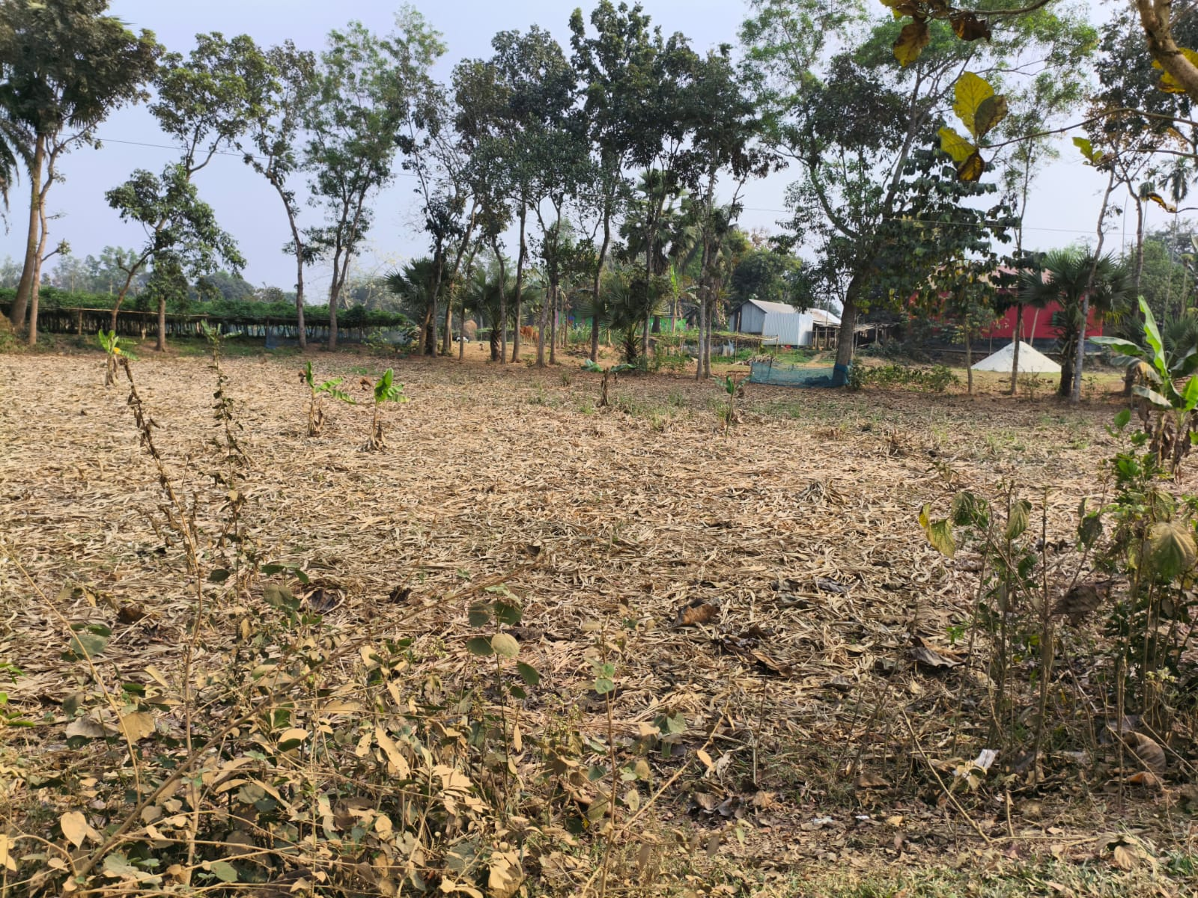  Field diagram of turmeric production time. | 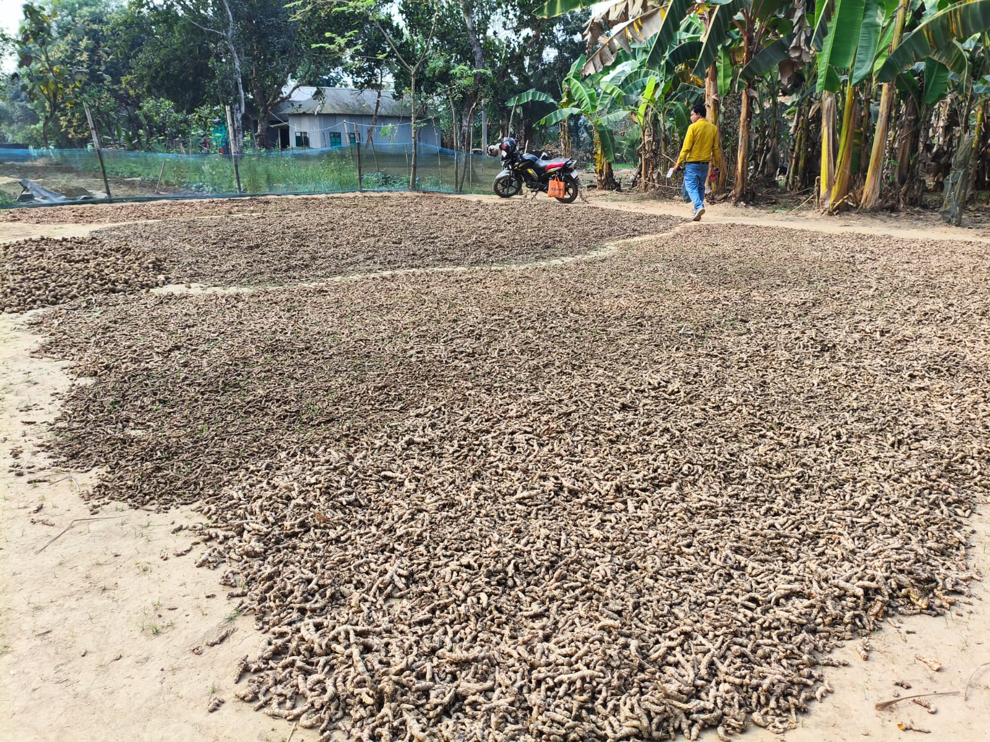  Drying scene to prevent yellowing.
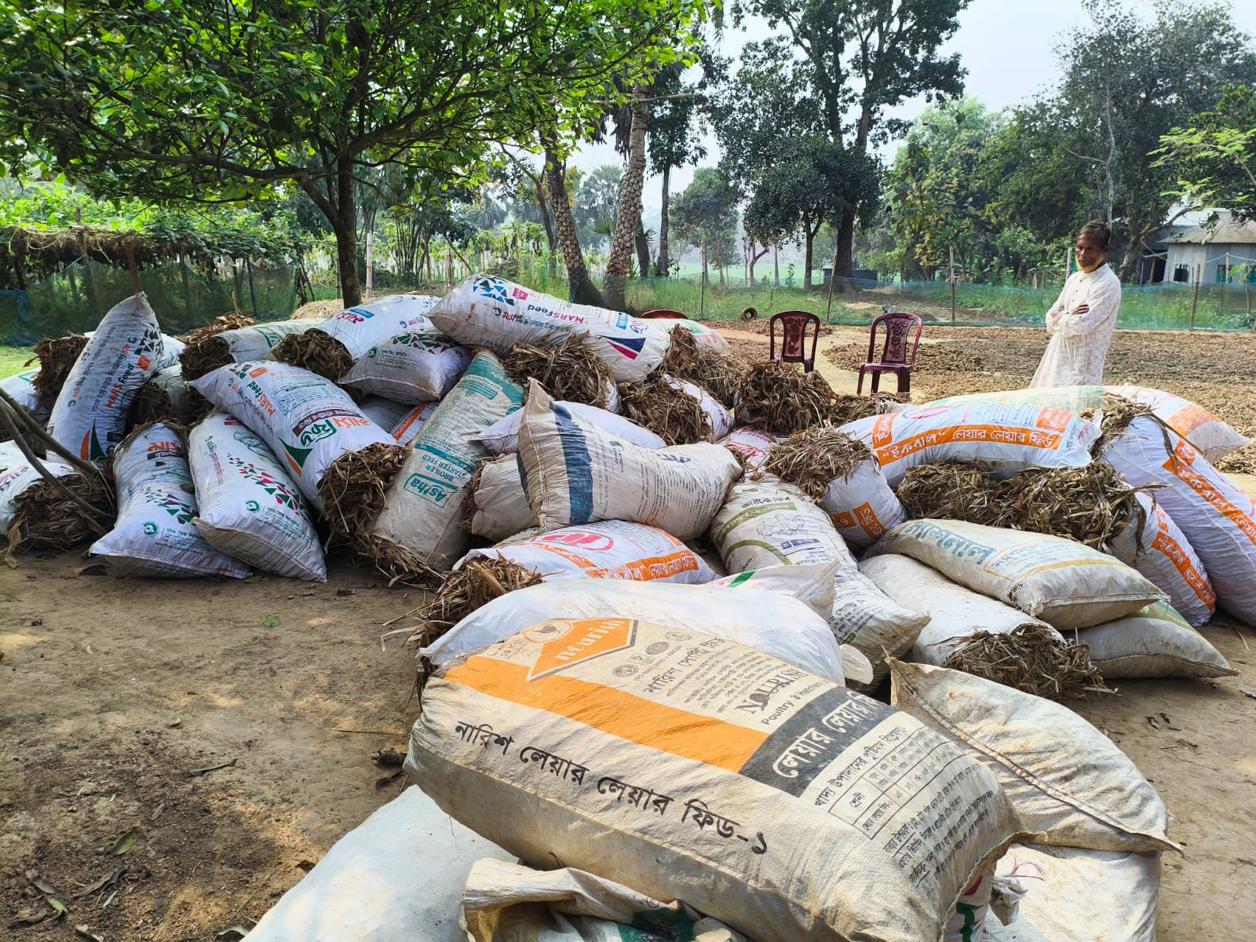  Turmeric has been lifted from the field in sacks. | 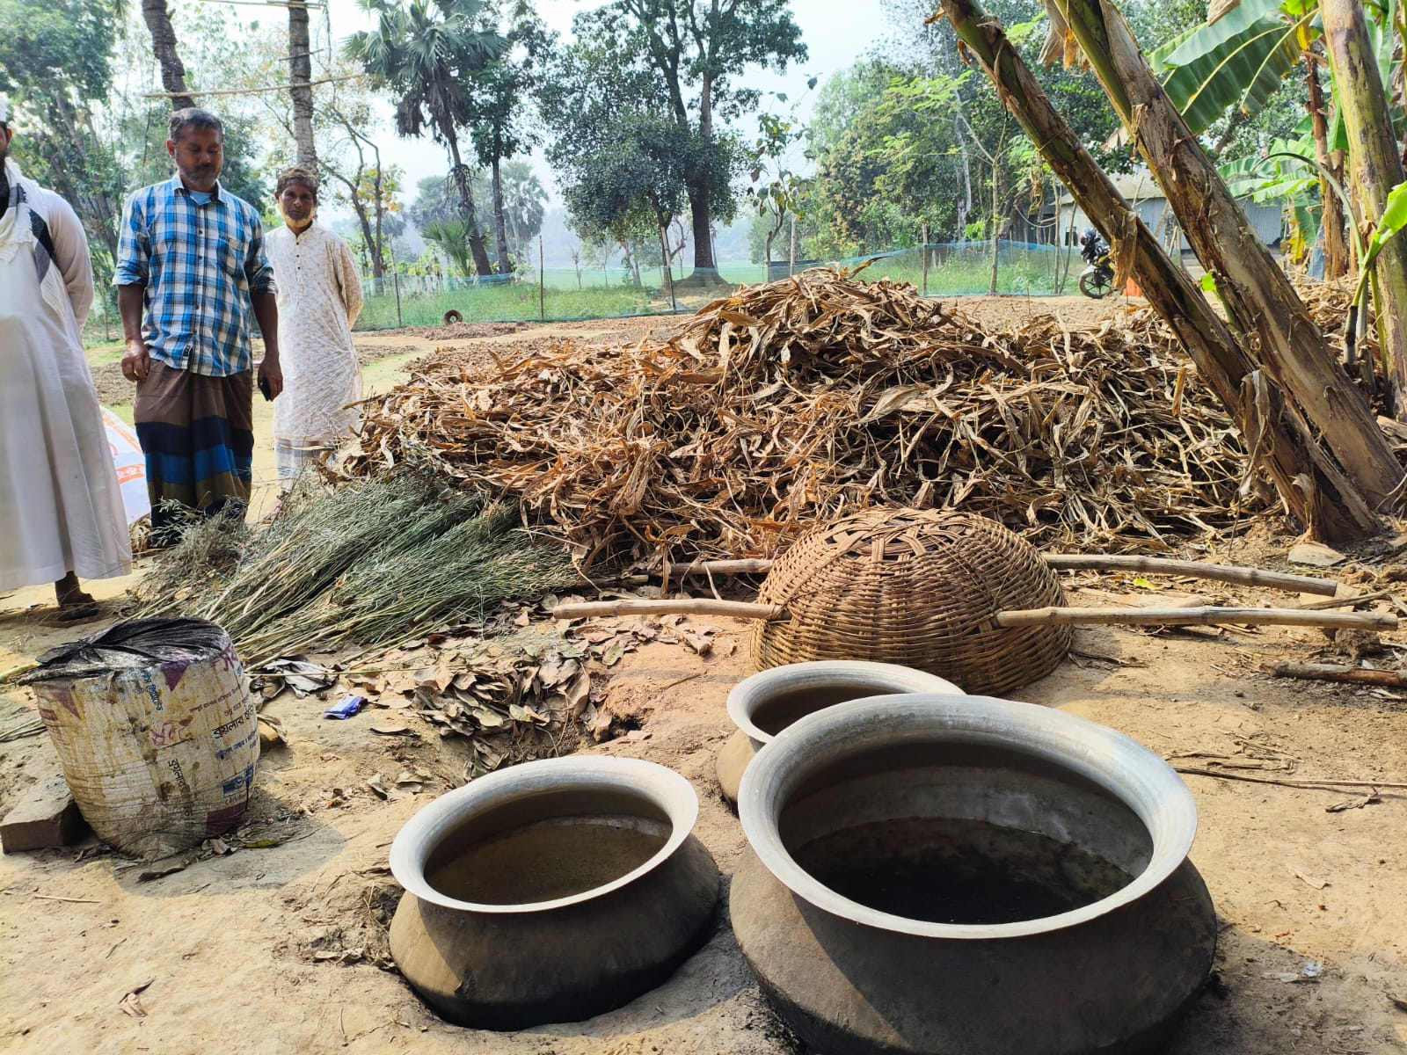  Turmeric Boiling Equipment.
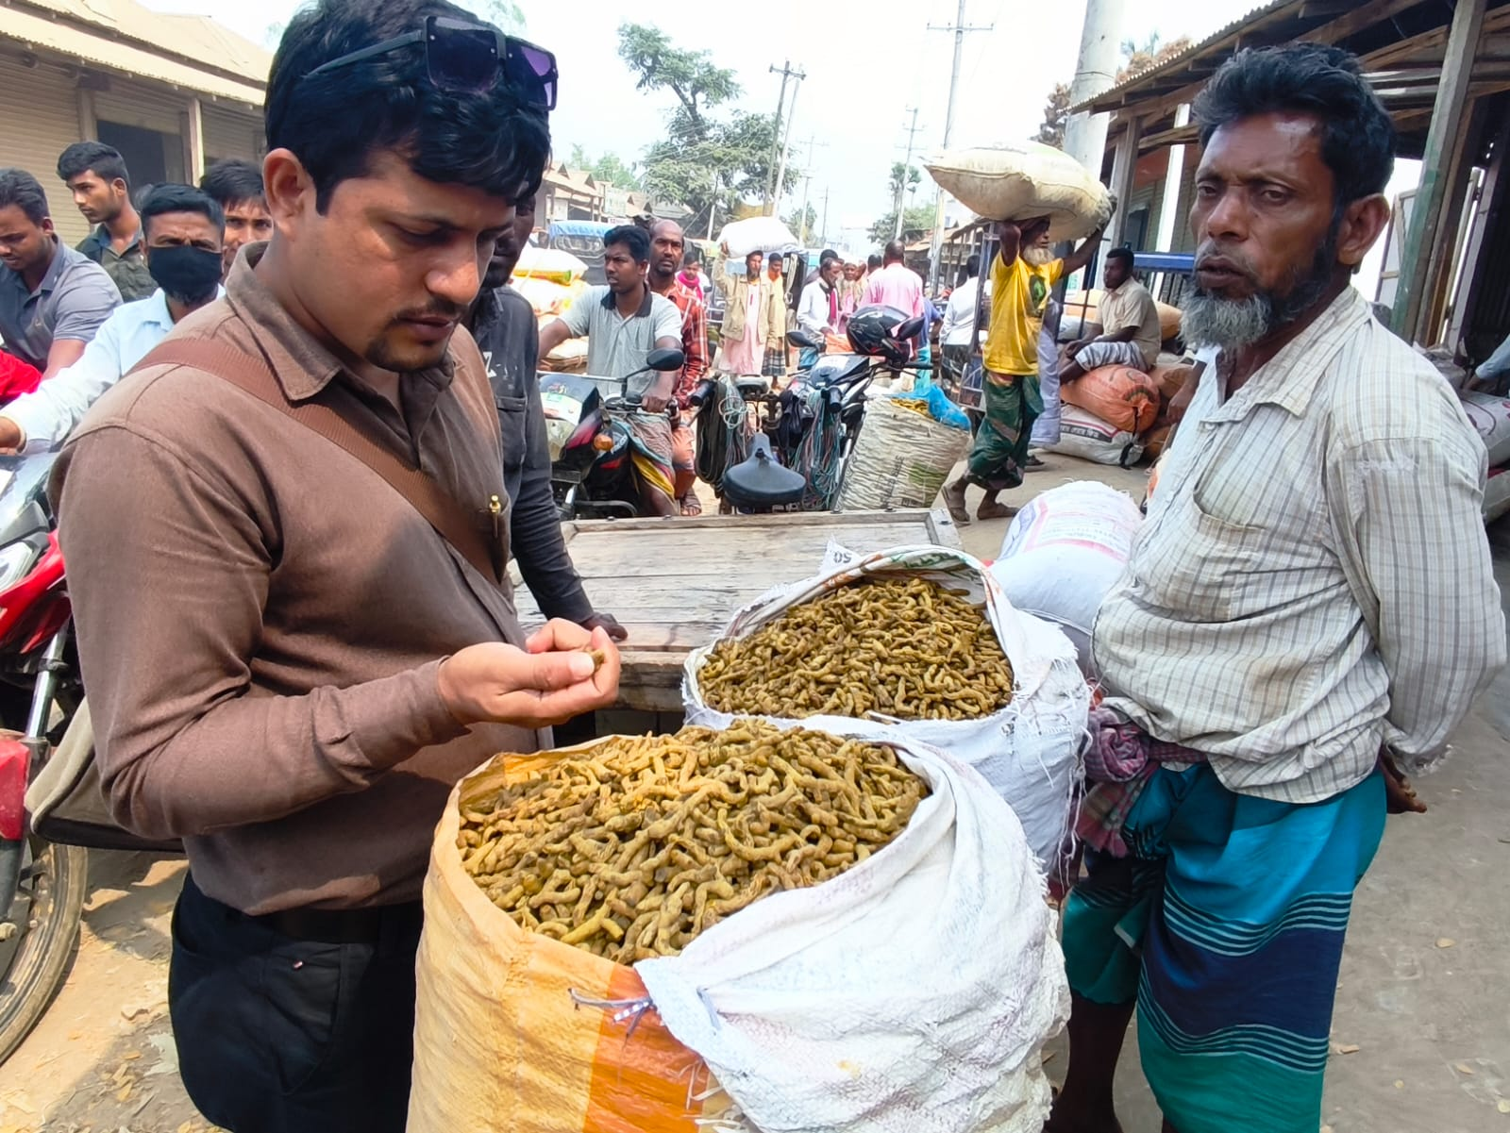  Researchers are taking farmers' opinions at the turmeric market. | 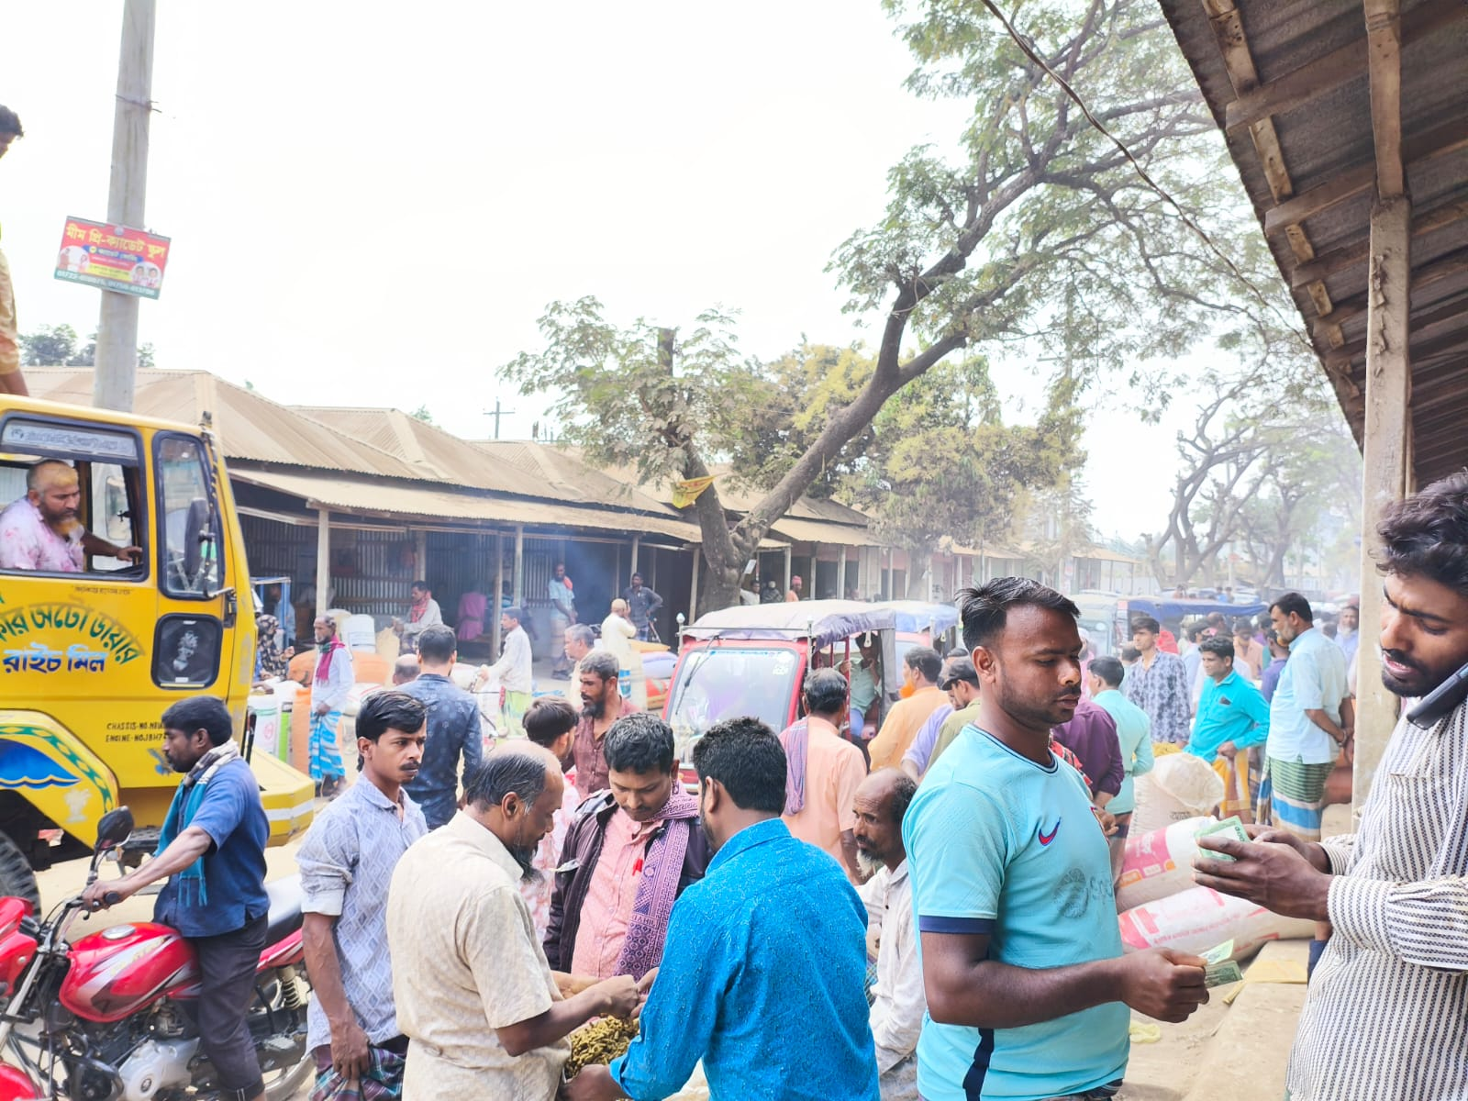  A Turmeric market scene
REFERENCES
Acharya, S.S. and Agarwal, N.L. (2011). Agricultural Marketing in India. Oxford & IBH Publishing Company, New Delhi.
Bangladesh Bureau of Statistics (2023). Yearbook of Agricultural Statistics of Bangladesh. Statistics and Informatics Division, Ministry of Planning, Government of Bangladesh, Dhaka.
Department of Agricultural Marketing (2024). Agricultural Marketing Information System. Ministry of Agriculture, Government of Bangladesh, Dhaka.
Directorate of Agricultural Extension (2025). Agricultural Extension in Bangladesh: Annual Report 2024-25. Ministry of Agriculture, Government of Bangladesh, Dhaka.
FAO (2023). The State of Agricultural Commodity Markets: Trade and Food Security. Food and Agriculture Organization of the United Nations, Rome.
Garrett, H.E. and Woodworth, R.S. (1969). Statistics in Psychology and Education. Vakils, Feffer and Simons Private Limited, Bombay.
Government of Bangladesh (2022). Population and Housing Census 2022: Fulbaria Upazila Report. Bangladesh Bureau of Statistics, Dhaka.
Haque, M.A., Rahman, M.S., and Islam, M.S. (2019). Marketing of Spices in Bangladesh: A Value Chain Analysis. Bangladesh Journal of Agricultural Economics, 40(1), 45-62.
Indian Spices Board (2023). Annual Report 2022-23. Ministry of Commerce and Industry, Government of India, Kochi.
Kahlon, A.S. and Karam Singh (1984). Economics of Farm Management in India. Allied Publishers Private Limited, New Delhi.
Kumar, P., Singh, R.K., and Reddy, G.P. (2020). Marketing Efficiency of Turmeric in Karnataka: A Comparative Analysis of Different Channels. Indian Journal of Agricultural Marketing, 34(2), 112-128.
Markets and Markets (2023). Turmeric Market by Form, Application, and Region - Global Forecast to 2028. Markets and Markets Research Private Limited.
Ministry of Agriculture (2024). National Spices Development Policy 2024. Government of Bangladesh, Dhaka.
Mymensingh District Administration (2023). District Statistics 2023. Deputy Commissioner's Office, Mymensingh.
Rahman, M.M. and Hossain, M.I. (2021). Constraints in Marketing of Agricultural Commodities in Bangladesh: Farmers' Perspective. Journal of Bangladesh Agricultural University, 19(3), 423-434.
Rao, K.V. and Subrahmanyam, K.V. (2018). Marketing Channels and Efficiency of Turmeric in Andhra Pradesh. Agricultural Economics Research Review, 31(1), 89-102.
Saha, D. and Das, P.K. (2019). Value Chain Analysis of Turmeric in Meghalaya. Economic Affairs, 64(4), 891-900.
Shepherd, G.S. (1972). Marketing Farm Products: Economic Analysis. The Iowa State University Press, Ames, Iowa.
Singh, H.P., Chand, R., and Joshi, P.K. (2022). Agricultural Marketing Reforms in India: Status, Impact and Way Forward. Indian Council of Agricultural Research, New Delhi.
Upazila Agriculture Office (2025). Agricultural Statistics of Fulbaria Upazila 2020-2025. Department of Agricultural Extension, Fulbaria, Mymensingh.
World Bank (2020). Enabling the Business of Agriculture: Annual Report. The World Bank Group, Washington DC.
Bangladesh Bureau of Statistics (2022). Population and Housing Census 2022, National Report (Volume I). Statistics and Informatics Division, Ministry of Planning, Government of Bangladesh, Dhaka.
Islam, A. (2015). Fulbaria Upazila. In S. Islam & S. Miah (Eds.), Banglapedia: National Encyclopedia of Bangladesh (2nd ed.). Asiatic Society of Bangladesh. Retrieved from http://en.banglapedia.org/index.php?title=Fulbaria_Upazila
Wikipedia contributors (2024). Fulbaria Upazila. Wikipedia, The Free Encyclopedia. Retrieved from https://en.wikipedia.org/wiki/Fulbaria_Upazila
Acharya, S.S. (2006). Agricultural Marketing in India (4th ed.). Oxford & IBH Publishing Company, New Delhi. [For marketing efficiency methodology]
Kohls, R.L. and Uhl, J.N. (2002). Marketing of Agricultural Products (9th ed.). Prentice Hall, New Jersey. [For marketing channel analysis framework]
Scarborough, V. and Kydd, J. (1992). Economic Analysis of Agricultural Markets: A Manual. Marketing Series 5, Natural Resources Institute, Chatham, UK. [For value chain and marketing margin analysis]
Tomek, W.G. and Robinson, K.L. (2003). Agricultural Product Prices (4th ed.). Cornell University Press, Ithaca, New York. [For price analysis and market efficiency assessment]
Kaplinsky, R. and Morris, M. (2001). A Handbook for Value Chain Research. Prepared for the IDRC, Institute of Development Studies, University of Sussex, Brighton. [For value chain analysis methodology]
Cramer, G.L. and Jensen, C.W. (1991). Agricultural Economics and Agribusiness (5th ed.). John Wiley & Sons, New York. [For agricultural marketing systems analysis]
Woldie, G.A. and Nuppenau, E.A. (2011). A contribution to transaction costs: Evidence from banana markets in Ethiopia. Agribusiness, 27(4), 493-508. [For transaction cost analysis in agricultural marketing]
Abebe, G.K., Bijman, J., Kemp, R., Omta, O., and Tsegaye, A. (2013). Contract farming configuration: Smallholders' preferences for contract design attributes. Food Policy, 40, 14-24. [For marketing strategies and farmer preferences]
Naziri, D., Aubert, M., Codron, J.M., Tsekouras, K., and Palma, M. (2014). Estimating the impact of small-scale farmer collective action on food safety: The case of vegetables in Vietnam. Journal of Development Studies, 50(5), 715-730. [For collective marketing (Naziri et al., 2014) analysis]

