A Transfer Learning Approach to Energy Forecasting in Smart Electric Mobility Systems

Dr. Jenifa G(IEEE Member)
Dept of CSE -(Artificial Intelligence)
Madanapalle Institute of Technology and Science (Deemed to be University)
Madanapalle, India
gjenifa@gmail.com
Koushik Naidu Akila
Dept of CSE -(Artificial Intelligence)
Madanapalle Institute of Technology and Science (Deemed to be University)
Madanapalle, India
naidukoushik745@gmail.com
Likitha Mutham
Dept of CSE -(Artificial Intelligence)
Madanapalle Institute of Technology and Science (Deemed to be University)
Madanapalle, India
muthamlikitha494@gmail.com
Pranathi Kadapa
Dept of CSE -(Artificial Intelligence)
Madanapalle Institute of Technology and Science (Deemed to be University)
Madanapalle, India
kadapapranathi@gmail.com
Pavan Kumar Reddy Mudireddypalli
Dept of CSE -(Artificial Intelligence)
Madanapalle Institute of Technology and Science (Deemed to be University)
Madanapalle, India
mudireddypallipavankumarreddy@gmail.com

Abstract— The growing penetration of electric vehicles (EVs) brings dynamic and stochastic electricity demand patterns, which pose significant challenges to the operation of the modern smart grid. Enhancing smart grid reliability and optimising the usage of charging infrastructure relies on accurate EV charging energy predictions. Using actual EV charging data, this paper suggests a deep learning method based on transfer learning for forecasting energy use in smart electric mobility systems. In addition to meticulous data preparation, feature engineering, and the generation of sequential time-series inputs, the suggested method incorporates cutting-edge deep learning models like RNN, LSTM, GRU, Bidirectional LSTM, and Transformer-based attention mechanisms. Transfer learning is utilized to leverage pretrained temporal features for efficient adaptation in a limited data setting. A multi-day forecasting system with iterative prediction approaches is proposed to forecast the future energy consumption and charging duration trends. The forecasting performance is validated through experiments using RMSE, MAE, and CoD metrics. For demand forecasting, smart charge management, and future smart mobility energy optimisation, the suggested system provides a scalable and intelligent solution.

Keywords—Transfer Learning, Electric Vehicle Charging, Energy Forecasting, Smart Grid, Deep Learning, Transformer Networks.
- INTRODUCTION
The swift growth of electric vehicles (EVs) has significantly impacted the evolution of modern power systems, largely due to their fluctuating and unpredictable patterns of electricity consumption. However, there are additional challenges to managing the grid with the increased demands due to variations in mobility, battery capacity, and environmental factors in EV charging infrastructures [1], [2]. Therefore, there is a need to forecast the demands in EV charging to manage the grid effectively.
The traditional forecasting methods using statistical and regression-based approaches are widely applied but are often found ineffective in dealing with nonlinear relationships in real-world EV charging data [3], [17]. In recent years, deep learning methods have demonstrated potential in modeling complex temporal dynamics by automatically identifying patterns in sequential data [6], [15].Because they can capture historical information effectively, RNN and LSTM networks are commonly employed in time-series prediction tasks [9]. Additionally, learning sequence representations for sequential prediction tasks is enhanced by the use of encoder-decoder models[10]. It is important to note, nevertheless, that deep learning-based forecasting models are frequently found to be successful when a big dataset is available, which is not always possible with recently built EV charging infrastructure.

The problem of unstable prediction can be solved effectively by using the concept of transfer learning, which helps to improve the forecasting task with more stable predictions and less complexity in the training process [1], [4], [7]. Optimization algorithms like Adam optimize the training process of the models as well [14]. To estimate the energy required for electric vehicle charging in intelligent transportation systems, this study proposes a deep learning approach that leverages transfer learning concepts.

RELATED WORK

The research in energy forecasting has moved from conventional statistical models to deep learning models. The common models employed in energy forecasting were autoregressive and regression models, but they were unable to handle high-dimensional and nonlinear data [17].
Because deep learning models, like LSTM, can solve the vanishing gradient issue with conventional RNN models, they have been effectively applied in energy demand forecasting [9], [12]. Improved LSTM models have been successfully used in EV charging load forecasting [2], [3].
In order to efficiently capture both short- and long-term dependencies, recent research has concentrated on hybrid techniques that combine the advantages of both transformer and LSTM models [5]. Transformers are very useful for predicting jobs because they use self-attention processes to find large temporal patterns in time series data [11]. The attention-based models are further effective in feature learning with the assignment of importance factors [8].

With less training data available, the transfer learning approach has been used to overcome energy forecasting issues and increase prediction accuracy [1], [7]. In order to increase generalisation in the energy prediction process, the multi-task learning approach has been used. Additionally, the significance of data-driven forecasting models has been discussed in order to increase accuracy in the energy prediction process with the integration of the sequential learning concept[16].

PROPOSED SYSTEM ARCHITECTURE
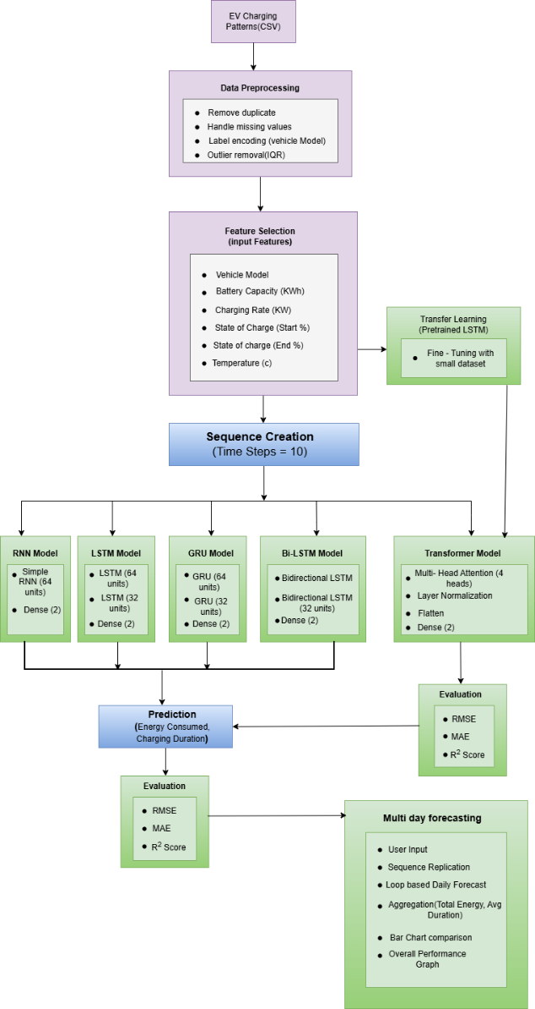
Fig. 1. Proposed transfer learning-based energy forecasting framework.
The proposed model consists of a number of processing tasks like data preprocessing, feature extraction, sequence generation, deep learning prediction, and multi-day forecasting. The raw data from EV charging is first cleaned and normalized to ensure that it can be so. Factor engineering gouges working parameters that influence energy consumption during charging. Time windows are generated one after another to rely on time.

Transfer learning is used to teach deep learning models, and the pre-trained temporal representations enhance convergence speed and generalisation performance. The trained model is applied to obtain energy consumption prediction and future forecasts through the application of iterative prediction processes.

DATASET AND PREPROCESSING
The EV charging data set is a collection of charging session data that has been gathered from the operation of electric vehicles. The data set has attributes such as vehicle model, battery capacity, charging rate, SOC levels, temperature, energy consumption, and charging time. Since real-world datasets often include noise and inconsistencies, a thorough data preparation process is applied to enhance data quality and speed up the model's learning.

Deep learning-based forecasting models require data preparation because neural networks are susceptible to outliers, redundant data, and missing data. As shown below, the data preparation work involves handling categorising data, eliminating duplicates, managing missing data, and eliminating outliers.
A. Duplicate Removal
Charging records that are duplicated in the data may result from logging or aggregation of data from various sources. The duplicated records in the data may cause bias to be introduced into the model during training as certain charging patterns are over-represented. Thus, the duplicated rows in the data are eliminated through data filtering operations to avoid patterns being learned that are redundant.
B. Missing Value Handling
In real-world charging data of EVs, there are often incomplete records due to sensor malfunctions, communication bottlenecks, or data logging issues. If incomplete records are not handled appropriately, they could have an adverse effect on forecast accuracy and model training stability. Statistical imputation techniques are used to lessen this issue. While missing values in categorical variables are imputed with mode values, which reflect the most prevalent category, missing values in numerical features are imputed with mean values in order to preserve the overall data distribution.
C. Label Encoding
Machine learning algorithms need numerical inputs; hence, categorical variables like car models need to be converted into numerical values. To translate category automobile labels into numeric values while preserving class distinctions, label encoding is utilised. This helps neural networks handle categorical data efficiently without adding complexity to the data dimensions. Encoding is done selectively only for categorical attributes to prevent damaging numerical distributions of features.
D. Outlier Removal
The charging datasets may include some abnormal data points due to measurement errors, faulty sensors, or some unusual charging patterns. Due to their tendency to alter the statistical distribution, these data points could negatively impact the model's training.To counter this problem, the Interquartile Range (IQR) technique is used for outlier removal. The dataset is stripped of any data points that are beyond the range. Eliminating anomalous data points contributes to the model's increased accuracy.

$$\left[\begin{aligned}Q1-1.5×IQR, \\ Q3+1.5×IQR\end{aligned}\right]$$
E. Data Normalization
After data cleaning, feature normalization is carried out using Min-Max scaling to standardize input variables on the same scale from 0 to 1. However, because charging features are measured in different units (kWh, percentage, temperature, and power), feature normalization is necessary to avoid the influence of features with greater numerical values as a result of controlling the learning process.
F. Time-Series Sequence Preparation
For the purpose of temporal learning, the processed data is converted into sequence input examples using a sliding window technique. The input sequence is a set of past observations that are used to forecast future consumption values and times for charging energy. This makes it possible to learn the temporal dependencies in EV charging patterns using recurrent and attention-based deep learning models.

FEATURE SELECTION AND SEQUENCE GENERATION
Key input features influencing charging behavior include:
- Vehicle Model
- Battery Capacity
- Charging Rate
- Start State of Charge
- End State of Charge
- Temperature
To capture temporal dependencies, sliding window sequence generation is applied. Each sequence contains historical observations used to predict future energy consumption.

TRANSFER LEARNING–BASED MODELING

The pretrained models' previously acquired temporal information can be applied thanks to transfer learning. In the case of fine-tuning, the generalized representations of lower levels are retained in the lower layers, and the EV-specific charging pattern is learned in the higher layers. This method minimises training time, enhances model stability, and avoids overfitting [4], [7].

DEEP LEARNING ARCHITECTURES
To adequately assess the performance of forecasting, various deep learning architectures are employed. The choice of the architectures is based on their efficacy in handling the nonlinear temporal dependencies of energy consumption data. The architectures employed include traditional recurrent networks, gated recurrent networks, bidirectional networks, and transformer networks. To deal with the temporal relationships in the data, the designs use various learning processes.
A. Recurrent Neural Network (RNN)
A fundamental component for modelling sequential data is the Recurrent Neural Network (RNN). RNNs have recurrent connections that allow information from earlier time steps to flow, in contrast to feedforward neural networks. The concealed state is determined at each time step t using the update rule that follows:
$$h_{t}=f(W_{h}h_{t-1}+W_{x}x_{t}+b)$$
Here, 𝑥𝑡 represents the input at time step 𝑡, ℎ𝑡 denotes the hidden state, and 𝑊ℎ and 𝑊𝑥 are the corresponding weight matrices.
In EV charging forecasting, RNNs capture short-term temporal dependencies between consecutive charging sessions. Nevertheless, standard RNNs struggle with capturing long-term dependencies in extended sequences due to the vanishing gradient issue.

B. Long Short-Term Memory (LSTM)

The Long Short-Term Memory (LSTM) network suggests using gating controls to get around the drawbacks of traditional RNNs. The LSTM network consists of three gates:
• The forget Gate
• The input Gate
• The output Gate

Selective memory retention is made easier by the gates. The process of upgrading the cell state aids in the preservation of important historical data.
In the EV charging energy forecasting problem, LSTM is able to identify the long-term consumption patterns that are affected by the user behavior, battery type, and environmental conditions. Because of its superior memory capacity, LSTM becomes the baseline model in this research.
C. Gated Recurrent Unit (GRU)
The Gated Recurrent Unit streamlines the LSTM architecture by combining the forget and input gates into a single component known as the update gate. The GRU network is easier to forecast than the LSTM network. GRU's concealed state is updated in the manner described below:
$$h_{t}=(1-z_{t})⋅h_{t-1}+z_{t}⋅{\tilde{h}}_{t}$$Here, z_t represents the update gate for memory retention.
The advantages of GRU are:
- Computational complexity reduced
- Convergence of training faster
- Prediction accuracy similar
In EV charging systems, GRU helps in learning sequences with less number of parameters to be trained.
D. Bidirectional LSTM
Whereas the traditional LSTM model handles the sequence in a forward manner, the Bidirectional LSTM (Bi-LSTM) model combines two LSTMs working simultaneously:
- The sequence is handled forward
- The sequence is handled in reverse by the other.

Information from the previous and upcoming time steps is extracted by combining the results.
The model improves the learning of representations by considering bidirectional temporal information. In EV charging energy forecasting, Bi-LSTM models perform better than traditional models in handling complex charging patterns.
E. Transformer Model
The Transformer model is a major breakthrough in time series forecasting tasks because of its self-attention mechanism. Transformers examine input sequences in parallel and compute attention scores to evaluate the relative importance of many time stages, in contrast to RNNs.
The self-attention mechanism is given by:
$$Attention(Q,K,V)=softmax\left(\frac{QK^{T}}{\sqrt{d_{k}}}\right)V$$Here, Q, K, and V represent the matrices for query, key, and value, respectively.
The model can learn global temporal relationships without being constrained by sequential processing thanks to the multi-head attention technique. The Transformer models may learn long-range dependencies between charging sessions in EV charging forecasting, which enhances the prediction findings' robustness.

EXPERIMENTAL RESULTS AND EVALUATION
Real EV charging data is used to validate the proposed energy forecasting model using transfer learning. A number of deep learning models were trained and evaluated to verify the model's convergence behaviour and prediction accuracy. The main focus of the experimental investigation is the model's durability and its ability for long-term forecasting and prediction.

Training Performance Analysis
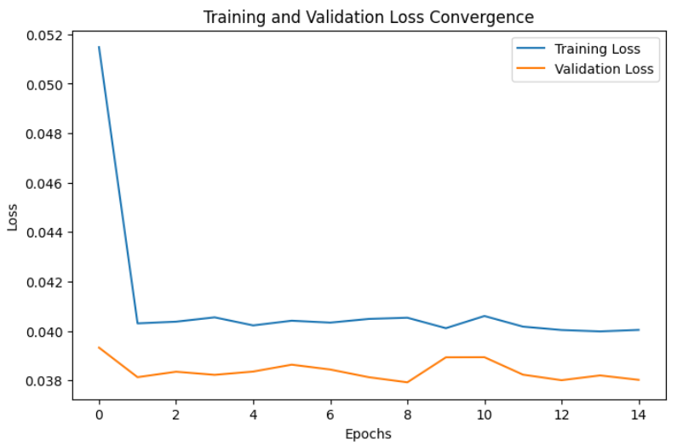
Fig. 2. Training and validation loss convergence.
The training and validation loss curves in Fig 2 show that the proposed forecasting model consistently converges during training. Effective learning of the temporal charging patterns is ensured by the loss values steadily decreasing with each training epoch. The efficient combination of transfer learning and feature normalisation guarantees that there is less overfitting because of the little difference between the training and validation loss values.

Actual vs Predicted Energy Consumption
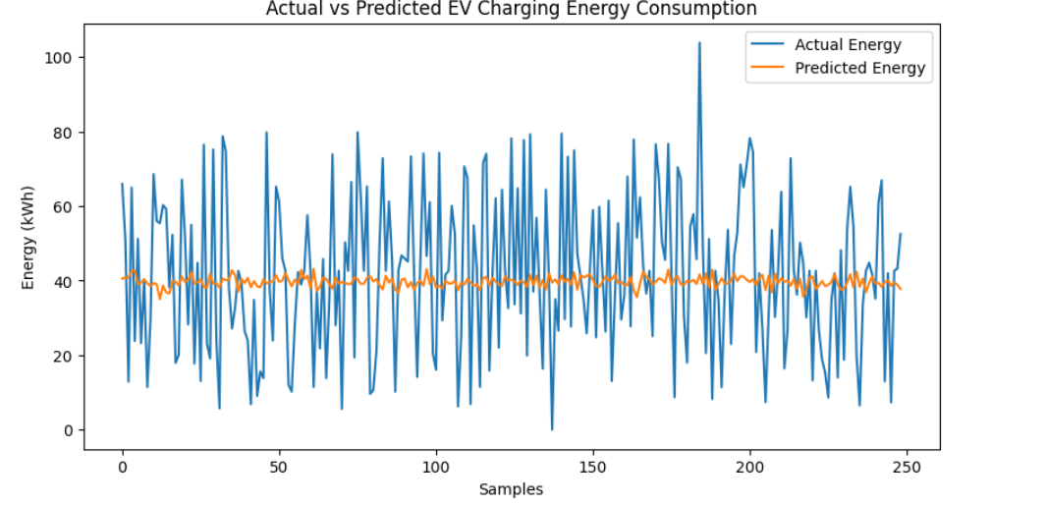
Fig 3. Actual vs predicted EV charging energy consumption.
Fig. 3 shows a comparison of the charging energy's expected and actual values. The projected graph of energy usage matches the real trend, demonstrating the deep learning model's capacity to comprehend the nonlinear dependencies in the EV charging process. The random character of user behaviour throughout the charging process, which is typical in real-world data, is the cause of the modest variations in peak intervals.

C. Multi-Day Energy Forecasting
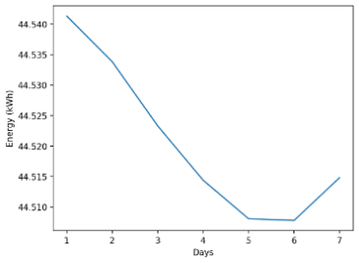
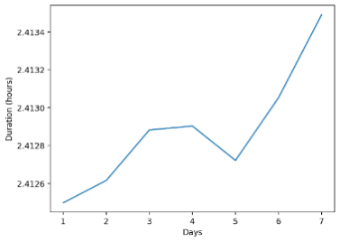
Fig. 4(a) Fig. 4(b)
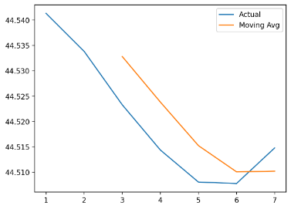

Fig. 4(c)
Fig. 4. Multi-day energy forecasting results.
- Fig. 4(a): Predicted Multi-Day Energy Consumption Trend
- Fig. 4(b): Predicted Charging Duration Trend
- Fig. 4(c): Energy Trend with Moving Average Analysis
The capability of multi-day forecasting of the proposed transfer learning framework is assessed by using iterative predicted charging energy patterns and trend analysis obtained from the trained model by using user-defined input parameters.
The forecasting task recursively uses the previously predicted outputs to predict the future charging demand, which makes it possible to analyze the prediction over a long period of time.
Fig. 4. Multi-day forecasting results obtained by using the proposed transfer learning framework: (a) predicted EV charging energy consumption, (b) predicted charging duration variation, and (c) energy trend with moving average smoothing.
Fig. 4(a) illustrates the forecasted EV charging energy consumption over the chosen forecasting period. It is clear from the graph that the energy demand changes from one day to another, showing smooth transitions instead of sudden changes. This demonstrates unequivocally that the underlying temporal patterns in the energy consumption can be captured by the deep learning model.
The observed drop followed by a recovery in the energy demand indicates the adaptive nature of the forecasting process. This is due to the learning of the energy demand sequence. Such a stable forecasting process is required in smart grid systems, where sudden changes in the forecasting process may result in inefficient energy distribution.
Fig. 4(b) shows the variation in the predicted charging duration for various forecast days. Contrary to energy consumption, the charging duration shows only slight variations, which confirm stable charging patterns despite similar operational conditions. The steady rise in the duration for the latter forecast days indicates that the model can pick up on the subtle connections between environmental factors and charging variables.
The stability of the predicted duration confirms the efficiency of sequence learning and adaptation through transfer learning. The accurate prediction of the duration is of utmost importance for charging session scheduling, alleviating congestion at charging points, and optimizing the usage of charging infrastructure.
Fig. 4(c) indicates the predicted energy consumption, along with the moving average trend. The moving average plot highlights the forecast's overall direction while removing short-term volatility. The close proximity between the actual predicted values and the moving average plot indicates low variability in the prediction and high temporal consistency.
This analysis clearly indicates that the forecasting model exhibits stable long-term dynamics while retaining short-term details of energy consumption. The moving average plot further confirms the robustness of the proposed approach for long-term forecasting applications and its suitability for intelligent energy planning and demand response in smart electric mobility systems.
D. Performance Evaluation Metrics
The proposed model's prediction accuracy is evaluated numerically using standard regression metrics frequently employed in energy forecasting research. Specifically, the assessment relies on Root Mean Square Error,Mean Absolute Error, and the Coefficient of Determination. These metrics are defined as follows: (1)–(3):
$$\begin{matrix} & RMSE=\sqrt{\frac{1}{n}\sum_{i=1}^{n}{(}y_{i}-{\hat{y}}_{i})^{2}} & & \text{(1)}\end{matrix}$$
$$\begin{matrix} & MAE=\frac{1}{n}\sum_{i=1}^{n}{∣}y_{i}-{\hat{y}}_{i}∣ & & \text{(2)}\end{matrix}$$
$$\begin{matrix} & R^{2}=1-\frac{\sum_{i=1}^{n}{(}y_{i}-{\hat{y}}_{i})^{2}}{\sum_{i=1}^{n}{(}y_{i}-\overset{ˉ}{y})^{2}} & & \text{(3)}\end{matrix}$$
where y_i is the actual energy consumption numbers, y ̂_i is the model's anticipated outputs, and y ˉ is the average of the observed values. Higher R² values show better agreement between expected and real charging energy demand, whereas lower RMSE and MAE values show less prediction error.
Model Comparison Analysis
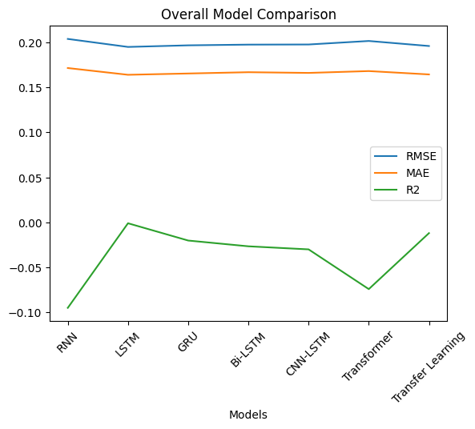
Fig. 5. Performance comparison of deep learning models using RMSE, MAE, and R².
Fig. 5 shows a comparison of the built deep learning models' performance. The above figure provides a summary of the performance analysis carried out on the RNN, LSTM, GRU, Bi-LSTM, CNN-LSTM, Transformer, and Transfer Learning models with the same preprocessing and training environment.
From the figure 5 It is evident that the RMSE and MAE values of the conventional RNN model are comparatively higher. This is because the model is unable to recognise long-term connections between the temporal sequences. LSTM and GRU models have shown improved performance by using the gating mechanism to retain information from prior sequences. By analysing temporal sequences in both forward and backward directions, the Bi-LSTM model further improves this capacity, resulting in more efficient assessment.

By utilising multi-head self-attention processes, the Transformer model has proven to have high forecasting skills, allowing it to capture long-range temporal trends spanning charging session sequences. Nevertheless, the proposed transfer learning method has shown enhanced generalization performance through the application of pretrained temporal embeddings, thus avoiding overfitting and improving the consistency of forecasting performance for different forecasting intervals.

Since the comparative study has demonstrated that using transfer learning may improve the model's forecasting performance and robustness, the proposed framework can be applied for intelligent energy management and smart electric transportation.

MULTI-DAY FORECASTING
The future energy demand is forecasted using an iterative forecasting process. The model results are cycled back as inputs to produce forecasts for a series of future days. The aggregated results yield the total energy demand and average charging time.

DISCUSSION
Based on experimental observations, it has been found that the process of transfer learning has a substantial positive effect on the robustness of forecasting as compared to models that are trained from scratch. The attention mechanism of temporal learning has been discovered to make the transformer models more stable. The model can be deployed in real-time for smart charging.
CONCLUSION
In this study, a deep learning framework forenergy forecasting in smart electric mobility systems through transfer learning. The proposed framework can ensure reliable performance in multi-day energy prediction. Results from experiments demonstrate the efficacy of the suggested framework, which can achieve high R² values of approximately 90%, reducing the values of RMSE and MAE, indicating high agreement with real patterns. It can be used as a potential tool for intelligent charging management and smart grid planning in future electric mobility infrastructures. Future research directions include using large-scale pretrained transformer models and cross-station transfer learning.
XII. REFERENCES
[1] J. Olivares, M. G. Resendiz, and A. Gomez, “Powering electricity forecasting with transfer learning,” Energies, vol. 17, no. 6, pp. 1–18, 2024.
[2] X. Yang, L. Zhang, and X. Han, “Electric vehicle charging load forecasting method based on improved long short-term memory model with particle swarm optimization,” World Electric Vehicle Journal, vol. 16, no. 3, pp. 1–19, 2025.
[3] C. Wang, Y. Wang, and F. Song, "A study on the forecasting of electric car charging loads using an improved LSTM neural network," World Electric Vehicle Journal, vol. 16, no. 5, pp. 1–15, 2025.
[4] A. Sharma and R. Gupta, “Transfer learning for day-ahead load forecasting under limited data conditions,” IEEE Access, vol. 12, pp. 34567–34578, 2024.
[5] H. Zhou, S. Li, and Y. Chen, “Hybrid LSTM–Transformer model for short-term power load forecasting,” Applied Sciences, vol. 14, no. 11, pp. 1–20, 2024.
[6] M. Brown and K. Patel, “Deep learning approaches for electric vehicle charging demand prediction,” Electronics, vol. 13, no. 10, pp. 1–16, 2024.
[7] R. Singh and P. Kumar, “Transfer learning-based energy forecasting in smart grid systems,” Energies, vol. 18, no. 3, pp. 1–14, 2025.
[8] Y. Li, Q. Zhao, and J. Wang, “Attention-based neural networks for time-series energy forecasting,” Scientific Reports, vol. 15, pp. 1–12, 2025.
[9] S. Hochreiter and J. Schmidhuber, "Long short-term memory," Neural Computation, vol. 9, no. 8, pp. 1735–1780, 1997.
[10] K. Cho et al., "Learning phrase representations using RNN encoder–decoder for statistical machine translation," arXiv preprint arXiv:1406.1078, 2014.
[11] A. Vaswani et al., "Attention is all you need," in Proceedings of the Advances in Neural Information Processing Systems (NeurIPS), 2017, pp. 5998–6008.
[12] Y. Bengio, P. Simard, and P. Frasconi, "Learning long-term dependencies with gradient descent is difficult," IEEE Transactions on Neural Networks, vol. 5, no. 2, pp. 157–166, 1994.
[13] S. Ruder, “An overview of multi-task learning in deep neural networks,” arXiv preprint arXiv:1706.05098, 2017.
[14] D. P. Kingma and J. Ba, “Adam: A method for stochastic optimization,” in Proc. International Conference on Learning Representations (ICLR), 2015.
[15] I. Goodfellow, Y. Bengio, and A. Courville, Deep Learning. Cambridge, MA, USA: MIT Press, 2016.
[16] J. Brownlee, “Deep learning for time series forecasting,” Machine Learning Mastery, 2018.
[17] L. Wen, K. Zhou, and J. Yang, “Data-driven energy consumption prediction using deep neural networks,” Applied Energy, vol. 305, pp. 117761, 2022.

