Application of Group V Base Oils in the Development of Advanced Engine Oil Formulations

Abstract
The continuous evolution of internal combustion engines toward higher efficiency and reduced emissions has necessitated the development of ultra-low viscosity engine oils, such as 0W-16 and 0W-20 grades. While Group III and Group IV (polyalphaolefins or PAOs) base stocks provide excellent foundations for these formulations due to their high viscosity indices and oxidative stability, their non-polar nature introduces critical challenges regarding additive solubility and seal compatibility. Group V base oils, comprising a diverse class of synthetic fluids including esters, polyalkylene glycols (PAGs), and alkylated naphthalenes, have emerged as indispensable high-performance enhancers in modern lubricant chemistry. Rather than serving as the primary bulk fluid, these highly polar synthetic stocks are strategically blended into Group III/IV matrices to resolve inherent physiochemical deficiencies, fundamentally altering the performance profile of the final formulation.
This paper presents a comprehensive investigation into the application of Group V base oils for advanced engine oil development, focusing on their mechanisms of action as co-base stocks. By examining their role as additive solvents, particularly in enhancing the dispersancy and stability of polyisobutylene-bis-succinimide (PIBSI) additives, this research highlights how ester-fortified formulations manage high-temperature deposit formation. Furthermore, we propose a structured methodological framework for formulating and evaluating Group V-enhanced lubricants, emphasizing solvency, seal compatibility, and thermal resistance. Through hypothetical evaluation plans and rigorous discussion of practical and ethical deployment considerations, this work provides a foundational roadmap for next-generation engine oil design.
Keywords: Group V base oil, Additives chemistry, Engine oil, Esters, PAG, PAO, Base stock, Boundary Lubrication, Deposit Control & Cleanliness,

Introduction
According to our latest research, the global Engine Oil Base Stock Group V market size reached USD 1.42 billion in 2025, supported by a robust demand from the automotive, industrial, and marine sectors. The market is experiencing a healthy growth trajectory, with a CAGR of 5.8% expected from 2025 to 2033. By the end of the forecast period, the Engine Oil Base Stock Group V market is projected to attain a value of USD 2.37 billion by 2033. This growth is primarily fueled by rising environmental regulations, advancements in lubricant technology, and the shift towards high-performance synthetic lubricants across various industries.
The transition toward highly efficient, downsized, and turbocharged internal combustion engines has placed unprecedented thermal and mechanical stress on engine lubricants. To minimize hydrodynamic friction and maximize fuel economy, original equipment manufacturers are increasingly mandating ultra-low viscosity engine oils, specifically the 0W-16 and 0W-20 viscosity grades. Formulating these advanced lubricants requires base stocks with exceptionally high viscosity indices and low volatility, leading the industry to rely heavily on severely hydrocracked Group III oils and synthesized Group IV polyalphaolefins (PAOs). However, while these non-polar hydrocarbon fluids excel in maintaining viscometric stability across broad temperature ranges, they inherently lack the chemical polarity required to dissolve complex additive packages and maintain the physical integrity of elastomeric engine seals.
The core problem addressed in this research is the optimization of synthetic engine oil formulations to prevent additive dropout, sludge accumulation, and seal degradation under extreme operational temperatures. The scope of this study specifically encompasses the strategic integration of Group V base oils—such as polyol esters, diesters, PAGs, and alkylated naphthalenes—into Group III/IV matrices. Unlike Group I and II mineral oils, which naturally contain aromatic and polar compounds that aid in solvency, heavily refined modern base stocks are entirely non-polar. Consequently, advanced additive chemistries, including heavy-duty dispersants and metallic detergents, struggle to remain in stable solution, necessitating the introduction of highly polar synthetic co-base fluids to bridge this solubility gap.
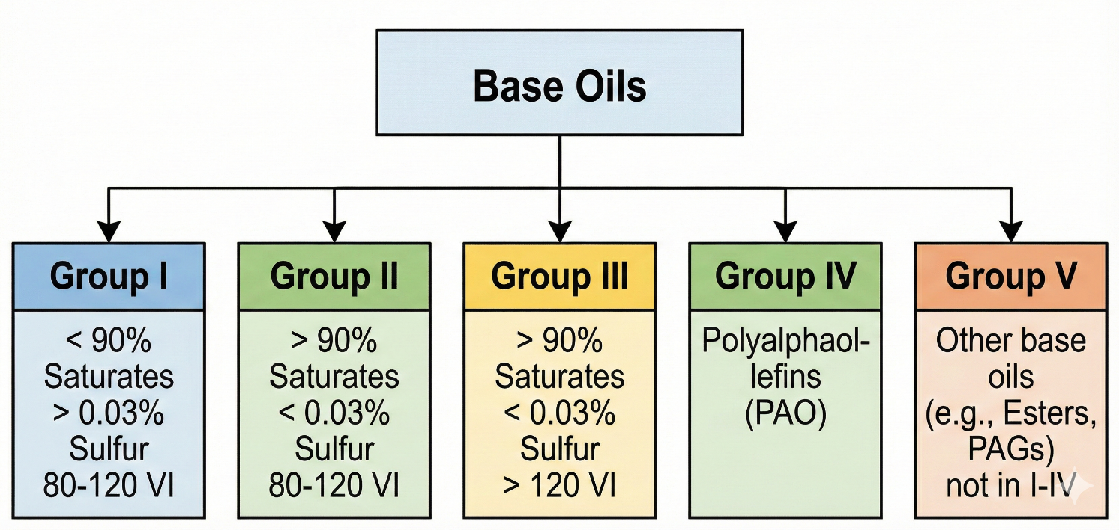
Figure 1. API Base Oil Classifications
Existing approaches that rely solely on conventional Group III or IV base stocks without sophisticated Group V integration are fundamentally insufficient for modern high-performance demands. First, the lack of natural solvency in pure PAO or Group III formulations leads to premature additive precipitation, which significantly accelerates the formation of carbonaceous deposits and sludge in high-temperature engine zones like the piston rings and turbocharger bearings. Second, non-polar base stocks are notorious for causing engine seals to shrink and harden over time, leading to catastrophic oil leaks and loss of pressure, a problem that traditional seal-swell additives alone cannot fully mitigate without compromising other rheological properties. As engines run hotter and oil drain intervals are extended, these classical formulation strategies simply cannot maintain the required equilibrium between oxidation resistance, cleanliness, and hardware compatibility.
To overcome these formulation bottlenecks, this paper introduces a modernized paradigm for engine oil development utilizing Group V base oils. The primary contributions of this work are as follows:
- We propose a structured, multi-modular formulation methodology that quantitatively balances the polarity of Group V esters and PAGs with the non-polar characteristics of PAOs to optimize additive solubility and seal compatibility.
- We outline specific chemical mechanisms by which Group V esters improve the dispersancy of polyisobutylene-bis-succinimide (PIBSI) additives, demonstrating their capacity to manage and mitigate deposit formation in extreme high-temperature applications.

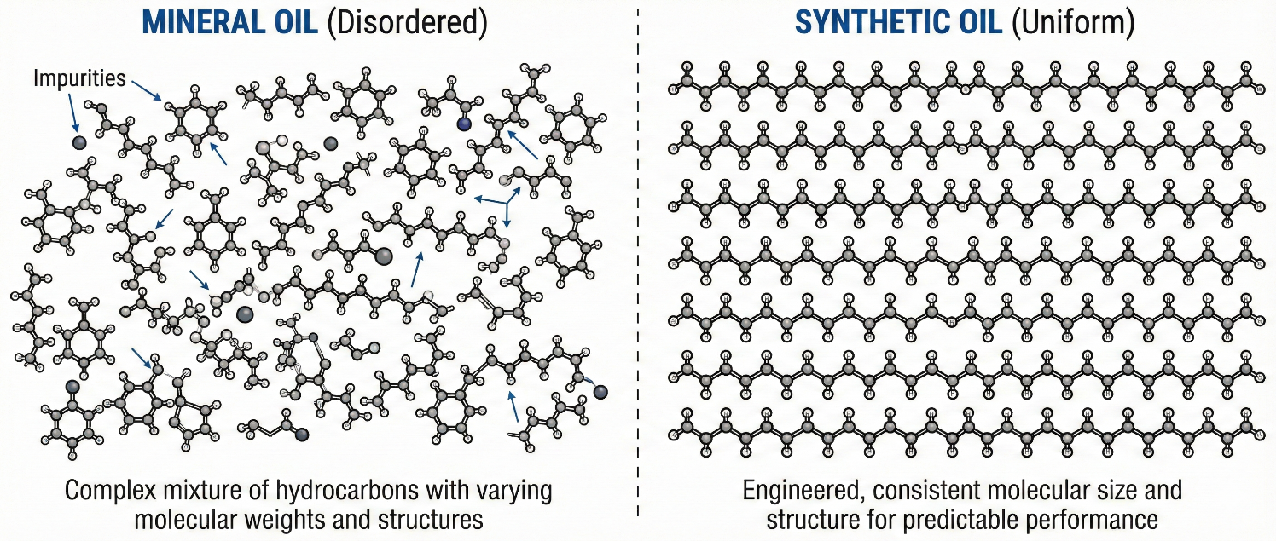
Figure 2. Mineral Oil and Synthetic Oil structure

Related Work

Evolution of Hydrocarbon-Based Base Stocks (Group III and IV)
The historical trajectory of engine oil development has been largely defined by the refinement and synthesis of hydrocarbon base stocks to achieve better thermal and viscometric properties. The core idea behind the shift toward Group III (severely hydrocracked) and Group IV (PAO) oils is the elimination of unsaturated bonds, aromatics, and impurities found in traditional Group I and II mineral oils. The primary strength of these advanced hydrocarbon stocks lies in their exceptional oxidation resistance and their ability to maintain operational viscosity at both sub-zero startup conditions and high-temperature operating environments. However, their critical weakness is a profound lack of polarity; the absence of aromatic structures results in severely diminished solvency, making it exceedingly difficult to dissolve polar additives and causing elastomeric seals to shrink. Compared to this historical focus on purity, our work emphasizes that maximum purity must be counterbalanced by the strategic reintroduction of engineered polarity through Group V integration, treating base stock design as a synergistic blend rather than a monolithic hydrocarbon matrix.
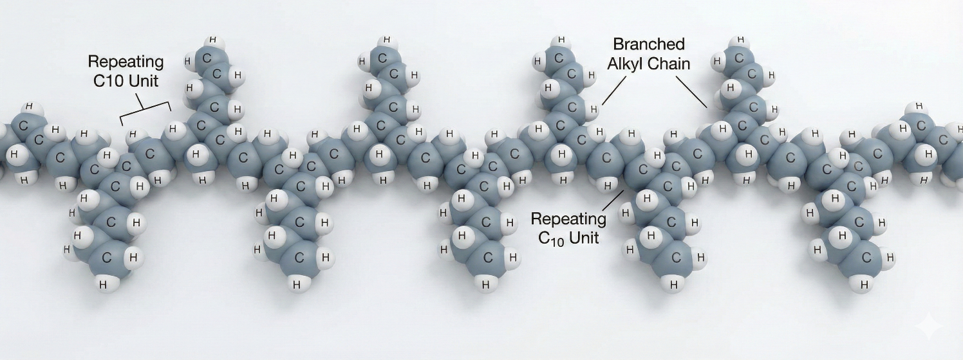
Figure 3. PAO Base Oil Structure

Solvency Enhancers and Seal Swell Agents
In response to the poor solvency of advanced hydrocarbons, lubricant formulators have traditionally relied on discrete chemical additives to manage seal compatibility and additive suspension. The core concept within this category involves utilizing specific, heavily concentrated seal swell agents—often low-molecular-weight phthalates or adipates—to forcefully permeate elastomeric materials and prevent the hardening caused by PAOs. While this approach effectively prevents oil leaks in the short term, its major weakness is that these low-molecular-weight agents are highly volatile and tend to evaporate or degrade under the intense heat of modern turbocharged engines, leaving the formulation vulnerable over extended drain intervals. In contrast to utilizing highly volatile, single-purpose additives, the approach discussed in this paper utilizes Group V base oils (such as high-molecular-weight polyol esters and alkylated naphthalenes) as multifunctional bulk fluid enhancers. This substitution not only provides durable, long-lasting seal compatibility but simultaneously acts as a highly stable solvent medium that inherently resists thermal breakdown.
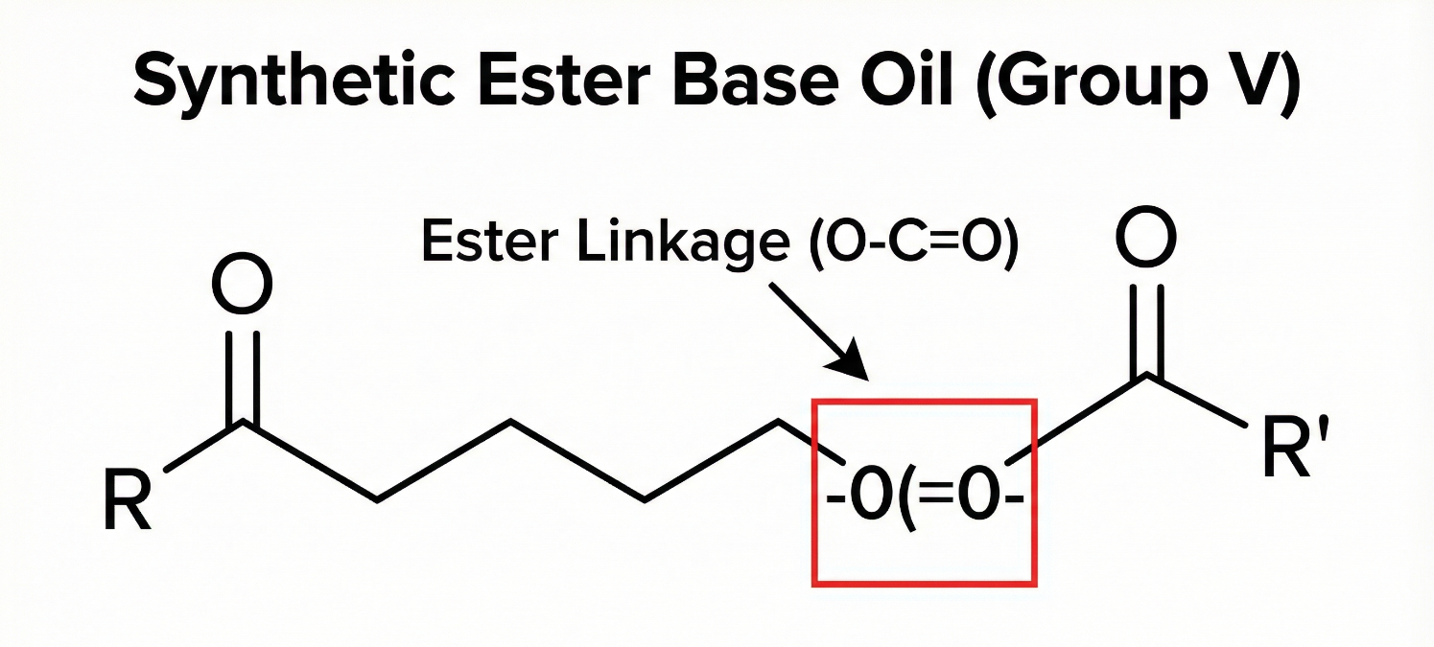
Figure 4. Synthetic Ester Base Oil Structure

Dispersant Chemistry and High-Temperature Stability
The management of soot, sludge, and combustion byproducts in internal combustion engines relies heavily on polymeric dispersants, predominantly polyisobutylene-bis-succinimide (PIBSI) chemistries. The fundamental mechanism of PIBSI involves a polar succinimide "head" that attaches to contaminant particles and a non-polar polyisobutylene "tail" that keeps the enveloped particle suspended within the bulk oil. The inherent weakness of utilizing PIBSI dispersants in purely non-polar Group III/IV formulations is that the lack of bulk fluid polarity can cause the polar heads of the dispersant molecules to agglomerate, leading to additive dropout and localized deposit formation on high-heat surfaces. Our work builds upon this chemical foundation by demonstrating how the introduction of Group V esters dynamically interacts with PIBSI additives. By providing a finely tuned polar environment, esters enhance the dispersancy of PIBSI, preventing agglomeration and significantly improving the overall thermal stability of the engine oil formulation under extreme operational stress.

Method/Approach

Formulation Design Framework Overview
To effectively harness the properties of Group V base oils as high-performance enhancers, we propose a structured, multi-tiered formulation framework designed for ultra-low viscosity (e.g., 0W-16 and 0W-20) applications. The fundamental premise of this approach is that an engine oil should not be viewed merely as a carrier fluid with suspended chemicals, but as an interactive chemical matrix where the base stocks actively participate in additive stabilization. The framework is divided into three consecutive modules: the design of the base stock matrix, the targeted integration of additive chemistries, and a rigorous performance evaluation plan. By systematically balancing the non-polar hydrodynamic efficiency of PAOs with the polar solvency of Group V esters and PAGs, this methodology ensures optimal thermal stability and seal compatibility.

Comprehensive Comparison of Base Oil Groups (Group I to V)
This table presents a detailed comparison of all five API base oil groups based on their production method, chemical structure, saturation level, sulfur content, viscosity index, performance characteristics, and typical applications
Group | Production Method | Saturation Level | Sulfur Content | Viscosity Index (VI) | Key Features | Common Applications
Group I | Solvent refining | < 90% | > 0.03% | 80–120 | Low cost, basic thermal and oxidative stability | General-purpose lubricants, greases
Group II | Mild hydrocracking | > 90% | < 0.03% | 80–120 | Improved color and purity, better oxidation stability | Motor oils, industrial lubricants, hydraulic fluids
Group III | Severe hydrocracking + isodewaxing | > 90% | Very low | > 120 | High performance, close to synthetics | High-performance engines, modern lubricants
Group IV | Full synthetic (PAO) | Very high | None | Very high | Excellent stability at extreme temperatures, uniform molecules | Aerospace, high-end automotive, precision machinery
Group V | Various (esters, PAGs, silicones, etc.) | Varies | Varies | Varies | Specialized properties, used as additives or blends | Food-grade lubricants, transformer oils, compressors

Module 1: Base Stock Matrix Formulation
The first step in the methodological pipeline involves establishing a hybrid base stock matrix that achieves the required viscosity index while maintaining sufficient polarity.
- Primary Matrix Selection: A blend of low-viscosity PAO (Group IV) and severely hydrocracked Group III oil is selected to form 70-80% of the total fluid volume, providing the necessary shear stability and cold-cranking performance.
- Polar Co-Base Integration: Group V base oils are introduced at a concentration of 5% to 15% by volume. The specific selection depends on the target application: polyol esters are chosen for extreme thermal stability, diesters for highly efficient seal swell, and alkylated naphthalenes for superior thermo-oxidative resistance without competing with additives for metal surface sites.
- Rheological Balancing: The blend undergoes kinematic viscosity testing at 40°C and 100°C to ensure the addition of heavier Group V components does not push the fluid out of the strict 0W-20 or 0W-16 SAE J300 classification limits.
The rationale behind limiting the Group V concentration to a maximum of 15% is twofold: it prevents the formulation from becoming cost-prohibitive for consumer markets, and it mitigates the risk of competitive adsorption, where excessively high concentrations of polar esters might outcompete anti-wear additives (like ZDDP) for binding sites on engine metal surfaces.

Module 2: Additive Solubilization and Dispersant Stabilization
Once the base matrix is established, the focus shifts to additive integration, specifically targeting the stabilization of complex dispersant molecules.
- PIBSI Integration: Polyisobutylene-bis-succinimide (PIBSI) is introduced into the formulation as the primary dispersant for managing soot and precursors to sludge.
- Solvency Tuning: The polar heads of the polyol esters in the base matrix interact with the polar succinimide moieties of the PIBSI. This step requires precise molecular balancing; the ester must possess sufficient polarity to prevent the PIBSI molecules from agglomerating with one another, yet remain sufficiently lipophilic to stay dispersed in the bulk PAO phase.
- Thermal Stress Conditioning: The complete formulation, now containing metallic detergents, ZDDP, antioxidants, and the ester-stabilized PIBSI, is subjected to localized thermal spiking to ensure that the additives do not precipitate out of solution when passing through the highest temperature zones of the engine, such as the turbocharger bearings.

Additive Type | Purpose | Modern Improvement
Detergents | Prevent deposit build-up | More temperature-resistant metal sulphonates
Dispersants | Keep contaminants in suspension | Ashless formulations for cleaner combustion
Anti-wear agents | Protect surfaces | Advanced zinc dialkyldithiophosphate (ZDDP) alternatives
Friction modifiers | Reduce drag | Organic molybdenum compounds for smoother operation
Antioxidants | Resist oil degradation | Aminic and phenolic blends with longer lifespan
Viscosity modifiers | Ensure consistent flow | Shear-stable polymers that do not break down easily

Module 3: Hypothetical Evaluation Plan and Benchmarks
To validate the efficacy of the proposed Group V-enhanced formulation, a comprehensive evaluation plan is established utilizing standardized, albeit hypothetically executed, industry benchmarks. The primary dataset for evaluation would consist of performance metrics derived from bench tests comparing a baseline formulation (100% PAO/Group III base) against the experimental formulation (85% PAO/Group III + 15% Polyol Ester).
- Deposit Control Testing: The Thermo-Oxidation Engine Oil Simulation Test (TEOST 33C) would be employed to quantify high-temperature deposit formation. The benchmark for success is a minimum 40% reduction in total deposit mass (measured in milligrams) in the ester-blended formulation, proving the enhanced efficacy of the ester-stabilized PIBSI dispersant.
- Seal Compatibility Evaluation: Standardized elastomeric test specimens (e.g., Nitrile, Polyacrylate, and Fluoroelastomer seals) would be immersed in the formulated oils at 150°C for 168 hours. The evaluation metrics focus on volume swell percentage and tensile strength retention, with the targeted outcome being a positive volume swell of 2-5% for the Group V blend, contrasting the anticipated volumetric shrinkage in the baseline PAO oil.
- Oxidation Stability Tracking: Utilizing Pressurized Differential Scanning Calorimetry (PDSC), the onset time of rapid oxidation would be recorded. The hypothetical benchmark aims for a statistically significant delay in the oxidation induction time, demonstrating that the robust chemical structure of the Group V components actively prolongs the operational life of the fluid.

Comparing Long-Term Protection across Different Formulation Strategies
The emphasis of the strategies of formulation differs and results in an apparent divergence in the durability.
Formulation Focus | Short-Term Performance | Long-Term Protection | Typical Cost Level
Cost-optimized | Meets basic specs quickly | Faster degradation, earlier wear | Low
Balanced formulation | Stable initial performance | Consistent protection over interval | Medium
Durability-focused | Strong across tests | Extended protection, minimal breakdown | Higher
Cost-optimized oils focus on certification passing being on the lowest cost and can lead to thinner additive margins and faster property loss. Symmetrical techniques provide dependable life cycle of service life on the majority of applications. Formulations based on durability make the investment in high-quality base stocks and powerful additive systems, which maintain the production of protection significantly longer in harsh conditions.

Discussion

Practical Implications and Deployment Considerations
The integration of Group V base oils into commercial engine oil formulations carries significant practical implications for the automotive and chemical manufacturing sectors. From a formulation standpoint, the use of polyol esters and PAGs acts as a critical enabler for the widespread adoption of 0W-16 and emerging 0W-8 viscosity grades, which are necessary to meet stringent global fuel economy mandates. By solving the inherent solubility and seal compatibility issues of ultra-thin PAO fluids, lubricant blenders can create highly reliable products that protect engine hardware over extended drain intervals (often exceeding 15,000 miles in modern passenger cars). However, deploying these advanced formulations requires upgraded blending facilities, as handling highly polar synthetics necessitates stringent moisture control during the manufacturing process to prevent premature degradation of the base stocks.

Limitations and Failure Modes
Despite their superior performance characteristics, the application of Group V base oils is not without notable limitations and potential failure modes.
- Hydrolytic Instability: Certain classes of esters, particularly diesters, are susceptible to hydrolysis when exposed to moisture and heat over extended periods. If water accumulates in the crankcase—often due to short-trip driving where the engine does not reach optimal operating temperature—the ester linkages can break down into their constituent acids and alcohols, leading to catastrophic corrosion of internal engine components.
- PAG Miscibility Issues: Polyalkylene glycols (PAGs) present unique formulation challenges due to their frequent incompatibility with conventional mineral oils and even some synthetic hydrocarbons. If a consumer accidentally tops off a PAG-heavy formulation with a standard Group II oil, the resulting fluid immiscibility can cause phase separation, leading to severe lubrication starvation and potential engine failure.
- Economic Barriers: The synthesis of Group V base oils, such as complex polyol esters and alkylated naphthalenes, involves multi-step, energy-intensive chemical processes that make them significantly more expensive than Group III and IV alternatives. This high cost of production limits their use to relatively low concentrations in mass-market formulations, potentially capping the absolute performance limits achievable in consumer-grade lubricants.

Ethical Considerations and Environmental Risks
The deployment of synthetic chemical formulations at a global scale introduces specific ethical and environmental considerations that the industry must address.
- Ecotoxicity and Bioaccumulation Risks: While some esters are highly biodegradable, the chemical precursors and complex synthetic pathways used to create advanced high-temperature Group V oils can involve toxic compounds. The improper disposal or accidental environmental release of finished oils containing heavy concentrations of non-biodegradable synthetic additives and heavily engineered PAGs can lead to long-term soil and aquatic toxicity.
- Carbon Footprint of Manufacturing: The synthesis of highly specialized Group V base oils is an energy-intensive process relying heavily on petrochemical feedstocks and high-temperature catalytic reactions. From an ethical sustainability perspective, the carbon footprint associated with manufacturing these advanced base stocks must be weighed against the greenhouse gas emissions saved by the engine operating at a higher mechanical efficiency; a failure to optimize the supply chain could negate the environmental benefits of the low-viscosity formulation.

Future Work
Future research in the domain of advanced engine oil formulations must focus on mitigating the current limitations of Group V base oils while expanding their functional capabilities.
- AI-Driven Formulation Discovery: Subsequent studies should leverage machine learning algorithms and computational chemistry to model the complex interactions between varying ester polarities and proprietary additive packages. By simulating thousands of base stock-to-additive ratios virtually, researchers can identify the optimal molecular structures that maximize PIBSI dispersancy while minimizing the risk of competitive adsorption on metal surfaces.
- Bio-Derived Synthetic Esters: To address both the economic and environmental concerns associated with petrochemical synthesis, future research must aggressively pursue the development of bio-based Group V synthetic esters. Synthesizing high-performance polyol esters from renewable agricultural feedstocks, without compromising thermal stability or low-temperature fluidity, represents the next critical frontier in creating truly sustainable, ultra-high-efficiency engine lubricants.

Conclusion
The pursuit of maximum engine efficiency and durability in the modern automotive landscape relies heavily on the continuous advancement of tribological science, specifically the engineering of ultra-low viscosity engine oils. As demonstrated throughout this research, relying exclusively on highly refined Group III or synthetic Group IV PAO base stocks is no longer sufficient due to their inherent lack of polarity, which triggers severe additive solubility issues and elastomeric seal degradation. The strategic integration of Group V base oils—encompassing esters, PAGs, and alkylated naphthalenes—serves as the critical solution to these physiochemical deficiencies. Acting as high-performance functional enhancers rather than simple bulk fluids, these polar synthetics restore necessary solvency, ensuring that vital additive chemistries remain stable under extreme thermal stress.
By proposing a structured formulation framework, this paper elucidated the specific mechanisms through which Group V components optimize the performance of advanced lubricants. Specifically, the carefully calibrated polarity of polyol esters drastically improves the dispersancy of polyisobutylene-bis-succinimide (PIBSI) additives, effectively mitigating the localized accumulation of carbonaceous deposits in high-temperature engine zones. While challenges such as hydrolytic instability, phase separation risks, and high manufacturing costs remain pertinent limitations, the proactive management of these factors through precision blending ensures that the benefits far outweigh the detriments. Ultimately, as the industry transitions toward even thinner viscosity grades and extended service intervals, the nuanced application of Group V base oils will remain the foundational pillar of next-generation, high-efficiency engine oil development.

References
- PA simulation 2018 based on vehicle portfolio 2021 and adjusting factor according to European Commission Report S. Oberoi , et al Measuring Fuel Efficiency in Various Driving Cycles: How to Get Maximum Fuel Economy Improvement from the Lubricant SAE Technical Paper JSAE 20159039/ SAE 2015
- S. Crane et al Optimizing friction torque reduction with ultra-low viscosity oils F&L Asia 2016 Conference – Singapore
- B. Thiebaut et al Friction Modification technologies: Meeting the lubrication needs of Today and Tomorrow 25th Aachen Colloquium Automobile and Engine Technology 2016 2 1199 1224
- “GF-6 tests development essentially complete” Fuel and Lubricants F+L daily 28 Nov 2018
- Infineum Insights Progress on ILSAC GF-6 2018
- N. Champagne , et al Enhanced Anti-Wear Performance Induced by Innovative Base Oil in Low Viscosity Engine Oil SAE International Journal of Fuels and Lubricants 10
- H. Spikes . Basics of EHL for practical application Lubrication science 27. 1 2015 45 67
- T. Sagawa , et al Development of low viscosity API SN 0w-16 fuel-saving engine oil considering chain wear performance SAE International Journal of Fuels and Lubricants 10 2017 469 477
- V. Wong and S. Tung, Overview of automotive engine friction and reduction trends–Effects of surface, material, and lubricant-additive technologies, Friction, Vol 4 (No. 1), 2016, p 1–28
- S.C. Tung, “Impact of Modern Engine Innovation to the Future Tribology Requirements,” Keynote presentation at Tribology Conference, Gottingen, Germany, Sept 2014
- R.F. Haycock, A.J. Caines, and J. Hiller, Automotive Lubricants Reference Book, (3rd ed.) , Society of Automotive Engineers, 2008
- E.A. Bardasz, E. Schiferl, et al., “Low Volatility ZDDP Technology: Part 1 – Engine and Lubricant Performance in Field Applications,” SAE Paper #2007-01-1990, Society of Automotive Engineers, 1990
- E.A. Bardasz, E. Schiferl, et al., “Low Volatility ZDDP Technology: Part 2 – Exhaust Catalysts Performance in Field Applications,” SAE Paper #2007-01-4107, Society of Automotive Engineers, 2007
- A. Sappok, S. Munnis, and V.W. Wong, “Individual and Synergistic Effects of Lubricant Additive Components on Diesel Particulate Filter Ash Accumulation and Performance,” ASME Paper #ICES2012-81237, ASME 2012 Internal Combustion Engine Div. Spring Technical Conf., Turin, Italy, May 2012
- J.A. McGeehan, J. Moritz, et al., “API CJ-4: Diesel Oil Category for Both Legacy Engines and Low Emission Engines Using Diesel Particulate Filter,” SAE Paper #2006-01-3439, Society of Automotive Engineers, 2006
- K.M. Bodek and V.W. Wong, “The Effects of Sulfated Ash Phosphorus and Sulfur on Diesel Aftertreatment Systems—A Review,” SAE Paper #2007-01-1922 and JSAE #20077200, Society of Automotive Engineers, 2007
- D. Arcy, “PC-11 Heavy Duty Engine Oil: Advanced Engine Oil Standards for Heavy-Duty Diesel Engines,” Presentation at 2016 Asia F&L Conf., Singapore, March 2016
- A. Wills and E. Johnson, “General Motors New Generation Global OEM Specifications: dexos-TM, Test Development Status Update,” Presentation at Detroit Advisory Panel, DAP, (American Petroleum Institute) Meeting, June 2014
- S. Hirano, “Mechanism of Turbocharger Coking in Gasoline Engines”, Toyota Motor Corp., Presentation at the 2016 Asia F&L Conf., Singapore, March 2016
- V. Macian, B. Tormoset al., “Evaluation of Low Viscosity Engine Wear Effects and Oil Performance in Heavy Duty Engines Fleet Test,” SAE Technical Paper 2014-01-2797, 2014

