Industrial cultivation of green onions: multi-bud bulbs, varietal material, and the challenges of the modern seed industry

Introduction
Green onions are among the most common green crops in closed ground and intensive vegetable growing systems. Stable retail demand, a short growing cycle, and the possibility of year-round production make them an important element of modern agrarian business [1].
Despite the external simplicity of the crop, industrial cultivation of green onions has a number of specific features that significantly distinguish it from the classic production of onions for storage. In practice, the efficiency of forcing is determined not only by the parameters of the microclimate, irrigation, or lighting, but primarily by the quality of the planting material and its physiological state [2].
For the market of commercial turnips, onion breeding has long been aimed at obtaining dense, leveled, and transportable bulbs with high keeping quality and minimal tendency to sprout [3]. Such properties are critically important for long-term storage and logistics. However, in green onion production, such characteristics can negatively affect the speed of forcing and the uniformity of feather formation.
For intensive production of greens, a bulb with high physiological activity is required, capable of quickly emerging from dormancy and forming several growth points simultaneously [4]. In this context, a multi-bud bulb is of particular importance - a biological property of onions, in which several independent growth centers are formed inside one bulb [5]. In recent years, the problem of a shortage of suitable varietal material for forcing green onions has become increasingly noticeable. A significant part of modern hybrids demonstrates high turnip yield indicators, but they are inferior to traditional varieties in terms of germination intensity and the number of formed shoots [6].
Materials and Methods
The work used a comprehensive approach that combines the analysis of scientific sources with production observations obtained in the conditions of industrial cultivation of green onions.
The assessment was carried out on the basis of the analysis of various varieties and hybrids of onion (Allium cepa L.), which were used for forcing feathers in closed production systems. During the study, the intensity of germination, the number of formed shoots, the rate of growth of green mass, the uniformity of the batch and the commercial yield of products were taken into account.
Special attention was paid to the comparison of multi-bud varietal forms with modern hybrids, oriented mainly to long-term storage and sale of onions [7]. The influence of the physiological state of the bulb on the stability of the production cycle and the uniformity of forcing was also analyzed.
In the process of preparing the article, scientific works devoted to the physiology of onion germination, breeding of Allium cepa L., features of the dormancy period, and biology of the formation of multi-bud bulbs were used [8–10].
Results
The multi-bud trait as a production factor
The multi-bud trait is one of the most critical characteristics of planting material in the industrial production of green onions. Due to the presence of multiple internal growing points, a single bulb can form several independent shoots, which directly affects the yield of green mass [11].
Under production conditions, this trait ensures higher efficiency in space utilization and increases the yield of marketable foliage per unit of planting material. Multi-bud forms typically produce denser clusters of greens, showing better batch uniformity and a lower percentage of weak plants.Practical observations indicate that even under optimal microclimate parameters, single-bud hybrids often exhibit uneven sprouting and unstable foliage development. In commercial production, this leads to a loss of marketability and complicates the formation of standardized products for the retail sector.
Biologically, multi-centeredness is linked to the specific formation of meristematic tissues in the onion basal plate [12]. The number of buds depends on both the genetic characteristics of the cultivar and the growing and storage conditions of the planting material [13].
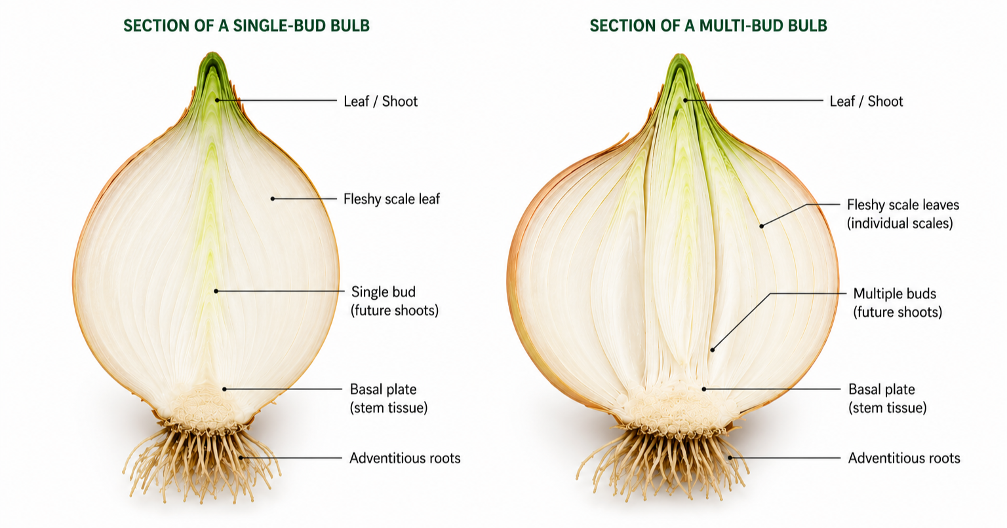
Figure 1. Internal structure of single-bud and multi-bud onion bulbs (Allium cepa L.)
The contradiction between modern breeding and forcing requirements
The modern seed industry is largely oriented toward the needs of the global storage market for vegetable crops. The primary breeding objectives include bulb density, transportability, uniformity, extended shelf life, and resistance to premature sprouting [14].
While this is an obvious advantage for bulb onion production, such traits can become technological limitations for green onion forcing systems. A bulb genetically predisposed to a prolonged dormancy state activates growth processes more slowly after planting and often produces weaker feathers [15].
Thus, a contradiction arises between the requirements of these two distinct production sectors. The marketable bulb onion market demands a bulb that resists sprouting for as long as possible. Conversely, green onion production requires material with high sprouting energy and active shoot formation.
Consequently, traditional cultivars, which may lag behind modern hybrids in terms of shelf life or bulb uniformity, often prove to be more effective in commercial feather forcing [16].
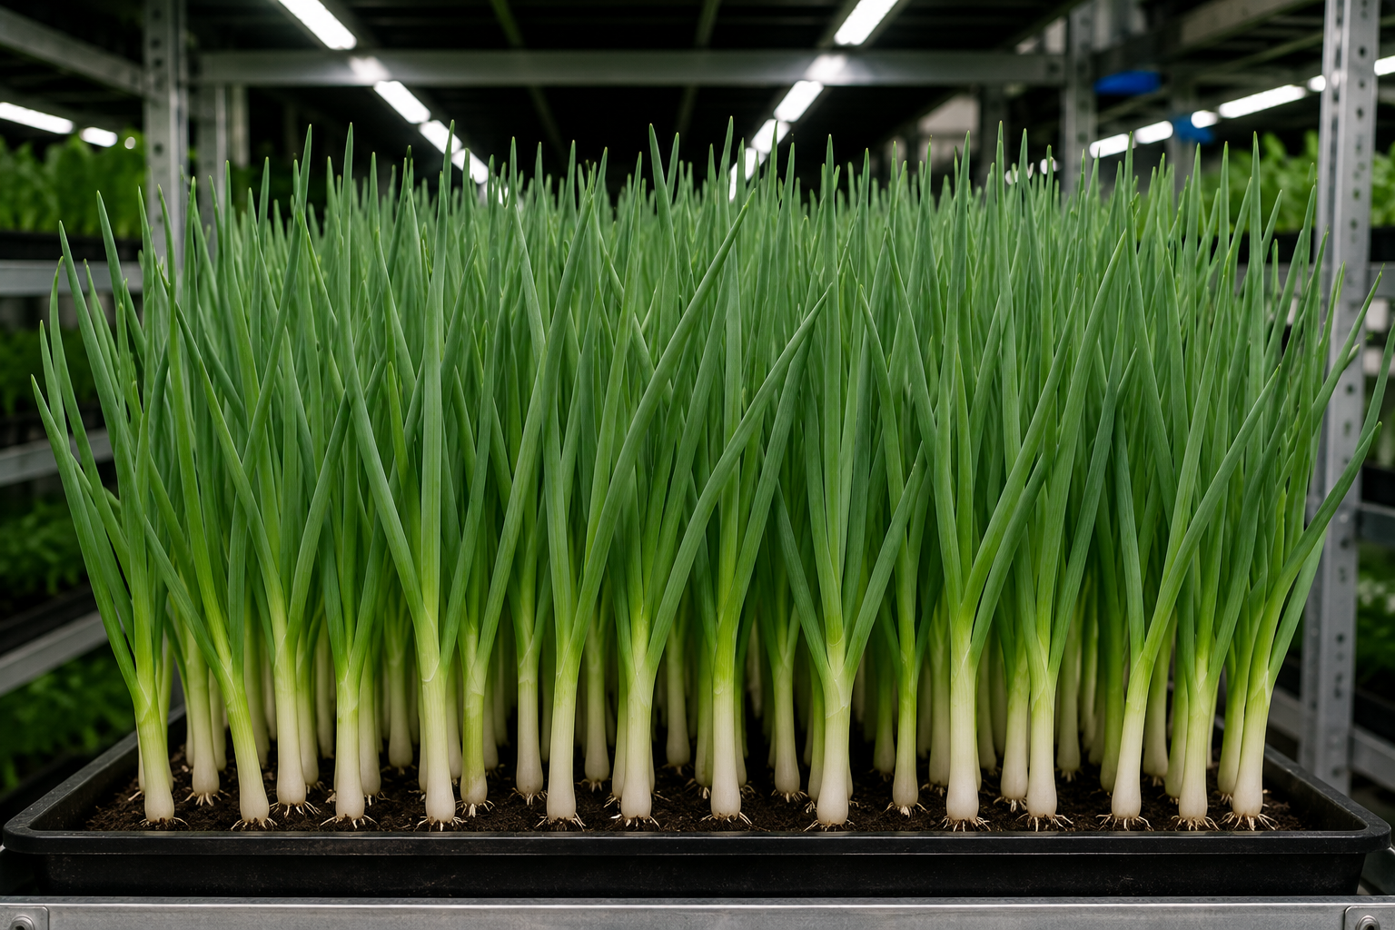
Figure 2. Photo of green onions in the forcing phase
The two-years cycle and the problem of planting material planning
The bulb onion is a biennial crop. In the first year, seeds form onion sets (small bulbs), which, after a storage period, are replanted to obtain a full-sized mature bulb [16]. This mature bulb is subsequently used for green onion forcing.For the industrial production of green onions, this biological characteristic of the crop is of fundamental importance, as the development of high-quality planting material requires a long time and advance planning.
The main stages of the production cycle include:
- Selection of cultivar material with high multi-bud traits;
- Cultivation of onion sets from seeds;
- Storage of onion sets under controlled environmental conditions;
- Replanting to obtain marketable bulb onions;
- Sorting bulbs by size fraction and physiological state;
- Preparation of the material for feather forcing.
Each of these stages affects the future germination intensity and the quality of the green mass. Disruptions in the temperature regime during storage, incorrect size fraction selection, or the use of physiologically weakened material can lead to uneven forcing and a reduction in commercial yield [15].
A distinct challenge for green onion producers is the limited availability of multi-bud cultivars. Most modern hybrids are developed for the bulb onion market and are oriented toward shelf life, transportability, and resistance to premature sprouting [17]. As a result, a significant portion of the available planting material exhibits insufficient feather formation intensity.
Under industrial conditions, this complicates production forecasting and necessitates the development of an in-house system for selecting and accumulating planting material for subsequent forcing cycles.
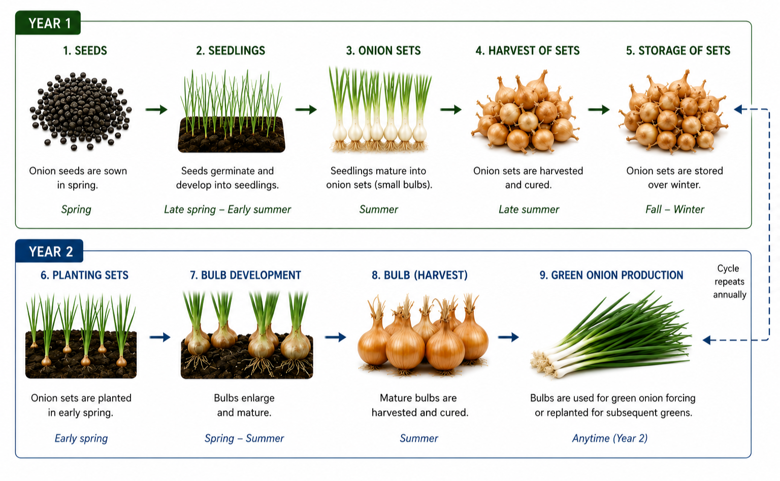
Figure 3. Two-years development cycle of onion bulbs used for green forcing
Conclusion
Industrial green onion production involves fundamentally different biological and technological requirements compared to the production of bulb onions for storage. The preparation cycle of high-quality planting material for commercial forcing essentially spans two seasons. For the producer, this implies the necessity of long-term planning, encompassing not only future production volumes but also the specific cultivar composition, the physiological state of the bulbs, and their storage system. It is this stage that often becomes one of the most underestimated factors in green onion cultivation technology. The operational experience of large-scale enterprises demonstrates that even with modern forcing chambers, automated microclimate control, and stable irrigation systems, it is impossible to achieve a predictable outcome without properly selected planting material [17].
The multi-bud trait directly affects the commercial yield of foliage, batch uniformity, and production economics. For this reason, traditional cultivar material may, in many cases, be more suitable for commercial forcing than modern hybrids oriented toward extended storage. The deficit of viable multi-bud cultivars creates severe production risks. If the required planting material was not integrated into the cycle in advance, quickly compensating for its shortage using regular marketable bulb onions is practically impossible without losing feather yield, batch uniformity, and commercial product quality [15].
In industrial production oriented toward retail supply, this is of critical importance. Retail chains require a stable, year-round supply of standardized products with predictable quality parameters. Consequently, the planning system for planting material effectively becomes a distinct element of green onion cultivation technology.
The practical experience of commercial enterprises shows that the core secret to stable green onion production begins not within the forcing chamber, but at the stage of understanding bulb biology. It is essential to work not merely with marketable bulb onions, but with physiologically active planting material capable of ensuring intensive and uniform feather development. In this regard, the enterprise technologist must operate not only as a forcing system operator but also as a specialist who understands crop biology, the specifics of cultivar material, and the long-term logic of production cycle formation.
References
- Brewster J. L. Onions and Other Vegetable Alliums. 2nd ed. Wallingford: CAB International; 2008.
- Rabinowitch H. D., Currah L. Allium Crop Science: Recent Advances. Wallingford: CABI Publishing; 2002.
- Mallor C., Thomas B. Breeding and genetics of onions for quality and storage performance. Plant Breeding Reviews. 2019;43:151–185.
- Singh B., Sharma Y. Physiology of bulb dormancy and sprouting in onion. Agricultural Reviews. 2016;37(3):179–188.
- Khokhar K. M. Environmental and genotypic effects on bulb development in onion — a review. Journal of Horticultural Science and Biotechnology. 2014;89(5):448–454.
- Havey M. J. Onion breeding and genetics. Plant Breeding Reviews. 1993;11:109–145.
- Currah L., Proctor F. J. Onion in Tropical Regions. Natural Resources Institute Bulletin. 1990;35:1–232.
- Jones H. A., Mann L. K. Onions and Their Allies: Botany, Cultivation and Utilization. New York: Interscience Publishers; 1963.
- Lancaster J. E., Collin H. A. Onion storage physiology and pathology. Horticultural Reviews. 1981;3:315–347.
- Ansari N. A. Effect of storage conditions on sprouting behavior of onion bulbs. Scientia Horticulturae. 2007;112(1):56–59.
- Bose T. K., Som M. G. Vegetable Crops in India. Kolkata: Naya Prokash; 1986.
- Brewster J. L. The physiology of onion bulbs. Annual Review of Plant Physiology. 1994;45:25–50.
- Rabinowitch H. D. Physiology of bulb crops. Boca Raton: CRC Press; 1990.
- Cramer C. S. Breeding and genetics of Fusarium basal rot resistance in onion. Euphytica. 2000;115:159–166.
- Yoo K. S., Pike L. M. Determination of onion bulb dormancy by storage conditions and genotype. Journal of the American Society for Horticultural Science. 1998;123(4):586–590.
- McCallum J. Onion breeding for quality traits. Acta Horticulturae. 2007;770:133–140.
- Fritsch R. M., Friesen N. Evolution, domestication and taxonomy of the genus Allium. Plant Genetic Resources. 2002;3:5–30.

