Design and Implementation of an Intelligent Waste Bin with Real-time Monitoring and Automated Compaction Facilities

Abstract
In many urban and rural regions, ineffective waste management techniques pose a serious threat to human health, the environment, and municipal budgets. In order to improve garbage disposal efficiency, this project demonstrates the design and implementation of an intelligent waste management system with automatic waste compaction and real-time monitoring. In order to monitor waste levels, initiate compaction, and alert authorities for prompt evacuation, the system combines ultrasonic sensors, an ATMEGA 328P microcontroller, DC motors, and a GSM communication module. To guarantee dependability, every system component—including the sensing, power, communication, and compaction mechanisms—was created and tested gradually. In addition to delivering SMS warnings when the bin is full, the microcontroller uses sensor data to operate the opening, closing, and compaction operations. Evaluation of the system's performance showed that it operated efficiently, with a low latency of 5.6 seconds for opening and 15.8 seconds for compaction. Over ten trials, the system was 100% available. To guarantee seamless functioning, issues including power management and sensor calibration were resolved. The research work shows how adding intelligent features can boost environmental safety, decrease overflow, and improve waste management.
Keywords: Intelligent Waste Bin, Automated Compaction, Real-Time Monitoring, Latency, Microcontroller, Sensor
- Introduction
Waste management is becoming a growing problem every day in both developed and developing nations due to the rapid rate of urbanization. Rapid urbanization and industrialization have altered the nature of solid waste in Nigeria and other emerging nations [1, 2]. The production of municipal solid trash has expanded dramatically due to rapid urbanization, creating major obstacles to public hygiene and environmental sustainability. Garbage management has become a global challenge due to rapid urbanization, growing consumerism, and inadequate infrastructure. A significant amount of urban waste is made up of dry waste, which includes paper, plastics, metals, and packaging materials. When such garbage is handled improperly, it frequently results in overflowing bins, dispersed litter, and decreased recycling effectiveness [3]. When dry trash combines with organic or wet materials, the situation gets worse, leading to contamination and reducing its potential for reuse [4][5]. Many areas still rely on labor-intensive, manual collection methods that lack real-time monitoring capabilities, despite advances in waste management technologies [6][7]. Burning, open dumping, and routine manual trash can emptying are examples of conventional waste collecting methods that are often labor-intensive, inefficient, and environmentally unsustainable. The need for innovative solutions to these issues has led to the development of intelligent waste management systems [8]. With their sensors and connectivity capabilities, intelligent trash cans present a viable way to improve the sustainability and efficiency of waste management. These bins can optimize collection routes, cut down on pointless trips, and enhance overall trash management operations by offering real-time data on waste amounts, types, and locations [9]. Although the idea of intelligent trash cans is becoming more popular, there are a few issues that need to be resolved. These include the difficulties of connecting intelligent garbage bins with current infrastructure, the high implementation costs, and the requirement for a dependable power source. Notwithstanding these difficulties, smart trash cans have a lot of potential advantages. These technologies can help create a cleaner, more livable urban environment by increasing efficiency, cutting expenses, and fostering environmental sustainability [10].
Inefficient waste management practices present a major challenge in many urban and rural areas, contributing to environmental pollution, public health risks, and rising costs for municipalities. Traditional waste collection methods, which often depend on manual labor, are not only time-consuming but also prone to errors, such as missed pickups or overflowing bins [11].
Without real-time monitoring and automated compaction, waste bins can't optimize collection routes, identify high waste areas, or reduce emptying frequency. This issues leads to higher costs, more emissions, and environmental damage, thus, the need to develop an intelligent waste bin with real-time monitoring and automated compaction facilities for enhancing the general sustainability and effectiveness of waste management activities in urban environments.
1.2 Literature Review
Previous literatures on smart or intelligent trash cans have concentrated on a number of facts, such as data analysis, communication protocols, and sensor technology. However, more research is required in areas like real-time monitoring and automated compaction. By creating an intelligent garbage container with real-time monitoring and automated compaction capabilities, this research work seeks to close these research gaps. This approach develops intelligent waste management technologies and offers a potential remedy for the problems that communities and cities around the world confront.
Recent research works in waste management has focused on computer technologies to improve monitoring, collection efficiency, and sustainability in urban environments. Several studies have highlighted the growing need for automated systems to address issues such as bin overflow, inefficient collection schedules, and poor waste handling practices.

The authors presented a research work that uses RFID technology to track waste bin status and collection. RFID tags on bins allow for data collection on waste disposal patterns and frequency but no real-time waste level monitoring or compaction mechanisms, making it less effective for bins that frequently reach capacity [12].

This research by [13] develops a wireless sensor network (WSN) to monitor waste levels in large parks and recreational areas. The network relays data to a central system for real-time monitoring but the drawback is that there are no mechanisms for waste compaction or increasing bin capacity, leading to frequent collections.

Authors presented a study that investigated the use of IoT technology to monitor waste bins in urban settings. Data was transmitted to a centralized system, enabling optimized collection routes and schedules but the gap of this research is that it lacks any physical enhancements such as compaction, meaning bins still reach capacity quickly despite efficient monitoring [14].

This research focuses on the development of a smart waste bin network that uses sensors to remotely monitor waste levels in public spaces. Data is transmitted in real-time to waste management teams but there are no mechanisms for reducing the waste volume or extending bin capacity [15].

IoT-Based Waste Management System for Remote Monitoring developed by [16] uses IoT technology to monitor and manage waste levels in bins located in remote areas. The data is transmitted via GSM to ensure timely collection but its drawback is that No compaction or volume management features, requiring frequent collection trips despite remote monitoring.

This research by [17] presents a cloud-connected waste bin system that tracks and monitors waste levels in real time. The system helps optimize collection routes and reduce operational costs but the identified gap is that the system did not include compaction mechanisms to increase bin capacity, resulting in frequent collection despite improved monitoring.

The authors introduced an IoT-based system for real-time waste level monitoring in public bins. The system uses ultrasonic sensors to detect waste levels and notifies waste management authorities when bins are full but it lacks mechanisms to enhance bin capacity, relies solely on monitoring without addressing physical waste reduction or compaction. [18].

Authors presented a smart waste management system that focuses on waste level monitoring in public spaces. It uses weight sensors to track bin capacity and notifies collection teams when bins are nearing full capacity but there were no feature to reduce the physical volume of waste in the bin, requiring frequent collection despite monitoring improvements [19].

This research work by [20] integrated IoT sensors and cloud technology to monitor waste levels in urban areas. The data is uploaded to a cloud platform for real-time monitoring and route optimization but it focuses only on monitoring and route optimization, with no capacity-enhancing features such as waste compaction.

- Methodology
Software development, prototyping, and simulation are used in an organized manner to create the intelligent waste management system. To ensure that the Arduino Nano, sensors, and motor drivers interacted properly, Proteus software was used to mimic the system's electronic components. Smoother hardware integration was made possible by the early resolution of possible problems. Key hardware elements, including proximity sensors, waste height sensors, DC motors, GSM modules, and the Arduino Nano, were put together into a working prototype once the simulation proved effective. With an emphasis on automated lid control, trash compaction, and remote notifications, every component is verified to guarantee dependable performance.
The Arduino IDE was used to construct the system's software, which controls functions like GSM notifications, motor control, and sensor data processing. This software is designed for automated waste management and real-time monitoring, which enables the system to regulate the motor for the lid and garbage compaction as well as send alerts when the bin is full. The system was tuned for effective performance through iterative testing and improvement, guaranteeing its preparedness for practical use.
3.1 Materials
The intelligent waste management system comprises several major materials:
- Arduino Nano – The main microcontroller responsible for controlling sensors and actuators.
- Proximity Sensor – This detects the presence of users near the bin.
- Waste Height Measurement Sensor – This monitors waste levels inside the bin.
- DC Motor – This powers the automated lid mechanism and the waste compaction system.
- GSM Module – Sends notifications to waste management authorities when the bin is full.
- LCD Display – Displays system status and real-time updates.

  - System Block Diagram
The block diagram of the intelligent waste management system is shown in Fig 1. It shows the interaction between the various components, and how the system operates efficiently to achieve automated waste monitoring, compaction, and remote communication.
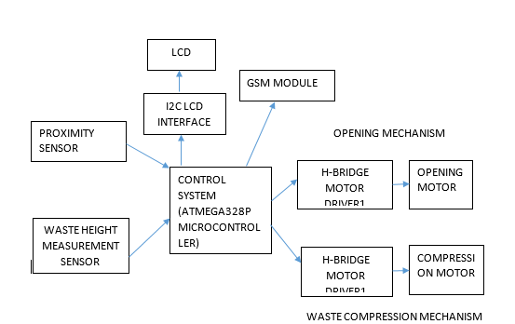

Figure 1: Block Diagram of the intelligent waste management system
Listed below is the breakdown of the key blocks or components of the intelligent waste management system and their various functions:
- Input Devices (Sensors):
- Proximity Sensor: This sensor detects when a user approaches the bin and sends a signal to the control unit to trigger the automatic lid opening mechanism.
- Waste Level Sensor: An ultrasonic sensor that continuously monitors the level of waste inside the bin. When the waste reaches a predefined threshold, the sensor sends a signal to the control unit to initiate the compaction process.
- Control Unit (Arduino Nano):
- The Arduino Nano microcontroller is the brain of the system. It processes signals from the sensors and sends commands to the output devices. For example, it triggers the motor to open/close the lid or activate the compaction mechanism when necessary. The Arduino Nano also communicates with the GSM module to send notifications to waste management teams when the bin is full.
- Output Devices:
- DC Motor: The motor is responsible for two key functions: operating the lid and powering the waste compaction mechanism. It is controlled by an H-Bridge motor driver, which allows for bidirectional control (open/close lid, start/stop compaction).
- GSM Module: The GSM module is used for sending SMS notifications to waste management authorities. When the waste bin is full, the system automatically sends an alert, ensuring timely collection.
- Power Supply:
- The system operates using a 12V power supply. The motor and GSM module require 12V, while the sensors and Arduino Nano operate on 5V, which is achieved through a buck converter that steps down the voltage for these low-power components.
- Display (LCD):
- The LCD provides real-time information about the system’s status. It displays messages such as “Lid Open,” “Bin Full,” or “Compaction in Progress,” making it easier for users and maintenance personnel to interact with the system.
This block diagram ensures seamless coordination between the sensors, control unit, motor, and communication module, optimizing waste collection and minimizing manual intervention.

3.3 Flowchart
The intelligent waste bin system follows a series of key steps to manage waste efficiently, starting from detecting the user, managing waste disposal, monitoring waste levels, and, if necessary, activating the compaction mechanism or notifying waste management teams. Each of the four segments outlined below is critical to the system’s overall operation.
Segment 1: Initialization and System Check
The first segment is responsible for setting up the system and ensuring that all components are functioning correctly before the bin enters normal operation mode. This segment is crucial for making sure the sensors, motor, and communication module are initialized and ready to perform their functions as shown in Figure 2.
Key Steps:
- System Boot-Up: When the system is powered on, the Arduino Nano initializes all components, such as sensors, motor drivers, and the GSM module. This also includes setting up the default variables and checking the communication between components.
- Self-Diagnosis: The system runs a diagnostic check to ensure that all components are working correctly. If any component fails to initialize or if there are communication errors, an error message is displayed on the LCD, alerting maintenance personnel to fix the issue.
- Set Default States: After initialization, the system sets the default state for components. This includes ensuring that the lid is closed, the motor is not engaged, and the sensors are ready to detect proximity or waste levels.
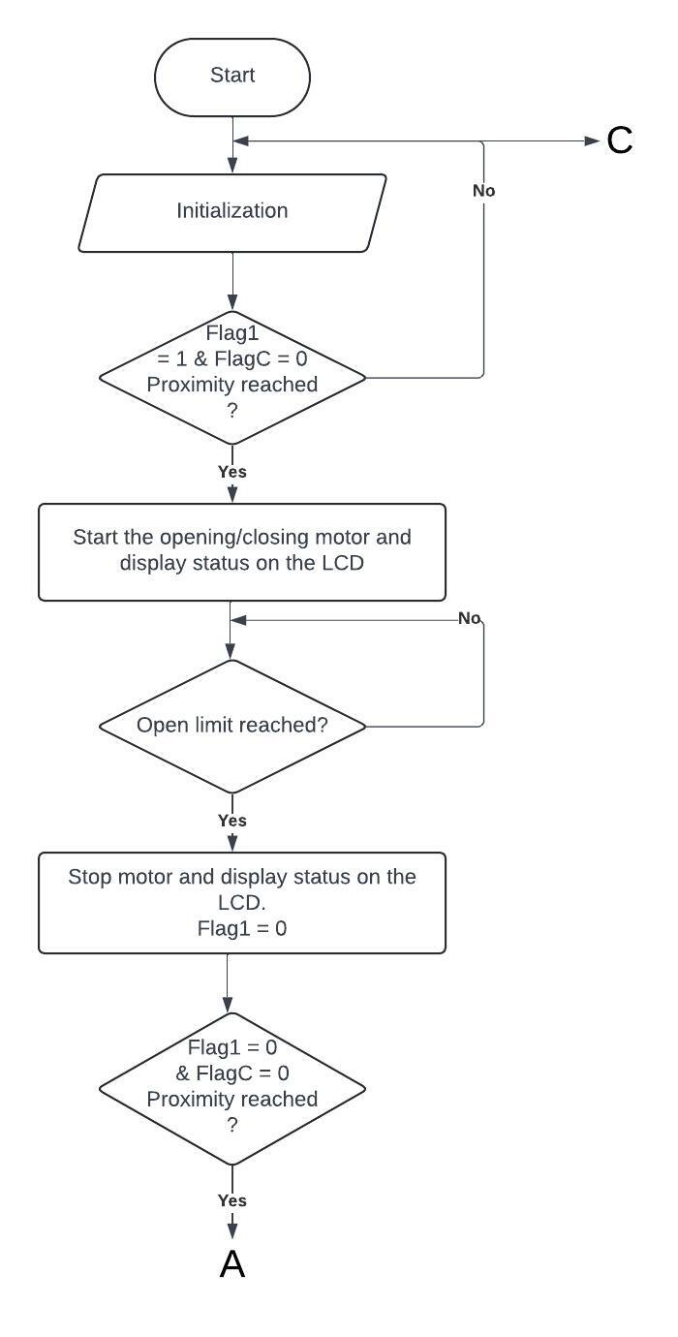
Figure 2: First Segment of the Flow Chart
Segment 2: Proximity Detection and Lid Control
This segment focuses on detecting a user’s approach and opening the bin lid automatically, providing a hands-free, hygienic waste disposal experience. This is shown in Figure 3.
Key Steps:
- Proximity Sensor Activation: The proximity sensors are continuously active and monitor the area around the bin. When the sensor detects an object or a user within the defined range (9 cm to 80 cm), it triggers the next step in the process.
- Lid Opening: Upon detecting a user, the Arduino Nano sends a signal to the motor driver to engage the motor and open the lid. The motor runs until the lid reaches the fully open position.
- Lid Open Monitoring: The system monitors the status of the lid to ensure that it is fully open. If the lid does not open correctly (due to obstructions or motor issues), the system can display an error message or take corrective action.
- Timeout for Lid Closure: The system waits for a predefined time after the user has disposed of waste. Once the user leaves the detection range of the proximity sensor, the system initiates the lid closure process.
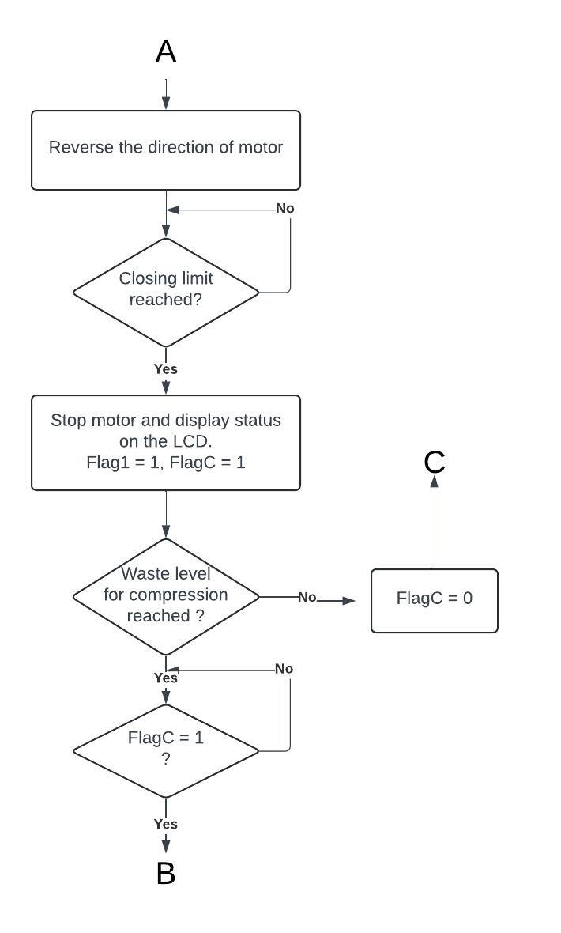
Figure 3: Second Segment of the Flow Chart
Segment 3: Waste Level Monitoring and Compaction
The third segment is responsible for monitoring the level of waste inside the bin. If the waste level reaches a preset threshold, the system triggers the compaction mechanism to compress the waste and create more space inside the bin as shown in Figure 4.
Key Steps:
- Activate Waste Height Sensor: After the lid has closed or during the waiting period when no users are nearby, the waste height sensor measures the level of waste inside the bin.
- Waste Level Check: The sensor data is processed by the Arduino Nano to determine whether the waste level has exceeded a predefined threshold (for example, when the waste reaches 70% of the bin’s capacity). If the waste level is below the threshold, the system returns to its default monitoring state.
- Compaction Trigger: If the waste level is above the threshold, the system activates the motor to engage the compaction mechanism. The motor drives a mechanical compactor that compresses the waste, reducing its volume.
- Compaction Completion: Once the compaction process is complete (based on a time limit or a sensor detecting the compactor's position), the system resets the compactor and returns to normal operation, ready for the next waste disposal event.
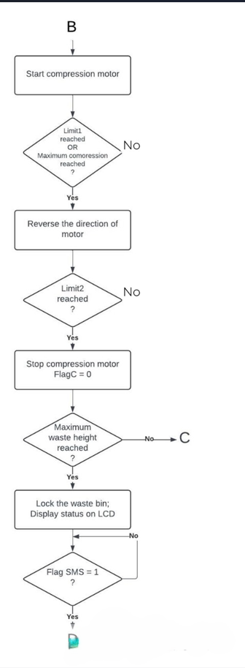
Figure 4: Third Segment of the Flow Chart
Segment 4: Notification and System Reset
This final segment is responsible for sending notifications when the bin is full or when there are system errors. After compaction, if the waste level still exceeds the threshold, the system sends a notification to waste management authorities to empty the bin. This is shown in Figure 5.
Key Steps:
- Check Waste Level Post-Compaction: After the compaction process, the system re-checks the waste height. If the waste level remains above the full threshold (for example, 95% capacity), the system proceeds to notify waste management teams.
- Send Notification via GSM: The Arduino Nano triggers the GSM module to send an SMS notification to a predefined number, such as waste management personnel. The message includes the bin’s status and location, indicating that the bin is full and needs emptying.
- Retry Mechanism: If the GSM message fails to send due to network issues, the system retries sending the message after a set interval. This ensures that even in areas with poor connectivity, the message eventually reaches the responsible parties.
- System Reset: Once the notification is sent, the system resets to a standby state, ready to repeat the entire process from proximity detection. It will also continue monitoring the waste level in case further compaction is needed.
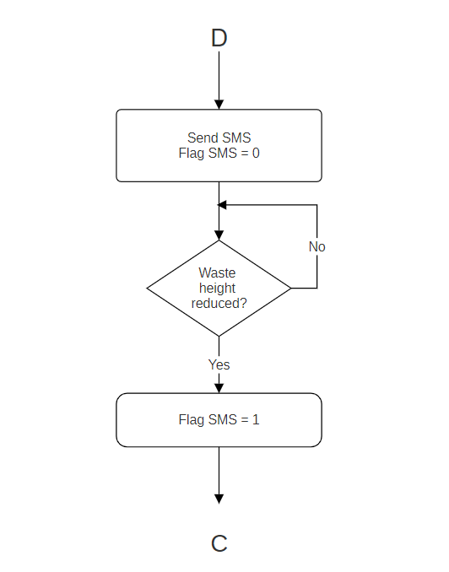
Figure 5: Fourth Segment of the Flow Chart

3.4 Components and Specifications
This section provides a comprehensive overview of the key components used in the design of the intelligent waste bin system. Each component has been carefully selected based on its role in achieving the system’s objectives, such as real-time monitoring, automated compaction, and GSM-based notifications. The system combines mechanical, electrical, and software elements to ensure efficient and reliable performance.

3.4.1 Arduino Nano
The Arduino Nano, shown in Figure 6, is the central microcontroller responsible for processing inputs from the sensors and managing outputs to the motor and GSM module. The Arduino Nano is an open-source platform known for its small form factor, making it ideal for compact systems like the smart waste bin. It is programmable using the Arduino IDE, and its flexibility allows easy integration of various sensors and actuators.
- Role: The Arduino Nano serves as the brain of the system, handling data from the sensors, executing the control logic, and triggering actions like lid opening, waste compaction, and GSM communication.
- Specifications:
  - Microcontroller: ATmega328P
  - Operating Voltage: 5V
  - Input Voltage (recommended): 7-12V
  - Digital I/O Pins: 22 (6 can be used as PWM outputs)
  - Analog Input Pins: 8
  - Clock Speed: 16 MHz
  - Flash Memory: 32 KB
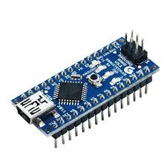
Figure 6: Arduino Nano

3.4.2 Proximity Sensors
The proximity sensors, shown in Figure 7, used in the smart waste bin are ultrasonic sensors that detect when a user or object approaches the bin. These sensors send out ultrasonic pulses and measure the time it takes for the pulse to bounce back after hitting an object. The Arduino Nano processes this data to determine if an object is within a preset range.
- Role: The proximity sensors detect the presence of a user approaching the bin. When an object is detected within the range of 9 cm to 80 cm, the system triggers the DC motor to open the bin's lid.
- Specifications:
  - Operating Voltage: 5V
  - Detection Range: 9 cm to 80 cm
  - Operating Frequency: 40 kHz
  - Measurement Accuracy: ±1 cm
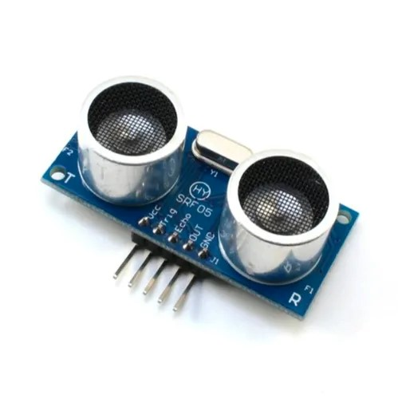
Figure 7: Proximity Sensor

3.4.3 Waste Height Measurement Sensor
The waste height sensor, shown in Fig 3.8, is also an ultrasonic sensor that monitors the level of waste inside the bin. It measures the distance from the sensor to the surface of the waste, allowing the system to calculate how full the bin is. When the waste reaches a certain height, the Arduino Nano activates the compaction mechanism.
- Role: The waste height sensor monitors the bin's waste level and triggers the compaction process when the waste reaches a predefined height.
- Specifications:
  - Operating Voltage: 5V
  - Detection Range: Up to 3 meters
  - Measurement Accuracy: ±1 cm
  - Operating Frequency: 40 kHz
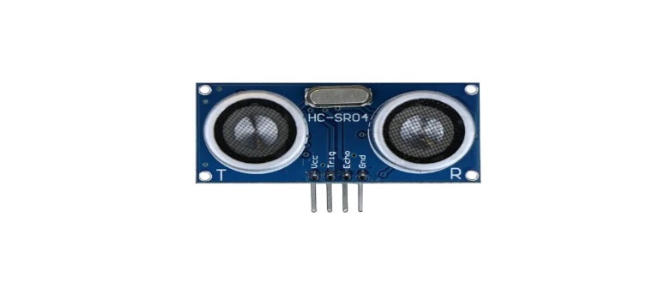
Figure 8: Waste Height Measurement Sensor

3.4.4 DC Motor
The DC motor, shown in Figure 9, powers both the automatic lid mechanism and the compaction system. A DC motor was selected due to its simple control, reliable performance, and the ability to drive mechanical systems efficiently. The motor is controlled by an H-Bridge motor driver, allowing it to run in both forward and reverse directions for opening the lid and compressing the waste.
- Role: The DC motor opens and closes the bin's lid and operates the compaction mechanism that compresses waste to maximize the bin’s capacity.
- Specifications:
  - Voltage: 12V
  - Torque: High-torque motor suitable for driving both lid and compaction mechanisms
  - Current: 1-2A (depending on load)
  - Speed: Adjustable through PWM control
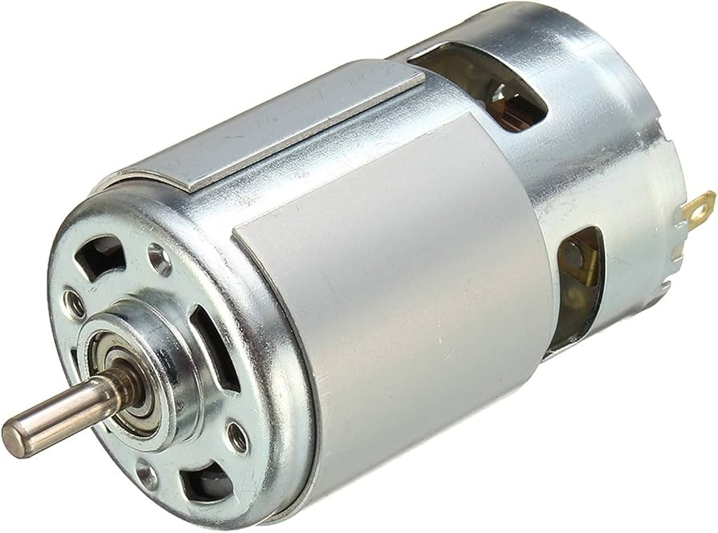
Figure 9: DC Motor

3.4.5 H-Bridge Motor Driver
The H-Bridge motor driver, shown in Fig 10, allows the Arduino Nano to control the direction and speed of the DC motor. This component enables the motor to operate in both forward (for opening the lid or compressing waste) and reverse directions (for closing the lid or resetting the compaction mechanism).
- Role: Controls the direction and speed of the DC motor for both lid movement and waste compaction.
- Specifications:
  - Voltage: 12V (for motor control)
  - Current Capacity: 2A (continuous), 3A (peak)
  - Control: Digital input from Arduino (PWM capable for speed control)

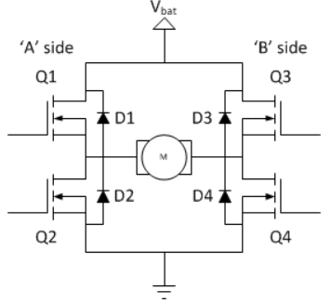
Figure 10: H-Bridge Circuit

3.4.6 GSM Module
The GSM module, shown in Figure 11, enables the smart waste bin to communicate with remote waste management teams by sending SMS notifications when the bin is full. It uses a SIM card to connect to the mobile network, allowing the system to notify the authorities in real time, ensuring timely waste collection.
- Role: Sends SMS notifications when the bin is full, ensuring that waste management teams are alerted for timely collection.
- Specifications:
  - Operating Voltage: 3.3V – 5V
  - GSM Frequencies: 850/900/1800/1900 MHz (Quad-band)
  - Data Rate: Supports GPRS for data transmission
  - SIM Card: Standard SIM card slot for mobile network access

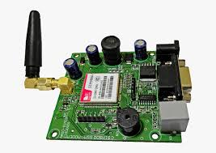
Figure 11: GSM Module

3.4.7 Liquid Crystal Display (LCD)
The LCD shown in Figure 12 is used to provide real-time feedback to the user, displaying information about the system’s status, such as whether the bin is open, closed, or full. It also provides data to waste management personnel on waste levels and system errors, improving user interaction and system transparency.
- Role: Displays system status and error messages for users and maintenance personnel.
- Specifications:
  - Display Type: 16x2 character LCD
  - Operating Voltage: 5V
  - Interface: I2C for easy communication with the Arduino Nano
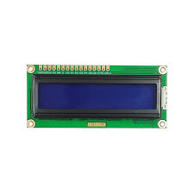
Figure 12: LCD
3.4.8 Buck Converter
The buck converter shown in Figure 13, steps down the 12V power supply used by the motor to 5V for the Arduino Nano, sensors, and GSM module. This allows the system to efficiently distribute power between components with different voltage requirements without overloading or damaging sensitive parts.
- Role: Converts the 12V power supply to 5V for the low-voltage components like the Arduino Nano, sensors, and GSM module.
- Specifications:
  - Input Voltage: 12V
  - Output Voltage: 5V
  - Current Rating: 2A

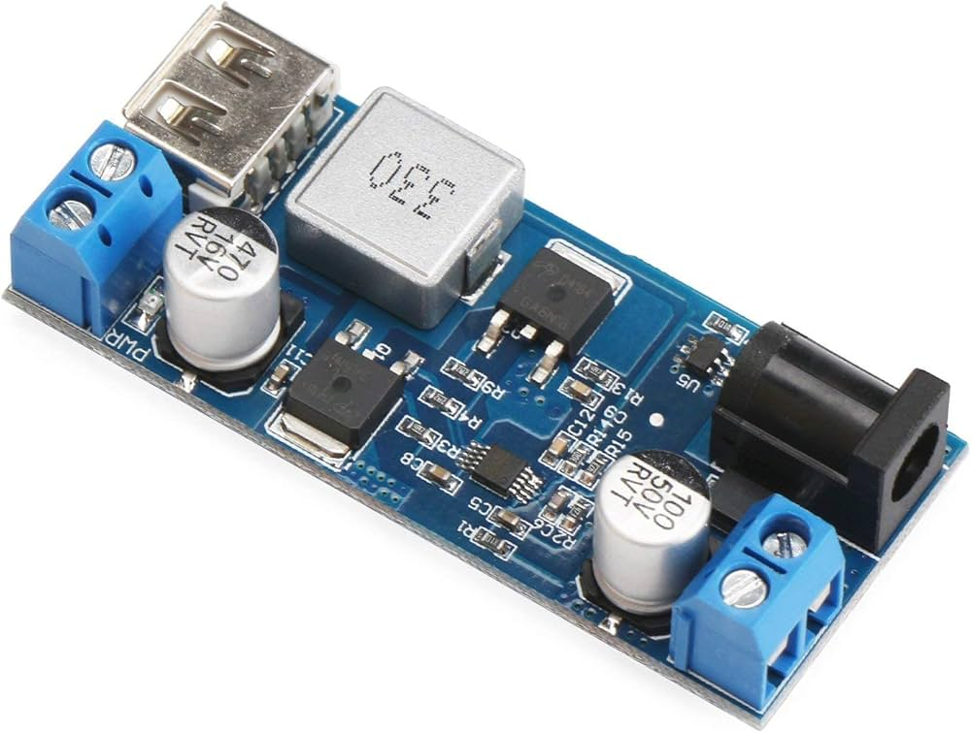
Figure 13: Buck Converter

3.4.9 Power Supply
The 12V power supply, shown in Figure 14, provides the necessary voltage for the high-power components, particularly the DC motor and GSM module. It was chosen to ensure the system can operate reliably under the load of the compaction mechanism and motorized lid.
- Role: Supplies power to the entire system, particularly the motor, sensors, and GSM module.
- Specifications:
  - Voltage: 12V
  - Current: 5A (sufficient for motor and GSM module)

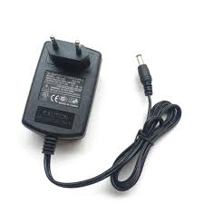
Figure 14: 12V Power Supply

3.4.10 Resistors and Capacitors
Resistors, shown in Figure 15, are used to limit current in various parts of the circuit to protect components like the LEDs and sensors from excessive current. Capacitors are added for voltage regulation and noise suppression, ensuring smooth operation of the sensors and microcontroller.
- Role: Resistors limit current to protect sensitive components, while capacitors provide voltage smoothing and noise reduction.
- Specifications:
  - Resistors: 220Ω, 1KΩ (depending on circuit requirements)
  - Capacitors: 10μF, 100μF (for noise suppression and voltage stabilization)
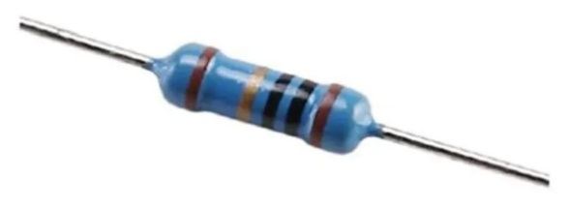
Figure 15: Resistor
- System Implementation
The system was implemented in units, each section of the system was implemented separately and tested so that once all the units have given the desired results, the sections are integrated to form the smart waste management system.
4.1 Implementing the Output Unit of the System
The output unit of the system in this project is the LCD display, this acts as the user interface between the user and the system as a whole, it displays the current status of the system and tells the user about the next phase of instruction that is being carried out by the controller. Figure 16 shows the circuit connection of the LCD display in the system.

Figure 16: Proteus Design of the System showing its LCD

4.2 Implementing the Sensing Unit
During the implementation of this unit, we tested the major components that make up the unit, which is the ultrasonic sensor controlled by the microcontroller. During the design of this work, the sensors were mounted both for distance and depth measurement at the front and inside facing downward respectively. Both sensors cannot function at the same time as a while loop was used in the coding of the microcontroller, which implies that no multiple actions can be performed at the same time. So the distance is first measured before the depth is measured by the system.
4.3 Implementing the SMS Sending unit using the GSM Module
The reaction of this unit was as a result of the low state assigned to the level sensor when the waste bin was filled up. The microcontroller sends a signal to activate the GSM module which is connected to its serial port. The GSM module sends a message across to waste authorities notifying them that the waste bin is filled and is ready for evacuation. The SMS message reads “ATTENTION THE WASTE BIN AT X-LOCATION IS FILLED AND NEEDS DISPOSAL.THANKS”. This message is embedded in the coding of the microcontroller.
4.4 Implementing the Power Unit.
This section being the part to power up the entire system to function as it should. This is an essential component of a smart waste bin system, as it provides the energy needed for the sensors, microcontrollers, DC motors and communication modules to function. The main item used in this section was the power jack and a bulk converter. A 12 volts power jack is a device that allows a smart waste bin to be plugged into an AC power source, such as a wall outlet or an extension cord. A power jack can be used to implement the power unit of a smart waste bin system, as long as the system has a compatible voltage and current rating, thus can provide a steady and reliable power supply to the smart waste bin. In this design, the microcontroller requires 5 volts for its operation; a photo-coupler is implemented to achieve a safe voltage for the microcontroller.
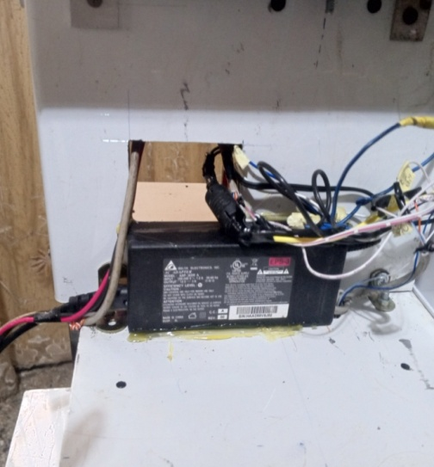2
Figure 17: Image of the Power Jack of the System

4.5 Implementing the compaction and opening and closing mechanism using DC motors
The compaction mechanism and opening and closing mechanism are controlled by DC motors connected to the pins of the microcontroller. Both sensors send the signal necessary for open and closing mechanism or compaction mechanism. The DC motors are fitted at the rear of the system for the opening and closing mechanism, while the compaction mechanism is achieved by a DC motor imbedded on a plate inside of the waste bin. Figure 18 shows the motor which control the opening and closing mechanism.
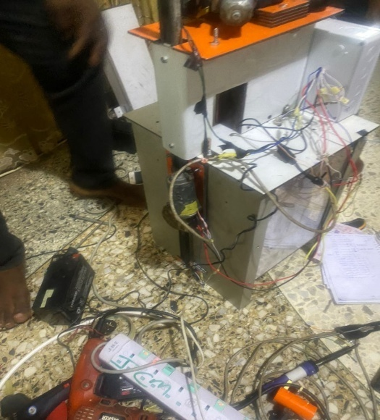
Figure 18: Image of the Opening and Closing Motor Mounted at the Rear of the Waste Bin
4.6 Assembling and Testing of the Project
The electronic components were soldered on a Vero board and placed inside an adaptable box after which the box was fitted to the ceramic waste container as shown fig 19 and the ATMEGA 328P was programmed using C++. The software logic includes reading data from the ultrasonic sensors for both proximity and level sensing and controlling the DC motors based on the fill proximity and level readings.
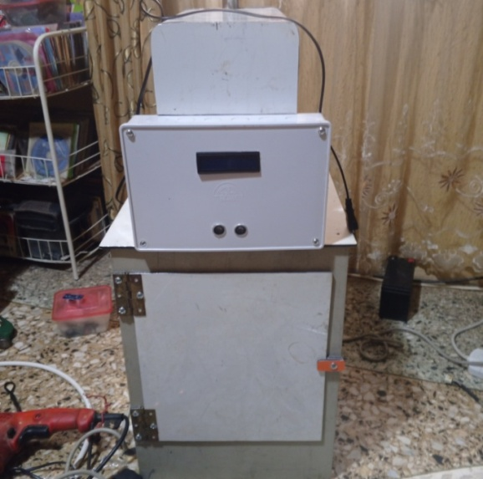
Figure 19: Adaptable Box Fitted on the Waste Container
4.7 System Testing.
Once the system units were integrated, an open circuit test was conducted to verify continuity of individual connections. After confirming continuity, a power supply test ensured that the power requirements for all branches were met, and the functionality of each sensor and component was evaluated. Testing was done incrementally; each application unit was assessed individually before proceeding to the next. The second unit was only tested once the first unit met the expected results and functioned as required. After all units were verified to be operational, they were assembled together, and the complete system was developed and tested. This approach made it easier to identify bugs and issues since the performance of each unit was understood during testing. If the system had been developed and tested only after completion, diagnosing problems would have been significantly more difficult.
4.8 Test Result and Performance of the System.
The aim of the project was to design and implement an intelligent waste management system with real time monitoring and automated compaction of waste and the goal was met. The microcontroller unit responds to the signals sent by the sensors according to what they sensed from the environment. The microcontroller also triggers the GSM module to send an SMS to the waste authorities anytime the waste is filled up. Below is a test result table of the system.
Table 1: Test Result Table of the Developed System
UNIT | MICROCONTROLLER ONGOING OPERATION | WASTE CONTAINER STATUS | OUTPUT OF THE SYSTEM AS DISPLAYED BY THE LCD PANEL
Motion sensing |  |  | System in operation
Motion sensing | Checking proximity of waste container | Not full | Opening for waste disposal then closing
Motion sensing | Checking proximity of waste container | Full | Closing of waste initiates
Level sensing | Check the fill level and Activating DC motor | Full | Compaction of waste initiates
Level sensing | Activating GSM module | Full | Container full check elsewhere
GSM module | SMS sending in progress | Full | Waiting for waste evacuation
Evacuation hatch | Lock waste bin | Full | waste evacuation
Level sensing | Activating sensor for opening mechanism | Empty

The Table 1 shows the processes of the system once plugged in and it detects motion, it operations will initialize. As a person approaches the waste bin at a distance of 80 centimeters the sensors send that information to the microcontroller which then send signal to the DC motor for the opening mechanism, after disposal, the bin will close when the person leaves. The level sensor is activated. If the bin is filled, the compaction process is activated by the microcontroller and after compaction is done, an SMS is sent when the bin can no longer compress waste via the GSM module. The bin is locked in a while loop in the code of the microcontroller.
Table 2: System Availability on Demand for the Electronic Waste Bin System
Number of trial (N) | Result
1 | Successful
2 | Successful
3 | Successful
4 | Successful
5 | Successful
6 | Successful
7 | Successful
8 | Successful
9 | Successful
10 | Successful

Table 2 shows the System availability on demand for the electronic waste bin system on ten (10) trials. The Table also confirms that the system responded successfully to all attempts for all of its operations that are shown in Table 1.

Table 3: Latency Experienced at Every Successful Waste Bin Opening
Number of trial (N) | Waste bin latency (sec) opening mechanism | Waste bin latency (sec) compaction mechanism
0 | 0 | 00
1 | 05 | 15
2 | 05 | 15
3 | 07 | 18
4 | 05 | 16
5 | 06 | 17
6 | 07 | 15
7 | 05 | 18
8 | 05 | 17
9 | 06 | 15
10 | 05 | 16
Total average | 5.6 | 15.8

From Table 3, it can be seen that latency of operation is a feasible wait time for operations of both opening and compaction where an average wait time of 5.6 seconds is optimal for an individual to wait for opening of the waste bin. And since no human influence is required, for compaction 15.8 seconds is an optimal time.
4.8.1 Performance Evaluation of the Real-time and Compaction Electronic Waste Bin System.
The developed waste real time and compaction system enhances waste management efficiency. This system employs a compaction mechanism that reduces the volume of waste, allowing for more effective use of space within the bin. During evaluation, its performance unlike that of traditional waste bins, which are widely available throughout the city show results revealing that the success rate, reflecting systems performance was comparable to that of existing bins. This indicates that, with the intelligent features and compaction capabilities, there was significant improvement in overall performance.
Key performance indicators for the environmental waste bin system include environmental safety and availability. The compaction mechanism plays a crucial role in environmental safety by minimizing overflow and reducing the frequency of waste collection, which in turn decreases vehicle emissions.

4.9 Challenges and Solutions
- Technical Challenges: Initial tests revealed issues with sensor accuracy in certain environmental conditions. This was resolved by recalibrating the sensors and implementing filtering algorithms to enhance data reliability.
- Speed and frequency of compaction was an issue because a high speed compaction could damage the mechanism if it encounters a very hard object, this was resolved by reducing the speed and the bin will only compact when there is waste as this saves power.
- Future Improvements: Future iterations of the project could explore the integration of additional sensors, such as temperature or humidity sensors, to provide more comprehensive data for waste management.
5. Conclusion
The development of an intelligent electronic waste bin with real-time monitoring and automated compaction represents a significant advancement in waste management technology. This system not only optimizes waste collection efficiency but also enhances sustainability by reducing the frequency of waste collection trips, thus lowering cost of waste management and improve efficiency. The integration of sensors for monitoring fill levels and compaction mechanisms allows for a proactive approach to waste management, enabling different towns, offices and areas to respond effectively to changing waste generation patterns.
References

[1] Abd Manaf L, Abu Samah MA, Mohd Zukki NI (2009). “Municipal solid waste management in Malaysia Practices and challenges”, 29[11] pp. 2902 – 2906.

[2] Thompson A, Afolayan A, Ibidunmoye E, (2013). “Application of Geographic Information System to Solid Waste Management”, Pan African International Conference on Information Science, Computing and Telecommunications Lusaka, Zambia: IEEE.

[3] Suma, B.V., Jyothi R K, Kavya M, Kavyashree K, Margaret Sheela C.; (2025), “IoT-Enabled Smart Dry Trash Bin with Wet Detection and Compaction”, International Journal of Engineering Research & Technology, Vol. 14, Issue 12, pp. 1 – 6.

[4] Jyoti Lamani, Ashwini Kolkar, Uday Bhajantri, Abhishek Nagannavar, Akshata Patted, and Supanna S. Shirguppe; (2022). ”Design and Fabrication of Low-Cost Solar Powered Trash Compactor for Smart Cities.” Department of Electrical and Electronics Engineering, SGBIT Belagavi, Karnataka, India.

[5] Bhuvaneswari.T, Hossen J.Amir Hamzah, N.Velrajkumar, P., and Jack, O. H. (2020). ”Internet of Things (IoT) Based Smart Garbage Monitoring System.” Indonesian Journal of Electrical Engineering and Computer Science, 20(2), pp. 736–743.

[6] Sandhya, Anjali N, and M. Prabhakar; (2023). ”Smart DustbinGarbage Segregation and Trash Level Indicator Using IoT.” International Scientific Journal of Engineering and Management, vol. 2, no. 4.

[7] Abba, S., and Ihechukwu, C. (2020). ”IoT-Based Framework for Smart Waste Monitoring and Control System: A Case Study for Smart Cities.” Presented at the 7th Electronic Conference on Sensors and Applications. Available online: https://ecsa7.sciforum.net/

[8] T. O'Connor and J. Lawson, (2021), "Smart Waste Management Technologies: An Overview of Current Trends and Future Directions," Int. J. Waste Manage., vol. 45, no. 2, pp. 65-80.

[9] R. James and S. Patel, (2020), "Integrating IoT and Cloud-Based Technologies for Smart Waste Management," J. Environ. Technol., Vol. 33, Iss. 3, pp. 112-123.

[10] Y. Wang and M. Li, (2022), "Sustainable Waste Management Through IoT and Automation," J. Waste Disposal Recycle., vol. 30, no. 4, pp. 253-267.

[11] G. Martin and L. Xu, (2019), "Automation in Urban Waste Management Systems: A Review," Waste Technol. Rev., vol. 29, no. 1, pp. 98-110.
[12] R. Gupta, E. Ahmed, and S. Kumar, "RFID-Based Smart Waste Management System," Int. J. Waste Disposal Recycl., vol. 20, no. 1, pp. 15-30, 2022. doi: 10.1177/0734242X20972250.
[13] M. Wilson, N. Zhang, and D. Taylor, "Wireless Sensor Network for Smart Waste Monitoring," J. Environ. Technol., vol. 33, no. 2, pp. 210-222, 2022. doi: 10.1080/10643389.2022.1716042.
[14] G. Roberts, K. Lee, and T. Smith, "Internet of Things for Urban Waste Management," Int. J. Waste Technol., vol. 29, no. 1, pp. 112-128, 2023. doi: 10.1080/09593330.2023.1653767.
[15] J. Hughes, S. Patel, and C. Miller, "Smart Bin Network with Remote Waste Monitoring," Int. J. Waste Manage., vol. 38, no. 2, pp. 55-68, 2022. doi: 10.1016/j.wm.2022.01.004.
[16] H. Shah, V. Joshi, and P. Nair, "IoT-Based Waste Management System for Remote Monitoring," J. Environ. Technol., vol. 33, no. 3, pp. 95-110, 2023. doi: 10.1080/10643389.2023.1716041.
[17] L. Martin, A. Thomas, and P. Jones, "Cloud-Connected Smart Waste Bins for Urban Waste Management," Int. J. Waste Disposal Recycl., vol. 14, no. 2, pp. 123-138, 2023. doi: 10.1177/0734242X20972252.
[18] J. Smith, A. Brown, and L. Green, "Real-Time Waste Level Monitoring System Using IoT," Int. J. Waste Manage., vol. 38, no. 2, pp. 75-89, 2023. doi: 10.1016/j.wm.2023.01.001.
[19] P. Johnson, M. Lee, and R. Clark, "IoT-Enabled Waste Monitoring System for Public Spaces," J. Environ. Technol., vol. 33, no. 3, pp. 123-138, 2022. doi: 10.1080/10643389.2022.1716040.
[20] S. Patel, T. Das, and V. Singh, "Smart Waste Bin with IoT and Cloud Integration for Urban Areas," Int. J. Sustain. Waste Manage., vol. 14, no. 3, pp. 45-56, 2023. doi: 10.1080/21699073.2023.1817208.

