Optimization of improved biodiesel production from used cooking oil and soyabean oil blend using NaOH and CH₃ONa as homogeneous catalyst via ethanolysis

Abstract:
An eco-friendly fatty acid ethyl ester (FAEEs) production has gained significant interest as a cleaner energy pathway that can reduce the environmental pollution associated with conventional fossil fuel. In this context, the present study aims to investigate an optimized approach for improved biodiesel production from a blended feedstock of used cooking oil (UCO) and soybean oil via ethanol-based transesterification. The utilization of UCO provides an effective pathway for waste valorization and cost reduction, while soybean oil contributes to improved reaction stability. Ethanol was utilized as a renewable, bio-sourced solvent to ensure a greener production process, generating improved biodiesel (FAEEs) with superior fuel properties such as higher cetane numbers, elevated flash points (safer handling), enhanced lubricity and better cold flow behavior. Two homogeneous catalysts, sodium hydroxides (NaOH) and sodium methoxide (CH₃ONa) were employed to evaluate their catalytic performance. The transesterification process was being systematically optimized by varying key reaction parameters. The biodiesel with the best properties was obtained using ethanol to oil molar ratio (12:1), catalyst loading (0.75 wt%), reaction temperature (60 ℃) and reaction time (50 min), favor maximum biodiesel (FAEEs) yield (90.4 %). Overall, this study is expected to demonstrate an efficiency and sustainable pathway for improved biodiesel production using a combined waste and edible oil system.

Keyword: Biodiesel, Used cooking oil, Soyabean oil blend, Ethanolysis, Ethyl ester, Optimization.
1. Introduction:
The escalating global energy crisis, driven by industrialization and population growth has led to a significant depletion of finite fossil fuel resources [1,2]. The combustion of traditional petroleum diesel is a primary contributor to greenhouse gas emissions and environmental degradation, promoting an urgent search for sustainable, renewable and eco-friendly energy alternatives [3,4]. Biodiesel chemically defined as fatty acid alkyl esters, has emerged as a prominent competitor to fossil fuels due to its biodegradability, non-toxicity and lower emission profile of pollutants like carbon monoxide and sulfur dioxides [5]. A critical challenge in the widespread adoption of biodiesel is the high cost of raw materials, which can account for up to 70-85% of total production expenses [6]. While edible oils such as soybean oil are efficient feedstocks, their use for fuel production often sparks “food versus fuel” debates and impacts food security [7,8]. Used cooking oil (UCO) presents a sustainable and economical alternative by utilizing byproducts and lowering environmental pollution [9]. Recent studies have highlighted the significance of leveraging feedstocks combinations through blending to optimize fuel properties, capitalize on synergistic effects and maintain engine performance while reducing cost [5,10]. The conversion of these oils into biodiesel is primarily achieved through transesterification, a process influenced by factors such as the type of alcohol and catalyst used [11].
Methanol remains the predominant alcohol utilized in biodiesel synthesis, primarily attributed to its widespread availability and economic viability. Nevertheless, the transesterification of triglycerides derived from vegetable oils and animal fats can alternatively be performed with other volatile alcohols, especially ethanol. This process, termed ethanolysis, resulting fatty acid ethyl esters (FAEEs), which are increasingly recognized as a sustainable form of biodiesel [12,13]. The choice of catalyst is equally essential; sodium hydroxide (NaOH) is widely used for its high reaction rate and availability [9]. However, sodium methoxide is anhydrous (water free), thus using it directly in methanol or ethanol solution minimize the saponification (less of the conversion of fat/oils is wasted converting into soap). Less soap means cleaner fuel, less waste and improved biofuels [14]. Sodium methoxide (CH₃ONa) offers potential advantage, including higher tolerance to free fatty acids and a reduction in soap formation, which can otherwise complication the purification process [13,14].
In the recent years, both the methanolysis and ethanolysis of vegetable oils with homogeneous basic catalysts have been widely investigated [15,16]. Much of the existing studies are devoted to the investigation and optimization of the main operating variables, namely the initial alcohol-to-oil molar ratio, type and concentration of the catalyst and reaction temperature for a variety of vegetable oils, including waste (used) cooking oils. Whereas there is almost general agreement about the influence of the operating parameters on the methanolysis reaction, this is not the case for the ethanolysis whose results show greater discrepancies among the published results [17,18]. As a renewable and less harmful reactant derived from local agricultural biomass, ethanol (bio ethanol) ensures that the resulting FAEEs are of 100 % biological origin promoting energy independence. These ethyl esters exhibit superior fuel characteristics over traditional methyl esters, including higher cetane numbers, improved cold-flow behavior in temperate climates and enhanced safety during handling due to increase flash points. While technical hurdles such as water sensitivity and complex phase separation persist, FAEEs offer a more sustainable profile through significant reduced exhaust emissions and better aquatic biodegradability compared to petroleum-based fuels [19].
Despite extensive research on single feedstock biodiesel, there is a remaining gap in the systematic comparative study and optimization of blends derived specifically from used (waste) cooking oil and soybean oil using different base catalysts during ethanolysis [20]. The efficiency and biodiesel (FAEEs) yield for UCO and soybean oil blend is highly dependent to the optimization of various reaction variables such as ethanol/oil molar ratio, catalyst concentration/type, temperature, agitation rate and reaction time. One study evaluated UCO for biodiesel for biodiesel synthesis through an optimized transesterification process using methanol to oil molar ratio 6:1, NaOH catalyst loading 1 wt%, reaction temperature 60 ℃ and reaction time 90 min, achieving maximum biodiesel yield of 85% [21]. Another investigation reported a maximum biodiesel yield 92% from a blend of algae oil and WCO (1:40) using 1.5 wt% NaOH catalyst, alcohol to oil ratio of 12:1, reaction temperature 50 ℃ and reaction time of 100 min [22]. In addition, biodiesel from used vegetable oil using ethanol and sodium methoxide was carried out a concentration of 4:100 (v/v %), ethanol to oil ratio 35:100 (v/v %), with reaction temp 65 ℃ and time 75 min, resulting in 84% fatty acid ethyl ester (FAEEs) and 16% fatty acid methyl ester (FAMEs) yield [23].
This study aims to evaluate the effect of NaOH and CH₃ONa on the physicochemical properties (e.g., density, viscosity, cloud and pour point, calorific value) and yield of improved biodiesel (FAEEs) produced from a UCO-soybean oil blend [3]. This research seeks to identify the ideal reaction parameters including catalyst concentration, ethanol to oil molar ratio, reaction temperature and reaction time to improve the fuel quality and ensure the ASTM standard [8]. The proposed study also aims to contribute to renewable energy development while simultaneously addressing waste management challenges, offering strong potential for environmentally and economically viable fuel production.
2. Materials and methods
2.1 Chemicals
The chemicals for this study such as ethanol (Germany), n-hexane (India), sodium hydroxide (Germany), sodium methoxide powder (Mumbai, India), potassium hydroxide pellets (Mumbai, India) sulfuric acid 98% (Merck, Germany), hydrochloric acid 37% (Merck, Germany), phenolphthalein (Merck, Germany), methyl orange was high analytical grade from Merck (Germany).
2.2 Sample collection and pretreatment
The used cooking oil (UCO) was collected from local restaurants, fried chicken sellers, while the refined soybean oil was produced from a local grocery shop. To remove food residues and moisture, the UCO was filtered and pre-heated. The oils will then be blended in a specific ratio (e.g., 50:50 v/v) to create a consistent feedstock for the transesterification process.
2.3 Acid pretreatment and transesterification of oil blend
2.3.1 Physicochemical analysis of oil blend
The initial properties of UCO-soybean oil blend such as density, free fatty acid (FFA) value, saponification value was determined following the standard methods of the American Oil Chemists Society (AOCS). If the FFA value of the blend is found to be greater than 1% a two-step process acid catalyzed esterification followed by base-catalyzed transesterification must have employed to prevent soap formation. The esterification was conducted by using sulfuric acid as catalyst and free fatty acid content was reduced significantly by reaction of oil with an acidified ethyl alcohol.
2.3.2 Acid-catalyzed esterification (Pre-treatment)
Ideally for the base catalyzed transesterification, the FFA value of the feedstock oil should be less than 1.0%. To reduce high FFA levels, the oil blend was reacted with ethanol and a small amount of sulfuric acid (H₂SO₄) as a acid catalyst. The reaction was conducted in a reactor at a specific temperature (e.g., 60- 65 ℃) for approximately 60 minutes until the FFA content drops less than 1%. The FFA value of the acid pretreated UCO and soybean oil blend was determined again and found to be 0.845%.
The acid value (A.V.) of the blend oil was determined by 1 gm UCO and 1 gm soyabean oil mixed vigorously into 20 ml ethanol and added 2-3 drops phenolphthalein indicator in it and titrated with 0.1N KOH solution. The samples A.V. is measured by following equation,
Acid value (%) = $\frac{V × N × 56.10}{W (g)}$
Where V is KOH volume (ml) used for titration, N is normality (mol/L) of KOH, 56.10 is the molecular weight (g/mol) of KOH. The sample FFA percentage is one-half of the corresponding AV. Thus, AV was halved to obtain FFA content of the sample. FFA is determined by following equation:
FFA = $\frac{Acid value}{1.99}$
The acid value of the blended oil (UCO and soybean oil) is 1.683 mg KOH/g and the FFA value is obtained 0.845%. Acid-catalyzed esterification was omitted in this study because the FFA value of the blend was already significantly low (0.845%), meeting the condition for direct alkaline-catalyzed transesterification.
2.4 Optimization of transesterification (ethanolysis) parameter
Transesterification is a chemical process used to transform triglycerides from renewable sources, such as vegetable oils/oil blends or animal fats into fatty acid ethyl esters (FAEEs) commonly known as biodiesel. This reaction involves reacting oil with a short-chain alcohol (methanol/ethanol) in the presence of catalyst to accelerate the reaction rate. Technically a multistep equilibrium reaction where the triglycerides are successively converted into diglycerides and monoglycerides, ultimately producing glycerol as a by-product. At each stage of this chemical conversion, one mole of alkyl ester is released.
In this study, the blended oil was allowed to undergo transesterification using alkaline catalyst to synthesize fatty acid ethyl ester (FAEEs) (Figure 1). In order to appraise the influence of different kinds of catalyst, two catalysts i.e., sodium hydroxide (NaOH) and sodium methoxide (CH₃ONa) were selected for this study. The catalyst giving highest biodiesel yield was preferred for optimizing other reaction parameters. Additionally, the effect of catalyst concentration was assessed by using 0.3%. 0.50%, 0.75%, 0.87% and 1.0% per wt % of the oil. The influence of temperature at various time was observed from 40 ℃ to 60 ℃. To maximize FAEE yield, 50 gm of preheated oil was reacted with optimized amounts of NaOH and CH₃ONa catalyst dissolved in ethanol. The study also optimized the ethanol to oil molar ratios (6:1, 9:1 and 12:1 v/v) and reaction temperatures. Experiments were conducted on a heating hot plate with a consistent stirring intensity such as 400 rpm. The ethanolysis reaction is as follow:
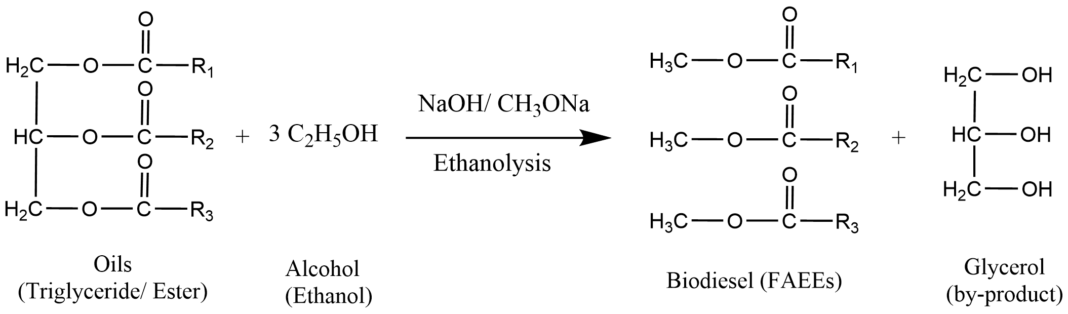
Figure 1. Transesterification reaction using NaOH/CH₃ONa catalysts via ethanol
2.5 Production of biodiesel
Ethanolysis reaction was conducted in 500 ml reactor consisting three neck round bottom flasks fitted with a condenser in the central neck and a thermometer and magnetic stirrer at the side necks. In this experiment 100 g pre heated blended oil was reacted with ethanol (6:1 ethanol/oil molar ratio) and treated with optimum amount of catalyst (NaOH and CH₃ONa) in the reaction with optimized conditions such as alcohol to oil molar ratio 6:1, temperature of 60 ℃, catalyst concentration 1.0%, reaction time 60 min, stirring speed of 400 rpm. After completion of the reaction, the flask was allowed to cool down and shifted into a separatory funnel for phase separation. As such two layers, upper is thin layer of biodiesel and lower thick layer of glycerin were obtained. Some of the soapy materials and unreacted ethanol and traces of catalyst were deemed to present in the upper biodiesel layer. Hence, the upper layer of FAEEs were collected and further purified by washing it with warmed distilled water. After filtration with a filter paper, the final FAEEs (Figure 2) product was heated over 105 ℃ to remove water content. Finally, the yield of biodiesel was determined by using following the formula: | 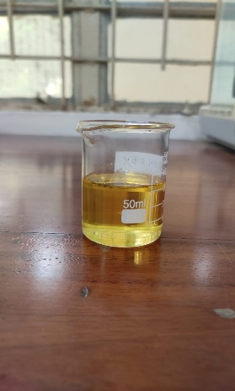
 | Figure 2. FAEEs (Biodiesel)

FAEEs/biodiesel yield = $\frac{amount of ethyl ester synthesized}{amount of oil used}$× 100

2.6 Experimental Procedure
The synthesis of improved biodiesel (FAEEs) was performed through a systematic ethanol-based transesterification of UCO-soybean oil blend. The successive experimental steps, encompassing the reaction setup, phase separation and final purification process are outlined in the flowchart (Figure 3):

Figure 3. Experimental flowchart of FAEEs production from blended oils
2.7 Characterization of biodiesel/FAEEs
The quality of FAEEs (biodiesel) is comparison with UCO and soybean oil was evaluated by recording their furrier transform infrared (FTIR) spectroscopy (Figure 8). Different absorption peaks recorded in FT-IR spectra were used for the group identification.
2.8 Analytical Methods for fuel characterization tests
2.8.1 Density
Density is defined as the mass of a substance per unit volume, though the scientific community frequently employs the dimensionless term specific gravity to describe the ratio of a liquid’s density relative to a reference medium, most commonly water [24]. The density of FAEEs was checked through an analyzer following ASTM D4052 (digital density meter) standard. For the characterization of biofuels, these parameters are typically measured at room temperature (25 ℃) using standardized protocol and following this formula:
Density, ρ = $\frac{m}{v}$
Here’s m = mass of oil (g) and v = volume of oil (ml)
Density is crucial for academic publication because it dictates the volumetric mass flow into the engine’s combustion chamber [25].
2.8.2 Flash point
Flash point is the lowest temperature at which a volatile material can vaporize to form an ignitable, applying an external ignition source (i.e., a spark or flame). It serves as a critical indicator of the overall flammability hazard of a fuel when exposed to the atmosphere [26]. The presence of non-volatile FAEEs results in a substantially higher flash point for biodiesel compared to petroleum diesel, despite their overlapping boiling points. The flash point of blended oil base biodiesel was measured with Pensky Marten Closed Cup apparatus and justified with ASTM D93 standards. The thermal stability of biodiesel is governed by stringent global protocols, while the American ASTM D6751 standard mandates a minimum threshold of 130 ℃, the European EN 14214 requires at least 101 ℃. Alkyl esters derived from non-edible feedstocks exhibit a flash point that considerably exceeds that of petroleum-based diesel reinforcing its status as a safer alternative for high-temperature handling and distribution [27].
2.8.3 Cloud and Pour point
Cloud and pour point are the critical parameters that define the cold-flow characteristics of biodiesel, which are essential for ensuring reliable engine performance in cold temperature. Could point (CP) identifies the thermal threshold at which wax crystal begin to participate, potentially causing terminal blockages in fuel filters and delivery lines. Pour point (PP) indicates the temperature at which the fuel loses its mobility [28]. The cloud and pour point determination of biodiesel was measured through ASTM D2500 and ASTM D97 method respectively via cloud and pour point apparatus. During the cloud point measurement, a sample of biodiesel gradually cooled in a glass beaker. The process monitors and note down the temperature at which the first starts to appear cloudy. This cloudiness indicates that wax crystals have begun to precipitate. One the other side the pour point measurement identifies the absolute limit of the fuel’s ability to be pumped or moved. The fuel sample continues to be cooled beyond the cloud point and observes the temperature at which the liquid losses its fluidity. This is the point at which the fuel has effectively gelled form.
2.8.4 Kinematic Viscosity
Kinematic viscosity represents a liquid’s inherent resistance to flow and internal molecular friction. In the evaluation of biodiesel properties, this parameter is a critical significance as it justifies the chemical conversion of raw oils into esters; unprocessed feedstocks are typically ten to seventeen times more viscous than biodiesel. For that, it can lead to detrimental effects such as poor fuel atomization, injector malfunction and incomplete combustion. The experimental quantification of viscosity is typically conducted at a controlled temperature of 40 ℃ using precision instruments such as the Canon-Fenske viscometer tube or the Redwood viscometer. This empirical process involved monitoring the efflux time the interval for a set quantity of fuel to migrate through a standardized capillary tube and subsequently multiplying this value by the instrument’s specific constant at 40 ℃. To ensure the fuel’s operational reliability and compliance with international benchmarks, the measurement adheres the ASTM D445 strategy, which specifies a range of 1.9 to 6.0 mm²/s or the EN ISO 3104 standard with a tighter limit of 3.5-5.0 mm²/s [29]. The mathematical expression used to determine the kinematic viscosity are as follows:
Kinematic viscosity (mm²/s) = Calibration constant (mm² / s²) × Mean efflux time (s) [25]

2.8.5 Cetane Number
The cetane number (CN) serves as a pivotal unitless index that quantifies the auto ignition capacity of a fuel which is especially vital for ensuring efficient engine activation during low temperature conditions. The fatty acid architecture of the main feedstocks significantly dictates the cetane number of the resulting biodiesel esters. As a measure of ignition quality, a superior CN correlates with a condensed induction period, effectively minimizing the latency between fuel delivery and the onset of combustion. According to international benchmark such as ASTM D6751 (USA) and EN 14214, biodiesel must maintain a minimum CN of 47 to 51, significantly exceeding the baseline of 40 required for conventional petroleum diesel [30]. This high cetane number, often attributed to the substantial oxygen content within the alkyl esters, facilitates a more steadier burning process and reduce acoustic vibrations (knocking) within the combustion chamber. Furthermore, while an increased degree of unsaturation tends to depress the CN, the overall superior ignitibility of biodiesel ensures cleaner oxidation and enhanced operational reliability.

3. Results and discussion
3.1 physico-chemical characterization of biodiesel
The physico-chemical characteristics i.e., density, FFA content of UCO and soybean oil was estimated and the results can be seen in Table 1. Each property was investigated by assuming all the experiments three times as standard deviation of the average values. The estimated density of UCO is 0.90 g/ml and soybean oil density is 0.916-0.927 g/ml, which is comparable with the value of reported literature (Namwong, S., & Pusnsuvon, V. (2016)) for other common feedstocks such as Jatropha oil (0.91 g/ml) and sunflower oil (0.91 g/ml) [31,32]. These findings align with previous studies where the density of used vegetable oil was recorded at approximately 908.9 kg/m³ (0.9089 g/ml) and 0.916 g/cm³ [23,33]. Additionally reported densities for various waste cooking oil samples and their blends generally fall within the range of 901.01 kg/m³ to 919 kg/m³ [22,34].
The FFA value of UCO was estimated to be 0.84 %, which is mostly compatible with the previously reported value of 0.51% and vegetable oil was obtained 1.69% (as oleic acid) noted also consistent with other used vegetable (1.8%) and cooking oil studies [23]. The iodine value was noted for the soyabean oil and UCO and the iodine value of the blended oil g I₂/100g, which is aligns well with the reported range of 83 to 112.2 g I₂/100g for similar waste oils and 118.40 g I₂/100g for microalgae and waste cooking oil (WCO) blends [32]. The saponification value such as 207 mg KOH/g for WCO and 220-223 mg KOH/g range reported for high and low acid value blends [35].
It can be noted that FFA content of waste oil blend is to be suitable for transesterification reaction with alkali catalyst with ethanol. Technically, a vegetable oil with FFA value less than 1.0 % is preferred for base catalyzed transesterification. A higher FFA value of feedstock oils leads to decrease the yield of biodiesel during transesterification as this adversely affects the formation and separation of fatty acid ethyl esters (FAEEs) due to soap formation.

Table 1 Physicochemical characteristics of UCO and soybean oil blend
S. No. | Parameters | Results
01 | Colour | Brownish Yellow
02 | Odour | Oily smell
03 | Density (g/cm³) | 0.94
04 | Free fatty acid value (mg KOH/ g) | 0.845

3.2 Optimization of transesterification reaction parameters
3.2.1 Optimization of catalyst types/concentration
The experiments were run at different concentration of NaOH and CH₃ONa concentration from 0.3%, 0.5%, 0.75% and 0.87% of blended oil 1.0% (wt%) maintaining of ethanol to oil molar ratio (6:1), reaction time (60 min), agitation speed 400 rpm and reaction temperature 60 ℃ (Figure 4(a)). The transesterification rate was examined continuously at different times by varying the concentration of homogeneous catalyst and keeping other parameters constant. It can be noted that maximum yield of FAEEs is achieved at 89.38 % using NaOH catalyst and 89.98% for CH₃ONa, and catalyst concentration were achieved at 0.75%. However, as the catalyst concentration was increased beyond the optimum level, the biodiesel yield declined due to saponification and subsequent challenges in the purification stage (Figure 4(b)).
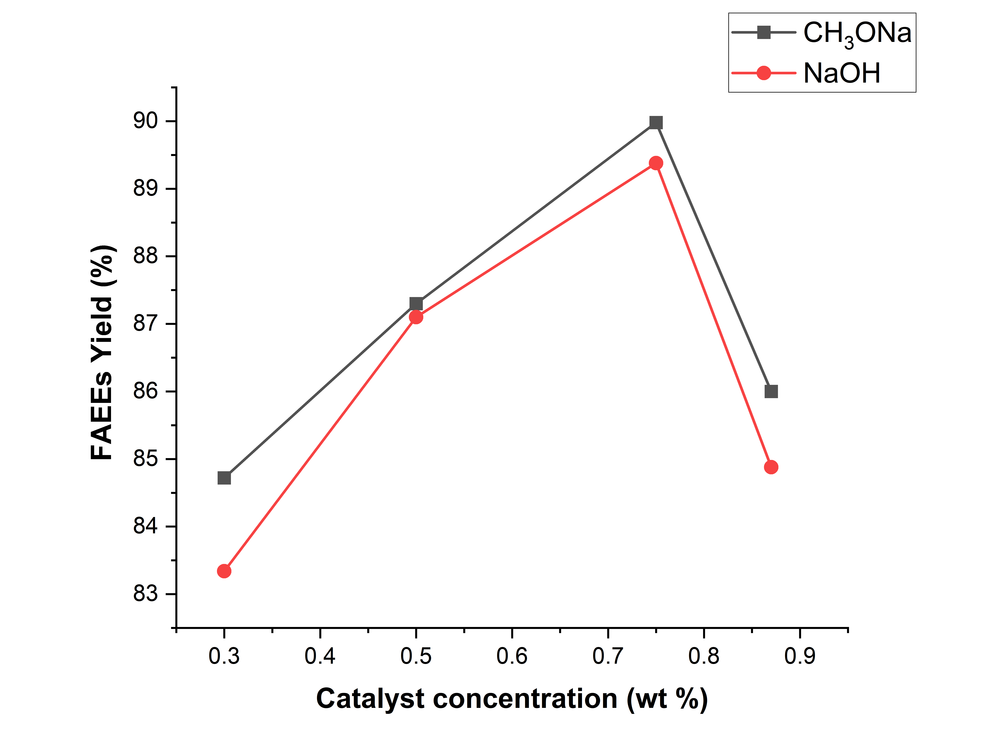 | 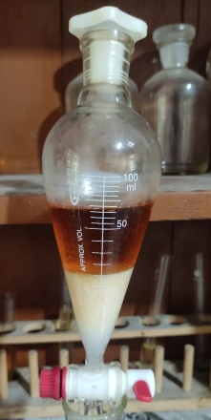
Figure 4(a). Influence of catalyst concentration (wt%) on biodiesel yield and reaction stability | Figure 4(b). Visual observation of soap formation at 1.0 wt% catalyst concentration during washing

3.2.2 Optimization of alcohol to oil molar ratio
The percentage yield of FAEEs was significantly influenced by varying the ethanol to oil ratio. In this work, three experiments were performed at various molar ratios of alcohol to oil 6:1, 9:1 and 12:1 by taking all others variables constant (0.75 % catalyst concentration, 60℃ temperature, reaction time 60 min and stirrer speed 400 rpm). The percentage yield of FAEEs during specific intervals of time was calculated for various molar ratios and yield was noted up to molar ratio of 12:1. However, further increase resulted in a slight decrease in yield owning to excess unreacted alcohol in biodiesel which cause the separation of biodiesel and glycerol difficulty.

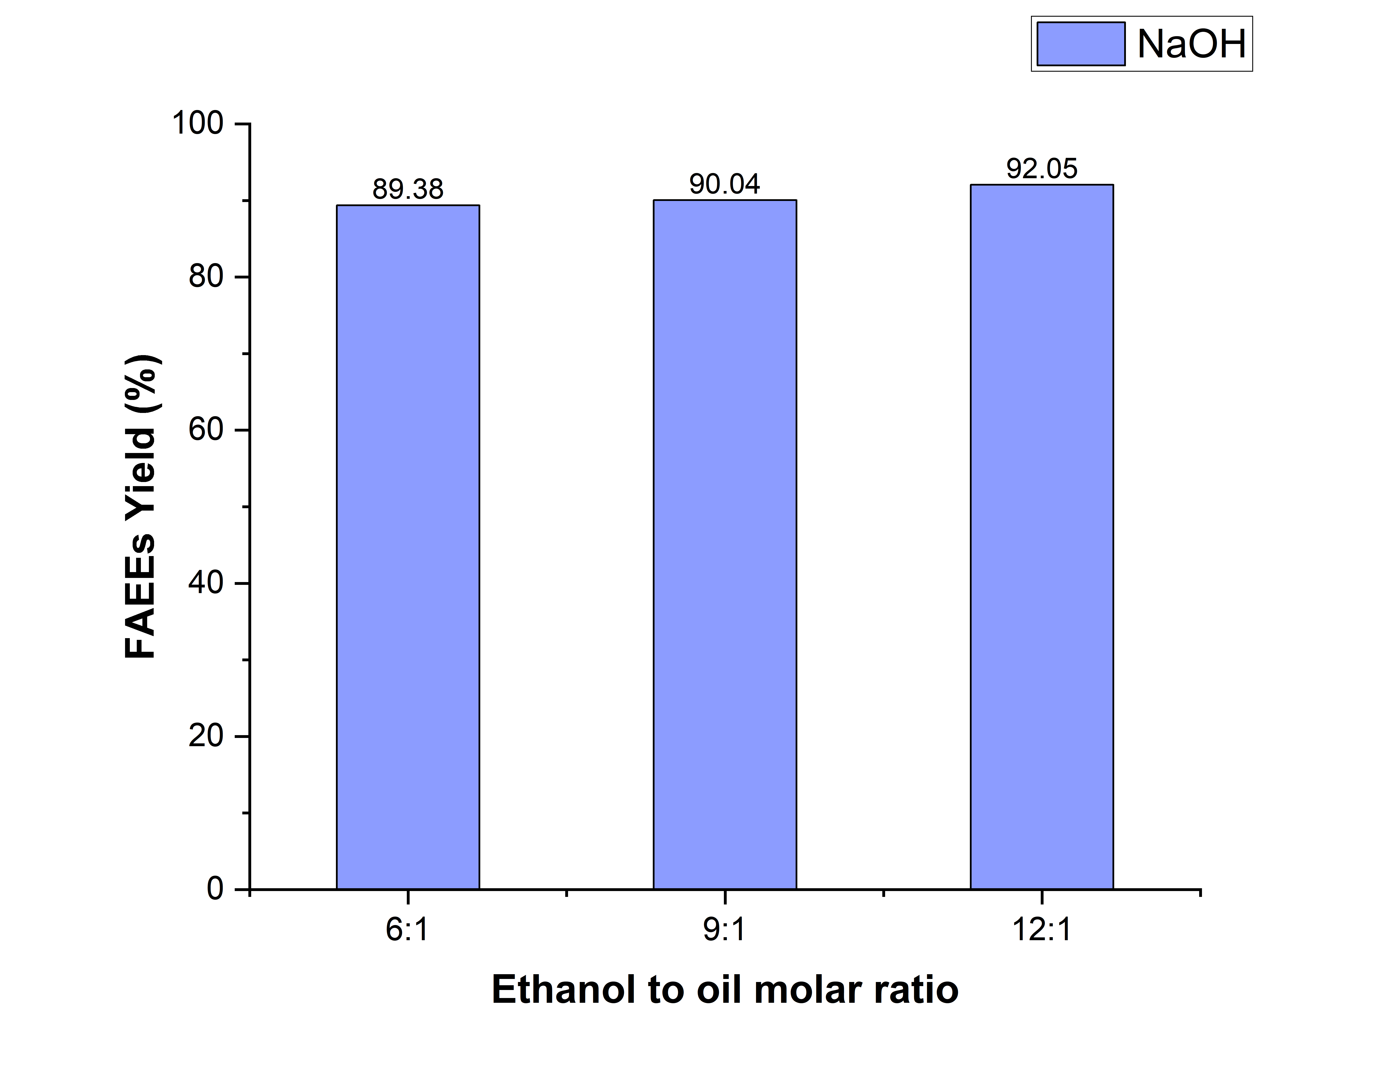 | 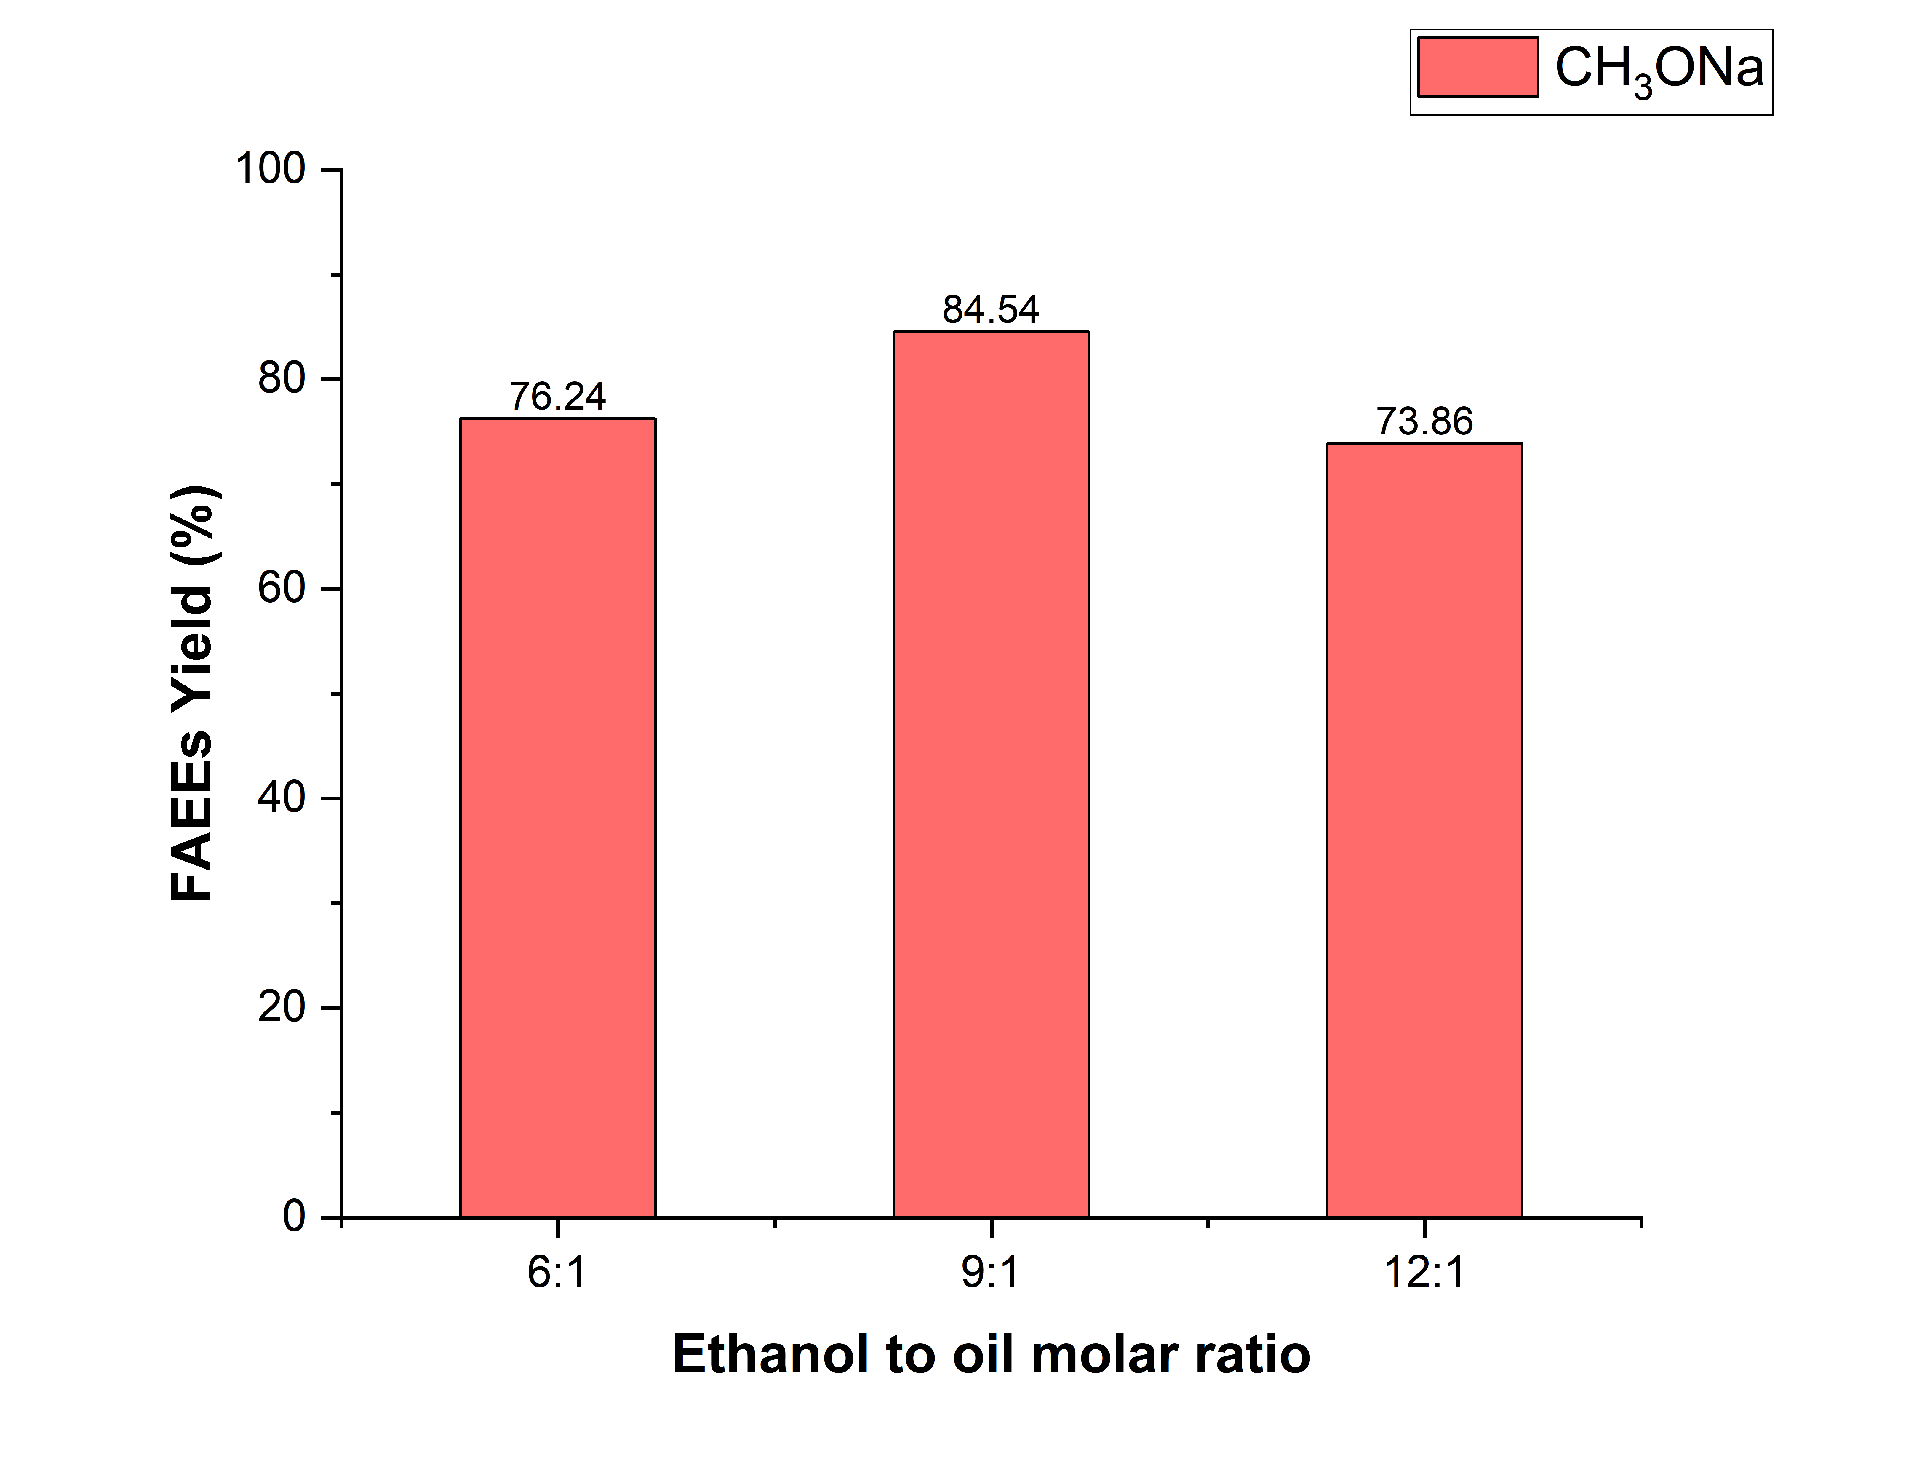
Figure 5(a). Effect of ethanol to oil molar ratio for FAEEs yields (NaOH) | Figure 5(b). Ethanol to oil molar ratio for FAEEs yields (CH₃ONa)

Comparative transesterification studies using NaOH and CH₃ONa were conducted under identical reaction conditions. Initial experimental data, as illustrated in the column graph showed that NaOH achieved its maximum yield at a 12:1 ratio, whereas CH₃ONa exhibited maximum yield at 9:1 molar ratio (Figure 5(a) and Figure 5(b)). The variation in optimum molar ratio was attributed to the different catalytic behaviors of the two catalysts. NaOH acts through in situ formation of alkoxide ions and is comparatively more sensitive to moisture and saponification side reactions, and also produce water which can reduce the effective conversion efficiency. Therefore, the higher ethanol concentration was required to shift the reversible transesterification equilibrium towards ester formation and overcome the side effects. In contrast, CH₃ONa is a highly active direct alkoxide catalyst that promotes rapid transesterification even at relatively lower alcohol concentration and not to produce water. However, excessive ethanol beyond the optimum ratio may increase glycerol solubility in the ester phase and hinder phase separation, thereby slightly reduced the effective biodiesel yield at 12:1 molar ratio. Among all investigated conditions, the NaOH catalyzed reaction at 12:1 alcohol to oil molar ratio produced the maximum biodiesel yield within the experimental range. Therefore, 12:1 molar ratio was selected as the optimized condition for further parameter optimization studies.

3.2.3 Reaction time optimization
The present work involved the transesterification of UCO-soybean oil blend following the determination of ideal 12:1 alcohol to oil molar ratio, keeping other parameters constant to optimize the reaction time. The percentage yield of FAEEs was continuously checked during specific time intervals and CH₃ONa was found more suitable than the NaOH with respect to yields of ester conversion.
The percentage yield of FAEEs versus time using both NaOH and CH₃ONa as well as homogeneous catalyst is given bellow. The reaction time was optimized for transesterification of UCO and soybean oil blend under constant operating conditions e.g., 12:1 ethanol to oil ratio, 0.75% catalyst loading, 60 ℃ temp and 400 rpm. The experiments conducted at 40 min, 50 min and 60 min revealed that the highest biodiesel yield 90.34% (CH₃ONa) and 89.42% (NaOH) was achieved at 50 minutes, establishing it as the optimum reaction time (Figure 6).
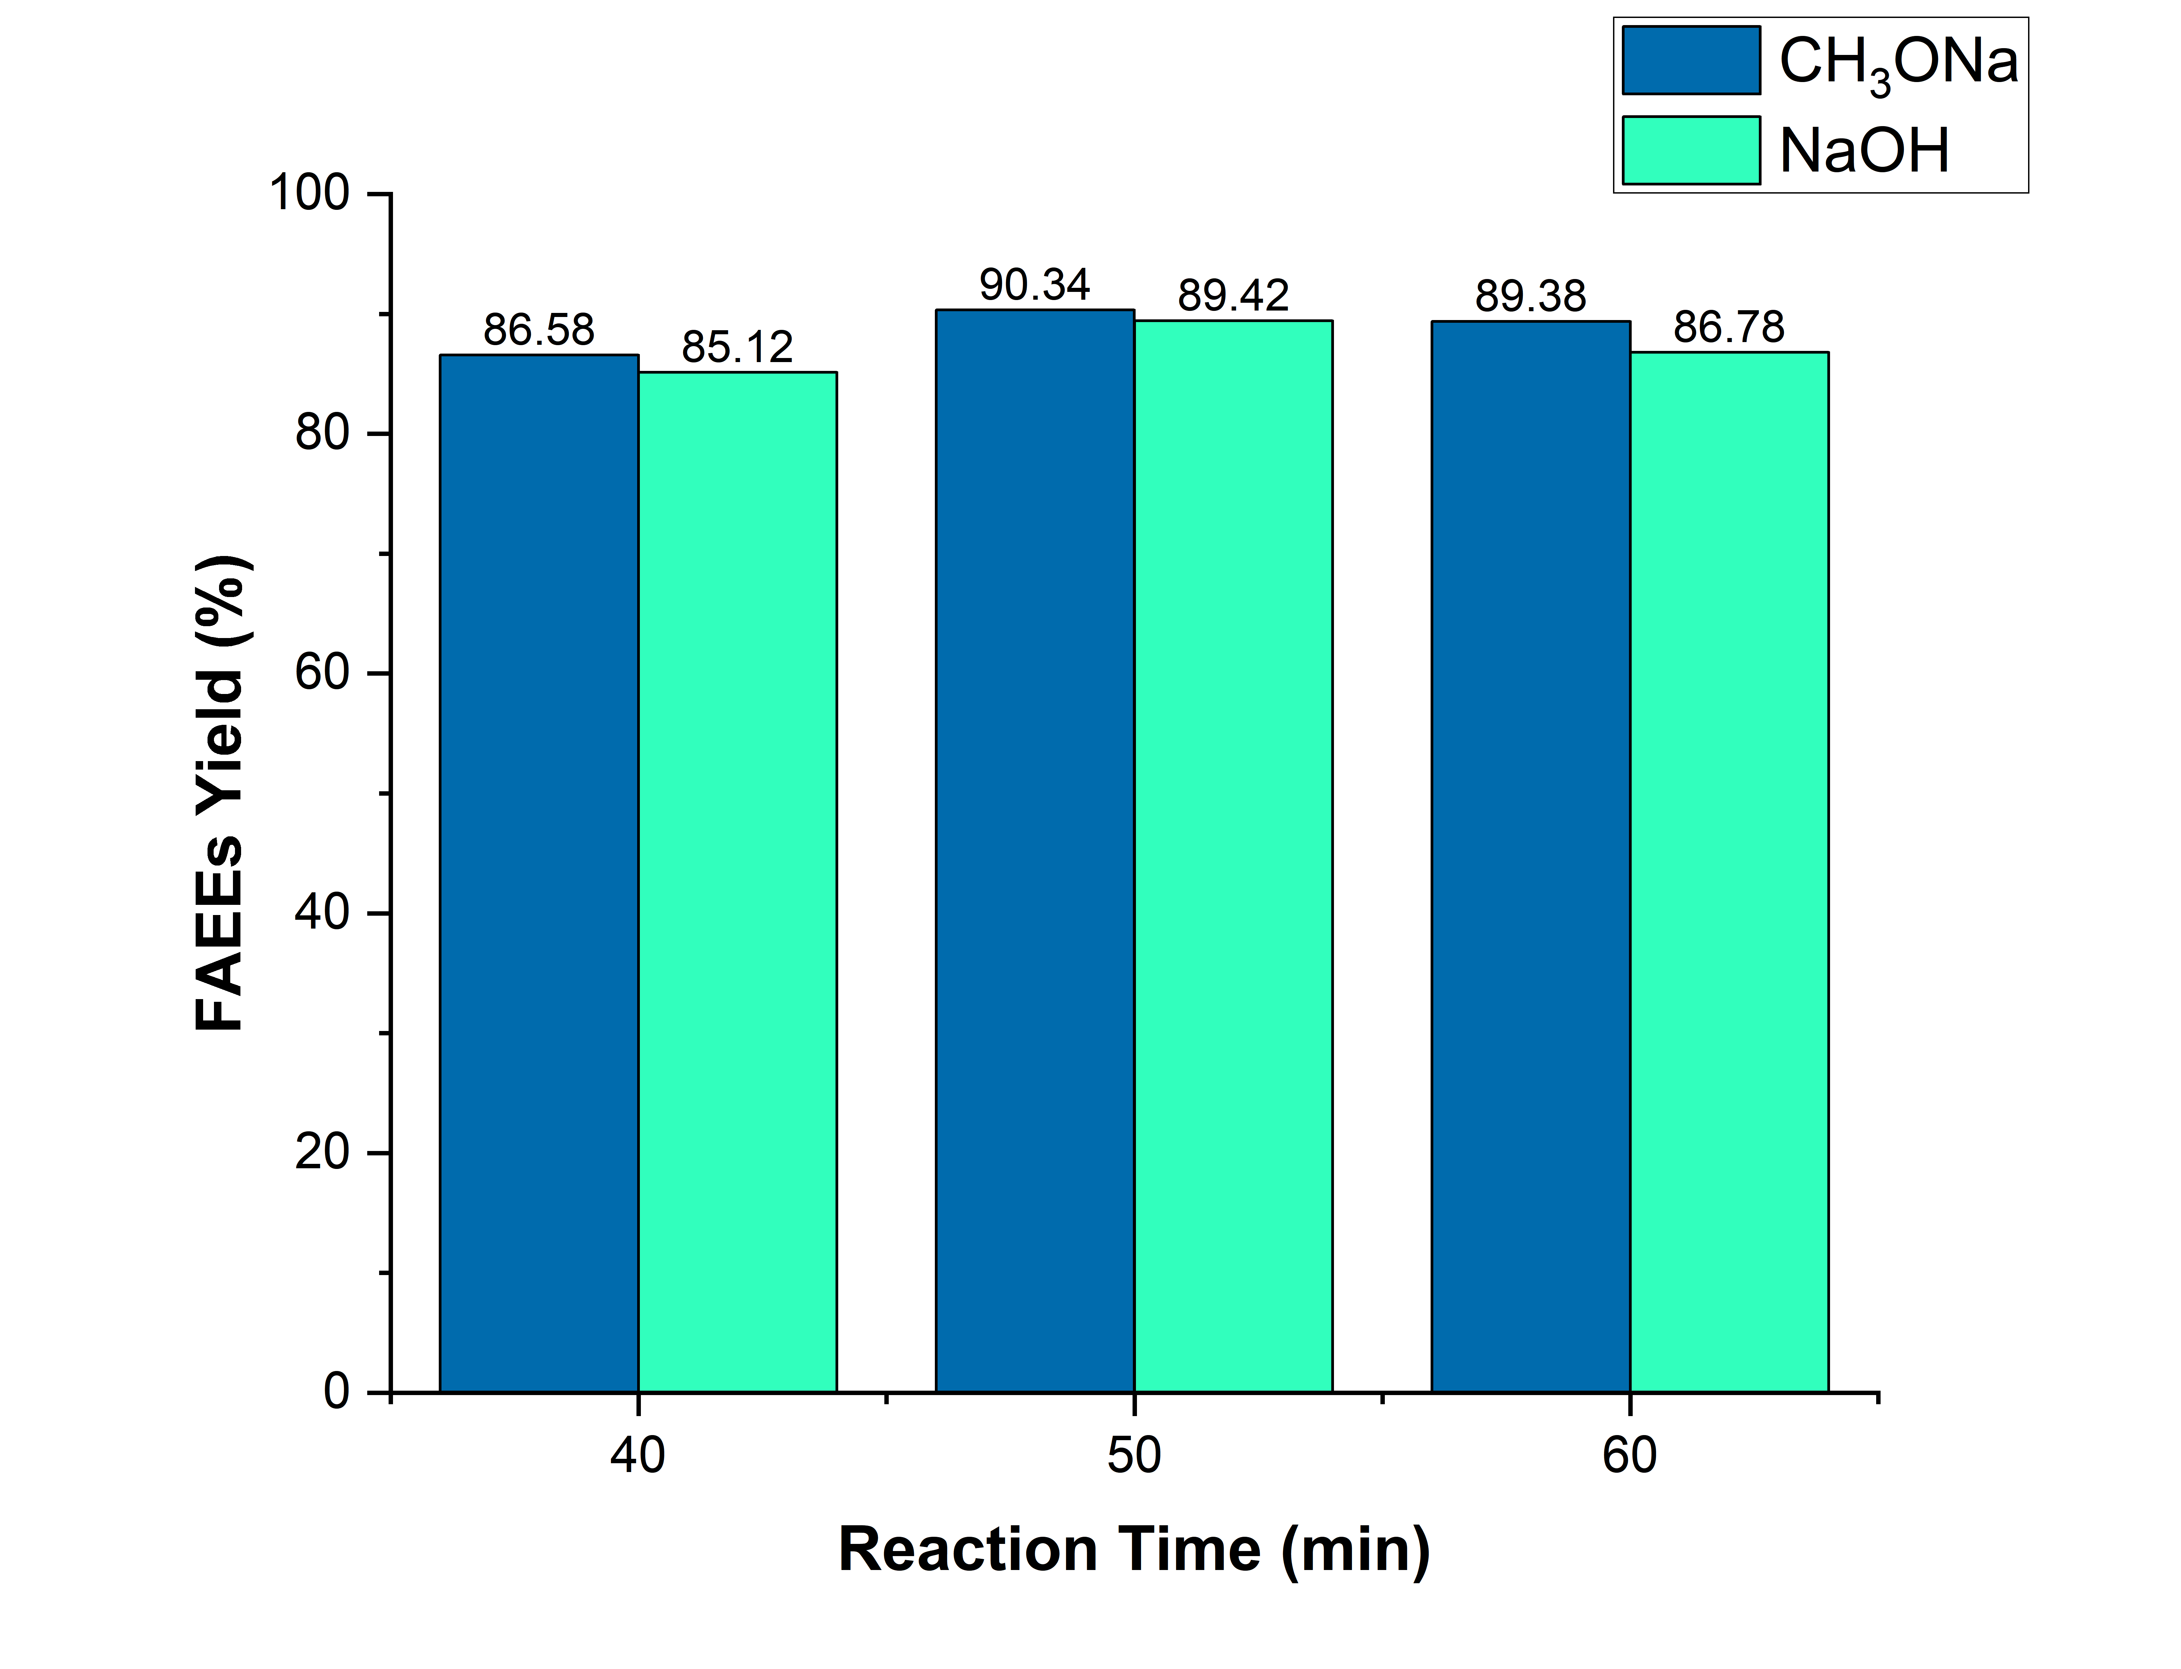 | 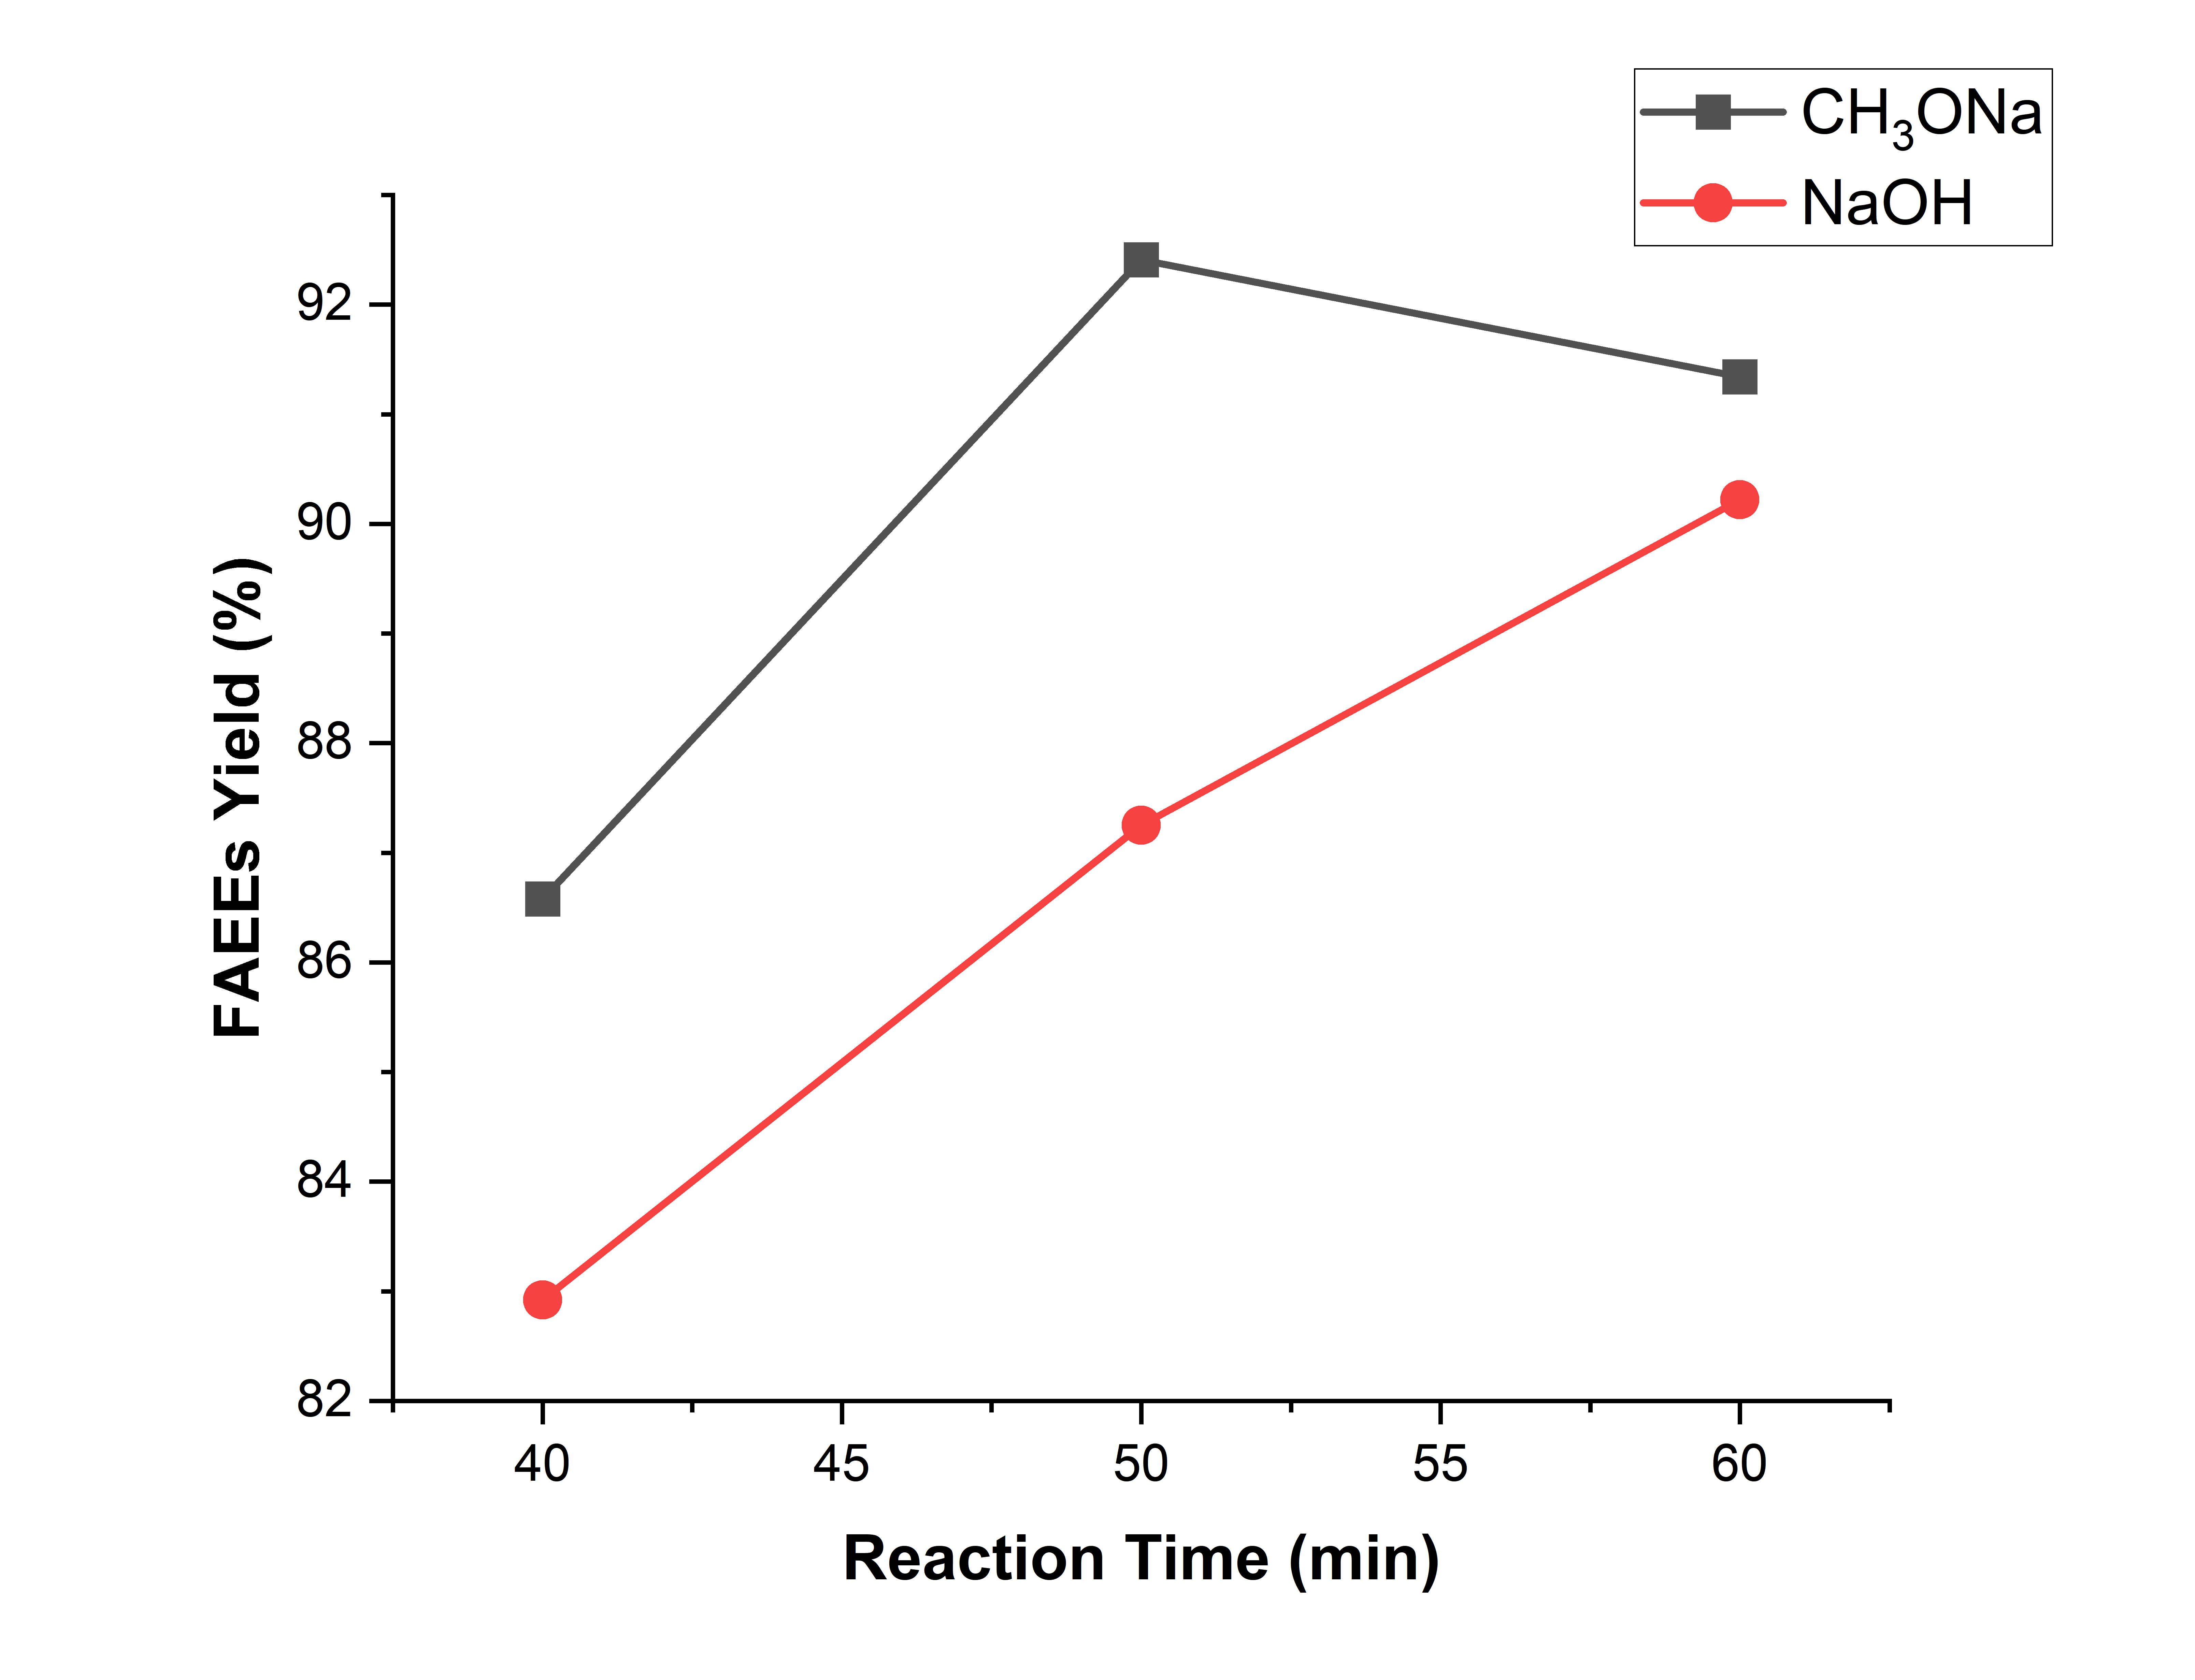
Figure 6. Influence of reaction time for conversion of FAEEs (Molar ratio =12:1, catalyst = 0.75 wt%, Temp. 60 ℃)

3.2.4 Reaction temperature optimization
Ethanolysis reaction was conducted at different temperatures between 50-70 ℃ by keeping all others reaction parameters constant i.e., ethanol to oil molar ratio (12:1), catalyst concentration (0.75 wt%) and stirring speed (400 rpm) is presented (Figure 7(a)). Elevation of temperature was noted to justify impact on biodiesel yield but further rise of temperature led the reaction towards saponification of triglycerides resulting in lowering the yield of FAEEs. The yield of FAEEs against the reaction time was continuously checked for various experiments conducted at different temperatures and it found maximum yield 90.34% for CH₃ONa and 89.42% for NaOH respectively, which was achieved at 50℃ (Figure 7(b)). Darnoko and Cheryan observed an increase in the rate of transesterification of palm oil with rise the temperature [36]. Similarly, Demirbas observed an increase in the yield of biodiesel from waste cooking oil with rise in reaction temperature however, the yield was not regular [37]. Another study was investigated the Karanja seed oil methyl ester (KMOHs) 92% was obtained at 60 ℃ using NaOH catalyst [38].

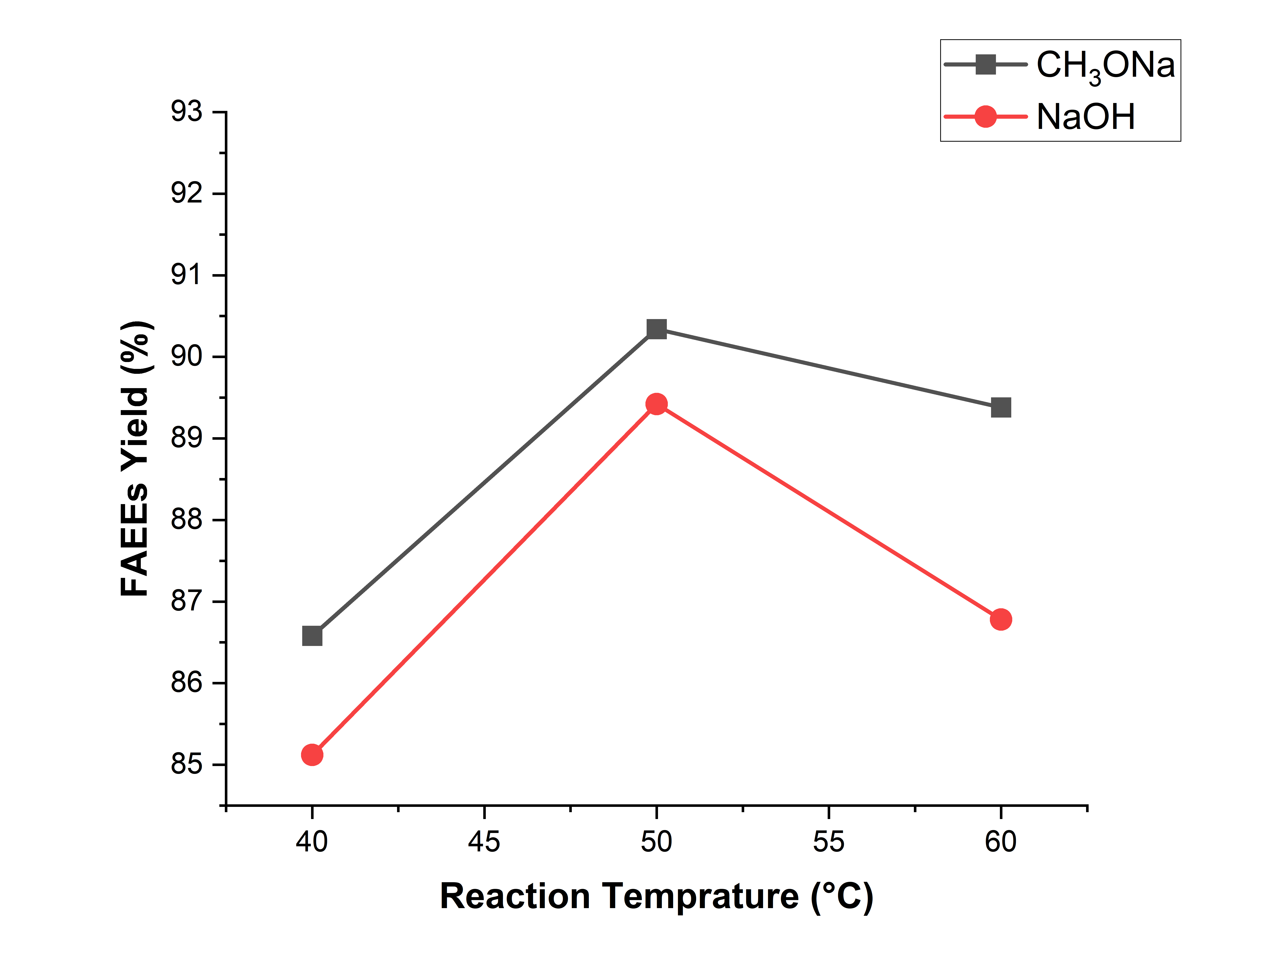 | 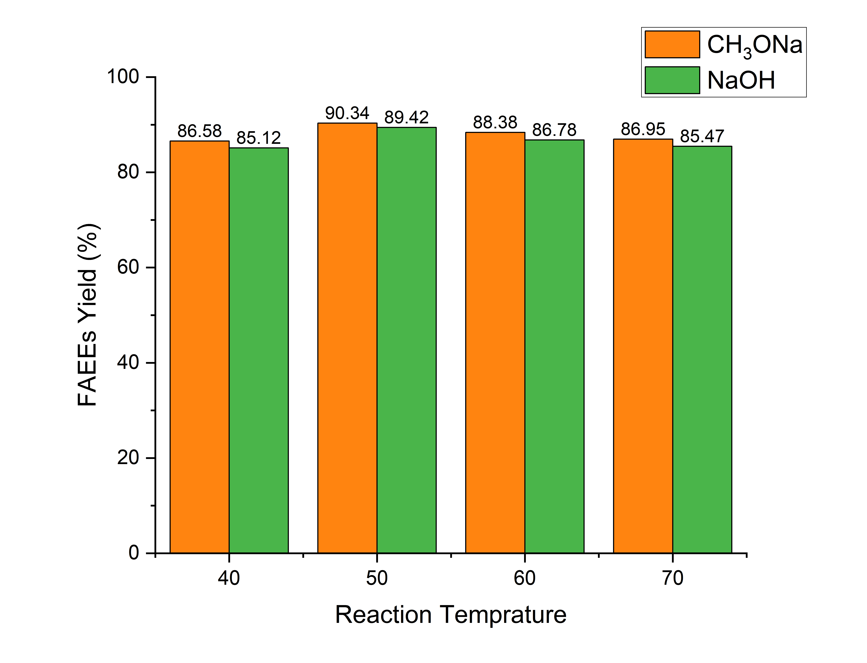
Figure 7(a). Reaction temperature optimization | Figure 7(b). Reaction temperature optimization

3.3 Characterization of FAEEs
3.3.1 FTIR analysis
The visual appearance of the synthesized biodiesel was examined to ensure its clarity and phase separation. Figure 7 illustrated the final FAEEs product, which exhibited a clear, yellowish tint, indicating successful glycerol removal. The samples of FAEEs were analyzed using FT-IR spectroscopic technique Figure 9 and compared with UCO and soyabean oil from literature spectrum of FT-IR. The FT-IR spectra of UCO and soybean oil is ranged of 4000-500 cm⁻¹ as given. The spectrum presents some distinct absorption bands relating to vegetable oil/ triglycerides. In the raw oils, soybean and WCO a very broad absorption band generally appears in the region of 3600-3200 cm⁻¹ due to O-H stretching vibrations associated with moisture, free fatty acids and other hydroxy-containing compounds [39,40]. However, this broad peak was absent in the biodiesel spectrum, suggesting effective purification and removal of unwanted impurities during biodiesel production.

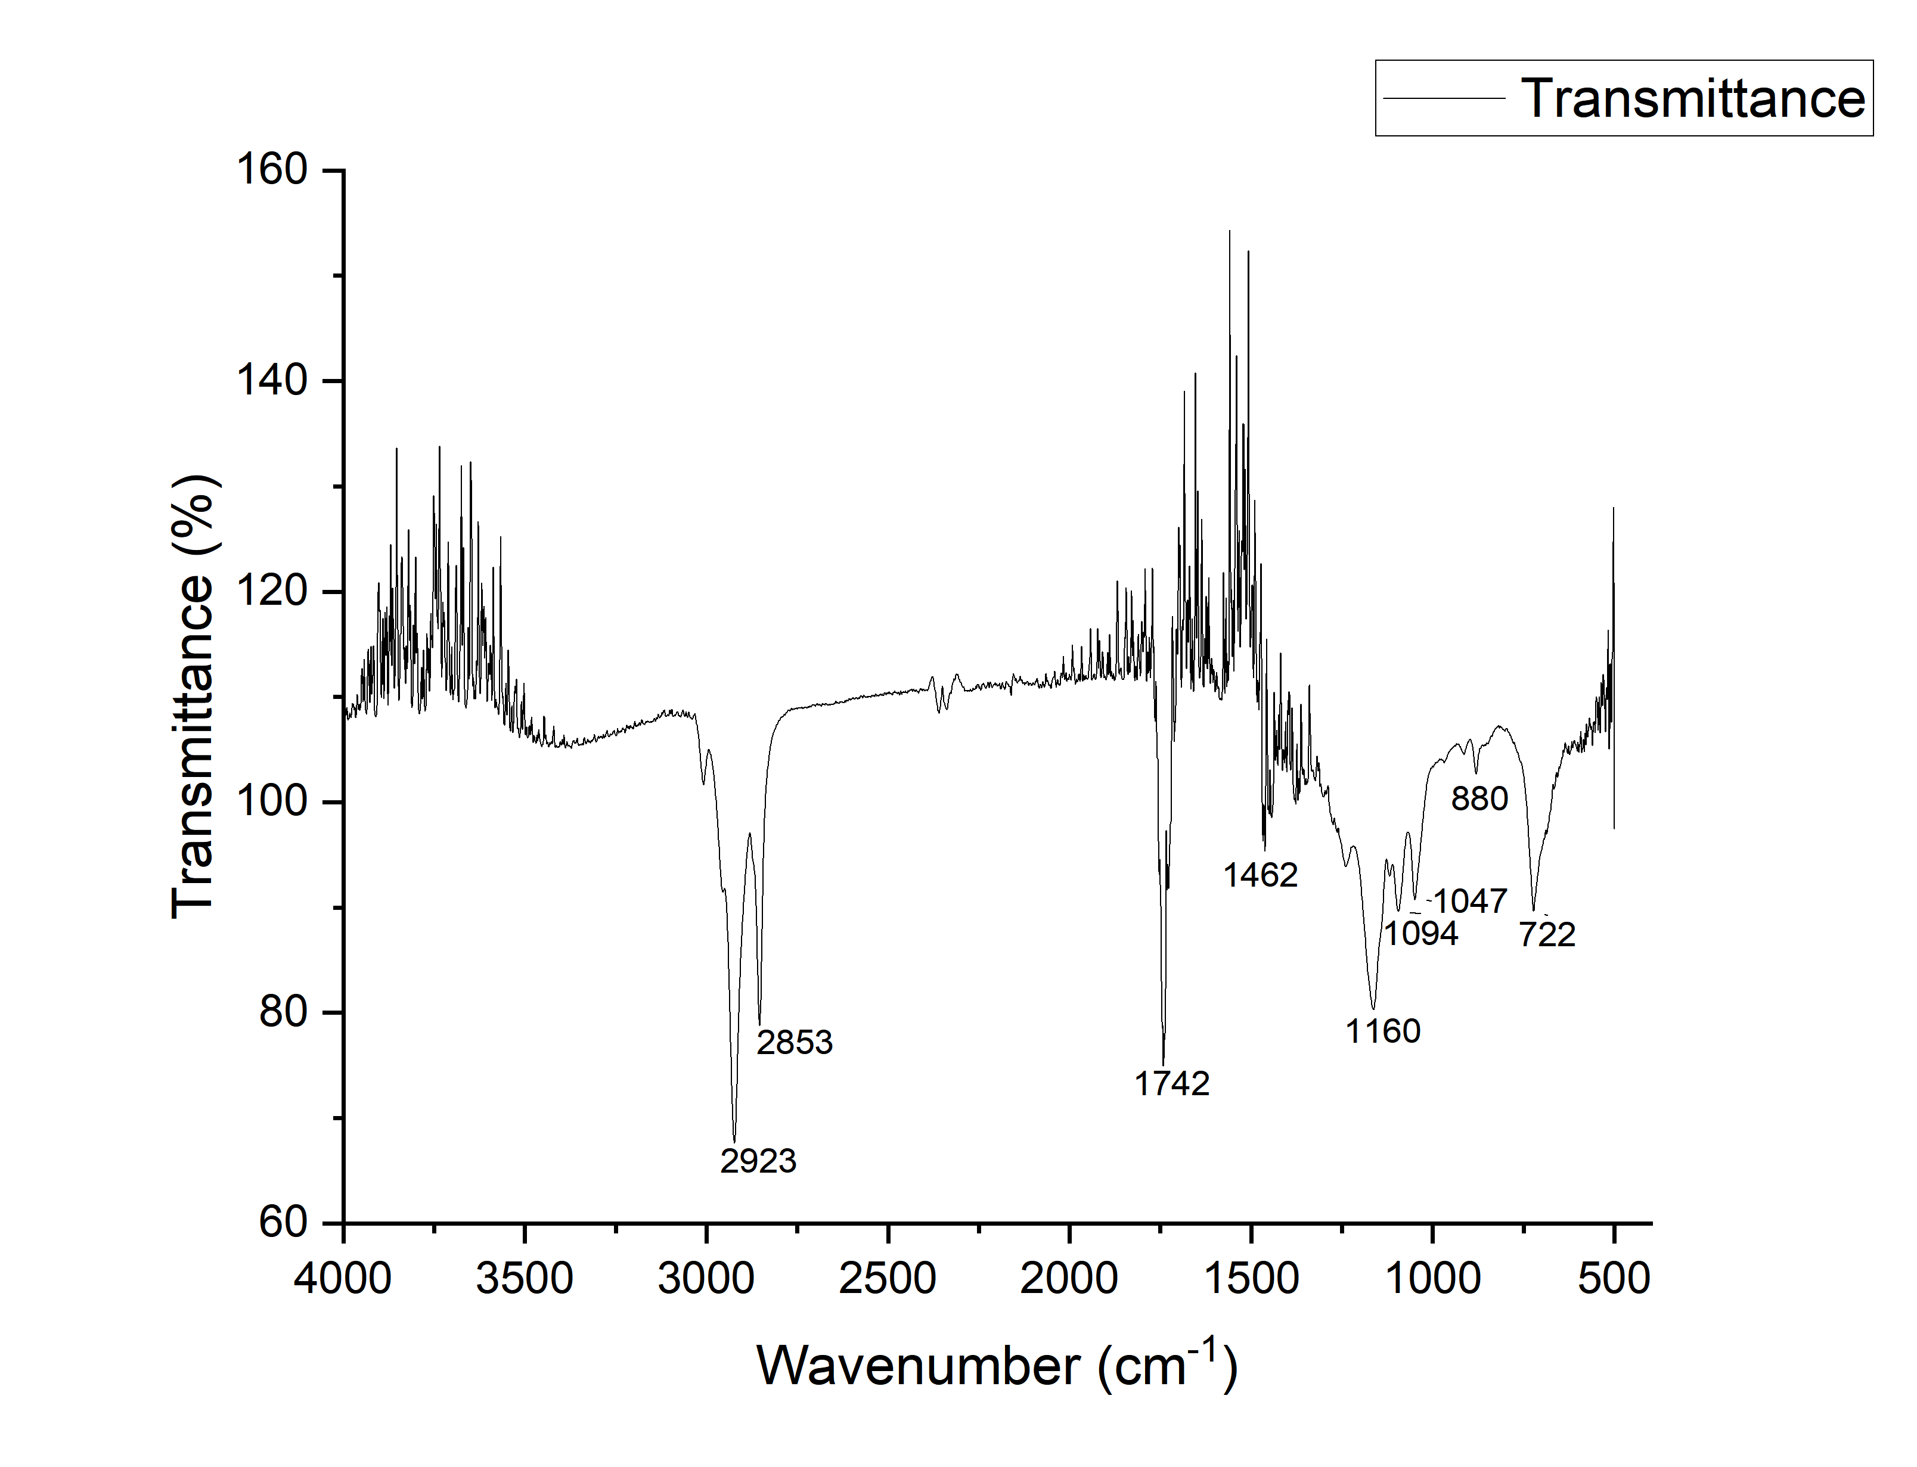
Figure 8. FTIR spectrum of fatty acid ethyl ester (FAEEs)
The FTIR spectrum of the produced biodiesel confirmed the successful formation of FAEEs (improved biodiesel), which are the principal components of biodiesel. The characteristics absorption bands observed in the spectrum correspond to the functional groups commonly present in the ester molecules. A strong absorption band observed the region of 2920-2850 cm⁻¹ is attributed to the asymmetric and symmetric stretching vibration of aliphatic C-H bonds (-CH₂ and -CH₃ groups) presents in long chain fatty acid esters. The prominent peak around 1740 cm⁻¹ corresponds to the stretching vibration of ester carbonyl groups (C=O), which is most considered the most important characteristics peak of biodiesel. The strong ester group peak confirms the conversion of triglycerides into FAEEs during ethanolysis. The peak near 1650 cm⁻¹ indicates unsaturated fatty acid chains, while peaks around 1460 cm⁻¹ and 1375 cm⁻¹ correspond to CH₂ and CH₃ groups. The bands near 1240-1170 cm⁻¹ and 1130-1030 cm⁻¹ confirm ester formation through C-O and C-O-O stretching vibrations. The weak peak near 720 cm⁻¹ represents long chain methylene groups present in biodiesel.

3.3 Fuel characteristics of improved FAEEs
The FAEEs synthesized in this research exhibit distinguished technical and ecological merits. This improved biodiesel demonstrates higher oxidation stability and enhanced lubricity, which are instrumental to mitigate internal engine friction and less carbon monoxide (CO) and sulfur oxide emission. A primary advantage of FAEEs is lower cloud and pour points to improve cold weather performance. However, the integration of ethanol as an environmentally benign alcohol reinforces the sustainable lifecycle of fuel while contributing to sustained engine durability. The essential fuel properties of the synthesized improved biodiesel evaluated against international ASTM D6751 and EN 14214 standards are summarized in Table 2 [41,42].

Table 2 Properties of improved biodiesel (FAEEs)
Sl. No. | Parameters | FAEEs | ASTM D 6751 | EN 14214
01 | Density (kg/m³) | 0.86 | 870-900 | 860-900
02 | Kinematic Viscosity (mm²/s) | 3.9 | 1.9-6.0 | 3.5-5.0
03 | Calorific value MJ/kg | 37.83 | - | 35-40
04 | Pour point (℃) | -8.6 | - | -
05 | Cloud point (℃) | 3-4.5 | - | -
06 | Flash point (℃) | 135.2 | 100-170 | >120
07 | Cetane number | 48-55 | >47 | >51
4. Conclusions
The ethanolysis of triglycerides has potential for improving some characteristics of biodiesel as fuel of compression-ignition engines and also increasing its sustainable character. In this work, the used cooking oil and soybean oil blend was transformed into fatty acid ethyl esters (improved biodiesel) via an optimized transesterification process. The effect of different types of reaction variables on the yield of FAEEs were investigated. Under optimized set of transesterifications which included ethanol to oil molar ratio of 12:1, CH₃ONa catalyst concentration of 0.75 %, reaction time 50 min and agitation rate of 400 rpm is an optimum condition for high percentage yield (90.34 %) of biodiesel/FAEEs was achieved. The FT-IR data verified the purity and quality of FAEEs. The fuels characteristics of produced biodiesel were also comparable with ASTM standards and supported the utility of biofuel. Overall, the findings of this study indicates that FAEEs was explored as a good substitute to conventional diesel and CH₃ONa for homogeneous catalyst has better performance than NaOH catalyst on this process.

Acknowledgements
The author, M. A. Hossain would like to thank the research funding from DRE/08/764(52)/Pro/2025-26/48 (6). Gratitude is also addressed to the Head of the Research Laboratory, Department of Chemistry, Rajshahi University of Engineering and Technology, Rajshahi, Bangladesh, for all support and to the team members.

5. References
[1] R. B. Aremanda, D. Tekleweyni, M. Arebu, G. Fufa, and M. Nasir, “Influence of Methanol Solvent and Alkali Catalyst on Biodiesel Production from Cottonseed Oil,” vol. 10, no. 1, pp. 24–30, 2025.
[2] P. Scroll and D. For, “Distributed Generation & Alternative Energy Journal Comparatives Study of Production Biodiesel from Soybean oil and Jatropha Curcas Seeds Oil,” no. June, pp. 37–41, 2013.
[3] S. M. Asaad, A. Inayat, F. Jamil, and P. Hellier, “Process Optimization of Biodiesel Production from Waste Cooking Oil and Neem Oil Blend,” pp. 1–25, 2025.
[4] N. S. Topare, K. D. Patil, and S. V Khedkar, “Synthesis of Biodiesel from Waste Cooking Oil and Emission Characteristics of Its blends Synthesis of Biodiesel from Waste Cooking Oil and Emission Characteristics of Its blends,” 2020, doi: 10.1088/1757-899X/983/1/012015.
[5] R. Ahmed, N. Bin Nazrul, S. Ahammed, A. Siddike, and K. M. O. Islam, “Comparative Study of Biodiesel Blends Derived from Vegetable Oils : Properties Investigation,” vol. 3, pp. 365–369, 2025.
[6] K. H. Warsi, A. Moina, and C. Engineering, “Production of Biodiesel from a Blend of Jatropha Oil and Waste Frying Soybean Oil,” 2016.
[7] R. Helaimia, “Araştırma Makalesi Soybean Oil : An Alternative Source of Biodiesel,” pp. 684–690, 2024.
[8] D. U. Paulinus and U. E. Inyang, “Available online www.jsaer.com Optimization of Biodiesel Production from Vegetable Oils ( Soyabean and Refined Palm Kernel Oil ),” vol. 12, no. 5, pp. 26–38, 2025.
[9] F. Mahmuddin, M. R. Alwi, M. U. Pawara, and W. Setiawan, “Effect of Methanol – NaOH Catalyst Variations on the Properties and Engine Performance of B50 Biodiesel from Waste Cooking Oil,” vol. 15, no. 1, pp. 79–89, 2026.
[10] F. Qiu, Y. Li, D. Yang, X. Li, and P. Sun, “Biodiesel production from mixed soybean oil and rapeseed oil,” Appl. Energy, vol. 88, no. 6, pp. 2050–2055, 2011, doi: 10.1016/j.apenergy.2010.12.070.
[11] M. A. Jamil, B. Sciences, M. A. Jamil, and M. A. Jamil, “Production and Optimization Study of Biodiesel Produced from Non-edible Seed Oil”.
[12] A. V Velic and V. B. Veljkovic, “The production of biodiesel from vegetable oils by ethanolysis : Current state and perspectives ˇ kovic,” vol. 90, pp. 3141–3155, 2011, doi: 10.1016/j.fuel.2011.06.049.
[13] I. Reyero, G. Arzamendi, S. Zabala, and L. M. Gandía, “Kinetics of the NaOH-catalyzed transesteri fi cation of sun fl ower oil with ethanol to produce biodiesel,” vol. 129, pp. 147–155, 2015, doi: 10.1016/j.fuproc.2014.09.008.
[14] S. Koohikamali, C. P. Tan, and T. C. Ling, “The cientific WorldJOURNAL Optimization of Sunflower Oil Transesterification Process Using Sodium Methoxide,” vol. 2012, no. 2007, 2012, doi: 10.1100/2012/475027.
[15] C. Series, “Palm oil methanolysis for biodiesel synthesis using sodium methoxide Palm oil methanolysis for biodiesel synthesis using sodium methoxide”, doi: 10.1088/1742-6596/3160/1/012019.
[16] H. Li and H. Zhao, “Energy Sources , Part A : Recovery , Utilization , and Environmental Effects Preparing Biodiesel from High-acidity Waste Cooking Oil Catalyzed by Sodium Methoxide,” no. April, pp. 37–41, 2015, doi: 10.1080/15567036.2011.590854.
[17] F. Ferella, G. M. Di, I. De Michelis, V. Stanisci, and F. Vegliò, “Optimization of the transesterification reaction in biodiesel production,” Fuel, vol. 89, no. 1, pp. 36–42, 2010, doi: 10.1016/j.fuel.2009.01.025.
[18] J. Dai, D. Li, Y. Zhao, and Z. Xiu, “Statistical Optimization for Biodiesel Production from Soybean Oil in a Microchannel Reactor,” 2014.
[19] C. Brunschwig, W. Moussavou, and J. Blin, “Use of bioethanol for biodiesel production,” Prog. Energy Combust. Sci., vol. 38, no. 2, pp. 283–301, 2012, doi: 10.1016/j.pecs.2011.11.001.
[20] M. Primata and Y. Chan, “Effect of alkali catalyst on biodiesel production in South Korea from mixtures of fresh soybean oil and waste cooking oil,” pp. 223–228, 2013, doi: 10.1007/s10163-012-0111-8.
[21] R. Foroutan, H. Esmaeili, and G. Ff, “Optimization of Biodiesel Production from Waste Cooking Oil by Alkaline Catalysts,” vol. 1, no. 41, pp. 1–7, 2018.
[22] S. Jain et al., “Transesterification of Algae Oil and Little Amount of Waste Cooking Oil Blend at Low Temperature in the Presence of NaOH Transesterification of Algae Oil and Little Amount of Waste Cooking Oil Blend at Low Temperature in the Presence of NaOH”.
[23] S. Namwong and V. Punsuvon, “Biodiesel Production from Used Vegetable Oil Using Ethanol and Sodium Methoxide Catalyst,” vol. 723, pp. 551–555, 2017, doi: 10.4028/www.scientific.net/KEM.723.551.
[24] E. G. Giakoumis, “A statistical investigation of biodiesel physical and chemical properties , and their correlation with the degree of unsaturation,” 2013, doi: 10.1016/j.renene.2012.07.040.
[25] S. S. R, B. M. Gitte, and S. D. Joshi, “‘ Characterization of Biodiesel: A Review ,’” vol. 2, no. 10, pp. 2077–2082, 2013.
[26] A. K. Hossain and P. A. Davies, “Plant oils as fuels for compression ignition engines : A technical review and life-cycle analysis,” Renew. Energy, vol. 35, no. 1, pp. 1–13, 2010, doi: 10.1016/j.renene.2009.05.009.
[27] V. Kesari and L. Rangan, “Development of Pongamia pinnata as an Alternative Biofuel Crop - Current Status and Scope of Plantations in India,” vol. 2010, no. 10, pp. 127–137, 2012.
[28] A. Sarin, R. Arora, N. P. Singh, R. Sarin, R. K. Malhotra, and K. Kundu, “Effect of blends of Palm-Jatropha-Pongamia biodiesels on cloud point and pour point,” Energy, vol. 34, no. 11, pp. 2016–2021, 2021, doi: 10.1016/j.energy.2009.08.017.
[29] A. Gupta, S. K. Sharma, and A. P. Toor, “An empirical correlation in predicting the viscosity of refined vegetable oils,” vol. 14, no. November, pp. 642–645, 2007.
[30] F. Edition, “Biodiesel Handling and Use Guide,” no. September, 2008.
[31] S. Namwong and V. Punsuvon, “Biodiesel Production from Used Vegetable Oil Using Ethanol and Sodium Methoxide Catalyst,” vol. 723, pp. 551–555, 2017, doi: 10.4028/www.scientific.net/KEM.723.551.
[32] Z. Yaakob, M. Mohammad, M. Alherbawi, and Z. Alam, “Overview of the production of biodiesel from Waste cooking oil,” Renew. Sustain. Energy Rev., vol. 18, pp. 184–193, 2013, doi: 10.1016/j.rser.2012.10.016.
[33] S. M. Asaad, A. Inayat, F. Jamil, and P. Hellier, “Process Optimization of Biodiesel Production from Waste Cooking Oil and Neem Oil Blend Cooking Oil and Neem Oil Blend”.
[34] D. Beyene, D. Bekele, and B. Abera, “Biodiesel from blended microalgae and waste cooking oils : Optimization , characterization , and fuel quality studies,” vol. 12, no. February, pp. 408–438, 2024, doi: 10.3934/energy.2024019.
[35] M. Hsiao, J. Kuo, P. Hsieh, S. Hou, and S. Homogenizer, “Improving Biodiesel Conversions from Blends of High- and Low-Acid- Value Waste Cooking Oils Using Sodium Methoxide as a Catalyst Based on a High Speed Homogenizer Sodium Methoxide as a Catalyst Based on a High,” 2018, doi: 10.3390/en11092298.
[36] D. Darnoko and M. Cheryan, “Kinetics of Palm Oil Transesterification in a Batch Reactor PDF created with FinePrint pdfFactory trial version http://www.fineprint.com PDF created with FinePrint pdfFactory trial version http://www.fineprint.com,” vol. 12, pp. 1263–1267, 2000.
[37] A. Demirbas, “Biodiesel production from vegetable oils via catalytic and non-catalytic supercritical methanol transesterification methods,” vol. 31, pp. 466–487, 2005, doi: 10.1016/j.pecs.2005.09.001.
[38] V. R. Mamilla, M. V Mallikarjun, and G. L. N. Rao, “Preparation of Biodiesel from Karanja Oil,” vol. 1, no. 2, pp. 94–100, 2011, doi: 10.5963/IJEE0102008.
[39] C. Socaciu et al., “applied sciences Attenuated Total Reflectance-Fourier Transform Infrared Spectroscopy ( ATR-FTIR ) Coupled with Chemometrics , to Control the Botanical Authenticity and Quality of Cold-Pressed Functional Oils Commercialized in Romania,” pp. 1–15.
[40] A. Soni, M. Yusuf, V. Kumar, and M. Beg, “Materials Today : Proceedings An assessment of thermal impact on chemical characteristics of edible oils by using FTIR spectroscopy,” Mater. Today Proc., no. xxxx, 2022, doi: 10.1016/j.matpr.2022.05.568.
[41] E. N. Ali and C. Isis, “Characterization of Biodiesel Produced from Palm Oil via Base Catalyzed Transesterification,” Procedia Eng., vol. 53, pp. 7–12, 2013, doi: 10.1016/j.proeng.2013.02.002.
[42] L. M. Das, D. Kumar, S. Pradhan, M. K. Naik, and S. N. Naik, “Long-term storage stability of biodiesel produced from Karanja oil,” vol. 88, pp. 2315–2318, 2009, doi: 10.1016/j.fuel.2009.05.005.

