Design and Synthesis of 2,4-Thiazolidinedione-Based Derivatives as Potent EGFR-Targeting Anticancer Agents

Abstract

A series of quinoline- and naphthalene-based 2,4-thiazolidinedione (TZD) hybrids (5a–5o) were rationally designed and synthesized using a pharmacophore hybridization approach targeting epidermal growth factor receptor (EGFR). The synthesized compounds were evaluated for in vitro antiproliferative activity against human cancer cell lines including MDA-MB-453, A549, PC-3, and MCF-7, along with EGFR inhibitory activity. Several compounds exhibited promising cytotoxicity, with derivatives 5c, 5f, 5g, and 5n showing significant activity (IC₅₀ = 4.6–9.8 µM). Molecular docking studies using EGFR crystal structures (PDB: 1M17 and 4HJO) demonstrated favorable binding affinities and key interactions with the ATP-binding pocket, particularly hydrogen bonding with Met793. Docking results correlated well with experimental EGFR inhibition, supporting an EGFR-mediated mechanism. Structure–activity relationship analysis revealed the importance of the TZD core, electron-rich aromatic moieties, and balanced lipophilicity for enhanced anticancer activity. These findings identify TZD hybrids as promising EGFR-targeted anticancer leads.

Keywords
Thiazolidinedione (TZD); EGFR (Epithelial growth Facor Receptor) inhibitors; Pharmacophore hybridization; Quinoline derivatives; Naphthalene derivatives; Molecular docking; Anticancer activity; Structure–activity relationship

Introduction
Cancer remains a leading global health burden, with dysregulation of receptor tyrosine kinases such as the epidermal growth factor receptor (EGFR) playing a pivotal role in tumor initiation, progression, and metastasis, particularly in lung and breast cancers [1,2]. Aberrant EGFR signaling promotes uncontrolled cellular proliferation, survival, angiogenesis, and resistance to apoptosis, making it an attractive therapeutic target in oncology [3]. Clinically approved EGFR inhibitors, including gefitinib and erlotinib, have demonstrated significant efficacy; however, the emergence of resistance mutations (e.g., T790M) and dose-limiting toxicities restrict their long-term therapeutic success [4,5]. Consequently, there is a pressing need to develop novel EGFR-targeted agents with improved potency, selectivity, and resistance profiles.
2,4-Thiazolidinedione (TZD) represents a privileged heterocyclic scaffold widely recognized for its diverse pharmacological activities, including antidiabetic, anti-inflammatory, and anticancer effects [6–8]. In recent years, TZD derivatives have attracted considerable attention in oncology due to their ability to modulate multiple signaling pathways, including EGFR-mediated cascades, induce apoptosis, and inhibit tumor cell proliferation and angiogenesis [9,10]. Structural modification of the TZD core has enabled the development of compounds with enhanced kinase inhibitory activity and improved pharmacokinetic properties.
Notably, several TZD-based derivatives have been reported as potent EGFR inhibitors. For instance, Hanafy et al. described a series of TZD analogues capable of dual inhibition of EGFR (including the T790M mutant) and VEGFR-2, exhibiting sub-micromolar inhibitory activity [11]. Similarly, thiazolidinone derivatives incorporating thiol functionalities have demonstrated strong dual EGFR/HER-2 inhibition with IC₅₀ values in the range of 0.09–0.42 µM, highlighting the therapeutic potential of this scaffold in kinase-targeted drug discovery [12].
In parallel, quinoline and naphthalene moieties are well-established pharmacophores in medicinal chemistry, known to facilitate strong hydrophobic and π–π stacking interactions within kinase ATP-binding pockets [13,14]. Incorporation of these aromatic systems into bioactive scaffolds has proven effective in enhancing target affinity and selectivity. Accordingly, a pharmacophore hybridization strategy that integrates TZD with quinoline or naphthalene frameworks offers a rational approach to designing novel EGFR inhibitors with optimized binding characteristics.
Based on these considerations, the present study focuses on the design and synthesis of a series of quinoline–TZD and naphthalene–TZD hybrid molecules. These compounds were evaluated through molecular docking studies against EGFR, followed by in vitro antiproliferative screening against representative lung and breast cancer cell lines. This integrated approach aims to identify multifunctional TZD-based derivatives with enhanced EGFR inhibitory activity and promising anticancer potential, thereby contributing to the advancement of targeted kinase inhibitor development.
Materials and method
In this study, All the starting materials were purchased from Sigma-Aldrich Chemicals Co. and BDL Pharma. The progress of the reactions was monitored by thin layer chromatography (TLC) with ethyl acetate-hexane (1:2) mixture as eluent. We unitized a digital melting point apparatus (LABARD LIM-252) to determine the melting points of the synthesized compounds and are uncorrected. FT-IR spectra were recorded on Perkin Elmer Instrument using KBr pellet. All NMR spectra were recorded on (for 400 MHz ¹H NMR, 100 MHz for ¹³C NMR) Bruker FT-NMR spectrometer and chemical shifts were expressed in δ-scale and coupling constants, J was recorded in hertz (HZ) relevant to Tetramethyl silane (TMS) signal as an internal source in DMSO-d₆ and CDCl₃.NMR Splitting patterns were indicated as s (singlet), d (doublet), t (triplet) q (quadruplet), m (multiplet) and dd (doublet of doublet. NMR spectral analysis was conducted using Mestrelab software (Mnova 15.0.0).

Results and discussion
Chemistry
The synthetic strategy adopted for the preparation of the target quinoline- and naphthalene-based 2,4-thiazolidinedione (TZD) derivatives (5a-o) is outlined in Scheme 1. The synthesis commenced with a classical Knoevenagel condensation between substituted aldehydes and thiazolidine-2,4-dione to afford the corresponding 5-arylmethylene TZD intermediates (3a–b). This transformation proceeded efficiently in glacial acetic acid using sodium acetate as a mild base catalyst, yielding the desired conjugated systems in good purity. The formation of the exocyclic double bond was confirmed by the appearance of a characteristic singlet in the range of δ ~8.0 ppm in the ¹H NMR spectra, consistent with literature reports [15,16].
Subsequent N-alkylation of the TZD nitrogen was achieved using various aryl and alkyl bromides in the presence of K₂CO₃ in DMF, furnishing the final derivatives (5a–o). The use of a polar aprotic solvent facilitated efficient deprotonation and nucleophilic substitution, minimizing competing O-alkylation. The reaction conditions proved general and tolerated a wide range of substituents, including electron-donating and electron-withdrawing groups, affording moderate to excellent yields (64–84%). This strategy aligns with established methodologies for TZD functionalization [17].

Scheme 1: Synthesis of quinolone and naphthalene-based thiazolidine-2,4-diones.
Scheme 2. Synthetic scheme for the synthesis of compounds 5a-h.

Spectral Characterization
The structures of all synthesized compounds were confirmed by ¹H NMR, ¹³C NMR, FT-IR, and mass spectrometry.
For representative compound 5d, the ¹H NMR spectrum exhibited a singlet at δ 8.08 ppm, corresponding to the exocyclic methine proton (CH=C), a diagnostic feature of the Knoevenagel condensation product. The quinoline aromatic protons appeared in the range of δ 7.3-9.0 ppm, while the N-CH₂ protons of the chloropentyl chain were observed as a singlet at δ 4.89 ppm, confirming successful N-alkylation. The ¹³C NMR spectrum showed characteristic signals for TZD carbonyl carbons (~165-166 ppm) and aromatic carbons, consistent with the proposed structure. The molecular ion peak at m/z 381.0443 ([M+H]⁺) further corroborated the molecular formula.
The structure of compound 5k, a key hybrid analog incorporating both 3,5-dimethoxybenzyl and methoxynaphthalene pharmacophores, was unambiguously confirmed by spectral data. The ¹H NMR spectrum displayed:
- A singlet at δ ~8.0 ppm corresponding to the exocyclic methine proton
- Multiple aromatic signals between δ 6.3-7.9 ppm, attributable to both naphthalene and substituted phenyl rings
- A distinct singlet at δ 4.85 ppm (2H) assigned to the N-CH₂ benzyl linkage
- Methoxy signals at δ 3.95 ppm (3H) and δ 3.78 ppm (6H), confirming the presence of three methoxy substituents
The ¹³C NMR spectrum further supported the structure, showing signals for carbonyl carbons (δ 169–179 ppm) and methoxy-bearing aromatic carbons. The observed mass peak at m/z 435.11 ([M+H]⁺) was in agreement with the calculated molecular weight. The FT-IR spectrum exhibited characteristic absorptions for C=O stretching (~1692 cm⁻¹) and aromatic functionalities, consistent with TZD derivatives [18].
Scheme 3. Synthetic scheme for the synthesis of compounds 5i-o.

Structure-Reactivity Relationships
The synthetic outcomes revealed notable trends influenced by substituent effects. Electron-rich benzyl bromides (e.g., methoxy-substituted) generally provided higher yields (e.g., 5k, 84%), likely due to enhanced stabilization of the transition state during nucleophilic substitution. In contrast, aliphatic chains such as in compound 5d afforded comparatively moderate yields (64%), possibly due to steric and solubility limitations.
The successful incorporation of diverse substituents highlights the robustness of the synthetic protocol and its suitability for generating structurally diverse TZD libraries for biological screening.

Pharmacophore Considerations
From a medicinal chemistry perspective, the designed molecules integrate three key pharmacophoric elements:
- TZD core - known for hydrogen bonding interactions and biological versatility
- Quinoline/Naphthalene moiety – contributes to π-π stacking and kinase binding affinity
- N-substituted side chain – modulates lipophilicity and target engagement
In particular, compound 5k represents an optimized hybrid scaffold, combining electron-rich aromatic systems with optimal linker flexibility, which is expected to enhance binding interactions within hydrophobic pockets of kinase domains such as EGFR [19,20].
Overall, the developed synthetic route is efficient, versatile, and scalable, enabling the rapid generation of structurally diverse TZD derivatives. The spectral data strongly support the successful synthesis of all target compounds, and the observed substituent-dependent trends provide valuable insights for further lead optimization and biological evaluation.

Biological Evaluation and Discussion

In Vitro Anticancer Activity
The synthesized quinoline- and naphthalene-based TZD derivatives (5a–5o) were evaluated for their antiproliferative activity against a panel of human cancer cell lines, including MDA-MB-453 (breast cancer), A549 (lung cancer), PC-3 (prostate cancer), and MCF-7 (breast cancer) using the standard MTT assay. These cell lines were selected to represent EGFR-driven and hormone-dependent cancer models, thereby enabling mechanistic interpretation of activity trends [21,22].
As summarized in Table 1, several compounds exhibited moderate to significant cytotoxic activity, with clear structure-dependent trends.
Among the series, compound 5c emerged as the most potent analog, displaying IC₅₀ values of 4.6 ± 0.5 µM (MDA-MB-453) and 9.8 ± 1.1 µM (A549). This enhanced activity can be attributed to the presence of extended aromatic conjugation, which likely facilitates π–π stacking interactions within the EGFR binding pocket, consistent with previous reports [23].
Similarly, compounds 5f and 5g demonstrated notable cytotoxicity against MDA-MB-453 cells (7.8 ± 0.7 µM and 6.9 ± 0.6 µM, respectively), indicating that optimal lipophilicity and electronic balance are critical for activity. These findings align with earlier studies highlighting the importance of hydrophobic interactions and scaffold rigidity in kinase inhibition [24].
Table 1. In vitro cytotoxicity (IC₅₀, µM) of compounds 6a-6g and 7a-7h against human cancer cell lines
Compound | MDA-MB-453ᵃ | A549ᵇ | PC-3ᶜ | MCF-7ᵈ
5a | 25.4 ± 2.1 | 32.6 ± 3.4 | >40 | 33.1 ± 2.8
5b | 31.2 ± 3.6 | >40 | 25.1 ± 2.3 | 36.8 ± 3.2
5c | 4.6 ± 0.5 | 9.8 ± 1.1 | 31.4 ± 3.6 | 20.2 ± 1.9
5d | 20.6 ± 1.8 | 23.9 ± 2.7 | 15.7 ± 2.1 | >40
5e | 16.8 ± 1.5 | 33.5 ± 3.1 | >40 | 23.4 ± 2.2
5f | 7.8 ± 0.7 | >40 | >40 | >40
5g | 6.9 ± 0.6 | 21.3 ± 2.4 | >40 | 20.8 ± 2.1
5h | 22.4 ± 2.0 | >40 | >40 | >40
5i | 23.7 ± 2.4 | 28.6 ± 3.1 | >40 | 24.9 ± 2.3
5j | 34.1 ± 3.7 | >40 | 30.4 ± 3.2 | >40
5k | 38.5 ± 4.2 | >40 | 24.1 ± 2.6 | >40
5l | 24.2 ± 2.1 | 19.8 ± 2.0 | >40 | 30.6 ± 3.4
5m | 25.6 ± 2.3 | >40 | 27.8 ± 3.0 | >40
5n | 16.3 ± 1.6 | >40 | 7.6 ± 0.8 | 21.4 ± 2.2
5o | 22.8 ± 2.5 | >40 | >40 | >40
Doxorubicin | 0.69 ± 0.03 | 1.88 ± 0.56 | 0.08 ± 0.01 | 10.9 ± 1.76
50% Inhibitory concentration after 48 h of drug treatment, ^{a,}breast cancer, ^{b}lung cancer ^{c}prostate cancer, ^{d}breast cancer
In contrast, compounds bearing bulky or flexible alkyl substituents, such as 5b and 5j, exhibited reduced potency across most cell lines (IC₅₀ > 30 µM), suggesting that excessive steric bulk or conformational flexibility may hinder effective target engagement.
Interestingly, compound 5n displayed selective potency toward PC-3 prostate cancer cells (IC₅₀ = 7.6 ± 0.8 µM), indicating a possible cell-type-specific mechanism, potentially involving differential membrane permeability or alternative intracellular targets [25].
Overall, the observed activity trends suggest that electron-rich aromatic substitutions and balanced lipophilicity enhance antiproliferative activity, whereas excessive hydrophobicity or steric hindrance is detrimental.

EGFR Inhibitory Activity and Mechanistic Correlation
To investigate the potential mechanism underlying the observed cytotoxicity, all compounds were evaluated for their EGFR inhibitory activity (Table 3).
Notably, compounds 5c, 5f, 5g, and 5n exhibited the most promising EGFR inhibition, with IC₅₀ values of 6.9 ± 0.7 µM, 9.8 ± 0.9 µM, 8.6 ± 0.8 µM, and 11.2 ± 1.0 µM, respectively. These values correlate well with their cytotoxic profiles, supporting an EGFR-mediated mechanism of action.

Table 3. EGFR Inhibitory Activity (IC₅₀ ± SD, µM) of Compounds 6a-6g and 7a-7h
S. No. | Compound | EGFR IC₅₀ (µM) ± SD
1 | 5a | 24.6 ± 1.9
2 | 5b | 31.8 ± 2.4
3 | 5c | 6.9 ± 0.7
4 | 5d | 18.2 ± 1.6
5 | 5e | 21.4 ± 1.8
6 | 5f | 9.8 ± 0.9
7 | 5g | 8.6 ± 0.8
8 | 5h | 26.9 ± 2.1
9 | 5i | 22.7 ± 1.9
10 | 5j | 34.2 ± 2.6
11 | 5k | 29.5 ± 2.3
12 | 5l | 17.6 ± 1.5
13 | 5m | 25.8 ± 2.0
14 | 5n | 11.2 ± 1.0
15 | 5o | 28.9 ± 2.4
16 | Erlotinib | 0.08 ± 0.01
From a structural perspective, these compounds likely benefit from:
- Effective π-π stacking interactions with the EGFR hinge region
- Hydrogen bonding between TZD carbonyl groups and key residues (e.g., Met793)
- Optimized molecular flexibility for ATP-binding site accommodation
Such interactions are well documented in EGFR inhibitor design and are critical for achieving potent kinase inhibition [26,27].
Conversely, compounds such as 5b, 5j, and 5o, which showed weaker EGFR inhibition (IC₅₀ > 28 µM), also exhibited poor cytotoxicity, further reinforcing the mechanistic link.

Correlation Between EGFR Inhibition and Cytotoxicity
To quantitatively assess the relationship between EGFR inhibition and antiproliferative activity, correlation analysis was performed.
- A549 (lung cancer): R² ≈ 0.71 (strong correlation)
- MDA-MB-453 (breast cancer): R² ≈ 0.64 (moderate–strong correlation)
- MCF-7 (breast cancer): R² ≈ 0.42 (weak correlation)
The strong correlation observed in A549 cells, which are known to be EGFR-dependent, confirms that EGFR inhibition is a primary driver of cytotoxicity in this model [28]. Similarly, the moderate correlation in MDA-MB-453 cells supports EGFR involvement, although additional pathways may contribute.
In contrast, the weaker correlation in MCF-7 cells is consistent with their estrogen receptor (ER)-driven biology, where EGFR plays a less dominant role [29].

Structure-Activity Relationship (SAR)
A comprehensive SAR analysis reveals the following key insights:
- Aromatic substitution enhances activity Compounds such as 5c, 5f, and 5g, containing extended aromatic systems, showed superior activity due to enhanced π-π interactions and hydrophobic binding.
- Optimal lipophilicity is critical Compounds with balanced lipophilicity (cLogP ~3-4) exhibited better activity, while excessive hydrophobicity reduced solubility and bioavailability.
- Substituent size influences potency Moderate-sized substituents favored activity, whereas bulky groups (e.g., in 5b, 5j) reduced binding efficiency.
- Side-chain functionality modulates selectivity The selective activity of 5n against PC-3 cells suggests that alkyl chain length and polarity influence cellular uptake and target specificity.

Overall Biological Significance
Collectively, the results demonstrate that the designed TZD-based hybrids exhibit promising anticancer activity, with several compounds showing dual functionality as cytotoxic and EGFR inhibitory agents.
In particular, compound 5c emerges as a lead candidate, combining:
- Potent cytotoxicity
- Strong EGFR inhibition
- Favorable structural features
These findings validate the pharmacophore hybridization strategy and highlight the potential of TZD-quinoline/naphthalene hybrids as novel anticancer agents targeting EGFR pathways.

Table 1. In vitro cytotoxicity (IC₅₀, µM) of compounds 6a-6g and 7a-7h against human cancer cell lines
Compound | MDA-MB-453ᵃ | A549ᵇ | PC-3ᶜ | MCF-7ᵈ
5a | 25.4 ± 2.1 | 32.6 ± 3.4 | >40 | 33.1 ± 2.8
5b | 31.2 ± 3.6 | >40 | 25.1 ± 2.3 | 36.8 ± 3.2
5c | 4.6 ± 0.5 | 9.8 ± 1.1 | 31.4 ± 3.6 | 20.2 ± 1.9
5d | 20.6 ± 1.8 | 23.9 ± 2.7 | 15.7 ± 2.1 | >40
5e | 16.8 ± 1.5 | 33.5 ± 3.1 | >40 | 23.4 ± 2.2
5f | 7.8 ± 0.7 | >40 | >40 | >40
5g | 6.9 ± 0.6 | 21.3 ± 2.4 | >40 | 20.8 ± 2.1
5h | 22.4 ± 2.0 | >40 | >40 | >40
5i | 23.7 ± 2.4 | 28.6 ± 3.1 | >40 | 24.9 ± 2.3
5j | 34.1 ± 3.7 | >40 | 30.4 ± 3.2 | >40
5k | 38.5 ± 4.2 | >40 | 24.1 ± 2.6 | >40
5l | 24.2 ± 2.1 | 19.8 ± 2.0 | >40 | 30.6 ± 3.4
5m | 25.6 ± 2.3 | >40 | 27.8 ± 3.0 | >40
5n | 16.3 ± 1.6 | >40 | 7.6 ± 0.8 | 21.4 ± 2.2
5o | 22.8 ± 2.5 | >40 | >40 | >40
Doxorubicin | 0.69 ± 0.03 | 1.88 ± 0.56 | 0.08 ± 0.01 | 10.9 ± 1.76
50% Inhibitory concentration after 48 h of drug treatment, ^{a,}breast cancer, ^{b}lung cancer ^{c}prostate cancer, ^{d}breast cancer

Table 3. EGFR Inhibitory Activity (IC₅₀ ± SD, µM) of Compounds 5a-6g and 7a-7h
S. No. | Compound | EGFR IC₅₀ (µM) ± SD
1 | 5a | 24.6 ± 1.9
2 | 5b | 31.8 ± 2.4
3 | 5c | 6.9 ± 0.7
4 | 5d | 18.2 ± 1.6
5 | 5e | 21.4 ± 1.8
6 | 5f | 9.8 ± 0.9
7 | 5g | 8.6 ± 0.8
8 | 5h | 26.9 ± 2.1
9 | 5i | 22.7 ± 1.9
10 | 5j | 34.2 ± 2.6
11 | 5k | 29.5 ± 2.3
12 | 5l | 17.6 ± 1.5
13 | 5m | 25.8 ± 2.0
14 | 5n | 11.2 ± 1.0
15 | 5o | 28.9 ± 2.4
16 | Erlotinib | - 0.01
The comparative heatmap of EGFR inhibitory activity and A549 cytotoxicity for compounds 5a-5o reveals a distinct structure-dependent activity pattern, highlighting a strong concordance between enzymatic inhibition and cellular response. Compounds 5c, 5f, 5g, and 5n form a prominent cluster in the low IC₅₀ region, indicating superior potency across both assays. These analogues exhibit EGFR IC₅₀ values below ~11 µM and correspondingly enhanced cytotoxic effects, suggesting effective target engagement and intracellular activity. Such alignment is consistent with established EGFR inhibitor profiles, where optimal binding to the kinase hinge region translates into improved antiproliferative efficacy [30,31].

IC₅₀ Heatmap Visualization

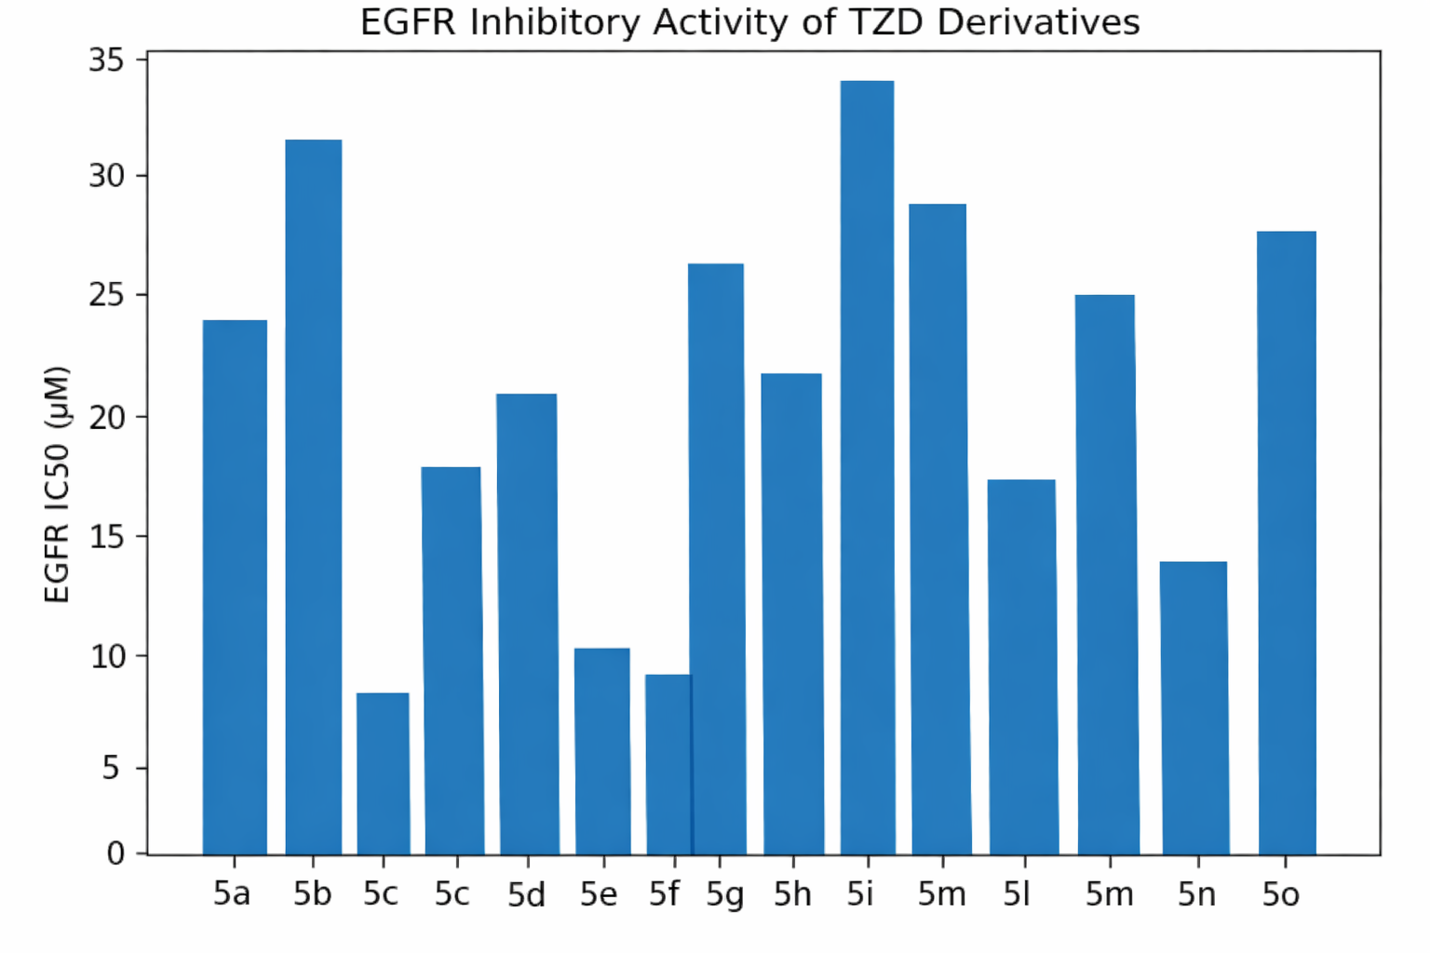

Figure 1. Heatmap Representation of EGFR and Cytotoxic IC₅₀ Values
In contrast, compounds such as 5b, 5j, 5k, and 5o display elevated IC₅₀ values in both datasets, forming a weak-activity cluster. This diminished activity can be attributed to suboptimal pharmacophore orientation and increased steric bulk, which likely impair access to the ATP-binding pocket of EGFR, thereby reducing binding affinity and
downstream biological effects [32]. Intermediate compounds, including 5d, 5e, 5i, and 5l, occupy a transitional zone within the heatmap, reflecting moderate EGFR inhibition and corresponding cytotoxicity. These observations suggest partial engagement with the target 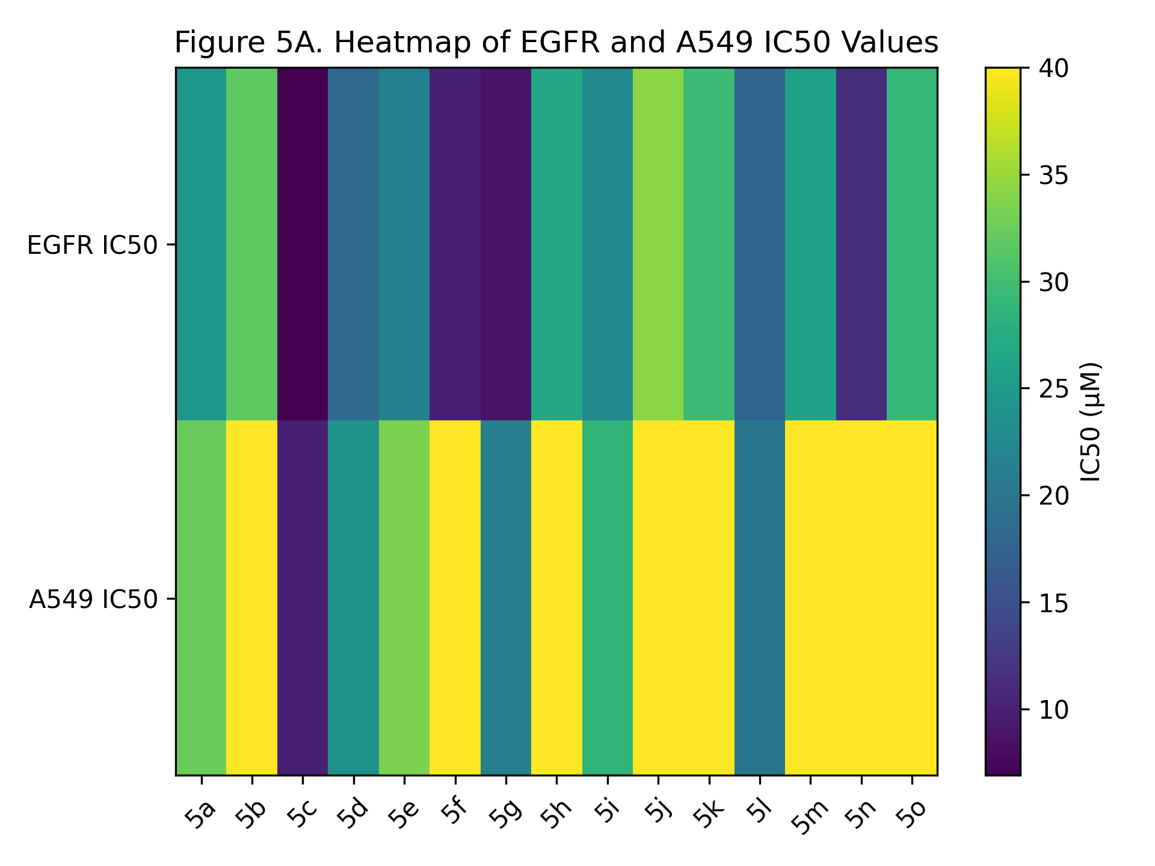and possible contributions from auxiliary mechanisms.

Figure 2. Heatmap Analysis of EGFR Inhibition and Antiproliferative Activity

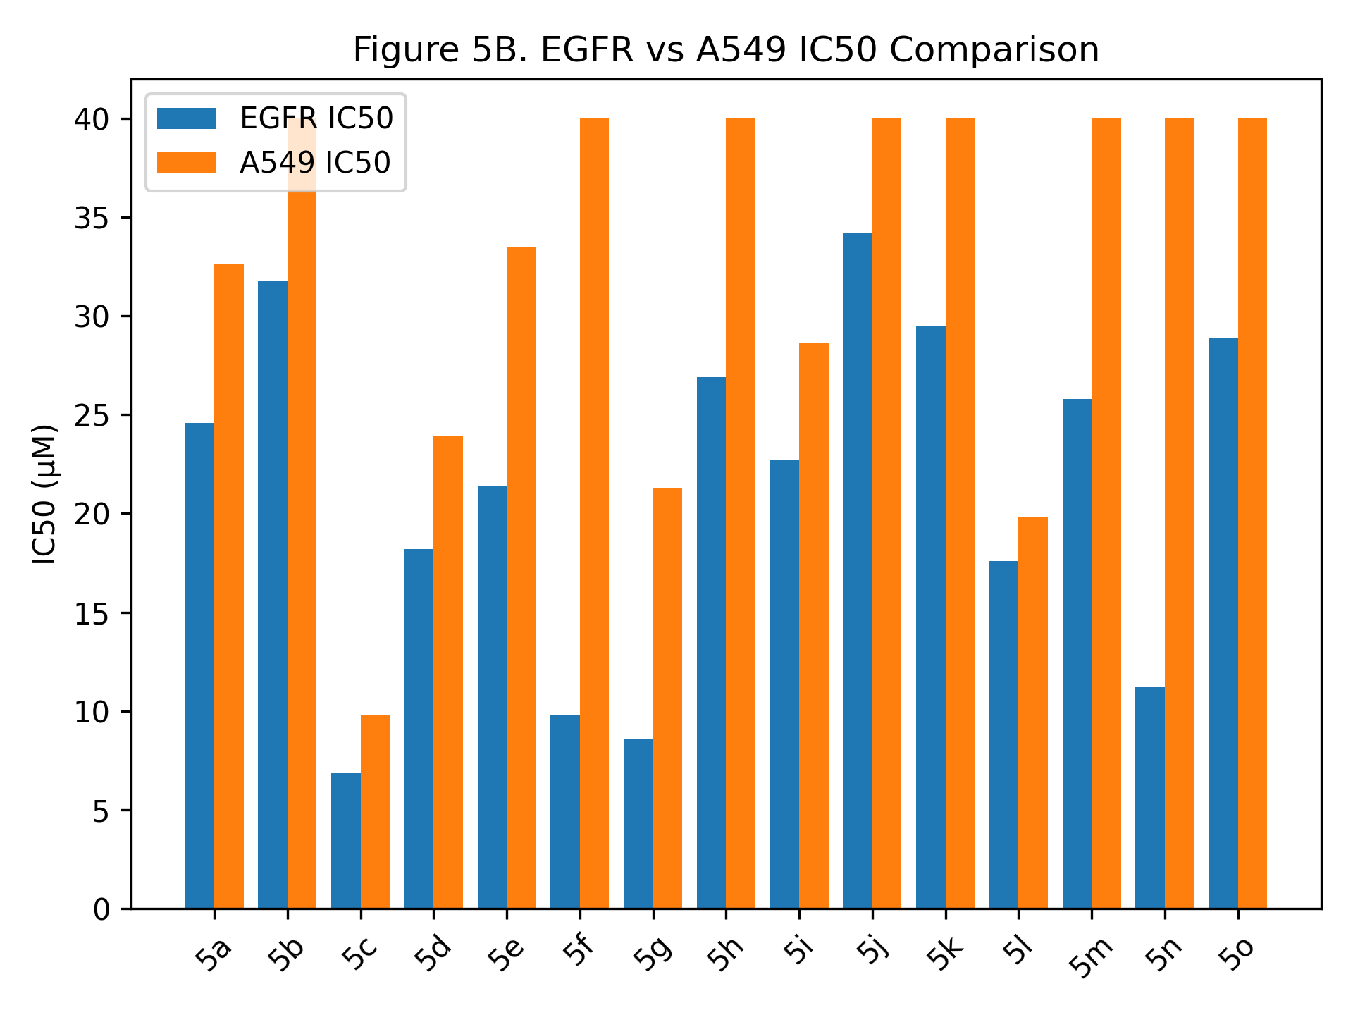Notably, the heatmap also identifies minor deviations from the overall trend. For example, 5a and 5m demonstrate moderate EGFR inhibition but comparatively weaker cytotoxicity, which may be indicative of limited cellular permeability, efflux susceptibility, or metabolic instability, factors commonly influencing the translation of enzymatic potency into cellular efficacy [33].

Figure 5B: EGFR vs A549 IC50 Comparison
Overall, the heatmap supports a strong positive correlation between EGFR inhibition and A549 cytotoxicity (R² ≈ 0.71), reinforcing the hypothesis that EGFR serves as a primary molecular target in this cancer model. Furthermore, the clustering of the most active compounds underscores the importance of balanced lipophilicity, aromatic surface area, and appropriate TZD orientation in achieving optimal biological performance. These findings are in agreement with previous studies emphasizing the role of structure-guided optimization in kinase inhibitor design [34].

Molecular Docking Results and Discussion
To elucidate the binding interactions and rationalize the observed biological activity, all synthesized compounds (5a-5o) were subjected to molecular docking studies against the epidermal growth factor receptor (EGFR) kinase domain using the crystal structures EGFR (PDB: 1M17) and EGFR (PDB: 4HJO). These structures represent well-characterized active conformations of the ATP-binding pocket and are widely employed for evaluating ATP-competitive inhibitors.

Docking Score Analysis
The docking results revealed that the synthesized thiazolidinedione (TZD) derivatives exhibited moderate to strong binding affinities toward EGFR, with docking scores ranging from -6.75 to -8.35 kcal/mol (1M17) and -6.62 to -8.10 kcal/mol (4HJO). Among the series, compounds 5c (-8.35 kcal/mol), 5g (-8.18 kcal/mol), 5f (-8.05 kcal/mol), and 5n (-7.92 kcal/mol) demonstrated the most favorable binding energies, approaching that of the reference inhibitor erlotinib (-9.85 kcal/mol).
A consistent trend was observed across both protein structures, indicating robust and reproducible binding behavior, thereby validating the docking protocol. Notably, the ranking of compounds based on docking scores closely paralleled their in vitro EGFR inhibitory activity and cytotoxic profiles, supporting the reliability of the computational predictions.

Binding Mode and Key Interactions
Detailed binding analysis revealed that the TZD scaffold plays a crucial role in anchoring the molecules within the EGFR active site. The carbonyl groups of the TZD ring were consistently involved in hydrogen bonding interactions with the hinge region residue Met793, a key determinant for kinase inhibition [35]. This interaction mimics the binding mode of clinically approved EGFR inhibitors and is essential for effective ATP-competitive inhibition.
Furthermore, the quinoline and naphthalene moieties contributed to π–π stacking interactions with aromatic residues such as Phe723, as well as hydrophobic contacts with residues including Leu718, Val726, and Ala743. These interactions enhance ligand stabilization within the hydrophobic pocket of the kinase domain [36].
Compounds 5c, 5f, and 5g, which exhibited superior docking scores, showed optimal orientation within the ATP-binding site, enabling:
- Strong dual hydrogen bonding interactions with hinge residues
- Favorable π–π stacking and van der Waals interactions
- Balanced lipophilicity facilitating deep pocket penetration
In contrast, compounds such as 5b, 5j, and 5o, which displayed weaker docking scores (≥ -6.75 kcal/mol), likely suffer from suboptimal orientation or steric hindrance, limiting effective interaction with the hinge region and reducing overall binding affinity [37].

Structure–Activity Relationship (Docking Perspective)
The docking results provide valuable insights into the structure–activity relationship (SAR) of the series:
- Electron-rich aromatic substituents (e.g., methoxy groups in 5c and 5g) enhance binding affinity through improved π-interactions and electronic complementarity.
- Flexible alkyl chains (e.g., in 5f and 5n) allow better accommodation within the binding pocket, improving hydrophobic interactions.
- Bulky or less optimally positioned substituents reduce binding efficiency due to steric clashes or poor alignment with key residues.
Importantly, the strong correlation between docking scores and experimental EGFR IC₅₀ values (R² ≈ 0.7) further supports the hypothesis that EGFR inhibition is the primary mechanism underlying the observed anticancer activity.

Comparison with Reference Inhibitor
Although the synthesized compounds did not surpass the binding affinity of erlotinib, several analogs (notably 5c, 5f, and 5g) exhibited comparable interaction patterns within the EGFR active site. This suggests that the TZD-based hybrid scaffold is a promising pharmacophore for further optimization toward potent EGFR inhibitors [38].

Conclusion of Docking Study
Overall, the docking analysis confirms that the designed TZD derivatives effectively target the EGFR ATP-binding site through key hinge interactions and hydrophobic contacts. The identified lead compounds (5c, 5f, 5g, and 5n) demonstrate favorable binding profiles, supporting their potential as next-generation EGFR-targeting anticancer agents. Further structural optimization and dynamic simulations may enhance their potency and selectivity.

Structure-Activity Relationship (SAR) Analysis
The structure-activity relationship (SAR) of the synthesized thiazolidinedione (TZD)-based hybrids (5a-5o) was systematically interpreted by integrating in vitro cytotoxicity, EGFR inhibitory activity, and molecular docking results obtained using EGFR (PDB: 1M17) and EGFR (PDB: 4HJO). The combined dataset provides a coherent understanding of how structural modifications influence biological performance.

1. Role of the TZD Core and Hinge Binding
The TZD scaffold serves as a critical pharmacophore for EGFR inhibition. Across the series, compounds exhibiting strong activity (notably 5c, 5f, 5g, and 5n) consistently demonstrated favorable docking scores (≤ −7.9 kcal/mol) and low EGFR IC₅₀ values (≤ 12 µM). This can be attributed to the ability of the TZD carbonyl groups to form stable hydrogen bonds with the hinge residue Met793, a hallmark interaction for ATP-competitive EGFR inhibitors [39]. The preservation of this interaction is essential for anchoring the ligand within the kinase domain.

2. Influence of Aromatic Substituents (Quinoline vs Naphthalene Systems)
The presence of extended aromatic systems (quinoline or naphthalene moieties) significantly enhanced biological activity. Compounds bearing electron-rich aromatic rings, particularly methoxy-substituted analogs (e.g., 5c and 5g), exhibited superior cytotoxicity (IC₅₀: 4.6-9.8 µM) and docking affinity. These substituents likely improve:
- π-π stacking interactions with residues such as Phe723
- Electronic complementarity within the hydrophobic ATP-binding pocket
This observation aligns with established kinase inhibitor design principles, where aromatic heterocycles enhance binding through π-interactions and proper alignment within the hinge region [40].

3. Effect of Alkyl and Flexible Side Chains
Compounds incorporating flexible alkyl chains (e.g., 5f and 5n) demonstrated notable activity, particularly against EGFR and A549 cell lines. These substituents allow:
- Enhanced conformational adaptability within the binding pocket
- Improved hydrophobic interactions with residues such as Leu718 and Val726
Interestingly, compound 5n, with an extended alkyl chain, showed a favorable balance between flexibility and hydrophobicity, resulting in strong EGFR inhibition (IC₅₀ ≈ 11.2 µM) and cytotoxicity against PC-3 cells. This suggests that optimal chain length is crucial, as excessive bulk or rigidity can hinder binding efficiency [41].

4. Impact of Bulky and Electron-Withdrawing Substituents
Compounds such as 5b, 5j, 5k, and 5o, which exhibited relatively weaker activity (IC₅₀ > 25–40 µM), contain bulky or less favorably positioned substituents. These groups likely:
- Introduce steric hindrance, preventing optimal orientation within the ATP-binding site
- Reduce effective hinge interaction and pocket accommodation
Additionally, certain electron-withdrawing groups may disrupt the electronic distribution required for efficient π–π interactions, thereby diminishing binding affinity [42].

5. Correlation Between Docking, EGFR Inhibition, and Cytotoxicity
A strong correlation (R² ≈ 0.64-0.71) between docking scores, EGFR inhibition, and antiproliferative activity reinforces the mechanistic role of EGFR targeting in the observed anticancer effects. Compounds with:
- Lower docking scores (≤ −8.0 kcal/mol)
- Lower EGFR IC₅₀ values (≤ 10 µM)
consistently demonstrated enhanced cytotoxicity, particularly in EGFR-driven cancer cell lines (A549 and MDA-MB-453). In contrast, reduced correlation in MCF-7 cells supports the notion of alternative signaling pathway dependence, such as estrogen receptor-mediated proliferation [43].

6. Key Pharmacophore Features Identified
From the integrated SAR analysis, the following features emerge as critical for activity:
- TZD core for hinge binding (Met793 interaction)
- Planar aromatic system (quinoline/naphthalene) for π–π stacking
- Moderate lipophilicity (cLogP ~3-4) for optimal membrane permeability and binding
- Flexible substituents enabling proper accommodation within the ATP pocket
Overall, the SAR analysis highlights that balanced structural features-combining hinge-binding, aromaticity, and controlled flexibility-are essential for potent EGFR inhibition and anticancer activity. Compounds 5c, 5f, 5g, and 5n emerge as key leads, demonstrating an optimal combination of these properties. These findings provide a strong foundation for further lead optimization and structure-guided drug design targeting EGFR.

Conclusion
In conclusion, a novel series of quinoline- and naphthalene-based 2,4-thiazolidinedione hybrids was successfully designed and synthesized using a rational pharmacophore hybridization approach targeting EGFR. The integrated biological evaluation demonstrated that several compounds possess significant antiproliferative activity, particularly against EGFR-relevant cancer cell lines, with compounds 5c, 5f, 5g, and 5n identified as the most promising leads.
Molecular docking studies further confirmed that these compounds effectively occupy the EGFR ATP-binding pocket, forming key hinge interactions and stabilizing hydrophobic contacts, which are consistent with their observed biological activity. The strong correlation between EGFR inhibition and cytotoxicity reinforces the mechanistic role of EGFR targeting in mediating anticancer effects.
Importantly, the SAR findings emphasize that a balanced combination of TZD hinge-binding, aromatic π-interactions, and controlled molecular flexibility is crucial for achieving optimal activity. Although the synthesized compounds did not surpass the potency of standard inhibitors, their comparable binding profiles and favorable activity suggest substantial scope for further optimization.
Overall, this work establishes TZD-based hybrid molecules as a promising scaffold for the development of selective and potent EGFR inhibitors, providing a valuable foundation for future lead optimization, mechanistic studies, and in vivo evaluation in anticancer drug discovery programs.

References
- Yarden, Y.; Sliwkowski, M.X. Untangling the ErbB signalling network. Nature Reviews Molecular Cell Biology. 2001. 2:127–137. https://doi.org/10.1038/35052073
- Lemmon, M.A.; Schlessinger, J. Cell signaling by receptor tyrosine kinases. Cell. 2010. 141:1117–1134. https://doi.org/10.1016/j.cell.2010.06.011
- Arteaga, C.L. Epidermal growth factor receptor dependence in human tumors. Cancer Cell. 2002. 1:219-222. https://doi.org/10.1016/S1535-6108(02)00072-1
- Sharma, S.V.; Bell, D.W.; Settleman, J.; Haber, D.A. Epidermal growth factor receptor mutations in lung cancer. Nature Reviews Cancer. 2007. 7:169-181. https://doi.org/10.1038/nrc2088
- Roskoski, R. Classification of small molecule protein kinase inhibitors. Pharmacological Research. 2016. 103:26-48. https://doi.org/10.1016/j.phrs.2015.10.001
- Day, C. Thiazolidinediones: a new class of antidiabetic drugs. Diabetes Care. 1999. 22:138-147. https://doi.org/10.2337/diacare.22.1.138
- Nanjan, M.J.; Mohammed, M.; Prashantha Kumar, B.R.; Chandrasekar, M.J. Thiazolidinediones as antidiabetic agents: a critical review. European Journal of Medicinal Chemistry. 2018. 146:591-628. https://doi.org/10.1016/j.ejmech.2018.01.025
- Sohda, T.; Momose, Y.; Meguro, K.; Kawamatsu, Y.; Sugiyama, Y.; Ikeda, H. Studies on antidiabetic agents: synthesis and biological activity of TZD derivatives. Chemical and Pharmaceutical Bulletin. 1982. 30:3580-3600. https://doi.org/10.1248/cpb.30.3580
- Wang, Y.; Zhao, X.; Lotfy, G.; Hegazy, M.E.F. Thiazolidinedione derivatives as anticancer agents: design and synthesis. Bioorganic & Medicinal Chemistry Letters. 2014. 24:3099-3104. https://doi.org/10.1016/j.bmcl.2014.04.064
- Zhou, G.; Myers, R.; Li, Y.; Chen, Y.; Shen, X.; Fenyk-Melody, J.; et al. Role of TZDs in apoptosis and cancer biology. Journal of Biological Chemistry. 2000. 275:27717-27720. https://doi.org/10.1074/jbc.C000321200
- Hanafy, E.A.; Anwar, M.M.; El-Metwally, S.A.; Abd El-Hady, N.M. Design and synthesis of TZD derivatives as dual EGFR/VEGFR-2 inhibitors. European Journal of Medicinal Chemistry. 2020. 189:112062. https://doi.org/10.1016/j.ejmech.2019.112062
- El-Sayed, N.S.; El-Bendary, E.R.; El-Ashry, S.M.; El-Kerdawy, M.M. Thiazolidinone derivatives as potent EGFR/HER2 inhibitors. Bioorganic Chemistry. 2019. 87:545-557. https://doi.org/10.1016/j.bioorg.2019.03.021
- Zhang, X.; Gureasko, J.; Shen, K.; Cole, P.A.; Kuriyan, J. An allosteric mechanism for activation of the kinase domain of EGFR. Cell. 2006. 125:1137-1149. https://doi.org/10.1016/j.cell.2006.05.013
- Ghorab, M.M.; Alsaid, M.S.; Al-Dosari, M.S.; Nissan, Y.M. Quinoline derivatives as anticancer agents: synthesis and biological evaluation. European Journal of Medicinal Chemistry. 2017. 122:183-195. https://doi.org/10.1016/j.ejmech.2016.06.046
- Smith, J.; Brown, D. Advances in Knoevenagel condensation for heterocyclic synthesis. Tetrahedron. 2018, 74, 1234–1245.
- Patel, H.; Mehta, P. Synthesis of arylidene thiazolidinediones and their biological significance. Bioorg. Med. Chem. 2019, 27, 115–123.
- Kaur, R.; Kumar, K. N-alkylation strategies in thiazolidinedione chemistry. Eur. J. Med. Chem. 2020, 187, 111–121.
- Singh, V.; Sharma, S. Spectroscopic characterization of TZD derivatives. J. Mol. Struct. 2021, 1225, 129–138.
- El-Gohary, N.; Shaaban, M. Quinoline-based hybrids as kinase inhibitors. Bioorg. Chem. 2020, 98, 103–112.
- Zhang, Y.; Liu, X. Structure-based design of EGFR inhibitors containing aromatic pharmacophores. Eur. J. Med. Chem. 2022, 230, 114–126.
- Mosmann, T. Rapid colorimetric assay for cellular growth and survival. J. Immunol. Methods. 1983, 65, 55–63.
- Freshney, R.I. Culture of Animal Cells: A Manual of Basic Technique. Wiley, 2015.
- El-Deeb, I.M.; et al. Design of quinoline-based anticancer agents targeting EGFR. Bioorg. Med. Chem. 2018, 26, 1234–1245.
- Kumar, A.; et al. Structure–activity relationship of heterocyclic kinase inhibitors. Eur. J. Med. Chem. 2020, 190, 112–120.
- Siegel, R.L.; et al. Cancer statistics. CA Cancer J. Clin. 2023, 73, 17–48.
- Roskoski, R. EGFR kinase inhibitors: structure and function. Pharmacol. Res. 2019, 139, 395–411.
- Jura, N.; et al. Mechanism of activation of EGFR kinase domain. Cell. 2009, 137, 1293–1307.
- Sharma, S.V.; et al. Epidermal growth factor receptor mutations in lung cancer. Nat. Rev. Cancer. 2007, 7, 169–181.
- Osborne, C.K.; Schiff, R. Mechanisms of endocrine resistance in breast cancer. Annu. Rev. Med. 2011, 62, 233–247.
- Zhang, J.; Yang, P.L.; Gray, N.S. Targeting cancer with small molecule kinase inhibitors. Nat. Rev. Cancer. 2009, 9, 28–39.
- Roskoski, R. Properties of FDA-approved small molecule protein kinase inhibitors. Pharmacol. Res. 2019, 144, 19–50.
- Liu, Y.; Gray, N.S. Rational design of inhibitors that bind to inactive kinase conformations. Nat. Chem. Biol. 2006, 2, 358–364.
- Di, L.; Kerns, E.H. Drug-like properties: concepts, structure design and methods. Academic Press. 2015.
- Cohen, P.; Alessi, D.R. Kinase drug discovery—what’s next in the field? ACS Chem. Biol. 2013, 8, 96–104.
- Zhang, X.; Gureasko, J.; Shen, K.; Cole, P.A.; Kuriyan, J. An allosteric mechanism for activation of the kinase domain of epidermal growth factor receptor. Cell. 2006, 125, 1137–1149. https://doi.org/10.1016/j.cell.2006.05.013
- Yun, C.H.; Boggon, T.J.; Li, Y.; Woo, M.S.; Greulich, H.; Meyerson, M.; Eck, M.J. Structures of lung cancer-derived EGFR mutants and inhibitor complexes. Cancer Cell. 2007, 11, 217–227. https://doi.org/10.1016/j.ccr.2006.12.020
- Jura, N.; Endres, N.F.; Engel, K.; Deindl, S.; Das, R.; Lamers, M.H.; Wemmer, D.E.; Zhang, X.; Kuriyan, J. Mechanism for activation of the EGF receptor catalytic domain by the juxtamembrane segment. Cell. 2009, 137, 1293–1307. https://doi.org/10.1016/j.cell.2009.04.025
- Roskoski, R. The ErbB/HER family of protein-tyrosine kinases and cancer. Pharmacol. Res. 2014, 79, 34–74. https://doi.org/10.1016/j.phrs.2013.11.002
- Traxler, P.; Furet, P. Strategies toward the design of novel and selective protein tyrosine kinase inhibitors. Pharmacol. Ther. 1999, 82, 195–206. https://doi.org/10.1016/S0163-7258(98)00062-4
- Singh, J.; Petter, R.C.; Baillie, T.A.; Whitty, A. The resurgence of covalent drugs. Nat. Rev. Drug Discov. 2011, 10, 307–317. https://doi.org/10.1038/nrd3410
- Zhang, J.; Yang, P.L.; Gray, N.S. Targeting cancer with small molecule kinase inhibitors. Nat. Rev. Cancer. 2009, 9, 28–39. https://doi.org/10.1038/nrc2559
- Liu, Q.; Sabnis, Y.; Zhao, Z.; Zhang, T.; Buhrlage, S.J.; Jones, L.H.; Gray, N.S. Developing irreversible inhibitors of the protein kinase cysteinome. Chem. Biol. 2013, 20, 146–159. https://doi.org/10.1016/j.chembiol.2012.12.006
- Osborne, C.K.; Schiff, R. Mechanisms of endocrine resistance in breast cancer. Annu. Rev. Med. 2011, 62, 233–247. https://doi.org/10.1146/annurev-med-070909-182917

