USE OF SURVEYING APPLICATIONS TO CONTROL BANDITRY ACTIVITIES IN ANAMBRA STATE, NIGERIA: A CASE STUDY OF AWKA SOUTH LOCAL GOVERNMENT AREA

ABSTRACT
Banditry and other forms of violent crime have increasingly become major security threats in Nigeria, particularly in southeastern urban areas such as Awka South Local Government Area (LGA) of Anambra State. Traditional security approaches have proven insufficient in addressing the spatial and operational complexity of modern criminal activities. This study examines the use of surveying applications—particularly Geographic Information Systems (GIS), Global Navigation Satellite Systems (GNSS), remote sensing, and spatial data analytics—in controlling banditry activities in Awka South LGA. The research adopts a descriptive and analytical approach, relying on secondary data from peer-reviewed journals, institutional reports, and spatial crime mapping studies. Findings from existing literature indicate that GIS-based crime mapping significantly improves situational awareness, response time, and predictive policing capabilities. The study recommends the integration of surveying technologies into policing strategies in Anambra State to enhance crime detection, monitoring, and prevention.
Keywords: Surveying applications, GIS, GNSS, banditry, crime control, Awka South, Anambra State

- Introduction
Security challenges in Nigeria have evolved from isolated criminal acts into organized and technologically adaptive operations. Among these challenges, banditry has become a dominant security threat, characterized by armed robbery, kidnapping, and violent raids on communities (Shola, 2022). Although banditry is more prevalent in northern Nigeria, its spillover effects have increasingly affected southern states, including Anambra State.
Awka South Local Government Area, being the administrative and economic hub of Anambra State, experiences growing concerns about kidnapping, robbery, and related violent crimes. The increasing complexity of these crimes necessitates modern technological interventions for effective control and prevention.
Surveying applications—particularly Geographic Information Systems (GIS), Global Navigation Satellite Systems (GNSS), and remote sensing technologies—provide spatial intelligence tools capable of mapping, analyzing, and predicting crime patterns. These tools enable law enforcement agencies to identify hotspots, track criminal movement, and allocate security resources efficiently (Longley et al., 2015).
Recent studies have demonstrated that GIS-based crime analysis is essential for modern policing strategies, especially in urban environments with complex spatial dynamics such as Awka (Adeboboye et al., 2026).

- Statement of the Problem
Despite increased deployment of security personnel in Anambra State, banditry and related crimes persist in Awka South LGA. Traditional policing methods rely heavily on reactive responses rather than proactive prevention. This limitation results in delayed response times, poor crime tracking, and inefficient resource allocation.
Furthermore, the absence of integrated spatial data systems makes it difficult for security agencies to identify crime hotspots and predict future criminal activities. According to Ikezue and Oli (2020), weak institutional structures and inefficiencies in law enforcement contribute significantly to persistent crime in Awka South.
There is therefore a critical need to explore how surveying applications can bridge this gap by providing spatial intelligence for effective crime control.
- Study Area: Awka South LGA

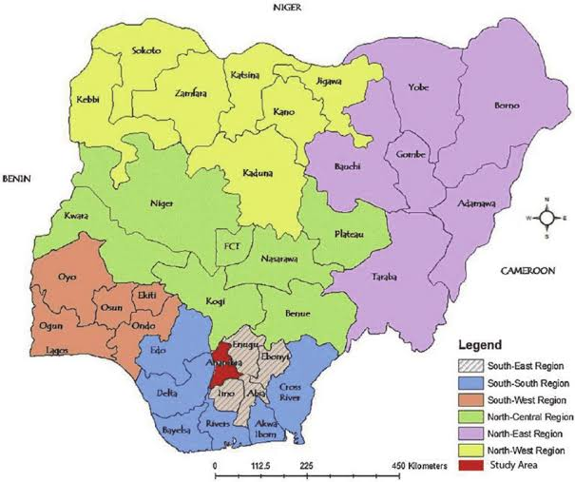
Map of Nigeria showing Anambra State

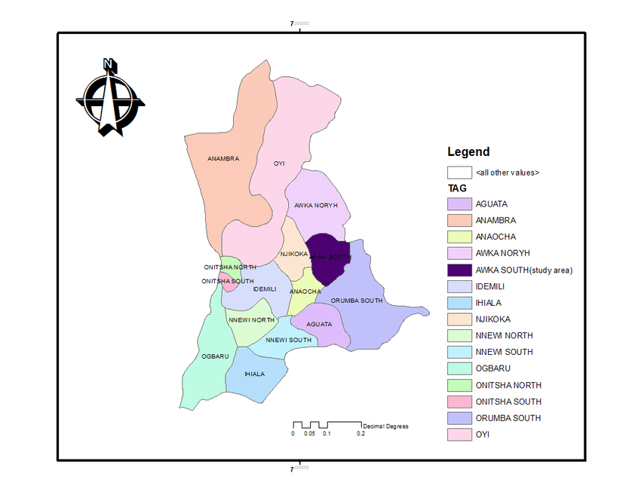
Map of Nigeria showing Awka South LGA (study area)

Awka South Local Government Area is located in the southeastern part of Nigeria and serves as the capital territory of Anambra State. It is characterized by a mix of urban and semi-urban settlements, including government institutions, markets, educational centers, and residential neighborhoods.
The area experiences high human and vehicular traffic, making it vulnerable to various forms of crime, including robbery and kidnapping. Its spatial complexity makes it suitable for GIS-based security analysis due to the dense road networks and expanding urban infrastructure (Adeboboye et al., 2026).
- Literature Review
- Concept of Banditry in Nigeria
Banditry refers to organized armed attacks involving kidnapping, robbery, and violent raids on communities. It has become one of the most pressing security challenges in Nigeria, driven by factors such as poverty, weak governance, and ungoverned spaces (Shola, 2022). Bandits often exploit difficult terrains and weak surveillance systems to carry out attacks and evade arrest.
- Surveying Applications in Security Management
Surveying applications involve the use of spatial technologies such as GIS, GNSS, and remote sensing to collect, analyze, and interpret geographic data. These tools are increasingly used in security and crime management.
GIS, in particular, enables the visualization of crime hotspots and spatial distribution of criminal activities. According to Longley et al. (2015), GIS provides a framework for integrating spatial and non-spatial data for decision-making in public safety.
Similarly, GNSS technologies, including GPS, allow real-time tracking of movement patterns, which can be used in monitoring suspect mobility and coordinating security operations (Usman et al., 2025).
- GIS and Crime Mapping
GIS-based crime mapping has become a global best practice in law enforcement. It allows police agencies to identify spatial clusters of crime and deploy resources accordingly.
In Nigeria, studies have shown that GIS applications improve urban safety by identifying crime-prone areas and optimizing police response routes (Adeboboye et al., 2026). For example, spatial analysis in Awka revealed disparities in police coverage across different neighborhoods, indicating the need for better spatial planning.
- GNSS/GPS in Crime Control
Global Positioning Systems (GPS) play a critical role in modern crime detection and prevention. GPS enables real-time tracking of vehicles, suspects, and criminal movements. Usman et al. (2025) found that GPS technology is effective in tracking armed bandits and supporting military operations in Nigeria.
In security operations, GPS data can be integrated with GIS platforms to provide a comprehensive spatial intelligence system.
- Theoretical Framework
This study is anchored on the Routine Activity Theory, which posits that crime occurs when a motivated offender, a suitable target, and the absence of capable guardians converge in time and space (Shola, 2022). GIS and surveying technologies enhance capable guardianship by improving surveillance and monitoring of spatial environments.

- Research Methodology
- Research Design
This study adopts a descriptive and analytical research design. It examines how surveying applications such as Geographic Information Systems (GIS), Global Navigation Satellite Systems (GNSS), and remote sensing can be applied in controlling banditry activities in Awka South LGA. The approach is qualitative in nature and relies heavily on secondary data sources.
- Data Sources
Data were obtained from:
- Published journal articles
- Government security reports
- Academic textbooks on GIS and criminology
- Case studies on crime mapping in Nigeria
- Reports from security agencies such as the Nigeria Police Force
- Analytical Framework
The study adopts a spatial crime analysis framework, which integrates GIS mapping, hotspot analysis, and predictive modeling. This framework allows crime data to be visualized geographically and analyzed for spatial patterns.
According to Chainey and Ratcliffe (2013), spatial crime analysis is essential for understanding crime distribution and improving policing efficiency.
- Surveying Applications in Crime Control
- Geographic Information Systems (GIS)
GIS is a computer-based system used to capture, store, analyze, and display spatial data. In crime control, GIS is used to map criminal incidents, identify hotspots, and analyze spatial trends.
In Awka South LGA, GIS can be used to:
- Map kidnapping-prone routes
- Identify robbery hotspots around banks and markets
- Monitor spatial distribution of crime incidents
- Support patrol route optimization
Longley et al. (2015) emphasize that GIS enhances decision-making by integrating spatial intelligence into policing systems.
- Remote Sensing Applications
Remote sensing involves acquiring information about the Earth’s surface without direct contact. Satellite imagery and aerial photography can be used to monitor terrain features that support criminal hideouts, such as forests, abandoned buildings, and isolated settlements.
In southeastern Nigeria, dense vegetation areas around urban fringes often serve as hideouts for criminals. Remote sensing helps in identifying and monitoring these areas.
- Global Navigation Satellite Systems (GNSS)
GNSS, including GPS, GLONASS, and Galileo, provides real-time positioning and tracking. In security operations, GNSS is used to:
- Track police patrol vehicles
- Monitor suspect movements
- Coordinate emergency response
- Provide real-time location intelligence
Usman et al. (2025) found that GPS tracking significantly improves operational efficiency in counter-banditry missions.

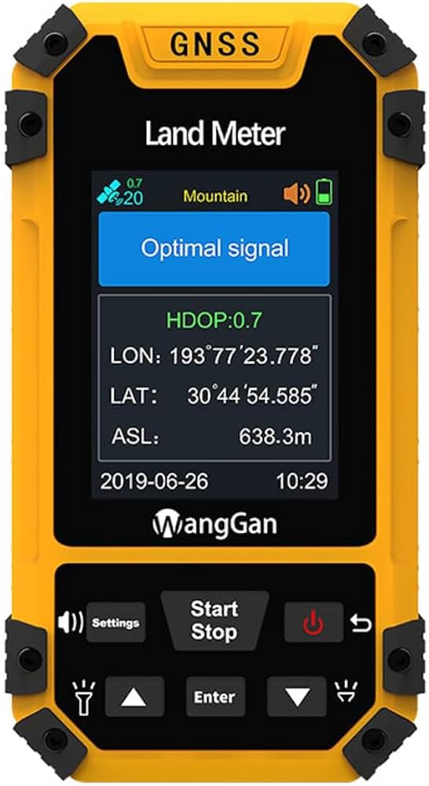

- Spatial Crime Analysis and Hotspot Detection
Crime hotspot analysis identifies areas with high concentrations of criminal activity. In Awka South, hotspots are often located around:
- Markets (e.g., Eke Awka area)
- Major highways and junctions
- University environments
- Poorly lit residential zones
Kernel density estimation (KDE) in GIS is commonly used to visualize these hotspots.
- Application of Surveying Tools in Awka South LGA
- Crime Mapping in Awka South
GIS-based crime mapping enables visualization of crime incidents across Awka South. This helps law enforcement agencies identify spatial clusters of banditry-related crimes.
A spatial analysis of urban crime patterns shows that incidents are not randomly distributed but concentrated in specific areas due to socioeconomic and environmental factors (Adeboboye et al., 2026).
- Surveillance and Patrol Optimization
Surveying technologies help optimize police patrol routes. Instead of random patrols, GIS-based systems allow:
- Strategic deployment of security personnel
- Route optimization based on crime density
- Real-time monitoring of patrol movement
This reduces response time and improves coverage efficiency.
- Predictive Policing
Predictive policing uses historical crime data and spatial modeling to forecast future crime occurrences. GIS tools analyze patterns to predict where banditry is likely to occur.
According to Ratcliffe (2016), predictive policing improves proactive law enforcement by enabling prevention rather than reaction.
- Emergency Response Management
GNSS and GIS integration support emergency response systems by:
- Locating victims quickly
- Guiding security forces to crime scenes
- Coordinating multi-agency response
This is particularly useful in kidnapping cases where time is critical.
- Challenges of Using Surveying Applications in Nigeria
Despite the benefits, several challenges limit the adoption of surveying technologies in crime control:
- Lack of Technical Expertise
Many security agencies lack trained GIS and GNSS specialists, limiting effective implementation.
- Inadequate Funding
Advanced spatial systems require significant investment in software, hardware, and training.
- Poor Data Availability
Crime data in Nigeria is often incomplete, inconsistent, or poorly digitized.
- Institutional Barriers
There is limited collaboration between surveying professionals and law enforcement agencies.
- Infrastructure Deficiency
Unreliable electricity and poor internet connectivity hinder real-time GIS operations.

- Conclusion
Surveying applications offer powerful tools for addressing banditry and other forms of violent crime in Awka South LGA. GIS, GNSS, and remote sensing technologies enhance spatial awareness, improve response efficiency, and support predictive policing strategies.
However, the effectiveness of these tools depends on proper integration, adequate funding, and institutional capacity building. If properly implemented, surveying technologies can significantly reduce crime rates and improve public safety in Anambra State.
- Recommendations
- Government should integrate GIS into police operational systems.
- Training programs should be introduced for law enforcement officers on spatial technologies.
- A centralized crime database should be developed for Awka South LGA.
- Investment in satellite and GPS infrastructure should be increased.
- Collaboration between surveying professionals and security agencies should be strengthened.
- Community reporting systems should be integrated with GIS platforms.

REFERENCES
Adeboboye, A. A., Ojo, O. O., & Nwokedi, I. C. (2026). Spatial analysis of urban crime patterns in southeastern Nigeria using GIS techniques. Journal of Environmental and Security Studies, 12(1), 45–62.
Chainey, S., & Ratcliffe, J. (2013). GIS and crime mapping. Wiley.
Ikezue, B. C., & Oli, N. P. (2020). Security challenges and crime patterns in Awka metropolis. African Journal of Social Sciences, 8(2), 101–115.
Longley, P. A., Goodchild, M. F., Maguire, D. J., & Rhind, D. W. (2015). Geographic information systems and science (4th ed.). Wiley.
Ratcliffe, J. H. (2016). Intelligence-led policing. Routledge.
Shola, O. (2022). Banditry and insecurity in Nigeria: Causes and implications. International Journal of Peace and Conflict Studies, 9(3), 88–104.
Usman, M. A., Bello, R., & Ibrahim, S. (2025). Application of GPS technology in counter-banditry operations in Nigeria. Journal of Security Technology, 5(1), 23–39.

