REIMAGINING MIXED METHODS RESEARCH IN NUTRITION EDUCATION: BRIDGING QUANTITATIVE EVIDENCE AND QUALITATIVE INSIGHTS

ABSTRACT
Introduction: Nutrition education plays a crucial role in promoting healthy eating habits, improving nutritional status, and preventing nutrition-related diseases. Traditional research has mainly relied on quantitative methods to assess knowledge, attitudes, and practices; however, these methods may not fully capture the social and behavioral factors influencing dietary choices. Mixed methods research integrates quantitative and qualitative approaches to provide a broader understanding of nutrition education outcomes. Aim and Objectives: This review aims to examine the importance of mixed methods research in nutrition education and its role in combining quantitative evidence with qualitative insights. The objectives are to explore its applications, identify opportunities and challenges, and discuss implications for future research. Review of Literature: Existing studies suggest that mixed methods research offers a comprehensive understanding of nutrition-related behaviors and educational interventions. Quantitative methods measure outcomes such as knowledge improvement and dietary changes, while qualitative methods provide insights into participants’ experiences, perceptions, and contextual influences. The integration of both approaches has been shown to strengthen intervention design and evaluation. Methodology: A narrative review was conducted using peer-reviewed journal articles, research reports, and scholarly publications related to mixed methods research in nutrition education. Relevant literature was analyzed to identify key themes and methodological trends. Results and Discussion: Findings indicate that mixed methods research enhances data triangulation, improves validity, and provides deeper insights into nutrition education outcomes. Challenges include methodological complexity, resource demands, and difficulties in data integration. Conclusion: Mixed methods research is a valuable approach for advancing nutrition education by combining numerical data with contextual understanding. It supports the development of effective, evidence-based interventions and contributes to addressing complex public health nutrition challenges.
Keywords: Mixed Methods Research, Nutrition Education, Quantitative Research, Qualitative Research, Evidence-Based Practice, Public Health Nutrition.

INTRODUCTION
Nutrition education is a key strategy in public health for promoting healthy dietary behaviors, preventing malnutrition, and reducing the burden of nutrition-related diseases. Effective nutrition education programs help individuals make informed food choices, improve nutritional status, and enhance overall health outcomes. Research in nutrition education has traditionally relied on quantitative methods such as surveys, questionnaires, and experimental studies to assess knowledge, attitudes, practices, and intervention outcomes.
Although quantitative approaches provide measurable and statistically significant results, they often fail to explain the underlying reasons behind behavioral changes or the contextual factors influencing dietary practices. Human eating behaviors are influenced by numerous social, cultural, economic, psychological, and environmental factors that cannot always be adequately captured through numerical data alone.
Mixed methods research has emerged as an innovative methodological approach that integrates both quantitative and qualitative research techniques. By combining numerical evidence with personal experiences and contextual insights, mixed methods research provides a more comprehensive understanding of nutrition education interventions and their effectiveness. This approach is increasingly recognized as valuable in addressing complex public health nutrition issues and improving evidence-based practice.
BACKGROUND OF THE STUDY
Nutrition education plays a vital role in promoting healthy dietary practices, preventing malnutrition, and improving overall health outcomes. Over the years, researchers have increasingly recognized that dietary behaviors are influenced not only by knowledge but also by social, cultural, environmental, and psychological factors. Consequently, understanding the effectiveness of nutrition education interventions requires a comprehensive research approach that can capture both measurable outcomes and human experiences.
Traditionally, nutrition education research has relied heavily on quantitative methods such as surveys, questionnaires, and experimental studies to assess changes in nutrition knowledge, attitudes, and dietary practices. While these methods provide valuable statistical evidence, they often fail to explain the underlying reasons behind behavioral changes or the contextual factors influencing individuals' food choices.
In recent years, mixed methods research has emerged as an important methodological approach in health and nutrition sciences. By integrating quantitative and qualitative data, mixed methods research enables researchers to obtain a more holistic understanding of nutrition-related behaviors and intervention outcomes. Quantitative findings provide objective measurements, whereas qualitative insights help explain participants’ perceptions, motivations, experiences, and barriers to change.
The growing complexity of public health nutrition challenges, including malnutrition, obesity, food insecurity, and lifestyle-related diseases, has increased the need for research approaches that combine numerical evidence with contextual understanding. Therefore, mixed methods research has gained considerable attention as a valuable strategy for designing, implementing, and evaluating nutrition education programs.
The present review explores the role of mixed methods research in nutrition education and highlights its contribution to bridging quantitative evidence and qualitative insights for improving evidence-based practice and public health nutrition outcomes.
AIM AND OBJECTIVES
Aim
To examine the importance of mixed methods research in nutrition education and explore its role in bridging quantitative evidence and qualitative insights.
Objectives
- To understand the concept and principles of mixed methods research.
- To review the applications of mixed methods approaches in nutrition education.
- To identify the opportunities and advantages of integrating quantitative and qualitative methods.
- To examine the challenges associated with mixed methods research.
- To discuss implications for future nutrition education research and practice.

REVIEW OF LITERATURE
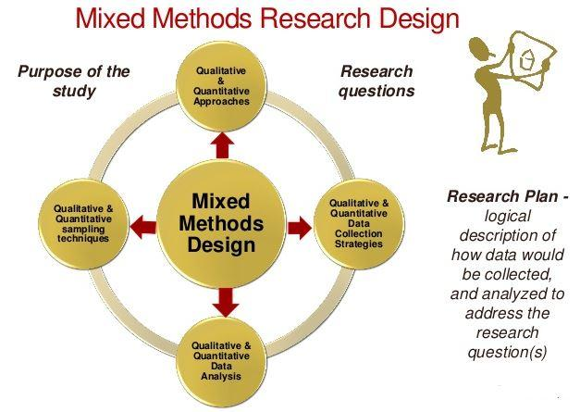
Concept of Mixed Methods Research

According to Creswell and Plano Clark (2018), mixed methods research integrates quantitative and qualitative approaches within a single study to provide a comprehensive understanding of research problems. Quantitative methods focus on numerical measurements and statistical analysis, while qualitative methods explore participants' experiences, perceptions, and contextual factors.
Importance of Mixed Methods in Nutrition Education
Contento (2016) emphasized that nutrition education involves complex behavioral, social, and cultural factors that cannot be fully understood through quantitative data alone. Mixed methods research enables researchers to assess measurable outcomes such as nutrition knowledge and dietary practices while also exploring participants' beliefs, attitudes, and barriers to behavior change.
Applications in Nutrition Education Research
Gibbs and Chapman-Novakofski (2012) reported that mixed methods approaches are increasingly used in nutrition education to evaluate intervention effectiveness and understand participant experiences. Studies in school nutrition programs, maternal and child nutrition, and community nutrition interventions have demonstrated the value of combining surveys, dietary assessments, interviews, and focus group discussions.
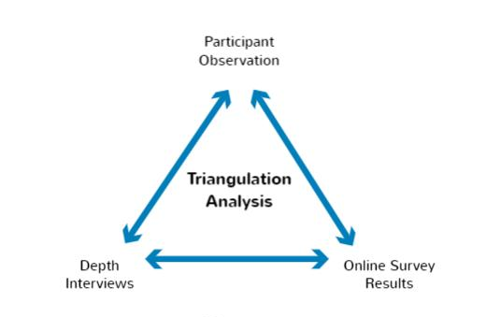
Opportunities Offered by Mixed Methods Research

Greene (2007) stated that mixed methods research enhances data triangulation and strengthens the validity of findings. The integration of quantitative and qualitative evidence provides a deeper understanding of nutrition-related behaviors and supports the development of effective nutrition education programs and policies.
Challenges in Mixed Methods Research
Tashakkori and Teddlie (1998) highlighted that mixed methods research requires expertise in both quantitative and qualitative methodologies. Additional challenges include increased resource requirements, complexity in data integration, and difficulties in interpreting findings from multiple data sources.
Methodology
This review paper adopted a narrative review approach to examine the role of mixed methods research in nutrition education. Relevant literature was collected from peer-reviewed journals, books, and research reports related to nutrition education and mixed methods research. The selected studies were reviewed and synthesized to identify key themes, opportunities, challenges, and future directions in the application of mixed methods approaches within nutrition education.
METHODOLOGY
This review paper adopted a review approach to examine the role of mixed methods research in nutrition education.
Sources of Data
Relevant literature was identified from:
- Peer-reviewed journal articles
- Academic textbooks
- Research reports
- Public health publications
- Nutrition education studies
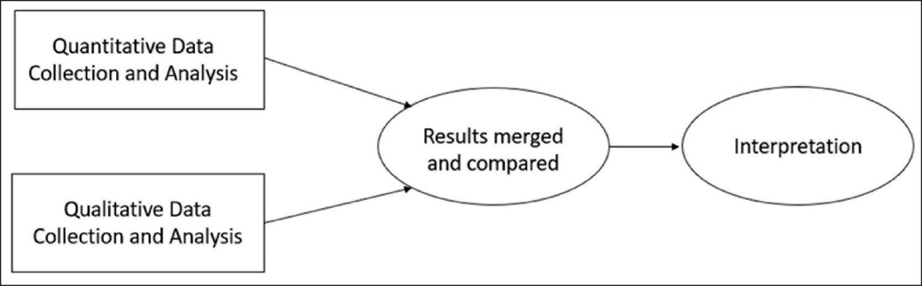
RESULTS AND DISCUSSION

The review demonstrates that mixed methods research offers significant advantages for nutrition education research. Quantitative methods provide objective evidence regarding intervention effectiveness through measurable indicators such as knowledge scores, dietary behaviors, nutritional status, and health outcomes. These methods support statistical analysis, comparison of results, and generalization of findings across populations.
Qualitative methods complement quantitative findings by exploring participants' experiences, perceptions, motivations, beliefs, cultural influences, and social contexts. Such information helps researchers understand why nutrition interventions succeed or fail and identifies barriers and facilitators that influence dietary behavior change. The inclusion of qualitative insights allows researchers to capture participant perspectives that may not be reflected in numerical data alone.
The integration of quantitative and qualitative findings strengthens data triangulation and enhances the validity and reliability of conclusions. Researchers are able to confirm findings through multiple sources of evidence, resulting in more robust and comprehensive interpretations. Mixed methods approaches also facilitate a deeper understanding of complex nutrition-related issues by combining measurable outcomes with contextual explanations.
Several studies reviewed reported improved understanding of nutrition education outcomes when mixed methods approaches were employed. This was particularly evident in maternal nutrition programs, community nutrition interventions, school-based nutrition education initiatives, and public health campaigns. The combination of surveys, dietary assessments, interviews, and focus group discussions provided a more complete evaluation of intervention effectiveness than either method alone.
The review further indicates that mixed methods research contributes to the development of more participant-centered nutrition education programs. Insights gained from qualitative findings help researchers modify educational strategies according to the needs, preferences, and cultural backgrounds of target populations. This enhances program acceptability, participant engagement, and long-term sustainability.
Another important finding is that mixed methods research supports evidence-based decision-making in public health nutrition. Policymakers and program planners can utilize both statistical evidence and participant experiences to design more effective interventions and allocate resources efficiently. The approach also improves monitoring and evaluation processes by providing comprehensive information on program implementation and outcomes.
In addition, mixed methods research encourages interdisciplinary collaboration among nutritionists, public health professionals, educators, behavioral scientists, and healthcare providers. Such collaboration contributes to the development of innovative and comprehensive strategies for addressing nutrition-related challenges.
However, methodological complexity remains a significant challenge. Researchers require specialized training in both quantitative and qualitative methodologies. Resource limitations, increased time requirements, and difficulties in integrating diverse datasets may hinder implementation. Challenges related to data interpretation, analysis, and reporting have also been identified in the literature.
Despite these challenges, the advantages of mixed methods research outweigh its limitations. The approach provides valuable insights into complex nutrition-related behaviors and supports evidence-based intervention development. Overall, the findings of this review suggest that mixed methods research is a powerful tool for advancing nutrition education research, improving intervention effectiveness, and addressing contemporary public health nutrition challenges.
CONCLUSION
Mixed methods research represents a powerful and innovative approach for advancing nutrition education research. By integrating quantitative evidence with qualitative insights, researchers can develop a deeper understanding of dietary behaviors, intervention outcomes, and contextual influences affecting nutrition practices.
The review highlights that mixed methods research enhances data validity, improves intervention evaluation, and supports evidence-based decision-making in public health nutrition. Although challenges such as methodological complexity and resource demands exist, the benefits of obtaining comprehensive and meaningful evidence make mixed methods research an essential tool for addressing contemporary nutrition challenges.
Future nutrition education research should encourage the wider adoption of mixed methods designs to strengthen scientific evidence, improve program effectiveness, and contribute to better health outcomes at individual and community levels.
REFERENCES
1. Creswell JW, Plano Clark VL. Designing and Conducting Mixed Methods Research. 3rd ed. Thousand Oaks, CA: Sage Publications; 2018.
2. Contento IR. Nutrition Education: Linking Research, Theory, and Practice. 3rd ed. Burlington, MA: Jones & Bartlett Learning; 2016.
3. Azzurra A, Penco L, et al. Evaluating a social marketing campaign on healthy nutrition and lifestyle among primary-school children: a mixed-method research design. Evaluation and Program Planning. 2021;89:101965.
4. Mostafavi F, Zamani-Alavijeh F, Mansourian M, et al. The promotion of healthy breakfast and snacks based on the social marketing model: a mixed-methods study. Journal of Health, Population and Nutrition. 2021;40:22.
5. Bharmal N, Beidelschies M, Alejandro-Rodriguez M, et al. A nutrition and lifestyle-focused shared medical appointment in a resource-challenged community setting: a mixed-methods study. BMC Public Health. 2022;22:447.
6. Gelman R, Whelan J, et al. Adoption, implementation, and sustainability of early childhood feeding, nutrition and active play interventions in real-world settings: a systematic review. International Journal of Behavioral Nutrition and Physical Activity. 2023;20:32.
7. Assilian T, Dehove H, Charreire H, et al. Improving student diet and food security in higher education using participatory and co-creation approaches: a systematic review. International Journal of Behavioral Nutrition and Physical Activity. 2024;21:71.
8. Muzaffar H, Difilipo KN, Fitzgerald N, et al. A systematic review of interventions to improve the diet of children. Journal of Public Health. 2024;34:53–69.
9. Wang A, Wan J, Zhang T, et al. Blended nutrition education with real-life scenarios enhances learning and nutritional counseling capabilities in nursing students. Scientific Reports. 2025;15:11570.
10. Wincie Wilmah A, Jaishree Karthiga RK. Indian teachers' and parents' perceptions and experiences of food and nutrition education in primary schools: a mixed-method study. Frontiers in Nutrition. 2025;12:1635389.

