INTEGRATING CANVA: IMPACT ON INSTRUCTIONAL MATERIALS DEVELOPMENT SKILLS ON BEED STUDENTS

Author’s Name and Email:

QAISNAYAH A. DATUMAN
qaisnayahdatuman2003@gmail.com

NOR-AIN M. ABDULLAH
dakotawp43@gmail.com

FEB YVONNEY M. MATUGAS, MA
febyvonney@gmail.com

SETTIE-ZHYMAH S. PADATE
alradjiepadate@gmail.com

NAJEB B. ALOYOD
najebaloyod@gmail.com

MINDANAO STATE UNIVERSITY- SULTAN NAGA DIMAPORO

ABSTRACT
Despite the availability of various digital design tools, many students continue to depend on traditional methods in creating instructional materials, which restricts their creativity and digital proficiency. This reveals a gap in teacher education, particularly in effectively integrating Canva to enhance pre-service teachers’ instructional materials development skills. To address this concern, the study investigated the impact of Canva integration on students’ ability to design and develop instructional materials. A developmental research design was utilized, which involved a two-day workshop and the administration of pre-survey, post-survey, pre-test, and post-test instruments to measure students’ perceptions and performance. The study was conducted among twenty-eight (28) third-year BEEd students from Mindanao State University–Sultan Naga Dimaporo during the Academic Year 2025–2026. Results indicated that although students had prior experience using Canva, their perception and performance improved significantly after the intervention. Statistical analysis using the Wilcoxon Signed Rank Test revealed a significant difference between pre-survey and post-survey scores, resulting in the rejection of the null hypothesis. Similarly, pre-test results showed moderate achievement, while post-test results were rated highly achieved. The Paired T-test further confirmed a significant difference between pre-test and post-test scores. These findings demonstrate that Canva integration effectively enhances creativity, digital competence, and instructional materials development among future educators.

Keywords: Canva, Instructional Materials, Development Skills, BEEd Students

- Introduction
In recent years, the integration of digital tools in education has transformed traditional teaching and learning practices, offering new opportunities for enhancing student engagement and academic achievement. In classrooms, students and teachers use graphic media (textbooks, pictures), video media (educational videos), Power Point presentations, and display media (boards) to enhance learning through visual aids, audiovisual content, interactive lessons, and student engagement (Andriani, 2022; Roistika, 2021; Shalawati et al., 2022; Wulandari, 2020).
Canva has become a popular digital tool in education, known for its user-friendly interface that allows users to create visually appealing materials effortlessly. This web-based graphic design platform offers a wide range of templates, making it versatile for producing various educational materials (Firdayanti et al., 2024; Pedroso et al., 2023; Zahroh & Febrianingrum, 2023). As an online design application, Canva serves as an effective learning media tool. It enables users to create diverse visual content, including text, videos, animations, audio, images, and graphics, all of which can significantly enhance the learning experience (Salminawati et al., 2023; Fitria, 2022; Santiana et al., 2021).
The user-friendly interface, diverse templates, and accessible tools of Canva enable students to create professional-quality designs without extensive prior experience. This accessibility fosters creativity and skill development, as students feel more competent and confident in their design capabilities (Nur Rahma & Bagus, et al, 2024) .
The study by Nur Aini and Suwandi (2024) explores students’ perceptions of the effectiveness of writing procedural texts, offering valuable insights into how learners view this specific writing genre. However, a notable research gap exists in that the study focuses solely on subjective perceptions without assessing actual improvements in students' writing performance. This creates a disconnect between how effective students feel the process is and how effective it actually is in enhancing their skills. Additionally, the study's narrow focus on procedural texts limits its applicability to broader writing competencies, neglecting other important genres such as narrative, descriptive, or argumentative texts. The research also appears to be context-specific, which raises concerns about its generalizability across different educational levels or cultural settings. Furthermore, the study does not incorporate teacher perspectives or examine the instructional methods used, missing an opportunity to align students' perceptions with pedagogical strategies. Lastly, it does not explore the role of digital tools or innovative teaching methods in supporting procedural text writing, an increasingly relevant area in modern education.

These gaps highlight the need for more comprehensive research that includes objective performance data, broader genre coverage, varied educational contexts, and the integration of technological and pedagogical advancements and there is no researchers that explore the use of the Canva App in this context. Specifically on Integrating Canva; in the instructional materials development skills of the students. Thus, the primary goal of this study is to investigate the impact of integrating Canva into the instructional design practices of Bachelor of Elementary Education.
This study explored the impact of Canva on the instructional materials development practices of third-year Bachelor of Elementary Education students. Specifically, it examined the respondents’ perceptions regarding the development of instructional materials, evaluated the quality of the instructional materials they created using Canva, and measured their level of instructional materials development skills through pre-test and post-test scores, thereby providing a comprehensive understanding of Canva’s role in enhancing instructional materials development skills.

- Research Objective
This study aimed to investigate the impact of integrating Canva as instructional design practices of Bachelor of Elementary Education students of Mindanao State University- Sultan Naga Dimaporo. Specifically, this study sought to determine the perceptions of the respondents regarding Canva; evaluate the instructional materials developed; assess the respondents’ level of instructional materials development skills as measured by pre-test and post-test scores; determine if there is significant difference between the respondents’ pre-survey and post-survey perceptions regarding the development of instructional materials; determine if there is a significant difference between the respondents’ pre-test and post-test scores in instructional materials development skills; and propose a backup plan that BEEd students can use to continue developing quality instructional materials and ensure the effectiveness of Canva integration.

- Hypotheses
This study proposed that there is no significant difference between the pre-survey and post-survey scores perceptions of the respondents and there is no significant difference between the pre-test and post-test scores of the respondents instructional materials development skills.

- Theoretical Framework
This study is anchored on the following theories; Multimedia Learning Theory (Mayer, 2001); Vygotsky’s Zone of Proximal Development (ZPD); Cognitive Load Theory by John Sweller (1988); and Constructivist Learning Theory (Piaget, 1936). The Multimedia Learning Theory (Mayer, 2001) posits that students learn more effectively when information is presented through a combination of words and images rather than text alone. Mayer highlights that dual-channel processing visual (images, graphics) and auditory (spoken or written words) enhances knowledge retention and understanding. Canva as a multimedia design tool, enables BEEd students to combine text, images, videos, and graphics to create visually rich instructional materials. This theory provides a foundation for understanding how Canva supports BEEd students in producing dynamic, learner-centered instructional materials by integrating various multimedia elements such as text, visuals, audio, and interactive graphics to enhance teaching effectiveness.
In addition, Vygotsky’s Zone of Proximal Development (ZPD) supports this perspective by emphasizing the importance of guided learning and social interaction in helping learners reach higher levels of understanding. Within the ZPD, learners can perform tasks with the assistance of more knowledgeable others such as peers, mentors, or instructors which facilitates cognitive development. When using Canva, BEEd students can work collaboratively, receive scaffolding, and engage in peer feedback while designing instructional materials. This aligns with the principles of the ZPD, as Canva becomes not just a design tool but also a medium for collaborative learning and guided practice.
The theory supports the idea that using Canva can enhance students’ ability to develop engaging materials that improve knowledge retention and comprehension among learners.
The theory Cognitive Load Theory (Sweller, 1988) suggests that learning is most effective when instructional materials are designed in a way that minimizes unnecessary cognitive effort. Canva helps reduce extraneous cognitive load by providing pre-designed templates, structured layouts, and easy-to-use tools, allowing BEEd students to focus on the quality of their teaching content rather than struggling with complex design processes. This theory help in use to explain how Canva helps students design more effective and user-friendly instructional materials by analyzing the way information is presented.
The theory emphasizes the importance of reducing unnecessary mental effort to optimize learning. Canva helps organize information clearly through templates and visuals, potentially lowering extraneous cognitive load and improving the overall quality and clarity of instructional materials.
The theory Constructivist Learning Theory (Piaget, 1936; Vygotsky, 1978) emphasizes that students construct their own knowledge through active engagement, experience, and interaction. Piaget (1936) and Vygotsky (1978) suggest that learning is most effective when individuals actively participate in the learning process rather than passively receiving information.
Canva encourages active learning by allowing BEEd students to experiment with design, layout, and content creation. Instead of relying on pre-made instructional materials, students develop their own teaching aids, fostering creativity, critical thinking, and problem-solving skills. This theory helps as the use of Canva enables students to construct ideas, to design materials that are relevant to real classroom settings, such as lesson plans, worksheets, and interactive learning aids, making learning more meaningful and practical.
This theory argues that learners actively construct their own understanding through experience and interaction students use Canva to develop teaching materials, they engage in an active, creative process of constructing knowledge. They must evaluate content, choose appropriate media, and reflect on instructional goals promoting deeper understanding and the development of practical teaching skills.

- Research Methodology
The study employed developmental research design, developmental research is particularly important in the field of instructional technology (Rita, 1994). This design was deemed appropriate in determining the impact of utilizing Canva on the instructional materials development skills of third-year Bachelor of Elementary Education students.
The respondents of this study were third year BEEd students of MSU-SND who are officially enrolled during the Academic Year 2025-2026. The researchers used purposive sampling technique, selecting participants who were most relevant to the objectives of the study. Third-Year BEEd students were chosen because they are on the stage of their program where they begin preparing instructional materials as part of their teaching demonstration and in preparation for their pre-service teaching. Data were collected through pre-survey and post-survey questionnaires, pretest and posttest assessments. Additionally, a rubric was used to evaluate the respondents developed instructional materials for data collection. The researchers asked for approval from the Campus Research Ethics Committee (CREC). They made permission letters addressed to the Dean, College Chairperson, and Department Coordinator. To assess the reliability of the questionnaire, a pilot test was done beforehand. The study conducted a two-day training on utilizing Canva. The researchers decided to invite their resource person for effective and quality training.
On August 14, 2025, a day before conducting the study, the researchers administered pre-survey questionnaires to the respondents to assess their perception on utilizing Canva. Additionally, the respondents presented their Traditional Instructional materials.
The study utilized the JAMOVI statistical tool to analyze the collected data and ensure accurate interpretation of results. Various methods were applied, including the weighted mean to assess respondents’ perceptions of Canva based on Likert-scale indicators, and the mean to determine the average pre-test and post-test scores of the developed instructional materials. Cronbach’s Alpha was used during pilot testing to establish the reliability and validity of the questionnaire. To examine differences within the same group, the Wilcoxon Signed-Rank Test was employed for pre-survey and post-survey comparisons, while the paired t-test was used to identify significant differences between pre-test and post-test scores. A normality test was also conducted to determine whether the data followed a normal distribution, and thematic analysis was applied to interpret qualitative responses from the participants.

- Research findings
4.1 Perceptions of the Respondents
4.1.1 Perceptions of the Respondents Before the Training
Table 4.1 presents the weighted mean of the respondents’ perception regarding the development of instructional materials before using Canva. The results reveal a grand weighted mean of 2.65, interpreted as Effective, indicating that most respondents had a positive perception of Canva in developing instructional materials.
Respondents who rated as effective to the following indicators: I need minimal assistance when using Canva for educational content (3.14); Canva is an effective tool for BEEd students in instructional materials development (2.78); I am satisfied with Canva’s capabilities for my academic needs (2.75); I would recommend Canva to other education students for creating instructional materials (2.75); Canva is accessible and convenient for school-related design tasks (2.75); Canva enhances the overall quality of my instructional materials (2.71); Using Canva helps me organize content in a visually engaging way (2.71); I feel more confident presenting lessons with Canva-designed materials (2.67), Canva helps me develop creativity in designing teaching materials (2.67); I have improved my instructional design skills through Canva (2.67); Canva enhances their confidence, creativity, and design skills. Canva saves me time in developing visual learning resources (2.64); Canva has contributed to my growth as a future educator (2.60); I prefer using Canva over traditional methods like hand-drawn or printed materials (2.60); Canva’s tools and features are simple to understand and use (2.57); I can work on my instructional materials anytime and anywhere using Canva (2.53); I find Canva easy to navigate when creating instructional materials (2.53); The availability of templates and graphics in Canva makes content creation easier (2.53). Meanwhile, the indicators interpreted as Slightly Effective were the following indicators: Canva’s collaborative features help me work better with peers on group projects (2.50); My layout and content planning skills have improved with Canva use (2.46); and Canva improves my ability to communicate lessons effectively through visuals (2.39), which received the lowest mean scores among all indicators. This implies that Canva is not only effective in boosting student motivation and participation, but also plays a significant role in enhancing their ability to develop instructional materials an essential skill for future educators.
According to studies by Nanda & Fatimah (2023) and Utami (2021), students who used Canva in their learning activities, such as English language learning or writing classes, reported higher levels of interest and enthusiasm. The platform's interactive and visually appealing features, such as its easy-to-use templates and design tools, encouraged students to actively participate in their assignments. This increased engagement led to a more dynamic and enjoyable learning experience, which in turn helped improve their academic performance. Moreover, Canva provides an opportunity for students to showcase their work in creative ways, further stimulating their enthusiasm for the subject matter.

Table 4.1 Weighted Mean of the Perception of the Respondents Before
Using Canva (n=28).
INDICATORS | WEIGHTED MEAN | VERBAL INTERPRETATION
1. I find Canva easy to navigate when creating instructional materials. | 2.53 | Effective
2. Canva’s tools and features are simple to understand and use. | 2.57 | Effective
3. I need minimal assistance when using Canva for educational content. | 3.14 | Effective
4. Canva saves me time in developing visual learning resources. | 2.64 | Effective
5. Canva enhances the overall quality of my instructional materials. | 2.71 | Effective
6. Using Canva helps me organize content in a visually engaging way. | 2.71 | Effective
- Canva improves my ability to communicate lessons effectively through visuals. | 2.39 | Slightly Effective
- I feel more confident presenting lessons with Canva-designed materials. | 2.67 | Effective

Table 4.1 (Continued) Weighted Mean of the Perception of the Respondents
Before using Canva (n=28).
9. Canva helps me develop creativity in designing teaching materials. | 2.67 | Effective
10. I have improved my instructional design skills through Canva. | 2.67 | Effective
11. Canva has contributed to my growth as a future educator. | 2.60 | Effective
12. My layout and content planning skills have improved with Canva use. | 2.46 | Slightly Effective
13. Canva is accessible and convenient for school-related design tasks. | 2.75 | Effective
14. I can work on my instructional materials anytime and anywhere using Canva. | 2.53 | Effective
15. The availability of templates and graphics in Canva makes content creation easier. | 2.53 | Effective
16. Canva's collaborative features help me work better with peers on group projects. | 2.50 | Slightly Effective
17. Canva is an effective tool for BEEd students in instructional materials development. | 2.78 | Effective
18. I am satisfied with Canva’s capabilities for my academic needs. | 2.75 | Effective
19. I prefer using Canva over traditional methods like hand-drawn or printed materials. | 2.60 | Effective
20. I would recommend Canva to other education students for creating instructional materials. | 2.75 | Effective
Grand Weighted Mean | 2.65 | Effective
4.1.2 Perceptions of the Respondents After the Training
Table 4.2 presents the grand weighted mean of 3.78 which interpreted as highly effective of the respondents’ perception regarding the development of instructional materials after the training. All indicators were rated as highly effective: Canva is an effective tool for BEEd students in instructional materials development (4.00); Canva helps me develop creativity in designing teaching materials (3.92); Using Canva helps me organize content in a visually engaging way (3.92); I find Canva easy to navigate when creating instructional materials (3.89); Canva has contributed to my growth as a future educator (3.89); I would recommend Canva to other education students for creating instructional materials (3.85); I feel more confident presenting lessons with Canva-designed materials (3.82); Canva improves my ability to communicate lessons effectively through visuals (3.82); Canva saves me time in developing visual learning resources (3.82), My layout and content planning skills have improved with Canva use (3.82); Canva's collaborative features help me work better with peers on group projects (3.82); Canva’s tools and features are simple to understand and use (3.78); Canva is accessible and convenient for school-related design tasks (3.78); The availability of templates and graphics in Canva makes content creation easier (3.78); Canva enhances the overall quality of my instructional materials (3.78); I prefer using Canva over traditional methods like hand-drawn or printed materials (3.75); I am satisfied with Canva’s capabilities for my academic needs (3.75); I have improved my instructional design skills through Canva (3.71); I can work on my instructional materials anytime and anywhere using Canva (3.50); and I need minimal assistance when using Canva for educational content (3.32).
The findings of this study imply that integrating Canva in instructional materials development can effectively enhance the creativity, skills, and confidence of Bachelor of Elementary Education students in designing teaching resources. As supported in the study of Utami, et al (2021) and Autila, (2022) which demonstrated Canva’s role in increasing student motivation, interest, and engagement, this study highlights that Canva not only serves as a visual and interactive platform for language learning but also as a powerful tool in developing instructional materials for future teachers. The use of Canva allowed students to transform traditional instructional resources into more innovative, visually appealing, and learner-centered outputs, making classroom instruction more engaging and effective.
The impact of this study extends to both preservice teachers and the teaching profession. More broadly, this research underscores that technology integration fosters a positive learning environment, supports differentiated instruction, and contributes to improved learning outcomes by making instructional materials more interactive and accessible.

Table 4.2 Weighted Mean of the Perception of the Respondents After using
Canva (n=28).
INDICATORS |  |  | WEIGHTED MEAN | VERBAL INTERPRETATION
- Canva helps me develop creativity in designing teaching materials. |  |  | 3.92 | Highly Effective
- I can work on my instructional materials anytime and anywhere using Canva. |  |  | 3.50 | Highly Effective
- I prefer using Canva over traditional methods like hand-drawn or printed materials. |  |  | 3.75 | Highly Effective
4. I feel more confident presenting lessons with Canva-designed materials. |  |  | 3.82 | Highly Effective
5. Canva is an effective tool for BEEd students in instructional materials development. |  | 4 |  | Highly Effective
6. I need minimal assistance when using Canva for educational content. |  | 3.32 |  | Highly Effective
7. Canva improves my ability to communicate lessons effectively through visuals. |  | 3.82 |  | Highly effective
8. Canva saves me time in developing visual learning resources. |  | 3.82 |  | Highly Effective
9. Canva’s tools and features are simple to understand and use. |  | 3.78 |  | Highly Effective
10. My layout and content planning skills have improved with Canva use. |  | 3.82 |  | Highly Effective
11.Canva is accessible and convenient for school-related design tasks. |  | 3.78 |  | Highly Effective
12. I find Canva easy to navigate when creating instructional materials. |  |  | 3.89 | Highly Effective
13. The availability of templates and graphics in Canva makes content creation easier. |  |  | 3.78 | Highly Effective
14. Canva enhances the overall quality of my instructional materials. |  |  | 3.78 | Highly Effective
15. I am satisfied with Canva’s capabilities for my academic needs. |  |  | 3.75 | Highly Effective
16. Canva's collaborative features help me work better with peers on group projects. | 3.82 |  |  | Highly Effective
17. Using Canva helps me organize content in a visually engaging way. | 3.92 |  |  | Highly Effective
18. Canva has contributed to my growth as a future educator. | 3.89 |  |  | Highly Effective
19. I have improved my instructional skills through Canva. | 3.71 |  |  | Highly Effective
20. I would recommend Canva to other education students for creating instructional materials. | 3.85 |  |  | Highly Effective
Grand Weighted Mean | 3.78 |  |  | Highly Effective
Table 4.2 (Continued) Weighted Mean of the Perception of the Respondents
After Using Canva (n=28).

4.2 Respondents’ Developed Instructional Materials

4.2.1 Before Canva Utilization
Group 1 presented the topic “Mahahalagang Pansariling Gamit sa Araw-araw” intended for Grade 2 learners. They began the discussion with a short motivation activity using traditional Instructional Materials (IMS), such as picture cards and visual aids showing common personal items like a toothbrush, soap, towel, and clothes. These visual tools helped capture learners’ attention and support understanding. The group discussed the importance of keeping these items clean and using them properly as part of good hygiene and self-care habits. Each member took turns explaining the items and facilitated engagement through simple questioning and hands-on demonstration. Overall, their presentation was clear, organized, and suitable for the learners’ level, effectively using IMS to emphasize cleanliness and responsibility in daily life.
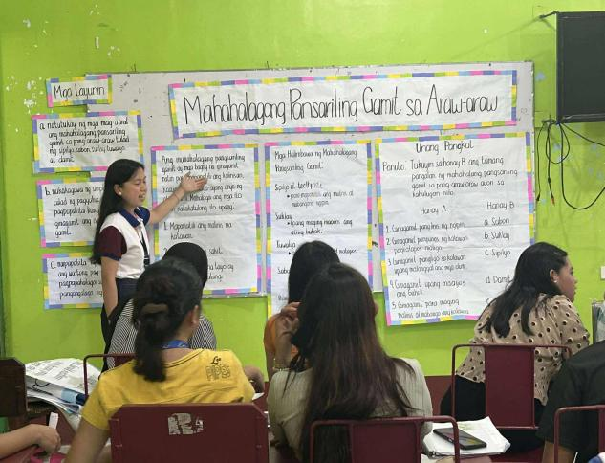
Figure 4.1 Traditional Instructional Materials Developed (Group 1)
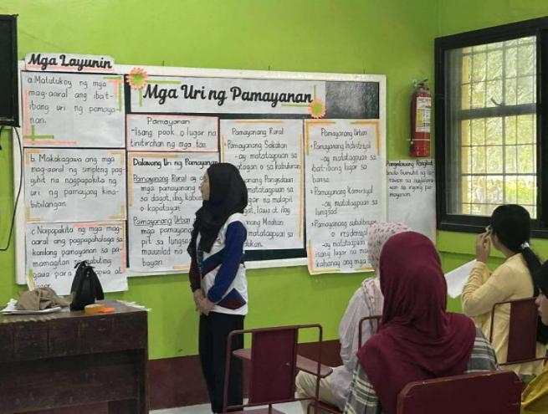
Group 2, on the other hand, presented the topic “Mga Uri ng Pamayanan” for Grade 2, Quarter 1. They began their presentation by asking the class about the kind of community they live in, which served as an effective motivation activity leading to an introduction of the three types of communities: rural, urban, and suburban. The group used various Instructional Materials (IMS), such as picture cards and visual charts to illustrate the unique characteristics of each community, including common occupations, types of houses, and familiar places. Their presentation was interactive, with simple questioning and guided sharing that encouraged learners to relate the lesson to their own environment. Overall, the use of IMS made the discussion clear, engaging, and age-appropriate, helping learners understand how communities differ from one another.
Figure 4.2 Traditional Instructional Materials Developed (Group 2)
Group 3 presented the topic “Pagkilala sa Heograpiya ng Lanao del Norte” intended for Grade 3, Quarter 3. The group began the discussion by describing the province’s geographical features, including its mountains, rivers, coastal areas, capital, and neighboring provinces. They also emphasized Lanao del Norte’s rich natural resources and the common livelihoods of its people. To support the lesson, the group used various Instructional Materials (IMS) such as maps, labeled images, and visual charts, which helped clarify the locations and key features being discussed. They made the presentation more interactive by asking simple questions that encouraged learners to recall familiar places within their own community.
The combination of visuals and clear explanations enabled learners to better understand the geography of Lanao del Norte and appreciate its beauty and importance.

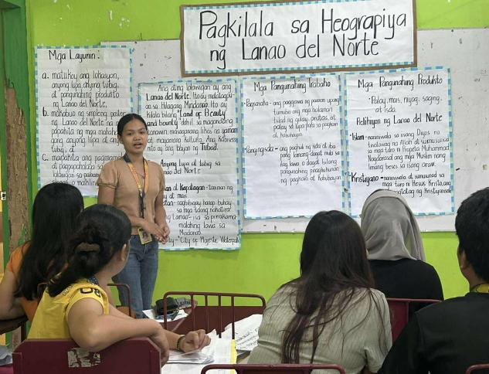
Figure 4.3 Traditional Instructional Materials Developed (Group 3)
Meanwhile, Group 4 presented the topic “Mga Tradisyon, Paniniwala, at Pagdiriwang ng Rehiyon X” for Grade 4, Quarter 2. They began by introducing the provinces that make up Region X and giving an overview of its cultural diversity. The group explained various traditions, beliefs, and celebrations observed in the region, including local festivals, religious practices, and community gatherings. To make their discussion engaging, they used Instructional Materials (IMS) such as pictures of popular festivals, to visualize the cultural practices being discussed. They also emphasized the importance of respecting and preserving the region’s unique cultural heritage. The presentation was lively, well-prepared, and successfully captured the interest of the learners.

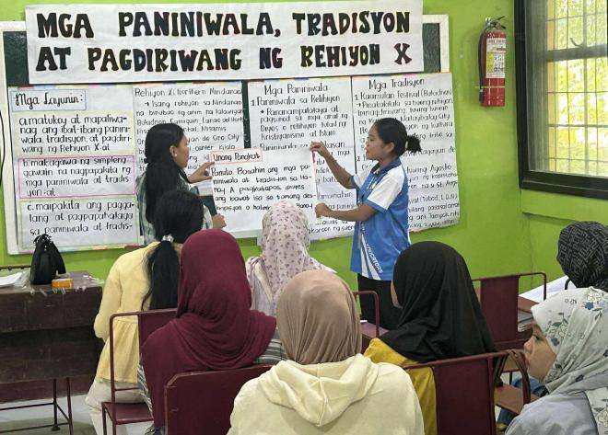
Figure 4.4 Traditional Instructional Materials Developed (Group 4)
Group 5 presented the topic “Ang Kahalagahan ng Katangiang Pisikal ng Bansa” intended for Grade 4, Quarter 3. The group explained how physical characteristics influence people’s way of life, livelihood, and culture. To support their discussion, they used Instructional Materials (IMS) such as visual aids, labeled images, and simple graphic organizers to help learners understand the importance of mountains, rivers, and plains in daily living. They also engaged the class through a short question-and-answer activity that assessed learners’ understanding of how geography affects human activities. Overall, the presentation was informative, clear, and effectively highlighted the importance of appreciating the country’s natural features.
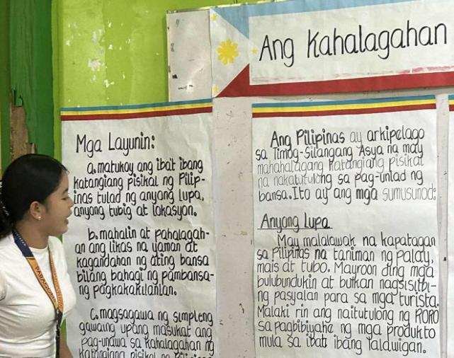
Figure 4.5 Traditional Instructional Materials Developed (Group 5)
On the other hand, Group 6 presented the topic “Pamumuhay ng Sinaunang Pilipino” for Grade 5, Quarter 1. They began by discussing how early Filipinos lived before Spanish colonization, focusing on their clothing, houses, livelihood, beliefs, and social organization. The group used Instructional Materials (IMS) such as pictures, charts, and illustrated timelines to show how ancient Filipinos farmed, fished, traded, and governed their communities. These visual tools helped the learners clearly see the differences and similarities between past and present ways of living. The group’s presentation was creative, well-researched, and effectively connected the lifestyle of early Filipinos to modern Filipino culture.

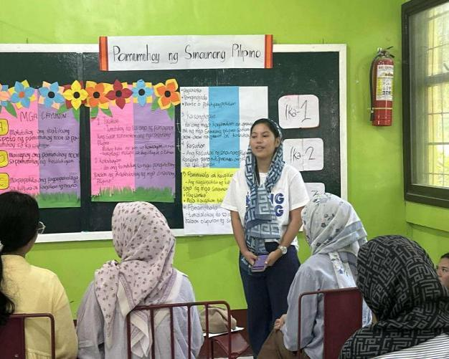
Figure 4.6 Traditional Instructional Materials Developed (Group 6)

Group 7 presented the topic “Mga Teoryang Pinagmulan ng Lahing Pilipino” intended for Grade 5, Quarter 1. The group began their presentation by discussing early human migration and showing maps and illustrated visuals to help learners understand how early people traveled and settled in different regions. They also used Instructional Materials (IMS) such as pictures and comparative charts to introduce the early groups that settled in the Philippines, including the Negritos, Indones, and Malays. Each group was explained in terms of their unique characteristics and contributions to Filipino ancestry. The presentation was organized, informative, and supported by clear visuals that helped learners grasp the different theories of Philippine origin.

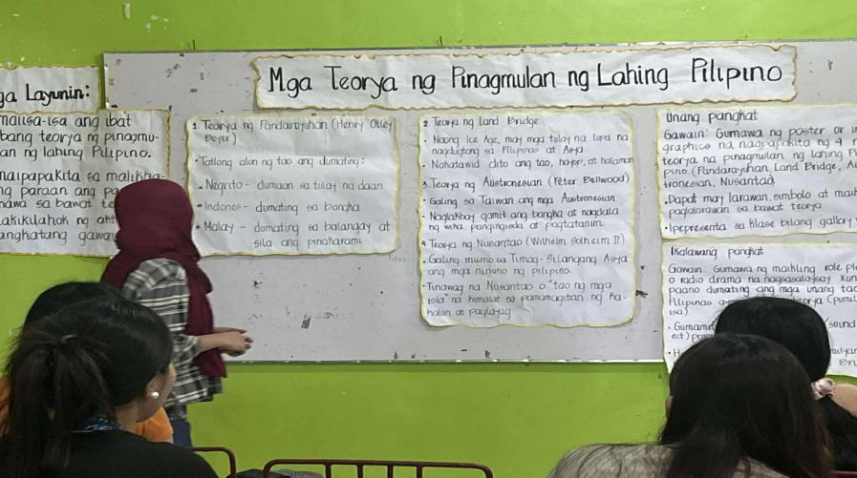
Figure 4.7 Traditional Instructional Material Developed (Group 7)
The presenters encouraged participation by asking the class questions after every theory discussed, helping learners recall important details and reflect on the origins of the Filipino people. Their discussion was well-organized, factual, and easy to understand, which made complex historical concepts accessible to Grade 5 learners. Overall, the presentation was informative and effectively deepened the learners’ understanding of how the Filipino race evolved based on different historical and anthropological perspectives.

4.2.2 After Canva Utilization and Presentation of Output
Group 1 presented the topic “Mahahalagang Pansariling Gamit sa Araw-araw” intended for Grade 2 learners. The group utilized Canva to design their instructional material, incorporating colorful layouts and clear visuals of common personal items such as toothbrush, soap, and clothing. Their presentation focused on teaching the importance of cleanliness, hygiene, and responsibility in daily life. Each member confidently explained the use and purpose of every personal item, ensuring that the content was appropriate and engaging for young learners.

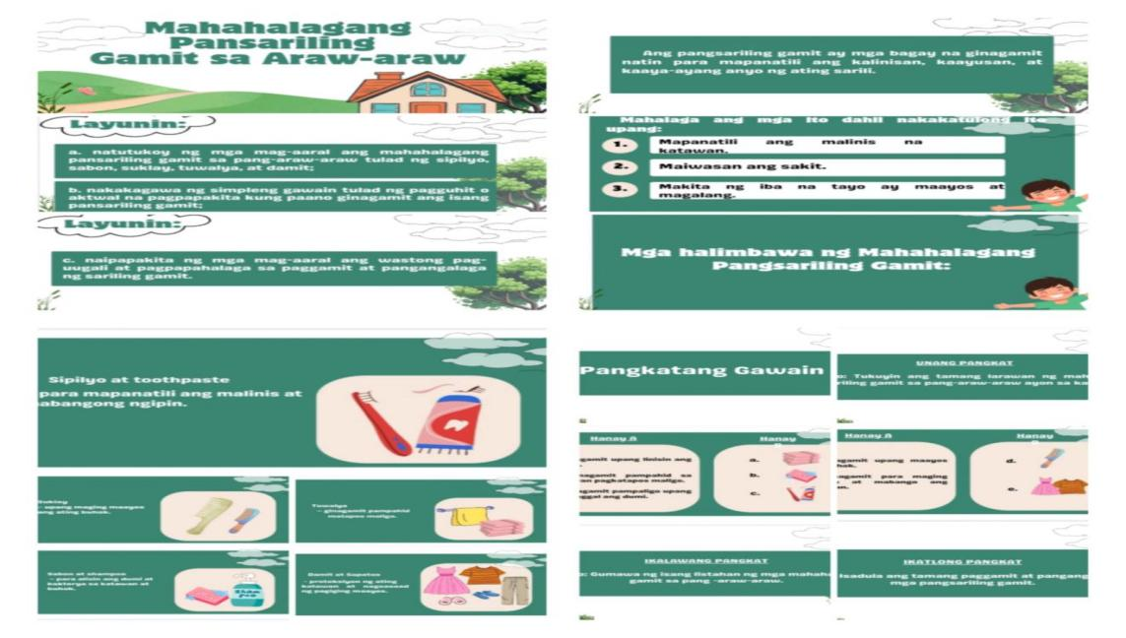
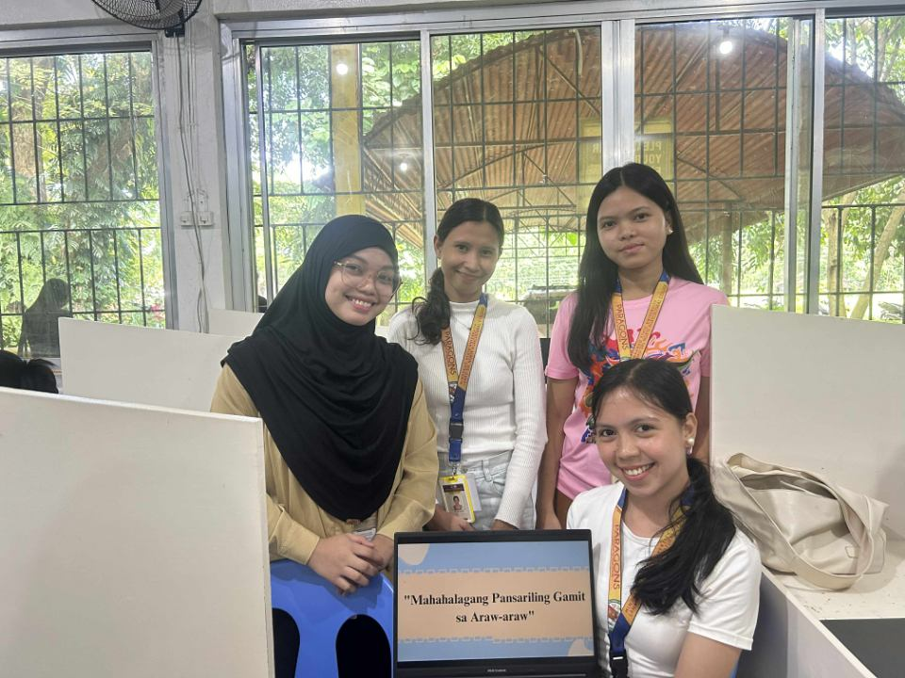
Figure 4.8 Instructional Materials developed using Canva (Group 1)
Group 2 also used Canva in creating their instructional material, which featured vibrant images and neatly arranged text that captured the learners’ attention. Their topic emphasized the significance of everyday materials and activities in students’ lives. The group’s presentation was interactive, and each member took turns in discussing key points, showing preparedness and teamwork. They maximized Canva’s features to enhance visual communication, making the lesson more dynamic and student-centered.
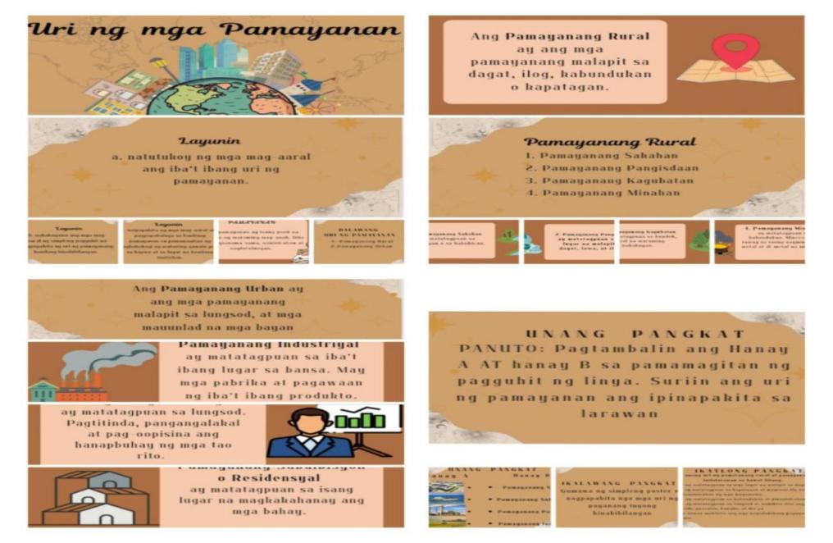
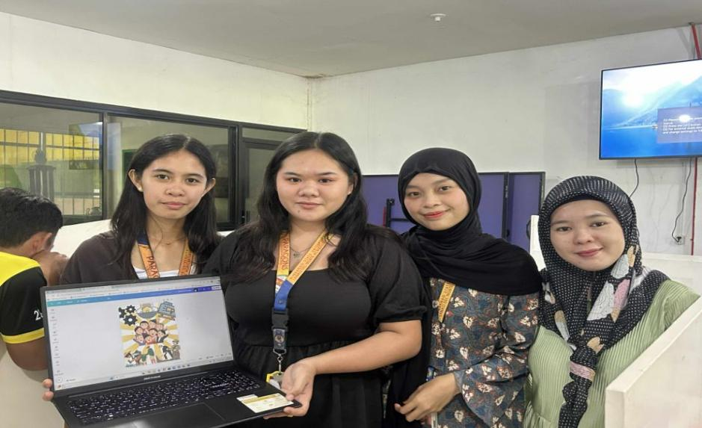
Figure 4.9 Instructional Materials Developed using Canva (Group 2)

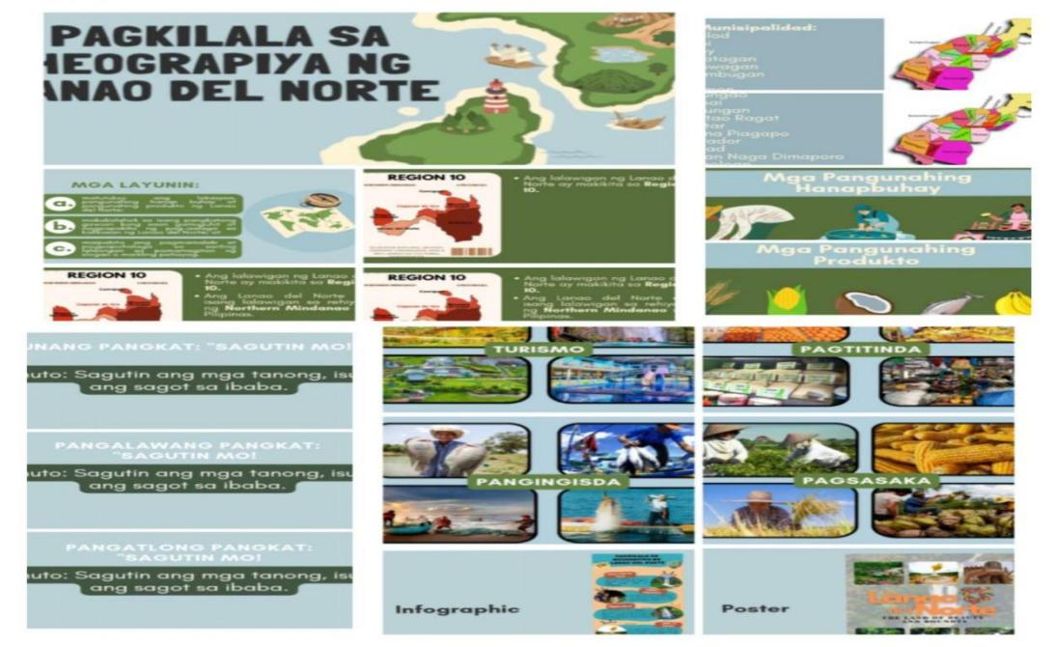
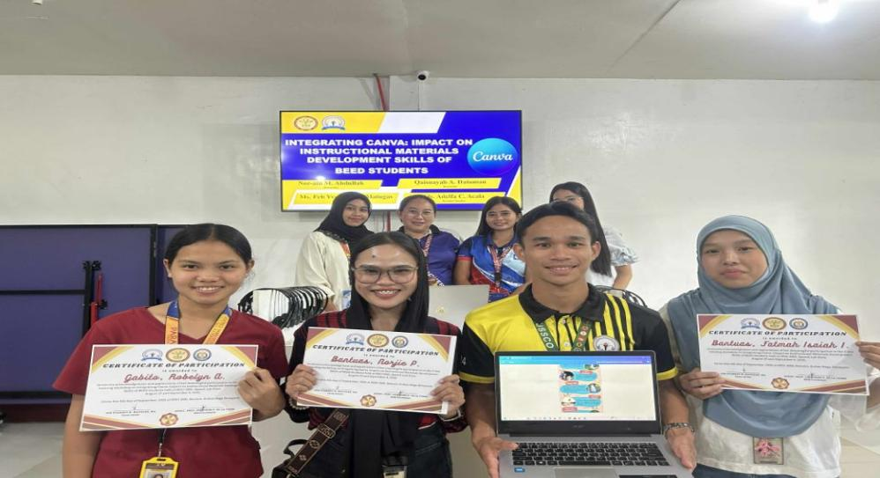
Figure 4.10 Instructional Materials developed using Canva (Group 3)
The Group 3 utilized Canva to design an attractive and organized instructional material that demonstrated their creativity and mastery of digital tools. Their presentation highlighted how Canva can be used to produce visually engaging learning materials suitable for elementary learners. Each member confidently explained the purpose and process of creating their output, emphasizing how Canva enhanced the layout, color balance, and overall appeal of their instructional material. The group’s teamwork and professionalism were evident throughout their presentation, reflecting their growing competence as future educators who can effectively integrate technology into teaching.
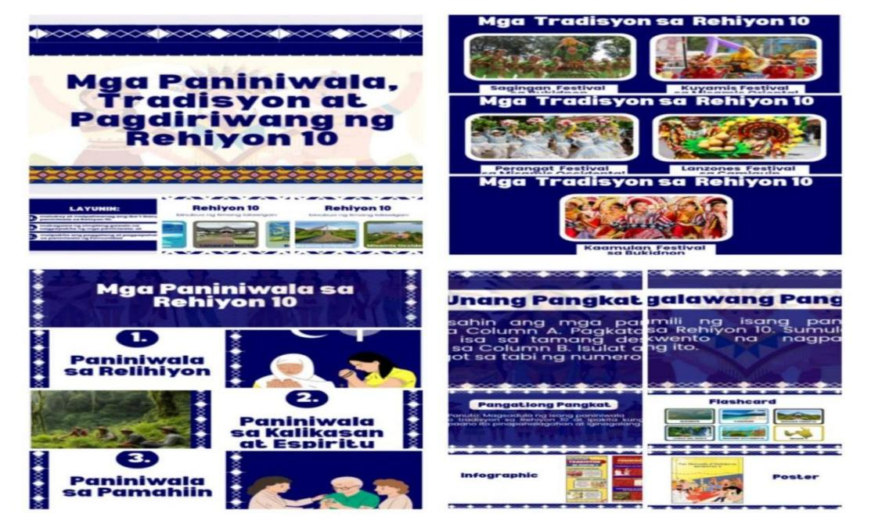
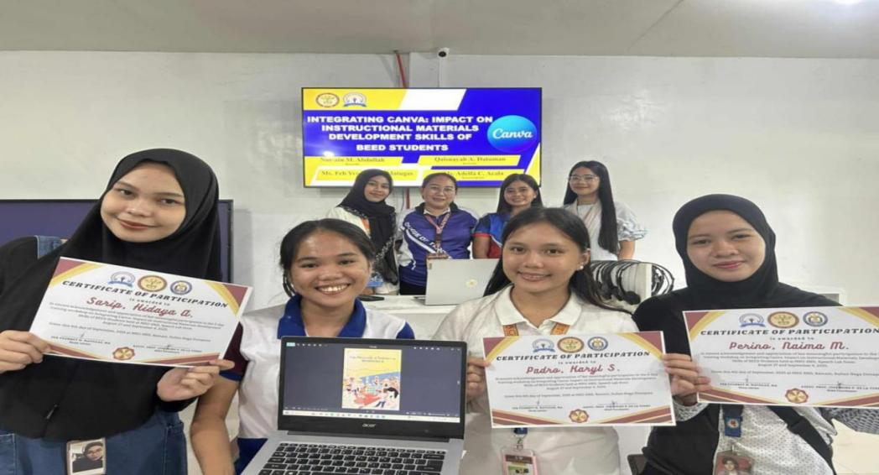
Figure 4.11 Instructional Materials developed using Canva (Group 4)

Group 4 presented their instructional materials and also created through Canva, showcasing colorful designs, clear texts, and well-arranged learning content. Their materials focused on key educational concepts that were made more engaging through visuals and creative layouts. The members enthusiastically explained their design choices and how these support effective learning for pupils. Their presentation demonstrated not only their creativity but also their understanding of how digital tools like Canva can transform traditional teaching materials into interactive and visually appealing learning resources.
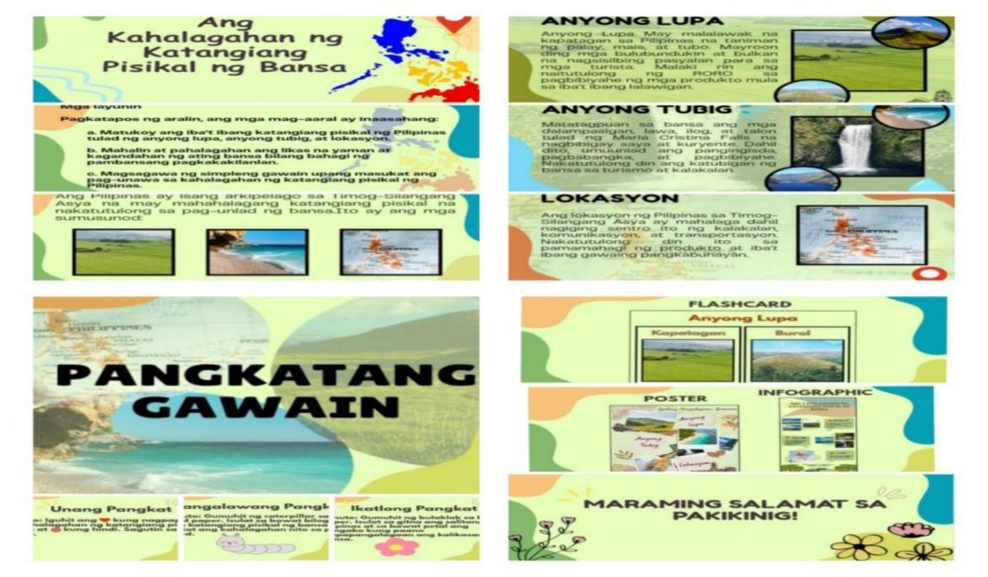
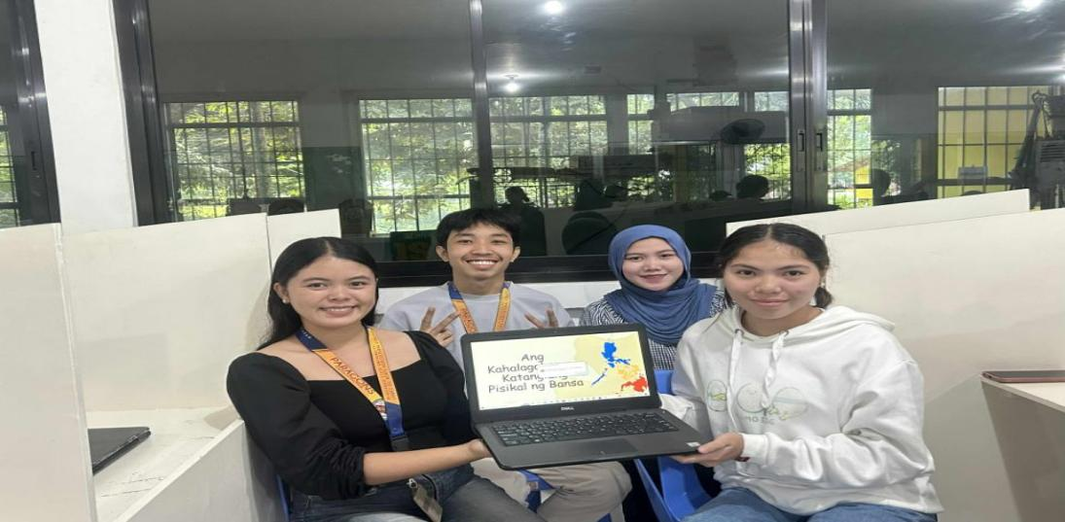
Figure 4.12 Instructional Materials developed using Canva (Group 5)

Group 5 presented their instructional materials and also created through Canva. Which featured colorful visuals and a clear map of the Philippines highlighting its major landforms and bodies of water. The group’s Canva-designed material was neatly organized and visually engaging, helping to capture attention and support comprehension. Their teamwork and preparedness were evident, as they delivered their presentation smoothly and interacted with their audience through simple questions.

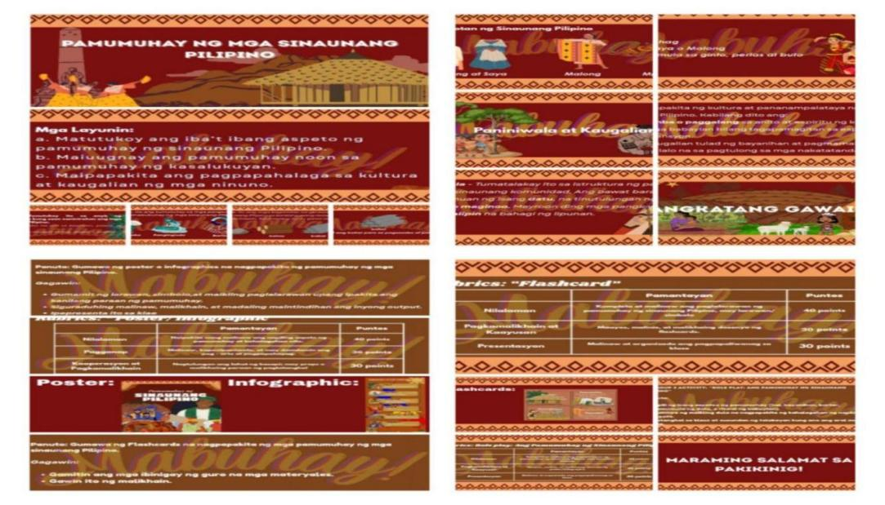
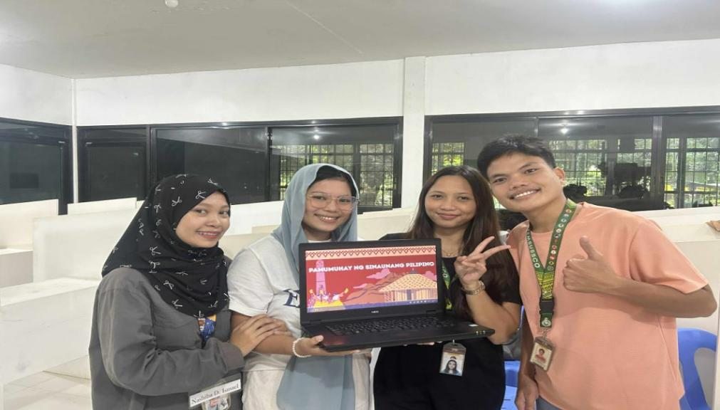
Figure 4.12 Instructional Materials developed using Canva (Group 5)

Group 6 utilized Canva to design their instructional material, showcasing a creative and visually appealing layout that featured images of early Filipino communities, clothing, houses, and occupations. Their presentation began with a brief introduction to the lifestyle of ancient Filipinos before the arrival of the Spaniards. Each member took turns explaining different aspects such as livelihood, culture, and beliefs. The group demonstrated excellent teamwork, confidence, and creativity, successfully conveying the rich cultural history of early Filipinos.

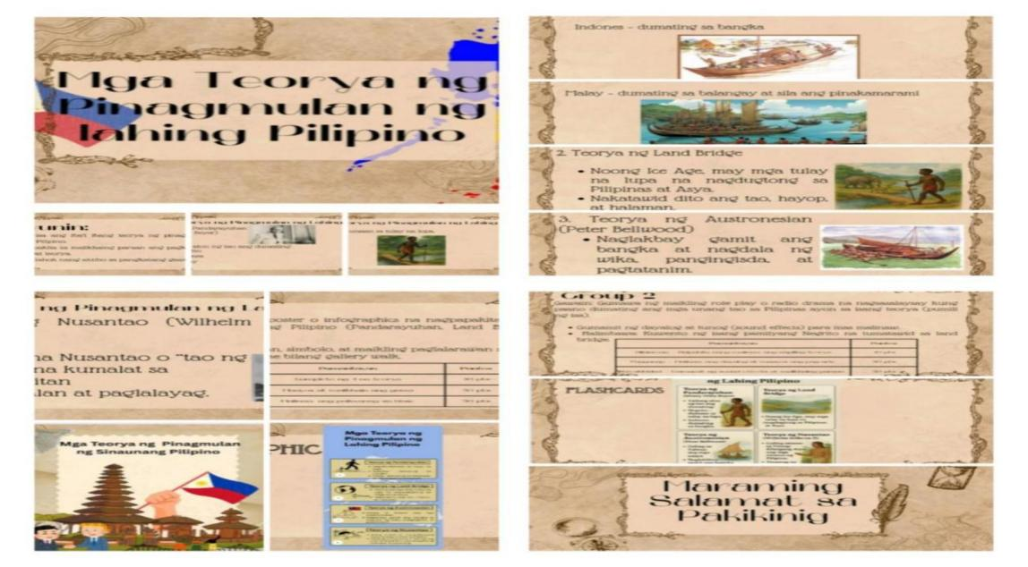
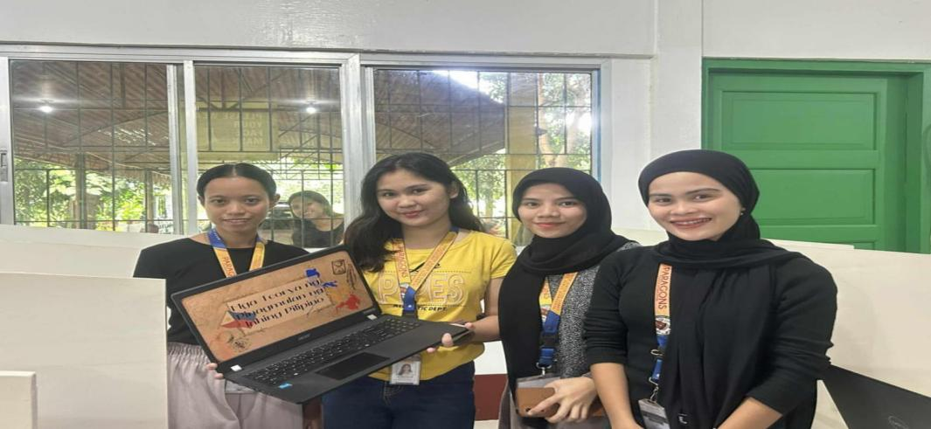
Figure 4.14 Instructional Materials developed using Canva (Group 7)
Group 7 presented a well-organized and colorful slide that included maps, diagrams, and pictures. Each member confidently discussed one theory, explaining its main ideas and significance. Their presentation encouraged curiosity and understanding by asking reflective questions after every discussion. The group’s Canva design made the topic more engaging, supporting visual learning and helping simplify complex historical concepts for elementary students.
All groups showed preparedness, cooperation, and mastery of their assigned lessons. Their use of Canva as an educational tool demonstrated how digital platforms can enhance instructional materials, making learning more interactive and visually stimulating for students.

4.3 Pre-test and Post-test Scores of the Respondents’ Developed Instructional Materials.

4.3.1 Respondents’ Developed Instructional Materials Before Utilizing Canva.
Table 4.3 presents the mean scores and verbal interpretations of the developed instructional materials of each group before using Canva. As shown, in the table the grand mean score of 2.14 with an interpretation of Moderately Achieved. All the groups obtained moderately achieved. The highest mean score was obtained by Group 7 (2.28), which is verbally interpreted as Moderately Achieved. This indicates that the group was able to meet the expected outcomes at a moderate level. Following closely are Group 1 (2.22) and Group 3 (2.22), both also interpreted as Moderately Achieved. Group 5 likewise achieved a Moderately Achieved rating with a mean score of 2.17. On the other hand, Group 4 (2.11), Group 2 and 6 obtained the lowest mean score of (2.00) respectively, which are also verbally interpreted as Moderately Achieved. This suggests that these groups did not meet the expected standards in developing instructional materials prior to Canva integration.
These results imply that although students have begun integrating digital tools like Canva, their proficiency and creativity in utilizing its features for instructional material development remain at a developing stage. It suggests a need for more structured training and guided practice to help them fully maximize the platform’s potential
In contrast with the studies of Christiana & Anwar (2021) and Nanda & Fatimah (2023) noted that Canva helped bridge the gap between traditional learning methods and modern, technology-enhanced education, making learning more relevant to the digital age. Furthermore, Canva’s versatility allowed it to be applied in a variety of subjects, from language learning to project-based assignments, proving its adaptability across diverse curricula.

GROUPS | Mean Score | Verbal Interpretation
1 | 2.22 | Moderately Achieved
2 | 2 | Moderately Achieved
3 | 2.22 | Moderately Achieved
4 | 2.11 | Moderately Achieved
5 | 2.17 | Moderately Achieved
6 | 2 | Moderately Achieved
7 | 2.28 | Moderately Achieved
Grand Mean | 2.14 | Moderately Achieved
Table 4.3 Pre-test Scores of the Respondents’ Developed Instructional
Materials before Integrating Canva (n=28).

4.3.2 Respondents’ Developed Instructional Materials after utilizing Canva.

Table 4.4 shows the mean scores of each group’s developed instructional materials after using Canva. As seen in the table, the grand mean score of 3.59 with an interpretation of Highly Achieved. The highest mean scores were obtained by Groups 2 and 6 (3.67), followed by Group 1 (3.61), Group 3 (3.58), Group 4 (3.56), Group 5 (3.56), and finally Group 7 (3.44). Groups 1 to 6, with mean scores ranging from 3.56 to 3.67, are verbally interpreted as Highly Achieved, indicating that these groups successfully met the expected outcomes and demonstrated strong performance in developing instructional materials. Meanwhile, Group 7, with a mean score of 3.44, was verbally interpreted as Highly Achieved. Although slightly lower than the others, this still reflects a satisfactory level of performance. Overall, the results highlight the effectiveness of integrating Canva in improving students’ creativity, proficiency, and quality of instructional material development.
These results imply that the integration of Canva significantly enhanced students’ ability to design and develop creative, visually appealing, and pedagogically sound instructional materials. The high mean scores across most groups suggest that Canva’s user-friendly interface and accessible design tools supported the students in applying their understanding of instructional design principles effectively. Furthermore, the consistency of high performance among the majority of groups reflects a positive adaptation to technology-assisted material development.
This findings supported by Catubig (2024), who found that students were able to integrate visual elements with their in lesson content, helping them communicate more effectively and improving their overall visual literacy. This aligns with Rezkyana and Agustini’s (2022) findings that Canva can enhance the teaching of writing by enabling students to visually represent their ideas. This helped students organize and present their thoughts in creative ways, making writing more accessible and less intimidating.

GROUPS | Mean Score | Verbal Interpretation
1 | 3.61 | Highly Achieved
2 | 3.67 | Highly Achieved
3 | 3.61 | Highly Achieved
4 | 3.61 | Highly Achieved
5 | 3.56 | Highly Achieved
6 | 3.67 | Highly Achieved
7 | 3.44 | Highly Achieved
Grand Mean | 3.59 | Highly Achieved
Table 4.4 Post-test Scores of the Respondents’ Developed Instructional
Materials after Integrating Canva (n=28).

4.4 Significant Difference of Pre-survey and Post-survey Scores of the Respondents Regarding the Development of Instructional Materials

Table 4.5 presents the result of the Wilcoxon Signed Rank Test which was employed to examine the difference between the pre-survey and post-survey scores of the third year BEEd students. The test resulted in a p-value of 0.001, which is below the 0.05 level of significance. Stating that there is no significant difference between the pre-survey and post-survey scores, the null hypothesis was rejected. This finding indicated that students obtained significantly higher scores in the post-survey than in the pre-survey, demonstrating that the integration of Canva into instruction had a positive impact on their instructional materials development skills of third year BEEd students.
This findings supported by Christiana and Anwar (2021), whose study about the effectiveness of canva. The researcher concluded that using canva as media tool for teaching is highly effective. Therefore integrating canva in teaching is highly effective given by the result.

Table 4.5 Wilcoxon Signed-Rank Test Result on the Significant Difference
between Pre-survey and Post-survey Scores (n=28).
p-value | Level of Significance | Interpretation
0.001 | 0.05 | - Rejected
S=Significant

4.5 Significant Difference of Pre-test and Post-Test Scores of the Respondents’ Developed Instructional Materials.

Table 4.6 presents the result of the Paired T-test which was employed to examine the difference between the pre-test and post-test scores of the respondents’ developed instructional materials. The test resulted in a p-value of 0.001, which is below the 0.05 level of significance. The null hypothesis, stating that there is no significant difference between the pre-test and post-test scores was rejected. This finding indicated that students obtained significantly higher scores in the post-test than in the pre-test, demonstrating that the integration of Canva into instruction had a positive impact on their instructional materials development skills of third year BEEd.

As supported by Pedrosa et al. (2023) and Haniah et al. (2021) which reveals that students found Canva particularly useful for group work and collaborative projects. The platform’s real-time editing and sharing features allowed students to work together, exchange ideas, and refine their projects. This collaborative environment fostered teamwork and communication skills, which are essential in today’s educational landscape. In conclusion, Canva serves as an excellent teaching tool that promotes student engagement, creativity, and collaboration. Whether used in writing classes, language learning, or visual literacy development, Canva helps students express their ideas in innovative ways. However, like any tool, it requires thoughtful integration to maximize its educational benefits while minimizing potential distractions. Therefore integrating canva in making Instructional materials is effective given by the result.

Table 4.6 Paired T-test Result on the Significant Difference between Pre-test
and Post-test Scores of the Respondents’ Developed Instructional
Materials (n=28).
p-value | Level of Significance | Interpretation
0.001 | 0.05 | - Rejected
S=Significant

4.6 Back-up Plan Used to Continue Developing Quality Instructional Materials and Ensure the Effectiveness of Canva Integration.

The common challenges encountered by the respondents during the workshop training were identified and analyzed to determine the factors that affected their learning experience and performance:

4.6.1 Technical challenges
“The main challenge I experienced during the training was the unstable internet connection.” Groups 1-7.
To address these concerns researchers should ensure a strong and stable internet connection before conducting training sessions by testing bandwidth, arranging backup Wi-Fi, or providing mobile data support to minimize technical disruptions during Canva training.

4.6.2 Struggles in keeping up with the resource speaker
“During the training, we struggled to keep up with our resource speaker because the internet connection was unstable which made it difficult for us to follow the step-by-step instructions.” Group 4
To address this concerned researchers are encouraged to prepare offline learning resources, including printed manuals, PDF guides allowing participants to continue following the training even when unstable internet interferes with online discussions.
4.6.3 Coping through alternatives methods
“Take detailed notes, explore available features to practice what was accessible.” Group 3
To address this concerned researchers should remind participants to regularly save their outputs throughout the training, reinforcing the importance of frequent savoring habits to secure work progress and reduce risks of data loss during training activities.

4.6.4 Unclear instructions
“During our training with Canva, one problem we had was that the instructions were sometimes not clear”. Group 4
To address this concerned researchers should design training materials with explicit, step-by-step guidelines, provide concrete examples, and establish consistent communication channels for clarification to ensure participants’ understanding.

- Discussion
The findings of this study indicate that the integration of Canva as an instructional tool had a significant positive impact on the instructional materials development skills of third-year BEEd students. Prior to the intervention, the pre-survey results showed that students already had a basic level of familiarity with Canva and generally perceived it as a useful educational tool. This suggests that learners entered the training with prior knowledge, which may have contributed to their readiness to engage with the platform more deeply during the intervention.

Following the two-day Canva training, which included discussions, hands-on practice, and output presentations, a noticeable increase in post-survey scores was observed. The Wilcoxon Signed-Rank Test confirmed that this improvement was statistically significant, indicating that the integration of Canva effectively enhanced students’ perceptions of instructional materials development. This implies that structured exposure to digital design tools can reshape learners’ attitudes and deepen their appreciation of technology in education.
In addition to changes in perception, the quality of the students’ developed instructional materials also improved substantially. The results of the paired t-test revealed a significant difference between the pre-test and post-test scores, with most students advancing from the “Moderately Achieved” and “Achieved” levels to the “Highly Achieved” category. This progression highlights the effectiveness of Canva in enhancing key components of instructional design, such as layout, creativity, and content organization. It also suggests that hands-on, technology-supported activities provide meaningful opportunities for skill development.
Moreover, the findings emphasize the role of Canva as an engaging and user-friendly platform that supports collaborative and creative learning. Through the training, students were able to explore their creativity, build confidence in designing materials, and apply critical thinking in organizing content effectively. These outcomes align with the goals of teacher education programs, which aim to equip pre-service teachers with both pedagogical and technological competencies.
Overall, the results imply that integrating digital tools like Canva into teacher education can significantly strengthen instructional material development skills while promoting essential 21st-century skills. The study therefore affirms that Canva is a valuable innovation in education, as it enables future educators to create high-quality, learner-centered instructional materials and enhances their digital competence for modern teaching practices.

- Conclusion
In conclusion, the integration of Canva as an instructional tool significantly enhanced the instructional materials development skills of third-year BEEd students. The study revealed that while students initially had basic familiarity with Canva, the structured training led to a marked improvement in both their perceptions and actual performance. Statistical results confirmed significant differences between pre- and post-assessments, demonstrating that Canva effectively improved students’ creativity, layout design, content organization, and overall instructional design skills. Moreover, the findings highlight that Canva is not only an accessible and user-friendly platform but also an effective tool for fostering creativity, collaboration, and critical thinking among pre-service teachers. Its integration in teacher education programs supports the development of essential technological and pedagogical competencies needed in modern classrooms. Therefore, the study affirms that incorporating Canva in instructional practices is a valuable innovation that helps future educators produce high-quality, learner-centered materials while strengthening their digital skills for 21st-century teaching.

- Suggestion
Based on the findings of the study, it is recommended that Canva be continuously integrated into instructional practices, particularly in the development of instructional materials among third-year BEEd students. The significant improvement in students’ post-survey and post-test results indicates that Canva is an effective tool in enhancing both their perceptions and skills in instructional design. Engaging students in collaborative activities, such as group projects using Canva, is also encouraged to promote teamwork, idea sharing, and creativity. Furthermore, students should be given opportunities to explore advanced Canva features, including custom templates and animations, to further improve the quality and innovation of their outputs. It is also recommended that teachers incorporate Canva into their lesson plans and provide clear guidance in the creation of digital instructional materials. Providing detailed and constructive feedback on students’ outputs, focusing on both content and design, can further enhance their skills. Professional development programs for teachers may also be conducted to strengthen their competence in integrating Canva effectively in both instruction and assessment, ensuring consistent and meaningful application in the classroom.
In addition, school administrators play a vital role in supporting the implementation of Canva by ensuring access to reliable internet connectivity and appropriate digital devices. Providing continuous training for teachers on the use of digital tools like Canva can help maximize its benefits in teaching and learning. A stable and fast internet connection is essential to allow seamless access to the platform and support collaborative work among students. Moreover, parents are encouraged to support students by guiding them in managing their time effectively between academic tasks and Canva-related activities. Providing access to necessary resources, such as internet connection and devices, can also contribute to the successful use of Canva for learning purposes.
Finally, future researchers may explore the accessibility and usability of Canva among students in different contexts, particularly those with limited technological resources. Further studies may also investigate how Canva supports diverse learners with varying needs and learning styles, as well as examine its long-term impact on students’ instructional design skills, creativity, and digital competence.

- Acknowledgements
The authors would like to express their sincere gratitude to their thesis adviser and panel members for their valuable guidance and constructive feedback throughout the conduct of this study. Appreciation is also extended to the administrators, resource speaker and students of Mindanao State University-Sultan Naga Dimaporo for their cooperation and support.

- References

Andriani, K. (2022). Teaching media in EFL classrooms: What are they and why select them. Journal of Language Testing and Assessment. Universitas Muhammadiyah Makassar, Indonesia. https://doi.org/10.56983/jlta.v2i1.214

Astaño, J. L. (2025). The effectiveness of Canva as an instructional tool in improving students’ academic outcomes: A meta-analysis. Journal of Digital Learning and Distance Education. https://doi.org/10.56778/jdlde.v3i10.468
Autila, R., Riza A., Wahyuni F. (2022). Increasing Students’ Interest In Learning English Through Canva Application. Inovish Journal, Vol. 7, No. 2, https://d1wqtxts1xzle7.cloudfront.net/113725128/1329-libre.
Budi, B. S., and Anwar, K. (2024). The implementation of a Canva-based e-portfolio: Its impact on achievement, self-efficacy, and anxiety in ESP-writing instruction. English Education Department, Post Graduate Program, Universitas Muhammadiyah Gresik, Indonesia. https://doi.org/10.25134/erjee.v12i3.10369

Brown, M. (2021). The power of Canva in digital design and education. Journal of Educational Technology. https://doi.org/10.51574/jrip.v4i2.2018
Christensen, R. (2018) Analysis of Variance, Design, and Regression: Linear Modeling for Unbalanced Data. Journal of Applied Mathematics and Physics.https://www.scirp.org/reference/referencespapers?referenceid=4093400

Christiana, E. and Anwar, K. (2021). The perception of using technology Canva application as a media for English teacher creating media virtual teaching and English learning in Loei, Thailand. Journal of English Teaching, Literature, and Applied Linguistics. https://doi.org/10.30587/jetlal.v5i1.2253
Edilene T. Ayeras. (2023). Movement Games: It’s Effectiveness to the Learning Competencies of Teaching Mathematics to the Learners with Disabilities. International Journal of Research Publication and Reviews, Vol4,no8,pp33603365. https://doi.org/10.55248/gengpi.4.923.51790
El-Sherbiny, D. M. A. (2024). Leveraging the effect of Canva on developing students’ report writing skills and their perception towards the application in Amman Governorate. Educational Sciences Journal. English Lecturer Delta University for Science and Technology. https://journals.ekb.eg/article_401579.html
Firdayanti, E., Emiliyana, P. M., Fitriah, S., & Kurniati, U. (2024). Teacher and student’s pedagogical tasks using Canva as media for English language teaching (ELT) in developing creativity for high school. International JournalofEnglishLanguageStudies. https://doi.org/10.32996/ijels.2024.6.2.19
Fitria, T. N. (2022). Using Canva as media for English language teaching (ELT) in developing creativity for informatics students. ELT Echo: The Journal of English Language Teaching in Foreign Language Context, 7(1), Article 1. https://doi.org/10.24235/eltecho.v7i1.10789
Hutapea, N. S., Manullang, Z. P. J., & Hartati, R. (2024). Enhancing student engagement and academic performance through digital literacy: A transformative approach in Canva application. State University of Medan. https://doi.org/10.61132/fonologi.v2i4.1227
Ikhlas, Z. R., Japakiya, R., & Muzayanah, T. (2023). Utilization of Canva application as a learning media video creation. Journal of Social Science Utilizing Technology. https://doi.org/10.70177/jssut.v1i3.558
Jamaludin, N., & Sedek, S. (2023, November 9). CANVA as a digital tool for effective student learning experience. Journal of Advanced Research in Computing and Applications. https://www.akademiabaru.com/submit/index.php/arca/article/view/5064
K. H., and Rahardi, P. (2023). Teacher professional development: "Be a force for good." Journal of Community Service and Empowerment. https://doi.org/10.22219/jcse.v4i3.28191
Kocaarslan, G. E., and Eryaman, M. R. (2024). Using “Canva for Education” application with collaborative learning in visual arts lesson: Sample activities for teachers. Elektronik Sosyal Bilimler Dergisi. https://doi.org/10.17755/esosder.1371676
Larasati, M. (2022). Empowering students’ creative writing ability by using Canva. Journal of English Education Program (JEEP). https://doi.org/10.25157/jeep.v9i2.8548
Nanda K. and Fatimah H., (2024). Teacher's perceptions on the development of Clitoria ternatea extracts as a learning media to enhance students' scientific creativity. Indonesian Journal of Science and Mathematics Education. https://ejournal.radenintan.ac.id/index.php/IJSME/index
Nur-aini, and Suwandi. (2024). Students’ perception of writing procedure text with project-based learning model. International Journal of Research and Scientific Innovation. https://www.researchgate.net/publication
Oudat, Q., and Othman, M. (2024). Embracing digital learning: Benefits and challenges of using Canvas in education. Journal of Nursing Education and Practice. https://doi.org/10.5430/jnep.v14n10p39
Oxford English Dictionary. (2024). Oxford English Dictionary online. Oxford University Press. https://www.oed.com

Pedroso, J. E. P., Sulleza, R. V. S., F. K. H. M. C., Noman, A. J. O., and Martinez, C. A. V. (2023). Students’ views on using Canva as an all-in-one tool for creativity and collaboration. Journal of Digital Learning and Distance Education. https://doi.org/10.56778/jdlde.v2i1.117
Rahma, D. N., Bagus, G., et al. (2024). The influence of Canva application features on the graphic design confidence: A case study of college students. Journal of Applied Multimedia and Networking (JAMN). https://jurnal.polibatam.ac.id/index.php/JAMN/article/view/7684/2395
Richey, R. C. (1994). Developmental Research: The Definition and Scope. National Convention of the Association for Educational Communications and Technology Sponsored by the Research and Theory Division. https://files.eric.ed.gov/fulltext/ED373753.pdf
Remillard, J. T. & Heck, D. J. (2023). Conceptualizing the Curriculum Enactment Process in Mathematics Education. ZDM Mathematics Education, 46(5), 705–718.
Roistika, N. (2021). English teaching media during pandemic. Atlantis Press aims to publish journals in all STM disciplines including Physical Sciences, Life Sciences, Health Sciences and Social Sciences. https://doi.org/10.2991/assehr.k.210427.057
Salminawati, Mayang, S., and Syafii, M. (2023). The impact of using Canva as media in teaching natural science field to the fifth grade students of SD Negeri Pucok Lupu, Pidie. Universitas Bina Bangsa Getsempena, Banda Aceh, Indonesia. https://doi.org/10.46244/iconesth.vi.145
Santiana, S., Silvani, D., and Ruslan, R. (2021). Optimizing LMS Canvas for interactive online learning perceived by the students. Journal of English Education and Teaching, Article 4. https://doi.org/10.33369/jeet.5.4.529-543
Shalawati, S., Astuti, M. T., Hidayati, A. N., and Hadijah, S. (2022). Designing and developing video as an instructional media in English language teaching setting. Lectura: Jurnal Pendidikan. https://doi.org/10.33633/es.v3i02.4225
Silva, P., Vieira, I., Babo, L., and Torres, C. (2024). Integrating digital tools to enhance learning experiences in higher education.Lecture Notes in Networks and Systems, vol 859. Springer, Cham. https://doi.org/10.1007/978-3-031-78155-1_38
Sugiarni, S., Widiastuti, D. E., Tahrun, T., Indriani, L., Nugrahaeni, D. A., and Manggolo, N. S. (2024). The implementation of Canva as a digital learning tool in English. English Learning Innovation (englie), 5(2), 264–276. https://doi.org/10.22219/englie.v5i2.34839

Syahdan, S., Herlinawati, H., Syaifullah, S., and Syafitri, D. T. (2023). Challenges and strategies of teachers in integrating Canva in English classroom teaching. Journal of English Education and Teaching, 5(4), Article 4. https://doi.org/10.33369/jeet.5.4.529-543
Utami, Y., Apriliya, S., and Saputra, E. (2022). The Urgency of Digital Literacy and Ethics for Parents in Educating Children in the Digital Age. Jurnal Kependidikan, 8(1), 58–67. https://doi.org/10.33394/jk.v8i1.4605
Wahdania, W., Permana, D. R., & Angraini, N. (2024). An investigation of Canva’s impact on narrative text writing skill. Indo-MathEdu Intellectuals Journal. http://doi.org/10.54373/imeij.v5i6.2026
Wang, J. T., and Newman, S. J. (2013). Family, income. In M. D. Gellman & J. R. Turner (Eds.), Encyclopedia of behavioral medicine Springer. https://doi.org/10.1007/978-1-4419-1005-9_955
Wulandari, H. (2020). Strategies in teaching speaking used by teachers of young, junior high school, senior high school, and university students. E-Structural English. National Journal Accreditation (ARJUNA)
Zahroh, A., and Febrianingrum, L. (2023). Students’ perception of the use of infographics at Canva application in accomplishing TOEFL class assignment. INSANIA: Jurnal Pemikiran Alternatif Kependidikan. https://ejournal.uinsaizu.ac.id/index.php/insania/article/view/8499
Zimmerman, B. J. (1990). Self-regulated learning and academic achievement: An overview. Educational Psychologist. https://doi.org/10.1207/s15326985ep25012

