

Overview
As part of my STEM diploma at AUC, I tackled the challenge of helping students use AI tools effectively without compromising the authenticity of their work or the quality of their learning. Using the 5 stages of the creative process—Preparation, Incubation, Insight, Evaluation, and Elaboration—I developed a handbook for teachers and students. This guide provides practical strategies for integrating AI into learning while addressing concerns like fairness, transparency, and critical thinking. From gathering insights to crafting a solution, this journey highlights how AI can be a powerful ally in education when used responsibly.

Creative Process Stage

1. Preparation:
through this stage we held a zoom meeting to discuss why we as teachers find it not comfortable with the idea of using AI tools. Also, we thought of creating a google form to share it with students to ask them why they like to use the AI tools for finalizing the assignments, explaining them experiences whether it was good or bad. Also, during the schooldays, I used to ask my students about this subject, I used my mobile note app to record their answers. The output of this stage was mix of teachers & students’ thoughts about using AI into learning:
- Using AI tools is one of the technical skills we need our students to be familiar with because of their potential capabilities.
- Mobile & PC apps now have a built-in AI feature, for example office suite such as Microsoft Word has auto-complete and adobe Photoshop has AI content awareness to detect image items and so on. Again, this means that AI tools cannot be avoided.
- Nowadays, most of the jobs benefit from the AI tools to perform tasks easier, faster, or more efficiently. So, teaching our students how to use AI tools is a competitive advantage for tomorrow’s jobs.
- Teachers do not reject the use of AI tools, they just hope the students know how to use it legally
- Teachers like to have a technique or tools to verify the originality of the work the students apply to be sure that they have learned for sure.
- AI offer promises for students with disabilities.
- Students who do not use AI tools to complete their assignments find it not fair to allow them colleagues to use.
- Concerns about “why” AI gives this output as most of AI tools are black-box.
- Concerns about the pricing plans & privacy issue.

2. Incubation
At this point and according to Snyder & Raichle our brain concentrates all its energy to digest all the data collected from the previous stage and the problem’s perspectives become more specific. The useful tool I used during this stage is Canva to visualize the preparation output as shown below:
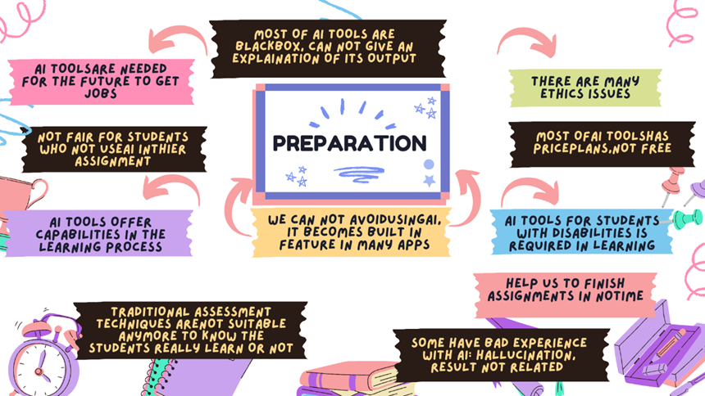

3. Insight:
The amazing thing in this stage is that sometimes an idea crossed my mind during routine day activities, and I used to hurry up hold my phone write it Fastly. A massive idea about why we won’t do that and why shall we do this. I believe that avoiding judging any idea or solution in this stage is essential to let the mental flow of the ideas. And again, I used Canva finally to write the suggested solution or sometimes a new portion of the solution. Previously, I used to use yellow sticky notes, but it has limitations such as you cannot access remotely, you cannot edit the content, and you have to replace the note paper.
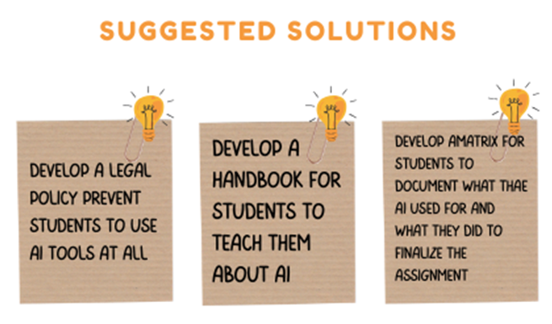

4. Evaluation:
At this point I developed two dimensions evaluating tool to check which suggested solution is more suite to solve the issue:

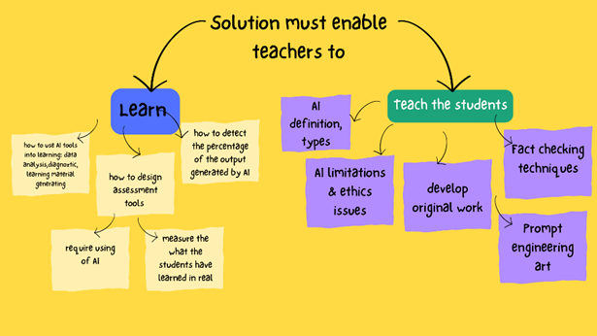
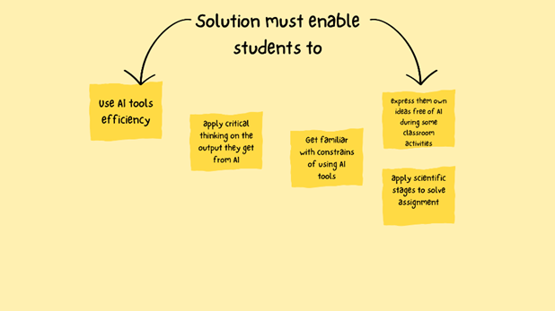
And finally, I chose to develop a handbook.

5. Elaboration:
I develop the following handbook with 4 sections as shown below to solve the problem:

