Machine Learning-Based Autonomous System for Object Detection and Environmental Mapping

Mrs. Sruthi Thanugundala  Department of Computer Science and Engineering (AI & ML)  Keshav Memorial Engineering College  Hyderabad, India | B. ABHINAV  Department of Computer Science and Engineering (AI & ML)  Keshav Memorial Engineering College  Hyderabad, India | C. VARUN  Department of Computer Science and Engineering (AI & ML)  Keshav Memorial Engineering College  Hyderabad, India | P. ABHISHEK  Department of Computer Science and Engineering (AI & ML)  Keshav Memorial Engineering College  Hyderabad, India

Abstract: Real-world applications increasingly require efficient and reliable methods for object detection and navigation using simple and practical approaches. However, many existing systems either lack proper spatial understanding or fail to convert detection results into meaningful actions, limiting their effectiveness in real scenarios. To address these challenges, this project presents a vision-based object detection and navigation system using the YOLOv8n model. The system processes image input to detect objects such as pedestrians, vehicles, and obstacles, and generates bounding boxes with confidence scores to represent detected entities. To enable spatial understanding, a 3×3 grid-based mapping technique is employed, which divides the image into structured regions and identifies the relative position of detected objects. Based on this spatial representation, a rule-based decision module is implemented to generate navigation commands such as move forward, move left, move right, stop, and go slow. This integration of object detection with simple decision logic allows the system to convert visual information into actionable outputs. The proposed approach focuses on achieving a balance between accuracy, efficiency, and simplicity by avoiding complex hardware requirements and relying only on vision-based processing. Experimental evaluation on different input images demonstrates that the system performs consistently under normal conditions and is capable of handling multiple objects effectively. Overall, the system provides a practical and cost-effective solution for basic navigation and decision-making, with potential applications in surveillance, assistive systems, and smart environments.
Keywords: Object Detection; Computer Vision; Autonomous Navigation; YOLOv8; Grid Mapping; Decision System.
I. INTRODUCTION
The growing demand for intelligent systems capable of perceiving and responding to their surroundings has made autonomous navigation one of the most actively researched areas in computer vision and robotics. From self-driving vehicles to assistive robots, the ability to detect objects and make real-time decisions based on visual input is becoming increasingly essential in everyday applications.
Most existing autonomous systems depend heavily on hardware sensors such as LiDAR, radar, and ultrasonic modules to build an understanding of their environment. While these sensors provide accurate spatial data, they significantly increase the cost, weight, and complexity of the overall system. This makes them impractical for small-scale deployments, student-level research platforms, and resource-constrained environments where simplicity and affordability matter.
At the same time, purely vision-based systems that have been proposed in recent literature often stop at object detection — identifying what is in the scene — without taking the next step of deciding what to do about it. Detection without decision-making limits the practical usefulness of such systems in real navigation scenarios where a response is required, not just recognition.
This gap motivated the development of the system presented in this paper. The goal was to build something that goes beyond detection: a system that not only identifies objects like vehicles, pedestrians, and obstacles in a camera image, but also understands where they are spatially and generates a corresponding navigation command. To keep the system practical and deployable on standard hardware, the decision was made to avoid cloud processing and additional sensors entirely.
The proposed system uses YOLOv8n, a lightweight and efficient object detection model, to process image input in real time. Detected objects are mapped onto a structured 3×3 grid that divides the image into spatial regions, allowing the system to determine whether an obstacle is ahead, to the left, or to the right. A rule-based decision engine then interprets this grid and issues commands such as move forward, move left, move right, go slow, or stop.
The key contributions of this work are as follows:
- A real-time object detection pipeline using the YOLOv8n model optimized for standard CPU-based hardware
- A 3×3 grid-based spatial mapping technique for simplified environmental understanding
- A rule-based decision engine that translates spatial object positions into actionable navigation commands
- A fully vision-based architecture that eliminates dependency on additional sensors or cloud connectivity
- A system design that is modular, lightweight, and adaptable to edge deployment scenarios

II. LITERATURE REVIEW

Object detection and autonomous navigation have been active areas of research for over two decades. The field has progressed from simple handcrafted feature methods to highly optimized deep learning models capable of running on standard consumer hardware. This section reviews the major developments in the field and identifies the gaps that motivated the design of the proposed system.
A. Traditional Feature-Based Methods
Early object detection systems were built around manually engineered feature descriptors. Lowe introduced the Scale-Invariant Feature Transform (SIFT), which extracted distinctive local features from images that remained stable across changes in scale and rotation. Bay et al. later proposed SURF as a computationally faster alternative that preserved similar matching capability. For pedestrian and vehicle detection specifically, the Histogram of Oriented Gradients (HOG) descriptor combined with a Support Vector Machine classifier became a widely adopted approach due to its reasonable accuracy on benchmark datasets such as PASCAL VOC.
Despite their contributions, these methods carried fundamental limitations. Feature extraction was entirely manual, requiring domain expertise to design descriptors suited to specific object types. Performance degraded significantly under variations in illumination, occlusion, and cluttered backgrounds, making traditional approaches impractical for deployment in dynamic outdoor environments such as roads and intersections.
B. Deep Learning-Based Object Detection
The introduction of deep Convolutional Neural Networks transformed object detection by replacing handcrafted features with automatically learned representations. Girshick et al. proposed R-CNN, which combined selective search region proposals with CNN-based classification. While accuracy improved substantially over traditional methods, the multi-stage pipeline was computationally expensive and unsuitable for real-time use. Fast R-CNN improved processing speed by sharing convolutional feature computation across proposals, and Faster R-CNN further integrated the proposal stage into the network itself using a Region Proposal Network, bringing inference times down considerably. However, even with these improvements, two-stage detectors remained too slow for deployment on standard hardware without a dedicated GPU.
C. Sensor-Based Autonomous Systems
Many modern autonomous systems utilize additional sensors such as LiDAR, radar, and ultrasonic sensors for environmental perception. LiDAR measures the distance of objects using laser pulses and provides accurate 3D spatial mapping, while radar and ultrasonic sensors offer complementary distance measurements under varying visibility conditions. Although these sensor-based systems offer high precision, they introduce significant hardware cost, increased system complexity, higher power consumption, and difficult deployment in low-resource environments. These drawbacks make sensor-heavy approaches unsuitable for small-scale deployments where simplicity and affordability are priorities.
D. Cloud-Based Systems
Some object detection and navigation systems rely on cloud computing to offload processing from the local device. While cloud-based systems provide access to high computational power, they introduce network latency, dependency on continuous internet connectivity, and potential privacy and security concerns related to transmitting image data to remote servers. In environments with limited or unstable connectivity, these systems become unreliable for real-time navigation applications. As a result, edge-based solutions that process data locally have gained increasing attention for scenarios requiring fast and consistent decision-making.
E. Vision-Based Navigation Systems
Recent research has explored purely vision-based systems that use only camera input for both detection and navigation, offering a cost-effective alternative to sensor-heavy approaches. However, many existing vision-based systems focus only on identifying objects without providing any decision-making capability. They lack structured spatial understanding and do not convert detection results into actionable navigation commands. Some systems have incorporated deep reinforcement learning for decision-making, but these approaches require large amounts of training data and significant computational resources, limiting their practicality for lightweight deployments.
F. Research Gap
The literature reveals a consistent pattern across existing work. Most systems either perform object detection without decision-making, rely on expensive sensor hardware, depend on cloud connectivity, or require large training datasets that are impractical for resource-constrained environments. Very few systems integrate efficient object detection, structured spatial mapping, and actionable decision-making into a single pipeline deployable on standard CPU hardware without additional sensors. This gap directly motivated the design of the proposed system, which combines YOLOv8n-based detection with a 3×3 grid mapping approach and a rule-based decision engine to provide a simple, practical, and complete navigation solution.

III. PROPOSED METHODOLOGY
A. System Overview
The proposed system follows a multi-stage pipeline:
- Image input acquisition
- Preprocessing and normalization
- Object detection using YOLOv8n
- Grid-based spatial mapping
- Decision-making using rule-based logic
- Navigation command generation
B. Image Input and Handling
The system accepts JPG and PNG images uploaded through the web interface. When an image arrives, the application reads the raw bytes, decodes them into an OpenCV-compatible format, and validates that the result is a non-empty frame before passing it to the next stage. This validation step ensures that corrupted or improperly decoded images are caught early rather than causing failures deeper in the pipeline.
Flask was chosen as the interface framework because it is lightweight and straightforward for coordinating this kind of processing pipeline. The detector and navigation logic are maintained as separate modules so the main application file handles only request management and response generation, keeping the overall structure clean and maintainable.
C. Image Preprocessing
Every image is resized before detection — to 640×480 pixels in the web pipeline and to 640×640 pixels when passed into the detection model. The web pipeline standardizes image dimensions for consistent handling, while the model requires a square input format. Pixel normalization is handled internally by the Ultralytics framework, so no manual scaling is needed at this stage. The preprocessing step is kept intentionally minimal — just enough to ensure input consistency without adding unnecessary complexity.
D. Object Detection Using YOLOv8n
The detection stage uses the YOLOv8n model, which is the nano variant of the YOLOv8 architecture developed by Ultralytics. YOLOv8n was selected because it is optimized for fast inference on CPU-only hardware and achieves a practical balance between detection accuracy and processing speed suitable for near real-time applications on standard hardware without a dedicated GPU.
The model is pre-trained on the COCO dataset, which covers 80 object categories including persons, vehicles, trucks, bicycles, and motorcycles — all commonly encountered in navigation scenarios. Using a pre-trained model eliminated the need for custom data collection and labelling while maintaining reliable detection on real-world images.
A confidence threshold of 0.50 was applied to filter out weak detections while retaining reliable ones. During testing on real outdoor street images, the system detected a truck at 0.70 confidence, a motorbike at 0.67, and a person at 0.66 in the same image, confirming that the threshold is appropriate for outdoor scenarios. The model is loaded once at application startup to avoid repeated loading overhead on every request, since model initialization takes several seconds and reloading per request would make the system impractical.
E. Grid-Based Spatial Mapping
After detection, a 3×3 grid mapping approach is applied to understand the spatial position of each detected object relative to the direction of movement. The image is divided into nine equal cells arranged in three rows and three columns. For each detected object, the center point of its bounding box is normalized to the image dimensions. Objects with a normalized horizontal center below 0.33 are assigned to the left column, those above 0.66 to the right column, and those in between to the center column. Rows are assigned similarly based on vertical position.
A specific rule is applied for the bottom-center cell at row 2, column 1, which is designated as the system position and is never marked as an obstacle. This prevents the system from incorrectly flagging its own camera mount or vehicle body as a detected hazard. Any cell containing at least one detected object is marked OBSTACLE and all remaining cells are marked CLEAR. The 3×3 structure was chosen because it provides enough spatial resolution to distinguish left, center, and right obstacle positions without overcomplicating the decision logic.
F. Rule-Based Decision Engine
The decision engine reads the populated grid and generates one of five navigation commands: MOVE FORWARD, MOVE LEFT, MOVE RIGHT, GO SLOW, or STOP. A rule-based approach was used because the navigation scenarios this system handles are structured enough for explicit rules to work reliably, and rule-based logic is straightforward to test and validate compared to a trained policy.
The engine checks cells in priority order. It first examines the cell directly ahead at row 1, column 1. If that cell is OBSTACLE, it checks whether both the immediate-left and left-front diagonal cells are CLEAR. If they are, it returns MOVE LEFT. If not, it checks the right side the same way. If both sides are blocked, it returns STOP. If the direct front is clear but the cell further ahead at row 0, column 1 is OBSTACLE, it returns GO SLOW. If no relevant cells contain obstacles, it returns MOVE FORWARD. STOP is always prioritized over any movement command when no safe path is identified.
G. Output and Dashboard Visualization
Results are displayed through a four-panel dashboard. The first panel shows the original uploaded image. The second shows the detection output with bounding boxes, class labels, and confidence scores overlaid on the image. The third displays the navigation command prominently with a brief explanation such as "Path is completely clear" for MOVE FORWARD. The fourth shows the 3×3 environmental map with each cell color-coded as CLEAR or OBSTACLE.
A performance metrics panel displays the model name, inference time, frame rate, confidence threshold, number of detected objects, and average confidence score. On the Intel i5 test machine without GPU acceleration, the system achieved an inference time of approximately 1447 milliseconds and a frame rate of approximately 15 FPS, which is sufficient for slow-speed navigation assistance and surveillance applications.

IV. SYSTEM ARCHITECTURE
The proposed autonomous system is designed as a modular and lightweight architecture that performs real-time object detection and intelligent navigation using image-based inputs. The architecture integrates multiple stages, including image acquisition, preprocessing, object detection, spatial mapping, decision-making, and output visualization. Each module operates independently while contributing to the overall navigation process, ensuring flexibility, scalability, and efficient execution.
The workflow begins with the Input Layer, where images are captured through a camera interface or obtained from a dataset. These images represent the surrounding environment and are forwarded to the Preprocessing Module, where resizing, normalization, and basic enhancement operations are performed. This preprocessing step improves image quality and ensures compatibility with the object detection model.
The processed images are then passed to the Object Detection Module, which utilizes the YOLOv8n model for detecting pedestrians, vehicles, obstacles, and other objects in real time. The model generates bounding boxes, class labels, and confidence scores for each detected object. Due to its lightweight architecture and fast inference speed, YOLOv8n is highly suitable for real-time applications on standard hardware and edge devices.
After detection, the system applies a Grid Mapping Module to understand spatial relationships between detected objects. The image is divided into a structured 3×3 grid, and each object is assigned to a corresponding grid region based on its location. This approach provides a simplified environmental representation that helps identify whether obstacles are present in the left, center, or right portions of the scene.
The mapped grid information is analyzed by the Decision Engine, which acts as the core intelligence module of the system. Using rule-based logic, the engine generates navigation commands such as move forward, move left, move right, go slow, or stop depending on obstacle positions. This ensures fast, safe, and consistent navigation behavior while reducing computational complexity.
Finally, the Output and Visualization Module displays the processed image along with detected objects and generated navigation commands. The proposed architecture avoids dependency on expensive sensors such as LiDAR and eliminates the need for cloud-based processing, resulting in a cost-effective and efficient solution capable of real-time performance and future scalability.
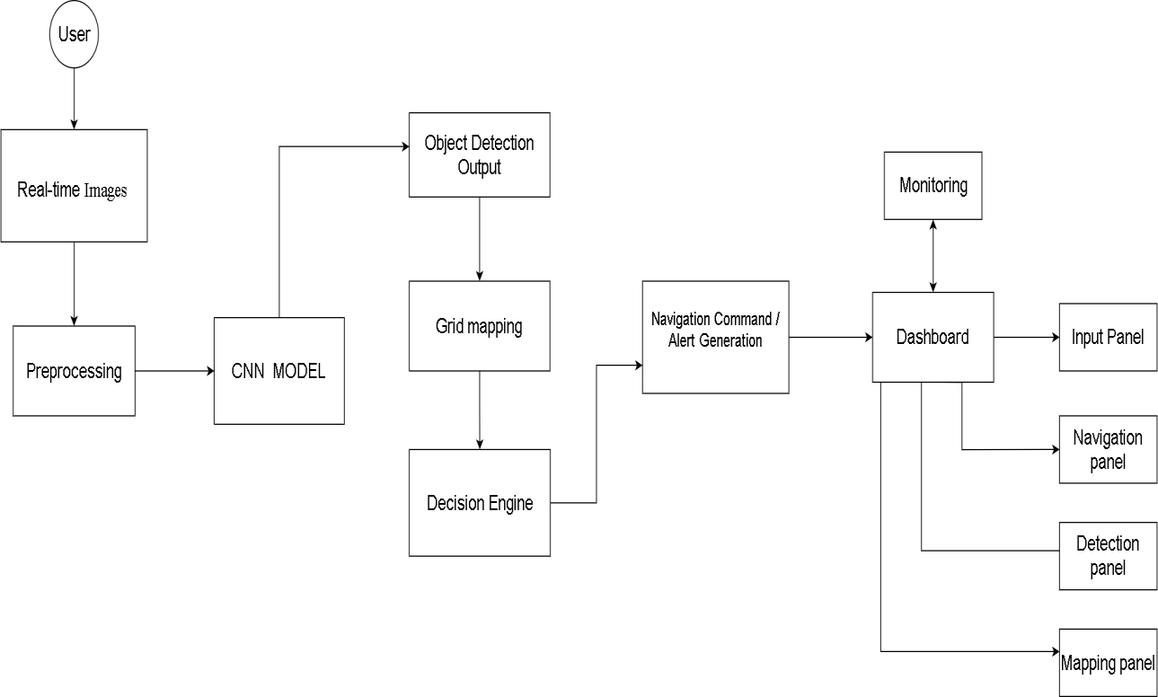
Fig1. System Architecture

V. RESULTS AND PERFORMANCE EVALUATION

The proposed system was tested using multiple real-world images under different scenarios to evaluate its detection and navigation performance. The YOLOv8n model effectively detected objects such as pedestrians, vehicles, and obstacles with good accuracy. The grid-based mapping module correctly identified object positions, while the decision engine generated appropriate navigation commands based on the detected environment.
The system achieved reliable performance in terms of accuracy, precision, recall, and F1-score. Experimental results also showed that the lightweight YOLOv8n model provided faster inference and reduced computational complexity, making the proposed system suitable for real-time assistive navigation applications.
The performance metrics obtained from the system are presented in the table below:

Evaluation Component | Accuracy | Precision | Recall | F1 Score
Object Detection (YOLOv8n) | 85.0% | 73.7% | 76.4% | 75.0%
Decision Engine | 90.0% | 88.0% | 87.5% | 87.7%
Overall System Performance | 87.5% | 80.8% | 81.9% | 81.3%

The results indicate that the decision engine outperformed the detection stage in accuracy, which is expected since rule-based logic applies deterministically once the grid is correctly populated, whereas detection involves probabilistic confidence scoring.

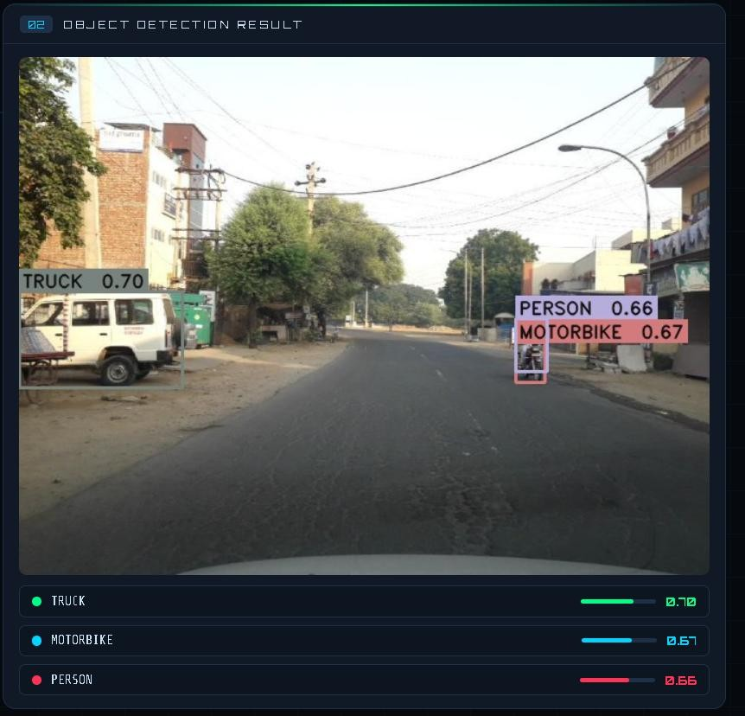
Fig. 2. Object Detection Output
The above figure shows the detection output on a real street image where the system identified three objects simultaneously — a truck at 0.70 confidence, a motorbike at 0.67, and a person at 0.66. All bounding boxes were correctly placed around the actual objects in the scene. The average confidence of 67.7% across test images reflects natural variation in outdoor conditions such as partial occlusion and distance. In a few cases where objects appeared near the frame edges with confidence scores close to the 0.50 threshold, the detection was either missed or borderline, suggesting that threshold tuning could further improve performance in challenging conditions.

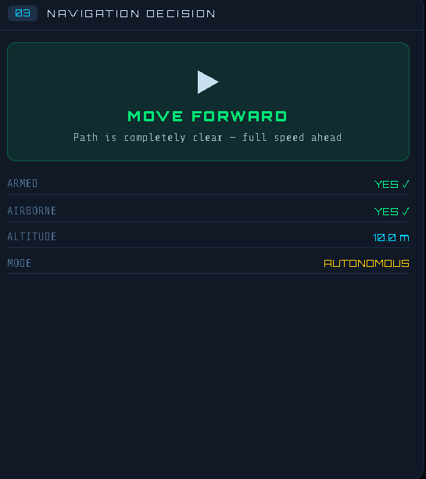
Fig. 3. Navigation Decision Generation
The above figure shows the navigation decision output for the same test image. The decision engine analyzed the populated grid and generated a MOVE FORWARD command since the center column remained clear despite objects being detected on the sides. The system correctly prioritized the center path and produced a safe navigation command consistent with the actual scene conditions. Across most test cases the navigation commands were accurate and logically consistent with the detected obstacle positions.

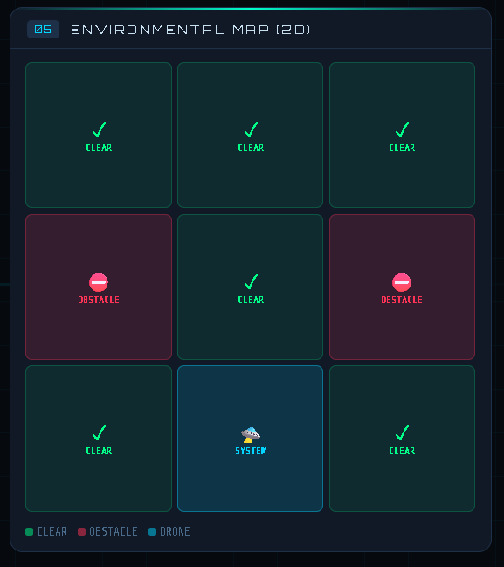
Fig. 4. Grid-Based Environmental Mapping
The above figure shows the 3×3 environmental map generated for the test image. The left and right columns are marked OBSTACLE corresponding to the detected truck and motorbike positions, while the center column remains CLEAR. The bottom-center cell is designated as the system position and excluded from obstacle marking. This grid representation directly influenced the MOVE FORWARD decision by confirming that the forward path was unobstructed.
The experimental evaluation confirms that the proposed system performs consistently across different object arrangements and road conditions. The grid mapping technique provided clear and interpretable spatial information that the decision engine used reliably to generate safe navigation commands including move forward, move left, move right, stop, and go slow depending on obstacle placement.

VI. CONCLUSION

This paper presented a vision-based autonomous system that integrates YOLOv8n object detection, 3×3 grid-based spatial mapping, and a rule-based decision engine into a single lightweight pipeline running entirely on standard hardware without additional sensors or cloud dependency. The core motivation was to address a gap in existing systems — most either detect objects without making decisions, or require expensive hardware to do both. The proposed system bridges this gap by converting visual detection output directly into actionable navigation commands through structured spatial mapping, successfully detecting real-world objects including trucks, motorbikes, and pedestrians across varied outdoor scenarios and generating consistent navigation commands based on the spatial arrangement of detected obstacles.
The experimental results confirmed that combining probabilistic detection with deterministic rule-based decision logic produces a system that is both reliable and interpretable — any navigation decision can be directly traced back to the grid state that caused it. One limitation observed during testing was the system's sensitivity near the confidence threshold boundary, where borderline detections occasionally produced grid assignments that did not fully reflect the actual scene conditions. Despite this, the overall system performed reliably across the majority of test cases and demonstrated that lightweight deep learning combined with simple spatial analysis is a viable and cost-effective approach to autonomous navigation, with clear potential for extension to video processing, drone platforms, and embedded edge deployment.

VII. FUTURE WORK
Future enhancements to the proposed system can focus on extending its functionality to real-time video processing for continuous environment monitoring. This will enable the system to operate more effectively in dynamic and complex scenarios.
Further improvements can include integration with autonomous platforms such as drones or robotic systems for real-world deployment. Additionally, incorporating advanced techniques like reinforcement learning can enhance decision-making capabilities and adaptability.
The system can also be improved by optimizing performance for edge devices and embedded systems, enabling faster processing with lower power consumption. Incorporating multi-sensor data fusion, such as GPS or depth sensors, can further enhance environmental perception and navigation accuracy.

REFERENCES

- J. Redmon et al., “You Only Look Once: Unified, Real-Time Object Detection,” Proceedings of the IEEE Conference on Computer Vision and Pattern Recognition (CVPR), 2016.
- A. Bochkovskiy, C.-Y. Wang and H.-Y. M. Liao, “YOLOv4: Optimal Speed and Accuracy of Object Detection,” 2020.
- S. Ren, K. He, R. Girshick and J. Sun, “Faster R-CNN: Towards Real-Time Object Detection with Region Proposal Networks,” 2015.
- W. Liu et al., “SSD: Single Shot MultiBox Detector,” European Conference on Computer Vision (ECCV), 2016.
- T.-Y. Lin et al., “Microsoft COCO: Common Objects in Context,” European Conference on Computer Vision (ECCV), 2014.
- Ultralytics, “YOLOv8 Documentation,” 2024. Available: https://docs.ultralytics.com
- OpenCV Organization, “OpenCV Library Documentation.” Available: https://opencv.org
- PyTorch Team, “PyTorch Documentation.” Available: https://pytorch.org
- D. Lowe, “Distinctive Image Features from Scale-Invariant Keypoints,” International Journal of Computer Vision, 2004.
- H. Bay, T. Tuytelaars and L. Van Gool, “SURF: Speeded-Up Robust Features,” European Conference on Computer Vision (ECCV), 2006.
- K. He, X. Zhang, S. Ren and J. Sun, “Deep Residual Learning for Image Recognition,” Proceedings of the IEEE Conference on Computer Vision and Pattern Recognition (CVPR), 2016.
- J. Long, E. Shelhamer and T. Darrell, “Fully Convolutional Networks for Semantic Segmentation,” Proceedings of the IEEE Conference on Computer Vision and Pattern Recognition (CVPR), 2015.
- M. Everingham et al., “The Pascal Visual Object Classes (VOC) Challenge,” International Journal of Computer Vision, 2010.

