Fundamental Advancement and Potential Application of Stimuli Responsive Microgel

Nisarg M. Parwe¹ , Roshani D. Agrawal² , Dr. Tulsidas Nimbekar³

Shri Laxmanrao Mankar Institute of Pharmacy, Amgaon

Corresponding Author : Nisarg M. Parwe
Contact Details: madhukarparwe70@gmail.com

ABSTRACT :
Stimuli-responsive microgels are a versatile class of soft, cross-linked polymeric particles capable of undergoing reversible structural or volume changes when exposed to external triggers such as pH, temperature, ionic strength, enzymes, redox conditions, light, or magnetic fields. Their unique combination of swelling behavior , high water content, tunable porosity, and surface functionality makes them highly suitable for modern biomedical and technological applications. Over the past two decades, significant advancements in polymer chemistry, nanofabrication, and microfluidics have enabled the development of sophisticated microgel architectures including core–shell, hollow, hybrid, and multi-stimuli responsive systems. These engineered microgels are now widely explored for controlled drug delivery, biosensing, imaging, tissue engineering, and environmental remediation. This review provides a comprehensive overview of the historical development, chemistry, mechanisms of responsiveness, synthesis approaches, characterization methods, recent technological advancements, and diverse applications of stimuli-responsive microgels. Additionally, current challenges, limitations, and future research directions are discussed to highlight the growing potential of microgels as next-generation smart materials.

Keyword :
Stimuli-Sensitive Microgel , Swelling-Deswelling Mechanism of Stimuli-Responsive Microgel , Temperature Responsive microgel , Synthesis & Fabrication Techniques of Microgel.

INTRODUCTION
Stimuli-responsive microgels, also known as “intelligent” or “smart” microgels, represent a rapidly advancing class of soft, cross-linked polymeric particles capable of undergoing significant, reversible physical or chemical changes when exposed to external stimuli. These stimuli may include temperature, pH, ionic strength, light, magnetic fields, redox conditions, biomolecules, or specific enzymes. Unlike conventional micro- or nanoparticles, stimuli-responsive microgels exhibit dynamic swelling and deswelling transitions due to the unique interplay between polymer network chemistry, solvent interactions, and environmental triggers. This responsiveness distinguishes microgels as highly versatile systems for biomedical, pharmaceutical, environmental, and industrial applications.[1]

Microgels typically range in size from 50 nm to several micrometers and possess a three-dimensional, cross-linked polymer network that can absorb large quantities of water without dissolving. This swollen, porous structure allows them to encapsulate a variety of active molecules including small-molecule drugs, proteins, peptides, nucleic acids, imaging agents, and even nanoparticles. Furthermore, the mechanical softness, biocompatibility, high water content, and tunable elasticity of microgels make them extremely attractive for biological interactions, especially in drug delivery and regenerative medicine.[2]

Recent advancements in polymer chemistry have enabled the creation of microgels with complex architectures such as core–shell, hollow, multilayered, anisotropic, and hybrid organic–inorganic structures. These advanced microgel systems provide superior control over drug release, site-specific targeting, responsiveness to multiple stimuli, and mechanical adaptability. For example, thermo-responsive microgels like poly(N-isopropylacrylamide) (PNIPAM) shrink above their lower critical solution temperature (LCST), making them ideal for temperature-triggered drug delivery or sensing applications. Similarly, pH-responsive microgels containing ionizable functional groups are highly valuable for oral, gastrointestinal, and tumor-targeted drug delivery, where pH gradients naturally exist in the body.[3]

The interest in stimuli-responsive microgels has grown tremendously due to the increasing demand for personalized and controlled drug delivery systems. Traditional dosage forms often face challenges such as poor solubility, limited bioavailability, off-target toxicity, and unpredictable release profiles. Microgels provide solutions through: trigger-specific drug release, environment-sensitive behavior, prolonged circulation ,enhanced tissue penetration, and improved therapeutic efficiency. In addition to drug delivery, microgels serve as key components in modern biomedical technologies such as biosensors, injectable scaffolds, cell carriers, and wound-healing materials. Their soft and deformable nature allows them to navigate complex biological environments, mimicking the physical properties of natural tissues. Microgels are now increasingly used as bioinks in 3D bioprinting due to their self-healing properties and customizable rheology, allowing fabrication of tissue-like structures with high precision.[4]

Beyond biomedicine, stimuli-responsive microgels also demonstrate significant potential in environmental applications. Their ability to swell, shrink, and selectively interact with molecules enables efficient removal of pollutants, dyes, and heavy metals from water systems. Smart microgels are also being explored in agriculture for controlled release of fertilizers and pesticides, thereby reducing environmental impact and improving crop productivity. In industrial fields, microgels are incorporated into smart coatings, cosmetics, food stabilization systems, and stimuli-adaptive materials.With the emergence of nanotechnology, controlled radical polymerization techniques, and microfluidics, the fabrication of microgels has reached high precision and scalability. This progress allows fine control over size, porosity, cross-linking density, mechanical strength, and surface chemistry, resulting in highly customizable microgel systems tailored for specific applications.[5]

The continuous evolution of stimuli-responsive microgels has positioned them as one of the most promising materials of the 21st century. Their adaptability, biocompatibility, responsiveness, and multi-functionality align perfectly with the growing global demand for intelligent, sustainable, and highly efficient technological solutions. As research continues to expand, microgels are expected to play an even more significant role in next-generation therapeutics, diagnostics, environmental management, and smart materials.[6]

HISTORY & BACKGROUND
The concept of microgels originated from early research on hydrogels and cross-linked polymers during the 1940s–1960s, when scientists first discovered that certain polymers could absorb large amounts of water and swell without dissolving. These materials laid the foundation for the later development of microgels, which are essentially hydrogel particles on the micro-scale. The real beginning of modern microgel science occurred in the 1980s, when synthetic polymer chemistry advanced enough to enable the creation of cross-linked, colloidally stable polymer particles in the micro- and nanoscale range. During this period, the most important discovery was the thermo-responsive polymer poly(N-isopropylacrylamide) (PNIPAM), which showed a reversible volume phase transition at around 32°C. This discovery transformed microgels from simple polymer particles into “smart” materials capable of responding to environmental stimuli .In the 1990s, research expanded toward understanding swelling–deswelling behavior, polymer–solvent interactions, and the effect of cross-link density. Scientists also began designing microgels with core–shell architectures, allowing better control of drug loading and release. Studies in colloid science during this period provided deeper insight into microgel stability, charge behavior, and interactions with biological environments .The 2000s marked a significant turning point due to the introduction of controlled/living radical polymerization techniques such as RAFT, ATRP, and click chemistry. These methods allowed precise control over-particle size, composition ,functional group placement, and responsiveness. [14]
This era also introduced nanocomposite microgels, where nanoparticles (gold, silver, magnetic iron oxide) were embedded into the polymer network to impart optical, magnetic, or catalytic properties. From 2010 onwards, advancements in nanotechnology, biotechnology, and microfabrication resulted in highly sophisticated microgel systems. Microfluidic devices enabled production of perfectly monodisperse microgels, while biocompatible and biodegradable polymers expanded their use in medicine. New categories such as multi-stimuli responsive microgels, hollow microgels, and microgel bioinks for 3D bioprinting emerged during this period .Today, microgels have become an essential platform in drug delivery, diagnostics, tissue engineering, smart coatings, and environmental remediation. Their history reflects a continuous evolution driven by improvements in polymer science, nanotechnology, and biomedical engineering.[15]

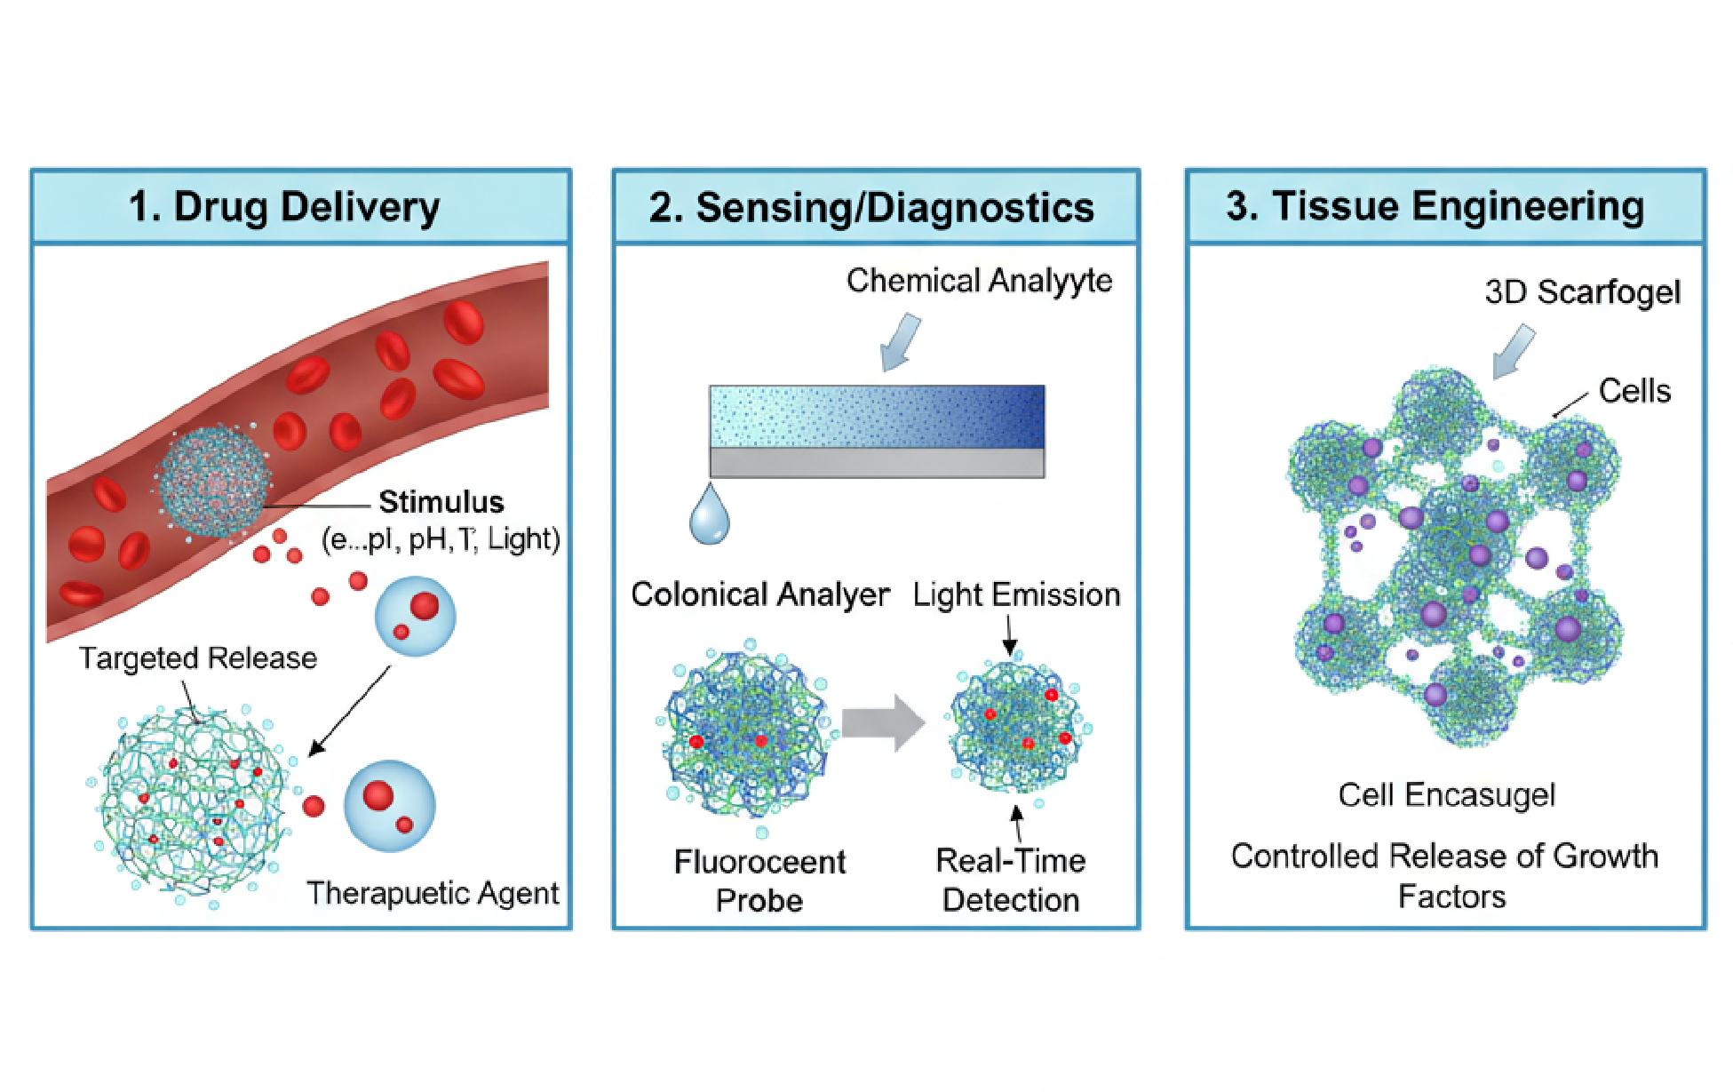Diagram : Functional Uses of Stimuli-Sensitive Microgels

Drug Delivery: Microgels release medicine only when a stimulus (pH, temperature, light) triggers them. Sensing /Diagnostics: Microgels detect chemicals and give a light signal for real-time monitoring .Tissue Engineering: Microgels form 3D structures that hold cells and slowly release growth factors to help tissues grow.

CHEMISTRY & POLYMER SCIENCE
The chemistry of microgels is rooted in the design of cross-linked polymer networks that can absorb water, respond to external stimuli, and maintain structural stability. At the molecular level, a microgel is composed of polymer chains joined together through covalent or physical cross-links, forming a three-dimensional network. The nature of the monomers, the density of cross-linking, and the type of functional groups present within the polymer structure collectively determine the swelling behavior, mechanical strength, and stimuli responsiveness of the microgel .A key aspect of microgel chemistry is the selection of monomers that impart specific physicochemical characteristics. For example, N-isopropylacrylamide (NIPAM) is widely used to create thermo-responsive microgels due to its ability to exhibit a reversible phase transition at around 32°C. Below this temperature, the polymer network strongly interacts with water, causing the microgel to swell; above this temperature, hydrophobic interactions dominate, leading to network collapse. Similarly, monomers containing ionizable groups such as acrylic acid, methacrylic acid, or amino-containing monomers enable pH-responsiveness. These functional groups can gain or lose protons depending on the surrounding pH, resulting in changes in charge density and osmotic pressure that drive swelling or deswelling.[16]
Cross-linkers play an equally significant role in determining microgel properties. Molecules such as N,N′-methylene-bisacrylamide (MBA) introduce covalent bridges between polymer chains, creating a stable network architecture. The proportion of cross-linker controls the rigidity and porosity of the microgel: higher cross-link density results in a tighter, less swollen network, while lower density produces a softer, more flexible structure. This tunability allows microgels to be engineered for different applications, such as strong and stable particles for environmental use or soft and highly swollen networks for biomedical applications .Polymer chemistry also influences the distribution of functional groups within the microgel particle. Depending on the polymerization technique used, microgels can be designed with homogeneous networks or with more complex architectures such as core–shell structures, gradient networks, and hollow particles. In core–shell microgels, the core is usually more highly cross-linked, while the shell contains functional groups responsible for stimuli responsiveness or biological interactions. This architectural control enhances loading efficiency, responsiveness, and surface reactivity.[17]
Furthermore, the hydrophilic–hydrophobic balance of the polymer network is a crucial determinant of microgel behavior. Incorporating hydrophilic polymers like polyethylene glycol (PEG) improves biocompatibility and water uptake, whereas hydrophobic components can be included to modulate drug loading or control the collapse behavior of the gel. Natural polymers such as chitosan, alginate, gelatin, and hyaluronic acid introduce biodegradability and bioactivity, making them highly suitable for tissue engineering and drug delivery.[18]

In addition to chemical composition, polymer science principles like polymer–solvent interactions, network elasticity, and osmotic pressure govern the swelling kinetics of microgels. The Flory–Rehner theory, which describes the balance between elastic restoring forces and mixing forces within polymer networks, is often used to explain microgel swelling behavior. Stimuli responsiveness arises when environmental changes alter this balance, triggering network expansion or collapse .Overall, the chemistry and polymer science behind microgels provide a versatile platform for tailoring their structure, responsiveness, and functionality. By manipulating monomer choice, cross-link density, network architecture, and functional group distribution, researchers can design microgels customized for applications ranging from targeted drug delivery to environmental remediation and advanced biomaterials.[19]

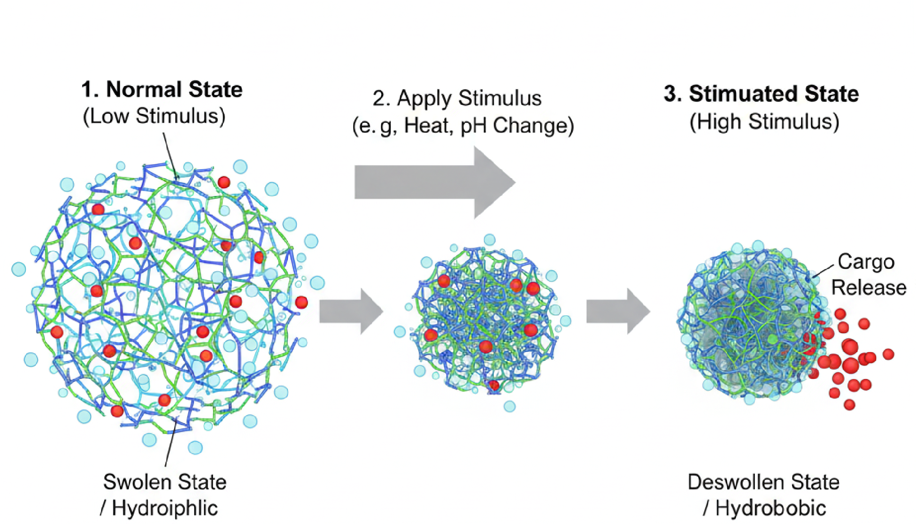

Diagram : Swelling–Deswelling Mechanism of Stimuli-Responsive Microgels

MECHANISMS OF STIMULI-RESPONSIVENESS
Stimuli-responsive microgels exhibit their intelligent behavior because their polymer network is highly sensitive to changes in the surrounding environment. These changes affect the balance between polymer–polymer interactions, polymer–solvent interactions, and the internal osmotic pressure of the microgel. When external stimuli disturb this balance, the microgel undergoes a reversible transition between a swollen and a de-swollen state. This phenomenon is the foundation for targeted drug release, sensing, and smart material behavior .At the molecular level, the responsiveness arises due to the presence of functional groups—such as amide, carboxyl, amino, hydroxyl, or aromatic groups—within the polymer chains. These groups can interact with heat, ions, light, pH, or biomolecules, causing changes in hydration, ionization, or cross-linking density. As a result, the microgel may expand when it attracts water (hydrophilic state) or shrink when hydrophobic interactions dominate. Such reversible transitions give microgels their unique ability to act like tiny “actuators” or “switches” inside biological or chemical environments.[20]
Temperature-Responsive Mechanism
One of the most common triggers is temperature. Polymers like PNIPAM have a lower critical solution temperature (LCST) near physiological temperature .Below LCST: polymer chains are hydrated → microgel swells .Above LCST: hydrophobic interactions dominate → microgel collapses .This switch-like transition makes temperature-responsive microgels ideal for on–off drug release. pH-Responsive Mechanism Polymers containing ionizable groups respond strongly to pH changes. In acidic or basic environments, these groups protonate or deprotonate. This alters the charge density inside the network. Increased charge causes swelling (electrostatic repulsion); decreased charge causes collapse. This mechanism is widely used for tumor targeting and oral drug delivery. Ionic Strength Mechanism The presence of salt ions changes the osmotic pressure inside the network .High ionic strength screens charges → microgel shrinks. Low ionic strength increases repulsion → microgel swells.This principle is important for environmental and industrial [21].
Enzyme-Responsive Mechanism
Some microgels contain cleavable linkers that degrade in the presence of specific enzymes.When these enzymes are present in disease sites (e.g., tumors, inflamed tissues), the microgel disassembles or softens, triggering controlled release of bioactive molecules.[22] Light-Responsive Mechanism Light-sensitive bonds (photo-cleavable groups) or incorporated nanoparticles respond to UV or near-infrared light.Light can break chemical bonds. Or generate heat via photothermal effect. This results in rapid volume change and precise, localized drug release.Redox-Responsive Mechanism Disulfide bonds within the network break under reducing environments (such as inside cells with high glutathione levels). This causes network loosening and allows the cargo to escape.[22]
Magnetic-Responsive Mechanism
Microgels embedded with magnetic nanoparticles respond to external magnetic fields.A magnetic field can generate localized heating or mechanical movement, triggering collapse and drug release.[23]

SYNTHESIS & FABRICATION TECHNIQUES OF MICROGELS
The synthesis of stimuli-responsive microgels is based on creating a cross-linked polymer network that can respond to environmental triggers. The choice of polymerization method determines the size, morphology, uniformity, and functional behavior of the final microgel. Most fabrication techniques aim to control parameters such as particle size, cross-link density, and distribution of functional groups, as these features strongly influence swelling behavior and drug-loading efficiency.One of the most widely used methods is precipitation polymerization, where monomers and cross-linkers polymerize in water at elevated temperatures, forming uniform and stable microgel particles. This technique is especially common for thermoresponsive systems like PNIPAM. Another important method is emulsion or mini-emulsion polymerization, where droplets of monomer are dispersed in a continuous phase, allowing precise control over particle size and preventing aggregation.[24]
More advanced fabrication approaches include controlled radical polymerization techniques such as RAFT (Reversible Addition–Fragmentation Chain Transfer) and ATRP (Atom Transfer Radical Polymerization). These methods allow microgels to be synthesized with well-defined structures, narrow size distribution, and specific functional groups placed exactly where they are required. They are particularly useful when designing core–shell or multi-layered microgels. Micro-fluidic fabrication is a modern technique that produces highly monodisperse microgels. In this method, droplets containing monomers are formed in micro-channels and later polymerized, allowing exceptional control over size and shape. Microfluidics also enables fabrication of complex architectures such as Janus, hollow, and anisotropic microgels.[25]
Main Techniques :
  - Precipitation polymerization – simple, water-based, ideal for thermo-responsive microgels.
  - Emulsion / mini-emulsion polymerization – produces stable and uniform particles.
  - RAFT / ATRP polymerization – offers controlled, precise microgel architectures.
  - Microfluidic synthesis – generates highly monodisperse and custom-shaped microgels.
  - Click chemistry – allows surface modification and addition of bioactive groups.
Overall, synthesis methods continue to evolve toward greater precision, scalability, and ability to incorporate multifunctional properties, making microgels suitable for advanced biomedical and environmental applications. [1]

CHARACTERIZATION METHODS OF MICROGELS
Characterization of microgels is essential to understand their size, structure, chemical composition, swelling behavior, and responsiveness. Since microgels are soft, water-rich, and nanoscale to microscale in nature, multiple analytical techniques are used to confirm their physical and chemical properties.Microscopy techniques provide detailed information about morphology. Scanning Electron Microscopy (SEM) and Transmission Electron Microscopy (TEM) reveal surface structure, particle shape, and internal architecture. Confocal Laser Scanning Microscopy is particularly useful for hydrated microgels, allowing visualization of swollen states and distribution of encapsulated molecules.[2]
Particle size and distribution are commonly measured using Dynamic Light Scattering (DLS), which determines hydrodynamic diameter and polydispersity index. This technique is crucial because the swelling-deswelling behavior of microgels strongly depends on particle size uniformity. Zeta potential analysis provides information on surface charge, which affects stability, interaction with cells, and responsiveness to pH or ionic strength.Chemical composition and functional groups are typically identified using Fourier Transform Infrared Spectroscopy (FTIR) and Nuclear Magnetic Resonance (NMR) spectroscopy. These methods confirm the successful incorporation of monomers, cross-linkers, and functional groups responsible for stimuli responsiveness.[3]
Thermal behavior and stability are evaluated using Differential Scanning Calorimetry (DSC) and Thermogravimetric Analysis (TGA). These techniques help determine phase transition temperatures, degradation profiles, and compatibility with biological environments.Mechanical properties are studied using rheology and Atomic Force Microscopy (AFM). These techniques provide information about stiffness, elasticity, and deformation behavior, which are important for applications such as tissue engineering and injectable systems.[4]
Key Techniques :
  - SEM/TEM – morphology and structure.
  - DLS – particle size and swelling behavior.
  - FTIR/NMR – chemical composition.
  - DSC/TGA – thermal properties.
  - Zeta potential – surface charge and stability.
Characterization ensures that microgels perform as intended and meet the requirements of specific biomedical or industrial applications.[5]

RECENT ADVANCEMENTS IN MICROGEL TECHNOLOGY
In recent years, microgel research has progressed rapidly due to improvements in polymer chemistry, nanotechnology, and fabrication techniques. Modern microgels are no longer simple swelling particles; they are highly engineered systems capable of performing complex functions in biomedical, environmental, and industrial fields. One major advancement is the development of multi-stimuli responsive microgels, which can react to two or more signals—such as pH, temperature, and redox conditions—allowing precise control of drug release in complex biological environments. These microgels are particularly valuable in cancer therapy, where multiple physiological triggers exist.[6]
Another important advancement is the creation of hybrid and nanocomposite microgels, where inorganic nanoparticles (gold, silver, silica, or magnetic iron oxide) are incorporated into the polymer network. These hybrid systems exhibit additional functionalities such as magnetic responsiveness, photothermal heating, enhanced imaging ability, or antimicrobial activity. This makes them suitable for theranostic applications, combining diagnosis and therapy in a single platform.[7]
Significant progress has also been made in microfluidic-based microgel fabrication, which produces monodisperse particles with tailored shapes and internal structures. Microfluidics allows the design of Janus microgels, hollow microgels, and multi-compartment systems that provide advanced drug-loading capabilities and controlled swelling behavior. These precisely engineered structures are opening new possibilities in targeted drug delivery and high-resolution biosensing.[8]
In the field of tissue engineering, microgel bioinks have emerged as a major breakthrough. These bioinks exhibit excellent printability, self-healing properties, and cell compatibility, enabling the 3D printing of soft tissue-like structures. Microgel-based scaffolds allow controlled release of growth factors and improved cell support, contributing to progress in regenerative medicine.[9]
Environmental applications have also expanded, with smart microgels designed for pollutant capture, heavy-metal adsorption, and controlled agricultural release. Their selective swelling and binding properties make them effective for sustainable environmental solutions.

Key Advancements :
  - Multi-stimuli responsive microgels for complex biological environments.
  - Hybrid/nanocomposite microgels with magnetic or optical functions.
  - Microfluidic fabrication for precise and customizable structures.
  - Microgel-based bioinks for 3D bioprinting and tissue regeneration.
  - Smart environmental microgels for pollutant removal and agriculture.
  - Theranostic microgels integrating imaging and therapy.

Overall, these advancements have transformed microgels into multifunctional platforms capable of performing highly specialized roles in medicine, technology, and environmental science.[10]

APPLICATIONS OF STIMULI-RESPONSIVE MICROGELS
Stimuli-responsive microgels have become valuable across biomedical, environmental, and industrial fields due to their ability to swell, shrink, and release cargo in a controlled manner. Their soft, water-rich structure and tunable chemistry make them suitable for interacting with biological systems, detecting molecules, capturing pollutants, and forming smart functional materials.In drug delivery, microgels offer targeted and controlled release of therapeutics. Their responsiveness to pH, temperature, enzymes, or redox conditions allows them to release drugs only at specific sites, such as tumor tissues, inflamed regions, or the gastrointestinal tract. Swollen microgels can encapsulate a wide variety of molecules, while their collapse under stimulus helps push out the drug, improving therapeutic efficiency and minimizing side effects.[11]
Microgels are also widely used in biomedical diagnostics and biosensing. Their sensitivity to chemical or biological signals enables them to act as miniature sensors that respond with a measurable change, such as fluorescence or optical shift. These properties allow detection of glucose, pH, enzymes, toxins, and biomarkers. Incorporation of fluorescent dyes or metal nanoparticles further enhances their sensing capability.In tissue engineering, microgels serve as injectable scaffolds or building blocks for 3D structures. Their biocompatibility, softness, and ability to support cell attachment make them ideal candidates for regenerating cartilage, skin, and soft tissues. Microgel-based bioinks are now used in 3D bioprinting to create customizable tissue constructs with controlled mechanical and biological properties.[12]
Environmental applications have grown as well. Stimuli-responsive microgels are used for water purification, where their network binds to heavy metals, dyes, or pollutants and removes them effectively. In agriculture, microgels enable the controlled release of fertilizers or pesticides, improving efficiency and reducing environmental contamination.Industrially, microgels are employed in cosmetics and personal care products because of their ability to retain moisture and deliver active ingredients. They are also used in food stabilization, smart coatings, and soft robotics, where their reversible swelling behavior allows them to act as soft actuators or adaptive materials.[13]
Major Application Areas :
  - Drug delivery and targeted therapy.
  - Diagnostics, biosensing, and imaging.
  - Tissue engineering and 3D bioprinting.
  - Water purification and pollutant removal.
  - Agricultural controlled-release systems.
  - Cosmetics, food, and smart industrial materials.
  - Soft robotics and adaptive materials.
Overall, the versatility of stimuli-responsive microgels has made them essential components in modern healthcare, environmental sustainability, and advanced technological systems.[14]

CHALLENGES & LIMITATIONS OF STIMULI-RESPONSIVE MICROGELS
Despite their broad potential, stimuli-responsive microgels face several challenges that limit their widespread clinical and industrial use. One major issue is the complexity of synthesis, as methods like controlled radical polymerization or microfluidic fabrication require specialized equipment and may not be easily scalable for mass production. Inconsistency in particle size, cross-link density, and responsiveness can occur during large-scale manufacturing, affecting performance and reproducibility.Another limitation is biocompatibility and safety concerns. Although many microgels are designed using biocompatible polymers, residual monomers, surfactants, and cross-linkers may introduce toxicity. Their long-term behavior in the body—such as degradation products, immune response, and clearance pathways—needs thorough evaluation before regulatory approval.[15]
Stimuli sensitivity in real biological environments can also be unpredictable. For example, pH, temperature, and enzyme concentrations vary widely across tissues and can interfere with the intended response. Microgels designed to respond at specific thresholds may not behave optimally in the complex and dynamic environment of the human body.Mechanical weakness is another challenge. Many microgels are soft and fragile, making them unsuitable for load-bearing tissues or harsh environmental applications. Their swelling and deswelling rates may also be slow, limiting rapid drug release or sensing performance.From an environmental perspective, the use of synthetic polymers raises questions about biodegradability and ecological impact, especially in wastewater or agricultural applications. Another major barrier is regulatory approval, as new materials require extensive testing for toxicity, stability, and long-term safety, which increases cost and delays commercialization.[16]
Major Limitations :
  - Difficulty in large-scale, uniform manufacturing.
  - Potential toxicity from monomers or additives.
  - Unpredictable responsiveness in real biological environments.
  - Mechanical weakness and slow swelling kinetics.
  - Limited biodegradability of some synthetic polymers.
  - High development and regulatory approval costs.
Overall, while stimuli-responsive microgels show great promise, overcoming these challenges is essential for their successful transition from laboratory research to real-world applications.[17]

FUTURE SCOPE OF STIMULI-RESPONSIVE MICROGELS
The future of stimuli-responsive microgels is highly promising, as ongoing research continues to expand their capabilities in biomedicine, environmental science, and advanced materials. One major direction is the development of multi-stimuli and highly programmable microgels, which can respond to combinations of triggers such as pH, temperature, enzymes, and light. These systems will allow more precise control over drug release, making them suitable for complex diseases like cancer, where multiple physiological signals are present.[18]
Another important future trend is the creation of personalized drug delivery systems, where microgels are designed based on patient-specific conditions, genetic profiles, or disease markers. With advances in artificial intelligence and computational modeling, polymer structures can be optimized to achieve highly predictable swelling behavior and therapeutic outcomes.In the field of regenerative medicine, microgel-based 3D bioprinting is expected to grow rapidly. Microgels with self-healing and tunable mechanical properties can be used to print tissues and organ-like constructs with improved cell viability. These technologies may contribute to breakthroughs in organ replacement and tissue repair.[19]
Environmental applications also hold strong potential. Researchers are working on biodegradable and eco-friendly microgels capable of selectively capturing pollutants, heavy metals, or microplastics from water systems. Future agricultural microgels may offer smart release of nutrients or pesticides based on plant needs and soil conditions, improving sustainability.On the industrial side, microgels may evolve into components for soft robotics, flexible electronics, and smart coatings, where their reversible swelling can act as an actuator or adaptive material. Incorporation of new functional nanomaterials will further expand their optical, electrical, and mechanical properties.[20]

Expected Future Directions :
  - Multi-stimuli and programmable microgels.
  - Personalized and precision medicine applications.
  - Advanced 3D bioprinting and tissue engineering.
  - Biodegradable and environmentally adaptive microgels.
  - Smart agricultural delivery systems.
  - Microgels for soft robotics and flexible electronics.

CONCLUSION
Stimuli-responsive microgels represent a highly versatile class of smart materials with significant potential across biomedical, environmental, and industrial applications. Their unique ability to undergo reversible changes in swelling, structure, and functionality in response to external stimuli makes them ideal for controlled drug delivery, targeted therapy, biosensing, tissue engineering, and pollutant removal. Over the years, advancements in polymer chemistry, nanotechnology, and fabrication techniques have enabled the development of complex architectures such as multi-stimuli, hybrid, and microfluidic-generated microgels, greatly enhancing their performance and adaptability.
Despite the remarkable progress, several challenges remain, including scalability issues, potential toxicity, limited mechanical strength, and regulatory hurdles. Addressing these limitations will be essential for translating microgel technology from research laboratories to real-world medical and industrial use. Future innovations are expected to focus on personalized medicine, environmentally responsive systems, 3D bioprinting, and smart materials for robotics and flexible electronics.
In summary, stimuli-responsive microgels continue to evolve as powerful platforms capable of meeting modern demands for intelligent, efficient, and sustainable solutions. With ongoing research, they are poised to play a transformative role in next-generation healthcare and advanced technologies.

REFERENCES :
- Pelton R. Temperature-sensitive microgels: preparation, properties, and applications. Colloid & Polymer Science, 2000.Link: https://pubmed.ncbi.nlm.nih.gov/10696447/
- Oh J.K., Drumright R., Siegwart D.J. The development of microgel systems for drug delivery. Progress in Polymer Science, 2008. Link:https://doi.org/10.1016/j.progpolymsci.2008.01.002
- Lyon L.A., Serpe M.J., Kim J. Stimuli-responsive microgels and their applications. Journal of Materials Chemistry, 2009.Link:https://pubs.rsc.org/en/content/articlelanding/2009/jm/b820157k
- Saunders B.R., Vincent B. Microgel particles as smart materials. Advances in Colloid and Interface Science, 1999.Link: https://doi.org/10.1016/S0001-8686(98)00069-7
- Nayak S., Lyon L.A. Soft nanotechnology with responsive microgels. Angewandte Chemie International Edition, 2005.Link: https://doi.org/10.1002/anie.200500167
- Karg M., Hellweg T. Smart microgels: synthesis, characterization, and applications. Polymer Chemistry, 2013.Link: https://doi.org/10.1039/C3PY00130G
- Hamidi M., Azadi A., Rafiei P. Hydrogel nanoparticles in drug delivery. Advanced Drug Delivery Reviews, 2008.Link: https://doi.org/10.1016/j.addr.2007.08.002
- Smeets N.M., Hoare T. Design of multi-responsive microgels. Macromolecular Rapid Communications, 2013.Link: https://doi.org/10.1002/marc.201200683
- Wu C., Zhou S. Thermoresponsive microgel systems. Macromolecules, 2010.Link: https://pubs.acs.org/doi/10.1021/ma9023854
- Senff H., Richtering W. Temperature and pH sensitive microgels. Colloid and Polymer Science, 1999.Link: https://doi.org/10.1007/s003960050428
- Hoare T., Pelton R. Functionalization of microgel particles. Langmuir, 2004.Link: https://pubs.acs.org/doi/10.1021/la049720i
- Moura M.J. et al. Microgels for tissue engineering applications. Biomaterials, 2011.Link: https://doi.org/10.1016/j.biomaterials.2010.10.050
- Kabanov A.V., Vinogradov S.V. Nanogels in drug delivery. Advanced Drug Delivery Reviews, 2009.Link: https://doi.org/10.1016/j.addr.2009.01.017
- Ghosh S. et al. Nanocomposite microgels: preparation and applications. Journal of Nanoscience and Nanotechnology, 2012.Link: https://www.ingentaconnect.com/content/asp/jnn/2012/00000012/00000004/art00010
- Zhang X. et al. Microgel-based biosensors and diagnostics. Analytical Chemistry, 2015. Link: https://pubs.acs.org/doi/10.1021/ac504606d
- Vinogradov S.V. Nanogels in biomedical applications. Advanced Drug Delivery Reviews, 2010.Link: https://doi.org/10.1016/j.addr.2009.10.009
- Debord J.D., Lyon L.A. Synthesis and characterization of pH-responsive microgels. Langmuir, 2003.Link: https://pubs.acs.org/doi/10.1021/la026103p
- Berndt I., Richtering W. Temperature-sensitive poly(N-isopropylacrylamide) microgels. Macromolecules, 2003.Link: https://pubs.acs.org/doi/10.1021/ma021491x
- Snowden M.J., Chowdhry B.Z., Vincent B. Colloidal microgels: fundamentals and applications. Colloids and Surfaces A, 1996.Link: https://doi.org/10.1016/0927-7757(95)03379-3
- Nayak S., Ganesh K. Polymer-based microgels for biomedical and environmental use. Chemical Reviews, 2011.Link: https://pubs.acs.org/doi/10.1021/cr100204t
- Schmaljohann D. Thermo- and pH-responsive polymers in drug delivery. Advanced Drug Delivery Reviews, 2006.Link: https://doi.org/10.1016/j.addr.2006.09.020
- Stieger M. et al. Small-angle neutron scattering on responsive microgels. Journal of Chemical Physics, 2004.Link: https://doi.org/10.1063/1.1631733
- Wu W., Mitra N. Redox-responsive microgels for controlled drug delivery. Journal of Controlled Release, 2012.Link: https://doi.org/10.1016/j.jconrel.2012.04.034
- Zeiser M. et al. Microfluidic synthesis of monodisperse microgels. Lab on a Chip, 2008. Link: https://pubs.rsc.org/en/content/articlelanding/2008/lc/b802000k
- Meng Z. et al. Hybrid microgels for environmental pollutant removal. Environmental Science & Technology, 2015. Link: https://pubs.acs.org/doi/10.1021/es505645j

