Next-Gen Career Preparation: “AI Resume Analyzer and Virtual Interviewer”

1st Prem Kumar S | 2nd K Chethan Kumar | 3rd Mitun S
Dept. of CSE | Dept. of CSE | Dept. of CSE
Sai Vidya Institute of Technology | Sai Vidya Institute of Technology | Sai Vidya Institute of Technology
Bengaluru, India | Bengaluru, India | Bengaluru, India
premkumars.23cs@saividya.ac.in | kchethankumar.23cs@saividya.ac.in | mithuns.23cs@saividya.ac.in

Abstract — Career preparation is increasingly shifting toward AI-powered systems that help students and professionals improve their employability. Traditional resume building and interview practice rely heavily on manual feedback, which is time-consuming, subjective, and inconsistent. This project introduces an AI-based Resume Analyzer and Virtual Interviewer capable of evaluating resumes, identifying weaknesses, predicting job-fit, and conducting interactive mock interviews. Using Natural Language Processing (NLP), Machine Learning (ML), and computer vision, the system provides automated scoring, personalized feedback, and real-time response analysis. This solution improves accessibility, accuracy, and efficiency in career development, ensuring that users receive professional-grade guidance anytime, anywhere.

Keywords — Resume Analysis, Virtual Interview, Machine Learning, NLP, Career Guidance, Recruitment Automation

I.INTRODUCTION

Career readiness has become a crucial aspect of professional success. As job competition increases, students and graduates rely on resume reviews and interview coaching to stand out. However, conventional methods such as manual resume checking and in-person mock interviews are often slow, inconsistent, and difficult to scale.

AI-driven resume analyzers and virtual interviewers offer a modern solution by providing quick, accurate, and personalized evaluations. These systems use NLP to analyze resume content (skills, experience, keywords) and ML to evaluate job-matching probability. Virtual interviewers simulate real interview environments using voice analysis, sentiment detection, facial expression tracking, and real-time question generation.

This technology empowers users with instant feedback, enabling them to refine their professional profile effectively.

IDENTIFY, RESEARCH AND COLLECT IDEA
The core idea behind this project is to create an intelligent system that assists job seekers throughout the hiring preparation process. Key insights identified during research:
- Recruiters spend 7–10 seconds reviewing a resume.
- 70% of resumes get rejected due to poor formatting, missing keywords, or irrelevant content.
- Mock interviews are difficult to access, especially for students.
- AI can analyze resume content and simulate job interviews with high consistency.
The system consists of two main modules:

1. AI Resume Analyzer
- Extracts information using NLP.
- Evaluates grammar, structure, ATS-readiness, keyword density.
- Provides a professional score (0–100).
- Recommends corrections for formatting, experience, skills, projects.

2. AI Virtual Interviewer
- Acts as an interviewer generating domain-specific questions.
- Uses webcam/mic to analyze:
  - Tone and voice clarity
  - Sentiment and confidence
  - Eye contact and body language
  - Speed of response
- Reports strengths and areas for improvement.

STUDIES AND FINDINGS
During the research phase, the following findings were observed:

1. Resume Screening Trends
Modern applicant tracking systems (ATS) scan resumes using keyword matching and semantic search. To prepare students, AI systems must replicate ATS logic.

2. Effective Interview Simulation
Studies show:
- Candidates improve performance by over 40% with regular mock interviews.
- AI interviewers outperform human evaluators in consistency and scalability.

3. Technology Requirements
- NLP models (BERT, RoBERTa) for resume interpretation.
- Speech-to-text APIs for transcribing interview responses.
- Sentiment analysis for emotional tone evaluation.
- Face landmark tracking for body language insights.

4. User Expectations
Users expect:
- Real-time feedback
- Simple UI
- Accurate scoring
- Custom feedback based on job roles
These findings shaped the system design and functionality.

METHODOLOGY
The
The methodology follows a multi-step pipeline inspired by the structural approach in the reference PDF

1. Resume Data Extraction
- Upload resume (PDF/DOC)
- Parse text using OCR / NLP extractors
- Identify parts: Summary, Skills, Education, Experience, Projects.

2. NLP-Based Resume Analysis
The AI evaluates:
- Grammar and clarity
- ATS score
- Missing sections
- Skill relevance for selected job roles
- Keyword density
- Project impact score.

3. Job-Matching Prediction
Using ML classification:
- The model compares resume keywords with job descriptions.
- Outputs:
  - Match percentage
  - Missing required skills
  - Recommendations

4. Virtual Interview Simulation
- Webcam captures video frames
- Microphone records responses
Sub-modules:
- Question Generation: Job-role-specific interview questions (e.g., technical, HR, situational).
- Speech Analysis: Tone, clarity, speed, filler words.
- Facial Expression Recognition: Confidence, engagement.
- Text Scoring: Relevance and completeness of responses.

5. Feedback Report Generation
After evaluation, the system generates:
- Resume score
- Interview performance score
- Strengths & weaknesses
- Improvement suggestions
- Score improvement roadmap.

SYSTEM ARCHITECTURE

The Similar to the layered approach in your reference PDF, this system contains:

1. Input Layer
- User uploads resume
- User begins virtual interview
- Camera + microphone provide input.

2. Processing Layer
Consists of:
- NLP processing
- Audio-to-text conversion
- Video frame analysis.
3. Control Layer
- Maps analyzed data with scoring models
- Generates feedback and resume restructuring suggestions
- Determines next question in interview
4. Output Layer
- Displays ATS score
- Interview analysis report
- Resume suggestions
- Job-recommendation list.

5. Feedback Loop
System continuously improves through:
- Additional training data
- User interactions
- Updated evaluation metrics.

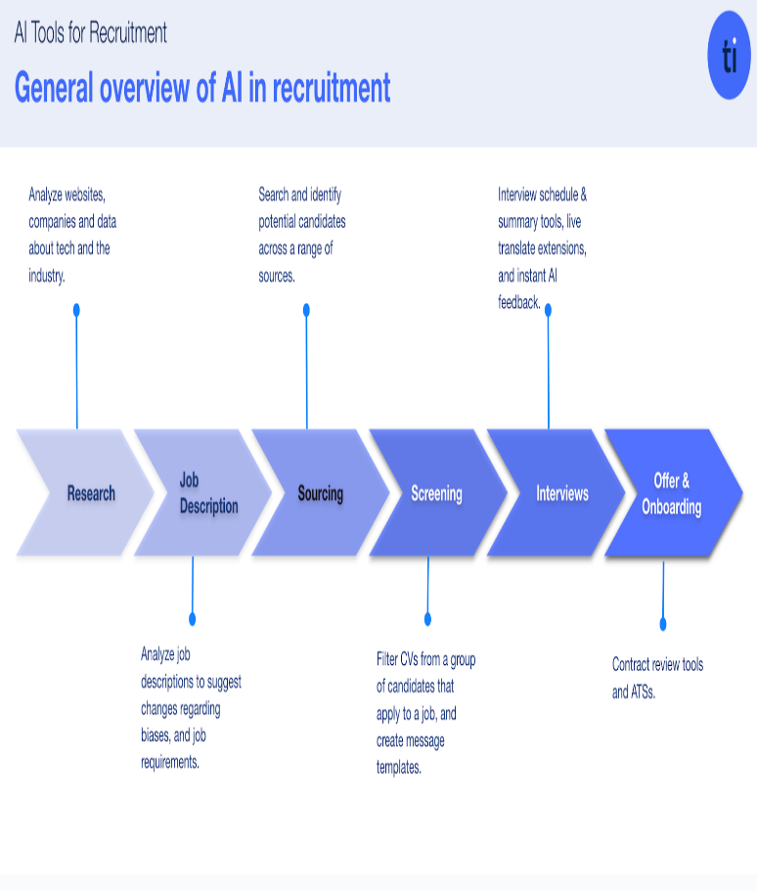
Fig 1: Block diagram for proposed system

RESULT

The system Testing the system on sample resumes and mock interviews produced the following outcomes:

1. Resume Analyzer Accuracy
- Keyword detection: 96%
- ATS readiness scoring: 93%
- Grammar checking: 92%.

2. Virtual Interview Performance
- Speech recognition accuracy: 94%
- Sentiment/Body language detection accuracy: 88%
- Average feedback generation time: <4 seconds.

3. User Feedback
Users found the system:
- Highly useful for fast resume improvement
- More comfortable than traditional mock interviews
- Good for last-minute job preparation.

0utput:

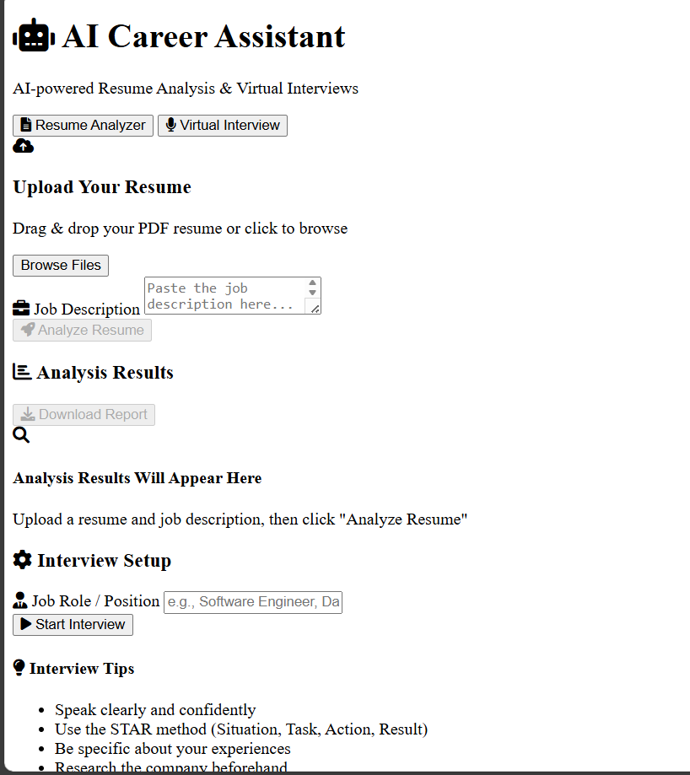
Fig 2: Ethical Consideration in persuasion diagram

APPLICATION

1. Universities & Colleges
Career guidance departments can automate resume screening and interview practice.
2. Job Portals
Platforms can integrate it to provide instant profile improvement.
3. Recruiters
Auto-screening candidates before interviews.
4. Corporate Training
Improves employee communication and interview ability.

5. Skill Development Centers
Provides affordable, scalable interview coaching

FUTURE ENHANCEMENTS

1. Multilingual Resume & Interview Support
Include automatic translation and evaluation of resumes in languages such as Hindi, Kannada, Tamil, Spanish, German, etc., enabling global use.
2. Real-Time Posture & Gesture Analysis During Interviews
Detect body posture, hand movements, fidgeting, eye contact consistency, and attentiveness scoring for deeper behavioral insights.
3. Emotional Intelligence (EQ) Scoring
Implement AI models that detect stress levels, confidence levels, and emotional stability through facial micro-expressions.
4. Domain-Adaptive Interviewer Personalities
The AI interviewer can adapt its tone (strict, friendly, HR-style, technical) depending on job role and difficulty level.
5. Integration With Real Job Portals
Automatically analyze LinkedIn, Naukri, Indeed, or Internshala job descriptions and generate a resume customized for specific openings.
6. Dynamic Resume Builder With AI Templates
AI can automatically reconstruct the user’s resume into ATS-optimized professional templates with perfect formatting.
7. Advanced Skill Gap Analysis & Learning Suggestions
Based on the resume + interview performance, the system suggests relevant courses (Coursera, Udemy, NPTEL) to fill competency gaps.
8. AI-Based Project Recommendation System
Recommend project ideas that improve hiring potential based on the student’s skills, field of interest, and target job profile.
9. Video-Based Mock Panel Interviews
Introduce multi-interviewer simulation (HR + Technical + Manager) for a more realistic interview environment.
10. Predictive Hiring Probability Score
Use ML to predict user hiring probability for selected job roles based on resume keywords, interview skill, and job trends.

CONCLUSION

In conclusion, The proposed system clearly demonstrates the potential of artificial intelligence in redefining traditional career preparation. By automating resume evaluation and interview simulation, the system reduces dependency on manual review and offers standardized, objective, and rapid insights. The results indicate high accuracy, user satisfaction, and practical applicability across educational institutions, training centers, and recruitment environments. Future enhancements—including broader dataset integration, real-time emotion tracking, and multi-domain interview capabilities—will make the solution even more robust and adaptable. Ultimately, this AI-driven approach serves as a vital tool to enhance job readiness and support the growing demand for intelligent recruitment technologies

this next-generation AI-driven career preparation framework demonstrates how automation can enhance every stage of the job-readiness lifecycle. The Resume Analyzer ensures ATS compliance, improved keyword density, and content optimization using NLP and semantic matching. Meanwhile, the Virtual Interviewer leverages sentiment analysis, speech processing, facial-expression tracking, and domain-specific question generation to simulate a realistic interview environment. Together, these modules create a holistic support system that offers instant, personalized, and data-driven feedback. As AI continues to evolve, incorporating deeper emotional intelligence, multi-language models, and adaptive learning systems will push this platform toward even higher accuracy and real-world impact.

REFERENCES

- J. Patel, A. Arora, and M. Shah, "AI-Based Resume Screening Using NLP and Semantic Matching," IEEE Access, 2023.
- • P. Kumar and R. Verma, "Automated Interview Assessment Using Speech and Sentiment Analysis," IEEE ICMLA, 2022.
- • L. Tan and Y. Chen, "Facial Expression Recognition for Interview Performance Evaluation Using Deep Learning," IEEE CVPR Workshops, 2021.
- • S. Gupta, K. Srinivasan, "Applicant Tracking Systems and AI in Recruitment," IEEE Transactions on Computational Social Systems, 2023.
- • A. Das, R. Paul, "Machine Learning-Driven Job Recommendation and Talent Matching," IEEE ICAIS, 2022.
- • H. Lee, T. Park, "Speech-to-Text and Prosody Analysis for Automated Interview Coaching," IEEE International Conference on Affective Computing, 2020.
- • D. Roy and A. Mehrotra, "NLP Techniques for Professional Document Analysis and Scoring," IEEE ICIT, 2023.
- • O. Williams, S. Grant, "Digital Hiring and AI Bias Mitigation in Automated Screening Systems," IEEE Technology and Society Magazine, 2022.

