Re-thinking Organisational Ambidexterity Through Artificial Intelligence: A Dimensional Approach

Abstract
In the contemporary business landscape, characterised by the increasing prevalence of artificial intelligence (AI), organisations of various sizes are striving to understand its role within their operational frameworks. Companies striving to remain competitive in this dynamic environment are compelled to investigate the potential of AI, raising critical questions about the significance, timing, and level of investment required for AI-enabled resources. This paper proposes a debate to include use of AI into the metrics used to assess organizational ambidexterity. A review of pertinent literature on AI and ambidexterity suggests that AI holds considerable importance, and further research on including AI in the measurement scale of both the dimensions of organisational ambidexterity, exploration and exploitation, becomes all the more logical and befitting.
Keywords: Organisational Ambidexterity, Artificial Intelligence, Dynamic Capabilities, Exploration, Exploitation

1. Introduction
The rapid advancement of artificial intelligence (AI) has significantly altered the competitive dynamics of modern organisations. From predictive analytics to autonomous decision-making, AI is no longer a peripheral tool but a central strategic resource (Dwivedi et al., 2021). As firms navigate increasingly volatile, uncertain, complex, and ambiguous (VUCA) environments, the ability to simultaneously pursue innovation (exploration) and efficiency (exploitation) has become critical.
Organisational ambidexterity, conceptualised by March, 1991 and defined by Tushman and O’Reilly (1996), remains a cornerstone for understanding how firms balance these dual imperatives. They define it as “the ability to simultaneously pursue both incremental and discontinuous innovation and change that result from hosting multiple contradictory structures, processes, and cultures within the same firm”.
Also, O’Reilly and Tushman (2013), improvised the definition as “the ability of an organization to both explore and exploit to compete in mature technologies and markets where efficiency, control, and incremental improvement are prized and to also compete in new technologies and markets where flexibility, autonomy, and experimentation are needed”.
However, traditional measures of ambidexterity have used operational and innovative dimensions and have not yet included the role of AI as a capability enabler in the ambidexterity metrics. This omission is increasingly problematic, given that AI reshapes both exploratory innovation processes and exploitative efficiency mechanisms (Raisch & Krakowski, 2021).
When flipping pages to understand the use of AI, many companies are fighting the competition to stay operationally efficient while encouraging innovation. Companies like John Deere are using precise technology (called See and Spray Technology), which is effectively reducing the production cost for the farmers by detecting and spraying on weeds, thus, reducing the use of non-residual herbicide. VideaHealth, a company in the healthcare industry, has integrated AI driven technology to detect potential dental issues which may get ignored by the human eye.
Lubatkin et al. (2006) conceptualizes organizational ambidexterity as the simultaneous presence of exploration and exploitation, measured through multi-item Likert-scale questions. The scale assumes both are driven mainly by human decision-making and organizational routines, overlooking technological augmentation. Similarly, Gibson and Birkinshaw's (2004) contextual ambidexterity scale measures ambidexterity through alignment and adaptability, shifting focus from structural separation to contextual integration, where individuals make trade-offs between competing demands. Together, these paradigms reveal a limitation: both treat ambidexterity as human and process-driven rather than technology-augmented, an omission increasingly problematic in AI-driven organizations.
Considering the above discussion, this paper argues that AI should be reconceptualised as a measurable dimension within organisational ambidexterity. Accordingly, the study addresses the following research question:

Should artificial intelligence be integrated into the measurement framework of organisational ambidexterity across its exploratory and exploitative dimensions?

2. Literature Review

2.1 Organisational Ambidexterity: Conceptual Background
Organisational ambidexterity refers to the ability of firms to balance exploration (innovation, experimentation) and exploitation (efficiency, refinement) (O’Reilly & Tushman, 2013). Recent studies have extended this concept into dynamic environments, emphasising its role in resilience and long-term performance (Zimmermann et al., 2020).
Literature is evidence of organisational ambidexterity being operationalised through:
- Structural ambidexterity (separate units; Tushman & O’Reilly, 1996): Balance between exploration and exploitation may be achieved by making specialized units for these activities, processes and systems.
- Contextual ambidexterity (behavioural integration; Gibson & Birkinshaw, 2004; Turner et al., 2013): Meeting conflicting demands of alignment and adaptability by managing human behaviour within organizations by enabling them to choose and split their time between alignment and adaptability as and when required.
- Sequential ambidexterity (temporal separation; Boumgarden et al., 2012): Managing both, exploration and exploitation, and focusing on one type over a period of time, to meet competing demands.
- Managerial Ambidexterity (personal and team level; O’Reilly & Tushman, 2011): Sharpening managers’ ability to be ambidextrous at the individual and team level to manage organizational tensions.

The organisations are said to cope with the evermore challenging environment through innovation and efficiency. However, the above-listed approaches largely rely on human-centric and process-based metrics, overlooking technological augmentation, which is the need of the hour.
This study draws on the Dynamic Capabilities Theory (Teece, 2020), which emphasises sensing, seizing, and transforming capabilities. This further expands the research question in the current study and highlights the need for deeper conceptual grounding when examined against established ambidexterity scales, particularly those proposed by Lubatkin et al. (2006) and Gibson and Birkinshaw (2004). These foundational measurement approaches provide a robust basis for understanding how ambidexterity has traditionally been operationalised, while simultaneously revealing critical limitations in capturing technology-enabled capabilities.
The measurement framework developed by Lubatkin et al. (2006) conceptualizes organizational ambidexterity as the simultaneous presence of exploration and exploitation orientations, operationalized through multi-item Likert-scale questions. Specifically, exploration is measured through items reflecting innovation, experimentation, and the pursuit of new opportunities, whereas exploitation is measured through items relating to efficiency, refinement, and implementation of existing competencies. Importantly, ambidexterity is often computed as the interaction or multiplicative term between exploration and exploitation, reflecting an organization’s ability to pursue both dimensions concurrently.
While this operationalization has been widely adopted, it is fundamentally rooted in behavioural and managerial orientations, such as top management team integration and organizational learning processes. The scale assumes that exploration and exploitation are driven primarily by human decision-making and organizational routines, thereby overlooking the increasing role of technological augmentation. However, in contemporary organizations, AI systems actively participate in both exploratory and exploitative activities—identifying opportunities, generating insights, automating processes, and optimizing decisions—thereby, challenging the adequacy of purely human-centric measurement models.
Similarly, the contextual ambidexterity scale proposed by Gibson and Birkinshaw (2004) adopts a different but complementary approach by measuring ambidexterity through the dual constructs of alignment and adaptability. Alignment refers to an organization’s capacity to efficiently manage current operations, whereas adaptability reflects its ability to respond to environmental changes and innovate. These constructs are typically assessed using perceptual survey items that capture the organizational context, discipline, stretch, support, and trust.
This framework shifts the focus from structural separation to contextual integration, suggesting that ambidexterity emerges from an organizational environment that enables individuals to make trade-offs between competing demands. However, similar to the Lubatkin et al. (2006) scale, this approach implicitly assumes that ambidexterity is embedded within the organizational culture and human agency, without explicitly accounting for the role of digital technologies or AI-enabled systems.
Taken together, these two dominant measurement paradigms reveal a significant conceptual limitation: both treat ambidexterity as a human and process driven phenomenon rather than a technology-augmented capability.
Although, studies have shown a positive relationship between digital transformation and organizational ambidexterity through ethical and social considerations regarding operational efficiency and innovation (Hassani & Bougadir, 2026). However, there is an omission, that is increasingly problematic in the context of AI-driven organizations, where intelligent systems actively shape both alignment (through automation and optimization) and adaptability (through data-driven innovation and predictive analytics).

  - AI as a Strategic Resource
AI has evolved into a general-purpose technology that enhances organisational decision-making, automation, and innovation (Brynjolfsson & McAfee, 2020). It contributes to data-driven insights, process optimisation and predictive capabilities
According to Dwivedi et al. (2021), AI adoption is directly linked to organisational performance and strategic flexibility. Moreover, AI enables firms to reconfigure resources dynamically, aligning with the dynamic capabilities framework (Teece, 2020).

2.3 AI and Organisational Ambidexterity Dynamics
The literature available on Organisational ambidexterity includes traditional items related to exploration and exploitation (Lubatkin et al., 2006) and alignment and adaptation (Gibson & Birkinshaw, 2004). But recent research highlights AI’s dual role in supporting the above-mentioned dimensions of ambidexterity.

- Exploration / Adaptation
AI facilitates opportunity recognition through big data analytics, new product development via machine learning and knowledge discovery. This is evident from the literature in studies such as Haefner et al. (2021) which show that AI enhances exploratory innovation by identifying non-obvious patterns.
- Exploitation / Alignment
AI improves process efficiency, cost reduction and decision accuracy. Raisch and Krakowski (2021) argue that AI reduces trade-offs between exploration and exploitation by enabling simultaneous optimisation.
Considering the above discussed exploration and exploitation dynamics, the researcher asserts that it is inevitable to accept that AI is gradually becoming a major constituent of the air, as organisations seek survival and advancement in technology, processes and much more, to visualize themselves as successful units in their respective industry.

2.4 Gaps in Existing Research
With the help of the literature available on the two constructs, it can be said that despite growing interest, certain gaps may be encountered. The key ones can be enumerated as:
- Measurement Gap: AI is rarely included in ambidexterity scales.
- Conceptual Gap: AI is treated as a tool, not a capability dimension.

In light of these limitations, the research question can be further refined and expanded as follows:
To what extent can artificial intelligence be conceptualised and operationalised as an embedded dimension within existing organisational ambidexterity measurement scales specifically those based on exploration–exploitation (Lubatkin et al., 2006) and alignment–adaptability (Gibson & Birkinshaw, 2004) and how does its inclusion enhance the explanatory and predictive validity of ambidexterity in contemporary organisations?

3. Theoretical Framework
This expanded formulation introduces critical dimensions of ‘measurement extension’ as inquiry:
The question seeks to examine how AI can be integrated into existing scales by extending traditional items. For instance:
- Exploration items (e.g., innovation, experimentation) can incorporate AI-driven knowledge discovery and machine learning applications.
- Exploitation items (e.g., efficiency, refinement) can include AI-enabled automation, optimisation, and decision support systems.
Similarly, within the contextual ambidexterity framework:
- Adaptability can be extended to include AI-enabled sensing and predictive capabilities.
- Alignment can incorporate AI-driven process standardisation and operational control.

4. Conceptual Model and Propositions
4.1 AI as a Dimensional Extension of Ambidexterity
This paper proposes a three-layered dimensional approach:
- Exploratory AI Capability: AI-driven innovation, Data-based experimentation
- Exploitative AI Capability: Process automation, Efficiency optimisation
- Integrative AI Capability: Real-time balancing of exploration and exploitation

4.2 Research Propositions
P1: AI capability positively influences exploratory activities within organisations.
P2: AI capability positively enhances exploitative efficiency.
P3: AI reduces the trade-off between exploration and exploitation, enabling simultaneous ambidexterity.
P4: Incorporating AI into ambidexterity measurement improves organisational performance.
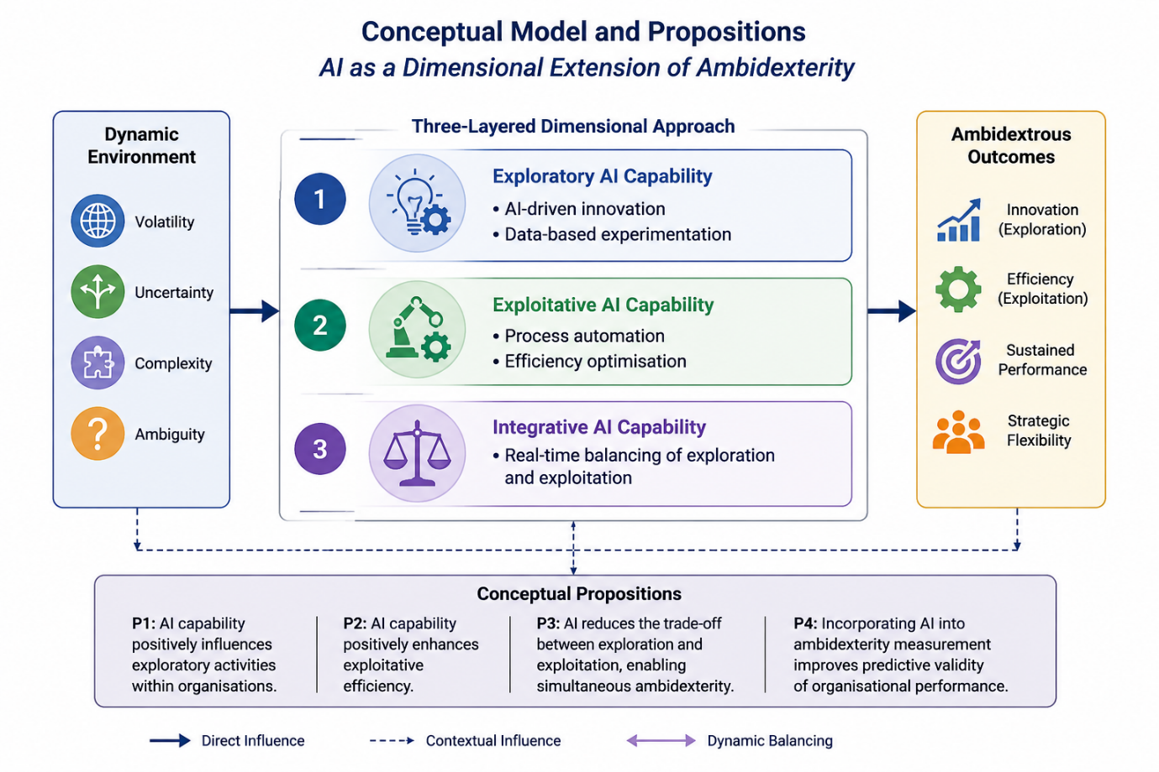
Figure 1: Author’s Compilation

5. Methodology
This study adopts a conceptual research design, with scope for future empirical validation for including AI as a dimension in measuring organisational ambidexterity.
5.1 Conceptual Repositioning of AI
The expanded research question moves beyond treating AI as an external variable and instead positions it as:
- A capability embedded within exploration and exploitation, and
- A mechanism that enables the simultaneous achievement of alignment and adaptability
This aligns with the dynamic capabilities perspective, where AI enhances sensing, seizing, and transforming activities.
By grounding the research question in the measurement traditions of Lubatkin et al. (2006) and Gibson and Birkinshaw (2004), this study not only strengthens its theoretical foundation but also highlights a crucial gap in contemporary research. The integration of AI into ambidexterity measurement is not merely an incremental extension; rather, it represents a paradigmatic shift from human-centric to techno-centric capability frameworks.
Accordingly, the expanded research question positions this study at the intersection of organisational theory, digital transformation, and capability measurement, thereby offering a novel contribution to the literature on organisational ambidexterity.
The empirical evidence can be drawn after reconceptualising the ambidexterity scales with artificial intelligence tools and technology. Secondary data and surveys including AI adoption intensity, AI integration depth, AI-driven decision autonomy, may be used to measure the existence and level of ambidexterity in organisations.

6. Discussion
The integration of AI into ambidexterity reconceptualises how organisations balance competing demands. Rather than viewing exploration and exploitation as a trade-off, AI enables both simultaneously and at scale.
This aligns with recent findings that digital technologies dissolve traditional organisational tensions (Verhoef et al., 2021). AI acts as a force multiplier, enhancing both efficiency and innovation without proportional increases in resource allocation.
This expanded formulation introduces critical dimensions of ‘measurement extension’ as inquiry:
The question seeks to examine how AI can be integrated into existing scales by extending traditional items for both, Exploration (e.g., AI driven innovation, experimentation) and Exploitation (AI enabled efficiency, refinement in automation, optimisation, and decision support systems).
Similarly, within the contextual ambidexterity framework, Adaptability can be extended to include AI-enabled sensing and predictive capabilities, and, Alignment can incorporate AI-driven process standardisation and operational control.
A key aspect of the refined question is whether incorporating AI into ambidexterity scales improves their ability to explain organisational performance, innovation outcomes and strategic flexibility. Given that existing models were developed in pre-AI contexts, their predictive power may be limited in explaining outcomes in digitally transformed organisations.
7. Implications
The study poses certain theoretical as well as managerial implications. Theoretically, it extends ambidexterity theory by introducing AI as a measurable dimension, bridges technology and organisational theory and enhances dynamic capabilities literature. As far as managerial implications are concerned, the study encourages firms to treat AI as a strategic capability, not just a tool, guides investment decisions in AI adoption and supports real-time strategic balancing.

8. Conclusion
This paper argues that, although ambidexterity has been considered an integral part of organisational performance in this dynamic era, artificial intelligence should be integrated into the measurement framework for organisational ambidexterity to enhance its validity in organisations, given the present-day scenario. By influencing both exploration and exploitation, AI is showing significant effects and transformation as to how organisations achieve balance in dynamic environments where businesses and academic organisations struggle to survive.
Future research should empirically validate the proposed framework and develop AI-inclusive ambidexterity scales.

References
- Brynjolfsson, E., & McAfee, A. (2020). The business of artificial intelligence. Harvard Business Review.
- Dwivedi, Y. K., et al. (2021). Artificial intelligence (AI): Multidisciplinary perspectives. International Journal of Information Management, 57, 101994.
- Gibson, C. B., & Birkinshaw, J. (2004). THE ANTECEDENTS, CONSEQUENCES, AND MEDIATING ROLE OF ORGANIZATIONAL AMBIDEXTERITY. Academy of Management Journal, 47(2), 209–226. https://doi.org/10.2307/20159573
- Haefner, N., Wincent, J., Parida, V., & Gassmann, O. (2021). Artificial intelligence and innovation management. R&D Management, 51(1), 43–57.
- Hassani, A., & Bougadir, H. (2026). Responsible digital transformation and sustainable performance: role of organisational ambidexterity. International Journal of Organizational Analysis, 1–19. https://doi.org/10.1108/ijoa-07-2025-5795.
- March, James G. "Exploration and exploitation in organizational learning." Organization science 2.1 (1991): 71-87.
- O’Reilly, C. A., & Tushman, M. L. (2013). Organizational ambidexterity. Academy of Management Perspectives, 27(4), 324–338.
- Raisch, S., & Krakowski, S. (2021). Artificial intelligence and management. Academy of Management Review, 46(1), 192–210.
- Teece, D. J. (2020). Dynamic capabilities and entrepreneurial management. Journal of Business Research, 124, 679–689.
- Tushman, M. L., & O'Reilly III, C. A. (1996). Ambidextrous organizations: Managing evolutionary and revolutionary change. California management review, 38(4), 8-29.
- Verhoef, P. C., et al. (2021). Digital transformation. Journal of Business Research, 122, 889–901.
- Zimmermann, A., Raisch, S., & Cardinal, L. (2020). Managing persistent tensions. Organization Science, 31(1), 1–20.

Corresponding Author, email address- prabh2709@pu.ac.in
https://online.hbs.edu/blog/post/ai-in-business

