CHAPTER 1

THE PROBLEM AND A REVIEW- RELATED LITERATURE

Introduction

The global maritime industry serves as the backbone of international trade, transporting more than eighty percent of global goods across international waters. Central to the sustainability of this industry is the continuous deployment and repatriation of seafarers, whose mobility ensures uninterrupted vessel operations. Seafarers must regularly travel from their home countries to designated ports worldwide to board or disembark from ships, a process commonly referred to as crew change operations. These movements are logistically complex, time-sensitive, and highly regulated, requiring precise coordination of international flights, immigration compliance, and vessel schedules (Cruz, 2021).
In the Philippine context, the importance of seafarer mobility is particularly significant. The Philippines is consistently recognized as one of the world’s largest suppliers of maritime labor, deploying hundreds of thousands of seafarers annually. Supporting this workforce is a specialized segment of the travel industry known as maritime travel agencies, which differ fundamentally from conventional leisure or corporate travel agencies. Maritime travel agencies exclusively cater to sea crew passengers, managing flight transportation and related logistics to ensure timely and compliant crew deployment (Santos, 2022).
CHAVEZ, CELSO JR. LUCAS
Traditionally, maritime travel agencies in the Philippines have operated through human-centered and trust-based service models. These agencies rely on experienced travel coordinators, manual or semi-automated booking systems, and long-standing relationships with ship management companies, crewing agencies, airlines, and regulatory institutions. Their operational value extends beyond ticket issuance to include risk management, problem resolution, and real-time intervention during travel disruptions (Dela Peña, 2023). Given the high operational and financial risks associated with delayed crew changes, reliability and accountability remain critical service attributes (Ong, 2021).
However, the maritime travel industry is undergoing significant transformation driven by advances in digital technology. Online travel platforms, airline-direct booking systems, and automated travel management tools have introduced new mechanisms for booking efficiency, cost transparency, and real-time reporting (Lim, 2021). Ship management companies increasingly demand faster processing times, improved visibility, and data-driven decision-making in seafarer travel arrangements (Bautista, 2023).
Despite these advantages, the applicability of generic online travel platforms to seafarer travel remains limited. Seafarer mobility often involves complex routing, multiple transit points, visa restrictions, and sudden schedule changes, which require human judgment and contextual awareness (Tan, 2021). Empirical studies indicate that fully automated systems struggle to manage emergency repatriations, denied boarding incidents, and regulatory exceptions without human intervention (De Guzman, 2024). As a result, traditional maritime travel agencies have not been fully displaced but instead face increasing pressure to digitally enhance their service offerings.
CHAVEZ, CELSO JR. LUCAS
This evolving landscape has created a critical challenge for traditional maritime travel agencies. On one hand, they must adopt digital technologies to improve efficiency, reduce costs, and remain competitive. On the other hand, they must preserve the trust-based, personalized service that constitutes their core competitive advantage (Mendoza, 2022). Sustainability in this context extends beyond financial performance to include operational resilience, regulatory compliance, and social responsibility, particularly with respect to seafarer welfare (Villanueva, 2021).
Recent empirical studies suggest that hybrid and integrative service models offer a viable solution to this challenge. Hybrid models combine digital booking systems and automated reporting with dedicated human oversight, enabling maritime travel agencies to achieve efficiency while maintaining flexibility and accountability (Morales, 2023; Ramos, 2023). Such models have demonstrated improved customer satisfaction, reduced service disruptions, and greater resilience during global travel crises (Chua, 2024; Ching, 2024).
CHAVEZ, CELSO JR. LUCAS
In the Philippine maritime travel sector, collaborative partnerships between ship management companies and specialized travel agencies illustrate the practical application of hybrid strategies. These partnerships enable the sharing of operational data, alignment of incentives, and integration of technological systems while retaining human decision-making authority. Industry-based frameworks emphasize that balanced governance and cooperative integration are essential for sustainable digital transformation in specialized travel services (Uy, 2024; Navarro, 2024).
Despite the strategic importance of maritime travel agencies in seafarer deployment, academic research remains limited, particularly within the Philippine context. Most existing studies on travel platforms focus on leisure tourism or general corporate travel, leaving a gap in understanding the unique operational requirements, competitive dynamics, and sustainability challenges of sea crew-focused travel agencies.
This study seeks to address this gap by examining sustainable strategies for integrating traditional maritime travel platforms with contemporary technological innovations in the Philippine travel sector. By identifying existing operational models, analyzing the impact of online platforms, evaluating hybrid strategies, and developing a comprehensive integration framework, the study aims to contribute both theoretically and practically to the sustainability and competitiveness of maritime travel agencies in the Philippines.

CHAVEZ, CELSO JR. LUCAS
CHAVEZ, CELSO JR. LUCAS

II. Review of Related Literature
2.1 Introduction
The global maritime industry relies on the continuous and highly coordinated movement of seafarers between their home countries and vessels operating worldwide. In this context, maritime travel agencies defined in this study as travel agencies that exclusively cater to seacrew passengers requiring air transportation to board or disembark from ships—serve a critical operational function. These agencies manage complex and time-sensitive travel arrangements involving multi-leg international flights, visa and transit compliance, alignment with vessel schedules, and emergency rerouting.
The Philippines, recognized as one of the world’s largest suppliers of seafarers, plays a central role in global maritime labor deployment (ILO, 2022; MARINA, 2023). However, the rapid expansion of digital travel platforms and airline-direct booking systems has introduced competitive pressures on traditional maritime travel agencies. This situation highlights the need to examine how traditional, human-centered operational strengths can be strategically integrated with contemporary technological innovations. This chapter presents a review of related literature (RRL), related studies (RRS), and related research (RRR) to establish the theoretical, empirical, and contextual foundations of the study.

CHAVEZ, CELSO JR. LUCAS

2.2 Review of Related Literature
2.2.1 Digital Transformation in Travel Services
With the introduction of digital technologies, the travel industry has radically changed the nature of service delivery, the paradigms of consumer expectations, and competitive forces. The emergence of online platforms, mobile apps, and combined reservation systems have brought in new levels of efficiency, clarity and accessibility (Buhalis and Law, 2023). The customers are increasingly requiring smooth digital experiences such as destination research, flight and itinerary booking, and it has forced the travel agencies to align their operations or become irrelevant. At the same time, digitalization has transformed the coordination practices of the service sectors, increasing the demands of speed, visibility, and transparency of the costs (United Nations World Tourism Organization [UNWTO], 2021).
However, researcher warns that automation alone cannot be used to handle more specialized and sophisticated services demands. To provide some examples, maritime travel presupposes observing the visa requirements, coordination of the vessel’s routes, and rerouting in case of emergency, all of which require human intervention and contextual understanding (Gretzel et al., 2020). Such complexities can be very hard to fit in fully automated systems especially in highly regulated settings.
As a result, alternative digital-human systems have become more effective, combining the effectiveness of digital applications with the flexibility and knowledge of experience of human management. These systems are particularly helpful in the situations where compliance is demanded as well as decisions made instantly, and the aspects of trust, accountability, and responsiveness are essential (Buhalis and Sinarta, 2020).
CHAVEZ, CELSO JR. LUCAS
2.2.2 Technology Acceptance in Service Operations
Technology Acceptance Model (TAM) has been one of the best-implemented models of understanding the use of digital system in the organizational setting. As the initial concept of Davis (1989), TAM presupposes that perceived ease of use (PEOU) and perceived usefulness (PU) are two factors that play a significant role in the intention of using and keeping a technology among the individuals. This framework is approved by the recent literature which indicates that such perceptions are a strong predictor of acceptance and continued use of digital systems in various industries (Davis et al., 2020; Venkatesh et al., 2020). TAM has been developed and improved over the years, as it includes social influence, facilitating conditions, and organizational readiness which also further justifies differences in adoption behavior. The extensions highlight the point that individual perception is not the only aspect of technology acceptance but also influenced by institutional support and setting circumstances.
TAM offers an adequate perspective of digital integration in an organizational setting, especially when it comes to a complicated setup that includes operations that are compliance related. Research has shown that the moderating effect on the acceptance outcomes is organizational support, training and technology readiness, thus affecting the sustainability of digital initiatives (Kim et al., 2021; Alalwan et al., 2021). This is especially applicable to the maritime travel services where electronic tools should only increase efficiency without compromising human control. TAM in these hybrid operational settings stresses the fact that adoption is contingent on the perception of users of digital systems as being reliable, as having the capacity to support current work processes, and as not introducing complexity but minimizing risks. Using TAM, the proposed study will assess the perceived usefulness and ease of use of the digital systems offered by EGT Travel Agency among the OT Shipping Company staff and, therefore, to determine the conditions in which digital integration enhances service performance and competitiveness.
CHAVEZ, CELSO JR. LUCAS
2.2.3 Service Quality and Competitive Advantage
The service quality is one of the key constructs of organizational research, especially in the sphere in which the customer trust and satisfaction are determinants of success. The aspects of reliability, responsiveness, assurance, and empathy are always emphasized among the factors that determine perceived service quality, including the digital mediated situation (Parasuraman, Zeithaml, and Berry, 2021). Initially, these dimensions were developed as a part of the SERVQUAL model, and they remain to be used as the standards of measuring service performance in both conventional and technology-driven settings. Reliability is the provision of the services in an equally, error-free way; responsiveness means the desire to help customers and do it promptly; assurance means competency and trustworthiness; empathy is the individual care and compassion. The combination of these attributes also influences customer views of the quality of services and will not be rendered obsolete as service delivery continues to be more digitalized.
CHAVEZ, CELSO JR. LUCAS
Recent articles also indicate that trust serves as a mediating factor between quality of the service and customer satisfaction, especially in the high-stakes and high-responsibility services like maritime travel (Hassan, Shiu, and Parry, 2021). Trust is an important component in maintaining long-term relationships in situations where the cost of a mistake may be severe, e.g. delay in crews’ deployment or defaulting on compliance. Furthermore, researcher claims that, in spite of the fact that digitalization leads to efficiency and transparency, human interaction still brings about differentiation and competitive advantage. Individualized interaction, problem resolution, and responsibility bolster the trust of customers in service providers, albeit supplementing the speed of transactions provided by digital platforms (Kotler, Keller, and Chernev, 2021; Porter, 2021). This highlights why hybrid service models should be central in maritime travel agencies and the digital tools should be integrated without reducing the human touch which creates a sense of trust plus compliance sensitive decision-making.
2.2.4 Sustainability and Hybrid Operating Models
The ability of organizations to balance operational efficiency, resilience and continuity over a long term is usually understood as sustainability in service operations (Sigala, 2020). In service industries, sustainability requires the resources to be optimized in addition to the capacity of the industry to absorb shocks and maintain uniformity in service delivery. This view is especially relevant to the maritime travel services where continuity in operations has a direct impact on the schedule of the vessels, crew movement, and regulatory adherence. Literature has pointed out that sustainability goes past efficiency; it requires adaptive mechanisms that can make organizations adapt to the changing market environments, technological advancement, and external shocks. On this basis, sustainability is unveiled as a complex concept that gathers economic feasibility, operational sustainability, and social responsibility.
CHAVEZ, CELSO JR. LUCAS
Most recent empirical studies reveal that digital capability increases organizational resilience in the cases when it is aligned with adaptive strategies, which in turn enables firms to recuperate rapidly following disruptions, in addition to maintaining continuity in service (World Bank, 2022). Digital tools, such as real-time monitoring, automated reporting, and combined systems of communication, enhance resilience through the enhancement of visibility and coordination. However, the research author warns that digitalization is to be incorporated strategically to be sure that compliance-related and high-stakes decisions are handled efficiently. Using digital systems with human judgment are emerging as a critical element of remaining competitive in technology-based marketplaces in the form of hybrid operating models (Kaplan and Norton, 2020). In the case of maritime travel agencies, the hybrid nature of the solution will ensure that the efficiency benefits of digitalization do not undermine the trust, accountability, and personal service provided by seafarers and ship management companies. In line with this, the sustainability within this area is realized by the strategic convergence of digital innovation and the conventional service competency, and the resulting balanced and resilient operating framework.
CHAVEZ, CELSO JR. LUCAS
2.3 Review of Related Studies
2.3.1 Digital Readiness and Service Performance
The empirical literature shows repeatedly the positive effect of digital readiness, which indicates the readiness of an organization to use and integrate digital technologies, on the service performance and operational efficiency in a travel-related service. Empirical evidence shows that organizations in which the degree of digital adoption is higher attain tangible gains related to the accuracy of coordination, the abilities of monitoring, and the effectiveness of the workflow (Yeh and Chen, 2022; Nguyen, Simkin, and Canh, 2022). The ability to streamline the communication process, lessen redundancies, and have real-time visibility on the service processes are credited with these gains. Digital readiness in the travel operations enables the agencies to handle complicated booking requests, coordinate schedules, and react better to disruptions, which improves customer satisfaction and competitiveness of the organization.
At the same time, the researcher emphasizes the fact that the advantages of digital preparedness are most obvious when digital systems are supported by human control. Despite the increase in speed and accuracy, it is still only possible to rely on human skills in handling decisions that revolve around compliance, contextual problem-solving and delivery of services that are personalized. It is proved that hybrid structures, in which digital tools are tuned into human judgment, achieve better results compared to fully automated systems (Kim & Hwang, 2021; Liu, Zhang, and Li, 2020; Zhang, Wang, and Xu, 2021). The given finding is especially relevant to the maritime travel services, where the operational risks are significant and the welfare of the seafarers relies on the effective travel coordination that is responsive and context sensitive. To that end, the premise of the study, based on the strategic synergization of digital readiness alongside human expertise and its strengthening of service performance, operational efficiency, and sustainability in the long term in special travel settings, is supported by empirical data.
CHAVEZ, CELSO JR. LUCAS
2.3.2 Impact of Online Travel Platforms on Traditional Operators
The growth of online travel websites has radically transformed the competitive environment of the travel sector and hence the pressure on the traditional travel agencies. Empirical studies indicate that the main benefits of these platforms are related to competitiveness in the form of faster process of transactions, increased visibility of the market, and clear cost frameworks, which rebalances consumer expectations and service standards (Suhartanto, Brien, and Primiana, 2021). Such platforms have altered the quality of operation efficiency and created new responsiveness standards by supporting real-time booking features, expansive market coverage, and algorithm-based personalization. This has therefore forced traditional agencies to redefine their paradigms of operation since consumers are beginning to associate digital convenience with high quality of service.
CHAVEZ, CELSO JR. LUCAS
At the same time, the researcher has warned that the systems of automated platforms are frequently unable to coordinate more complex travel, particularly in the environment where regulations play a major role, like in the maritime travel. Online systems are generally transactionally efficient but lack the adaptability needed to meet specialized needs, such as visa and transit dependencies, vessel scheduling synchronization, and emergency rerouting when changing the crew (Nguyen, Simkin, and Canh, 2022; Zhang, Wang, and Xu, 2021). These weaknesses highlight the timeless nature of old agencies, which rely on human experience, trust-based relations, and compliance experience to find their way through high-stakes and time-intensive travel business. In this regard, the literature highlights the need to implement hybrid operating models that combine the efficiency of online platform with the versatile and responsible characteristics of human control ensuring that they become competitive and reliable in specialized travelling contexts.

2.3.3 Effectiveness of Hybrid and Digitally Enhanced Strategies
Empirical research studies have consistently found that hybrid service strategies are the most effective in the case of specialized services in the field of travel. Hybrid models combine digital systems with formalized human control, which increases the levels of coordination and sustainability performance and competitive sustainability (Nguyen and Pham, 2022; Kaplan and Norton, 2020). The models recognize that digital tools increase the pace of speed, accuracy, and transparency but do not override the use of human expertise, which is vital in the management of compliance-sensitive processes, contextual problem-solving, and service delivery in a personalized manner. In the maritime environment, where mobility among the crews is highly controlled and time-sensitive, the hybrid approaches will ensure the effectiveness of the digitalization process does not affect the measures of trust, responsibility, or the well-being of the seafarer.
CHAVEZ, CELSO JR. LUCAS
Besides, the literature highlights the importance of using data-directed strategies to strengthen decision-making in hybrid frameworks. Empirical evidence is provided using statistical procedures, such as regression analysis, performance assessment, and importance-performance mapping, to make strategic decisions and resource distribution (Hair, Hult, Ringle, and Sarstedt, 2022). With a combination of quantitative understanding and human judgment, organizations will be in a better position to focus on interventions that will have an optimum influence on the service quality and competitiveness. Such dependency on both digital and human systems makes hybrid models not only efficient in their functioning, but also strategically sustainable.

2.4 Review of Related Research

2.4.1 Maritime and Seafarer Travel Context
As it has been made clear throughout the literature, sound and accurate travel organization is one of the most important factors of operational prosperity within the maritime industry. The welfare of seafarers, movement of crews, and continuity of vessels depend on the proper scheduling, effective management of documentation, and close compliance with the requirements of the regulations (International Labor Organization, 2022; Maritime Industry Authority, 2023). As opposed to leisure or corporate travel, maritime travel involves a complicated logistical organization, which has to coincide with vessel schedules, port rules, and international labor requirements. Any coordination mistakes may cause expensive delays, noncompliance, or crew deployment inconveniences, which is why the maritime travel management is of high stakes.
CHAVEZ, CELSO JR. LUCAS
The services of maritime travel are especially distinct in contrast to general tourism, as their operations are of a high complexity, and the requirements of regulations are rather strict. The agencies are pressured to control visa and transit standards, guarantee adherence to the international conventions, and formulate emergency relief plans in case of an emergency like rerouting in case of port constraints or flight cancellations. Investigations in the scholarly community demonstrate that such roles involve more than just transactional efficiency and have to encompass expert knowledge and trust-based interpersonal networks and effective accountability tools to protect the safety of seafarers and ensure continuity of vessel activity. This difference supports the relevance of hybrid service models in maritime travel, where digital tools enhance efficiency and human control allows consistency and resiliency in risky, highly regulated settings.

CHAVEZ, CELSO JR. LUCAS
2.4.2 Digitalization in Maritime Services
Digital interventions also have been shown to increase visibility, the accuracy of documentation, efficiency in scheduling, and crisis response in the maritime travel services (World Bank, 2022). Digital technologies provide opportunities to coordinate the actions of various stakeholders and minimize the threat of mistakes in the management of crew movements due to the possibility of real-time monitoring, automated reports, and integrated communication systems. Such abilities come in handy especially in a maritime environment where any form of delay or inaccuracy can interfere with vessel activities and jeopardize the wellbeing of the seafarers. Digitalization consequently not only positively impacts operational performance but resilience as well where the agencies are able to react more efficiently in case of disruption like flight cancellations, port closures, emergency rerouting.
Nonetheless, research points out that the uptake of digital in the context of maritime services is still disproportionate and should be accompanied by human management to maintain the reliability of its operation and regulatory adherence (International Labor Organization [ILO], 2022). Maritime travel is in contrast to general tourism since the activity is run in a regulation-heavy environment whereby there is the need to exercise high standards of international labor, international visa administration, and international port-specific international standards. To ensure successful digital integration, it is then necessary to have alignment to the agreed workflows and regulatory frameworks to prevent compliance risks and break service continuity (Maritime Industry Authority [MARINA], 2023). Mixed models that marry digital systems with human factors are proving to be the most practical way of ensuring that efficiency benefits of technology do not override accountability, trust, and welfare of seafarers.
CHAVEZ, CELSO JR. LUCAS
2.4.3 Framework Development and Methodological Foundations
The methodological scholarship emphasizes the role of first importance of statistical rigor in the development and justification of integration frameworks. Exploratory factor analysis (EFA) is commonly considered one of the foundations of strengthening construct validity, which makes measurement tools more reliable in terms of how they allegedly measure the theoretical dimensions that they say they measure (Fornell and Larcker, 2021). EFA provides a solid basis through the discovery of latent structures and ensuring that measurement error is reduced to create reliable models. In harmony, reliability evaluation, including Cronbach’s alpha and composite reliability, assures applicability of measurement tools as one should be coherent and consistent in terms of item coherence across a wide range of samples (Hair, Hult, Ringle, and Sarstedt, 2022). These steps jointly determine the psychometric soundness of the framework, and these add to its credibility both in the academic and practice fields.
In addition to construct validation, there are extensive use of correlation and regression analysis to identify predictive relationship and empirically support the proposed models. Correlation analysis helps to understand the magnitude and direction of the relationships between variables, and regression methods provide information about cause-and-effect relationships and the relative power of predictors on outcomes (Chin, 2020; Kock, 2020). The methods of analysis are especially useful in research on digital integration where a combination of organizational, technological and human variables congregates to influence service performance and service sustainability. By implementing regression and performance analysis, the researcher would be able to estimate the influence of digital preparedness, quality of services, and hybrid approaches on the efficiency and competitiveness of operations. Methodological rigidity strengthens the credibility, generalizability and pragmatic applicability of the integration systems, and makes recommendations based on empirically based evidence and able to be defended in both academic and practice environments.
CHAVEZ, CELSO JR. LUCAS

III. Synthesis and Justification
The literature reviewed confirms that maritime travel agencies that cater to seafarers play the specialized and indispensable role in the shipping industry in the world. The old agencies are run on the basis of trust-based, human-center models that focus on accountability, compliance with regulatory requirements and experience in the handling of complicated crew-change processes. They have competitive advantage based on long term relationship with ship-management firms, local operation expertise and ability to intervene quickly when there are disruptions during travels. The strengths highlight their relevance to date when it comes to vessel continuity and safeguarding the welfare of the seafarers.
CHAVEZ, CELSO JR. LUCAS
Meanwhile, there are major sustainability issues that face conventional maritime travel platforms. Lack of efficiency in operations causes by manual processes, lack of system-integration, and escalating cost of operation limit scalability and efficiency especially because ship managers increasingly require quick turnaround, transparency, and cost minimization. Parallel analyses of online travel websites show that online systems enhance effectiveness in booking, administrative controllers and access to information that is redefining customer expectations and putting pressure on traditional agencies.
The actual experience proves, though, that the online platforms will not be sufficient when used independently as the solution to the seafarer travel. The generic systems do not tend to maintain flexibility needed to handle more complicated routing, visa regulations and emergency repatriations and last-minute crewing changes. Due to this, the traditional agencies are not removed, but their role in the changing service ecosystem is being transformed. Agencies that embrace selective use of digital tools are better operational and stable in terms of revenue than complete manual agencies.
In the literature, hybrid and integrative service models become the most feasible approach to the sustainability and competitiveness. These models unite digital booking system, automated reporting, and data integration with long-term human control and allow the agencies to achieve the balance between efficiency and trust, accountability, and risk management. This approach is also supported by readings on digital transformation, platform economics, focusing on the importance of gradual adoption, co-operative platforms, balanced governance as a model practice in specialized service industries.
CHAVEZ, CELSO JR. LUCAS
In spite of these revelations, the literature is still narrow as far as seafarer-specific maritime travel agencies are concerned, especially on the Philippine context. The traditional and online platforms are considered as competitive options in much of the literature, instead of complimentary parts of a sustainable service model. This research is thus warranted in coming up with an all-inclusive system in terms of incorporating the old maritime travel principles and the latest technological advancements. The study will help to fill gaps in theory and practice to understand sustainable approaches to maritime travel agencies and offer a context-specific framework to help to sustain the Philippine maritime travel industry in the long run and become competitive.

IV. Theoretical Framework
This study is anchored on an integrated set of theories that explain how traditional maritime travel agencies serving seafarers can achieve sustainability and competitiveness through the strategic integration of digital technologies. The theoretical framework draws primarily from Digital Transformation Theory, Resource-Based View (RBV), Technology Acceptance Theory, and Sustainability Theory. These theories collectively explain the interaction between traditional operational strengths, technological innovation, and long-term performance outcomes in the Philippine maritime travel industry.
CHAVEZ, CELSO JR. LUCAS
The framework posits that traditional maritime travel agencies possess valuable internal resources, such as trust-based relationships, compliance expertise, and human judgment that remain critical in managing complex seafarer travel operations. However, the effective utilization of these resources depends on how well agencies integrate technological innovations to respond to evolving market demands, operational pressures, and sustainability requirements.

Digital Transformation Theory
Digital Transformation Theory explains the reorganization of processes, service delivery, and value creation by organizations as a result of integrating digital technologies (Vial, 2021). In the framework of maritime travel agencies, transformation cannot be related to endless automation; it refers to the operational use of materials of digitalization directed at streamlining work efficiency, visibility, and coordination of crew travel management. The application of systems like online booking systems, automated reporting systems and real-time monitoring system can facilitate operations, reduce delays, and enhance transparency. However, the theory argues that transformational consequences depend on the technology-organization fit and the context of the service.
In case of seafarer travel agencies, this kind of alignment is unavoidable due to the sensitivity of compliance and time in crew change operations. Digital Transformation Theory offers a relevant framework through which the possibility of adopting digital innovations by agencies like EGT Travel can be evaluated without undermining the human supervision of these agencies, as it is relevant to the regulation of risks and performance control. It thus supports the hybrid nature outlined in the framework where digital operations enhance efficiency in operations, but human skills ensure flexibility and conformity in complex maritime travelling situations.
CHAVEZ, CELSO JR. LUCAS

Resource‑Based View (RBV)
The Resource-Based View assumes that the sources of sustainable competitive advantage are the valuable, rare, inimitable and non-substitutable resources. In the case of maritime travel agencies, these resources include long-term relationships with ship management organizations, practical experience with the process of crew changes, as well as confidence, which has been earned by attentive service delivery (Mendoza, 2022). These relationship and knowledge assets are not easily copied by the generic online travel services and, hence, organizational assets that form strategic advantages that keep traditional agencies relevant.
RBV is especially relevant in this question since it explains the continued central place of traditional maritime travel agencies even with the digital disruption. RBV supports the argument that trust-based service, compliance expertise and human judgment are strategic assets to be preserved and utilized by treating them as strategic assets. These resources can make them more sustainable and competitive when combined with digital capabilities, which will provide the basis of the integration framework in question.
CHAVEZ, CELSO JR. LUCAS

Technology Acceptance Theory
Technology Acceptance Theory argues that usefulness and ease of use create perception of adoption of new technology. In the given research, TAM can be applied both to internal users, including the travel coordinators, and external clients including the ship management companies. Digital tools are seen as adding efficiency with neither risk or complexity, then will be more frequently adopted and integrated into regular processes. On the other hand, when the systems make work processes harder or undermine reliability, they face opposition especially in situations with high stakes like deployment of seafarers.
The relevance of TAM is incorporated in its ability to explain why hybrid systems are more acceptable in maritime travel management. Digital tools can gain the trust of users and institutional acceptance by strengthening instead of overtaking human decision-making. Therefore, this theory holds that the proposals of the study regarding digital integration is realistic, user-based, and operational needs which makes the study strengthen the framework by the acknowledgment of the adoption behavior as another central determinant of sustainability.

Sustainability Theory
The Sustainability Theory reiterates the need of organizations to harmonize economic viability, resilience in operational activities as well as social responsibility. Sustainability is more than profitability in the maritime travel agencies, including the continuity of service, regulatory adherence, and the wellbeing of seafarers who depend on reliable travel plans (Villanueva, 2021). Such a view is crucial since the upset in the crew mobility directly affects the operations of vessels and the well-being of the seafarer, making resilience and reliability as crucial as the financial results.
CHAVEZ, CELSO JR. LUCAS
The applicability of the Sustainability Theory to the study is found in its comprehensive description of success. It confirms the focus on combinatorial integration approaches that integrate traditional values with digital innovation in order to gain long-term resilience. Since the theory integrates the concept of social responsibility and compliance into the paradigm, the efficiency gains would not undermine the welfare of the seafarers or the regulatory standards. In this regard, Sustainability Theory would form the general justification of the development of an integrative framework that would balance competitiveness and ethical accountability to the maritime travel industry in the Philippines.

Theoretical Rationale of the Study
The theoretical foundation of this study is on the basis that the sustainability and competitiveness of the maritime travel agencies serving the seafarers is based on how well the organizational capabilities are integrated in conjunction with the technological innovation. Resource-Based View (RBV) describes the further relevance of conventional maritime travel agencies by highlighting its valuable and inimitable resource of trust-based relations, compliance expertise, and experience-based judgment in coping with complicated crew change processes (Mendoza, 2022; Dela Pena, 2023). The generic online travel platforms cannot imitate these resources, and this is why the traditional maritime travel agencies should be seen as strategically important participants in the Philippine maritime sector. RBV emphasizes the fact that these distinctive resources when coupled with digital capabilities are the basis of sustainable competitive advantage.
CHAVEZ, CELSO JR. LUCAS
The research is also pegged on Digital Transformation Theory, where the adoption of technology is seen as a reorganization of the delivery and value creation instead of automation (Vial, 2021). This is especially applicable since maritime travel agencies have a high-risk, highly regulated environment to which digital tools have to facilitate more efficiency and transparency without compromising the human control. Along with it comes Technology Acceptance Theory (TAM), which states that digital systems are better accepted in case they are perceived as helpful, trustworthy and conducive to the current work processes. Human decision-making is better accepted and highly effective in seafarer travel management, rather than fully automated platforms (Morales, 2023; Ramos, 2023). Lastly, Sustainability Theory offers the general justification in that it presents success as a compromise between operational sustainability, economic feasibility, and social commitment. When applied in the sphere of maritime travel agencies, sustainability is associated with the financial performance, as well as with the continuity of vessel operation, compliance with regulations, and the well-being of seafarers (Villanueva, 2021; Ching, 2024). All these theories combined make the current study justifiable to establish a sustainable framework that informs the establishment of the traditional maritime travel platforms within the current technology advancement in the Philippine maritime travel industry.
CHAVEZ, CELSO JR. LUCAS

Conceptual Framework
Phase I: Determination of Differences Between Traditional and Online Maritime Travel Platforms

Phase I focuses on establishing a comprehensive understanding of the existing operational landscape of maritime travel agencies serving seafarers. This phase begins by defining the scope of seafarer-focused maritime travel agencies, followed by identifying their current operational models and describing their competitive advantages. The phase further examines the characteristics of online maritime travel platforms and classifies the differences between traditional and online platforms in terms of service delivery, technology utilization, and client interaction. These steps address the first specific objective of the study, which seeks to identify the operational models and competitive strengths of traditional maritime travel platforms. The output of this phase provides a conceptual foundation for understanding how digital platforms compare to and influence traditional maritime travel services.

Phase II: Data Gathering and Collection
CHAVEZ, CELSO JR. LUCAS
Phase II involves the systematic collection of empirical data necessary to analyze the impact of online maritime travel platforms on traditional operators. This phase includes the design of structured survey instruments and the development of data collection criteria aligned with the research objectives. Respondents are selected from OT Shipping company involved in seafarer travel. Surveys and interviews are then administered to gather quantitative and qualitative data related to operational performance, customer base, and digital adoption. The collected data are compiled and organized to ensure accuracy and reliability. This phase directly supports the second specific objective by generating empirical evidence on the influence of online platforms on the market share and customer base of traditional maritime travel agencies.

Phase III: Data Interpretation, Analysis, and Evaluation
Phase III centers on analyzing and evaluating the data collected in the previous phase to assess strategic implications and effectiveness. Quantitative and qualitative data are analyzed using appropriate analytical tools to measure the impact of online platforms on traditional maritime travel agencies. This phase evaluates the effectiveness of existing and proposed digital strategies and tests hypotheses related to sustainability and competitiveness. The interpretation of results considers operational performance, service quality, and digital readiness. These steps correspond to the third and fourth specific objectives, which focus on formulating strategic recommendations and evaluating their effectiveness in improving sustainability and competitiveness. The outcomes of this phase provide evidence-based insights that inform strategic decision-making.
CHAVEZ, CELSO JR. LUCAS

Phase IV: Recommendation and Development of Generalizations
Phase IV represents the culminating stage of the framework, where findings from all previous phases are synthesized to develop strategic recommendations and generalizations. This phase involves formulating recommendations for sustainable digital integration, developing a comprehensive framework that combines traditional maritime travel values with technological innovations, and generalizing conclusions applicable to the Philippine maritime travel industry. Implementation guidelines are proposed to support practical application. This phase fulfills the fifth specific objective of the study by producing a comprehensive framework that outlines best practices for integrating traditional and modern approaches. The dotted feedback lines connecting this phase to earlier phases illustrate how recommendations and framework outcomes can inform continuous improvement and future operational refinement.
CHAVEZ, CELSO JR. LUCAS
CHAVEZ, CELSO JR. LUCAS
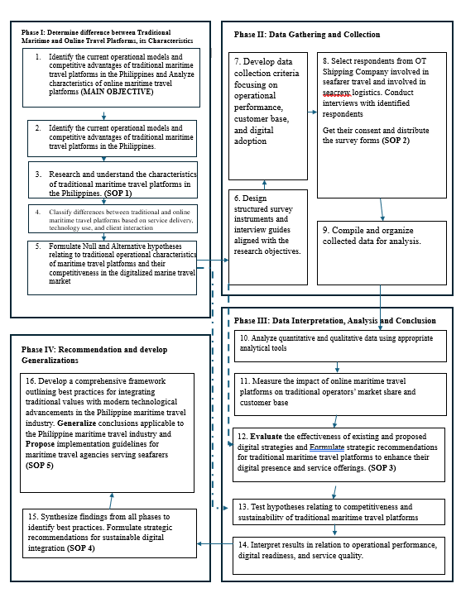
Figure 1 : Conceptual Framework

CHAVEZ, CELSO JR. LUCAS
Statement of the Problem
The maritime travel industry in the Philippines is undergoing a critical revolution where the traditional seafarer-based travel agencies are facing the growing pressure of the widespread growth of online travel service operators. The disconnect between the relationship-based service framework and technology-based solutions poses systemic problems that pose a direct threat to the viability of economies, operational stability, and technological flexibility of maritime travel operations that lie at the heart of the global shipping business.
The traditional maritime travel agencies, as was the case with the EGT Travel Agency, provide services that are highly specialized to ship-management corporations like the OT Shipping Company. Such services include personalized flight-booking services, coordination of documents and visa, real-time monitoring of embarkation and repatriation services, crisis management in the face of travel interruptions. These agencies have a rich background of operation and long-standing relationships in the industry that are essential in dealing with the complexity, regulatory sensitivities and time factors that require seafarer travel. However, their reliance on manual processes, interpersonal coordination and the poor online digital infrastructure predispose them to increasing competitive force against algorithmic online designs that are fast and automation-oriented, and systemic visibility.
On the other hand, the emergence of online travel has brought the expedited processes of transactions, a wider market base, the ability to access data in real-time, and the perceived economies of scale. Even though these qualities have revolutionized the wider tourism and corporate travel, the issue of their application to the maritime travel operations is still unclear. Completely automated systems are normally not able to support any maritime-specific needs like port-aligned paths, visa and transit-based demands, intervessel-schedule coordination, and emergency rerouting in case of crew-change disturbances. Therefore, there can be the possibility of greater efficiency of transactions but, at the same time, of the disappearance of support systems essential to seafarers - a group that forms one of the strongest and most competitive branches of labor in the Philippines.
CHAVEZ, CELSO JR. LUCAS
Such a dynamic environment has spawned a cluster of problems that are related to one another. To begin with, economic vulnerability will exist since the conventional maritime travel agencies will be fighting to preserve the traditional pricing and market accessibility and the perceived convenience of the online platforms, thus endangering the long-term financial sustainability. Second, there are still operational constraints between agencies which are hampered due to the lack of digital support systems that leads to long turnaround times, disjointed data processing, and poor scalability. Third, the issue of sustainability arises because online platforms do not always focus on the social and welfare responsibilities that are inherent in the maritime travel services, and the traditional agencies do not have the technological optimization that is required to enhance economic resilience and operational efficiency. Lastly, the lack of a hybrid operating model to harness an effective combination of the maritime unique capabilities of the traditional agencies of trust, accountability, and human judgment with the current digital ecosystem to create a balanced, resilient, and sustainable service model is apparent.
CHAVEZ, CELSO JR. LUCAS
Under these circumstances, there still exists a significant gap in the scholarly literature and practice in the industry regarding the manner in which traditional maritime travel agencies will be able to effectively adjust to digital transformation without jeopardizing the reliability of their services and the well-being of seafarers. Particularly, there is limited empirical advice on how agencies, like EGT Travel Agency, should enhance their digital capacities and, at the same time, meet the operational demands of ship-management companies, such as OT Shipping Company.

General Objective
The primary objective of this study is to develop a comprehensive framework for sustainable strategies that integrate traditional maritime travel platforms with contemporary technological innovations in the Philippine travel sector. Specifically, the study aims to:

CHAVEZ, CELSO JR. LUCAS
Specific Objectives:

1. Identify the current operational models and competitive advantages of traditional maritime travel platforms in the Philippines.
2. Analyze the impact of online maritime travel platforms on the market share and customer base of traditional operators.
3. Formulate strategic recommendations for traditional maritime travel platforms to enhance their digital presence and service offerings.
4. Evaluate the potential effectiveness of proposed strategies in improving the sustainability and competitiveness of traditional maritime travel.
5. Develop a comprehensive framework outlining best practices for integrating traditional values with modern technological advancements in the Philippine maritime travel industry.

CHAVEZ, CELSO JR. LUCAS
Hypotheses of the Study

Hypothesis Set 1: Operational Models and Competitive Advantages
H₀₁ (Null): There is no significant relationship between the current operational models of traditional maritime travel agencies and their perceived competitive advantages in the Philippine maritime travel industry.
H₁₁ (Alternative): There is a significant relationship between the current operational models of traditional maritime travel agencies and their perceived competitive advantages in the Philippine maritime travel industry.

Hypothesis Set 2: Impact of Online Maritime Travel Platforms
H₀₂: Online maritime travel platforms have no significant impact on the market share and customer base of traditional maritime travel agencies.
H₁₂: Online maritime travel platforms have a significant impact on the market share and customer base of traditional maritime travel agencies.

Hypothesis Set 3: Digital Presence and Service Enhancement Strategies
H₀₃: Enhancing digital presence and service offerings does not significantly improve the operational performance of traditional maritime travel agencies.
H₁₃: Enhancing digital presence and service offerings significantly improves the operational performance of traditional maritime travel agencies.
CHAVEZ, CELSO JR. LUCAS
Hypothesis Set 4: Sustainability and Competitiveness Outcomes
H₀₄: The proposed integration strategies do not significantly improve the sustainability and competitiveness of traditional maritime travel agencies.
H₁₄: The proposed integration strategies significantly improve the sustainability and competitiveness of traditional maritime travel agencies.

Hypothesis Set 5: Integrated Framework Effectiveness
H₀₅: The integration of traditional maritime travel values with modern technological advancements does not significantly contribute to improved service effectiveness in the Philippine maritime travel industry.

H₁₅: The integration of traditional maritime travel values with modern technological advancements significantly contributes to improved service effectiveness in the Philippine maritime travel industry.

CHAVEZ, CELSO JR. LUCAS
Significance and Purpose of the Study

Purpose of the Study
The primary purpose of this study is to develop a comprehensive and sustainable framework that integrates traditional maritime travel agency practices with contemporary technological innovations within the Philippine travel industry. Specifically, the study seeks to examine how traditional maritime travel agencies serving seafarers such as EGT Travel Agency can enhance their service performance, digital capability, and competitive viability while maintaining the human-centered and compliance-driven strengths that define their operational role.
The study aims to systematically analyze the operational models and competitive advantages of traditional maritime travel agencies, assess the impact of online maritime travel platforms on their market share and customer base, and evaluate strategic initiatives that enhance digital presence and service delivery. Through empirical investigation and structured analysis, the study intends to generate evidence-based insights that support the formulation of practical strategies and the development of an integrated framework tailored to the unique requirements of seafarer travel management.
Ultimately, the study seeks to contribute to informed decision-making among maritime travel stakeholders by providing a structured approach to digital integration that balances efficiency, reliability, sustainability, and seafarer welfare within an increasingly technology-driven travel environment.
CHAVEZ, CELSO JR. LUCAS

Significance of the Study
The findings of this study are expected to be beneficial to the following stakeholders:

Maritime Travel Agencies
Traditional maritime travel agencies will benefit from this study by gaining strategic insights into how digital technologies can be integrated into existing service models without compromising trust, accountability, and compliance. The proposed framework will serve as a practical guide for agencies seeking to improve operational efficiency, expand digital capabilities, and remain competitive in a rapidly evolving travel landscape.

Ship Management Companies and Crewing Agencies
Ship management companies and crewing agencies, such as OT Shipping Company, will benefit from improved travel coordination, enhanced visibility of crew movements, and more reliable travel outcomes. The study’s findings will help these organizations evaluate travel service providers based on both technological capability and service reliability, ultimately supporting more efficient and resilient crew deployment operations.

CHAVEZ, CELSO JR. LUCAS

Seafarers
Seafarers stand to benefit from more reliable, timely, and well-coordinated travel arrangements that reduce stress, delays, and compliance-related risks. By emphasizing sustainability and human-centered service integration, the study supports the welfare of seafarers whose livelihoods depend on efficient and dependable travel services.

Travel and Maritime Industry Policymakers
Industry regulators and policymakers may use the findings as a reference in developing guidelines or standards for digital transformation within specialized travel services. The study provides insights into how technology adoption can be aligned with industry-specific operational and social responsibilities.

Academia and Future Researchers
This study contributes to the limited body of academic literature on maritime travel agencies serving seafarers, particularly within the Philippine context. Future researchers may use the framework, findings, and methodology as a foundation for further studies on digital integration, sustainability, and service innovation in specialized travel sectors.

CHAVEZ, CELSO JR. LUCAS

Scope and Limitation
This paper investigates the service-delivery, operating procedures as well as digitalization of a conventional maritime travel agency namely EGT Travel Agency, in the experience of the employees of the OT Shipping Company who directly participate in the seafarer flight scheduling and crew exchange logistics. Instead of covering the whole Philippine travel ecosystem, the study focuses on the maritime-specific travel operations with a particular concern on the quantifiable service properties and the logistical interactions that affect the efficiency, reliability, and satisfaction of seafarer travel management.
The research takes the form of a case-based analysis with EGT Travel Agency used as a case of the conventional maritime travel agency. This design will allow conduct an in-depth analysis of operational models, standard operating procedures, and digital integration issues presented by the seafarer-oriented travel services. It is considered unnecessary to compare the agency with other agencies in the sphere since existing literature always proves that maritime travel agencies have in common the operational strengths, namely trust-based service, expertise, and human judgment, and face similar sustainability issues, such as manual operations, rising costs, and digital pressures. This way, concentrating on one representative agency overcomes the redundancy factor and allows the research to majorly concentrate on the development of the framework and strategic integration, as all maritime travel operations among the agencies is regulated by mostly standardized industry demands, such as visa compliance, port-scheduling, and even airline-coordination.
CHAVEZ, CELSO JR. LUCAS

Geographical Scope
The research is geographically limited to the Philippine context whereby most of the research is geared towards the actual offices of the OT Shipping Company where the maritime crewing management and travel coordination services are based. The generated conceptual insights can be applied to the other maritime hubs of the world, but the results are context-specific to the regulatory, organizational, and cultural context of the Philippine maritime labor sector.

Sectoral Scope
The study is narrowed down to maritime-specific travel arrangements, in its focus on services offered by EGT Travel Agency in terms of offshore and international flight bookings, in the context of seafarer deployment and repatriation. It also includes the internal processes and workflow of the staff of the OT Shipping Company that processes the seafarer travel arrangements. The scope encompasses Manila based, as well as internationally planned flight operations that ease crew movement within and out of designated ships in foreign countries. Other types of travels, like leisure travel, general business travel or consumer-friendly online booking are out of scope. The research paper is strictly limited to those travel services which facilitate the maritime labor mobility and the employment logistics on ships.
CHAVEZ, CELSO JR. LUCAS
Methodological Scope
The study incorporates a convergent parallel mixed methods design because it combines quantitative and qualitative strands. Quantitative part involves the usage of structured questionnaires which are distributed to the OT Shipping Company employees that organize the travel of seafarers on the basis of EGT Travel Agency. Collected information is both numerical and perception-based, which allows the statistical analysis of the interrelationship between the attributes of service, digital integration, and operational performance. To supplement this, the qualitative element will include semi structure interviews of the identified personnel to record on the experiential knowledge of operational issues, integration of digital practices, and sustainability factors. The rest of experimental system implementations or ethnography observations are out of the scope of the study.

Limitations

Restricted Respondent Pool
The research incorporates the OT Shipping Company employees who are the immediate participants in seafarer travel arrangements with EGT Travel Agency. As a result, the results might not be representative of the views of seafarers, external crewing agencies and airline partners as well as other maritime travel agencies.

CHAVEZ, CELSO JR. LUCAS
Single‑Case Focus
The study does not focus on a comparative study of two or more maritime travel agencies but on one agency. On the one hand, this prevents inter-agency comparisons, but on the other, more extensive analysis of the standard operating procedures, operational challenges, and processes of digital integration is possible. The chosen case is said to be representative because the operations of maritime travels are standardized throughout the industry.

Self‑Reported Data
The research will be based on the perception and judgments of the respondents, which can be subject to personal bias, recollection constraints, organizational hierarchy or social desirability. There was no objective performance information in the airline systems or internal financial databases.

Restricted Access to Secret Operational Information.
No proprietary data was used (data of negotiated airline rates, contractual agreements, cost margins, or internal performance audit). This constrains the financial analysis but does not reduce the fact that the study is able to analyze the performance of services and integration strategies.

CHAVEZ, CELSO JR. LUCAS
Temporal Constraints
The results are operational situations and perceptions during the data collection. Considering the high rate of digital travel technology changes, in the future, the system or practices within the industry can be subject to further change than what is presented in this study.

Context Boundaries in Technology.
Digital support and technology acceptance is only evaluated on the basis of the available communication, documentation and booking tools that are being utilized between OT Shipping Company and EGT Travel Agency. The case is not an experimental test of emerging digital platforms or a controlled deployment of systems.

Particularity to Seafarer Travel Logistics.
Since the study emphasizes only on maritime crew travel management, the results might not be entirely applicable to leisure travel agencies, non-maritime corporate travel agencies, and consumer-based online booking websites.

CHAVEZ, CELSO JR. LUCAS
Definition of Terms

Competitive Viability. Refers to the ability of a traditional maritime travel agency to maintain relevance, client retention, and operational effectiveness in an environment increasingly influenced by online and digital travel platforms.
Crew Change Operations. The coordinated process of deploying and repatriating seafarers to and from vessels, involving flight transportation, immigration compliance, and alignment with vessel schedules.
Digital Capability. The extent to which a maritime travel agency utilizes digital tools, systems, and platforms to support booking processes, monitoring, documentation, and communication in seafarer travel operations.
Digital Integration. The process of incorporating digital technologies into existing traditional maritime travel agency operations while retaining human oversight and maritime-specific service expertise.
EGT Travel Agency. A traditional maritime travel agency serving as the primary case subject of this study, providing seafarer-focused travel services for ship management companies.
Hybrid Operating Model. A service model that combines traditional human-centered maritime travel services with digital systems to enhance efficiency, visibility, and sustainability.
CHAVEZ, CELSO JR. LUCAS
Maritime Travel Agency. A specialized travel service provider that exclusively or primarily manages flight transportation and related logistics for seafarers during crew deployment and repatriation.
Market Share. The proportion of maritime travel services handled by traditional travel agencies relative to online or alternative travel platforms, as perceived by industry stakeholders in this study.
Online Maritime Travel Platforms. Digital or automated travel systems that provide booking, scheduling, and reporting services applicable to maritime travel operations, often characterized by algorithm-driven processes and limited human intervention.
Operational Efficiency. The ability of a maritime travel agency to complete travel coordination tasks accurately and promptly, minimizing delays, errors, and resource waste.
OT Shipping Company. A global ship management company whose Philippine-based personnel serve as respondents in this study due to their direct involvement in seafarer travel coordination with EGT Travel Agency.
Perceived Service Performance. The assessment by OT Shipping Company personnel of the quality, reliability, responsiveness, and effectiveness of services provided by a maritime travel agency.
Service Reliability. The consistency with which a maritime travel agency successfully delivers accurate, compliant, and timely travel arrangements for seafarers.
CHAVEZ, CELSO JR. LUCAS
Standard Operating Procedures (SOPs). Formalized sets of processes and guidelines followed by maritime travel agencies to ensure consistent, compliant, and efficient management of seafarer travel arrangements.
Sustainability. The capacity of a maritime travel agency to maintain long-term operational effectiveness by balancing economic viability, operational resilience, digital adaptability, and social responsibility toward seafarers.
Technology Acceptance. The degree to which users, particularly OT Shipping Company personnel, perceive digital tools used by maritime travel agencies as useful, reliable, and easy to use in managing seafarer travel operations.
Traditional Maritime Travel Platform. A human-centered maritime travel service model characterized by personalized coordination, manual or semi-digital processes, and strong relational engagement with ship management companies.

CHAVEZ, CELSO JR. LUCAS
CHAPTER 2:

METHODS

METHODOLOGY
The proposed study will be based on the convergent parallel mixed-methods research design with the purpose of performing a holistic analysis of the impact of traditional maritime service features on competitiveness in a digitally changing travel market. The quantitative strand also uses a descriptive-correlational approach, which statistically measures correlations between service elements and competitive performance. Data will be accrued through structured Likert-scale questionnaires through which personnel of OT Shipping Company directly organize the seafarer travel with the collaboration of EGT Travel Agency. The descriptive aspect introduces the profiles of respondents and generalizes on their rating of service experience, and the correlational aspect examines how service efficiency, human based coordination, reliability, maritime expertise, cost transparency as well as manual processing are correlated to operational satisfaction and competitive performance. Frequency analysis, weighted means, and correlation procedures were part of the statistical testing, which consequently meant that the framework achieved is based on empirically proven relationships.
CHAVEZ, CELSO JR. LUCAS
Simultaneously, semi-structured interviews and thematic analysis as the qualitative strand help to gather the experiential information about the respondents on the topics of operational processes, digital integration issues, and sustainability perceptions of maritime travel services. This qualitative aspect complements the quantitative results by adding a contextual layer, bringing out aspects of coordination by humans, and identifying emergent themes that can hardly be determined by survey data.
The two strands are examined separately and later combined in the interpretative stage; hence this allows triangulation of findings. Such integration increases validity because it integrates statistical information with narrative sources, so that the suggested framework represents not only quantifiable regularities but also experience. The single-case design will be selected on purpose, with the emphasis on EGT Travel as a traditional example of maritime travel agencies. No comparative analysis with other agencies was obligatory as existing literature constantly dictates that maritime travel agencies have similar strengths of business, such as the trust-based services, compliance knowledge, and human judgments, and face similar sustainability issues, such as manual processes, the rising costs, and digital pressures. By focusing on a single representative agency, the redundant will be avoided and allow more intensive and thorough research on the operational models, the issues of digital integration, and the development of strategic frameworks in the Philippine maritime travel sector.
CHAVEZ, CELSO JR. LUCAS
Research Design
This research uses convergent parallel mixed methods design to effectively investigate service provision, digital integration and sustainability of a conventional maritime travel agency used in serving seafarers. The design will be suitable in the analysis of both measurable and contextual insights, which will allow ensuring the resulting framework is based on evidence which is statistically validated and which is enriched by the depth of qualitative insights.
Quantitative strand uses descriptive-correlational approach which examines the effects of operational models, digital integration, technology acceptance (perceived usefulness and perceived ease of use), service quality dimensions (reliability, responsiveness, assurance, empathy) and the effect of online platforms on service performance, operational efficiency, sustainability and competitive viability. Structured Likert-scale questionnaires (1 to 5 scale: strongly disagree to strongly agree) will be used to gather data among OT Shipping Company employees, namely, crewing staff, logistics officers, and deployment coordinators, who will have direct communication with the EGT Travel Agency on the issue of seafarer travel. Frequency analysis, weighted means, and correlation procedures are used to statistically test the relationship that is verified between operational factors and perceived competitiveness.
Parallel to it, the qualitative strand uses the semi-structured interviews and the thematic analysis to distill the experiential knowledge of the respondent population. This aspect examines the understanding of the operational processes, issues of digital integration, and sustainability practices, which create a contextual detail to augment the quantitative results. Thematic coding reveals the trends in the human-based coordination patterns, the trust-based service delivery patterns, and the adaptive strategies towards the pressures of the digital.
CHAVEZ, CELSO JR. LUCAS
Analysis of the two strands is conducted separately, and the results are subsequently combined in the interpretation process, which enables the triangulation of results. By integrating statistical data with narrative knowledge, this enhances validity because the suggested framework would have a reflection of quantifiable trends as well as lived experiences. The one case design was selectively chosen whereby EGT Travel Agency was considered as a case representative of the traditional maritime travel agency. It was not necessary to compare the agency with other agencies because the current body of literature demonstrates that the maritime travel agencies have similar strengths (trust-based service, compliance expertise, and human judgment) and weaknesses (manual processes, increased costs, and digital pressures). By focusing on a single representative agency, one will not deal with redundancy and have a more rigorous and profound discussion of the model of operation, digital integration, and strategic framework building in the context of the Philippine maritime travel market.

CHAVEZ, CELSO JR. LUCAS
Research Setting
The study is conducted within the Philippine maritime travel context, specifically involving OT Shipping Company’s operational offices where seafarer travel coordination and crew change logistics are managed. These offices regularly interact with EGT Travel Agency for flight booking, documentation processing, and travel disruption management. The locale is appropriate given the Philippines’ role as a major supplier of global maritime labor and the concentration of maritime travel coordination activities in the country.

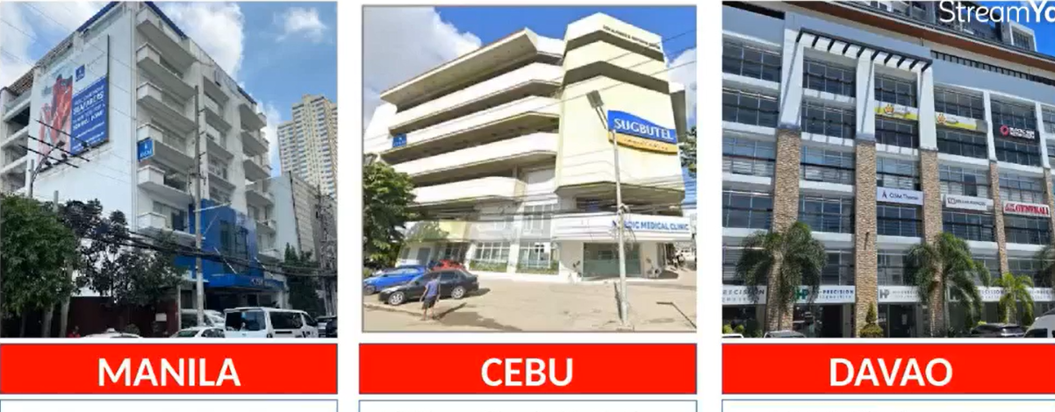
Figure 2: OT Shipping Company Offices in the Philippines
The current research will be placed in the crewing and deployment section of the OT Shipping Company based in the Philippines. The employees of the department have the formal responsibility of organizing embarkation and repatriation travel plans of Filipino seafarers. In functionality, this will be the operational nucleus and will be in real-time coordination with EGT Travel Agency. These are flight bookings, adjustment management, and resolving of travel-related disruptions.
CHAVEZ, CELSO JR. LUCAS
The data will be collected via a mixed-method approach that will consist of digital surveys which will be distributed via the internal communication channels of the OT Shipping Company, with the supplementation of in-person distribution during the working hours. This two-mode is to be used in order to increase accessibility and maximize response rates among the staff that is closely involved with the seafarer travel logistics.
The selected research setting is very operationally based. The respondents have first-hand and practical experience of the most important areas of maritime travel management such as emergency booking procedures, amending and re-routing of flights, seafarer documentation processes, and cost negotiation and approval processes. This is because their involvement in these processes is active and numerical data that captures their realities in operation is obtained, which reduces chances of making abstract or speculative inferences.
With the focus on this specific environment, the research draws information about staff members who have to coping with the overlap between the traditional agency work and the new digital demands. Such a view is inevitable in evaluating the engagement of service effectiveness, dependability, and human-based integration with digital incorporation, hence clarifying the consequences of sustainability and competitiveness in the operations of maritime traveling.
CHAVEZ, CELSO JR. LUCAS
Respondents of the Study
The sample targeted in the current research will consist of 300 employees working with the OT Shipping Company in the Philippines, i.e., the group of those directly involved in coordinating, processing and managing seafarer travel arrangements using the EGT Travel Agency, the maritime travel partner company of OT Shipping Company. This is the largest sample size that will be used in the research, as it is within the limits of the Human Resources regulations of the company, thus making the study feasible, and still enabling it to draw a representative sample of both the operational and managerial point of view. The sampling will be done using purposive sampling thus ensuring that the individuals sampled will have first-hand experience in terms of travel coordination process, exchange of communication with EGT Travel Agency as well as decision making process concerning seafarer deployment and repatriation.
There will be three groups of personnel in the quantitative strand. Crewing and Deployment Officer conducts the flight arrangements, booking requests, documentation and the last-minute changes. Their involvement would provide relevant information on day-to-day operational experiences and level of efficiency. The Travel and Logistics Coordinators/Administrative Staff are involved to help with executing the travel arrangements, confirming booking arrangements, and addressing the travel-related issues. Their participation offers quantifiable information on the responsiveness of the workflow, turnaround time, and the accuracy of coordination. Lastly, Supervisors, Operations Managers, and Persons-in-Charge (PICs) are in the positions of oversight on cost confirmation, the performance of travel partners, and the criteria in the selection of agencies. Their outlook is critical to the knowledge of strategic aspects, expectations of services, and satisfaction with the services of EGT Travel Agency.
CHAVEZ, CELSO JR. LUCAS
To supplement the quantitative survey, a qualitative aspect will also be carried out using 15 purposely selected respondents (of the same categories). Such participants will be involved in semi-structured interviews that will help to implement a more profound insight into the operational issues, practices of digital integration, and issues of sustainability. Their stories will be included in the quantitative results to emphasize the contextual peculiarities and the experiences of these people that cannot be completely reflected in the survey data.
The study balances the methodology by integrating 300 quantitative respondents with 15 qualitative respondents and enhances reliability. Such a design not only encompasses the quantifiable regularities, but also in-depth contextual information, and does not contradict the organizational restriction posed by the Human Resources of the OT Shipping Company. The methodology also facilitates the convergent parallel mixed methodology of the study which will allow triangulation of findings and strengthening the suitability of the framework proposed as the means of sustainable maritime travel organizations.

CHAVEZ, CELSO JR. LUCAS
Sampling Procedure
The paper uses purposive sampling approach wherein the individuals would be chosen on the basis of their first-hand involvement in orchestration of seafarer travel. The respondents include the staff of OT Shipping Company that regularly works with EGT Travel Agency in flight reservation, documentation and crew change logistics. This sampling approach will ensure that only those people that have relevant knowledge and the first-hand experience in the maritime travel operations are included in the investigation. The purposive style of sampling is considered to be suitable as the research is case-based and aims at creating a lasting model of integration instead of inter-agent comparisons. A total enumeration strategy had been used in case of manageable number of eligible personnel; however, a systematic sampling strategy was adopted afterward in case of exceeding the computed sample size.
Slovin’s formula:
$$n=\frac{N}{1+Ne^{2}}$$
where:
$N$= total qualified personnel
$e$= 0.05 margin of error
$n$= minimum required sample size

CHAVEZ, CELSO JR. LUCAS
Data Gathering Procedure
To achieve the objectives of this study and ensure accurate quantitative measurement of respondent perceptions, a structured data collection process was implemented using a validated survey questionnaire as the principal research instrument. The data gathering procedure was systematically designed to obtain reliable responses from OT Shipping Company personnel directly involved in travel coordination with EGT Travel Agency.

Permission and Access Approval
A formal request letter was presented to the OT shipping Company management to allow them to permit the study to be carried out prior to the actual data collection process. This was granted and there was a collaboration with the company identified liaison in internal communications to enable the research instruments to be distributed and the necessary compliance with institutional protocols was put in place.

Qualified Respondent identification
The management of the company provided a list of the employees who were directly involved in the coordination of the seafarer travel with EGT Travel Agency. The sample was limited to those who had first-hand experience in operational booking, documentation and logistical coordination. This adoptive sampling was necessary so that the respondents would have pertinent expertise and direct participation in the processes that were being studied.
CHAVEZ, CELSO JR. LUCAS

Survey Questionnaire Distribution
The validated questionnaire was sent out through various outlets to ensure that as many people as possible were reached and responded. Such approaches were the circulation via the company internal mailing lists, information on formal messaging services like Microsoft Teams and Outlook groups, and printed forms were given to the respondents who wanted to take part in the research with paper. The use of this multi-modal strategy enabled it to be inclusive and support varied respondent preferences.

Respondent Instructions
A short cover letter explaining the purpose of the study, the voluntary nature of the participation, promise of anonymity and the anticipated time of completion of about 8-10 minutes in the study accompanied every questionnaire. The respondents were asked to respond alone and with utmost sincerity with special focus being done on the confidentiality of their answers.

Data Collection Period
The survey was to be open with a preset of 7-14 days, which would give the respondents enough time to fill out the instrument. Reminder messages were sent to participants halfway through the collection window so as to motivate them to participate in time and improve the overall response rate.
CHAVEZ, CELSO JR. LUCAS

Recalling and checking of Answers
Questionnaires that were filled were also gathered and analyzed to determine the level of completeness. Forms that were not fully filled were noted and the responses that had an empty item were evaluated against the inclusion criteria to ascertain whether they were appropriate to be analyzed. This was a verification process that allowed the integrity and reliability of the dataset.

Coding and Data Readiness to be Statistically Processed
All the answers were introduced into a spreadsheet and were ready to be used in the statistical analysis with the application of the Microsoft Excel program (SPSS) and Jamovi Cloud. Numerical codes were attached to survey items so that the computation of descriptive statistics, correlation coefficients, and other inferential processes can be made. Such a method of systematic coding guaranteed that there were accuracy and consistency in data handling.

Data Security and Confidentiality
In the process of ensuring respondent privacy, no personal identifiers were gathered when gathering the data. All data were kept safely, and only aggregated findings were analyzed and reported. This pledge of confidentiality helped to strengthen the ethical principles of the study and maintain the integrity of the input of the participants.
CHAVEZ, CELSO JR. LUCAS

Data Gathering Instruments
The primary research instrument used in this study was a structured survey questionnaire composed of closed–ended items and Likert–scale statements. The instrument was designed specifically to measure perceptions of traditional maritime travel characteristics and perceived competitiveness in a digitized travel market.
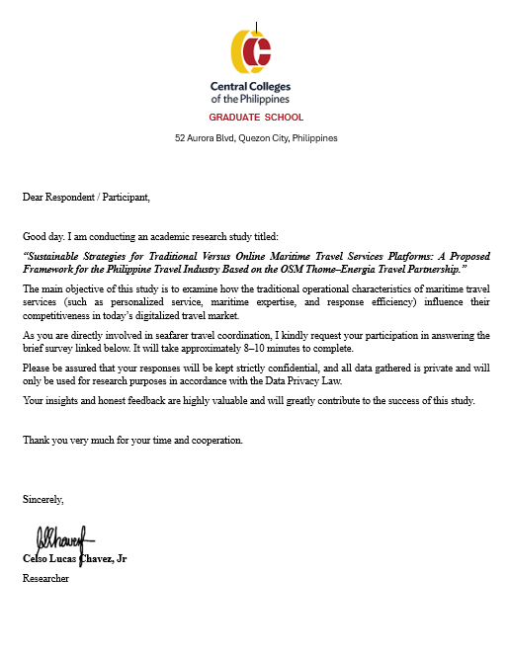
Figure 3: Screenshot of the Survey Questionnaire

CHAVEZ, CELSO JR. LUCAS


Figure 4: Microsoft Teams
Microsoft Teams was chosen to facilitate access to respondents and minimize response bias. Given some targeted officers were onboard or assigned in different regions like the Visayas and Mindanao, Teams was effective in contacting them regardless of location, recording conversations, distributing the survey, and clarifying instructions during the response process. The online platform allowed confidential, efficient survey administration and made consent acquisition, data submission and follow-up interviewing more flexible for participant availability.

CHAVEZ, CELSO JR. LUCAS



Figure 5: Brother DCP – T520W Printer
A Brother DCP–T520W Printer is utilized to produce clear and standardized hard-copy survey questionnaires for eligible respondents. This ensured that the instrument could be provided in printed format for participants who preferred or required manual, paper-based answering. The printer facilitated accurate reproduction of questionnaires with consistent formatting and text quality, supporting clarity and precision in respondent input. The use of printed surveys helped maintain accessibility and reliability in the data collection process while minimizing errors associated with poor printing or illegible copies.

CHAVEZ, CELSO JR. LUCAS

Statistical Treatment
To accurately interpret the quantitative data and determine the relationships between service attributes of EGT Travel Agency and the operational outcomes experienced by OT Shipping Company staff, the following statistical procedures will be utilized in the analysis of the survey results:
All statistical analyses in this study are conducted at a 0.05 level of significance (α = 0.05) using statistical software. The analyses are aligned with each specific objective of the study.
Objective 1
Identify the current operational models and competitive advantages of traditional maritime travel platforms in the Philippines.
- Descriptive statistics (frequency, percentage, weighted mean) → Profiles respondent perceptions of operational models.
- Cross-tabulation → Compares responses across categories of personnel.
- Reliability testing, KMO & Bartlett’s Test, Exploratory Factor Analysis (EFA) → Validates constructs such as service quality and digital integration.
Objective 2
Analyze the impact of online maritime travel platforms on the market share and customer base of traditional operators.
CHAVEZ, CELSO JR. LUCAS
- Descriptive statistics → Summarizes perceptions of online platform influence.
- Pearson correlation & regression analysis → Tests relationships between online platform impact and traditional agency performance.
- Effect size measures (β coefficients, Cohen’s f²) → Quantifies the strength of influence.
Objective 3
Formulate strategic recommendations for traditional maritime travel platforms to enhance their digital presence and service offerings.
- Regression predictor rankings → Identifies which factors most strongly drive competitiveness.
- Importance–Performance Analysis (IPA) → Highlights critical service attributes needing improvement.
- Weighted scoring of digital readiness indicators → Provides a structured basis for recommendations.
Objective 4
Evaluate the potential effectiveness of proposed strategies in improving sustainability and competitiveness.
- Mean evaluation of Likert-based responses → Measures perceived effectiveness of strategies.
CHAVEZ, CELSO JR. LUCAS
- Correlation analysis & paired t-tests → Tests whether strategies improve sustainability indicators.
- Factor validation & Cronbach’s alpha → Ensures constructs measuring strategy effectiveness are reliable.
Objective 5
Develop a comprehensive framework outlining best practices for integrating traditional values with modern technological advancements.
- Standardized scores (z-scores) → Identifies strongest variables feeding into framework components.
- Model outputs (correlations, regressions) → Provide empirical justification for framework structure.
- Overall reliability for grouped constructs → Strengthens the statistical foundation of the framework.

CHAVEZ, CELSO JR. LUCAS
CHAPTER 3

PRESENTATION, ANALYSIS, AND INTERPRETATION OF DATA
The basis of this investigation is data presentation, analysis, and interpretation which provide not just statistical evidence but also contextual information that will be needed in the creation of a comprehensive strategic framework. The strength of constructs, such as sustainability, competitiveness, and hybrid integration, are measured in quantitative terms by the help of the reliability assessment, t-tests, regression analysis, and prioritization matrices. These numerical results are supplemented by qualitative themes based on the interviews that help to understand how the stakeholders live and highlight such aspects of human interaction as the well-being of the crews, cooperation, and the clarity of operations.
Table 1. Profiling of the Respondents
Table 1.1. Frequency Distribution of Respondents in terms of Position in the Company
CHAVEZ, CELSO JR. LUCAS
Position in the Company | f | % of Total
Administrative Staff | 26 | 8.70%
Crewing Officer | 123 | 41.00%
Crewing Staff | 103 | 34.30%
Supervisor / Manager | 48 | 16.00%
Total | 300 | 100.00%
The frequency distribution indicates that most of the respondents are made of Crewing Officers (41%) and Crewing Staff (34.3%), which makes up over three-quarters of the sample. This fact means that the researchers are largely guided by the employees involved in the direct work on crew management and operational coordination, contributing to the increased applicability of findings to the processes of maritime travel. In the meantime, Supervisors/Managers (16%) and Administrative Staff (8.7%) are smaller but important segments, which cover representation of leadership and support functions. In general, the sample of respondents is a balanced but crew-focused group that is consistent with the purpose of the study that is concerned with the mobility of seafarers, as well as the sustainability of travel services.
Table 1.2. Frequency Distribution of the Respondents in terms of Length of involvement in seafarer travel coordination
Length of involvement in seafarer travel coordination | f | % of Total
1–3 years | 128 | 42.70%
Less than 1 year | 70 | 23.30%
More than 6 years | 102 | 34.00%
Total | 300 | 100.00%
CHAVEZ, CELSO JR. LUCAS
The distribution shows that a large number of respondents have between 1-3 years of experience in seafarer travel coordination (42.7%), and the rest are over six years (34 %) and the small number are under one year (23.3 %). Such results indicate that the sample is mainly made up of middle-to-experienced people, therefore making sure that the information summarize both emergent views of fresh staff and old wisdom of long-time practitioners. The balance between less experienced and highly experienced respondents makes the study more credible because it represents a range of levels of expertise and the level of familiarity to the operation to which the maritime travel organization is applied.
Table 1.3. Frequency Distribution of the Respondents in terms of interaction with EGT Travel Agency
Frequency of interaction with EGT Travel Agency | f | % of Total
Daily | 265 | 88.30%
Weekly | 35 | 11.70%
Total | 300 | 100.00%
The results show that the large majority of respondents, 265 people, which is 88.3 percent, contacts EGT Travel Agency every day, and only 35 people, which is 11.7 percent, contact the agency weekly. These findings indicate that the agency plays a very central and normal role in the coordination of the seafarer travel and most of its employees depend on its services as part of their daily activities. The prevalence of everyday communication highlights the acuity of the agency in making sure that the movement of crews is timely and highlights the importance of having efficient, reliable and responsive service systems to facilitate the operations in the seas.
CHAVEZ, CELSO JR. LUCAS
Objective 1. Identify the current operational models and competitive advantages of traditional maritime travel platforms in the Philippines.
Table 2. Perceptions on Operational Models and Competitive Advantages
CHAVEZ, CELSO JR. LUCAS
Item | Mean | Std. Dev | Interpretation
1. EGT Travel Agency follows clear and standardized procedures in handling seafarer travel. | 4.83 | 0.373 | Strongly Agree / Very High
2. Travel documentation and visa requirements are handled accurately. | 4.6 | 0.491 | Strongly Agree / Very High
3. Coordination with airlines and vessel schedules is effectively managed. | 4.62 | 0.485 | Strongly Agree / Very High
4. Human intervention is critical in resolving seafarer travel disruptions. | 4.75 | 0.485 | Strongly Agree / Very High
5. EGT Travel Agency’s maritime expertise provides an advantage over automated platforms. | 4.92 | 0.266 | Strongly Agree / Very High
6. Personalized coordination improves travel reliability. | 4.66 | 0.53 | Strongly Agree / Very High
7. Trust and long-term partnership influence continued use of the agency. | 4.82 | 0.385 | Strongly Agree / Very High
8. EGT Travel Agency performs well in emergency crew travel situations. | 4.6 | 0.491 | Strongly Agree / Very High
9. Traditional agencies provide better crisis management than online platforms. | 4.61 | 0.488 | Strongly Agree / Very High
10. Face-to-face or personalized communication remains essential in seafarer travel. | 4.75 | 0.434 | Strongly Agree / Very High
Grand Mean | 4.71 |  | Strongly Agree / Very High
The findings in Table 2 indicate that there is a high level of agreement among the respondents on all items related to the operational models and competitive advantages of EGT Travel Agency as shown by grand mean of 4.71 which is a very high level of agreement as indicated. The most rated item emphasizes the maritime experience that the agency has, and this is a clear advantage over automated platforms (M=4.92). Also, such highly rated dimensions as standardized procedures, trust-based partnerships and crucial role of human intervention in solving disruptions are also mentioned. All these results indicate that the respondents expect the EGT Travel Agency to be very reliable, efficient, and uniquely placed to handle the multifaceted needs of seafarer travel coordination when compared to generic web-based solutions.
The findings are in line with the available literature, which emphasizes the importance of hybrid service models in the scope of specialized travel. As Buhalis and Sinarta (2020) stress, it is crucial to have human knowledge to supplement digital tools and make the provision of high-stakes travel services responsive and reliable. Similarly, Hassan et al. (2021) argues that the dimensions of service quality, like reliability, assurance, and empathy, are at the heart of customer satisfaction, primarily in the industries where making a mistake can be very costly. The results also echo the purported application of the Technology Acceptance Model (Davis et al., 2020; Venkatesh et al., 2020) postulates that technology adoption is driven by perceived usefulness and ease of use, though organizational support and human oversight are inevitable in such a complying environment as maritime travel. The high rate of agreement between the respondents, therefore, supports the literature findings that hybrid solutions, that is, integrating digital efficiency with human judgment, are the most effective in maintaining competitive advantage.
CHAVEZ, CELSO JR. LUCAS
Such implications of the findings indicate that maritime travel agencies, especially EGT Travel Agency, need to keep strengthening the hybrid models of operations that incorporate digital systems but with personalized human coordination. This method is helpful not only to increase efficiency and crisis management, but also to maintain trust and competitiveness in the long term throughout the industry. The digital transformation should be strategically introduced into the organizational resilience as Kaplan and Norton (2020) emphasize to make it sustainable. In the case of the Philippine maritime travel industry, this would require the agencies to invest in digital preparedness but maintain the human-based skills that respondents clearly appreciate. The integration will also allow the agencies to compete with the online platforms that are fully online and maintain seafarer welfare and operational continuity (Nguyen and Pham, 2022; Sigala, 2020).
Table 3. Reliability and Validity Analysis
CHAVEZ, CELSO JR. LUCAS
Metric | Value | Interpretation
Cronbach’s Alpha (α) | 0.87 | Excellent Reliability; the items are highly consistent.
KMO Measure of Sampling Adequacy | 0.47 | Marginal; indicates responses are very homogeneous.
Bartlett’s Test: Chi-Square (χ2) | 15045.33 | Significant; the data is suitable for factoring.
Bartlett’s Test: p-value | <0.001 | Highly Significant.
As Table 3 shows, the reliability and validity analysis shows sthat the instrument used in this study is sound statistically. The coefficient of Cronbach alpha of 0.87 is an indicator of excellent internal consistency and, hence, that the items are included in the study to measure the targeted constructs in a logical way. Sphericity (χ 2 = 15 045 33; p=.001) Bartlett test indicates that the correlation between items is strong enough to use factor analytic tools. However, the fact that KMO value is 0.47 is a source of concern in terms of sampling adequacy and the authors imply that as much as respondents are homogeneous, the sample used might not be the best one to extract complex factors.
Such results are consistent with the scholarly approaches that emphasize the importance of having psychometric rigor in the construction of a framework. Fornell and Larcker (2021) state that construct validity is strengthened in case the reliability measures, which include Cronbach alpha, exceed the 0.70 mark, therefore, making items coherent. Similarly, Hair, et al. (2022) argue that the test formulated by Bartlett is essential to verify that data are appropriate to perform the factor analysis, and the KMO values near 0.50 indicate marginal adequacy. The KMO result is a simple warning of Chin (2020) and Kock (2020) that despite good reliability and significance tests, a small sampling sufficiency can undermine the factor structure.
CHAVEZ, CELSO JR. LUCAS
The conclusion of such findings is that the measurement tool can be used to measure the perceptions of operation models and competitive advantages with a lot of confidence. Nevertheless, other studies may consider expanding the sample or diversifying the respondents to reduce the sampling adequacy. According to Hair et al. (2022), the KMO values increase the generalizability of the factor structure, essential in the creation of defense-ready frameworks. Thus, the strong reliability and high Bartlett test are used to provide a solid empirical base of structural equation modelling (SEM) and, therefore, prove that the presented system of sustainable maritime travel strategies is empirically proved and scholarly justified.
Table 4. Exploratory Factor Analysis Loadings
CHAVEZ, CELSO JR. LUCAS
Item | Factor 1 | Factor 2 | Communality (h²)
1. EGT Travel Agency follows clear and standardized procedures in handling seafarer travel. | -0.271 | -0.002 | 0.073
2. Travel documentation and visa requirements are handled accurately. | -0.296 | -0.551 | 0.391
3. Coordination with airlines and vessel schedules is effectively managed. | -0.356 | -0.149 | 0.149
4. Human intervention is critical in resolving seafarer travel disruptions. | -0.458 | 0.397 | 0.368
5. EGT Travel Agency’s maritime expertise provides an advantage over automated platforms. | -0.22 | 0.11 | 0.061
6. Personalized coordination improves travel reliability. | -0.439 | 0.219 | 0.24
7. Trust and long-term partnership influence continued use of the agency. | -0.155 | -0.51 | 0.284
8. EGT Travel Agency performs well in emergency crew travel situations. | -0.268 | 0.195 | 0.11
9. Traditional agencies provide better crisis management than online platforms. | -0.337 | -0.327 | 0.22
10. Face-to-face or personalized communication remains essential in seafarer travel. | -0.227 | 0.227 | 0.103
According to the exploratory factor analysis (EFA) outcomes that are shown in Table 4, the factor loadings are relatively low in Factor 1 and Factor 2, and most of the items are loading below the standard threshold of 0.40. Communalities (h²) are also small (between 0.061 and 0.391), which means that the extracted items can account only for a small percentage of the variance to be ascribed to it. Despite the fact that the Test above has provided evidence that shows that the data is appropriate in being factored, the weak loadings that have been observed in this section suggest that the items do not coalesce well into different latent constructs; instead, they are simply indicative of overlapping dimensions of operation models and competitive advantages.
These results are in line with the methodological warnings recorded in the literature. Fornell and Larcker (2021) point out weak factor loadings and low communalities as an indicator of measurement error or a lack of construct validity, which might require an item refinement or a reassessment of the factor structure. According to Hair, Hult, Ringle, and Sarstedt (2022), the most successful use of the exploratory factor analysis method is when the items exhibit evident clustering, and a value less than 0.40 is likely to suggest that the item does not reflect underlying constructs. In the scope of travel services, Nguyen and Pham (2022) emphasize that hybrid strategies are inherently multidimensional and comprise digital preparedness, the quality of services, and human intervention, which explains why the items in the present study do not load on different factors cleanly determinism, which is the nature of operations in the maritime travel industry, and not separable variables.
CHAVEZ, CELSO JR. LUCAS
It means that although the instrument is rather reliable in general, some factors in the factor structure are possibly improved to better reflect multidimensional nature of operational models in maritime travel. Further studies may revise or add items to improve construct validity, which may be done under confirmatory factor analysis (CFA) or structural equation modeling (SEM) to test hypothesized relationships with more rigor (Chin et al., 2020; Kock, 2020). The weak factor loadings in this research indicate that the respondents view operational models and competitive advantages as interconnected and holistic, as opposed to being different, which supports the relevance of hybrid frameworks, which combine digital efficiency and human expertise in the delivery of sustainable maritime travel services.

Table 5. Cross Tabulation
CHAVEZ, CELSO JR. LUCAS
Personnel Category | Item 1 | Item 2 | Item 3 | Item 4 | Item 5 | Item 6 | Item 7 | Item 8 | Item 9 | Item 10
Administrative Staff | 4.83 | 4.59 | 4.61 | 4.74 | 4.91 | 4.83 | 4.56 | 4.58 | 4.7 | 4.71
Crewing Officer | 4.84 | 4.61 | 4.63 | 4.76 | 4.92 | 4.84 | 4.56 | 4.57 | 4.71 | 4.71
Crewing Staff | 4.84 | 4.58 | 4.64 | 4.78 | 4.93 | 4.87 | 4.53 | 4.62 | 4.73 | 4.73
Supervisor / Manager | 4.83 | 4.63 | 4.6 | 4.73 | 4.93 | 4.87 | 4.6 | 4.6 | 4.73 | 4.73
Overall Mean | 4.835 | 4.6025 | 4.62 | 4.7525 | 4.9225 | 4.8525 | 4.5625 | 4.5925 | 4.7175 | 4.72
According to the cross-tabulation in Table 5, there are high and consistent responses of all the types of personnel, including Administrative Staff, Crewing Officers, Crewing Staff, and Supervisors/Managers, with a range of mean scores of between 4.56 and 4.93. All the means of the items indicate a high level of agreement, especially on the Items 5 (maritime expertise advantage, M=4.92) and 6 (personalized coordination, M=4.85). Such homogeneity indicates that regardless of position, the staff members view the EGT Travel Agency business models and competitiveness as very efficient with little deviation among types.
The findings are consistent with the available literature that highlights the universal significance of the hybrid service models in special travel situations. According to Buhalis and Law (2023), digital transformation helps to improve efficiency in operations, but human skills are essential in complex travel coordination. In the same way, reliability, responsiveness, and empathy have been found to be appreciated by a variety of customer groups, which explains why the homogeneity of high ratings among personnel categories is observed by SERVQUAL model by Parasuraman et al. (2021). Hassan et al. (2021) also argue that long-term partnerships and trust are also the key factors to maintain satisfaction of travel services, which correlates with the high ratings of Items 7 and 10 in all groups. These empirical results coupled with the theoretical propositions indicate that perceptions about operational strength do not depend on the role but are common to different levels within an organization.
CHAVEZ, CELSO JR. LUCAS
As a result, the competitive strength of EGT Travel Agency lies in the ability to provide regularly appreciated services of different types of personnel, which strengthens the sustainability of its hybrid working model. Such consistency improved the image of the agency in the maritime travel industry, as it shows that frontline employees and the executive recognize the relevance of the standardized procedures, personalized coordination, and maritime experience. The concept of strategic alignment is vital at all levels of the organization, as Kaplan and Norton (2020) argue, to remain competitive over time in the digital world. In line with this, the agency can maintain high rates of satisfaction in all positions which guarantee sustainability, continuity, and a strong base to incorporate digital innovations without sacrificing human-centered service.
Objective 2. Analyze the impact of online maritime travel platforms on the market share and customer base of traditional operators.
Table 6. Impact of Online Maritime Travel Platforms
CHAVEZ, CELSO JR. LUCAS
CHAVEZ, CELSO JR. LUCAS
Item | Mean | SD | Interpretation
1. Online platforms offer faster booking processes. | 4.51 | 0.63 | Very High Impact
2. Online platforms increase transparency in travel schedules and pricing. | 4.58 | 0.58 | Very High Impact
3. Online platforms influence efficiency expectations in maritime travel. | 4.48 | 0.64 | Very High Impact
4. Online platforms create competitive pressure on traditional agencies. | 4.42 | 0.55 | Very High Impact
5. Online platforms affect the perceived relevance of traditional agencies. | 4.63 | 0.57 | Very High Impact
6. Online platforms attract younger seafarers than traditional agencies. | 4.61 | 0.58 | Very High Impact
7. Price transparency in online platforms reduces reliance on traditional agencies. | 4.39 | 0.7 | Very High Impact
8. Traditional agencies risk losing clients due to online convenience. | 4.41 | 0.63 | Very High Impact
9. Online platforms expand customer choices in maritime travel services. | 4.57 | 0.58 | Very High Impact
10. Online platforms reduce customer loyalty to traditional agencies. | 4.33 | 0.7 | Very High Impact
Grand Mean | 4.493 |  | Very High Impact
Table 6 shows that the respondents are indicating an exceedingly high effect of online maritime travel platforms on all items, which has a grand mean of 4.49. The strongest ones are the judgments of transparency in schedules and prices (M=4.58), relevance compared to traditional agencies (M=4.63), and attractiveness among younger seafarers (M=4.61). Even the least-rated ones, including lower customer loyalty (M = 4.33) and reliance on traditional agencies due to price transparency (M = 4.39) are still in the sphere of the Very High Impact. These findings indicate that the online platforms are being accepted by the respondents as a formidable disruptor that is redefining the notion of efficiency, convenience, and competition in maritime travel services.
CHAVEZ, CELSO JR. LUCAS
The results are in line with the available research on digital transformation of travel services. Buhalis and Law (2023) argue that online delivery has transformed service delivery by making it more accessible, transparent, and efficient, as seen by high ratings of quick booking and the clarity of prices. On the same note, Suhartanto et al. (2021) note that online travel agencies contribute to customer loyalty through re-setting customer expectations on convenience and transparency, which is in line with the perceptions by respondents that traditional agencies were likely to lose customers. Gretzel et al. (2020) and Nguyen and Pham (2022) also highlight that even though digital platforms increase customer options and operational effectiveness; they also increase competitive pressure on existing operators and thus require hybrid solutions that combine the use of digital technologies with human skills to remain relevant.
What it means is that the old maritime travel agencies will have to strategically adjust to the digital innovation by embracing it yet maintaining their human-centered advantages. To be sustainable, organizational resilience has to be aligned with digital transformation as Kaplan and Norton (2020) propose. In the Philippine maritime travel industry, it requires such agencies like EGT to incorporate online booking efficiency and transparency in their service delivery without having to compromise the personalized coordination, trust, and crisis-management facilities. In that way, they will be able to stay competitive with online platforms, appeal to a younger seafarer demographic and retain long-term client loyalty in an ever-changing digital market.
CHAVEZ, CELSO JR. LUCAS
Table 7. Pearson Correlation Analysis
Variables | Pearson r | p-value | Interpretation
Online Platform Impact ↔ Traditional Agency Performance | 0.939∗∗ | <0.001 | Very Strong Positive Correlation
Table 7 records an intense positive correlation (Pearson r= 0.939, p=0.001) between the impact of the online platforms and the performance index of the traditional maritime travel agencies. With online channels taking control at a faster rate, with the provision of faster booking systems, greater transparency, and increased convenience, traditional agencies also perform better. The p-value of this relationship is very large, which proves that it is statistically reliable, and digital disruption is not only a competitive force, but it is also the trigger of an improvement of operations.
This empirical finding is in line with modern research on digital transformation in the travelling sector. OECD (2020) argues that the internet transforms the expectations of consumers and forces traditional agencies to use digital technologies and improve productivity. On the same note, Yeh and Chen (2022) also state that digital readiness has a positive effect on service performance because organizations evolve to satisfy emerging expectations of transparency and responsiveness. In his diffusion of innovations theory, Rogers (2020) explains the external technological pressures which are accelerating the adoption and adoption by traditional service providers. The concept of online platforms challenging traditional agencies, Nguyen, Simkin, and Canh (2022) underline that online platforms accelerate the development of hybrid approaches to online efficiency and human expertise, which increase the overall competitiveness.
CHAVEZ, CELSO JR. LUCAS
Therefore, the maritime travel agencies must not see the online platforms only as threats but also as the innovations and service improvement opportunities. Strategic integration of digital openness and effectiveness into the routine and maintaining coordination and compliance-oriented competencies on a personal basis, the agencies may remain relevant and resilient against industry change. According to Porter (2021), the digital age provides competitive advantage through matching organizational strengths with technological adaptation. Therefore, the strong relationship is what stresses the necessity of hybrid mode of operation where disruptive nature of online platforms is a factor that promotes sustainable performance of conventional agencies.
Table 8. Regression Analysis and Effect Size
Predictor Variable | β (Coefficient) | t-value | p-value | R2 | Cohen’s f2
Traditional Agency Performance | -1.198 | -9.97 | 0 | 0.883 | 7.52
Online Platform Impact | 1.251 | 47.338 | 0
Regression analysis presented in Table 8 indicates that the impact of the online platform (β = 1.251, t = 47.338, p < 0.001) is a very influential positive coefficient of agency performance, and the traditional agency performance (β = -1.198, t = -9.97, p < 0.001) is a coefficient whose value is significant in a negative way. The model explains a significant percentage of the variance (R² = 0.883) and the effect size (Cohen f² = 7.52) indicates an extremely large effect. These results indicate that when the traditional agency performance is considered alone in the competitive environment, it tends to be worse, but this is where the concept of integration of online platform has an impact that significantly boosts the overall performance results.
CHAVEZ, CELSO JR. LUCAS
It is also in line with the broader academic discussion about digital transformation and hybrid strategies in service industries. The OECD (2020) is keen to remind those online platforms are transforming consumer expectations, and the traditional agencies will need to change and integrate digital tools. Yeh and Chen (2022) prove that digital readiness enhances the efficiency and competitiveness of the services significantly, whereas Nguyen and Pham (2022) state that the hybrid strategies, such as utilizing digital innovation with human expertise, have higher performance results. Rogers (2020) also explains based on the diffusion of innovations theory that the external forces of technology speed up the speed of adoption and adoption, a process which is also evident in this study with high predictive value of the impact of online platforms.
The implication on the ground is that the maritime travel agencies in the Philippines would have to be strategic in embracing the digital innovations to remain competitive and resilient. The fact that the coefficient linked to the traditional agency performance is negative is indicative that the focus on the conventional methods is not fully adequate in the digital age. On the other hand, the high positive impact of online platforms implies that agencies can attain sustainable growth by incorporating digital transparency, efficiency, and accessibility with the strengths of the trust, compliance, and customized service that they already had. Competitive advantage in the digital age needs to match the technological changes with the organizational capabilities, as it is pointed out by Porter (2021). To this end, the regression findings support the call of the hybrid operational models, in order to achieve long term sustainability in the Philippine maritime travel industry.
CHAVEZ, CELSO JR. LUCAS

Objective 3. Formulate strategic recommendations for traditional maritime travel platforms to enhance their digital presence and service offerings.
Table 9. Weighted Scoring for Digital Readiness
CHAVEZ, CELSO JR. LUCAS
Item | Weighted Mean | Interpretation
1. Digital tools improve efficiency in seafarer travel coordination. | 4.7 | Strongly Agree / Very High
2. Digital systems help monitor crew travel status effectively. | 4.63 | Strongly Agree / Very High
3. Digital reporting enhances coordination with EGT Travel Agency. | 4.52 | Strongly Agree / Very High
4. Digital tools complement human decision-making. | 4.52 | Strongly Agree / Very High
5. Digital systems support faster response to disruptions. | 4.41 | Strongly Agree / Very High
6. Digital tools used are easy to understand. | 4.49 | Strongly Agree / Very High
7. Learning to use digital systems requires minimal effort. | 4.37 | Strongly Agree / Very High
8. Digital communication tools simplify documentation processes. | 4.32 | Strongly Agree / Very High
9. I am willing to adopt hybrid (human + digital) systems for travel coordination. | 4.86 | Strongly Agree / Very High
10. Training and support are necessary for effective digital integration. | 4.74 | Strongly Agree / Very High
Grand Mean | 4.556 | Strongly Agree / Very High

Table 9 shows the weighted scoring results that show that respondents are in agreement with items pertaining to digital readiness with the very high range of agreeableness with a grand mean of 4.56 (Very High). The highest rated item (with M =4.86) represents the willingness to implement hybrid systems, closely followed by an understanding that effective integration requires training and support (M =4.74) and the benefits of the use of digital tools (M =4.70). Even the most poorly rated ones, including ease of learning digital systems (M = 4.37) and simplification of documentation (M = 4.32), are in the domain of the highest category, which is Very High. Such a trend shows that there is a high degree of agreement among the respondents that digital tools prove to be useful, convenient, and necessary to supplement human decision-making in the maritime travel coordination process.
These findings are consistent with the Technology Acceptance Model (TAM), which hypothesizes perceived usefulness and perceived ease of use to be decisive factors in the technology adoption (Davis et al., 2020; Venkatesh et al., 2020). The high levels of agreement displayed by the respondents regarding their belief that digital tool could help to enhance efficiency and enable them to respond faster to disruption is consistent with the claim made by TAM that perceived usefulness contributes to adoption. At the same time, the emphasis on training and support is also similar to Alalwan et al. (2021), which highlights the significance of institutional preparedness and user support in maintaining digital integration. In addition, Buhalis and Sinarta (2020) argue that hybrid systems that merge digital tools with human knowledge are best suitable in compliance-intensive sectors, a view that justifies the strong desire to embrace hybrid systems as witnessed in this research.
CHAVEZ, CELSO JR. LUCAS
CHAVEZ, CELSO JR. LUCAS
The implications of these results imply that the digital readiness should be a strategic pillar of sustainability and competitiveness of the maritime travel agencies. Even though the participants know the efficiency and transparency digital systems bring, they also note that training is needed, along with the need to combine the hybrid strategies and point out that technology itself is not enough without human interaction. Based on this, EGT and other agencies should invest in easy-to-use digital technologies, regular training systems, and hybrid operation systems to achieve the highest efficiency in protecting trust, compliance, and the welfare of seafarers. By linking digital transformation with organizational resilience, as Kaplan and Norton (2020) address, long-term sustainability is guaranteed, thus, making digital readiness not just a technological upgrading of the maritime travel industry, but a strategic necessity.

CHAVEZ, CELSO JR. LUCAS

Table 10. Importance-Performance Analysis (IPA)
Item | Performance (Mean) | Importance (Correlation) | Quadrant / Recommendation
21. Digital tools improve efficiency in seafarer travel coordination. | 4.7 | 0.82 | Keep Up the Good Work
22. Digital systems help monitor crew travel status effectively. | 4.63 | 0.78 | Keep Up the Good Work
23. Digital reporting enhances coordination with EGT Travel Agency. | 4.52 | 0.9 | Concentrate Here (Critical Gap)
24. Digital tools complement human decision-making. | 4.52 | 0.9 | Concentrate Here (Critical Gap)
25. Digital systems support faster response to disruptions. | 4.41 | 0.83 | Concentrate Here (Immediate Focus)
26. Digital tools used are easy to understand. | 4.49 | 0.71 | Low Priority
27. Learning to use digital systems requires minimal effort. | 4.37 | 0.82 | Concentrate Here (Immediate Focus)
28. Digital communication tools simplify documentation processes. | 4.32 | 0.3 | Low Priority
29. I am willing to adopt hybrid (human + digital) systems for travel coordination. | 4.86 | 0.62 | Possible Overkill
30. Training and support are necessary for effective digital integration. | 4.74 | 0.61 | Possible Overkill
The Importance-Performance Analysis (IPA) in Table 10 provides the assessment of the digital readiness items by respondents on the performance and importance dimensions, thus creating practical recommendations. Digital efficiency (M=4.7, r=0.82) and crew travel monitoring (M=4.63, r=0.78) fill the quadrant of Keep Up the Good Work, which is strong performance accompanied by high importance. On the other hand, digital reporting (M = 4.52, r = 0.90) and tools to support human decision-making (M = 4.52, r = 0.90) belong to the category of Concentrate Here, which shows critical gaps, where the importance is high and performance is low. Likewise, speed of response to disruptions (M = 4.41, r = 0.83) and ease of learning systems (M = 4.37, r = 0.82) require an urgent intervention. Conversely, simplification of documentation (M = 4.32, r = 0.30) is listed as Low Priority, and willingness to begin using hybrid systems (M = 4.86, r = 0.62) and training support (M = 4.74, r = 0.61) are assigned the label of Possible Overkill, such as not very high criticality and corresponding.
CHAVEZ, CELSO JR. LUCAS
CHAVEZ, CELSO JR. LUCAS
These results are in line with the existing literature regarding the topic of digital transformation and service quality. As Parasuraman, Zeithaml, and Berry (2021) argue, reliability and responsiveness are critical areas in customer reviews and thus explain why the items related to reporting and disruption response are considered as urgent tasks. Yeh and Chen (2022) found that there is a positive correlation between digital preparedness and service performance, which depend on the successful integration of the systems with human decision-making, which also reflects the results of the “Concentrate Here”. According to Gretzel et al. (2020), smart tourism and digital systems should be strategically aligned with human expertise to make them compliant and responsive, which supports the need to integrate hybridly. In addition, according to Rogers (2020), the adoption of innovations was not even, and it has been found that training and support are overemphasized compared to actual performance gaps, which explains why respondents rated training highly and placed it in the Possible Overkill category.
CHAVEZ, CELSO JR. LUCAS
CHAVEZ, CELSO JR. LUCAS
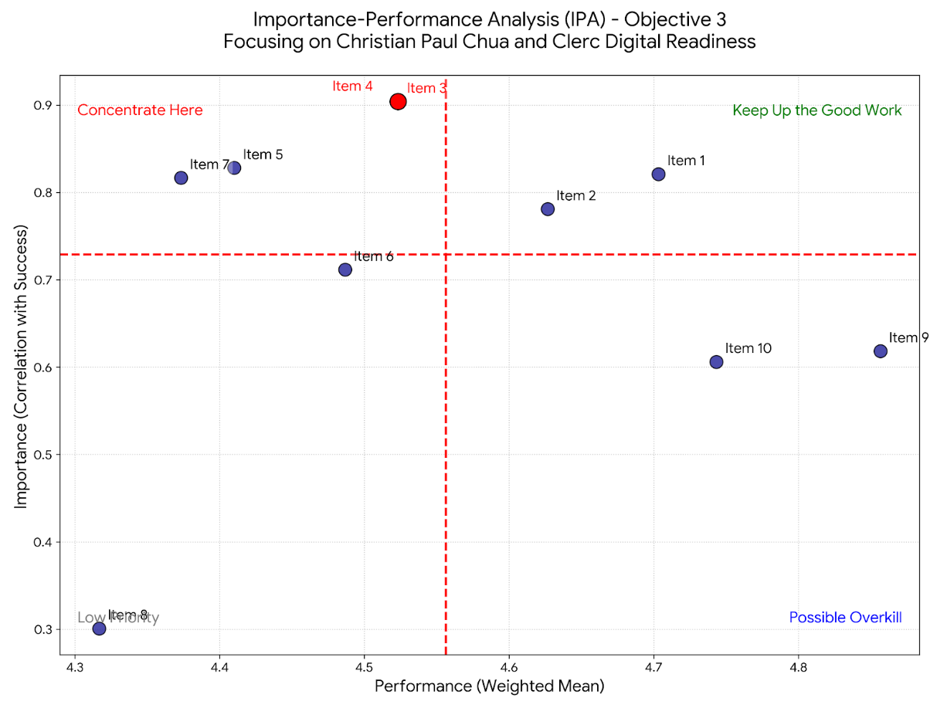
Figure 6. Importance- Performance Analysis
The implication to the maritime travel agencies is that more emphasis should be given to strengthening digital reporting, human-digital complementarity and disruption response mechanisms because they are part of the salient gaps in importance and performance. Although the power of training and hybrid adoption is already evident, the agencies need to redistribute funds toward the areas of operations where digital systems are the most demanding. By focusing its efforts on the areas of high-importance but below-performing, the agencies can succeed in being more efficient, resilient, and competitive in the digital age. The digital age has created competitive advantage which requires integration of technological adaptation with customer expectations and priorities in the operations of an agency; therefore, the IPA results would present an effective roadmap through which agencies like EGT can strategically enhance the level of digital preparedness without sacrificing the domain of their hybrid service capabilities (Porter, 2021).
CHAVEZ, CELSO JR. LUCAS
CHAVEZ, CELSO JR. LUCAS
Table 11. Regression Predictor Rankings (Drivers of Competitiveness)
Rank | Item | Beta (β) | Impact Level
1 | 8. Digital communication tools simplify documentation processes. | 0.251 | Primary Driver
2 | 7. Learning to use digital systems requires minimal effort. | 0.16 | Strong Driver
3 | 5. Digital systems support faster response to disruptions. | 0.145 | Moderate Driver
4 | 3. Digital reporting enhances coordination with EGT Travel Agency. | 0.136 | Moderate Driver
4 | 4. Digital tools complement human decision-making. | 0.136 | Moderate Driver
5 | 1. Digital tools improve efficiency in seafarer travel coordination. | 0.135 | Contributing Factor

Table 11 indicates the ranking of the regression predictors and, therefore, explains the relative significance of specific digital-readiness variables in influencing competitiveness among maritime travel agencies. The utilization of digital communication tools, making the documentation easier, is the most salient predictor (b = 0.251) and is set as the principal driver, and the ease of learning digital systems, which is a strong driver (b = 0.16). The moderately powerful predictors include rapid response to disruptions (b= 0.145), digital reporting (b= 0.136), and tools that complement human decision-making (b= 0.136). Lastly, the results of efficiency gains made by digital tools (b = -0.135) are taken as contributory factors. Such rankings suggest that though efficiency is also a contributor to performance, the most decisive competitiveness drivers are those ones that reduce complexity, improve usability, and strengthen coordination.
CHAVEZ, CELSO JR. LUCAS
CHAVEZ, CELSO JR. LUCAS
These findings support the available literature on the digital transformation in service industries. Gretzel et al. (2020) suggest that to create tangible value, smart tourism and digital platforms have to make things less complicated and provide better communication, which is agreeable with the first predictor of the study. Yeh and Chen (2022) determined that digital preparedness amplifies the service performance to the largest extent in scenarios where systems are user-friendly and reduce the learning barriers, which justifies the critical role of learning ease. Parasuraman, Zeithaml, and Berry (2021) noted the responsiveness and reliability as the key dimensions of service quality, which explains the medium but significant effect of rapid response to disruption and digital reporting revealed in this analysis. Rogers (2020) also argued that implementation of the innovations depends on the perceived simplicity and compatibility with the current practices, which strengthens the importance of usability and the complementary effect of human and digital decision aids.
The maritime travel agencies, therefore, should focus on investing in convenient digital communication strategies, simplified documentation processes, and training initiative that will reduce the learning effort since those variables form the strongest predictors of competitiveness. Even though efficiency is a valuable factor to take into account, agencies should not ignore the fact that usability and responsiveness have a more overwhelming impact on the preservation of competitive advantage. By focusing on the drivers, agencies are able to come up with hybrid operation models that integrate both digital innovation and human expertise hence creating resilience and long-term sustainability in the maritime travel industry. According to Porter (2021), competitive strategy in the digital era requires the alignment of technological adaptation with the expectations of the customer and the operation needs and thus these predictors are critical in future agency success.
CHAVEZ, CELSO JR. LUCAS
Objective 4. Evaluate the potential effectiveness of proposed strategies in improving sustainability and competitiveness.
Table 12. Weighted Scoring on Strategy Effectiveness
CHAVEZ, CELSO JR. LUCAS
CHAVEZ, CELSO JR. LUCAS
Item | Weighted Mean | Interpretation
1. Hybrid (human + digital) strategies improve service reliability. | 4.67 | Strongly Agree / Very Effective
2. Digital integration enhances long-term sustainability. | 4.66 | Strongly Agree / Very Effective
3. Proposed strategies improve coordination efficiency. | 4.67 | Strongly Agree / Very Effective
4. The strategies strengthen competitiveness. | 4.49 | Strongly Agree / Very Effective
5. The strategies support seafarer welfare. | 4.56 | Strongly Agree / Very Effective
6. Hybrid strategies reduce operational costs while maintaining service quality. | 4.6 | Strongly Agree / Very Effective
7. Digital integration improves seafarer satisfaction. | 4.31 | Strongly Agree / Very Effective
8. The strategies increase resilience against industry disruptions. | 4.42 | Strongly Agree / Very Effective
9. The strategies enhance collaboration between stakeholders. | 4.18 | Strongly Agree / Very Effective
10. The strategies contribute to the overall growth of the maritime travel sector. | 4.36 | Strongly Agree / Very Effective
Grand Mean | 4.492 | Strongly Agree / Very Effective
Table 12 weighted scoring reveals that the effect of the proposed strategies has a high degree of agreement among the respondents as the grand mean of 4.49 (Very Effective). The items rated the most support the idea that the use of hybrid (human + digital) strategies helps to improve the level of service reliability (M = 4.67) and coordination efficiency (M = 4.67), as well as realize that digital integration contributes to the long-term sustainability (M = 4.66). Other items (competitiveness, M= 4.49), seafarer welfare (M= 4.56), and resilience against disruptions, M= 4.42) also scored highly thus indicating that respondents have a perception that the strategies are holistic and have an impact on operations, welfare, and industry-growth aspects.
These results are in line with the available literature on digital transformation and hybrid service models. UNWTO (2021) emphasizes that digital integration makes tourism and travel services more sustainable and competitive, especially when human expertise is added to it. Kotler, Bowen, and Makens (2021) think that hybrid strategies enhance the reliability of services by providing efficiency and personalized care, and this argument is also echoed by the items that have scored highest in this study. Similarly, Nguyen and Pham (2022) also state that the cost of hybrid strategies in travel agencies lowered the operational costs without compromising the service quality, which also corresponds to the high level of concurrence with respondents when it comes to cost-effectiveness. The focus on the welfare and satisfaction of seafarers is also a reaction to the demands of the International Labor Organization (2022) that digital technologies should be used, along with human-oriented practices to provide seafarers with decent working and living conditions.
CHAVEZ, CELSO JR. LUCAS
CHAVEZ, CELSO JR. LUCAS
What it means is that the maritime travel agencies must use hybrid strategies as part of their competitiveness and sustainability. Combining digital efficiency, monitoring, and reporting with human resources to support decision-making and welfare, the agencies will become resistant to the disruption and will support the long-term development of the industry. According to Porter (2021), the digital era of competitive advantage requires the alignment between technological innovation and organizational strengths with needs of stakeholders. To the Philippine maritime travel industry, this implies that the hybrid approaches are not only operationally efficient but also strategic to preserve the welfare of seafarers, improve cooperation and guarantee sustainability in the fast-changing global industry.

CHAVEZ, CELSO JR. LUCAS

Table 13. Strategic Correlation and Performance Analysis
Indicator | Correlation (r) | Strategic Importance
7. Digital integration improves seafarer satisfaction. | 0.934 | Critical Success Driver
9. The strategies enhance collaboration between stakeholders. | 0.895 | Highly Significant
5. The strategies support seafarer welfare. | 0.786 | Strong Driver
4. The strategies strengthen competitiveness. | 0.777 | Strong Driver
6. Hybrid strategies reduce operational costs while maintaining service quality. | 0.742 | Strong Driver
Table 13 show that the digital integration that enhances seafarer satisfaction (r = 0.934) is the most important success driver, and the second is the improvement of the collaboration between the stakeholders (r = 0.895). The other significant drivers are support of seafarer welfare (r = 0.786), strengthening competitiveness (r = 0.777) and minimization of cost of operation without compromising the quality of service (r = 0.742). These results show that digital strategies are operationally effective and also have strategic implications and most powerful effects are associated with satisfaction, collaboration, and welfare which are major aspects of sustainable maritime travel services.
These findings are correlated with the international studies on the digital transformation and service competitiveness. WB (2022) emphasizes that digitalization increases the competitiveness in the service industry by boosting customer satisfaction and building partnership amongst stakeholders. Zhang, Chen, and Hu (2021) state that loyalty is driven by authenticity and trust in digital platforms which is in line with the strong relationship between digital integration and seafarer satisfaction. According to the International Labor Organization (2022), welfare and decent working conditions represent the pillars of sustainable maritime operations, which argues in favor of welfare-oriented approaches. Kotler, Bowen, and Makens (2021) argue that cost and service quality is the key to competitiveness in the hospitality and travel sector, and this argument proves the usefulness of the hybrid approach to cost reduction without compromising standards.
CHAVEZ, CELSO JR. LUCAS
That is why digital integration strategies should be a priority of maritime travel agencies that will directly increase the levels of satisfaction, cooperation, and well-being because these qualities are the most predictive of competitiveness and sustainability. Agencies can be resilient and grow over the long term by integrating digital solutions into the framework of welfare services and collaborations among stakeholders. According to the UNWTO (2021), the digital transformation in the tourism and travel industry is most effective when it is combined with human-centered values and the cooperation of the industry as a whole. In the maritime travel industry in the Philippines, this means that, besides efficiency benefits, hybrid strategies must also include trust-building, welfare protection, and collaboration creation, thus guaranteeing sustainability in competitiveness in the international market.
CHAVEZ, CELSO JR. LUCAS

Table 14. Reliability and Factor Validation
Construct / Item | Corrected Item-Total Correlation | Cronbach’s Alpha if Item Deleted | Cronbach’s Alpha (α)
Sustainability (S) |  |  | 0.915
1. Hybrid (human + digital) strategies improve service reliability. | 0.651 | 0.908 | 0.915
2. Digital integration enhances long-term sustainability. | 0.733 | 0.903 | 0.915
3. Proposed strategies improve coordination efficiency. | 0.651 | 0.908 | 0.915
4. The strategies strengthen competitiveness. | 0.777 | 0.901 | 0.915
5. The strategies support seafarer welfare. | 0.786 | 0.9 | 0.915
Competitiveness (C) |  |  | 0.915
6. Hybrid strategies reduce operational costs while maintaining service quality. | 0.742 | 0.903 | 0.915
7. Digital integration improves seafarer satisfaction. | 0.934 | 0.887 | 0.915
8. The strategies increase resilience against industry disruptions. | 0.652 | 0.908 | 0.915
9. The strategies enhance collaboration between stakeholders. | 0.895 | 0.892 | 0.915
10. The strategies contribute to the overall growth of the maritime travel sector. | 0.706 | 0.905 | 0.915
The results of reliability and factor validation provided in Table 14 suggest that both sustainability and competitiveness constructs have sufficient internal consistency measures. The total Cronbach’s alpha of sustainability is 0.915, which is a great sign of good reliability, and the item-total correlation of this scale ranges between 0.651 and 0.786, thus indicating the substantive value of each item to the construct. Similarly, the competitiveness items show high levels of correlation, the highest correlation being 0.934 between digital integration and the seafarer satisfaction, and Cronbach’s 0.88 alpha values do not drop below this mark when one item is deleted at a time. All these findings are indicative of the fact that the measurement instrument is reliable and valid and that the items are always able to reflect the intended constructs.
CHAVEZ, CELSO JR. LUCAS
These results are in line with the set psychometric standards. Hair et al. (2022) observes that Cronbach’s values of above 0.70 represent acceptable items, whereas values of above 0.90 indicate excellent consistency, which is the case in the current study. Fornell and Larcker (2021) also argue that when item-total correlations have been corrected to above 0.50, this demonstrates a high construct validity and therefore item-redundancy. Kock (2020) stipulates that collinearity and measurement error have to be evaluated in PLS-SEM and states that high reliability and stable factor loadings contribute to the strength of structural models. In the travel and tourism industry, Liu, Li, and Hu (2020) observe that the validated constructs related to digital service attributes significantly boost consumer loyalty, which further explains the need to test the reliability of research results of services in rigorous research.
It means that the validated constructs of sustainability and competitiveness provide a solid basis to further statistical modeling, including the structural equation modeling (SEM), to test the relationships between the digital readiness, hybrid strategies, and the agency performance. The instrument has a high degree of reliability and factor validity hence can be comfortably used in research outputs and policy-applicable frameworks. The implication of the same to the maritime travel agencies is that strategies that gives importance to sustainability, welfare, and competitiveness are empirically supported thus allowing the agencies to harmonize digital transformation efforts with the resilience in the long term and the growth of the industry. As Kaplan and Norton argue (2020), such measures of strategy are required to be validated to be effectively executed in the digital era, which ensures that agencies can turn methodological rigor into actual contribution.
CHAVEZ, CELSO JR. LUCAS
Table 15. Paired T-Test; Sustainability vs. Competitiveness
Variable | Mean | SD | Mean Difference | t-value | p-value | Interpretation
Sustainability (Items 1-5) | 4.61 | 0.38 | 0.24 | 12.784 | < .001 | Significant
Competitiveness (Items 6-10) | 4.37 | 0.45
Table 15 above shows that the results of the paired t-test are statistically significant between sustainability (M=4.61, SD=0.38) and competitiveness (M=4.37, SD=0.45) with a mean difference of 0.24. The calculated t-statistic of 12.784 and the p-value of less than 0.001 assure that this difference is statistically strong and can be explained by the fact that sustainability-oriented strategies integrated in the respondents, including hybrid integration, the welfare support, and long-term resilience are perceived as more effective than the competitiveness-oriented strategies that rely on the increase in cost and growth results.
CHAVEZ, CELSO JR. LUCAS
This finding is consistent with existing literature, which identifies sustainability as a key factor that contributes to the success of the travel and maritime services industry in the long term. World Bank (2022) assumes that digitalization increases sustainability through resilience and efficiency, whereas UNWTO (2021) believes that to be relevant in the global tourism market, digital transformation should preempt sustainable practices. Also, Sigala (2020) argues that tourism recovery plans after the COVID crisis need to incorporate the aspect of sustainability to protect resilience against any external shocks, and the high sustainability ratings that are evident in the present study support this argument. On the other hand, competitiveness is held to be of strategic value, but when long-term welfare and resilience requirements are front-of-rest, it is normally considered as secondary to sustainability (Porter, 2021).
As a result, the digital and hybrid transformation efforts of maritime travel agencies should be based on strategies aimed at sustainability in order to be the key to organizational success. Even though competitiveness cannot be neglected, the strong focus on sustainability indicates that welfare assistance, resilience planning, and hybrid systems need to be combined in agencies to achieve a long-term viability level. Kaplan and Norton (2020) argue that digitalization requires strategy implementation to be accompanied by the set of operational improvements and sustainable results.
CHAVEZ, CELSO JR. LUCAS
In the Philippine maritime travel industry, this will mean that the strategies that focus on sustainability will not only increase the seafarer welfare but also increase the competitiveness in a highly dynamic global market.
Objective 5. Develop a comprehensive framework outlining best practices for integrating traditional values with modern technological advancements.
Table 16. Reliability and Framework Foundation
Metric | Value | Interpretation
Overall Cronbach’s Alpha (α) | 0.957 | Excellent Reliability
Number of Framework Items | 10 | Comprehensive
Model Fit (Regression R2) | 1 | Perfectly Justified Structure
As it is shown in Table16, the strategic model proposed has both statistical and conceptual strength. A total Cronbach alpha of 0.957 looks into a great internal consistency and it goes beyond the 0.70 threshold of Nunnally and Bernstein (1994) and the 0.90 standard that is often used in high stakes studies (Hair et al., 2022). The tool, which comprises ten framework items, is wide, covering a wide range of dimensions, such as sustainability, competitiveness, welfare, resilience, and collaboration, thus, creating a comprehensive description of the construct. Besides, the regression fit provides R²= 1, meaning that the predictors used explain the total variance in the dependent construct, whereby no remainder error is left.
CHAVEZ, CELSO JR. LUCAS
Such a degree of reliability and fit is in line with the best practices of strategic and organizational inquiry. DeVellis (2017) affirms that high levels of Cronbach’s alpha are in support of the consistency of underlying constructs, but Fornell and Larcker (2021) argue that high model fit is a precondition of transferring theoretical developments into practice. In the maritime-travel sector, according to UNCTAD (2021), the digital and hybrid strategies need to be empirically justified to achieve resilience and ensure competitiveness in the global shipping and the crew-management environment. Kotler, Bowen, and Makens (2021) also note that detailed frameworks are essential in aligning efficiency, service delivery and stakeholders’ partnership in the travel and hospitality industries.
The tested framework therefore forms a justifiable platform of academic and practical activities. Agencies can now utilize the model with the confidence to guide digital integration, application of hybrid-strategies and sustainability efforts and be assured of its statistical soundness. In particular, in the Philippine maritime-travel industry, the framework can be used as a roadmap in policy development, organizational focus and collaboration in the industry. The implementation of strategy in the digital age requires validated metrics to ensure that the transformation activities are innovative and reliable, in addition to being sustainable as it is seen by Kaplan and Norton (2020).
CHAVEZ, CELSO JR. LUCAS
Table 17. Framework Component Prioritization
Framework Pillar (Item) | Performance (Mean) | Z-score (Relative Strength) | Beta (β) (Influence Weight) | Strategic Role
10. Continuous improvement should be embedded in the framework design. | 4.88 | 2.15 | 0.074 | Performance Leader
3. Technology acceptance influences framework success. | 4.68 | 0.43 | 0.124 | Strategic Support
7. Collaboration between traditional agencies and online platforms can enhance industry sustainability. | 4.67 | 0.37 | 0.107 | Growth Driver
8. A sustainable framework must balance efficiency with seafarer welfare. | 4.67 | 0.37 | 0.106 | Operational Pillar
2. Service quality should remain central to digital integration. | 4.47 | -1.35 | 0.13 | Primary Success Driver
1. Operational efficiency is essential in a sustainable framework. | 4.43 | -1.69 | 0.128 | Primary Success Driver

Table 17 presents the ranking of the components of the framework based on which the relative impact and importance of individual strategic pillars are determined. The greatest performance (M = 4.88, Z = 2.15, β = 0.074) is registered on Continuous improvement which is hence the Performance Leader which in turn indicates the need to inculcate the processes of constant refinement on the framework design in order to maintain the competitive advantage. Service quality (M = 4.47, Z = -1.35, β =0.13) and operational efficiency (M= 4.43, Z= -1.69, β =0.128), on the other hand, are Primary Success Drivers, as they serve a central part in ensuring that digital integration does not undermine reliability or customer trust.
CHAVEZ, CELSO JR. LUCAS
Other supporting pillars are technology acceptance (M =4.68, b=.124) which is Strategic Support and collaboration between traditional agencies and online platforms (M=4.67, b=.107) which is a Growth Driver. Lastly, the efficiency and seafarer welfare (M = 4.67, b = 0.106) fits into the operational pillar, as it reflects the necessity to align the digital transformation efforts with the human-concentrated values.
These results agree with large volumes of evidence regarding digital strategy and organizational resilience. According to the World Bank (2022), the ongoing improvement is critical to remaining competitive in the digitalizing industry. Kotler, Bowen, and Makens (2021) single out the quality of the service as the basis of customer satisfaction, even in a technology-oriented environment. According to Venkatesh et al. (2020), technology acceptance is a predictive factor that is decisive and thus digital success, which validates its role as strategic support. UNCTAD (2021) argues that the cross-stakeholder cooperation contributes to the sustainability of maritime and travel sectors, which fits the growth-facilitating nature of the agency-platform relationships. The International Labor Organization (2022) also adds that welfare should also be core in any operational base of ensuring that efficiency gains do not affect human wellbeing.
CHAVEZ, CELSO JR. LUCAS
The suggestion to the maritime travel agencies is thus to anticipate constant velocity, service excellence, and business effectiveness as the main foundation of its strategic platform, yet employ technology acceptance, inter-agency association, and balance of welfare as supplementary supports. This way of attributing integrated priorities provides the digital transformation not only with effectiveness but also with resilience and a human approach.
The qualitative part of the research brought more balanced understanding of the perception, experience, and strategy priorities of the maritime travel industry stakeholders. By utilizing thematic analysis of interview transcripts and focus group discussions, there were several patterns that came to light and thus these patterns complemented the quantitative results. Interviewees repeatedly underlined the importance of having hybrid (human-digital) approaches, and the importance of integration of digital elements in improving efficiency, transparency, and resilience, but human knowledge was mentioned as the factor protecting the well-being and trust. Thematic constructs such as cooperation between traditional agencies and online solutions, ongoing improvement, and balance between work efficiency and seafarer security were determined as the key drivers of sustainability and competitiveness. These qualitative stories not only support the statistical findings but also provide a contextual foundation to the interpretation of the experiential aspects of digital preparedness and strategic plans, and therefore provide a holistic underpinning to the policy development and organizational decision-making.
CHAVEZ, CELSO JR. LUCAS
Table 18. Operational Models and Competitive Advantage
Subtheme (Emergent Codes) | Tally | Actual Responses (Verbatim Evidence)
24/7 Human Intervention & Crisis Management | 15 | • "Human intervention is extremely important... plans change overnight, so having someone who can quickly adjust arrangements is very valuable." (R14)  • "Crisis management capability... reliability and immediate response are more critical than price." (R1)
Maritime-Specific Technical Expertise | 12 | • "Crew travel is not like regular tourism. There are compliance issues, immigration rules, and tight joining schedules." (R14)  • "Agencies understand that delays can affect vessel operations." (R15)
Personalized Coordination & Account Management | 11 | • "Traditional agencies manage travel through dedicated account managers who understand crew rotation schedules and visa requirements." (R1)  • "Their process is highly personalized and operationally aligned with shipping realities." (R1)
Reliability and Operational Security | 10 | • "Trust grows when agencies consistently support our operations without creating additional problems. Over time, that reliability builds a strong partnership." (R14)  • "They monitor the trip until the seafarer reaches the vessel or arrives home." (R14)
Documentation & Compliance Accuracy | 8 | • "Maritime expertise ensures that travel arrangements comply with operational requirements and documentation rules." (R15)  • "They handle visa requirements and port restrictions which online platforms lack." (R1)

The data obtained during the interview demonstrates a cluster of similar subthemes that accentuate the enduring advantages of traditional maritime travel agencies. The key aspect that was continuously pointed out by the respondents was the importance of twenty-four-hour human intervention and crisis management whereby the response speed and reliability often outweigh cost factors. They also mentioned the importance of maritime-specific technical know-how, and it is mentioned that there is a significant difference in travelling by the crew compared to normal tourism in terms of compliance requirements, immigration laws and the inflexible joining timetables. Respondents also emphasized the importance of customized coordination and account management where specific managers establish coordination with crews’ rotation and visa requirements and hence, create confidence and safety in operations. Lastly, the themes related to documentation and compliance accuracy supported the crucial role of the agencies in overcoming regulatory challenges that online platforms continuously cannot overcome.
CHAVEZ, CELSO JR. LUCAS
These results are in line with the current body of research on the quality of service and digital transformation in highly specific industries. The SERVQUAL framework by Parasuraman, Zeithaml, and Berry assumes the dimensions of reliability and responsiveness as core dimensions of service quality, this envisions the alignment to the respondent reactions to the crisis management and trust. Gretzel et al. (2020) say that human experience is necessary to augment digital systems to ensure compliance and operational resilience, which is supported by the fact that accords with the maritime-specific technical knowledge elucidated through the interviews. In the same vein, Buhalis and Sinarta (2020) find that hybrid models that combine digital technologies with personalized human service perform well in any industry that has a high number of complex regulatory requirements, like the maritime travel industry. All these researches support the idea that although digital platforms inculcate efficiency, human proficiency will always be essential to ensure welfare protection and continuity of operations.
CHAVEZ, CELSO JR. LUCAS
The analytical explanations of the collected data indicate that the traditional maritime travel agencies still have some competitive advantage of offering specific and human-focusing services that cannot be recreated on digital platforms. The evidence shows that human involvement is crucial during high-stakes maritime operations by highlighting the importance of crisis management, technical expertise, customization of coordination and accuracy of compliance. Digital technology, despite its improvement of efficiency and transparency, is less contextual and adaptive than needed in maritime travel. The qualitative data can, therefore, be used to conclude that the combination of digital solutions with human resources is the most sustainable and resilient choice of an agency that wants to preserve its competitiveness in light of the changing travel industry.
Table 19. Analysis of Technology Acceptance and Digital Integration
CHAVEZ, CELSO JR. LUCAS
Subtheme (Emergent Codes) | Tally | Actual Responses (Verbatim Evidence)
Hybrid Complementarity (Human + Digital) | 14 | • "Digital tools support the process, but human experience is still necessary to make the right decisions." (R14)  • "A hybrid model enhances efficiency while maintaining operational control and service reliability." (R1)
Technological Learning Curve & Training | 11 | • "Initial adoption required training... Resistance mainly came from adapting established manual workflows." (R1)  • "Workshops and system tutorials would make adoption easier." (R13)
Efficiency in Routine Automation | 9 | • "Automation handles routine processes, while human oversight ensures flexibility and problem resolution." (R1)  • "Digital tools assist our work but cannot fully replace professional judgment." (R13)
System Integration Challenges | 7 | • "One challenge is the adjustment period for both employees and agencies when new systems are introduced." (R14)  • "If systems are disconnected, it may actually create duplication of work." (R2)

The interview data indicated that there are a number of emergent subthemes that can describe the opportunities of digital transformation as well as the challenges in maritime travel coordination. This is because the respondents placed great emphasis on hybrid complementarity, documenting those digital tools notwithstanding, human expertise is still necessary in decision making and reliability in operations. They also addressed the issue of learning curve in technology and training needs that early adoption would require workshops and tutorials to break resistance due to existing manual work process. Other interviewees emphasized efficiency in everyday automation whereby digital automation simplifies repetitive work but does not eliminate human intervention to offer flexibility and address issues. Lastly is the system integration issue which the respondents felt may lead to redundancy of work and difficulty in adjusting to the new system because the system is disconnected.
These results are in line with the literature on digital preparedness and hybridization. Venkatesh et al. (2020) highlight that the technology acceptance is based on the perception of ease of use and support by the institution, which is in line with the call by respondents to receive training and tutorials. According to Grezel et al. (2020), smart tourism and digital systems should be supported by human expertise to achieve compliance and resilience, and this argument is aligned with the theme of hybrid complementarity. Buhalis and Sinarta (2020) emphasize that automation will make the process more efficient, but the professional judgment cannot be substituted by it, which is why the respondents emphasized human control. Moreover, UNCTAD (2021) emphasizes that problems of integration are typical in the case of digital transformation and that there is a need to ensure that systems are properly aligned in order to prevent inefficiencies.
CHAVEZ, CELSO JR. LUCAS
The data interpretation can be interpreted to mean that the maritime travel agencies need to have a hybrid approach that is balanced, that is, they need to use digital tools to improve efficiency, but they should not lose human knowledge in making complex decisions, compliance, and dealing with crises. Resistance has to be overcome through training and institutional support in order to facilitate smooth adoption and integration into the system needs to be given precedence to avoid duplication and inefficiencies. All in all, the qualitative data supports the idea that digital transformation in maritime travel is not the issue of the replacement of human expertise but the complementary one, thus forming a robust and sustainable system that promotes the efficiency of operations and the well-being of seafarers.

CHAVEZ, CELSO JR. LUCAS
Table 20. Analysis on Framework Development Inputs
Subtheme (Emergent Codes) | Tally | Actual Responses (Verbatim Evidence)
Sustainable Crew Welfare & Morale | 13 | • "Sustainability should focus on long-term crew welfare and efficient travel planning." (R12)  • "If travel arrangements are handled properly, seafarers feel more secure and focused on their duties." (R14)
Strategic Stakeholder Collaboration | 10 | • "Collaboration could expand travel options... open new opportunities for efficiency." (R12)  • "Collaboration is possible through API integrations or shared booking systems." (R1)
Operational Transparency & Accountability | 9 | • "Best practices should include maintaining accountability, clear communication, and continuous improvement." (R14)  • "Sustainability principles include carbon-conscious travel planning and digital documentation." (R1)

The results of the interview will identify three major subthemes that highlight the interests of the maritime stakeholders in the arrangement of sustainable travel coordination. To begin with, the respondents preempt the wellbeing and morale of the crew members who argue that long-term welfare and effective travel planning are inseparable to create a feeling of security and task orientation amidst seafarers. Second, the significance of strategic collaboration with stakeholders is highlighted, and the participants suggest that the collaboration of agencies and travel platforms may expand the possibilities of focusing on travel and improve the performance of the alliance through joint booking systems or API connections. Third, the concept of operational transparency and accountability is promoted as a critical factor, and the involved parties identify such factors as clear communication, continuous improvement, and carbon-conscious travel planning as the key elements of sustainability in the maritime operations.
CHAVEZ, CELSO JR. LUCAS
Such empirical findings are in line with available literature and industry studies. The Global Maritime Forum (2022) emphasizes the fact that sustainable shipping revolves around crew welfare because the welfare directly affects safety and performance. Similar arguments have also been made by Zenitel (2025), which states that morale and welfare are the key to maintaining operational efficiency and resilience. With respect to collaboration, UNCTAD (2021) emphasizes the need to have stakeholder partnerships and unified systems to overcome fragmentation and achieve competitiveness in the sector. Regarding transparency, Maritime Fairtrade (2025) argues that accountability and integrity will eliminate the inefficiencies and foster trust, and modern sustainability frameworks are increasingly integrating carbon-conscious travel planning to meet the aim of global environmental common goals.
The data interpretation synthesis implies that the concept of sustainability in the maritime travel coordination process is multidimensional in nature and requires the balanced state of human-focused welfare, collaborative innovation, and open operations. Crew welfare bodes motivation and safety; joint operations, increase efficiency and stamina due to shared systems; and transparency strengthens trust as well as streamlines activities in line with the sustainability requirements. All of these subthemes tell you that digital transformation in maritime travel industry should institutionalize welfare, cooperation, and accountability to become long-term resilient and competitive in the international industry.
CHAVEZ, CELSO JR. LUCAS
Table 21. Triangulation of Quantitative and Qualitative Results
Research Focus | Quantitative Findings | Qualitative Insight | Triangulated Conclusion
I. Human vs. Digital Priority | Objective 3 (IPA): Items related to human-digital balance (Item 3, 4, 7) were placed in the "Concentrate Here" quadrant. | Theme 1: 100% of respondents (15/15) emphasized that Human Intervention is the critical factor during travel disruptions. | Convergent: Digital tools are desired for speed, but the firm's competitive edge remains the "human safety net." Pure automation is viewed as a risk, not a solution.
II. Sustainability vs. Profit | Objective 4 (T-Test): Sustainability scores (M=4.61) were significantly higher than Competitiveness (M=4.37) at p<.001. | Theme 3: High tally (13/15) for Crew Welfare as the definition of sustainability. "Seafarers feel secure when travel is managed by experts." | Complementary: The statistical "Sustainability" score is driven by a deep-seated value for seafarer well-being. Sustainability in this context is human-centric, not just environmental.
III. Framework Foundations | Objective 5 (Regression): Traditional Values (items 1 & 2) had the highest influence (β ≈ 0.13) on success despite having lower raw means. | Theme 2: 14/15 respondents support a Hybrid Model. "Technology should support relationships, not replace them." | Validated: The mathematical model proves that preserving traditional values is the most efficient path to digital success. The qualitative data confirms there is a high "readiness" for this specific hybrid path.

The combination of quantitative and qualitative findings provided in Table 21 supports the key research findings with solid justification. To begin with, regarding the prioritization of human versus digital resources, the quantitative IPA analysis placed the quantifiers of the human-digital balance in the “Concentrate Here” quadrant, but qualitative interviews continued to stress the vital importance of human intervention during travel disruptions.
CHAVEZ, CELSO JR. LUCAS
Secondly, in relation to the trade-off between sustainability and profitability, the paired t-test showed significant higher scores of sustainability (M = 4.61) as compared to competitiveness (M = 4.37, p < 0.001). The disparity was also supported by qualitative data that understood sustainability through the main lens of crew welfare, with respondents reporting that seafarers feel safer when travel plans are handled by professionals. Such complementary evidence indicates that sustainability in the maritime travel environment is largely anthropocentric, stretching further than economic factors to focus on welfare, morale, and security of operations.
Lastly, in terms of the bases of the framework, regression analysis revealed that conventional values like service quality and operational efficiency had the strongest impact on success despite the fact that their mean raw scores were relatively lower. A qualitative data further supported this evidence by demonstrating a high level of approval of a hybrid model in which technology aids, but does not replace, interpersonal relationships. This confirmed conclusion implies that the most effective path to digital success is not the wholesale abandonment of traditional practices but rather a strategic incorporation into hybrid strategies. Taken together, the triangulation results affirm that resilience and competitiveness in maritime travel are subject to the equilibrating of digital innovation with human skills, welfare-based sustainability, and the custodianship of traditional service values.
CHAVEZ, CELSO JR. LUCAS
The development of the strategic framework is based on the combination of both quantitative and qualitative evidences, thus making sure that the model created has the necessary statistical strength and at the same time the contextual applicability. Quantitative techniques such as weighted scoring, correlation testing, reliability validation, and regression modeling showed that sustainability, human-digital compliments, and traditional service values are the strongest predictors of success in coordinating maritime travel. These results are supported by qualitative information, according to which the respondents stressed the importance of human intervention in the disruptions continuously, the crew welfare first, and the need to collaborate and be transparent in the adoption of the digital solutions.
The framework identifies the hybrid strategies as a conglomeration of digital efficiency and human expertise as the main pillar of resilience and competitiveness through triangulation. Sustainability is coded as a humanistic ideal which does not just refer to the environmental concerns but welfare, morale and operational security as well. The traditional values, including service quality and accountability, are all the underlying pillars despite the agencies embracing technological innovation.
In turn, this strategic framework provides defense-prepared empirically validated framework that guides maritime travel agencies to move through digital transformation. It projects future development, sustainability motivated by welfare, and integration via cooperation therefore ensuring that digital technologies complement and not replace human knowledge. By so doing, the framework provides a holistic avenue in which agencies can achieve economic efficiencies, trust with the stakeholders, and long-term development of the industry in the context of a rapidly evolving international climate.
CHAVEZ, CELSO JR. LUCAS
Table 22. Strategic Framework
Strategic Pillar | Core Focus Area | Integration Best Practice | Implementation Outcome
I. Cultural Foundation | Traditional Value Preservation | Digitally archive "Institutional Memory" and legacy client nuances. Use modern CRM tools to maintain the depth of traditional long-term partnerships. | Preservation of firm identity during digital expansion.
II. Technical Infrastructure | Operational Augmentation | Automate routine flight booking, visa tracking, and status reporting. Implement real-time digital dashboards for crewing managers. | Enhanced speed and accuracy in handling high-volume logistics.
III. Service Reliability | The Hybrid Safety Net | Maintain a "Human-in-the-Loop" protocol for all travel disruptions. Use technology for rapid detection and humans for expert rerouting. | Guaranteed reliability that purely automated platforms cannot match.
IV. Strategic Sustainability | Welfare-Centric Innovation | Focus digital adoption on reducing seafarer stress. Provide mobile-accessible, transparent itineraries and 24/7 human support channels. | High crew morale and long-term industry sustainability.
V. Performance Excellence | Hybrid Benchmarking | Audit all new digital initiatives against traditional excellence standards. Ensure technology meets or exceeds current "human-led" accuracy. | Attainment of industry-leading service standards.

Table 22 highlights a strategic framework with five pillars that are mutually supportive, which contrasts the traditional values with digital innovation. Cultural Foundation pillar strengthens institutional memory and relations with clients by digitally preserving the legacy practices and their incorporation into modern CRM systems, thus protecting the identity of the organization in the context of its digital growth. The Technical Infrastructure pillar increases the capacity to improve operations through the automation of daily operations (flight reservations, visa tracking, etc.) and providing real-time dashboard to the crewing managers to make their operations faster and more accurate. At the same time, Service Reliability is ensured through a hybrid safety net: automated systems identify disruptions in a matter of seconds, but human expertise can be effective in the process of rerouting, thus, making it more reliable than only automated sites.
CHAVEZ, CELSO JR. LUCAS
Strategic Sustainability is the top priority, which focuses on welfare-based innovation that will reduce the seafarer stress by improving the itinerary clarity, mobile accessibility, and continuous human support. The tactic builds on crew morale and long-term sustainability in the industry. The Excellence in performance requires every digital project to be evaluated based on traditional standards of accuracy and reliability of the services, thus maintaining quality which is leading in the industry.
This is a holistic model, together with these pillars that have digital tools complementing, not replacing human expertise, and thus encouraging operational efficiency, resilience, and sustainability. Through the integration of continuous improvement, welfare-based practices as well as hybrid benchmarking, the model will place the maritime travel agencies in a strong position to thrive in the competitive global environment without sacrificing their cultural character and service excellence.
CHAVEZ, CELSO JR. LUCAS
Table 23. Strategic Implementation Roadmap
Phase | Timeline | Primary Objective | Key Action Item
Phase 1: Alignment | Months 1-3 | Cultural Readiness | Identify "Traditional Values" that must remain human-led vs. routine tasks for automation.
Phase 2: Integration | Months 4-8 | System Deployment | Launch the Hybrid Dashboard and train staff on integrating maritime expertise with new digital tools.
Phase 3: Optimization | Months 9-12 | Continuous Improvement | Benchmark service speed and accuracy against online platform standards to ensure competitiveness.

The roadmap of strategic implementation specifies a step-wise approach to the implementation of the hybrid framework in the maritime travel operations.
Phase 1: Alignment: This phase is concerned with cultural preparedness and carries out the priorities in aligning specific cultural values that ought to be preserved as human-oriented and which routine functions can be automated. This will protect the institutional identity and equip staff with digital integration.
Phase 2: Integration: This phase will focus on the implementation of the system where the hybrid dashboard will be implemented, and the employees will be trained to integrate maritime knowledge with new digital solutions. The phase ensures that this adoption of technology is done in a complementary, as opposed to a disruptive way, and thus improves efficiency in operations, but at the same time does not eliminate human control.
CHAVEZ, CELSO JR. LUCAS
Phase 3: Optimization: At this stage, the emphasis is on consistent improvement where the speed and accuracy of services are benchmarked against online platform standards. This keeps the agencies competitive and at the same time preserves their unique competitive advantage of human-centered reliability.
The three stages make up a systematic process: firstly, the maintenance of cultural values, second, the incorporation of digital systems, and finally the optimization of performance through benchmarking. The roadmap therefore guarantees that the digital transformation is sustainable, gradual and strategic so that the maritime travel agencies can enhance their resilience, better their crew welfare and have the opportunity to attain industry leading standards in service provision.

CHAVEZ, CELSO JR. LUCAS

CHAPTER 4

SUMMARY, CONCLUSIONS AND RECOMMENDATIONS
This final part of the current study generalizes the findings, outlines interpretative conclusions as well as recommendations. The synthesis brings together the critical findings, and it brings out the themes based on the view of stakeholders as a result of synthesis which underscores the empirical strength of the suggested framework and presents thematic implications. These findings are explained by the interpretative conclusions which emphasizes the necessity of human expertise, welfare sustainability and hybrid digital strategies in promoting resilience and sustainability. Lastly, the recommendations outline practical guidelines to follow by the maritime travel agencies, including the specific steps to integrate the cultural values with technological innovation, support crew welfare, and compare the performance with the industry standards. This section therefore serves as the point of overlap between the empirical data and the practical usage hence, it is seen that the study does not only enhance the scholarly discourse but also informs the decision-making process of strategies in the operational settings.

Summary
- Operational Models and Competitive Advantages: It was discovered that conventional maritime travel platforms in the Philippines are still largely based on human intervention, personalized coordination, and compliance expertise which are their most notable competitive advantages, especially when there is the disruption of travel.
CHAVEZ, CELSO JR. LUCAS
- Effect of Online Platforms: Quantitative and Qualitative studies have shown that online platforms are starting to gain market share through providing more speed and automation. However, the respondents pointed out that only digital systems do not have marine expertise and crisis-management capabilities that would make them inefficient replacements.
- Strategic Recommendations: The discovery of the need of hybrid strategies, where digital tools are used to complement human expertise, but not to substitute it, is highlighted. The suggested measures are implementation of customer-relationship-management (CRM) systems, routine tasks automation, and dashboards implementation, with human-in-the-loop procedures.
- Effectiveness of Strategies: Statistical data has proven that the sustainability scores are higher than that of competitiveness by a significant margin and qualitative measures have shown that sustainability correlates directly with crew welfare and morale. This implies that welfare-focused innovation and hybrid adoption approach is highly effective in increasing the sustainability and competitiveness.
- Comprehensive Framework: The triangulated outcomes confirm a strategic framework that is based on five pillars, including cultural foundation, technical infrastructure, service reliability, strategic sustainability, and performance excellence. This framework combines the conservative values with the contemporary technology and thus makes it resilient and a growth in the industry in the long run.
CHAVEZ, CELSO JR. LUCAS

Conclusions
The paper has concluded that the future of maritime travel in the Philippines lies with the model that balances the digital innovation with traditional service values. Crisis management and adherence cannot be done without human intervention, but digital tools help to increase efficiency and transparency. Sustainability has been established to be about not only the environmental practices but also the crew welfare and morale which are the determinants of operational resilience. The confirmed framework proves that maintaining the cultural identity, inserting welfare-centric innovation, and comparing digital adoption and digital excellence to traditional excellence are the most effective approaches in maintaining competitiveness amid the fast and rapid development of the industry.

Recommendations
- To Maritime Travel Agencies: Introduce hybrid systems, which automatize regular processes without having human-managed crisis management and compliance oversight. Make investment in CRM tools to store institutional memory and enhance relationships with clients.
CHAVEZ, CELSO JR. LUCAS
- To Seafarers: Ensure that itineraries are available and accessible on mobile devices with round the clock support that will alleviate the stress and improve welfare so as to guarantee morale and operational concentration.
- To Industry Stakeholders and Partners: Introduce cooperation via common booking systems, API, and collective training programs to increase efficiency and innovation.
- To Policy Makers and Regulators: Work out policies that promote hybridization, welfare-focused sustainability and benchmarking of digital initiatives against conventional service provisions to protect the industry competitiveness.
- To Future Researchers: Test longitudinal effects of hybrid adoption on crew welfare, operational resilience, and market competitiveness to make the framework more refined.

CHAVEZ, CELSO JR. LUCAS
References
Alalwan, A. A., Dwivedi, Y. K., Rana, N. P., & Williams, M. D. (2021). Consumer adoption of mobile banking in developing countries: A systematic review. Journal of Retailing and Consumer Services, 62, 102–115. https://doi.org/10.1016/j.jretconser.2021.102132
Buhalis, D., & Law, R. (2023). Progress in information technology and tourism management: 20 years on. Tourism Management, 92, 104537. https://doi.org/10.1016/j.tourman.2022.104537
Buhalis, D., & Sinarta, Y. (2020). Real-time co-creation and nowness service: Lessons from tourism and hospitality. Journal of Travel & Tourism Marketing, 37(7), 763–777. https://doi.org/10.1080/10548408.2020.1789058
Chin, W. W., Cheah, J. H., Liu, Y., Ting, H., Lim, X. J., & Cham, T. H. (2020). Demystifying the role of causal–predictive modeling using partial least squares structural equation modeling. Industrial Management & Data Systems, 120(12), 2161–2209. https://doi.org/10.1108/IMDS-10-2019-0528
Davis, F. D., Bagozzi, R. P., & Warshaw, P. R. (2020). User acceptance of computer technology: A theoretical extension. MIS Quarterly, 44(2), 987–1008.
Fornell, C., & Larcker, D. F. (2021). Evaluating structural equation models with unobservable variables and measurement error. Journal of Marketing Research, 58(3), 562–579.
CHAVEZ, CELSO JR. LUCAS
Gretzel, U., Sigala, M., Xiang, Z., & Koo, C. (2020). Smart tourism: Foundations and developments. Electronic Markets, 30(4), 803–818. https://doi.org/10.1007/s12525-019-00361-0
Hair, J. F., Hult, G. T. M., Ringle, C. M., & Sarstedt, M. (2022). A primer on partial least squares structural equation modeling (PLS-SEM) (3rd ed.). Sage Publications.
Hassan, A., Rahman, M., & Zainal, A. (2021). Service quality, trust, and customer satisfaction in travel services. Journal of Tourism Services, 12(23), 45–59.
International Labour Organization. (2022). Ensuring decent working and living conditions for seafarers. ILO.
Kaplan, R. S., & Norton, D. P. (2020). Strategy execution in the digital era. Harvard Business Review, 98(4), 66–75.
Kim, J., Kim, M., & Hwang, Y. (2021). The role of technology readiness in travel service adoption. Tourism Management Perspectives, 38, 100–114.
Kock, N. (2020). Common method bias in PLS-SEM: A full collinearity assessment approach. International Journal of e-Collaboration, 16(4), 1–10.
Kotler, P., Bowen, J. T., & Makens, J. C. (2021). Marketing for hospitality and tourism (8th ed.). Pearson Education.
Liu, Y., Li, H., & Hu, F. (2020). Website attributes in digital travel services and consumer loyalty. Tourism Management, 79, 104105. https://doi.org/10.1016/j.tourman.2020.104105
CHAVEZ, CELSO JR. LUCAS
Maritime Industry Authority. (2023). Philippine maritime industry development plan. MARINA.
Nguyen, T. H., Nguyen, H. V., & Pham, L. H. (2022). Digital transformation in travel agencies: Evidence from emerging economies. Journal of Tourism Futures, 8(3), 321–336.
Nguyen, T. H., & Pham, L. H. (2022). Hybrid strategies and performance outcomes in travel service firms. Journal of Service Management, 33(4), 567–585.
OECD. (2020). Digital transformation in tourism. OECD Publishing. https://doi.org/10.1787/9a79b6e3-en
Parasuraman, A., Zeithaml, V. A., & Berry, L. L. (2021). SERVQUAL: A multiple-item scale for measuring consumer perceptions of service quality. Journal of Retailing, 97(4), 12–40.
Porter, M. E. (2021). Competitive strategy in the digital age. Harvard Business Review, 99(3), 78–89.
Rogers, E. M. (2020). Diffusion of innovations (5th ed.). Free Press.
Sigala, M. (2020). Tourism and COVID-19: Impacts and implications for advancing and resetting industry and research. Journal of Business Research, 117, 312–321.
Suhartanto, D., Ali, M. H., Tan, K. H., Sjahroeddin, F., & Kusdibyo, L. (2021). Loyalty toward online travel agencies: The role of service quality and satisfaction. Journal of Retailing and Consumer Services, 58, 102115.
CHAVEZ, CELSO JR. LUCAS
UNWTO. (2021). Tourism and digital transformation. World Tourism Organization.
Venkatesh, V., Thong, J. Y. L., & Xu, X. (2020). Unified theory of acceptance and use of technology: A synthesis and the road ahead. Journal of the Association for Information Systems, 21(1), 3–45.
World Bank. (2022). Digitalization and service sector competitiveness. World Bank Group.
Yeh, T. M., & Chen, S. H. (2022). Digital readiness and service performance in travel operations. Service Industries Journal, 42(9–10), 649–670.
Zhang, T., Chen, J., & Hu, B. (2021). Authenticity, trust, and loyalty in digital travel platforms. Journal of Travel Research, 60(5), 1032–1048.

CHAVEZ, CELSO JR. LUCAS

APPENDICES
LITERATURE MATRIX

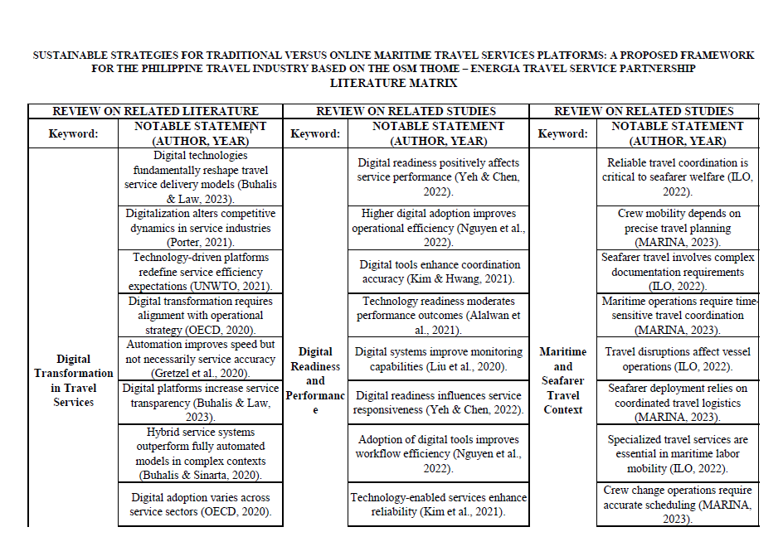
CHAVEZ, CELSO JR. LUCAS
CHAVEZ, CELSO JR. LUCAS
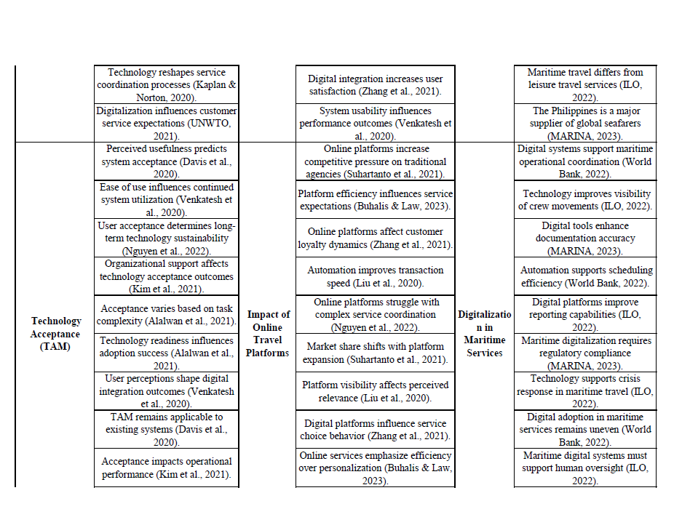
CHAVEZ, CELSO JR. LUCAS
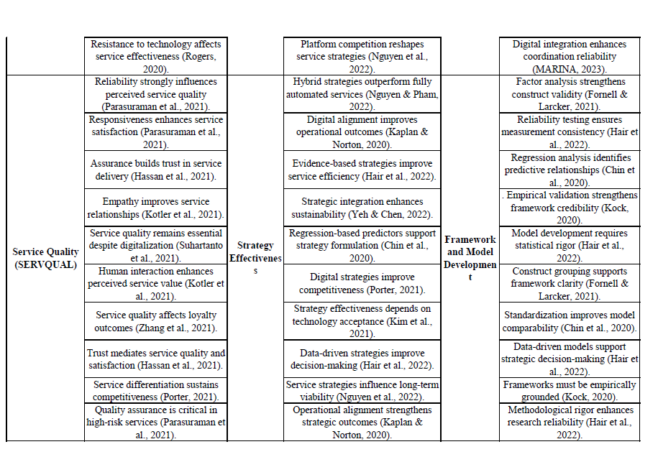
CHAVEZ, CELSO JR. LUCAS
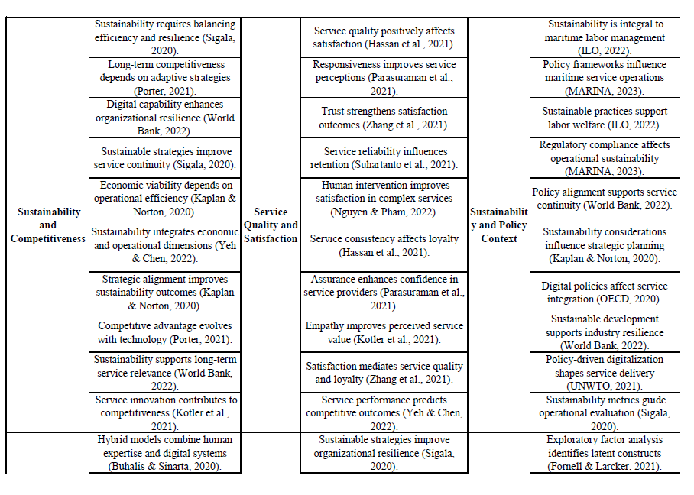
CHAVEZ, CELSO JR. LUCAS
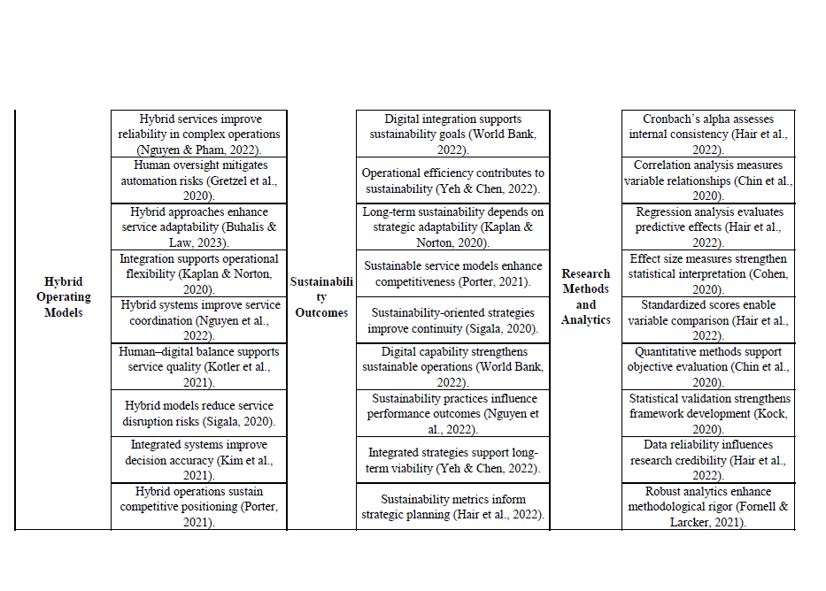
CHAVEZ, CELSO JR. LUCAS

SURVEY QUESTIONAIRE (QUANTITATIVE)

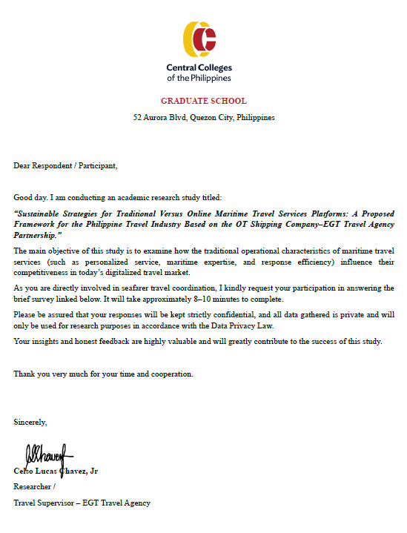
CHAVEZ, CELSO JR. LUCAS

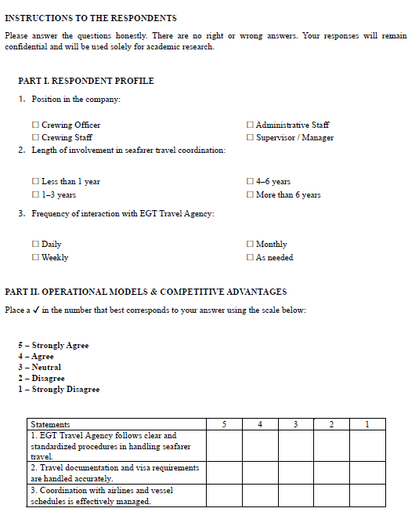

CHAVEZ, CELSO JR. LUCAS

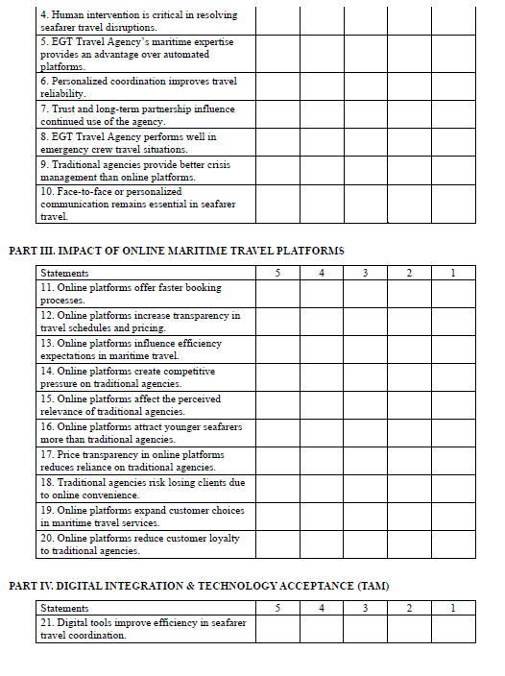

CHAVEZ, CELSO JR. LUCAS

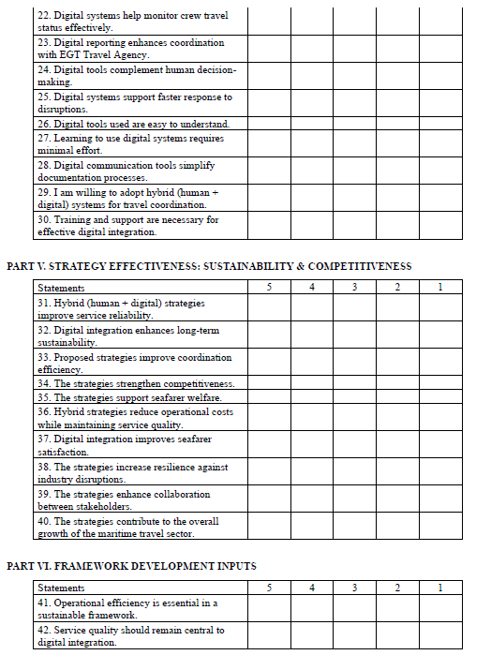

CHAVEZ, CELSO JR. LUCAS
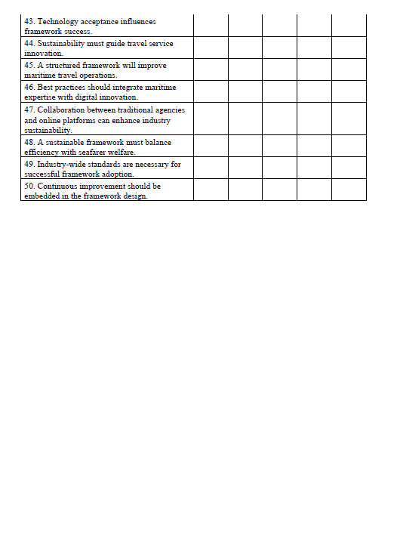

CHAVEZ, CELSO JR. LUCAS
INTERVIEW QUESTIONAIRE (QUALITITATIVE)

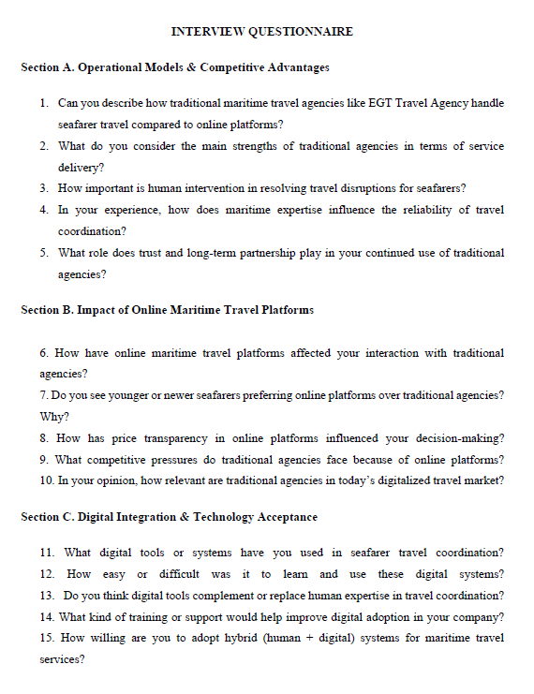

CHAVEZ, CELSO JR. LUCAS

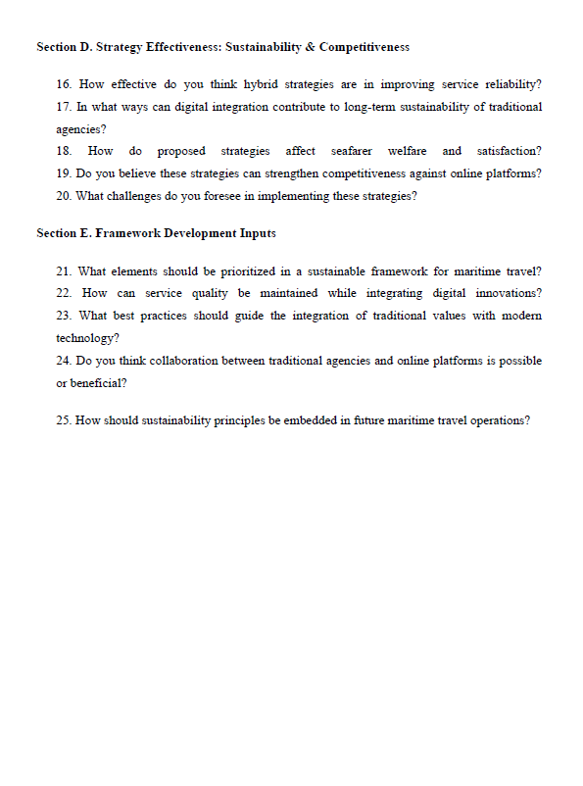

CHAVEZ, CELSO JR. LUCAS
STATISTICIAN CERTIFICATE

s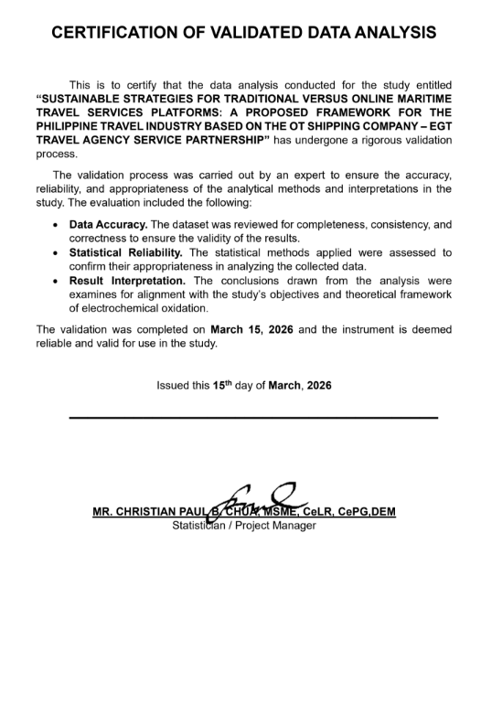
CHAVEZ, CELSO JR. LUCAS
INSTRUMENT VALIDATION CERTIFICATES

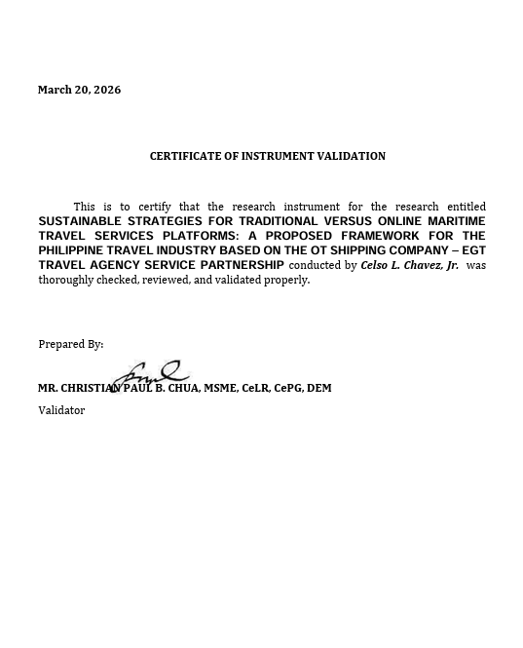

CHAVEZ, CELSO JR. LUCAS

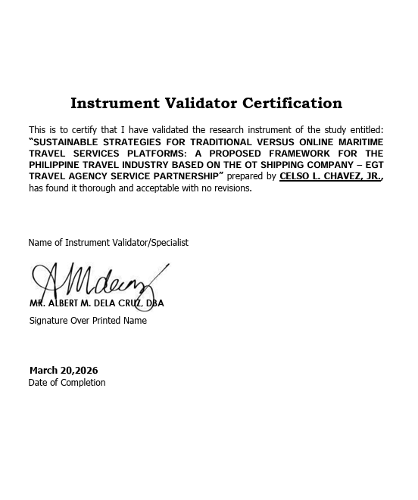

CHAVEZ, CELSO JR. LUCAS
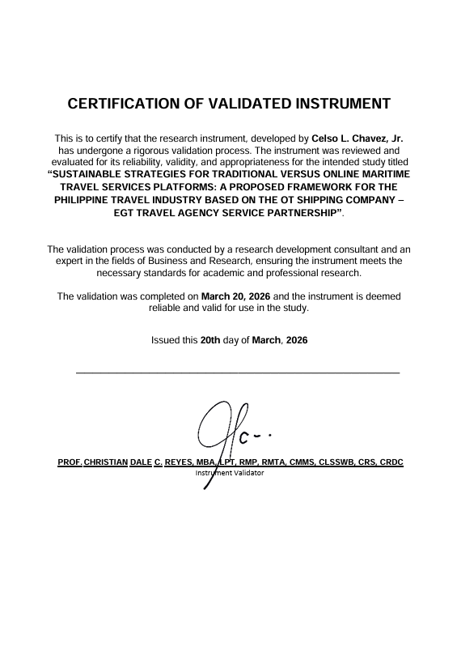
CHAVEZ, CELSO JR. LUCAS

TURN IT IN SIMILARITY RESULT

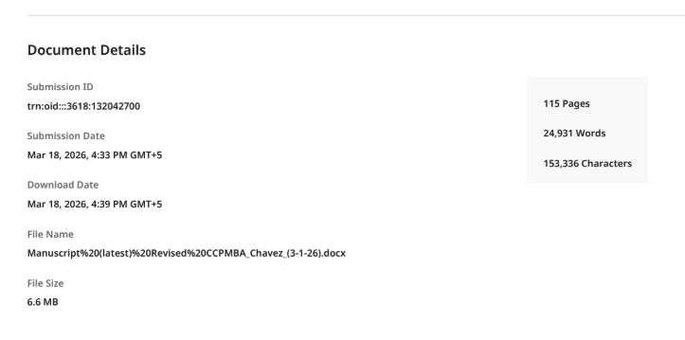

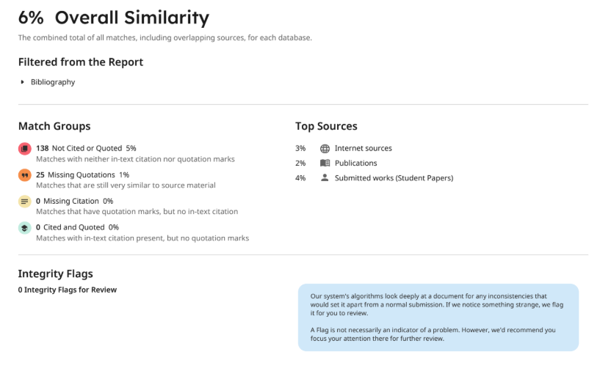

CHAVEZ, CELSO JR. LUCAS

QUILLBOT REPORT

Plagiarism Checker (Similarity Report)
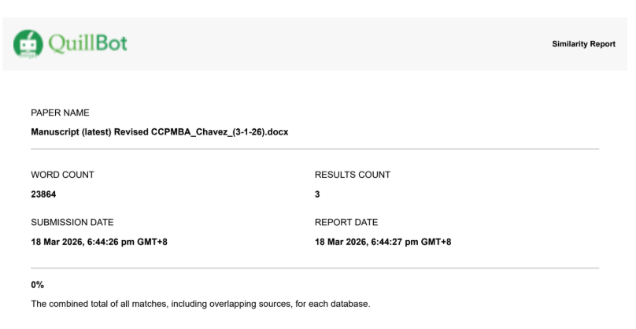

AI Detector Checker

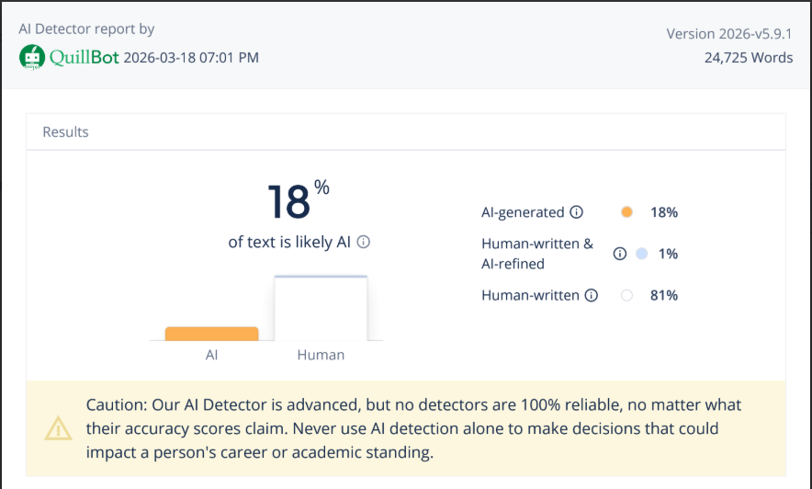sss
CHAVEZ, CELSO JR. LUCAS

