DEVELOPMENT AND VALIDATION OF STABILITY INDICATING RP-HPLC METHOD FOR THE ESTIMATION OF ANTIHYPERTENSIVE DRUG IN BULK AND PHARMACEUTICAL DOSAGE FORM
Miss Seema D. Sakhare, Dr. Madhuri A. Theng*, Dr. Ashutosh K. Dash.
Assistant Professor Quality Assurance Department Gawande College of Pharmacy, Lavala road, Sakharkerda, Dist Buldana MS Maharastra, India-443203
Assistant Professor Pharmacology Department Gawande College of Pharmacy, Lavala road, Sakharkerda, Dist Buldana MS Maharastra, India-443203thengmadhuri7@gmail.com
Principal of Gawande College of Pharmacy, Lavala road, Sakharkerda, Dist Buldana MS Maharastra, India-443203

Abstract: Analysis of any product is very important to assure the quality of product followed by safety and efficacy. Its play very important role in the medicinal field. To assure desire quality of the product analysis is very important. Few spectrometric method and chromatographic method have been reported for the determination of Nicardipine HCL in single dosage form.Following method have been developed for the determination of Nicardipine HCL. Analytical Method Development and Validation of Calcium Channel Blocker in Bulk and Pharmaceutical Dosage Form. A new RP-HPLC method was developed for the assay of Nicardipine HCL pharmaceutical dosage form. The separation was achieved by using C₁₈ Hypersil BDS (250x4.6 mm, 5µm) column by using MeoH:ACT:H2O as a mobile phase with the flow rate 1.0ml/min. Where detection was carried out by wavelength at 242nm. The retention time was found to be 15min.The system suitability test shows the response with Retention time, Theoretical plate, Tailing Factor and peak area. Validation of the proposed method was carried out according to ICH guideline. The method developed for quantitative determination of Nicardipine HCL is rapid, precise, accurate and selective. The method was completely validated showing satisfactory data for all method-validated parameters tested. The developed method is stability indicating and can be used for assessing the stability of Nicardipine HCL as bulk drugs. The developed method can be conveniently used for the assay determination of Nicardipine HCL in bulk drugs and pharmaceutical dosage form. The developed method can be conveniently used for dissolution of tablets of the pharmaceutical dosage forms containing Nicardipine HCL in quality control.
Keywords: RP HPLC, Nicardipine, precision, robustness, LOD, and LOQ.

Introduction The process of drug development starts with the innovation of a drug molecule that has showed therapeutic value to battle, control, check or cure diseases. The synthesis and characterization of such molecules which are also called active pharmaceutical ingredients (APIs) and their analysis to create preliminary safety and therapeutic efficacy data are prerequisites to identification of drug candidates for further detailed investigations. Pharmaceutical analysis play important role in the discovery, development, and manufacturing of pharmaceuticals. ‘‘Pharmaceutical analysis may be define as branch of practical chemistry which deals with the resolution, purification, identification and determination of a given sample of a medicine or a pharmaceutical as well as the detection and estimation of impurities that may be present in it’’.

CHROMATOGRAPHY ^{[7, 8]}
The word Chromatography is derived from two greek words “chroma” means colour and graphein means to write/study.Physical method in which separation of components takes place between two phases-a stationary phase and mobile phase‘‘Chromatography is define as a procedure by which solutes are separated by a dynamic differential migration process in a system consisting of two phases, one of which moves continuously in a given direction and which the individual substances exhibits mobilities by reasons of difference in adsorption, partition, solubility, vapor pressure , molecular size or ionic charge density.’’
The most common chromatographic methods are -
- Planar Chromatography : It includes Paper Chromatography, Thin Layer Chromatography (TLC) and High Performance Thin Layer Chromatography (HPTLC)
- Column Chromatography: It includes High Performance Liquid Chromatography (HPLC), Gas Chromatography (GC), etc
12 Nobel prizes were awarded alone for work in chromatography during 1937 to 1972
High Performance Liquid Chromatography (HPLC) ^{[9, 10]}
HPLC stands for “high performance liquid chromatography”(sometimes referred to as high pressure liquid chromatography).
High performance liquid chromatography is a powerful tool in analysis, it yields high performance and high speed compared to traditional columns chromatography because of the forcibly pumped mobile phase.HPLC is a chromatographic technique that can separate a mixture of compounds.It is used in biochemistry and analytical chemistry identify, quantify and purify the individual components of a mixture. High Performance Liquid Chromatography (HPLC) was developed in the late 1960s and early 1970s. Today it is widely applied for separation and purification in a variety of areas including pharmaceuticals, biotechnology, environmental, polymer and food industries.

DRUG PROFILE
Nicardipine Hydrochloride
Structure
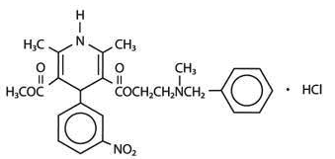
Fig 1. Structure of Nicardipine Hydrochloride
Chemical name : 3 - { 2 [ benzyl (methyl) amino ] ethyl } 5 - methyl 2,6 dimethyl - 4 - ( 3 nitrophenyl ) 1, 2 - dihydropyridine 3, 5 - dicarboxylate hydrochloride.
Molecular formula : C₂₆H₃₀CN₃o₆
Molecular weight : 516 g/mol
Melting point : 136 - 138⁰C/277-280⁰F
pKa value : 8.18
Description : Nicardipine Hydrochloride is the hydrochloride salt form of nicardipine, a synthetic derivative of nitrophenylpyride and potent calcium channel blocker, Nicardipine ( Nifedipine Family) blocks calcium ions from certain cell walls and inhibits contraction of coronary and peripheral arteries, resulting in lowered oxygen requirements for heart muscle and decreased arterial contraction and spasm. It is used clinically as a cerebral and coronary vasodilator.
Solubility : Methanol, Acetonitrile, Water
Category : Antihypertensive (Calcium channel blockers)
Metabolism : Nicardipine HCL is metabolized extensively by the liver.
Protein binding : 95% Route of elimination : Nicardipine has been shown to be rapidly and extensively metabolized by the liver.
Half-life : 8.6 hours
Drug interaction : Cimetidine, Cyclosporine, Tacrolimus avoid dosage of caffeine.
Dose : 20mg/8hrs, 30mg/8hrs.
Material and Chemical :
Drug/API – The drug used for present analysis was obtained from pharmaceutical or industrial gift sample
Drug : Nicardipine HCL
Supplied by : Peaks Analytical Research and Training Centre, Nagpur
Manufacture by : Zim Laboratory Pvt. Ltd. Nagpur
Brand name : Cardipin Retard 20mg
Solvents : All the solvents use for the proposed work will be of HPLC grade or as per the guidelines
Chemical used : Trifluoro acetic acid, Methanol, Water, Hydrogen peroxide, Hydrochloric acid, acetonitrile gradient, Sod. Hydroxide.
Instruments :
HPLC Table 1.
Sr. No. | Name of instrument | Model/ Specification
1 | HPLC | Model no. ACMe 9000
1 | Software | Autochro 3000
1 | Hardware | Younglin
2 | Column | Hypersil BDS C₁₈ 250mm x 4.6mm, 5µm
3 | pH meter | Digital pH meter
4 | Analytical Balance | PGB 100
5 | Sonicator | Wensar Ultra Sonicator
6 | Filter | Ultipor N₆₆ Nylon 6,6 Membrane .45µm
Chromatographic Conditions: The analysis of the drug was carried out on Hypersil BDS (9000) Gradient system UV ditector. Equipped with Reverse Phase Hypersil BDS (C₁₈ 250mm x 4.6mm, 5µm), a SP930D pump, a 20ml injection loop and UV730D Absorbance Detector and running Chemistation software.
Selection of Stationary phase: Table 2.
1 | HPLC | Model no. ACMe 9000
2 | Software | Autochro 3000
3 | Hardware | Younglin
4 | Particle size packing | 5µ
5 | Stationary phase | C18 BDS Hypersil
6 | Mobile phase | MeOH : H20 : ACN : TFA 650:50:300 2ml
7 | Detection wavelength | 242nm
8 | Flow rate | 1.0 ml/min
9 | Temperature | Ambient
10 | Sample conc. | 50ppm
11 | pH | 3.5
12 | Run time | 15 min
13 | Filter | Ultipor N₆₆ Nylon 6,6 Membrane 0.45µm
Analytical method development of HPLC:Table 3.
Sr. no | Mobile phase
1 | MeOH : H2O (90:10)
2 | ACN : Buffer (800 : 200)
3 | MeOH : H2O : Acetic acid (700:300:1ml)
4 | ACN : H2O TFA (550:450:1ml)
Method Development : Table 4.
Column | Hypersil BDS (C₁₈) 250mm x 4.6mm 5μm
Flow Rate | 1.0 mL/min
Wavelength | 242nm
Injection Volume | 20.0 µL
Column Temperature | Ambient
Run Time | 15 min
Mobile Phase | MeOH:ACT:H₂O:TFA (650:50:300:0.2)
Ph | 3.5(Acidic)
Preparation of stock standard solution: Stock solution(50ppm)50mg of nicardipine HCL standard was weight accurately and transfer into a 100ml capacity of volumetric flask , then add dilute 100ml of methanol : water : ACN mix properly and sonicate it till dissolve and make volume up to the mark with the same solvent to get 500µg/ml standard stock solution . after 15 min sonicate to dissolve it and the form the resulting solution . 10ml solution was transfer in volumetric flask, add into 100ml diluent . result as shown in (fig.no : 09)(tab.no : 09)
Preparation of sample solution:Weight 13 tablet accurately and crushed it into fine powder of Nicardipine tablet sample, equivalent to 250mg, transfer it into 100ml volumetric flask , then dilute it in to 100ml diluents.( Methanol : ACN : water ) 10ml of solution dilute into 100ml diluents (methanol : ACN : Water) and sonicate for 15min up to mix well completely. The sample was cooled to temperature and volume was made up to mark with diluent. Solution filtered through filter paper.(Nylon , membrane 0.45µm)
Validation of method for Analysis of Nicardipine HCL:The develop method was validate as per ICH guidelines. Analytical method validation was carried out as per ICH method validation guidelines .
Specificity: SPECIFICITY is the ability to assess unequivocally the analyte in presence of components which may be expected to be present.An investigation of specificity should be conducted during the validation of identification tests, the determination of impurities and the assay. The procedures used to demonstrate specificity will depend on the intended objective of the analytical procedure.
Identification:To compare the detention time obtain for nicardipine for standard on test preparation peaks
Standard preparation: Preparation of nicardipine standard stock solution .Weight accurately about 50.1mg of nicardipine transfer to 100ml volumetric flask add 100ml of diluents. Take 10ml solution diluents into 100ml, and sonicated to dissolve make up the volume mark with diluents and mixed.(fig 09, tab 09)
Preparation of test solution:Weight 13 tablet accurately and crushed it into fine powder of Nicardipine tablet sample, equivalent to 250.1mg, transfer it into 100ml volumetric flask , then dilute it in to 100ml diluents.(Methanol : CAN : water ) 10ml of solution dilute into 100ml diluents (methanol : ACN : Water) and sonicate for 15min up to mix well completely. The sample was cooled to temperature and volume was made up to mark with diluent. Solution filtered through filter paper.(Nylon , membrane 0.45µm) (fig 10, tab 10)
Observation:To compare the retention time obtain for nicardipine HCL standard solution 4.35 and test solution 4.37 of main peak (fig 09-10) (tab 09-10)
Precision:Precision of an analytical method is the degree of agreement among individual test result when the procedure is applied repeatedly to multiple sampling of homogenous sample. Precision of an analytical method is usually expressed as standard deviation or relative standard deviation. Also, the result obtain ware subjected to one way ANOVA and within day mean square and between day mean square was determined and compared using F-test.(fig: no 11-25)
Preliminary studies on Nicardipine HCL
Melting point : The procured reference standard of Nicardipine HCL were found to melt in the 136º-138ºC
Solubility : Freely soluble in Methanol and Acetonitrile practically soluble in water.
UV Spectroscopy :
7.2 Determination of λ_{max} and selection of Analytical Wavelength:The standard solution of Nicardipine is scanned over the range of 200- 400 nm wavelengths. The wavelength of absorption was found to be 242 nm. So the wavelength selected for the determination of Nicardipine is 242nm.

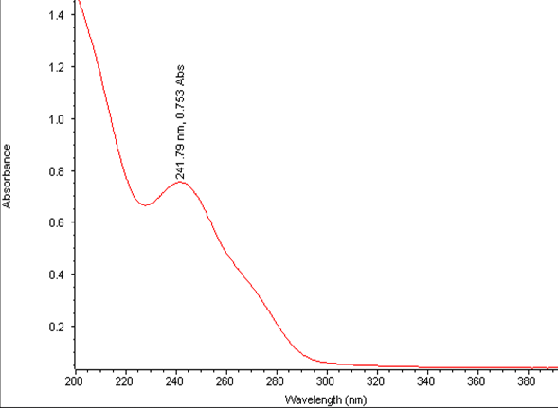
Fig 02 : UV Spectrum of Nicardipine HCL
Chromatogram of Trial -I
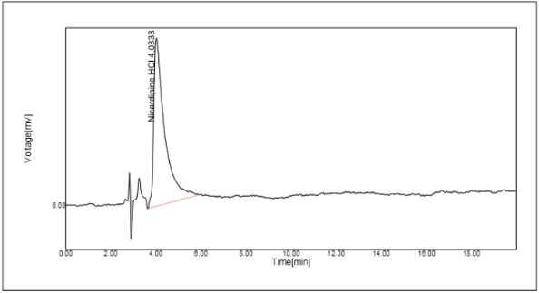
Fig 03: Chromatogram of method development-Trial I
No | Name | RT [min] | Area[mV*s | TF | TP
1 | NicardipineHCL | 4.03 | 548.8273 | 2.55 | 456
2 |  |  | 548.8273
Table 05: Chromatogram of method development-Trial I
Observation: In first Trial MET: H2O (90:10%, v/v) were taken in which Nicardipine HCL was good obtained but peak is not eluted properly. Hence this method was not suitable.
Chromatogram of Trial VI :
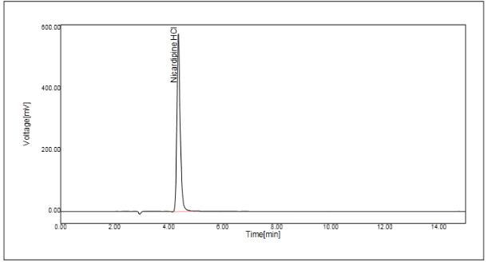
Fig 04 : Chromatogram of method development-Trial VI
No | Name | RT [min] | Area[mV*s | Area | TF | TP
1 | Nicardipine HCL | 4.37 | 5050.8198 | 100.00 | 1.20 | 7260
Sum |  |  | 5050.8198
Table 06 : Chromatogram of method development-Trial VI
Result for Chromatogram of method development Standard Nicardipine HCL
Validation of RP-HPLC Method for Estimation of Nicardipine HCL
Standard:Chromatogram
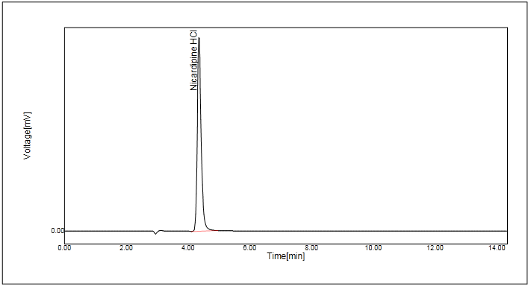 Fig 05 : Chromatogram of Nicardipine standard
Table 09 : Chromatogram of Nicardipine standard
Linearity
Con. (ppm) | Area
25.10 | 2702.0388
50.20 | 5516.3657
75.30 | 8010.1289
Correlation Coefficient | 0.9994
Table : 10.Result of Linearity of Nicardipine
Calibration Curve of Nicardipine

Fig no : 06 Calibration Curve of linearity of Nicardipine
Regression Equation Data Y= mx + c
Slope(m) | 105.74
Intercept | 101.42
Correlation Coefficient | 0.9994
Accuracy : Recovery studies were performed to validate the accuracy of developed method. To pre analyzed Capsule solution, a definite concentration of standard drug (80%, 100%, and 120%) was added and then its recovery was analyzed (Tab. No 36-37). Statistical validation of recovery studies.
Accuracy 80%
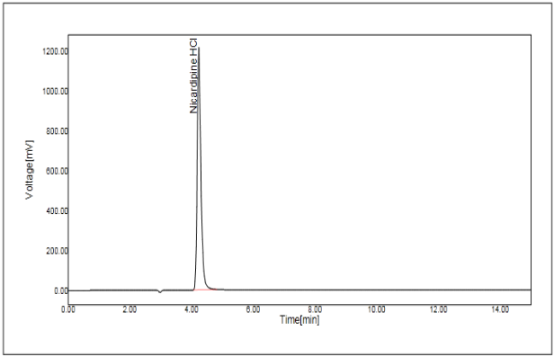
Fig 07 : Chromatogram of Accuracy 80%
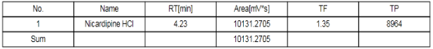
Table 11 : Chromatogram of Accuracy 80%
Table 12. Accuracy for Nicardipine HCL
% conc. | Wt. of test | Area | Amount added in mg. | Amount found | Amount recovered | % Recovery
Acc.80% | 250.2 | 101321.2705 | 16.0640 | 35.7946 | 15.9314 | 99.17
Acc.80% | 250.9 | 10110.8547 | 16.0640 | 35.6228 | 15.7596 | 98.11
Acc.80% | 251.2 | 10155.6425 | 16.0640 | 35.7379 | 15.8747 | 98.82
Acc.100% | 248.6 | 11146.3252 | 20.0800 | 39.6344 | 19.7712 | 98.46
Acc.100% | 249.0 | 11158.4571 | 20.0800 | 39.6138 | 19.7506 | 98.36
Acc.100% | 247.8 | 11125.5375 | 20.0800 | 39.6882 | 19.8250 | 98.73
Acc.120% | 248.5 | 12313.3896 | 24.0960 | 43.80185 | 23.9387 | 99.35
Acc.120% | 248.9 | 12412.14160 | 24.0960 | 44.08218 | 24.2190 | 100.51
Acc.120% | 249.1 | 12389.56420 | 24.0960 | 43.96666 | 24.1035 | 100.03

Std. Nicardipine | Area | RT (Min) | TF | Tp
Std_1 | 5685.2125 | 4.15 | 1.26 | 7583
 | 5672.8146 | 4.15 | 1.28 | 7825
 | 5678.6054 | 4.16 | 1.30 | 7629
Average | 5678.8775
SD | 6.203427271
%RSD | 0.11

Acceptance criteria :Mean recovery should be in the range of 98.0% to 102.0%. The RSD should not be more than 2.0%
Table 13.Calculations of LOD &LOQ
Con.(ppm) | Area
50.40 | 5516.3657
25.20 | 2685.1252
10.08 | 1187.3726
5.04 | 629.0388
0.50 | 67.2046
0.10 | 17.2464

Correlation | 0.9997
STEYX | 59.39078
SLOPE | 108.29058
LOD (ppm) | 1.81
LOQ (ppm) | 5.48

LOD = 3.3 X STEYX / SLOPE
LOQ = 10 X STEYX / SLOPE
Where, STEYX = Standard Derivation of Y Intercept, SLOPE = Calibration Curve

Fig no : 08 Calibration curve of LOD & LOQ
Table 14. Robustness Study of Nicardipine HCL : Flow rate change 0.95 ml
Name | Area | RT
Nicardipine_std_1 | 5055.9951 | 4.43
Nicardipine _std_2 | 5085.2781 | 4.43
 | 5091.8173 | 4.42
Mean | 5077.696833 | 4.43
SD | 19.07653549 | 0.0058
%RSD | 0.38 | 0.13
Name | Area | RT | Nicardipine observed in mg | Nicardipine claim in mg | % Assay
Test_1 | 5183.2173 | 4.47 | 20.12 | 20.00 | 100.62
Test_2 | 5159.1287 | 4.43 | 20.05 | 20.00 | 100.27

Table 15. Precision
Intraday Precision | % Assay
Initial Preparation_1 | 99.51
Initial Prepatation_2 | 98.80
Intraday preparation_1 | 100.62
Intraday Preparation_2 | 100.27
Mean | 99.8
SD | 0.81
%RSD | 0.81

Thermal Degradation
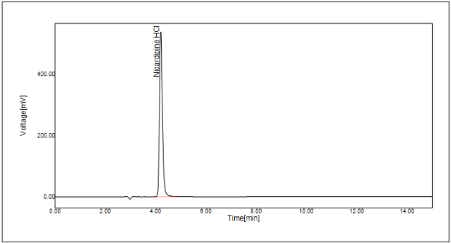
Fig no.09.Thermal Degradation
Table 16. forced degradation
 | Area
Nicardipine STD | 5052.3560
 | Area(MV*S) | Area % | %Degradation | % Assay
Acid degradation | 3811.9961 | 4585.8984 | 24.55 | 75.45
Base degradation | 3818.7747 | 4633.7656 | 24.42 | 75.58
Peroxide degradation | 3958.7616 | 4079.1128 | 21.65 | 78.35
Photo degradation | 4459.6465 | 4661.7437 | 11.73 | 88.27
Thermal degradation | 4323.3970 | 4323.3970 | 14.43 | 85.57
SUMMARY :
Analysis of any product is very important to assure the quality of product followed by safety and efficacy. Its play very important role in the medicinal field. To assure desire quality of the product analysis is very important. Few spectrometric method and chromatographic method have been reported for the determination of Nicardipine HCL in single dosage form.
Following method have been developed for the determination of Nicardipine HCL. Analytical Method Development and Validation of Calcium Channel Blocker in Bulk and Pharmaceutical Dosage Form.
A new RP-HPLC method was developed for the assay of Nicardipine HCL pharmaceutical dosage form. The separation was achieved by using C₁₈ Hypersil BDS (250x4.6 mm, 5µm) column by using MeoH:ACT:H2O as a mobile phase with the flow rate 1.0ml/min. Where detection was carried out by wavelength at 242nm. The retention time was found to be 15min.
The system suitability test shows the response with Retention time, Theoretical plate, Tailing Factor and peak area. Validation of the proposed method was carried out according to ICH guideline.
Specificity: Rt 4.35, 4.37
The Development Method was validated by various parameters like Accuracy, Precision, Linearity, Reputability, Robustness and LOD & LOQ.
Precision: System suitability parameter is obtaining within the limit for nicardipine HCL that is %RSD not more than 2.0, Tailing factor not more than 2.0, Theoretical plate not less than 2000, Retention time not more than 2.0.
%RSD 0.63, Rt 1.00, %assay 99.51, 98.80.
Intraday precision - %assay98.05, 98.14 , %RSD-0.69
Interday precision- %assay98.33, 98.77, %RSD-0.49
Linearity : Correlation coefficient range should not be less than 0.999. The method was found to be Linear for Nicardipine HCl. The correlation coefficient of the plot found to be 0.9994.
Accuracy: Mean recovery should be in the range of 98.0% to 102.0%. The RSD should not be more than 2.0%.
Accuracy 80% 99.17, 98.11, Accuracy 100% 98.46, 98.36, Accuracy 120% 100.51, 100.03, %RSD 0.11
LOD & LOQ: The LOD of Nicardipine was found to be 1.81ppm analytical method that concluded and LOQ of nicardipine was found to be 5.48ppm analytical method that concluded.
Robustness: Robustness study of Nicardipine was carried out. In which various parameters like change in Flow rate, change in Wavelength, change in Mobile phase composition was carried out. The method was applied on Nicardipine HCL marketed formulation. The mean amount was found to be . The value of %RSD is not more than 2%.
Flow rate change 0.95ml 0.81%RSD
Flow rate change 1.05ml 0.36%RSD
Wavelength change 240nm 0.70%RSD
Wavelength change 244nm 0.43%RSD
8.2 CONCLUSION :
The method developed for quantitative determination of Nicardipine HCL is rapid, precise, accurate and selective. The method was completely validated showing satisfactory data for all method-validated parameters tested. The developed method is stability indicating and can be used for assessing the stability of Nicardipine HCL as bulk drugs. The developed method can be conveniently used for the assay determination of Nicardipine HCL in bulk drugs and pharmaceutical dosage form. The developed method can be conveniently used for dissolution of tablets of the pharmaceutical dosage forms containing Nicardipine HCL in quality control laboratory.
Data availability statement: All data analyzed during this study are included in this research paper.
Funding: For the submission this study, does not include any research funding.
Competing Interests: The authors declare no conflict of interest with this research.
Ethical approval: Since no animals were used in this study, Ethical approval was not needed.

Acknowledgement: Authors highly acknowledge Prof. Dr. Dash sir Principal of Gawande College of Pharmacy, Sakharkerda for giving support and permission to do work also Prof Anil Vispute, Peaks Analytical Research and Training Centre, Nagpur for giving their valuable time and support for the research work.

References:
- P.C. Kamboj., ‘Pharmaceutical Analysis’. Vallabh Prakashan., (2010) ; Vol.I :1-2.
- Kasture A. V., Wadodakar S. G., “Pharmaceutical Analysis Instrumental method”.1st edition, Nirali Prakashan (2011); Vol-II: 1.1- 4.11
- Kasture A. V., Wadodakar S. G., “Pharmaceutical Analysis Instrumental method”.1st edition, Nirali Prakashan (2011); Vol-II: 2.1- 2.6
- P. D. Sethi. “Quantitative Analysis Of Pharmaceutical Formulation”. CBS Publication And Distributors (2001); (3): 5-11
- Devi Reddy., ”Instrumental method of Analysis”.1st edition, CBS Publisher (2013);1-15
- Skoog D. A., West D. M., “ Fundamentals of Analytical Chemistry”. Chemical education. (1963);40, 11, 614
- Bansal V., Sharma P. K.,”High Performance Liquid Chromatography ”. Journal of Global Pharma Technology.(2010); 2(5): 22-26
- D. A. Skoog., F. J. Holler., “Instrumental Analysis”. Indian Edition, Page No : 14
- Kasture A. V., Wadodakar S. G., “Pharmaceutical Analysis Instrumental method”.1st edition, Nirali Prakashan (2011); Vol-II: 7.1- 7.10
- Chatval G. R., Anand, Sham K., “Instrumental Methods Of Chemical Analysis”.5th edition, Himalaya Publication House (2005); Vol.II : 2.624-2.639.
- Department of Chemistry, Saurashtra University, Rajkot.1-45
- Shimadzu UV-1700. Instruction Manual Operation Guide. Analytical Instrument Division, Kyoto, Japan (2001), Page No : 1-8.
- G.R.Chatwal, S.K.Anand. ‘Chromatography In Instrumental Methods Of Chemical Analysis. Himalaya Publishing House (2005), (5) Page No : 2.566.
- P.Nagaraju, G.Rao. ‘Role of HPLC In Pharmaceutical Analysis’. Indian Pharmacist (2003), Page No : 25-27.
- Swarbrick James, Boylan James C. ‘Encyclopedia Of Pharmaceutical Technology’. Marcel Dekker Inc., New York (1998), (1) Page No : 217 - 224
- Lindsay Sandy. “HPLC By Open Learning”. John Wiley And Sons, London (1991); 30-45.
- P. D. Sethi., “High Performance Liquid Chromatography Quantitative Analysis of Pharmaceutical Formulation”. 1st Edition, CBC Publication and Distributors. (2001); 5: 8-10
- Meyer Veronica. R., “Practical High Performance Liquid Chromatography”. John Wiley And Sons, London, 2nd edition, (1993); 26-258.
- Szepei Gabor., “HPLC In Pharmaceutical Analysis”. (1990); (1) : 101-173.
- Https://en.wikipedia.org/wiki/Validation(drug manufacture)#The validation process.
- M. A. Potdar., “Pharmaceutical Quality Assurance”. Nirali Prakashan, Page No : 8.1.
- I. R. Berry & Robert A. Nash., “Pharmaceutical Process Validation”. 3rd edition, Marcel Dekkar Publication. (2002); 1-883.
- R. Raghunandhan., “Validation of Pharmaceutical Process”. Pharma Times (1999); 31 (11): 61-62
- Ubale B. Milind, Vilas Chaudhari, A validated Stability-indicating HPLC method for Nicardipine hydrochloride in bulk drug and dosage form. Elixir Application chem.⁽⁴¹⁾ (2011); 5867-5870
- Sheikha M. Al-Ghannam, stability indicating HPLC method for the determination of Nicardipine in capsules and Spiked human plasma. Identification of degradation products using HPLC. Arabian journal of Chemistry, (2014); 1-11
- Aashis A. Gawai, RP-HPLC method development and validation for determination of an Antihypertensive agent. International journal of chem. tech. Research, (2018);11(2): 228-239
- K. E. Ibrahim, A selective high performance liquid chromatographic method to follow the hydrolytic degradation of Nicardipine Hydrochloride. E-journal of chemistry (2010); 7(1) :85-92
- Yaswant Kumar D., stability Indicating RP-HPLC method for the 12quantitation of Nicardipine HCL in capsules. journal of pharmacy Research (2012); 5(5):2473-2476
- Tiwari R. N., Development and validation of HPLC method for Nicardipine hydrochloride. journal of pharmacy research (2011); 4(7): 2226-2227

