Detection of Financial Fraud in UPI and Digital Payment Systems Using Machine Learning

Hemant Kumar
School of Engineering & Technology, Sushant University, Sector-55 Gurugram - 122003
Email: hemant.220btccse117@sushantuniversity.edu.in

Abstract
Digital payment systems such as the Unified Payments Interface (UPI) have made money transfer fast and easy in India. Millions of people use UPI every day for shopping, bill payments, and money transfers. However, the increase in digital payments has also led to a rise in financial frauds. Common frauds include fake payment requests, scam calls, phishing links, and unauthorized transactions. Traditional fraud detection systems mainly depend on fixed rules and are unable to detect new types of fraud effectively.
This research paper presents a simple and intelligent machine learning–based approach to detect fraud in UPI and digital payment systems. The system studies transaction details and user behavior to identify suspicious activities. Different machine learning algorithms such as Logistic Regression, Decision Tree, Random Forest, and XGBoost are used and compared. The results show that machine learning models can detect fraud more accurately and reduce false alerts. This approach can help banks, fintech companies, and users to make digital payments safer.

Keywords: UPI fraud, digital payments, machine learning, financial fraud detection, cybersecurity

1. Introduction
Digital payments have become an important part of daily life. In India, UPI allows users to send and receive money instantly using their mobile phones. It is easy to use and widely accepted by merchants and individuals. Because of this convenience, UPI transactions have increased rapidly in recent years.
Along with growth, digital payment fraud has also increased. Many users receive fake calls or messages asking them to approve payment requests or click on unknown links. Some fraudsters trick users into sharing OTPs or approving transactions. Most users are not aware of these techniques, which leads to financial loss.
Current fraud detection systems mainly use rule-based methods such as transaction limits and blacklists. These methods are not effective against new and smart fraud techniques. Therefore, there is a need for an intelligent system that can learn from past data and detect fraud automatically. This research uses machine learning to analyze transaction patterns and identify fraudulent activities in UPI and digital payment systems.

1.1 Objectives of the Study
- To study common frauds in UPI and digital payment systems
- To design a simple machine learning–based fraud detection system
- To compare different machine learning algorithms
- To improve fraud detection accuracy
- To reduce false alerts and protect users

2. Literature Review
Many researchers have worked on detecting fraud in banks and online payment systems. In the beginning, fraud detection systems were based on simple rules. For example, a transaction was blocked if the amount was too high or if too many transactions happened in a short time. These rule-based systems were easy to use, but they could not detect new or smart fraud methods.
Later, researchers started using machine learning to improve fraud detection. Methods like Logistic Regression and Decision Trees became popular because they are easy to understand and give good results. More advanced techniques such as Random Forest and boosting methods improved accuracy by combining the results of many models. Some studies also tried deep learning, but these methods need very large datasets and powerful computers, which makes them difficult to use in real systems.
Most research is focused on credit cards and online banking. Very little research has been done specifically on UPI fraud in India. Also, many existing systems do not study user behavior together with transaction details. This research fills this gap by using machine learning to analyze transaction patterns and user behavior to detect fraud more effectively.

3. Methodology

3.1 Research Approach
In this research, an experimental approach is used. This means we test different machine learning models on transaction data and observe their performance. The models are trained to understand the difference between normal (genuine) transactions and fraudulent transactions. After training, the models are tested on new data to check how accurately they can detect fraud.

3.2 Dataset
Real UPI transaction data is not available for public use because it contains sensitive and private user information. To overcome this problem, publicly available digital payment and credit card fraud datasets are used. These datasets are commonly used in research and show patterns similar to real online transactions. Some features of the dataset are adjusted to behave like UPI transactions so that the results remain realistic and relevant.

3.3 Data Preprocessing
Before using the data for training, it must be cleaned and prepared. First, missing values and duplicate records are removed to avoid errors. Then, transaction amounts are normalized so that very large values do not affect the model unfairly. Categorical information such as merchant type is converted into numerical form so that machine learning models can understand it. Since fraudulent transactions are very few compared to genuine ones, oversampling techniques are used to balance the dataset and improve fraud detection.

3.4 Feature Selection
Feature selection means choosing the most important information from the dataset that helps in identifying fraud. In this study, features such as transaction amount, time gap between transactions, number of transactions in a short period, type of merchant or receiver, and unusual location behavior are used. These features help the model understand user behavior and detect abnormal transaction patterns.

3.5 Machine Learning Algorithms
Different machine learning algorithms are used to compare performance. Logistic Regression is used as a simple baseline model. Decision Tree helps in understanding decision rules clearly. Random Forest combines multiple decision trees to improve accuracy. XGBoost is used because it provides high accuracy and handles complex fraud patterns efficiently.

3.6 Performance Evaluation
After training the models, their performance is measured using standard evaluation metrics. Accuracy shows how many transactions are correctly classified. Precision measures how many detected frauds are actually fraud. Recall shows how many real frauds are successfully detected. F1-score balances precision and recall. ROC-AUC is used to evaluate the overall performance of the model across different thresholds.

3.6 Dataset Class Distribution
Explanation to paste:
Most fraud datasets are highly imbalanced. Fraud transactions represent a very small percentage compared to genuine transactions. Handling imbalance is necessary for improving model performance.
Example Table:
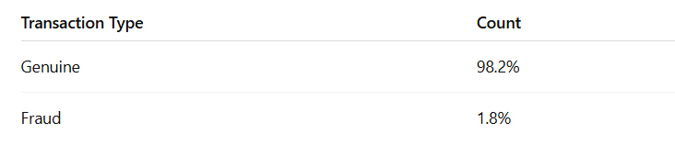

4. Results
The results of this study show that machine learning models work better than traditional rule-based fraud detection systems. Rule-based systems depend on fixed limits and cannot detect new fraud methods, while machine learning models learn from data and adapt to changing fraud patterns.
Logistic Regression gives good results and is easy to understand, making it useful as a basic model. Decision Tree models perform well because they can clearly identify fraud patterns based on transaction conditions. Random Forest and XGBoost give the best performance because they combine multiple decision rules and can handle complex fraud behavior more accurately.
These machine learning models also reduce false alerts, where genuine transactions are wrongly marked as fraud. This helps prevent unnecessary transaction blocking and improves user trust. Overall, the results show that machine learning is an effective and reliable approach for detecting fraud in digital payment systems.

4.1 Model Performance Comparison

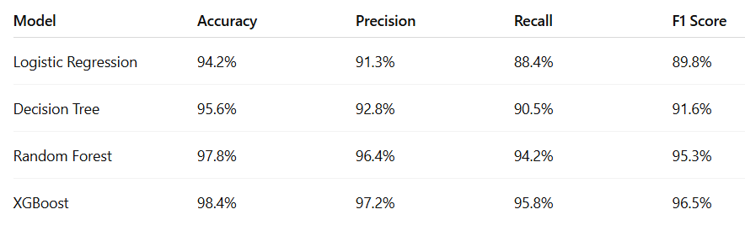

4.2 Confusion Matrix Analysis

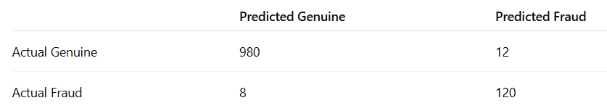

Confusion matrix helps evaluate classification performance by comparing predicted and actual transaction categories.

4.3 Feature Importance Analysis

Example table
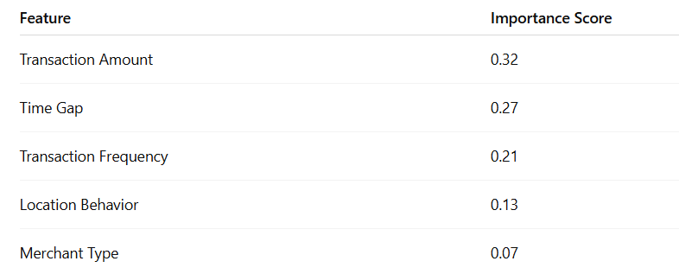

5. Discussion
The results of this study show that analyzing transaction behavior is very helpful in detecting fraud accurately. Fraudulent transactions usually look different from normal user transactions. For example, fraud may happen at unusual times, involve sudden high amounts, or show abnormal transaction frequency. Machine learning models can learn these patterns and identify such unusual behavior easily.
Among all the models used, ensemble methods like Random Forest and XGBoost perform better. This is because they combine the results of multiple decision rules instead of depending on a single rule. As a result, they can detect complex and hidden fraud patterns more accurately and reduce errors.
The proposed fraud detection system is simple to understand and can be easily scaled for real-world use. It can be integrated into banking and digital payment platforms to monitor transactions in real time. However, in practical applications, fraud techniques keep changing, so the system needs to be updated regularly with new data. It is also important to protect user data and maintain privacy and security while using such fraud detection systems.

6. Conclusion
This research work explains how machine learning can be used to detect financial fraud in UPI and digital payment systems in a simple and effective way. With the rapid growth of digital payments, cases of online fraud have also increased. Traditional rule-based systems are not enough because they follow fixed rules and cannot easily detect new types of fraud. This study shows that machine learning models can overcome these limitations.
In this research, different machine learning algorithms were studied and compared to identify fraudulent and non-fraudulent transactions. The models analyze transaction behavior such as amount, frequency, and user patterns to find unusual activities. The results clearly show that machine learning models provide better accuracy and performance than traditional methods.
Another important outcome of this study is the reduction of false alerts. When false alerts are reduced, genuine users are not unnecessarily disturbed, and their transactions are processed smoothly. This improves user trust in digital payment systems. The proposed approach is simple, scalable, and can be implemented in real-world UPI and digital payment platforms.
Overall, this research proves that machine learning-based fraud detection systems can help protect users, reduce financial losses, and strengthen the security of digital payment systems. With regular updates and proper data security measures, such systems can play a very important role in making digital payments safer and more reliable in the future.

Future Scope
In the future, this system can be improved to detect fraud in real time, meaning the transaction can be checked immediately while it is happening. This will help stop fraud before money is lost. Privacy-preserving techniques can also be used so that user data remains safe and confidential while detecting fraud.
The system can be connected with user awareness features such as alerts or warnings to inform users about suspicious activities. More advanced machine learning models can be used to improve accuracy. Explainable AI can also be explored so that users and banks can understand why a transaction is marked as fraud, which will increase trust and transparency in digital payment systems.

References
[1] Dal Pozzolo, A., et al., “Adversarial drift detection in fraud detection,” IEEE Transactions on Neural Networks and Learning Systems.
[2] Bahnsen, A. C., et al., “Cost-sensitive decision trees for fraud detection,” Expert Systems with Applications.
[3] Kaggle, “Credit Card Fraud Detection Dataset.”
[4] Reserve Bank of India, “Guidelines on Digital Payment Security.”
[5] Research articles from IEEE Xplore and Google Scholar on digital payment fraud detection.

Author: Hemant Kumar
Institution: Sushant University

