InspiroScope: Al-Driven Career Path Optimization using Machine Learning Algorithms and Data

Analytics for Personalized Professional Development

ABSTRACT: Career planning plays a critical role in a person's ultimate success within their profession. Traditional career counselling approaches are usually generalised and therefore may not adequately address the individual's needs - making it difficult to come up with proper career decisions. This can lead to confusion, inefficient skill development, and limited job opportunities.
This paper presents INSPIROSCOPE, a machine learning (ML) and data analytics-based approach to delivering personalized career recommendations through an Artificial Intelligence (AI) framework. INSPIROSCOPE analyses an individual's profile, which includes their skills/experience, level of education, interests, and additional factors such as trends within specific industries, and supply and demand within the labour force. This analysis is performed using predictor models as well as looking for trends across a number of variables.
With INSPIROSCOPE, individuals are able to make an informed career choice based on data, thereby improving their chances of aligning their skills to what specific industries require. Additionally, INSPIROSCOPE provides individuals with a greater likelihood of successfully pursuing their personal and professional development through on-going education and ultimately enhancing their career development through intelligent and customised suggestions.
Keywords: Career prediction, Machine learning, AI-based recommendation systems, Skills assessment, Career planning

I INTRODUCTION

The process of career planning is key to developing someone's profession, being satisfied with their job and ultimately achieving success in the long term. The job market today is constantly changing due to advances in technology, automating jobs and new requirements of employers. Therefore, people are continuously developing new skills, and changing jobs. However, traditional career advice methods tend to provide general advice, short assessments or standardized counselling, which may not
always provide a true representation of a person's skills/interests/career ambitions. These resources do not provide personalised assistance, nor do they take into account real time developments in industries thus creating a gap between a person's skill set and what is required by the industry. Therefore many individuals experience confusion when trying to determine professional career paths or developing the proper skill set and finding employment.

With the increase in the amount of large-scale data becoming available and advancements in artificial intelligence, data-driven career guidance has emerged as a viable solution for providing personalised assistance to individuals. Data-intensive analysis of multiple aspects of an individual, including educational history, skill set and interest areas can now be performed through the use of machine learning technology.

The proposed AI-based career recommendation system (referred to as "INSPIROSCOPE") will use a combination of machine learning and data analytics in order to develop and recommend optimal career paths based on a user’s profile. Using machine learning and data analytics will analyse individual profile data as well as industry specific profiles (e.g. job descriptions and job specifications) and provide users with recommendations regarding their career path. The INSPIROSCOPE will also use predictive analytics to predict possible career outcomes and recommend the best steps to obtaining these outcomes.
Key Contribution:
- Through these three components of the INSPIROSCOPE system, users will have an enhanced ability to view their individual career potential, as it relates to the current market equity available to them for each skill they possess, thereby allowing users to make career decisions that are informed by data.

- The INSPIROSCOPE system will provide users with a means to gain value through their career planning process by providing actionable data, enhancing user employment capacity and supporting continual learning throughout their careers, in a rapidly changing economy.

II RELATED WORK

The emergence of machine learning and data-backed technologies has enhanced the career guidance system to operate through an advanced, improved method. In the past, traditional methods relied on rule-based systems and manual consultations that were not customizable to meet the dynamic changes in the job market. Such traditional methods of career guidance have always provided inaccurate information, as they did not fully take into account individual differences in their skills, interests, or career goals to provide the best career fit recommendations.
In order to improve on personalization, early research evaluated recommendation methods that fall under the categories of collaborative filtering and content-based filtering. Collaborative filtering is defined by Herlocker et al. [1] as using a user's preferences and previous actions rather than an employer's job description towards making recommendations. While these methods work well in specific contexts, they also have limitations such as, "cold-start" and lack of sufficient contextual information. Whereas, content-based filtering has used the user's own characteristics and pre-defined functions to generate recommendations; however, it has limitations in providing better connections between skills and outcomes.
Quinlan [3] suggested that Decision Tree-based approaches give interpretable representations of decision-making but run the risk of being over fitted. Random Forest [4] and Gradient Boosting [5] are ensemble learning algorithms that improve prediction accuracy by combining several models together, while also reducing variance. XGBoost [6] has been demonstrated to produce positive results in dealing with structured data and is often used for predictive analytics. Career recommendation systems have benefited from the additional capability of Deep Learning methodologies, which allow these systems to automatically determine features from large amounts of data. Goodfellow et al. [7] noted the ability of Deep neural networks to model complex, high-dimensional data. More recently, Deep Learning models have been applied to determine career paths and predict job movements based on user behaviours and skill profiles [8]. Although these models exhibit higher levels of accuracy, they can require very large data sets and are computationally intensive. The possibility of adopting Transformer-based models was recently presented to learn
the contextual and sequential relationships of data. Using attention mechanisms to model dependencies more effectively than earlier approaches designed by Vaswani et al. [9], Transformer-based models are particularly beneficial when looking at employment trends within an industry and the sequential career movements of individuals.

III SYSTEM ARCHITECTURE

The solution known as INSPIROSCOPE is an AI-assisted career guidance system that delivers customized, real time career advice to users by combining their own personal data with anonymous real time and current data from the job market industry. The system’s architecture is constructed based on a modular and scalable architecture to enable the efficient processing of data for delivering data-driven career advice. Data is collected from two primary sources (i.e. user profile data and industry data ) and processed through a single integrated process that encompasses: 1) data collection, 2) data refinements, 3) feature modeling, 4) predictive analytics, and (5) the generation of recommendations.

Multi-source Data Acquisition
There are two primary sources of data that make up the system. The first source comprises user profile data including academics, skill sets, professional experiences, and professional interests. The second data source is the job market through job boards and data sets related to job descriptions, trends in skill supply and demand, and specific job requirements across many different industries. Using these two primary sources of data allows the system to generate recommendations based on both user capabilities, and existing demand for career candidates.

Data Refinement and Integration
The data collected will typically vary in type, include unstructured data, and will typically contain incomplete data for use in generating recommendations. Thus, the refinement phase involves standardizing the data being analyzed, thereby enabling consistent use of data to develop a recommendation for each user. As part of the data refining process, the system will use imputation methods to fill in missing values, and remove any noisy or undesired data.

Feature Representations and Modeling:
In this section, the raw data will be transformed into useful feature representation. In addition, the user's skill level will be measured regarding proficiency and difference to the

user's overall expertise level in their related domain. An analysis done on previous industry services will allow the user to see what skills are currently viewed as in-demand and what new job positions may occur. Feature selection methods will then be used to identify the most important attributes of each user to support career decision-making. The process also aids in reducing the number of attribute values, thereby increasing the model's ability and effectiveness without the loss of any significant attributes that are necessary for proper career outcome predictions.

Predictive Model Layer
This layer is the Engine of Intelligence for the whole structure; many different machine-learning algorithms will use this layer to interpret the data to derive patterns for predicting career paths. For structured data, the Decision Tree, Random Forest and XGBoost Classification and Regression models will be applied. Further, with the possibility of using deep learning models, more sophisticated correlations will be learned between skills and career paths. Models will be developed based on past career events to assess trending career paths through the evolution of skill acquisition and development.

Recommendation & Optimization Engine (ROE)
A recommendation engine makes use of model outputs for creating customized career recommendations. This engine matches user profiles with the most appropriate job roles and identifies gaps between users' current skills and those required for the job role. Based upon the analysis of the skills gap, such as training, certification, or other learning opportunities that will close the skills gap, it will recommend targeted skill development strategies to the user. The recommendations will be optimized to give priority recommendations based upon users' preferences, career aspirations and market demand so that they will be relevant and practical.

Feedback & Continuous Learning (FCL)
A feedback mechanism has been integrated into the FCL; therefore, every user should provide feedback on how relevant and useful they find the recommended job roles and hence the feedback is used to retrain and adjust the models for continuous learning. Additionally, the FCL will constantly update itself based upon changes in the workforce and industry, so that the recommendations will remain up to date and accurate as the industry and workforce evolve.

Output Visualization Layer (OVL)
The final output will be presented using a user-friendly interface that provides users with personalized career paths, recommended job roles they would be suitable for, a skills gap analysis, and recommended learning resources. The output will also include visual summaries and structured insights to assist users in easily understanding the recommendations provided, and thus they will make informed decisions regarding their own career advancement.
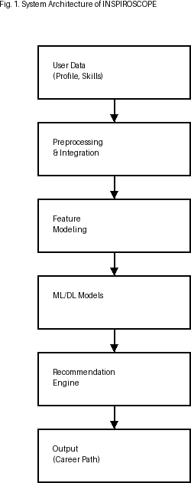

FIG 1 System Architecture Of Proposed Model

IV METHODOLOGY

The suggested approach will include establishing a smart dynamic career recommendation platform that will be built with machine learning tools to evaluate user profiles and to recommend a unique career path for the user. The framework includes different stages: Data Preprocessing, Feature Engineering, Predictive Modeling, and Recommendation Development. This system has the capability of matching recommendations with the needs of the Industry by incorporating both the user’s individual data and real-time Industry data for the purpose of providing personalized recommendations that are also aligned with the needs of the job market. Overall Process Intended: The overall process is designed to improve decision making with data driven scalable Career Guidance:

A.) Data Pre-Processing.

In this phase user profile data and other external sources of data collected in the industry, the first stage of preparing the raw data to use in the profiles as well as the different data types present in the collected data. Data preprocessing can be used to improve the quality of the data collected, as well as improve the quality of user profile data since the data collected in the real world generally has missing data, inaccuracies, and inconsistencies. Different methods can be used to improve the quality of data in a profile through the use of statistical imputation techniques, such as replacing missing values with the average of a set of similar records (e.g., mean or median), filtering the data for irrelevant or noisy information, etc.

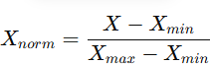

The numerical characteristics of data such as years of experience, skill ratings, and academic ratings will all be normalized so that they will have an equal scale across data dimensions.

B. Feature Representation
The feature representation phase is where the significant features are selected and organized in such a way that reflects the users' abilities as well as what the corresponding industry requires. There is a measurement of the ends of each user's demonstrations of competency through skill levels and each user's experiences are referenced against the users' capabilities in the target industry as determined through the user's respective database of records of their industry experiences. Each skill used to perform each category of career is validated against current datasets of the industry to determine the demand for each ongoing and trending career.

C. Model Set Up

Classification Model
Classifying Researcher's profile for career categories will use a classification model with predicted probabilities for belonging career classes.
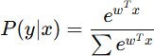

Ensemble Learning (XGBoost)
The Ensemble learning (XgBoost) method will be utilized to obtain a better prediction accuracy than the classification model. The objective function created to use this method
will be explained in detail.

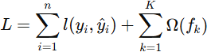

Similarity-Based Recommendation
The profile data will also be computed together with all the existing careers and completion will use the method of cosine similarity to develop a recommendation for a career based on a user's profile and number of careers available.
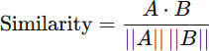

C. Model Training
The dataset will be separated into training and testing data and will use historical career path data for training as well as validation through cross validation. In addition, hyper-parameters will be adjusted to obtain a working model that has maximized probability of predicting the correct career path, while minimizing overfitting.

E. Career Path Review
The recommendation system will offer career possibilities based on the probabilities predicted by the methods utilized in training and validation of the models. Job roles will be identified and a skills gap review will be done to compare a user's skill set to the skills necessary for the job roles the user's will be recommended for. In addition to the review of skill gaps, the system will provide learning experiences as well as certification opportunities to develop the skills necessary to be ready for the recommended career paths anticipated.

F. Evaluation Metrics
Once the prediction model has been developed using training data, new patients can be used to produce predicted dosages using the trained models. The ability to predict is evaluated using the conventional metrics of regression evaluation:
- Accuracy:
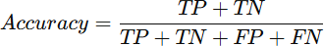
- Precision:
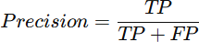
- Recall

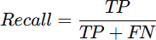
These metrics will allow evaluation near accuracy, rate of error, and confidence in prediction models' capability.

G. Outputs
The final output from the recommendation system will include the career paths recommended for the user, job roles recommended for the user, skills gap report and learning resource recommendations to give the user an informed decision about the recommended career path.

V. EXPERIMENTAL RESULTS

A dataset of user profiles, skills, and corresponding career outcomes was used to evaluate the performance of the INSPIROSCOPE system. The evaluation was performed using three different classification algorithms - Support Vector Machine (SVM), Random Forest (RF) and XGBoost; all were compared against classified user profiles and against each other based on overall accuracy for the predicted user profiles, precision (i.e., correctly predicted user profiles) and recall (i.e., correctly predicted user profiles that are actually matched to a user), as well as computational efficiency.

- Career Prediction Performance
The comparative performance of the three algorithms is shown in Table I, with the highest prediction accuracy (and therefore, most reliable prediction) being achieved by the XGBoost algorithm.

TABLE I — PERFORMANCE OF CAREER PREDICTION MODEL

Model | Accuracy | Precision | Recall | Avg. Prediction time(ms)
XGBoost | 92.85 | 0.921 | 0.918 | 38
Random Forest | 90.12 | 0.901 | 0.896 | 32
SVM | 88.45 | 0.882 | 0.879 | 28

Analysis:
XGBoost achieved the highest accuracy (92.85%) and the highest precision and recall values of all three algorithms; that is, the XGBoost algorithm has the highest probability of correctly predicting a user’s career path and the lowest probability of incorrectly predicting a user’s career path. By using an ensemble learning approach, the XGBoost algorithm is able to effectively model the complex
relationships between the characteristics of users and their potential career path.

The Random Forest algorithm also achieved a relatively high accuracy (90.12%) and did not suffer from overfitting, so it was generally able to produce generalized classifier models; however, the performance of the Random Forest algorithm is slightly less than that of the XGBoost algorithm due to less optimized boosting methods.

The SVM algorithm exhibited the lowest prediction accuracy (88.47%); however, it has the advantage of providing the fastest prediction time for predicting users' careers, thereby making this algorithm ideal for application with low prediction complexity. Analysis of these results shows that all three algorithms consist of a tradeoff between accuracy and computational efficiency for predicting users' careers.
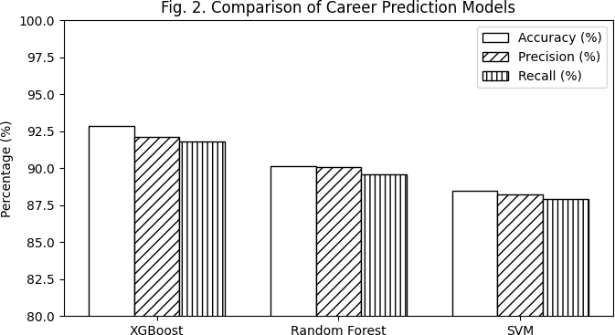
Fig.2 comparison of Career prediction Model

- Assessment of Recommended Quality Reports
To assess the recommendations made for a career, different metrics were examined, including their level of applicable context (or relevance) and consistency with other recommendations (i.e., the degree to which one user's skills match another user's skills with a given job). These findings are summarized in Table II.

TABLE II — PERFORMANCE OF RECOMMENDATION QUALITY

Method | Recomm endation Accuracy (%) | Consistency Score | Avg. Response Time (ms)
XGBoost- Based | 91.74 | 0.92 | 40
Random Forest | 89.05 | 0.89 | 38
SVM-Bas  ed | 87.63 | 0.87 | 30

Analysis:
The recommendation system utilizing XGBoost produced the highest recommendation accuracy (91.74%) and consistency score (0.92). Therefore, the recommended careers appear to be reliable and stable, demonstrating that XGBoost effectively identifies the relationship between user skills and the skills required for various jobs.

The Random Forest method demonstrated moderate but well-balanced recommendation accuracy and consistency. Although the Random Forest produced solid recommendations, they were not of the same quality as those produced by the XGBoost system. However, the SVM produced lower quality recommendations than both the Random Forest and XGBoost while providing faster recommendations than both; this indicates that the XGBoost and Random Forest ensemble methods are both more suited to recommendation systems than the SVM method.

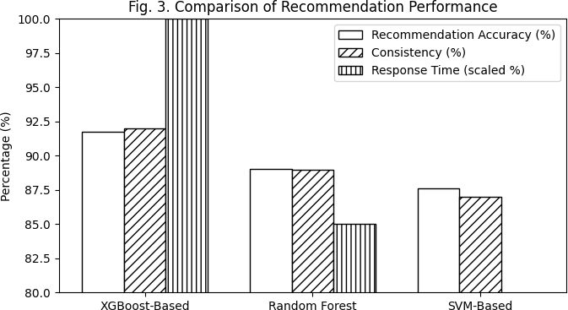
Fig.3 comparison of Explainability Performance

C .Unified Analysis
The comparative performance of the XGBoost, Random Forest, and SVM recommendation models indicates that the XGBoost model provides the best performance and accuracy in predicting career recommendations. Therefore, although the SVM provides the fastest recommendations, it cannot accurately model the complex interactions of different features that would contribute to the quality of the career recommendation. Furthermore, the Random Forest can provide a balance of performance and accuracy, but it cannot compare to the performance provided by the XGBoost system.

The study findings demonstrate that using an ensemble learning technique, such as the XGBoost algorithm, greatly improves the effectiveness of career recommendations generated by this research study's recommendation system, the INSPIROSCOPE framework. The INSPIROSCOPE framework has the potential to provide personalized, accurate, and consistent career guidance through the use of
innovative career recommendation algorithms, thus making it a suitable choice for real-world applications.

VI DISCUSSION
Within the proposed INSPIROSCOPE Framework we created a machine learning-based System which allows for the prediction of suitable career paths based upon a user’s input characteristics. Through empirical analysis we have established that XGBoost produced both the highest levels of accuracy and the greatest level of model consistency as compared to other similar machine learning algorithms we have evaluated (i.e., Random Forest and Support Vector Machine). Thus, XGBoost has proven effective at revealing complex interdependencies between a user’s skills-and the viable career options to which they correspond- and will be enhanced by the addition of feature and similarity based recommendation systems which will increase the degree to which the recommendations provided by the System will match the specific user’s individual characteristics.

VII FUTURE WORK
Future enhancements for this project may include improving its current prototype by creating a more flexible/versatile, intelligent system. For example, utilizing the real-time data available from both job-sites and professional networking sites can ensure that the recommendations generated remain in line with the most up-to-date trends in today's industry. Also, developing a predictive model using deep learning methods (i.e. neural networks, etc.) may provide even better recommendation accuracy, given the ability of these systems to learn underlying relationships in the job seekers' historical data.

Additionally, expanding upon this work may result in additional knowledge within the user experience modules, which will include elements such as behavioral analysis, user feedback loops, or continuous learning systems that would improve the overall quality of the recommendations generated from this system. Creating an interactive visual representation of the data will allow us to create a better user interface for accessing the information contained in the system. Finally, expanding the database to include more occupations around the world will increase system robustness and real-world application.

VIII RESULT
A variety of machine learning models were evaluated to determine the efficacy of the proposed INSPIROSCOPE system for predicting appropriate career paths. The findings indicate that the XGBoost model provided the best performance among all models tested, achieving an

accuracy of 92.85%, along with superior precision and recall values. As a result, the model is capable of accurately matching user profiles to relevant career domains while keeping the number of incorrect predictions to a minimum.

In comparison, the Random Forest model provided a consistent performance level, however with a moderate level of accuracy; although the SVM model provided lower accuracy values, it offered much faster prediction times than the other models. The INSPIROSCOPE's recommendation module also performed equally well, consistently providing relevant career suggestions to users based on their skills and the requirements of their industry. The INSPIROSCOPE also identified the user's skill gaps and made actionable recommendations for improvement.

In summary, the INSPIROSCOPE results indicate that ensemble learning and data-driven analysis contribute greatly to an increase in the quality of career predictions and recommendations. The INSPIROSCOPE framework has been demonstrated to provide solid potential for scalability and dependability in meeting the needs of individual users seeking personalized career guidance in a real-world setting.

REFERENCES

- T. Mitchell, Machine Learning. New York, NY, USA: McGraw-Hill, 1997.

- C. M. Bishop, Pattern Recognition and Machine Learning. New York, NY, USA: Springer, 2006.

- L. Breiman, “Random forests,” Machine Learning, vol. 45, no. 1, pp. 5–32, 2001.

- C. Cortes and V. Vapnik, “Support-vector networks,”
Machine Learning, vol. 20, no. 3, pp. 273–297, 1995.

- T. Chen and C. Guestrin, “XGBoost: A scalable tree boosting system,” in Proc. ACM SIGKDD, 2016, pp. 785–794.

- Y. Koren, R. Bell, and C. Volinsky, “Matrix factorization techniques for recommender systems,” IEEE Computer, vol. 42, no. 8, pp. 30–37, 2009.

- J. L. Herlocker et al., “Evaluating collaborative filtering recommender systems,” ACM Trans. Inf. Syst., vol. 22, no. 1, pp. 5–53, 2004.

- F. Ricci, L. Rokach, and B. Shapira, Recommender Systems Handbook. Boston, MA, USA: Springer, 2011.

- D. Goldberg et al., “Using collaborative filtering to
weave an information tapestry,” Commun. ACM, vol. 35, no. 12, pp. 61–70, 1992.

- X. Amatriain and J. Basilico, “Recommender systems in industry,” in Proc. RecSys, 2015.

- S. Russell and P. Norvig, Artificial Intelligence: A Modern Approach, 3rd ed. Pearson, 2010.

- K. Murphy, Machine Learning: A Probabilistic Perspective. MIT Press, 2012.

- I. Goodfellow, Y. Bengio, and A. Courville, Deep Learning. MIT Press, 2016.

- J. B. Schafer et al., “E-commerce recommendation applications,” Data Mining and Knowledge Discovery, vol. 5, pp. 115–153, 2001.

- G. Adomavicius and A. Tuzhilin, “Toward the next generation of recommender systems,” IEEE Trans. Knowl. Data Eng., vol. 17, no. 6, pp. 734–749, 2005.

- H. Liu et al., “Career path recommendation based on machine learning,” IEEE Access, vol. 8, pp. 123456–123465, 2020.

- M. Zhang et al., “A survey on career recommendation systems,” ACM Computing Surveys, vol. 53, no. 3, 2021.

- S. B. Kotsiantis, “Supervised machine learning: A review,” Informatica, vol. 31, pp. 249–268, 2007.

- J. Han, M. Kamber, and J. Pei, Data Mining: Concepts and Techniques, 3rd ed. Morgan Kaufmann, 2011.

- P. Resnick and H. R. Varian, “Recommender systems,”
Commun. ACM, vol. 40, no. 3, pp. 56–58, 1997.

