FROM DIVERGENCE TO CONVERGENCE: HUMAN LANGUAGE EVOLUTION AND THE ACCELERATING ROLE OF EMOJIS AND DIGITAL TECHNOLOGY

Ms. Elizabeth Njeri Ngigi
Orangeburg County School District; Orangeburg Wilkinson High School
Master of Education Technology, Mount Kenya University, Thika, Kenya
*Corresponding Author: elizabeth.ngigi@ocsdsc.org

Abstract

This theoretical paper argues that human language exhibits a long-term tendency to move from divergence toward convergence. While migration and cultural isolation produced thousands of distinct languages, human communities have repeatedly developed symbolic systems that transcend local speech. From Egyptian hieroglyphs and Chinese characters to modern emojis, visual signs have enabled meaning to travel across linguistic boundaries.
Digital technology has accelerated this process by creating a globally shared symbolic layer embedded in everyday communication. Drawing on linguistics, semiotics, media ecology, and information theory, this paper proposes that emojis function as compressed semantic units that restore ancient pictographic tendencies within networked communication. The paper does not claim that natural languages are disappearing. Rather, it argues that written language is becoming increasingly hybrid: alphabetic, visual, and algorithmically mediated.
This convergence has important implications for education, intercultural communication, and the future of human expression

Keywords
language evolution, emojis, semiotics, digital communication, linguistic convergence, hieroglyphs

1. Introduction
Human language has always balanced two opposing tendencies. One tendency pushes communities apart. Geography, migration, politics, and identity generate new dialects and eventually new languages. The other tendency draws communities together. Trade, empire, religion, and technology encourage shared symbols and common communicative conventions.
This paper proposes that the history of language can be understood as a recurring movement from divergence to convergence. In one era, speech communities multiply and differentiate. In another, new media and symbolic systems compress those differences into forms that are more widely intelligible. Today, emojis and digital icons are accelerating this convergent tendency.
The smiling face, the heart, and the thumbs-up are now recognized by billions of people. They are not a complete language, but they are a shared symbolic overlay that can modify tone, convey emotion, and signal intent across linguistic boundaries.
1.1 Literature Review
Recent scholarship has increasingly examined emojis as meaningful components of digital discourse. Danesi (2016) argues that emojis constitute a semiotic system that supplements written language by encoding affect and social intent. Evans (2017) similarly demonstrates that emojis contribute pragmatic and emotional nuance rather than replacing grammar. McCulloch (2019) situates emoji use within the broader evolution of internet language, showing how users adapt writing to recover tone and interpersonal signals often lost in text-based communication.
1.2 Conceptual Framework Analysis
The conceptual framework presented in this paper illustrates the movement from linguistic diversity toward symbolic convergence within digitally mediated communication systems. The framework connects ancient symbolic traditions such as Egyptian hieroglyphics and Chinese ideographic writing with contemporary digital communication practices. At the center of the framework is the idea of shared visual cognition, which suggests that human beings repeatedly develop visual systems capable of transmitting meaning across linguistic and cultural boundaries.
The framework further identifies technology, education, and emotional communication as major convergence forces shaping the evolution of modern language practices. Technological systems such as Unicode standardization, artificial intelligence translation, and visual interface design increasingly normalize symbolic communication across global platforms. Educational systems similarly contribute by promoting multilingual literacy, intercultural communication, and digital semiotic competence. Emotional expression also remains central because emojis and visual signs frequently communicate affective meaning more efficiently than purely textual forms.
Collectively, these forces contribute to what this paper describes as a convergent language ecosystem. In this ecosystem, written communication becomes increasingly hybrid, combining alphabetic writing, visual symbolism, and algorithmically mediated expression. The framework therefore supports the broader argument of this paper that digital technology is not replacing human language but accelerating a long-standing historical tendency toward symbolic convergence and shared semantic intelligibility.
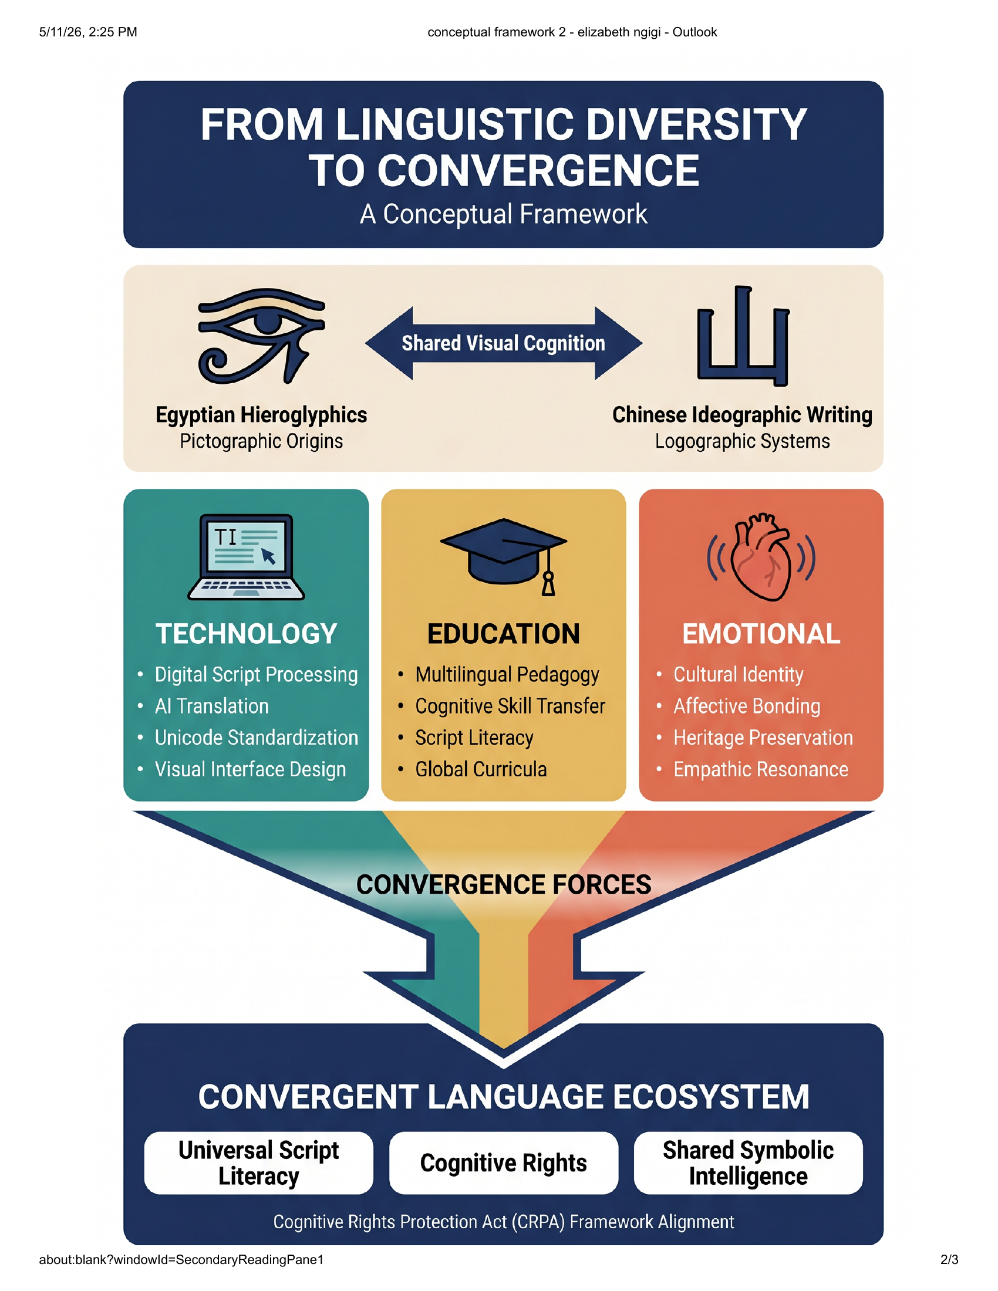
Figure 1. Conceptual framework illustrating the convergence of symbolic communication systems in the digital age.
2. Language Divergence in Human History
Linguists estimate that more than 7,000 languages are spoken worldwide. This diversity emerged because human communities adapted to distinct ecological, social, and historical conditions. Divergence is therefore a natural property of language.
At the same time, convergence has always accompanied divergence. Lingua francas such as Latin, Arabic, Swahili, and English reduced communicative friction across large populations. Writing systems further extended this process by stabilizing meaning over time and space.
3. Ancient Symbolic Systems
Egyptian hieroglyphs combined phonetic values with visual representations. Chinese characters, although more complex than popular descriptions suggest, preserve a strong semantic dimension that allows readers of different spoken varieties to access shared written forms.
These systems reveal an enduring human preference for visual compression. A single sign can condense an object, action, relation, or abstract concept into a compact and memorable unit.
4. Semiotic Foundations
Saussure described language as a system of signs linking signifiers and signified concepts. Peirce distinguished icons, indexes, and symbols. Emojis often function iconically because they resemble the ideas or emotions they express.
McLuhan argued that communication technologies reshape the structure of perception. Shannon showed that communication systems tend toward efficiency and compression. Together, these theories help explain why digital media favor highly condensed symbolic forms.
5. Emojis as Modern Hieroglyphs
Emojis emerged from practical design constraints in Japanese mobile communication and were later standardized by the Unicode Consortium. Their rapid global adoption demonstrates a remarkable appetite for shared visual signs.
Calling emojis “modern hieroglyphs” is metaphorical rather than literal. Hieroglyphs were full writing systems. Emojis are supplementary signs. Yet both systems reveal a common principle: images can communicate meaning quickly and memorably.
6. Convergence in the Digital Age
Digital communication rewards brevity. Character limits, small screens, and rapid exchanges encourage users to compress meaning. Emojis, GIFs, and icons reduce ambiguity, especially in text where vocal tone and facial expression are absent.
Recent research shows that emojis perform pragmatic functions such as signaling irony, affection, politeness, and solidarity. They do not replace grammar, but they enrich interpretation and increase cross-cultural intelligibility.
7. Counter-arguments and Limits
Emojis are not universally interpreted in identical ways. Meanings vary by age, culture, and platform design. Natural languages also remain indispensable for abstraction, law, science, and philosophical reasoning.
For these reasons, the present argument is not that a single universal language will replace existing languages. Rather, a shared symbolic layer is emerging alongside them.
8. Educational Implications
Educators should treat emojis as legitimate objects of linguistic study. They provide accessible examples of semantics, pragmatics, visual rhetoric, and intercultural communication. Students can analyze how symbols modify meaning and how digital conventions evolve.
Understanding symbolic convergence can also improve media literacy by helping learners recognize how technology shapes expression.
9. Future of Language
The future of language is likely to be hybrid. Spoken languages will continue to diversify, but written communication will increasingly combine words, symbols, and algorithmically suggested expressions.
Artificial intelligence may intensify convergence by translating languages in real time and recommending common symbolic conventions. Human languages will persist, but global communication may become more semantically interoperable than at any point in history.
10. Conclusion
From Egyptian hieroglyphs to Chinese characters and from telegraph abbreviations to emojis, humans have repeatedly sought ways to compress meaning into forms that travel widely and endure.
Language therefore appears to exhibit a recurring movement from divergence to convergence. Technology has not created this tendency, but it has accelerated it dramatically. Emojis are one visible sign of a broader transformation: humanity is developing a shared symbolic layer that supplements local languages and reshapes how meaning circulates across the planet.
References
Alshenqeeti, H. (2016). Are emojis creating a new or old visual language for new generations? Journal of English Language and Literature, 3(1), 56–69.

Baron, N. S. (2021). How we read now. Oxford University Press.

Coulmas, F. (2003). Writing systems: An introduction to their linguistic analysis. Cambridge University Press.

Crystal, D. (2022). Language and the Internet (3rd ed.). Cambridge University Press.

Danesi, M. (2016). The semiotics of emoji. Bloomsbury.

Evans, V. (2017). The emoji code. Picador.

Gibson, W., Huang, H., & Yu, Q. (2024). Emoji interpretation and pragmatic meaning in digital discourse. Journal of Pragmatics, 229, 1–15.

Jones, R. H., Chik, A., & Hafner, C. A. (2015). Discourse and digital practices: Doing discourse analysis in the digital age. Routledge.

Kress, G. (2010). Multimodality: A social semiotic approach to contemporary communication. Routledge.

Lacková Bennett, Ľ. (2025). From hieroglyphs to emoji: A spiral model for writing systems evolution. Semiotica.

Lupton, D. (2023). Digital media and society (2nd ed.). Sage.

McCulloch, G. (2019). Because Internet: Understanding the new rules of language. Riverhead Books.

McLuhan, M. (1964). Understanding media: The extensions of man. McGraw-Hill.

Peirce, C. S. (1931–1958). Collected papers of Charles Sanders Peirce. Harvard University Press.

Saussure, F. de. (2011). Course in general linguistics (W. Baskin, Trans.). Columbia University Press. (Original work published 1916)

Shannon, C. E., & Weaver, W. (1949). The mathematical theory of communication. University of Illinois Press.

Unicode Consortium. (2025). Unicode emoji charts. Unicode Consortium

Vigliocco, G., et al. (2023). Visual symbols and cross-linguistic comprehension in digital communication. Current Directions in Psychological Science, 32(6), 512–519.

