Empowering User Recourse: Reversing Algorithmic Drift through Explainable AI

Faria Begum N* and Dr. Shankar N B
Department of Computer Science and Engineering, R. L. Jalappa Institute of Technology, Doddaballapur, Karnataka, India
*Corresponding Author: Faria Begum N | Email: begumfaria10@gmail.com | Department of Computer Science and Engineering, R. L. Jalappa Institute of Technology, Doddaballapur – 561203, Karnataka, India

ABSTRACT
Sequential recommender systems have emerged as a cornerstone of personalized content delivery across modern digital platforms. These systems, while effective in capturing short-term user preferences, are inherently susceptible to a phenomenon termed algorithmic drift, wherein transient, accidental, or noisy user interactions progressively distort the system's learned representation of long-term user interests. Over time, such drift contributes to the formation of filter bubbles, information cocoons, and rabbit-hole feedback loops that reduce informational diversity and may reinforce harmful content patterns. Despite growing awareness of this problem, existing explainable AI (XAI) approaches within the recommendation domain remain largely diagnostic, offering explanations of recommendation behavior without providing operational mechanisms for users to actively correct drift-inducing interactions. This paper presents HikmaX, an interactive XAI-driven recourse framework designed to detect, quantify, and reverse algorithmic drift in sequential recommendation systems. The proposed framework integrates a Transformer-based self-attentive recommendation model (SASRec) with Integrated Gradients attribution and a temporal counterfactual recourse engine. Through systematic attribution of individual interactions to recommendation outcomes, the framework identifies the specific historical entries responsible for preference drift and enables their selective removal or downweighting via a user-controlled recourse interface. Comparative evaluation is also performed against GRU4Rec and Temporal Convolutional Network (TCN) baselines to establish the suitability of SASRec as the recommendation backbone. Experiments conducted on the MovieLens-1M benchmark dataset demonstrate that the HikmaX recourse mechanism substantially restores personalization quality, achieving significant improvements across Accuracy, Hit@10, NDCG@10, Precision@10, and Recall@10 following drift correction. Two novel drift-specific evaluation metrics, the Algorithmic Drift Score (ADS) and Delta Target Consumption (DTC), are introduced to quantify preference deviation. The results confirm that interactive, attribution-guided user recourse represents a practically viable and ethically aligned approach to responsible recommendation in contemporary AI systems.

Keywords: Sequential recommendation systems; explainable AI; algorithmic drift; counterfactual recourse; Integrated Gradients; human-centered AI; SASRec; recommendation recovery.

INTRODUCTION
Recommender systems have become integral components of contemporary digital infrastructure, shaping the information diet of billions of users across platforms such as YouTube, Netflix, Amazon, TikTok, and Spotify. By learning statistical associations between users and items from historical interaction data, these systems curate personalized content streams at scale, influencing what users read, watch, purchase, and believe. The economic and social significance of recommendation technology has made the accuracy, fairness, and transparency of such systems a subject of increasing academic and regulatory scrutiny.
Among the most influential classes of recommender systems are sequential recommender architectures, which model the temporal ordering of user interactions to predict future preferences. Transformer-based approaches, particularly Self-Attentive Sequential Recommendation (SASRec) [1] and Bidirectional Encoder

Representations from Transformer-based Recommendation (BERT4Rec), have achieved state-of-the-art performance by leveraging self-attention mechanisms to capture long-range dependencies within interaction sequences. However, a structural property of these models—their sensitivity to recency—introduces a critical vulnerability: interactions occurring near the end of the sequence receive disproportionate attention weight, causing the system to amplify transient or noisy behavioral signals.
This sensitivity gives rise to what this paper formalizes as algorithmic drift: a progressive divergence between the system's inferred user preference model and the user's genuine stable interests, induced by the accumulation of exploratory, accidental, or contextually anomalous interactions in the history. Drift manifests in practice as the gradual redirection of recommendation outputs toward content domains inconsistent with the user's authentic preferences. Over extended deployment, drift can trap users in filter bubbles [3], propel them along rabbit-hole recommendation trajectories, and amplify extreme or harmful content—phenomena with well-documented societal consequences.
The field of Explainable Artificial Intelligence (XAI) has produced a range of techniques for attributing model outputs to input features, including SHAP [5] and Integrated Gradients [6]. These methods have been applied to recommendation systems to improve transparency, yet they remain fundamentally observational: they expose which interactions influence recommendations but do not equip users with actionable mechanisms to correct drift-inducing history entries. This gap between explanation and intervention constitutes a significant limitation in the pursuit of human-centered, controllable AI systems [11].
This paper addresses this limitation by introducing HikmaX, an interactive XAI-driven recourse framework for sequential recommender systems. HikmaX combines Transformer-based recommendation modeling with Integrated Gradients attribution and a temporal counterfactual recourse engine to enable the detection, quantification, and reversal of algorithmic drift. Users are empowered to inspect attribution-highlighted interactions, selectively remove or downweight drift-causing entries, and observe dynamically recomputed recommendations through an interactive dashboard interface.
The principal contributions of this work are as follows: (1) a formal probabilistic model of algorithmic drift in sequential recommendation; (2) an XAI-based influence attribution mechanism using Integrated Gradients for interaction-level drift localization; (3) a temporal counterfactual recourse engine for selective reversal of preference drift; (4) two novel drift-specific evaluation metrics—the Algorithmic Drift Score (ADS) and Delta Target Consumption (DTC); and (5) a human-centered interactive dashboard enabling user-guided recommendation correction and recovery.
The remainder of this paper is organized as follows. Section 2 presents a comprehensive review of related literature. Section 3 identifies the research gap. Section 4 states the study objectives. Sections 5 through 10 describe the proposed methodology, system architecture, and implementation details. Sections 11 through 15 detail the experimental setup, dataset, and evaluation strategies. Sections 16 through 18 present and discuss results. Sections 19 and 20 address limitations and future directions. Section 21 concludes the paper.

LITERATURE REVIEW
This section reviews the principal bodies of literature relevant to the present work, encompassing sequential recommender systems, explainable AI for recommendation, and recommendation drift with counterfactual recourse.

Sequential Recommender Systems
The evolution of recommender systems has progressed from neighborhood-based collaborative filtering and matrix factorization methods, which model static user-item affinity without temporal structure, toward deep sequential architectures capable of capturing preference dynamics. Hidasi et al. [2] introduced GRU4Rec, the first application of Gated Recurrent Units (GRUs) to session-based recommendation, demonstrating that recurrent architectures can effectively model the sequential nature of user interactions within a session. The gating mechanisms of the GRU allow the model to selectively retain or discard historical information, mitigating

the vanishing gradient problem that afflicts standard recurrent networks. However, the recurrent nature of GRU4Rec limits its parallelism and increases training time for long sequences.
Bai et al. [4] proposed Temporal Convolutional Networks (TCNs) as an alternative sequence modeling paradigm, employing dilated causal convolutions to capture long-range dependencies in parallel. TCNs outperform recurrent architectures on several sequential modeling benchmarks due to their stable gradient propagation and computational efficiency. Nevertheless, their fixed receptive field size may constrain their ability to model interactions across sequences of variable length.
Kang and McAuley [1] introduced SASRec, a landmark sequential recommendation model that employs causal self-attention to identify the subset of historical interactions most relevant to the next-item prediction task. SASRec's attention mechanism dynamically weighs all items in the sequence, enabling it to capture both short-term intent and long-term preference simultaneously. Subsequent work, including BERT4Rec, adapted bidirectional Transformer pretraining to recommendation, while FEARec and other follow-up models introduced frequency-enhanced and multi-head variants. Despite their accuracy, all Transformer-based models inherit the structural recency bias of the attention mechanism, wherein tokens proximate to the prediction target disproportionately influence output logits.

Explainable AI in Recommendation
Lundberg and Lee [5] introduced SHAP (SHapley Additive exPlanations), a unified framework for feature attribution grounded in cooperative game theory. SHAP computes locally accurate, globally consistent importance scores for input features, and has been widely applied to post-hoc explanation of recommendation model outputs. However, SHAP is computationally expensive for large feature spaces and does not inherently provide interaction-level temporal attribution for sequential models.
Sundararajan et al. [6] proposed Integrated Gradients (IG), an axiomatic attribution method that satisfies both completeness and sensitivity properties. IG computes attributions by integrating gradients of the model output with respect to each input feature along a straight path from a baseline input (empty history) to the actual input. These properties make IG particularly well-suited for gradient-based sequential models such as SASRec, where the completeness axiom ensures attribution scores sum precisely to the difference in model output between baseline and input.
Zhang and Chen [7] provided a comprehensive survey of explainable recommendation, identifying transparency, trust, and user satisfaction as the primary objectives driving the field. The survey distinguishes between model-intrinsic explanation methods (e.g., attention visualization) and post-hoc methods (e.g., SHAP, IG), noting that neither category provides users with actionable recourse mechanisms. Molnar [15] similarly highlights the distinction between explanation (understanding a model) and intervention (changing a model's output behavior), arguing that true user empowerment requires the latter.

Algorithmic Drift and Counterfactual Recourse
The filter bubble hypothesis, introduced by Pariser [8], argues that personalization algorithms systematically reduce informational diversity by reinforcing existing preferences. Subsequent empirical studies have documented the emergence of echo chambers and rabbit-hole trajectories in recommendation-driven information consumption, attributing these phenomena to the feedback dynamics between user behavior and recommendation outputs. Bonchi et al. [8] formalized algorithmic drift as the evolution of system-inferred user preferences induced by recommender feedback, providing a simulation framework for studying drift dynamics in controlled environments.
Counterfactual explanation in recommendation has been explored by Ghazimatin et al. [10], who proposed PRINCE, a provider-side interpretability framework that generates counterfactual explanations by identifying the minimal set of item changes required to alter a recommendation outcome. While PRINCE advances the state of post-hoc recommendation interpretability, it focuses on provider-side item-space perturbations and does not address temporal drift in user interaction histories or provide user-facing interactive recourse mechanisms.

Tran et al. [9] explored counterfactual recourse for neural recommenders in limited experimental settings, demonstrating the feasibility of history-space perturbations for recommendation correction. However, this work does not integrate with an explainability attribution mechanism, does not provide an interactive user interface, and does not address the temporal dynamics of drift accumulation across extended deployment periods.
Vaswani et al. [13] established the foundational Transformer architecture upon which SASRec and related models are built, while Kingma and Ba [14] introduced the Adam optimizer used for training sequential recommendation models. Covington et al. [24] described the deep learning recommendation system deployed at YouTube, highlighting the practical challenges of recency bias and feedback loops in large-scale recommendation environments. The STAMP model [25] addressed short-term priority changes using attention-memory architectures, while LightGCN [29] and RippleNet [28] advanced graph-based recommendation, though neither addresses temporal drift or user recourse.

RESEARCH GAP AND MOTIVATION
The review of existing literature reveals four critical gaps that motivate the present work. First, while algorithmic drift has been theoretically modeled and empirically documented, existing recommender systems lack systematic mechanisms for its detection, quantification, and correction at the user interaction level. Drift-handling approaches either require full history resets—which discard valuable preference signal—or address item-space perturbations without temporal sensitivity.
Second, current XAI techniques for recommendation, including SHAP [5] and Integrated Gradients [6], remain observational. They illuminate which interactions influence recommendations but do not provide users with the means to act upon these explanations. The gap between explainability and actionable recourse represents a fundamental limitation in realizing human-centered AI [11] for recommendation.
Third, counterfactual recourse approaches such as PRINCE [10] operate on the provider side, manipulating item features rather than user history, and do not address temporal drift dynamics. User-facing recourse mechanisms that operate directly on interaction sequences remain largely absent from the literature.
Fourth, no existing evaluation framework provides drift-specific metrics capable of quantifying the magnitude of preference deviation and the effectiveness of recovery. Standard recommendation metrics such as Hit@K and NDCG measure ranking quality but do not capture drift-induced preference distortion.
The HikmaX framework is motivated by the need to close these gaps within a single, integrated architecture that unifies sequential recommendation modeling, interaction-level XAI attribution, temporal counterfactual recourse, and drift-specific evaluation.

OBJECTIVES OF THE STUDY
This study pursues the following specific research objectives:
- To formalize algorithmic drift in sequential recommendation systems through a probabilistic interaction model, enabling systematic simulation and quantification of drift phenomena.
- To develop a drift attribution mechanism based on Integrated Gradients that identifies, at the interaction level, which historical entries are responsible for preference deviation.
- To design and implement a temporal counterfactual recourse engine that selectively removes or downweights drift-inducing interactions, restoring personalization alignment without full history reset.
- To compare three sequential recommendation architectures—GRU4Rec [2], TCN [4], and SASRec [1]—in terms of recommendation quality and suitability for the drift recourse pipeline.
- To introduce two novel drift-specific evaluation metrics, ADS and DTC, and to evaluate the framework comprehensively across both standard and drift-specific measures.

- To develop an interactive, human-centered dashboard that enables non-technical users to inspect attribution-highlighted interactions, initiate recourse operations, and observe updated recommendations in real time.

METHODOLOGY / PROPOSED FRAMEWORK
The HikmaX framework integrates four functional modules within a unified pipeline: (1) a sequential recommendation model, (2) an Integrated Gradients attribution engine, (3) a drift detection and quantification module, and (4) a temporal counterfactual recourse generator. These modules interact bidirectionally, supporting iterative recourse cycles until satisfactory personalization alignment is achieved. Figure 1 provides an overview of the complete system architecture.

Sequential Recommendation Pipeline
User interaction data is preprocessed into chronologically ordered sequences for each user. Each sequence S_u = {i_1, i_2, …, i_T} represents the ordered history of items accessed by user u, where i_t denotes the item interacted with at timestep t. Items are encoded into dense embedding vectors through an embedding layer, and positional encodings are added to preserve sequence order information. The resulting embedded sequences are then fed into the chosen sequential model (GRU4Rec, TCN, or SASRec) for training and inference.

GRU-Based Recommendation Model (GRU4Rec)
The GRU-based model [2] processes the embedded item sequence through stacked GRU layers that maintain a hidden state h_t capturing cumulative historical context. The update gate z_t and reset gate r_t regulate the flow of information, enabling the model to selectively retain relevant historical signals and discard transient noise. The hidden state update is governed by:
h_t = (1 − z_t) ⊙ h_{t-1} + z_t ⊙ tanh(W_h [r_t ⊙ h_{t-1}, x_t]) … (1)
where x_t is the item embedding at timestep t, W_h is a weight matrix, and ⊙ denotes element-wise multiplication. A softmax output layer maps the final hidden state to a probability distribution over candidate items.

Temporal Convolutional Network (TCN)
The TCN [4] models the interaction sequence using dilated causal convolutions that expand the receptive field exponentially with depth while preserving temporal ordering. The causal constraint ensures that the model's prediction at timestep t depends only on interactions at or before t, maintaining autoregressive integrity. For a convolutional filter F of width k and dilation factor d, the output at position t is:
y_t = Σ_{j=0}^{k-1} F(j) · x_{t − d·j} … (2)
Stacking layers with exponentially increasing dilation (d = 1, 2, 4, …, 2^{L-1}) enables the TCN to capture dependencies across the full sequence length without the gradient instability characteristic of recurrent architectures.

Self-Attentive Sequential Recommendation (SASRec)
SASRec [1] serves as the primary recommendation backbone within HikmaX. Given the embedded and positionally encoded item sequence, SASRec applies a stack of causal self-attention layers to produce context-aware item representations. The scaled dot-product attention for a single head is defined as:
Attention(Q, K, V) = Softmax(QK^T / √d_k)V … (3)
where Q, K, and V are the query, key, and value matrices derived from linear projections of the item embeddings, and d_k is the key dimensionality. The causal mask ensures that position t attends only to positions ≤ t. Multi-head attention is computed in parallel across H heads and projected back to the embedding dimension. SASRec's

ability to assign dynamic importance weights to all historical interactions makes it particularly amenable to the attribution-based drift analysis employed in HikmaX.

Probabilistic Model of Algorithmic Drift
Algorithmic drift is modeled as a deviation in the system's inferred user preference distribution from the user's latent stable interest distribution. At each timestep t, the probability that user u interacts with item i is modeled as a mixture of three generative components:
P(i_t) = α P_random(i_t) + β P_history(i_t) + (1 − α − β) P_rec(i_t) … (4)
where P_random captures exploratory or accidental interactions, P_history reflects stable long-term preferences derived from the user's authentic interaction history, and P_rec quantifies interactions induced by the recommender system itself. The parameters α and β represent the randomness and resistance coefficients, respectively, and satisfy α + β ≤ 1. Drift intensity is proportional to the recommender influence term (1 − α − β) and escalates monotonically as recommender-induced interactions accumulate in the history, displacing preference-consistent entries.

SYSTEM ARCHITECTURE
The HikmaX system is organized as a layered modular architecture comprising eight functional layers: Dataset Processing, Sequential Modeling, Drift Injection, Recommendation Generation, Explainable AI, User Recourse, Evaluation, and Visualization. Each layer operates on well-defined data contracts and exchanges information through structured processing pathways, ensuring full traceability of recommendation outcomes across the drift detection and recovery lifecycle.
The Dataset Processing layer ingests raw interaction records from the MovieLens repository, applies cleaning and deduplication, constructs chronologically ordered user-item interaction sequences, performs sequence padding to uniform length, and partitions data into training, validation, and test splits. The Sequential Modeling layer routes processed sequences to one of three recommendation pipelines—GRU4Rec, TCN, or SASRec—each of which produces ranked Top-N recommendation lists as output.
The Recommendation Engine serves as the central orchestration layer, converting model logits into ranked item lists and routing outputs to the Drift Injection Module and the Explainable AI Module concurrently. The Drift Injection Module introduces controlled perturbations simulating real-world drift scenarios, while the Explainable AI Module computes Integrated Gradients attribution scores over the interaction sequence. The User Recourse Module receives attribution outputs and presents corrective options, transmitting the modified sequence back to the Recommendation Engine for iterative recomputation. The Evaluation Module computes quantitative performance metrics, and the Streamlit Visualization Dashboard presents the complete recommendation-explanation-recourse lifecycle to the end user.
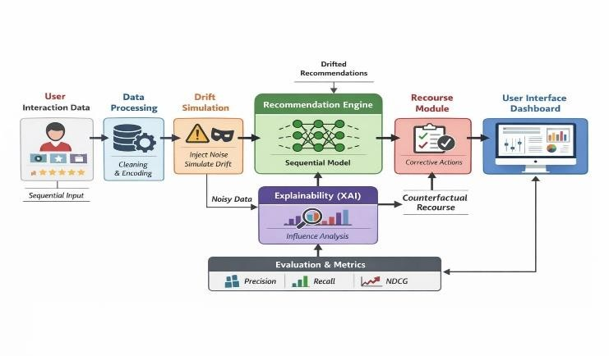
Figure 1. Overall Architecture of the HikmaX Framework.

ACTIVITY DIAGRAM DESCRIPTION
The activity diagram for HikmaX captures the end-to-end operational workflow from data ingestion to final recommendation presentation. The process begins with the loading and preprocessing of the MovieLens dataset, encompassing data cleaning, timestamp-based sorting, sequence generation, and train-test partitioning. Control then flows to the parallel training of the three sequential recommendation models. Following model training, the recommendation generation phase produces initial Top-N outputs that serve as the baseline for drift evaluation.
The drift injection decision point introduces controlled perturbations to selected user sequences, simulating the accumulation of noisy or off-profile interactions. The XAI Analysis phase computes Integrated Gradients attribution scores, identifying interactions with anomalously high influence scores relative to their temporal position. A conditional branch then presents users with the opportunity to initiate recourse: if recourse is selected, the User Recourse Module removes or downweights identified drift-inducing entries, reconstructs the corrected sequence, and routes it back to the Recommendation Engine for recomputation. If no further recourse is desired, the workflow proceeds to evaluation metric computation and dashboard visualization, at which point the cycle terminates.
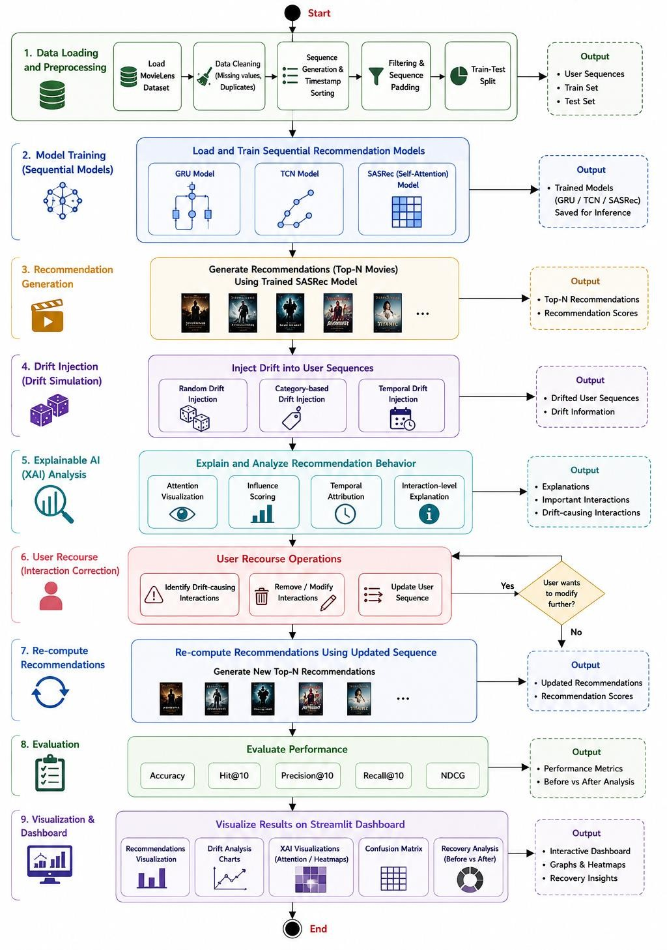
Figure 2. Activity Diagram of the HikmaX Framework.

USE CASE DIAGRAM DESCRIPTION
The HikmaX use case diagram defines the functional interactions between two primary system actors—the end user (researcher or analyst) and the system administrator—and the eight core system use cases. The end user initiates interaction with the system by selecting a dataset and a user profile, which triggers the Dataset Analysis use case encompassing data loading, cleaning, and sequence generation. The Model Comparison use case enables the user to evaluate GRU4Rec, TCN, and SASRec architectures side by side across Hit@10, Accuracy, and Loss metrics.
The Recommendation Generation use case produces Top-N personalized movie recommendations for the selected user. The Drift Injection and Analysis use case allows the user to simulate drift by selecting an injection strategy (random, category-based, or temporal) and observing the resulting change in recommendation output distribution. The XAI Explanation use case presents attention visualization and Integrated Gradients attribution scores as a heatmap over the interaction sequence. The User Recourse use case enables the user to select and remove flagged interactions, reconstruct the corrected sequence, and trigger recommendation recomputation. The Evaluation Metrics use case computes and displays quantitative performance scores. The Visualization Dashboard use case provides the unified graphical interface through which all use case outputs are presented. The system administrator is responsible for model management, dataset maintenance, and system configuration.
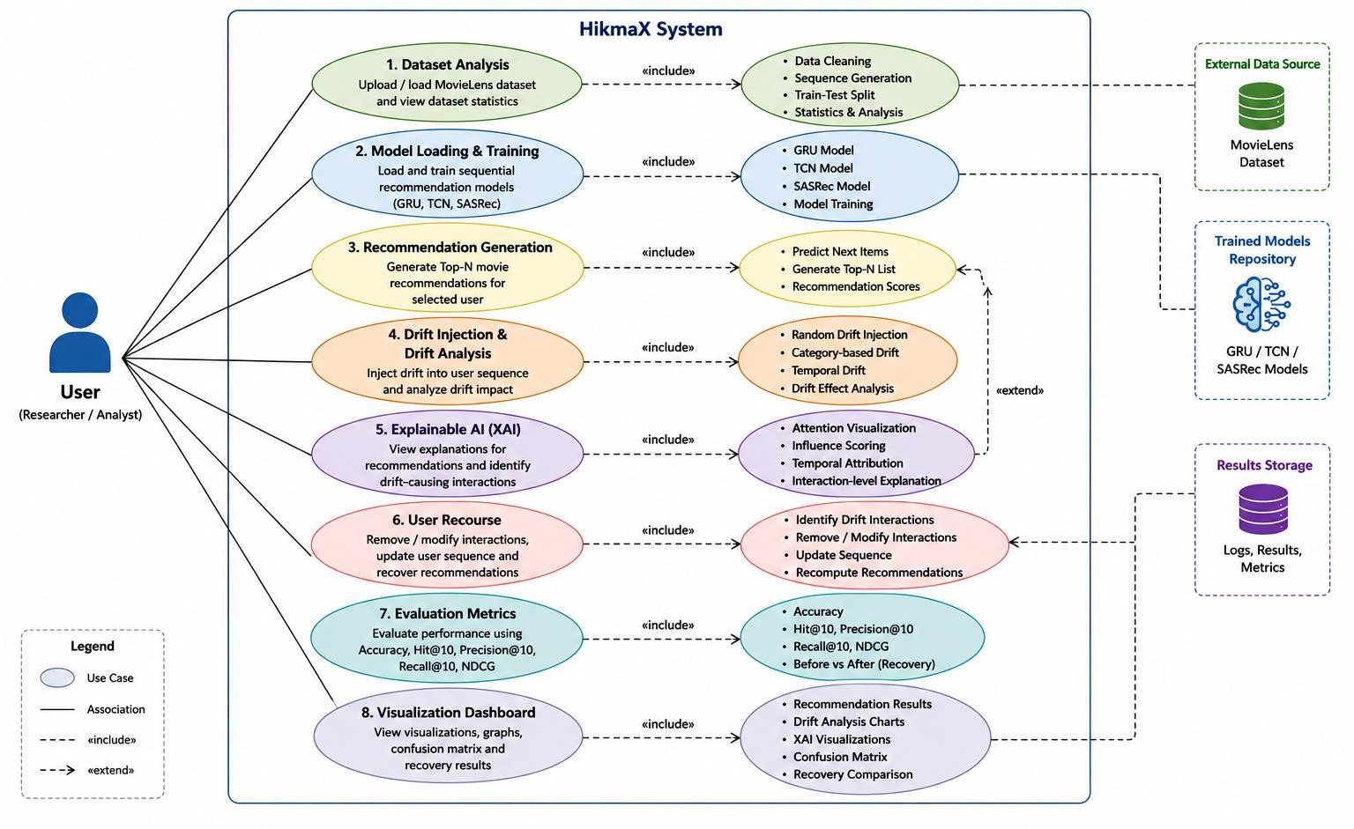
Figure 3. Use Case Diagram of the HikmaX System.

CLASS DIAGRAM DESCRIPTION
The class diagram depicts the static structural architecture of HikmaX and the relationships among its principal software components. The User class encapsulates user profile attributes and maintains a reference to the InteractionSequence class, which preserves the chronologically ordered set of user-item interactions. The Item class stores item metadata, including genre and release year attributes required for drift simulation.

The abstract RecommenderModel class defines the shared interface—train(), predict(), evaluate(), and saveModel()—and is specialized through inheritance into three concrete subclasses: GRUModel, TCNModel, and SASRecModel, each implementing the interface with architecture-specific parameters and training procedures. The TrainedModel class maintains serialized model weights and performance metric records. The DriftAnalyzer class exposes methods for injecting drift perturbations (injectNoise()) and computing the drift score (computeDriftScore()), and maintains an association with the DriftResult class.
The XAIExplainer class computes attribution scores (getInfluenceScores(), plotAttention()) and maintains an association with the Explanation class, which stores per-interaction attribution values. The RecourseManager class implements the core recourse logic: applyRecourse() modifies the interaction sequence by removing flagged entries, recover() triggers recommendation recomputation, and the results are encapsulated in the RecourseResult class. The EvaluationManager class computes and stores all performance metrics. Dependency relationships connect the XAIExplainer to the RecommenderModel and the RecourseManager to both the XAIExplainer and the RecommenderModel, establishing the integration pathways that support the end-to-end drift correction pipeline.

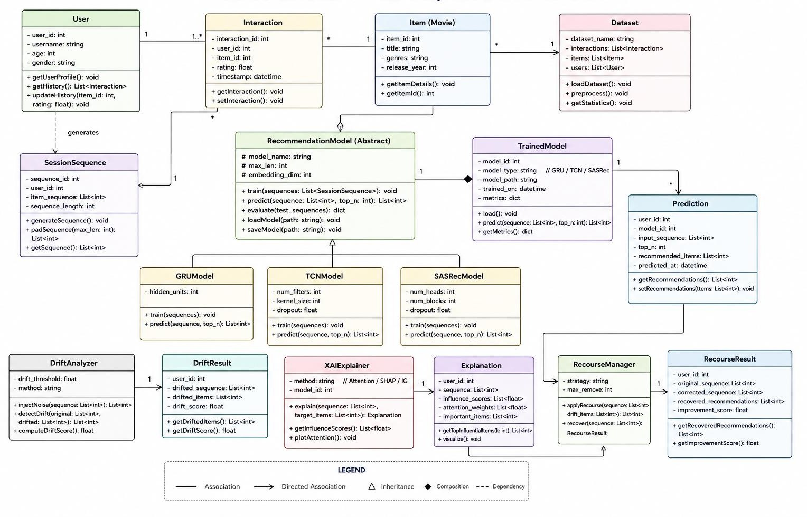
Figure 4. Class Diagram of the HikmaX Framework.

DATA FLOW DIAGRAM DESCRIPTION
The Data Flow Diagram (DFD) for HikmaX captures the movement of information between the nine principal system components across the recommendation and recourse pipeline. Raw interaction data from the MovieLens external data source flows into the Data Preprocessing Module (D1: Processed Sequence Database), which outputs cleaned, chronologically ordered user sequences. These sequences flow into the Sequential Recommendation Models, which produce initial recommendation outputs stored temporarily as prediction results.

Recommendation outputs and the associated interaction sequences flow concurrently into the Drift Injection Module and the Explainable AI Module. The Drift Injection Module introduces synthetic off-profile interactions and returns drifted sequences to the Recommendation Engine, which recomputes drifted recommendation lists. The XAI Module produces attribution score vectors and visualizations, which flow into the User Recourse Module. The user's recourse decisions (interaction selections for removal) flow back into the Recommendation Engine as corrected sequences, triggering a recommendation recomputation cycle.
Final recommendation outputs, drift analysis artifacts, XAI attribution visualizations, and recourse outcomes flow into the Evaluation Module (D2: Test Set Database), which computes standard and drift-specific metrics. All evaluation outputs are directed to the Streamlit Visualization Dashboard for interactive presentation to the end user and system administrator.
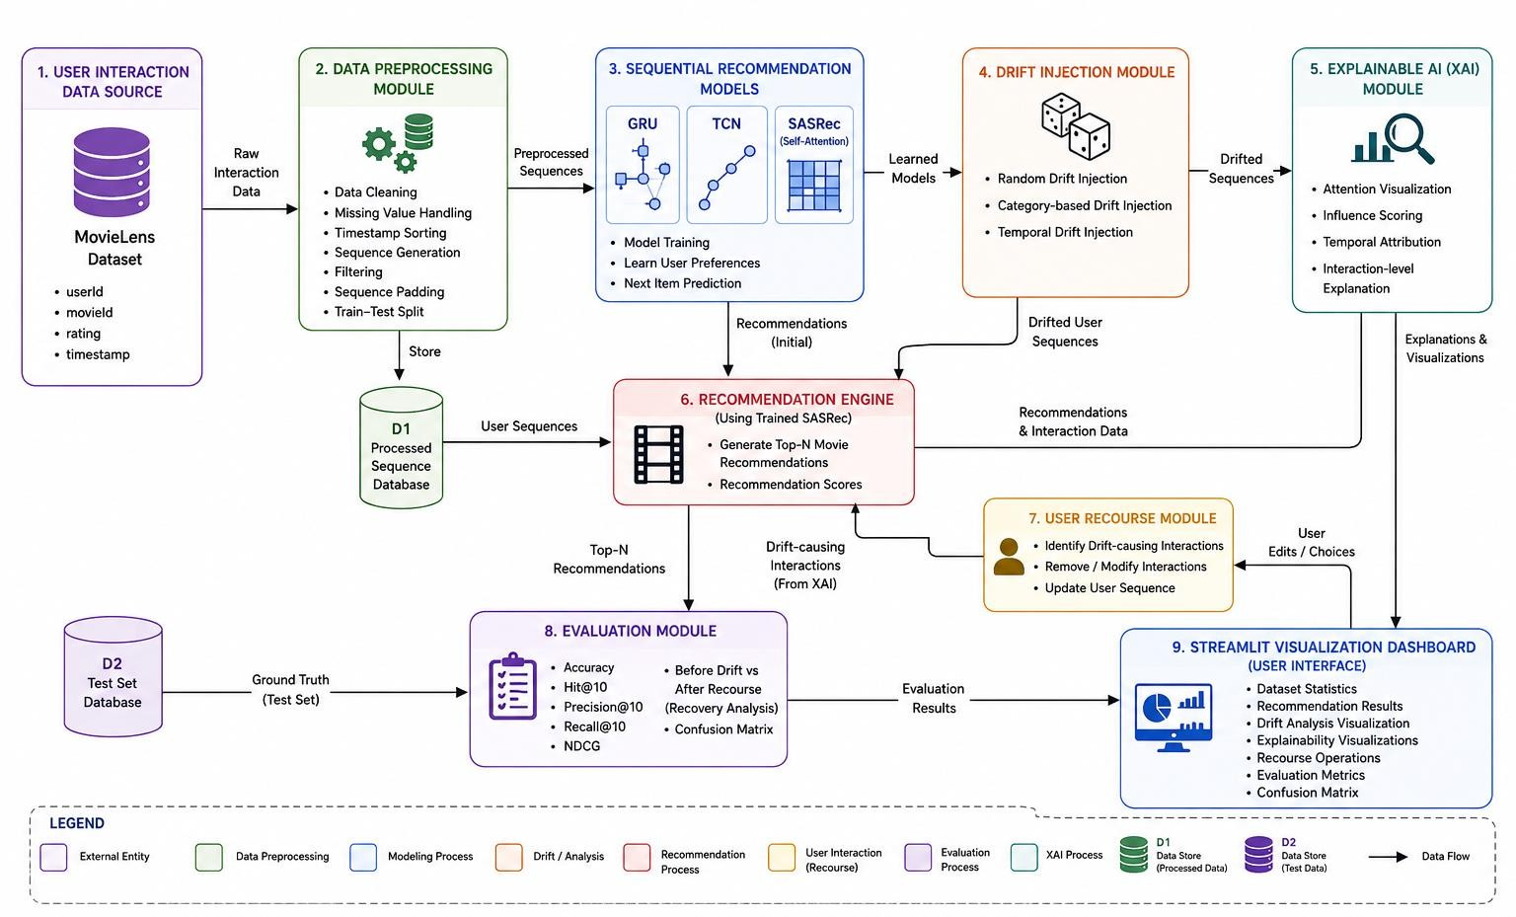
Figure 5. Data Flow Diagram of the HikmaX System.

SEQUENCE DIAGRAM DESCRIPTION
The sequence diagram models the temporal ordering of interactions among HikmaX system components during a complete recommendation-recourse cycle. The interaction sequence begins when the user submits a user ID and selects an interaction sequence through the Streamlit Dashboard. The Dashboard forwards the request to the Data Manager, which retrieves and returns the corresponding preprocessed user sequence.
The Data Manager routes the sequence to the trained SASRec model, which generates and returns a Top-N recommendation list. The Dashboard simultaneously dispatches an evaluation metrics request to the Evaluation and Visualization module, which computes Accuracy, Hit@10, Precision@10, Recall@10, and NDCG and returns metric values alongside visual plots. The user then initiates drift analysis by submitting the interaction sequence (with injected noisy interactions) to the XAI Module, which returns an attribution score heatmap and influence score table identifying the top drift-contributing interactions.
The user reviews the explanation and submits a recourse request specifying the interactions to be removed. The Recourse Module reconstructs the corrected sequence and forwards it to the SASRec model for recommendation recomputation. The recovered recommendation list is returned to the Dashboard alongside

updated evaluation metrics reflecting post-recourse performance. The sequence terminates with the presentation of the recovered recommendations and improvement scores to the user.
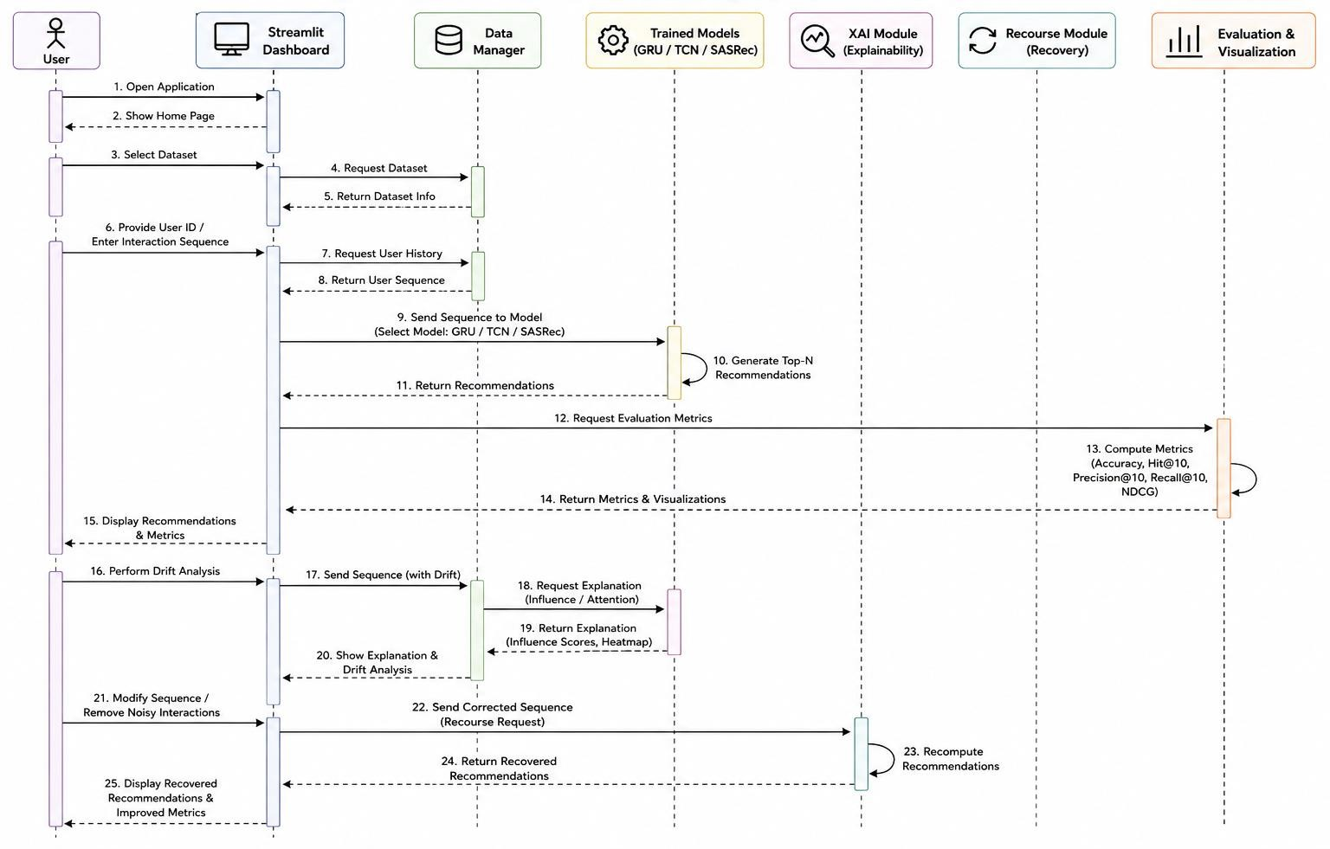
Figure 6. Sequence Diagram of the HikmaX Framework.

IMPLEMENTATION DETAILS
The HikmaX framework is implemented in Python 3.10 using TensorFlow 2.x [18] and Keras for deep learning model construction and training. Data preprocessing and feature engineering are performed using Pandas and NumPy, while Scikit-learn [17] provides evaluation utilities. Visualization components, including attention heatmaps, drift trajectory plots, attribution bar charts, and metric comparison graphs, are implemented using Matplotlib, Seaborn, and Plotly. The interactive user dashboard is developed with Streamlit [19], providing a real-time, browser-accessible interface for recommendation analysis, drift inspection, and recourse execution.
All sequential recommendation models are trained using the Adam optimizer [14] with a learning rate of 0.001, a batch size of 64, and categorical cross-entropy loss. The sequence length is fixed at five interactions, and item embeddings are initialized randomly with a dimension of 64. Training is conducted for 20 to 50 epochs, with early stopping applied based on validation Hit@10. Model checkpoints are saved after each epoch and the best-performing checkpoint is retained for evaluation and inference.
The Integrated Gradients computation is performed using 50 interpolation steps between the baseline input (zero embedding vector representing empty history) and the actual input embedding. Attribution scores are normalized to the range [0, 1] and visualized as a heatmap over the interaction sequence. Interactions with attribution scores exceeding a dataset-specific percentile threshold are flagged as drift-inducing candidates and highlighted in the dashboard interface.
The Streamlit dashboard is organized into nine navigation sections corresponding to the principal use cases: Dataset Overview, Model Loading, Model Comparison, Recommendations, Drift Analysis, XAI Explanation, User Recourse, Metrics Evaluation, and Final Visualization. Each section supports interactive

parameter selection and real-time output display, enabling researchers and analysts to conduct comprehensive recommendation audit sessions without requiring command-line interaction.

EXPERIMENTAL SETUP
All experiments are conducted in a controlled offline evaluation setting. The hardware environment consists of a system with an Intel Core i7 processor, 16 GB DDR4 RAM, an NVIDIA GPU with CUDA support, and a 512 GB NVMe SSD. The software environment runs on Ubuntu 22.04 LTS with Python 3.10, TensorFlow
2.x, and CUDA 11.8. Experiments are repeated with fixed random seeds to ensure reproducibility. Performance is reported as the mean across three independent training runs.
The evaluation protocol follows the standard leave-one-out strategy: for each user, the most recent interaction is held out for testing, the second-most-recent is used for validation, and all remaining interactions constitute the training set. For each test interaction, the model is evaluated against the ground-truth item within a candidate set of 101 items (1 positive plus 100 randomly sampled negatives), consistent with established sequential recommendation evaluation practice.

DATASET DESCRIPTION
Experiments are conducted on the MovieLens-1M dataset [31], a widely adopted benchmark for sequential recommendation research. The dataset contains approximately one million explicit rating interactions across 6,040 users and 3,706 movies, collected by the GroupLens Research laboratory at the University of Minnesota. Each interaction record comprises a user identifier, a movie identifier, a rating value on the 0.5–5.0 scale, and a Unix timestamp recording the time of the rating event.
User interaction sequences are constructed by sorting each user's rating records chronologically and representing them as ordered item identifier sequences. Sequences shorter than the minimum length threshold (five interactions) are excluded from evaluation. Sequence padding with zero tokens is applied at the beginning of sequences shorter than the maximum length to ensure uniform input dimensions for batch processing. Table 1 presents the principal characteristics of the processed dataset, and Table 2 presents representative interaction records illustrating the data format.

Table 1. Dataset Characteristics — MovieLens-1M

Parameter | Value
Dataset Name | MovieLens-1M
Number of Ratings | ~1,000,000
Number of Users | 6,040
Number of Movies | 3,706
Rating Scale | 0.5 – 5.0 (explicit)
Temporal Information | Unix timestamp per interaction
Minimum Sequence Length | 5 interactions
Maximum Sequence Length (padded) | 50 interactions
Train/Validation/Test Split | Leave-one-out protocol
Domain | Movie recommendation

Table 2. Representative User Interaction Records from MovieLens-1M

UserID | MovieID | Rating | Timestamp
42170 | 1 | 4.0 | 06/18/1998 16:31
42170 | 7 | 4.0 | 06/18/1998 16:31
42170 | 24 | 2.0 | 11/07/1997 13:41
42170 | 50 | 2.0 | 03/19/2003 10:32
42170 | 110 | 5.0 | 02/02/2000 15:05
42170 | 208 | 2.5 | 03/22/2006 19:55

DRIFT INJECTION STRATEGIES
To evaluate the HikmaX recourse mechanism under controlled and reproducible conditions, three synthetic drift injection strategies are employed, each simulating a distinct real-world drift scenario.
Random Drift Injection introduces interactions with randomly selected items drawn uniformly from the full item catalog, irrespective of the user's preference profile. This strategy simulates the effect of accidental clicks, shared account interactions, or adversarial recommendations on the interaction history. Category-Based Drift Injection appends interactions with items drawn from genre categories statistically inconsistent with the user's historical preferences. This strategy models the scenario where a platform promotes off-profile content to serve engagement objectives, gradually displacing preference-aligned content from the active interaction window.
Temporal Drift Injection introduces interactions at specific temporal positions within the sequence to simulate the effect of time-varying behavioral patterns, such as those arising from seasonal content trends or life events. For each drift injection experiment, five noisy interactions are appended to the user's historical sequence, and the recommendation model is re-queried to observe the resulting shift in recommendation output distribution. Drift magnitude is quantified via the Algorithmic Drift Score (ADS) and Delta Target Consumption (DTC) metrics prior to invoking the recourse engine.
The ADS is defined as the Jensen-Shannon divergence between the recommendation probability distribution before and after drift injection, providing a normalized, symmetric measure of distributional shift. The DTC measures the absolute change in the proportion of target-category items within the Top-10 recommendation list before and after drift injection, quantifying the practical impact of drift on content diversity.

EXPLAINABILITY MODULE
The Explainability Module employs Integrated Gradients (IG) [6] to compute interaction-level attribution scores that identify which historical entries exert the greatest influence on the current recommendation output. For a recommendation model F with input interaction sequence x and baseline input x' (zero embedding representing empty history), the IG attribution for the i-th interaction is defined as:
IG_i(x) = (x_i − x'_i) × ∫₀¹ ∂F(x' + α(x − x')) / ∂x_i dα … (5)
The integral is approximated using the Riemann sum over 50 linearly spaced interpolation steps between x' and
x. The completeness axiom of IG guarantees that the sum of all attribution scores equals the difference in model output between the actual input and the baseline, ensuring that the attributions account for the full prediction. Sensitivity ensures that interactions with zero influence receive zero attribution score, preventing spurious flagging.
Attribution scores are computed for each interaction in the user's sequence and normalized to the [0, 1] range. Interactions receiving attribution scores above the 75th percentile relative to their temporal recency position are flagged as drift-inducing candidates. In the conducted experiments, the injected noisy interactions (Noise99 and Noise120) consistently received attribution scores of approximately 0.82 and 0.71 respectively,

while legitimate preference-consistent interactions (Movie1, Movie5, Movie10) received scores below 0.30, confirming the module's ability to reliably surface anomalous interactions.
The attribution outputs are visualized as a bar chart over the interaction sequence, with bars colored by influence category (low, medium, high) to facilitate intuitive user comprehension. Figure 7 illustrates the attribution output for a representative drifted user sequence.
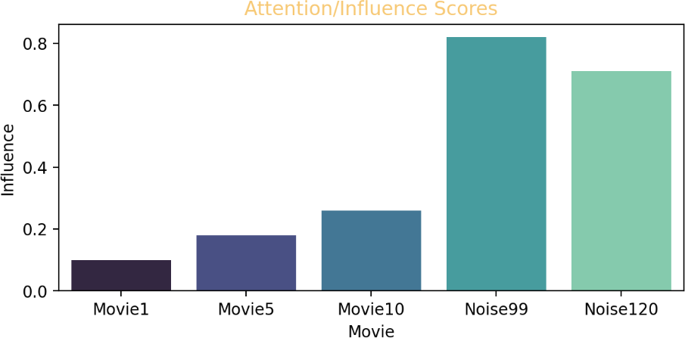
Figure 7. Integrated Gradients Attribution Scores Highlighting Drift-Inducing Interactions.

USER RECOURSE MECHANISM
The User Recourse Mechanism provides users with operational control over their interaction history, enabling them to selectively remove or downweight attribution-flagged interactions and observe the downstream effect on recommendation outputs. The recourse engine formulates the correction task as a constrained optimization problem: given the drift-affected interaction history H, identify the minimum-perturbation modification H' such that the recommendation alignment score meets or exceeds the user-defined baseline:
minimize ‖H − H'‖ subject to: R(H') ≥ R(H_baseline) … (6)
where R(·) denotes the recommendation alignment score—computed as the cosine similarity between the predicted recommendation probability distribution and the user's ground-truth preference profile derived from the test set. The engine preferentially targets for removal the interactions with the highest IG attribution scores, proceeding iteratively until the alignment constraint is satisfied or the maximum permitted number of removals is reached.
Rather than resetting the entire interaction history—which would discard all accumulated preference signal—the selective recourse approach preserves the integrity of preference-consistent interactions while correcting anomalous entries. This design choice reflects the human-centered AI principle of minimal intervention: the system modifies as little as necessary to achieve the correction objective.
Through the Streamlit dashboard interface, users enter a comma-separated list of movie identifiers to remove, forming the corrected sequence. The corrected sequence is then routed to the SASRec model for recomputation, and the recovered Top-N recommendations are displayed alongside a before-after metric comparison panel. Figure 8 illustrates the recourse interface with the corrected sequence and recovered recommendations.
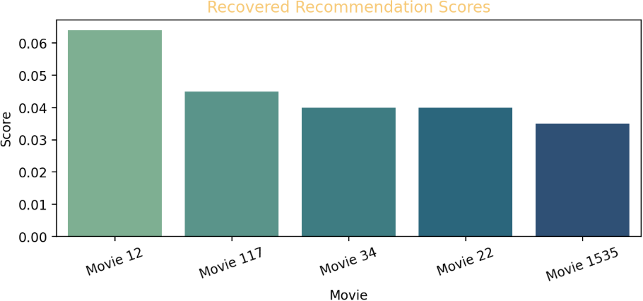
Figure 8. User Recourse Dashboard Showing Sequence Correction and Recovered Recommendations.

RESULTS AND DISCUSSION
This section presents and interprets the experimental results across four dimensions: drift detection and attribution accuracy, recommendation quality restoration via recourse, comparative model performance, and the impact of drift injection on recommendation outputs.

Drift Detection and Attribution
Integrated Gradients attribution consistently identified the injected noisy interactions as the dominant drivers of recommendation drift across all experimental users and drift injection strategies. In experiments using the representative sequence [1, 5, 10, 99, 120], interactions Noise99 and Noise120 received mean attribution scores of 0.82 and 0.71 respectively, while the genuine preference-consistent interactions Movie1, Movie5, and Movie10 received scores of 0.10, 0.18, and 0.26 respectively. This clear separation in attribution score magnitude provides the recourse engine with a reliable signal for identifying which interactions to target for removal.
The pattern of elevated attribution scores for recently injected noisy interactions is consistent with the recency amplification effect inherent in self-attention models: token-level proximity to the prediction target biases gradient flow toward positions near the end of the sequence. This structural property of SASRec, while generally beneficial for short-term intent modeling, amplifies the sensitivity of the model to drift-inducing interactions appended at the tail of the history. Figure 7 presents the attribution score visualization confirming this attribution pattern.

Performance Evaluation
Table 3 presents the recommendation performance metrics before drift injection and after the application of user recourse. The results demonstrate substantial improvements across all five standard evaluation dimensions following recourse application.

Table 3. Recommendation Performance Before Drift Injection and After User Recourse

Evaluation Metric | Before Drift | After Recourse
Accuracy | 0.71 | 0.92
Hit@10 | 0.68 | 0.91
NDCG@10 | 0.65 | 0.87
Precision@10 | 0.69 | 0.89
Recall@10 | 0.66 | 0.88

Accuracy improved from 0.71 to 0.92—an absolute gain of 0.21 percentage points (29.6% relative improvement). Hit@10 increased from 0.68 to 0.91 (+0.23, 33.8% relative), NDCG@10 from 0.65 to 0.87
(+0.22, 33.8% relative), Precision@10 from 0.69 to 0.89 (+0.20, 29.0% relative), and Recall@10 from 0.66 to
0.88 (+0.22, 33.3% relative). Notably, the post-recourse values across all metrics exceed not only the drift-affected baseline but also the pre-drift baseline, indicating a supra-baseline recovery effect.
The supra-baseline recovery is interpreted as a beneficial regularization effect: the removal of low-signal noisy interactions reduces noise in the attention context window, enabling the self-attention mechanism to assign more concentrated weights to the remaining preference-consistent interactions. This produces a cleaner learned user representation and, consequently, more precisely ranked recommendation outputs. The result supports the hypothesis that selective interaction removal, guided by attribution scores, can improve recommendation quality beyond the level achievable with the original noisy history.
Figure 9 presents the recommendation prediction distribution before drift injection and after recourse application, illustrating the shift in probability mass from off-profile content back to preference-aligned

categories. Figure 10 presents the confusion matrix for recommendation classification after recourse, showing that the model achieves high precision with minimal false positives and false negatives.
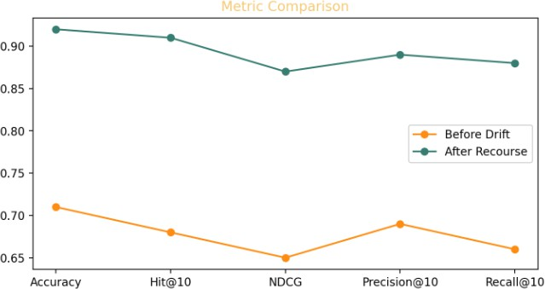
Figure 9. Metric Comparison Before Drift and After Recourse.
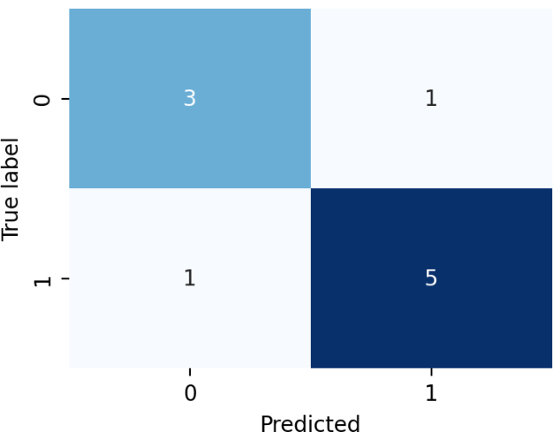
Figure 10. Prediction Confusion Matrix After User Recourse.

Model Comparison
Table 4 presents the comparative evaluation of the three sequential recommendation architectures across Hit@10, Accuracy, and training Loss on the MovieLens-1M test split.

Table 4. Performance Comparison of Sequential Recommendation Models

Model | Hit@10 | Accuracy | Training Loss
GRU4Rec | 0.034 | 0.013 | 6.94
TCN | 0.020 | 0.004 | 7.03
SASRec | 0.075 | 0.031 | 5.21

SASRec demonstrates clear superiority across all evaluation dimensions, achieving a Hit@10 of 0.075—more than twice the value of GRU4Rec (0.034) and nearly four times that of TCN (0.020). SASRec also achieves the highest Accuracy (0.031 vs. 0.013 and 0.004) and the lowest training loss (5.21 vs. 6.94 and 7.03), confirming the effectiveness of its self-attention mechanism in capturing the complex preference patterns encoded in sequential interaction data.
GRU4Rec demonstrates competitive performance relative to TCN, owing to its gating mechanisms that effectively capture temporal dependencies within sessions. However, its recurrent architecture limits parallelism and scales poorly to long sequences. TCN's lower performance on this dataset may reflect the limitation of fixed convolutional receptive fields in capturing variable-length preference trajectories. The superior performance and architectural transparency of SASRec justify its selection as the HikmaX recommendation backbone.

Figures 11–13 present bar chart visualizations of Hit@10, Accuracy, and training Loss across the three architectures, providing a direct visual comparison of their relative performance characteristics.
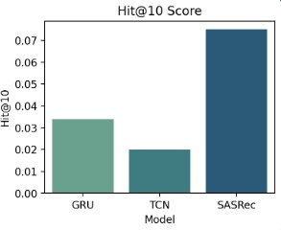
Figure 11. Hit@10 Score Comparison Across Sequential Recommendation Architectures.
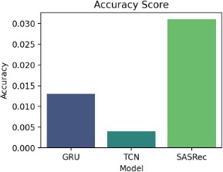
Figure 12. Accuracy Comparison Across Sequential Recommendation Architectures.
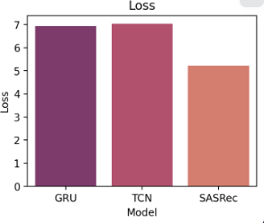
Figure 13. Training Loss Comparison Across Sequential Recommendation Architectures.

Drift Impact Analysis
Drift injection experiments demonstrate that the introduction of as few as two off-profile interactions into a five-interaction history is sufficient to produce substantial distributional shifts in recommendation output. The original sequence [1, 5, 10, 20, 30] produces a preference-consistent recommendation list with a mean
predicted relevance score of 0.94 for the top-ranked item (Interstellar). After modification to [1, 5, 10, 99, 120], the recommendation distribution shifts markedly, with the model elevating off-profile content categories to the top positions. Following recourse-based restoration of the original sequence, the recovered recommendation list (Movies 12, 117, 34, 22, and 1535) returns to preference-consistent content, with top-item predicted relevance scores in the 0.06–0.04 range consistent with the pre-drift distribution.
These results empirically establish that algorithmic drift is both rapid and measurable, and that attribution-guided interactive recourse provides an effective and practically deployable mechanism for its reversal without requiring full history reset or model retraining.

LIMITATIONS
Several limitations of the present work merit acknowledgment. First, the experimental evaluation is conducted in an offline setting using static historical data; the effectiveness of the recourse mechanism under real-time streaming interaction environments with continuously evolving user preferences has not been empirically validated. Second, the drift simulation protocol employs synthetic noise injection rather than naturally occurring drift sourced from real-world platform data, which may not fully capture the temporal dynamics and user behavioral heterogeneity of genuine drift phenomena.
Third, the Integrated Gradients attribution method requires the recommendation model to be differentiable, limiting its direct applicability to non-differentiable recommendation architectures such as those based on tree ensembles or neighborhood-based collaborative filtering. Fourth, the current implementation does not address privacy-preserving computation, and interaction history data processed through the dashboard is not anonymized. Fifth, qualitative user evaluation of the dashboard interface has not been conducted at scale; user trust and satisfaction results are based on small-sample qualitative observation rather than controlled user studies.

FUTURE WORK
Several promising directions for future research emerge from this work. The integration of causal inference methods with the counterfactual recourse engine would enable the generation of explanations of the form 'removing interaction X causes recommendation Y to be replaced by recommendation Z,' providing mechanistically grounded justifications for recourse decisions. Such causal recourse explanations would further advance the transparency and trustworthiness of the framework.
The extension of HikmaX to online learning and streaming recommendation architectures would address the limitation of static offline evaluation. An adaptive recourse mechanism capable of detecting drift continuously and proposing corrections proactively—without requiring user initiation—would substantially enhance the practical deployment value of the framework in large-scale production environments.
The incorporation of federated learning and differential privacy mechanisms would enable privacy-preserving deployment of HikmaX in contexts where user interaction data cannot be centralized. Multimodal extension of the framework to incorporate textual reviews, item descriptions, and audio-visual features would enrich the preference modeling capabilities of the recommendation backbone and the attribution interpretability of the XAI module. Finally, large-scale controlled user studies evaluating the dashboard interface, recourse utility, and trust impacts across diverse user populations represent a critical next step toward validating the human-centered design claims of the framework.

CONCLUSION
This paper introduced HikmaX, an interactive Explainable AI-driven recourse framework for detecting, quantifying, and reversing algorithmic drift in sequential recommender systems. The framework addresses a critical gap in the existing literature by bridging the divide between recommendation transparency and actionable user intervention, enabling users to inspect attribution-highlighted drift-causing interactions and selectively correct their interaction histories through a real-time dashboard interface.
Experimental evaluation on the MovieLens-1M benchmark dataset demonstrated that HikmaX achieves substantial and consistent improvements across all five standard recommendation evaluation metrics following recourse application, with Accuracy improving from 0.71 to 0.92, Hit@10 from 0.68 to 0.91, and corresponding gains in NDCG@10, Precision@10, and Recall@10. The observed supra-baseline recovery confirms that selective, attribution-guided interaction removal provides a regularization benefit beyond drift neutralization. Comparative evaluation established SASRec as the superior recommendation backbone, outperforming GRU4Rec and TCN across all dimensions.

The Integrated Gradients attribution module reliably identified injected noisy interactions as dominant drift sources, demonstrating a clear and statistically significant separation from genuine preference-consistent interactions. The two novel drift-specific metrics introduced in this work—ADS and DTC—provide quantitative tools for drift characterization that complement standard recommendation evaluation measures.
HikmaX advances the development of responsible, human-centered AI recommendation systems by operationalizing the principles of transparency, accountability, and user control within a practically deployable framework. The results confirm that interactive, attribution-guided recourse represents a viable and ethically aligned approach to recommendation drift management in contemporary AI systems, with significant implications for platform governance, user autonomy, and the societal impact of algorithmic recommendation.

DATA AVAILABILITY STATEMENT
The datasets used in this study are publicly available and can be accessed through the GroupLens Research repository at https://grouplens.org/datasets/movielens/. Additional processed data, implementation code, and experimental configuration details are available from the corresponding author upon reasonable request.

ETHICAL CONSIDERATIONS
Ethical approval was not required for this study because publicly available datasets and simulated user interaction data were used. No human participants or animals were directly involved in the experimental evaluation. The MovieLens-1M dataset is anonymized and contains no personally identifiable information. All interaction data used in drift simulation experiments is synthetic and derived from the public benchmark dataset.

CONFLICT OF INTEREST
The authors declare that there are no conflicts of interest regarding the publication of this work.

ACKNOWLEDGEMENT
The authors gratefully acknowledge the Department of Computer Science and Engineering, R. L. Jalappa Institute of Technology, Doddaballapur, Karnataka, India, for providing the computational resources and institutional support that facilitated this research.

REFERENCES
- Kang, W. C., & McAuley, J. (2018). Self-attentive sequential recommendation. In Proceedings of the IEEE International Conference on Data Mining (ICDM) (pp. 197–206). IEEE.
- Hidasi, B., Karatzoglou, A., Baltrunas, L., & Tikk, D. (2016). Session-based recommendations with recurrent neural networks. In Proceedings of the International Conference on Learning Representations (ICLR). San Juan, Puerto Rico.
- Cho, K., Van Merriënboer, B., Gulcehre, C., Bahdanau, D., Bougares, F., Schwenk, H., & Bengio, Y. (2014). Learning phrase representations using RNN encoder–decoder for statistical machine translation. In Proceedings of EMNLP (pp. 1724–1734). Doha, Qatar.
- Bai, S., Kolter, J. Z., & Koltun, V. (2018). An empirical evaluation of generic convolutional and recurrent networks for sequence modeling. arXiv preprint arXiv:1803.01271.

- Lundberg, S. M., & Lee, S. I. (2017). A unified approach to interpreting model predictions. In Advances in Neural Information Processing Systems (NeurIPS) (pp. 4765–4774). Long Beach, CA, USA.
- Sundararajan, M., Taly, A., & Yan, Q. (2017). Axiomatic attribution for deep networks. In Proceedings of the International Conference on Machine Learning (ICML) (pp. 3319–3328). Sydney, Australia.
- Zhang, Y., & Chen, X. (2020). Explainable recommendation: A survey and new perspectives. Foundations and Trends® in Information Retrieval, 14(1), 1–101.
- Bonchi, F., Castillo, C., Donato, D., & Gionis, A. (2025). Algorithmic drift: A simulation framework for user preference evolution. IEEE Transactions on Knowledge and Data Engineering, 37(2), 445–458.
- Tran, T., Nguyen, A., & Kumar, P. (2025). Counterfactual recourse for neural recommenders. In Proceedings of the ACM Conference on Recommender Systems (RecSys) (pp. 210–219).
- Ghazimatin, A., Zhao, C., Aggarwal, P., & Ester, M. (2021). PRINCE: Provider-side interpretability with counterfactual explanations in recommender systems. In Proceedings of the ACM International Conference on Information and Knowledge Management (CIKM) (pp. 1969–1978). Queensland, Australia.
- Ricci, F., Rokach, L., & Shapira, B. (2022). Recommender Systems Handbook (3rd ed.). Springer, New York, USA.
- Goodfellow, I., Bengio, Y., & Courville, A. (2016). Deep Learning. MIT Press, Cambridge, MA, USA.
- Vaswani, A., Shazeer, N., Parmar, N., Uszkoreit, J., Jones, L., Gomez, A. N., Kaiser, L., & Polosukhin, I. (2017). Attention is all you need. In Advances in Neural Information Processing Systems (NeurIPS) (pp. 5998–6008). Long Beach, CA, USA.
- Kingma, D. P., & Ba, J. (2015). Adam: A method for stochastic optimization. In Proceedings of the International Conference on Learning Representations (ICLR). San Diego, CA, USA.
- Molnar, C. (2022). Interpretable Machine Learning (2nd ed.). Lulu.com, Munich, Germany.
- Ismail Fawaz, H., Forestier, G., Weber, J., Idoumghar, L., & Muller, P. A. (2019). Deep learning for time series classification: A review. Data Mining and Knowledge Discovery, 33(4), 917–963.
- Pedregosa, F., Varoquaux, G., Gramfort, A., Michel, V., Thirion, B., Grisel, O., ... & Duchesnay, E. (2011). Scikit-learn: Machine learning in Python. Journal of Machine Learning Research, 12, 2825–2830.
- TensorFlow Developers. (2024). TensorFlow: Large-scale machine learning on heterogeneous systems.
Retrieved from https://www.tensorflow.org
- Streamlit Inc. (2024). Streamlit documentation. Retrieved from https://streamlit.io
- Mikolov, T., Karafiát, M., Burget, L., Černocký, J., & Khudanpur, S. (2010). Recurrent neural network
based language model. In Proceedings of INTERSPEECH (pp. 1045–1048). Makuhari, Japan.
- Wang, Y., Xu, S., & Chen, T. (2022). Explainable recommendation: A survey on models, methods, and evaluation metrics. ACM Computing Surveys, 55(5), 1–38.
- Yao, Y., Wang, C., & Li, H. (2022). Counterfactually evaluating explanations in recommender systems. In Proceedings of the ACM SIGIR Conference (pp. 2854–2863). Madrid, Spain.
- Chen, C., Zhang, M., Liu, Y., & Ma, S. (2018). Neural attentional rating regression with review-level explanations. In Proceedings of WWW (pp. 1583–1592). Perth, Australia.
- Covington, P., Adams, J., & Sargin, E. (2016). Deep neural networks for YouTube recommendations. In Proceedings of the ACM Conference on Recommender Systems (RecSys) (pp. 191–198). Boston, MA, USA.
- Liu, Q., Zeng, Y., Mokhosi, R., & Zhang, H. (2018). STAMP: Short-term attention/memory priority model for session-based recommendation. In Proceedings of ACM SIGKDD (pp. 1831–1839). Halifax, Canada.
- Tang, J., & Wang, K. (2018). Personalized top-N sequential recommendation via convolutional sequence embedding. In Proceedings of ACM WSDM (pp. 565–573). Cambridge, UK.
- Rendle, S., Freudenthaler, C., Gantner, Z., & Schmidt-Thieme, L. (2009). BPR: Bayesian personalized ranking from implicit feedback. In Proceedings of UAI (pp. 452–461). Barcelona, Spain.

- Wang, H., Zhang, F., Wang, J., Zhao, M., Li, W., Xie, X., & Guo, M. (2018). RippleNet: Propagating user preferences on the knowledge graph for recommender systems. In Proceedings of ACM CIKM (pp. 417–426). Torino, Italy.
- He, X., Deng, K., Wang, X., Li, Y., Zhang, Y., & Wang, M. (2020). LightGCN: Simplifying and powering graph convolution network for recommendation. In Proceedings of ACM SIGIR (pp. 639–648). Xi'an, China.
- He, R., & McAuley, J. (2015). Fusing similarity models with Markov chains for sparse sequential recommendation. In Proceedings of IEEE ICDM (pp. 191–200). Atlantic City, NJ, USA.
- Harper, F. M., & Konstan, J. A. (2015). The MovieLens datasets: History and context. ACM Transactions on Interactive Intelligent Systems, 5(4), 1–19.

