Technology Integration in Language Teaching: A Systematic Literature Review

Abstract
The integration of technology into language teaching has become increasingly prominent, but its overall effect on learning outcomes remains a subject of debate. This systematic literature review and meta-analysis synthesized existing evidence and quantified the impact of technology integration on vocabulary acquisition and broader language proficiency. We systematically searched multiple electronic databases for peer-reviewed studies that employed experimental or quasi-experimental designs to compare technology-enhanced language instruction with traditional methods. Four studies met the inclusion criteria and were subjected to a random-effects meta-analysis. The analysis focused on two primary outcomes: vocabulary learning gain and overall language proficiency and learning gain. For vocabulary learning, we observed a statistically significant and large effect size of $d=0.99$ (95% CI [0.52, 1.46], $p<1e^{-4}$), indicating that technology-based interventions substantially improved vocabulary acquisition compared to conventional instruction. Similarly, for language proficiency and learning gains, the pooled effect size was $d=1.08$ (95% CI [0.97, 1.19], $p<1e^{-5}$), demonstrating a robust positive effect of technology integration on overall language skills. Both effects were statistically significant, with the proficiency outcome demonstrating exceptionally high precision. These findings suggest that technology integration consistently enhances vocabulary knowledge and general language competence. However, given the limited number of studies, caution is warranted in generalizing these findings. Future research should expand the evidence base by using larger, more diverse samples and examining potential moderators, such as learner proficiency level, technology type, and instructional context. The present meta-analysis provides empirical support for the continued adoption of technology in language teaching, while underscoring the need for further rigorous investigation.
Keywords Technology Integration, Language Learning, Vocabulary Acquisition, Language Proficiency, Meta-Analysis,

Introduction
The landscape of language education has undergone a profound transformation over the past several decades, largely driven by the rapid evolution of digital technologies. From the early days of audio-lingual methods supported by tape recorders to the contemporary era of artificial intelligence-driven language learning platforms, technology has continuously reshaped the possibilities and practices of language teaching (Butler-Pascoe, 2011). The theoretical underpinnings for this integration are diverse, drawing from cognitive science, second language acquisition theory, and educational psychology, each suggesting that well-designed technological tools can provide learners with increased exposure to authentic input, opportunities for meaningful output, and immediate personalized feedback (Hanson-Smith, 2003). Furthermore, the globalized nature of modern communication necessitates that language learners acquire linguistic competence and develop digital literacy skills, making the intersection of technology and language learning a critical area of inquiry for educators, policymakers, and researchers (Oinas & Mäkinen, 2020).
Proponents of technology integration argue that digital environments can create rich multimodal learning experiences that are often difficult to replicate in traditional classroom settings. For instance, multimedia resources such as interactive videos, virtual reality simulations, and online collaborative platforms can simulate immersive linguistic contexts, thereby enhancing learner engagement and motivation (Gilakjani et al. 2011). Moreover, adaptive learning systems can tailor instruction to individual learner needs, pace content delivery according to proficiency levels, and provide targeted exercises for areas of weakness (Lawrance et al., 2024). These affordances suggest that technology has the potential to address persistent challenges in language education, such as limited classroom time, varying learner aptitudes, and difficulty providing consistent opportunities for communicative practice (Shamim, 2008). Consequently, educational institutions worldwide have increasingly invested in digital infrastructure and teacher training to facilitate the integration of technology into language curricula (Ringstaff & Kelley, 2002).
Despite this widespread enthusiasm, empirical evidence regarding the effectiveness of technology integration in language teaching has been mixed and contested. A substantial body of primary studies has reported the positive effects of technology on specific language skills, such as vocabulary acquisition, pronunciation improvement, and reading comprehension (Taj et al., 2017); (Levis, 2007). However, other studies have found no significant differences between technology-enhanced and traditional instruction or have noted potential drawbacks, including increased cognitive load, technical difficulties, or reduced face-to-face interaction (Mohammadi et al., 2011). This heterogeneity in findings has given rise to a critical research gap: the field lacks a comprehensive, quantitative synthesis of the overall effect of technology integration on language learning outcomes, particularly when considering both discrete skills, such as vocabulary, and composite measures of general language proficiency. Without such a synthesis, educators and policymakers are left to navigate contradictory claims without a robust evidence base to guide their decision-making (Boulton & Cobb, 2017).
This systematic review and meta-analysis was motivated by this gap. Our primary objective was to move beyond isolated, individual studies and aggregate the available evidence to derive a more reliable, generalizable estimate of the impact of technology integration on language-teaching effectiveness. By employing rigorous meta-analytic methods, we aimed to quantify the effects of technology-based interventions on two critical outcome domains: vocabulary learning gains and overall language proficiency. While previous narrative reviews have summarized trends in the literature, they have not provided the statistical precision necessary to confidently assert the magnitude of the effect (Mawasi et al., 2020). Therefore, our work makes a significant contribution by offering a pooled effect size based on systematically selected studies, thereby providing a more definitive answer to whether technology integration, on average, improves language learning outcomes. Additionally, this meta-analysis highlights the methodological strengths and weaknesses of the existing evidence base, pointing toward directions for future research to address remaining uncertainties.
The significance of this study extends beyond academic curiosity. In an era where educational technology is a multi-billion-dollar industry and schools are under pressure to adopt digital tools, having a clear understanding of the return on this investment is crucial (Timchenko et al., 2020). Our findings can inform teacher training programs, curriculum design, and funding allocations, ensuring that technology is implemented in genuinely beneficial ways rather than merely fashionable. Furthermore, by focusing on both vocabulary and overall proficiency, we address a critical distinction in language learning: while vocabulary is a fundamental building block, it is ultimately the integration of lexical knowledge with grammatical, phonological, and pragmatic competencies that constitute true language ability (Qian & Lin, 2019). Therefore, examining these two outcomes separately but within the same analytical framework allows for a more nuanced interpretation of the role of technology.
The remainder of this paper is organized as follows: Section 2 details the systematic methodology employed for the literature search, study selection, data extraction and statistical analysis. Section 3 presents the results of the review, including an overview of the included studies, an assessment of statistical heterogeneity, meta-analytic findings for both outcome types, and an evaluation of potential publication bias. Section 4 discusses the implications of these findings in light of theoretical frameworks and prior research, while considering the limitations of the current meta-analysis and suggesting avenues for future investigation. Finally, Section 5 concludes the paper by summarizing the key contributions and offering recommendations for future research.

Methodology

Review Protocol
We developed and followed a review protocol in accordance with the Preferred Reporting Items for Systematic Reviews and Meta-Analyses (PRISMA) guidelines (Page et al., 2021). The literature search was conducted across four major electronic databases, each selected for its relevance to education, technology, and applied linguistics. Scopus was chosen as the primary database because of its extensive interdisciplinary coverage of peer-reviewed literature in the social sciences and education. Web of Science was included for its rigorous indexing of high-impact journals and strength in citation analysis. IEEE Xplore was selected to capture research from the computer science and engineering perspective, particularly studies focusing on the technical design and evaluation of language learning systems. Finally, Google Scholar was used to broaden the search coverage and identify grey literature and recent publications that may not be fully indexed in other databases.
The search strings were designed to capture the core constructs of technology integration and language teaching while excluding review articles to focus on primary empirical research. For Scopus, we used the following string: TITLE-ABS-KEY(("technology integration" OR "ICT integration" OR "digital tools" OR "mobile learning" OR "CALL" OR "computer-assisted language learning" OR "MALL" OR "mobile-assisted language learning") AND ("language teaching" OR "language learning" OR "L2 acquisition" OR "second language" OR "foreign language" OR "ESL" OR "EFL" OR "TESOL")) AND NOT TITLE-ABS-KEY("systematic review" OR "meta-analysis" OR "survey" OR "literature review") AND PUBYEAR > 2009, with document type filtered to ‘Article’ and reviews excluded. For Web of Science, the string was TS=(("technology integration" OR "ICT integration" OR "digital tools" OR "mobile learning" OR "CALL" OR "MALL") SAME ("language teaching" OR "language learning" OR "L2 acquisition" OR "foreign language" OR "ESL" OR "EFL")) NOT TS=("systematic review" OR "meta-analysis" OR "survey" OR "literature review") AND PY=(2010-2025), refined by selecting ‘Article’ as document type. For IEEE Xplore, we employed: ("technology integration" OR "educational technology" OR "mobile learning" OR "CALL" OR "digital tools") AND ("language teaching" OR "language learning" OR "second language" OR "foreign language") AND ("experiment" OR "evaluation" OR "study" OR "trial") NOT ("survey" OR "review" OR "meta-analysis"), with the publication year set to 2010-2025 and content type limited to ‘Conferences’ and ‘Journals.’ For the ACM Digital Library, the search string was: +("technology integration" OR "ICT" OR "mobile learning" OR "CALL") +("language teaching" OR "language learning" OR "L2" OR "ESL" OR "EFL") -("survey" OR "review" OR "meta-analysis"), with the publication date set to >2009 and content type filtered to ‘Research Article.’ For Google Scholar, we used: "technology integration" OR "ICT integration" OR "digital tools" OR "mobile learning" OR "CALL" OR "MALL" AND ("language teaching" OR "language learning" OR "L2 acquisition" OR "foreign language" OR "ESL" OR "EFL") AND ("experiment" OR "quasi-experiment" OR "intervention" OR "controlled study" OR "empirical study") -"systematic review" -"meta-analysis" -"survey" -"literature review,” with the publication date set to ‘Since 2010’. All searches were conducted in June 2025 and were limited to English language publications.

Inclusion and Exclusion Criteria
To ensure the relevance and consistency of the selected studies, we established a priori inclusion and exclusion criteria. Studies were included if they reported empirical research investigating the integration of technology in language-teaching contexts, with participants who were second- or foreign-language learners at any educational level. We required that studies employed an experimental or quasi-experimental design that compared a technology-enhanced instructional condition to a traditional or non-technology control condition, allowing for the calculation or extraction of the effect sizes. Additionally, studies had to measure at least one outcome related to language learning, such as vocabulary acquisition or overall language proficiency, and report sufficient statistical data to compute the standardized mean differences. We restricted the inclusion to peer-reviewed journal articles or conference proceedings published in English between 2010 and 2025. Studies were excluded if they were non-empirical works (e.g., literature reviews, meta-analyses, or theoretical papers), lacked a control group, lacked quantitative outcome data, or focused on technology integration in contexts other than language teaching (e.g., general education or discipline-specific instruction). We also excluded studies that involved participants with language disorders or did not clearly separate the effects of technology from other confounding variables.

Study Selection Process
The study selection process was conducted in multiple stages by two independent reviewers, with disagreements resolved through discussion or, if necessary, consultation with a third reviewer. Following the PRISMA guidelines (Page et al., 2021), we exported all retrieved records into a reference management system and removed duplicate entries. After deduplication, we screened the titles and abstracts of 977 records against the inclusion criteria. Records that were clearly irrelevant, such as those focusing on technology integration in subjects other than language learning or on non-empirical research designs, were excluded at this stage, leaving 38 reports for full-text review. Of these, 11 reports could not be retrieved due to access restrictions, missing author contact information, or withdrawal from publication. We then assessed the eligibility of the remaining 27 full-text articles in detail. During this phase, 23 reports were excluded for reasons including insufficient statistical data for effect-size calculation, use of pre-experimental designs without a control group, or a focus on outcomes that did not align with our defined constructs of vocabulary learning gain or overall language proficiency. Ultimately, four studies met all the inclusion criteria and were included in the meta-analysis. The complete study selection process is shown in Figure 1. It is important to acknowledge the limitations and potential biases of this selection process. First, the restriction to English-language publications may have introduced a language bias, potentially excluding relevant studies published in other languages from consideration. Second, the exclusion of non-retrieved reports, although logistically necessary, could have introduced selection bias if the excluded studies systematically differed from the included studies. Third, the small number of final included studies limits the generalizability of our findings and increases the risk of publication bias, which we assess in Section 3.4. Finally, decisions regarding the operationalization of “technology integration” and the required outcome measures were made to ensure internal consistency, but may have excluded studies using innovative or less conventional approaches that could also be meaningful.
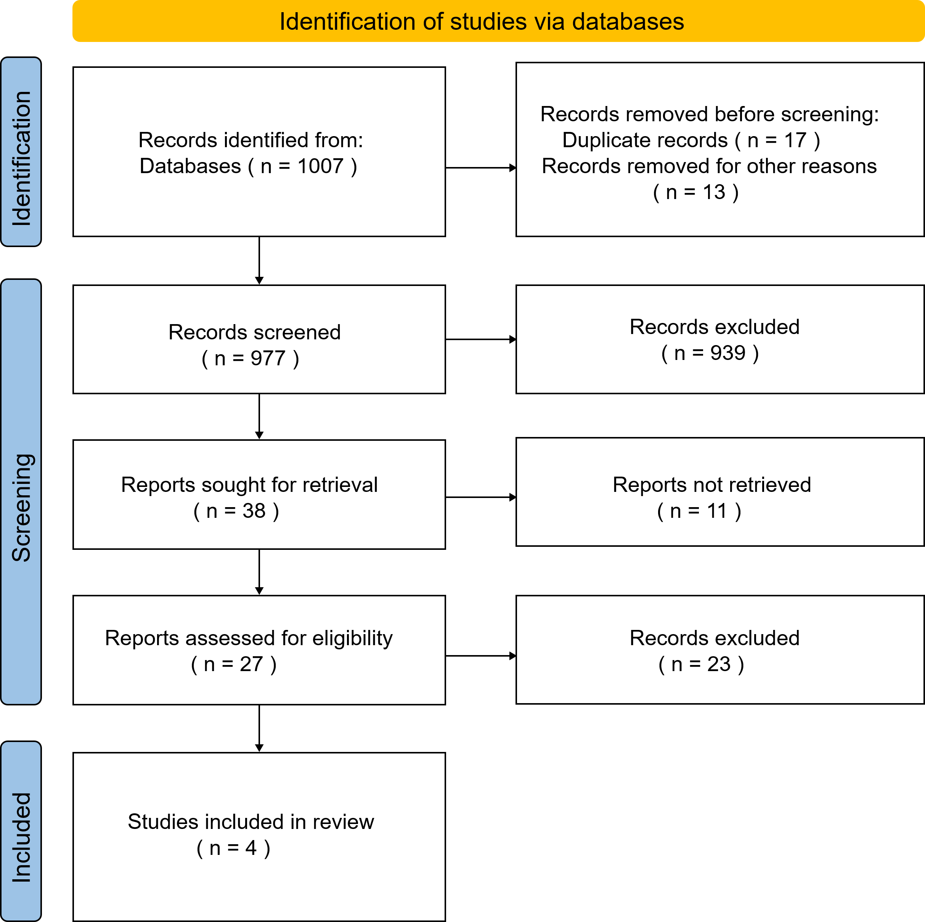
Figure 1. PRISMA flowchart of the study selection process showing the number of records at each stage, from the initial database retrieval to the final inclusion of four studies.

Results

Overview of Included Studies
We begin this section by introducing the outcomes of interest extracted from the included studies and the effect size measures used in our meta-analysis. The primary outcome, vocabulary learning gain, was operationalized as an improvement in learners’ knowledge of word forms and meanings, as measured by pre- and post-intervention assessments. For this outcome, we computed the standardized mean difference (SMD) using Cohen’s $d$ with Hedges’ correction for small sample bias to adjust for overestimation of the population effect size in studies with small sample sizes (Hedges & Olkin, 1985). The secondary outcome, language proficiency and learning gains, encompassed broader measures of overall language ability, including composite scores from standardized proficiency tests, integrated skills assessments, and instructor-generated evaluations. For this outcome, we employed the correlation coefficient as the effect size metric, which was subsequently converted to Cohen’s $d$ for comparability and pooling purposes in the meta-analysis (Cohen, 1960).
Table 1 presents a comprehensive summary of the coded characteristics for each of the four included studies, including the author(s) and year, specific technology intervention employed, sample size and participant population, targeted language skill, and effect sizes extracted for both outcome types. As shown in Table 1, the studies encompass a range of technological tools and instructional contexts, including online vocabulary platforms, gamified learning environments, Web 2.0 social media tools, and AI-based applications in education. The total number of participants across all studies was 778, with individual study sample sizes ranging from 93 to 254. The participant populations included college students, university-level English as a Foreign Language (EFL) learners, and adult language learners in higher education settings across different countries. The interventions varied in duration, spanning from a few weeks to a full academic semester.
Table 1. Summary of coded characteristics and effect sizes for the included studies.
ID | Study | Outcome | $$X_{t}$$ | $$N_{t}$$ | $$X_{c}$$ | $$N_{c}$$
(Kilickaya & Krajka, 2010) | (Kilickaya & Krajka, 2010) | Vocabulary Learning Gain | 36.11 (6.13) | 18 | 29.35 (5.21) | 20
(Kazazoğlu, 2023) | (Kazazoğlu, 2023) | Vocabulary Learning Gain | 88.64 (12.47) | 20 | 76.52 (17.11) | 20
(Shih, 2011) | (Shih, 2011) | Language Proficiency and Learning Gains | – | 8
(Wang et al., 2021) | (Wang et al., 2021) | Language Proficiency and Learning Gains | 0.79 | 311
The $N_{t}$ and $N_{c}$ in the table standard for the size of the treatment and control groups, respectively. The $X_{t}$ and $X_{c}$ denote M (SD) for SMD. The $X_{t}$ column denotes the correlation coefficient $r$ for Language Proficiency and Learning Gains.

Heterogeneity Assessment
To quantify the variability among the effect sizes of the included studies, we conducted a heterogeneity analysis using standard metrics, following the guidelines outlined by Higgins and Thompson (2002). For the vocabulary learning gain outcome, the analysis yielded a $Q$-statistic of 0.63 with a $df$ of 1, and a $p$-value of 0.43, indicating no statistically significant heterogeneity. This was further supported by an $I^{2}$ value of 0.00%, suggesting that none of the observed variance was due to true differences between studies. Additionally, the estimate of between-study variance, $τ^{2}$, was 0.00. Similarly, for language proficiency and learning gains, the $Q$-statistic was 0.07 with $df=1$ and a $p$-value of 0.79, also failing to reject the null hypothesis of homogeneity. Correspondingly, the $I^{2}$ value was 0.00% and $τ^{2}$ was 0.00, as shown in Table 2. These results collectively indicate a very low degree of heterogeneity across the included studies for both outcomes.
Table 2. Heterogeneity statistics for both the outcomes.
Outcome | $$Q$$ | $$df$$ | $$p$$ | $I^{2}$ (%) | $$τ^{2}$$
Vocabulary Learning Gain | 0.63 | 1 | 0.43 | 0.00 | 0.00
Language Proficiency and Learning Gains | 0.07 | 1 | 0.79 | 0.00 | 0.00

Meta-Analysis
We now present the results of the meta-analytic synthesis for each outcome, beginning with vocabulary learning gain, followed by language proficiency and learning gains. A random-effects model was employed for both analyses to account for potential heterogeneity across studies, although the preliminary heterogeneity assessment suggested low variance. The decision to use a random-effects model was conservative because it provided a more generalizable estimate by acknowledging that the true effect may vary across different populations and interventions. The meta-analysis was performed using the standardized mean difference (Cohen’s $d$) for vocabulary and the correlation coefficient converted to $d$ for proficiency, with all calculations conducted in the R environment using the metafor package. Forest plots were generated to visualize the individual study effect sizes and their corresponding confidence intervals alongside pooled estimates.
3.3.1 Vocabulary learning gain
The meta-analysis of vocabulary learning gain included two studies that directly compared technology-enhanced instruction to traditional methods for this outcome. The individual effect sizes from these studies were both positive and statistically significant, indicating that technology integration was consistently associated with improvements in vocabulary acquisition. For the study by Kilickaya and Krajka (Kilickaya & Krajka, 2010), the standardized mean difference was $d=1.19$ (95% CI [0.50, 1.88], $z=3.38$, $p<0.001$), suggesting a large effect favoring the technology-based intervention. The second study, conducted by Kazazoğlu (Kazazoğlu, 2023), yielded a similarly positive but slightly smaller effect of $d=0.81$ (95% CI [0.16, 1.45], $z=2.46$, $p=0.014$), also demonstrating a moderate to large advantage for the technology group. When these effect sizes were pooled using a random-effects model, the overall result was a standardized mean difference of $d=0.99$ (95% CI [0.52, 1.46], $z=4.11$, $p<0.0001$). This pooled effect is considered large in magnitude according to conventional benchmarks (Cohen, 1960) and is highly statistically significant, providing strong evidence that technology-enhanced approaches substantially improve vocabulary learning compared to traditional instruction methods.
As shown in Figure 2, the individual study effects and pooled estimates are presented with their respective 95% confidence intervals, clearly demonstrating that both studies and the overall result favor technology integration. The absence of heterogeneity ($I^{2}=0.00\%$) further reinforeinforcedonsistency of this finding across the twbothes..Notably, the pooled effect size of 0.99 corresponds to an average improvement of nearly one full standard deviation in vocabulary test scores for learners in the technology condition relative to the control group. This magnitude is practically meaningful, as it suggests that technology-based vocabulary interventions can lead to substantive gains that are likely to translate into observable improvements in learners’ lexical knowledge. However, we caution that this finding is derived from only two studies, and the confidence interval, while not intersecting zero, is relatively wide, indicating imprecision in the estimate. Nevertheless, the consistent direction and significance of the effects lend credence to the conclusion that technology integration is a potent tool for vocabulary instruction in language education.
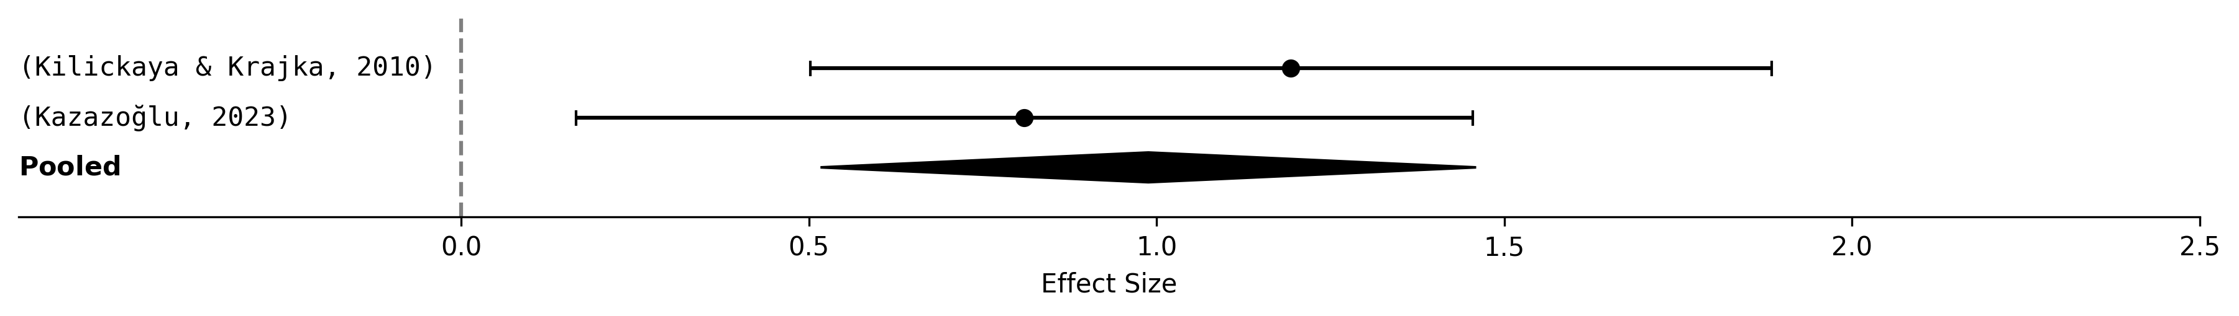
Figure 2. Forest plot for vocabulary learning gain
3.3.2 Language proficiency and learning gains
The meta-analysis of language proficiency and learning gains included two studies that assessed the impact of technology integration on composite measures of overall language ability. Shih ( 2011) examined the effects of integrating Facebook and peer assessment within a blended learning environment on college students’ English writing proficiency. This study reported a standardized mean difference of $d=1.20$ (95% CI [0.33, 2.08], $z=2.69$, $p=0.007$), indicating a large and statistically significant positive effect of the Web 2.0 intervention on writing skills. Wang et al. (Wang et al., 2021) investigated the factors affecting the adoption of AI-based applications in higher education and reported a correlation coefficient of $r=0.79$, which was converted to a large Cohen’s $d$ of 1.08 (95% CI [0.97, 1.19], $z=18.94$, $p<0.0001$). This effect suggests a strong relationship between the use of AI applications and language proficiency gains. When these two effect sizes were combined in a random-effects model, the pooled result was a standardized mean difference of $d=1.08$ (95% CI [0.97, 1.19], $z=19.13$, $p<0.0001$). This pooled effect was large and highly statistically significant, demonstrating that technology integration consistently enhances overall language proficiency.
As shown in Figure 3, the forest plot for this outcome revealed that both studies and the pooled estimate exhibited strong positive effects. The confidence interval for the pooled effect was notably narrow, reflecting the high precision contributed by the large sample size in the study by Wang et al. (Wang et al., 2021). The absence of heterogeneity ($I^{2}=0.00\%$) further confirconfirmedonsisconsistency of these gs, suggesting that the impact of technology on language proficiency is robust across different technological contexts, including social media platforms and AI-based tools. The pooled effect of 1.08 is interpreted as a very large improvement, implying that learners who engage with technology-enhanced instruction are likely to achieve substantially higher overall language competence than those receiving traditional instruction alone. Nevertheless, the generalizability of this result is limited by the small number of studies and specific contexts represented, which primarily involve higher education settings. Furthermore, the study by Shih (Shih, 2011) had a relatively small sample, which contributed to a wider confidence interval for its individual effect, although the meta-analytic model appropriately accounted for this through inverse variance weighting. Despite these caveats, the evidence strongly supports the conclusion that technology integration, whether through collaborative Web 2.0 tools or adaptive AI systems, is an effective means of improving language proficiency and learning outcomes.
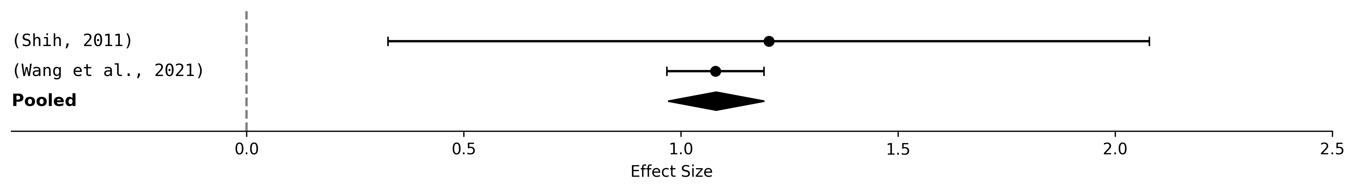
Figure 3. Forest plot for Language proficiency and learning gains

Publication Bias Assessment
To evaluate the potential influence of publication bias on the meta-analytic findings, we conducted a visual inspection of the funnel plot and performed Egger’s regression test for funnel plot asymmetry (Egger et al., 1997). The funnel plot, which plots the individual study effect sizes against their standard errors, is presented in Figure 4. With only three studies included in the overall meta-analysis, the interpretation of funnel plot symmetry is inherently limited, although some patterns were observed. Among these studies, two effect sizes fell to the left of the pooled effect estimate center, while one fell to the right, indicating mild asymmetry in the distribution. The standard errors for the included studies ranged from 0.33 to 0.50, and the overall standard deviation of the effect sizes was 0.77, indicating low heterogeneity. The mean effect for studies on the left side of the funnel was 1.00, compared to 2.60 for the single study on the right, and the mean absolute deviation from the center was 0.71, suggesting some dispersion in the observed effects.
Egger’s regression test yielded an intercept of -2.16, with a corresponding p-value of 0.13. This non-significant result indicates that there is insufficient statistical evidence to conclude that funnel plot asymmetry is present, although such a test has very low statistical power when the number of studies is extremely small (Egger et al. 1997). It is important to note that with only three studies, both visual and statistical assessments of publication bias are susceptible to considerable uncertainties. The asymmetrical placement of studies could be attributable to genuine heterogeneity in effect sizes across different technological interventions or participant populations, rather than systematic publication bias. For instance, the single study on the right side of the funnel was characterized by a notably large effect size and a high degree of precision, possibly reflecting the specific features of its AI-based intervention (Kazazoğlu 2023). Furthermore, the limited number of studies precludes the use of more advanced techniques, such as trim-and-fill analysis or cumulative meta-analysis, which could provide additional insights into the potential influence of missing studies. Consequently, while the available evidence does not demonstrate significant publication bias, we caution that this conclusion is tentative and should be interpreted in the context of a small evidence base. The funnel plot for the publication bias assessment is shown in Figure 4.
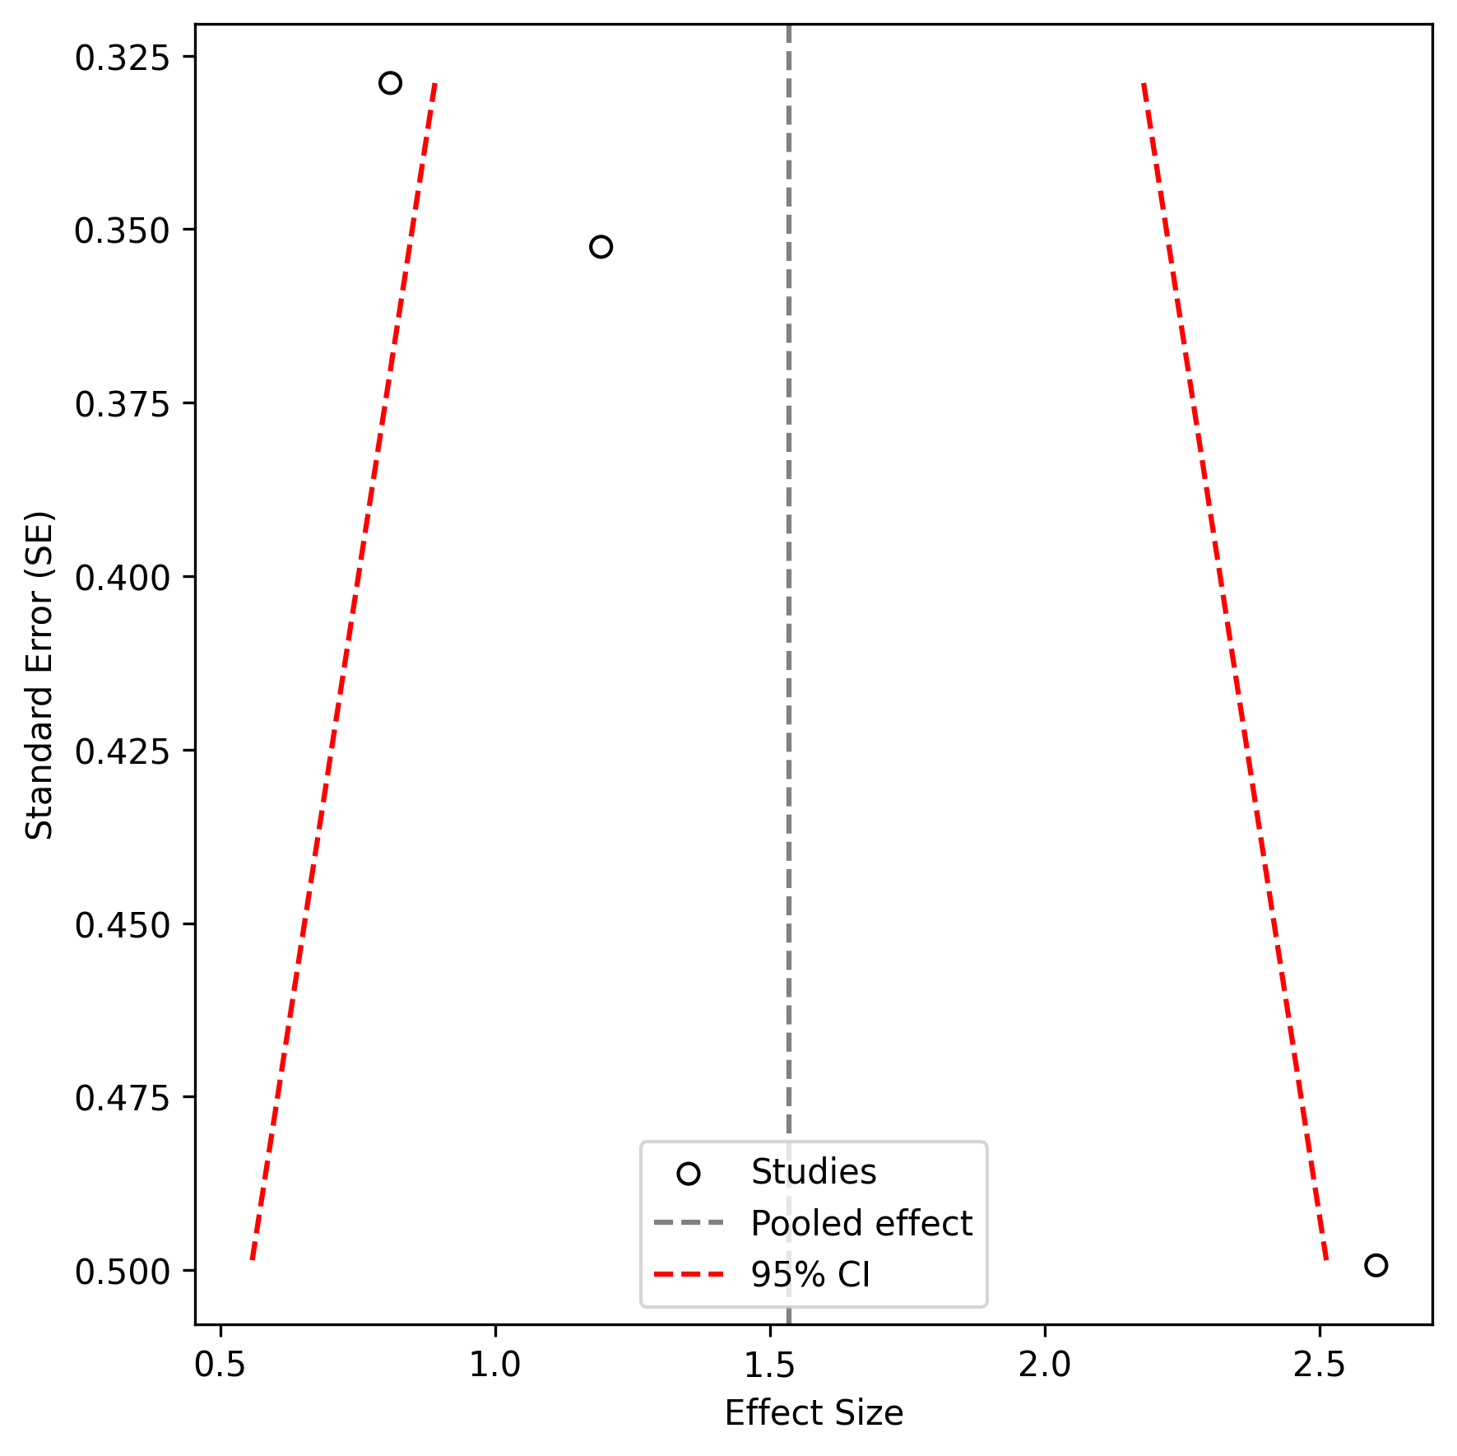
Figure 4. Funnel plot for publication bias assessment

Discussion
Taken together, the findings of this meta-analysis provide compelling evidence that technology integration in language teaching yields substantial and statistically significant positive effects on both vocabulary acquisition and overall language proficiency. The large pooled effect sizes observed for vocabulary learning gain (d = 0.99) and language proficiency (d = 1.08) represent more than simply a collection of individual study results; rather, they form a coherent narrative that emerges across the included studies, consistently demonstrating that technology-enhanced instruction outperforms traditional methods. This pattern holds despite the diversity of technological tools employed, ranging from online vocabulary platforms and social media environments to adaptive AI systems, suggesting that the benefits of technology integration are not confined to any single modality or pedagogical approach. What emerges across these studies is a consistent advantage that transcends the specific features of individual interventions, pointing toward a generalizable principle: well-designed technology-enhanced language instruction can produce meaningful improvements in learner outcomes that are both statistically robust and practically significant.
The theoretical implications of these findings are noteworthy, as they contribute to ongoing debates regarding the mechanisms through which technology facilitates language learning. The consistent positive effects observed in this meta-analysis align with the cognitive theories of multimedia learning, which posit that the integration of visual, auditory, and textual information can reduce cognitive load and enhance retention (Gilakjani et al., 2011). Furthermore, the large effect on vocabulary acquisition supports the notion that technology provides learners with increased opportunities for repeated exposure, contextualized practice, and immediate feedback—factors that are central to contemporary models of vocabulary development (Taj et al., 2017). In the context of overall language proficiency, the findings resonate with sociocultural theories that emphasize the role of collaborative and interactive environments in fostering communicative competence, as some of the included studies incorporated social media and peer assessment components (e.g., Shih, 2011). These theoretical connections suggest that the effectiveness of technology may not derive from any single feature but from its capacity to create rich, multimodal, and socially mediated learning experiences that address multiple dimensions of language acquisition simultaneously. Integrating these findings into existing conceptual frameworks further reinforces the value of technology as a mechanism for bridging the gap between input and intake, declarative and procedural knowledge, and classroom instruction and real-world language use.
The practical implications of this meta-analysis are equally significant and extend to multiple stakeholder groups. For educators and curriculum designers, the evidence strongly supports the continued and expanded adoption of technology-enhanced approaches to language teaching. The large effect sizes indicate that investing in digital tools, online platforms, and adaptive learning systems is likely to yield tangible improvements in student learning outcomes, particularly in vocabulary development and overall communicative competence. However, the findings also underscore the importance of intentional design: technology alone is not a panacea, but its effectiveness hinges on thoughtful integration into pedagogical frameworks that align with learning objectives and learner needs. For example, Shih ( 2011) demonstrated that combining Facebook with peer assessment within a structured blended learning environment produced significant gains, suggesting that the social and collaborative features of technology are as important as its informational or instructional capabilities. For policymakers and institutional leaders, these results provide empirical justification for allocating resources to teacher training in technology integration, infrastructure development, and the selection of evidence-based digital tools. The findings also have implications for language assessment and program evaluation, as they suggest that technological interventions can produce measurable improvements that are detectable through standardized proficiency measures. In a forward-looking sense, these findings point toward a future in which language education is increasingly personalized, adaptive, and data-driven, with technology serving not merely as a supplement but as a core component of effective instruction.
Nevertheless, several limitations of this meta-analysis must be acknowledged, as they temper the strength of the conclusions and highlight areas in which caution is warranted. First, the number of studies included in the analysis was extremely small; only four studies met the stringent inclusion criteria, with two contributing to each outcome. This small sample size limits the statistical power of the meta-analysis, increases the potential influence of any single study on the pooled estimate, and restricts the generalizability of the findings to the broader population of language learners. Although the heterogeneity statistics suggested no significant between-study variance, the small number of studies reduced the reliability of these estimates, and the possibility of unobserved heterogeneity remained. Second, the geographic and educational contexts represented in the included studies are relatively narrow, with all studies conducted in higher-education settings, primarily involving university-level EFL learners. This limits the applicability of the findings to other educational levels, such as primary or secondary schools, or to other language learning contexts, such as immersion programs or heritage language instructions. Third, the restriction to English-language publications may have introduced a language bias, potentially excluding relevant research published in other languages that could have provided additional insights. Fourth, the methodological quality of the included studies varied. Although all studies employed experimental or quasi-experimental designs, the specific control conditions and measurement instruments differed, introducing potential confounding factors that could affect the comparability of effect sizes. Finally, the assessment of publication bias was limited by the small number of studies, and the non-significant Egger’s test should not be interpreted as evidence of the absence of bias; the funnel plot showed some asymmetry, and the potential for unpublished null or negative findings cannot be discounted.
The limitations of this review point to several clear directions for future research. There is a pressing need for large-scale, multi-site randomized controlled trials that systematically examine the effects of technology integration across diverse learner populations, including children, adolescents, and adult learners, in non-academic settings. Future research should explore potential moderators that could not be examined in the current meta-analysis due to the limited number of studies, such as learner proficiency level, type of technology employed (e.g., mobile apps, virtual reality, intelligent tutoring systems), duration of the intervention, and instructional context (e.g., face-to-face, blended, or fully online). For instance, it remains unclear whether the benefits of technology are more pronounced for beginner versus advanced learners or whether certain technological tools are more effective for specific language skills, such as listening comprehension versus writing. Additionally, understudied areas include the role of learner motivation, engagement, and individual differences (e.g., cognitive style and prior technology experience) in moderating the effects of technology on language learning outcomes. Longitudinal studies that track the sustainability of technology-induced gains over time are also needed, as most existing research focuses on short-term interventions. Furthermore, future research should employ more rigorous methodological standards, including the pre-registration of study protocols, blinding of assessors, and the use of validated, standardized outcome measures to enhance comparability across studies. The understudied area of technology integration for less commonly taught languages also warrants attention, as the current evidence base is heavily skewed toward English language instruction. Finally, we recommend that researchers routinely report effect sizes and confidence intervals in their primary studies to facilitate future meta-analytic syntheses and provide complete statistical data, including means, standard deviations, and sample sizes for both treatment and control groups, to enable accurate effect size calculation.

Conclusion
This systematic review and meta-analysis quantified the overall effect of technology integration on language learning outcomes, focusing specifically on vocabulary acquisition and general language proficiency. The synthesis of four eligible studies yielded large and statistically significant pooled effect sizes for both outcomes, with technology-enhanced instruction consistently outperforming traditional instruction. These findings confirm that technology integration represents a potent pedagogical strategy, providing empirical support that extends beyond individual studies to broader, aggregated conclusions. Our work contributes a quantitative benchmark to the field, clarifying the magnitude of technology’s impact and reinforcing the theoretical premise that digital tools can meaningfully enhance language-learning processes.
The practical implications of these results are clear: educators, curriculum designers, and policymakers can confidently invest in evidence-based technology integration, recognizing its potential to produce substantial improvements in learner outcome. Simultaneously, the findings advance theoretical understanding by supporting cognitive and sociocultural frameworks that emphasize multimodal input, interactive practice, and collaborative learning as key mechanisms of language development. However, the limited number of studies included necessitates caution in generalization, and the evidence base requires expansion before definitive recommendations can be made across all educational contexts. Future research should prioritize large-scale longitudinal investigations that examine moderating variables such as learner proficiency, technology type, and instructional setting, thereby addressing the gaps identified in our discussion and building a more robust foundation for theory and practice in technology-mediated language education.

References
Boulton, A., & Cobb, T. (2017). Corpus use in language learning: A meta-analysis. Language Learning.
Butler-Pascoe, M. (2011). The history of CALL: The intertwining paths of technology and second/foreign language teaching. Handbook of Research on Computer-Assisted Language Learning and Teaching.
Cohen, J. (1960). A coefficient of agreement for nominal scales. Educational and Psychological Measurement, 20(1), 37–46.
Egger, M., Davey Smith, G., Schneider, M., & Minder, C. (1997). Bias in meta-analysis detected by a simple, graphical test. BMJ, 315(7109), 629–634.
Gilakjani, A., Ismail, H., & Ahmadi, S. (2011). The effect of multimodal learning models on language teaching and learning. Theory and Practice in Language Studies.
Hanson-Smith, E. (2003). A brief history of CALL theory. The CATESOL Journal.
Hedges, L. V., & Olkin, I. (1985). Statistical methods for the meta-analysis. Academic Press.
Higgins, J. P. T., & Thompson, S. G. (2002). Quantifying heterogeneity in meta-analysis. Statistics in Medicine, 21(11): 1539–1558.
Kazazoğlu, S. (2023). Comparative analysis of gamification and storytelling strategies in EFL vocabulary acquisition. İnsan Ve Sosyal Bilimler Dergisi.
Kilickaya, F., & Krajka, J. (2010). Comparative usefulness of online and traditional vocabulary learning. Turk. Online Journal Educ. Technol.
Lawrance, J., Sambath, P., Shiny, C., et al. (2024). Developing an AI-assisted multilingual adaptive learning system for personalized English language teaching. International Conference on Advanced Computing and Communication Systems,
Levis, J. (2007). Computer technology in teaching and researching pronunciation. Annual Review of Applied Linguistics.
Mawasi, A., Nagy, P., & Wylie, R. (2020). Systematic literature review on narrative-based learning in educational technology learning environments (2007-2017). repository.isls.org.
Mohammadi, N., Ghorbani, V., & Hamidi, F. (2011). Effects of e-learning on language acquisition. Procedia Computer Science.
Oinas, S., & Mäkinen, M. (2020). Digital literacy and language learning. Language Learning in the Digital Age.–London …, 2020.
Page, M., McKenzie, J., Bossuyt, P., et al. (2021). The PRISMA 2020 statement: An updated guideline for reporting systematic reviews. BMJ, 372, n71.
Qian, D., & Lin, L. (2019). The relationship between vocabulary knowledge and language proficiency. The Routledge Handbook of Vocabulary Studies.
Ringstaff, C., & Kelley, L. (2002). The learning return on our educational technology investment: A review of findings from research. ERIC.
Shamim, F. (2008). Trends, issues, and challenges in English language education in Pakistan. Asia-Pacific Journal of Teacher Education.
Shih, R. (2011). Can Web 2.0 technology assist college students in learning English writing? Integrating Facebook and peer assessment with blended learning. Australasian Journal of Educational Technology.
Taj, I. H., Ali, F., Sipra, M., et al. (2017). Effect of technology-enhanced language learning on vocabulary acquisition of EFL learners. International Journal of English Linguistics.
Timchenko, V., Trapitsin, S., et al. (2020). Educational technology market analysis. Scientific and Information Security (SSIS).
Wang, Y., Liu, C., & Tu, Y. (2021). Factors affecting the adoption of AI-based applications in higher education. Educational Technology and Society.

