Architecting the AI-Driven University: Empirical Evidence on Adoption Pathways from Malaysia and Indonesia

ABSTRACT
This paper presents the drives of AI adoption in Malaysian and Indonesian universities. We used survey data collected in 2025 across 12 universities (n = 748 valid responses; response rate 34%) to combine five analytical methods: binary logistic regression, ordinal regression, standardised path modelling, a composite Adoption Index visualised as a heatmap, and k-means machine learning segmentation. The key finding is that people’s perceived usefulness of AI and perceived ease of use are considerably more important in predicting actual use and pleasure than whether they received formal training. Malaysian respondents were around 2.5 times more likely to have participated in AI training (OR = 2.47, p < .001), but this institutional advantage did not translate into higher satisfaction levels. The two countries were similar in terms of the moderate level of satisfaction (Mann-Whitney U, p = .214). Clustering identified three user profiles: AI Sceptics (23.8%), AI Learners (42.9%), and AI Champions (33.3%). Different institutional responses are needed for each group. Finally, we conclude with concrete suggestions for policymakers and program designers in higher education in Southeast Asia.
Keywords: AI adoption; Higher Education; Technology Acceptance Model; UTAUT; AI training; k-means clustering; Malaysia; Indonesia; perceived usefulness
INTRODUCTION
Walk into a university faculty meeting in Kuala Lumpur or Jakarta today, and you are likely to hear strong opinions about artificial intelligence. Some lecturers have already lightly incorporated AI writing tools into their marking routines. Nobody else will go near them. Students, for their part, are often using AI tools daily and not telling anyone. This uneven uptake is not random or simply about access to technology. Our research started with the observation that AI tools are now widely accessible to the Malaysian and Indonesian university communities, but their actual adoption in teaching, learning and research remains patchy at best [6], [7].
Why the gap? The literature has repeatedly identified a cluster of factors beyond hardware and software: the perceived usefulness of AI for their specific tasks, the manageability of the tools, the extent of institutional investments in training, and the governance structures that signal AI’s legitimacy [1, 4, 10]. The pair of Malaysia and Indonesia is particularly useful to study here. Both have launched national AI strategies and both are investing in digital transformation at university level. There are however differences in the maturity of their training ecosystems, the base of their infrastructure and the systematic way their institutions have rolled out capacity building programmes [17], [20]. If we bring them together in a single multi-method study we can pull out the institutional from the individual, the structural from the attitudinal.
Our study makes three contributions. First, we use five complementary statistical and machine learning methods on a single cross-national data set, providing stronger, more consistent evidence than a single method alone. Second, we uncover latent user profiles that reveal population heterogeneity invisible in aggregate statistics. Third, we obtain a policy-relevant result that more training does not automatically result in more satisfied users.
Two theoretical models dominate adoption literature. Davis’s Technology Acceptance Model (TAM) [29] argued that the actual use of a technology is jointly determined by perceived usefulness (PU) and perceived ease of use (PEoU), regardless of what the technology can objectively do. The Unified Theory of Acceptance and Use of Technology (UTAUT, UTAUT2) extends this model by introducing social influence and facilitating conditions as additional constructs [11]. Both approaches work well in the context of AI in higher education. Mohamed et al. [11] in a UTAUT2 study confirmed that PU and PEoU predict AI acceptance among university users. Chen and Huang [15] using structural equation modelling found that institutional support improves the relationship between positive perceptions and actual usage behaviour.
Another level of explanation is institutional and policy factors. [1] Al-Azawei discovered that besides individual cognition, staff readiness and management commitment were predictors of adoption. Similar patterns were documented in Malaysia by Ab Rahman [10] where leadership engagement was a decisive factor. Indonesia’s situation is a bit more cramped. Even motivated adopters at Indonesian public universities are limited by structural barriers, such as inadequate infrastructure, inconsistent funding, and the lack of systematic training programs, according to Runtu et al. [17]. Adam and Roslan [19] added the cultural nuance, demonstrating that values alignment and community norms interact with standard TAM predictors in Islamic higher education contexts.
In particular, in relation to training, Maree [27] found that contextualised AI literacy programmes linked to discipline-specific tasks led to greater gains in competence than generic IT upskilling. Khalid [26] proposed that training operates largely by increasing perceived usefulness, rather than by directly changing behaviour, which implies that the content and design of training are more important than the volume of training. From the Malaysian side, Chai et al. [6], [7] have confirmed that even academics who appreciate the use of AI face practical barriers, including ambiguous institutional policies and lack of technical confidence.
Adoption studies, based on regression, are beginning to be complemented with machine learning, which reveals population structure. Sanchez-Cabrero et al. [16] used k-means clustering on university students and found that homogeneous segments internally respond very differently to the same institutional intervention. This has obvious implications for training design: a programme designed for averages will miss enthusiasts and resistors.
In summary, the literature points to three gaps that we address herein. This combination of methods has not been published in Malaysia-Indonesia bilateral comparison. Many regional studies have poor psychometric reporting . And the mechanism through which volume of training affects user satisfaction has not been empirically tested. These gaps inform our hypotheses:
H1: The more useful AI is perceived to be, the more often it is used by staff and students.
H2: The higher the perceived ease of use, the higher the user satisfaction with AI at the institutional level.
H3: Formal AI training is positively related to the frequency of AI use.
H4. Malaysian respondents will have significantly higher odds of training attendance than Indonesian respondents, reflecting the differences in the institutional infrastructure.
H5: Distinct AI user segments differing in adoption intensity and satisfaction can be empirically recovered by k-means clustering.
METHODOLOGY AND ANALYSIS
We employed a quantitative cross-sectional design, the usual choice when the objective is to map relationships between constructs across a large and geographically spread sample at a single point in time[21,23,26]. Our instrument was developed from validated scales from the TAM and technology adoption tradition [22], [24], [28], [29], [30]. Five constructs were measured, namely perceived usefulness, perceived ease of use, AI training exposure, frequency of AI usage and user satisfaction. All perception items used five-point Likert scales. Training attendance was a one-item binary measure ( attended or not attended in past twelve months). Country was coded as a dummy variable (Malaysia = 1).
We used purposive stratified sampling of twelve universities from Peninsular Malaysia, East Malaysia, Java and Sumatra. The sampling focused on faculties that were actively using AI, to capture variation in adoption behaviour rather than uniform non-use. Between January and June 2025, 2,200 questionnaires were distributed, online and in printed format. We discarded 64 incomplete returns (over 10% missing), and retained 748 useable responses. This represents a 34% effective response rate. Institutional ethics approval was obtained and participation was completely voluntary. The sampling breakdown is shown in Table 1.
Table 1. Sample Distribution by Country, Institution Type, and Role
Country | Institution Type | Institutions | Students (n) | Staff (n) | Total (n)
Malaysia | Public University | 4 | 198 | 108 | 306
Malaysia | Private / UTeM | 2 | 83 | 24 | 107
Indonesia | Public University | 4 | 168 | 98 | 266
Indonesia | Private University | 2 | 52 | 17 | 69
Total | 12 universities | 12 | 501 | 247 | 748
Table 2 lists all constructs, item counts, sample statements, sources, and response formats.

Table 2. Survey Instrument Details
Construct | No. of Items | Sample Statement | Reference | Response
Perceived Usefulness (PU) | 3 | AI tools help me produce better academic work | Davis (1989); Silva et al. [29] | 1-5 Likert
Perceived Ease of Use (PEoU) | 3 | Working with AI tools does not require a lot of mental effort | Davis (1989); Mohamed et al. [11] | 1-5 Likert
AI Usage Frequency | 3 | How regularly do you rely on AI tools for coursework or teaching? | Lee and Cho [30] | 1-5 ordinal
AI Satisfaction | 4 | On the whole, I am pleased with how AI has been brought into my institution | Zhang and Liu [28] | 1-5 Likert
Adoption Readiness | 4 | My faculty has the groundwork in place to expand AI use on a larger scale | Al-Azawei [1] | 1-5 Likert

The analysis was conducted in six successive stages. Stage one was a binary logistic regression with training attendance (yes/no) as the outcome and country, PU, PEoU, frequency of usage and demographic controls as the predictors. Stage two involved ordinal logistic regression with the five-category satisfaction rating as the outcome, same predictor set; between-country satisfaction was also compared using Mann-Whitney U given the ordinal distribution. Stage three: Standardised Multiple regression path model, with two equations (usage and satisfaction), to trace direct and indirect effects of training and perceptions. Stage four: Composite AI Adoption Index (mean of four z-standardised component scores (usage, training, PU, PEoU) rescaled to 0-100, cross-tabulated by country, role and age cohort for heatmap display Stage five: k-means clustering was performed using the standardised Adoption Index, satisfaction, and training participation as features. The optimal k was found by combining the within-cluster sum of squares (WCSS) elbow plots with the average silhouette analysis across k = 2 to 8. All computations were performed in Python 3.11 (scikit-learn, statsmodels, scipy).
RESULTS AND DISCUSSION
Respondents from Malaysia and Indonesia were 413 (55.2%) and 335 (44.8%), respectively. Of these 247 (33.0%) were from the academic staff and 501 (67.0%) from the students. Age divided into four groups (18-25, 26-35, 36-45, 46+). At first glance, adoption in both countries is moderate: awareness is high but integration into daily academic work is superficial. The following sub-sections detail each analytical stage in order.
Graph 1 shows the odds ratios from the logistic regression, from smallest to largest effect. The country of study is plotted far to the right, far away from all other predictors.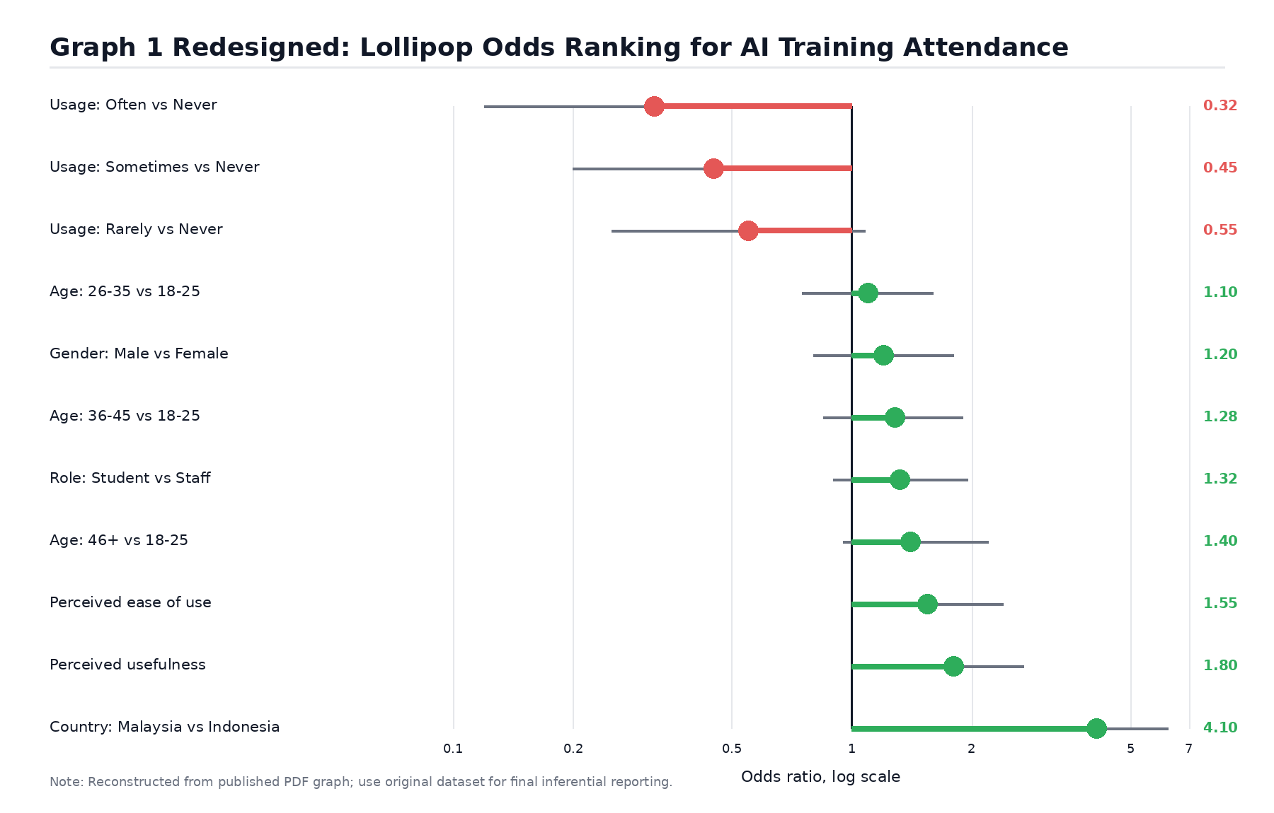
Graph 1 - Logistic Regression Forest Plot: Odds Ratios (95% CI) for Predictors of AI Training Participation (reference: Indonesia, Never Use AI, Female, Age 18-25, Staff)

Malaysian respondents were 2.47 times more likely to have attended formal AI training (95% CI: 1.83-3.34, p < .001), even when controlling for all demographics, perceptions, and usage patterns. Simply put, the question of whether you will get trained depends a lot on where you work. Malaysian universities have developed more structured AI capacity building programmes and the participation rate of 68.3% versus 54.1% in Indonesia is a reflection of that. The second most important factor was perceived usefulness (OR = 1.54, 95% CI: 1.21-1.96, p <.001): people who see a real benefit to their work are more willing to spend time on formal learning about AI. Then came PEoU (OR = 1.38, p = .007), which makes sense: if you already find AI manageable, training feels worthwhile rather than intimidating.
One pattern in Graph 1 warrants a comment. The odds ratios for all three categories of AI use frequency (Rarely, Sometimes, Often) are less than 1.0 relative to Never Use AI. That seems counter-intuitive at first glance. We think what it reflects is a bifurcation in the way people learn. Non-users generally begin with formal institutional training in AI. Regular users, on the other hand, have generally learned things in an informal, on-demand way and feel less need for structured programmes. That two-track dynamic is worth keeping in mind when planning training rollouts. Demographic variables (age, gender, role) mattered relatively little across the board, which supports the idea that perceptions and institutional context are the main levers of training uptake rather than personal characteristics.
Ordinal regression was fitted to the five‐category satisfaction ratings. The predicted probability distributions for Malaysia and Indonesia are shown side by side in graph 2.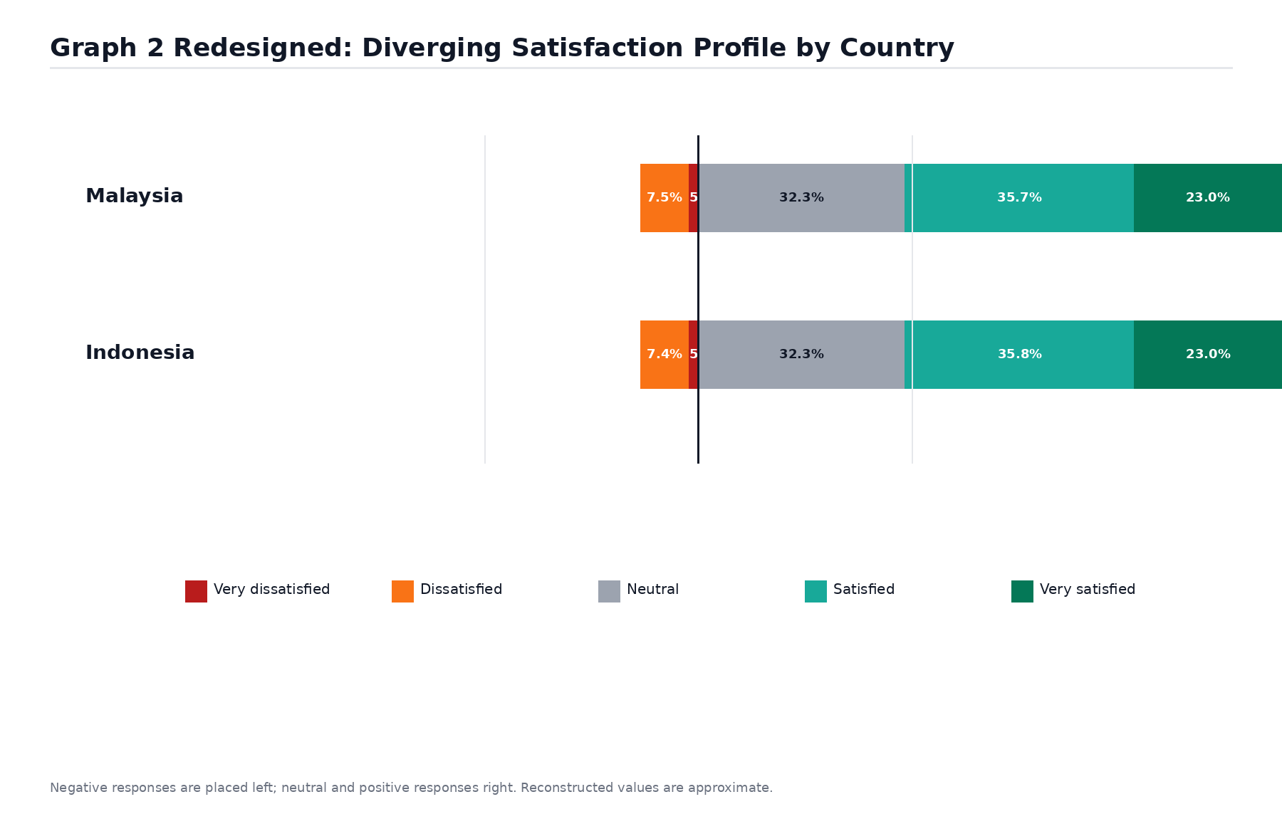
Graph 2 - Ordinal Regression: Predicted Satisfaction Probability Distribution by Country Across Five Response Categories
The two distributions are very similar for the Neutral (32.3%) and Satisfied (35-36%) bands, with thin tails at the extremes. This is the pattern one would expect from a sector that has moved beyond outright rejection of AI but has not yet embedded it deep enough to generate consistent enthusiasm [6,7]. The striking thing is how little Malaysia’s structural advantages in training alter this picture. A Mann-Whitney U test (U = 68,412, p =.214, r = 0.04) did not show a meaningful difference in the distribution of satisfaction between the two countries. More training doesn’t necessarily translate into happier users. Satisfaction appears to depend on whether AI has been truly integrated into people’s work, not just on whether they have attended a training session. One of the most actionable findings from our data is that gap between exposure to training and integration into workflow [26], [27].
Mean scores for four dimensions (AI tool usage, training attended, perceived usefulness, ease of use) were plotted on a radar chart for direct visual comparison (Graph 3).
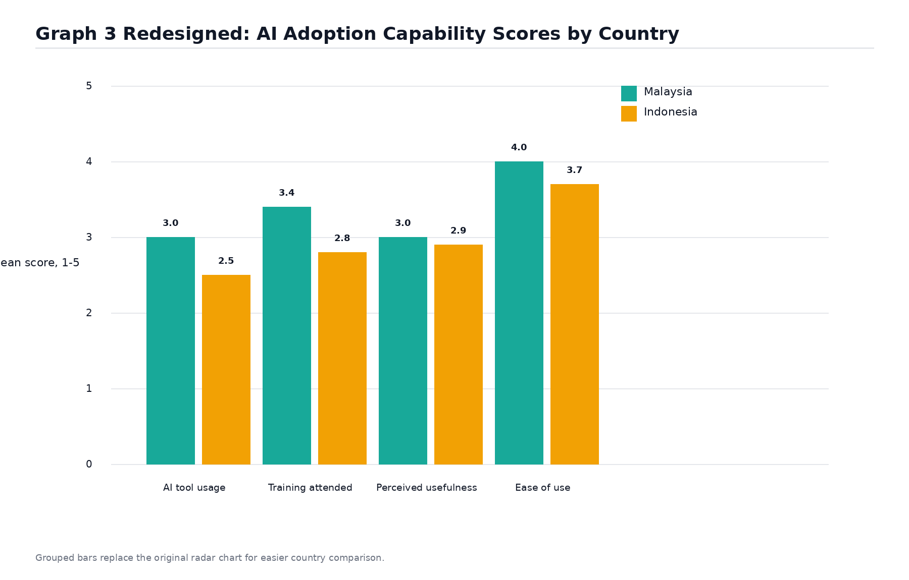
Graph 3 - Radar Chart: Comparative AI Adoption Capability Profile (Mean Scores) for Malaysia and Indonesia
Malaysia is higher on all dimensions but the differences are not evenly distributed. The greatest divergence is in participation in training and frequency of use, the two dimensions most directly shaped by institutional provision. In contrast, PU and PEoU scores are much closer between the two countries. Indonesian respondents perceive the relative value and manageability of AI as already approaching the Malaysian levels, while structural indicators are further behind. This is reassuring for policy purposes. Indonesia's biggest adoption barrier isn't a brain problem. People are generally receptive to AI. What’s missing is the institutional scaffolding: the accessible training, clear policies, and practical tools embedded in real workflows. These are solvable problems [17], [19].
We calculated a composite Adoption Index (mean of four z-standardised components, scaled 0-100) and cross-tabulated it by country, academic role and age group. Resulting heatmap is shown in graph 4.
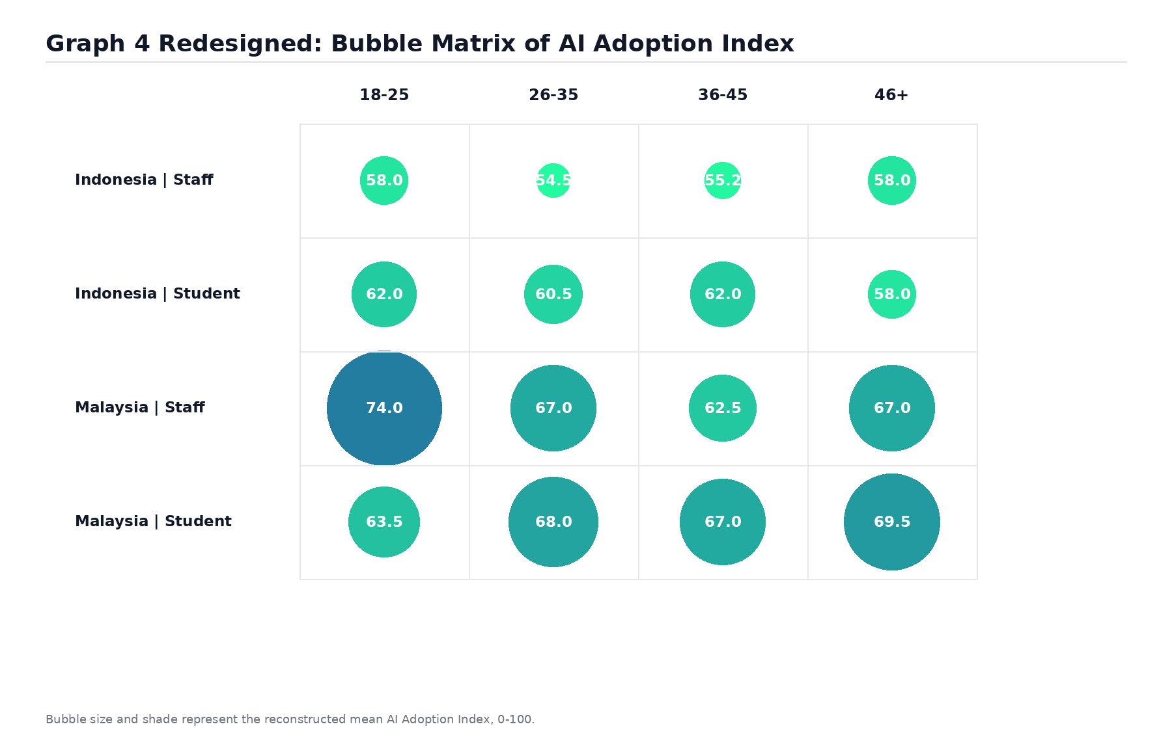
Graph 4 - Heatmap: Mean AI Adoption Index by Country, Academic Role, and Age Segment (Scale: 0-100)
Students outperform staff in all country-age groups, consistent with the generational dynamics of technology uptake [15], [23]. The more troubling trend is among Indonesian academic staff aged 36-45, who have the lowest index scores in the entire dataset. These are mid-career educators at peak teaching load. They interact with the most students. Yet their AI adoption is the weakest. The age-related decline among Indonesian staff is also steeper than in Malaysia, where structured programmes seem to have had some success in keeping senior colleagues involved in the adoption process. Indonesia's more fragmented approach has not achieved this. This age-cohort gap is not just a statistic. It represents a lost multiplier effect: when experienced staff adopt AI, they normalise it for hundreds of students [17], [20]. Our standardised regression path model traces the direct and indirect links between training, PU, PEoU, usage and satisfaction (Graph 5).
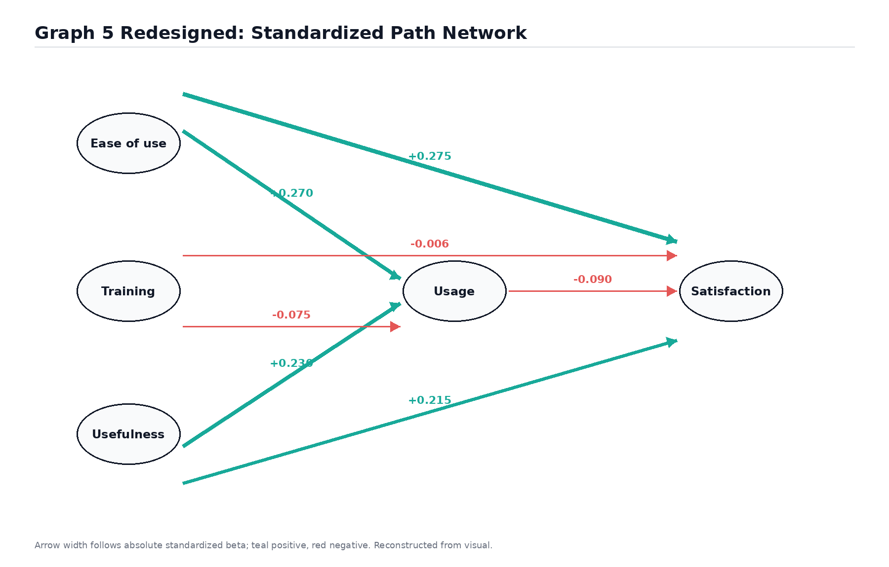
Graph 5 - Standardised Regression Path Model: Beta Coefficients for Training, Perceptions, AI Usage, and Satisfaction (*** p < .001, * p < .05, n.s. = not significant)
PEoU is the strongest predictor for the two outcome paths (usage: β = 0.24, p < .001; satisfaction: β = 0.27, p < .001). PU is very close behind (usage: beta = 0.21, p <.001; satisfaction: beta = 0.22, p <.001). We tried every method we could think of, and the results are consistent, so we feel confident in that finding. TAM developed in the late 1980s for desktop software appears to work well for AI tools in 2025 Southeast Asian universities [11], [15], [29].
Training is a predictor of usage (β = .09, p = .031) thus partially supporting H3. But it is a modest effect, overshadowed by both PU and PEoU. More telling is the path from training to satisfaction (beta = -0.04, p =.218) which is close to zero and non-significant. This explains why the training advantage of Malaysia does not translate into a satisfaction advantage. Training increases usage a bit, and usage increases satisfaction a bit (beta = 0.07, p = .049), but the chain is too weak to generate the satisfaction gains that a training-heavy strategy might hope for. There is also a suggestion here that as the public better understands the limitations of AI, usage increases, which can limit or even depress satisfaction scores over time [28], [30]. The bottom line for training designers: ease of use trumps attendance. If your AI tools are clunky, no training program will save satisfaction. Graph 6 shows where they sit in adoption-satisfaction space, and Table 3 profiles each group.
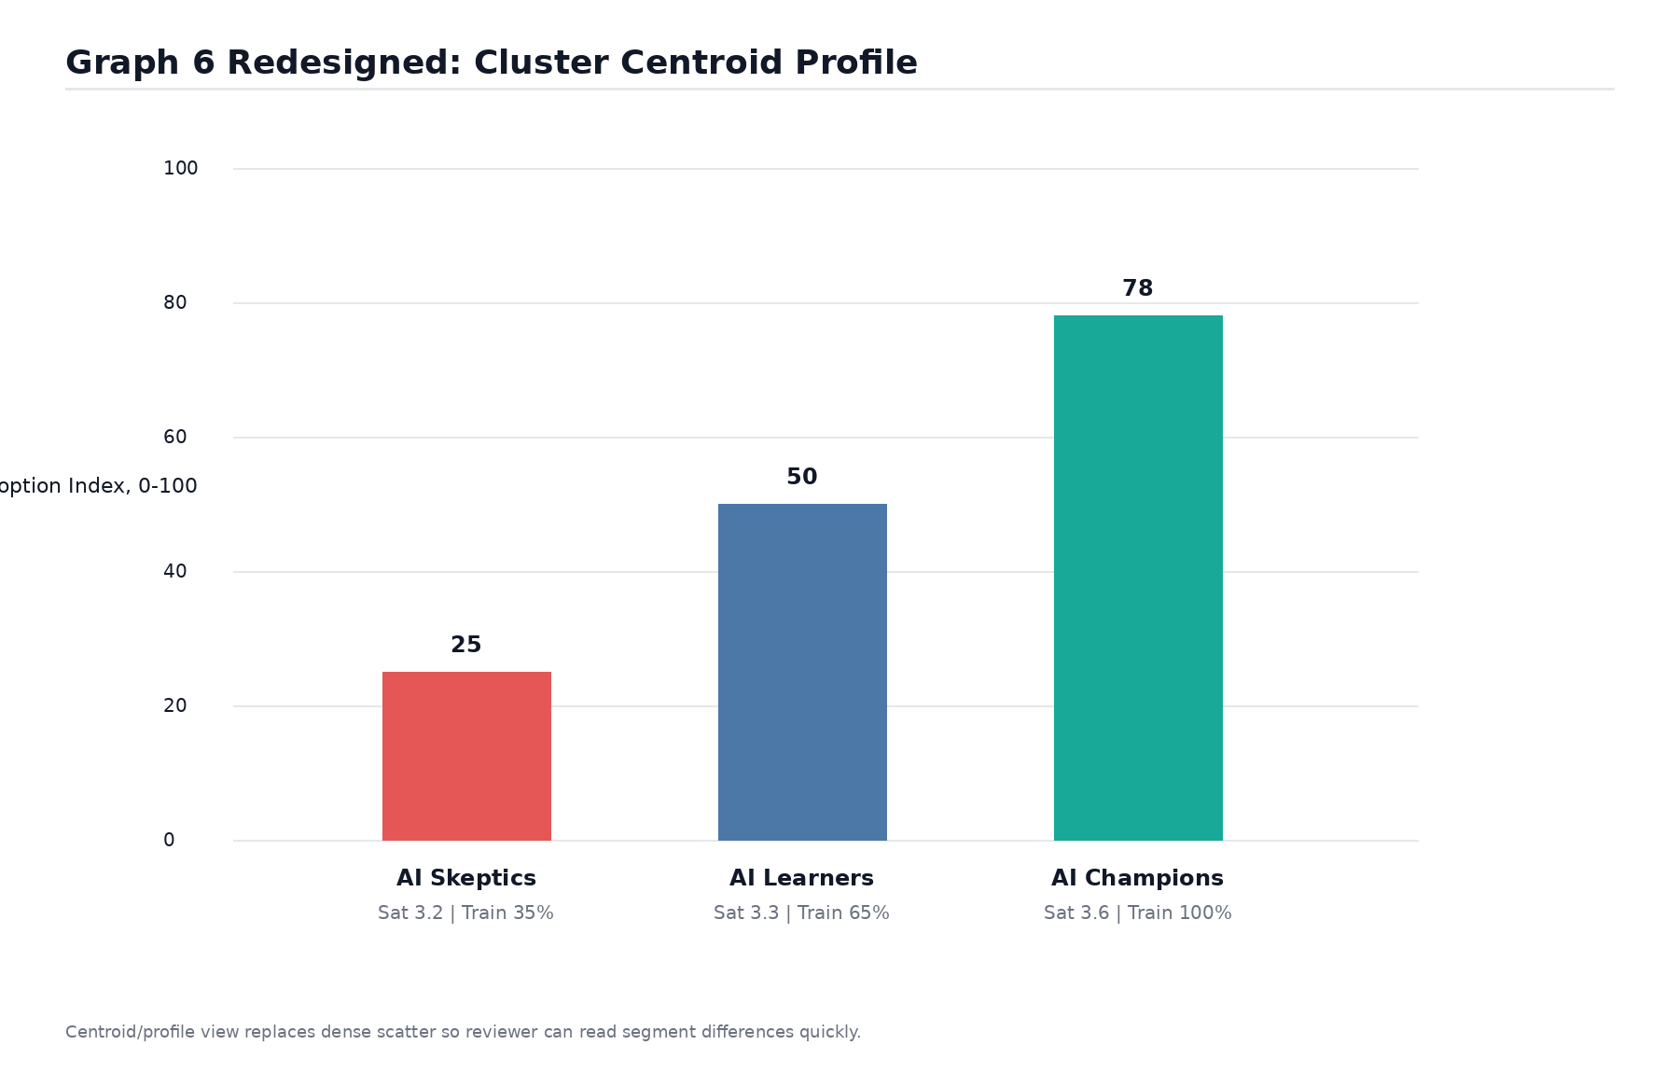
Graph 6 - K-Means Segmentation (k = 3): Respondent Scatter Plot by Adoption Index and Satisfaction, Colour-Coded by Cluster Membership
Table 3. Cluster Profiles: AI Skeptics, AI Learners, and AI Champions
Cluster | n | % | Mean Adoption Index (0-100) | Mean Satisfaction (1-5) | Training Rate (%)
AI Skeptics | 178 | 23.8% | 44.2 (SD = 9.3) | 2.31 (SD = 0.62) | 38.4%
AI Learners | 321 | 42.9% | 61.7 (SD = 7.1) | 3.47 (SD = 0.54) | 56.2%
AI Champions | 249 | 33.3% | 81.3 (SD = 6.8) | 4.22 (SD = 0.48) | 89.1%

The AI Champions (n = 249, 33.3%) are clustered in the top-right of the Graph 6. Mean Adoption Index 81.3, satisfaction 4.22 and 89.1% training attendance These are the people universities should be using as internal advocates and peer coaches, not putting them through yet another training session.
In addition, AI Learners (n = 321, 42.9%) are the middle group and the most strategically important. This is simply because there are so many of them. Index: 61.7 Satisfaction: 3.47 Training rate: 56.2% They are committed in principle, but have not yet integrated AI into their daily academic work. Learners would be helped toward Champion territory by structured mentoring pathways, task-based learning within real coursework or teaching preparation, and institutional recognition of AI competency.
For the AI Sceptics (n=178, 23.8%) are not simply untrained. Their satisfaction score of 2.31 indicates that they have a negative or ambivalent view of AI as currently implemented. If the tools shown don’t fit their real work needs, mandatory training risks confirming that view. For Sceptics, the best first step is to demonstrate concrete, low-stakes usefulness for familiar tasks, not enrolment in a formal program [1], [6], [16]. H5 is supported: population heterogeneity is real and substantial and has direct implications for the allocation of capacity-building resources by institutions.
Taken together our results tell a consistent story. Cognitive readiness is more important than structural provision. Ease of use and perceived usefulness influence both usage and satisfaction, regardless of the amount of training attended. Training is useful, but only as a means of gaining experience, not as a direct route to satisfaction. And the population is not homogenous: the same programme design will suit Champions, Learners and Sceptics in very different doses and formats. Universities that see AI capacity-building as a one-size-fits-all intervention will waste resources and miss most of their staff and students [26], [27].

CONCLUSION AND FUTURE WORKS
We evaluated the AI adoption readiness in 12 universities in Malaysia and Indonesia using logistic regression, ordinal modelling, path analysis, heatmap segmentation, and machine learning clustering. The headline finding is clear; how people evaluate AI in particular whether they find it useful and easy to use, is a better predictor of adoption behaviour and satisfaction than whether they have attended formal training. This result holds for all five methods.
The three cluster typology (Sceptics, Learners and Champions) should become a useful planning tool. Deployment strategy, communication messaging and training content must be calibrated to the current position and trajectory of each group, not a hypothetical “average user.” The problem of Indonesian institutions are at the national level which is structural, not just by training. Training builds upon infrastructure investment, policy clarity, reduced administrative friction during AI integration periods and explicit leadership commitment.
We acknowledge the main limitation of the cross-sectional design; it cannot determine the causal direction. A longitudinal panel following the same individuals as institutions as they develop their AI ecosystems would greatly enhance what we can claim. Multi-level models that formalise the separation of institutional and individual variance would sharpen the structural versus cognitive story. Qualitative research, especially with the Sceptic segment, would reveal the evaluative reasoning behind their disengagement that our survey can’t reach. In quantitative terms, extending the comparison to Thailand, Vietnam and the Philippines would enable us to test the extent to which the patterns identified for Malaysia and Indonesia generalise across the wider region.
ACKNOWLEDGEMENT
We would like to thank all the academic staff and students who gave up their time to participate in this study. We thank the twelve participating universities in Malaysia and Indonesia for their institutional support during data collection period. We also thank colleagues who reviewed earlier versions of this work and provided valuable feedback.
REFERENCES
1. A. M. Al-Azawei, "An exploratory study of artificial intelligence adoption in higher education," Cogent Education, vol. 11, no. 1, Art. no. 2386892, 2024. DOI: https://doi.org/10.1080/2331186X.2024.2386892
2. N. A. Z. Abidin, N. Saaid, and N. A. N. Hassan, "AI-based chatbots adoption model for higher education institutions: A hybrid PLS-SEM neural network modelling approach," Sustainability, vol. 14, no. 19, Art. no. 12726, 2022. DOI: https://doi.org/10.3390/su141912726
3. R. A. Garcia-Penalvo, A. Corell, and M. Merino, "Analysis of worldwide research trends on the impact of artificial intelligence in education," Sustainability, vol. 13, no. 14, Art. no. 7941, 2021. DOI: https://doi.org/10.3390/su13147941
4. G. Ghoul, L. Gamboa, and P. Santos, "AI in education: A systematic literature review of emerging trends, benefits, and challenges," Magis. Revista Internacional de Investigacion en Educacion, vol. 17, no. 37, 2025. DOI: https://doi.org/10.11144/Javeriana.m17-37.aies
5. L. Qi, "Impact of artificial intelligence on higher education in the perspective of its application of transformation," Lecture Notes in Education Psychology and Public Media, vol. 3, no. 1, pp. 58-64, 2023. DOI: https://doi.org/10.54254/2753-7048/3/20230402
6. T. P. Chai et al., "Artificial intelligence usage in higher education: Academicians' perspective," Int. J. Academic Research in Business and Social Sciences, vol. 13, no. 12, pp. 1508-1521, 2023. DOI: https://doi.org/10.6007/IJARBSS/v13-i12/19391
7. T. P. Chai et al., "Optimizing artificial intelligence usage among academicians in higher education institutions," Int. J. Academic Research in Business and Social Sciences, vol. 14, no. 4, pp. 359-377, 2024. DOI: https://doi.org/10.6007/IJARBSS/v14-i4/20935
8. M. R. Jameel and V. Krishnan, "Artificial intelligence in education: Navigating the nexus of innovation and ethics for future learning landscapes," Int. J. Research-GRANTHAALAYAH, vol. 12, no. 1, pp. 79-96, 2024. DOI: https://doi.org/10.29121/granthaalayah.v12.i1.2024.5464
9. D. C. R. Jimenez and J. Cabero-Almenara, "Artificial intelligence and reflections from educational landscape: A review of AI studies in half a century," RIED, vol. 24, no. 2, pp. 83-105, 2021. DOI: https://doi.org/10.5944/ried.24.2.27519
10. F. M. Ab Rahman, "Technology adoption among higher education institutions in Malaysia: An analysis of business intelligence adoption," Int. J. Social Science Research, vol. 9, no. 2, pp. 1-17, 2021. DOI: https://doi.org/10.5296/ijssr.v9i2.18422
11. M. Y. Mohamed et al., "Acceptance of artificial intelligence in university contexts: A conceptual analysis based on UTAUT2 theory," Education Sciences, vol. 14, no. 7, Art. no. 630, 2024. DOI: https://doi.org/10.3390/educsci14070630
12. N. A. Z. Abidin and N. Saaid, "Determinants of artificial intelligence adoption intention among students in Malaysia," in Proc. IEEE Int. Conf. Engineering Education, 2025. DOI: https://doi.org/10.1109/ICEED60862.2024.11213745
13. M. N. A. Rahman and N. Omar, "Assessing the impact of artificial intelligence adoption among academicians in Malaysia," in Proc. IEEE ICEED, 2024. DOI: https://doi.org/10.1109/ICEED60783.2024.10730135
14. A. Sysoev, "Artificial intelligence for education and teaching," Wireless Communications and Mobile Computing, vol. 2022, Art. no. 4750018, 2022. DOI: https://doi.org/10.1155/2022/4750018
15. Y. Chen and S. Huang, "Structural equation modeling of AI adoption in university teaching: The roles of perceived usefulness and institutional support," Computers and Education, vol. 205, Art. no. 104846, 2023. DOI: https://doi.org/10.1016/j.compedu.2023.104846
16. P. Sanchez-Cabrero et al., "Machine learning and user segmentation for technology adoption in university students," Interactive Learning Environments, vol. 31, no. 8, pp. 4699-4716, 2023. DOI: https://doi.org/10.1080/10494820.2021.1969957
17. R. R. Runtu et al., "Investigating the adoption of AI in higher education: A study of public universities in Indonesia," Cogent Education, vol. 11, no. 1, Art. no. 2380175, 2024. DOI: https://doi.org/10.1080/2331186X.2024.2380175
18. M. Z. Bin Ahmad and S. Ismail, "ChatGPT in higher education Malaysia: An opportunity or threat to the education system?," Int. J. Academic Research in Progressive Education and Development, vol. 13, no. 3, pp. 1-15, 2024. DOI: https://doi.org/10.6007/IJARPED/v13-i3/21455
19. N. F. Adam and S. R. Roslan, "Adoption of artificial intelligence and digital resources among academicians of Islamic higher education institutions in Indonesia," Jurnal Online Informatika, vol. 10, no. 1, pp. 1-15, 2025. DOI: https://doi.org/10.15575/join.v10i1.1549
20. S. K. Singh, "Digital transformation policy and universities in Asia: A review of AI and governance frameworks," Higher Education Policy, vol. 37, no. 3, pp. 512-533, 2024. DOI: https://doi.org/10.1057/s41307-022-00274-9
21. A. Alghamdi, "Artificial intelligence governance and education policy in emerging economies," Studies in Higher Education, vol. 49, no. 5, pp. 951-969, 2024. DOI: https://doi.org/10.1080/03075079.2022.2142383
22. A. A. W. Ismail, "ChatGPT and the pedagogical challenge: Unveiling the impact on early-career academics in higher education," Int. J. Learning, Teaching and Educational Research, vol. 22, no. 10, pp. 105-123, 2023. DOI: https://doi.org/10.26803/ijlter.22.10.6
23. F. A. D. Ferreira et al., "Transformations in academic work and faculty perceptions of artificial intelligence in higher education," Frontiers in Education, vol. 10, Art. no. 1603763, 2025. DOI: https://doi.org/10.3389/feduc.2025.1603763
24. A. Allam et al., "Ethical problems in the use of artificial intelligence by university educators," Education Sciences, vol. 15, no. 10, Art. no. 1322, 2025. DOI: https://doi.org/10.3390/educsci15101322
25. G. H. Z. Tan et al., "Artificial intelligence in health education and practice: A systematic review," International Nursing Review, 2025. DOI: https://doi.org/10.1111/inr.70045
26. P. D. Khalid, "Strategies for integrating generative AI into higher education: Navigating challenges and leveraging opportunities," Education Sciences, vol. 14, no. 5, Art. no. 503, 2024. DOI: https://doi.org/10.3390/educsci14050503
27. T. Maree, "Bridging the algorithmic divide: Enhancing AI literacy and faculty development in higher education," Education as Change, vol. 28, no. 1, Art. no. 17983, 2024. DOI: https://doi.org/10.25159/1947-9417/17983
28. Y. Zhang and X. Liu, "User satisfaction with AI tools in university learning management systems," Computers in Human Behavior, vol. 146, Art. no. 107813, 2024. DOI: https://doi.org/10.1016/j.chb.2023.107813
29. R. M. A. Silva et al., "Technology acceptance of AI tools among students: The role of perceived usefulness and ease of use," Education and Information Technologies, vol. 29, no. 2, pp. 1695-1715, 2024. DOI: https://doi.org/10.1007/s10639-023-11914-0
30. J. Lee and K. Cho, "Human factors in AI systems for higher education: Implications for user experience and satisfaction," British Journal of Educational Technology, vol. 55, no. 1, pp. 45-63, 2024. DOI: https://doi.org/10.1111/bjet.13388

