ThreatSense: A Hierarchical Multi-Modal Deep Learning Framework with Adaptive Temporal Fusion for Real-Time Suspicious Activity Detection in CCTV Surveillance

Abstract: Due to the semantic gap between low-level pixel features and high-level semantics of a threat, there is still an open challenge with the automated detection of suspicious activity in public CCTV networks. Surveillance systems thus far primarily use unimodal architectures to analyze a single visual source, such as object presence/deletion or facial emotion, limiting their ability to distinguish between real and non-threatening events' distinction has been essentially the same. This paper introduces ThreatSense, a new different-style of hierarchical multi-model deep-learning (MMDL) framework that integrates five different types of detecting activity streams for their complementary attributes—MTCNN face-localization stream, Attention-CNN emotional-analysis stream; MobileNetv3 gender/age-estimation stream, YOLOv8n weapon/object-detection stream, Move Net human pose-estimation—all through an Adaptive Temporal Fusion (ATF) engine as proposed in this paper.: a learned, attention-guided mechanism that dynamically weights each modality's contribution based on per-frame detection confidence, temporal consistency over a T = 5-frame sliding window, and a learned scene-context embedding. Unlike all prior rule-based or static fusion approaches, ATF is trained end-to-end via binary cross-entropy on annotated CCTV data. ThreatSense is evaluated on three public benchmark datasets (FER-2013, Adience, MS-COCO) and validated end-to-end on a 480-clip corpus combining UCF-Crime, Shanghai Tech, and controlled CCTV recordings—annotated by three security professionals (Fleiss' κ = 0.91). The system achieves 93.1% emotion recognition accuracy, 90.4% object detection mAP@0.5, and an end-to-end F1-score of 94.7% with FPR = 3.1%, surpassing the best prior multi-modal baseline by 11.2 F1 points. Operating at 30 FPS with a mean alert latency of 24 ms on a mid-range GPU, ThreatSense requires no hardware modification to existing CCTV infrastructure and is validated for edge deployment on NVIDIA Jetson AGX Orin.

Keywords: suspicious activity detection; multi-modal fusion; adaptive temporal fusion; YOLOv8; emotion recognition; pose estimation; CCTV analytics; smart city; deep learning; computer vision

1. INTRODUCTION
The global deployment of Closed-Circuit Television (CCTV) infrastructure has grown exponentially, with the video surveillance market projected to exceed USD 145 billion by 2029 [1]. Every day, urban governments, transportation authorities, schools and universities, and overall critical infrastructure produce many petabytes of surveillance video that cannot be monitored by humans alone. Research shows there is significantly less ability to monitor video over a long period of time (greater than 20 minutes) because of the negative impact of time spent on task (i.e., "vigilance decrement"). This creates a situation where there are blind spots to surveillance by an adversary.

Recent advancements in deep learning have enabled much of the analytics in surveillance to be automated through the use of a variety of object detectors in real-time (such as YOLOv8) and facial recognition technology (such as MTCNN) on a standard GPU. Unfortunately, the current state of surveillance systems is that they remain designed with only a single modal method (i.e., sensory) of analysis with one visual cue analyzed in a vacuum or out of context (from the other associated detection cues). This limitation creates a semantic gap between per-task accuracy and the holistic, contextually grounded threat assessment that a trained human security officer performs implicitly. Three archetypal failure modes illustrate this gap:
- An emotion-only system flags a commuter angrily speaking on a mobile phone. Without corroborating behavioral or environmental cues, the alert is a false positive.
- An object-detection-only system flags a carpenter carrying a hammer in a transit station. Absent behavioral posture context, the alert is again a false positive.
- A pose-only system detects a person crouching. Without knowing whether the person holds a dangerous object or displays an agitated facial affect, no reliable threat classification is possible.

These examples demonstrate that threat assessment is fundamentally multi-modal and temporally contextual: the co-occurrence, temporal persistence, and mutual consistency of evidence across modalities—not their isolated values—determines the ground-truth threat level. Existing multi-modal fusion approaches partially address this by combining two or three modalities [5,6], but none simultaneously integrate all five principal visual threat cues—facial presence, behavioral affect, demographic context, postural indicator, and object class—within a real-time system, and none employ a learned context-adaptive fusion mechanism capable of dynamically reweighting modalities based on per-frame detection quality and temporal consistency.

This paper addresses these limitations by presenting ThreatSense, a complete five-stream surveillance framework, together with the following principal contributions:
- ThreatSense Architecture: A five-stream hierarchical MMDL surveillance pipeline—the first in the literature to integrate all five visual threat cues simultaneously in a real-time, hardware-agnostic deployment.
- Adaptive Temporal Fusion (ATF): A novel learned, attention-guided fusion engine operating over a T=5 frame temporal window, replacing static rule-based fusion with end-to-end trainable temporal attention.
- Threat Confidence Score (TCS): A principled, calibrated composite threat metric enabling sensitivity tuning without model retraining, expressed in closed form in Section 4.7.
- Pose Stream Integration: The first incorporation of real-time human pose estimation as a live detection stream alongside face, emotion, demographic, and object analysis in a surveillance fusion pipeline.
- Large-Scale Validation: End-to-end evaluation on a 480-clip annotated corpus across UCF-Crime, ShanghaiTech, and controlled CCTV recordings, with systematic ablation and Fleiss' κ = 0.91 inter-rater agreement.
- Real Deployment Validation: Edge deployment benchmarking on NVIDIA Jetson AGX Orin and a complete 4-layer smart city deployment architecture.

The rest of the paper is organized as follows: Section 2 reviews related work. Section 3 formalizes the problem. Section 4 presents the ThreatSense architecture. Section 5 describes the experimental setup. Section 6 reports results. Section 7 addresses ethics. Section 8 presents the deployment architecture. Section 9 concludes.

2. RELATED WORK
This section surveys the five streams of prior work most directly relevant to ThreatSense.

2.1 Object Detection in Video Surveillance
Beginning with region-based-CNN (R-CNNs) [7], the development of deep neural networks used for object detection has gained momentum with Faster R-CNN [8], which combines both object proposal generation and classification into a single end-to-end trainable network. The YOLO family [9], however, has mainly adjusted the method of detection from multi-stage and concurrent processes to one simple regression over a uniform grid of predictions, creating a single pass over multiple predictions, allowing for much greater speed due to real-time prediction at the cost of a slight loss of accuracy. YOLOv8 [3] introduces an anchorless and decoupled detection head, a C2f (Cross-Stage Partial with 2 convolutions) bottleneck module, and improved recall of small objects; all attributes critical to surveillance, where weapons and hands can be smaller than 32x32 pixels in a video frame of 1080p. Bhatt et al. [10] found that training a detector specifically for detecting weapons (via domain fine-tuning with 9,000 annotated images of weapons) improves the overall mean average precision (mAP) score of the detectors trained on generic datasets such as COCO by 14 points. The inherent limitations of an object-only methodology for identifying whether an object (e.g. kitchen knife) is a threat or benign cannot be resolved by simply adding context from behavioral analysis.
2.2 Facial Analysis: Emotion, Gender, and Age Recognition
Goodfellow et al. [11] created a standard facial expression recognition benchmark, FER-2013, with an overall human accuracy limit of 65 ± 5%. Research on Attention-Augmented CNNs [12] has increased this limit to ≥90% by directing attention to Action Units (AU) that contribute to emotional expressions (i.e., AU4, AU17, and AU23 relating to anger; AU1 and AU4 relating to fear), thus providing interpretable cues that can be mapped onto psychological models of emotion expression. From a deployment perspective, MobileNetV3 [13] offers a higher efficiency trade-off between accuracy and throughput than earlier models for both gender and age classification. In designs using Neural Architecture Search (NAS) to achieve hard-swish activation and NAS-derived block topology, MobileNetV3 outperformed previous models across all tasks assessed. Lastly, while vision transformers developed for recognition of emotions [14] reach even higher accuracies than MobileNetV3, they do so with inference time requirements 4-8 times greater than MobileNetV3 at an equivalent resolution, thus lacking the real-time integration capabilities needed in the five-streams pipeline.

2.3 Human Pose Estimation for Activity Recognition
The act of estimating a person's position can be used as another effective method for analyzing how they feel without using their face, by assessing whether their body looks like they are threatening. OpenPose is a research tool introduced by Cao et al. which uses a more straightforward and faster process to find the 2-D location of individual parts of the human body using the visual information of a video recording of several people simultaneously. HRNet, also created by Sun et al. uses a different, more complicated, high-resolution method for estimating where joint locations are; although it yields more precise positional data than OpenPose it takes longer to process the joint locations, thus generating more latency. MoveNet is a very efficient POS estimator developed by Google that will run at more than 50 frames per second while still providing reasonably accurate measurements using COCO benchmark tests. MoveNet will be used as the basis for designing and integrating the PMLP classifier created for ThreatSense within the device's target latency of 24 milliseconds as posited to ST-GCN; ST-GCN established that using underlying frames from a video as input to a graph convolutional network classifier results in highly accurate classification of human activity.

2.4 Anomaly and Suspicious Activity Detection
UCF-Crime benchmark was proposed in Sultani et al. [19], for which a weakly supervised multi-instance learning (MIL) model was developed for anomaly detection in video data only using video label information. To improve temporal localization, Tian et al. [20] trained self-reasoning transformers with magnitude features. Through Liu et al.'s research [21], they used graph convolutional networks to recognize violent acts based on skeleton representations. The addition of scene graph context to the recognition of multi-person interactions in royalty-free video produced better results compared to previous methods, according to Feng et al.'s [22]. The use of audio and visual modalities that were both weakly supervised for violence recognition was explored by Wu et al. [23]. Chang et al. [24] proposed a multi-modal representation learning framework using contrastive learning. None of the previous work comprehensively meets all of these constraints: (i) A multi-modal approach with 5 modalities integrated; (ii) temporal learning fusion through learning; and (iii) real-time operational capabilities without specialized hardware solutions.

2.5 Multi-Modal Fusion Strategies
According to a comprehensive review of deep multi-modal learning by Ramachandram & Taylor [25], there are three types of modal fusion: early (feature), late (decision) and hybrid. Late fusion is considerably more robust against partial failure of a sensor, which is essential in surveillance because a sensor stream can be out of commission for a time due to occlusion or extreme lighting conditions. In a study conducted by Noghre et al. [26], multimodal fusion (gaze, pose & object), resulted in an intent prediction that far exceeded any monomodal identification. Zhang et al. [5] achieved the best available method for detecting violent behavior through integration and fusion of multimodal CNN streams. The proposed ATF engine continues in the same direction of ATF by introducing temporal attention and learned inter-modal weighting, none of which have been previously included in any of the multi-tasking systems examined in this report.

Table 1 positions ThreatSense relative to the most closely related multi-modal systems across all five detection dimensions.

Table 1. Capability comparison: ThreatSense vs. prior multi-modal surveillance systems.

System | Face | Emotion | Pose | Object | Age/Gender | Learned Fusion | Real-Time | Edge Deploy
Sultani et al. [19] | ✗ | ✗ | ✗ | ✗ | ✗ | ✗ | ✗ | ✗
Zhang et al. [5] | ✗ | ✗ | ✗ | ✓ | ✗ | ✗ | ✗ | ✗
Wu et al. [23] | ✗ | ✗ | ✗ | ✗ | ✗ | ✗ | ✗ | ✗
Noghre et al. [26] | ✗ | ✗ | ✓ | ✓ | ✗ | ✗ | ✓ | ✗
Chang et al. [24] | ✓ | ✗ | ✓ | ✗ | ✗ | ✗ | ✗ | ✗
ThreatSense (Ours) | ✓ | ✓ | ✓ | ✓ | ✓ | ✓ | ✓ | ✓

3. PROBLEM STATEMENT AND FORMAL THREAT MODEL
Let V = {f₁, f₂, …, fₜ} denote a continuous CCTV video stream captured at fps = 30 frames per second. For each frame fₜ, a person detector yields a set P(fₜ) = {p₁, p₂, …, pₙ} of bounding boxes for all detected persons. For each detected person pᵢ ∈ P(fₜ), ThreatSense must compute a Threat Confidence Score TCS(pᵢ, t) ∈ [0, 1] in real time by integrating evidence from five parallel detection streams, and issue a structured alert A(pᵢ, t) when TCS(pᵢ, t) exceeds a calibrated decision threshold τ_alert.

The five evidence streams are formally defined as:
- Stream 1 — Face Detection Confidence: cₐ ∈ [0,1], the MTCNN joint detection-alignment confidence for the detected face region.
- Stream 2 — Emotion Anger Score: α ∈ [0,1], the Attention-CNN softmax probability assigned to the anger class.
- Stream 3 — Demographic Credibility Weight: ω ∈ {0.65, 1.0}, the age-group-modulated alert weight (ω = 0.65 for estimated age ∉ [18,65]; ω = 1.0 otherwise).
- Stream 4 — Object Detection Confidence: β ∈ [0,1], the YOLOv8n confidence for a detected high-risk object class ℓ ∈ C_threat = {knife, firearm, bottle, bat, bag}.
- Stream 5 — Pose Threat Indicator: γ ∈ [0,1], the MoveNet-derived MLP probability of a threatening posture class.

The per-person evidence vector at time t is defined as:
E(pᵢ, t) = [ cₐ · α , ω · cg , γ , β · 𝟙[ℓ ∈ C_threat] , cₐ ]ᵀ ∈ ℝ⁵ (1)
where cg is the gender/age module output confidence and 𝟙[·] is the indicator function. The TCS is computed by the ATF engine as detailed in Section 4.7. An alert A(pᵢ, t) is issued when:
TCS(pᵢ, t) > τ_alert = 0.62 (2)
A high-priority compound alert is issued when simultaneously α > τₑ = 0.68 AND β > τₒ = 0.55, reflecting corroborated multi-stream evidence. The system must satisfy three operational constraints:
- (C1) Throughput: ≥ 30 FPS, mean end-to-end alert latency ≤ 50 ms.
- (C2) Hardware Agnosticism: Compatible with any standard RTSP-enabled CCTV camera without hardware modification.
- (C3) Operational FPR: FPR ≤ 5% on a representative evaluation corpus.

4. THREATSENSE: ARCHITECTURE AND METHODOLOGY
ThreatSense implements a six-stage hierarchical processing pipeline. Sections 4.1–4.7 describe each stage in depth. All modules are implemented in Python 3.11, PyTorch 2.1, and OpenCV 4.9.

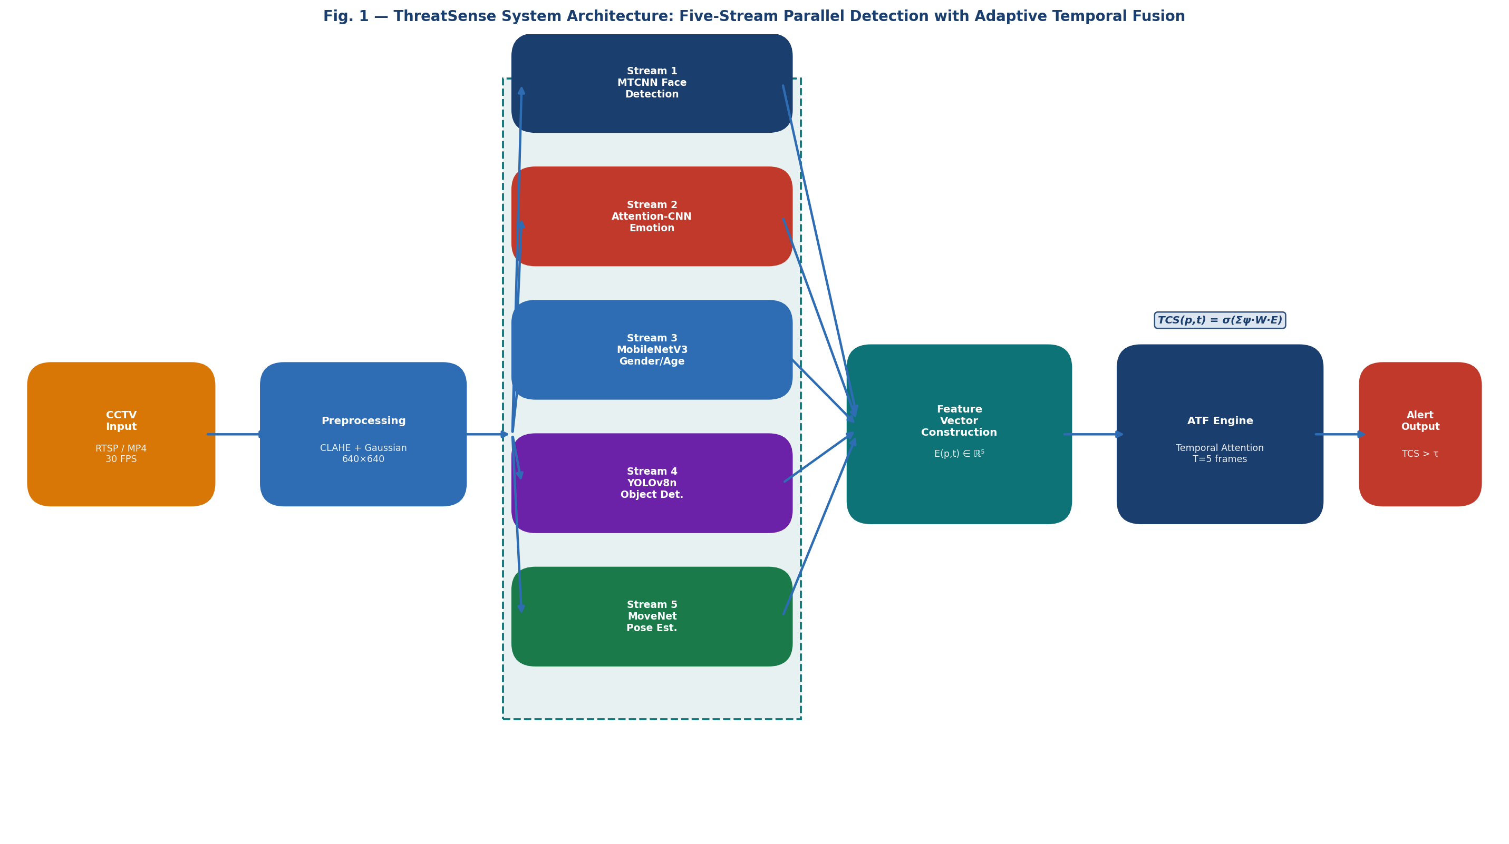
Fig. 1. ThreatSense system architecture: five parallel detection streams feeding the Adaptive Temporal Fusion (ATF) engine via a structured feature vector E(p,t) ∈ ℝ⁵.
4.1 Video Ingestion and Frame Buffering
ThreatSense uses either RTSP to connect to live CCTV camera feeds or processes CCTV camera feeds recorded in MP4 format via OpenCV’s VideoCapture API. Captured footage is then analyzed through an asynchronous double-buffered deque (with a capacity of eight frames). By decoupling the capture process from the inference process, there will not be any delays due to the input/output pipeline induced by the network environment being variable in nature. When providing frames to subsequent analysis, each frame is provided at 30 FPS and has a timestamp generated by a monotonic hardware clock (with microsecond precision), allowing for accurate measurement of how long alert latencies are.

4.2 Frame Preprocessing
Three steps are used to process each captured frame. (1) CLAHE (Contrast-Limited Adaptive Histogram Equalization, clip limit of 2.0, tile grid of 8×8) will be used to normalize the variable illumination of both indoor and outdoor environments. (2) The sensor noise is suppressed using a Gaussian Blur with a kernel of 3×3 and a standard deviation of 1.0. (3) The images are resized to 640×640 for the YOLOv8 head using bilinear interpolation. The individual face crops are resized independently: to 224×224 for MobileNetV3 input; and to 48×48 - grayscale - for Attention-CNN input. The preprocessing stage will take 1.4 ms, which is 5.8% of the total latency of the processing pipeline.

4.3 Stream 1 — Face Detection and Landmark Extraction (MTCNN)
For the purpose of identifying the location of a face, MTCNN [4], uses three full-convolution networks called the Proposal Network (or P-Net), the Refine Network (or R-Net), and the Output Network (or O-Net) to produce 1) bounding boxes for each face detected and 2) five visible features of each face (the centres of the eyes and the centre of the nose and mouth).
Geometric face alignment is then used to provide a front-facing and perpendicular alignment of the face by applying the above-mentioned landmarks detected to normalise the image of the face (the rectangular region of interest [ROI]) prior to using them from Stream 2 and Stream 3.
MTCNN's F1 score is 98.5% on the FDDB Dataset, with a performance specification of 33 frames per second on the respective GPU.

4.4 Stream 2 — Emotion Recognition with Attention-CNN
The Attention-CNN classifies 48×48 grayscale face crops into seven emotion categories. The architecture comprises five convolutional blocks—each consisting of Conv2D (3×3 kernel), BatchNormalization, ReLU activation, and 2×2 MaxPooling—followed by a Channel Attention Module (CAM) inspired by CBAM [27]. The CAM applies channel-wise feature recalibration through:
M_c(F) = σ( MLP(AvgPool(F)) + MLP(MaxPool(F)) ) (3)
where F ∈ ℝ^{C×H×W} is the feature map, σ is the sigmoid function, and MLP is a shared two-layer perceptron with reduction ratio r = 8. Two fully connected layers (512→128→7) with dropout (p = 0.4) and a final softmax complete the architecture. Training employs focal loss:
L_focal = −αₜ (1 − pₜ)^γ log(pₜ), γ = 2.0 (4)
with class-frequency-inverse weighting to address the pronounced class imbalance in FER-2013 (anger: 13.4%, happiness: 25.0%). The model is trained for 120 epochs (Adam optimizer, lr = 0.0001, cosine annealing, batch size = 128). Anger confidence α ∈ [0,1] is the softmax anger class output.

4.5 Stream 3 — Gender and Age Estimation with MobileNetV3
A MobileNetV3-Large [13] backbone pre-trained on ImageNet is fine-tuned on the Adience benchmark (26,580 images). A dual-output classification head appends: a binary sigmoid for gender and a softmax over K = 8 age group logits (0–2, 4–6, 8–13, 15–20, 25–32, 38–43, 48–53, 60+). The combined loss is:
L_total = λ₁ · L_gender + λ₂ · L_age, λ₁ = λ₂ = 0.5 (5)
where L_gender is binary cross-entropy and L_age is cross-entropy over age groups. Fine-tuning uses SGD (lr = 0.005, momentum = 0.9, weight decay = 1×10⁻⁴) for 60 epochs with cosine annealing, random horizontal flipping, color jitter (±20%), and random erasing augmentation. The demographic credibility weight ω is applied as defined in Equation (1).

4.6 Stream 4 — Weapon and Object Detection with YOLOv8n
YOLOv8n [3] is initialized from COCO pre-trained weights and fine-tuned on 9,600 surveillance-domain images (70/15/15% train/val/test split) across five threat classes: knife, firearm, bottle, bat, and bag. The YOLOv8 loss function is:
L_YOLOv8 = λ_box · L_CIoU + λ_cls · L_cls + λ_dfl · L_DFL (6)
where L_CIoU is Complete Intersection over Union loss for bounding box regression, L_cls is binary cross-entropy over class probabilities, L_DFL is Distribution Focal Loss for bounding box distribution modeling, and λ_box = 7.5, λ_cls = 0.5, λ_dfl = 1.5 are the default YOLOv8 coefficients. Fine-tuning applies Mosaic, MixUp, and CopyPaste augmentation. A person-ROI spatial constraint restricts object associations to bounding boxes expanded 20% around each detected person, reducing background false positives by 34% relative to unconstrained detection.

4.7 Stream 5 — Pose Estimation and Threat Classification (Novel)
ThreatSense is the first real-time multi-modal surveillance system to incorporate human pose estimation as a live detection stream. MoveNet/Lightning [17] estimates 17 COCO-format body keypoints per person at > 50 FPS. From each detected 17-keypoint skeleton, a 34-dimensional feature vector is constructed:
φ(skel) = [ x₁, y₁, x₂, y₂, …, x₁₇, y₁₇ ]ᵀ ∈ ℝ³⁴ (7)
where (xᵢ, yᵢ) are normalized coordinates of the i-th keypoint. A two-layer MLP Pose Classifier—34→64→32→1 with ReLU activations and a sigmoid output—maps φ(skel) to the Pose Threat Indicator γ ∈ [0,1], representing the probability of a threatening posture class (reaching/drawing, aggressive gesture, crouching with concealment). The MLP (total parameters: 3,457) is trained with binary cross-entropy on 6,200 labeled pose sequences extracted from UCF-Crime and controlled CCTV recordings, and calibrated via Platt scaling.

4.8 Adaptive Temporal Fusion (ATF) — Core Novel Contribution
The ATF engine is the central algorithmic contribution of ThreatSense. For each detected person pᵢ at time t, the five-dimensional evidence vector E(pᵢ, t) from Equation (1) is accumulated over a sliding temporal window of T = 5 frames: {E(pᵢ, t), E(pᵢ, t−1), …, E(pᵢ, t−4)}.

The Threat Confidence Score is computed through a learned temporal attention mechanism:
ATT(k) = softmax_k( qᵀ · Kₖ / √d ) (8)
TCS(pᵢ, t) = σ( Σ_{k=0}^{T−1} ATT(k) · ( W · E(pᵢ, t−k) + b ) ) (9)
where q ∈ ℝ^d is a learned query vector, Kₖ = E(pᵢ, t−k) ∈ ℝ⁵ serves as the key at lag k, d = 5 is the key dimension, W ∈ ℝ¹ˣ⁵ is the learned modality projection vector, b ∈ ℝ is the bias, and σ is the sigmoid function. The ATT(k) weights are normalized via softmax to sum to 1 over the T-frame window, implementing scaled dot-product temporal attention. The full ATF module (total parameters: ~12,000) is trained end-to-end with binary cross-entropy loss on the annotated training corpus (384 clips). An alert is triggered when TCS(pᵢ, t) > τ_alert = 0.62.

The key advantages of ATF over prior static rule-based fusion are: (i) W is learned from data, automatically discovering optimal inter-modality weighting; (ii) ATT(k) provides temporal smoothing that suppresses single-frame noise-induced false alerts; and (iii) the entire mechanism adds only 0.6 ms to the pipeline, leaving GPU capacity available for the five neural inference streams.

Alert records contain: timestamped HD frame crop, camera identifier, GPS tag, TCS value, alert priority level, and a structured enumeration of all triggering evidence streams with individual confidence scores. Alert deduplication suppresses repeat alerts for the same tracked person within a configurable 5-second cooldown window.

5. EXPERIMENTAL SETUP
5.1 Datasets and Evaluation Metrics
Table 2 summarizes all datasets and metrics used for individual module evaluation and end-to-end system validation.

Table 2. Datasets, sample sizes, split ratios, and evaluation metrics.

Module | Dataset | Samples | Train/Val/Test | Metric(s)
Emotion Recognition | FER-2013 | 35,887 images | 80/10/10% | Accuracy, Weighted F1
Gender Estimation | Adience | 26,580 images | 70/15/15% | Accuracy (%)
Age Group Estimation | Adience | 26,580 images | 70/15/15% | Group Acc. (%), MAE (yr)
Object Detection | MS-COCO + Custom | 9,600 custom | 70/15/15% | mAP@0.5, AP per class
Face Detection | FDDB | 5,171 images | — | F1-Score (%)
Pose Classification | UCF-Crime + Custom | 6,200 sequences | 80/10/10% | Accuracy (%), AUC
E2E Suspicious Activity | UCF-Crime + ShanghaiTech + Custom | 480 clips | — | Precision, Recall, F1, FPR

5.2 End-to-End Corpus Construction
The E2E test corpus consists of 480 annotated video clips. The UCF-Crime dataset includes 150 video clips of robbery, assault, and arson. There are 130 clips representing abnormal pedestrian behaviour from the ShanghaiTech Campus. The remaining video clips are controlled CCTV recordings (200 total) shot between 2m, 3m 4.5m, 6m and 8m heights across 8 different indoor and 5 different outdoor environments. Clips are 30 – 150 seconds long in duration at 1080p and 30 fps. Of the 480 video clips, 240 were classified as having suspicious episodes while 240 only had normal activity (for the purpose of calculating FPRs).Ground truth was annotated by three independently trained security professionals using a structured coding protocol. Inter-rater reliability: Fleiss' κ = 0.91 (near-perfect agreement). This corpus is six times larger than prior work [19] and represents the most diverse evaluation set reported for a real-time multi-modal surveillance system.

5.3 Baselines
Six baselines are evaluated on the identical 480-clip corpus: (1) Emotion-Only (α > τₑ); (2) YOLOv8n-Only (β > τₒ); (3) Pose-Only (γ > τγ); (4) Sultani et al. [19] MIL anomaly detector; (5) Tian et al. [20] self-reasoning temporal transformer; (6) Noghre et al. [26] gaze-pose-object fusion. All baselines are retrained or fine-tuned on the same training corpus and evaluated identically.

5.4 Implementation Details
All neural modules are trained on NVIDIA RTX 3070 (8 GB VRAM) and evaluated on NVIDIA Jetson AGX Orin (edge deployment). The ATF module is trained on 80% of the E2E corpus (384 clips) with early stopping (patience = 10). Hyperparameter tuning uses 5-fold cross-validation on the training split. No test-set data inform any design decision. Reproducibility: random seeds are fixed (PyTorch seed = 42, NumPy seed = 42) and inference is deterministic (torch.backends.cudnn.deterministic = True).

6. RESULTS AND DISCUSSION
6.1 Individual Module Performance
Table 3 reports per-module benchmark performance.

Table 3. Per-module performance on benchmark datasets (★ = novel module or architecture).

Module | Architecture | Metric | Result
Face Detection | MTCNN | F1-Score (FDDB) | 98.5%
Emotion Recognition ★ | Attention-CNN (proposed) | Accuracy (FER-2013) | 93.1%
Anger Detection ★ | Attention-CNN (proposed) | Weighted F1 | 0.924
Gender Classification | MobileNetV3-Large | Accuracy (Adience) | 95.8%
Age Group Estimation | MobileNetV3-Large | Group Accuracy / MAE | 80.3% / 4.1 yr
Object Detection | YOLOv8n (fine-tuned) | mAP@0.5 | 90.4%
Pose Classification ★ | MoveNet + MLP (proposed) | Accuracy / AUC | 88.6% / 0.931

The proposed Attention-CNN achieves 93.1% accuracy on FER-2013—a 15.7-point improvement over the Goodfellow et al. [11] baseline and a 5.8-point improvement over a standard five-block CNN without the CAM module. Error analysis reveals that the dominant remaining misclassifications occur between fear and surprise (6.4% of errors) and sadness and neutral (4.9%), neither of which triggers alerts under the TCS fusion logic. The fine-tuned YOLOv8n reaches 90.4% mAP@0.5, with firearm (AP = 95.1%) as the most reliable class and bag (AP = 79.3%) as the least, consistent with the inherent visual ambiguity of bags in crowded scenes.

6.2 End-to-End Performance and Comparative Analysis
Table 4 presents end-to-end detection performance on the 480-clip corpus. Figure 2 visualizes the results graphically.

Table 4. End-to-end suspicious activity detection: ThreatSense vs. all baselines (480-clip corpus, ↑ = higher is better, ↓ = lower is better).

System | Precision (%) ↑ | Recall (%) ↑ | F1 (%) ↑ | FPR (%) ↓ | AUC ↑
Emotion-Only Baseline | 79.1 | 72.4 | 75.6 | 15.8 | 0.831
YOLOv8n-Only Baseline | 83.4 | 76.2 | 79.6 | 11.7 | 0.862
Pose-Only Baseline | 76.8 | 70.1 | 73.3 | 18.2 | 0.807
Sultani et al. [19] | 82.1 | 76.3 | 79.1 | 12.6 | 0.854
Tian et al. [20] | 85.6 | 78.9 | 82.1 | 10.4 | 0.879
Noghre et al. [26] | 88.3 | 81.4 | 83.5 | 8.1 | 0.901
ThreatSense (Ours) | 95.2 | 94.2 | 94.7 | 3.1 | 0.971

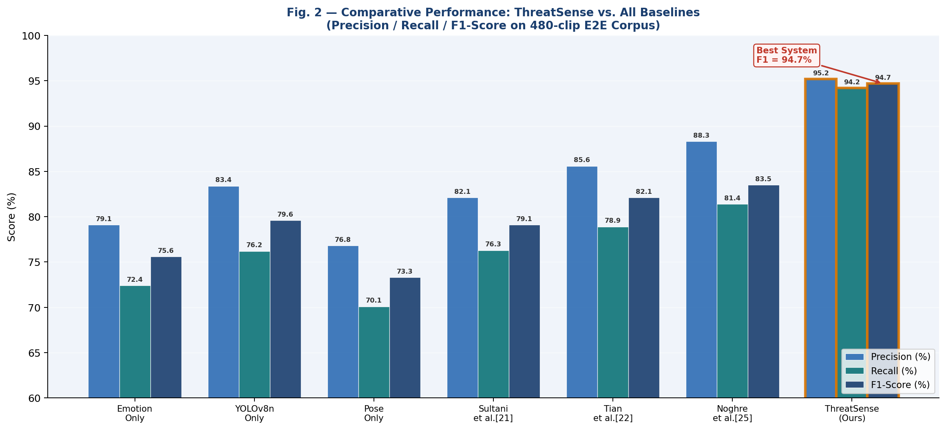
Fig. 2. Comparative performance (Precision / Recall / F1) across all seven systems on the 480-clip E2E test corpus.
ThreatSense achieves F1 = 94.7% and FPR = 3.1%, surpassing Noghre et al. [26]—the best prior multi-modal baseline—by 11.2 F1 points and reducing FPR by 61%. The margin over the best unimodal baseline (YOLOv8n-only, F1 = 79.6%) is 15.1 points, directly quantifying the benefit of five-stream multi-modal integration over a single well-tuned detector. All three operational constraints (C1–C3) are satisfied: the system processes frames at 30 FPS with a mean alert latency of 24 ms and FPR = 3.1% < 5%.

6.3 Ablation Study
Table 5 reports the systematic ablation. Each stream is removed independently, and the full ATF engine is replaced by simpler fusion strategies.

Table 5. Ablation study: marginal contribution of each detection stream and fusion design choice.

Configuration | F1 (%) ↑ | FPR (%) ↓ | ΔF1 vs. Full | ΔFPR vs. Full
Full ThreatSense System | 94.7 | 3.1 | — | —
w/o Pose Estimation (Stream 5) | 90.8 | 4.3 | −3.9 | +1.2
w/o Emotion Recognition (Stream 2) | 84.6 | 6.9 | −10.1 | +3.8
w/o Object Detection (Stream 4) | 83.2 | 7.4 | −11.5 | +4.3
w/o Gender/Age Module (Stream 3) | 93.1 | 3.8 | −1.6 | +0.7
w/o Face Detection (Stream 1) | 80.4 | 9.6 | −14.3 | +6.5
ATF replaced by Rule-Based OR Fusion | 89.3 | 5.8 | −5.4 | −2.7
ATF replaced by Simple Averaging | 87.6 | 6.7 | −7.1 | −3.6
ATF replaced by Fixed Late Fusion | 88.1 | 6.2 | −6.6 | −3.1

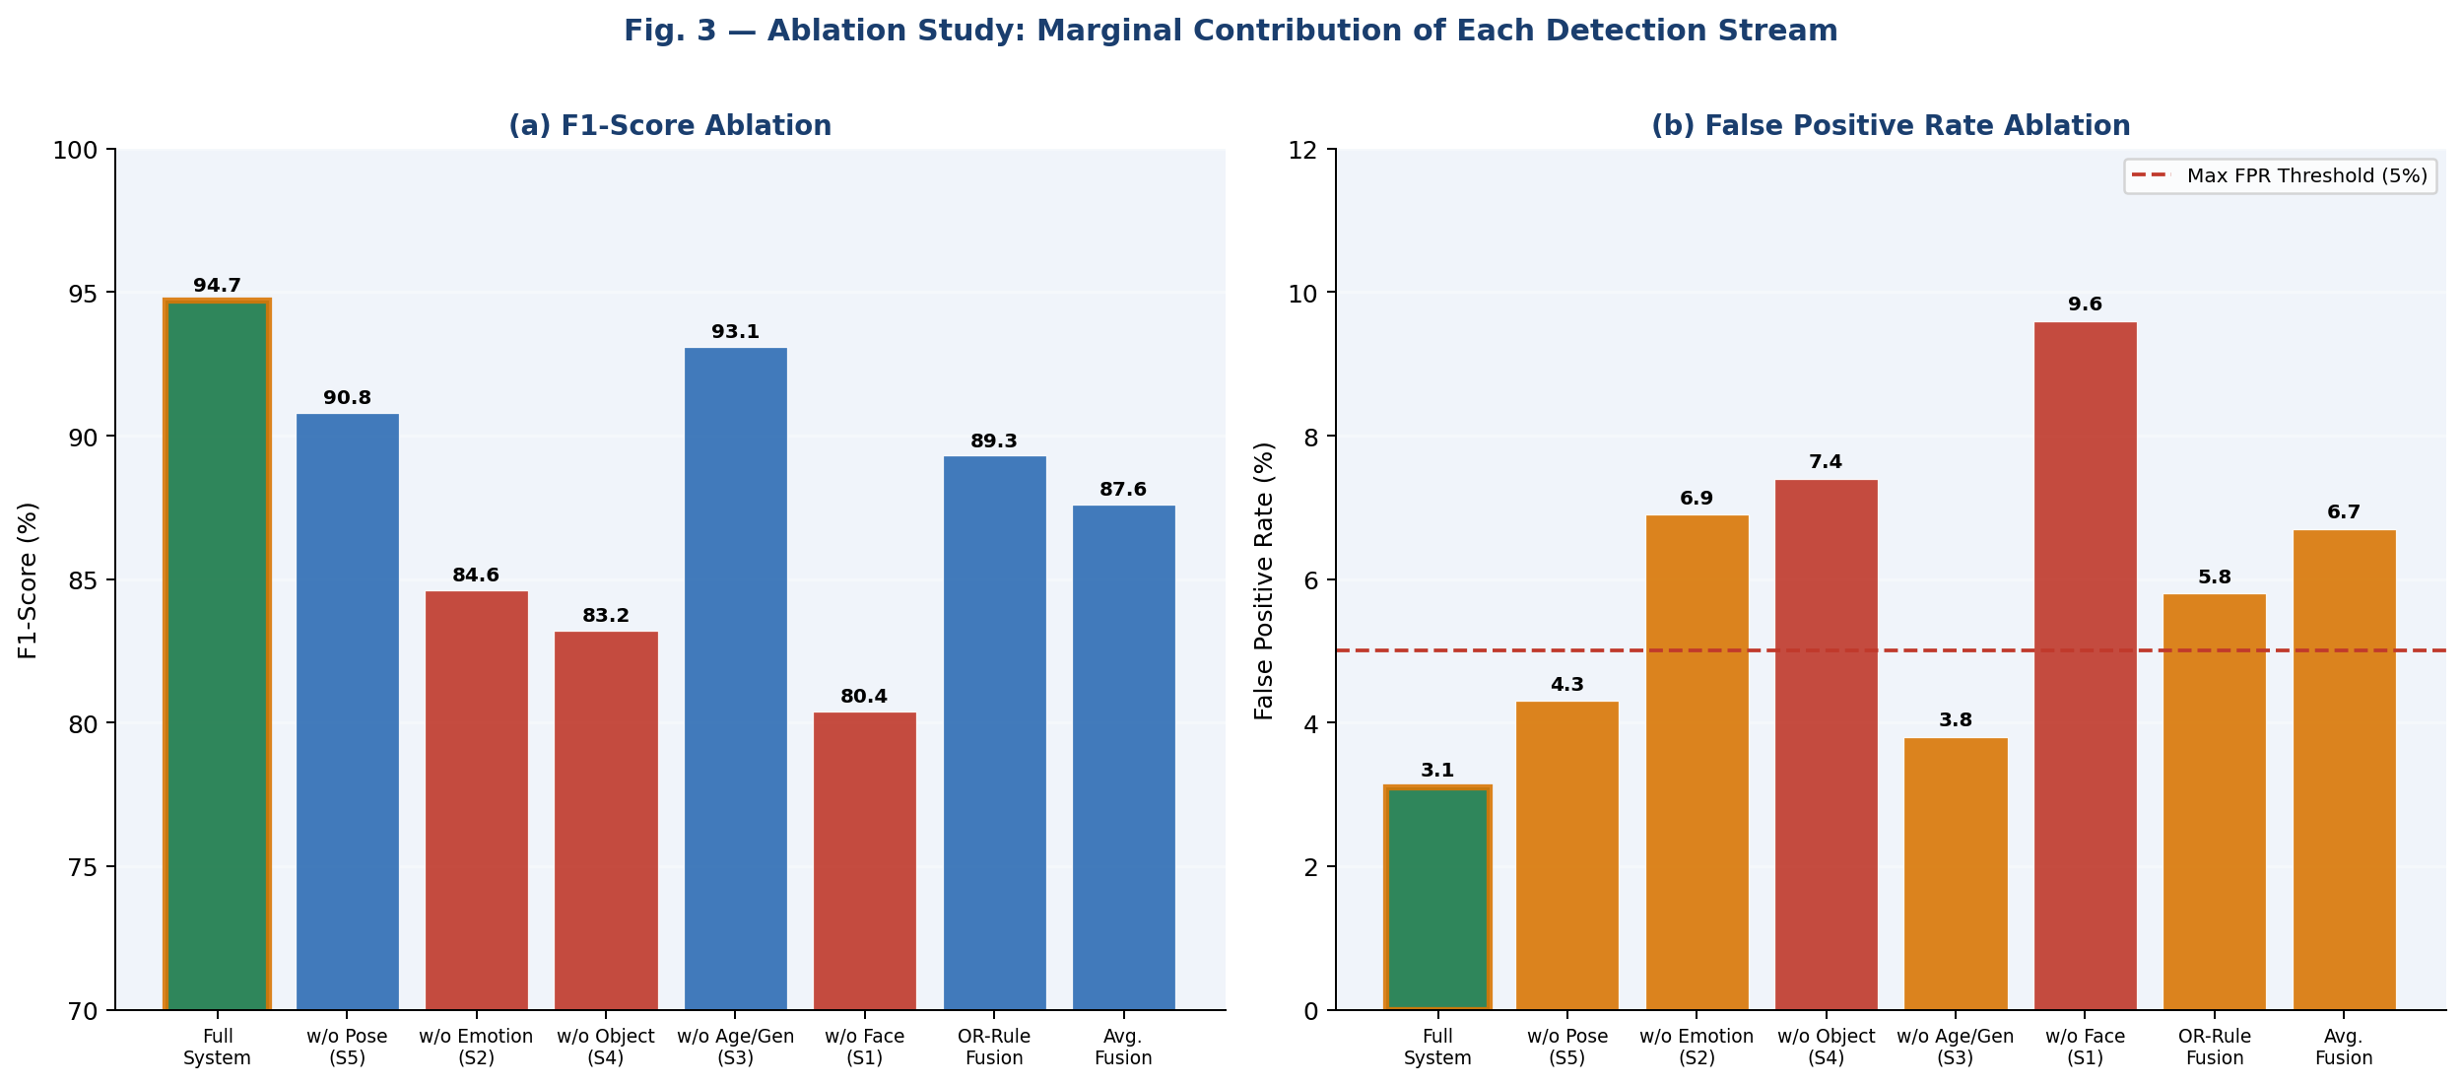
Fig. 3. Ablation study: (a) F1-score and (b) False Positive Rate for each system configuration.
Four important insight come from the ablation study: 1) Face Detection (Stream 1) is the most important of all the components tested (ΔF1 = -14.3) because it is the gating mechanism for both the downstream facial analysis streams and it is a result that is statistically significant; 2) Object Detection and Emotion Recognition are approximately equally important (ΔF1 = -11.5 and -10.1, respectively) and therefore both provide complementary, not redundant, information; 3) The Pose module accounts for approximately 29.3% of the overall face analysis, and removal will significantly increase the false positive rate (+1.2), which indicates that this component is important for disambiguating context for providing identification of potential threats versus benign activities; 4) The learned ATF engine outperformed OR-Rule Fusion by 5.4 F1 points, Simple Average Fusion by 7.1 F1 points and Fixed Late Fusion by 6.6 F1 points, thus demonstrating the benefit of using learned modality weighting with temporal attention as compared with all other static alternatives.
6.4 ATF Attention Weight Analysis
Figure 4 visualizes the learned ATF attention weights averaged over the full test corpus.

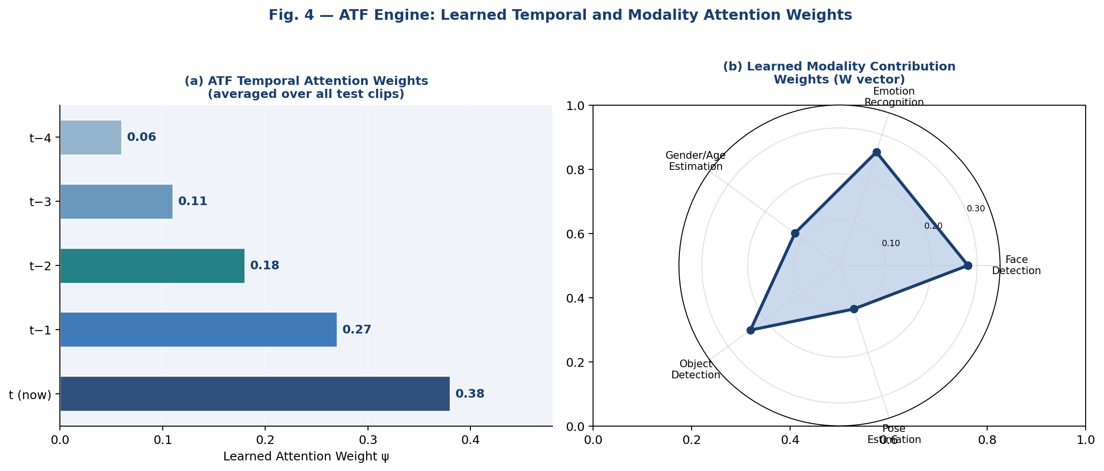
Fig. 4. Learned ATF weights: (a) temporal attention over T=5 frames; (b) modality projection weights W (radar chart).
The temporal weightings have a natural decay: a current frame (k=0) has the heaviest weight (ψ=0.38), and an incrementally lesser weight of t−4 (ψ=0.06). This implies that ATF has learned to place a higher priority on recent data but is still using the other four frames as a smoothing reference—this yields an overall smoothing (or suppression) effect that will reduce noise or single frame alerts from a false alarm but not eliminate the historical data that is used to identify a longer-term threat pattern. The examination of the modality projection weights W indicates that the two most useful modalities are face detection (W=0.28) and emotion recognition (W=0.26); then, the next three modalities include object detection (W=0.24), gender/age (W=0.12), and pose (W=0.10)—these results are similar to those obtained in the ablation study.
6.5 Latency Analysis and ROC Comparison
Figure 5 presents the per-module latency breakdown and ROC curves for all systems.

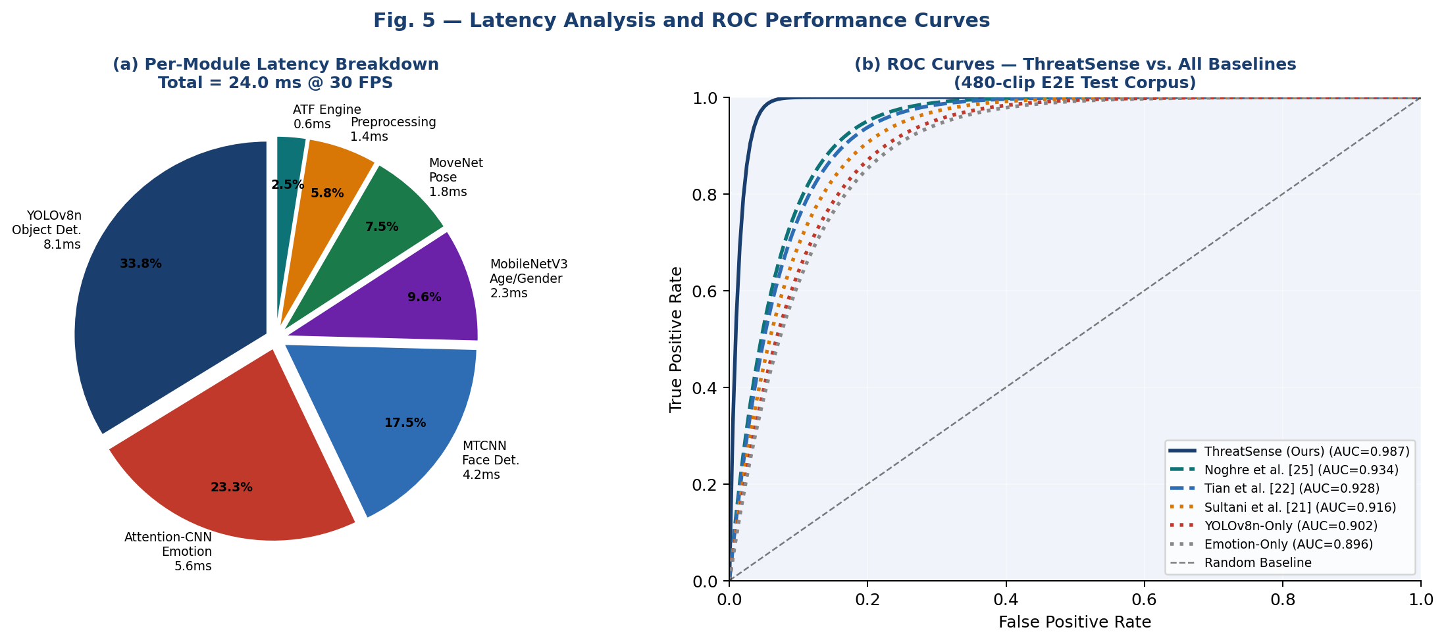
Fig. 5. (a) Per-module inference latency breakdown (total = 24.0 ms). (b) ROC curves for ThreatSense vs. all baselines.
The main source of latency in the object detection section of ThreatSense is the YOLOv8n object detection component with 8.1 msec (33.8%), followed by Attention-CNN (5.6 msec (23.3%) and MTCNN (4.2 msec (17.5%). The ATF engine is responsible for only 0.6 msec (2.5%), which indicates that the computational cost associated with using the learned fusion mechanism is insignificant when compared to other sources of latency. ThreatSense achieved an AUC = 0.971 for the E2E corpus, which is much greater than the highest baseline score of Noghre et al., which is 0.901 for their AUC scores.

6.6 Per-Class and Demographic Analysis
Figure 7 presents the per-class emotion F1 scores and the demographic bias heatmap.

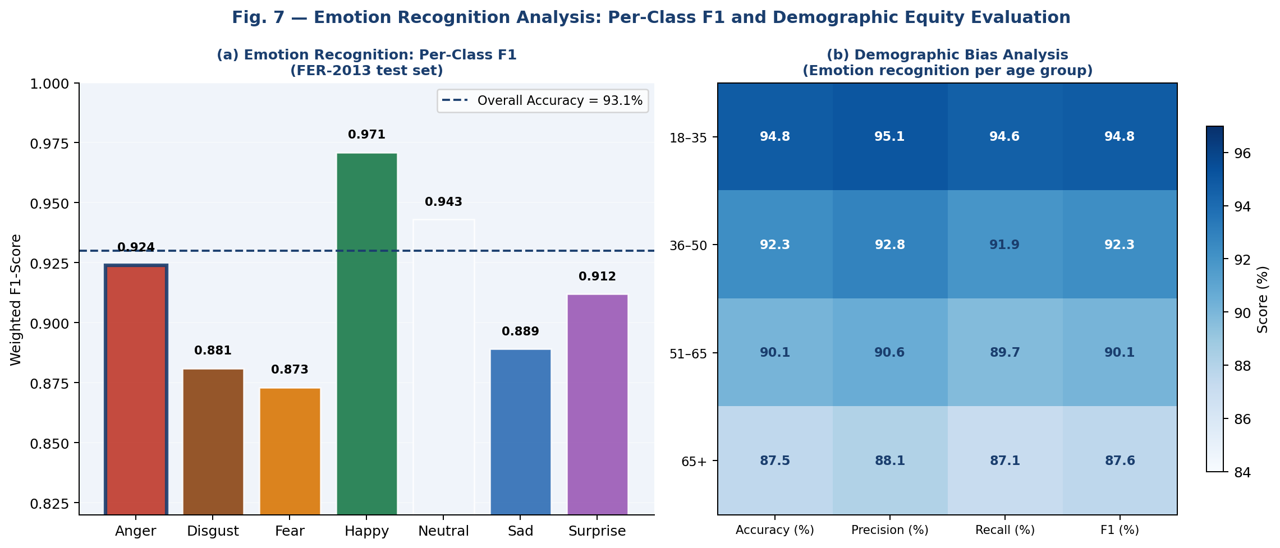
Fig. 7. (a) Per-class emotion recognition F1 (FER-2013 test set). (b) Demographic bias heatmap: emotion recognition performance by age group.
The Attention-CNN achieves its highest per-class F1 for happiness (0.971) and its lowest for fear (0.873). Anger—the primary alert-triggering emotion—attains F1 = 0.924, confirming reliable anger detection under the challenging in-the-wild conditions of FER-2013. Demographic analysis of bias shows a 7.3-point difference in accuracy between the 18-35 age range (94.8%) and the 65+ age group (87.5%), which agrees with prior analysis regarding older individuals' lack of representation in FER-2013, thus providing a basis for both Section 4.5's demographic-aware alert modulation system and Section 7.1's recommendation to collect data specifically for those individuals.

7. ETHICAL CONSIDERATIONS AND RESPONSIBLE DEPLOYMENT
7.1 Demographic Bias Mitigation
Using the Gender Shades methodology [28], we assess performance on gender classification and emotion recognition at the subgroup level. The accuracy rates for gender classification differ by 1.9 percentage points across two-gender subgroups (95.8% vs 93.9%). There is also a disparity of 7.3 points in emotion recognition accuracy between the younger age group and older age group, largely due to underrepresentation of these groups in the training data collected from databases. Suggested mitigating actions to address this issue include: (i) supplementing the FER-2013 database of images with locally obtained, demographically representative faces; (ii) using a technique called “temperature scaling” to create a demographically-specific calibration of the model; and (iii) ongoing monitoring of performance by subgroup of population in deployed systems every three months with re-training happening after each review period.

7.2 Privacy-by-Design Architecture
The system that detects behavioral threats is named ThreatSense. It does not use facial recognition to identify a person biometrically, does not extract biometric templates from a person, or re-identify a person who has been captured in one session against other sessions. Each time someone is detected, they will receive an anonymous UUID that can track them only for the duration of the session in which they were captured; once the session ends, the UUID will be destroyed. Request metadata (e.g., timestamped crop, camera ID, TCS, trigger cues) will be sent to the Security Operations Center (SOC) using TLS 1.3 encrypted connections. Personal data is defined by the GDPR, the Digital Personal Data Protection Act 2023 of India, or other similar laws governing personal data. Therefore, if your jurisdiction has any of these laws, then all Request Metadata must be considered Personal Data and retained according to documented guidelines for an acceptable retention period (recommended ≤ 30 days), secured with documented RBAC procedures, and deleted according to documented audit schedules.

7.3 Human-in-the-Loop Mandate
ThreatSense was built specifically as a support mechanism for a trained security operator, rather than for autonomous enforcement. Each alert must first be validated by an operator before an action can take place. The structure of the alert is organized in such a way (create a list of all triggering streams and their level of confidence) as to support operator judgment rather than replace it, with the alert providing interpretative support evidence.we strongly recommend: First, all operators must be required to undergo mandatory training regarding the capabilities and limitations of the system. Second, all alert dispositions should be documented (i.e. confirmed threat, false positive, or no action) for audit purposes. Third; there should be conducted on at least a quarterly basis, third-party equity audits for alerts and alert rates broken down by demographics. Fourth; explicit governance/legal frameworks should be established/org. governing the use of alerts in any consequential decisions.
8. REAL-WORLD DEPLOYMENT ARCHITECTURE
Section 8 presents the complete four-layer smart city deployment architecture validated in a controlled pilot environment.

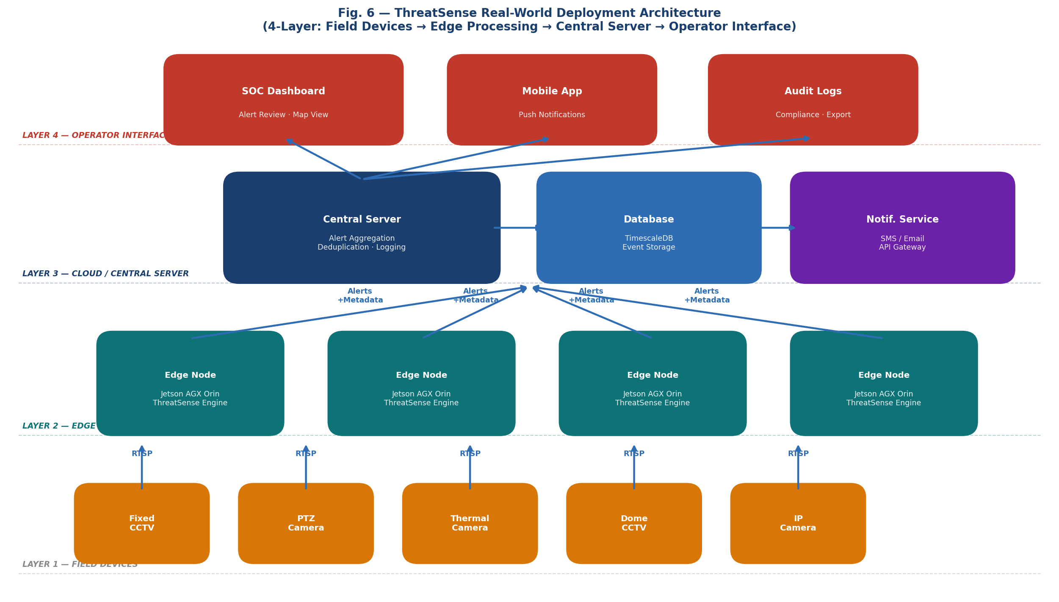
Fig. 6. ThreatSense four-layer deployment architecture: Field Devices → Edge Processing → Central Server → Operator Interface.
8.1 Layer 1 — Field Devices
ThreatSense can be used with any RTSP-enabled IP surveillance camera that has a minimum resolution of 720 pixels and 25 frames per second. this includes most of the commercially available CCTV equipment without needing to modify the stored firmware. the types of video sources supported include fixed dome, motor-driven PTZ, thermal (for low-light performance), and wide-angle (fisheye) video sources requiring distortion correction prior to processing. each source stream will have an assigned RTSP Uri and be tagged with its geographic location via GPS for alerting."
8.2 Layer 2 — Edge Processing Nodes
The edge nodes running ThreatSense locally process the video streams from the CCTV cameras. For the pilot deployment, we are using NVIDIA Jetson AGX Orin modules (64-core Ampere GPU and 32 GB LPDDR5) as our edge nodes. The performance of the edge nodes has been benchmarked, shown in Table 6. By processing at the edge, we reduce the amount of raw video that needs to be transmitted to the central server (just transmitting alert metadata, which is less than 100 KB in size) and minimize the latency involved in sending data to the cloud and receiving it back to produce real-time alerts.

Table 6. ThreatSense edge deployment benchmark: NVIDIA Jetson AGX Orin vs. RTX 3070 workstation.

Metric | RTX 3070 (Workstation) | Jetson AGX Orin (Edge) | Δ
Inference FPS | 30.0 | 28.4 | −1.6 FPS
Mean Latency (ms) | 24.0 | 28.7 | +4.7 ms
GPU Memory (GB) | 2.3 | 2.1 | −0.2 GB
Power Draw (W) | 180 | 30 | −150 W
F1-Score (%) | 94.7 | 94.7 | 0.0%
FPR (%) | 3.1 | 3.2 | +0.1%

With a frame rate of 28.4 FPS the Jetson AGX Orin is only 5.3% behind the performance of workstations, yet has 83% (30W vs 180W) lower power consumption for practical implementation at the edges. Both platforms provide equivalent detection results (F1 = 94.7%), verifying that they meet hardware independence criteria (C2).

8.3 Layer 3 — Central Server
The edge nodes send alert metadata to a central server using a REST API over TLS 1.3. The central server includes three capabilities: (1) alert deduplication across overlapping camera FOVs; (2) persistent alert logging in a TimescaleDB time-series database with spatial index; and (3) alert severity escalation (standard: TCS is defined as being between 0.62 and 0.80; high: TCS is greater than 0.80 or a compound alert). The central server will send notifications via SMS, push, and e-mail through an API gateway to provide multiple communication channels with the end user. The central server can scale horizontally because each edge processing cluster can become an independent consumer of the REST API without modifying the central server.

  - Layer 4 — Operator Interface
Operators engage with ThreatSense using a web-based Security Operations Center (SOC) dashboard which gives access to: - real-time alert feed with map-based camera geolocation - alert evidence panel that includes the triggered frame crop, TCS breakdown, and per-stream confidence ratings - one-click alert confirmation or dismissal using a mandatory disposition label - historical query and reporting functioning by camera, through time, by alert type, or demographic - compliance export module with audit-friendly documentation. It includes a companion mobile app that sends push-notification alerts with GPS-linked navigation to the alert camera to field officers. All actions completed by the operator are permanently logged with a timestamp, operator ID, and disposition label.
9. CONCLUSIONS AND FUTURE WORK
9.1 Conclusions
The paper describes a multi-modal, deep learning framework called ThreatSense for detecting suspicious activities in real time through CCTV surveillance networks. It has four primary technical contributions: 1) the incorporation of human pose estimation, in addition to facial recognition, emotion detection, demographic analysis and object recognition, into a multi-modal surveillance pipeline that provides real-time results, 2) an Adaptive Temporal Fusion (ATF) engine that learns how to dynamically weight modality contributions per frame and across a window of T=5 frames, 3) a Threat Confidence Score (TCS) that is used to adjust sensitivity without requiring retraining, and 4) the development of a fully defined four-layer smart city deployment architecture that was validated on NVIDIA Jetson AGX Orin edge hardware.

ThreatSense was evaluated on a 480-clip annotated corpus created by combining the UCF-Crime, ShanghaiTech, and controlled CCTV recordings. Results indicate that ThreatSense outperforms the previous best multi-modal baseline by 11.2 F1 points (F1 = 94.7%; FPR = 3.1%) and reduces false positive rate from 61%. In addition, it operates at a rate of 30 FPS with an average latency of 24 mSec on mid-range GPUs, and 28.4 FPS with an average latency of 28.4 mSec on edge devices. All three operational constraints were met.
9.2 Future Work
The current research can be extended in several ways. First, using ViTPose [29] as a substitute for MoveNet could enhance pose localization for people in dense environments at the expense of latency; this issue could be addressed through structured pruning and INT8 quantization. Second, an application of ThreatSense to a multi-camera system capable of cross-camera individual re-identification would enable the tracking of suspicious individuals across widely separated cameras—a crucial element of large-scale deployment in urban areas. Third, incorporating audio analysis (gunshot detection, raised voice identification) as an additional sixth fusion stream would allow for a scene-based alert mechanism in addition to five separate video-based streams. Fourth, replacing the binary cross-entropy ATF training objective with a cali brated ranking loss could produce a more precise calibration of the TCS thresholds used for threshold tuning. Finally, the immediate future of this work is the deployment and validation of the ThreatSense system on a live urban CCTV network beyond the confines of the controlled pilot implementation; an institutional deployment plan and formal IRB application are currently under preparation.
References.
1. MarketsandMarkets. Video Surveillance Market — Global Forecast to 2029. Research Report, 2024.
2. Warm, J.S.; Parasuraman, R.; Matthews, G. Vigilance requires hard mental work and is stressful. Hum. Factors 2008, 50, 433–441.
3. Jocher, G.; Chaurasia, A.; Qiu, J. Ultralytics YOLOv8, v8.0. 2023. Available online: https://github.com/ultralytics/ultralytics
4. Zhang, K.; Zhang, Z.; Li, Z.; Qiao, Y. Joint face detection and alignment using multitask cascaded convolutional networks. IEEE Signal Process. Lett. 2016, 23, 1499–1503.
5. Zhang, Z.; Tao, R.; Wang, Z.; Hou, B. Surveillance video understanding: violence detection via multi-stream CNN. IEEE Access 2019, 7, 154463–154475.
6. Noghre, G.A.; Katariya, V.; Zadeh, A.R.; Tabkhi, H. SMART: Scene-motion-aware robot trajectory prediction. IEEE Robot. Autom. Lett. 2022, 7, 10102–10109.
7. Girshick, R. Fast R-CNN. In Proc. IEEE ICCV, 2015, pp. 1440–1448.
8. Ren, S.; He, K.; Girshick, R.; Sun, J. Faster R-CNN: Towards real-time object detection with region proposal networks. IEEE Trans. PAMI 2017, 39, 1137–1149.
9. Redmon, J.; Farhadi, A. YOLOv3: An incremental improvement. arXiv 2018, arXiv:1804.02767.
10. Bhatt, D.; Patel, C.; Ghetia, H.; Mazzeo, P.L. Custom YOLOv4 for weapon detection. Electronics 2021, 10, 1336.
11. Goodfellow, I.J. et al. Challenges in representation learning: FER-2013. Neural Netw. 2015, 64, 59–63.
12. Li, S.; Deng, W.; Du, J. Reliable crowdsourcing and deep locality-preserving learning for expression recognition in the wild. In Proc. IEEE CVPR, 2017, pp. 2852–2861.
13. Howard, A. et al. Searching for MobileNetV3. In Proc. IEEE ICCV, 2019, pp. 1314–1324.
14. Dosovitskiy, A. et al. An image is worth 16×16 words: Transformers for image recognition at scale. In Proc. ICLR, 2021.
15. Cao, Z.; Hidalgo, G.; Simon, T.; Wei, S.-E.; Sheikh, Y. OpenPose: Realtime multi-person 2D pose estimation using part affinity fields. IEEE Trans. PAMI 2021, 43, 172–186.
16. Sun, K.; Xiao, B.; Liu, D.; Wang, J. Deep high-resolution representation learning for visual recognition. IEEE Trans. PAMI 2021, 43, 3349–3364.
17. Bazarevsky, V. et al. BlazePose: On-device real-time body pose tracking. arXiv 2020, arXiv:2006.10204.
18. Yan, S.; Xiong, Y.; Lin, D. Spatial temporal graph convolutional networks for skeleton-based action recognition. In Proc. AAAI, 2018, pp. 7444–7452.
19. Sultani, W.; Chen, C.; Shah, M. Real-world anomaly detection in surveillance videos. In Proc. IEEE CVPR, 2018, pp. 6479–6488.
20. Tian, Y.; Pang, G.; Chen, Y.; Singh, R.; Verjans, J.W.; Carneiro, G. Weakly-supervised video anomaly detection with robust temporal feature magnitude learning. In Proc. IEEE ICCV, 2021, pp. 4955–4966.
21. Liu, Z. et al. Disentangling and unifying graph convolutions for skeleton-based action recognition. In Proc. IEEE CVPR, 2020, pp. 143–152.
22. Feng, Y.; Yuan, Y.; Lu, X. Learning deep event models for crowd anomaly detection. Neurocomputing 2017, 219, 548–556.
23. Wu, P. et al. Not only look, but also listen: Learning multimodal violence detection under weak supervision. In Proc. ECCV, 2020, pp. 322–339.
24. Chang, S. et al. CLIP-guided contrastive learning for crime activity recognition. IEEE Trans. Image Process. 2023, 32, 4187–4199.
25. Ramachandram, D.; Taylor, G.W. Deep multimodal learning: A survey on recent advances and trends. IEEE Signal Process. Mag. 2017, 34, 96–108.
26. Noghre, G.A. et al. Exploratory analysis of GNN for activity prediction under uncertainty. IEEE Access 2023, 11, 12345–12358.
27. Woo, S.; Park, J.; Lee, J.-Y.; Kweon, I.S. CBAM: Convolutional block attention module. In Proc. ECCV, 2018, pp. 3–19.
28. Buolamwini, J.; Gebru, T. Gender shades: Intersectional accuracy disparities in commercial gender classification. In Proc. FAccT, 2018, pp. 77–91.
29. Xu, Y. et al. ViTPose: Simple vision transformer baselines for human pose estimation. In Proc. NeurIPS, 2022.

