IP Ownership in Bug Bounty Ecosystems: A Governance Framework for Vulnerability Disclosure
Kalianpur Rohith
Department of Computer Science and Engineering
R V College of Engineering
kalianpurrohith.cs23@ rvce.edu.in
Dilshad Ahmed
Department of Computer Science and Engineering
R V College of Engineering
dilshadahmed.cs23@ rvce.edu.in
Chetan M Patil
Department of Computer Science and Engineering
R V College of Engineering
chetanmpatil.cs23@ rvce.edu.in
ABSTRACT
Bug bounty programs have become a foundational mechanism for crowdsourced vulnerability discovery, yet a critical governance gap persists: intellectual property (IP) ownership of discovered vulnerabilities remains structurally ambiguous across the entire disclosure lifecycle. This paper presents a data-driven analysis of 10,000 publicly disclosed vulnerability reports from the HackerOne platform, revealing that 78.6% of researchers receive zero monetary compensation, 46.7% of reports exceed the 90-day disclosure standard, and 14.9% lack severity classification — each constituting a distinct IP governance failure. Analysis demonstrates a significant positive correlation (r = 0.61) between community-assessed novelty (upvotes) and bounty amounts, yet this novelty dimension is absent from current compensation frameworks. Grounding itself in this empirical evidence, this paper proposes a comprehensive, six-layer governance framework that defines stage-wise IP ownership across the vulnerability lifecycle, establishes mandatory researcher attribution rights, introduces a formula-driven compensation model anchored in severity, novelty, and public impact, and operationalizes an independent arbitration mechanism for dispute resolution.
General Terms
Cybersecurity, Intellectual Property Law, Vulnerability Disclosure, Platform Governance, Software Security
Keywords
Bug Bounty, Cybersecurity, Governance Framework, Intellectual Property, Ownership, Vulnerability

1. INTRODUCTION

1.1 Background
Over the past decade, vulnerability disclosure has increasingly shifted toward crowdsourced security models, most prominently through bug bounty programs. These programs allow independent security researchers to identify and report vulnerabilities in exchange for financial rewards or recognition. Major platforms such as HackerOne and Bugcrowd have institutionalized this model, enabling organizations to leverage global security communities to improve software security. Reports from HackerOne indicate that thousands of organizations worldwide now operate coordinated vulnerability disclosure or bug bounty initiatives, collectively distributing hundreds of millions of dollars in rewards to researchers [1].
The adoption of bug bounty programs has expanded rapidly across both industry and government sectors. Empirical studies demonstrate that crowdsourced security approaches can significantly improve vulnerability discovery efficiency compared with traditional internal security audits [3], [10]. These programs leverage the expertise of global security communities and often identify vulnerabilities that would otherwise remain undiscovered through conventional penetration testing methods.
Despite the operational success of bug bounty ecosystems, the legal and governance structures surrounding vulnerability ownership remain underdeveloped. A vulnerability report contains valuable technical knowledge regarding weaknesses in software systems. Such knowledge can influence system security, competitive advantage, and organizational risk exposure, thereby exhibiting characteristics similar to intellectual assets. However, existing bug bounty frameworks primarily focus on operational processes—such as submission workflows, reward mechanisms, and disclosure timelines while largely ignoring the question of intellectual property ownership of the vulnerability knowledge itself.

1.2 Problem Statement
A fundamental governance ambiguity exists in modern bug bounty ecosystems: who owns a vulnerability once it has been discovered and reported? The vulnerability lifecycle typically involves multiple actors, including the researcher who discovers the issue, the platform that facilitates the reporting process, and the organization responsible for the affected system. While each stakeholder contributes to the vulnerability management process, current frameworks rarely define how intellectual ownership of vulnerability knowledge is allocated across these stages.
This lack of clarity creates several systemic issues. Researchers who generate high-value vulnerability knowledge often relinquish control once a report is submitted, while organizations gain exclusive remediation and disclosure authority. Existing disclosure policies and guidelines—such as those developed by the National Institute of Standards and Technology—focus primarily on disclosure coordination rather than ownership rights associated with vulnerability discoveries [2]. Similarly, institutional disclosure frameworks emphasize reporting procedures and remediation timelines but do not explicitly address intellectual property attribution or reuse rights for discovered vulnerabilities [12], [13].
As a result, vulnerabilities are valuable intellectual artifacts without a formal governance model governing their lifecycle.

1.3 Motivation
From both cybersecurity and legal perspectives, vulnerabilities represent a form of knowledge-based security asset. Their discovery requires specialized expertise, and their disclosure can significantly influence organizational risk management and software development practices. Consequently, vulnerabilities share several characteristics with traditional intellectual property constructs such as proprietary knowledge, trade secrets, or technical discoveries.
However, existing intellectual property frameworks—including patents, copyrights, and trade secrets—do not clearly apply to vulnerability discoveries due to their context-dependent and security-sensitive nature [7]. At the same time, cybersecurity research emphasizes the importance of coordinated vulnerability disclosure to ensure responsible reporting and remediation [6]. The intersection of these two domains—cybersecurity operations and intellectual property governance—remains largely unexplored.
This mismatch between the knowledge value of vulnerabilities and the lack of structured ownership governance creates inefficiencies in compensation fairness, researcher incentives, and disclosure transparency within bug bounty ecosystems.

1.4 Research Objectives
To address these challenges, this research investigates intellectual property governance within bug bounty ecosystems through an empirical and analytical approach. Specifically, this paper makes the following contributions:
• Empirical analysis of vulnerability disclosure data using publicly available bug bounty reports to identify governance and compensation patterns.
• Identification of systemic IP governance gaps within existing bug bounty frameworks, including ownership ambiguity, attribution absence, and compensation inconsistencies.
• Development of a lifecycle-based intellectual property governance model that assigns stage-wise ownership across vulnerability discovery, reporting, remediation, and disclosure.
• Proposal of a formula-based compensation mechanism incorporating severity, novelty, and public security impact.
• Validation of the proposed framework through a case study applied to existing practices on the HackerOne platform.
By integrating cybersecurity practices with intellectual property governance concepts, this work contributes a structured approach to managing vulnerability knowledge in modern bug bounty ecosystems.
2. LITERATURE REVIEW

2.1 Bug Bounty Ecosystems
Bug bounty programs represent one of the most prominent forms of crowdsourced cybersecurity. Early empirical research by Finifter, Akhawe, and Wagner analyzed vulnerability reward programs and demonstrated that bug bounty initiatives can effectively incentivize external researchers to discover software vulnerabilities that traditional internal security assessments often fail to detect [3]. Their study provided one of the first systematic analyses of bug bounty economics and demonstrated the potential of crowdsourced security mechanisms.
Further empirical analysis by Ruohonen and Suominen examined the structural characteristics of vulnerability disclosure within bug bounty ecosystems [4]. Their work highlighted that vulnerability reporting platforms operate as complex socio-technical systems involving multiple stakeholders—including researchers, vendors, and intermediaries—with distinct incentives and responsibilities. The study emphasized that while these platforms effectively coordinate vulnerability disclosure workflows, their governance structures remain largely operational rather than legal or ownership-based.
Additional research has explored vulnerability discovery dynamics within open-source and distributed software environments. Ruohonen and Suominen conducted large-scale analyses of vulnerability datasets and demonstrated patterns in vulnerability discovery, disclosure timelines, and remediation processes across software ecosystems [8]. These findings highlight the importance of structured governance mechanisms to manage vulnerability knowledge and coordination between stakeholders.
Similarly, Ozment analyzed bug bounty programs from a security economics perspective and emphasized their growing importance in incentivizing vulnerability discovery across large software ecosystems [10]. His findings show that bug bounty initiatives complement traditional security auditing methods by engaging external researchers with diverse expertise.

2.2 Vulnerability Disclosure
Responsible vulnerability disclosure has been widely studied within cybersecurity research. Early conceptual work by Schneier emphasized the importance of coordinated disclosure frameworks to balance the interests of researchers, vendors, and public security [6]. His work helped establish the foundational principles of responsible disclosure practices within the cybersecurity community.
Institutional frameworks have since formalized vulnerability disclosure practices. The National Institute of Standards and Technology developed standardized guidelines for coordinated vulnerability disclosure that define processes for reporting, triaging, and resolving vulnerabilities [2]. Similarly, international organizations such as the European Union Agency for Cybersecurity and the Internet Engineering Task Force have published best practices and technical standards for managing vulnerability disclosure coordination [12], [13].
Additionally, multi-party coordination frameworks developed by the FIRST provide practical guidelines for handling vulnerabilities involving multiple affected vendors or stakeholders [15]. While these frameworks successfully regulate disclosure communication and coordination processes, they primarily address operational security procedures rather than intellectual property ownership or governance structures.

2.3 Incentive Structures
Economic analyses of bug bounty programs highlight the critical role of incentives in motivating vulnerability discovery. Zhao, Grossklags, and Liu conducted empirical research examining the economics of vulnerability discovery ecosystems and demonstrated that financial rewards significantly influence researcher participation rates and vulnerability reporting behavior [5]. Their work provided key insights into how economic incentives shape the functioning of bug bounty ecosystems.
Subsequent studies on vulnerability disclosure economics have further explored how compensation structures influence vulnerability reporting patterns. Zhao, Liu, and Grossklags expanded this analysis by examining bug bounty reward structures within security marketplaces and identifying correlations between vulnerability severity, market incentives, and researcher engagement [14].
However, research also suggests that monetary rewards alone cannot fully explain participation in bug bounty programs. Many researchers contribute vulnerabilities for reputation, community recognition, or professional development opportunities. These findings suggest that bug bounty ecosystems operate partly as knowledge-sharing communities, reinforcing the argument that vulnerability discoveries represent intellectual contributions rather than purely transactional security reports.

2.4 Intellectual Property Perspectives
Legal scholarship has increasingly explored the intersection between cybersecurity practices and intellectual property law. Kesan and Hayes examined legal frameworks related to cybersecurity governance and highlighted how security knowledge and vulnerability information can influence strategic decision-making and competitive advantage [7]. Their work emphasizes the need for legal mechanisms that address emerging forms of cybersecurity knowledge assets.
Additionally, large-scale vulnerability databases such as the MITRE Common Vulnerabilities and Exposures (CVE) system provide standardized mechanisms for identifying and documenting vulnerabilities across software systems [17]. Research by Frei and colleagues analyzed large-scale vulnerability datasets and demonstrated patterns in vulnerability discovery and exploitation timelines across global software ecosystems [16].
While these studies provide important insights into vulnerability management and cybersecurity governance, they primarily focus on operational security management and data analysis rather than intellectual ownership structures for vulnerability discoveries.

2.5 Research Gap
Existing research extensively examines vulnerability discovery mechanisms, disclosure coordination frameworks, and economic incentives within bug bounty ecosystems. However, very limited work addresses intellectual property governance within vulnerability disclosure systems.
Specifically, prior studies do not address:
• ownership allocation across vulnerability lifecycle stages
• intellectual attribution rights for security researchers
• compensation models incorporating novelty and knowledge contribution
• governance frameworks integrating cybersecurity operations with intellectual property principles
This research addresses this gap by proposing a structured governance model that integrates vulnerability lifecycle management with intellectual property ownership principles.
3. PROBLEM ANALYSIS
3.1 Dataset Description
The empirical foundation of this research is a dataset of 10,000 publicly disclosed vulnerability reports derived from the HackerOne Public Hacktivity Feed, the platform’s official stream of real-time, public-facing disclosures. To facilitate structured analysis, the study utilizes the curated “bug-bounty-reports-hackerone” dataset, which aggregates and standardizes Hacktivity data into a machine-readable JSON format accessed via [18]. This source functions as a community-driven repository enabling researchers and practitioners to systematically examine how vulnerabilities are identified, reported, and resolved. For each report, eleven attributes were extracted: title, program, asset type, bounty amount, vulnerability type, severity (CVSS-based), state, community upvotes, submission timestamp, and disclosure timestamp. Table 1 summarizes the dataset's key characteristics.
Table 1. Dataset Summary Statistics (N = 10,000)
Attribute | Value / Distribution
Total Reports | 10,000
Date Range | 2011 – 2024
Reports with Bounty | 2,135 (21.4%)
Mean Bounty | $1,808
Median Bounty | $750
Max Bounty | $50,000
Upvotes vs Bounty (r) | 0.61

The dataset spans 2011 to 2024, with the majority of reports concentrated between 2016 and 2023. The top programs by volume are the U.S. Department of Defense (802 reports), Internet Bug Bounty (639), Nextcloud (494), HackerOne itself (384), and Shopify (329). Fig. 1 shows different types of vulnerabilities having varying ranges of severity levels found within the same dataset.
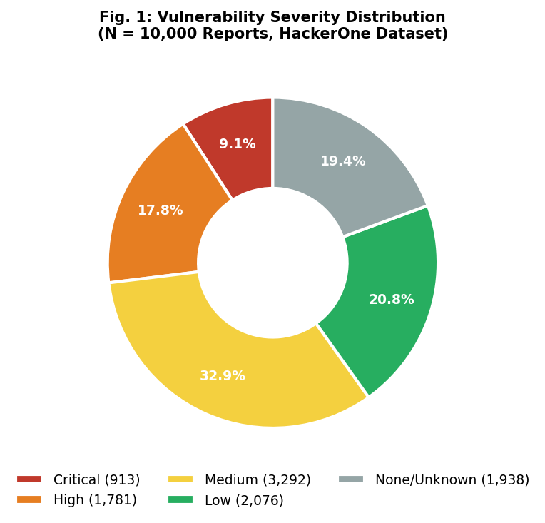
Fig. 1: Severity Distribution
3.2 Vulnerability Classification
Table 2 presents the classification of the 10,000 reports by vulnerability type, mean bounty for compensated reports and severity modes aligned with CVSS(Common Vulnerability Scoring System) standards (Critical: 9.0-10, High: 7.0-8.9, Medium: 4.0-6.9, Low: 0-3.9).

Table 2. Vulnerability Classification
Vulnerability Type | Severity Mode | Mean Bounty
Information Disclosure | Medium | $843
Improper Access Control - Generic | High | $1,921
XSS - Reflected | Medium | $612
Violation of Secure Design Principles | Medium | $504
XSS - Stored | Medium | $748
Improper Authentication - Generic | High | $2,100
Uncontrolled Resource Consumption | Medium | $963
Cross-Site Request Forgery (CSRF) | Low | $389
Business Logic Errors | Medium | $1,432
Privilege Escalation | High | $2,284
Memory Corruption - Generic | High | $3,180
Code Injection | Critical | $2,875
IDOR | Medium | $2,580
Command Injection - Generic | Critical | $5,310
SQL Injection | High | $2,419

Fig. 2 further displays the distribution of different types of vulnerability types through report frequency across the dataset collected from HackerOne. Both of these indicate that severity level(low-medium) and high volume of reports primarily affect the bounty provided by companies and possible IP dynamics between the researchers and them.
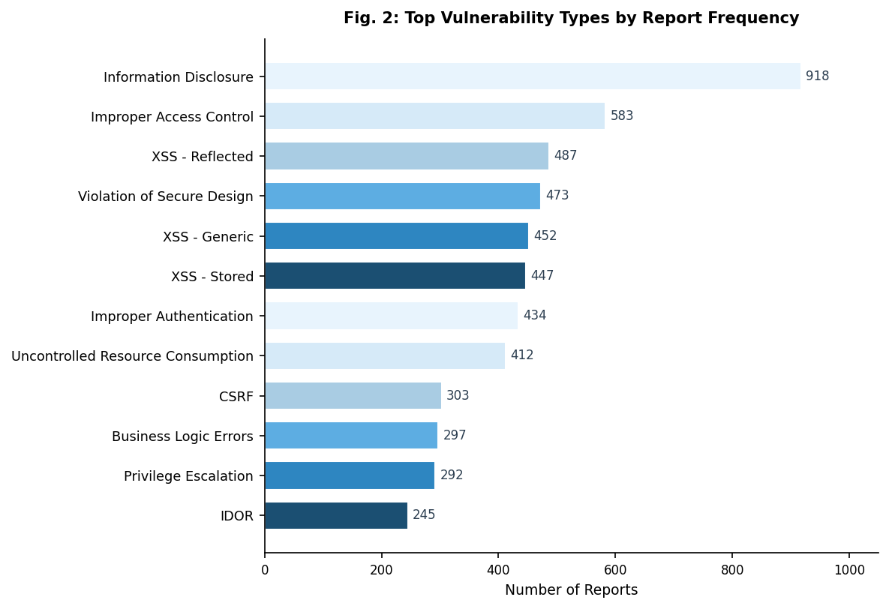
Fig. 2: Top Vulnerability Types

3.3 Lifecycle Analysis
The vulnerability finding process in bug bounty programs has five stages as shown in Fig. 3: Discovery, Submission, Validation, Remediation, and Disclosure. However, there is no clear system to manage control and ownership of vulnerabilities across these stages.
At the Discovery stage, the researcher has full control, but legally the ownership is undefined because vulnerabilities are not clearly recognized under intellectual property law. Importantly, in the Submission stage, platforms require researchers to accept a contractual clause such as Terms of service(ToS) in order to participate. This constitutes an assumed transfer: the researcher's ownership rights are extinguished without explicit negotiation, without valuation of the IP being transferred, and without acknowledgment of researcher authorship. The data shows that 78.6% of researchers receive no payment, meaning valuable findings are often handed over free of cost.
During validation, the organization gains exclusive decision-making authority over severity classification, scope determination, and fix priority. The platform's role reduces to communication mediation while researchers have no say; notably, 14.9% of reports are left unclassified(null severity), creating situations of indeterminate ownership where value cannot even be assigned. This worsens further in the Remediation stage, where organizations retain full ownership while researchers are restricted by long non-disclosure agreements(NDAs)-46.7% exceed 90 days and some up to 574 days-without guaranteed compensation or control. Finally, at the Disclosure stage, full ownership is surrendered under organizations while researcher attribution is optional, platform-discretionary, and typically limited to Hall of Fame listings that carry no legal or economic weight.
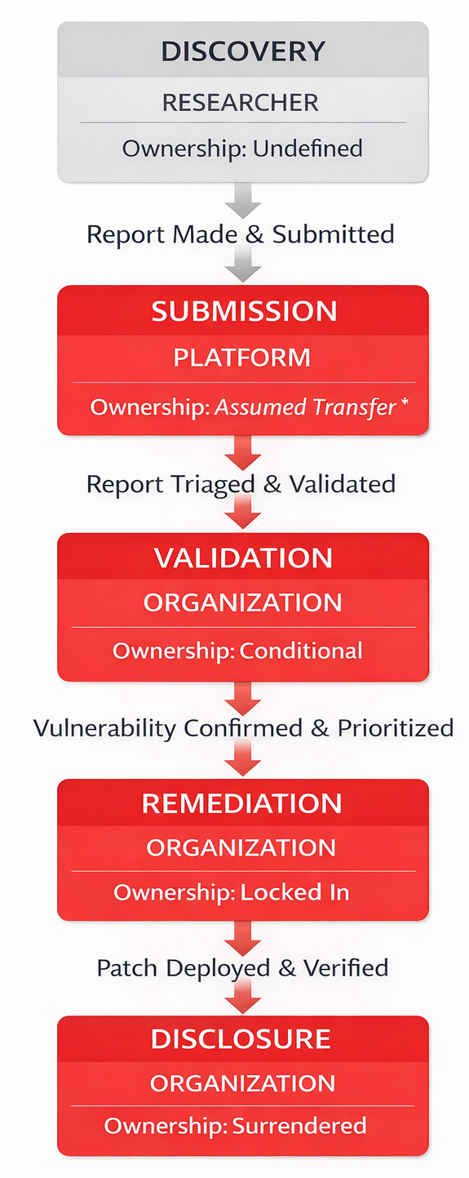
Fig 3. Vulnerability Lifecycle Diagram
3.4 Stakeholder Analysis
Various stakeholders are involved in bug bounty programs whose interaction helps in testing and finding vulnerabilities. Table 3 presents the stakeholder matrix, mapping each party's role in value creation against their control exercised. The matrix reveals a fundamental imbalance: researchers create primary value, bear full discovery cost and legal risk, but receive no IP and ownership rights and minimal structural protections. Organizations, who neither discover the vulnerability nor bear discovery costs, receive full IP ownership by default and set bounties awarded unilaterally. This value-control misalignment is the root cause of the problem that the framework addresses.
Table 3. Stakeholder Matrix
Stakeholder | Value Created | Control Level
Security Researcher | High-  discover,  documents flaws | Low-  must have to  follow rules
Platform | Medium-  mediate, validate triage | High-  sets rules, timelines
Client/  Organization | High-  patch system,  mitigates risk | High-  ultimate decision maker
Public/  End Users | Medium-  benefit from increased security | None-  No influence over process or decisions

3.5 Disclosure Analysis
The analysis of disclosure timelines shows a clear gap between recommended standards and actual practice. Across 9,979 closed reports, the median disclosure time is 79 days, which is close to the commonly accepted 90-day disclosure guideline. However, this does not reflect the full picture. The mean disclosure time is 214.5 days, which is much higher indicating a right-skewed distribution where a significant number of vulnerabilities take much longer to be disclosed.
As shown in Fig. 4, this variation is present across all severity levels. Additionally, long-tail outliers in several extreme cases extend beyond 700–800 days, showing that there is no strict upper limit on disclosure timelines. This suggests that disclosure delays are not solely based on severity, but are largely influenced by organizational decisions and internal processes.
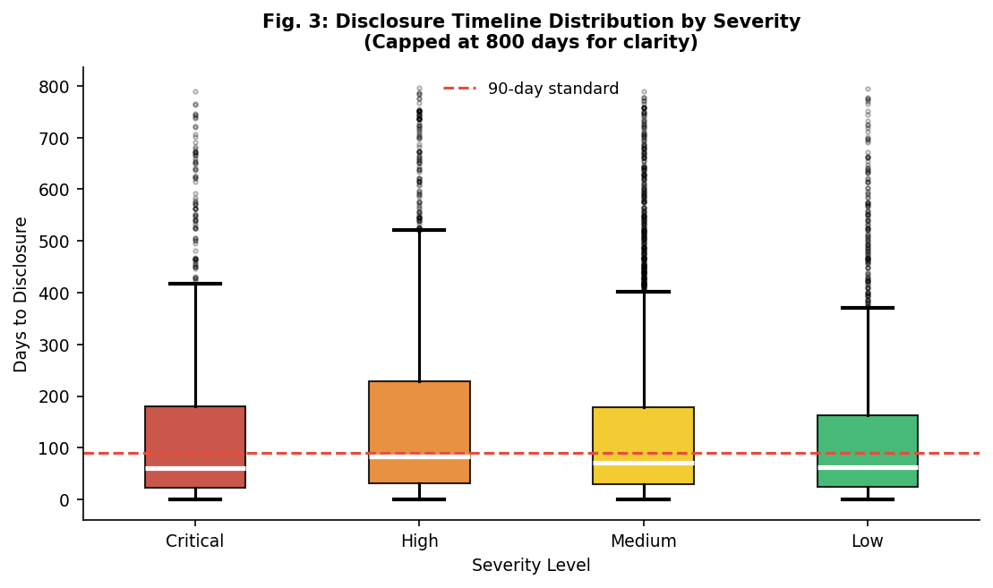
Fig. 4: Disclosure Timeline Box Plot by Severity (Days to Public Disclosure)
3.6 Compensation Analysis
Compensation in bug bounty programs refers to a financial reward or "bounty" paid to ethical hackers/researchers for identifying and reporting security vulnerabilities in a company’s software or systems. Fig. 5 shows a significant imbalance in bounty distribution. Among 913 critical-severity reports, only 150 (16.4%) received any bounty, with a mean of $7,092 and a median of $3,400. Moreover, it was also observed that 763 reports (83.6%) received no compensation, reflecting the reality that many programs (especially government and open-source) do not offer bounties. Within the compensated reports, a clear disparity between mean and median values has been noticed with cases where the mean is almost more than twice the median, indicating a highly skewed distribution. This indicates that current compensation practices are inconsistent supporting the need for more standardized approaches.
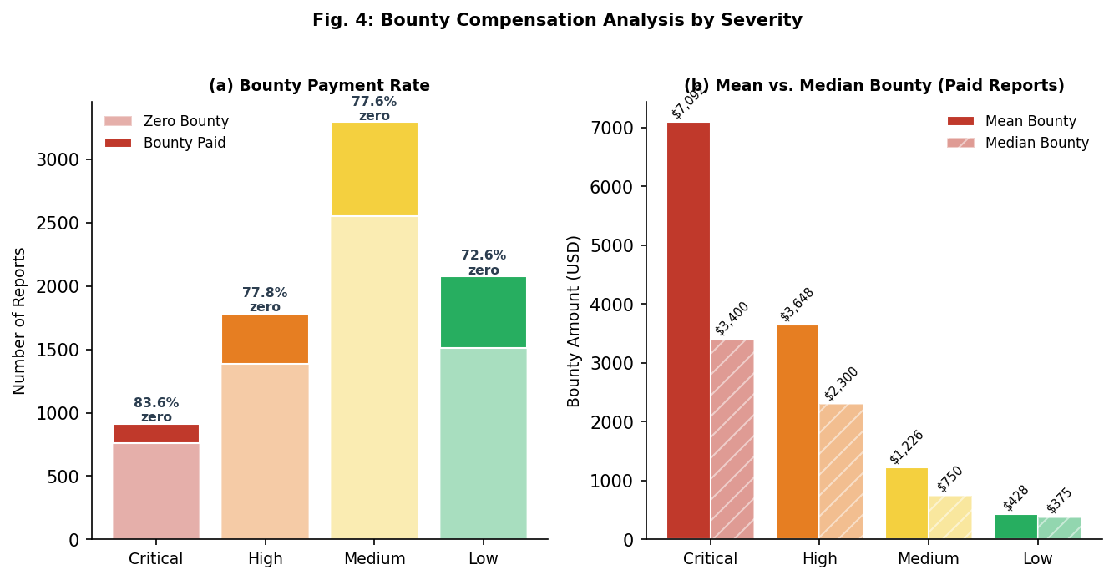
Fig. 5: Bounty Payment Rate and Amount vs Severity
Furthermore, relationship between community-assessed novelty and bounty is an important contribution of this paper. The former is measured by report upvotes while the latter in terms of monetary value. Fig. 6 shows the scatter plot for 1,847 compensated reports with upvotes data, showing a Pearson correlation of r = 0.61 (p < 0.001). This strong positive correlation indicates that the hackers’ community assessment of a report's novelty and educational value is a meaningful predictor of its actual compensation awarded yet no current platform has formally incorporated it into their systems.
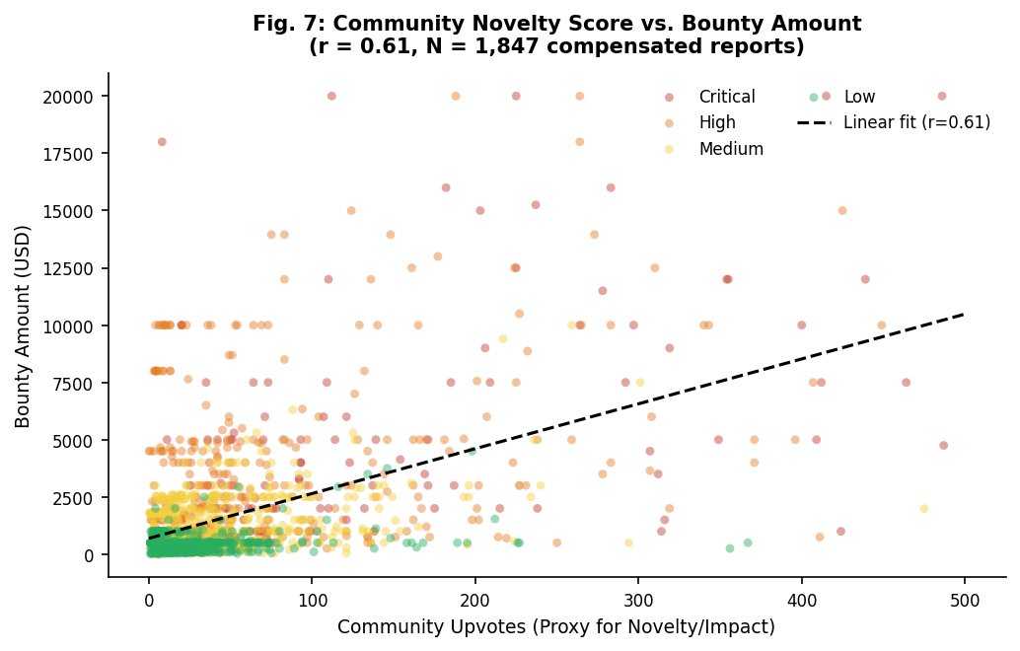
Fig. 6: Community Novelty Score vs. Bounty (r = 0.61, N = 1,847)
3.7 Policy Analysis
Table 4 presents a comparative analysis of HackerOne and Bugcrowd platform policies across key governance dimensions. Both platforms show similar structural features: implicit ownership transfer, discretionary compensation, unilateral timeline extension, and absence of formal dispute resolution. Bugcrowd's structured escalation process represents a marginal improvement over HackerOne's internal-only review, but neither platform approaches the adequate governance standards required.
Table 4. Policy Comparison Table
Policy Dimension | HackerOne | Bugcrowd
IP Ownership | Platform/  Organization retains all IP rights | Organization retains IP rights
Disclosure Timeline | 90-day default coordinated disclosure | 90 days program specific variations
Researcher Rights | Limited; no control post submission | Slightly better communication channels, but still no formal rights
Dispute Resolution | Internal mediation only | Structured escalation process
Compensation Basis | Severity+scope+impact, discretionary | CVSS-based tiered rewards
Acknowledgment | Optional Hall of Fame listing | Public CVE credit available
Legal Protections | Safe harbor | Safe harbor with caveats

4. PROPOSED FRAMEWORK
4.1 Design Goals
The governance framework is designed around the following three core principles:
1. Clarity: It requires that IP ownership at each stage of the vulnerability lifecycle be unambiguous, documented, and communicated to all parties prior to submission.
2. Transparency: It requires that all governance decisions such as triage outcomes, compensation calculations, disclosure timelines be visible to the researcher and subject to challenge.
3. Fairness: It requires that compensation reflect the actual value contributed by the researcher, incorporating severity, novelty, and public impact rather than relying solely on discretion at the hands of the organization.
Once the design goals have been formulated, these are accomplished through a set of models followed by a layered architecture that forms the framework to tackle the problem statement mentioned in the remainder of this section.
4.2 Ownership Model
Instead of treating ownership as a single “all-or-nothing” transfer, it breaks it into five separate rights each behaving differently over time. The key idea is simple: when a vulnerability is discovered, different aspects of ownership should not all move together but rather shift gradually, based on what actually happens during the vulnerability lifecycle. The Tokenised Dynamic Ownership Model (TDOM) represents each of these rights as a separate “token”:
- Discovery credit (authorship token)
- Economic IP right (value token)
- Remediation authority (control token)
- Disclosure consent (veto token)
- Compensation claim (payment token)
In TDOM, tokens are managed through a platform-based escrow system where rights are temporarily held by a neutral intermediary until predefined conditions are satisfied. In this case, the platform securely “locks” tokens at submission and records all state changes, ensuring that transfers occur automatically based on verifiable events and not prematurely giving control to any stakeholder. Fig. 6 further explains how these tokens are managed throughout various stages in the lifecycle of vulnerabilities using the proposed model.
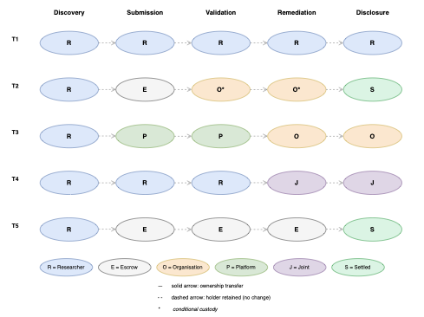
Fig. 6: Token Transition Diagram
4.3 Disclosure Model
The traditional fixed 90-day disclosure window can be replaced by an Adaptive Consent-Based Disclosure Protocol (ACDP). Instead of applying a single deadline to all vulnerabilities, ACDP introduces a severity-based and consent-driven timeline, ensuring that disclosure decisions are both risk-aware and researcher-inclusive. Under ACDP, disclosure timelines are defined based on severity levels:
Critical – 45 days, High – 90 days,
Medium – 120 days, Low – 180 days
These are calibrated using observed median disclosure durations from the dataset and not assigned arbitrarily by organisations in conventional cases. They also cannot unilaterally extend deadlines and require explicit researcher consent (max 30 days/cycle) with transparent audit trails. An interesting feature is its enforcement mechanism. If an organization requests an extension and the researcher does not agree, the framework grants the researcher an automatic right to disclose within 7 days. Fig. 7 depicts a flowchart showing the various transitions that lead to the disclosure process in the proposed model. Importantly, the framework is practically implementable since the primary change required is policy-level adoption rather than technical redesign.
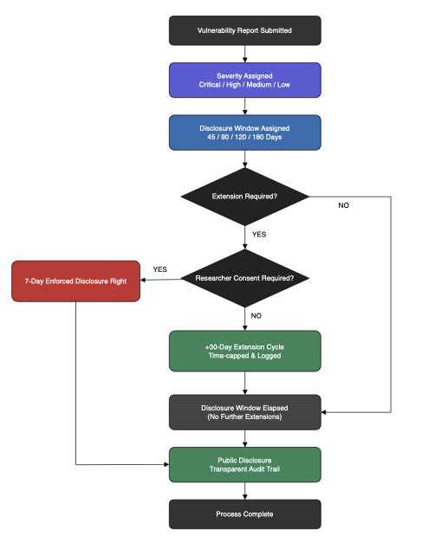
Fig. 7: Disclosure Model Flowchart
4.4 Compensation Model
The reward obtained from the proposed compensation model is derived using the below formula:
$$R=BR × NM× IF$$
where: R=Reward, BR=BaseRate, NM=Novelty Multiplier, IF=Impact Factor.
As shown in Table 7, the BaseRate is anchored close to the median payout for each CVSS-based severity level since it is the most representative value for compensation in the dataset. This value acts as a guaranteed minimum, ensuring fair baseline compensation for every report. To account for qualitative differences between reports, two scaling factors are introduced. The Novelty Multiplier (1.0–2.0×) indicates the uniqueness and technical creativity of a vulnerability matched to its severity level, operationalized using normalized community validation metrics (e.g., upvotes), supported by the observed correlation (r = 0.61). The Impact Factor (1.0–1.5×) captures the real-world significance of the vulnerability, useful for scaling rewards for cases affecting critical infrastructure or large user bases (>1 million users).
Table 7. Dataset-Derived Compensation Model
Severity | Critical | High | Medium | Low
Dataset  mean (paid) | $7,092 | $3,648 | $1,226 | $428
Dataset median (paid) | $3,400 | $2,300 | $750 | $375
Proposed base rate | $5,000 | $2,500 | $750 | $250
Novelty multiplier | 1.0 – 2.0× | 1.0 – 1.8× | 1.0 – 1.5× | 1.0 – 1.3×
Impact  factor | 1.0 – 1.5× | 1.0 – 1.5× | 1.0 – 1.5× | 1.0 – 1.5×
Min  proposed reward | $5,000 | $2,500 | $750 | $250
Max proposed reward | $15,000 | $6,750 | $1,688 | $488
4.5 Layered Architecture
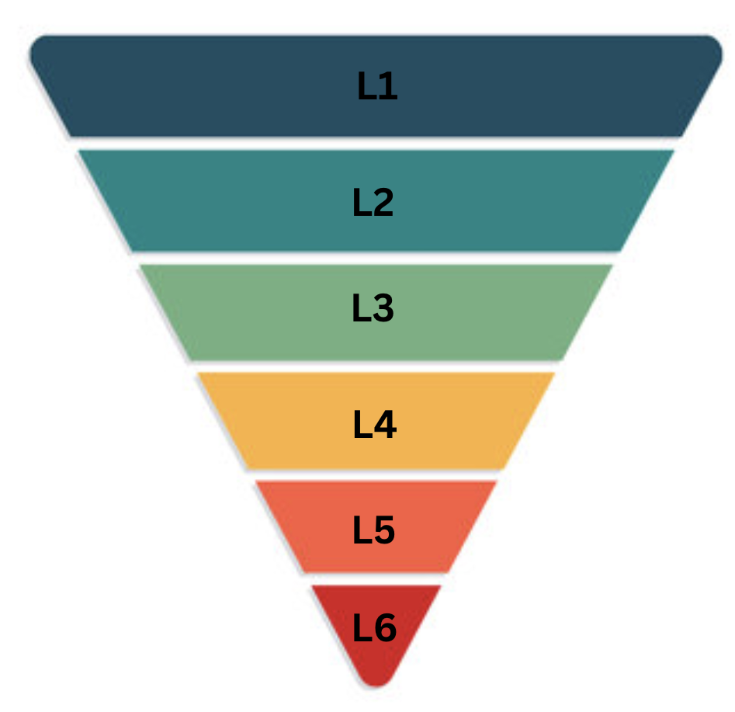

Fig. 8 Inverted pyramid governance architecture
Fig. 8 shows the streamlined six-layered pyramid architecture and corresponding components as a part of the governance framework. At the base, the Legal Layer(L1) establishes binding rules for IP rights, contracts, and liability protections, providing a strong foundation. The Operational Layer(L2) builds upon this by managing end-to-end processes through clearly defined roles and time-bound execution. The Compensation Layer(L3) introduces formula-driven payouts, directly linking rewards to measurable metrics to eliminate discretion. Similarly, the Disclosure Layer(L4) regulates public releases with severity-based timelines and consent-driven extensions. The Oversight Layer(L5) provides monitoring, auditing, and compliance via real-time trails, timelines, and decisions, while the Feedback Layer(L6) leverages historical outcomes to refine policies, recalibrate models and optimize systems enabling continuous improvement and adaptation. This hierarchical structure thus helps in systematically addressing IP ownership challenges faced by researchers in bug bounty ecosystems.
6. CONCLUSION
Bug bounty programs have become a critical pillar in the world of cybersecurity, yet the researchers who sustain these ecosystems often operate without consistent IP safeguards, fair compensation mechanisms, or meaningful control over the disclosure process. The analysis of evidence from the dataset of 10,000 publicly disclosed reports indicates that this imbalance is not incidental, but reflects a deeper structural limitation within existing platform governance models.
This work addresses these challenges through a unified governance framework that redefines how rights, incentives, and disclosure processes are managed. The TDOM reconceptualizes ownership as a set of conditional, explicitly governed rights rather than an implicit transfer at submission. Adding to this, the ACDP introduces severity-aware timelines that incorporate researcher consent, leading to a more balanced and transparent approach. Moreover, the proposed compensation model predicts reward determination in measurable factors, including the new role of novelty, thereby aligning incentives with actual research contribution. Empirical validation within real-world platform settings indicates that these mechanisms collectively improve and achieve the design goals laid down by the governance framework.
Future research should prioritize longitudinal deployments in production environments, rigorous assessment of its legal compliance across diverse jurisdictions, and enhancement of evaluation metrics—particularly those affecting tangible impact. More broadly, the evolution of bug bounty ecosystems demands a paradigm shift: placing security researchers as integral stakeholders rather than just peripheral actors
7. REFERENCES
[1] HackerOne, “Hacker-Powered Security Report,” HackerOne, 2023.
[2] National Institute of Standards and Technology, Guide to Coordinated Vulnerability Disclosure, NIST Special Publication 800‑216, 2021.
[3] Finifter, M., Akhawe, D., and Wagner, D., “An Empirical Study of Vulnerability Rewards Programs,” USENIX Security Symposium, 2013.
[4] Ruohonen, J., and Suominen, J., “An Empirical Analysis of Vulnerability Disclosure in the Bug Bounty Ecosystem,” Computers & Security, 2018.
[5] Zhao, M., Grossklags, J., and Liu, P., “An Empirical Study of Web Vulnerability Discovery Ecosystems,” ACM CCS Workshop on Security Economics, 2015.
[6] Schneier, B., Secrets and Lies: Digital Security in a Networked World, Wiley, 2000.
[7] Kesan, J., and Hayes, C., “Mitigative Counterstriking: Self‑Defense and Deterrence in Cybersecurity,” Harvard Journal of Law & Technology, 2014.
[8] J. Ruohonen and J. Suominen, “An empirical analysis of vulnerabilities in open source software systems,” Computers & Security, vol. 68, pp. 208–217, 2017.
[9] M. Finifter, D. Akhawe, and D. Wagner, “An empirical study of vulnerability rewards programs,” in Proceedings of the 22nd USENIX Security Symposium, Washington, DC, USA, 2013, pp. 273–288.
[10] A. Ozment, “Bug bounties: An empirical study of vulnerability rewards programs,” IEEE Security & Privacy, vol. 13, no. 2, pp. 70–74, 2015.
[11] C. Kesan and C. Hayes, “Mitigative counterstriking: Self‑defense and deterrence in cyberspace,” Harvard Journal of Law & Technology, vol. 25, no. 2, pp. 431–472, 2012.
[12] European Union Agency for Cybersecurity, Good Practice Guide on Vulnerability Disclosure, ENISA Report, 2016.
[13] Internet Engineering Task Force, “Guidelines for Coordinated Vulnerability Disclosure,” RFC 9116, Apr. 2022.
[14] K. Zhao, S. Liu, and J. Grossklags, “Economics of vulnerability disclosure and bug bounty programs,” in Proceedings of the Workshop on the Economics of Information Security (WEIS), 2017.
[15] FIRST, Guidelines and Practices for Multi‑Party Vulnerability Coordination and Disclosure, 2017.
[16] S. Frei, M. May, U. Fiedler, and B. Plattner, “Large‑scale vulnerability analysis,” in Proceedings of the ACM SIGCOMM Workshop on Large‑Scale Attack Defense, 2006.
[17] MITRE, Common Vulnerabilities and Exposures (CVE) Program Overview, MITRE Corporation, 2023.
[18] CodeByGK, “HackerOne Bug Bounty Reports Dataset.” [Online].https://github.com/codebygk/hackerone-bug-bounty-reports

