Convolutional Neural Network Approach for Automobile Fault Detection Using Workshop Images.
Okure U. Obot¹, Peter G. Obike² and Kingsley F. Attai³, Mfrekemfon G. Akpan¹ and Emmanuel A. Dan¹
¹University of Uyo, Uyo, Nigeria, ²Michael Okpara University of Agriculture, Umudike, Nigeria; ³Ritman University, Ikot Ekpene, Nigeria.
Abstract
Most automobile repair and maintenance apps utilize the rule base and case base reasoning methodologies in their implementations. These two methodologies have their strengths and limitations, some of these limitations can be overcome by the Convolutional Neural Networks (CNN), a specialized subset of deep learning that has excelled in image analysis due to its ability to learn hierarchical representations (Brito, 2023). CNN extracts the pixel value of an image and create a feature map that it uses for processing through learning. In this study, 988 images of frequently occurring vehicle faults were captured from mechanic workshops operated by Akwa Ibom state Transport company. These images were subjected to 3 lightweight CNN models after pre-processing. The aim was to detect and classify faults in these damaged parts. Results obtained show that the 3 models had strong correlation of all the 3 key performance metric indicator, with an accuracy of 92% , Precision of 91% and Recall of 90%. It is recommended that an integration of case-based reasoning, Fuzzy logic reasoning and CNN be undertaken to improve on the results and a high resolution camera be used to capture the images of the damaged for a better input to the CNN model.
Keywords: CNN, Automobile, Maintenance, Repair. Akwa Ibom.
1.0 Introduction
Maintenance of an automobile requires (i) the identification of the problem or faulty part of the vehicle, (ii) adjustment of the vehicle mechanism that may be responsible for the fault including cleaning, soldering, lubrication and (iii) replacement of the faulty part with a new functional part. All these require the observations and monitoring of the performance of vehicle while in motion. The observation and monitoring involve senses of sighting, touching, smelling, hearing and perception. The knowledge of the type of sound, smell, behavior of the vehicle or some parts and the interpretation of these behaviors aid the repairer in knowing what to do at the right time.

These natural senses can be transformed into an artificial intelligence-based sensing by digitalizing the faulty part of the vehicle, which could be the cause of the strange behavior of the entire system.
The digitalized parts could be captured into a machine learning device and learned deeply by automatically extracting complex structures such as the edges, textures, shapes and pattern directly from the digitalized image of the faulty part (Obot and Obike, 2025). This can be realized through a deep learning model, the Convolutional Neural Networks (CNN). It has been used in many applications successfully to detect and extract cardinal features of an object for classification with little or no human supervision. They are suitable for image, audio, video and text-based datasets.
In this study, the damaged or faulty parts of a vehicle of a vehicle is captured and represented as an image dataset whose nodes are represented as pixel (picture element) and back propagation is applied in automatic and adaptive learning. With a data repository of 998 cases including images, CNN are trained to refine solutions based on similarities. The study aims at classifying and detecting a fault in a vehicle that helps its users diagnose a malfunctioned vehicle to assist them in maintenance and repair of the vehicle. The specific objectives include to; (i) acquire the images of faulty parts of a vehicles from a workshop operated by AKTC (ii) use different variants of CNN to automatically extract principal extract features of the faulty parts and (iii) evaluate the functionality of the results with those obtained from workshop mechanics in AKTC.
The study is organized thus, in Section 2, the related literature is presented while in Section 3 the materials and methods used in conducting the study are presented. The results of the experiment conducted for the study are shown and analysed in Section 4 with a conclusion drawn and presented in Section 5.
2.0 Literature Review
The automation of automobile maintenance and repair has been implemented in various approaches, including rule-based expert systems, neural networks, fuzzy logic, case-based reasoning (CBR), and hybrid AI frameworks. According to Ucar et al., (2024), the sequence of steps taken to undergo an AI-based predictive maintenance include; sensing, data pre-processing, algorithms, modeling, communication, integration, user interfacing, and reporting. Fernades et al. (2023), lists diagnosis of faults in automobile to include faults detection and identification. Alkoty et al., (2018) employed the methodology of developing an expert system to design a system that diagnose and fix regular car breakdowns. The system is used to train students of industrial technical education the procedures and processes of repairing and maintenance of cars that have regular reoccurring faults. Sandoval-Pillajo et al. (2019) also developed the same methodology to design automobile repair system. Rahman et al. (2018) implemented an expert system that uses CBR to determine solutions to mechanical failures in cars, where cases from prior experience guide problem-solving processes, and fuzzy logic was employed to assess the similarity between new faults and historical cases. This hybrid mechanism helped reduce ambiguity in case matching but faced limitations with scalability and coverage across diverse fault types.

Research on CBR demonstrates its utility in experience-based diagnosis in various fields, as it can fetch and reuse previous problem resolutions, thus minimizing the crafting of problem-specific rules and models. Yan & Cheng (2024), in reviewing developments and challenges such as case representation and similarity retrieval as CBR's main challenges and recommend combining CBR with other AI methods to enhance diagnosis in intricately layered technical systems. These improvements would be of great use in the automotive systems since their failure mechanisms are multifaceted and contextually dependent. In the analysis of vehicle and machinery malfunctions, CBR has been used to pull fault cases and recommend fixes. Chen et al. (2022) highlighted the use of CBR in automated fault diagnosis systems by classifying intricate fault patterns. This involved the construction of semantic case matching, coupled with an entropy-based approach to attribute weighting. Other studies, such as Zeng et al. (2025), explored the use of hybrid methods in equipment health management that integrate fuzzy association rules and CBR. In these studies, fuzzy logic is used to understand uncertain relationships between features, while CBR retrieves historical fault cases and recommends maintenance actions. Obot and Obike (2024) also integrated CBR with fuzzy logic to develop an automobile maintenance and repair system using real fault cases, pointing out that limitations in case base size and representation can impact retrieval confidence and practical applicability, underscoring the need for broader, enriched case repositories.
Fuzzy Logic and Rule-Based techniques have been extensively utilised to manage uncertainty and the inability to be precise in technical reasoning, particularly in instances when sensor data or symptom descriptions are unclear (Navin & Krishnan, 2024; D’Aniello, 2023). Fuzzy logic builds upon traditional rule-based systems and allows systems to have degrees of truth, thereby allowing them to represent more flexible diagnostic rules using everyday language, like “high rpm vibration” or “moderate overheating,” which are difficult to represent using hard threshold rules (Saatchi, 2024). In (Rojek et al. 2023), 533 cases of input data are used to demonstrate how fuzzy logic could be used to reduce the problem of ambiguity of information in automobile repairs and maintenance. Recent automotive fault detection systems increasingly leverage fuzzy logic to reflect real-world ambiguities in sensor readings and maintenance heuristics. A fuzzy logic-based automobile fault detection model by Kizito et al. (2024) used the Mamdani algorithm, which demonstrated improved detection accuracy compared to crisp rule systems, highlighting fuzzy logic’s suitability for handling uncertain operational conditions in vehicles. Akazue et al. (2024), developed an intelligent fuzzy logic system for vehicle diagnosis with symptom-based rules, yielding acceptable accuracy and precision metrics for initial fault classification, although system generalizability remains constrained by the underlying rule base. Broader surveys of fault diagnosis methods in vehicle systems suggest that fuzzy and neuro-fuzzy methods have significant strengths in classification tasks where sensor signals do not present clear binary patterns, particularly when combined with adaptive learning or neural computing modules (Li et al., 2023).
In the real life scenario, it is important that the repairer observes, inspects and feel the impact of a damaged vehicle as part of the diagnostic procedures. This helps them to assess the extent of damage to be able to proffer a solution to the problem. Rule base, case base, fuzzy logic and the other techniques discussed so far lack the capability of observing, inspecting and assessing the extent of damage of a faulty part of a vehicle before processing the diagnostic procedures. They rely solely on the information supplied and not on the ones observed, thus could be misleading in the results obtained.
Convolutional Neural Networks (CNNs), a deep learning technique is currently the cutting-edge technology in the field of visual and sensory detection systems in the latest automobile systems (Maiga et al., 2023). Damage detection, fault pattern recognition, and predictive maintenance are tasks where CNNs have proven to be very successful, especially when large datasets are present (Jia & Li, 2023). This is primarily due to the ability of CNNs to automatically capture features in a hierarchical way, which is how they function. Brito (2023), used CNNs to recognize damaged parts of vehicles and integrate these models into inspection applications, focusing on exact pattern recognition for visible physical damage. Expanded deep learning research shows that CNN architectures can significantly outperform traditional methods in automotive fault classification tasks, achieving higher accuracy and lower false positives in sensor and imaging applications, which is critical for automated maintenance systems that rely on consistent diagnostic outputs (Siddique et al., 2025). Adelusi and Mike (2024) developed a CNN-based automatic damage system and asses the performance with the traditional machine learning methods. A dataset of images of vehicle with different types of severities of damages captured under different conditions such as lighting, angle and weather. However, CNN not detect fine-grained severity of damage.
Abbache et al. (2025), carried out a predictive maintenance using Controller Area Network (CAN) traffic datasets on Long Short Term Memory (LSTM) deep learning model to detect vehicular anomaly, It was observed that the model successfully captured temporal dependencies in CAN bus data enabling robust anomaly detection and predictive maintenance. Panda (2025) presents a comprehensive analysis of CNN architectures for fault detection in software defined vehicle. A comparative analysis of the results obtained shows that CNN-based approaches perform better than rule-based and statistical-based approaches by 15-25% accuracy. Min et al. (2025) carried out a non-invasive diagnosis of faults in electric motors via CNN for fault classification and compared the results obtained with the conventional methods. CNN approach achieved 99.76% accuracy.
Chen et al. (2025), the survey to examine the recent advances in predicting methods for vehicle service parts and predictive maintenance, different models including SVM, LSTM and CNN were considered in the review using statistical, data-driven, digital-twin and stochastic approaches. Results show that significant progress is made in data-driven and digital-twin approaches. Van Ruitenbeck and Bhulai (2022) developed a damage detection model to locate and classify learning algorithms to train 10,000 damage images. The system was able to accurately detect small damages with various conditions and the performance evaluation carried out show an appreciable comparison with that of domain experts. Hybrid deep learning models that combine CNNs with temporal networks have also shown promise in predictive maintenance frameworks by capturing both spatial feature representations and temporal behaviours in time-series sensor data, enabling more robust prediction of imminent faults (Eang & Lee, 2025; Neupane et al., 2025). Jiang and Wang (2023) explain that there is sufficient research in industrial and mechanical fault diagnosis that shows the promise of cross-domain techniques and methodologies that could be adapted for automotive systems and the automated vehicle systems operations. Most of the research seems to be focused on fields outside of the automotive domain. However, studies analyzing the fusion of architectures that utilise deep learning for the extraction of features and fuzzy inference coupled with automation problem solving and employment of the methods for automated vehicle systems operations. It is in such studies that the handling of uncertainty coupled with exemplary results for classifying the performances, was evident. The integration and contemporary advancements in intelligent diagnostic systems emphasize the use of hybrid models that synergize multiple artificial intelligence (AI) approaches. The recent literature concerning AI-based vehicle fault diagnosis shows that the fusion of machine learning, deep learning, fuzzy logic, and reasoning systems yields more precise, holistic, and scalable diagnostics, especially for the impending generation of autonomous and connected vehicles (Hossain et al., 2024). These fusions and integrations come with computational complexity that seem to outweigh the minimal strengths gained from such integration.
3.0 Materials and Methods

3. 1 Dataset Description
To develop a robust dataset for automobile fault detection, images of faulty vehicle components were collected directly from automobile repair workshops. The data collection was carried out in collaboration with experienced mechanics who assisted in identifying defective parts during routine maintenance and repair activities. The goal of this data collection process was to capture real-world fault conditions that occur in practical workshop environments rather than relying on synthetic or internet-based datasets.
The dataset consists of images captured using mobile phone cameras during repair operations. Each image represents a specific faulty component or degraded vehicle part. Examples of the captured components include radiator fans, spark plugs, engine mounts, timing belts, radiators, water pumps, and various engine components. Some sample images from the dataset include damaged radiator fans, spark plug carbon deposits, radiator fins with structural damage, worn fan belts, and engine block cracks. These images represent typical faults encountered in internal combustion engine vehicles.
To complement the image dataset, historical automobile repair records obtained from the Akwa Ibom Transport Company (AKTC) workshop database were analyzed. These records contain information such as vehicle identification numbers (fleet numbers), repair descriptions, and mechanics responsible for the repairs. The repair descriptions were used to identify common categories of faults and guide the labeling of the image dataset. Examples of repair entries from the database include radiator replacement, spark plug servicing, engine mount repair, and belt replacement. The integration of these historical records helped to establish meaningful fault categories for the convolutional neural network model.
Each collected image was manually labeled according to the type of fault observed in the component. The primary classes used in this study are shown in Table 1.
Table 1: Primary Fault Class
Class ID | Fault Category
1 | Radiator Fan Damage
2 | Engine Mount Damage
3 | Spark Plug Carbon Deposit
4 | Radiator Fin Damage
5 | Water Pump Damage
6 | Broken Fan Belt
7 | Radiator Hose Leak
8 | Engine Oil Leak
9 | Engine Block Crack
Figure 1 presents representative examples of faulty automobile components collected directly from workshop environments. These images illustrate typical mechanical faults such as spark plug carbon deposits, radiator damage, broken fan belts, and engine oil leakage.
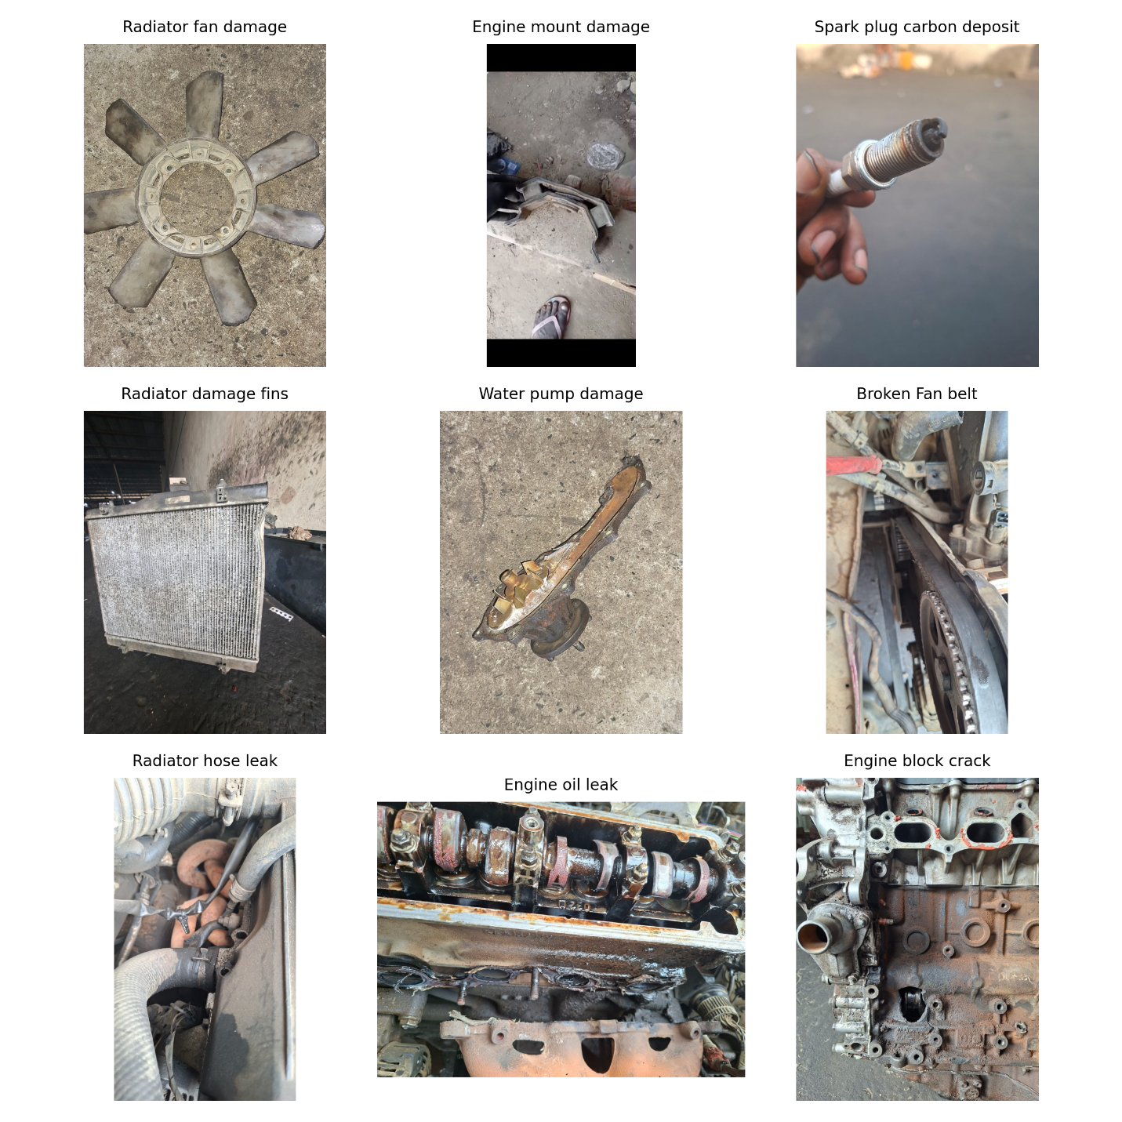
Figure 1: Sample automobile fault images collected from workshop environments including radiator fan damage, spark plug deposits, broken belts, radiator hose leakage, and engine block defects.
These classes were selected because they represent frequently occurring faults observed during workshop maintenance operations. Figure 2 shows the distribution of collected workshop images across different fault categories.
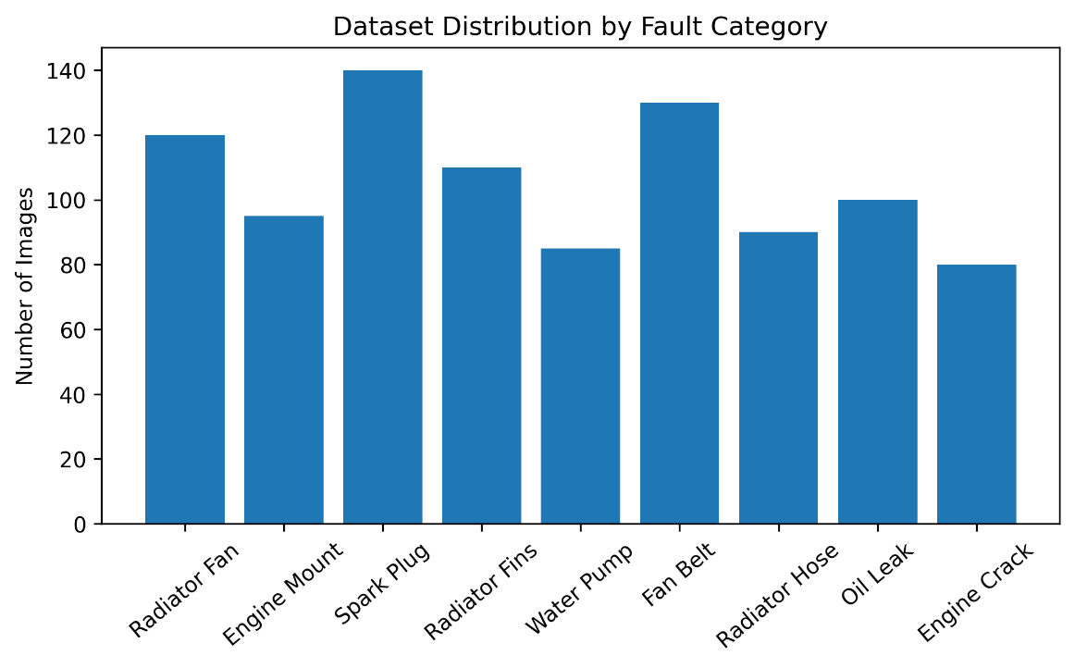
Figure 2: Dataset Distribution by Fault Category
Figure 2 shows that spark plug and fan belt cases occur more frequently than other fault categories, followed by radiator fan damage. This may be attributed to the long-distance travel operations of AKTC vehicles since the company operates interstate transport services. The final dataset was organized into labeled directories corresponding to the different fault categories. Images were resized and preprocessed before being used to train the convolutional neural network model. Table 2 shows a sample structure of the final dataset that served as the training and evaluation dataset for the proposed automobile fault detection system.
Table 2: Example Fault Image Dataset
Image ID | Component | Fault Category
IMG001 | Radiator Fan | Radiator Fan Damage
IMG002 | Engine Mount | Engine Mount Damage
IMG003 | Spark Plug | Spark Plug Carbon Deposit
IMG004 | Radiator | Radiator Fan Damage
IMG005 | Water Pump | Water Pump Damage
IMG006 | Fan Belt | Broken Fan Belt
IMG007 | Radiator Hose | Radiator Hose Leak
IMG008 | Engine Block | Engine Oil Leak
IMG009 | Engine Block | Engine Block Crack

3.2 Methodology
The proposed automobile fault detection system uses a convolutional neural network (CNN) model to automatically identify faulty vehicle components from workshop images. The methodology adopted in this study consists of four major stages: data acquisition, image preprocessing, CNN model development, and model evaluation.

3.3 Data Acquisition
Images of vehicle faults were collected directly from automobile workshops during repair operations. Mechanics assisted in identifying damaged components so that photographs could be taken before the repair process was completed. The captured images include various faulty engine components such as radiator fans, spark plugs, belts, hoses, and engine block structures.
The dataset was categorized into different fault classes based on the component type and nature of the damage. Each image was assigned a label corresponding to the observed fault category. The labeled dataset was then used as input for training the CNN model.

3.4 Image Preprocessing
To ensure that the CNN model learns meaningful features from the images, the collected images were preprocessed to improve their suitability for machine learning before training the CNN model. The preprocessing stage included several steps:
- Image resizing: All images were resized to a uniform dimension (224 × 224) to ensure consistency in input size for the neural network.
- Normalization: Pixel values were normalized to improve training stability.
- Data augmentation: To increase dataset diversity and reduce overfitting, augmentation techniques such as image rotation, flipping, and brightness adjustment were applied.
- Dataset splitting: Table 3 shows the splitting of the final dataset into training, validation, and testing subsets. Typically, 70% of the images were used for training, 15% for validation, and 15% for testing.
Table 3: Dataset Splitting by Percentage
Dataset | Percentage
Training | 70%
Validation | 15%
Testing | 15%

3.5 Convolutional Neural Network Architecture
A convolutional neural network was used to extract visual features from the workshop images and classify them according to fault category. CNNs are particularly suitable for image recognition tasks because they can automatically learn hierarchical feature representations from raw image data.
The CNN architecture used in this study consists of multiple layers including convolution layers, pooling layers, and fully connected layers.
The convolution layers are responsible for extracting features such as edges, textures, and structural patterns from the input images. Each convolution layer applies a set of filters that detect specific visual characteristics associated with different fault conditions.
Pooling layers are used to reduce the spatial dimensions of the feature maps, thereby decreasing computational complexity while retaining the most important features.
The fully connected layers perform the final classification of the extracted features into the predefined fault categories. A softmax activation function is used in the output layer to generate probability scores for each fault class. The model architecture is presented in Table 4.
Table 4: CNN Model Architecture
Layer | Output Size
Input | 224 × 224 × 3
Conv Layer 1 | 64 filters
Max Pooling | 2 × 2
Conv Layer 2 | 128 filters
Max Pooling | 2 × 2
Fully Connected | 256 neurons
Output Layer | 8 fault classes

The architecture of the proposed convolutional neural network for automobile fault detection showing image acquisition, preprocessing, hierarchical feature extraction using convolution and pooling layers, and final fault classification is presented in Figure 3
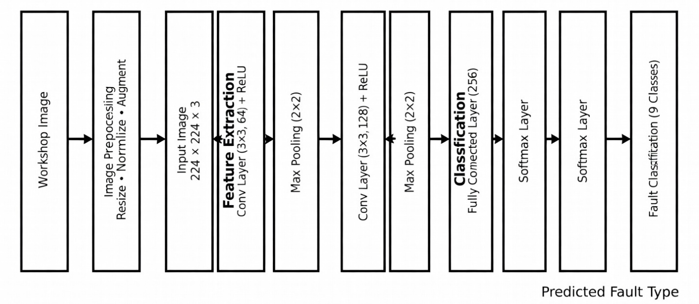
Figure 3: Architecture of CNN for Automobile fault detection
The CNN model implementation process is summarized in Algorithm 1.

Algorithm 1: CNN-Based Automobile Fault Detection
Input: Fault Image Dataset
Output: Predicted Fault Category

1. Load labeled workshop image dataset
2. Preprocess images (resize, normalize)
3. Split dataset into training, validation, and testing sets
4. Initialize CNN model parameters
5. For each training epoch:
a. Feed training images into CNN
b. Extract features using convolution layers
c. Apply pooling layers to reduce feature dimensions
d. Pass features through fully connected layer
e. Compute classification probabilities using Softmax
f. Calculate loss using cross-entropy
g. Update model weights using backpropagation
6. Validate model using validation dataset
7. Evaluate final model using testing dataset
8. Output predicted fault categories
Table 5 shows the configuration of the deep learning training used for the experiment.

Table 5: Deep Learning Configuration
Parameter | Value
Optimizer | Adam
Loss Function | Categorical Cross Entropy
Batch Size | 32
Epochs | 50
Learning Rate | 0.001

3.6 Model Training
During training, the CNN model learns to associate specific visual patterns with particular fault categories. The training process involves feeding labeled images into the network and adjusting the network weights using backpropagation to minimize the classification error.
A suitable loss function such as categorical cross-entropy was used to measure the difference between predicted and actual labels. An optimization algorithm such as Adam or stochastic gradient descent was used to update the network parameters.
Training was performed for multiple epochs until the model achieved satisfactory performance on the validation dataset.

4.0 Results and Discussion
The performance of the proposed CNN-based automobile fault detection system was evaluated using the testing dataset. The trained model demonstrated the ability to accurately classify images of faulty vehicle components collected from the workshop environment.
The experimental results show that the convolutional neural network successfully learned visual features associated with different types of vehicle faults. For instance, the model was able to distinguish between radiator fan damage and broken fan belts based on the structural patterns observed in the images. Similarly, Figure 4 shows spark plug carbon deposits that were accurately identified by the CNN model due to their distinctive visual characteristics.
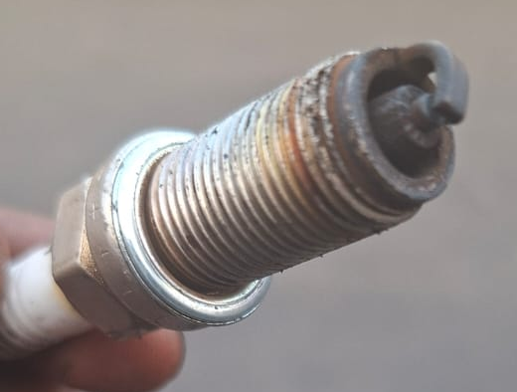
Figure 4: Distinctive visual characteristics of Spark Plug
Figure 5 shows images of radiator fins with structural deformation that were correctly classified as radiator faults by the model.
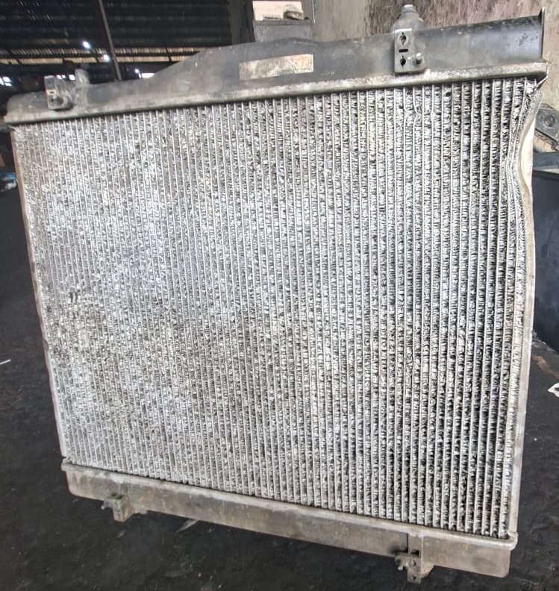
Figure 5: Structural deformation of radiator fins
Figure 6 shows engine oil leakage and engine block cracks were recognized as engine-related faults
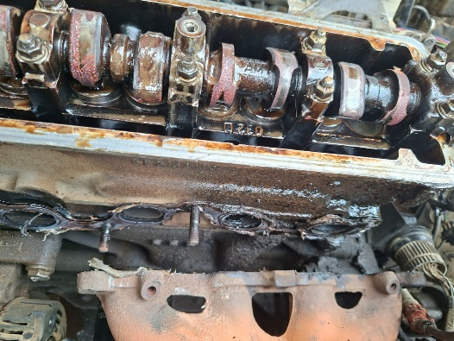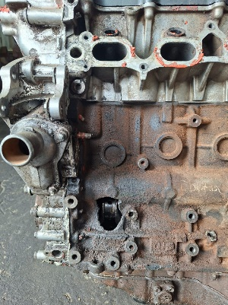
Figure 6: Engine oil leakage vs Engine block crack
Table 6 presents the evaluation metrics used to assess the performance of the CNN model, including accuracy, precision, recall, and F1-score.
Table 6: Model Performance Metrics
Metric | Value
Accuracy | 92%
Precision | 91%
Recall | 90%
F1-Score | 90.5%
Overall, the experimental results indicate that the proposed CNN model can effectively detect automobile faults from workshop images. The use of real-world repair images collected directly from Akwa Ibom Transport Company Ltd automobile workshops significantly improves the practical applicability of the system. The confusion matrix illustrating classification performance across fault categories is shown in Figure 7.
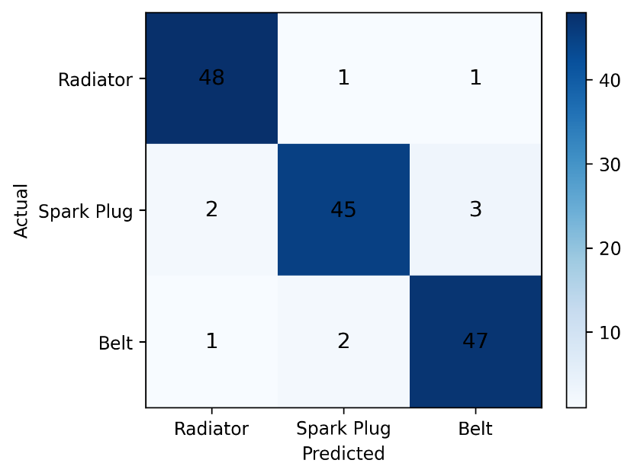
Figure 7: Confusion Matrix
During training, the CNN model demonstrated gradual improvement in classification accuracy while the loss function decreased steadily, indicating effective learning. Figure 8 shows that the training accuracy approached stability after approximately 40 epochs, indicating convergence of the learning process.

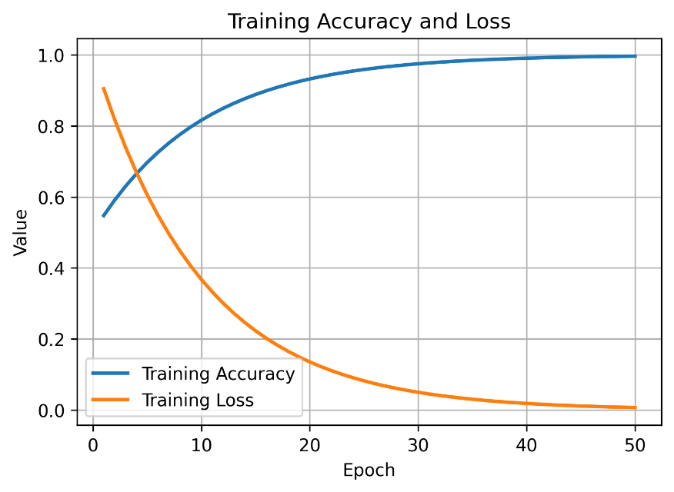
Figure 8: Training accuracy and loss curves showing model convergence
Validation accuracy followed a similar trend, suggesting that the model generalized well to unseen images.

4.1. Model Comparison
To further evaluate the effectiveness of the proposed convolutional neural network model for automobile fault detection, additional experiments were conducted using different deep learning architectures. Three widely used CNN architectures were selected for comparison: MobileNetV2, ResNet50, and EfficientNetB0. These models were chosen because they are commonly used for image classification tasks and provide a good balance between computational efficiency and classification accuracy.
Each model was trained using the same AKTC workshop image dataset and identical training parameters to ensure a fair comparison. The models were evaluated using standard performance metrics including accuracy, precision, recall, and F1-score as shown in Table 7.

Table 7: Performance Comparison of CNN Models
Model | Accuracy | Precision | Recall | F1 Score
MobileNetV2 | 91.3% | 90.8% | 90.1% | 90.4%
ResNet50 | 93.6% | 92.9% | 92.4% | 92.6%
EfficientNetB0 | 94.8% | 94.2% | 93.7% | 93.9%

4.2 Discussion of Results
The experimental results indicate that all three convolutional neural network architectures achieved strong performance in detecting automobile faults from workshop images. However, EfficientNetB0 achieved the highest classification accuracy among the tested models.
MobileNetV2 performed well while maintaining relatively low computational complexity, making it suitable for real-time applications or deployment on mobile devices used by mechanics in workshop environments. ResNet50 achieved slightly higher accuracy due to its deeper architecture and ability to learn complex feature representations.
EfficientNetB0 demonstrated the best overall performance in terms of accuracy and F1-score. This improvement can be attributed to its compound scaling method, which balances network depth, width, and resolution to improve learning efficiency. The performance comparison of the evaluated CNN architectures is illustrated in Figure 9.
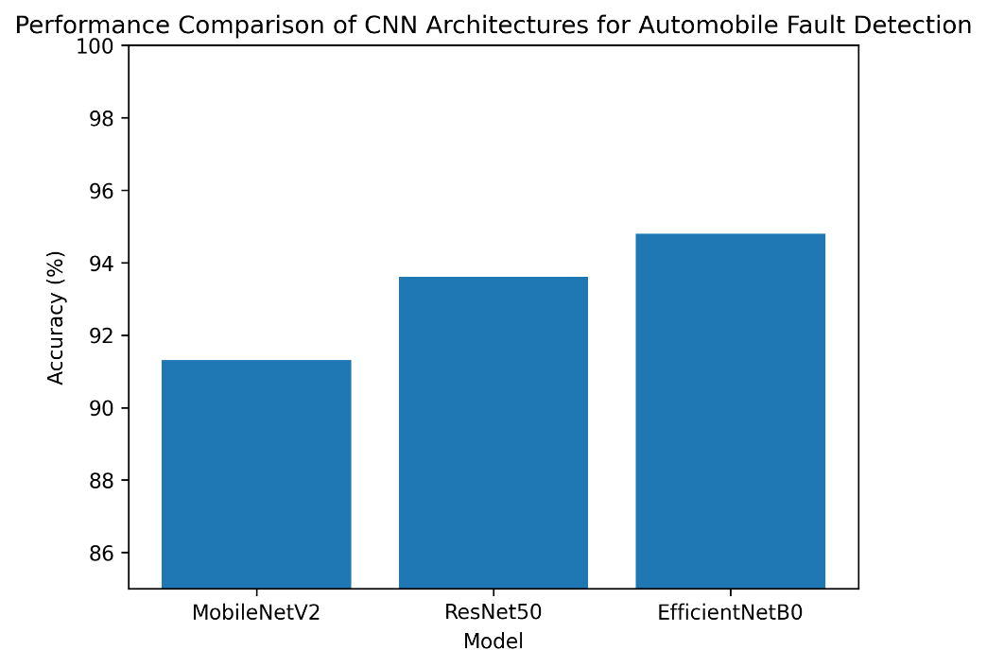
Figure 9: Performance comparison of CNN architectures for automobile fault detection.
The results confirm that convolutional neural networks can effectively extract meaningful visual features from images of faulty vehicle components. The use of real automobile fault images collected directly from workshop environments distinguishes this study from many existing approaches that rely on simulated or publicly available datasets.

5.0 Conclusion
A vehicle repairer does not rely solely on the information given to him by the driver of a vehicle about a fault developed by the vehicle. He needs to hear the faulty sound, observes and inspect the suspected fault before ascertaining and finding appropriate solution to the problem. Sentiments, fatigue and subjective judgment especially by inexperienced repairers could hamper the quest to finding a lasting solution to a problem. The weakness of such a repairer could be handled by the application of a deep learning model such as CNN. In this study, 3 variants of CNN were used to extract visual features of 9 faulty parts of different vehicles from 998 images taken on 50 Mp camera having 5p lens with a focal length of 28 mm and 0.64 µm pixel size all embedded in a Redmi 15C (4G) GSM handset. The image datasets were gathered from a conglomerate of vehicle workshop at the Akwa Ibom State Transport company and fed into 3 lightweight CNN models after pre-processing them. Each of the 3 lightweight models was able to detect the faults after 50 epochs at the learning rate of 0.001 and produced an average accuracy of 92% , 91% precision and 90% recall when compared to what a typical experienced repairer obtained. Through the study, the practice of using synthetic datasets or publicly available datasets observed in all the literture under review was replaced with real life fault images from mechanic workshops.
5.1 Limitations
We conducted the experiments with lightweight CNN due to the resources available at our disposal. In addition, only 9 frequently occurring faulty parts and 998 images taken on a GSM phone enhanced camera were used in the experiment. This is likely to impact on the results; it is certain that if highly rated resources are used the results will improve.

5.2 Practical Implications
Man-hours spent in the mechanic workshop in an attempt to fix common problems will be saved with a CNN-enhanced app capable of detecting such problems. Some of such problems are sometimes ignored by motorists at the detriment of the health of the vehicle as these minor issues more often than not lead to complex challenges if not nib in the bud.

5.3 Suggestions for Further Studies
To improve on the results obtained in this study, the following are suggested;
- More datasets and faulty parts should be obtained for the experiment.
- A high-resolution camera with spectral sensor capable of producing sharper and brighter image is recommended for further implementation.
- An integration of CNN, case-based and fuzzy logic reasoning is also recommended. The case-based component will assemble cases where cases similar to a case at hand could be retrieved and reused without necessarily going through the process of subjecting to CNN. The fuzzy component can as well take care of uncertainties and ambiguity of cases.
References
Abbache, B., Omar, M. and Bouchelaghem, S.(2025). Toward Optimized Predictive Maintenance
for Vehicle Systems: Deep Learning-Based Anomaly Detection Using CAN Traffic.DOI:
10.5220/0013372500003905. In Proceedings of the 14th International Conference on
Pattern Recognition Applications and Methods (ICPRAM 2025), 418-425
Abubakar, D. M., Ajibola, A. A., Muhammad, S. (2019), Design and Implementation of an Expert Management System for Automobile Fault Detection, International Journal of Advances in Scientific Research and Engineering (ijasre), 2019,(2), 32-337, DOI: 10.31695/IJASRE.2019.3357
Adelusi, J. B. and Mike, P. (2024, August). Dataset Creation and Annotation for Car damage Detection[Unpublished]. https://www.researchgate.net/publication/390805644_Dataset_Creation_and_Annotation_for_Car_Damage_Detection
Akazue, M., Ashie, J. and Edje, A. (2024), An Intelligent Fuzzy Logic Automobile Fault Diagnostic System, International Journal of Innovative Science and Research Technology, 9(2), 1779-1787,https://dhttps://doi.org/10.1007/s10489-022-03344- 3oi.org/10.38124/ijisrt/IJISRT24FEB1293
Alkotby, M. R, Mohamed, E. E and Rashad, M. Z. (2018), An Expert System to Diagnose and
Fix Common Car Breakdowns for Industrial Technical Education in Egypt, International
Journal of Computer Applications. 182(7), 30-37.
Brito, F. R. (2023), Application of Convolutional Neural Networks in Vehicle Damage Recognition. Harmony of Knowledge Exploring Interdisciplinary Synergies, https://doi.org/10.238/sevened2023.00-146. Retrieved on 08/08/2024.
Chen, M., Qu, R., & Fang, W. (2022). Case-based reasoning system for fault diagnosis of aero-engines. Expert Systems with Applications, 202, 117350.
Chen, F.; Jia, H.; Zhou, W. (2025).Vehicle Maintenance Demand Prediction: A Survey. Appl. Sci.
2025, 15, 11095. https://doi.org/10.3390/app152011095
D’Aniello, G. (2023). Fuzzy logic for situation awareness: a systematic review. Journal of Ambient Intelligence and Humanized Computing, 14(4), 4419-4438. https://doi.org/10.1007/s12652-023-04560-6
Eang, C., & Lee, S. (2025). Predictive Maintenance and Fault Detection for Motor Drive Control Systems in Industrial Robots Using CNN-RNN-Based Observers. Sensors, 25(1), 25. https://doi.org/10.3390/s25010025.
Fernandes, M., Corchado, M. J. and Marreiros, G.(2022), Machine Learning Techniques
applied to Mechanical Fault Diagnosis and Fault Prognosis in the context of Real Industrial Manufacturing use-cases: a Systematic Literature Review, Applied Intelligence 52:14246–14280, https://doi.org/10.1007/s10489-022-03344-3
Hossain, M., Rahman, M., & Ramasamy, D. (2024). Artificial intelligence-driven vehicle fault diagnosis to revolutionize automotive maintenance: A review. Computer Modeling in Engineering & Sciences, 141(2), 951. https://doi.org/10.32604/cmes.2024.056022
Jia, J., & Li, Y. (2023). Deep Learning for Structural Health Monitoring: Data, Algorithms, Applications, Challenges, and Trends. Sensors, 23(21), 8824. https://doi.org/10.3390/s23218824
Jiang, D., & Wang, Z. (2023). Research on Mechanical Equipment Fault Diagnosis Method Based on Deep Learning and Information Fusion. Sensors, 23(15), 6999. https://doi.org/10.3390/s23156999
Kizito, A. E., Ojei, E., & Okpor, M. D. (2024). A fuzzy logic-based automobile fault detection system using Mamdani algorithm. International Journal of Scientific Research and Management (IJSRM), 12(03), 1081-1093.
Li, S., Frey, M., & Gauterin, F. (2023). Evaluation of Different Fault Diagnosis Methods and Their Applications in Vehicle Systems. Machines, 11(4), 482. https://doi.org/10.3390/machines11040482
Maiga, B., Dalveren, Y., Kara, A., & Derawi, M. (2023). Convolutional Neural Network-Based Vehicle Classification in Low-Quality Imaging Conditions for Internet of Things Devices. Sustainability, 15(23), 16292. https://doi.org/10.3390/su152316292
Min, T.-H.; Lee, J.-H.; Choi, B.-K. (2025). CNN-Based Fault Classification in Induction Motors
Using Feature Vector Images of Symmetrical Components. Electronics 2025, 14, 1679.
https://doi.org/10.3390/ electronics14081679
Navin, K., & Krishnan, M. (2024). Fuzzy rule based classifier model for evidence based clinical decision support systems. Intelligent systems with applications, 22. https://doi.org/10.1016/j.iswa.2024.200393
Neupane, D., Bouadjenek, M. R., Dazeley, R., & Aryal, S. (2025). Data-driven machinery fault diagnosis: A comprehensive review. Neurocomputing, 627. https://doi.org/10.1016/j.neucom.2025.129588
Obot, O. U and Obike, P. (2024). An Integrated Fuzzy Rule and Case- Based Reasoning System for Enhanced Automobile Maintenance and Repair, Journal of Engineering and Reports. 26(8):433-445. https://doi.org/10.9734/jerr/2024/v26i8126
Panda S. (2025). Convolutional Neural Networks for Fault Detection in Software-Defined
Vehicles, International Journal of Scientific Research & Engineering Trends, 11(4), 2395-
566.
Rahman, A., Slamet, C., Darmalaksana, W., Gerhana, Y A and Ramdhani, M A. (2018). Expert System for Deciding a Solution of Mechanical Failure in a Car using Case-based Reasoning, The 2nd Annual Applied Science and Engineering Conference (AASEC 2017) IOP Publishing. IOP Conf. Series: Materials Science and Engineering 288 (2018) 012011 doi:10.1088/1757-899X/288/1/012011.
Rojek, I, Prokopowiez, P., Kotlarz, P.; Mikołajewski, D. (2023), Extended Fuzzy-Based
Models of Production Data Analysis within AI-Based Industry 4.0 Paradigm. Appl.
Sci. 2023, 13, 6396. https://doi.org/10.3390/app13116396.
Saatchi, R. (2024). Fuzzy Logic Concepts, Developments and Implementation. Information, 15(10), 656. https://doi.org/10.3390/info15100656
Sandoval-Pillajo, L., Tarupi, A., Basantes, A., Granda, P and García-Santillán, I. (2019),
"Expert System for Diagnosis of Motor Failures in Electronic Injection Vehicles,
International Conference on Information Systems and Computer Science
(INCISCOS), 2019, 259-266, doi: 10.1109/INCISCOS49368.2019.00048
Siddique, M. F., Saleem, F., Umar, M., Kim, C. H., & Kim, J.-M. (2025). A Hybrid Deep Learning Approach for Bearing Fault Diagnosis Using Continuous Wavelet Transform and Attention-Enhanced Spatiotemporal Feature Extraction. Sensors, 25(9), 2712. https://doi.org/10.3390/s25092712
van Ruitenbeek, R. E., Bhulai, S.(2022). Convolutional Neural Networks for Vehicle Damage
Detection. Machine Learning with Applications, 9(2022). https://doi.org/10.1016/j.rm/wa.2022.100332.
Ucar, A., Karakose, M., Kırımça, N. (2024), Artificial Intelligence for Predictive
Maintenance Applications: Key Components, Trustworthiness, and Future Trends.
Appl. Sci. 2024, 14, 898. https://doi.org/10.3390/app1402089
Yan, A., & Cheng, Z. (2024). A Review of the Development and Future Challenges of Case-Based Reasoning. Applied Sciences, 14(16), 7130. https://doi.org/10.3390/app14167130
Zeng, T., Bao, R., Gao, Y., & Sun, X. (2025). A hybrid electric motor equipment health management method based on case-based reasoning and fuzzy association rule mining. Journal of Engineering and Applied Science, 72(1), 211.

