TRANSCENDING LIMITS: THE LIVED EXPERIENCES OF REPATRIATED

ABSTRACT

PEÑALOSA, SHIRLEY N. (2026). Transcending Limits: The Lived Experiences of Repatriated Domestic Workers of La Union. Master in Development Administration Major in Public Administration. Don Mariano Marcos Memorial State University, Mid La Union Campus, College of Graduate Studies, City of San Fernando, La Union.

This study employed a qualitative research design using a transcendental phenomenological approach to examine the lived experiences of ten repatriated domestic workers in La Union. Using purposive criterion sampling, participants were selected and interviewed through a semi-structured interview guide to gather in-depth insights into their challenges, coping mechanisms, and reasons for repatriation. Data were analyzed primarily through Colaizzi’s (1978) 7-step phenomenological method, supported by Braun and Clarke’s (2006) thematic analysis procedures for coding and theme development. The findings revealed major socio- cultural, economic, and psychological challenges, including social isolation, restricted freedom, debt, financial insecurity, emotional distress, anxiety, and depression. Participants employed coping strategies such as faith and spiritual resilience, family-oriented motivation, social support, and financial discipline. The primary reasons for repatriation included physical and mental health deterioration, employer-employee conflict, unsafe work environments, and family-related concerns. Based on these findings, the study proposed the Sustained Resiliency and Reintegration Toolkit (SRRT) as a holistic intervention program to support the psychosocial, familial, and economic reintegration of repatriated domestic workers in La Union.

Keywords: Intervention Program, Repatriated Domestic Workers

INTRODUCTION

In the contemporary global context, migration has emerged as a complex and multifaceted phenomenon, with the United Nations estimating 281 million international migrants worldwide as of 2020. This global movement is largely driven by economic disparities, political instability, and the forces of globalization (IOM, 2020). For labor-sending nations such as the Philippines, migration presents a dual-edged reality. On one hand, it serves as a significant mechanism for poverty alleviation through remittances and employment opportunities abroad; on the other hand, it poses serious risks such as brain drain, family dislocation, and social fragmentation (World Bank, 2020; ILO, 2018).
Moreover, migration is increasingly intertwined with issues of human rights, social justice, and sustainable development. As the global community continues to grapple with the complexities of cross-border movement, there is a growing recognition of the need for comprehensive and rights-based migration governance that protects the dignity and welfare of migrants, addresses the root causes of migration, and promotes social inclusion in both sending and receiving societies (IOM, 2020; United Nations, 2018). In this context, international cooperation, dialogue, and collaborative policy-making have become essential in addressing the challenges and opportunities brought about by migration in the twenty-first century.
The Philippines remains one of the world’s largest labor-exporting countries, with Overseas Filipino Workers (OFWs) serving as a pillar of the national economy (PSA, 2021). Among this population, domestic workers constitute one of the most vulnerable sectors. Guided by the New Economics of Labor Migration theory proposed by Stark and Bloom (1985), as well as deeply rooted Filipino cultural values such as utang na loob, many individuals choose to work abroad as

a strategy to improve the economic condition of their families. However, this migration pathway often exposes workers to a trifecta of challenges, namely socio-cultural isolation, economic exploitation, and psychological distress (Parreñas, 2015).
Among the many domestic workers contributing to this migration trend are those from the province of La Union. Their experiences, particularly those who have been repatriated, offer a rich and compelling area of inquiry in contemporary migration studies. The decision of domestic workers from La Union to seek employment overseas is influenced by numerous factors, with economic considerations often serving as the primary motivation. Limited local employment opportunities, low wages, and economic instability push many individuals to seek better prospects abroad, especially in sectors such as healthcare, hospitality, and domestic work (Martin et al., 2017). In addition, socio-cultural factors such as familial obligations, aspirations for upward mobility, and the desire to provide better educational and financial opportunities for their families further shape migration decisions (Parreñas, 2005).
This economic motivation strongly aligns with Stark and Bloom’s (1985) New Economics of Labor Migration (NELM), which posits that migration decisions are often made at the household level as a strategy to diversify income sources and reduce economic risks. In the Philippine context, remittances from OFWs function as a financial safety net that sustains families and stabilizes their socio-economic standing despite limited domestic opportunities (Kikkawa Takenaka et al., 2020). For many households in provinces such as La Union, working abroad becomes not merely an individual decision but a collective family strategy for survival and advancement.
Despite the economic benefits associated with migration, the journey of domestic workers is often marked by numerous challenges that span socio-cultural, economic, and psychological dimensions. Socio-cultural challenges include adapting to unfamiliar cultural norms, dealing with language barriers, and experiencing discrimination or social exclusion in host countries (Parreñas, 2015). Economic challenges may involve low wages, delayed salaries, job insecurity, and workplace exploitation (Guevarra, 2010). Furthermore, psychological stressors such as homesickness, loneliness, trauma, and prolonged separation from family members significantly affect the emotional and mental well-being of OFWs (de Guzman, 2014).
While the Philippine government has made notable strides through the establishment of the Department of Migrant Workers (DMW) under Republic Act No. 11641, significant gaps remain in the repatriation and reintegration process. Existing government programs, such as the Balik Pinas, Balik Hanapbuhay Program, often focus primarily on financial assistance and livelihood support. Although these initiatives are beneficial, they frequently overlook the long-term socio- cultural and psychological needs of repatriated workers. Bureaucratic hurdles, inadequate assistance, and gaps in legal protection continue to contribute to the vulnerabilities experienced by domestic workers both abroad and upon their return (Asis, 2020; Spitzer & Pipkin, 2019).
In light of these realities, understanding the lived experiences of repatriated domestic workers from La Union is crucial in informing more responsive policies, programs, and interventions. While there is a considerable body of research on Filipino migrant workers in general, there remains a notable dearth of studies specifically focusing on repatriated OFWs from La Union. This gap in literature underscores the need to examine their unique experiences, challenges, coping mechanisms, and reintegration journeys.
Furthermore, existing research often overlooks the nuanced and intersectional nature of their lived experiences, particularly the socio-cultural, economic, psychological, and gendered dimensions of migration (Parreñas, 2005). There is also limited empirical evidence evaluating the

effectiveness of existing government policies and support services in addressing the needs of repatriated domestic workers at the local level. By identifying the gaps and limitations of current interventions, this study seeks to contribute valuable insights for policymakers, stakeholders, and service providers in strengthening support mechanisms for migrant workers.
This study aims to explore the lived experiences of repatriated domestic workers from La Union in order to propose a structured intervention program. Specifically, it seeks to answer the following questions: What socio-cultural, economic, and psychological challenges are faced by domestic workers from La Union while working abroad? What coping mechanisms do they employ to address these challenges? What reasons led to their repatriation? Lastly, what intervention program can be proposed based on the findings?
By shedding light on their motivations, struggles, and reintegration journeys, this research seeks to inform policymakers and service providers in designing holistic, sustainable, and human- centered interventions. Ultimately, it aims to bridge the existing gaps in current reintegration programs and advocate for a more comprehensive approach that addresses not only economic concerns but also the socio-cultural and psychological well-being of repatriated domestic workers.

METHODS

This study employed a qualitative research design to explore and present the lived experiences of repatriated Overseas Filipino Workers (OFWs) from La Union. Qualitative research is particularly appropriate for studies that seek an in-depth understanding of human experiences, perceptions, and behaviors within real-life contexts. According to Elīna and Pipere (2023), qualitative research enables a comprehensive understanding of lived experiences, while Tenny (2022) emphasized that it allows researchers to gather rich, detailed, and context-bound insights into participants’ perspectives and realities.
Specifically, this study utilized the transcendental phenomenological approach. This approach focuses on describing the essence of a phenomenon as consciously experienced by individuals, giving primary importance to the participants’ own accounts and narratives rather than the researcher’s interpretations. As explained by Neubauer et al. (2019), phenomenology seeks to describe both what was experienced and how it was experienced. In the context of this study, the approach was employed to faithfully capture the lived experiences of repatriated OFWs, particularly their working conditions abroad, the challenges they encountered, and the circumstances surrounding their repatriation.
Consistent with the principles of transcendental phenomenology, the study emphasized the description and narration of participants’ experiences as directly lived and expressed by the respondents themselves, rather than theorizing or imposing the researcher’s own interpretations. This descriptive orientation ensured that the participants’ voices remained central to the study and that the essence of their experiences was preserved (Moustakas, 1994).
Moreover, the analysis of the gathered data followed Colaizzi’s (1978) seven-step method, a widely recognized and rigorous procedure in phenomenological research. This method involves:
(1) familiarization with the data, (2) identifying significant statements, (3) formulating meanings, (4) clustering themes, (5) developing an exhaustive description, (6) producing the fundamental structure of the phenomenon, and (7) validating the findings through participant verification. The use of this analytical framework enabled the researcher to systematically organize, describe, and interpret the participants’ lived experiences while preserving the essence of the phenomenon under study.
Therefore, the transcendental phenomenological approach was deemed the most appropriate for this study as it aligns with the objective of presenting the authentic lived experiences of repatriated OFWs from La Union.
In selecting the participants, the researcher adhered to the recommendations of Creswell (1998) and Morse (1994), who suggested a sample size ranging from 5 to 25 participants, with Morse specifically recommending at least six respondents for phenomenological studies. Based on these guidelines, ten participants were selected for this study. To ensure that the selected participants could provide rich, relevant, and experience-based insights aligned with the objectives of the study, purposive sampling, specifically criterion sampling, was employed.
The researcher established specific inclusion criteria as the basis for participant selection. These included: (1) Filipino nationals originally from La Union; (2) individuals who had worked abroad for at least one year prior to repatriation; (3) individuals currently residing in the Philippines for at least six months following their most recent overseas employment; and (4) individuals aged 25 to 40 years old. The age restriction of 25 to 40 years was intentionally chosen to focus specifically on early-to-mid adulthood migration and repatriation experiences. This bracket isolates the peak working years of the overseas domestic work workforce. According to the Philippine Statistics Authority, the highest proportion of female land-based Overseas Filipino Workers (OFWs) falls within the 30–34 age demographic, with a mean age of returned workers in the Luzon region hovering around 37 years old (Asis, 2022; Gomez-Magdaraog et al., 2024). Consistently, preliminary data from the Department of Migrant Workers (DMW) Region 1 Office indicates that the demographic profile of repatriated domestic workers from La Union is concentrated within this active age stratum. Thus, age information was gathered to maintain empirical consistency and contextual relevance to peak-deployment trends during data collection. The study strictly complied with relevant data protection regulations, particularly the Data Privacy Act of 2012 (Republic Act No. 10173), which mandates the protection of personal information collected in research. Ethical approval was likewise secured from the university’s Research Ethics Committee to ensure that all procedures were conducted in accordance with the ethical standards and in research guidelines set by DMMMSU.
For data collection, the researcher developed a semi-structured interview guide in English, Filipino, and Iloko to effectively capture the lived experiences of repatriated domestic workers. The interview guide underwent a rigorous validation process conducted by a five-member professional panel, consisting of a legal officer, two labor and employment officers, a guidance counselor, and a language professor. This process resulted in a Content Validity Index (CVI) of 0.94, indicating a high level of validity and confirming the appropriateness of the instrument for the study. Following this, the instrument received formal approval from the university’s Research Ethics Committee, ensuring adherence to ethical standards, confidentiality, and informed consent procedures.
After the validation stage, the researcher conducted pilot testing with ten respondents from nearby provinces, specifically Ilocos Norte (3), Ilocos Sur (2), and Pangasinan (5), to assess the effectiveness of the instrument and determine the adequacy of the sample size. This pilot phase was essential in confirming data saturation, as responses from participants across the different regions consistently revealed repetitive patterns, with no new themes emerging. The findings from the pilot test demonstrated that a sample size of ten respondents was sufficient to achieve thematic
depth and saturation, thereby finalizing the instrument for the primary data collection phase in La Union.
According to Lauterbach (2018, as cited in Crotty, 1998), semi-structured interviews rely on participants’ memories and reflections, enabling them to meaningfully revisit and narrate their lived experiences. Guided by this principle, the interview guide was structured into three sections:
(1) warm-up questions to establish rapport and ease participants into the conversation; (2) main questions focusing on motivations, challenges, coping mechanisms, family dynamics, and experiences with existing government policies and support services; and (3) follow-up or probing questions designed to elicit deeper insights and clarify significant responses shared by the participants.
Furthermore, to address potential psychological risks such as emotional distress during the interview, the researcher reminded participants that they may decline to answer any question or discontinue the interview at any time.
A distress protocol was established before data collection: any participant showing signs of emotional distress would be referred to the City of Municipal Social Welfare and Development Office (C/MSWDO) in La Union, which offers free counselling services. The researcher coordinated with the CSWDO or MSWDO to ensure counseling support was available if needed. During the actual interviews, no participants exhibited signs of distress requiring referral.

RESULTS

Socio-Cultural, Economic, and Psychological Challenges Encountered by Repatriated Domestic Workers Abroad

The journey of Filipino domestic workers (FDWs), while celebrated for its massive economic contribution through remittances, often masks a complex reality defined by profound socio-cultural, economic, and psychological distress (Asis, 2006). This study reveals that repatriation is rarely a simple choice, but rather the result of a "breaking point" where compounding stressors override the financial incentive to remain abroad.
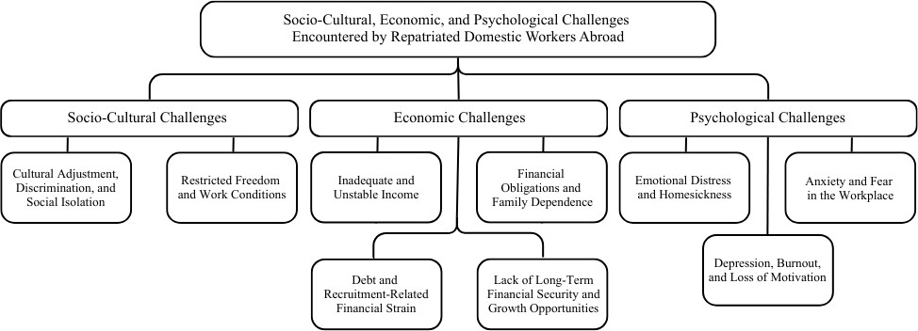
Figure 1. Socio-Cultural, Economic, and Psychological Challenges Encountered
by Repatriated Domestic Workers Abroad

Socio-Cultural Challenges
Cultural Adjustment, Discrimination, and Social Isolation
Cultural adjustment served as a primary source of distress, manifesting through linguistic barriers and differences in fundamental life practices. Respondents highlighted how a lack of fluency in the local language led to "communicative displacement," where misunderstandings were often misinterpreted by employers as incompetence or defiance (Parreñas, 2015). This was exacerbated by discrimination rooted in the perceived low social status of domestic workers.
These findings imply that current Pre-Departure Orientation Seminars (PDOS) may be insufficient in addressing the "soft skills" of cultural navigation. There is a need for language- specific training and "cultural literacy" programs that go beyond basic phrases to help workers negotiate their rights in the local tongue. Furthermore, the persistent discrimination suggests that the Philippine government must strengthen bilateral labor agreements to include "dignity clauses" that protect workers from socio-cultural dehumanization.
Restricted Freedom and Work Conditions
Restricted freedom emerged as a profound challenge, characterized by the absolute control employers exercised over movements and social interactions. This confinement creates a "live-in trap," where the domestic worker is physically present but socially erased (Constable, 2014). The inability to communicate freely with family was a significant source of emotional erosion, as the "transnational lifeline" is often the only thing sustaining a worker's mental health.
The presence of unregulated work conditions—long hours and lack of rest—implies a failure of labor monitoring in host countries. This suggests that "repatriation" should not be viewed as a personal failure of the worker, but as a systemic failure of labor protection. Policy-wise, this necessitates the push for "live-out" options or mandatory "digital access rights," ensuring workers cannot be legally or physically isolated from their support systems.

Economic Challenges
Inadequate and Unstable Income
The challenge of inadequate income was characterized by wages that were either significantly lower than promised or insufficient to meet the dual demands of supporting a family and self-sustenance. This is compounded by wage theft—delayed payments and arbitrary deductions—which functions as a tool of employer control (Galotti, 2015).
These findings suggest a policy gap: while bilateral agreements specify minimum wages, participants’ reports of wage theft and inadequate income indicate that these nominal figures may not translate into actual earnings. A recommended policy response is the establishment of digital payment monitoring systems (e.g., mandatory bank transfers) to create a verifiable audit trail of earnings, protecting workers from ‘financial invisibility’ that enables wage theft.
Financial Obligations and Family Dependence
Being the primary breadwinner creates a scenario where the worker's earnings are immediately liquidated to cover family survival, education, and medical costs. This "remittance pressure" forces workers to endure abusive conditions because the cost of losing a job is the immediate deprivation of their dependents (Asis, 2017).
This shows that the domestic worker is often a "conduit" for capital rather than a beneficiary of it. For reintegration, this suggests that financial literacy programs should not just target the worker, but the entire family unit in the Philippines. Without managing family expectations and dependence, the worker remains at high risk for "re-migration" cycles.
Debt and Recruitment-Related Financial Strain
Financial strain often begins before the worker even leaves the Philippines. The requirement to pay excessive recruitment fees necessitates loans, creating a state of "pre-migration indebtedness." Consequently, the first several months—or even years—of employment are dedicated solely to debt servicing rather than savings (Killias, 2018).
This suggests that the "no-placement fee" policy is frequently bypassed through "salary deduction" schemes. There is an urgent implication for stricter regulation of sub-agents and recruitment intermediaries. Policymakers must address the "debt-migration" link, as workers in debt are significantly less likely to report abuse for fear of being sent home before the loan is paid.
Lack of Long-Term Financial Security and Growth Opportunities
The study highlights a significant lack of career trajectory. Unlike other sectors, domestic work offers minimal skill advancement or salary progression. This stagnation, coupled with the inability to accumulate ipon (savings), means that workers often return to the Philippines with the same—or worse—economic status than when they left.
This points to the need for "skills-upgrading" while abroad. If domestic work remains a dead-end occupation, the cycle of poverty will continue. Implications for reintegration involve bridging these workers into different sectors (e.g., caregiving or hospitality) where their experience can be translated into certified skills, allowing for professional growth upon their return.

Psychological Challenges
Emotional Distress and Homesickness
The study identifies homesickness as a form of "chronic grief" rather than a transient emotion. For these women, missing significant life milestones—births, deaths, and graduations— results in a permanent emotional deficit. This distress is exacerbated by social isolation, which functions as a form of sensory and emotional deprivation (Yusoff et al., 2021). Without a social outlet, the domestic worker experiences "emotional numbness," a clinical precursor to major depressive disorder.
These findings imply that the "martyr" or "hero" narrative often used to describe Overseas Filipino Workers (OFWs) may be harmful, as it romanticizes the suppression of their emotional needs. There is an urgent need for "digital inclusion" policies—ensuring that workers have guaranteed, private access to communication technology to maintain their emotional ties, which serves as a critical buffer against depression.
Anxiety and Fear in the Workplace
The central characteristic of this challenge is a state of chronic hypervigilance. The constant fear of making mistakes—and the subsequent "survival anxiety" regarding job loss—triggers a persistent physiological stress response. This manifests as insomnia and nervousness, symptoms often associated with Post-Traumatic Stress Disorder (PTSD). The power imbalance in the household environment means the worker is never truly "off-duty" even when they are sleeping (Parreñas, 2015).
The presence of such intense fear implies that grievance mechanisms in host countries are either inaccessible or untrusted. This suggests that labor monitoring should include "psychological safety" as a metric. Implications for returnees include the need for screening for anxiety disorders, as the hypervigilance developed abroad often persists long after the worker has returned to a safe environment.
Depression, Burnout, and Loss of Motivation
The culmination of these stressors is burnout, defined here as a profound loss of vitality and purpose. When the initial motivation for migration (financial upliftment) is overshadowed by emotional depletion and the realization of stagnant savings, the worker experiences a collapse of "self-efficacy"—the belief in one’s ability to succeed (Guevarra, 2014). This loss of motivation is often what ultimately necessitates repatriation, as the worker can no longer physically or mentally perform their duties.
This suggests that repatriation is a form of "emergency exit" from burnout. Consequently, reintegration programs must move beyond "livelihood training" and include "psychological rehabilitation." If a returnee is still suffering from burnout and low self-efficacy, they are unlikely to succeed in domestic business ventures, leading to a cycle of failure and re-migration.

Coping Mechanisms Employed by Repatriated Domestic Workers
in Managing Overseas Challenges

The immense psychological burden and trauma inherent in overseas domestic work necessitate the adoption of diverse coping mechanisms (Garabiles et al., 2020). This study finds that while some strategies are proactive and empower the worker, others are "survival-based" and may mask underlying trauma, forming a critical context for post-repatriation care (Yusoff et al., 2021).
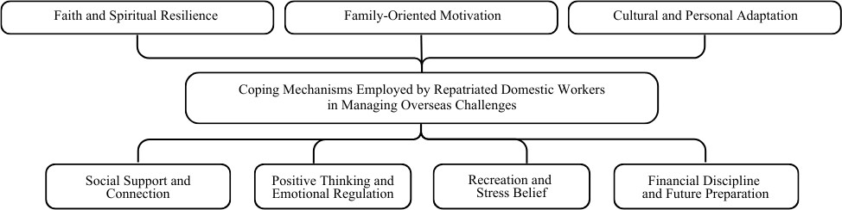
Figure 2. Coping Mechanisms Employed by Repatriated Domestic Workers
in Managing Overseas Challenges

Faith and Spiritual Resilience
Faith served as the bedrock of emotional endurance, acting as a "personal sanctuary" in the absence of social support. The frequent use of prayer and religious framing helps workers process feelings of hopelessness. Faith justifies personal sacrifice by reframing suffering as a spiritual test (Lanuza, 2002).
Religious organizations are the de facto first responders for OFWs in distress. For reintegration, it is recommended that the government partner with faith-based groups to provide mental health pathways, as workers are often more comfortable seeking help through religious channels than clinical ones.

Family-Oriented Motivation
Family-oriented motivation functions by re-centering the worker’s focus away from present abuse toward future benefits for their children. This "sacrificial mothering" transforms endurance into a strategic necessity (Parreñas, 2015).
While this sustains work longevity, it implies a risk of "self-erasure." The worker’s identity becomes entirely tied to their utility as a provider. Reintegration programs must help returnees reclaim an identity separate from being a "remittance machine" to prevent post-return depression.

Cultural and Personal Adaptation
Adaptation involved overcoming linguistic barriers to reduce employer conflict. Personal adaptation, however, often took the form of "passive compliance"—deliberately suppressing one’s personality or rights to maintain job security and avoid physical or verbal abuse.
This suggests that "successful adaptation" abroad is often actually a high-level performance of submission. These survival behaviors may manifest as a loss of agency or passivity upon return, requiring interventions that focus on reclaiming assertiveness and self-efficacy.

Social Support and Connection
Maintaining connections through digital means serves as a "transnational lifeline." Co- ethnic support networks, often built via social media due to physical confinement, mitigate the profound loneliness of live-in work (Guevarra, 2014).
Access to a smartphone is not a luxury but a fundamental psychological right. Labor policies should categorize the confiscation of mobile phones as a form of psychological abuse, as it removes the worker’s primary coping mechanism against isolation.

Positive Thinking and Emotional Regulation
This strategy centers on "cognitive reframing"—treating the contract as a time-bound endurance test. However, the "emotional masking" (forced positivity) used to avoid conflict represents a significant labor of the self that leads to long-term burnout.
The prevalence of emotional masking implies that many repatriated workers may appear "fine" while harboring deep-seated resentment or exhaustion. Post-repatriation screening should look beyond outward positivity to identify hidden emotional depletion.

Recreation and Stress Relief
Activities like listening to Filipino music or cooking Filipino food provide "sensory repatriation"—a momentary feeling of being home. These acts of cultural immersion provide necessary emotional catharsis in a hostile environment.
These findings suggest that cultural identity is a protective factor. Encouraging "Pinoy communities" abroad is not just social; it is a mental health necessity that provides the cultural "home-base" required to survive a foreign environment.

Financial Discipline and Future Preparation
By strictly limiting personal consumption, workers maximize remittances and savings. This financial proactivity provides a rare sense of control and boosts self-efficacy, making the hardship feel productive.
This tells that the worker’s sense of "success" is tied directly to their savings. If they return due to repatriation without the expected ipon (savings), they are at a higher risk of psychological collapse. Therefore, a reintegration that includes financial "soft-landing" grants is recommended to prevent the immediate shame of an empty-handed return.

Factor Leading to the Repatriation of Domestic Workers from La Union

The return of domestic workers to La Union is rarely a simple conclusion to a successful contract; rather, it is a complex outcome shaped by the intersection of external pressures and the collapse of personal resilience (Asis, 2008). This section analyzes the determinants that transform migration into a "forced" return, revealing that repatriation is frequently an incomplete cycle influenced by factors beyond the worker's control (Rother, 2009).

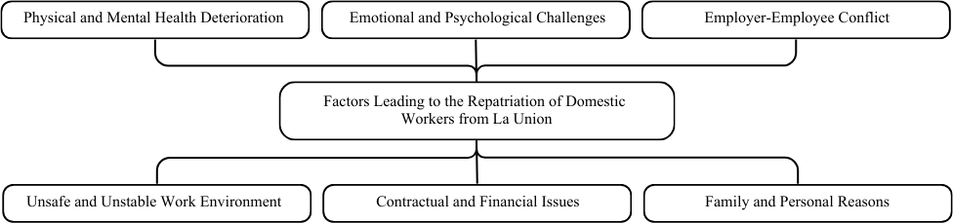
Figure 3. Factors in the Repatriation of Domestic Workers of La Union

Physical and Mental Health
Repatriation in this context is often an agency-mandated necessity driven by medical emergencies. Chronic fatigue and the lack of rest manifest physically as hypertension and cardiovascular issues, while unmanaged emotional distress leads to insomnia and chronic anxiety. This underscores the failure of labor protections in host countries where 16-hour workdays are common (Human Rights Watch, 2014).
These findings imply that for many domestic workers, the decision to return is stripped of personal agency and financial strategy; it is a matter of survival. This places a significant burden on the local health systems of La Union, as returnees often arrive with long-term medical conditions and no savings to fund their treatment, creating a "health-poverty trap."

Emotional and Psychological Challenges
This factor is characterized by the collapse of psychological resilience. Even without a specific medical diagnosis, the "migration fatigue" caused by long-term separation and intense labor leads to a desire for reunification that eventually surpasses the need for income (Asis, 2006). This suggests that the psychological toll of migration has a "shelf life." There is a critical implication for the Overseas Workers Welfare Administration (OWWA) to provide psychosocial debriefing immediately upon arrival. Without addressing this "breaking point," returnees may struggle to reintegrate into their families, potentially leading to domestic conflict or social
withdrawal.

Employer-Employee Conflict
Repatriation under this theme is triggered by the inherent power imbalance of live-in work. Conflicts often escalate from minor misunderstandings or "insubordination" to unilateral termination or overt physical and verbal abuse. In severe cases, emergency repatriation follows an escape from the employer’s household.
Repatriation due to abuse is a failure of the host country's legal system. For the worker, the implication is a lack of "closure" or justice. This necessitates legal support services at the provincial level to help workers file claims against agencies or employers, ensuring they do not return home empty-handed and traumatized.

Unsafe and Unstable Work Environment
Environmental threats, such as armed conflict or political instability in the host country, fundamentally invalidate employment contracts. These mass repatriations are mandatory and immediate, often facilitated by the Philippine government's diplomatic actions.
Workers repatriated from conflict zones suffer a "catastrophic failure" of the migration endeavor. They often lose all accumulated belongings and final wages. This shows that there is a need for "Emergency Reintegration Grants" that are specifically tailored for conflict-area returnees who had no time to prepare for their financial displacement.
Contractual and Financial Issues
Repatriation serves as a final act of resistance against economic exploitation, such as wage theft or delayed payments. Additionally, employer economic instability (losing their own jobs or income) can lead to the abrupt termination of the domestic worker's contract, irrespective of her debt status.
When the central economic promise of migration is shattered, the worker returns in a state of "financial deficit." Therefore, it is advised that the Philippine government needs to strengthen "wage guarantee funds" to compensate workers who are forced to return due to an employer's inability to pay, preventing the worker from bearing the full weight of the employer's financial failure.

Family and Personal Reasons
This factor is driven by the collapse of the family structure at home, such as a child’s illness or a husband’s inability to manage the household. In these instances, the mother’s physical presence is required, leading to a voluntary but crisis-driven return that prioritizes the family's social health over its financial goals.
This reflects the "care drain" paradox: by caring for families abroad, workers lose the ability to care for their own. This recommends that reintegration programs should focus on "family- based" economic models (like small home businesses) that allow the mother to remain physically present while still contributing to the family's financial stability.
The findings strongly support the New Economics of Labor Migration theory's proposition that migration decisions are made at the household level as a risk-diversification strategy. The theme of 'Financial Obligations and Family Dependence' and the coping mechanism of 'Family-Oriented Motivation' demonstrate that the domestic worker's individual experience cannot be separated from the family system; repatriation occurs not only when individual resilience collapses but when the family's ability to function without the worker's physical presence is threatened. Similarly, the cultural value of utang na loob (debt of gratitude) appears to operate in two directions: workers feel indebted to their families to provide remittances, and upon repatriation, families may feel indebted to the worker for their sacrifice, creating complex relational dynamics that Module 2 of the SRRT (Family and Relational Re-Alignment) is designed to address.

Proposed Intervention Program for the Welfare of Repatriated Domestic Workers

The proposed intervention is the Sustained Resiliency and Reintegration Toolkit (SRRT), a modular, community-based psycho-socio-economic program designed to address the specific, non-economic barriers to reintegration faced by repatriated domestic workers in La Union. This
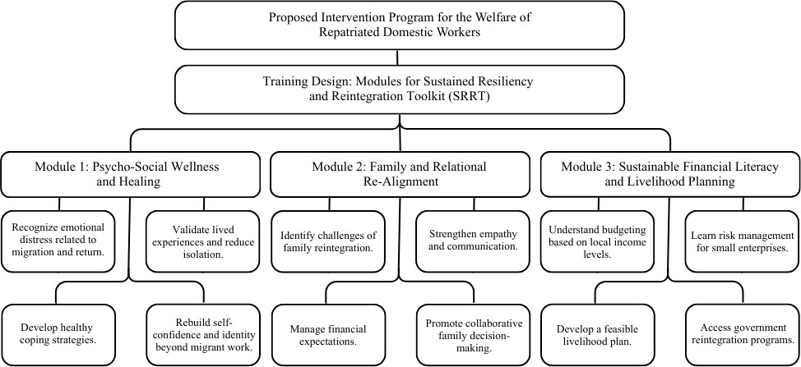
Figure 4. Proposed Intervention Program for the Welfare
of Repatriated Domestic Workers

program moves beyond the standard livelihood assistance provided by the Department of Migrant Workers (DMW) and OWWA, focusing instead on mental health normalization, sustainable financial behavior, and family relational repair—all critical needs identified in the lived experiences of the respondents.
The SRRT is justified by the understanding that repatriation resulting from family breakdown (R6) and emotional exhaustion (R8) requires more than just capital infusion. The successful transition back to life in the Philippines necessitates a holistic approach that validates the emotional cost of migration.
Existing government programs under the DMW/NRCO focus heavily on financial tools, such as cash assistance and enterprise training. While necessary, they often overlook the psychological and social capital required to manage these resources successfully. The respondents' experiences highlight a critical gap: the absence of professional interventions addressing transnational mothering guilt, post-migration emotional distress, and the need for family realignment.

Training Design: Modules for Sustained Resiliency and Reintegration Toolkit
The SRRT is structured into three intensive, interconnected modules designed to be delivered over five days in a collaborative, community setting in La Union.

Module 1: Psycho-Social Wellness and Healing
This is implemented by MSWDO social workers and LGU health officers with the primary goal of de-stigmatizing emotional distress and building foundational mental resilience. Activities within this module include trauma-informed debriefing through group sharing sessions, which allow participants to normalize their experiences of isolation or abuse. The module facilitates a transition from the "crisis-mode" coping mechanisms used overseas to sustainable local strategies, such as mindfulness and community volunteerism, while focused exercises help returnees rebuild a sense of self-efficacy that extends beyond their former identity as an "Overseas Filipino Worker" (OFW).

Module 2: Family and Relational Re-Alignment
Recognizing that successful reintegration is a collective effort, this module addresses the complexities of transnational family dysfunction. This module is mandatory for both the worker and their primary family members and is facilitated by family counselors and MSWDO social welfare officers. The curriculum focuses on managing "return shock" and the logistical challenges of role reversal within the household. Families participate in collaborative budgeting exercises to adapt to changes in income and engage in structured communication training. These activities are designed to bridge the emotional distance created by years of separation, allowing the family to resolve underlying feelings of guilt or resentment and establish a shared governance structure for their future.

Module 3: Sustainable Financial Literacy & Livelihood Planning
In the final phase, this module ensures that the domestic helpers' financial decisions are sustainable and aligned with their long-term family goals. Implemented by PESO officers, DTI representatives, and OWWA reintegration officers, this module provides practical training in personal finance management tailored to Philippine wage scales and the local cost of living. Beyond basic literacy, participants engage in micro-enterprise planning for viable local markets, such as agri-retail or tourism-based services in La Union. The toolkit culminates in "Strategic Access to Government Services," where OWWA officers provide direct, hands-on guidance to help participants navigate the documentary requirements and application processes for existing state livelihood grants, ensuring that the participants' transition from repatriation to self-reliance is both successful and permanent.
Ultimately, the SRRT serves as a comprehensive response to the multifaceted crises identified in the respondents’ lived experiences by transforming individual vulnerabilities into collective resilience. By specifically targeting the nine major challenge themes—most notably the psychological burnout and socio-cultural isolation that often render economic aid ineffective—the toolkit ensures that the "repatriation cycle" is broken. Unlike traditional programs that treat returnees as mere economic units, the SRRT’s modular approach addresses the root causes of premature repatriation, such as employer-employee conflict and family misalignment, by providing professional psychosocial scaffolding and relational repair. Through the "Convergence Model" of stakeholder support, the intervention replaces the temporary, often maladaptive coping strategies used abroad with sustainable, locally-grounded resources. Consequently, the SRRT functions not merely as a temporary welfare measure but as a strategic bridge that empowers repatriated domestic workers in La Union to transition from a state of crisis to one of sustained self-reliance and emotional stability within their home communities.

REFERENCES:

Asis, M. M. (2006). Living with migration: Experiences of left-behind children in the Philippines. Asian Population Studies, 2(1), 45–67. https://doi.org/10.1080/17441730600700556
Asis, M. M. (2008). How the Philippines became a model for managing migration (Policy Brief No. 1). Migration Policy Institute. https://www.migrationpolicy.org/research/how-philippines-became-model-managing-migration
Asis, M. M. (2017). The Philippines: Beyond labor migration, toward development and (maybe) return. Migration Information Source. https://www.migrationpolicy.org/article/philippines-beyond-labor-migration-toward-development-and-maybe-return
Asis, M. M. B. (2020). Repatriation and reintegration of Filipino migrant workers in times of crisis. Asian and Pacific Migration Journal, 29(2), 135–154. https://doi.org/10.1177/0117196820942651
Asis, M. M. B. (2022). Uncertain homecoming: Challenges faced by returned overseas Filipino workers. International Organization for Migration (IOM) Philippines. https://philippines.iom.int/resources/uncertain-homecoming-challenges-faced-returned-overseas-filipino-workers
Constable, N. (2014). Maid to order in Hong Kong: Stories of Filipina workers (2nd ed.). Cornell University Press. https://doi.org/10.7591/99780801454844
de Guzman, M. R. T. (2014). Yaya: Philippine domestic care workers, the children they care for, and the children they leave behind. International Perspectives in Psychology: Research, Practice, Consultation, 3(3), 197–214. https://doi.org/10.1037/ipp0000017
Galotti, M. (2015). The price of migration: Are low-skilled migrant workers paying too high a price? International Labour Organization. https://www.ilo.org/global/topics/labour-migration/publications/WCMS_379782/lang--en/index.htm
Garabiles, M. R., Ofreneo, M. A. P., & Hall, B. J. (2020). "To help my family": Internalized reasons for migration and its relationship with the health and well-being of Filipino domestic workers. International Journal of Environmental Research and Public Health, 17(21), Article 7750. https://doi.org/10.3390/ijerph17217750
Guevarra, A. R. (2014). Marketing dreams, manufacturing heroes: The transnational labor brokering of Filipino workers. Rutgers University Press. https://doi.org/10.36019/9780813561660
Gomez-Magdaraog, K. M., Burton-Jeangros, C., & Jackson, Y. (2024). Socio-economic impact of the COVID-19 pandemic on Overseas Filipino Workers and their left-behind families: A scoping review. Frontiers in Political Science, 6, Article 1320021. https://doi.org/10.3389/fpos.2024.1320021
Human Rights Watch. (2014). I already bought you: Abuse and exploitation of female migrant domestic workers in the United Arab Emirates. https://www.hrw.org/report/2014/10/22/i-already-bought-you/abuse-and-exploitation-female-migrant-domestic-workers-united
Kikkawa Takenaka, A., Villafuerte, J., Gaspar, R., & Narayanan, B. (2020). COVID-19 impact on international migration, remittances, and recipient households in developing Asia (ADB Briefs No. 148). Asian Development Bank. https://doi.org/10.22617/brf200219-2
Killias, O. (2018). Follow the maid: Domestic worker migration in and from Indonesia. NIAS Press.
Lanuza, G. M. (2002). The Filipino return migration: A review of literature. Philippine Social Sciences Review, 54(1), 1–22.
Martin, P., Abella, M., & Midgley, E. (2004). Best practices to manage migration: The Philippines. International Migration Review, 38(4), 1544–1559. https://doi.org/10.1111/j.1747-7379.2004.tb00246.x
Parreñas, R. S. (2015). Servants of globalization: Women, migration and domestic work (2nd ed.). Stanford University Press. https://doi.org/10.1515/9780804796149
Rother, S. (2009). Changed in migration? Philippine return migrants and (re)unions. Asian and Pacific Migration Journal, 18(2), 245–274. https://doi.org/10.1177/011719680901800204
Spitzer, D. L., & Pipkin, S. (2021). The gendered landscape of return and reintegration: Filipina domestic workers navigating return migration. International Migration, 59(4), 112–128. https://doi.org/10.1111/imig.12812
Yusoff, N. H., Sahrir, M. S., & Al-Adwan, A. S. (2021). Mental health issues and challenges among migrant workers: A systematic review. Journal of International Migration and Integration, 22(4), 1321–1345. https://doi.org/10.1007/s12134-020-00790-2

