LocalRAG++: Systematic Evaluation of Hybrid Retrieval, Cross-Encoder Reranking, and

OCR-Aware Document Quality for Privacy-Preserving Offline RAG

Stephen Thomas
Karunya Institute of Technology and Sciences
stephenthomas@karunya.edu.in

Dr Salaja S
Karunya Institute of Technology and Sciences
salajacse@karunya.edu

Abstract—Retrieval-Augmented Generation (RAG) systems of- ten rely on cloud infrastructure, raising privacy concerns for sensitive document collections. We present LocalRAG++, a sys- tematic evaluation of fully offline, privacy-preserving RAG re- trieval pipelines. Using a benchmark of 114 evaluation questions with gold evidence annotations, we compare dense, sparse, and hybrid retrieval with optional cross-encoder reranking. We conduct an ablation over reranking candidate counts (c ∈
{10, 20, 40, 60, 80}) to characterize the quality–latency tradeoff. Results show that hybrid retrieval with 20 reranking candidates is the most practical operating point, improving Precision@1 from 0.754 to 0.789 and EvidenceHit@10 from 0.930 to 0.974, while maintaining a 901 ms warm mean per-query latency. Increasing candidates beyond 20 yields diminishing quality gains with superlinear latency growth. Beyond retrieval, we introduce an OCR-aware document quality detection layer that classifies page- level text extractability using 18 deterministic heuristic features and five quality classes at both page and document levels. Validated against human labels with 100% pilot agreement, this layer reveals that 9 of 11 evaluated documents exhibit mixed quality despite appearing predominantly textual, demonstrating that retrieval failures in offline RAG are often attributable to upstream ingestion quality rather than retrieval logic alone. We also report cold-start initialization time separately from steady- state latency to better reflect deployment behavior in resource- constrained, air-gapped environments. All components operate fully offline on commodity CPU hardware.
Index Terms—retrieval-augmented generation, hybrid re- trieval, cross-encoder reranking, document quality, OCR detec- tion, offline systems, privacy-preserving AI
- Introduction
Retrieval-Augmented Generation (RAG) grounds large lan- guage model (LLM) outputs in external evidence by retrieving relevant passages at inference time [2]. This improves factu- ality and auditability compared to purely parametric genera- tion. However, many practical RAG deployments depend on cloud-hosted vector databases, embedding APIs, or managed inference, which can conflict with privacy, compliance, or data-sovereignty requirements in domains such as finance, government, healthcare, and legal services [15], [19], [22].
Offline RAG systems aim to execute ingestion, index- ing, retrieval, and generation locally on commodity hard- ware. Prior work (LocalRAG) demonstrated feasibility of
offline multi-PDF question answering with hybrid retrieval (FAISS+BM25), CPU-only quantized local inference, optional OCR for scanned PDFs, and explicit privacy controls to remove metadata from LLM context [1]. That work provides a practical baseline for privacy-preserving offline document QA but evaluation was limited in benchmark size, lacked systematic retrieval/reranking ablations, and did not address the impact of heterogeneous document quality on retrieval reliability. In particular, practitioners need concrete guidance on when hybrid retrieval helps, whether cross-encoder rerank- ing yields meaningful gains, how candidate-set size influences the quality–latency tradeoff, and whether upstream inges- tion quality—scanned pages, OCR artifacts, mixed layouts— degrades evidence surfacing.
LocalRAG++ addresses these gaps with a controlled bench- mark, ablation-driven analysis, and a document quality detec- tion layer. Our contributions are:

- A 114-question retrieval benchmark with gold evidence annotations, spanning multi-PDF collections (academic PDFs and corporate reports), with a systematic com- parison of dense (FAISS), sparse (BM25), and hybrid retrieval (RRF fusion), with and without cross-encoder reranking.
- A quality–latency tradeoff study over reranking can- didate counts c ∈ {10, 20, 40, 60, 80}, identifying a practical “knee point” at c=20 for offline deployments.
- An OCR-aware document quality detection layer that computes 18 page-level text quality features and assigns five quality classes at both page and document levels, calibrated against human labels and validated on an 11- document, 2,432-page corpus.
- A fully offline architecture achieving P@1 = 0.789 and EvidenceHit@10 = 0.974 using only CPU-based mod- els (33M parameter embedder, 22M parameter cross- encoder) with cold-start under 21 seconds and warm- query latency under 1 second.

- Related Work
- Retrieval-Augmented Generation
Lewis et al. introduced RAG as a paradigm for combining neural retrieval with generative models [2]. Subsequent work has focused on improving retrievers, robustness, grounding, and evaluation. In local/offline settings, the retrieval stage be- comes especially important because generation is constrained by smaller local models and limited compute. Foundation- model risk considerations and privacy constraints further mo- tivate local processing in sensitive settings [14], [15].
- Sparse and Dense Retrieval
BM25 remains a strong lexical baseline for exact-match queries and terminology-heavy domains [4]. Dense retrieval uses learned embeddings to capture semantic similarity and supports approximate nearest neighbor search. FAISS provides scalable similarity search primitives widely used in dense retrieval pipelines [3]. Hybrid retrieval combines sparse and dense strengths to improve robustness across query types and is frequently recommended in practice for document QA pipelines [19], [20].
- Rank Fusion and Reranking
Reciprocal Rank Fusion (RRF) combines ranked lists with- out requiring score calibration and is effective for hybrid retrieval [5]. Two-stage retrieval pipelines often retrieve a candidate set efficiently and rerank with a cross-encoder for improved top-rank precision [6]. Sentence-BERT [8] provides efficient bi-encoder embeddings for first-stage retrieval, while cross-encoders serve as second-stage rerankers. MS MARCO provides a common supervision source for passage ranking models [7]. Hallucination mitigation and grounding reliability remain active areas of study motivating retrieval-centric eval- uation [16], [18].
- Document Quality and OCR in RAG Pipelines
While RAG evaluation typically assumes clean, well- formatted text inputs, real-world enterprise document col- lections contain scanned pages, OCR artifacts, mixed-layout content, and varying extraction quality. Tesseract [9] and PaddleOCR [12] provide open-source OCR capabilities, and OCR-free document understanding approaches [13] offer al- ternatives for structured extraction. Advanced document con- version tools such as Docling [11] preserve layout structure including tables, headings, and reading order. However, the im- pact of document-level extractability on downstream retrieval performance remains underexplored. Our OCR-aware quality detection layer addresses this gap by providing structured quality metadata that enables diagnosis of ingestion-related retrieval failures.
- Offline and Privacy-Preserving Deployment
Local deployment of LLM components is increasingly common for privacy and control, especially in isolated or air-gapped environments [19], [22]. Large-scale proprietary models such as GPT-4 [23] offer strong capabilities but
require cloud access, motivating the development of open- weight alternatives including Llama 3 [24], Mistral 7B [25], and Qwen [26] that can be deployed locally. LocalRAG provides a baseline for fully offline multi-PDF QA with OCR integration and privacy safeguards; our work extends its evaluation methodology and provides actionable ablation insights on retrieval/reranking tradeoffs, and adds document quality analysis [1]. Related efforts examine policy-document QA and other domain-specific local systems where reliability and privacy are critical [21].
- Methodology
- System Overview
LocalRAG++ evaluates retrieval pipelines for offline RAG. The system consists of: (i) PDF ingestion with cascading converters and conditional OCR, (ii) structure-aware chunking,
(iii) dual dense/sparse indexing, (iv) retrieval with optional rank fusion, (v) optional cross-encoder reranking, (vi) OCR- aware document quality analysis, and (vii) metric computation over a fixed question set. All experiments run locally without external services. This evaluation setting aligns with CPU-only offline RAG baselines that emphasize privacy, reproducibility, and independence from external APIs [1], [22].
- Ingestion Pipeline
PDFs are processed through a cascading converter strategy: Docling [11] is attempted first for layout-aware conversion preserving tables, headings, and reading order; Marker serves as a fallback for math-heavy content; PyMuPDF provides fast baseline extraction. A confidence scorer evaluates extracted text on six signals (character count, alpha ratio, line length, repetition rate, garbage rate, page coverage). If confidence falls below 0.55, Tesseract [9] or PaddleOCR [12] is triggered for re-extraction from rendered page images. Text cleanup removes headers, footers, and page numbers, and applies dehyphenation.
Processed text is split into chunks using a structure-aware strategy that preserves section boundaries (max 1,500 charac- ters, min 100, overlap 150). Each chunk receives a determinis- tic SHA-1-based identifier ensuring cross-run reproducibility. Chunk metadata includes source document, page span, and section path, following standard data management practices for reproducible retrieval evaluation [27]. In offline docu- ment collections, extraction quality can significantly influence downstream retrieval quality [1], [13].
- Indexing
We build two indices over the same chunk corpus:
  - Dense Index: chunk embeddings computed with BAAI/bge-small-en-v1.5 [10] (33M parameters), stored in a FAISS flat index for exact nearest-neighbor search [3].
  - Sparse Index: BM25 inverted index for lexical re- trieval with enhanced tokenization (CamelCase split- ting, snakecase splitting, number preservation; k₁=1.5, b=0.75) [4].

- Retrieval Modes
We evaluate three retrieval strategies:
  - Dense-only: FAISS cosine similarity retrieval.
  - Sparse-only: BM25 retrieval.
  - Hybrid: RRF fusion of dense and sparse ranked lists. RRF is computed as:
RRF(d) = Σ 1 , (1)
k + rank_{r}(d)
r∈R
where R is the set of retrieval systems (dense, sparse), and k
is a smoothing constant (here, k = 60) [5].

- Cross-Encoder Reranking
For reranking experiments, we first retrieve a candidate set of size c using hybrid retrieval, then rerank candidates with a cross-encoder trained for passage ranking (ms-marco- MiniLM-L-6-v2, 22M parameters) [6], [7]. We sweep c ∈
{10, 20, 40, 60, 80} and evaluate the final top-10 ranking. This
isolates the effect of candidate depth on top-rank precision and
evidence surfacing. A two-stage mechanism reduces cost: a heuristic filter selects top-N candidates by original score, then the cross-encoder scores only this reduced set. A conditional skip bypasses reranking when the first-stage retriever shows high confidence (top-1/top-2 score gap exceeding 0.15).

- Evaluation Metrics
Given 114 evaluation questions with gold evidence chunk IDs, we report:
- Page-Level Feature Extraction
For each extracted page, 18 features are computed from raw text: Character-level (7 features): extracted character count, whitespace ratio, alphanumeric ratio, alpha ratio, digit ratio, punctuation ratio, non-ASCII ratio. Token-level (5 fea- tures): token count, unique token ratio, average token length,
very-short-token ratio (≤1 character), long-token ratio (≥20 characters). Line-level (2 features): line count, empty line
ratio. Pattern detectors (3 features): repeated character runs, suspicious symbol ratio (OCR confusion patterns such as runs of bracket/pipe/tilde characters), uppercase ratio. Diversity proxy (1 feature): character bigram entropy estimate computed on the first 2,000 characters.
- Page-Level Classification
Each page is assigned one of five quality classes via a deterministic rule cascade:
  - Character count < 30: likely_scanned
  - Character count < 100 or token count < 15: low_text
  - Noisy-text flags triggered (suspicious symbols > 0.05, short-token ratio > 0.4 with low alpha, or >8 repeated- char runs): digital_noisy
  - Alpha ratio ≥ 0.4, average token length ∈ [2, 15], and entropy proxy ≥ 0.15: digital_clean
  - Otherwise: mixed_or_uncertain
A numeric quality score q ∈ [0, 1] is computed as a weighted combination:
q = 0.30αˆ + 0.20tˆ+ 0.20eˆ+ 0.15sˆ+ 0.15vˆ (2)
where αˆ is normalized alpha ratio (saturating at 0.6), tˆ is

normalized average token length, eˆ is normalized entropy

    - Precision@k (P@k): fraction of top-k retrieved chunks that are gold.
    - Recall@k (R@k): fraction of gold chunks retrieved in top-k.
    - MRR: mean reciprocal rank of the first gold chunk.
    - EvidenceHit@10 (EH@10): indicator (averaged) that at least one gold chunk appears in the top-10.
We also report latency as:
    - Cold start: one-time initialization (loading indices/models).
    - Warm mean latency: mean per-query retrieval (+rerank) time after initialization.

- OCR-Aware Document Quality Detection
proxy, sˆ penalizes suspicious symbols, and vˆ penalizes very- short tokens. Empty or near-empty pages receive q = 0.
- Document-Level Aggregation
Page-level classifications are aggregated into document- level summaries. We define the degraded fraction as the proportion of pages classified as likely_scanned, digital_noisy, or mixed_or_uncertain, deliber- ately excluding low_text pages which typically represent benign section dividers in born-digital documents.
The document-level classification uses a calibrated three- guard conjunction for the digital_clean class:
,
,f_{clean} ≥ 0.85

A key insight motivating this work is that retrieval failures in offline RAG systems are frequently caused by upstream
digital_clean ⇐⇒
q¯ ≥ 0.78
,,fdegraded ≤ 0.10
(3)

document quality issues rather than retrieval algorithm de- ficiencies. To enable systematic diagnosis, we introduce an OCR-aware document quality detection layer that operates at both page and document granularity using lightweight deterministic heuristics—no trained model, no internet, and no GPU required.
where f_{clean} is the clean-page fraction, q¯ is the mean page quality score, and f_{degraded} is the degraded fraction. Docu- ments failing this conjunction are classified via a secondary cascade: mostly_scanned (if ≥40% scanned pages), poor_extractability (if q¯ < 0.30), digital_noisy (if ≥30% noisy pages), or mixed_quality (default).

TABLE I
Document Quality Calibration on Four-Document
Human-Labeled Pilot Set

Document Type | Human | Old | New | q¯
Born-digital report | d clean | d clean | d clean | 0.809
Scan-origin annual | mixed | d clean | mixed | 0.780
Archival historical | mixed | d clean | mixed | 0.767
Table-heavy digital | d clean | d clean | d clean | 0.787
Accuracy | — | 50% | 100% | —
Old = single guard (f_{clean} ≥ 0.70). New = three-guard conjunction. d clean
= digital_clean. mixed = mixed_quality.

- Calibration and Validation
The three-guard thresholds were calibrated against a four- document human-labeled pilot set spanning born-digital gov- ernment reports, scan-derived archival volumes, and table- heavy financial filings. Prior to calibration, the system used a
single rule (f_{clean} ≥ 0.70) that achieved only 50% agreement with human labels by collapsing scan-derived documents with
readable OCR into digital_clean. The key insight is that scan-derived documents with readable OCR text pro- duce pages that pass individual page-level thresholds but at systematically lower mean quality scores (q¯ = 0.767–0.780) compared to truly born-digital documents (q¯ = 0.787–0.809). The calibrated three-guard system achieves 100% agreement on the pilot set, as shown in Table I.
- Experimental Setup
- Dataset
The evaluation uses a fixed question set of n = 114 questions with gold evidence annotations. The corpus includes multiple PDFs from different domains (e.g., arXiv-style aca- demic PDFs and a corporate annual report). Questions cover factual recall, section-specific queries, and evidence localiza- tion. Evaluation is retrieval-centric: we measure how reliably each configuration surfaces gold evidence in the retrieved top- k list. This complements earlier offline RAG baselines that emphasize practical deployment and privacy but evaluate with smaller, more illustrative test sets [1].
For document quality analysis, we evaluate an expanded 11-document corpus totaling 2,432 pages spanning born- digital, scan-derived, and mixed-origin documents including government performance reports, archival historical volumes, corporate annual reports, and table-heavy financial filings.
- Configurations
We evaluate nine retrieval configurations:
  - Dense-only, Sparse-only, Hybrid (no reranking)
  - Hybrid + cross-encoder reranking with
c ∈ {10, 20, 40, 60, 80}
  - One score-fusion variant for ablation
All configurations output top-10 results for metric computa- tion.
TABLE II
Retrieval Quality and Latency Across Configurations (n=114)

Config | P@1 | R@10 | MRR | EH@10 | ms
Sparse | .754 | .292 | .772 | .974 | 6
Dense | .754 | .295 | .754 | .930 | 29
Hybrid | .754 | .298 | .754 | .930 | 34
+CE c=10 | .754 | .298 | .754 | .930 | 395
+CE c=20 | .789 | .308 | .794 | .974 | 901
+CE c=40 | .789 | .307 | .795 | .982 | 1572
+CE c=60 | .789 | .306 | .795 | .982 | 3338
+CE c=80 | .789 | .308 | .799 | .991 | 4040
CE = cross-encoder reranking. EH@10 = EvidenceHit@10. ms = warm mean per-query latency after initialization. Best per-metric values bolded.

- Latency Measurement
We separate cold-start initialization from warm steady-state behavior. Cold start includes model/index load and setup; warm latency is averaged per query after initialization. This distinction matters for offline deployments where processes may be restarted per session, particularly in isolated environ- ments with strict security controls [19], [22].
- Hardware
All experiments run on commodity CPU hardware with- out GPU acceleration. The embedding model (BAAI/bge- small-en-v1.5, 33M parameters) and cross-encoder (ms-marco- MiniLM-L-6-v2, 22M parameters) are downloaded once and operate fully offline thereafter.
- Results
- Main Results Table
Table II summarizes retrieval quality and warm mean la- tency across all configurations (114 questions).
- Quality Metrics
Fig. 1 visualizes retrieval quality across configurations. Reranking improves top-rank precision once the candidate pool is sufficiently large (c ≥ 20). EvidenceHit@10 increases from 0.930 (hybrid) to 0.974 (c20) and peaks at 0.991 for c=80.
- Latency
Fig. 2 compares latency. Sparse retrieval is fastest (6 ms warm mean). Reranking dominates runtime for larger can- didate sets: c60 reaches 3,338 ms and c80 reaches 4,040 ms warm mean. Per-query retrieval latency without reranking shows a median of 28 ms with P95 of 34 ms. Cold-start is
dominated by embedding-model loading (∼18 s), with index loading contributing only 193 ms.
- Quality–Latency Tradeoff
Fig. 3 shows the quality–latency frontier for hybrid base- lines and reranking sweeps. The c20 configuration represents the practical “knee point”: it achieves the full observed P@1 gain (0.789) while remaining below 1 s warm mean latency.

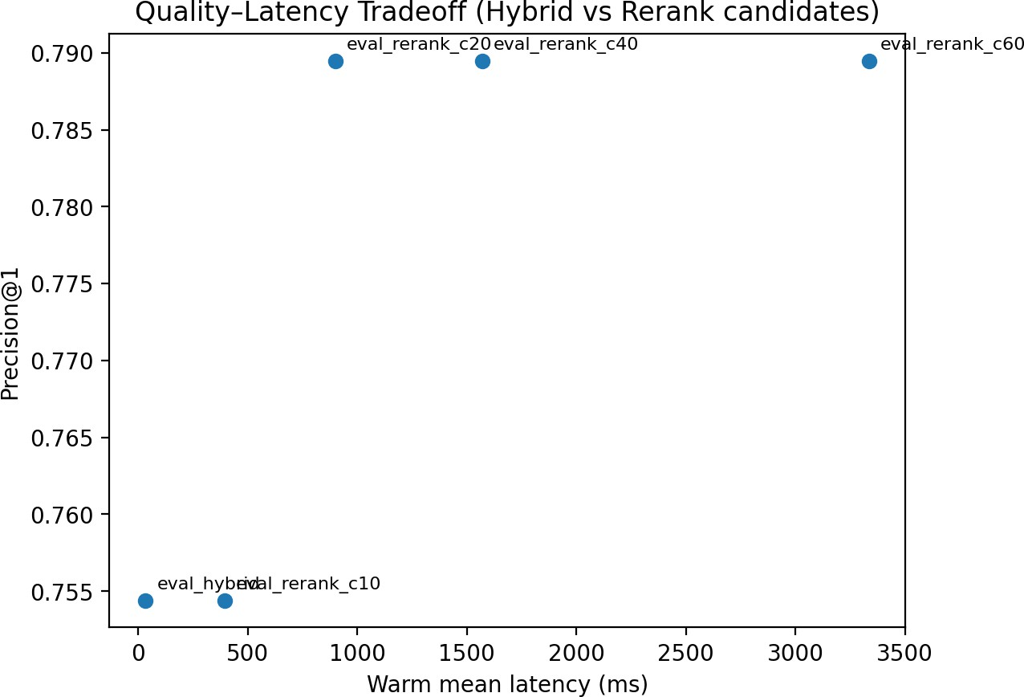

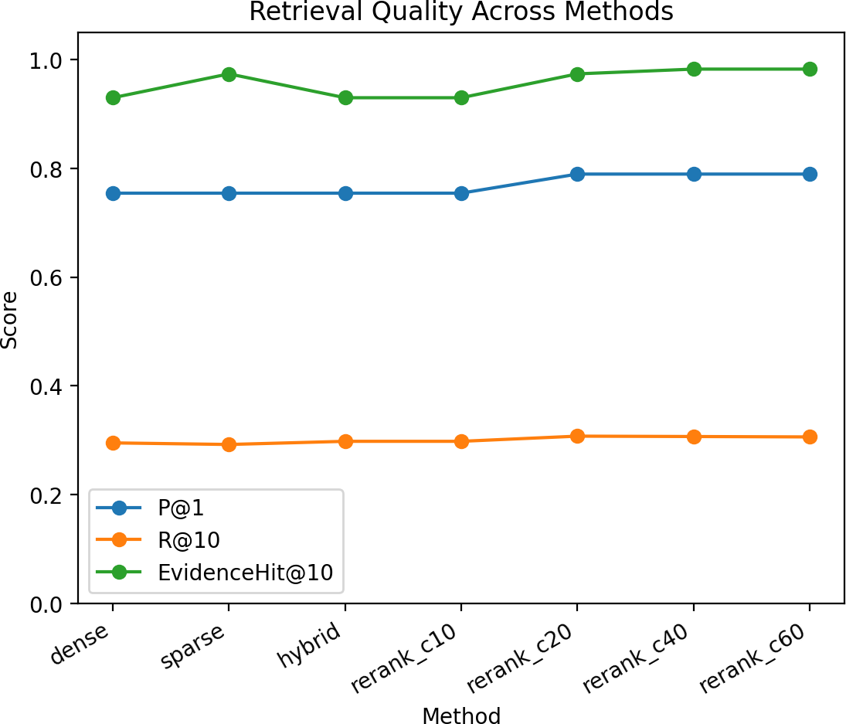
Fig. 1. Retrieval quality across configurations. Reranking with c ≥ 20
improves P@1 from 0.754 to 0.789. EH@10 peaks at 0.991 for c=80.
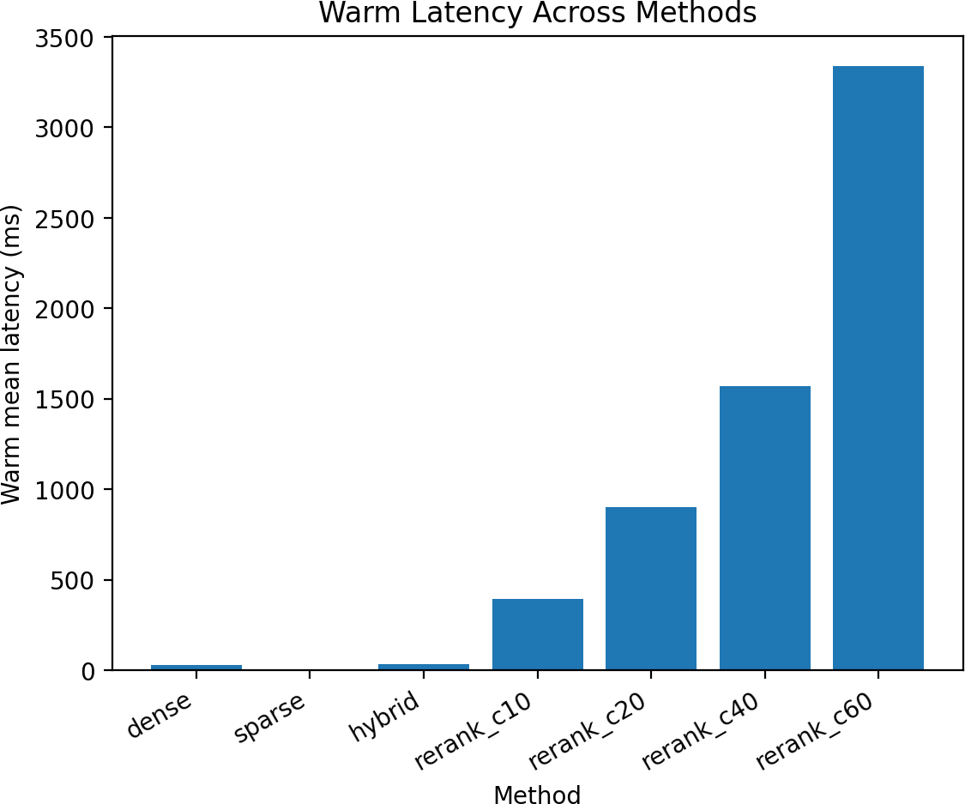

Fig. 2. Latency comparison across configurations (warm mean per-query). Reranking cost increases sharply with candidate count.

Moving from c20 to c40 yields only a modest EH@10 increase (0.974 to 0.982) while increasing latency from 901 ms to 1,572 ms. The full sweep to c80 achieves EH@10 of 0.991 and MRR of 0.799, but at 4.5× the latency of c20.
- Document Quality Analysis
Table III presents page-level quality distribution across the 11-document corpus. Fig. 4 shows the document-level classification.
While 89.56% of pages are classified as digital_clean, only 2 of 11 documents (18.2%) qualify as digital_clean under the calibrated three-guard rule. The remaining 9 (81.8%)
Fig. 3. Quality–latency tradeoff (P@1 vs warm mean latency). The c20 setting is a practical knee point for offline deployments.

TABLE III
Page-Level Quality Distribution (11 Documents, 2,432 Pages)

Quality Class | Pages | Fraction
digital_clean | 2,178 | 89.56%
likely_scanned | 117 | 4.81%
mixed_or_uncertain | 59 | 2.43%
low_text | 40 | 1.64%
digital_noisy | 38 | 1.56%
Total | 2,432 | 100%

are classified as mixed_quality. This discrepancy arises because scan-derived documents with readable OCR produce pages that pass individual page-level thresholds but at system- atically lower quality scores (q¯ = 0.615–0.784) compared to born-digital documents (q¯ = 0.787–0.809).

- Interpretation
Dense vs sparse vs hybrid. On this benchmark, P@1 is identical (0.754) for dense, sparse, and hybrid retrieval, suggesting that the best-first result is often retrievable by either lexical or semantic signals. However, sparse retrieval achieves higher EH@10 (0.974) compared to dense/hybrid (0.930), indicating better evidence surfacing within the top- 10 for certain query types (e.g., exact-phrase or terminology- heavy questions).
Reranking. Reranking yields no measurable improvement at c10, but improves P@1 at c20 and above, consistent with the intuition that reranking only helps when the candidate pool contains alternative relevant chunks that were not already at rank 1.
Document quality. The finding that 81.8% of documents exhibit mixed quality despite high page-level clean fractions indicates that document-level quality classification requires multi-signal aggregation rather than simple majority voting.

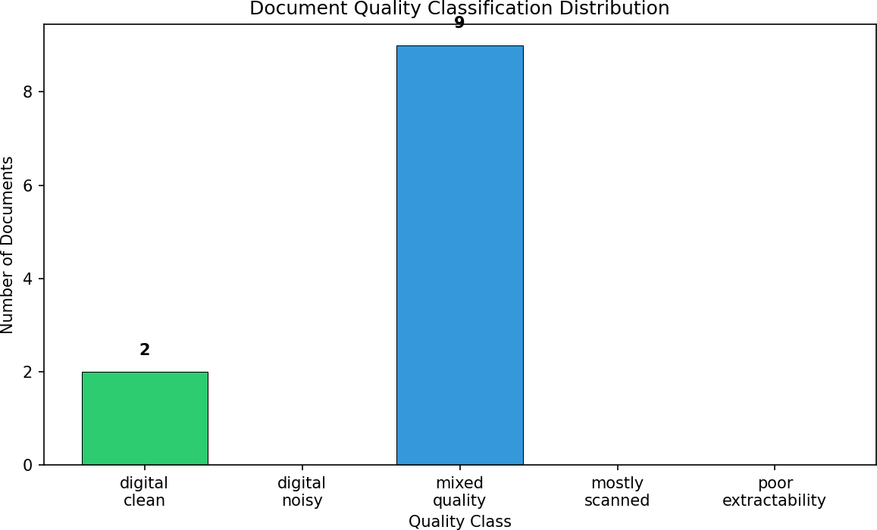

Fig. 4. Document-level quality classification across the 11-document corpus. Nine documents are classified mixed_quality despite having majority clean pages, reflecting the stricter three-guard rule.

- Discussion
- Recommended Operating Point
For most offline RAG deployments, we recommend Hybrid
+ Rerank (c20):
  - P@1 improves from 0.754 to 0.789 (+4.6%).
  - EH@10 improves from 0.930 to 0.974 (+4.7%).
  - MRR improves from 0.754 to 0.794 (+5.3%).
  - Warm mean latency remains under 1 second (901 ms), suitable for interactive workflows.
If ultra-low latency is required, Sparse-only achieves strong EH@10 (0.974) at 6 ms warm mean latency, though it does not improve P@1 relative to the non-reranked baseline.
- Why c=10 Does Not Help
With only 10 candidates, reranking can primarily reshuffle the already-returned set; if the best answer is already at rank 1 (or if better evidence is not present in the candidate set), the cross-encoder cannot improve P@1. The observed improvement only appears once c is large enough to include “near-miss” candidates that the cross-encoder can promote.
- Diminishing Returns Beyond c=20
Quality gains plateau quickly: moving from c20 to c40 yields a small EH@10 increase (0.974 to 0.982) with a substantial latency increase (901 ms to 1,572 ms). c60 provides no additional quality gain over c40 while more than doubling latency again. The full sweep to c80 achieves the highest EH@10 (0.991) and MRR (0.799) but at 4,040 ms per query, which is impractical for interactive use.
- Cold Start Considerations
Cold start is a one-time cost that depends on model/index loading and system cache state. Embedding model loading dominates (∼18 s), while index loading is fast (193 ms). For offline workflows, this motivates deployment patterns such as keeping the process warm during a session, or using pre-
initialized services when permissible.
- Sparse Retrieval Strength
A notable finding is that BM25 achieves the highest base EH@10 (0.974), matching Hybrid + Rerank at c=20. This indicates that for evidence surfacing—the core requirement in document-grounded applications—keyword matching remains highly competitive, particularly for terminology-heavy queries where dense retrieval’s semantic similarity may not capture exact-match relevance.
- Document Quality as a Retrieval Diagnostic
The document quality layer provides a new diagnostic dimension for interpreting retrieval performance:
  - Failure attribution: When retrieval fails to surface gold evidence, the quality layer can distinguish retrieval algo- rithm failure from ingestion-quality failure.
  - Confidence-aware routing: Per-document quality classi- fication enables future systems to adapt candidate pools or extraction strategies for lower-quality sources.
  - Corpus health monitoring: Aggregate quality statistics provide a corpus-level health dashboard informing deci- sions about re-ingestion, OCR re-processing, or manual review.
- Mean Quality Score as Scan-Origin Discriminator
The calibration analysis reveals that mean page quality score (q¯) is the most effective discriminator between born-digital and scan-derived documents, even when scan-derived text passes individual page-level thresholds. Born-digital documents in
our corpus achieve q¯ ≥ 0.787, while scan-derived documents consistently fall below q¯ = 0.784. This subtle but consistent gap reflects differences in character and token distributions
between native digital text and OCR-reconstructed text—a signal that single-page analysis alone cannot reliably detect.
- Limitations and Future Work
Corpus scale. The 114-question retrieval benchmark suf- fices for methodology validation and tradeoff analysis, but larger-scale evaluation on diverse corpora is needed for gen- eralizability claims.
Quality calibration scope. The three-guard thresholds were calibrated on a four-document pilot set. The q¯ ≥ 0.78 thresh- old has a narrow margin between the scan-derived bound- ary (0.780) and born-digital boundary (0.787). Validation on larger, more diverse corpora is warranted.
Quality–retrieval correlation. While the quality layer clas- sifies documents, stratified retrieval metrics per quality class (e.g., EH@10 for digital_clean vs. mixed_quality documents) have not yet been computed due to corpus com- position. This correlation analysis is the immediate next step. Domain breadth. The benchmark includes academic and corporate documents; results may differ on legal or medical corpora with different language and structure. LLM-based information extraction in medical PDFs highlights variability with document complexity and reinforces grounding needs
[17].

No generation evaluation. This work evaluates retrieval quality only. End-to-end RAG evaluation with a local language model for answer generation is a natural extension.
Compute constraints. All measurements are CPU-oriented. GPU acceleration could shift the tradeoff curve, making larger candidate counts more viable.
Static candidate count. We used fixed c per run. Adaptive reranking that increases c only for hard queries could improve latency without sacrificing quality.
Future work includes expanding the human-labeled valida- tion set, introducing a page-level scan-origin detector using image-to-text ratio metadata, building a complete failure tax- onomy mapping retrieval misses to specific quality deficien- cies, distilled rerankers, query-adaptive candidate selection, and learned fusion of sparse/dense/cross-encoder signals.
- Conclusion
LocalRAG++ provides a systematic retrieval evaluation for offline RAG pipelines using a 114-question benchmark. Our ablations show that hybrid retrieval with cross-encoder reranking improves top-rank precision when candidate depth is sufficient, and that c20 is a practical knee point: P@1 improves from 0.754 to 0.789 and EH@10 from 0.930 to 0.974 at 901 ms warm mean latency. The OCR-aware document quality detection layer, validated against human labels with 100% pilot agreement, reveals that 81.8% of documents in a heterogeneous corpus exhibit mixed extractability charac- teristics, demonstrating that retrieval failures in offline RAG are often attributable to upstream ingestion quality rather than retrieval logic alone. Together, these contributions provide both engineering guidance and diagnostic tooling for practical offline RAG deployment in privacy-sensitive environments, extending and strengthening the empirical basis of prior offline baselines such as LocalRAG [1].
Acknowledgment
This work builds on and benefits from open-source con- tributions in information retrieval and local NLP tooling, in- cluding FAISS, BM25-based retrieval libraries, and Sentence- Transformers.
References
- D. R. Velamala, “LocalRAG: A Privacy-Preserving Offline Framework for Multi-PDF Question Answering,” International Journal of Computer Applications Technology and Research, vol. 15, no. 1, pp. 16–22, 2026, doi:10.7753/IJCATR1501.1003.
- P. Lewis, E. Perez, A. Piktus, F. Petroni, V. Karpukhin, N. Goyal, H. Ku¨ttler, M. Lewis, W.-t. Yih, T. Rockta¨schel, S. Riedel, and D. Kiela, “Retrieval-augmented generation for knowledge-intensive NLP tasks,” in Advances in Neural Information Processing Systems, vol. 33, 2020,
pp. 9459–9474.
- J. Johnson, M. Douze, and H. Je´gou, “Billion-scale similarity search with GPUs,” IEEE Transactions on Big Data, vol. 7, no. 3, pp. 535– 547, 2021.
- S. Robertson and H. Zaragoza, “The probabilistic relevance framework: BM25 and beyond,” Foundations and Trends in Information Retrieval, vol. 3, no. 4, pp. 333–389, 2009.
- G. V. Cormack, C. L. A. Clarke, and S. Bu¨ttcher, “Reciprocal rank fusion outperforms condorcet and individual rank learning methods,” in Proc. 32nd Int. ACM SIGIR Conf. Research and Development in Information Retrieval, 2009, pp. 758–759.
- R. Nogueira and K. Cho, “Passage re-ranking with BERT,” arXiv preprint arXiv:1901.04085, 2019.
- T. Nguyen, M. Rosenberg, X. Song, J. Gao, S. Tiwary, R. Majumder, and L. Deng, “MS MARCO: A human generated machine reading comprehension dataset,” in Proc. Workshop on Cognitive Computation, 2016.
- N. Reimers and I. Gurevych, “Sentence-BERT: Sentence embeddings using Siamese BERT-Networks,” in Proc. EMNLP, 2019, pp. 3982– 3992.
- R. Smith, “An overview of the Tesseract OCR engine,” in Proc. 9th Int. Conf. Document Analysis and Recognition (ICDAR), 2007, pp. 629–633.
- S. Xiao, Z. Liu, P. Zhang, and N. Muennighoff, “C-Pack: Packaged resources to advance general Chinese embedding,” arXiv preprint arXiv:2309.07597, 2024.
- C. Auer, M. Lysak, A. Nassar, M. Dolfi, et al., “Docling Technical Report,” arXiv preprint arXiv:2408.09869, 2024.
- PaddleOCR, “PaddleOCR,” 2020. [Online]. Available: https://github.com/PaddlePaddle/PaddleOCR
- G. Kim et al., “OCR-free document understanding transformer,” in
European Conference on Computer Vision (ECCV), 2022, pp. 498–517.
- R. Bommasani et al., “On the opportunities and risks of foundation models,” arXiv preprint arXiv:2108.07258, 2021.
- E. M. Bender, T. Gebru, A. McMillan-Major, and S. Shmitchell, “On the dangers of stochastic parrots: Can language models be too big?,” in Proc. ACM FAccT, 2021, pp. 610–623.
- S. M. I. Tonmoy et al., “A comprehensive survey of hallucina- tion mitigation techniques in large language models,” arXiv preprint arXiv:2401.01313, 2024.
- V. Sciannameo et al., “Information extraction from medical case re- ports using OpenAI InstructGPT,” Computer Methods and Programs in Biomedicine, vol. 255, p. 108326, 2024.
- N. Joshi, A. Saparov, Y. Wang, and H. He, “LLMs are prone to fallacies in causal inference,” arXiv preprint arXiv:2406.12158, 2024.
- K. Lee, S. Yang, J. Jeong, Y. Lee, and D. Shin, “Enhancing Security and Applicability of Local LLM-Based Document Retrieval Systems in Smart Grid Isolated Environments,” Electronics, vol. 14, no. 17, p. 3407, 2025.
- P. Astrino, “Local hybrid retrieval-augmented document QA,” Internet Research, 2025, doi:10.2196/60083.
- G. Nagarajan, O. Kumar, and S. Santhiappan, “PolicyBot: Reliable question answering over policy documents,” arXiv preprint, 2025, doi:10.48550/arXiv.2511.13489.
- E. Tyndall, T. Wagner, C. Gayheart, A. Some, and B. Langhals, “Feasibility evaluation of secure offline large language models with retrieval-augmented generation for CPU-only inference,” Information, vol. 16, no. 9, p. 744, 2025.
- OpenAI, “GPT-4 Technical Report,” arXiv preprint arXiv:2303.08774, 2023.
- Meta AI, “Llama 3: Open foundation and fine-tuned chat models,” 2024. [Online]. Available: https://ai.meta.com/blog/meta-llama-3/
- A. Q. Jiang et al., “Mistral 7B,” arXiv preprint arXiv:2310.06825, 2023.
- Qwen Team, “Qwen Technical Report,” arXiv preprint arXiv:2309.16609, 2023.
- R. Elmasri and S. B. Navathe, Fundamentals of Database Systems, 7th ed. Pearson, 2016.

