A Condylar-Column Integrated Classification for Tibial Plateau Fractures: A Modified Schatzker Framework and a Simplified CT-Based CCC System

Abstract
Background: Tibial plateau fractures show substantial morphological variability and are frequently associated with posterior fragments, ligament injury, and neurovascular compromise. Although several systems exist, the Schatzker classification remains widely used because it is simple; however, it incompletely encodes posterior column involvement and clinically important modifiers.
Methods: A focused narrative review of major tibial plateau fracture classification systems (Schatzker, AO/OTA, Duparc, and CT-based column concepts) was performed. Based on a condylar concept, a modified Schatzker-based system (Types I-VIII) was constructed to incorporate missing patterns and injury modifiers. To bridge condylar and column paradigms while preserving simplicity, a Condyle-Column Classification (CCC) was developed using a short code: condylar category (C), CT-derived column flag (K), morphology (M), and optional modifiers (e.g., MD dissociation, neurovascular deficit, dislocation, ligament injury).
Results: The modified condylar concept classification provides an expanded hierarchy for extra-articular injuries, unicondylar and multicondylar intra-articular patterns, and clinically meaningful modifiers (central depression/bone loss, neurovascular deficit, knee dislocation, ligamentous disruption, polytrauma, and special associated injuries). CCC remains compatible with Schatzker I-VI terminology while explicitly capturing posterior involvement using a simple posterior flag (P/AP) on CT. Tables provide a practical crosswalk between CCC, Schatzker, and AO/OTA categories.
Conclusion: A combined condylar-column approach can be operationalized into a concise classification that remains easy to communicate at the bedside, improves representation of posterior fragments on CT, and allows addition of clinically relevant modifiers that influence approach selection, fixation strategy, staging, and rehabilitation.
Keywords: tibial plateau fracture; classification; Schatzker; AO/OTA; posteromedial fragment; computed tomography; column concept

Introduction
Tibial plateau fractures are common periarticular injuries with a bimodal epidemiology: high-energy trauma in younger adults and low-energy mechanisms in older patients with reduced bone quality. The fracture patterns arise from combinations of axial loading, bending, and rotational forces, and they frequently coexist with meniscal, ligamentous, and neurovascular injury. Because treatment planning depends on articular involvement, fragment location (particularly posterior components), and soft-tissue status, a practical classification is essential for communication, surgical strategy, and research.
Several systems have been proposed, including early split/depression concepts, the Schatzker classification, AO/OTA coding, Duparc variants, and CT-based column approaches. Despite known limitations, Schatzker remains widely used in routine clinical practice, likely because it is simple and rapidly communicated. However, clinically important posterior fragments and modifiers such as central depression, bone loss, knee dislocation, ligamentous disruption, and neurovascular deficit are not consistently encoded in commonly used schemes. The present work proposes (1) a Schatzker-based modification organized by a condylar concept (Types I-VIII) and (2) a simplified CT-based Condyle-Column Classification (CCC) that integrates condylar and column paradigms without sacrificing usability.

Materials and methods
A focused narrative review was performed using PubMed/MEDLINE to identify widely used tibial plateau fracture classification systems and studies assessing their reliability with radiographs and computed tomography. The practical shortcomings most frequently cited in the literature were summarized, with particular attention to posterior fracture components and modifiers that alter operative planning.
Development of the condylar concept modification: The modified Schatzker-based classification was constructed by reorganizing injuries into extra-articular patterns (aligned with AO/OTA 41-A) and intra-articular patterns defined primarily by condylar and quadrant involvement. Additional types were created to encode features that commonly change surgical strategy (central depression, bone loss, neurovascular deficit, knee dislocation, major ligamentous disruption, polytrauma, and special associated injuries).
Development of CCC: CCC is a short code assigned in three components: (1) Condylar category (C): C0 extra-articular; C1L unicondylar lateral; C1M unicondylar medial; C2 bicondylar. (2) Column flag (K), derived primarily from axial CT: A (no posterior fragment), P (posterior fragment present in unicondylar patterns), AP (anterior and posterior involvement in bicondylar patterns), and X (central depression dominant; optional). (3) Morphology (M): S split, D depression, SD split-depression, MF multifragmentary. Metaphyseal-diaphyseal dissociation is recorded using an additional MD modifier. Optional clinical modifiers may be appended where relevant (neurovascular deficit, knee dislocation, major ligamentous injury, and open/severe soft-tissue compromise).
This manuscript presents the framework, definitions, and illustrative schematics. Formal reliability testing and outcome correlation are proposed as future work.

Key variables and definitions
Table 1 summarizes the variables used to operationalize the condylar and column concepts on CT and radiographs.
Variable | Operational definition | Best imaging plane | Clinical relevance
Condylar involvement | Extra-articular (C0), unicondylar lateral (C1L), unicondylar medial (C1M), bicondylar (C2) | X-ray + CT coronal | Determines overall injury group and fixation complexity
Posterior fragment | Presence of a distinct posteromedial/posterolateral fragment or posterior shear component (K=P/AP) | CT axial | Influences approach, buttress fixation, and need for posterior/medial plating
Anterior involvement | Predominant anterior/anterolateral split or depression without posterior fragment (K=A) | CT axial | Supports anterolateral approach and standard lateral fixation
Central depression | Central impaction/depression dominant pattern (K=X, optional) | CT coronal/sagittal | May require elevation, void filling, rafting screws
Split | Discrete fracture line separating a major fragment (M=S) | CT axial | Fragment-specific reduction and fixation strategy
Depression | Articular surface depression without major split (M=D) | CT coronal | Elevation and subchondral support required
Split-depression | Combined split and depressed articular segment (M=SD) | CT axial/coronal | Often requires dual strategy: reduction + elevation
Multifragmentary | Articular/metaphyseal comminution (M=MF) | CT multi-planar | Higher instability; may require dual plating/external fixation
Metaphyseal-diaphyseal dissociation | Loss of metaphyseal-diaphyseal continuity (MD) | X-ray + CT sagittal | Corresponds to high-energy patterns; staging and fixation planning
Knee dislocation | Clinical/radiographic dislocation with plateau fracture (DIS) | Clinical + X-ray | High risk of ligament and vascular injury; may require staged management
Neurovascular deficit | Clinical deficit or vascular injury on Doppler/CTA (N) | Clinical + Doppler/CTA | Time-sensitive evaluation and management
Major ligament injury | Bicruciate and/or corner disruption (L) | Clinical + MRI (if used) | May change stability assessment, fixation, and rehabilitation

Results
The proposed framework consists of two complementary components: (1) a condylar concept modified Schatzker-based hierarchy (Types I-VIII) that encodes clinically relevant modifiers and associated injury contexts, and (2) a simplified CT-based CCC code compatible with Schatzker I-VI terminology while capturing posterior involvement using a posterior flag.

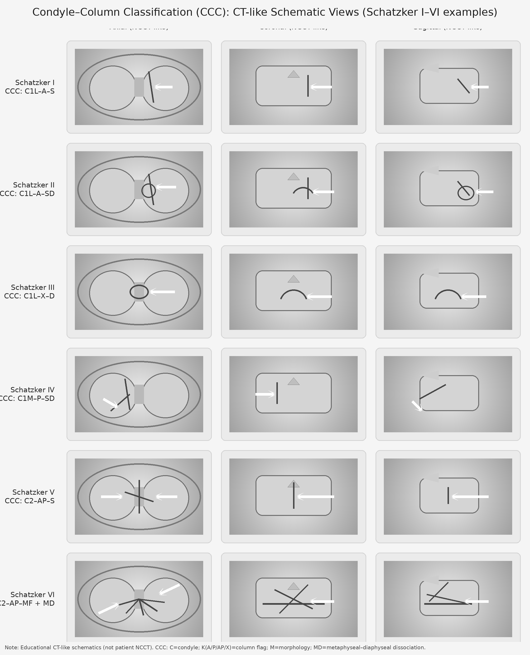
Figure 1. CT-like schematic axial, coronal, and sagittal views of Schatzker I-VI patterns with corresponding CCC codes (educational schematic, not patient imaging).
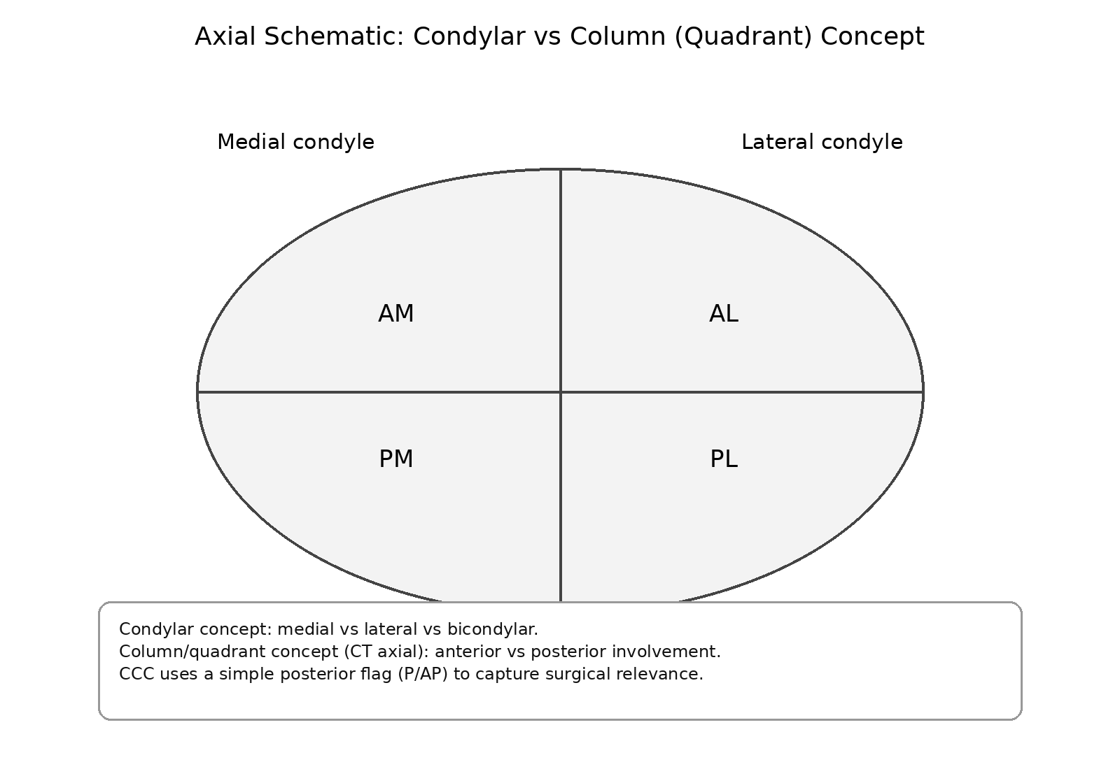
Figure 2. Axial schematic showing condylar (medial/lateral) and quadrant/column (anterior/posterior) concepts used in CCC.
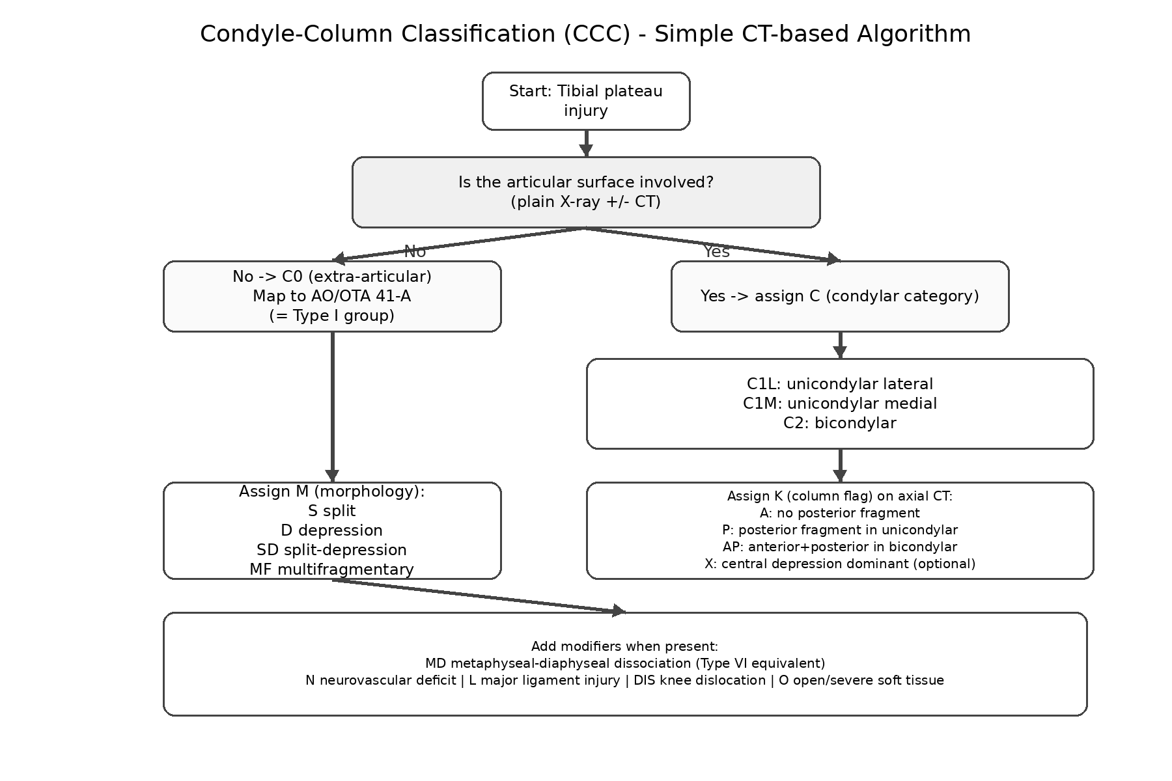
Figure 3. CCC decision algorithm for assigning C (condyle), K (column flag), M (morphology), and modifiers on radiographs and CT.
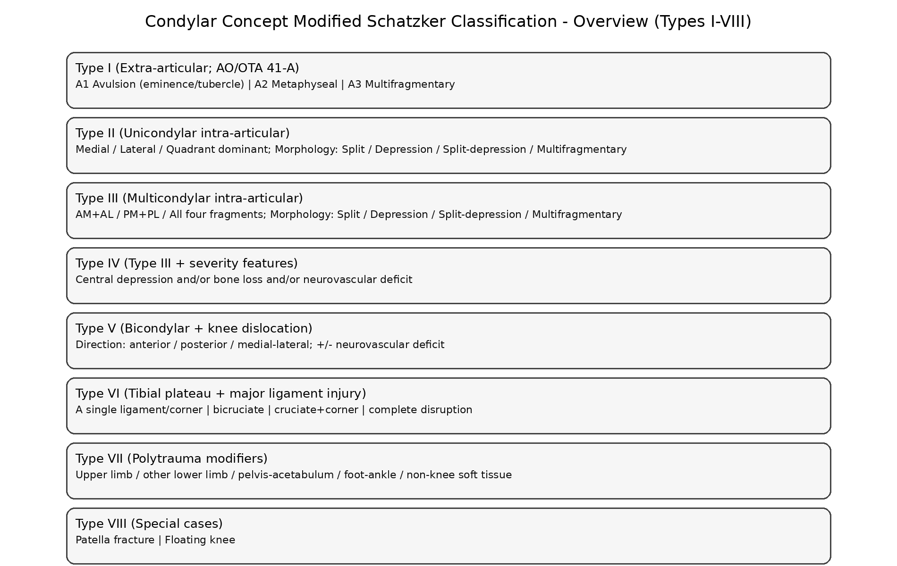
Figure 4. Overview of the condylar concept modified Schatzker classification (Types I-VIII).

Condylar concept modified the Schatzker classification (Types I-VIII)
Table 2 provides the proposed modified Schatzker-based hierarchy with AO/OTA mapping for extra-articular patterns.
Type | Definition | Groups | Subtypes / Notes
I | Extra-articular injuries (AO/OTA 41-A) | A. Avulsion (41-A1) | 1) Medial intercondylar eminence  2) Lateral intercondylar eminence  3) Tibial tubercle  4) Gerdy's tubercle
I | Extra-articular injuries (AO/OTA 41-A) | B. Metaphyseal (41-A2) | Extra-articular metaphyseal fracture
I | Extra-articular injuries (AO/OTA 41-A) | C. Multifragmentary metaphysis (41-A3) | Extra-articular comminution
II | Single-condyle intra-articular fractures (unicondylar) | A. Medial condyle | Morphology (applies to all Type II and Type III groups):  1) Split  2) Depression  3) Split-depression  4) Multifragmentary
II | Single-condyle intra-articular fractures (unicondylar) | B. Lateral condyle | Apply morphology 1-4
II | Single-condyle intra-articular fractures (unicondylar) | C. Predominant quadrant | Posteromedial / posterolateral / anteromedial / anterolateral; apply morphology 1-4
III | Intra-articular fractures involving more than one condyle (multicondylar) | A. Anteromedial + anterolateral fragments | Apply morphology 1-4
III |  | B. Posteromedial + posterolateral fragments | Apply morphology 1-4
III |  | C. All four fragments (AM + AL + PM + PL) | Apply morphology 1-4
IV | Multicondylar fractures with complicating features (any Type III pattern plus one or more) | A. Central depression | Record as Type IV-A (with underlying Type III group)
IV |  | B. Bone loss / impaction defect | Record as Type IV-B (with underlying Type III group)
IV |  | C. Neurovascular deficit | Record as Type IV-C; document clinical/imaging findings
V | Knee dislocation associated with bicondylar fracture | A. Anterior dislocation | Add V-D if neurovascular deficit
V | Knee dislocation associated with bicondylar fracture | B. Posterior dislocation | Add V-D if neurovascular deficit
V | Knee dislocation associated with bicondylar fracture | C. Medial or lateral dislocation | Add V-D if neurovascular deficit
V | Knee dislocation associated with bicondylar fracture | D. Neurovascular deficit | Popliteal artery/nerve deficit, etc.
VI | Tibial plateau fracture with major ligamentous/soft-tissue injury (knee-based) | A. Any one: ACL or PCL or PMC or PLC | Specify injured structure(s)
VI |  | B. ACL + PCL | Bicruciate injury
VI |  | C. Cruciate + PMC or PLC | Combined corner + cruciate pattern
VI |  | D. Complete disruption | Global instability / complete ligamentous disruption
VII | Polytrauma-associated patterns | A. Upper limb injury | Associated injury influencing staging/rehabilitation
VII | Polytrauma-associated patterns | B. Lower limb injury (excluding proximal tibia and patella) | Associated injury influencing staging/rehabilitation
VII | Polytrauma-associated patterns | C. Pelvic and/or acetabular fracture | Associated injury influencing staging/rehabilitation
VII | Polytrauma-associated patterns | D. Foot and ankle fracture | Associated injury influencing staging/rehabilitation
VII | Polytrauma-associated patterns | E. Soft-tissue injury other than knee | Associated injury influencing staging/rehabilitation
VIII | Special cases | A. Concomitant patellar fracture | Record when it changes approach or rehabilitation
VIII | Special cases | B. Floating knee | Ipsilateral femur + tibia fractures

Condyle-Column Classification (CCC) and crosswalk
Table 3 provides a practical translation between CCC, typical Schatzker types, and broad AO/OTA categories.
CCC (core code) | Fracture description (CCC) | Typical Schatzker type | Typical AO/OTA category*
C1L-A-S | Unicondylar lateral; no posterior fragment; split | I | 41-B1
C1L-A-SD | Unicondylar lateral; no posterior fragment; split-depression | II | 41-B3
C1L-X-D | Unicondylar lateral; central/impaction dominant depression | III | 41-B2
C1M-P-(S/SD/D) | Unicondylar medial; posterior fragment common; morphology varies | IV | 41-B (B1/B2/B3)
C2-A/AP-(S/SD/MF) | Bicondylar; anterior and/or posterior involvement; morphology varies | V | 41-C (often C1/C2)
C2-AP-MF + MD | Bicondylar; posterior involvement; multifragmentary with dissociation | VI | 41-C3 (often)
*AO/OTA categories shown represent common broad groupings; exact subtype depends on specific fracture morphology and comminution.

Discussion
The principal intent of combining condylar and column concepts is to preserve the bedside usability that has made Schatzker widely adopted, while adding CT-derived information that materially changes fixation strategy. Posterior fragments, particularly posteromedial components, are now recognized as common in complex injuries and are associated with specific surgical requirements, including posteromedial buttress fixation and alternative approaches. CT has been shown to improve the reliability of classification systems and surgical planning in multiple studies, and contemporary CT-based frameworks emphasize fragment-based fixation. Nevertheless, highly detailed schemes can be difficult to apply rapidly and may reduce adoption.
The condylar concept modification (Types I-VIII) expands the traditional fracture-only perspective by incorporating modifiers that influence staging and outcomes. Central depression and bone loss may indicate the need for elevation, grafting, and subchondral rafting. Neurovascular deficit, knee dislocation, and major ligament disruption are time-sensitive clinical problems that may prompt staged management and multidisciplinary input. Polytrauma and special associated injuries alter rehabilitation trajectories and can justify deviations from standard protocols.
CCC operationalizes the fusion of concepts into a short code that can be written in clinic notes and communicated in team discussions. The condylar component (C) keeps the familiar medial/lateral/bicondylar language, while the column flag (K) adds a minimal but high-impact CT decision: whether a posterior fragment is present (P/AP). This approach is intentionally conservative; it does not attempt to encode every nuance of AO/OTA coding, but it provides immediate guidance on approach selection and fixation priorities.
Limitations include the absence of formal inter- and intra-observer reliability testing and the lack of outcome correlation. These steps are required before the system can be recommended for widespread research reporting. Future validation should include multi-center CT-based reliability studies with surgeons of varying experience levels and correlation of CCC modifiers with approach selection, fixation constructs, complications, and functional outcomes.

Conclusion
A combined condylar-column framework can be simplified into a concise classification that remains compatible with Schatzker terminology while explicitly capturing posterior fragments on CT and allowing clinically meaningful modifiers. The proposed system is designed to support rapid communication and surgical planning, but it requires formal reliability and outcome validation.

Declarations
Ethics approval and consent: Not applicable (conceptual classification proposal with schematic figures).
Funding: None declared.
Conflict of interest: None declared.
Data availability: Not applicable.
Author contributions: To be completed by the authors.

References
1. Gerard-Marchant P. Fractures des plateaux tibiaux. Rev Chir Orthop. 1939;26:499-546.
2. Duparc J, Ficat P. Fractures articulaires de l'extremite superieure du tibia. Rev Chir Orthop. 1960;46:399-486.
3. Luo CF, Sun H, Zhang B, Zeng BF. Three-column fixation for complex tibial plateau fractures. J Orthop Trauma. 2010;24(11):683-692.
4. Walton NP, Harish S, Roberts C, Blundell C. AO or Schatzker? How reliable is a classification of tibial plateau fractures? Arch Orthop Trauma Surg. 2003;123:396-398.
5. Charalambous CP, Tryfonidis M, Alvi F, Moran M, Fang C, Samarji R, et al. Inter- and intra-observer variation of the Schatzker and AO/OTA classifications of tibial plateau fractures and a proposal of a new classification system. Ann R Coll Surg Engl. 2007;89:400-404.
6. Maripuri SN, Rao P, Manoj-Thomas A, Mohanty K. The classification systems for tibial plateau fractures: how reliable are they? Injury. 2008;39:1216-1221.
7. Hohl M, Moore TM. Articular fractures of the proximal tibia. In: Evarts CM, editor. Surgery of the Musculoskeletal System. 2nd ed. New York: Churchill Livingstone; 1990.
8. Hu YL, Ye FG, Ji AY, Qiao GX, Liu HF. Three-dimensional computed tomography imaging increases the reliability of classification systems for tibial plateau fractures. Injury. 2009;40:1282-1285.
9. Brunner A, Horisberger M, Ulmar B, Hoffmann A, Babst R. Classification systems for tibial plateau fractures: does computed tomography scanning improve their reliability? Injury. 2010;41:173-178.
10. Doornberg JN, Rademakers MV, van den Bekerom MP, Kerkhoffs GM, Ahn J, Steller EP, et al. Two-dimensional and three-dimensional computed tomography for the classification and characterization of tibial plateau fractures. Injury. 2011;42:1416-1425.
11. Stahel PF, Smith WR, Morgan SJ. Posteromedial fracture fragments of the tibial plateau: an unsolved problem? J Orthop Trauma. 2008;22(7):504-505.
12. Schatzker J, McBroom R, Bruce D. The tibial plateau fracture: the Toronto experience 1968-1975. Clin Orthop Relat Res. 1979;138:94-104.
13. Barei DP, O'Mara TJ, Taitsman LA, Dunbar RP, Nork SE. Frequency and fracture morphology of the posteromedial fragment in bicondylar tibial plateau fracture patterns. J Orthop Trauma. 2008;22:176-182.
14. Cinque ME, Godin JA, Moatshe G, Chahla J, Kruckeberg BM, Pogorzelski J, et al. Do tibial plateau fractures worsen outcomes of knee ligament injuries? A matched cohort analysis. Orthop J Sports Med. 2017;5(8).
15. van Dreumel RL, van Wunnik BP, Janssen L, Simons PC, Janzing HM. Mid- to long-term functional outcome after open reduction and internal fixation of tibial plateau fractures. Injury. 2015;46(8):1608-1612.
16. Wang Y, Cao F, Liu M, Wang J, Jia S. Incidence of soft-tissue injuries in patients with posterolateral tibial plateau fractures: a retrospective review from 2009 to 2014. J Knee Surg. 2016;29(6):451-457.
17. Poole GV, Miller JD, Agnew SG, Griswold JA. Lower extremity fracture fixation in head-injured patients. J Trauma. 1992;32:654-659.
18. Demling R, Riessen R. Pulmonary dysfunction after cerebral injury. Crit Care Med. 1990;18:768-774.
19. Helling TS, Evans LL, Fowler DL, Hays LV, Kennedy FR. Infectious complications in patients with a severe head injury. J Trauma. 1988;28:1575-1577.
20. Cakir O, Subasi M, Erdem K, Eren N. Treatment of vascular injuries associated with limb fractures. Ann R Coll Surg Engl. 2005;87:348-352.
21. Ashworth EM, Dalsing MC, Glover JL, Reilly MK. Lower extremity vascular trauma: a comprehensive, aggressive approach. J Trauma. 1988;28:329-336.
22. Kfuri M, Schatzker J. Revisiting the Schatzker classification of tibial plateau fractures. Injury. 2018;49:2252-2263.
23. Molenaars RJ, Solomon LB, Doornberg JN. Articular coronal fracture angle of posteromedial tibial plateau fragments: a computed tomography fracture mapping study. Injury. 2019;50(2):489-496.

Figure legends
Figure 1. CT-like schematic axial, coronal, and sagittal views of Schatzker I-VI patterns with corresponding CCC codes (educational schematic).
Figure 2. Axial schematic of condylar vs column/quadrant concepts used in CCC.
Figure 3. CCC assignment algorithm (C, K, M, and modifiers).
Figure 4. Overview of the condylar concept modified Schatzker classification (Types I-VIII).

