Gamification Learning Environment (GLE) for Supporting Self-Regulated Learning in Arabic Vocabulary: A Quasi-Experimental Study.
Liyana Abdul Ghafar*, Norah Md Noor
Faculty of Educational Sciences and Technology, Universiti Teknologi Malaysia, Skudai, Johor Bharu, Malaysia
*Corresponding Author
DOI: https://doi.org/10.47772/IJRISS.2026.10100586
Received: 30 January 2026; Accepted: 05 February 2026; Published: 19 February 2026
ABSTRACT
The purpose of this research is to see the effects of Gamification Learning Environment (GLE) developed towards students’ performance, motivation and the Self-Regulated Learning (SRL) strategies used in learning Arabic vocabulary; and the correlations between motivations, SRL strategies and performance. A quasi-experimental design was employed involving 55 secondary school students from one of the districts in Malaysia. Two online learning environments were developed: a gamified version for the experimental group and a non-gamified version for the control group. Pre and post tests were conducted prior and after the students learning in the online environment for three (3) weeks using Arabic vocabulary test and adapted Motivated Self-regulated Learning Questionnaire (MSLQ). The results indicated that although there was no statistically significant overall difference in performance gains between the two groups, students in the gamified group who initially had lower vocabulary scores demonstrated greater improvement compared to their counterparts. In addition, a strong positive correlation was found between post-intervention motivation and SRL strategies in the experimental group (r = .745, p < .001), as well as between changes in motivation and changes in SRL strategies (r = .638, p < .001). However, no significant correlations were observed between motivation or SRL strategies and vocabulary performance in either group. Overall, the findings suggest that while the GLE did not function as a universal performance enhancer, it was particularly effective in supporting lower-performing students and in strengthening the relationship between motivation and self-regulated learning strategies.
Keyword: Gamification, Self-Regulated Learning strategies, Motivation, Arabic language, Foreign language learning.
INTRODUCTION
Over the years, numerous studies have suggested ways to improve the learning environment and help students remain engaged in online learning. Online learning became an unavoidable necessity, imposed regardless of learners’ readiness. Institutions that had previously resisted moving away from traditional pedagogical models were left with no choice but to fully embrace online teaching and learning during the pandemic (Dhawan, 2020). This abrupt transition posed significant challenges to education systems worldwide, compelling educators to adopt digital teaching methods almost overnight. Undoubtedly, the student learning environment has changed; however, sustaining engagement and success in an online learning environment is difficult and requires students’ awareness and motivation.
Applying Self-Regulated Learning (SRL) strategies could enhance students' cognitive and metacognitive skills, thereby increase their learning awareness and transforming a passive learning attitude into an active one. Despite SRL strategies proven to increase students’ academic achievement across subjects (Alotaibi, 2017; Chen, 2009; Seker, 2016) it is difficult to employ and sustain because it demands discipline and high motivation from the students (Zimmerman & Schunk, 2008). Research found that the cognitive strategy used by students in Arabic vocabulary learning remains at a moderate level (Abdul Basit et al., 2017).
Apparently, motivation plays an important role in SRL strategies application (Pintrich, 1999). Gamification is one strategy that enhances motivation in learning (Aleksic-Maslac et al., 2018; Fathoni & Delima, 2017; Molnar, 2018; Permana & Kusumo, 2018; Rawendy et al., 2017; Yue & Ying, 2017) because of its fun and less pressuring nature. Panadero (2017) noticed that the introduction of computers in SRL research shows promising results not only for measuring but also for scaffolding SRL. This is supported by research conducted by (Chen, 2009; Chen et al., 2018). Several recent studies have examined gamification’s role in self-regulated learning. For example, gamified environments were found to significantly enhance both SRL behaviours and learning outcomes in language contexts (Maimaiti & Hew, 2025). However, very few instructional designers emphasise assisting learners in planning, monitoring, and evaluating their learning sessions in an online learning environment using gamification. For example, Chen et al. (2018) suggested further research to compare the effect of their proposed SRL app with and without game elements. This suggests the potential of gamification in SRL. Moreover, there are several research motivating gamifications, but very few for foreign language learning, especially Arabic. Seaborn & Fels (2015) encourage empirical research on the effects of gamification on learning performance or achievement, beyond motivation and engagement. Therefore, this study aimed to develop a Gamification Learning Environment (GLE) to support students’ SRL strategies in learning Arabic vocabulary and to examine its effects on students’ performance, motivation, and self-regulated learning strategies, as well as the correlations among these variables.
LITERATURE REVIEW
There are different theoretical perspectives on self-regulated learning, including social cognitive, operant phenomenological, volitional, Vygotskian, and cognitive constructive (Ng, 2010). Social cognitive theory is the most extensively used in SRL research among these theories. This study is based on the social cognitive learning perspective by Bandura (1986). Bandura works are widely recognised in the education field as one of the major theories of educational psychology used to date (Zimmerman, 2013). Through his Triadic Reciprocal Model of Causality, self-regulation was introduced. Within this model, human functioning is regulated by interaction of behaviour factors, personal factors, and environmental factors (Bandura, 1986). The term reciprocal refers to mutual action between causal factors, but it is not necessarily simultaneous and self-regulatory system is the core of causal processes (Bandura, 1991). He concluded that behaviour, cognitive and personal factors, and environmental events operate human functioning as interacting determinants of each other (Bandura, 1986). Interaction of these factors can be visualized in the Figure 1 below:
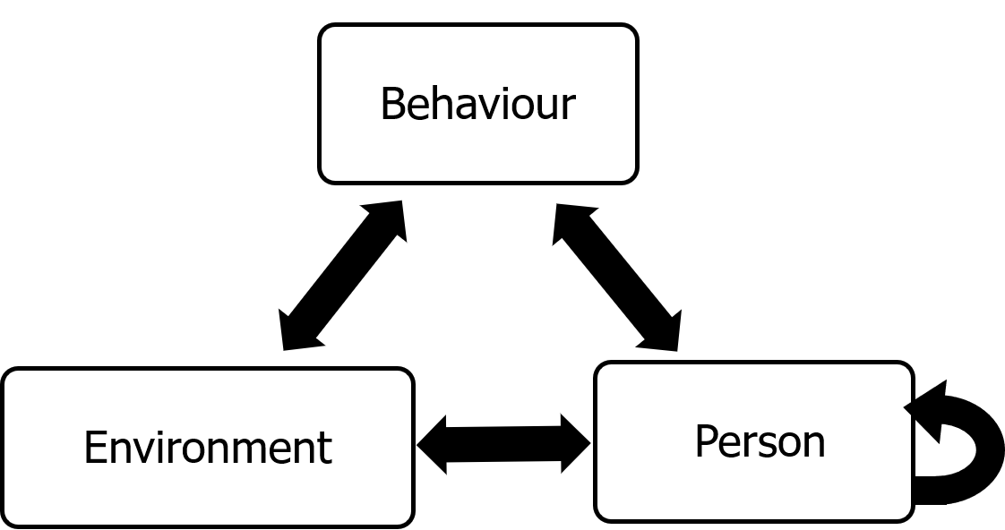
Figure 1 Bandura’s Model of Triadic Reciprocality
In this model, reciprocality refers to mutual direction but not necessarily equal. One factor may exert greater influence on another in a given context (Zimmerman, 1989). Personal factors include cognitive and motivation factors such as self-efficacy. Environmental influences may come from teachers or instructional aids. An example of an environmental influence on a person factor is when a teacher praises a student; the student’s self-efficacy may increase as a result of the feedback. When students’ self-efficacy is high, there are chances of exerting more effort to finish the work, and this is an example of a personal factor influencing behaviour. In the same way, behaviour influences personal factors: greater effort may increase students’ self-efficacy. The small loop beside the person factor shows that personal factors can influence one another. Supporting this model, Zimmerman defined SRL as the degree to which students are metacognitively, motivationally, and behaviourally active participants in their own learning processes (Zimmerman, 1989). This theory is the foundation for the gamification learning environment developed in this research.
There are several models of SRL available, such as Zimmerman, Boekaerts, Winne and Hadwin, and Pintrich. Each model gives a different emphasis on the main area of SRL, which is cognitive, motivation and emotion. Winne and Hadwin’s model emphasise metacognition foremost, then motivation, and lastly emotion. Meanwhile, Zimmerman and Pintrich both place importance on motivation, followed by cognition, then emotion. This study chose the Pintrich model because it highlights the motivation area in SRL more explicitly.
Motivation is “the process whereby goal-directed activity is instigated and sustained” (Pintrich & Schunk, 2002, p. 5). Motivation is not a product because it cannot be observed directly, but can be inferred from certain behaviour, therefore it is a process. Motivation involves goals that provide direction and requires activity, whether physical or mental, to attain them. Initiating the first step towards a goal is often difficult, thus motivational processes are important to start and sustain action. In a learning context, although learning could take place without the learner being motivated, motivation plays an important role in learning by leading students to engage in activities that facilitate learning. There are three sources of incentives that influence a person tendency to perform an observationally learned behaviour. First, direct incentives where people more likely to selectively imitate behaviour that give external rewards than unrewarded action or has punishment. Second, vicarious incentives where observed outcomes that are effective for others are favoured over negative outcomes. Lastly, self-produced incentives are those that are self-satisfying and are expressed more than what is disapproved according to the individual’s personal standard. These motivational processes are aligned with game structure. Therefore, this study tried to insert gamification into the learning environment, aiming to increase student motivation to apply SRL strategies in learning.
The most popular definition of gamification within a digital context is “the use of game design elements in non-game contexts” as proposed by Deterding, Khaled, Nacke and Dixon in 2011. The concept of gamification is not new in education. Teachers had already implemented game-based activities long before digital video games, such as leaderboards and tokens; however, these were implemented manually, without assistance from technological tools. Today, the term gamification is often used to refer to the gamification of learning in digital contexts. Simões, Redondo, and Vilas (2013) define gamification of education as the use of game elements in a learning environment, usually with the support of ICT. Gamifying learning does not mean changing the learning into a game. There are differences between gamification in education and commercial digital games in terms of its purpose and design. (Brigham, 2015) defined gamification as the addition of game-based elements into a learning approach that acts as a catalyst to increase students’ engagement, motivation or learning by solving problems or goals outside the context of a game.
Points, badges, leaderboards, and levels are among the most used gamification elements. This is because these components are easy to apply regardless of the game’s genre or type and give an instant effect. Moreover, users with diverse learning styles can benefit from points, badges, and leaderboards, even if their perceptions differ, such as in terms of reward, competition, or challenge. Based on an experiment, points, levels and leaderboards significantly increase the user participation compared to the normal condition, while levels and leaderboards significantly increase user participation compared to the points condition (Mekler et al., 2017). These results showed that the four most effective game elements are points, badges, leaderboards and levels, so these elements are inserted into the developed gamification learning environment.
Research Objectives
Objectives of this study are:
RO 1: To identify the effects of Gamification Learning Environment (GLE) towards students’ performance in Arabic vocabulary test, motivation in using self-regulated learning strategies and their SRL strategies.
RO 2: To identify the correlation between students’ motivation with self-regulated learning strategies and Arabic vocabulary performance.
The research questions for the first objective (RO 1) are:
RQ1 - Is there significant effect of Gamification Learning Environment towards students’ performance in Arabic vocabulary test?
RQ2 - Is there significant effect of Gamification Learning Environment towards students’ self-regulated learning strategies use in learning Arabic vocabulary?
RQ3 - Is there significant effect of Gamification Learning Environment towards students’ motivation to use self-regulated learning strategies in learning Arabic vocabulary?
The followings are research questions for the second objective (RO 2):
RQ4 - Is there significant correlation between students’ motivation and self-regulated learning strategies?
RQ5 - Is there significant correlation between students’ motivation and performance in Arabic vocabulary test?
RQ6 - Is there significant correlation between students’ self-regulated learning strategies and performance in Arabic vocabulary test?
METHODOLOGY
This study employed a quasi-experimental non-equivalent groups design to examine the effects of a Gamification Learning Environment (GLE) on students’ performance, motivation, and self-regulated learning strategies in online Arabic vocabulary learning. A true experimental design with random assignment at the individual level was not feasible due to institutional constraints and the natural classroom setting. Therefore, two intact school groups were used, with one school assigned as the experimental group and the other as the control group.
Although schools were randomly assigned to conditions, individual participants were not randomly allocated, resulting in non-equivalent baseline characteristics between groups. In particular, the control group demonstrated higher pre-test performance levels. Consequently, the findings should be interpreted as the results of associative and comparative analyses. This design is appropriate for authentic educational contexts in which randomisation is impractical, while still allowing a meaningful examination of instructional interventions (Creswell & Creswell, 2017).
Population and Sampling
The population for this study comprises Form 1 (13th-grade) students enrolled in Kelas Aliran Agama (KAA) programs at national secondary schools (SMK) in one (1) district in Selangor, Malaysia. These students are part of a specialised stream designed to strengthen Islamic and Arabic language education within the Malaysian national education system; therefore, they represent a relevant demographic for investigating Arabic vocabulary learning and SRL in online and gamified digital environments.
The criteria for selecting the schools are that they must first offer an Arabic language subject for Form 1 students. Second, the syllabus must follow the standard KSSM syllabus and are not other syllabi such as Kerajaan Negeri. Third, the schools are equipped with technology facilities such as the internet and a computer lab. Fourth, the students have experience in learning in an online learning environment. Lastly, to increase the homogeneity of both groups, both schools need to be in the same district or a similar environment so that there are fewer extraneous variables that may influence the students' learning.
In controlling interaction threats, samples for the experimental groups were taken from different schools of the control group. Within the selected schools, intact classes were used, resulting in a non-equivalent groups structure. One school was assigned as the experimental group and the other as the control group. Assignment at the school level was conducted randomly; however, individual students were not randomly assigned to conditions due to administrative and ethical constraints.
Testing threat could occur when samples are taken from different schools; therefore, the researcher followed the same procedure for each school involved. Both groups received an online learning intervention, distinct from their conventional classroom instruction. However, only the experimental group were exposed to gamification while the control group was only provided with an online learning environment without gamification. Schools were randomly assigned to the experimental and control groups.
Samples were drawn from the population using a purposive sampling approach, as participation in the study was voluntary, and students themselves chose to engage with the online learning platform. Invitations to participate were extended to all Form 1 KAA students in selected schools, and those who consented and accessed the platform formed the final sample. The final sample size was determined based on observed platform engagement and completion rates of the pre- and post-intervention instruments. Initially, 158 students were shortlisted as participants; only 55 were included in the final sample for data analysis.
Instruments
Based on Pintrich's MSLQ (1991), an adapted questionnaire was used to measure students’ motivational level and the learning strategies they used to learn Arabic vocabulary. The questionnaire was translated to Bahasa Malaysia to suit the research sample and was reviewed by language, SRL and motivation experts for validations. After correction, it was changed to a 5-point Likert scale containing 83 questions in total, 33 for motivation and 50 for learning strategies. Motivation constructs are intrinsic goal orientation, extrinsic goal orientation, task value, control belief, self-efficacy for learning and performance, and test anxiety. Meanwhile, learning strategies are rehearsal, elaboration, organisation, critical thinking, metacognitive self-regulation, time and study environment, effort regulation, peer learning and help-seeking.
Table 1 Items of the adapted Motivated Self-regulated Learning Questionnaire (MSLQ) instrument used in the study.
Scales | Dimensions | Constructs | Item no. | Total
Motivation | Value components | Intrinsic goal orientation | 1, 17, 24, 26 | 4
Motivation | Value components | Extrinsic goal orientation | 7, 11, 12, 14, 32 | 5
Motivation | Value components | Task value | 4, 10, 18, 25, 28, 29 | 6
Motivation | Expectancy components | Control belief | 2, 9, 19, 27 | 4
Motivation | Expectancy components | Self-efficacy for learning and performance | 5, 6, 13, 16, 21, 22, 23, 31, 33 | 9
Motivation | Affective components | Test anxiety | 3, 8, 15, 20, 30 | 5
Learning strategies | Cognitive & metacognitive strategies | Rehearsal | 41, 48, 61, 74 | 4
Learning strategies | Cognitive & metacognitive strategies | Elaboration | 55, 64, 66, 69, 71, 83 | 6
Learning strategies | Cognitive & metacognitive strategies | Organisation | 34, 44, 51, 65 | 4
Learning strategies | Cognitive & metacognitive strategies | Critical thinking | 40, 49, 53, 68, 73 | 5
Learning strategies | Cognitive & metacognitive strategies | Metacognitive self-regulation | 35, 38, 43, 46, 56, 57, 58, 59, 63, 78, 80, 81 | 12
Learning strategies | Resource management strategies | Time and study environment | 37, 45, 54, 67, 72, 75, 79, 82 | 8
Learning strategies | Resource management strategies | Effort regulation | 39, 50, 62, 76 | 4
Learning strategies | Resource management strategies | Peer learning | 36, 47, 52 | 3
Learning strategies | Resource management strategies | Help-seeking | 42, 60, 70, 77 | 4
Total number of items |  |  |  | 83

Table 2 below shows some examples of question:
Table 2 Examples of MSLQ questions
Construct | Item | Samples Questions
Cognitive Strategies | Rehearsal | 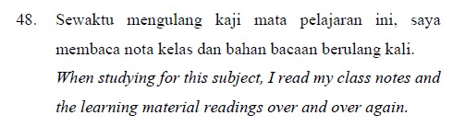
Cognitive Strategies | Organization | 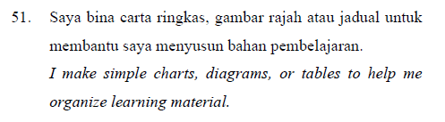
Resource management strategies | Time and study environment | 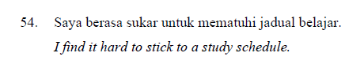  *reversed

An Arabic vocabulary test was also developed to assess students’ knowledge of selected target words from Topic 4 of the Form 1 Arabic Language textbook. The test consists of 45 questions divided into 4 sections and 7 sub questions with a total mark of 100. The difficulty levels of questions were based on Bloom’s taxonomy.
Table 3 Questions' difficulty level of the Arabic vocabulary test
Section | Question | Marks | Difficulty level | Bloom | Task
1 | 1 - 15 | 15 | Low | Remember | Fill in correct spelling for items in picture given.
2 | 16 - 25 | 20 | Low Medium | Remember  Understand | Complete word phrase with words given
3 | 26-30 | 10 | Medium high | Understand  Evaluate | Identify words that do not belong to the category
3 | 30-33 | 12 | Medium | Understand Analyze | Find opposite words.
3 | 34-37 | 8 | Low Medium | Remember  Analyze | Label word as noun or verb.
4 | 38-42 | 20 | Medium High | Understand  Analyze  Evaluate | Rearrange words into sentences
4 | 43-45 | 15 | High | Apply  Create | Make sentence using word given.

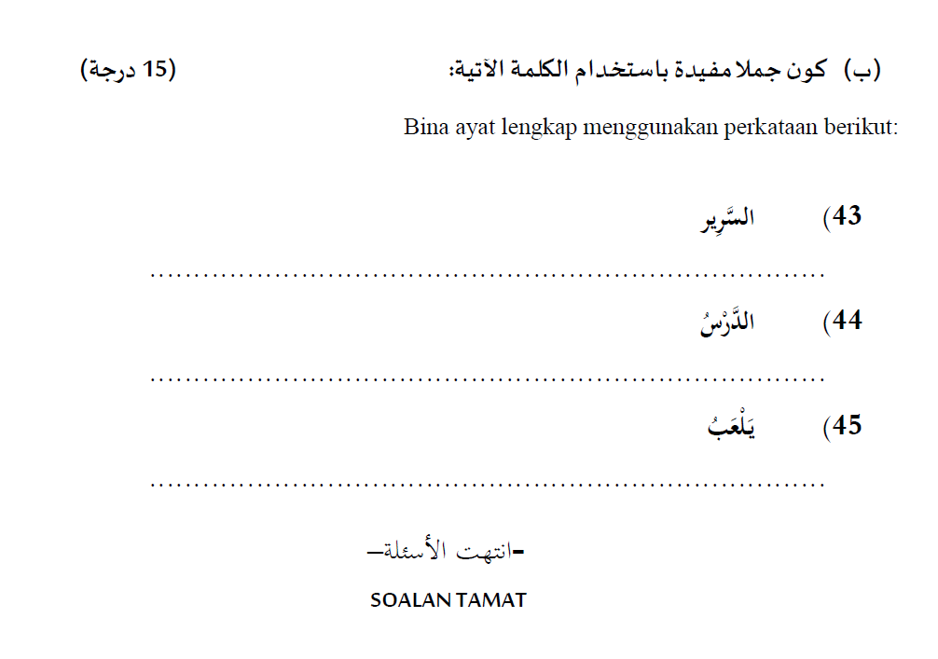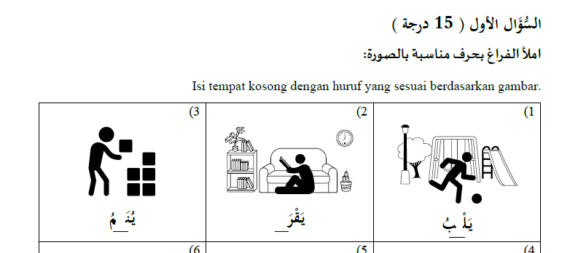
Figure 2 Example questions in the Arabic vocabulary test instrument

Gamification Learning Environment (GLE)
Using ADDIE instructional model, two online learning courses was designed and developed for the study using Moodle platform. Vocabulary inserted and tested in this GLE are based on one of the topics included in the Form 1 Arabic Language textbook within the new curriculum standard provided by the Ministry of Education of Malaysia (KSSM). Topic Four was selected and Figure 3 below shows some of the vocabulary included in the topic:
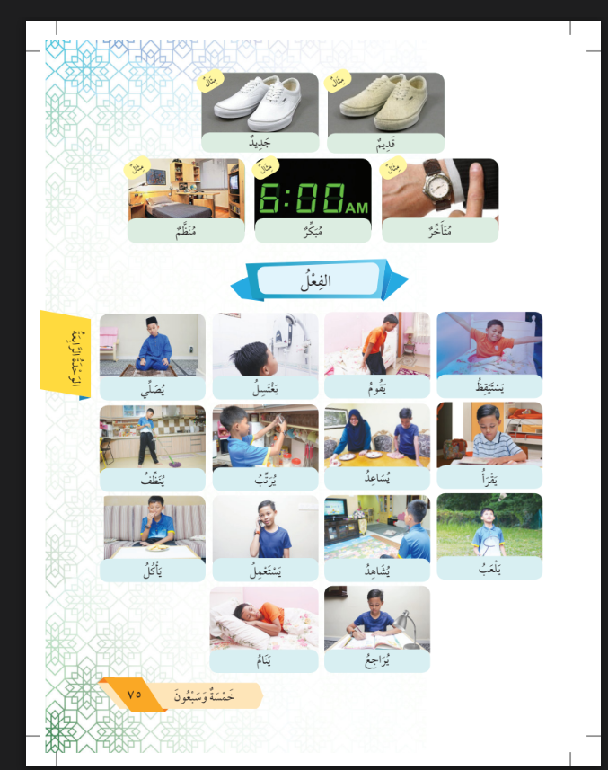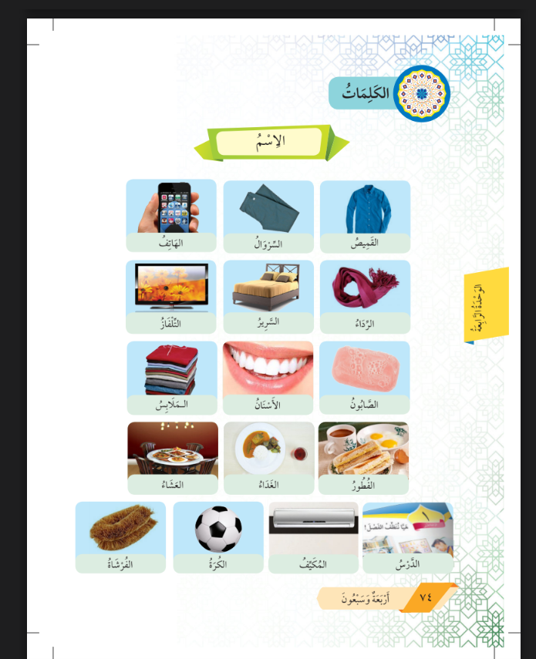
Figure 3 Vocabulary in the Topic 4 of Form 1 Arabic Language textbook
Moodle was selected as the platform to develop and design the GLE because it is a free, open-source, and very customizable platform to fit educational objectives. Although it was introduced in 2002, many educational institutions still use Moodle, indicating its stability and user-friendliness (Bousboula et al., 2025). It also supports both desktop and mobile views. In this study, Moodle is used as a Learning Management System (LMS) while several Learning Content Management systems (LCMS) and plugins are inserted into Moodle, such as Level Up! and Wordwall. Figure 4 below shows the structure of the GLE developed.
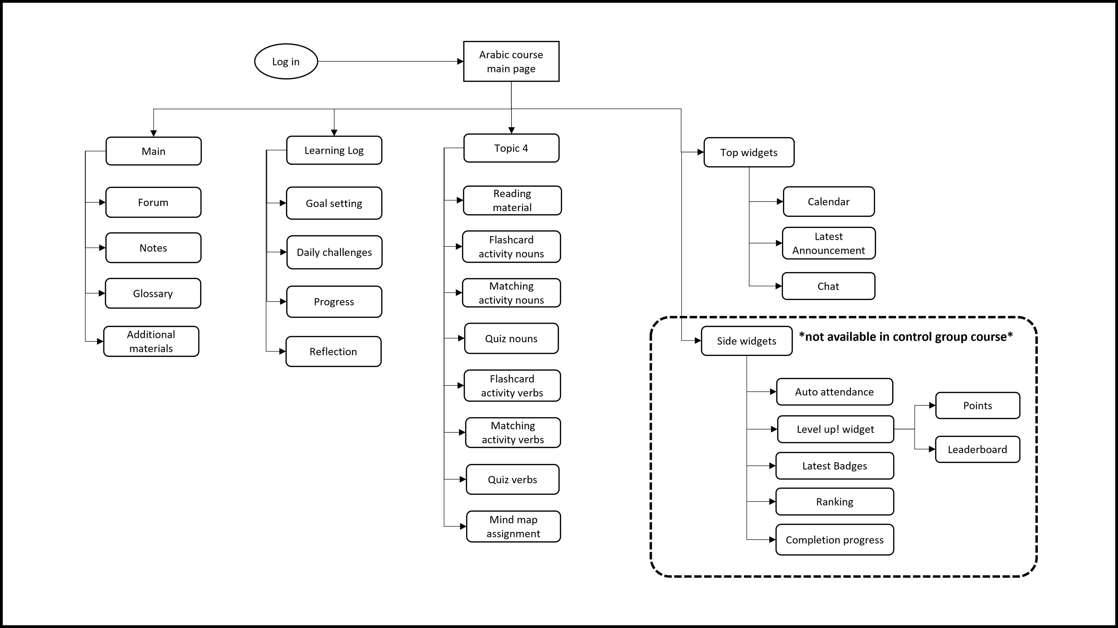
Figure 4 Structure of the developed Gamification Learning Environment (GLE)
Activities in the learning log, such as Goal setting, Daily challenges, and Progress monitoring, were designed using Canva coding, whereas reflections were designed using Moodle database templates.
As shown in Figure 4, side widgets are not available in the control-group learning environment and are only included in the experimental-group version of GLE. “Level Up!” is a gamification widget that offers points, levels and leaderboards and was inserted inside the Moodle course. Gamification rules can be set for any events or user actions in the course using this widget. For example, students will be awarded 15 points when they create or update Notes or Reflections.
Table 4 below shows the component that was included in the learning environment that was given as intervention to the experimental group:
Table 4 Components of the developed GLE
No. | Components | Screenshot Images
1. | Goal setting | 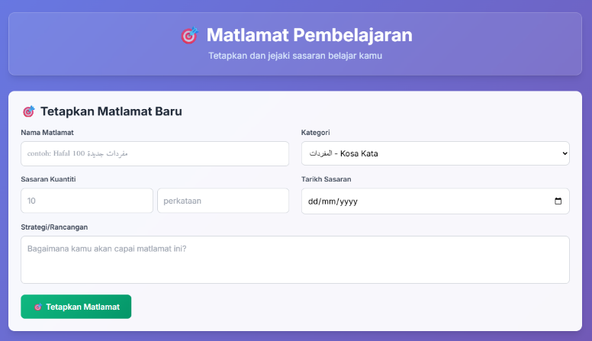
2. | Daily Challenges | 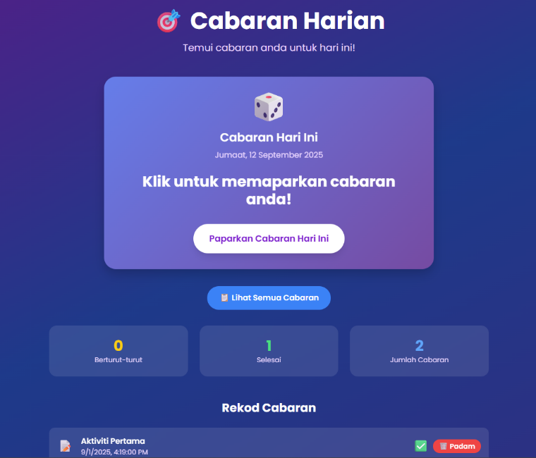
3. | Monitor progress | 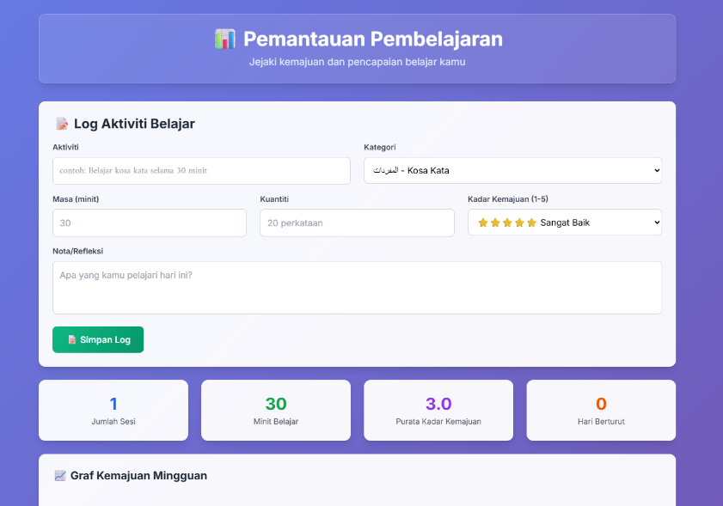
4. | Reflection | 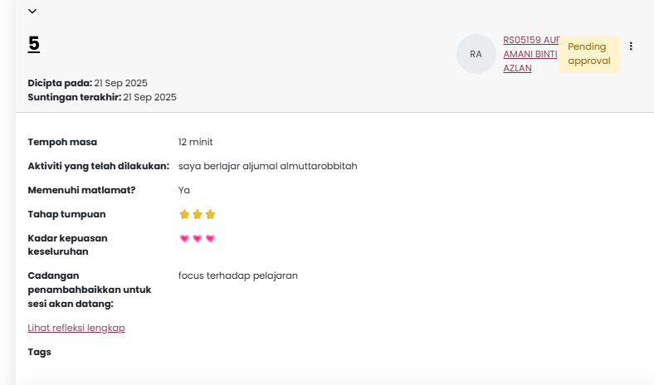
5. | Arabic vocabulary activities for Topic 4 | 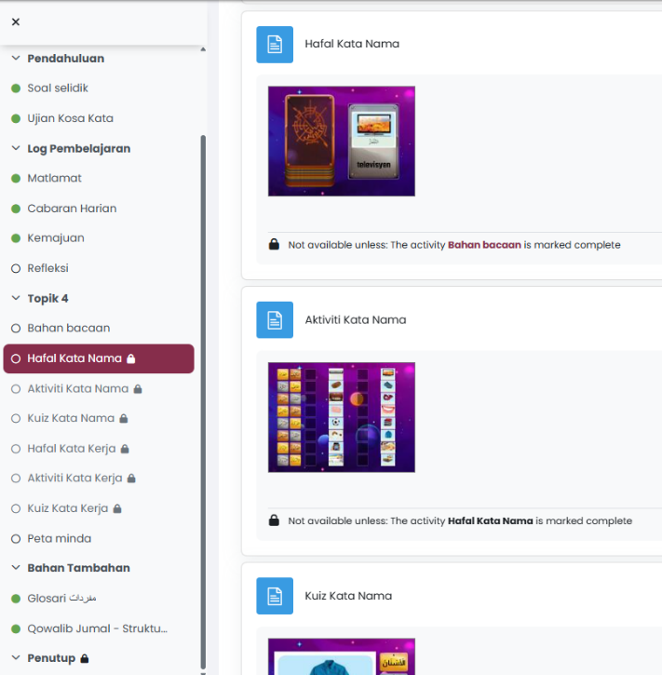
6. | Auto attendance | 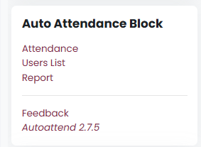
7. | Level up! widget | 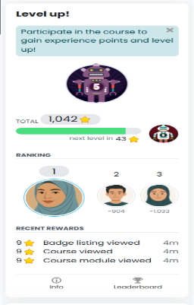  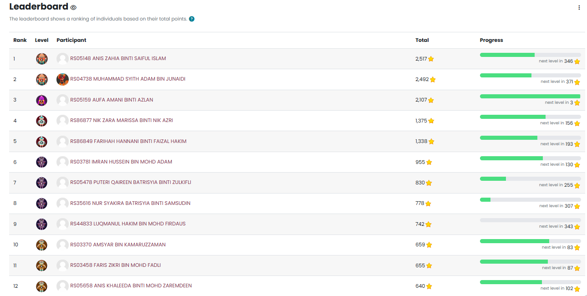
8. | Badges | 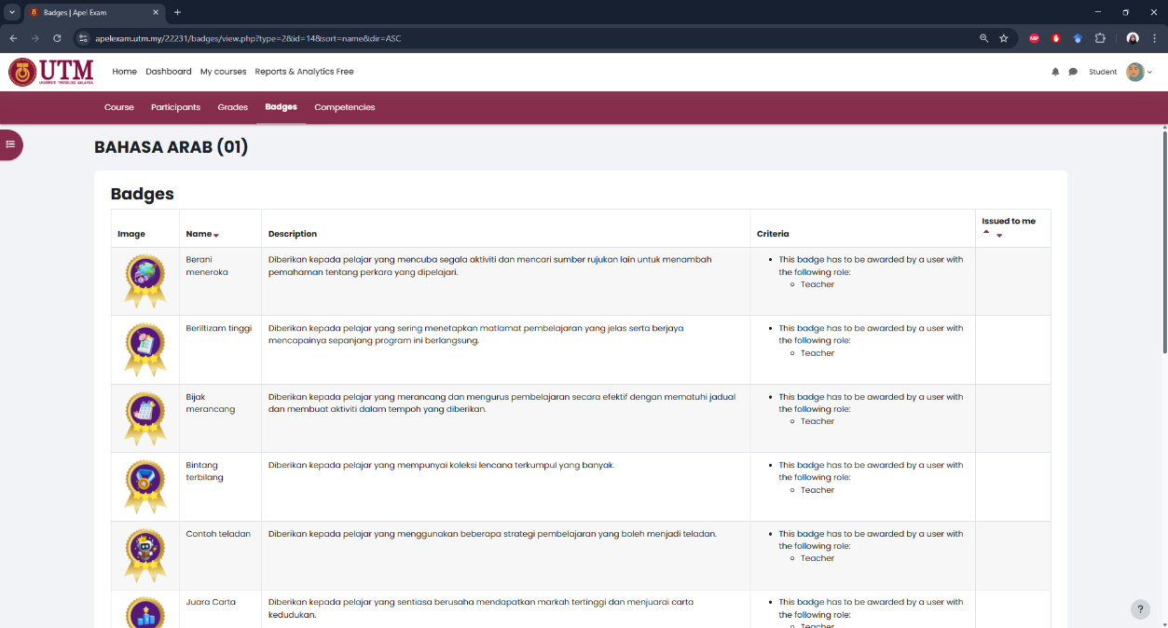
9. | Ranking | 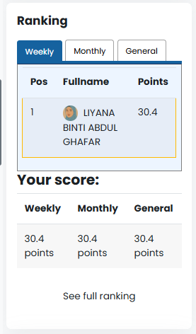 | 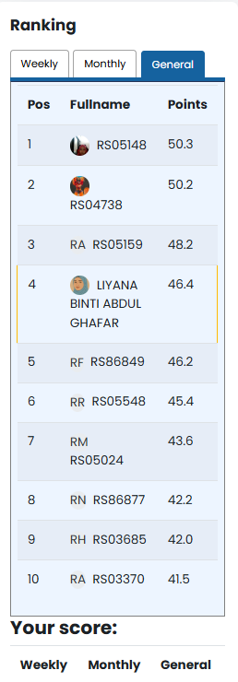
10. | Completion Progress / Indicator | 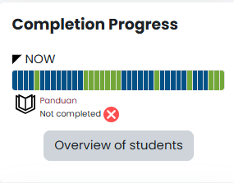 | 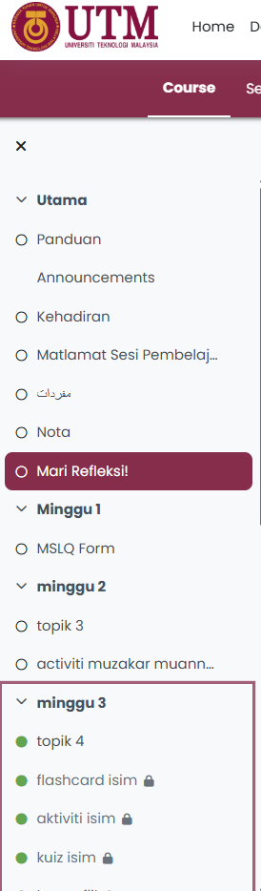

Components number 1-4 are the learning log features of the learning environment, where, in the experimental course, user actions were counted and awarded using Level up! widget points, level and ranking based on gamification rules set in the settings. In component number 5, the image shows example some of the activities for Topic 4 created using Word wall. For experimental group, activities in number 5 were locked by stages. Numbers 6-10 are features that have gamification elements such as points, leaderboards, and badges. Excluding the components number 2 (Daily challenges), gamification elements in 5, and components 6-10, the same structure were given to the control group.
Experiment Procedure
Prior to data collection, formal approvals were obtained from the Ministry of Education Malaysia (KPM) and the Selangor State Education Department (JPN). These approvals were essential due to the involvement of school-aged participants. Upon receiving clearance, school principals and teachers were briefed on the research objectives and procedures. Participants were given log in details and instructions to access the Arabic course developed through messaging app group which include parents and students. Two instruments were given to the samples in the pre- and post-test, Motivated Strategies for learning Questionnaire (MSLQ) and Arabic vocabulary test. Students were given time to explore and learn online using the developed learning environment within 3 weeks. Only students who had consented, accessed the online learning platform, and completed the pre and post-test were included in the evaluation phase.
FINDINGS
Normality Analysis
An analysis of the data's distribution conducted using the Kolmogorov-Smirnov and Shapiro-Wilk tests indicate that the overall score distributions are non-normal in both groups. The distribution significantly deviated from normality in both the Control group (n = 18; Shapiro–Wilk p = .003) and the Experiment group (n = 37; p = .016) for pre-test; and for post-test Control group (p = .002) and in the Experiment group (p = .006).
Table 5 Normality test from Arabic vocabulary pre-test and post-test scores
 | Group | Kolmogorov-Smirnovª |  |  | Shapiro-Wilk
 | Group | Statistic | df | Sig. | Statistic | df | Sig.
Pre | Control Group | .205 | 18 | .045 | .817 | 18 | .003
Pre | Experiment Group | .122 | 37 | .176 | .926 | 37 | .016
Post | Control Group | .244 | 18 | .006 | .801 | 18 | .002
Post | Experiment Group | .117 | 37 | .200* | .911 | 37 | .006
*. This is a lower bound of the true significance.

The results indicate that the control group has a higher pre-test performance score than the experimental group, which leads to a non-normal distribution of the sample. Since the critical assumption of normality for parametric tests is violated, the Mann-Whitney U test, a robust non-parametric alternative, was selected to compare the distribution of scores between the two independent groups.
RQ 1: Effects of the developed GLE on student performance in Arabic vocabulary test.
The study measured the change in scores from the Arabic pre-test to the Arabic post-test. Through data analysis, it was found that overall, students in the gamified environment did not perform significantly better than students in the control environment. A critical complicating factor is that the Control Group began the study with significantly higher pre-test scores across most sections. This initial advantage makes a direct comparison of improvements difficult. Based on Table 6, there was no statistically significant difference in the overall change score between the Control Group and the Experiment Group, Z=−1.364, p=0.173, at significance level of α=0.05. However, a small effect size was observed (r = .18), suggesting a modest practical difference in vocabulary performance between groups.
Table 6 Statistical analysis of scores
 | Overall Differences |  | Q1 - Q15 |  | Q16 - Q25 |  | Q26 - Q30 |  | Q31 - 33 |  | Q34 - Q37 |  | Q38 - Q42 |  | Q43 - Q45
Mean Rank Control Group |  | 32.22 |  | 18.89 |  | 36.53 |  | 25.11 |  | 34.11 |  | 45.86 |  | 13.89 |  | 29.92
Mean Rank Experiment Group |  | 25.95 |  | 32.43 |  | 23.85 |  | 29.41 |  | 24.54 |  | 19.32 |  | 34.86 |  | 27.07
Mann-Whitney U |  | 257.00 |  | 169.00 |  | 179.50 |  | 281.00 |  | 205.00 |  | 12.00 |  | 79.00 |  | 298.50
Wilcoxon W |  | 960.00 |  | 340.00 |  | 882.50 |  | 452.00 |  | 908.00 |  | 715.00 |  | 250.00 |  | 1001.50
Z |  | -1.364 |  | -2.989 |  | -2.785 |  | -.959 |  | -2.316 |  | -6.033 |  | -4.576 |  | -.621
Asymp. Sig. (2-tailed) |  | .173 |  | .003 |  | .005 |  | .338 |  | .021 |  | <.001 |  | <.001 |  | .535
Control Group = 18. Experimental Group = 37

Analysis of the sub-categories' score showed a mixed pattern of significant and non-significant differences. The nonparametric analyses show no overall between-group difference in total gains, but baseline-sensitive diagnostics indicate that the GLE particularly benefits students who start at a lower baseline. Mean Rank reflected that the students in experiment group significantly outperformed control group in Q1–Q15 and Q38–42, whereas sections where students in control group started higher at pre-test sometimes favoured the control group (e.g., Q16–25, Q31–33, Q34–37). These findings suggest that the impact of the gamified learning environment was influenced by students’ initial performance levels.
Further analysis indicated that students with lower starting scores in the experimental group tended to demonstrate greater improvement. For example, in section Q34–Q37, a strong negative correlation was observed between pre-test scores and improvement (Spearman’s ρ = −.697, p < .001), indicating that lower-performing students benefited more from the intervention. This pattern was weak or absent in the control group. These results suggest that while the gamified environment did not significantly increase overall performance, it supported lower-performing students in catching up in specific vocabulary areas.
RQ 2: Effects of the developed GLE on student motivation to use self-regulated learning strategies in learning Arabic vocabulary
Based on the Mann-Whitney U test results in Table 7, the gamified learning environment did not have a statistically significant effect on the change in student motivation compared to the control group.
Table 7 Mann-Whitney test for motivation
Ranks
 | Group | N | Mean Rank | Sum of Ranks
Pre_Motivation | Control Group | 18 | 31.97 | 575.50
Pre_Motivation | Experiment Group | 34 | 23.60 | 802.50
Pre_Motivation | Total | 52
Post_Motivation | Control Group | 18 | 35.42 | 637.50
Post_Motivation | Experiment Group | 37 | 24.39 | 902.50
Post_Motivation | Total | 55
Diff_Motivation | Control Group | 18 | 28.11 | 506.00
Diff_Motivation | Experiment Group | 34 | 25.65 | 872.00
Diff_Motivation | Total | 52
Test Statisticsª
 | Pre_Motivation | Post_Motivation | Diff_Motivation
Mann-Whitney U | 207.500 | 199.500 | 277.000
Wilcoxon W | 802.500 | 902.500 | 872.000
Z | -1.895 | -2.395 | -.558
Asymp. Sig. (2-tailed) | .058 | .017 | .577
a. Grouping Variable: Group

Changes in motivation before and after the intervention with Asymp. Sig. (2-tailed) value is .577. Since p-value of .577 is much higher than the standard alpha level of .05, there is no statistically significant difference in the amount of motivation change between the experimental group and the control group. However, a small effect size was observed (r = .08), mean ranks; 28.11 for control compared to 25.65 for experimental is suggesting a modest practical difference in vocabulary performance between groups were not likely due to random chance.
RQ 3: Effects of the developed GLE on students’ SRL strategies.
The results for the change in self-regulated learning strategy with Asymp. Sig. (2-tailed) is (p-value) = .628, as shown in Table 8. The p-value is much higher than the standard .05 significance level, there is no statistically significant difference between the experimental and control groups in how much their learning strategies changed. The intervention did not produce a greater improvement in learning strategies compared to the control method. Pre-Overall SRL (p = .462) indicates that at the start of the study, both groups had similar levels of self-learning strategies, suggesting a fair comparison. At the end of the study, there was still no significant difference between the two groups' final scores, as indicated by Post Overall SRL (p = .216).
Table 8 Mann-Whitney Test between Arabic scores and SRL strategies
Ranks
 |  | Group |  | N |  | Mean Rank | Sum of Ranks
Pre Overall SRL |  | Control Group |  | 18 |  | 30.28 | 545.00
 |  | Experiment Group |  | 37 |  | 26.89 | 995.00
 |  | Total |  | 55
Post Overall SRL |  | Control Group |  | 18 |  | 31.83 | 573.00
 |  | Experiment Group |  | 37 |  | 26.14 | 967.00
 |  | Total |  | 55
Difference Post-Pre SRL |  | Control Group |  | 18 |  | 29.50 | 531.00
 |  | Experiment Group |  | 37 |  | 27.27 | 1009.00
 |  | Total |  | 55
Test Statisticsª
 | Pre Overall SRL |  | Post Overall SRL |  | Difference Post-Pre SRL
Mann-Whitney U | 292.000 |  | 264.000 |  | 306.000
Wilcoxon W | 995.000 |  | 967.000 |  | 1009.000
Z | -.735 |  | -1.238 |  | -.484
Asymp. Sig. (2-tailed) | .462 |  | .216 |  | .628
a. Grouping Variable: Group

Based on the Wilcoxon Signed-Rank Test results, the Gamified Learning Environment (GLE) did not produce a statistically significant change within the experimental group's self-regulated learning strategies. The Mann-Whitney U test also showed that the magnitude of change in strategies did not differ significantly between the two groups. However, a small effect size was observed (r = .07), suggesting a small practical difference in vocabulary performance between groups.
RQ 4: Correlation between motivation and SRL strategies
Table 9 below presents the results of a Spearman correlation analysis for two separate groups: a Control Group (N=18) and an Experimental Group (N=34). The analysis examines the relationships between motivation and learning strategy scores, measured at two time points (pre- and post-intervention) and as a difference score to calculate change.
Table 9 Analysis of the correlation between motivation and SRL strategies.
Correlations ( Spearman's rho)
Group |  |  | Pre Overall SRL | Post Overall SRL | Difference SRL
Control Group | Pre Overall Motivation | Correlation Coefficient | .451 | .480* | .049
Control Group | Pre Overall Motivation | Sig. (2-tailed) | .060 | .044 | .848
Control Group | Pre Overall Motivation | N | 18 | 18 | 18
Control Group | Post Overall Motivation | Correlation Coefficient | .666** | .600** | .044
Control Group | Post Overall Motivation | Sig. (2-tailed) | .003 | .009 | .861
Control Group | Post Overall Motivation | N | 18 | 18 | 18
Control Group | Difference Motivation | Correlation Coefficient | .129 | .125 | .090
Control Group | Difference Motivation | Sig. (2-tailed) | .610 | .622 | .723
Control Group | Difference Motivation | N | 18 | 18 | 18
Experiment Group | Pre Overall Motivation | Correlation Coefficient | .629** | .526** | -.188
Experiment Group | Pre Overall Motivation | Sig. (2-tailed) | <.001 | .001 | .287
Experiment Group | Pre Overall Motivation | N | 34 | 34 | 34
Experiment Group | Post Overall Motivation | Correlation Coefficient | .506** | .745** | .209
Experiment Group | Post Overall Motivation | Sig. (2-tailed) | .001 | <.001 | .214
Experiment Group | Post Overall Motivation | N | 37 | 37 | 37
Experiment Group | Difference Motivation | Correlation Coefficient | .074 | .370* | .638**
Experiment Group | Difference Motivation | Sig. (2-tailed) | .676 | .031 | <.001
Experiment Group | Difference Motivation | N | 34 | 34 | 34

* means the correlation is significant at the p < .05 level.
** means the correlation is highly significant at the p < .01 level.
Among 18 participants in the control group, their motivation scores at both the beginning and end of the study were moderately to strongly correlated with learning strategy scores. For example, Post Overall Motivation was significantly correlated with both Pre Overall SRL (r=.666) and Post Overall SRL (r=.600). This shows that, in general, students with higher motivation also tend to use more learning strategies. It was expected that without an intervention, students' learning strategies would remain highly consistent over time. Critically, there was no significant correlation between changes in motivation and changes in self-regulated learning strategies (r = .090, p = .723). This means that for the control group, any natural fluctuation in motivation was unrelated to any change in their use of learning strategies.
Meanwhile, for the 34 participants who received the gamification intervention, the results show a different and more pronounced pattern: the relationship between motivation and learning strategies after the intervention is very strong. The correlation between Post Overall Motivation and Post Overall SRL is r=.745 (p<.001), which is considerably stronger than the same relationship in the control group (r=.600). The most important result is the strong, positive, and highly significant correlation between the change in motivation and the change in self-regulated learning strategies (r=.638, p= <001). The data support the conclusion that the intervention successfully demonstrated a significant relationship between growth in student motivation and increased use of learning strategies.

RQ 5 & 6: Correlations between motivation and SRL strategy with performance.
An analysis of the correlation between students’ motivation and SRL strategies towards their performance in learning Arabic vocabulary showed no statistically significant correlation in either the control or the experimental group.
Table 10 Correlation of motivation with performance
Group |  |  | Pre_Motivation | Post_Motivation
Control Group | Markah_PRE | Correlation Coefficient | -.199 | -.118
Control Group | Markah_PRE | Sig. (2-tailed) | .428 | .642
Control Group | Markah_PRE | N | 18 | 18
Control Group | Markah_POS | Correlation Coefficient | -.184 | .182
Control Group | Markah_POS | Sig. (2-tailed) | .464 | .470
Control Group | Markah_POS | N | 18 | 18
Experiment Group | Markah_PRE | Correlation Coefficient | .062 | -.117
Experiment Group | Markah_PRE | Sig. (2-tailed) | .727 | .490
Experiment Group | Markah_PRE | N | 34 | 37
Experiment Group | Markah_POS | Correlation Coefficient | -.126 | -.232
Experiment Group | Markah_POS | Sig. (2-tailed) | .476 | .167
Experiment Group | Markah_POS | N | 34 | 37

Table 11 Correlation SRL strategies with performance
 | Group |  |  | Pre_LearningStgy | Post_LearningStgy | Diff_LearningStgy
 | Control Group | Markah_PRE | Correlation Coefficient | -.167 | -.026 | .165
 | Control Group | Markah_PRE | Sig. (2-tailed) | .507 | .919 | .512
 | Control Group | Markah_PRE | N | 18 | 18 | 18
 | Control Group | Markah_POS | Correlation Coefficient | -.198 | -.085 | .088
 | Control Group | Markah_POS | Sig. (2-tailed) | .432 | .738 | .729
 | Control Group | Markah_POS | N | 18 | 18 | 18
 | Control Group | Markah_Diff | Correlation Coefficient | .084 | .011 | -.037
 | Control Group | Markah_Diff | Sig. (2-tailed) | .741 | .964 | .883
 | Control Group | Markah_Diff | N | 18 | 18 | 18
 | Experiment Group | Markah_PRE | Correlation Coefficient | -.183 | -.094 | -.088
 | Experiment Group | Markah_PRE | Sig. (2-tailed) | .299 | .578 | .621
 | Experiment Group | Markah_PRE | N | 34 | 37 | 34
 | Experiment Group | Markah_POS | Correlation Coefficient | -.301 | -.146 | .207
 | Experiment Group | Markah_POS | Sig. (2-tailed) | .084 | .390 | .241
 | Experiment Group | Markah_POS | N | 34 | 37 | 34
 | Experiment Group | Markah_Diff | Correlation Coefficient | -.213 | -.167 | .270
 | Experiment Group | Markah_Diff | Sig. (2-tailed) | .226 | .322 | .123
 | Experiment Group | Markah_Diff | N | 34 | 37 | 34

While the GLE successfully linked motivation to strategy (RQ4), this positive effect did not carry over to the final goal: better performance on the vocabulary tests. For students in the gamified environment, increases in motivation or use of learning strategies did not lead to higher scores. This outcome stands in contrast to studies that demonstrate a significant positive impact of gamification on academic performance, often mediated by enhanced motivation (García-López et al., 2023; Shen et al., 2024). This discrepancy suggests that while gamification can enhance engagement and foster strategic approaches to learning, its direct translation to improved academic performance is not always guaranteed and may depend on specific implementation characteristics (Jaramillo-Mediavilla et al., 2024; Shen et al., 2024).
CONCLUSION
The present study examined the effects of a Gamification Learning Environment (GLE) on students’ Arabic vocabulary performance, motivation, and self-regulated learning (SRL) strategies within an authentic online learning context. The findings indicate that the developed GLE did not produce a statistically significant overall difference in performance between the experimental and control groups. However, the results revealed a meaningful pattern in which students with lower initial vocabulary performance demonstrated greater improvement within the gamified environment. This suggests that the GLE may function more effectively as a targeted instructional support rather than as a universal performance enhancer.
This finding is consistent with previous studies showing that gamified or game-based learning environments may not always produce significantly higher overall test scores compared to traditional instruction but can improve learning outcomes for specific groups or content areas (Cabrera-Solano, 2022; Hernández-Fernández et al., 2020). The results therefore indicate that the effectiveness of gamification may be context-dependent and particularly beneficial for students with lower initial achievement levels.
Although some recent studies have reported strong positive effects of gamification on both self-regulated learning and academic performance (Maimaiti & Hew, 2025), the current findings suggest that such effects may be highly context-dependent, as they are supported by continuous behavioural analytics and adaptive feedback. The findings further suggest that gamification may function more effectively as a targeted instructional support rather than a universal performance-enhancing strategy. The observed improvement among lower-performing students aligns with research indicating that gamified environments can enhance engagement and motivation among learners who initially struggle, thereby supporting gradual improvement in foundational knowledge (Kiss et al., 2024; Lee, 2023; Puig et al., 2022). Consequently, gamification may be most effective when implemented strategically to support learners with specific learning needs rather than as a blanket instructional approach across all learners.
The correlation analysis further demonstrated that, within the experimental group, increases in motivation were strongly associated with increased use of SRL strategies. This relationship was considerably stronger than that observed in the control group, indicating that the gamified environment successfully strengthened the link between students’ motivational processes and their learning strategies. Nevertheless, these motivational and strategic improvements did not directly translate into significantly higher vocabulary performance within the duration of the intervention. This finding suggests that changes in motivation and self-regulatory awareness may precede measurable achievement gains, particularly in short-term interventions.
Although statistical significance was not achieved, the observed small effect size for vocabulary performance indicates that the gamified learning environment may have produced modest educational benefits. This pattern suggests that motivational and self-regulatory changes may precede measurable performance gains, particularly within short intervention periods. The findings therefore highlight the importance of interpreting instructional interventions not only through statistical significance but also through the magnitude and direction of observed effects within real educational settings.
The non-equivalent baseline performance between groups should also be considered when interpreting the findings. The control group demonstrated higher pre-test scores, which may have influenced the magnitude of observable improvement and limited direct comparison of gains between groups. Consequently, the results should be interpreted as indicative of comparative patterns rather than definitive causal effects. The improvement observed among lower-performing students in the experimental group may therefore reflect an interaction between initial performance level and the gamified learning environment rather than a uniform treatment effect across all learners.
One potential reason for this result is that the Control Group may have already been slightly more motivated and strategic at the start of the study. This would make it difficult for the GLE to achieve a greater increase in learning strategies than the traditional group. Consequently, the gamified environment did not demonstrate a significantly greater effect on students’ self-regulated learning strategies compared to the conventional online learning approach. This finding suggests that while gamification can foster engagement, it may not inherently cultivate more sophisticated self-regulation techniques without explicit instructional design focusing on strategy development (Li et al., 2022). The present study therefore evaluates the gamified learning environment as a holistic instructional design rather than isolating individual gamification components. This aligns with research indicating that while gamification can boost motivation and engagement, its impact on cognitive dimensions and self-regulation necessitates a targeted instructional approach (Li et al., 2022).
This interpretation is consistent with previous research indicating that self-reported measures of self-regulated learning often exhibit limited predictive power, reflecting a potential discrepancy between learners perceived regulatory abilities and their actual strategic behaviours (Panadero, 2017). In addition, self-regulation does not necessarily translate into improved use of learning tools or learning outcomes in all contexts, particularly when learners are not explicitly guided in how to apply these strategies effectively (Boudouaia et al., 2024). This highlights the complexity of measuring and influencing self-regulated learning, as students' self-awareness of their strategies may not always align with their observable behaviours or learning outcomes (Kleinman et al., 2021). Therefore, further research may include multimodal methods, such as trace data or behavioural measures, using data tracking or logs rather than self-reports alone.
Limitation And Future Research
The relatively small final sample size limits the generalizability of the findings beyond the participating schools. As participation was voluntary and intact school groups from different schools were used, the findings should be interpreted as comparative rather than strictly causal. Effect size analysis was therefore included to provide an indication of the magnitude of observed differences alongside statistical significance.
Non-equivalent baseline performance between the control and experimental groups may also have influenced the magnitude of observable improvement, as the control group demonstrated higher pre-test scores. Accordingly, the findings should be interpreted as reflecting comparative patterns and possible interactions between initial performance levels and the gamified learning environment rather than a uniform treatment effect.
In addition, self-regulated learning (SRL) was measured using self-reported instruments, which primarily capture perceived rather than directly observed learning behaviours. This may explain why strengthened motivation–SRL relationships were not accompanied by significant performance gains within the intervention period.
The gamification elements were implemented as an integrated learning environment rather than as isolated components, reflecting authentic instructional practice but limiting identification of the contribution of individual gamification features. Furthermore, the absence of qualitative or behavioural engagement data constrains deeper interpretation of learner experiences. Future research is therefore encouraged to incorporate multimodal data sources, such as learning analytics, engagement logs, or qualitative feedback, to better understand how gamified learning environments influence motivation, self-regulated learning, and learning outcomes over time.
REFERENCES
- Abdul Basit, N. F., Hamzah, I., & Baharudin, H. (2017). Strategi kognitif dalam pembelajaran kosa kata bahasa Arab. Journal of Advanced Research in Social and Behavioral Sciences, 6(1), 41–51.
- Aleksic-Maslac, K., Rasic, M., & Vranesic, P. (2018). Influence of gamification on student motivation in the educational process in courses of different fields. 2018 41st International Convention on Information and Communication Technology, Electronics and Microelectronics, MIPRO 2018 - Proceedings, 783–787. https://doi.org/10.23919/MIPRO.2018.8400145
- Alotaibi, K. (2017). The Relationship Between Self-Regulated Learning and Academic Achievement for a Sample of Community College Students at King Saud University. Education Journal, 6(1), 28. https://doi.org/10.11648/j.edu.20170601.14
- Bandura, A. (1986). Social Foundations of Thought and Action: A Social-Cognitive View. Prentice Hall, Inc.
- Bandura, A. (1991). Social cognitive theory of self-regulation. Organizational Behavior and Human Decision Processes. https://doi.org/10.1016/0749-5978(91)90022-L
- Boudouaia, A., Li, Y., Shadiev, R., & Xie, Y. (2024). Navigating virtual english learning horizons: a study on students’ use of 360° videos in self-directed learning. Education and Information Technologies, 29(18), 24223–24254. https://doi.org/10.1007/s10639-024-12788-8
- Bousboula, T., Fadli, F. El, & Khaldi, M. (2025). Comparative Study between Moodle, Canvas and Google Classroom. International Journal of Research and Innovation in Social Science, (9(3)), 2819–2824. https://doi.org/10.47772/IJRISS
- Brigham, T. J. (2015). An Introduction to Gamification: Adding Game Elements for Engagement. Medical Reference Services Quarterly, 34(4), 471–480.
https://doi.org/10.1080/02763869.2015.1082385
- Cabrera-Solano, P. (2022). Game-Based Learning in Higher Education: The Pedagogical Effect of Genially Games in English as a Foreign Language Instruction. International Journal of Educational Methodology, 8(4), 719–729. https://doi.org/10.12973/ijem.8.4.719
- Chen, C. M. (2009). Personalized E-learning system with self-regulated learning assisted mechanisms for promoting learning performance. Expert Systems with Applications, 36(5), 8816–8829. https://doi.org/10.1016/j.eswa.2008.11.026
- Chen, C. M., Chen, L. C., & Yang, S. M. (2018). An English vocabulary learning app with self-regulated learning mechanism to improve learning performance and motivation. Computer Assisted Language Learning, 0(0), 1–24. https://doi.org/10.1080/09588221.2018.1485708
- Cigdem, H., Ozturk, M., Karabacak, Y., Atik, N., Gürkan, S., & Aldemir, M. H. (2024). Unlocking student engagement and achievement: The impact of leaderboard gamification in online formative assessment for engineering education. Education and Information Technologies, 29(18), 24835–24860. https://doi.org/10.1007/s10639-024-12845-2
- Creswell, J. W., & Creswell, J. D. (2017). Research design: Qualitative, quantitative, and mixed methods approaches. Sage publications.
- Deterding, S., Khaled, R., Nacke, L., & Dixon, D. (2011). Gamification: toward a definition. Chi 2011, 12–15. https://doi.org/978-1-4503-0268-5/11/0
- Dhawan, S. (2020). Online Learning: A Panacea in the Time of COVID-19 Crisis. Journal of Educational Technology Systems, 49(1), 5–22. https://doi.org/10.1177/0047239520934018
- Duterte, J. P. (2024). The Impact of Educational Gamification on Student Learning Outcomes. https://doi.org/10.47772/IJRISS
- Fathoni, A. F. C. A., & Delima, D. (2017). Gamification of learning kanji with “musou Roman” game. 2016 1st International Conference on Game, Game Art, and Gamification, ICGGAG 2016, 1–3. https://doi.org/10.1109/ICGGAG.2016.8052664
- García-López, I. M., Acosta-Gonzaga, E., & Ruiz-Ledesma, E. F. (2023). Investigating the Impact of Gamification on Student Motivation, Engagement, and Performance. Education Sciences, 13(8). https://doi.org/10.3390/educsci13080813
- Hernández-Fernández, A., Olmedo-Torre, N., & Peña, M. (2020). Is classroom gamification opposed to performance? Sustainability (Switzerland), 12(23), 1–20.
https://doi.org/10.3390/su12239958
- Jaramillo-Mediavilla, L., Basantes-Andrade, A., Cabezas-González, M., & Casillas-Martín, S. (2024). Impact of Gamification on Motivation and Academic Performance: A Systematic Review. In Education Sciences (Vol. 14, Number 6). Multidisciplinary Digital Publishing Institute (MDPI). https://doi.org/10.3390/educsci14060639
- Kiss, R., Szili, K., Csapó, B., & Molnár, G. (2024). Empowering first graders with computer-based training to master pre-reading skills and bridge the learning gap. Education and Information Technologies, 29(10), 12863–12886. https://doi.org/10.1007/s10639-023-12356-6
- Kleinman, E., Gayle, C., & Seif El-Nasr, M. (2021). “Because I’m Bad at the Game!” A Microanalytic Study of Self Regulated Learning in League of Legends. Frontiers in Psychology, 12. https://doi.org/10.3389/fpsyg.2021.780234
- Lee, S. M. (2023). Factors affecting incidental L2 vocabulary acquisition and retention in a game-enhanced learning environment. ReCALL, 35(3), 274–289.
https://doi.org/10.1017/S0958344022000209
- Li, M., Ma, S., & Shi, Y. (2023). Examining the effectiveness of gamification as a tool promoting teaching and learning in educational settings: a meta-analysis. In Frontiers in Psychology (Vol. 14). Frontiers Media SA. https://doi.org/10.3389/fpsyg.2023.1253549
- Li, X., Xia, Q., Chu, S. K. W., & Yang, Y. (2022). Using Gamification to Facilitate Students’ Self-Regulation in E-Learning: A Case Study on Students’ L2 English Learning. Sustainability (Switzerland), 14(12). https://doi.org/10.3390/su14127008
- Lieberoth, A., Hanghøj, T., & Misfeldt, M. (2019). Same game, different impact diagnosing the successes and failures of one game-based intervention across four schools. 2018 Connected Learning Summit: Create. Play. Mobilize, 148–157.
https://2018.connectedlearningsummit.org/proceedings/
- Maimaiti, G., & Hew, K. F. (2025). Gamification bolsters self-regulated learning, learning performance and reduces strategy decline in flipped classrooms: A longitudinal quasi-experiment. Computers and Education, 230. https://doi.org/10.1016/j.compedu.2025.105278
- Mekler, E. D., Brühlmann, F., Tuch, A. N., & Opwis, K. (2017). Towards understanding the effects of individual gamification elements on intrinsic motivation and performance. Computers in Human Behavior, 71, 525–534. https://doi.org/10.1016/j.chb.2015.08.048
- Molnar, A. (2018). The effect of interactive digital storytelling gamification on microbiology classroom interactions. ISEC 2018 - Proceedings of the 8th IEEE Integrated STEM Education Conference, 2018-Janua(c), 243–246. https://doi.org/10.1109/ISECon.2018.8340493
- Ng, M. L. Y. A. (2010). Self-regulated learning Theory and Application. Penerbit Universiti Sains Malaysia.
- Panadero, E. (2017). A review of self-regulated learning: Six models and four directions for research. In Frontiers in Psychology. https://doi.org/10.3389/fpsyg.2017.00422
- Permana, Y. A., & Kusumo, D. S. (2018). Gamification for Learning Basic Algorithm. 2018 6th International Conference on Information and Communication Technology (ICoICT), 0(c), 402–408.
- Pintrich, P. R. (1999). The role of motivation in promoting and sustaining self-regulated learning. 31, 459–470.
- Pintrich, P. R. R., Smith, D., Garcia, T., & McKeachie, W. (1991). A manual for the use of the Motivated Strategies for Learning Questionnaire (MSLQ). Ann Arbor. Michigan. https://doi.org/ED338122
- Pintrich, P. R., & Schunk, D. H. (2002). Motivation in Education: Theory,Research and Application (2nd editio). Merril Prentice Hall.
- Puig, A., Rodríguez, I., Baldeón, J., & Múria, S. (2022). Children building and having fun while they learn geometry. Computer Applications in Engineering Education, 30(3), 741–758. https://doi.org/10.1002/cae.22484
- Rawendy, D., Ying, Y., Arifin, Y., & Rosalin, K. (2017). Development Game Chinese Language Learning with Gamification and Using Mnemonic Method. Procedia Computer Science, 116, 61–67. https://doi.org/10.1016/j.procs.2017.10.009
- Seaborn, K., & Fels, D. I. (2015). Gamification in theory and action: A survey. International Journal of Human Computer Studies, 74, 14–31. https://doi.org/10.1016/j.ijhcs.2014.09.006
- Seker, M. (2016). The use of self-regulation strategies by foreign language learners and its role in language achievement. Language Teaching Research, 20(5), 600–618.
https://doi.org/10.1177/1362168815578550
- Shen, Z., Lai, M., & Wang, F. (2024). Investigating the influence of gamification on motivation and learning outcomes in online language learning. Frontiers in Psychology, 15.
https://doi.org/10.3389/fpsyg.2024.1295709
- Simões, J., Redondo, R. D., & Vilas, A. F. (2013). A social gamification framework for a K-6 learning platform. Computers in Human Behavior, 29(2), 345–353.
https://doi.org/10.1016/j.chb.2012.06.007
- Yue, W. S., & Ying, C. Y. (2017). The Evaluation Study of Gamification Approach in Malaysian History Learning via Mobile Game Application. Proceedings - IEEE 17th International Conference on Advanced Learning Technologies, ICALT 2017, 150–152.
https://doi.org/10.1109/ICALT.2017.69
- Ženatý, E., Dosedla, M., Picka, K., & Šťastná, J. (2024). Didactic Game Based on the Unreal Engine and the Effectiveness of its Implementation in Mathematics Education. TEM Journal, 13(4), 3092–3102. https://doi.org/10.18421/TEM134-44
- Zimmerman, B. J. (1989). A Social Cognitive View of Self-Regulated Academic Learning. Journal of Educational Psychology, 81(3), 329–339. https://doi.org/10.1037/0022-0663.81.3.329
- Zimmerman, B. J. (2013). From Cognitive Modeling to Self-Regulation: A Social Cognitive Career Path. Educational Psychologist, 48(3), 135–147. https://doi.org/10.1080/00461520.2013.794676
- Zimmerman, B. J., & Schunk, D. H. (2008). Motivation: An essential dimension of self-regulated learning. In Motivation and Self-Regulated Learning: Theory, Research, and Applications (pp. 1–30). Taylor & Francis Group, LLC.

