Automated Attendance and Tardiness Monitoring with Biometric Verification and SMS Notification for SCC Non-Teaching Personnel
SY.2025-2026

A Thesis
Submitted to the Faculty
of Institute of Computer Studies

In Partial Fulfillment of the requirement

for the Degree of Bachelor of Science
in Computer Science

By:
IMPERIAL, JOHN RAYMARK
DAWAL, JANN MIKE B.
BUEZA, MICHAEL LENARD M.
LORENZO, CARISCIAN GOLD G.
ESCALDERON, JR ROLANDO M.
ALBA, ABEGAIL
MANTAL, KIM ANGELO
MARTE, JHON MARK D.
VELASCO, JOHN MICHAEL F.

April 2026

DATE / TIME OF DEFENSE | ACADEMIC YEAR / SEMESTER
April 24 2026 | 2025- 2026 2nd Semester

SECTION A: PROGRAM INFORMATION | SECTION B: STUDENT INFORMATION

COLLEGE OF  COMPUTER SCIENCE | MEMBERS:  IMPERIAL, JOHN RAYMARK  DAWAL, JANN MIKE B.  BUEZA, MICHAEL LENARD M.  LORENZO, CARISCIAN GOLD G.  ESCALDERON, JR ROLANDO M.  ALBA, ABEGAIL  MANTAL, KIM ANGELO  MARTE, JHON MARK D.  VELASCO, JOHN MICHAEL F.
DEPARTMENT
TERTIARY
DEGREE/PROGRAM
B.S. COMPUTER SCIENCE
MAJOR/SPECIALIZATION
N/A

SECTION C: THESIS / DISSERTATION INFORMATION

DEFENSE RESULT | NUMERICAL EQUIVALENT | THESIS / DISSERTATION TITLE
( ) PASSED | [1.0] | THESIS / DISSERTATION TITLE
( ) WITH MINOR REVISIONS | [1.5] | THESIS / DISSERTATION TITLE
( ) WITH MAJOR REVISIONS | [2.0] | THESIS / DISSERTATION TITLE
( )UNSATISFACTORY/FAILED | [5.0] | THESIS / DISSERTATION TITLE
* Revisions not approved and reported to the Office of the Department Chair, through the Panel Chair Report, not later than 10 days after the Final Defense Deliberation shall be considered as “FAILED”.  ** FAILED defense means student has to restart thesis/dissertation cycle. |  | THESIS / DISSERTATION TITLE

SECTION D: THESIS / DISSERTATION PANEL

NAME |  | SIGNATURE
PANEL CHAIR
MEMBER
MEMBER

SECTION E: PROGRAM INFORMATION

NAME |  | SIGNATURE
ADVISER | MS. JEANETHJOY D. NATURALES
DEPARTMENT CHAIR | MS. JEANETHJOY D. NATURALES

IMPORTANT: This Pre Oral Presentation Panel Report must be accomplished in four (4) copies by the Chair of the Defense Panel and submitted immediately to the Office of the Academic Affairs, without need for the revisions in the thesis/dissertation. Distribution of the copies shall be: Office of the Academic Affairs (1); Office of the Registrar (1); the Department (1); and the student (1).
PRE ORAL PRESENTATION PANEL REPORT

DATE / TIME OF DEFENSE | ACADEMIC YEAR / SEMESTER
 | 2025 - 2026 2nd Semester

SECTION A: PROGRAM INFORMATION | SECTION B: STUDENT INFORMATION

COLLEGE OF  COMPUTER SCIENCE | MEMBERS:
DEPARTMENT  TERTIARY | MEMBERS:
DEGREE/PROGRAM  B.S. COMPUTER SCIENCE | MEMBERS:
MAJOR/SPECIALIZATION  N/A | MEMBERS:

SECTION C: THESIS / DISSERTATION INFORMATION

DEFENSE RESULT | NUMERICAL EQUIVALENT | THESIS / DISSERTATION TITLE
( ) PASSED | [1.0] | THESIS / DISSERTATION TITLE
( ) WITH MINOR REVISIONS | [1.5] | THESIS / DISSERTATION TITLE
( ) WITH MAJOR REVISIONS | [2.0] | THESIS / DISSERTATION TITLE
( )UNSATISFACTORY/FAILED | [5.0] | THESIS / DISSERTATION TITLE
* Revisions not approved and reported to the Office of the Department Chair, through the Panel Chair Report, not later than 10 days after the Final Defense Deliberation shall be considered as “FAILED”.  ** FAILED defense means student has to restart thesis/dissertation cycle. |  | THESIS / DISSERTATION TITLE

SECTION D: THESIS / DISSERTATION PANEL

NAME |  | SIGNATURE
PANEL CHAIR
MEMBER
MEMBER

SECTION E: PROGRAM INFORMATION

NAME |  | SIGNATURE
ADVISER | MS. JEANETHJOY D. NATURALES
DEPARTMENT CHAIR | MS. JEANETHJOY D. NATURALES

IMPORTANT: This Pre Oral Presentation Panel Report must be accomplished in four (4) copies by the Chair of the Defense Panel and submitted immediately to the Office of the Academic Affairs, without need for the revisions in the thesis/dissertation. Distribution of the copies shall be: Office of the Academic Affairs (1); Office of the Registrar (1); the Department (1); and the student (1).

APPROVAL SHEET

In partial fulfillment of the requirements for the degree of BACHELOR OF SCIENCE IN COMPUTER SCIENCE this thesis entitled ______________________, has been prepared and submitted by:
Names Document (70%) System (30%)
- __________________________ ______________ ___________
- __________________________ ______________ ___________
- __________________________ ______________ ___________
- __________________________ ______________ ___________
- __________________________ ______________ ___________
- __________________________ ______________ ___________
- __________________________ ______________ ___________

MS. JEANETHJOY D. NATURALES, DIT,MIT, FRIIT
Adviser

Approved by the Committee on Pre-Oral Examination with a grade of ___________________________________________________________________ Chairman Accepted in partial fulfillment of the requirements for the degree of BACHELOR OF SCIENCE IN COMPUTER SCIENCE.
Date of Pre-Oral Examination: _____________________

TABLE OF CONTENTS
TITLE PAGE ........................................................................ 1
APPROVAL SHEET ................................................................. 2
ACKNOWLEDGEMENT ............................................................ 3 - 4
TABLE OF CONTENTS ......................................................... 5 - 6

CHAPTER I – INTRODUCTION ............................................. 7
Background of the Study ..................................................... 8 - 9
Statement of the Problem .................................................. 10 - 11
Objectives of the Study ..................................................... 12
General Objective .................................................. 12
Specific Objectives ................................................ 12
Significance of the Study .................................................. 13
Scope and Delimitation .................................................... 14
Definition of Terms .......................................................... 15

CHAPTER II – REVIEW OF RELATED LITERATURE AND STUDIES ......... 16
Related Literature (Foreign and Local) ............................. 16
Related Studies (Foreign and Local) ................................ 17 - 19
Synthesis ........................................................................... 20

CHAPTER III – METHODOLOGY ......................................... 21
Research Design ............................................................ 21 - 22
Research Locale ............................................................. 22
Respondents of the Study .............................................. 22
Research Instruments .................................................... 23
Data Gathering Procedure ............................................. 23
Data Analysis ................................................................. 25
Ethical Considerations .................................................... 25 SDLC.................................................... 26 Process Flowchart.................................................... 27 System Archetecture diagram........................................ 28 Diagram (System Overview) ...................................................29 Data Flow Diagram (DFD).................................................... 30 Expanded Diagram (Detailed DFD) ................................................31 Entity Relationship Diagram (ERD)........................................ 32

CHAPTER IV – PRESENTATION, ANALYSIS, AND INTERPRETATION OF DATA ..33
Presentation of Data ..................................................... 33 - 35
Analysis of Data ............................................................. 35 - 36
Interpretation of Data .................................................... 36

CHAPTER V – SUMMARY, CONCLUSIONS, AND RECOMMENDATIONS .... 37
Summary .......................................................................... 37
Conclusions ..................................................................... 37
Recommendations .......................................................... 38

APPENDICES ............................................................... 39
Appendix A – Survey Questionnaire ................................ 39
Appendix B – Interview Guide ......................................... 39
Appendix C – System Screenshots ................................. 39
Appendix D – Sample SMS Notification ......................... 40
Appendix E – Database Structure .................................. 40

BIBLICAL FOUNDATION .................................................. 41

CHAPTER I

INTRODUCTION

One of the major factors that help education institutions function efficiently and keep their operations stable is attendance and punctuality. At St. Clare College (SCC), non-teaching personnel are a major part of the daily administration and support functions that make the academic environment of the school. But, even with their great value, a lot of attendance-monitoring procedures are still based on the manual method of logging or using ID-based scanning systems that are, in turn, very susceptible to human error, delays, and inconsistencies. The manual ways of working also make it very difficult to track the arrival and departure of employees accurately, to identify the late ones, and to confirm the presence of employees.

Biometric technology has, in recent years, found its place as one of the most trustworthy identification verification methods, granting a very high level of precision and security. The inclusion of biometric fingerprint scanning in an attendance system completely removes the chances of proxy logging, fraudulent entries, and wrong time stamping. Besides, the developments in automated notification systems, for instance, SMS alerts, significantly enhance the transparency of the situation by keeping the employees and the supervisors informed of their daily attendance status in real time.
The Automated Attendance and Tardiness Monitoring System with Biometric Verification and SMS Notification for SCC Non-Teaching Personnel is presented in this research work as a system aimed at modernizing the attendance mechanism of the institution. It will do so by employing biometric verification that is automated, data that is recorded in a central place and notifications that are sent through SMS, the system is envisioned to be an effective, safe, and open attendance monitoring process. Besides, it alleviates the load on administration, reduces manual tracking errors, and increases employees' accountability.

This system intends to improve SCC in totality by offering the organization a modern and trustworthy attendance management solution while at the same time keeping the attendance data accurate, accessible, and secured.

BACKGROUND OF THE STUDY

Accurate attendance and punctuality are key factors in the smooth running and efficiency of any educational institution. St. Clare College (SCC) relies heavily on its non-teaching staff to perform various administrative and support functions, which is why the institution has put up an efficient system to keep the non-teaching staff organized. And yet, the conventional attendance system—with its manual logbooks or rudimentary ID-based time records—is still a source of mistakes, inconsistencies, and employee absenteeism difficulties.

Keeping track of attendance manually takes a lot of time and with human error or deliberate misuse, it is quite easy to cause discrepancies. Cases of proxy attendance, wrong time entries and unapproved absences are among the major problems that make attendance records less reliable. Furthermore, the control over timing is not instant in the case of supervisors; consequently they are not able to monitor the tardiness of the employees or evaluate if they have come to work on time.

In order to overcome such problems, this research is suggesting that there should be a development of an Automated Attendance and Tardiness Monitoring System with Biometric Verification and SMS Notification. Biometric fingerprint scanning will allow only the rightful employee to record their attendance, hence no more proxy or cheating entries. The time stamps will be logged automatically in a single database which will be both accurate and efficient. Moreover, SMS notifications will be used for immediate communication of logging in, logging out or tardiness, and thus transparency and accountability will be improved.

This system is meant to upgrade the attendance process in SCC, eliminate errors, improve monitoring, and finally generate non-teaching personnel attendance records that are reliable and secure.

STATEMENT OF THE PROBLEM

Time Efficiency

The attendance and tardiness monitoring system that will be automated will use biometric fingerprint scanning as a means to streamline the whole logging process. The non-teaching staff will no longer have to record their times in and out by writing in the logbooks but will just have to scan their fingerprints, thus the system will automatically capture and record their attendance. This automation reduces the delays to a great extent, cuts down on the repetitive administrative tasks, and at the same time guarantees a quicker, more pleasant, and more effective attendance process.

Accuracy and Prevention of Fraud

With biometric authentication, the system ensures that only authorized persons can mark their attendance, thus making it impossible to perform false, duplicate or proxy entries. As every person has their own fingerprint and cannot give it to someone else, the system inevitably gets rid of cheating and lowers the exception rate that is usually caused by manual encoding.

Real-Time SMS Notifications

An up-to-the-minute automatic SMS notification system is part of the technology. The late coming, early logout, or not logging in by the employees prompt the supervisors to receive messages. The availability of the attendance-related data has been ensured in real-time to the relevant offices thereby increasing the responsibility and allowing fast actions on attendance or lateness matters. Transparency between the staff and the administration has also been improved significantly because of the above-mentioned reason.

Data Security and Record Accuracy

The attendance data will be stored in a centrally located and encrypted database that is exclusively for administrative access and long-term record keeping. In addition to the use of strong security measures such as encryption, access control and regular backups, the system guarantees that all attendance data will be secure and free from unauthorized access, alteration or loss of data. Hence, the platform turns out to be not only reliable but also a very structured one upon which administrators can easily and confidently access, manage and preserve the attendance records securely.

Safe and Reliable Data Storage

Attendance data may be stored in a committed database where the data is well structured, secure, and backed regularly with administrative support. Implementation of access control, encryption, and redundancy guarantees that the data is secure from loss, tampering, and systems failures that accompany long-term usage and storage.

OBJECTIVES OF THE STUDY

General Objective

An automated monitoring system for attendance and tardiness using biometric verification and SMS messaging is designed to offer real-time attendance tracking for non-teaching staff at SCC by providing a reliable, secure, and convenient solution.

Specific Objectives:

- Create a biometric verification system and integrate it to verify the non-teaching staff at the start and end of their shifts.

- Create a single attendance database that captures and structures the attendance information precisely.

- Incorporate an SMS alert feature to dispatch immediate notifications on attendance and lateness.

- Minimize mistakes made by humans and altogether do away with the dishonest practice of signing in and out fraudulently by means of biometric validation.

- Make it easy and possible for the administrators to get the reports on attendance and tardiness that are both accurate and easy to understand.

SIGNIFICANCE OF THE STUDY

This study is significant as it introduces a modern, efficient, and secure approach to attendance monitoring for non-teaching personnel at St. Clare College (SCC). The implementation of an Automated Attendance and Tardiness Monitoring System with Biometric Verification and SMS Notification offers several benefits to different stakeholders.
For the institution, the system enhances operational efficiency by reducing administrative workload and minimizing errors associated with manual attendance tracking. It promotes a more organized and transparent process, contributing to improved institutional management.
For the administrators and supervisors, the system provides real-time access to accurate attendance data, enabling them to monitor employee punctuality and attendance behavior effectively. The SMS notification feature allows them to respond promptly to tardiness or absenteeism issues, thereby improving workforce management.
For the non-teaching personnel, the system ensures fairness and accountability in attendance recording. Biometric verification eliminates the possibility of proxy attendance, while SMS notifications keep them informed of their attendance status, encouraging responsibility and punctuality.
For future researchers, this study may serve as a reference or foundation for further development of automated systems related to employee management, biometric applications, and notification technologies in educational institutions or other organizations.

SCOPE AND DELIMITATION

This study focuses on the design and development of an Automated Attendance and Tardiness Monitoring System with Biometric Verification and SMS Notification specifically for non-teaching personnel at St. Clare College (SCC).
The system covers the use of biometric fingerprint scanning for recording employee attendance, including time-in and time-out. It also includes the development of a centralized database for storing attendance records and an SMS notification feature to inform employees and supervisors about attendance status, tardiness, and absences in real time.
The study is limited to non-teaching staff and does not include students, faculty members, or other personnel outside the specified group. The system will only function within the premises of SCC and relies on the availability of biometric devices and internet or network connectivity for SMS transmission.
Furthermore, the study does not cover advanced biometric modalities such as facial recognition or iris scanning. It also does not include payroll integration, performance evaluation systems, or other human resource management functions beyond attendance monitoring.

DEFINITION OF TERMS

The following terms are defined operationally as used in this study:

Attendance Monitoring System – A system designed to record, track, and manage the presence and absence of employees.
Biometric Verification – A method of identifying individuals based on their unique biological characteristics, such as fingerprints.
Fingerprint Scanning – A biometric technique that captures and analyzes the unique patterns of an individual’s fingerprint for identification.
Tardiness – The act of arriving late beyond the scheduled working time.
SMS Notification – A feature that sends automated text messages to inform users about attendance-related events such as time-in, time-out, or lateness.
Centralized Database – A single repository where all attendance records are stored, managed, and accessed securely.
Proxy Attendance – The act of one person recording attendance on behalf of another, which is considered fraudulent.
Real-Time Processing – The immediate recording and updating of attendance data as soon as an event occurs.
Data Security – The protection of digital information from unauthorized access, corruption, or loss.
Non-Teaching Personnel – Employees of an educational institution who perform administrative and support functions rather than instructional duties.

CHAPTER 2

REVIEW OF RELATED LITERATURE AND STUDIES

Foreign Literature

Biometric Verification in Attendance Systems
Foreign
The authors Jain, Ross, and Nandakumar (2016) state that biometric systems depend on unique physiological characteristics—like fingerprints and iris patterns— for the precise user authentication. As these intrinsic traits can't be easily copied, biometric systems are therefore extremely trustworthy for identity confirmation.

LOCAL

Numerous biometric systems have been applied throughout the Philippines, firstly in schools, secondly in local government units, and finally in private companies, with the goal of getting rid of such practices as “buddy punching,” logging in and out incorrectly, and manual encoding mistakes. The Department of Science and Technology (DOST) has assured that biometric solutions would not only provide the necessary digital transformation but also the enhancement of data accuracy, security, and operational efficiency in the work environment all over the country. A large number of Filipino companies now depend on bio-metrics mainly for payroll purposes, i.e. to make sure that attendance records are always in line with the actual work hours.

IoT-Based Attendance with SMS Notification
Foreign
Rao et al. (2021) developed an Internet of Things (IoT)-based attendance monitoring system designed to automate employee time logging and enhance organizational transparency through real-time updates. Their system utilized interconnected IoT devices such as RFID and biometric scanners, which transmitted attendance data to a centralized server through wireless communication modules. Once the system verified an employee’s presence, an automated SMS notification was immediately sent to supervisors or authorized personnel, ensuring that attendance events—including time-ins, time-outs, late logs, and absences—were communicated without delay.

LOCAL
Several Philippine projects have prototypes IoT/RFID/Arduino-based attendance systems that include SMS notification components for parents or supervisors. These local experiments demonstrate that low-cost micro controller platforms and local SMS gateways can effectively deliver real-time alerts and improve transparency in school and office settings.

Automated Attendance Monitoring

Attendance tracking that is automated is a process that greatly increases the speed and exceptional correctness of the operation. They lessen the need for coding done by hand, make daily operations more efficient, and cut down on the time that is wasted. Records of attendance taken by automation can not only be pulled out easily but also analyzed for administrative purposes.

LOCAL
Local institutions that shifted from paper to automated systems reported reduced encoding errors, faster payroll reconciliation, and improved traceability of attendance anomalies. Case studies from Philippine schools and offices reinforce that automation reduces administrative burden and provides actionable attendance analytics for supervisors.

SMS Notification Systems
Foreign
SMS has one of the most effective ways of communicating in real-time. Reports have shown that by immediately informing either employees or supervisors of log times, lateness, or unusual attendance behaviors, SMS notifications increase transparency and ultimately accountability.

Database Management for Attendance Records Foreign

A secure, well-designed database is central to any automated attendance system. Best practices call for: structured scheme to record time-stamped events (user ID, biometric template reference, device ID, timestamp, event type), role-based access control for administrators, encryption at rest and in transit, and regular backups. These practices ensure data integrity, confidentiality, and availability for reporting and audits.

Local
Philippine implementations must also comply with national data protection guidance and institutional policies. Local documents emphasize encrypting biometric templates (or storing hashes instead of raw images), restricting data-set access to authorized administrative roles, and maintaining backup/retention schedules to meet audit or labor record requirements. Your local project files include recommended schema s, backup routines, and role definitions that were used during system prototyping.

SYNTHESIS

The amalgamation of foreign and local studies has unvaryingly pointed out the integration of biometric validation, IoT-based data capture, SMS alerts, and vigorous database management in attendance and lateness monitoring systems as an effective and necessary measure. Biometric verification solves the problem of identity or authenticity, IoT devices provide the means for real-time capture and transmission, SMS irr-adiates the stakeholders with instant notifications, and secure databases assure the long-lasting authenticity and availability of the records. Having the SCC non-teaching staff as the target of this multi-layered approach makes it a practice that is in complete harmony with the best approaches in the world and also the pilot projects and institutional reports in the Philippines that have already shown local feasibility.

CHAPTER 3
METHODOLOGY

Research Design
This research will utilize a Mixed-Method Research Design that integrates both quantitative and qualitative methods to acquire a full understanding of the Automated Attendance and Tardiness Monitoring System with Biometric Verification and SMS Notification for Non-Teaching Personnel in terms of effectiveness, usability, and impact.

The quantitative aspect will measure data like the system’s accuracy, processing speed, the time saved on manual logging, the rate of attendance errors, the success rate of SMS delivery, and user evaluation scores obtained from standardized Likert-scale questionnaires. The collected data will be the objective proof of the system’s good performance and high efficiency.

The qualitative part will involve conducting interviews and collecting open-ended survey responses from the stakeholders that include non-teaching staff, administrators, and HR personnel. The aim is to get their experiences, opinions, and challenges regarding the use of the system as well as their suggestions. Such methodology will supply the researchers with narrative feedback that is not quantifiable. The assimilation of numerical metrics and descriptive insights offers a more vivid, trustworthy evaluation of the system’s practical impact on attendance monitoring at SCC.

In this way, the Mixed-Method design gives researchers the opportunity to authenticate quantitative findings through qualitative feedback while using quantitative evidence to explain qualitative insights. Thus, a balanced, holistic assessment is secured.

Research Locale
The research is planned to take place at St. Clare College and will target only those departments and units that have non-teaching staff, namely administrative offices, student services, finance, registrar, and support staff divisions. The study site will thus be a natural, practical environment for the testing and assessment of the system.

Respondents of the Study
The respondents include:
- The biometric system will be utilized for daily time-in/out by the non-teaching staff.

- Attendance records will be managed by the administrative / HR personnel.

- SMS notifications will be sent to supervisors and department heads who will assess attendance reports.

A purposive sampling technique will be employed for the selection of the people who are dealing with attendance processing and who are impacted by the change from manual to automatic systems directly.

Research Instruments
The following instruments will be used:
1. Biometric Attendance System Prototype
Complete with:
- Fingerprint scanner
- Automated attendance logging module
- SMS gateway integration
- Centralized database
2. Quantitative Instruments
- System Usability Scale (SUS) questionnaire
- Performance evaluation metrics (processing speed, time reduction, error rate)
3. Qualitative Instruments
- Interview guides for supervisors and personnel
- Open-ended survey questions for user experience feedback
4. Document Analysis
- Attendance logs (manual vs automated)
- System-generated reports
- SMS notification logs

Data Gathering Procedure
- System Development
The researchers design and develop the biometric-based attendance system with database and SMS features.
- Orientation and Deployment
Non-teaching personnel receive a brief orientation and fingerprint registration. The system is deployed in the HR or entrance area.
- Data Collection
  - Quantitative data:
    - System logs, SMS delivery reports, attendance accuracy tests, time-efficiency measurements
    - Survey ratings using Likert scale
  - Qualitative data:
    - Interviews with supervisors
    - Open-ended survey responses from personnel
- Data Comparison
Manual logs vs automated records are compared to determine improvements in:
  - Accuracy
  - Time efficiency
  - Error reduction
- Data Analysis
Quantitative data is statistically analyzed, while qualitative responses are coded and thematically analyzed.

Data Analysis

Quantitative Data Analysis

- Descriptive statistics such as:
  - Mean
  - Percentage
  - Standard deviation
- Comparison tables of manual vs automated performance
- SMS delivery success rate analysis
- SUS usability scoring

Qualitative Data Analysis
- Thematic coding
- Grouping responses into themes (accuracy, convenience, problems, recommendations)
- Narrative interpretation to support quantitative findings

Ethical Considerations
To ensure confidentiality and ethical compliance, researchers will:
- Obtain informed consent from all respondents
- Ensure anonymity in reports
- Encrypt biometric data within the system
- Use data solely for research purposes
- Follow institutional data privacy guidelines and the Philippine Data Privacy Act

Software Development Life Cycle (SDLC)

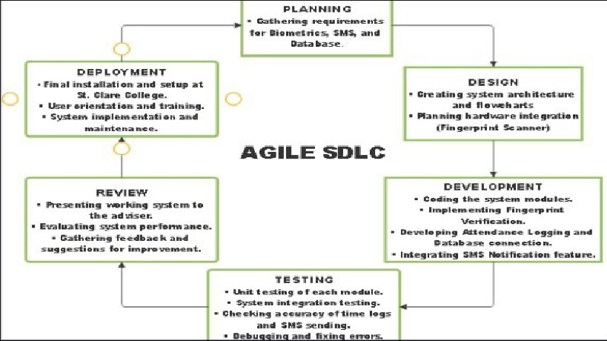
Process Flowchart

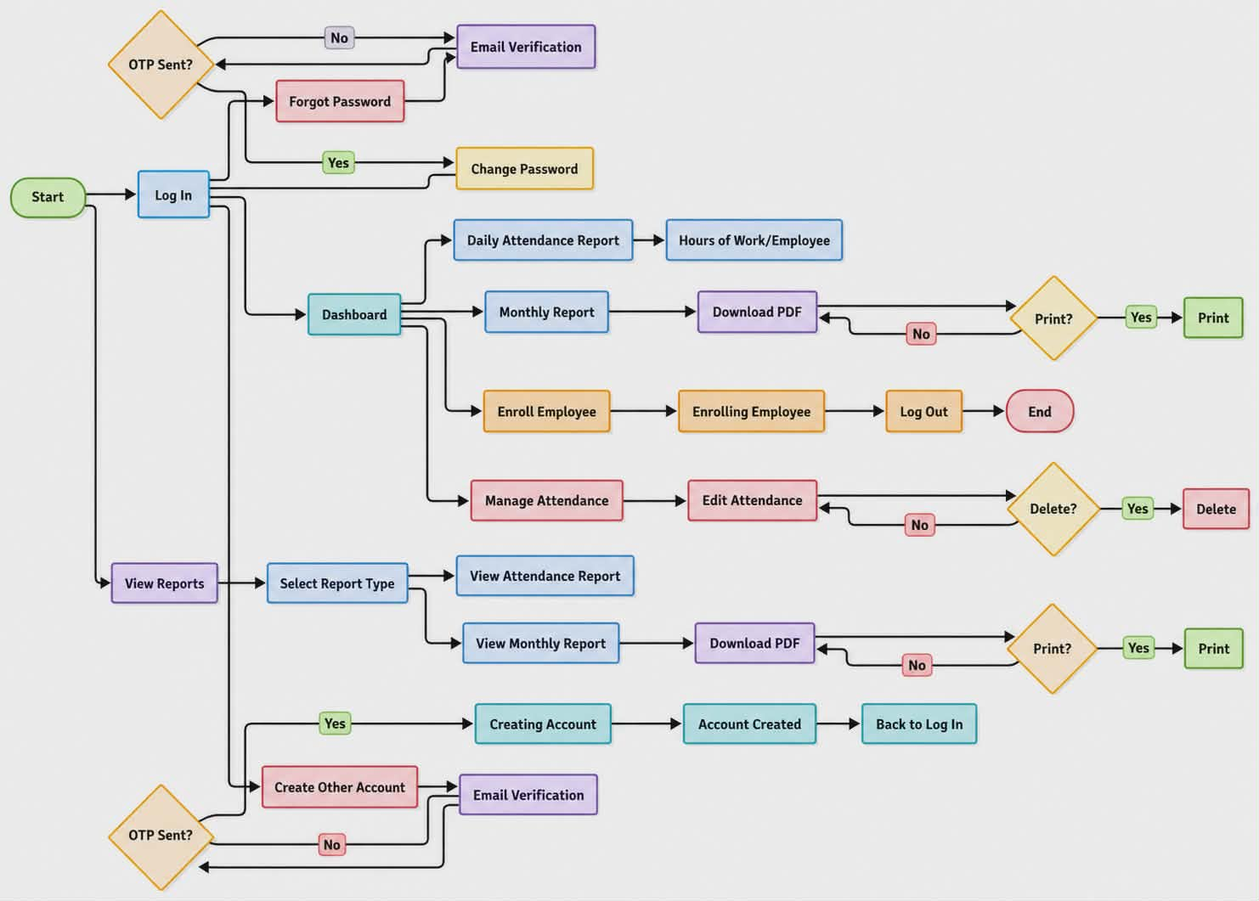
System Archetecture diagram

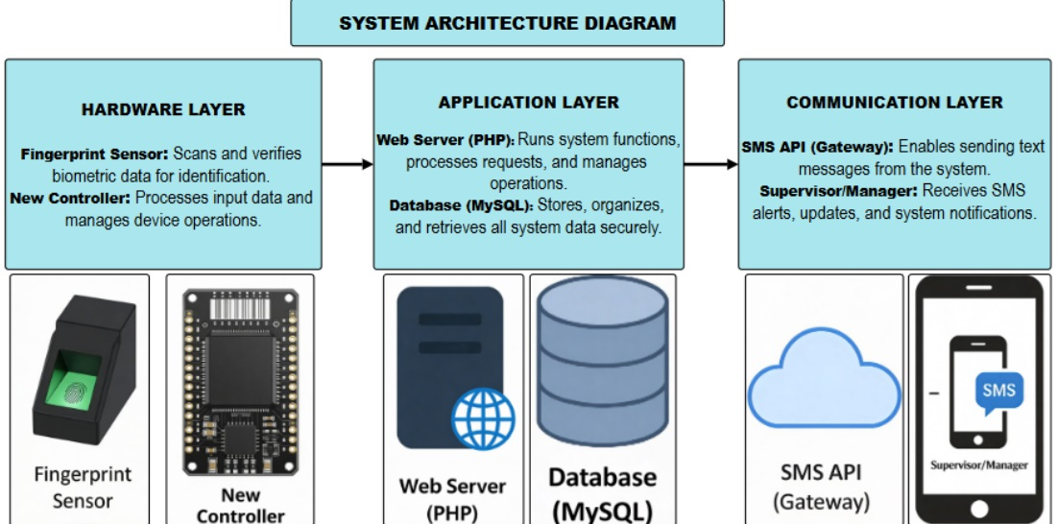
Diagram (System Overview)

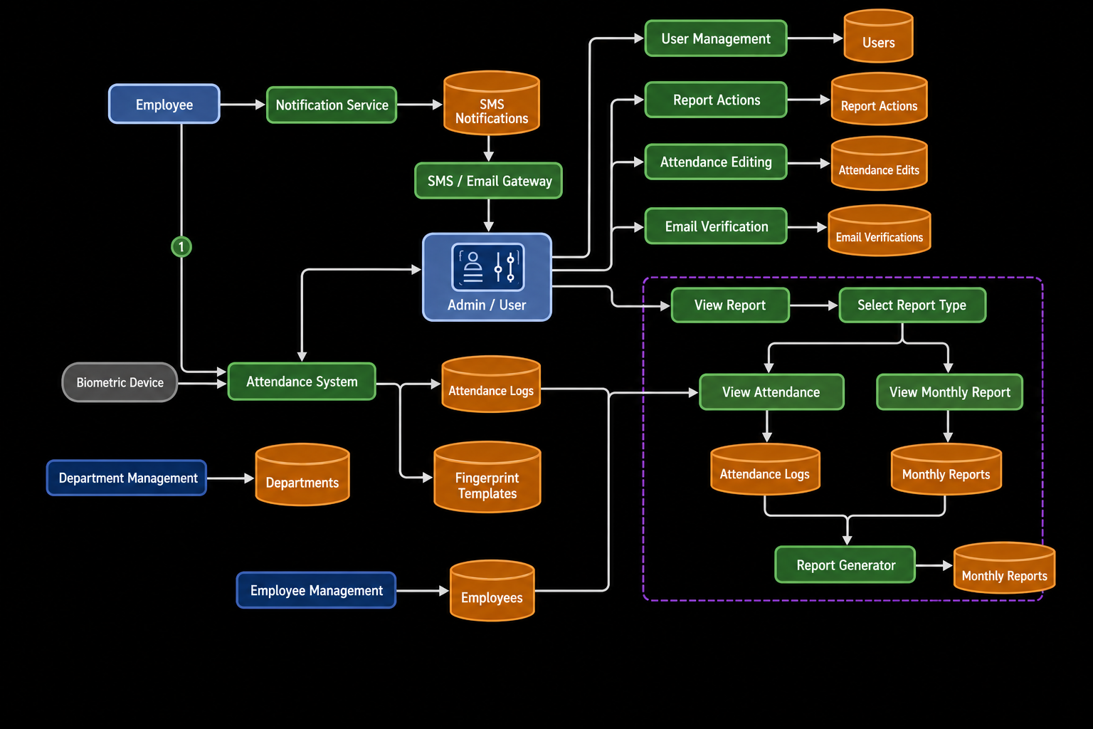
Data Flow Diagram (DFD)

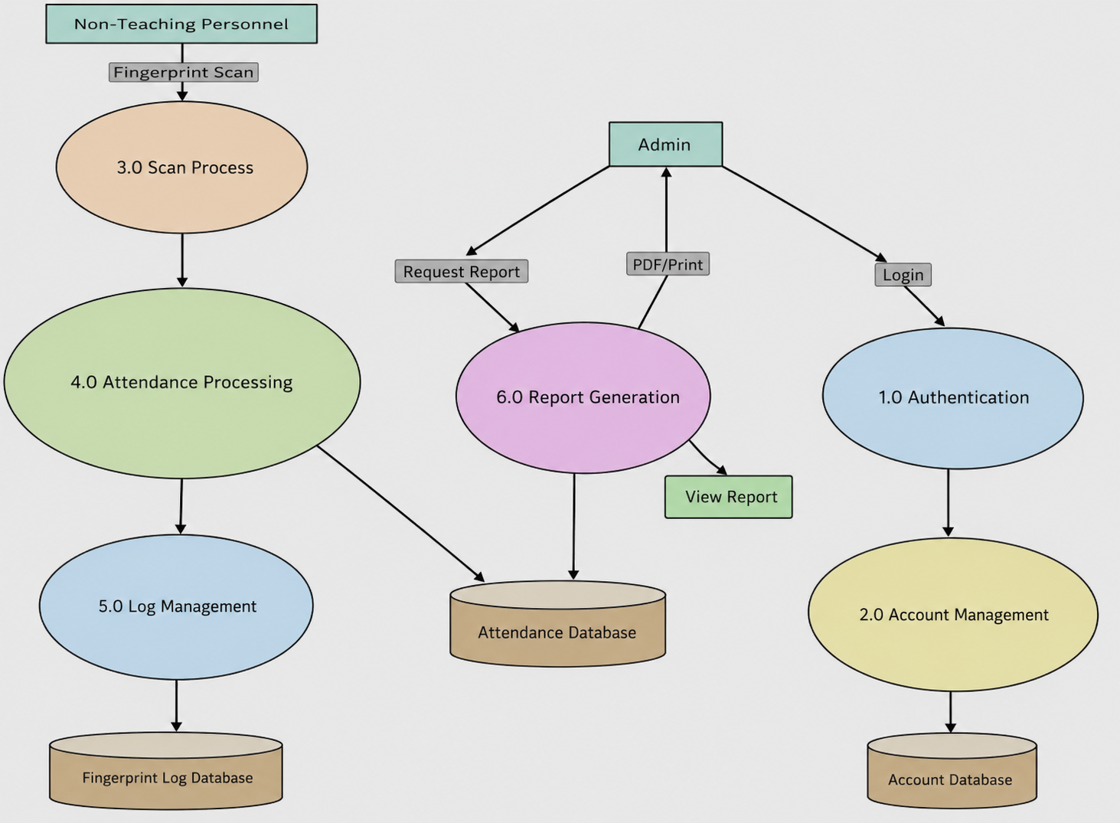
Expanded Diagram (Detailed DFD)

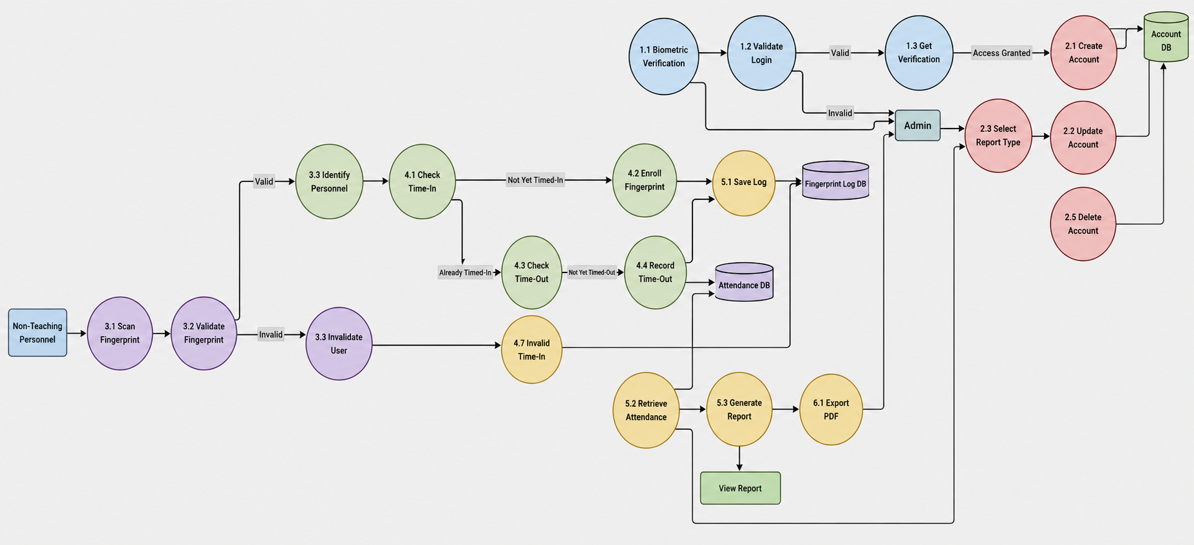
Entity Relationship Diagram (ERD)

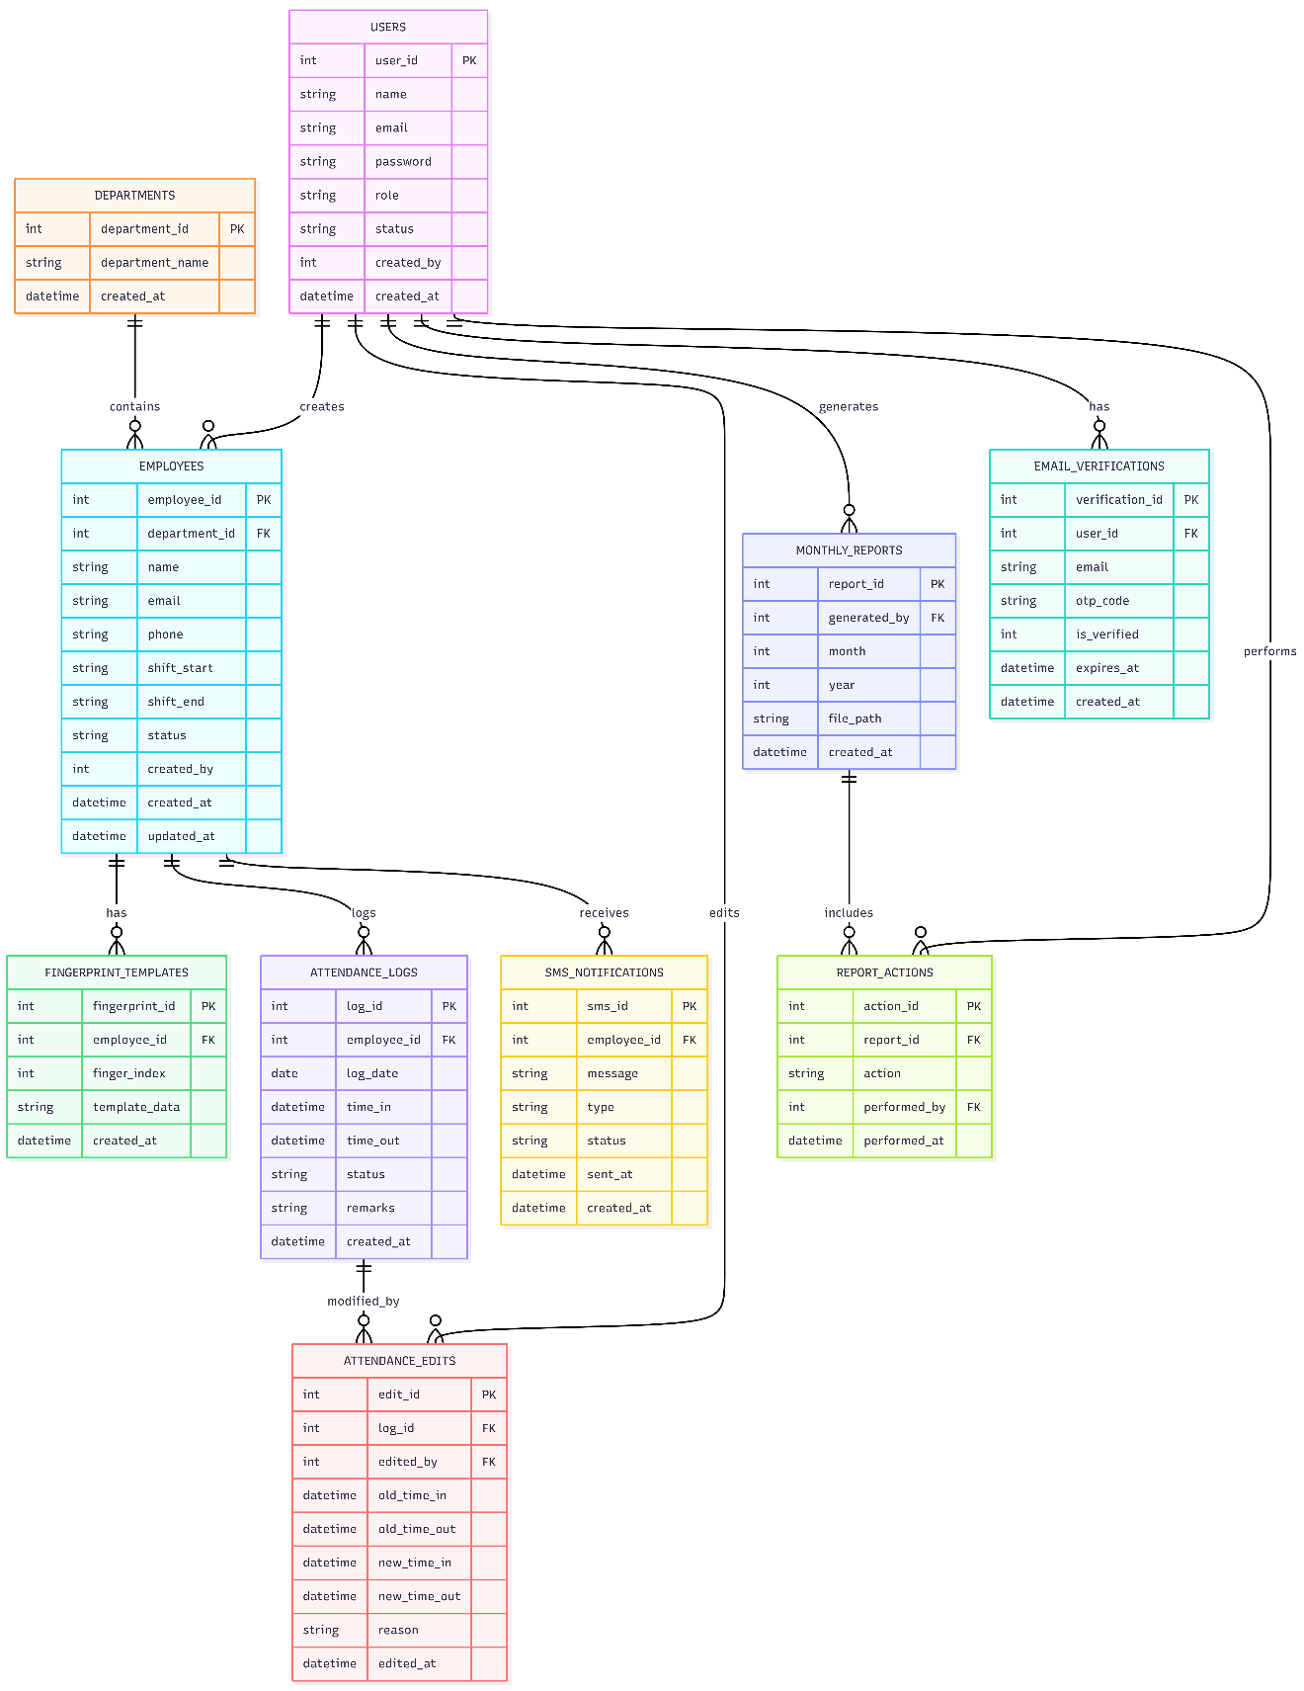

CHAPTER 4

PRESENTATION, ANALYSIS, AND INTERPRETATION OF DATA
This chapter presents the data gathered from the respondents regarding the effectiveness, usability, accuracy, and reliability of the Automated Attendance and Tardiness Monitoring System with Biometric Verification and SMS Notification. The data were analyzed using frequency, percentage, and weighted mean.

Legend for Interpretation
Weighted Mean Range | Interpretation
4.21 – 5.00 | Strongly Agree
3.41 – 4.20 | Agree
2.61 – 3.40 | Neutral
1.81 – 2.60 | Disagree
1.00 – 1.80 | Strongly Disagree

The fingerprint biometric system is an effective tool for recording attendance of non-teaching personnel.
Response Category | Frequency | Percentage | Weighted Score
Strongly Agree (5) | 10 | 38.5% | 50
Agree (4) | 11 | 42.3% | 44
Neutral (3) | 5 | 19.2% | 15
Disagree (2) | 0 | 0% | 0
Strongly Disagree (1) | 0 | 0% | 0
Total | 26 | 100% | 109
Weighted Mean = 4.19 (Agree)
Interpretation:
The majority of respondents agreed that the biometric system is an effective tool for attendance recording. This indicates that the system is reliable and suitable for practical use in monitoring attendance.

The fingerprint attendance system is easy to use.
Response Category | Frequency | Percentage | Weighted Score
Strongly Agree (5) | 10 | 38.5% | 50
Agree (4) | 10 | 38.5% | 40
Neutral (3) | 2 | 7.7% | 6
Disagree (2) | 4 | 15.4% | 8
Strongly Disagree (1) | 0 | 0% | 0
Total | 26 | 100% | 104
Weighted Mean = 4.00 (Agree)
Interpretation:
Most respondents found the system easy to use, indicating good usability. However, a small percentage disagreed, suggesting minor usability concerns that may require improvement.

The fingerprint verification process accurately records employee time-in and time-out.
Response Category | Frequency | Percentage | Weighted Score
Strongly Agree (5) | 9 | 34.6% | 45
Agree (4) | 8 | 30.8% | 32
Neutral (3) | 7 | 26.9% | 21
Disagree (2) | 2 | 7.7% | 4
Strongly Disagree (1) | 0 | 0% | 0
Total | 26 | 100% | 102
Weighted Mean = 3.92 (Agree)
Interpretation:
The results show that the system is generally accurate in recording attendance. However, the presence of neutral responses indicates that some users may still be uncertain about its consistency.

The fingerprint attendance system promotes accurate and reliable attendance recording.
Response Category | Frequency | Percentage | Weighted Score
Strongly Agree (5) | 10 | 38.5% | 50
Agree (4) | 11 | 42.3% | 44
Neutral (3) | 4 | 15.4% | 12
Disagree (2) | 1 | 3.8% | 2
Strongly Disagree (1) | 0 | 0% | 0
Total | 26 | 100% | 108
Weighted Mean = 4.15 (Agree)
Interpretation:
A large majority agreed that the system ensures reliable attendance recording. This confirms that biometric verification reduces errors and improves data accuracy.

Overall, the fingerprint biometric system enhances attendance monitoring and management.
Response Category | Frequency | Percentage | Weighted Score
Strongly Agree (5) | 12 | 48% | 60
Agree (4) | 7 | 28% | 28
Neutral (3) | 5 | 20% | 15
Disagree (2) | 1 | 4% | 2
Strongly Disagree (1) | 0 | 0% | 0
Total | 25 | 100% | 105
Weighted Mean = 4.20 (Agree)
Interpretation:
The results indicate that the system significantly enhances attendance monitoring and management, with most respondents expressing positive feedback.

Overall Analysis
The computed weighted means for all indicators fall under the “Agree” category, indicating that respondents generally have a positive evaluation of the system. The system is considered effective, accurate, reliable, and user-friendly. These findings support the objectives of the study in improving attendance monitoring through biometric technology.

CHAPTER 5

SUMMARY, CONCLUSIONS, AND RECOMMENDATIONS

Summary
This study aimed to develop an Automated Attendance and Tardiness Monitoring System with Biometric Verification and SMS Notification for non-teaching personnel at St. Clare College of Caloocan.
Using a quantitative research approach, data were collected through survey questionnaires and analyzed using frequency, percentage, and weighted mean.
The findings revealed that respondents generally agree that the system is:
- Easy to use
- Accurate in recording attendance
- Reliable in preventing errors
- Effective in improving attendance monitoring

Conclusions
Based on the findings of the study, the following conclusions were drawn:
- The biometric attendance system is effective in recording attendance.
- The system is user-friendly and easy to operate.
- It provides accurate and reliable time-in and time-out records.
- The system helps reduce human error and fraudulent practices.
- It significantly enhances attendance monitoring and management.
- The system is acceptable and beneficial for non-teaching personnel.

Recommendations
Based on the conclusions, the following are recommended:
- System Improvement
Enhance fingerprint scanning speed and reduce recognition errors.
- User Training
Conduct training sessions for users to improve familiarity and confidence.
- System Integration
Integrate the system with payroll and HR systems for better efficiency.
- SMS Enhancement
Improve SMS notification reliability for real-time communication.
- Technical Maintenance
Perform regular system maintenance to ensure continuous performance.
- Future Development
Future researchers may consider:
  - Facial recognition technology
  - Mobile-based attendance systems
  - Larger sample size for broader analysis

APPENDIX

Appendix A: Survey Questionnaire
Instructions: Please answer the following questions honestly. Your responses will be kept confidential and used only for research purposes.
Part I: System Evaluation
Rate the following statements using the scale:
5 – Strongly Agree
4 – Agree
3 – Neutral
2 – Disagree
1 – Strongly Disagree
- The fingerprint biometric system is an effective tool for recording attendance.
- The system is easy to use.
- The system accurately records time-in and time-out.
- The system improves attendance monitoring.
- The SMS notification feature is useful for real-time updates.

Appendix B: Interview Guide
- What is your experience using the biometric attendance system?
- What challenges did you encounter while using the system?
- How does the system compare to the previous manual method?
- What improvements can you suggest for the system?

Appendix C: System Screenshots (Insert actual images if needed)
- Login Interface
- Fingerprint Scanning Interface
- Attendance Dashboard
- SMS Notification Logs
- Reports Generation Page

Appendix D: Sample SMS Notification
- “You have successfully logged in at 8:01 AM.”
- “You are marked late today.”
- “You have logged out at 5:05 PM.”

Appendix E: Database Structure (Simplified)
Table: Employees
- Employee_ID
- Name
- Position
Table: Attendance
- Attendance_ID
- Employee_ID
- Time_In
- Time_Out
- Status

BIBLICAL FOUNDATION

This study is guided by biblical principles that emphasize honesty, responsibility, and diligence in work.
Colossians 3:23
"Whatever you do, work at it with all your heart, as working for the Lord, not for human masters."
This verse highlights the importance of dedication and sincerity in performing one’s duties. The proposed system promotes accountability and encourages employees to be responsible in their work attendance.
Proverbs 12:22
"The Lord detests lying lips, but he delights in people who are trustworthy."
The biometric system prevents dishonest practices such as proxy attendance, aligning with the value of truthfulness and integrity.
Ecclesiastes 9:10
"Whatever your hand finds to do, do it with all your might."
This supports the goal of improving efficiency and productivity through the use of modern technology in attendance monitoring.
1 Corinthians 14:40
"But everything should be done in a fitting and orderly way."
The system ensures organized and systematic recording of attendance, reflecting order and discipline in the workplace.

