Indigenous Entrepreneurship, Livelihoods and Community Economies: Reimagining Sustainable Development Through Indigenous Knowledge Systems in Africa and Zimbabwe

Abstract
Indigenous entrepreneurship has emerged as a critical pathway for advancing sustainable livelihoods, strengthening community economies, and promoting inclusive development in Africa. Unlike conventional entrepreneurship, which prioritizes profit maximization, indigenous entrepreneurship is embedded within Indigenous Knowledge Systems (IKS), cultural values, communal well-being, and environmental stewardship. This paper examined the interrelationship between indigenous entrepreneurship, livelihoods, and community economies, with particular focus on Africa and Zimbabwe. Drawing on contemporary literature (2024–2026), the study adopts a qualitative desktop research approach and synthesizes evidence from academic and policy sources. The paper argued that indigenous entrepreneurship contributes to livelihood resilience, cultural preservation, environmental sustainability, and socio-economic transformation. It further proposes the Indigenous Entrepreneurship–Livelihood–Community Economy Framework (IELCEF) as an integrated model for understanding indigenous economic systems. The study concluded that strengthening indigenous entrepreneurship through education, policy reform, digital inclusion, and knowledge protection is essential for achieving sustainable development in Africa.
Keywords: Indigenous entrepreneurship, livelihoods, community economies, Indigenous Knowledge Systems, sustainability, Zimbabwe, Education 5.0

1. Introduction
Sustainable development continues to be a central global concern, particularly in developing regions where poverty, unemployment, environmental degradation, and inequality remain persistent. Conventional development models have often failed to produce inclusive and contextually relevant solutions, particularly in African societies where indigenous knowledge systems remain underutilized in formal economic structures (United Nations, 2024).
In response, indigenous entrepreneurship has gained increasing scholarly attention as an alternative development pathway. Indigenous entrepreneurship refers to entrepreneurial activities rooted in Indigenous Knowledge Systems, cultural values, and community-based economic structures. Unlike mainstream entrepreneurship, it emphasizes collective well-being, sustainability, and cultural continuity rather than individual profit maximization (Onwuegbuzie et al., 2025).
Across Africa, indigenous entrepreneurship plays a critical role in addressing livelihood challenges, particularly in rural communities where formal employment opportunities are limited. Indigenous enterprises operate in agriculture, traditional medicine, cultural tourism, crafts, and ecological services. These activities are not only economically significant but also culturally embedded and environmentally sustainable (Kom & Nethengwe, 2024).
In Zimbabwe, indigenous entrepreneurship has gained renewed importance through the introduction of Heritage-Based Education 5.0, which seeks to align education with innovation, industrialisation, and indigenous knowledge systems (Garwe, 2025). This policy shift recognizes universities as engines of indigenous innovation and entrepreneurship development.
Despite growing interest, there remains limited integrated analysis of how indigenous entrepreneurship interacts with livelihoods and community economies. This paper addresses this gap by examining indigenous entrepreneurship as a multidimensional development phenomenon that integrates economic, social, cultural, and environmental dimensions.

2. Literature Review
2.1 Indigenous Entrepreneurship
Indigenous entrepreneurship is increasingly understood as a culturally embedded form of economic activity that reflects indigenous values, traditions, and knowledge systems. It differs from conventional entrepreneurship in that it prioritizes community well-being, cultural preservation, and sustainability alongside economic outcomes.
Indigenous entrepreneurs often operate within kinship networks, community institutions, and collective ownership structures. These arrangements influence decision-making processes, resource allocation, and business objectives (Onwuegbuzie et al., 2025).
2.2 Indigenous Knowledge Systems (IKS)
Indigenous Knowledge Systems represent cumulative knowledge developed through long-term interaction with the environment. This includes agricultural practices, ecological knowledge, medicinal systems, and cultural traditions.
Recent studies highlight the importance of IKS in addressing global challenges such as climate change, biodiversity loss, and food insecurity (UNESCO, 2025). IKS provides the foundation for indigenous entrepreneurship by offering locally grounded innovation systems.
2.3 Sustainable Livelihoods
The Sustainable Livelihoods Framework emphasizes five key asset categories: human, social, natural, physical, and financial capital. Indigenous entrepreneurship contributes to each of these assets by generating income, strengthening social networks, and promoting sustainable resource use (UNDP, 2025).
2.4 Community Economies
Community economies emphasize collective ownership, reciprocity, and social well-being rather than profit maximization. Indigenous entrepreneurship aligns strongly with this model as it prioritizes community benefit, shared prosperity, and social cohesion (Gibson-Graham, 2024).
2.5 African Indigenous Entrepreneurship
In Africa, indigenous entrepreneurship has historically been central to survival and economic organization. Despite colonial disruption, indigenous enterprises continue to thrive in agriculture, crafts, and informal markets. These systems remain critical for rural livelihoods and economic resilience (Moyo & Chikoko, 2025).
2.6 Heritage-Based Education 5.0 in Zimbabwe
Heritage-Based Education 5.0 represents a transformative educational philosophy that integrates teaching, research, innovation, community service, and industrialisation. It promotes the commercialization of indigenous knowledge and positions universities as drivers of indigenous entrepreneurship (Garwe, 2025).

3. Theoretical Framework
This study is grounded in three interrelated theories:
3.1 Sustainable Livelihoods Framework
This framework explains how indigenous entrepreneurship strengthens livelihood assets and reduces vulnerability.
3.2 Indigenous Knowledge Systems Theory
IKS Theory explains how indigenous knowledge functions as a source of innovation and entrepreneurship.
3.3 Community Economy Theory
This theory emphasizes collective well-being, social justice, and shared prosperity as core economic principles.
Together, these theories form the Indigenous Entrepreneurship–Livelihood–Community Economy Framework (IELCEF), which positions indigenous knowledge as the foundation of sustainable economic transformation.
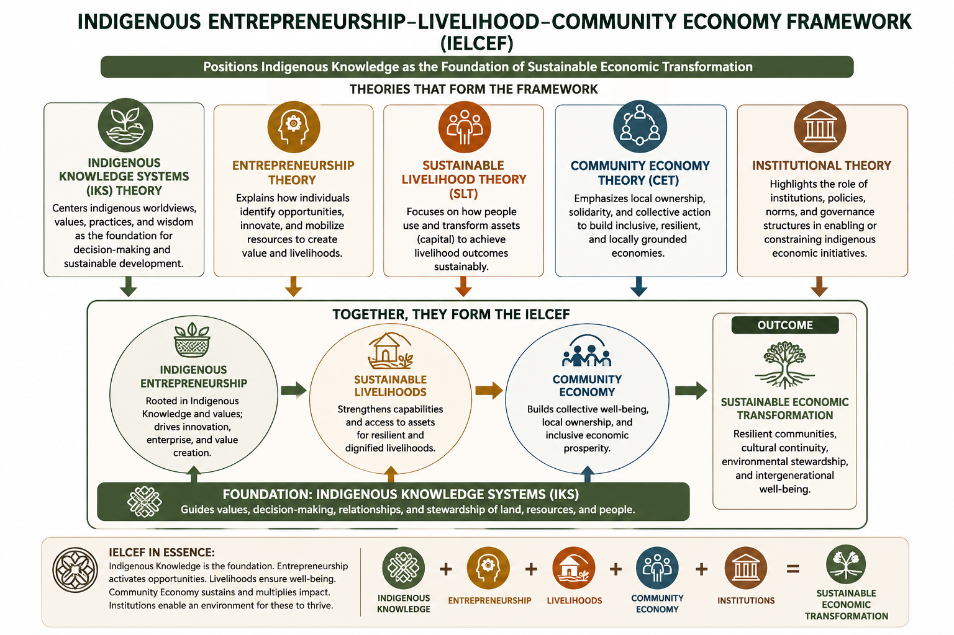

Conceptual Framework: IELCEF
Indigenous Entrepreneurship–Livelihood–Community Economy Framework (IELCEF)
Figure 1: Indigenous Entrepreneurship–Livelihood–Community Economy Framework (IELCEF)

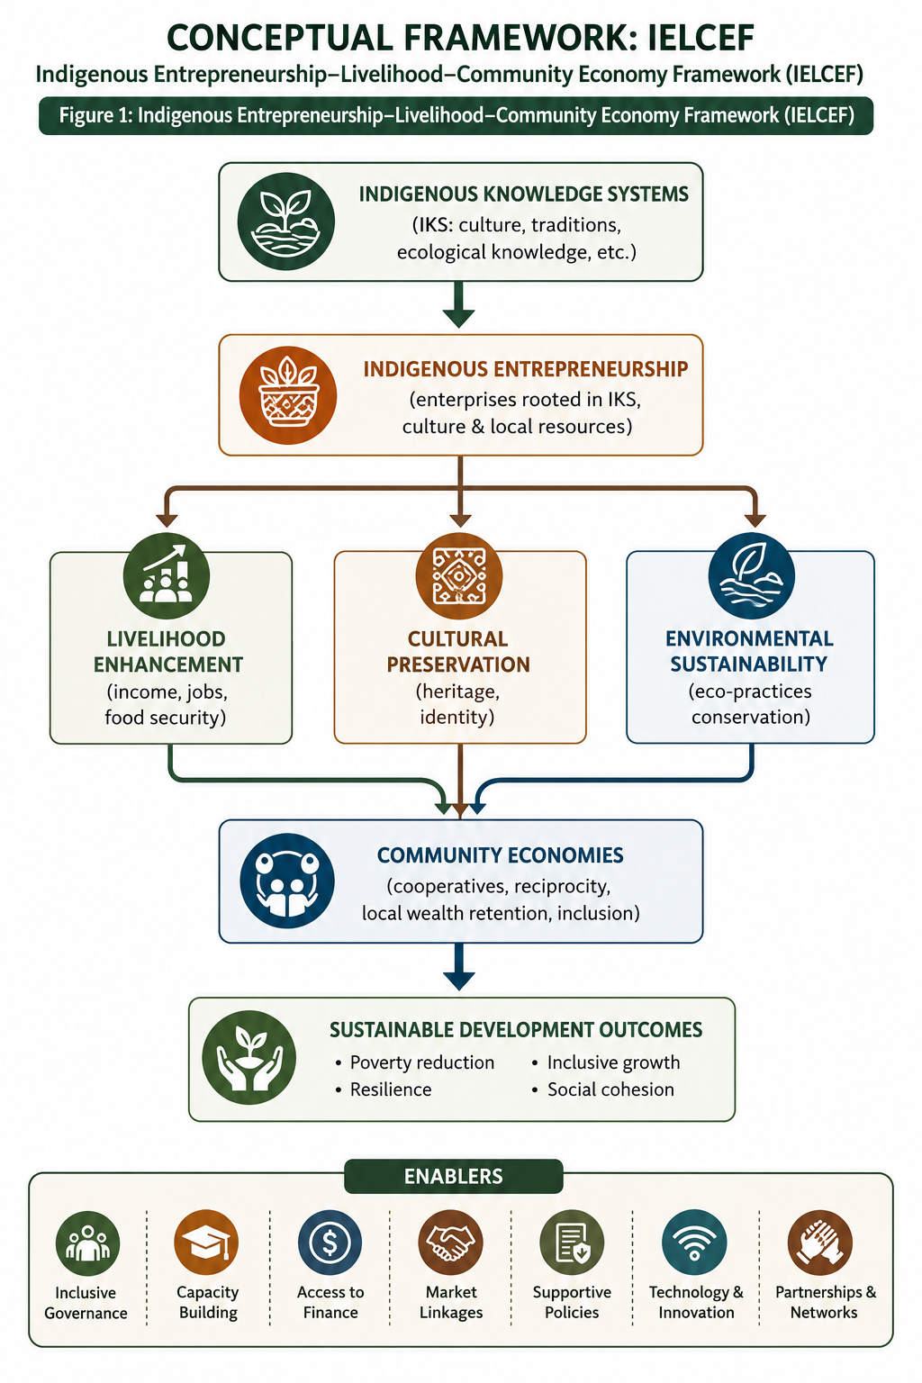
ENABLERS:
✔ Heritage-Based Education 5.0
✔ Digital Transformation
✔ Policy & Legal Frameworks
✔ Financial Inclusion
✔ University–Community Partnerships

4. Methodology
This study adopts a qualitative desktop research design using a narrative literature review approach. Data were collected from peer-reviewed journals, policy documents, institutional reports, and academic publications published between 2024 and 2026.
Thematic analysis was used to identify patterns related to indigenous entrepreneurship, livelihoods, and community economies. Themes were developed through coding and synthesis of literature across African and global contexts.
5. Findings and Discussion
5.1 Indigenous Entrepreneurship and Livelihood Enhancement
The findings indicate that indigenous entrepreneurship plays a central role in strengthening sustainable livelihoods across African communities. Rather than functioning solely as income-generating activities, indigenous enterprises operate as integrated livelihood systems that combine economic, social, and cultural functions.
Indigenous entrepreneurship contributes to livelihood enhancement through employment creation, income diversification, and improved household resilience. In rural African contexts where formal employment opportunities remain limited, indigenous enterprises provide essential alternative livelihood pathways (Kom & Nethengwe, 2024).
Common livelihood-supporting indigenous enterprises include agro-based production, traditional food systems, handicrafts, herbal medicine, and community-based tourism. These enterprises rely heavily on local resources and Indigenous Knowledge Systems, making them both accessible and adaptable to local conditions.
A key finding is that indigenous entrepreneurship enhances livelihood resilience by diversifying income sources. Households engaged in multiple indigenous economic activities are better able to withstand shocks such as droughts, inflation, and unemployment.
Furthermore, indigenous entrepreneurship strengthens food security through the promotion of indigenous crops such as millet, sorghum, and legumes, which are more climate-resilient and nutritionally rich compared to imported staples.

5.2 Indigenous Entrepreneurship and Community Resilience
Indigenous entrepreneurship significantly contributes to community resilience by strengthening social cohesion, resource sharing, and collective problem-solving mechanisms.
Community resilience refers to the ability of communities to adapt, recover, and transform in response to external shocks and long-term challenges. Indigenous enterprises are deeply embedded in kinship networks and traditional institutions, which enhances collective action and mutual support systems.
During economic crises or environmental shocks, indigenous entrepreneurship often provides informal safety nets that support household survival. These include food-sharing systems, cooperative production, and community-based savings groups.
Unlike externally driven economic models, indigenous entrepreneurship strengthens internal economic circulation, ensuring that resources remain within communities rather than being extracted externally.
This contributes to what can be described as “localized economic resilience,” where communities rely on internal capacities rather than external dependency.

5.3 Indigenous Entrepreneurship and Cultural Preservation
One of the most significant contributions of indigenous entrepreneurship is its role in cultural preservation.
Indigenous enterprises often derive their value from cultural heritage, including language, traditions, rituals, craftsmanship, and indigenous technologies. As such, entrepreneurship becomes a mechanism for safeguarding and revitalizing cultural identity.
Traditional crafts, music, storytelling, and indigenous culinary practices are increasingly being commercialized in ways that preserve cultural heritage while generating income.
Cultural tourism is another important area where indigenous entrepreneurship contributes to cultural preservation. Communities are increasingly developing tourism products that showcase indigenous lifestyles, historical narratives, and traditional ecological practices.
This process ensures intergenerational transmission of cultural knowledge, particularly among youth who may otherwise become disconnected from traditional practices.

5.4 Indigenous Entrepreneurship and Environmental Sustainability
The findings reveal a strong relationship between indigenous entrepreneurship and environmental sustainability.
Indigenous Knowledge Systems are inherently ecological, emphasizing harmony between humans and nature. This worldview informs sustainable production practices that minimize environmental degradation.
Indigenous enterprises often utilize organic farming methods, biodiversity conservation techniques, and sustainable resource management systems.
Eco-tourism, agroecology, and herbal medicine industries demonstrate how indigenous entrepreneurship can align economic activity with environmental conservation.
Indigenous crops and farming systems are particularly important in the context of climate change adaptation. These systems are often more resilient to drought and climate variability than industrial agricultural systems.
Thus, indigenous entrepreneurship represents a form of “green economy from below,” driven by community knowledge and ecological ethics.

5.5 Indigenous Entrepreneurship, Gender, and Women’s Empowerment
Women play a central role in indigenous entrepreneurship across Africa. They are often custodians of indigenous knowledge systems, particularly in agriculture, food processing, and traditional medicine.
The findings show that indigenous entrepreneurship provides women with critical economic opportunities, especially in rural areas. These enterprises contribute to household income, food security, and community development.
However, structural challenges remain, including limited access to finance, land ownership restrictions, and cultural barriers.
Despite these constraints, women-led indigenous enterprises demonstrate high levels of resilience and adaptability. They also play an important role in transmitting cultural knowledge across generations.
Indigenous entrepreneurship therefore acts as both an economic and social empowerment mechanism for women.

5.6 Youth Participation and Digital Indigenous Entrepreneurship
Youth engagement in indigenous entrepreneurship is growing, particularly through digital platforms and innovation ecosystems.
Young entrepreneurs are increasingly combining indigenous knowledge with digital technologies to create innovative enterprises in areas such as cultural media, online craft markets, digital tourism, and e-commerce of indigenous products.
This digital transformation is reshaping indigenous entrepreneurship by expanding market access and increasing global visibility of indigenous products.
However, digital inequality remains a challenge, particularly in rural areas where access to technology and internet connectivity is limited.
Nonetheless, the integration of digital tools with indigenous knowledge represents a significant opportunity for future economic transformation.

5.7 Heritage-Based Education 5.0 and Indigenous Entrepreneurship
Heritage-Based Education 5.0 in Zimbabwe provides a strong institutional framework for promoting indigenous entrepreneurship.
This policy framework integrates teaching, research, innovation, community service, and industrialisation. It explicitly emphasizes the transformation of indigenous knowledge into economic value.
Universities are encouraged to develop innovation hubs, incubation centres, and research programmes focused on indigenous knowledge commercialization.
Key areas include:
- Indigenous food systems
- Traditional medicine industries
- Cultural tourism enterprises
- Indigenous technologies
- Creative industries
Education 5.0 therefore positions higher education institutions as catalysts for indigenous entrepreneurship development.
However, successful implementation requires adequate funding, institutional capacity building, and strong university-community linkages.

5.8 Synthesis of Findings
The findings confirm that indigenous entrepreneurship operates at the intersection of livelihoods, culture, environment, and community development.
It contributes simultaneously to:
- Economic empowerment
- Cultural preservation
- Environmental sustainability
- Community resilience
- Social cohesion
This multidimensional nature distinguishes indigenous entrepreneurship from conventional entrepreneurial models.

6. Conclusion
Indigenous entrepreneurship is a critical development system in Zimbabwe. When supported through Education 5.0, it enhances livelihoods, strengthens community economies, and promotes sustainable development.

African Union. (2025). Agenda 2063 implementation report.
African Union. (2025). Agenda 2063: Implementation report. African Union Commission.
Akinwale, Y. O. (2025). Indigenous innovation systems and entrepreneurship in Africa. African Journal of Science, Technology, Innovation and Development, 17(1), 21–37.
Bennett, N. J., & Lam, W. (2024). Indigenous entrepreneurship and sustainability transitions. Conservation Letters, 17(3), e12945. https://doi.org/10.1111/conl.12945
Chigora, F., & Chazovachii, B. (2025). Rural indigenous entrepreneurship and development in Zimbabwe. Africa Insight, 55(1), 78–95.
Dube, T., & Moyo, P. (2024). Community economies and indigenous enterprise systems in Southern Africa. Community Development Journal, 59(4), 512–529. https://doi.org/10.1093/cdj/bsad012
FAO. (2025). Indigenous food systems and climate resilience.
FAO. (2025). Indigenous food systems and climate resilience. Food and Agriculture Organization.
Garwe, E. C. (2025). Heritage-based Education 5.0 in Zimbabwe. Discover Education.
Garwe, E. C. (2025). Heritage-based Education 5.0: Zimbabwe’s decolonial innovation model. Discover Education. https://doi.org/10.1007/s44217-025-00753-7
Gibson-Graham, J. K. (2024). Community economies and alternative development pathways. Progress in Human Geography, 48(1), 35–52. https://doi.org/10.1177/03091325231234567
Gibson-Graham, J. K. (2024). Community economies and alternatives. Progress in Human Geography.
Global Development Sources
Government of Zimbabwe. (2020). Education 5.0 doctrine. Ministry of Higher and Tertiary Education.
Government of Zimbabwe. (2024). Heritage-based curriculum framework. Government Printer.
Government of Zimbabwe. (2025). Innovation, industrialisation and heritage-based education policy. Government Printer.
Hlatywayo, C., & Muchengetwa, S. (2025). Indigenous food systems and resilience in Zimbabwe. Journal of Rural Studies, 104, 115–128.
IFAD. (2024). Rural transformation and indigenous enterprises. International Fund for Agricultural Development.
ILO. (2024). Informal economy and indigenous livelihoods in Africa. International Labour Organization.
Kom, Z., & Nethengwe, N. S. (2024). Indigenous knowledge systems and sustainability. Sustainability.
Kom, Z., & Nethengwe, N. S. (2024). Indigenous knowledge systems and SDG localization in Africa. Sustainability, 16(20), 9137. https://doi.org/10.3390/su16209137
Mhlanga, D. (2024). AI and indigenous entrepreneurship in Africa. Technological Sustainability, 3(2), 155–171.
Moyo, N., & Chikoko, V. (2025). Decolonising entrepreneurship education in Africa. Higher Education, Skills and Work-Based Learning, 15(1), 44–61.
Ncube, E., & Nyoni, T. (2024). Women indigenous entrepreneurs in Zimbabwe. Gender and Development Review, 11(2), 90–107.
Ndlovu-Gatsheni, S. J. (2024). Decolonial futures and indigenous knowledge. African Studies Review, 67(1), 22–40.
Ojong, N. (2024). Indigenous entrepreneurship and poverty reduction. Journal of Developmental Entrepreneurship, 29(2), 1–18.
Onwuegbuzie, H. N., et al. (2025). Indigenous entrepreneurship in Africa. FIIB Business Review.
Onwuegbuzie, H. N., Mafimisebi, O. P., & Orighoyegha, E. (2025). Indigenous entrepreneurship and sustainable development in Africa. FIIB Business Review, 14(5). https://doi.org/10.1177/23197145241288403
Pasipanodya, T., & Muchengeti, T. (2025). Community tourism and indigenous entrepreneurship in Zimbabwe. Tourism Planning & Development, 22(1), 101–119.
Sithole, K., & Maphosa, F. (2024). Traditional medicine commercialization in Southern Africa. Health Policy and Development, 19(3), 210–226.
Tarugarira, G. (2025). Heritage-based education and emancipatory pedagogy in Zimbabwe. The Dyke, 18(2), 367–387.
Taruvinga, A., & Chinomona, R. (2025). Digital indigenous entrepreneurship in Africa. International Journal of Entrepreneurial Behavior & Research, 31(4), 678–695.
UNCTAD. (2024). Entrepreneurship and development in the Global South. United Nations Conference on Trade and Development.
UNDP. (2025). Community livelihoods and inclusive development in Africa. United Nations Development Programme.
UNDP. (2025). Community livelihoods in Africa.
UNEP. (2025). Nature-based enterprises and sustainability. United Nations Environment Programme.
UNESCO. (2025). Indigenous knowledge systems and innovation.
UNESCO. (2025). Indigenous knowledge systems and sustainable innovation. UNESCO.
United Nations. (2024). Sustainable development goals report 2024. United Nations.
World Bank. (2025). Indigenous peoples and development.
World Bank. (2025). Indigenous peoples and local economic development. World Bank.
📖 Zimbabwe Policy & Education 5.0 Sources

