Factors Affecting Mold Growth in Homemade Bread Using Factorial Design
Chan Boon Hui¹, Norhaidah Mohd Asrah²
^{1, 2}Department of Mathematics and Statistics, Universiti Tun Hussein Onn Malaysia Kampus Cawangan Pagoh, Johor, Malaysia.

ABSTRACT
Homemade bread is considered healthier than commercial bread due to absence of chemical preservatives and additives. However, its high moisture content leads to mold growth and short shelf life. This study aimed to determine how combinations of preservative types, moisture conditions and storage conditions influence mold growth in homemade bread using a 3³ factorial design. Also, to evaluate the main and interaction effects of these factors through Analysis of Variance (ANOVA). The experiment involved three factors at three levels each, producing 27 treatment combinations, replicated to yield 81 samples. The response variable was the number of days until mold fully cover the bread surface. ANOVA was conducted to identify significant factors affecting mold growth and model adequacy checks were performed to validate reliability. Results indicated that all three factors significantly affected the mold growth. Storage condition had the strongest effect, followed by preservative types and moisture condition. bread treated with a chemical preservative, without water sprinkling and stored in open air exhibited the longest mold-free duration up to 27 days. While bread without preservative, sprinkled once every five days and stored fully covered showed the shortest shelf life about 9 days. Interaction effect revealed that there have significant effect for combinations of preservative types with storage conditions and moisture conditions with storage conditions. Overall, the study demonstrates that shelf life of bread can improved through combinations of preservative types, moisture conditions and storage conditions. For further study, it should include sensory evaluation and different preservative types to improve shelf-life prediction of homemade bread.
Keywords: Homemade bread, Molded, ANOVA, Factorial design, Experiment
INTRODUCTION
Homemade bread is a natural and healthy option for humans. Not like many marketable breads contain preservatives such as calcium propionate or artificial additives to extend its shelf life. These ingredients might be harmful to humans (Simpkins 2022). However, homemade bread has limited shelf life due to moisture loss and the spoilage of bread. These issues happened mainly because of the contamination from bacteria and molds, which degrade both quality and safety of bread. The high nutritional and moisture content from bread creates an ideal environment for the growth of mold spores, which leads to spoilage and potential harmful effects (Food Safety Information 2013). Although some people try to save the molded bread by cutting off the visible mold. However, experts advise against this because mold already growth deep inside the loaf and it is unsafe to eat anymore (McCulloch 2023).
Mold growth is a major issue associated with homemade bread, as it is decreasing the shelf life of bread and causing possible health risks to humans. Homemade bread is mostly free from additives and does not resist spoilage. Due to the high moisture content and rich in nutrient composition of bread, it creates perfect environment for mold growth, especially under inappropriate storage conditions (Food Safety Information 2013), (McCulloch 2023). Although preservatives are commonly used to extend shelf life, the effectiveness is still based on factors such as moisture conditions and storage conditions (Teng 2023).
Throughout the literature review, it highlights the study of mold growth on bread with the three key factors of types of preservatives, moisture conditions and storage conditions, where (Moro et al. 2022) and (Lohano et al. 2010) stated the effectiveness of calcium propionate in preventing the growth of fungi. Next, for moisture conditions, (Ma et al. 2020) explains that high moisture not only speeds up mold growth and accelerates oxidation, which spoils the quality of the bread and is harmful for humans. For storage conditions, based on (Torrijos et al. 2021) and (Nionelli et al. 2020), even with antifungal ingredients, poor storage conditions can reduce their effectiveness to extend the mold growth. Based on past studies, mold growth in bread is influenced by environmental fungi and poor storage practices, which made the situations become worst. While some studies apply factorial designs to determine the interaction effects of different ingredients and enzymes on bread (Santos et al. 2020).
This study aims to demonstrate the effect of combination factors to minimize the mold growth on the shelf life of homemade bread using 3³ factorial designs. Moreover, it also aims to analyse the effects of different factors on mold growth on homemade bread by analysing the main effects and interaction effects through Analysis of Variance (ANOVA) in 3³ factorial designs.
From this study, it explores the impact of natural and chemical preservatives, moisture conditions and storage conditions on the shelf life of homemade bread. It supports better food hygiene and minimizes the risk of foodborne illness that is caused by mold contamination (Rahman et al. 2022). By preventing microbial spoilage, the study contributes to reducing economic losses for consumers and small-scale businesses, while addressing broader food security concerns. Moreover, to minimize food waste and promote food safety through environmentally friendly and scientifically validated preservation methods (Alpers et al. 2021). Since there are no study of studying the effect of the three factors together, therefore, this study can provide a clearer vision about the factors that affect the mold growth on homemade bread.
METHODOLOGY
Design of Experiment
This study follows the principles of the design of experiment (DOE). Randomization was applied to eliminate systematic bias and ensure the validity of the results. First, each bread slice is randomly assigned to one of the 27 treatment combinations. Second, the placement of bread slices into different storage and the order of daily observations is randomized. Randomization helped to distribute any uncontrolled influences, such as slight differences in room temperature, air movement or bread handling, across all treatments evenly. Randomization is fundamental to making observations independent and to averaging out the effects of external factors (Montgomery, 2017).
Replication is also used in this study. By preparing three independent samples for each treatment, the experiment provided a way to estimate experimental variability. Since replication strengthens the experimental results by enabling meaningful comparisons between treatments through statistical tests such as ANOVA (Montgomery, 2017).
Factorial Design
A factorial design was used to study the effects of multiple factors simultaneously and efficiently. Factorial experiments allow all possible combinations of the factors and their levels to be investigated.
A full 3³ factorial design is chosen in this study. The three factors that are going to use in this study are types of preservative, moisture conditions and storage conditions while each factor had three levels. The three types of preservative are natural preservative (vinegar), chemical preservative (Calcium Propionate) and no preservative. Then, the three moisture conditions are without sprinkle any water, sprinkle once after every 3 days and sprinkle once after every 5 days. Next, the three storage conditions are open air, partially open air and fully cover. The combination of these levels produced 27 unique treatments. Each treatment is applied to three independent samples, giving a total of 81 experimental units. This complete factorial design allows a detailed understanding of how each factor and combination of factors influence mold growth.
A general effect model for a full 3³ factorial design with three factors at three levels is written in terms of main effects and interaction effects. The response variable is the number of days until mold is fully growth on the bread slices. The effect model is shown in Eq. (1).
(1)

A The description of the variables and parameters of the general effect model for a full 3³ factorial design are presented in Table 1.
Table 1: Description of variables of the model
State variables | Description
𝜇 | overall mean
𝜏_{𝑖} | effect of the ith level of the row factor A (preservative types)
𝛽_{𝑗} | effect of the jth level of the row factor B (moisture conditions)
𝛾_{𝑘} | the effect of the kth level of the row factor C (storage conditions)
(𝜏𝛽)_{𝑖𝑗} | effect of the interaction between A_{i} and B_{j}
(𝜏𝛾)_{𝑖𝑘} | effect of the interaction between A_{i} and C_{k}
(𝛽𝛾)_{𝑗𝑘} | effect of the interaction between B_{j} and C_{k}
(𝜏𝛽𝛾)_{𝑖𝑗𝑘} | three factor interaction effects for the ABC interaction
𝜖_{𝑖𝑗𝑘𝑙} | random error component
Model Adequacy Checking
Model adequacy checking helps ensure that the assumptions are satisfied underlying the statistical analysis such as normal distribution with a mean of zero, constant variance and residuals are independent of each other followed by the homogeneity of variance (Montgomery, 2017).
The normal assumption is that the residuals must be normally distributed. This assumption is important as the results of statistical tests may be unreliable. For plot of residuals in time sequence, residuals should appear as randomly scattered points without any obvious pattern. While for plot of residuals versus fitted values, it is one of the important plots for checking the assumption of constant variance. The residuals point randomly scattered around zero, without obvious patterns and outliers indicate that it is a constant variance.
Analysis of Variance (ANOVA)
Analysis of Variance (ANOVA) is a statistical method used to determine whether differences among treatment means are statistically significant. It is because it separates the total variation in the response variable into parts that can be linked to each individual factor, interaction effect and random error. ANOVA provides a structure for testing different factors that will influence the outcome of an experiment (Montgomery, 2017).
A full 3³ factorial design that involves three factors are preservative types, moisture conditions and storage conditions. Each factor is tested at three levels. The factorial design can be analysing the main effects of each factor and the interaction effects between two and three factors. These interactions are important because the effect of one factor may depend on the levels of the others. Significance level of 0.05 is used. When p-value that is associated with F statistics are less than 0.05, it means there have statistically significant effect on mold growth in bread. A full ANOVA table was constructed based on general layout and formulas provided shown in Table 2.

Table 2: ANOVA table for a 3³ factorial design (Montgomery, 2017)
Sources of Variation | Sum of Squares | Degrees of Freedom | Mean Squares | Expected Mean Square | F₀
A | SS_{A} | a-1 | MS_{A}
B | SS_{B} | b-1 | MS_{B}
C | SS_{C} | c-1 | MS_{C}
AB | SS_{AB} | (a-1)(b-1) | MS_{AB}
AC | SS_{AC} | (a-1)(c-1) | MS_{AC}
BC | SS_{BC} | ( b-1)(c-1) | MS_{BC}
ABC | SS_{ABC} | (a-1) (b-1)(c-1) | MS_{ABC}
Error | SS_{E} | abc(n-1) | MS_{E}
Total | SS_{T} | abcn-1
After conducting ANOVA analysis, the existence of significant differences among the treatment means have become important to identify which specific treatment pairs differ from each other. ANOVA only can confirm there is at least one group that means different, but it does not show which group is different. Therefore, comparing each pair of treatment means enabling us to know exactly which groups are differ and differ how much. Tukey’s Honestly Significant Difference (HSD) test can compare all possible pairs of treatment mean by calculate the absolute differences between them and compared to critical value, . The critical value is calculated using the following Eq. (2). When the observed difference between any two-treatment means is greater than the critical value, , the difference is considered as statistically significant.
(2)

The description of the variables and parameters of the critical value are presented in Table 3.
Table 3: Description of variables of the critical value
State variables | Description
 | confidence level
a | number of total treatments
f | degree of freedom for error
 | studentized range statistic
n | number of replications per treatment
 | mean square error from ANOVA
Main Effect
In factorial design, main effects show the average influence of each individual factor on the response variable, while ignoring the influence of other factors. It is because this analysis can help determine which single factors significantly affect the outcome (Montgomery, 2017). In this study, the three main factors are types of preservative, moisture conditions and storage conditions. Each factor is analysed to understand their main effects on mold growth in bread. The main effect of each factor was calculated by averaging the response variable, which is the number of days until mold growth fully on bread across all levels of the other two factors.
Interaction Effect
The interaction effect will occur when the effect of one factor on the response variable depends on the level of another factor (Montgomery, 2017). To visualize interaction effects, interaction plots are used. When getting a parallel line, this shows that there is no interaction between the factors, while non-parallel or crossing lines show that the effect of one factor changes across levels of the other factor. From this study, interaction effects are used between the three factors which are types of preservative, moisture conditions and storage conditions to analyse. For the two-factor interactions, for example, types of preservative with moisture conditions. While for the three-factor interaction, which are the types of preservative, moisture conditions and storage conditions that included in the model to see the combined effects that influencing mold growth and can use this to do interpretation on it.
RESULTS AND DISCUSSION
Data Collection
Total of 81 bread samples were prepared. Since each loaf produced 9 slices, a total of 9 loaves of bread were made. For one replicate, each loaf was prepared using 260g of flour, 25g of sugar, 20g of unsalted butter, 3g of yeast, 160ml of milk, 1 egg and 3g of salt. Depending on the treatment combination, either 5ml of vinegar, 0.78g of calcium propionate or no preservative was added during the dough-making stage. The dough was kneaded smoothly, then put inside oven and baked for 180°C for 31 minutes.
After baking, each loaf was cooled to room temperature and sliced into equal portions to form the experimental samples. Since the factors had 27 treatment combinations with three replications, the bread slices from each type of preservative were randomly assigned to the respective moisture and storage conditions. Each slice of bread was placed inside a labelled container according to its treatment combination.
On day 3 and 5, water was sprayed on the related bread samples. The bread samples were observed every day at 12 noon. The data was collected when the bread samples were full of mold as shown in Figure 1. After all the 81 samples were collected, the data was recorded in number of days in Table 4 where factor A, B and C are types of preservative, moisture conditions and storage conditions respectively. From the data shown in Figure 1, the shortest number of days is 9 days while the longest number of days is 27 days.
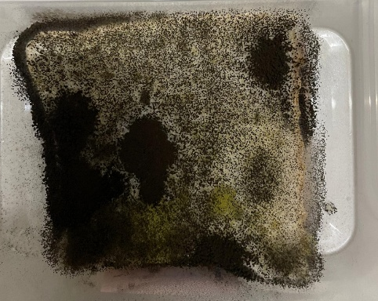
Figure 1: Fully molded bread sample

Table 4: Number of days of homemade bread to get fully molded
Factor | B
C  A | Without sprinkle |  |  | Sprinkle once after 3 days |  |  | Sprinkle once after 5 days
C  A | Open air | Partially open air | Fully cover | Open air | Partially open air | Fully cover | Open air | Partially open air | Fully cover
Natural Preservative | 24 | 13 | 9 | 22 | 14 | 12 | 19 | 11 | 9
Natural Preservative | 21 | 17 | 11 | 20 | 17 | 10 | 15 | 13 | 10
Natural Preservative | 22 | 16 | 9 | 21 | 17 | 9 | 19 | 15 | 10
Chemical Preservative | 27 | 20 | 17 | 27 | 20 | 14 | 24 | 18 | 16
Chemical Preservative | 26 | 22 | 16 | 26 | 21 | 14 | 24 | 17 | 13
Chemical Preservative | 27 | 19 | 17 | 26 | 20 | 15 | 26 | 20 | 14
No Preservative | 17 | 12 | 9 | 14 | 11 | 9 | 14 | 9 | 9
No Preservative | 15 | 9 | 9 | 17 | 9 | 9 | 12 | 9 | 9
No Preservative | 21 | 10 | 9 | 16 | 9 | 9 | 14 | 9 | 9
Analysis of Variance (ANOVA)
The analysis of variance (ANOVA) was conducted on 3³ factorial designs to determine how the three experimental factors affect the number of days of mold growth on bread. The result of the ANOVA is shown in Table 5. The starred value under p-value indicates as the source of variation is significant.
Table 5: ANOVA for 3³ factorial design
Sources of Variation | Sum of Squares | Degrees of Freedom | Expected Mean Square | F₀ | p-value
Preservative types | 1060.91 | 2 | 530.457 | 282.68 | 0.000*
Moisture conditions | 64.02 | 2 | 32.012 | 17.06 | 0.000*
Storage conditions | 1185.95 | 2 | 592.975 | 315.99 | 0.000*
Preservative types* Moisture conditions | 4.94 | 4 | 1.235 | 0.66 | 0.624
Preservative types* Storage conditions | 66.79 | 4 | 16.698 | 8.90 | 0.000*
Moisture conditions* Storage conditions | 23.01 | 4 | 5.753 | 3.07 | 0.024*
Preservative types* Moisture conditions* Storage conditions | 15.14 | 8 | 1.892 | 1.01 | 0.441
Error | 101.33 | 54 | 1.877
Total | 2522.10 | 80
The ANOVA results show the significant impact of the main effect of types of preservative is 𝐹_{(0.05,2,54)} = 3.17 at significance level of 0.05. Since the F ratio, 𝐹₀ = 282.68 > 3.17, there is sufficient evidence to reject 𝐻₀. Hence, it can be concluded that there were significant differences between the three levels of preservative types.
Next, for the value of F distribution for the main effect of moisture conditions is 𝐹_{(0.05,2,54)} = 3.17 at significance level of 0.05. Since the F ratio, 𝐹₀ = 17.06 > 3.17, there is insufficient evidence to reject 𝐻₀. Hence, it can be concluded that there were significant differences between the three levels of moisture conditions.
Then, for the value of F distribution for the main effect of storage conditions is 𝐹_{(0.05,2,54)} = 3.17 at significance level of 0.05. Since the F ratio, 𝐹₀ = 315.99 > 3.17, there is sufficient evidence to reject 𝐻₀. Hence, it can be concluded that there were significant differences between the three levels of storage conditions.
While for the interaction effects of preservative types and moisture conditions, the value of F distribution for the interaction effects of preservative types and moisture conditions is 𝐹_{(0.05,4,54)} = 2.54 at significance level of 0.05. Since the F ratio, F₀ = 0.66 < 2.54, there is insufficient evidence to reject 𝐻₀. Hence, it can be concluded that there was no difference effect in all the combinations between preservative types and moisture conditions.
Moreover, the interaction effects of preservative types and storage conditions show that the value of F distribution for the interaction effects of preservative types and storage conditions is 𝐹_{(0.05,4,54)} = 2.54 at significance level of 0.05. Since the F ratio, F₀ = 8.90 > 2.54, there is sufficient evidence to reject 𝐻₀. Hence, it can be concluded that there was at least one combination that had difference effect between preservative types and storage conditions.
Not only that, for the interaction effects of moisture conditions and storage conditions, the value of F distribution for the interaction effects of moisture conditions and storage conditions is 𝐹_{(0.05,4,54)} = 2.54 at significance level of 0.05. Since the F ratio, 𝐹₀ = 3.07 > 2.54, there is sufficient evidence to reject 𝐻₀. Hence, it can be concluded that there had at least one combination had difference effect between moisture conditions and storage conditions.
Last but not least, for the interaction effects of all the three factors, which are preservative types, moisture conditions and storage conditions, the value of F distribution for the interaction effects of preservative types, moisture conditions and storage conditions is 𝐹_{(0.05,8,54)} = 2.12 at significance level of 0.05. Since the F ratio, 𝐹₀ = 1.01 < 2.12, there is insufficient evidence to reject 𝐻₀. Hence, it can be concluded that there was no combination with difference effect between all the combinations of all the three factors.
Model Adequacy Checking
Model adequacy checking is done by using the plot of residuals in normal probability, plot of residuals in time sequence and plot of residuals versus fitted values. Based on Figure 2, 3 and 4, it shows the plots of normal probability plot, residuals versus fitted values plot and residuals versus order plot respectively.
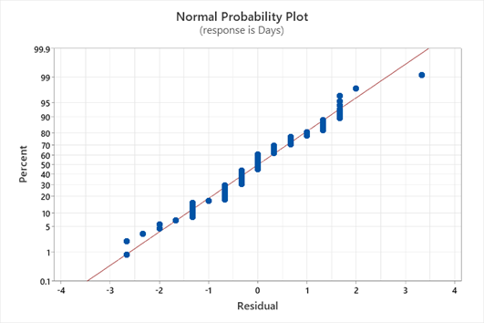
Figure 2: Normal probability plot
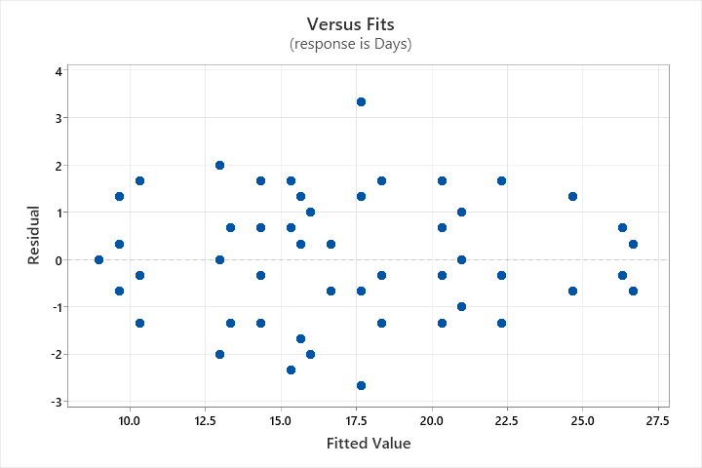
Figure 3: Residual versus fits plot
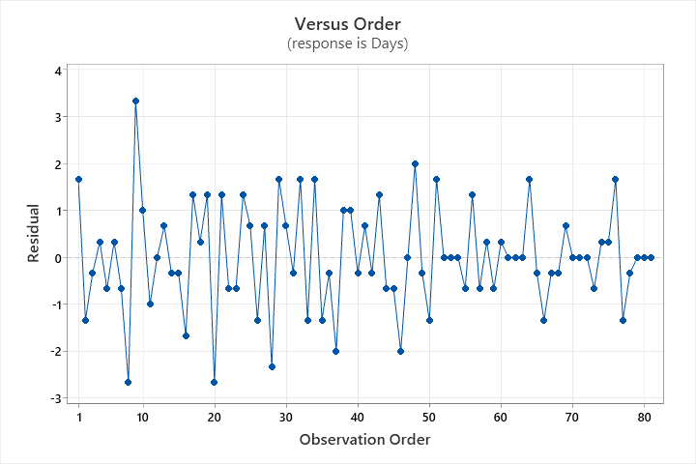
Figure 4: Residual versus order plot
According to Figure 2, the plot of normal probability plot shows that the residuals are close to the normal line with only one point is slightly deviate from the line. This indicates that the residuals are normally distributed.
Next, based on Figure 3, the plot of residuals versus fitted values shows that the residuals are scattered around 0 across all fitted values. Also, it does not show any obvious pattern on it. Hence, this indicates that this model has constant variance.
Then, according to Figure 4, the plot of residuals versus order plot shows that the residuals are randomly scattered around without any visible trend. Thus, it can be concluded that the model is independent.
A Tukey’s HSD test was tested to determine the pairwise differences in the average of the number of days until homemade bread gets molded. Tukey’s HSD test of preservative types is =0.51, all pairs of treatment mean had difference that greater than 0.51 as shown in Table 6. This means that all pairs of preservative types have significant differences.
Table 6: Tukey’s HSD test for differences of means for preservative types
Difference of Levels | Difference of Means
Natural preservative – Chemical preservative | 5.222*
No preservative – Chemical preservative | 8.815*
No preservative – Natural preservative | 3.593*
Next, a Tukey’s HSD test was also conducted for moisture conditions, with critical value of =0.51, all pairs of treatment mean had difference that greater than 0.51 as shown in Table 7. This means that all pairs of moisture conditions had significant differences.
Table 7: Tukey’s HSD test for differences of means for moisture conditions
Difference of Levels | Difference of Means
Sprinkle 3 days – Sprinkle 5 days | 1.519*
Sprinkle 3 days – Without sprinkle | 0.593*
Without sprinkle – Sprinkle 5 days | 2.111*
Moreover, a Tukey’s HSD test was also conducted for storage conditions, with critical value of =0.51, all pairs of treatment mean had difference that greater than 0.51 as shown in Table 8. This means that all pairs of storage conditions had significant differences.
Table 8: Tukey’s HSD test for differences of means for storage conditions
Difference of Levels | Difference of Means
Open air – Fully cover | 9.260*
Partially open air – Fully cover | 3.371*
Partially open air – Open air | -5.889*
Main Effect
The main effect plot in Figure 5 shows the main effect of the three factors which are preservative types, moisture conditions and storage conditions that affect the average of the number of days until homemade bread gets molded.
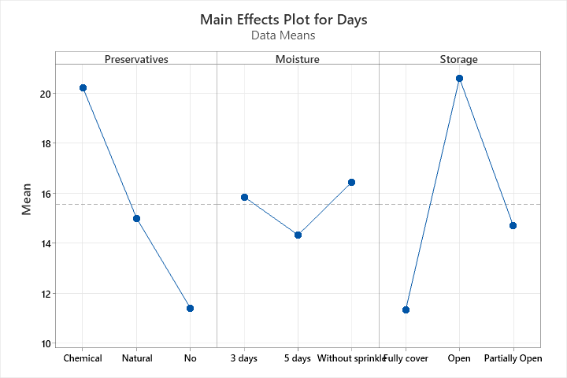
Figure 5: 3 Main effect plot for 3³ factorial design
From the main effects plot, for preservative types, it shows that chemical preservatives had the highest average number of days while no preservative had the lowest average number of days until the bread molded. Next, for moisture conditions, it shows that the bread without sprinkling any water had the highest average number of days while the bread that sprinkles water once after every 5 days had the lowest average number of days. Then, for storage conditions, it shows that open air condition had the highest average number of days while fully cover condition had the lowest average number of days.
Interaction Effect
According to Figure 6, it shows the interaction effects plot between the three factors which are preservative types, moisture conditions and storage conditions.
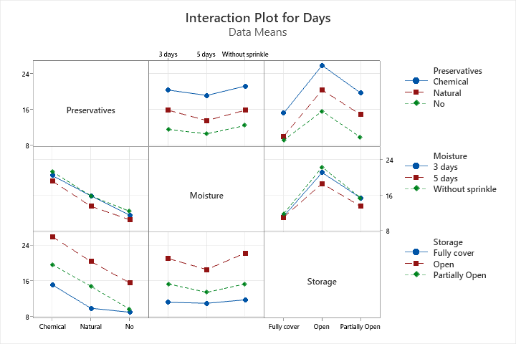
Figure 6: Interaction plot for 3³ factorial design
For the interaction effect of preservative types and storage conditions, the plot shows that the combination of no preservative with fully cover condition had the lowest average number of days while chemical preservative with open air condition had the highest average number of days until the bread got molded.
Besides, for interaction effect of moisture conditions and storage conditions, the plot shows that the combination of sprinkle water once every 5 days with fully cover condition had the lowest average number of days while no sprinkle water with open air condition had the highest average number of days for the bread to get molded.
CONCLUSION
In this study, a 3³ factorial design with three factors and each factor that is set for three different levels is conducted. The three factors are types of preservative, moisture conditions and storage conditions. For types of preservative, the three levels are natural, chemical and no preservative. Next, for moisture conditions, the three levels are sprinkling water once every 3 days, every 5 days and without sprinkling. Then, for storage conditions, the three levels are open air, partially open air and fully covered.
For the first objective, it had been successfully achieved by demonstrated the effect of combination factors that can minimize the mold growth on the shelf life of homemade bread. The results showed that the combination of chemical preservative, without sprinkling any water and open-air condition had the longest number of days until the bread became fully molded. While the combination with the longest number of days can be used frequently. This study demonstrated that the combination of the three factors is very important in influencing the mold growth in bread.
For the second objective, it also had achieved by using the Analysis of Variance (ANOVA) to identify the main and interaction effects of the three factors on mold growth in bread. The results showed that the three factors, types of preservative, moisture conditions and storage conditions had significant effects on the number of days until mold growth in bread. However, for the interaction effect, only types of preservative with storage conditions and moisture conditions with storage conditions had significant effects on the number of days until mold growth in bread.
Limitations
There were still several limitations that should be considered for future improvements. In this study, only focused on visible mold growth in bread without considering sensory attributes such as smell and texture. These are also another important factors that affect the selection of customers. Moreover, there are only one type of natural and chemical preservatives used in this study. This means that the results cannot be a reference to seller that used other types of preservative for making bread since their chemical compositions or effectiveness against mold growth are different. Besides, there might be slightly inconsistent in dough preparation stage such as the weight of ingredients like flour, yeast, butter or milk in making the three different types of preservative. It might affect the moisture content or the mold growth in the bread.
Recommendations
There are few recommendations suggested for future studies to improve the accuracy of findings. For future studies, it should not only observe the mold growth but also include sensory evaluations such as smell and texture so that it can provide more accurate number of days until the mold is fully growth. Moreover, the types of preservative can include more such as potassium sorbate, sorbic acid and honey to compare their effectiveness and determine which kind of preservatives can minimize mold growth while maintaining bread quality. Not only that, during the dough preparation stage, the weight of ingredients must also be consistent. Hence, precise weighing instruments that able to measure up to two decimal places should be used to ensure the bread samples are prepared uniformly. By following these recommendations, future studies might obtain data that is more accurate, consistent and meaningful since it provides a better reflection of real-world mold growth in bread.
REFERENCES
- Alpers, T., Kerpes, R., Frioli, M., Nobis, A., Hoi, K. I., Bach, A., Jekle, M., & Becker, T. (2021). Impact of storing condition on staling and microbial spoilage behavior of bread and their contribution to prevent food waste. Foods, 10(1), 76. https://doi.org/10.3390/foods10010076
- Food Safety Information. (2013, Aug 22). Molds on food: Are they dangerous?. USDA Food Safety and Inspection Service. Retrieved from https://www.fsis.usda.gov/food-safety/safe-food-handling-and-preparation/food-safety-basics/molds-food-are-they-dangerous
- Lohano, D. K., Sheikh, S. A., & Shahnawaz, M. (2010). Effect of chemical preservatives on the shelf life of bread at various temperatures. Pakistan Journal of Nutrition, 9(3), 279–283. https://doi.org/10.3923/pjn.2010.279.283
- Ma, M., Sun, Q., Li, M., & Zhu, K. (2020). Deterioration mechanisms of high-moisture wheat-based food – A review from physicochemical, structural, and molecular perspectives. Food Chemistry, 318, 126495. https://doi.org/10.1016/j.foodchem.2020.126495
- McCulloch, M. (2023, July 11). Is it safe to eat moldy bread?. Healthline. Retrieved from https://www.healthline.com/nutrition/can-you-eat-bread-mold
- Montgomery, D. C., (2017). Additional Design and Analysis Topics for Factorial and Fractional Factorial Designs. in Montgomery, D. Design and Analysis of Experiments Ninth Edition. Arizona State University: John Wiley & Sons, Inc. 25-461
- Moro, C. B., Lemos, J. G., Gasperini, A. M., Stefanello, A., Garcia, M. V., & Copetti, M. V. (2022). Efficacy of weak acid preservatives on spoilage fungi of bakery products. International Journal of Food Microbiology, 374, 109723. https://doi.org/10.1016/j.ijfoodmicro.2022.109723
- Nionelli, L., Wang, Y., Pontonio, E., Immonen, M., Rizzello, C. G., Maina, H. N., Katina, K., & Coda, R. (2020). Antifungal effect of bioprocessed surplus bread as ingredient for bread-making: Identification of active compounds and impact on shelf-life. Food Control, 118, 107437. https://doi.org/10.1016/j.foodcont.2020.107437
- Rahman, M., Islam, R., Hasan, S., Zzaman, W., Rana, M. R., Ahmed, S., Roy, M., Sayem, A., Matin, A., Raposo, A., Zandonadi, R. P., Botelho, R. B. A., & Sunny, A. R. (2022). A comprehensive review on bio-preservation of bread: An approach to adopt wholesome strategies. Foods, 11(3), 319. https://doi.org/10.3390/foods11030319
- Santos, F. G., Aguiar, E. V., Centeno, A. C. L. S., Rosell, C. M., & Capriles, V. D. (2020). Effect of added psyllium and food enzymes on quality attributes and shelf life of chickpea-based gluten-free bread. LWT - Food Science and Technology, 134, 110025. https://doi.org/10.1016/j.lwt.2020.110025
- Simpkins, E. (2022, Nov 28). Is homemade bread healthier?. Nutrisense. Retrieved from https://www.nutrisense.io/blog/is-homemade-bread-healthier
- Teng, Y.Y. (2023, July 11). 5 Ingredients that extend the shelf life of bread. Musim Mas. Retrieved from https://www.musimmas.com/resources/blogs/5-ingredients-that-extend-the-shelf-life-of-bread/
- Torrijos, R., Nazareth, T. d. M., Quiles, J. M., Mañes, J., & Meca, G. (2021). Application of white mustard bran and flour on bread as natural preservative agents. Foods, 10(2), 431. https://doi.org/10.3390/foods10020431

