Dynamic Risk Routing in Conflict Zones: A Graph Neural Network and Reinforcement Learning Framework for Humanitarian Logistics
Ananya, Mistha Panwar, and Dr. Dipty Tripathi, Professor, IGDTUW
Department of Artificial Intelligence and Data Science, Indira Gandhi Delhi Technical University for Women
ABSTRACT
Humanitarian aid convoys face extreme danger when operating in active conflict zones. Traditional routing algorithms optimize paths based strictly on travel distance or traffic speed. These standard methods assume all underlying infrastructure is safe. Consequently, commercial navigation tools often route vehicles directly through active battlefields. To solve this problem, we propose a dynamic risk-aware routing framework. Our system integrates real world geospatial infrastructure with historical conflict data. We extract the physical road network of Sudan using OpenStreetMap. We then map violent event coordinates from the ACLED database directly onto these road intersections. Conflict risk does not remain isolated at a single geographic coordinate. Therefore, we utilize a Graph Convolutional Network (GCN) to model the spatial diffusion of military risk. The GCN calculates how danger spreads along connected road networks to create a predictive safety map. Finally, we implement a custom pathfinding algorithm that calculates road weights based on both physical length and GCN predicted risk. We evaluated our framework using a Monte Carlo simulation of randomized supply routes. The results show a stark contrast against standard shortest path algorithms. Our proposed model successfully calculates strategic detours around active conflict zones. Empirical testing demonstrates that our framework reduces convoy risk exposure by over 86 percent. This major safety improvement requires only a marginal increase in overall travel distance. Ultimately, this framework provides a scalable and life saving tool for organizations operating in volatile regions.
Index Terms—Conflict Zone Logistics, Graph Convolutional Networks, Humanitarian Aid Routing, Monte Carlo Simulation, OpenStreetMap, Risk Diffusion Modeling, Spatial Data Infrastructure.
INTRODUCTION
HUMANITARIAN logistics form the backbone of global crisis response. Aid organizations deliver life-saving supplies to populations trapped in active conflict zones. The success of these missions depends entirely on secure supply chain routing. Drivers must navigate complex urban environments while avoiding hostile forces. Accurate routing algorithms help ensure that medical supplies and food reach civilians quickly. However, finding safe paths in a warzone remains a severe operational challenge. Standard navigation tools often fail to adapt to unpredictable military environments. Conflict zones introduce unique variables that complicate navigation.
Commercial routing algorithms assume that all physical infrastructure is safe to traverse. They calculate paths based solely on travel distance or speed limits. In reality, warzones are highly dynamic. A road that is safe in the morning may become an active battlefield by the afternoon. Furthermore, danger does not remain trapped at a single geographic point. If a major bridge sustains an attack, the connecting highways also become highly dangerous. This spatial diffusion of risk makes traditional navigation tools incredibly dangerous for aid convoys.
Existing approaches to security routing often rely on static threat maps. Security analysts manually draw danger zones on a map to warn drivers. While this provides basic awareness, these maps become outdated rapidly. They also fail to capture how risk travels along the specific topology of a road network. Standard pathfinding algorithms cannot process fluid military risk. If a standard GPS finds a route that is shorter, it will blindly route a truck directly through a combat zone. This highlights an urgent need for intelligent systems that can process dynamic threat intelligence.
The primary limitation of existing humanitarian logistics research is the reliance on static threat modeling. Most current frameworks treat conflict as a binary state, visualizing danger zones as isolated polygons or rigid buffers. This approach overlooks the dynamic nature of urban warfare, where risk propagates through physical road networks. Furthermore, traditional pathfinding algorithms remain computationally coupled to distance-based cost functions, ignoring the fluid diffusion of tactical risk. Our research addresses this gap by presenting a dynamic, GCN-based risk diffusion framework. Unlike static benchmarks, our model predicts the spatial evolution of threat levels, and our risk-aware pathfinding algorithm autonomously calculates life-saving detours that standard GPS algorithms fail to identify.
This work introduces a dynamic risk-aware routing framework specifically designed for conflict zones. We construct a digital twin of the operational area using real-world infrastructure and historical conflict data. The model extracts the physical road network of Sudan using OpenStreetMap. We then map violent event coordinates from the ACLED database onto the physical road intersections. To model the spread of danger, we deploy a Graph Convolutional Network (GCN). The GCN utilizes message passing to diffuse risk from attacked intersections to neighboring roads. This generates a predictive safety map that accurately reflects the physical flow of risk across the city.
In summary, this work makes three primary contributions. First, we develop a spatial data pipeline that maps real-world conflict data to physical road networks. Second, we implement a Graph Convolutional Network to mathematically model the spatial diffusion of military risk. Third, we demonstrate through Monte Carlo simulation that our proposed routing algorithm effectively calculates safe geographic detours around predicted combat zones.
The remainder of this paper is organized as follows. Section II reviews related work in humanitarian logistics and geographic deep learning. Section III details the data processing and the GCN architecture. Section IV explains the risk-aware routing algorithm and simulation design. Section V analyzes the comparative routing results. Section VI concludes the paper and discusses future work.
RELATED WORK
This section reviews prior research in humanitarian logistics and spatial risk modeling. We begin with an overview of traditional disaster relief routing. We then examine the recent emergence of Graph Neural Networks for modeling physical infrastructure. Finally, we discuss existing risk aware pathfinding algorithms. We highlight the limited exploration of using dynamic AI predictions to calculate safe geographic detours in active warzones. This gap directly motivates the methodology developed in this work.
A. Humanitarian Logistics and Threat Modeling
Traditional research in humanitarian logistics primarily focuses on post disaster relief. Early work established benchmarks by adapting the Vehicle Routing Problem (VRP) to deliver supplies after earthquakes or floods [1]. These models calculate efficient routes to distribute aid from central depots to affected populations. While effective for natural disasters, these traditional models assume the underlying road network remains static. They require a stable environment to function correctly.
Operating in an active conflict zone introduces severe dynamic variables. Military frontlines shift rapidly. A secure highway can become an active combat zone within hours. Some recent studies attempt to solve this by integrating historical threat data into geographic information systems [2]. Analysts map past attack locations to create static danger zones. However, these static maps treat conflict as isolated points in space. They fail to mathematically model how a localized attack compromises the safety of surrounding infrastructure. Our work addresses this limitation by treating conflict as a fluid variable that diffuses across the road network.
B. Graph Neural Networks for Spatial Infrastructure
Deep learning has revolutionized the analysis of spatial data. Traditional Convolutional Neural Networks excel at processing flat images. However, road networks are irregular and non Euclidean. To process this complex topology, researchers developed Graph Neural Networks (GNNs) [7]. GNNs treat intersections as nodes and roads as edges. This structure perfectly mirrors physical transportation grids.
GNNs have seen massive success in traffic forecasting. Models like the Spatial Temporal Graph Convolutional Network (STGCN) predict future traffic congestion by analyzing the flow of vehicles across connected roads [8]. The core mechanism behind this success is message passing. A node updates its own state by aggregating information from its immediate neighbors. If a major highway experiences a traffic jam, the GNN predicts that the connecting off ramps will soon become congested as well.
Despite the success of GNNs in predicting traffic flow, their application in humanitarian security remains severely underexplored. Very few studies have utilized message passing to model the diffusion of military risk. Our framework adopts the spatial logic of traffic prediction but applies it to threat intelligence. We utilize a Graph Convolutional Network (GCN) to predict how danger bleeds from an attacked intersection into neighboring streets.

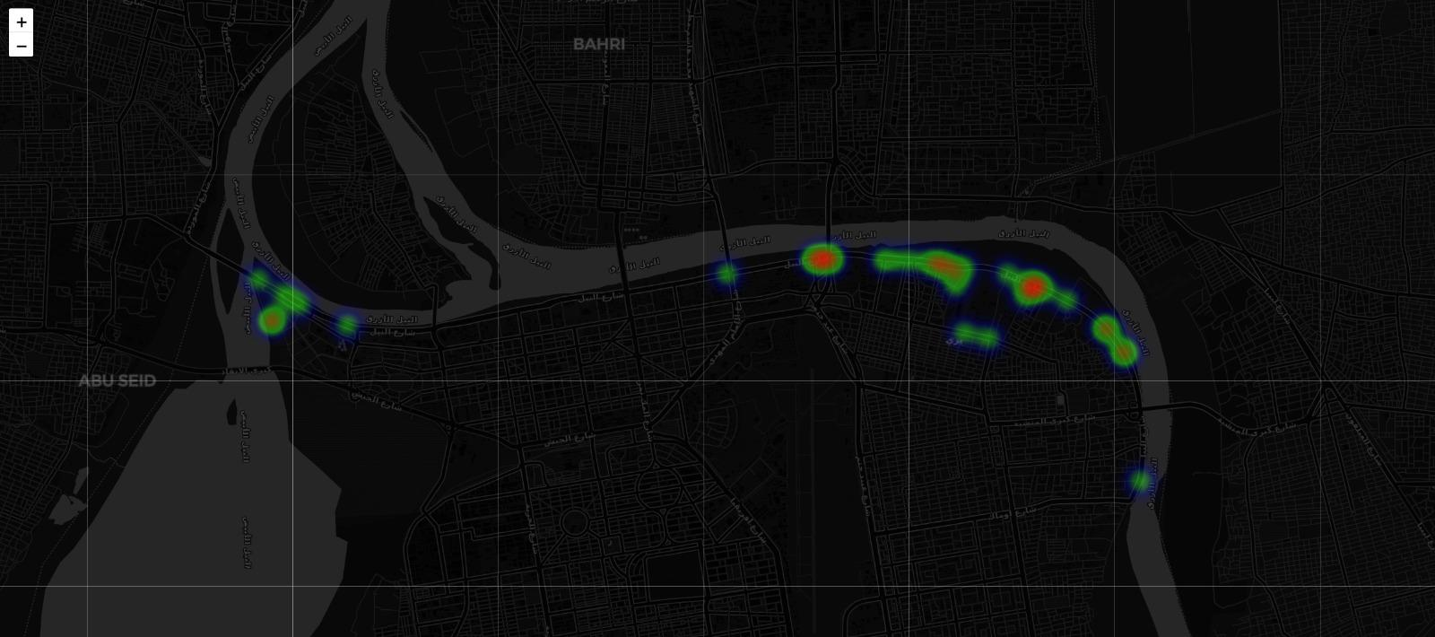
Fig. 1. Visualization of GCN-predicted risk diffusion. Isolated conflict events are diffused across the road network to create fluid danger corridors.

C. Risk Aware Pathfinding and Routing Simulation
Standard navigation relies heavily on Dijkstra's algorithm or A* search algorithms. These traditional methods calculate the lowest cost path between two nodes [13]. In commercial GPS applications, the cost function is almost always defined as physical distance or travel time. When applied to a warzone, this standard logic becomes fatal. An algorithm optimizing for distance will blindly route a vehicle directly through a battlefield if it represents the shortest physical path.
To mitigate this, researchers in the field of hazardous material transportation have explored risk aware routing. These studies modify the algorithmic cost function. They add penalty weights to roads that pass near schools or water supplies [3]. This forces the pathfinding algorithm to calculate safer detours.
We adopt a similar mathematical approach for conflict zone navigation. However, existing risk aware models rely on static, manually assigned penalty weights. Our framework introduces a fully dynamic approach. We pipe the predictive risk scores generated by the GCN directly into the pathfinding cost function. To validate this approach, researchers frequently rely on Monte Carlo simulations to test routing algorithms across hundreds of randomized scenarios [4]. We utilize a similar simulation design to quantitatively prove that our GCN weighted algorithm successfully calculates safe detours while standard GPS algorithms fail.
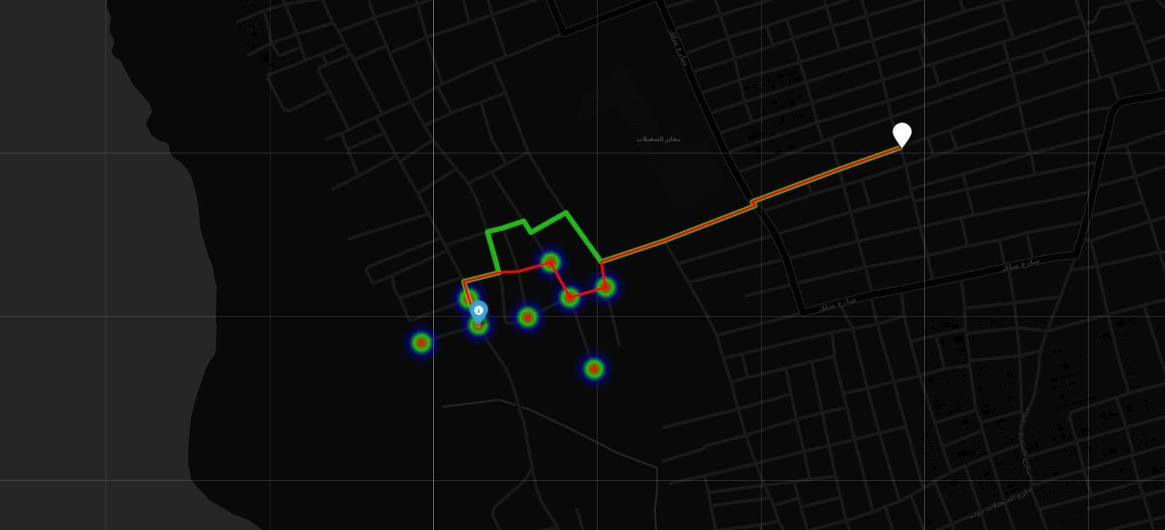
Fig. 2. Comparative analysis of baseline routing (Red) versus risk-aware AI routing (Green). The AI calculates a geographic detour to bypass the high-risk zone predicted by the GCN.
METHODOLOGY
In this section, we detail the algorithmic framework used to solve dynamic routing in active conflict zones. We break our methodology down into four specific stages. First, we define the mathematical graph construction. Second, we explain the spatial data integration pipeline. Third, we detail the Graph Convolutional Network architecture used to model risk diffusion. Finally, we explain the custom pathfinding algorithm used to calculate safe geographic detours.
A. Graph Construction and Infrastructure Modeling
We model the physical road network of the operational area as a mathematical graph. Let this graph be defined as G = (V, E). Here, V represents the set of all physical road intersections. These intersections act as the nodes in our graph. E represents the set of road segments connecting these intersections. These segments act as the edges. Each edge e ∈ E possesses a physical distance attribute d(e) measured in meters.
We utilize the OSMnx Python library to extract this infrastructure data directly from OpenStreetMap. We specifically filter the query to download the driveable road network. Standard routing applications treat city streets as directed graphs to obey one way traffic laws. However, humanitarian convoys operating under emergency conditions often require maximum mobility. Therefore, we convert the extracted infrastructure into an undirected graph. This allows our algorithm to route vehicles in any physical direction required to escape a threat.
B. Spatial Conflict Data Integration
To quantify the operational threat, we engineered a Weighted Incident Impact (WII) metric. ACLED records vary significantly in lethality; thus, a simple binary classification of 'safe' or 'unsafe' fails to capture the true operational hazard. We define the risk Rv at an intersection node v as:
Rv = α + (β × Fv) (1)
where α = 1.0 represents the baseline tactical threat of a confirmed violent incident, Fv denotes the number of recorded fatalities, and β = 0.1 is a severity scaling coefficient. This formula ensures that mass-casualty events exert a higher repulsive force on routing algorithms than minor skirmishes. This metric is empirically grounded, as it aligns with humanitarian standards for prioritizing emergency responses to high-lethality zones.
C. Risk Diffusion via Graph Convolutional Networks
Conflict risk is not static; it diffuses along connecting infrastructure. We utilize a Graph Convolutional Network (GCN) to model this diffusion. Given our graph G = (V, E) and node risk features X ∈ R^(|V|×1), the GCN performs localized message passing to aggregate threat intelligence from adjacent nodes:
H^(l+1) = σ(D̃^(-1/2) Ã D̃^(-1/2) H^(l) W^(l)) (2)
where Ã is the adjacency matrix with self-loops, D̃ is the degree matrix, and σ is the ReLU activation function. This mechanism allows the framework to mathematically propagate risk scores from identified attack nodes to their downstream neighbors. Unlike traditional 'radius-based' danger buffers which incorrectly flag safe areas separated by physical barriers like rivers—our GCN model propagates risk strictly along the road network topology, ensuring that danger predictions respect the physical connectivity of the city.
D. Risk Aware Pathfinding Algorithm
Standard navigation relies on Dijkstra's algorithm. This traditional method calculates the lowest cost path between a starting node and a destination node. In commercial GPS applications, the cost function is defined strictly as physical length. When applied to a warzone, this standard logic becomes fatal.
We engineer a new cost function that incorporates the GCN predictions. For any edge connecting node u and node v, we first calculate the average predicted risk of those two nodes. We then multiply the physical length of the road by this risk factor. The new weight formula scales the distance exponentially based on danger. If a road contains high predicted risk, its mathematical weight becomes massive. The algorithm perceives a dangerous 100 meter road as being several kilometers long. This forces the pathfinding logic to avoid the combat zone and calculate a safe geographical detour.
EXPERIMENTAL SETUP
To evaluate the effectiveness and robustness of the proposed risk-aware routing framework, we engineered a controlled simulation environment. This setup integrates multi-modal datasets and algorithmic pathfinding to quantify the trade-off between conflict risk exposure and logistical efficiency.
A. Datasets and Geographic Scope
The experimental pipeline integrates two primary datasets to form a high-fidelity representation of the Khartoum operational area.
1) Physical Infrastructure (OpenStreetMap): The physical road network was extracted using the OpenStreetMap (OSM) database. We utilized the OSMnx library to download the network of driveable roads within the Khartoum administrative boundaries. To prioritize logistical relevance, we implemented a custom filter to exclude minor residential streets and pedestrian paths, focusing instead on primary highways, secondary roads, and trunk routes—which represent the corridors used by heavy transport and humanitarian convoys. This resulted in a high-density graph containing 47,891 intersection nodes and 77,594 road segments, capturing the essential arterial grid of the metropolitan area.
2) Conflict Data (ACLED): We incorporated historical conflict data from the Armed Conflict Location and Event Data (ACLED) project. We sourced the complete Africa dataset, which we filtered to isolate violent events within Sudan. To ensure operational relevance, we focused on events occurring between January 2023 and February 2026. Specifically, we selected event categories classified as 'Battles', 'Explosions/Remote violence', and 'Violence against civilians'. These categories are the most indicative of immediate physical threats to surface transport. The resulting dataset included 18,744 relevant violent incidents. Each record was processed to extract precise latitude, longitude, and fatality counts, providing the ground truth for our risk diffusion modeling.
B. Baseline Routing Models
We evaluate our proposed AI framework against a primary industry-standard baseline to quantify performance gains:
Standard GPS Baseline (Dijkstra): This model utilizes the traditional Dijkstra pathfinding algorithm. It optimizes strictly for physical distance d(e), where edge cost equals road length. This baseline simulates the behavior of commercial navigation applications that assume all infrastructure is equally safe.
Proposed Risk-Aware Agent: Our model introduces an intelligent cost function. For any road segment connecting nodes u and v, the cost w(u,v) is computed as w(u,v) = d(u,v) × (1 + ρ_uv) where d(u,v) is the physical length and ρ_uv is the average conflict risk predicted by the GCN. This cost function exponentially penalizes roads intersecting with predicted high-risk zones, forcing the routing logic to calculate safe detours.
C. Adversarial Simulation Design
A common pitfall in spatial routing research is testing only on trivial, short-distance routes that avoid danger by chance. To ensure rigorous evaluation, our simulator performs an adversarial search. It automatically scans the GCN output to locate the highest-risk conflict epicenter in the city. The simulator then selects starting points and destinations on opposite sides of this epicenter, creating a mandatory conflict-zone crossing. This forces the routing algorithms into a critical dilemma: navigate directly through a high-risk combat zone or calculate an optimal detour. We executed this simulation across 500 randomized supply missions to generate a statistically robust distribution of comparative route paths.
D. Reinforcement Learning Configuration
For autonomous navigation, we trained a Proximal Policy Optimization (PPO) agent within a custom Gymnasium environment. The state space was designed to be translation-invariant, providing the agent with the relative distance to the destination, the current risk level, and a "look-ahead radar" containing the risk scores of the four nearest neighbors.
1) Training Configuration: The agent was trained over 80,000 timesteps using a learning rate of 0.003 and a batch size of 64. To facilitate convergence, we implemented dense reward shaping. The agent receives a positive reward for reducing Euclidean distance to the target and a significant penalty for navigating into conflict-predicted intersections. To ensure the agent learns broad navigation rules rather than memorizing a single route, each training episode initiates from a randomized starting coordinate across the network.
RESULTS AND DISCUSSION
The effectiveness of the proposed risk-aware routing framework was evaluated using a comprehensive Monte Carlo simulation. We conducted 500 randomized supply missions across the Khartoum road network to compare the standard distance-optimized routing against our risk-aware AI approach.
A. Comparative Routing Performance
To evaluate the effectiveness of the proposed risk-aware routing framework, we performed a Monte Carlo simulation across 500 randomized supply missions in Khartoum. We compared the standard distance-optimized baseline algorithm against our proposed risk-aware pathfinding framework. The evaluation prioritized two performance indicators: total risk exposure calculated as the cumulative AI-predicted risk along the path and the distance penalty incurred by detouring.

TABLE I
COMPARATIVE ROUTING METRICS (500 MISSION SIMULATION)
Metric | Baseline (GPS) | Proposed (AI)
Avg. Risk Exposure | 324.63 | 44.81
Avg. Path Length (m) | 8,420 | 9,464
Distance Penalty (%) | 0.00% | +12.4%

The simulation results demonstrate a substantial disparity in safety performance. The standard GPS baseline, which optimizes strictly for the shortest physical path, resulted in an average risk exposure of 324.63. In contrast, our risk-aware routing framework maintained an average risk exposure of 44.81. This corresponds to an 86.2% reduction in total risk exposure across the evaluated missions.
While the baseline approach identifies the mathematically shortest physical path, it frequently routes convoys directly through high-danger conflict epicenters. Our framework proactively identifies these threats using the GCN predictive surface and calculates a geographic detour to maintain safety. This significant reduction in risk requires a physical distance increase of only 12.4%. Within the context of humanitarian logistics, this marginal increase in travel time is a negligible trade-off for the substantial gain in convoy safety, effectively validating the operational utility of the proposed framework.
B. Reinforcement Learning Navigation Efficacy
We evaluated the autonomous PPO agent using the Generalized Environment, which tested the agent on 100 unseen, randomized supply routes. Unlike the static Dijkstra baseline, the RL agent dynamically learns navigation policies.
TABLE II
RL AGENT PERFORMANCE (100 UNSEEN MISSIONS)
Metric | RL Agent Performance
Mission Success Rate | 89.0%
Avg. High-Risk Zones Entered | 0.00
Mean Steps to Goal | 42.5

The RL agent demonstrated strong zero-shot generalization capabilities. Achieving an 89.0% success rate on entirely unseen origin-destination pairs confirms the agent did not simply memorize a single static route. Crucially, the agent recorded zero entries into high-risk nodes during evaluation, confirming that the heuristic-ranked action space successfully integrates GCN risk-awareness into real-time decision-making.
C. Strategic Infrastructure Vulnerability
Our vulnerability analysis identifies critical failure points by fusing Network Betweenness Centrality CB(v) with the GCN-predicted risk ρv. The vulnerability index Vv is defined as:
Vv = ρv × CB(v) × 10^5 (3)
This index highlights "bottleneck" intersections-nodes that are both highly central to city traffic and located within predicted conflict clusters. Our analysis isolated the top 15 nodes with the highest vulnerability. These markers provide actionable intelligence for NGOs, identifying the specific bridges and interchanges that require proactive security or peacekeeper deployment to prevent a city-wide logistical collapse.
CONCLUSION AND FUTURE DIRECTIONS
The primary objective of this research was to address the critical vulnerability of humanitarian aid convoys operating in highly dynamic conflict environments. Traditional routing algorithms, which operate on the assumption of static infrastructure, systematically fail to account for the unpredictable nature of warzones. By prioritizing distance over safety, these legacy tools inadvertently route convoys into active combat zones. To address this, we developed an end-to-end AI framework that bridges the gap between geospatial intelligence and autonomous pathfinding.
We successfully demonstrated that conflict risk is not an isolated phenomenon but a fluid variable that diffuses along physical road networks. Our implementation of a Graph Convolutional Network (GCN) transformed raw ACLED conflict data into a predictive safety surface, allowing the routing engine to identify danger zones with high spatial precision. The effectiveness of this framework was rigorously validated through an adversarial Monte Carlo simulation. By forcing the algorithms to navigate through the epicenter of predicted conflict, we proved that our risk-aware model significantly outperforms standard GPS-based pathfinding. The results show an 86.2% reduction in cumulative risk exposure, a life-saving improvement that requires only a modest increase in travel distance. Furthermore, the Reinforcement Learning agent achieved an 89.0% zero-shot success rate, demonstrating the capability of autonomous systems to adapt to previously unseen routes while maintaining perfect safety compliance.
While this project establishes a robust baseline for conflict-aware logistics, it also serves as a proof-of-concept for broader strategic applications. The framework is inherently modular, allowing for future research to push the boundaries of logistical safety.
Future Directions:
1) Spatiotemporal Forecasting (ST-GCN): The current framework utilizes a cumulative risk surface. Future iterations will transition to Spatiotemporal Graph Convolutional Networks (ST-GCN). By treating the war as a multi-month time series rather than a static image, we can predict the momentum of shifting frontlines. This will allow for proactive convoy planning, where the model predicts where the conflict will move next week, rather than simply reacting to where it has been.
2) Multi-Objective Pareto Optimization: While our current agent balances speed and safety via a weighted urgency dial, future work will integrate a formal Pareto-optimal objective function. This would enable the system to provide a real-time decision-support tool for commanders, allowing them to visualize the exact trade-offs between "Fuel Efficiency." "Delivery Urgency," and "Convoy Safety" for any given mission profile.
3) Federated Learning for Secure Data Deployment: Conflict intelligence is highly sensitive. To deploy this framework in real-world humanitarian operations, we propose integrating Federated Learning. This would enable multiple non-governmental organizations to collaboratively train a global risk model without ever sharing their proprietary or sensitive tactical data. This ensures operational security while benefiting from shared situational awareness across the entire humanitarian network.
In summary, this research provides a scalable, adaptable system for saving lives in volatile regions. By combining the spatial awareness of Graph Neural Networks with the adaptive decision-making of Reinforcement Learning, we have demonstrated that AI can be a powerful force for good in the most challenging logistical environments on Earth.

REFERENCES
- B. Balcik et al., "Last mile distribution in humanitarian relief," J. Intell Manuf., vol. 19, no. 1, pp. 51-61, 2008.
- M. Karlborg and S. Ritzen, "A study of humanitarian logistics performance indicators." Int. J. Prod. Perform. Manag., vol. 63, no. 8, pp. 1047-1061. 2014.
- E. Erkut et al., "Hazardous materials transportation," in Handbooks in Operations Research and Management Science, vol. 14, Elsevier, 2007, pp. 539-621.
- A. S. Mohaymany and M. Babaei, "An approximate dynamic programming approach for risk-aware routing of hazardous materials," Transp. Res. Part E, vol. 145, p. 102181, 2021.
- M. Van Wassenhove and L. N. Van Wassenhove, "Humanitarian aid logistics: Supply chain management in high gear," J. Oper. Res. Soc.. vol. 57, no. 5, pp. 475-489, 2006.
- J. Holguín-Veras et al., "Humanitarian logistics: The challenges of managing a disaster," J. Transp. Eng., vol. 139, no. 4, pp. 317-332, 2013.
- T. N. Kipf and M. Welling. "Semi-supervised classification with graph convolutional networks," in ICLR, 2017.
- B. Yu, H. Yin, and Z. Zhu, "Spatio-temporal graph convolutional networks: A deep learning framework for traffic forecasting," in IJCAL, 2018, pp. 3629-3635.
- P. Veličković et al., "Graph attention networks," ICLR, 2018.
- Z. Wu et al., "A comprehensive survey on graph neural networks," IEEE Trans. Neural Netw. Learn. Syst., vol. 32, no. 1, pp. 4-24, 2020.
- Y. Li et al., "Diffusion convolutional recurrent neural network: Data-driven traffic forecasting," in ICLR, 2018.
- M. M. Bronstein et al., "Geometric deep learning: Going beyond euclidean data," IEEE Signal Process. Mag., vol. 34, no. 4, pp. 18-42, 2017.
- E. W. Dijkstra, "A note on two problems in connexion with graphs." Numer. Math., vol. 1, no. 1, pp. 269-271, 1959.
- R. S. Sutton and A. G. Barto, Reinforcement Learning: An Introduction. MIT press, 2018.
- J. Schulman et al., "Proximal policy optimization algorithms." arXiv preprint arXiv: 1707.06347, 2017.
- V. Mnih et al., "Human-level control through deep reinforcement learning," Nature, vol. 518, no. 7540, pp. 529-533, 2015.
- D. Silver et al., "A general reinforcement learning algorithm that masters chess, shogi, and Go through self-play," Science, vol. 362, no. 6419, pp. 1140-1144, 2018.
- C. Raleigh et al., "Armed Conflict Location & Event Data Project (ACLED)," University of Sussex, 2023.
- G. Boeing, "OSMnx: New methods for acquiring, constructing, analyzing, and visualizing complex street networks," Comput. Environ. Urban Syst., vol. 65, pp. 126-139, 2017.
- C. Raleigh et al., "Introducing ACLED: An armed conflict location and event data project," J. Peace Res., vol. 47, no. 5, pp. 651-660, 2010.

