SAFETY ASSESSMENT OF GRADED DOSEADMINISTRATION OF SENNA OCCIDENTALIS, ANNONA MURICATA AND AJU-MBAISE ON SERUM PANCREATIC ENZYME OF MALE WISTAR RATS
Esther Ifeyinwa Etuª, Chibueze Owoh Odeh^{b}, Nkiruka Peace Ojiako^{c}, Nyejirime Young Wike*^{d},

ªDepartment of Medical Laboratory Science, Evangel University, Akaeze, Ebonyi State, Nigeria
^{b}Department of Biochemistry, University of Calabar, Nigeria
^{c}Department of Medical Laboratory Science, University of Nigeria, Enugu Campus, Enugu State, Nigeria
^{d}Department of Human Physiology, Faculty of Basic Medical Science, State University of Medical and Applied Sciences, Igbo-eno, Enugu State, Nigeria

Corresponding author*
Nyejirime Young Wike
nyejirime.wike@sumas.edu.ng
+2348167044210

ABSTRACT
Background and Aim: The pancreas is an interconnected organ having both endocrine and exocrine activities. Acute pancreatitis has a significant prevalence along with a fatality percentage.It is regarded as one of the most prevalent gastrointestinal illnesses around the globe. Elevated amylase and lipase release into the bloodstream are a sign of acute pancreatitis, which involves auto-cell damage. Serum lipase and amylase levels are increased by threefold beyond the boundaries of the physiological range in pancreatitis.This study examined the safety of administering a graded dose of Senna occidentalis, Annona muricata, and Aju-mbaise on the pancreatic tissue of male Wistar rats. Materials and Methods: Twenty wistar rats weighing 120– 150g were used in this study. After seven days of acclimatization, the rats were distributed into four groups, with five rats each. Group 1 served as control and was given water and normal rat chow. Groups 2, 3 and 4 were orally given Senna occidentalis, Annona muricata and Aju-mbaise extracts for 30 days, respectively. After respective oral administration exposure period of 30 days, blood samples were collected for biochemical analysis of the serum enzymes. Pancreas was also harvested for histopathological examinations. Results: Annona muricata and Aju-mbaise test groups revealed significant (p<0.05) effects on the pancreatic serum enzymes when compared with control and Senna occidentalis groups. However, histology of the pancreas showed no pathological effects. Conclusion: The consumption of the leaves of these plants should be with caution as high doses might result in an adverse effect on the pancreatic enzymes which is a regulatory factor for the pancreas.
Keywords: Pancreatic enzymes, Pancreas, Aju-mbaise, Senna occidentalis, Annona muricata

INTRODUCTION
The pancreas is an interconnected organ having both endocrine and exocrine activities. A minimum of five hormones, comprising glucagon, insulin, somatostatin, ghrelin, and pancreatic polypeptide, are secreted by the five distinct endocrine kinds of cells (alpha, beta, delta, epsilon, and upsilon) that make up the endocrine component, which is organized as distinct islets of Langerhans. The inflammatory illness known as acute pancreatitis (AP) has a significant prevalence along with a fatality percentage. This condition is typified by a poor prognosis, fast development, and a complex origin [1]. It is regarded as one of the most prevalent gastrointestinal illnesses around the globe, according to [2]. Regretfully, 20% of those with this condition get acute pancreatitis that requires critical care and is potentially fatal, according to Zhang et al. [3]. Each year, the prevalence of AP persists.
A growing body of research links weight gain, digestive problems, gallstones, and alcohol as the primary contributors of AP. According to reports, the pathophysiology of AP involves complicated intra-acinar processes such as endoplasmic pressure, antioxidant depletion, the breakdown of food, zymogen stimulation, and impaired mitochondrial function [4]. Furthermore, the autoimmune reactionwhich includes immune-cellular recruitment, damage-related molecular pattern stimulation, and the discharge of several cytokines associated with inflammation and chemokinesis also partially responsible for the onset of AP.
According to reports, acute lung injury is the biggest contributor to acute pancreatic deaths and the most prevalent distant organ illness in AP. The stimulation of allergic reactions leads to impairment to lung microvascular endothelial cells, which in turn causes acute lung injury (5).A number of medications, such as auxora [6], pentoxifylline [7], and rifadxmin [8], are undergoing research investigations. Although these medications can help during emergencies, more research is necessary to fully understand their safety record and ability to avert consequences. Past studies indicate that somatostatin and octreotide are both linked to problems.[9] Organic medications made from plants are being used in a growing range of therapies in an effort to create innovative treatment options that are less expensive and have fewer side effects.Serum levels of lipase and amylase surge three times during AP episodes, beyond the maximum bound of the physiological range[10].When the pancreas lacks the enzymes needed to break down fats, such as lipase, pancreatic insufficiency typically results in fewer than 10 percent of pancreatic function remaining. Clinical signs of steatorrhea result from this pancreatic enzyme shortage because fat is not absorbed correctly in the small intestine and is instead ejected. Deficiency in fat-soluble vitamins (A, D, E, and K) may be the result of improper fat absorption. Diabetes mellitus can also result from pancreatic insufficiency because insufficient insulin is released from pancreatic tissue[11].
Herbal remedies are essential in the production of contemporary drugs. Due to its potential to treat a variety of acute and chronic illnesses, herbal remedies have attracted a lot of attention in our day and age. According to [12-14], traditional medicine has historically been the most affordable and accessible type of care. It has also shown great potential for the treatment of a wide range of health disorders [15]. Natural goods are an important resource in conventional and traditional medical systems worldwide. About 40% of approved drugs that are offered on the market are made of natural products or their derivatives [14], [16]. Because herbal medicines have been used for a very long period, people believe them to be safe [17].Folk medicine has utilized Senna occidentalis, Annona muricata and Aju-mbaise to treat a variety of illnesses [18].
However, the safety profile of these plants on the pancreas and associated serum enzymes lack adequate research data. The purpose of this study was to examine the safety of administering a graded dose of Senna occidentalis, Annona muricata, and Aju-mbaise on the pancreas and its serum enzymes of male Wistar rats.

MATERIALS AND METHOD
Collection and Identification of Plant Materials: Fresh leaves of Senna occidentalis, Annona muricate and Aju-mbaise were obtained from the botanical garden of the University of Nigeria, Nsukka, Enugu State. They were identified and authenticated at the specie level at the department of Botany, University of Nigeria, Nsukka, Enugu State. The fresh plants were air dried, cut into bits, and ground. They were stored in dried containers until needed.
Experimental Animals: Twenty wistar rats weighing between 180-200 g were used for this study. They were purchased from animal house of the Department of medical laboratory science, Faculty of Basic medical Science, University of Nigeria. The wistar rats were housed in well ventilated laboratory cages with 12hour day/night cycles. They were maintained on a ration containing commercial feed made up of 54% carbohydrate, 20% protein, 2% minerals, 10% fiber, 1% vitamin and 13% fat. Water was also supplied ad libitum.
Preparation of Plant Extract: The extracts of the leaves of the plant were prepared by suspending 50 g each of the bark powder separately in 100 cm³ of distilled water and shaken intermittently with mechanical shaker for 6 hours. The preparation was allowed to stand for 24 hours and then filtered using a Whatman’s no 1 (11 cm) filter paper. The filtrate was concentrated to dryness at 40ºC and under reduced pressure on a rotary evaporator and stored in a refrigerator at -4 ºC until required.
Experimental Design: The wistar rats were divided into four groups of 5 rats each. The aqueous extract of the different plants was administered orally with a gastric tube for 4 weeks.
Animal Grouping
Group I: Control rats - received distilled water and normal feed only
Groups II: Rats administered with 200 mg kg-1 aqueous extract of Senna occidentalis
Group III: Rats administered with 400 mg kg-1 aqueous extract of Annona muricata
Group IV: Rats administered with 600 mg kg-1 aqueous extract of Aju-mbaise
Biochemical Analysis
Determination of Serum Biochemical Parameters: At the end of the experimental period, the animals were starved for 24 hours after last experimental treatment, and were anaesthetized with chloroform in an anesthetic chamber. The animals were sacrificed using cervical dislocation method. Blood samples were obtained by cardiac puncture from each rat by means of a 5ml syringe and needle. The blood samples were collected in heparinized tubes for biochemical estimation. The heparinized blood was centrifuged within 5minutes of collection at 2500 rpm for 10 minutes. Serum was collected into a dry sample container. The levels of biochemical parameters such as amylase, [19] and lipase,[20] were estimated. Pancreatic tissue was harvested from the sacrificed animals. The harvested tissue was immediately fixed in 10% formal saline to deactivate any bacteria present.
Histological Analysis: The histological examination of the pancreas was carried out to investigate any possible damage that administration of the extract of the plants might have caused within the experimental period.
Microscopic Examination of Pancreatic Tissue: Pancreatic tissue was dissected and immediately fixed in 10% formalin, paraffin-embedded, and stainedwith a hematoxylin-eosin stain. Then, the stained tissue sections were examined under bright-field microscopy(Olympus Optical, Japan) at x10 and x40 magnification.
Statistical Analysis: Values were reported as Mean ± standard error of mean (SEM), while Duncan Test of one-way ANOVA was used to test for significant differences between treatment groups using the Statistical Package for the Social Sciences (SPSS) (version 25.0). The results were considered significant at (p<0.05).
RESULT
Table 1: Effect of graded dose administration of S. occidentalis, A. muricata and A. mbaise on serum pancreatic enzymes
Groups | Amylase (U/L)  Mean ± SD | Lipase (U/L)  Mean ± SD
Group A (Control) | 156.79±2.52 | 29.19±1.08
Group B  (Senna Occidencalis)  200 mg/kg | 150.67±3.91 | 33.38±4.52^{*AB}
Group C  (Annona Muricata)  400 mg/Kg | 153.66±1.84^{*AB} | 36.84±2.41^{*AB}
(Group D  Aju-Mbaise)  600 mg/kg | 160.93±2.11^{*AB} | 40.65±3.89^{*AB}

Mean serum level of amylase and lipase demonstrated non-significant (p>0.05) change in all the test groups; B, C and D when compared with control group. Serum urea level in test groups B and D showed a significant (P<0.05) increase when compared with control (Group A). There was non-significant (p=0.101) different in test group C compared with control.

Histological Effects of Senna occidentalis, Annona muricata and Aju-mbaise on the Pancreatic Tissue of Male Wistar Rats

Group 1

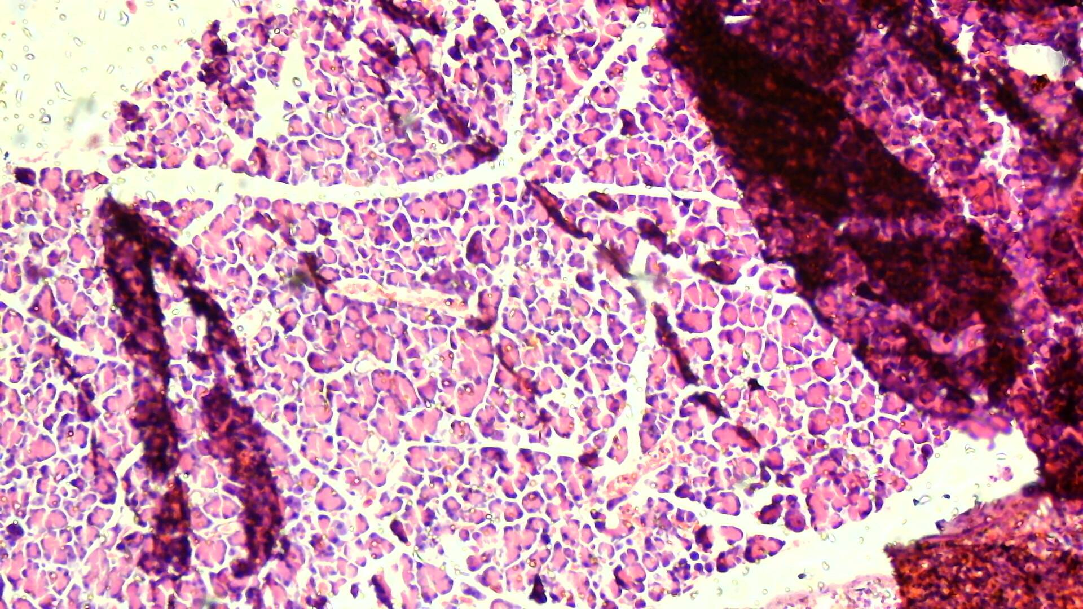

Plate 1: photomicrograph of the pancreas section from the control rat, stained with H and E showing normal pancreatic tissue (Magnification of x40).

Group 2
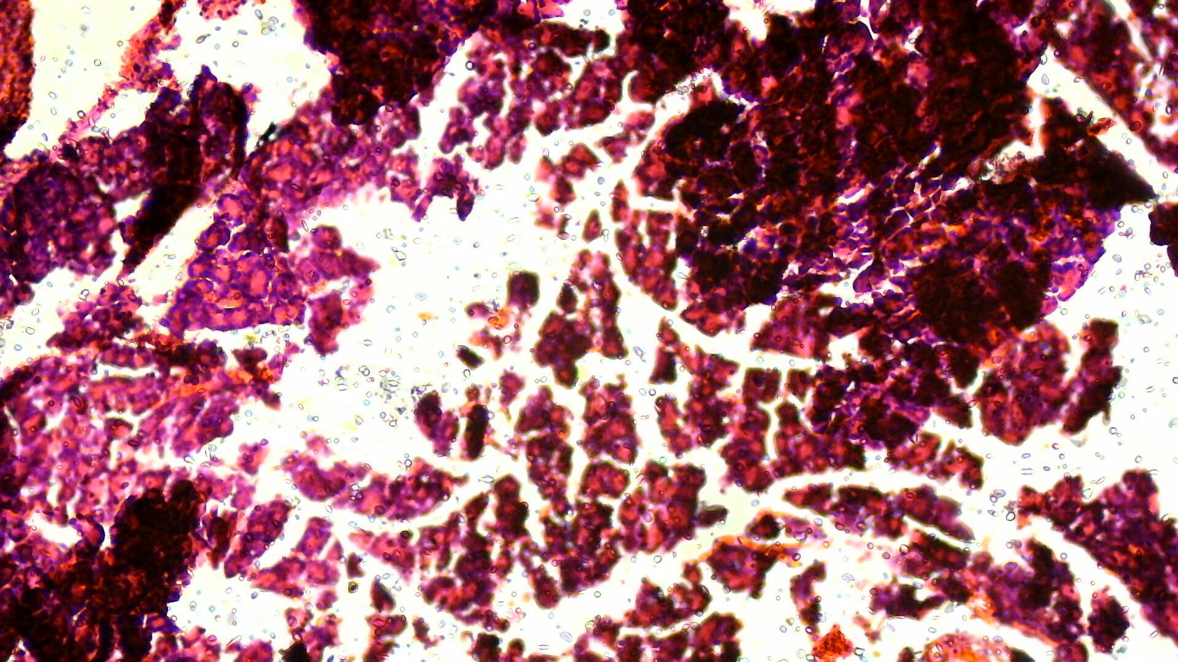

Plate 2A: photomicrograph of the pancreas section from group 2 stained with H and E showing abnormal pancreatic tissue (Magnification of x10).
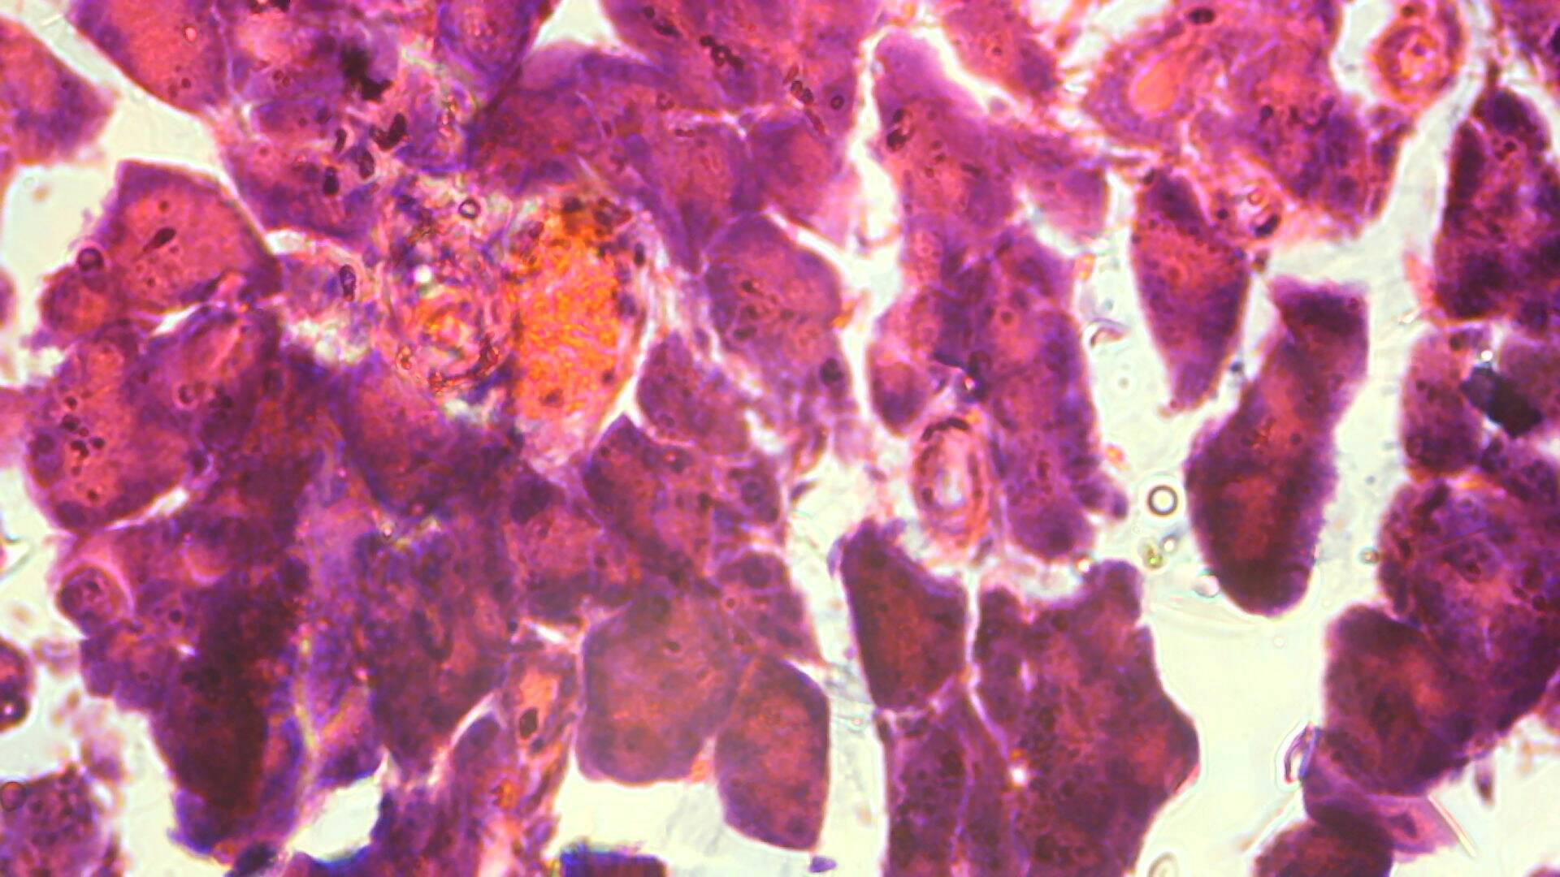

Plate 2B: photomicrograph of the pancreas section from group 2 stained with H and E showing abnormal pancreatic tissue (Magnification of x40)

Group 3
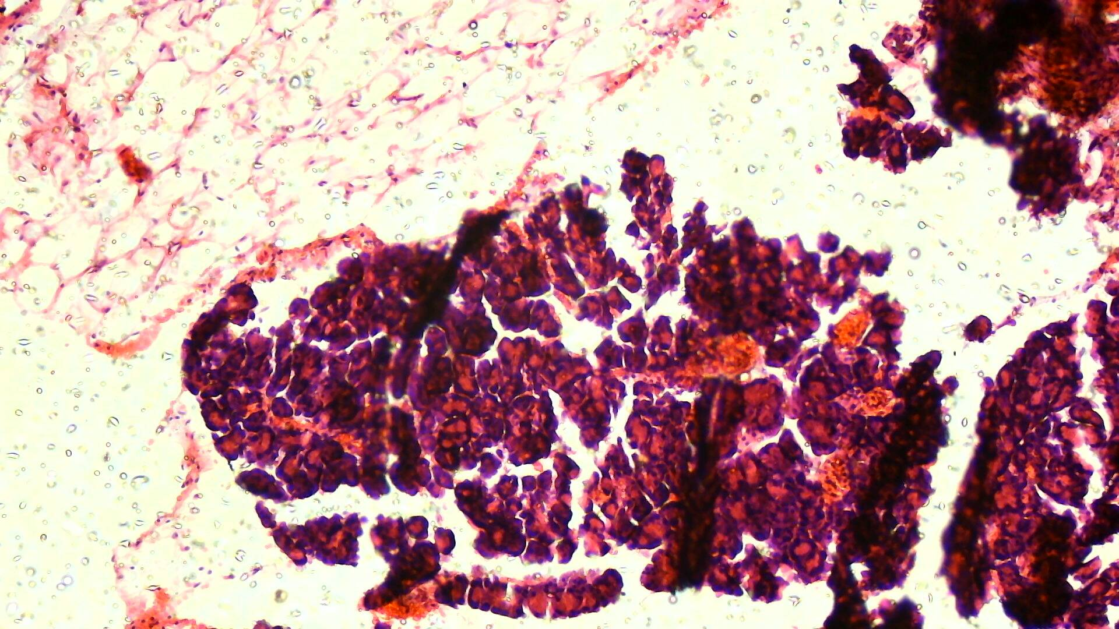

Plate 3A: photomicrograph of the pancreas section from group 3 stained with H and E showing abnormal pancreatic tissue (Magnification of x10).
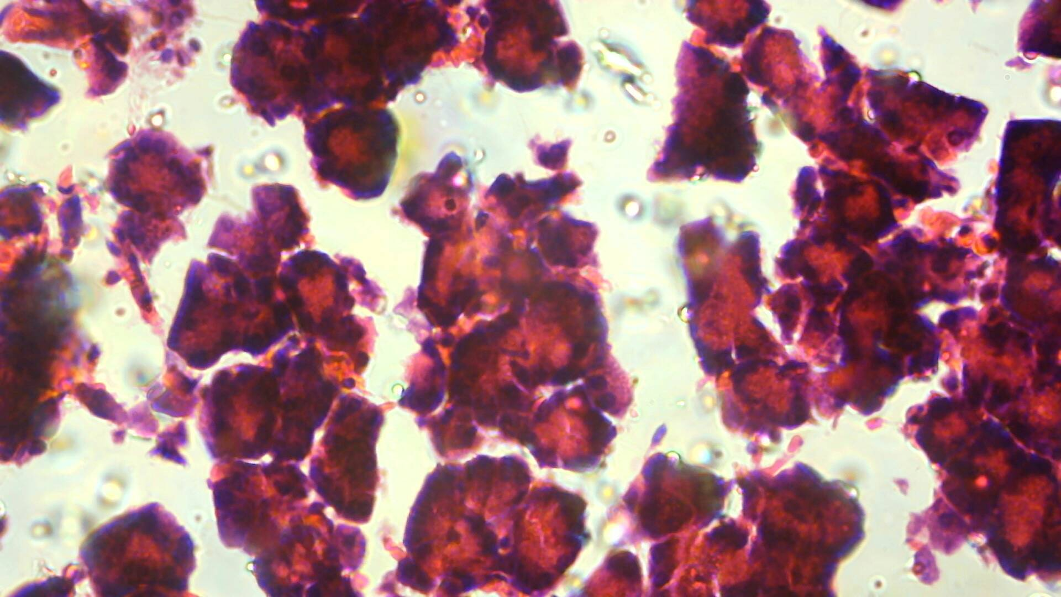

Plate 3B: photomicrograph of the pancreas section from group 3 stained with H and E showing abnormal pancreatic tissue (Magnification of x40).

GROUP 4
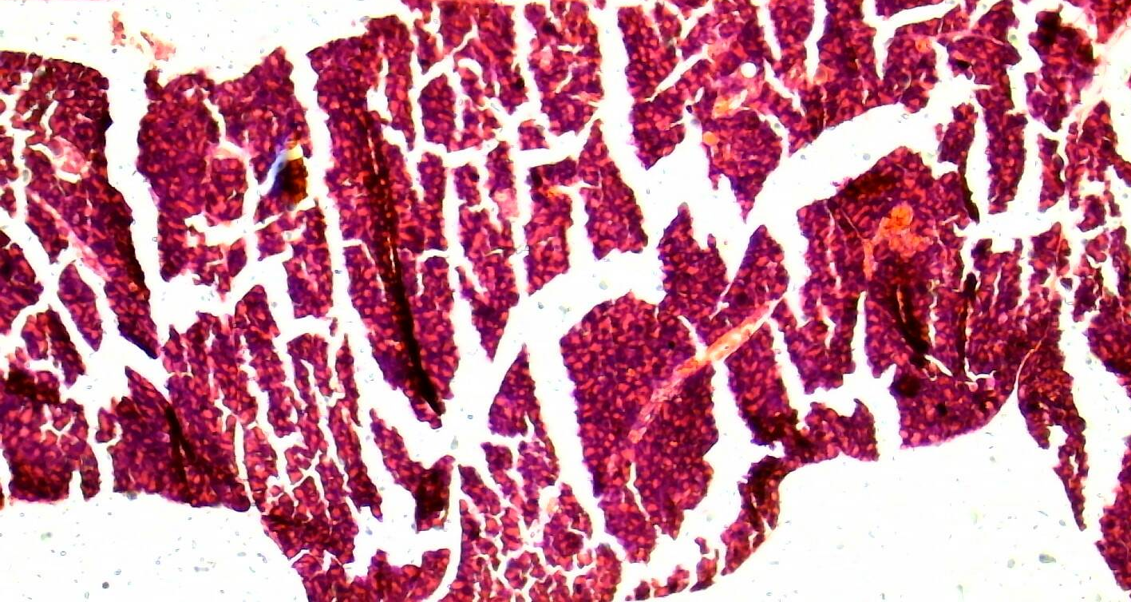

Plate 4A: photomicrograph of the pancreas section from group 4 Albino rat, stained with H and E showing abnormal pancreatic tissue (Magnification of x10).
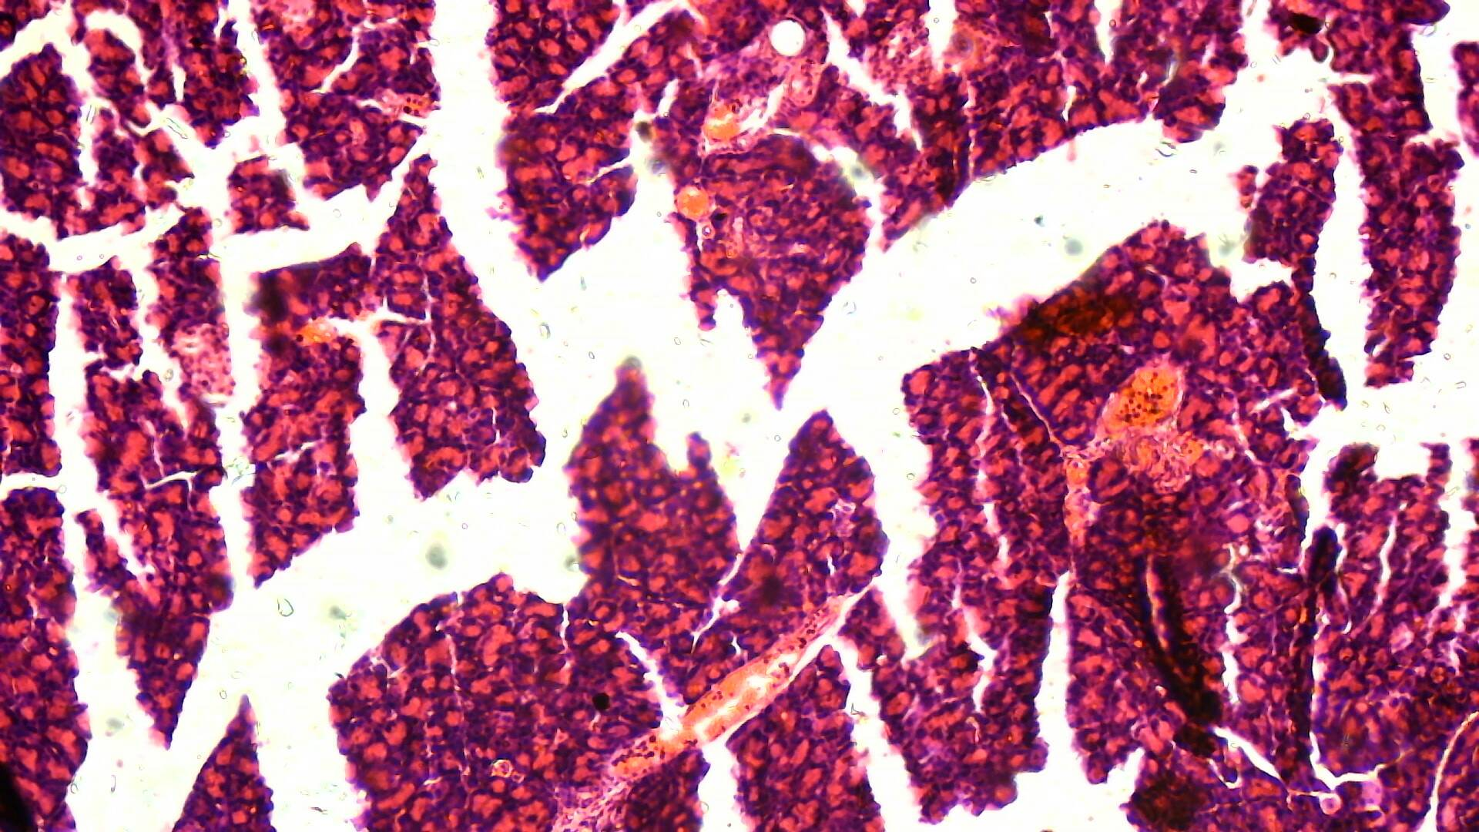

Plate 4B: photomicrograph of the pancreas section from group 2 Albino rat, stained with H and E showing abnormal pancreatic tissue (Magnification of x40).

KEY
ZYMOGEN GRANULES
PANCREATIC DUCT
PANCREATIC LOBULE.
CAPILLARY
INTERLOBULAR SEPTUM

DISCUSSION
The absorption of nutrients and digestion depends on the normal functioning of the pancreas, an organ with glands of great importance in the digestive system. Furthermore, numerous investigations have verified that the pathogeny of acute pancreatitis, a condition with a greater incidence, is linked to the oxidative damage caused by free radicals on the pancreatic endocrine and exocrine functions.
From this research, the result obtained showed that oral exposure to Senna occidentalis, Annona muricata and Aju-mbaise resulted in a significant (p<0.05) increase in serum pancreatic enzymes of the Wistar rats. Pancreatic lipase is found within the small intestine and is involved in degrading dietary triglycerides [21]. The elevated levels of serum pancreatic enzymes might be an indicator of acute pancreatis [4].
The pancreas has been reported to directly or indirectly regulate blood sugar levels, by secreting the hormones insulin, glucagon, somatostatin, and pancreatic polypeptide and also functions as an exocrine gland. Negative effects posed on this organ will cause organ damage which will put stop in the level of hormonal production [1]. This on its own can cause or aids diabetes as depletion in insulin production will increase sugar level in the blood stream, causing vein blockage and derangement in such an individual. The negative effects can also cause high level of acid in body as the pancreatic juice responsible for neutralization of acid secretion is no more available or too little to combat with acid reducing its negative effects, and this is not ideal for human survival [22].

The findings from this study revealed that the constituents of Senna occidentalis, Annona muricata and Aju-mbaise may have interacted with and influenced the exocrine glandular regions involved for hormone synthesis. This observation implies that oral exposure to Senna occidentalis, Annona muricata and Aju-mbaise is capable of posing a negative influence on the serum pancreatic enzymes in male rats as well as human when taken in high quantity with high concentration of the extract constituents.

CONCLUSION
From the result obtained from this study, it can be concluded that oral administration of S. occidentalis, A. muricata and A. mbaiseresulted in an unfavorable level of the serum pancreatic enzymes. However, the histology of the pancreas revealed no toxic effect. It is recommended that the constituents of these plants be taken with caution and the dose regulated.

Acknowledgment: None
Funding: This research did not receive any specific grant for funding agencies in the public, commercial, or not-for-profit sectors.
Conflict of Interest: The authors declare that there is no conflict of interest.
Ethical Clearance: Ethical clearance for this study was obtained from Research and Ethics Committee, University of Nigeria, Enugu.

REFERENCES
- Yang S, Song Y, Wang Q, Liu Y, Wu Z, Duan X, et al. Daphnetin ameliorates acute lung injury in mice with severe acute pancreatitis by inhibiting the JAK2-STAT3 pathway. Sci Rep. 2021;11(1):11491. doi: 10.1038/s41598-021-91008-6
- Karakayali FY. Surgical and interventional management of complications caused by acute pancreatitis. World J Gastroenterol. 2014;20(37):13412-13423. doi:10.3748/wjg.v20.i37.13412
- Zhang PY, Yu B, Men WJ, et al. Acetyl-α-boswellic acid and Acetyl-β-boswellic acid protects against caerulein-induced pancreatitis via down-regulating MAPKs in mice. Int Immunopharmacol. 2020;86:106682. doi:10.1016/j.intimp.2020.106682
- Jiang, X., Zheng, Y. W., Bao, S., Zhang, H., Chen, R., Yao, Q., & Kou, L. Drug discovery and formulation development for acute pancreatitis. Drug delivery; 2020;27(1), 1562–1580. https://doi.org/10.1080/10717544.2020.1840665
- Jiang N, Li Z, Luo Y, Jiang L, Zhang G, Yang Q, et al. Emodin ameliorates acute pancreatitis-induced lung injury by suppressing NLRP3 inflammasome-mediated neutrophil recruitment. Exp Ther Med. 2021;22(2):857. doi: 10.3892/etm.2021.10289.
- Bruen C, Miller J, Wilburn J, et al. Auxora for the treatment of patients with acute pancreatitis and accompanying systemic inflammatory response syndrome: clinical development of a calcium release-activated calcium channel inhibitor. Pancreas. 2021;50:537–543.
- Vege SS, Horibe M, Chari ST, et al. A single center randomized double blind controlled trial of pentoxifylline in acute pancreatitis: challenges and opportunities. Pancreatology. 2020;20:1592–1597.
- Tatur J, Lipiński M, Sznurkowska M, et al. Rifaximin in gut microbiota modification in acute pancreatitis: 15 years of retrospective clinical study. Adv Clin Exp Med. 2022;31:399–405.
- Sun C, Li Z, Shi Z, et al. Current diagnosis and treatment of acute pancreatitis in China: a real-world, multicenter study. BMC Gastroenterol. 2021;21:210.
- Bishop ML, Fody EP, Schoeff LE. Clinical Chemistry: Principles, Techniques, and Correlations. Lippincott Williams & Wilkins; 2013.
- Oh HC, Kwon CI, El Hajj II, Easler JJ, Watkins J, Fogel EL, McHenry L, Sherman S, Zimmerman MK, Lehman GA. Low Serum Pancreatic Amylase and Lipase Values Are Simple and Useful Predictors to Diagnose Chronic Pancreatitis. Gut Liver. 2017 Nov 15;11(6):878-883.
- Ugwah-Oguejiofor C. J., Okoli C. O., Ugwah M. O., et al. Acute and sub-acute toxicity of aqueous extract of aerial parts of Carallumadalzielii N. E. brown in mice and rats. Heliyon2019 ;5(1, article e01179) doi: 10.1016/j.heliyon.e01179.
- Ferrer B. E., Webster J., Bruce J., et al. Integrated community case management and community-based health planning and services: a cross sectional study on the effectiveness of the national implementation for the treatment of malaria, diarrhoea and pneumonia. Malaria Journal. 2016;15(1):p. 340. doi: 10.1186/s12936-016-1380-9.
- Nigatu T. A., Afework M., Urga K., Ergete W., Makonnen E. Toxicological investigation of acute and chronic treatment with GnidiastenophyllaGilg root extract on some blood parameters and histopathology of spleen, liver and kidney in mice. BMC Research Notes 2017;10(1):p. 625. doi: 10.1186/s13104-017-2964-3.
- Haidara M., Haddad M., Denou A., et al. In vivo validation of anti-malarial activity of crude extracts of Terminalia macroptera, a Malian medicinal plant. Malaria Journal 2018;17(1):p. 68. doi: 10.1186/s12936-018-2223-7.
- Aljawdah H. M. A., Abdel-Gaber R., al-Shaebi E. M., et al. Hepatoprotective activity of Eucalyptus camaldulensis extract in murine malaria mediated by suppression of oxidative and inflammatory processes. Microbiology. 2022;12: p. 1178. doi: 10.3389/fcimb.2022.955042.
- Ibrahim M. B., Sowemimo A. A., Sofidiya M. O., et al. Sub-acute and chronic toxicity profiles of Markhamiatomentosa ethanolic leaf extract in rats. Journal of Ethnopharmacology. 2016; 193:68–75. doi: 10.1016/j.jep.2016.07.036.
- Murugan K., Aarthi N., Kovendan K., et al. Mosquitocidal and antiplasmodial activity of Senna occidentalis (Cassiae) and Ocimumbasilicum (Lamiaceae) from Maruthamalai hills against Anopheles stephensi and Plasmodium falciparum. Parasitology Research. 2015;114(10):3657–3664. doi: 10.1007/s00436-015-4593-x.
- Gomori G. Assay of serum amylase with small amounts of serum. Am J Clin Pathol. 1957;2:714–6.
- Cherry IS, Crandall JR. The specificity of pancreatic lipase: Its appearance in the blood after pancreatic injury. Am J Physiol. 1932;100:266–73.
- Waldmann E, Parhofer KG. Apheresis for severe hypercholesterolaemia and elevated lipoprotein(a). Pathology. 2019 Feb;51(2):227-232.
- Gidado, N.M., Tanko, Y., Sada, N.H. and Mohammed, A. Effects of senna occidentalis leaf supplement on blood glucose level, liver enzymes and total protein in alloxan-induced diabetic wistar rats. Bayero Journal of Pure and Applied Sciences. 2016;9(1): 68 – 75.

