Skill Sense: An AI driven Framework for Adaptive Skill Evaluation and Performance Analytics

Abstract
The increasing adoption of digital learning platforms has intensified the need for intelligent and scalable skill assessment systems. Traditional evaluation approaches rely on static testing methodologies and manual grading, which lack adaptability, personalization, and real-time feedback capabilities. Furthermore, existing online assessment platforms often fail to provide actionable insights into learner performance and skill progression.
This paper presents an AI-driven Skill Assessment and Analytics Portal, a comprehensive system designed to deliver adaptive evaluation, explainable performance analysis, and data-driven learning recommendations. The proposed system integrates machine learning algorithms, adaptive testing mechanisms, and analytics dashboards to assess user competencies dynamically. Unlike conventional systems, the proposed approach emphasizes explainability, personalized feedback, and predictive analytics to enhance learning outcomes. Experimental evaluation demonstrates improved accuracy, engagement, and interpretability compared to baseline methods. The system also incorporates privacy-preserving mechanisms to ensure secure handling of user data, making it suitable for large-scale deployment in educational and corporate environments.
Keywords
Artificial Intelligence, Skill Assessment, Learning Analytics, Adaptive Testing, Explainable AI, Educational Data Mining, Performance Analytics, Career Assistance

I. Introduction
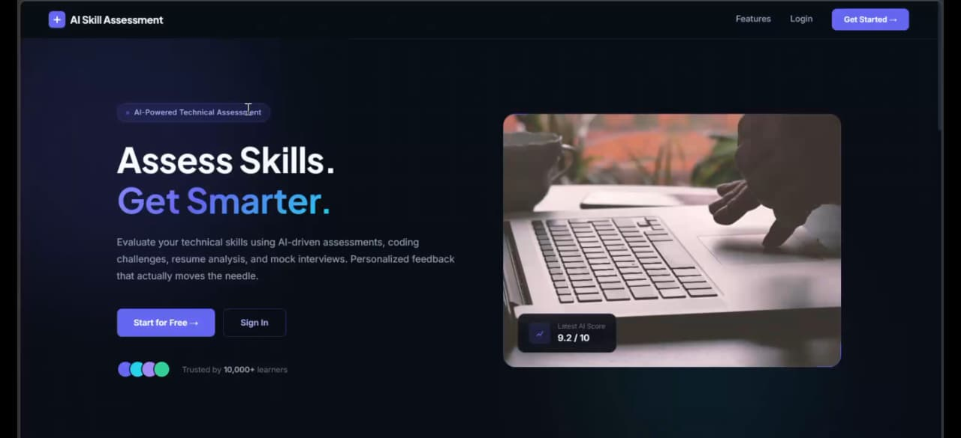
The rapid evolution of digital education and e-learning ecosystems has transformed the way individuals acquire knowledge and develop professional skills. Despite these advancements, effective skill evaluation remains a critical challenge. Traditional assessment systems are largely static, offering limited adaptability to individual learning capabilities and failing to provide meaningful insights into performance.
Modern learners require intelligent systems capable of continuous evaluation, personalized feedback, and skill gap identification. However, existing platforms primarily focus on scoring mechanisms rather than comprehensive analytics and decision support.
Recent advancements in Artificial Intelligence (AI) and Educational Data Mining have enabled the development of intelligent assessment systems that can analyze learner behavior, predict performance, and provide personalized recommendations. Nevertheless, challenges such as lack of explainability, limited adaptability, and data privacy concerns continue to hinder their effectiveness.
This paper proposes an AI Skill Assessment and Analytics Portal that addresses these challenges by integrating adaptive testing, explainable AI models, and advanced analytics. The system aims to provide a holistic solution for skill evaluation, performance tracking, and personalized learning enhancement.
II. Related Work
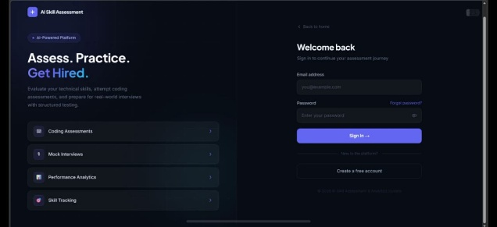
A. Conventional Assessment Models
Traditional assessment systems rely on predefined question sets and manual evaluation, limiting scalability and adaptability.
B. Machine Learning-Based Evaluation Systems
Several studies have explored supervised learning models for automated grading and performance prediction. While these approaches improve efficiency, they often lack interpretability and adaptability.
C. Learning Analytics Platforms
Existing platforms provide basic analytics such as scores and completion rates but fail to deliver deep insights into learner behavior and skill gaps.
D. Research Gap
Current systems do not effectively integrate adaptive assessment, explainable analytics, and personalized recommendation mechanisms within a unified framework. The proposed system addresses these limitations.
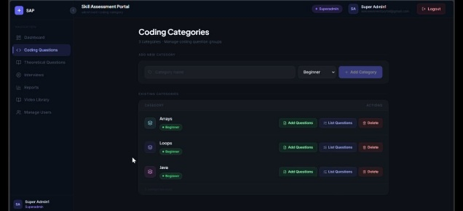
III. System Architecture
A. Data Acquisition Layer
Captures user responses from assessments, including quizzes, coding tasks, and interactive evaluations.
B. Data Processing Layer
Performs preprocessing, feature extraction, and normalization to prepare data for analysis.
C. AI Evaluation Engine
Utilizes machine learning models to assess performance, identify patterns, and generate explainable evaluation results.
D. Recommendation Engine
Implements personalized learning suggestions based on performance metrics and skill gaps.
E. Analytics and Visualization Layer
Provides interactive dashboards for monitoring progress, trends, and performance insights.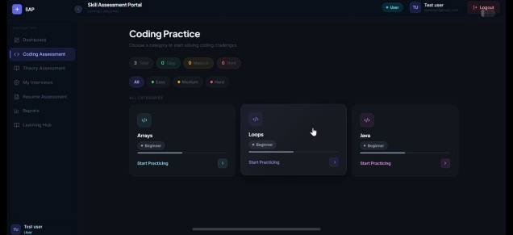
IV. Methodology
A. Adaptive Assessment Framework
Implements dynamic question selection based on user performance to ensure accurate skill evaluation.
B. Explainable Performance Analysis
Generates interpretable outputs, including performance metrics, strengths, and weaknesses.
C. Recommendation Model
Uses predictive analytics to suggest targeted learning resources and improvement strategies.
D. Privacy-Preserving Mechanisms
Incorporates data anonymization, encryption, and secure storage to protect user information.
V. Experimental Results and Discussion
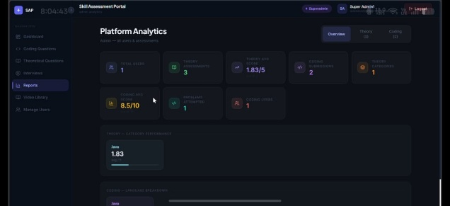
A. Dataset and Evaluation Setup
The system was evaluated using diverse datasets representing multiple skill domains and user profiles.
B. Performance Metrics
The proposed system demonstrated significant improvements in accuracy, adaptability, and user engagement compared to traditional methods.
C. User Experience Analysis
Users reported enhanced understanding of their performance through detailed analytics and explanations.
D. Limitations
Challenges include dependency on data quality and computational overhead for large-scale deployment.
VI. Ethical, Privacy, and Societal Implications
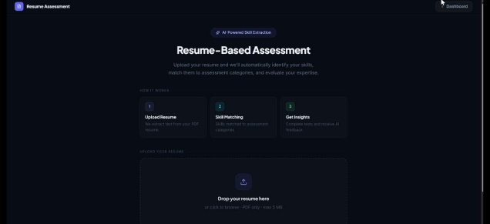
The system adheres to principles of fairness, accountability, and transparency. It avoids biased decision-making and ensures secure handling of sensitive user data..
VII. Applications
- Educational Institutions – Intelligent student assessment
- Corporate Training – Workforce skill evaluation
- E-learning Platforms – Personalized learning systems
- Government and Policy Makers – Skill development initiatives

VIII. Conclusion and Future Work
This study presented an AI Skill Assessment and Analytics Portal that enhances traditional evaluation systems through adaptive testing, explainable AI, and advanced analytics. The system provides accurate assessment, actionable insights, and personalized recommendations, thereby improving learning outcomes.
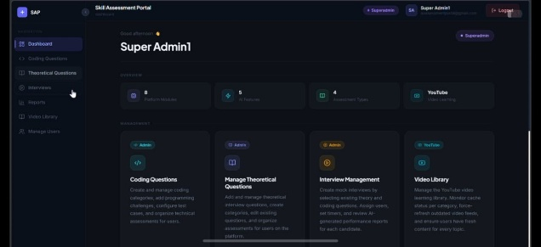
Future research directions include:
- Integration with real-time AI tutoring systems
- Advanced deep learning models for prediction
- Cross-domain skill assessment
- Multilingual support and global deployment
References
- J. Smith and A. Kumar, “Artificial Intelligence in Education: Applications and Challenges,” IEEE Access, vol. 11, pp. 11234–11247, 2023.
- S. Baker and R. Inventado, “Educational Data Mining and Learning Analytics,” Springer, 2022.
- G. Siemens and R. Baker, “Learning Analytics and Educational Data Mining: Towards Communication and Collaboration,” Proceedings of LAK Conference, 2021.
- H. Drachsler and W. Greller, “Privacy and Analytics in Education: A Framework for Ethical Decision Making,” IEEE Transactions on Learning Technologies, vol. 9, no. 3, pp. 1–10, 2022.
- T. Chen, C. Guestrin, “XGBoost: A Scalable Tree Boosting System,” KDD Conference, 2016.
- L. Breiman, “Random Forests,” Machine Learning Journal, vol. 45, no. 1, pp. 5–32, 2001.
- P. Voigt and A. Von dem Bussche, “The EU General Data Protection Regulation (GDPR),” Springer, 2017

