Human Stem Cells:

Abstract
Human stem cells possess two defining biological properties — self-renewal and differentiation — that underpin their transformative role in regenerative medicine. This article reviews the biology, classification, and harvesting of human stem cells, with emphasis on mesenchymal stem cells (MSCs), hematopoietic stem cells (HSCs), neural stem cells, and induced pluripotent stem cells (iPSCs). We describe the major harvesting methodologies — bone marrow aspiration, adipose tissue liposuction, umbilical cord collection, and peripheral blood apheresis — and outline the laboratory processes required for culture and expansion. The molecular mechanisms by which stem cells contribute to tissue healing (cell replacement, paracrine growth factor secretion, and immunomodulation) are discussed, followed by a survey of established and emerging clinical applications spanning skin grafting, bone marrow transplantation, spinal cord injury, cardiac repair, and organ regeneration. Ethical, regulatory, and safety considerations are addressed, and future directions including 3D bioprinting, organoid engineering, and gene-edited personalized medicine are highlighted.

Keywords: stem cells, mesenchymal stem cells, hematopoietic stem cells, iPSCs, regenerative medicine, tissue engineering, bone marrow transplantation, wound healing
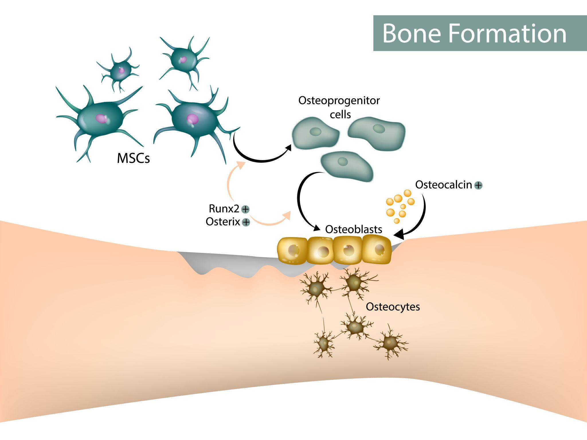
Figure 1. Overview of regenerative medicine modalities — including stem cell therapy, RNA therapy, tissue engineering, gene therapy, platelet-rich plasma, and organ transplantation — all centred on the human body.

1. Introduction
Human stem cells represent one of the most significant advances in modern regenerative medicine. These unique cells possess the remarkable ability to self-renew and differentiate into the specialized cells that form the tissues and organs of the human body. Stem cell science has transformed fields as diverse as tissue engineering, organ regeneration, wound healing, nerve repair, hematology, and cellular therapy.
Modern stem cell therapy aims to repair, replace, or regenerate damaged tissues using stem cells or stem cell-derived products. Researchers are currently exploring applications in burns, spinal cord injury, neurological disorders, diabetes, cardiac disease, liver disease, orthopedic injuries, and immune disorders. Often referred to as the "master cells" of the body, stem cells have created new therapeutic possibilities — especially in conditions where conventional approaches provide limited recovery.

2. Fundamental Properties of Stem Cell
Stem cells are primitive, undifferentiated cells defined by two essential biological properties that allow them to form the varied tissues and organs of the human body.

2.1 Self-Renewal
Self-renewal is the capacity of stem cells to undergo continuous cell division while maintaining an undifferentiated state. This property ensures the body retains a consistent pool of stem cells for future repair and growth throughout the organism's lifespan.

2.2 Differentiation
Differentiation is the mechanism by which undifferentiated cells transition into specialized mature cells — such as skin, nerve, bone, or blood cells. This transformation is governed by:
- Gene activation and epigenetic reprogramming
- Growth factor signaling cascades
- Extracellular matrix interactions
- Mechanical and biophysical stimulation

2.3 Potency Hierarchy
Closely related to differentiation is the concept of potency — a stem cell's capacity to generate different cell types. Potency is hierarchical, ranging from totipotent cells at the apex down to unipotent cells.

Table 1. Stem Cell Potency Hierarchy
Potency Level | Definition | Differentiation Potential | Example
Totipotent | Can form entire organism including extra-embryonic tissues | Highest — all cell types | Fertilized zygote
Pluripotent | Can differentiate into nearly any cell type in the body | Very broad — all three germ layers | ESCs, iPSCs
Multipotent | Limited range within a tissue lineage | Moderate — lineage-specific | MSCs, HSCs
Unipotent | Only one specific cell type; retains self-renewal | Restricted — one cell type | Epidermal stem cells
Table 1. Classification of stem cells by differentiation potential (potency hierarchy).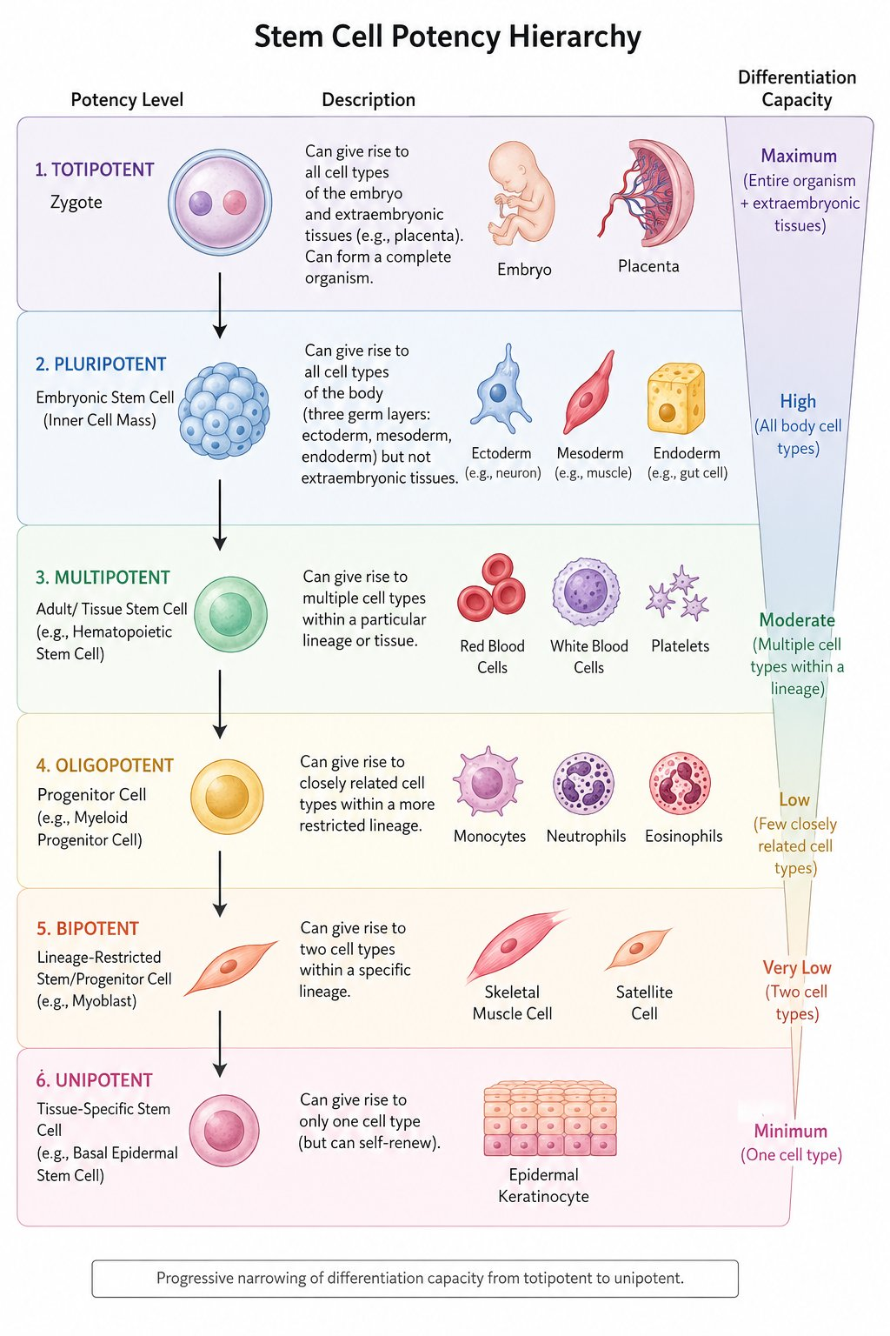
Figure 2. Stem Cell Potency Hierarchy: progressive narrowing of differentiation capacity from totipotent (zygote — entire organism + extraembryonic tissues) through pluripotent (ESCs — all three germ layers), multipotent (HSCs — lineage-specific), oligopotent (myeloid progenitors), bipotent (myoblasts — two cell types), down to unipotent (basal epidermal stem cells — single cell type).
3. Types of Human Stem Cells

3.1 Embryonic Stem Cells (ESCs)
Embryonic stem cells are derived from the inner cell mass of blastocyst-stage embryos. They are pluripotent with high proliferative capacity and the ability to form tissues from all three primary germ layers (ectoderm, mesoderm, and endoderm). Their principal applications include organ regeneration research, tissue engineering, neural repair, and developmental biology. Key limitations include ethical controversy surrounding embryo use, risk of teratoma formation, and immune rejection in allogeneic transplantation.

3.2 Adult (Somatic) Stem Cells
Adult stem cells reside within mature tissues and maintain ongoing tissue repair throughout life. They are generally multipotent and tissue-specific. Sources include bone marrow, adipose tissue, skin, dental pulp, umbilical cord, and peripheral blood.

3.3 Mesenchymal Stem Cells (MSCs)
MSCs are among the most extensively studied cells in regenerative medicine. Isolated from bone marrow, adipose tissue, placenta, umbilical cord, synovial tissue, and dental pulp, they are multipotent and capable of differentiating into osteoblasts, chondrocytes, adipocytes, fibroblasts, muscle cells, and Schwann-like cells. Beyond direct differentiation, MSCs exert powerful paracrine effects and immunomodulatory properties.

Table 2. MSC Differentiation Potential and Tissue Targets
Mature Cell Type | Tissue Formed | Clinical Application
Osteoblasts | Bone | Bone grafting, fracture repair
Chondrocytes | Cartilage | Cartilage regeneration, osteoarthritis
Adipocytes | Adipose tissue | Cosmetic reconstruction, fat grafting
Fibroblasts | Connective tissue | Wound healing, scar reduction
Muscle cells | Skeletal & smooth muscle | Muscular dystrophy, cardiac repair
Schwann-like cells | Peripheral nerve support | Nerve conduits, nerve grafts
Table 2. Differentiation potential of mesenchymal stem cells and corresponding clinical targets.

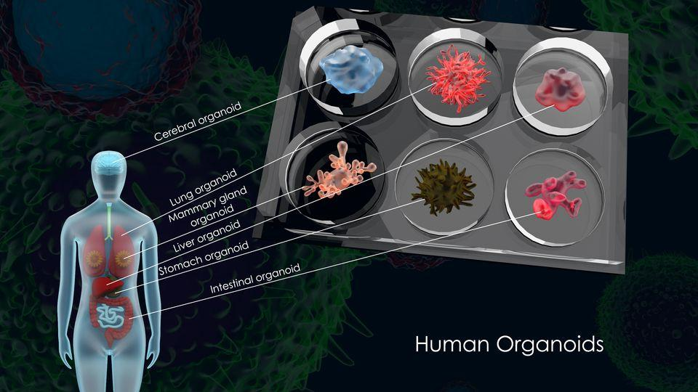
Figure 3. Adipocytes (fat cells) derived from MSC differentiation. Adipose tissue serves both as a rich MSC source and as the target tissue when MSCs undergo adipogenic differentiation.

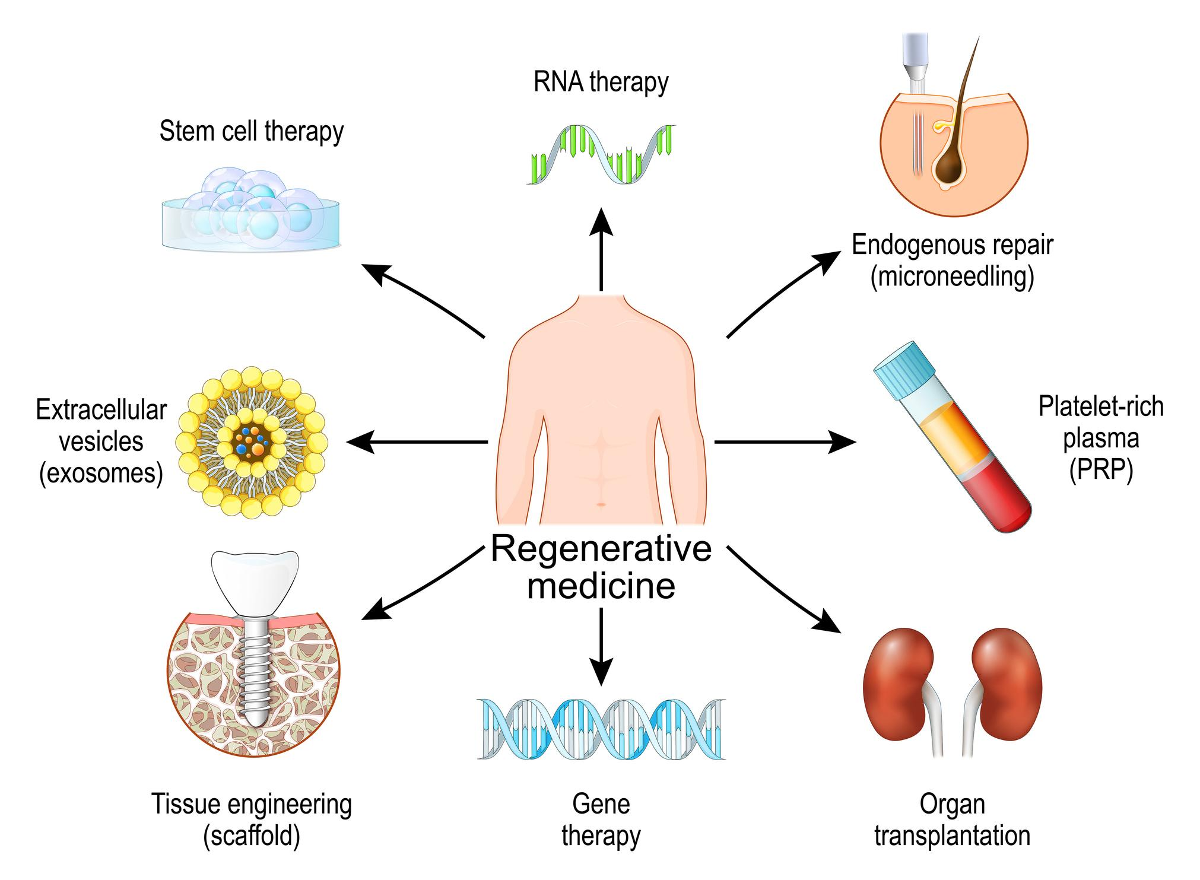
Figure 4. MSC-to-bone differentiation pathway: MSCs commit to osteoprogenitor cells under the influence of transcription factors Runx2 and Osterix, then differentiate into osteoblasts (with osteocalcin expression) and finally osteocytes embedded within bone matrix.
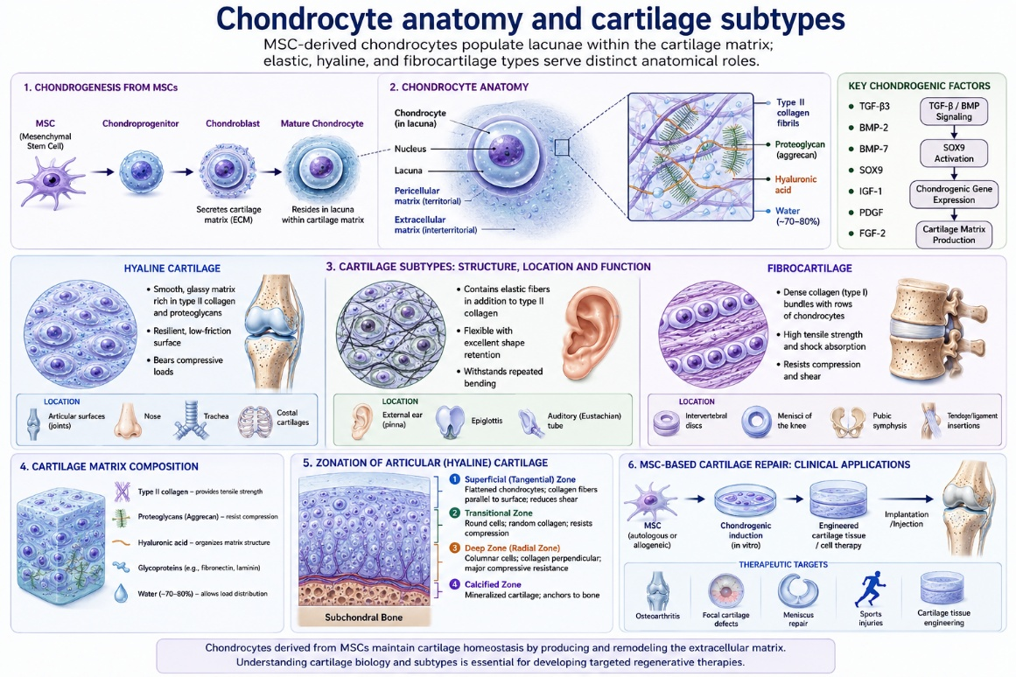
Figure 5. Chondrocyte anatomy and cartilage subtypes. MSC-derived chondrocytes populate lacunae within the cartilage matrix; elastic, hyaline, and fibrocartilage types serve distinct anatomical roles.

3.4 Hematopoietic Stem Cells (HSCs)
HSCs are responsible for the continual formation of blood and immune cells throughout life. Sourced from bone marrow, umbilical cord blood, and mobilized peripheral blood, they give rise to red blood cells, white blood cells, and platelets. Bone marrow transplantation using HSCs remains one of the most successful and established stem cell therapies in clinical medicine.

3.5 Neural Stem Cells
Neural stem cells are found in specific niches within the brain and spinal cord. They generate neurons, astrocytes, and oligodendrocytes, and hold promise for applications in spinal cord injury, stroke recovery, Parkinson's disease, and neurodegenerative disorders.

3.6 Schwann Cells and Schwann-like Cells
Schwann cells are specialized glial cells of the peripheral nervous system responsible for myelin sheath formation, axonal support, nerve regeneration, and neurotrophic factor secretion. Because native Schwann cell harvesting is technically demanding, researchers commonly differentiate MSCs into Schwann-like cells for use in nerve conduits and peripheral nerve repair.

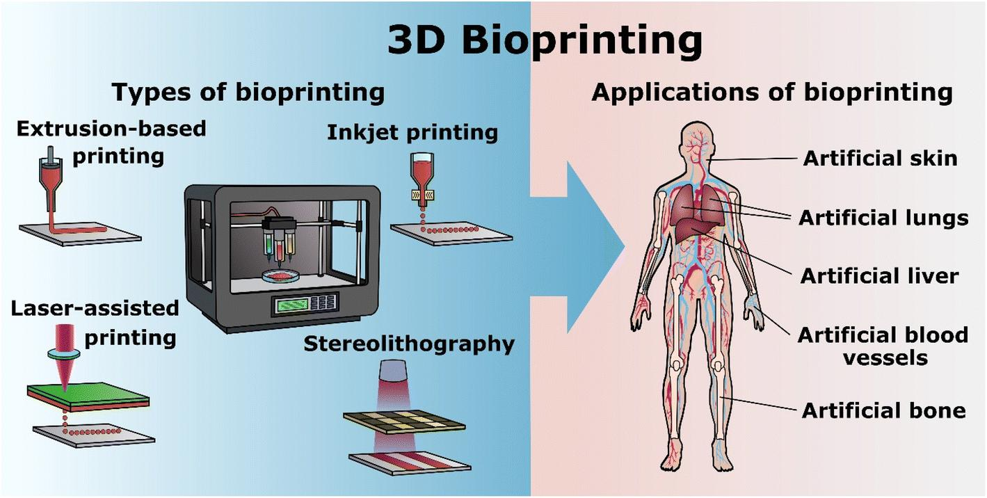
Figure 6. Three-dimensional anatomy of a Schwann cell showing the concentric myelin sheath wrapped around the axon (neurofibril), with the Schwann cell nucleus visible at the outer surface. This myelinating architecture is the primary target of nerve repair strategies.

3.7 Induced Pluripotent Stem Cells (iPSCs)
iPSCs are adult somatic cells — typically skin fibroblasts or blood cells — that have been genetically reprogrammed by introduction of transcription factors (OCT4, SOX2, KLF4, c-MYC) to return to a pluripotent state. They offer the regenerative breadth of ESCs with significantly reduced ethical concerns and the possibility of patient-specific autologous therapy.

4. Harvesting of Stem Cells
Stem cell harvesting refers to the collection of stem cells from human tissues using methods appropriate to the target cell type, source tissue, and intended clinical use.

4.1 Bone Marrow Aspiration
The iliac crest of the pelvis is the standard site for bone marrow aspiration. Under anesthesia, a trocar needle is inserted into the posterior iliac crest and marrow aspirated. The aspirate is processed to isolate MSCs and HSCs. While this method yields a rich stem cell source, it is invasive and associated with post-procedural discomfort.

4.2 Adipose Tissue Harvesting
Adipose tissue contains abundant MSCs within its stromal vascular fraction (SVF). The procedure involves tumescent liposuction, enzymatic digestion of the lipoaspirate, centrifugation, and SVF isolation. This is minimally invasive, provides high MSC yield, and is increasingly used in skin regeneration, orthopedics, cosmetic medicine, and nerve regeneration.

4.3 Umbilical Cord Collection
Both umbilical cord tissue (Wharton's jelly) and cord blood are rich sources of stem cells. Collection is entirely non-invasive, occurring at birth after cord clamping. Umbilical cord stem cells are young and proliferative with lower immunogenicity, making them suitable for allogeneic applications.

4.4 Peripheral Blood Stem Cell Apheresis
Stem cells are mobilized from bone marrow into peripheral blood by administering G-CSF over several days, then collected by leukapheresis and density gradient centrifugation.

Table 3. Comparison of Stem Cell Harvesting Methods
Method | Cell Type Obtained | Invasiveness | Yield | Main Applications
Bone marrow aspiration | MSCs, HSCs | High | Moderate | Transplantation, orthopedics
Adipose liposuction | MSCs (SVF) | Low | High | Wound healing, cosmetics, nerve
Umbilical cord | MSCs, HSCs | None (post-delivery) | Moderate | Blood disorders, regenerative Rx
Peripheral blood apheresis | HSCs (mobilized) | Low | Moderate–High | Hematopoietic transplantation
Table 3. Comparative overview of stem cell harvesting methods with regard to invasiveness, yield, and clinical utility.
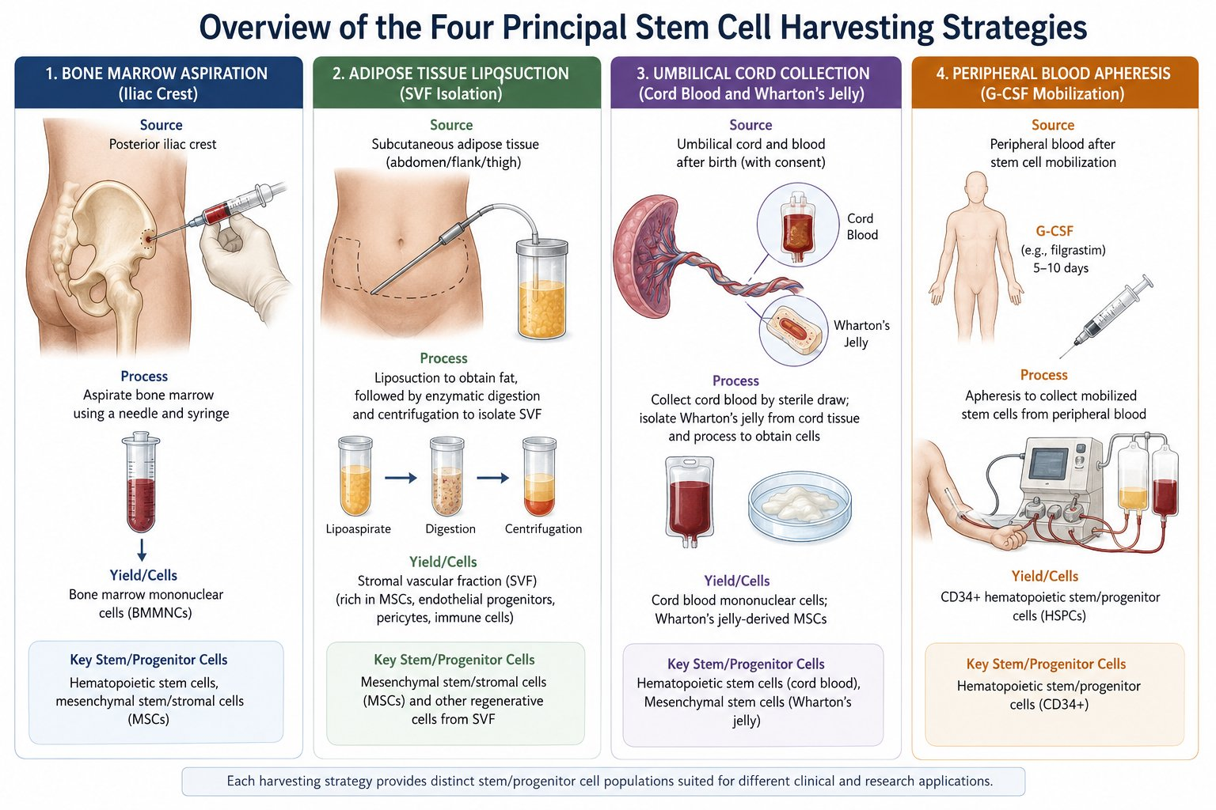
Figure 7. Overview of the four principal stem cell harvesting strategies: (1) Bone marrow aspiration from the posterior iliac crest yielding HSCs and MSCs; (2) Adipose tissue liposuction with enzymatic digestion and centrifugation yielding SVF (rich in MSCs); (3) Umbilical cord collection of cord blood and Wharton's jelly yielding cord-blood HSCs and MSCs; (4) Peripheral blood apheresis after G-CSF mobilization yielding CD34+ hematopoietic stem/progenitor cells.

5. Stem Cell Culture and Expansion
After harvesting, stem cells are processed and cultured in GMP-compliant laboratories. Core processes include cell isolation, culture medium preparation, expansion through serial passaging, sterility and mycoplasma testing, viability assessment, immunophenotypic characterization, and cryopreservation. Cells are maintained at 37°C, pH 7.2–7.4, controlled oxygen tension, and with appropriate nutrient supply. Growth factors and biochemical stimuli direct differentiation toward specific lineages.

6. Differentiation and Tissue Formation
Stem cells differentiate into specialized tissues through coordinated gene activation, growth factor signaling, extracellular matrix interaction, and mechanical stimulation. Table 4 summarizes key tissue types and their clinical applications.

Table 4. Stem Cell Differentiation Targets and Clinical Applications
Tissue | Cell Types Formed | Driving Cells | Clinical Applications
Skin | Keratinocytes, fibroblasts, melanocytes | MSCs, ESCs | Burn treatment, skin grafts, chronic wound healing
Nerve | Neurons, Schwann cells, astrocytes | Neural SCs, MSCs | Peripheral nerve repair, nerve conduits, spinal cord
Bone | Osteoblasts, osteocytes, chondrocytes | MSCs | Bone grafting, fracture repair, dental reconstruction
Blood | RBCs, WBCs, platelets | HSCs | Leukemia therapy, bone marrow transplantation
Heart | Cardiomyocytes | iPSCs, MSCs | Cardiac regeneration, myocardial repair
Liver | Hepatocytes | iPSCs, MSCs | Liver disease, toxicology modeling
Kidney | Renal tubular cells | iPSCs | Kidney tissue engineering (experimental)
Lung | Alveolar cells | iPSCs | Pulmonary regenerative medicine (experimental)
Table 4. Stem cell differentiation potential by target tissue type and primary clinical applications.

7. Mechanisms of Healing by Stem Cells
Stem cells contribute to tissue repair and regeneration through three principal mechanisms:

7.1 Cell Replacement
Stem cells engraft at sites of damage and directly replace lost or non-functional cells. This is most clearly demonstrated in bone marrow transplantation, where donor HSCs reconstitute the entire hematopoietic system.

7.2 Paracrine Growth Factor Secretion
Key secreted bioactive factors and their roles include:
- VEGF — promotes angiogenesis and neovascularization
- PDGF — stimulates fibroblast proliferation and connective tissue repair
- TGF-β — regulates collagen synthesis and fibrosis
- EGF — accelerates epithelial regeneration
- FGF — drives fibroblast and keratinocyte proliferation
- NGF and BDNF — support neuronal survival and axonal repair

7.3 Immunomodulation
MSCs suppress excessive inflammation by inhibiting T-cell and NK-cell proliferation, suppressing pro-inflammatory cytokines, and promoting regulatory T-cell activity. This is central to their application in autoimmune disorders and graft-versus-host disease.

8. Stem Cells in Tissue Engineering
Stem cells are frequently combined with biomaterial scaffolds to engineer replacement tissues. Scaffolds support cell attachment, permit nutrient diffusion, and guide three-dimensional tissue architecture. Commonly used biomaterials include collagen, chitosan, gelatin, silk fibroin, and polycaprolactone.

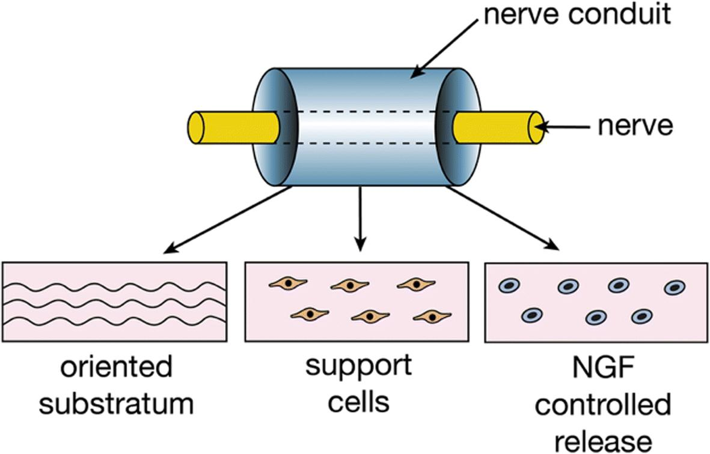
Figure 8. Tissue engineering approach matrix: scaffold polymers (natural and synthetic), 3D fabrication methods (solvent casting to bioprinting), cell types (chondrocytes, iPSCs, MSCs), transplantation categories (syngeneic, allogeneic, xenogeneic), stimulation factors, and cell-based strategies.
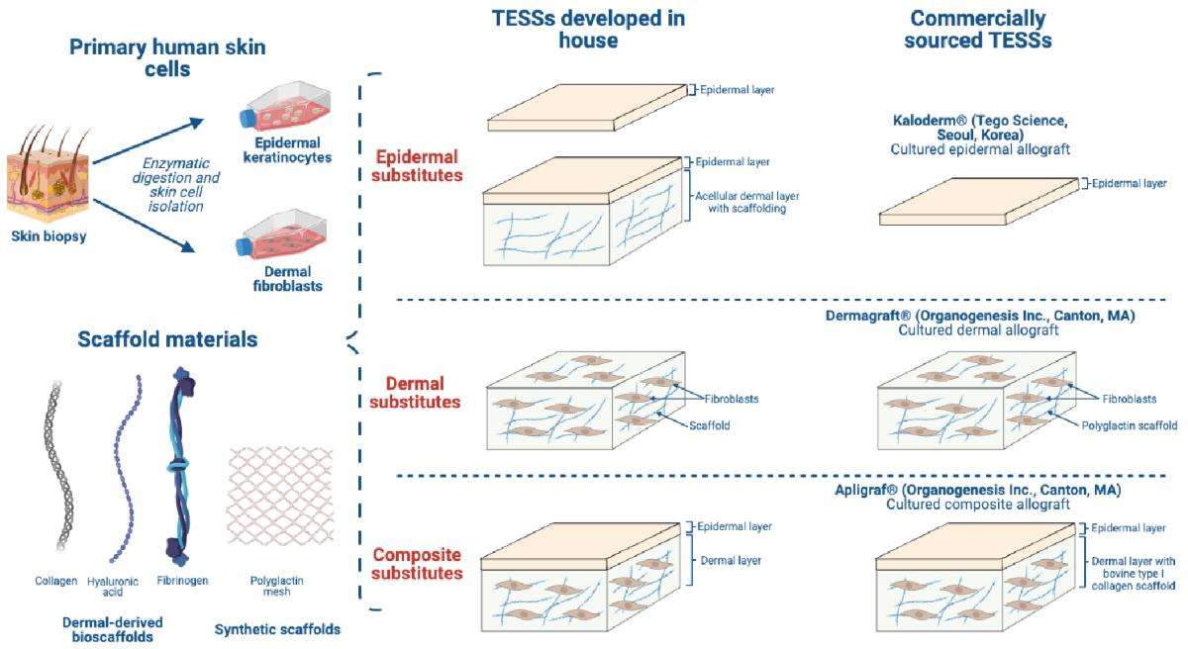
Figure 9. Cardiac tissue engineering workflow: stem cell-seeded scaffolds are cultured in a bioreactor under biochemical, electrical, and mechanical cues to form an organized cardiomyocyte construct, which is then applied to the damaged myocardial patch.

8.1 Skin Tissue Engineering
Tissue-engineered skin substitutes (TESSs) are constructed from primary keratinocytes and dermal fibroblasts seeded onto scaffold materials. Three tiers of substitutes exist: epidermal (keratinocyte sheets), dermal (fibroblast-seeded scaffolds), and composite (bilayer constructs combining both layers). Commercially available products include Kaloderm, Dermagraft, and Apligraf.

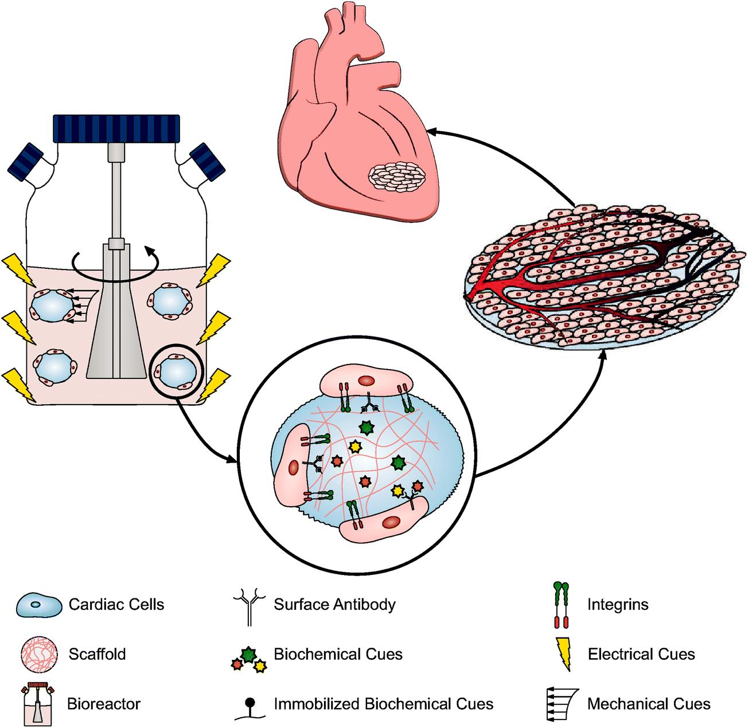
Figure 10. Tissue-engineered skin substitutes (TESSs): primary keratinocytes and dermal fibroblasts are isolated by enzymatic digestion of skin biopsies, then seeded onto scaffold materials to produce epidermal, dermal, or composite substitutes — both in-house and commercially sourced (Kaloderm, Dermagraft, Apligraf).

8.2 Nerve Conduits
Nerve conduits provide a tubular scaffold bridging severed nerve stumps, directing axonal regeneration across the gap. The conduit lumen may contain an oriented substratum (to guide axonal growth), support cells (Schwann cells or MSC-derived Schwann-like cells), and controlled-release depots of nerve growth factor (NGF).
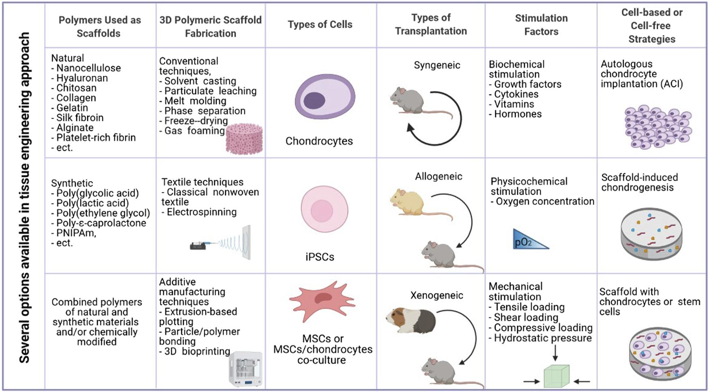
Figure 11. Biomaterial nerve conduit bridging a peripheral nerve gap. The conduit provides three elements critical to nerve regeneration: an oriented substratum guiding axon directionality, support cells (Schwann or Schwann-like cells), and NGF controlled-release for neurotrophic support.
9. Clinical Applications of Stem Cell Therapy

9.1 Established Therapies
- Bone marrow transplantation (hematological malignancies, aplastic anemia)
- Skin grafting using keratinocyte and fibroblast cultures
- Corneal epithelial regeneration
- Blood disorder treatment via HSC transplantation

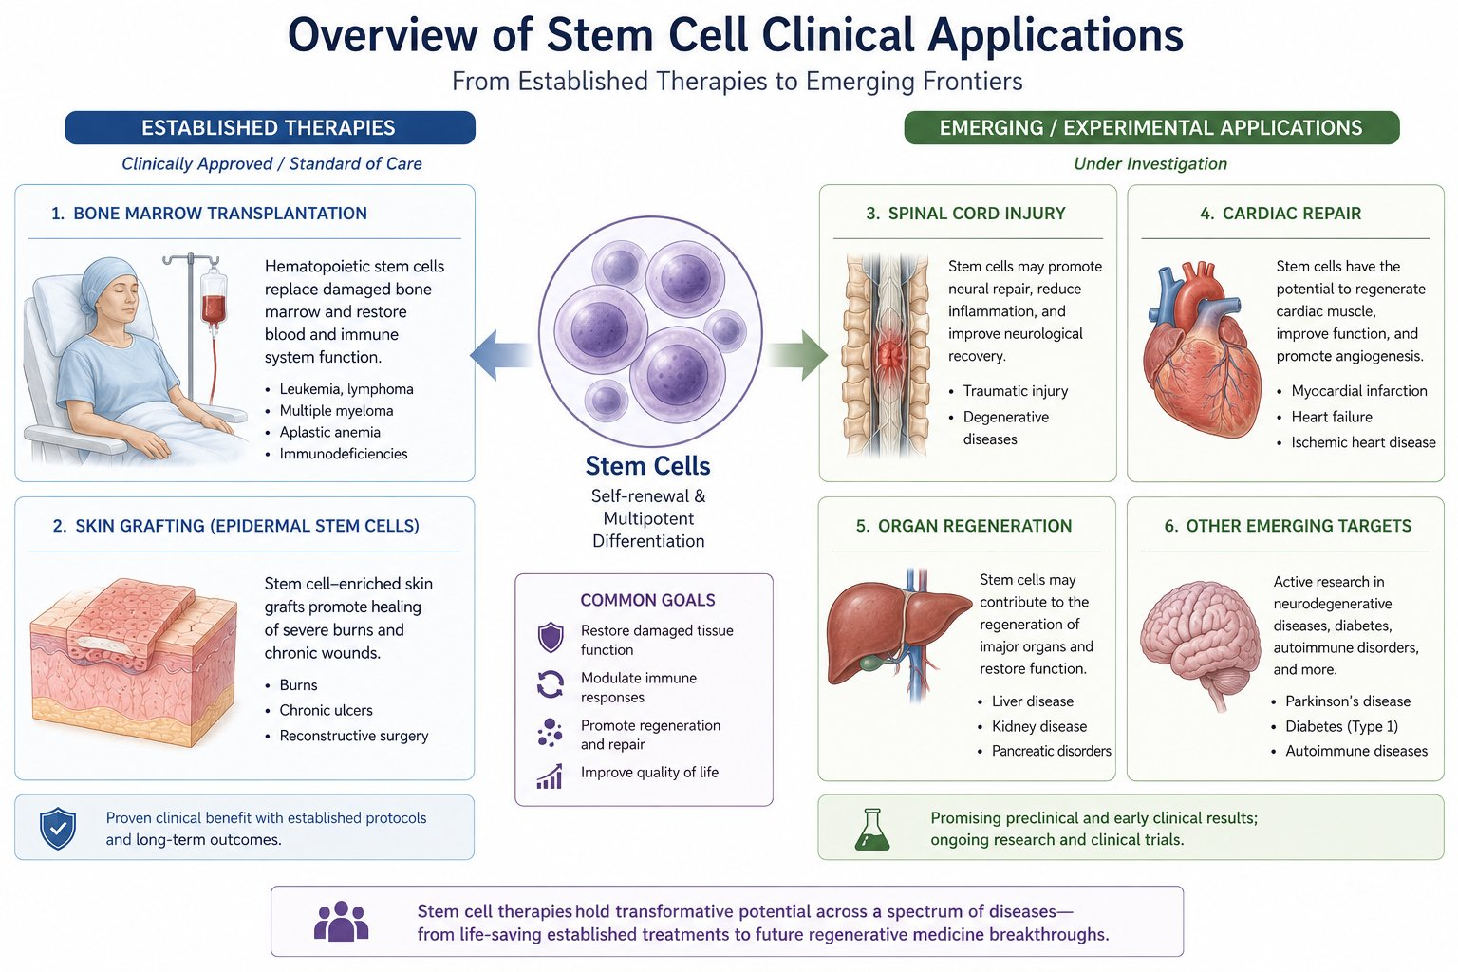
Figure 12. Overview of stem cell clinical applications — from established standard-of-care therapies (bone marrow transplantation for leukemia/aplastic anemia; skin grafting for burns and chronic wounds) to emerging experimental targets (spinal cord injury, cardiac repair, organ regeneration, and neurodegenerative/autoimmune diseases). Common therapeutic goals include restoring tissue function, modulating immune responses, promoting regeneration, and improving quality of life.

Table 5. Emerging Stem Cell Clinical Applications
Condition | Cell Type Used | Mechanism / Notes
Spinal cord injury | Neural SCs, MSCs | Axonal regeneration, neuroprotection, anti-inflammatory
Parkinson's disease | iPSCs → dopaminergic neurons | Replace lost dopaminergic neurons in substantia nigra
Heart failure | MSCs, iPSCs → cardiomyocytes | Myocardial regeneration, reduced infarct scarring
Osteoarthritis | MSCs (intra-articular) | Cartilage repair, anti-inflammatory paracrine effect
Type 1 Diabetes | iPSCs → β-cells | Pancreatic islet regeneration, insulin production
Liver disease | MSCs, hepatocyte-like cells | Hepatocyte replacement, anti-fibrotic signalling
Peripheral nerve injury | MSC-derived Schwann-like cells | Nerve conduit seeding, axonal guidance, myelination
Stroke recovery | Neural SCs, MSCs | Neuroregeneration, neuroprotective cytokines
Table 5. Selected experimental and emerging stem cell therapeutic applications with associated cell types and proposed mechanisms.
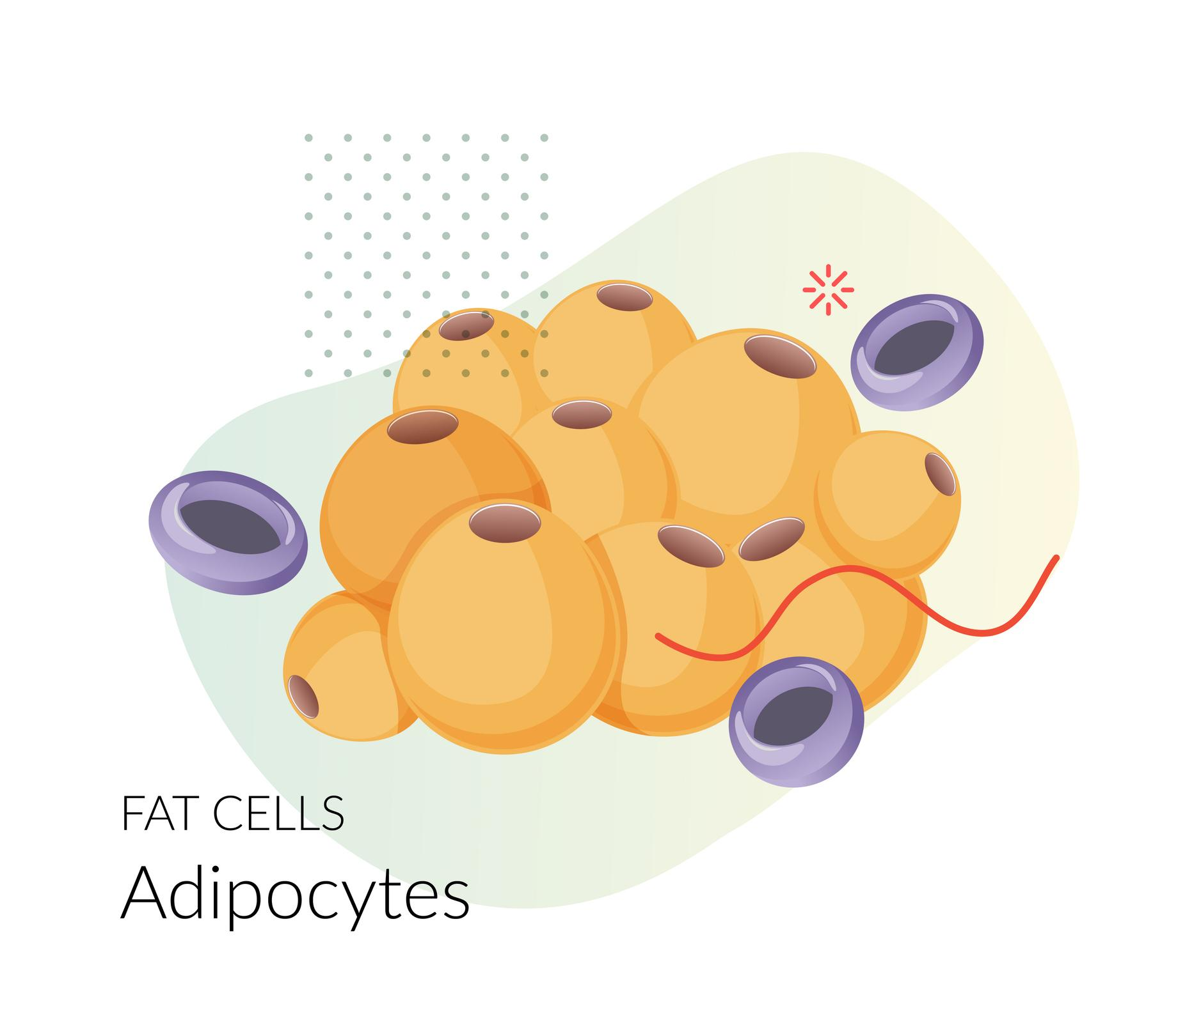
Figure 13. Human organoids derived from iPSCs: miniature three-dimensional organ models including cerebral, lung, mammary gland, liver, stomach, and intestinal organoids grown in culture wells. Organoids serve as powerful platforms for disease modeling, drug screening, and transplantation research.

10. Ethical and Regulatory Considerations
Human stem cell research requires robust ethical frameworks. Core requirements include informed donor consent, independent ethical oversight by institutional review boards (IRBs), GMP-compliant manufacturing, and phased clinical trial authorization by national regulatory authorities (FDA, EMA).
Embryonic stem cell research remains ethically contested due to the destruction of human embryos during ESC derivation. The development of iPSCs has mitigated — though not eliminated — these concerns by providing an alternative pluripotent source. Unregulated stem cell clinics globally offering unproven therapies pose public health risks including tumor formation, systemic infection, and false clinical hope for vulnerable patients.

11. Risks and Challenges
- Tumor and teratoma formation — particularly with pluripotent cells (ESCs, iPSCs)
- Immune rejection and graft-versus-host disease in allogeneic transplantation
- Genetic instability and chromosomal abnormalities during ex vivo culture
- Infection risk from laboratory processing and non-sterile technique
- High manufacturing cost and complex regulatory pathway to clinical approval
- Variable cell behavior depending on patient age, disease state, and tissue source

12. Future Directions
The future of stem cell medicine will be shaped by convergent advances across biotechnology, materials science, and genomics:
- 3D Bioprinting: Precise deposition of stem cells within bioinks to fabricate patient-specific tissues and organs.
- Organoid Engineering: iPSC-derived miniature organs enabling disease modeling, drug screening, and transplantation.
- Gene-Edited Stem Cells: CRISPR-Cas9 correction of disease-causing mutations in autologous iPSCs before engraftment.
- Exosome Therapy: Cell-free approach using stem cell-derived exosomes as paracrine signaling vectors.
- Personalized Regenerative Medicine: Patient-specific iPSC-derived products tailored to individual genetic profiles.
- Artificial Organs: Bioengineered constructs combining decellularized scaffolds with patient-derived stem cells.

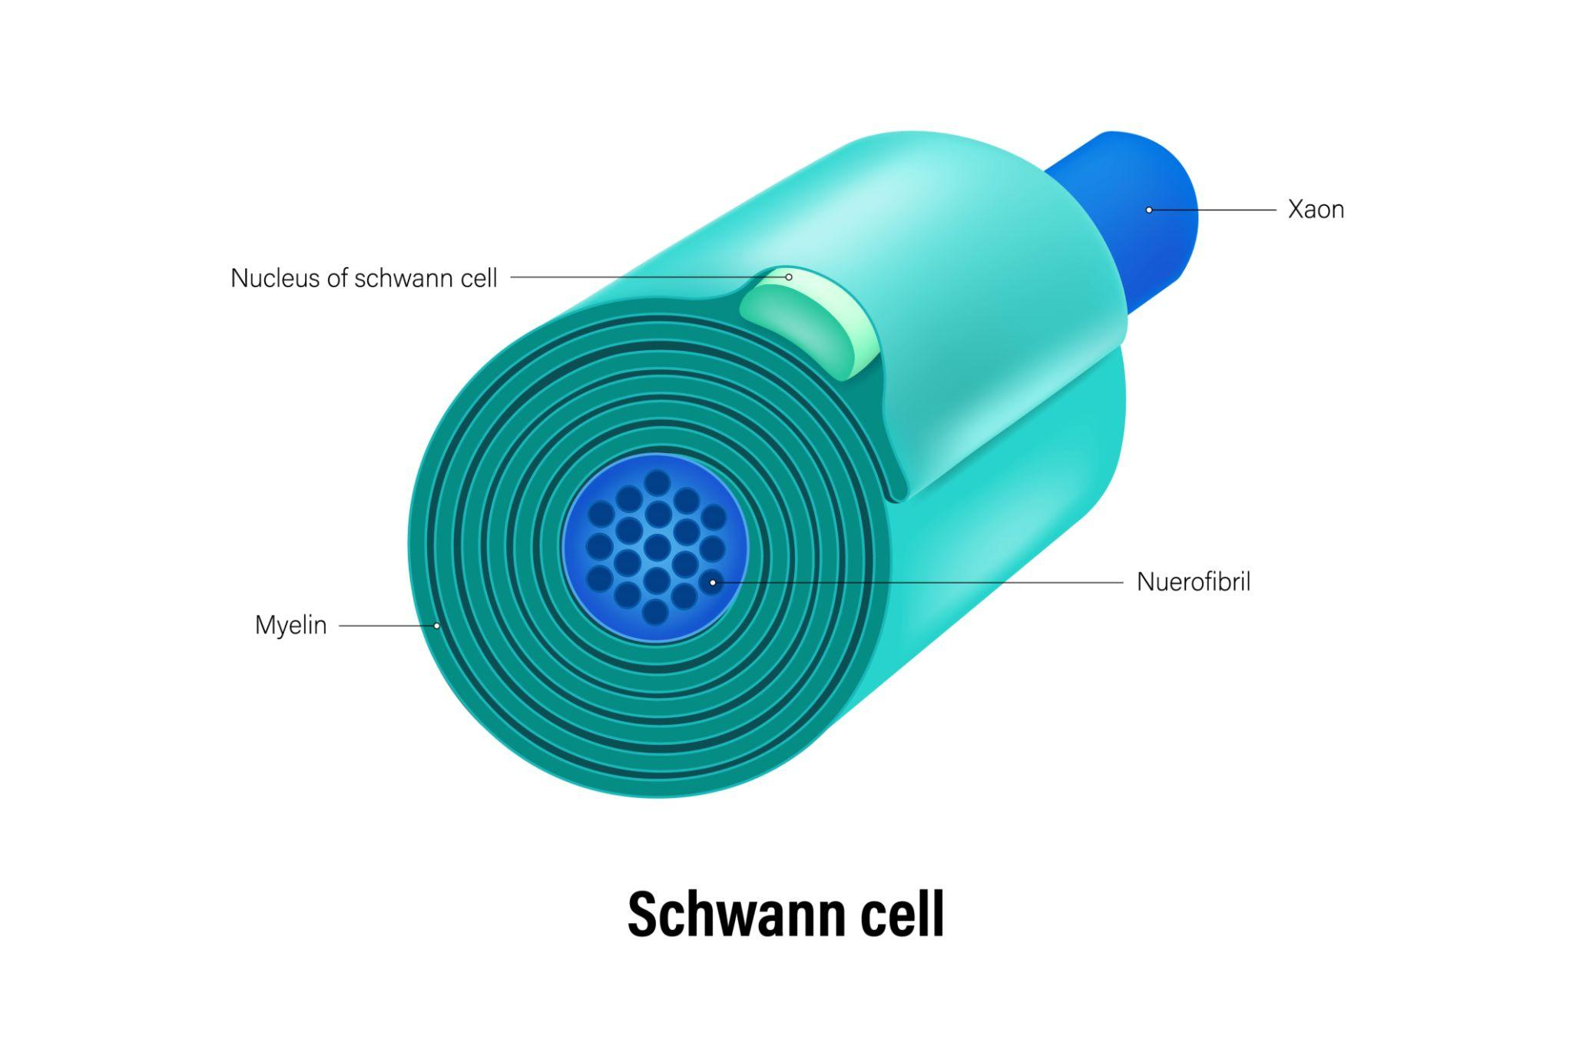
Figure 14. 3D Bioprinting technologies and applications: extrusion-based, inkjet, laser-assisted, and stereolithographic printing methods produce patient-specific constructs for artificial skin, lungs, liver, blood vessels, and bone.

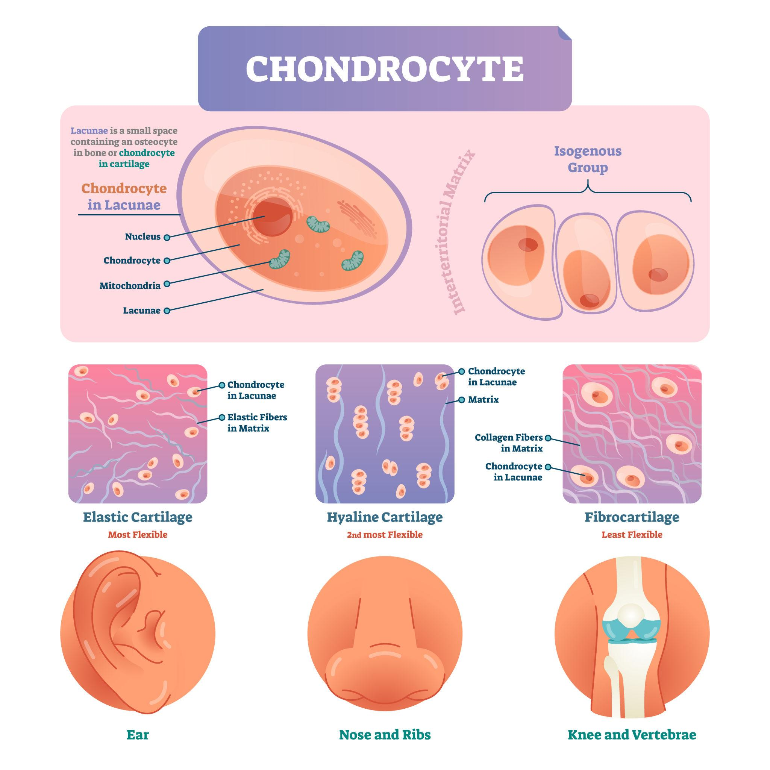
Figure 15. CRISPR-Cas9 gene editing system: (1) RNA targeting device guides the Cas9 nuclease to a specific DNA sequence; (2) Cas9 binds and cuts both DNA strands; (3) new genetic material is introduced and incorporated during DNA repair — enabling correction of disease-causing mutations in patient-derived stem cells.
Conclusion
Human stem cells have fundamentally transformed regenerative medicine by offering the prospect of repairing damaged tissues and regenerating organs that were previously beyond therapeutic reach. Stem cells harvested from bone marrow, adipose tissue, umbilical cord, and peripheral blood can be cultured, expanded, and differentiated into skin, nerve, bone, blood, and organ cells with broad clinical utility.
Mesenchymal stem cells, hematopoietic stem cells, neural stem cells, and induced pluripotent stem cells each possess distinctive regenerative properties. They are now central to tissue engineering, wound healing, nerve regeneration, orthopedic repair, and advanced cellular therapy. Although many applications remain investigational, stem cell science is advancing rapidly through integrated progress in biotechnology, biomaterials, gene editing, and precision medicine.
As scientific understanding deepens and regulatory frameworks mature, stem cells are poised to play an increasingly central role in the future of personalized medicine, organ regeneration, and curative therapies for currently intractable diseases.

References
1. National Institutes of Health (NIH). Introduction to Stem Cells. NIH Stem Cell Information. https://stemcells.nih.gov
2. Mayo Clinic. Stem Cells: What They Are and What They Do. https://www.mayoclinic.org
3. National Institutes of Health. Guidelines for Human Stem Cell Research. Federal Register, 2009.
4. National Academies Press. Stem Cells and the Future of Regenerative Medicine. Washington DC, 2002.
5. International Research Program (IRP), NIH. Mesenchymal Stem Cells and Regenerative Medicine.
6. Pittenger MF, et al. Multilineage potential of adult human mesenchymal stem cells. Science. 1999;284(5411):143–147.
7. Takahashi K, Yamanaka S. Induction of pluripotent stem cells from mouse embryonic and adult fibroblast cultures by defined factors. Cell. 2006;126(4):663–676.
8. Dominici M, et al. Minimal criteria for defining multipotent mesenchymal stromal cells. Cytotherapy. 2006;8(4):315–317.
9. Langer R, Vacanti JP. Tissue engineering. Science. 1993;260(5110):920–926.
10. Discher DE, Mooney DJ, Zandstra PW. Growth factors, matrices, and forces combine and control stem cells. Science. 2009;324(5935):1673–1677.

Author Profile:
 Dr. Pankaj Bablani, Ph.D. Scholar at Jamia Hamdard, New Delhi, Head Clinical operations & GM, Datt Mediproducts Pvt Ltd
 Dr. Manju Sharma; (PhD) Professor, Department of Pharmacology, School of Pharmaceutical Education and Research, Hamdard university.

